Case report

Case report of penile fracture: an unusual presentation

Abstract
Background: Penile fracture is a rare but serious urological emergency involving rupture of the tunica albuginea of the corpus cavernosum, typically during vigorous sexual activity. A sudden cracking sound, immediate pain, detumescence, and penile deformity often accompany it. Prompt diagnosis and surgical repair are critical to prevent long-term complications. This report presents a unique case of delayed and unusual presentation of penile fracture in a rural Ghanaian setting. Case Presentation: A 26-year-old male presented three weeks after sustaining penile trauma while watching pornography in a supine position on a motorbike. Physical examination revealed a swollen, ecchymotic, deformed penis (the classic "eggplant" sign). Surgical exploration revealed a bilateral partial rupture of the corpora cavernosa and a complete 4x3 cm urethral tear. The injury was repaired. Despite the delayed presentation, the patient recovered uneventfully and regained normal erectile function within two weeks postoperatively. Discussion: This case underscores the challenges of managing penile fractures in resource-limited settings, including delayed presentation due to stigma and lack of local surgical expertise. While early intervention is preferred, successful outcomes are still achievable with delayed surgical management. The ventral location of the injury correlated with the urethral involvement, consistent with anatomical susceptibility during erection. Surgical approach via subcoronal degloving provided adequate exposure for complete repair. Conclusion: Penile fracture with urethral involvement, even when presented late, can be effectively managed with surgical intervention in rural healthcare settings. Clinicians should maintain a high index of suspicion and prioritise early diagnosis and surgical repair to optimise outcomes.
Keywords: Penile fracture, urethral injury, emergency surgery, delayed presentation, rural healthcare.

Introduction
Due to the mobility of male genitalia, its vulnerability to traumatic injuries is not so common (1,2) Penile fracture, the rupture of the tunica albuginea of the corpus cavernosum, is a rare but well-documented urological emergency that commonly occurs during vigorous sexual intercourse, masturbation, rolling over an erect penis and is often accompanied by a popping sound, immediate detumescence, and penile swelling (2) The primary causes of penile fractures include nonsexual trauma and direct damage sustained during sexual activity. Ecchymosis, rapid detumescence, sudden swelling, and a cracking/ popping sound are common symptoms of penile fracture (3) When a subcutaneous haematoma causes ecchymosis and extensive penile enlargement, the patient frequently displays the "eggplant" sign (2) Diagnosis is based mainly on history and clinical examination. Surgical repair needs to be done immediately (4) Delayed surgical correction usually results from patients delaying seeking treatment out of shame (2), which raises the likelihood of adverse outcomes, including erectile dysfunction and penile curvature (4) Although early surgical intervention is the gold standard, resource constraints in rural areas, especially a lack of expertise, often complicate timely diagnosis and treatment. This report details an unusual cause of penile fracture and its successful management in a rural Ghanaian healthcare facility.
Case presentation
A 26-year-old man presented to the outpatient department of a surrounding district hospital with a chief complaint of pain and swelling in the penis with slight difficulty in voiding, which started three weeks ago following a fall on the erect penis whiles lying on a motorbike. An attempt at catheterisation due to urine retention failed. He was therefore, referred to our facility for management. On further inquiry, the patient was watching pornography in a supine position on a motorbike and suddenly lost balance and fell on the erect penis. The sudden onset of pain, penile swelling and loss of tumescence followed this. Physical examination revealed significant swelling, ecchymosis, and a deformed penis ('eggplant' sign) as seen in Figure 1. The patient was afebrile, anicteric, not pale, well hydrated, and had stable vitals signs. A diagnosis of penile fracture was made. The patient was taken to the operating theatre, and spinal anaesthesia was given. The patient was prepped and draped. A sub coronal degloving incision was made. A midshaft partial rupture of the left and right corpora cavernosa in the ventral side, associated with penile urethral injury measuring 4 x 3 cm as seen in Figure 2, was identified. A 16-gauge urethral catheter was passed, and the urethral rupture was repaired with Vicryl 3/0. The tunica albuginea was repaired with nylon 3/0. The wound was closed with Vicryl 0. The postoperative condition of the patient was satisfactory, and was discharged from the hospital after day 13. The long stay in the hospital was to afford us time to observe the patient and for him to have his first review before going home, since he is from a very far village and there was also the risk of loosing him to follow-up due to stigma associated with his condition.

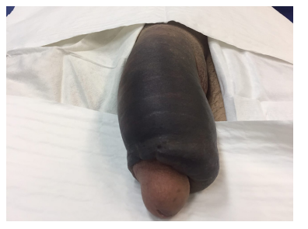Figure 1: Eggplant deformity: the classic appearance of a penile fracture, with haematoma of the penile shaft and ecchymosis extending into the scrotum.
Fig 2B
Fig 2A

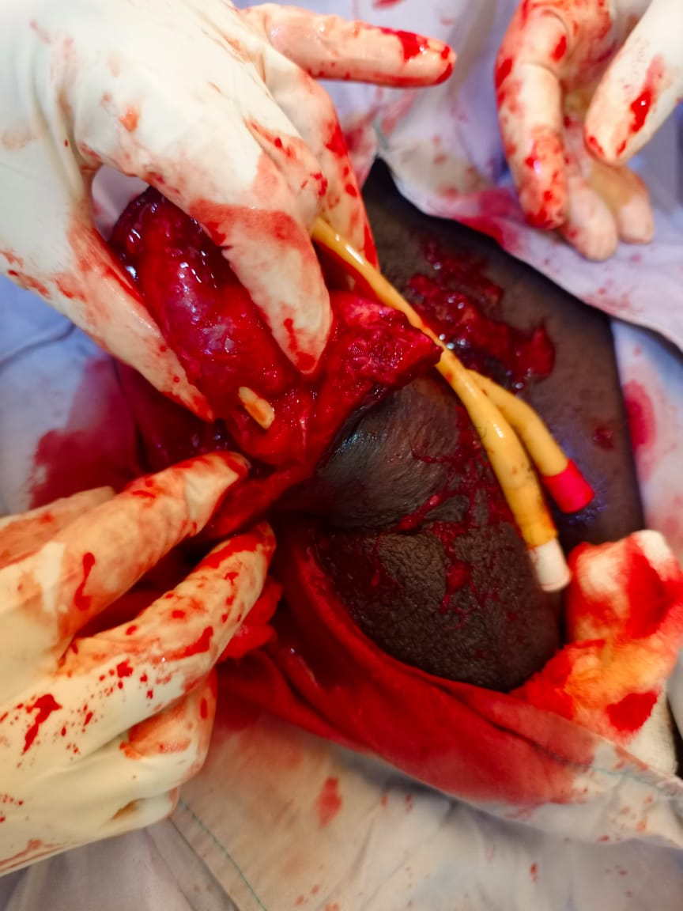
Figure 2: Intraoperative and postoperative pictures demonstrating bilateral partial rupture of the corpora cavernosa and complete rupture of the corpus spongiosum.White arrow site of left corporal injury, blue arrow-right corporal injury, black arrow- urethral injury

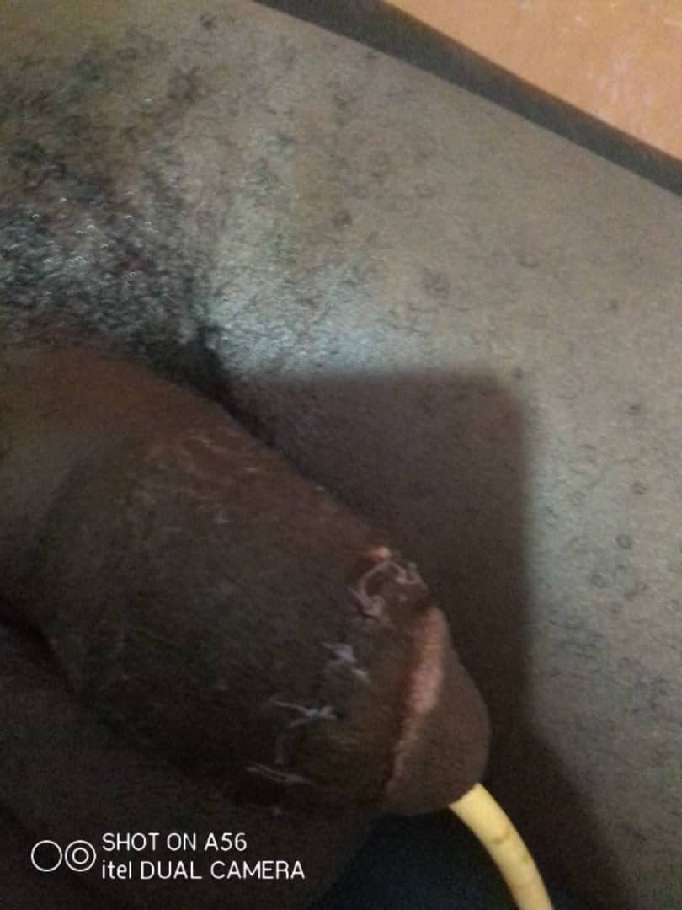
Figure 3: Skin incision sutured



Figure 4: Postoperative repaired penile fracture with normal erected penis
Upon review, two weeks after discharge, recovery was uneventful. The wound is well healed with normal erection as seen in Figures 3and 4, and no immediate postoperative complications.
Discussion
A penile fracture is a urological emergency that arises from a tear in the tunica albuginea of the penis, frequently brought on by violent manipulation, intense anal or vaginal sex or masturbation, gunshot wounds, or any other mechanical trauma that causes an erect penis to bend forcibly (5). Less frequent causes include rolling over in bed, taking a direct hit, bending too much, rushing to take off or put on clothes while the penis is erect, and falling on an aroused penis (1) In our case, the patient had a disruption in the tunica albuginea of both corpora cavernosa after he fell from a motorbike and landed on an erect penis while watching pornography. This is an unusual presentation, which, to the best of our knowledge, has not yet been reported in the literature. Falcone et al systematic review suggests that the major causes of penile fractures were those related to coital accidents in 80% of the cases whereas forcefully bending an erect penis to achieve detumescence, accounted for 8% (4).
Although they are uncommon, reported cases of penile fracture are gradually being reported in Ghana and other sub-Saharan African countries. Three such cases were documented at Cape Coast Teaching Hospital, Ghana, where patients had the usual signs and symptoms, such as discomfort and swelling after a popping sound during sexual activity (6) All these cases had good results after undergoing immediate surgical repair. The stigma andfear associated with genital injuries (7), as well as limitations to healthcare access, and unique cultural norms may prevent the timely presentation and management of penile fratcure. Our patient presented 3 weeks after the incident, which probably could be due to the stigma and the story associated with the injury. Not many people will readily admit to watching pornography. Therefore, it's not surprising that the patient in this case did not report early. The lack of expertise at the referral facility also contributed to the delay.
Clinically, the presentation of penile fractures is straightforward. A diagnosis is made based on the history and physical examination (3) The hallmarks of penile fracture are sudden pain, quick detumescence, and a loud cracking or popping sound. These, except for the popping sound, were reported by our patient. Figure 1 of this case report shows that the penile shaft is swollen, deformed, and discoloured locally, which conforms with the documented penile deformity, swelling, and ecchymosis (the so-called "eggplant" deformity) described in the literature.

Guidelines from the European Association of Urology indicate that imaging may be helpful in the diagnosis of penile fracture. Falcone et al in a systematic review on the management of penile fractures, established that most authors did not employ imaging to diagnose a penile fracture, and even if they did, it was for establishing the extent of injury and not diagnosing the fracture (4) This highlights the fact that a precise diagnosis may be made only by clinical evaluation, as was the case in this report. In clinical examination, ecchymosis, penile enlargement, and difficulty voiding in patients indicate urethral rupture caused by penile fracture. In instances where this is suspected, urethrography should be performed to assess the urethra. Our patient had some difficulties in voiding, which, together with the failed catheterisation at the referral facility, suggested urethral involvement. However, urethrography or ultrasonography was not done due to unavailability. In this case report, the diagnosis was made based on clinical manifestations, such as ecchymosis (bruising), substantial oedema, and a malformed penis, indicating that normal physical and history findings seldom call for further radiographic tests, such as sonography.
The ventral location of the fracture agrees with the literature (8) and explains why the urethral injury occurs since the urethra is more ventrally located. The tunica layers on the ventral side are thinner than the dorsal (4), making urethral involvement more likely in a ventral fracture. The urethral injury depends on the severity of the trauma. It's more likely to occur if the disruption of the corpus is bilateral (9), as was seen in this case. The tunica albuginea's thickness drops from 2 mm in the flaccid state to 0.25–0.5 mm during erection. (1).The penis is hence more susceptible to severe damage.
Most writers recommend immediate surgery as a therapy strategy to reduce hospital stays and surgical consequences, including erectile dysfunction and penile deformity (8,10) A circumferential sub-coronal incision approach was used in this case as it is the most commonly used surgical method for treating a penile fracture. This incision allows full degloving of the penis, giving complete access to inspect the corpora cavernosa and urethra, which was essential since, in the absence of imaging, the exact location of the tear could not be determined (4) This type of incision mitigated our lack of imaging modalities. Many other types of incisions have been reported by different authors, including a longitudinal incision over the suspected haematoma, a midline peno-scrotal incision along the median raphe, a para-penile incision, an inguino-scrotal incision, and an infra-pubic incision (11) This case report describes the use of nylon 3/0 as opposed to the use of absorbable suture(6,8) to patch the tunica albuginea. Even though there is no consensus on what type of sucture material to use for the tunica, most authors prefer slow-absorbable sutures to non-absorbable ones due to the formation of painful palpable knots or granulomas by the non-absorbable (4) Advocates for using non-absorbable sutures in closing tunical defects argue that they provide long-lasting support to the tunical edges, helping to maintain their alignment and prevent breakdown or recurrence of the defect during periods of increased intracorporeal pressure (12) The urethra and the wound in this report were sutured using Vicryl 3/0 and Vicryl 0, respectively. While surgery is preferable to conservative treatment, the outcomes of repair are unaffected by a delay of up to seven days following the injury. Our patient presented 3 weeks after injury, and getting a favourable outcome lends credence to that. Despite this allowance of seven days, most experts advise performing surgery right away for urethral damage in the penile fracture(10,13) During surgery for a penile fracture with urethral damage, bilateral corporal rupture should also be looked for, as it is commonly associated with urethral rupture (9) Following both corpora cavernosa and urethral repair, the majority of patients in the long-term follow-up continued to have normal erectile and voiding functions without any complications (4), as seen in our case.
Conclusions
A penile fracture is a rare urological emergency that should be repaired immediately, especially when the urethra is involved. However, delayed presentation should not discourage surgical exploration and repair. This case demonstrated that prompt clinical diagnosis and surgical management of penile fracture is possible in rural settings, with a favourable outcome.

References

1. Campbell A, Sharma D. Ballistic Genitourinary Trauma. In: Ballistic Trauma. Springer International Publishing; 2017. p. 309–36.
2. Wessells H, Mcaninch JW, Mydlo JH. Chapter 6 / Blunt Penile Trauma 95 95 From: Urological Emergencies: A Practical Guide Edited by: 6 Blunt and Penetrating Trauma to the Penis. 1998.
3. Fredrick Arieal, Vanni j, A. Traumatic penile injuries. 2021;
4. Falcone M, Garaffa G, Castiglione F, Ralph DJ. Current Management of Penile Fracture: An Up-to-Date Systematic Review. Vol. 6, Sexual Medicine Reviews. Elsevier B.V.; 2018. p. 253–60.
5. Tolani MA, Webber R, Buckley L. Penile trauma burden and aetiology in the paediatric and adult population: A scoping review and critical analysis of the literature. Journal of West African College of Surgeons. 2024 Jan;14(1):5–16.
6. Assabill F, Ofori EO, Maison POM, Asante-Asamani A. Penile Fracture—Report on Three Cases from Cape Coast, Ghana. Open Journal of Urology. 2022;12(02):146–56.
7. Ozcan S, Akpinar E. Diagnosis of penile fracture in primary care: A case report. Cases J. 2009;2(7).
8. Ofori EO, Adanu KK, Akpakli EA, Mensah JE. Penile Fracture: Our Experience in Korle Bu Teaching Hospital in Accra, Ghana. Journal of West African College of Surgeons [Internet]. 2025 Apr 5; Available from: https://journals.lww.com/10.4103/jwas.jwas_73_24
9. Duarsa GWK, Yusuf M, Kloping YP, Rahman IA, Soetojo. A rare case report of tricorpora penile fracture associated with urethral disruption. Int J Surg Case Rep. 2022 Aug 1;97.
10. Baba D, Ekici N, Taşkıran AT, Şenoğlu Y, Başaran E, Balik AY. Complete urethral rupture accompanying penile fracture: a case report. BMC Urol. 2025 Dec 1;25(1).
11. Derouiche A, Belhaj K, Hentati H, Hafsia G, Slama MRB, Chebil M. Management of penile fractures complicated by urethral rupture. Int J Impot Res. 2008 Jan;20(1):111–4.
12. Paluku Katswere J, Bahloul A, Hounsou R, Todalehou S, à Dieu BYABENE G, Avakoudjo J. Diagnostic and management of penile fracture: A literature review. J Med Res [Internet]. 2019;5(4):162–4. Available from: www.medicinearticle.com
13. Koladiya A, V Vaishnani B. A Case Report: A Case of Penile Fracture. International Journal of Science and Research (IJSR) [Internet]. 2025 Feb 27;14(2):1870–2. Available from: https://www.ijsr.net/getabstract.php?paperid=SR25301094628

