**A Brief Review on Invasion, Impact, and Ecology of *Thrips parvispinus* in India**

**Abstract:**

Thrips parvispinus (Karny) has recently emerged as a serious invasive pest, causing significant concern in agriculture across India and globally. Originally distributed in Southeast Asia and parts of Oceania, its rapid spread to various regions—including India, China, Africa, and Europe—has highlighted its adaptability and threat potential. This review paper provides a comprehensive overview of the pest’s biology, life cycle, and reproductive behavior, along with its extensive host range that includes economically important crops . The paper also discusses the damage symptoms associated with T. parvispinus infestation. Particular attention is given to its recent outbreaks in Indian . While primarily considered a destructive pest, T. parvispinus also contributes to pollination in certain tropical and subtropical plants, presenting a complex challenge for integrated pest management. This review aims to consolidate current knowledge and support the development of effective monitoring and control strategies against this invasive species.

**Keywords: invasive, chilli, thrips, black thrips, notorious, *Thrips parvispinus***

1. **Introduction:**

One of the most important commercial crop grown for vegetables, condiments, sauces, pickes and spice purpose is Chilli (*Capsicum annum* L.). India ranks first in consumption, export and production of chilli. Top growing states in India growing chilli includes AP, Telangana, Maharastra, Odisha and W.B. *Thrips* L., is considered to be the largest genus in the subfamily Thripinae with almost 301 species found around world out of which about 44 species are reported from India (Rachana and Varatharajan, 2017; <https://thrips.info/wiki/main-page> ). About three species in the genus is considered notorious and vectors of tospovirus [Mound,2002]. In chilli, *S. dorsalis* was considered to be the dominant native pest but the introduction of *T.parvispinus* as an invasive pest forced the native one to share the ecological niche. *Thrips parvispinus* (Karny) is a cosmopolitan pest, reported from Thailand to Australia and Europe [Mound and Collins,2000]. It is seen that in recent year many invasive species have been introduced in India due to severe climate change and export-import trade. One such examples is seen in Maize is the invasive allien species *Spodoptera frugiperda*(Smith.)[**Panigrahi,2023**]. A drastic change in geographical distribution is seen in case of *T.parvispinus.* It is a polyphagous pest having brinjal, papaya, strawberry, anthurium, chrysanthemum and ficus as its host [Tyagi et al. 2015]. A recent report from Indonesia revealed that almost 23% yield loss in chilli is caused by the Invasive black thrips [Johari et al. 2014].

India first recorded *T.parvispinus* in *Carica papaya* in Bangalore and eventually in *Brugmansia sp.* and *Dahlia sp*. [Tyagi et al. 2015]. Tyagi reported *T.parvispinus* for the first time in 2015 and emphasised for regular monitoring so as to restrict it to achieve the pest status. Estimated yield loss of about 50-75% in chilli was seen during 2021-2022 [Srinivasa et al. 2024]. Studies reveal that Invasive species in general cause heavy loss due to lack of competition by the Natural enemies [Sethy et al. 2022]. About 23 such invasive pest species have been introduced to India. *Thrips parvispinus* is placed in *Thrips orientalis* group has highest invasion and replacing ability as can replace other native thrips species. The pest considerably have spread contagiously in past seven years covering the entire Indian states. In India the pest is found in AP, Assam, Chattisgarh, Gujarat, Karnataka, Kerela, Maharashtra, Odisha, Telangana and Tamil Nadu [Naik et al. 2020]. In Gujarat it is seen that infestations is higher in Non pungent chilli than the pungent ones [Lodaya et al. 2022]. About 85% yield loss is seen in Karnataka [Prasanna et al. 2021]

1. **Invasive *Thrips Parvispinus* (Karny)**

Classified under *Thrips orientalis* group with major quarantine significance. Thrips parvispinus has emerged as a serious agricultural pest in India, particularly devastating chilli crops and causing significant yield losses. In Andhra Pradesh, farmers have reported losses of up to ₹1 lakh per acre due to widespread flower drop, fruit malformation, and reduced yields. Across various chilli fields in Andhra Pradesh and Telangana, crop damage caused by T. parvispinus has ranged between 40% and 80%.

Despite its destructive impact on agriculture, T. parvispinus is not entirely detrimental. It also plays a role in pollinating several tropical and subtropical plants (Varatharajan et al., 2016). This dual role—as both a pest and a pollinator—highlights the importance of developing integrated pest management strategies that balance its ecological functions with the need to protect crops from severe economic losses.

**2.1 Biology of the Pest**

The life cycle is temperature-dependent, with the time from egg to adult averaging around 15 days. After an incubation period of four to five days, females deposit their eggs into leaves. The emerging nymphs feed on foliage and flowers until they reach adulthood, undergoing two moults over a span of two to three days before pupating. Reproduction occurs primarily through sexual means, with females laying approximately 15 eggs over a lifespan of about nine days. Males, on the other hand, typically live for around six days. The pre-adult stage lasts roughly 12.97 days in both sexes and extends slightly to 13.57 days in females. Female adults live around nine days and produce about 15 eggs, while male adults average a lifespan of six days [**Ahmed et al. 2023**].

According to **Hutasoit et al. (2017**), *T. parvispinus* goes through five distinct immature stages: egg, two nymph stages, prepupa, and pupa. On average, females begin laying eggs about 1.1 days after emerging. The full life cycle takes around 13.7 days. Males tend to live for about 8.5 days, while females live slightly shorter, around 6 days. Each female lays approximately 15 eggs during her lifetime.

The species follows a Type III survivorship curve, meaning many individuals die early, but those that survive tend to live longer. The intrinsic rate of population growth is about 0.15 per female per day, with each female producing an average of 5.71 daughters per generation. One full generation lasts about 11.5 days, and the population can double in just under 5 days. Earlier research adds more context: Borror et al. (2005) noted that *T. parvispinus* shows traits that fall between incomplete (paurometabolous) and complete (holometabolous) metamorphosis. Murai et al. (2010) also reported on its average reproductive rates and generation length.

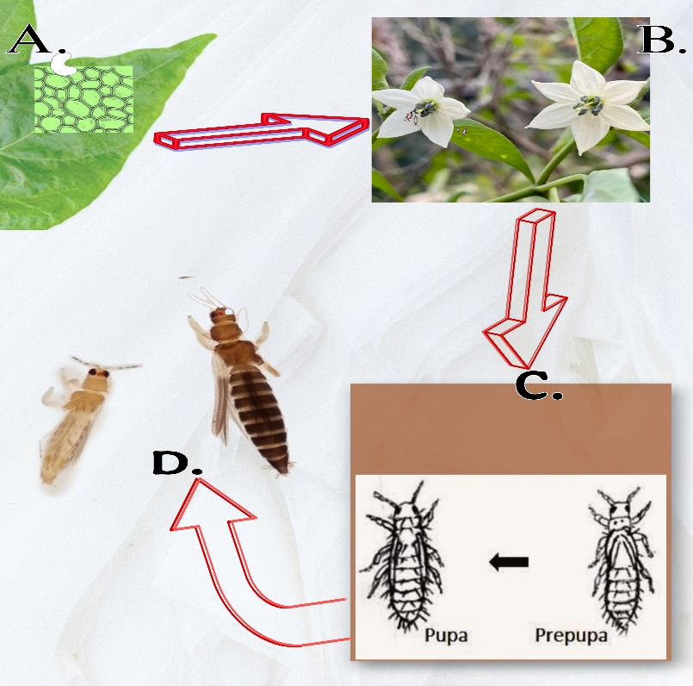

a-Site of Oviposition, b- site of larval feeding, c- site of pupation, d- adults

**fig 1-Pictorial Representation of Site of presence of biological stages of *T.parvispinus***

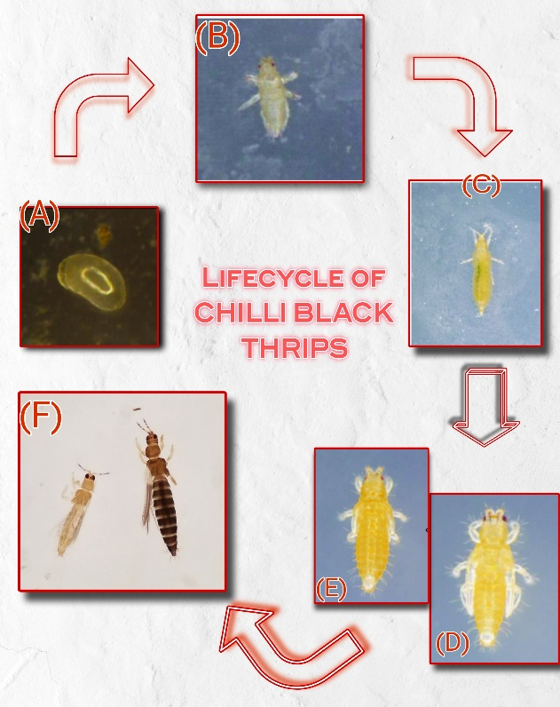

Fig 2-Pictorial representation of Lifecycle of Thrips

**a- egg stage, b and c – two larval stage, d- pre pupa stage, e – pupal stage and f- adult stage**

**2.2 SPREAD : Worldwide and Indian Context.**

T. parvispinus has been reported in a wide range of regions across the globe. Initially found in areas like Thailand, Malaya, New Guinea, northern Australia, Hawaii, Micronesia, and Greece, its distribution has steadily expanded over time. According to Palmer (1992), the species spread further into Southeast Asia, including northern Australia and the Solomon Islands. Later studies documented its presence in Yunnan, China (Zhang et al., 2011), Taiwan (Mound and Masumoto, 2005), and India (Tyagi et al., 2015; Rachana et al., 2018). Its first recorded appearance in Hawaii was in 2006 (Sugano et al., 2013). In Africa, T. parvispinus has also established itself, being identified in locations such as La Réunion (Bournier, 2000), Mauritius, Dar-es-Salaam in Tanzania, and Kampala, Uganda (Moritz et al., 2013). As for Europe, it was first noted in Greece in 1998 (Mound and Collins, 2000), followed by reports from Spain in 2017 (Lacasa et al., 2019), and France in 2018 (EFSA, 2019).

In 2021, a major outbreak of T. parvispinus was reported across the Indian states of Andhra Pradesh, Telangana, and Karnataka, causing severe damage to chilli crops—ranging from 70% to complete crop loss. The first signs of thrips on chilli flowers were noted in January in the Chilakaluripeta and Pratipadu mandals of Andhra Pradesh’s Guntur district (Sireesha et al., 2021). Soon after, the pest spread rapidly across all chilli-growing regions of the state, also affecting red chilli crops in both Andhra Pradesh and Telangana. The infestation persisted throughout the flowering phase, leading to significant yield losses. Interestingly, T. parvispinus wasn't limited to chilli crops alone. It was also found on various weed species like Parthenium, Amaranthus, Axonopus, Ageratum, Alternanthera, and Thunbergia (Nagaraju et al., 2021), which likely aided its survival and spread. Initially, the pest population went through a lag phase, during which its numbers remained relatively stable. However, over the following four years, its population surged. Its ability to adapt to different host plants and expand its geographical range makes it an especially challenging pest to manage (Rachana et al., 2021). Notably, T. parvispinus has now displaced the previously dominant chilli pest, Scirtothrips dorsalis, becoming the primary thrips species affecting chilli crops in Andhra Pradesh, Telangana, and Karnataka (Sridhar et al., 2021).

**2.3 Host Range**

It is highly polyphagous with a broad range of infestation in fruits, vegetables, ornamentals and even weeds. Global distribution of the pest is due to its adaptability to diverse climates and varied host species. Existing literatures have also revealed that it is also associated with ornamentals grown in green house environments. India first recorded *T.parvispinus* in *Carica papaya* in Bangalore and eventually in *Brugmansia sp.* and *Dahlia sp*. [Tyagi et al. 2015].

Fig 3-

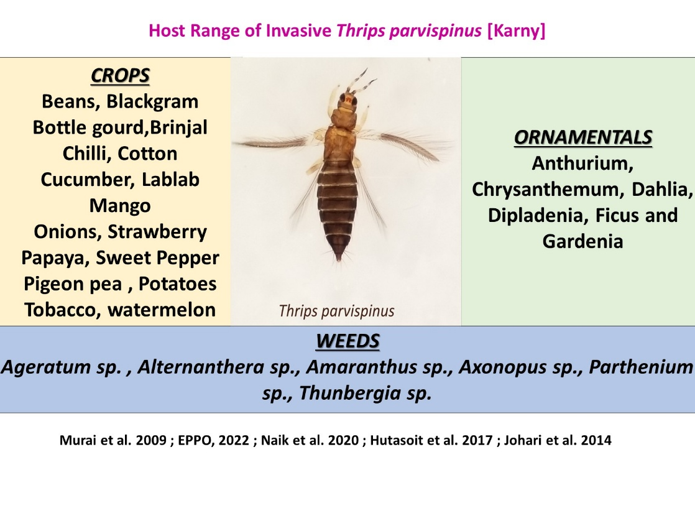

**Table 1- The table shows the names of the crops and their source of reference**

|  |  |
| --- | --- |
| **Crops** | **Reference Source** |
| Black Jack (Bidens Pilosa), coffee, Gardenia sp., papaya, chilli pepper,  paprika, potato, tobacco, Vigna sp., green bean, strawberry, eggplant, watermelon and other cucurbit | (Factsheet-*Thrips parvispinus*  (uni-halle.de)) |
| Pepper, anthurium and hoya | Johari *et al.,* 2014 |
| Papaya | Tyagi *et al.,* 2015 |
| Papaya, peppers, potatoes, eggplants, beans, shallots, crotalaria, vigna,  coffee, cucumber, tobacco | Hutasoit *et al.,* 2017 |
| Anthurium, chrysanthemum, dahlia, dipladenia, gardenia and ficus | NPPO, 2019 |
| Chilli, weed species like Parthenium, *Amaranthus* sp., *Axonopus* sp.,  *Ageratum* sp. *Alternanthera* sp. *Thunbergia* sp, foliage of neem and pongamia | Nagaraju *et al.,* 2021 |
| Guava | Ranjith *et al.,* 2022 |
| coriander | Verghese *et al.,* 2022 |
| Ridge gourd | Fening *et al.,* 2022 |
| Onion | Saini *et al.,* 2023 |
| cotton | Amutha and Rachana (2023) |
| Mungbean | Gothi *et al.,* 2024 |
| Mulberry | Kumar *et al.,* 2024 |
| **Manideep et al. 2024** | |

**2.4 Damage Symptoms**

Extensive and severe damage symptoms is observed in case of *Thrips parvispinus* due to its overall feeding ability. They generally rasp and suck plant tissues. Deep Punctures and scratches on underside of leaves which eventually turns to reddish brown appearance and yellowish patch on upper side is the prominent symptom. Later, distortion of leaf blades showing necrotic and yellow stains are observed. In floral parts, damage includes the scrapes on petals resulting in brown stripes. The fruit sets which are infested shows wither and dry out symptoms. In heavy infestation, significant flower drop is seen which directly affects the productivity [**Siresha et al. 2021**]. In morning hours, flight activity is seen in case of adults, preferring to inhabit the flowers. Nymphs usually resides on the leaf surfaces [Pratiwi et al. 2018]. About 71% of infestation is found in flowers, 56% in leaves of chilli [Hutasoit et al. 2019]. Infestation often results to improper and malformed development of fruits. In bell peppers the fruit exhibit a rough scratchy appearance when infested and can lead to an abnormal shape in fruits (button like shape). Adults and nymphs cause the damage with heavy feeding on leaves, flowers and buds. Feeding may some times create a scope for secondary infections in the entry points. In papaya the entry points is affected by *Cladosporium* spp. [Lim, 1989]. In ornamental crops the aesthetic value is lost directing to heavy commercial loss. During, off season weeds serves as the alternate host.

**Conclusion**

Thrips parvispinus (Karny) has emerged as a significant invasive species with a rapidly expanding global distribution and a notable impact on agricultural systems, particularly in India. Its ability to infest a wide range of host plants, coupled with its capacity to cause extensive damage such as flower drop, fruit deformation, and yield reduction has made it a pest of growing concern. The outbreaks observed in recent years highlight its adaptability and biological success in new environments. Continued study of its biology, distribution, and host interactions is essential for a deeper understanding of this species and its role within both cultivated and natural environments.

**References**

1. Ahmed, M. Z., Revynthi, A. M., McKenzie, C. L., & Osborne, L. S. (2023). *Thrips parvispinus (Karny), an emerging invasive regulated pest in the United States*.
2. Borror, D.J., Triplehorn, C.A. and Johnson, N.F. (2005). An Introduction to the Studies of Insects. 7th ed. United States of America, Brooks/Cole.
3. Bournier, J.P. (2000). Les Thysanoptères de l’île de la Réunion, Terebrantia. Bulletin de la Société Entomologique de France 105, 65-108.
4. EFSA (2019). Emerging risks exchange network. Minutes of the 21st meeting, 10–11 April 2019, Parma, Italy.
5. EPPO (2022) Thrips parvispinus (THRIPV). European and Mediterranean Plant Protection Organization Global Database. https://gd.eppo.int/taxon/THRIPV/hosts. Accessed on 15 June 2022
6. Fening, K.O., Amouzou, K., Hevi, W., Forchibe, E.E., Billah, M.K. and Wamonje, F.O. (2022). First report and population dynamics of the Tobacco Thrips, *Thrips parvispinus* (Karny) (Thysanoptera, Thripidae) on ridged gourd, *Luffa acutangula* (L.) Roxy in selected export fields in southern Ghana.
7. http://thrips.info/wiki/Main-Page (accessed on 13 July 2025).
8. Hutasoit RT, Triwidodo H, Anwar R (2017) Biology and demo graphic statistic of Thrips parvispinus Karny (Thysanoptera: Thripidae) in chilli pepper (Capsicum annuum Linnaeus). J Entomol Indones 14:107–116. https:// doi. org/ 10. 5995/ jei. 14.3. 107
9. Hutasoit, R.T., Triwidodo, H., Anwar, R. (2019). The abundance and diversity of thrips (Thysanoptera, Thripidae) on chili (*Capsicum annuum* L.) and cayenne (*Capsicum frutescens* L.) in Bogor. *J Hama dan Penyakit Tumbuhan,* **19**(1), 33–41.
10. Johari A, Herlinda S, Pujiastuti Y, Irsan C, Sartiami D (2014) Morphological and genetic variation of Thrips parvispinus (Thysanoptera: Thripidae) in chilli plantation (Capsicum ann uum L.) in the lowland and highland of Jambi Province. Indo nesia Am J Bio Sci 2:17–21. [https://doi.org/10.11648/j.ajbio.s. 2014020601.14](https://doi.org/10.11648/j.ajbio.s.%202014020601.14)
11. Johari, A., Herlinda, S., Pujiastuti, Y., Irsan, C. and Sartiami, D., Morphological and genetic variation of Thrips parvispinus (Thy sanoptera: Thripidae) in chilli plantation (Caspicum annuum L.) in the lowland and highland of Jambi Province, Indonesia. Am. J. Bio Sci., 2014, 2, 17–21.
12. Johari, T.A. and Desfaur, N. (2018). The abundance of *Thrips parvispinus* Karny (Thysanoptera, Thripidae) on various crops in Jambi region, Sumatera, Indonesia. *Journal of Entomologic Research,* **42**(2), 237-244.
13. Lacasa, A., Lorca, M., Martinez, M. C., Bielza, P. and Guirao, P. (2019). *Thrips parvispinus* (Karny, 1922), un nuevo trips en cultivos de plantas ornamentales. *Phytoma España,* **311**, 62-69.
14. Lim, W. H. (1989). Bunchy and malformed top of papaya cv. Eksotika caused by *Thrips parvispinus* and Cladosporium oxysporum. *Mardi Research Bulletin-Journal,* **17**, 200-207.
15. Lodaya, J.P., Suthar, M., Patel, H.C., Sisodiya, D.B., Acharya, R.R., Raval, A.T., Trivedi, N.P. and Mohapatra, A.R. (2022). Status of invasive species of thrips, Thrips parvispinus (Karny) infesting chilli grown in middle Gujarat. Omega 5(3), 1298-1302.
16. Moritz, G., Brandt, S., Triapitsyn, S. and Subramanian, S. (2013). Identification and information tools for pest thrips in East Africa. QAAFI Biological Information Technology (QBIT), The University of Queensland, Brisbane, Australia.
17. Mound, L. A. and Collins, D. W., A Southeast Asian pest species newly recorded from Europe: Thrips parvispinus (Thysanoptera: Thripidae), its confused identity and potential quarantine signific ance. J. Eur. Entomol., 2000, 97, 197–200.
18. Mound, L. A., So many thrips – so few tospoviruses. In Thrips and Tospoviruses: Proceedings of the 7th International Sympo sium of Thysanoptera (eds Marullo, R. and Mound, L. A.), Aus tralian National Insect Collection, Canberra, Australia, 2002, pp. 3–6.
19. Murai T, Watanabe H, Toriumi W, Adati T, Okajima S (2009) Damage to vegetable crops by Thrips parvispinus Karny (Thysa noptera: Thripidae) and preliminary studies on biology and con trol. J Insect Sci 10:166. https://doi.org/10.1673/031.010.14126
20. Murai, T., Watanabe, H., Toriumi, W., Adati, T. and Okajima, S. (2009). Damage to vegetable crops by *Thrips parvispinus* Karny (Thysanoptera, Thripidae) and preliminary studies on biology and control. *Journal of Insect Science,* **10**, 166.
21. Nagaraju, D. K., Uppar, V., Ranjith, M., Sriharsha, R., Ramesh, G., Verma, O. M. and Prakash, R. (2021). Occurrence of *Thrips parvispinus* (Karny) (Thripidae, Thysanoptera) in major chilli (*Capsicum annum*) growing areas of Karnataka. *Insect Environment*, **24**(4), 523-532.
22. Nagaraju, D. K., Uppar, V., Ranjith, M., Sriharsha, R., Ramesh, G., Verma, O. M. and Prakash, R. (2021). Occurrence of *Thrips parvispinus* (Karny) (Thripidae, Thysanoptera) in major chilli (*Capsicum annum*) growing areas of Karnataka. *Insect Environment*, **24**(4), 523-532.
23. Naik VCB, Pusadkar PP, Waghmare ST, Kranthi S, Kumbhare S, Waghmare VN (2020) Evidence for population expansion of cotton pink bollworm Pectinophora gossypiella (Saunders) (Lepi doptera: Gelechiidae) in India. Sci Rep 10(1):4740. https:// doi. org/10.1038/s41598-020-61389-1
24. Naik VCB, Pusadkar PP, Waghmare ST, Kranthi S, Kumbhare S, Waghmare VN (2020) Evidence for population expansion of cotton pink bollworm Pectinophora gossypiella (Saunders) (Lepi doptera: Gelechiidae) in India. Sci Rep 10(1):4740. https:// doi. org/10.1038/s41598-020-61389-1
25. NPPO (2019). *Thrips parvispinus*. Quick scan, QS. Ent./ 2019/001.
26. Palmer, J. M. (1992). Thrips (Thysanoptera) from Pakistan to the Pacific, a review. Bulletin of the British Museum Natural History (*Entomology*), **61**(1), 1-76.
27. Prasannakumar, N.R., Venkataravanappa, V., Rachana, R.R., Sridhar, V., Govindappa, M.R., Basavarajappa, M.P., Hemalatha, K.J., Aswathnarayana, D.S., Reddy, M.K. and Samuel, D.K. (2021). Status of the outbreak of Thrips parvispinus (Karny) on chilli in Karnataka. Pest Management in Horticultural Ecosystems, 27(2), 286-290.
28. Pratiwi, N. P. E., Supartha, I. W., & Yuliadhi, K. A. (2018). Aktivitas Penerbangan dan Perkembangan Populasi Thrips parvispinus Karny (Thysanoptera: Thripidae) pada Tanaman Cabai Besar (Capsicum annuum L.). *Agrotrop*, *8*(1), 29-37.
29. Rachana, R. R. and Varatharajan, R., Checklist of terebrantian thrips (Insecta: Thysanoptera) recorded from India. J. Threat. Taxa, 2017, 9(1), 9748–9755.
30. Rachana, R. R., Roselin, P., Amutha, M., Sireesha, K. and Reddy, N. G. (2021). Invasive pest, *Thrips parvispinus* (Karny) (Thysanoptera, Thripidae) - A looming threat to Indian agriculture. Current Science (In Press).
31. Ranjith, M., Nagaraju, D. K., Rachana, R. R., Ramya, R. S., Verma, O. P. and Prakash, R. (2022). New host record of *Thrips parvispinus* (Karny) (Thysanoptera, Thripidae) in India. *Pest Management in Horticultural Ecosystems,* **28**(1), 33-37.
32. Sireesha, K., Prasanna, B. V. L., Lakshmi, T. V. and Reddy, R. V. S. K. (2021). Outbreak of invasive thrips species *Thrips parvispinus* in chilli growing areas of Andhra Pradesh. *Insect Environment*, **24**(4), 514-519.
33. Sireesha, K., Prasanna, B. V. L., Lakshmi, T. V., & Reddy, R. V. S. K. (2021). Outbreak of invasive thrips species Thrips parvispinus in chilli growing areas of Andhra Pradesh.
34. Sridhar, V., Rachana, R. R., Prasannakumar, N. R., Venkataravanappa, V., Sireesha, K., Kumari, D. A., Reddy, K. M., Naik, O. S., Chandana, P. S. and Reddy, M. K. (2021). Dominance of invasive species, *Thrips parvispinus* (Karny) over the existing chilli thrips, *Scirtothrips dorsalis* Hood on chilli in the Southern states of India with a note on its host range, A likely case of species displacement. *Pest Management in Horticultural Ecosystems,* **27**(2), 132-136.
35. Srinivasnaik, Sabhavat & Lakshmi, Korlipara & Omprakash, s & Balram, Nenavath & Reddy, G.. (2024). Taxonomic characterization of invasive thrips species, Thrips parvispinus and its host range in Telangana,India.
36. Tyagi, K., Kumar, V., Singha, D. and Chakraborty, R., Morpho logical and DNA barcoding evidence for invasive pest thrips, Thrips parvispinus (Thripidae: Thysanoptera), newly recorded from India. J. Insect Sci., 2015, 15(1), 105.
37. Verghese, A., Rashmi, M.A. and Deepak, S. (2022). Report of heavy infestation of the thrips, *Thrips parvispinus* on coriander in Bangalore, India
38. Zhang, H.R., Xie, Y.H. and Li, Z.Y. (2011). Identification key to species of Thrips genus from China (*Thysanoptera, Thripidae*), with seven new records. Zootaxa 2810, 37-46