**Exploring Agriculture 4.0: A Systematic Review of Digital Innovations in the Agricultural Sector**

**Abstract**

Global food security remains fundamentally dependent on agricultural systems. Escalating demographic pressures have intensified demands on food production networks, compelling a shift from traditional agrarian practices toward technologically sophisticated methodologies under the Agriculture 4.0 paradigm. Optimizing the benefits of this transformation requires resolving implementation constraints across technological and socio-economic dimensions. This empirical investigation advances the Agriculture 4.0 discourse through systematic analysis of emergent digital farming innovations. Employing PRISMA (Preferred Reporting Items for Systematic Reviews and Meta-Analyses) standardized protocols, we conducted a decade-long assessment of peer-reviewed crop production research. From 148 methodologically selected publications, we evaluated technology adoption patterns across three analytical vectors: service typology, implementation maturity, and production system classification. Key findings demonstrate concentrated scholarly focus on autonomous robotics, IoT architectures, and machine learning implementations. Production environment analysis revealed disproportionate research attention: open-field systems represented 69% of examined cases, while controlled-environment agriculture constituted 31%. Most applications (71%) remain at prototype development stages. The study further codifies critical digitization barriers through multidimensional taxonomy, offering both a comprehensive assessment of current technological integration and a foundation for strategic advancement in precision agriculture.

Keywords: Agriculture 4.0, Systematic Review, Meta-Analysis, PRISMA, Digital Technologies

**1. Introduction**

Food security, a multifaceted concept essential for mitigating hunger, relies on sustained access to nutritious food. This imperative faces mounting pressure globally from anthropogenic drivers such as rapid population expansion, urbanization, industrial activity, degradation of arable land, freshwater shortages, and environmental decline (Tomashuk et al., 2025). These factors critically impact agriculture, the primary foundation of worldwide food production. Projections indicate that by 2050, the global population will rise from 7.7 to 9.2 billion, with urban populations increasing by 66%. Concurrently, arable land is expected to diminish by approximately 50 million hectares, global greenhouse gas emissions may rise by 50%, agricultural output could decrease by 20%, and food demand is estimated to surge by 59-98% (Schierhorn and Elferink, 2016), posing severe risks to food security and availability.

Addressing these escalating demands necessitates enhanced productivity in global crop and livestock systems (Finger, 2023). This review specifically examines agricultural practices related to food and cash crop development. While acknowledging the importance of the entire value chain, the analysis centers on the cultivation stage ("in-field"), encompassing processes like plowing, planting, spraying, and harvesting.

Conventional agricultural techniques, often labor-intensive and reliant on substantial arable land, time, and irrigation water, increasingly constrain sufficient production. Further complications arise from inconsistent pesticide and herbicide application and suboptimal technology utilization, contributing to crop damage and agricultural waste (Stupina et al., 2021). Implementing sophisticated technologies, optimizing agrochemical use, and improving crop quality offer potential solutions. This underscores the emergence of smart (or precision) agriculture. Integrating advanced digital solutions can enhance productivity and reduce resource consumption—such as water—while enabling more precise agrochemical deployment and superior crop outcomes (Niedbała & Kujawa, 2023).

This study aims to provide a comprehensive analysis of digital technologies applied during the in-field cultivation phase across diverse farming systems. Its primary theoretical contribution lies in systematically examining and categorizing the tools and techniques employed, farm types involved, technological maturity levels of implemented systems, and potential barriers hindering the advancement of Agriculture 4.0. The resultant insights are intended to guide researchers and agricultural practitioners in future endeavours related to Agriculture 4.0.

**1.1 Research Questions**

This study seeks to address three key research questions through a systematic methodological approach, as detailed in subsequent sections:

**RQ1:** What Industry 4.0 technologies are documented in scholarly literature as drivers of agricultural digitization?

**RQ2:** To what degree have these technologies been implemented, and what patterns emerge concerning their application across service categories, methodological frameworks, technological maturity levels, and agricultural systems?

**RQ3:** What critical barriers hinder the widespread adoption of Industry 4.0 technologies within smart agriculture frameworks?

**2. Review of Literature**

**2.1 Industry 4.0 and Its Transformative Role in Agriculture**

The Fourth Industrial Revolution (Industry 4.0) is fundamentally reshaping all economic sectors through the integration of disruptive digital technologies. These include the Internet of Things (IoT), big data analytics (BDA), system integration (SI), cloud computing (CC), simulation modeling, autonomous robotic systems (ARS), augmented reality (AR), artificial intelligence (AI), wireless sensor networks (WSN), cyber-physical systems (CPS), digital twins (DT), and additive manufacturing (AM) (Aceto et al., 2017). The application of these innovations in agriculture has given rise to next-generation industrial farming—commonly termed Agriculture 4.0, smart agriculture, or digital farming. However, realizing its full potential requires addressing key challenges and limitations (Abbasi et al., 2022).

**2.2 Technological Advancements in Smart Agriculture**

Empirical studies demonstrate that smart agriculture provides farmers with advanced tools to enhance productivity, mitigate environmental impact, improve food security, reduce crop losses, and promote sustainable production (Ozdogan, Gazar, & Aktas, 2017). IoT-enabled systems, such as WSNs, facilitate remote real-time farm monitoring and management. Meanwhile, drone-based hyperspectral imaging enables large-scale agricultural data collection, while autonomous robots streamline labor-intensive tasks (Liu et al., 2020). Advanced data analytics and decision-support software further optimize key parameters, including environmental conditions, weed control, crop health, water and soil management, irrigation scheduling, and agrochemical application (Silveira et al., 2021).

**2.3 Digital Transformation and Emerging Farming Practices**

The evolution of modern agriculture is driven by digital technologies that enhance operational efficiency and enable innovative farming systems (Idoje & Iqbal, 2021). Notably, digitalization supports advanced cultivation methods such as vertical farming (hydroponics, aquaponics, and aeroponics), offering potential solutions to global food security challenges. However, the transition to Agriculture 4.0 faces persistent technical, socio-economic, and managerial barriers that must be resolved (Miranda et al., 2019).

**2.4 Research Gaps and Future Directions**

While existing literature explores trends in Agriculture 4.0, most studies focus narrowly on specific technologies, supply chain improvements, or conceptual frameworks (Lezoche et al., 2020). Critical gaps remain in assessing the maturity levels of implemented systems, the methodologies behind their development, and their applicability to soilless farming systems (e.g., hydroponics, aquaponics, aeroponics). A comprehensive, multi-perspective analysis is needed to advance discourse in this field (Bhakta et al., 2019; Araújo et al., 2021; Bacco et al., 2019; Huang et al., 2019; Liyu et al., 2017).

**3. Research Methodology**

A systematic literature review (SLR) represents a rigorous methodological approach for synthesizing existing knowledge and identifying relevant studies within a defined research domain (Page et al., 2021). This study employs an SLR framework to critically examine the application of Industry 4.0 technologies in agriculture, specifically analyzing publications where agricultural terminology appears in conjunction with Industry 4.0 concepts within article titles, abstracts, or keywords.

To ensure methodological transparency and research quality - essential characteristics of robust SLRs (Ahmed et al., 2016) - we established a structured review protocol prior to conducting the literature analysis. This protocol serves to minimize potential bias through exhaustive search strategies and consists of three key components:

1. Formulation of research questions
2. Development of search methodology,
3. Establishment of inclusion/exclusion criteria.

The study implements the Preferred Reporting Items for Systematic Reviews and Meta-Analyses (PRISMA) guidelines to conduct the SLR. PRISMA provides a standardized, evidence-based minimum set of reporting items for systematic reviews and meta-analyses, ensuring methodological rigor and reproducibility in research synthesis.

Figure 1: PRISMA Approach for Our Study

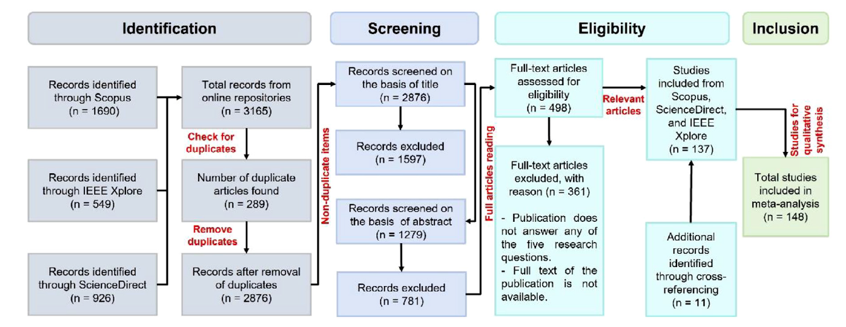

Source: Own Source (2025)

**Inclusion Criteria:**  
The study selection protocol established the following inclusion parameters:  
a) Peer-reviewed journal articles and conference proceedings  
b) Publications dated between 2011 and 2025 (inclusive)  
c) Studies directly addressing the formulated research questions  
d) Complete bibliographic records including title, publication year, source, abstract, and digital object identifier (DOI)  
e) Research specifically examining Industry 4.0 technology applications in crop production systems, with particular emphasis on in-field cultivation and harvesting operations

**Exclusion Criteria:**  
The following materials were systematically excluded:  
a) Non-peer-reviewed materials including conference abstracts, event summaries, book reviews, and editorial content  
b) Studies focusing on:

* Livestock production systems
* Pre-cultivation phases (genetic modification, seed development, or seed distribution)
* Post-harvest processes (crop distribution, food processing, or consumption)
* Agri-food supply chain management

c) Publications predating 2011

d) The publication is not fully accessible or the publication is not in English.

**4. Results and Discussion**

The distribution of these articles concerning digital technologies (and certain farm types is illustrated in Figure 2 and Figure 3.

Figure 2: Service-wise Distribution of selected research studies.

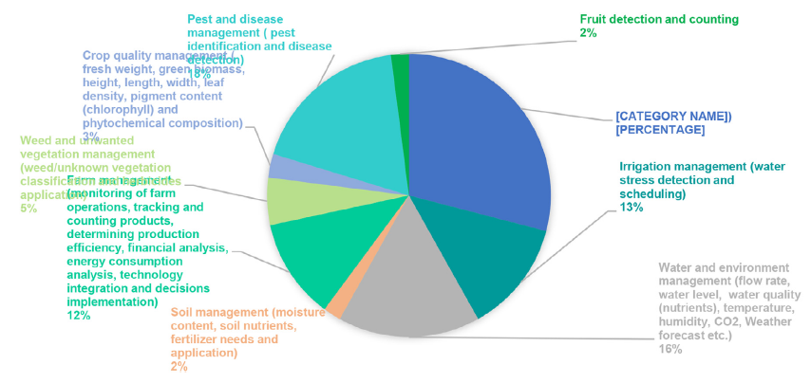

Source: Own Source (2025)

Farm classification in this context denotes the agricultural production system for which a technological application or framework was developed. Production systems are categorized as either soil-based (encompassing open-field and greenhouse cultivation) or soilless (incorporating controlled-environment methods such as hydroponics, aeroponics, and aquaponics).

Analysis of technological adoption patterns (Figure 2) reveals distinct implementation trends across agricultural systems, with column coloration indicating farm classifications. Key findings from the decade-long review include:

1. Dominant Technologies: Autonomous robotic systems (including UAVs and UGVs), IoT networks, and machine learning emerged as primary technological solutions deployed in agricultural settings.
2. Emerging Fields: Big data analytics, wireless sensor networks, cyber-physical systems, and digital twin applications represent growing research domains within agricultural technology.
3. Research Distribution: Investigative focus remains predominantly on open-air production systems (69% of analyzed studies), with controlled-environment agriculture receiving substantially less attention (31%).

Figure 3: Service Category and Maturity-wise Distribution of selected research studies.

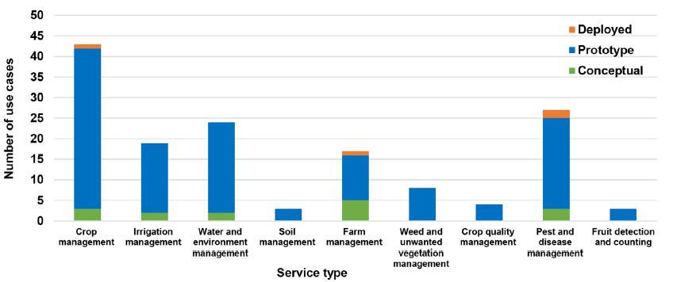

Source: Own Source (2025)

Research indicates limited scholarly attention toward soilless cultivation systems, with only 22 studies addressing aquaponics, aeroponics, or hydroponics—reflecting the emergent status of these production methods. The implemented solutions across all studies were systematically classified into nine functional service domains:

i) Cultivation Cycle Oversight: Projecting crop yields, growth trajectories, and optimal harvest windows; managing seeding, harvesting, and pollination operations  
ii) Produce Quality Optimization: Monitoring biometric indicators including fresh biomass, plant morphology (height, width), foliar density, and phytochemical composition  
iii) Environmental Resource Regulation: Monitoring and controlling hydrological parameters (flow rates, water quality), atmospheric conditions (temperature, humidity, CO₂), and meteorological forecasting  
iv) Precision Irrigation Systems: Detecting hydrological stress and automating irrigation scheduling  
v) Operational Farm Analytics: Tracking agricultural workflows, product inventory, production efficiency metrics, economic assessment, energy utilization, technology integration, and decision implementation  
vi) Phytopathology Control: Identifying pest infestations and diagnosing plant diseases  
vii) Pedological Management: Assessing soil hydration, nutrient profiles, and fertilizer requirements/application  
viii) Invasive Species Mitigation: Mapping, classifying, and controlling undesirable vegetation through targeted herbicide deployment  
ix) Produce Quantification: Automated detection and enumeration of fruits

Figure 4: Technological Distribution of the 148 Selected Studies.

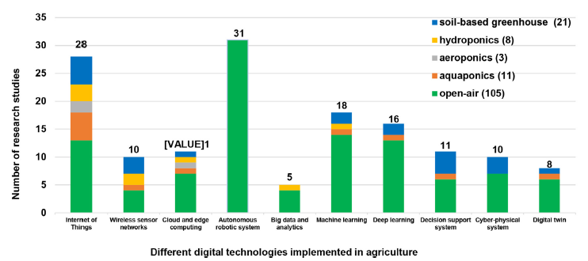

Source: Own Source (2025)

Analysis reveals significant disparities in research focus across smart agriculture domains. Digital technologies demonstrate diverse functional applications, yet scholarly attention remains unevenly distributed. Crop management applications—particularly yield forecasting, growth rate modeling, and harvest scheduling—predominated research efforts (29% of studies). Conversely, several critical domains received limited investigation: soil management (2%), automated fruit detection and enumeration (2%), and crop quality optimization (3%) collectively represent understudied areas.

**5. Conclusion**

Growing global concerns about food security are accelerating demand for intensified agricultural production systems and advanced farming methodologies. Industry 4.0 technologies offer transformative solutions within modern agriculture, enabling researchers to integrate disruptive innovations into conventional practices. This integration aims to enhance productivity, reduce operational expenditures, minimize waste, and optimize resource utilization. This study synthesizes current knowledge through a rigorous systematic literature review (SLR), selecting 148 relevant publications (2011–2025) for comprehensive analysis.

Four core research dimensions guided the investigation:  
i) Emerging technological trajectories in agricultural digitization  
ii) Functional implementation scope, technological maturity, farming systems, and methodological approaches  
iii) Critical implementation barriers  
iv) Ancillary benefits of agricultural digitalization

Key findings reveal nascent adoption of big data analytics, wireless sensor networks, cyber-physical systems, and digital twins, with most applications remaining prototypical. The study further identifies and classifies 21 adoption barriers across technical and socio-economic dimensions. Addressing these challenges is imperative for accelerating agricultural digitization.

This research demonstrates the expanding functional utility of digital technologies in agriculture and contributes meaningfully to the Agriculture 4.0 knowledge domain. Methodological limitations include database constraints (Scopus, IEEE Xplore, ScienceDirect) and potential keyword coverage limitations. While expanded search parameters might yield additional publications, the core findings are unlikely to change substantively. Future investigations should incorporate broader repositories, additional analytical variables, and emerging Agriculture 5.0 frameworks to advance comprehensive sectoral assessment.

**References**

1. Abbasi, R., Martinez, P., & Ahmad, R. (2022). The digitization of agricultural industry–a systematic literature review on agriculture 4.0. *Smart Agricultural Technology*, *2*, 100042.
2. Aceto, G., Persico, V., & Pescapé, A. (2019). A survey on information and communication technologies for industry 4.0: State-of-the-art, taxonomies, perspectives, and challenges. *IEEE Communications Surveys & Tutorials*, *21*(4), 3467-3501.
3. Ahmed, M. A., Ahsan, I., & Abbas, M. (2016, October). Systematic literature review: ingenious software project management while narrowing the impact aspect. In *Proceedings of the International Conference on Research in Adaptive and Convergent Systems* (pp. 165-168).
4. Araújo, S. O., Peres, R. S., Barata, J., Lidon, F., & Ramalho, J. C. (2021). Characterising the agriculture 4.0 landscape—emerging trends, challenges and opportunities. *Agronomy*, *11*(4), 667.
5. Bacco, M., Barsocchi, P., Ferro, E., Gotta, A., & Ruggeri, M. (2019). The digitisation of agriculture: a survey of research activities on smart farming. *Array*, *3*, 100009.
6. Bhakta, I., Phadikar, S., & Majumder, K. (2019). State‐of‐the‐art technologies in precision agriculture: a systematic review. *Journal of the Science of Food and Agriculture*, *99*(11), 4878-4888.
7. Da Silveira, F., Lermen, F. H., & Amaral, F. G. (2021). An overview of agriculture 4.0 development: Systematic review of descriptions, technologies, barriers, advantages, and disadvantages. *Computers and electronics in agriculture*, *189*, 106405.
8. Huang, X., Zanni-Merk, C., & Crémilleux, B. (2019). Enhancing Deep Learning with Semantics: an application to manufacturing time series analysis. *Procedia Computer Science*, *159*, 437-446.
9. Idoje, G., Dagiuklas, T., & Iqbal, M. (2021). Survey for smart farming technologies: Challenges and issues. *Computers & Electrical Engineering*, *92*, 107104.
10. Jiyu, L., Lan, Y., Jianwei, W., Shengde, C., Cong, H., Qi, L., & Qiuping, L. (2017). Distribution law of rice pollen in the wind field of small UAV. *International Journal of Agricultural and Biological Engineering*, *10*(4), 32-40.
11. Lezoche, M., Hernandez, J. E., Díaz, M. D. M. E. A., Panetto, H., & Kacprzyk, J. (2020). Agri-food 4.0: A survey of the supply chains and technologies for the future agriculture. *Computers in industry*, *117*, 103187.
12. Liu, Y., Ma, X., Shu, L., Hancke, G. P., & Abu-Mahfouz, A. M. (2020). From industry 4.0 to agriculture 4.0: Current status, enabling technologies, and research challenges. *IEEE transactions on industrial informatics*, *17*(6), 4322-4334.
13. Miranda, J., Ponce, P., Molina, A., & Wright, P. (2019). Sensing, smart and sustainable technologies for Agri-Food 4.0. *Computers in Industry*, *108*, 21-36.
14. Ozdogan, B., Gacar, A., & Aktas, H. (2017). Digital agriculture practices in the context of agriculture 4.0. *Journal of Economics Finance and Accounting*, *4*(2), 186-193.
15. Page, M. J., McKenzie, J. E., Bossuyt, P. M., Boutron, I., Hoffmann, T. C., Mulrow, C. D., ... & Moher, D. (2021). The PRISMA 2020 statement: an updated guideline for reporting systematic reviews. *bmj*, *372*.
16. Schierhorn, F., & Elferink, M. (2016). Global demand for food is rising. can we meet it. *Harvard business review,(May). Available at: https://www. researchgate. net/publication/302466629% 0AGlobal*.
17. Tomashuk, I., Koliadenko, S., & Burdіak, M. (2025). The impact of digital innovations on the development of agricultural business. Baltic Journal of Economic Studies, 11(1), 361-375.
18. Finger, R. (2023). Digital innovations for sustainable and resilient agricultural systems. European Review of Agricultural Economics, 50(4), 1277-1309.
19. Stupina, A. A., Rozhkova, A. V., Olentsova, J. A., & Rozhkov, S. E. (2021, September). Digital technologies as a tool for improving the efficiency of the agricultural sector. In IOP Conference Series: Earth and Environmental Science (Vol. 839, No. 2, p. 022092). IOP Publishing.
20. Niedbała, G., & Kujawa, S. (2023). Digital Innovations in Agriculture. Agriculture, 13(9), 1686.