**Students’ perception toward Agricultural Education**

**Abstract**

Agriculture is a prominent subject in Bangladesh. This study examines a selected university students’ perception on agriculture as an undergraduate subject in higher education in Bangladesh. Mixed method approach was used to collect data from 100 randomly selected candidates. Quantitative data was analysed using descriptive statistics. Finding revealed that, most of the students came from urban areas. It was observed that, while students opined that agriculture has wide career prospects and understandable, but many expresses highly dissatisfaction regarding the practical book writing. Students expressed that career flexibility and personal choice influenced them to consider studying agriculture while parents background had lower impact. Students also expressed that if they are taught properly, all students can learn agriculture topics more effectively. Open form of question revealed that students mainly concerned about education system in agriculture in higher education being highly theoretical rather than practical and tiring practical work. So, the study emphasizes the need for curriculum development and effective teaching strategies for better student participation in agricultural education.

**Keywords**: Agricultural Education, Perception, Attitude, Subjective Norm, Perceived Behavioral Control, Bangladesh, Theory of Planned Behavior

**1.INTRODUCTION**

Bangladesh is predominantly an agrarian country. Due to its very fertile land and favourable weather, varieties of crop grow abundantly in this country. Agriculture sector contributes about 11.38 percent in country`s Gross Domestic Product (GDP) and employs around 45.33 percent of total labor force (BBS, 2024).

Agriculture is an significant subject in Bangladesh. Several universities in Bangladesh are offering graduate and post graduate studies in Bangladesh. Some key subjects include agronomy, horticulture, soil science, crop botany, entomology, plant pathology, genetics and plant breeding and agricultural extension and rural development. Other subjects offered at universities include agricultural engineering, animal science, agricultural business, food science, and agroforestry. There are many reputed public agricultural universities in our country. Gazipur Agricultural University (Gazipur), Bangladesh Agricultural University (Mymensingh), Patuakhali Science and Technology University (Patuakhali), and Sher-E-Bangla Agricultural University (Dhaka) are some of the best institutes to pursue higher studies. There are many other colleges which also offer agriculture as an undergraduate programme. These subjects make students equipped with knowledge to face the new challenges in the agricultural field and take it to a new height. There are plenty of job opportunities for an agriculture graduate both in government and private job sectors. Also, there is much scope of research. (Rezwana, 2024).

Perception and attitude play crucial roles in shaping students' choices, influenced by factors such as parental advice , peer (Adebayo and Oloyede 2020, Adejoh et al 2016). Agriculture encompasses various aspects beyond farming, contributing significantly to a nation's economy (Rehman,2022). To promote Agricultural Science in secondary schools, students must develop an interest and a positive attitude, encouraged by effective teaching strategies (Agbidi et al 2022, Okeke and Nwosu,2022) and adequate learning facilities. Agbidi et al 2022, suggests that there is a gap exacerbated by a declining attitude to improve Nigeria's agriculture beyond the classroom.

Recent works (Leavy & Hossain, 2014; Ojebiyi et al., 2015) have demonstrated that young curiosity in the agricultural area is waning internationally, notably in Latin America, Africa, and Asia. Tafere & Woldehanna (2012) claim that there are two main reasons why young individuals are disinterested in agriculture. One is that since non-agricultural occupations are expected to be less difficult, more secure, and offer greater compensation, young people often have "occupational goals" outside of farming. Another factor is that young people are prevented from pursuing careers in agriculture because they lack entree to or ownership of industrious resources, notably farming land.

Despite being an progressive subject in Bangladesh, research related to students perception of agricultural subject is low in Bangladesh. In fact, still now few research has been conducted on the student’s perception of agricultural education in Bangladesh. For this reason, the research has been conducted : (i) To identify demographic characteristics of students and (ii) To investigate students perception of agricultural education.

**2. Methodology**

**2.1 Research Design**

This study employed mixed method approach, including both qualitative and quantitative approach to explore university students' perceptions of agricultural education.

**2.2 Study Area and Population**

The study was conducted among undergraduate students enrolled in Agricultural education programs at Patuakhali Science and Technology University in Bangladesh. It is chosen due to its prominence in agricultural education and diverse student representing various socio-economic and geographic backgrounds.

**2.3 Sampling Procedure and Sample Size**

A simple random sampling technique was applied to collect data. A total of 100 students from 180 students participated in the study.

* 1. **Data Collection Instruments**

A well structured questionnaire including both open and close ended questions used to gather data from students. The closed-ended section included: Demographic and academic variables (e.g., gender, Background, mothers occupation, fathers occupation and CGPA). Most popular perception theory developed by Ajzen named Theory of Planned Behavior (TPB), focusing on three key constructs: Attitude Toward Agriculture (ATA): 10 items assessing students’ personal evaluations of Agricultural Science. Subjective Norms (SN): 4 items measuring perceived social influences from parents and peers. Perceived Behavioral Control (PBC): 2 items assessing students’ perceived comfort of succeeding in the subject and employment chances.

Responses were recorded on the basis of a five-point Likert scale: Strongly Disagree (1), Disagree (2), No Comment (3), Agree (4), and Strongly Agree (5).

**2.5 Data Analysis**

Quantitative data were analysed using descriptive statistics (mean and standard deviation) to interpret students’ perceptions. The results were presented in tabular form and bar graphs uesed to illustrate differences in perceptions. To analyse the quantitative data SPSS (version 23) was utilized and R Programming used to prepare bar graph.

**3. Results and Discussion**

**3.1. Demographic characteristics of the students:**

**Table 1: Characteristics of the Surveyed Students**

| **Variable** | **Category** | **Percent (%)** | **Mean** | **Standard Deviation** |
| --- | --- | --- | --- | --- |
| **Gender** | Male | 55.0 | 0.55 | 0.50 |
|  | Female | 45.0 |  |  |
| **Background** | Rural | 43.8 | 0.56 | 0.49 |
|  | Urban | 56.3 |  |  |
| **Mother's Occupation** | Home | 81.3 | 0.18 | 0.39 |
|  | Service | 18.8 |  |  |
| **Father's Occupation** | Home maker | 1.30 | 2.32 | 1.18 |
|  | Govt. service | 30.0 |  |  |
|  | Business | 28.7 |  |  |
|  | Farming | 15.0 |  |  |
|  | Others | 25.0 |  |  |
| **CGPA** | Low (2.57 – 3.02) | 11.3 | 3.36 | 0.30 |
|  | Moderate (3.03 – 3.48) | 51.2 |  |  |
|  | High (3.49 – 3.94) | 37.5 |  |  |

**Table 1** presents the demographic characteristics of the surveyed students. The data show that a majority of the respondents (55%) were male, while 45% were female. Most students (56.3%) came from urban areas, with the remaining 43.8% from rural backgrounds. Regarding parental occupation, a big proportion of the students' mothers (81.3%) were homemakers, whereas only 18.8% were engaged in service-oriented professions. In contrast, fathers were employed across more diverse sectors: 30% in government service, 28.7% in business, 15% in farming, and 25% in other occupations, with only 1.3% reported as homemakers. In terms of academic performance, based on CGPA scores, the majority of students (51.2%) fell within the moderate range category (3.03–3.48), followed by 37.5% in the high range (3.49–3.94), and 11.3% in the low range (2.57–3.02). The mean CGPA was 3.36 with a standard deviation of 0.30, indicating that most students maintained satisfactory academic standing.

**3.2. Perception of students in agricultural science:**

**3.2.1. Attitude Toward Agriculture (ATA)**

This reflects students’ personal evaluation of Agricultural Science—whether they view it positively or negatively.

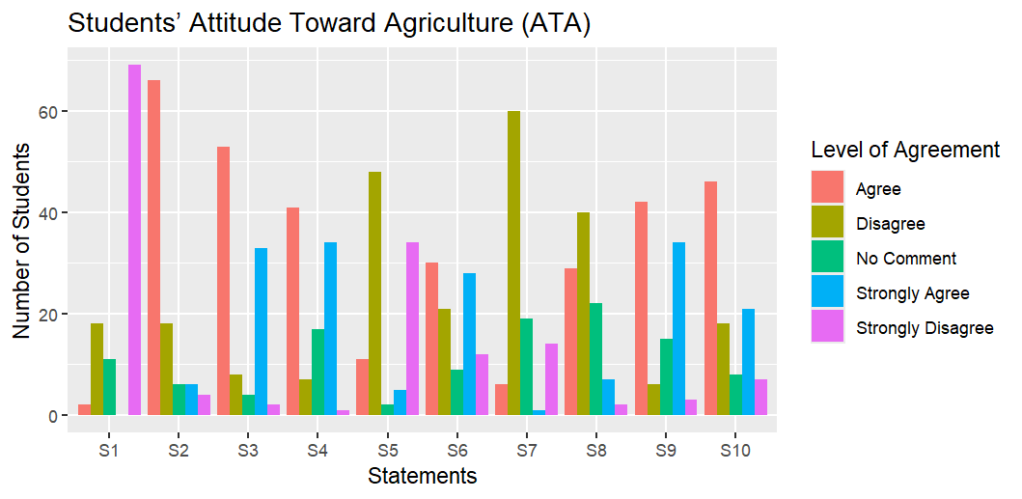**Fig 1: Students attitude about different aspects of agricultural education**

**Legend:** S1**=**Limited future prospects, S2=Easy to understand, S3=Boring practical tasks, S4= Considered a lucrative profession, S5=Perceived as just farming, S6=Lacks social respect, S7=Easy to shift to other careers, S8=Enjoyable subject matter, S9=Uninterested in agricultural careers, S10=Tend to skip agriculture classes.

To evaluate students’ perceptions of agricultural science, ten well-structured statements (S1–S10) is presented using a five-point Likert scale: Strongly Agree, Agree, No Comment, Disagree, and Strongly Disagree.

In the first statement (S1) students were asked whether agriculture has limited future prospects. Students answer revealed that a significant number of students (69 students from 100) disagreed, suggesting that many perceived agriculture as a potential field. On the other hand, “agriculture is easy to understand” (S2) received generally positive responses, indicating that students find agricultural science clear and understandable.

Interestingly, when students were asked the question whether practical tasks is boring, got notable agreement by 53 students, suggesting dissatisfaction with the practical components of agricultural courses. In contrast, the forth statement considering “agriculture sector as a lucrative profession” received positive responses, indicating, students has a good impression towards agriculture job sector.

For the fifth statement S5: “Perceived as just farming” a considerable number of students(48 students) expressed disagreement, and sixth statement S6: “Lacks social respect”, regarding the question around 30 students agreed that people sometimes think negatively about studying in agriculture subject.

Responses to seventh statement “Easy to shift to other careers” and eight statement S8: “Enjoyable subject matter” received predominantly positive responses, maximum number of students (60 and 40 students) expressed their satisfaction.

However, concerning the nineth statement “Uninterested in agricultural careers” and tenth statement: “Tend to skip agriculture classes,” a number of students (42 and 46 respectively) agreed that they are not willing to choose agricultural sector as their career choice and they love to avoid their classes. These findings point to a possible gap between academic content and students' career aspirations, highlighting the need for curriculum reform and better career guidance.

### **3.2.2. Subjective Norms Influencing Perception of Agricultural Science**

### Subjective norms refer to the social pressures students feel from people around them especially parents and peers regarding studying Agricultural Science.

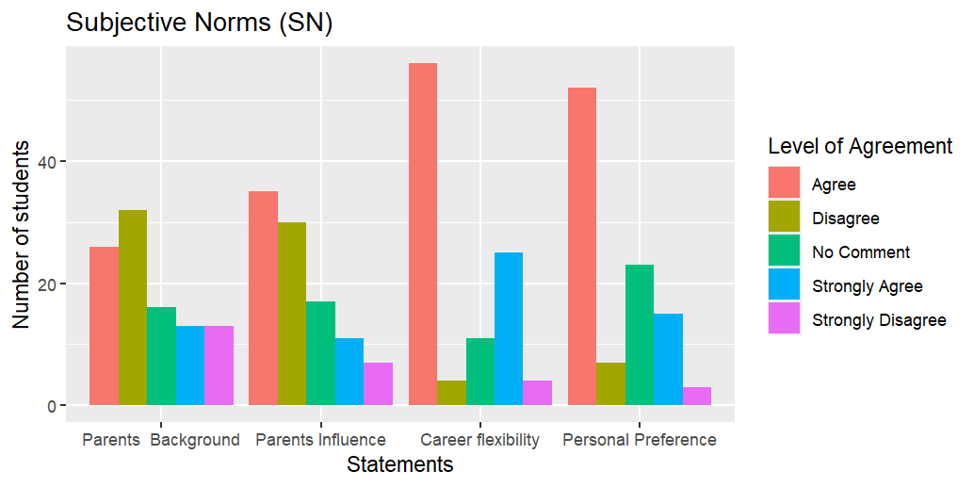

Figure 2: Distribution of students’ responses regarding Subjective Norms (SN)

The data revealed that parents’ background was more evenly distributed, with a considerable number of students (32 and 13 students) disagreeing or selecting “no comment.” This implies that the socioeconomic or occupational background of parents may not significantly shape students’ perceptions. However, direct parental influence had more agreement (35 students) than disagreement (30 students), suggesting that while background alone may not be influential, parents’ attitudes and guidance still play a role in forming students’ educational preferences.

In contrast, responses to career flexibility perceived very positively, with the majority of respondents (56 and 25 students) opined that it influenced their views on Agricultural education. This suggests that many students see the subject as offering diverse professional opportunities, which enhances its appeal. Similarly, personal preference received a high number of “agree” (52 students) and “strongly agree”(15 students) responses, indicating that students’ individual interest plays a substantial role in shaping their attitudes toward the discipline.

**3.2.3 Perceived Behavioral Control (PBC)**

This dimension relates to the students’ confidence in their ability to succeed in Agricultural Science and their perception of available opportunities.

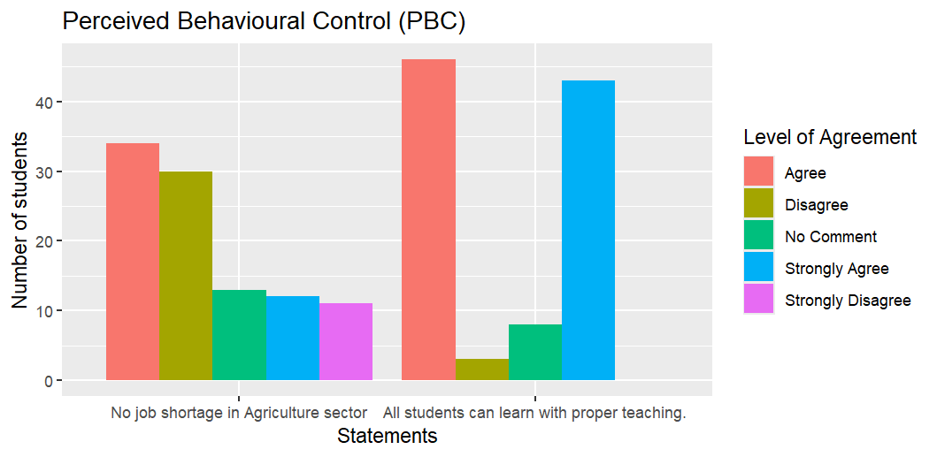

**Fig 3: Students opinion regarding perceived behavioural control**

Figure 3 illustrates student responses to two key statements: (1) “There is no lack of employment in the sector” and (2) “All students can learn complex Agricultural Science concepts if they are properly taught.”

Responses to the first statement show that a significant number of students (34 students) agreed there are employment opportunities within the agricultural sector. This indicates that many students recognize agriculture as a field with viable career prospects, reinforcing their sense of external control (i.e., opportunity structure) in choosing it as a profession.

Similarly, the majority of respondents agreed and strongly agreed (46 and 43 students) with the second statement, suggesting a strong belief in the learnability of Agricultural Science when proper teaching support is provided. This reflects positive perceived academic control, indicating that students do not view the subject as inherently too difficult if instructional methods are effective.

**3.3. Ranking of Statements on the basis of mean**

**3.3.1. Factors influencing students attitude of agricultural education**

On the basis of mean score, the statements of students’ attitude toward agricultural education ranked.

Table 2: Rank order by mean of Students’ Attitude of Agricultural Education

| **Statement** | **Mean** | **Rank Order by mean** |
| --- | --- | --- |
| Limited future prospects | 1.46 | 10 |
| Easy to understand | 3.42 | 4 |
| Boring practical tasks | 4.07 | 1 |
| Considered a lucrative profession | 4.00 | 2 |
| Perceived as just farming | 2.05 | 8 |
| Lacks social respect | 2.59 | 6 |
| Easy to shift to other careers | 3.80 | 3 |
| Enjoyable subject matter | 3.01 | 5 |
| Uninterested in agricultural careers | 2.02 | 9 |
| Tend to skip agriculture classes | 2.44 | 7 |

The mean score of the statement *“Boring practical tasks”* was 4.07. Being highest mean, it ranked as first. The second highest ranked statement was “Considered a lucrative profession” (Mean = 4.00), following this, Easy to shift to other careers received a mean score of 3.80, ranking third, The statement “Easy to understand “ranked fourth (Mean = 3.42), “Enjoyable subject matter” came in fifth (Mean = 3.01 In contrast, statements such as “Limited future prospects” (Mean = 1.46), “Uninterested in agricultural careers” (Mean = 2.02), and “Perceived as just farming” (Mean = 2.05) received lower mean scores and were ranked towards the bottom (ranks 10, 9, and 8 respectively).

**3.3.2. Factors influencing students perception of subjective norm**

Table 3: **Subjective Norms (SN)** the perceived social pressure influencing their attitude toward Agricultural Science.

| **Statements** | **Mean** | **Rank Order by mean** |
| --- | --- | --- |
| Family background affects my ideas. | 2.94 | 4 |
| My parents’ influence affects my views about Agricultural Science | 3.13 | 3 |
| Career flexibility influenced my perception. | 3.94 | 1 |
| My decisions influence my thoughts on Agriculture. | 3.69 | 2 |

The highest mean score was observed for the statement “Career flexibility influenced my perception” (Mean = 3.94). The second highest ranked statement was “My decisions influence my thoughts on Agriculture” with a mean score of 3.69. “My parents’ influence affects my views about Agricultural Science” ranked third with a mean score of 3.13. The lowest ranked statement was “Family background affects my ideas” (Mean = 2.94).

**3.3.3. Factors influencing students’ opinion of perceived behavioural control**

“All students can learn Agricultural Science if well taught”, the statement ranked first on the basis of mean score of **4.29**.

**Table 4:** **Perceived Behavioural Control**

| **Statements** | **Mean** | **Rank Order by Mean** |
| --- | --- | --- |
| The sector offers ample jobs | 3.06 | 2 |
| All students can learn Agricultural Science if well taught | 4.29 | 1 |

On the otherhand, the second-ranked statement, “The sector offers ample jobs”, had a mean score of **3.06**.

**3.4. Students Perception (from open form question)**

Students were asked how they perceived about agriculture as subject. In response to the open-ended question, students shared different thoughts about agriculture as a subject.

**Table 5: Students perception of agricultural education**

|  |  |
| --- | --- |
| **Students Perception** | **Students(%)** |
| The education system is too focused on theory and not enough hands-on learning | **90%** |
| Agriculture offers many job opportunities | **80%** |
| Practical work is dull and boring | **75%** |
| Easier to switch to other careers | **70%** |
| Agriculture can help fight world hunger | **50%** |
| Agriculture encourages new ideas, like creating new crop varieties | **50%** |
| People often criticize those who study it. | **50%** |
| Agriculture is not just about farming | **45%** |
| Agriculture allows to stay connected with farmers | **45%** |
| A good subject to study in foreign countries. | **45%** |
| Agriculture is interesting if teachers teach well | **40%** |

Approximately 90% opined that the education system is based on theory and not enough hands-on learning. Some students commented: “*As practical requirements are very essential in agriculture, so the education system should focus more on practical rather than theoretical. But education system in our country is theoretical, it’s boring. That’s why my lack of interest grows as a student” (Anonymous Student).* They suggested making the lessons more practical and improving the learning facilities.

Many students (80%) said that agriculture offers many job opportunities both in government and private organizations and easier to switch to other careers. *“The job sector in agriculture is broad like one can work in government sectors like scientific officer, extension officer and private sectors like ACI, Syngenta, Agrotek. A student can also move to other sectors easily like working in banks or government offices” (Anonymous student)*. Half of the students (50%) said agriculture encourages new ideas, such as creating new crop varieties or working as a plant doctors. *Before taking agricultural science as a subject, I had not enough knowledge about it, I did not even go to the field. But after studying agriculture I can feel all the plants, fields, crops and their growing process, their physiological process. It feels like I am a plant doctor” (Anonymous Student).* People often have negative thinking about agriculture. “*Though agriculture assists us to think critically and change my conception about cultivation. But people don,t recognize it as a science and always criticize us as a student of agriculture”(Anonymous Student)*. Students also pointed out that agriculture not only about farming but also includes several topics like soil science, animal care and understanding farmers' behaviour. Some students believed agriculture can terminate world hunger. Many also believe it is a good subject to study in foreign countries. In addition, students said their interest in the subject depends on how well the teachers teach. While some enjoyed how agricultural science helps with smart farming and stay connected to farmers, others found the practical work to be dull.

**4.Conclusion**

This study reveals undergraduate students' perceptions of Agricultural education in Bangladesh, particularly at Patuakhali Science and Technology University. Though, agriculture is an important sector in Bangladesh, students have mixed feelings about it.

Findings from Theory of Planned Behavior (TPB) proposes that though students acknowledged that the subject is highly demandable and have high probability for varied job opportunities, but opined that practical task is uninteresting.

Subjective norms show that direct parental influence and personal interest significantly affected students’ choices, while family background played a lesser role. Furthermore, perceived behavioral control is generally positive, with students expressing confidence in their ability to learn agricultural concepts if taught effectively and recognizing agriculture as a field with ample career opportunities.

This study provides significant information about students’ perception of agricultural education that will be useful for policy makers, who think about reforming education system in Bangladesh. Specially prioritizing more practical hands-on approach. The study was conducted at Patuakhali Science and Technology University and the respondents were 2nd year students. Therefore, future large-scale research encompassing all agricultural university in the country are recommendedto gain a more comprehensive understanding.

DISCLAIMER (ARTIFICIAL INTELLIGENCE)

Author(s) hereby declares that NO generative AI technologies such as Large Language Models (ChatGPT, COPILOT, etc) and text-to-image generators have been used during writing or editing of this manuscript.

CONSENT

Before interviewing, agreement was collected from the respondents and no personally recognisable information was collected.

COMPETING INTERESTS

Authors have declared that no competing interests exist.

COMPETING INTERESTS DISCLAIMER:

Authors have declared that they have no known competing financial interests OR non-financial interests OR personal relationships that could have appeared to influence the work reported in this paper.

**References**

Adebayo OA, Oloyede OO. Parental influence on students' career choices in agriculture: a case study. J Agric Educ Ext 2020; 26(1): 33-44.

Adejoh SO, Edoka MH, Shaibu MU. Assessment of students' attitude towards Agricultural Science Subject in secondary schools in Olamaboro Local Government Area of Kogi State, Nigeria. Int J Agric Vet Sci 2016; 2(1): 18 27.

Agbidi SS, Imobighe MI, Emefia I. Improvised instructional materials and improvement skills needed for teaching animal husbandry in Delta State, Nigeria. Delsu J Educ Res Dev 2022; 19(2): 52-60.

Bamidele R, Femi A, Arisukwu P, et al. Factors influencing career choices in agriculture-related fields amongst secondary school students [Internet]. 2023 [cited 2023]: 1-9. DOI: 10.1109/SEB-SDG57117.2023.10124545

Bangladesh Bureau of Statistics (BBS). (2024). Labour Force Survey 2022: Final Report. Bangladesh Bureau of Statistics, Statistics and Informatics Division, Ministry of Planning.

Eze CC, Onyemeh NC. Peer influence and career choice in agriculture: A study of secondary school students. J Agric Educ Ext 2022; 28(1): 31-42.

Leavy, J., & Hossain, N. (2014). Who wants to farm? Youth aspirations, opportunities and rising food prices. IDS Working Papers, 2014(439), 1–44.

Oduh WA, Agboola JO, Eibhalemen FA. Influence of Peer Group on the Career Choice of Secondary School Students in South Senatorial District of Edo State, Nigeria. Int J Hum Soc Sci Educ.

Ojebiyi, W. G., Ashimolowo, O. R., Soetan, O. S., Aromiwura, O. A., & Adeoye, A. S. (2015). Willingness to venture into agriculture-related enterprises after graduation among nal year agriculture students of Federal University of Agriculture, Abeokuta. International Journal of Applied Agriculture and Apiculture Research, 11(1–2), 103–114.

Okeke FI, Nwosu AC. Teaching strategies and students' enthusiasm for agricultural science. J Sci Teach Assoc Niger 2022; 53(2): 1-18.

# Rezwana Anjum. 2024. Agriculture Universities in Bangladesh: Programmes and prospects.

Rehman AB. Importance of Agriculture in Life. Int Rev Agric World 2022; 1(1). DOI: 10.15651/IRAW.22.1.03

Tafere, Y., & Woldehanna, T. (2012). Beyond food security: Transforming the productive safety net programme in Ethiopia for the well-being of children. Young Lives.