Exploring the Population Trends, and Impact of Fall Armyworm and Stem Borers on Maize, Along with Innovative Management Strategies.

**Abstract**

Maize (*Zea mays*) is one of the major cereal crops grown for its food and feed values. It is one of the most important staple foods providing calories for consumers and income for traders, but pest complex as major constraints to its production. The fall armyworm (FAW), *Spodoptera frugiperda* and Lepidopteran stem borers are the most devastating pests of maize. In view of the recent arrival of the fall armyworm in 2016 in Africa, there is paucity of information on the distribution and abundance together with stem borers in Cameroon. This study was conducted to generate baseline information on the effect of fall armyworm and stem borers, distribution, population dynamics and damage on maize in Buea. The study was carried out at the Faculty of Agriculture Teaching and Research Farm, University of Buea. There were 3 treatments including control. (Control (Traps only), Trap + wood ash and Trap + detasseling) replicated thrice and arranged in a randomized complete block design. Two varieties of maize; UBMS0001 and CMS8704 were used in the study and baited traps were deployed in maize fields, hung on wooden poles at an approximate height of about 1.5 m above ground, to assess moth’s population and variations over time. Captured moth species were counted, and the attractant renewed weekly. Wood ash was applied gently on the leaves and stems of the plants manually soon as infestation was detected. Detasseling was done when the maize had tasseled because the 1st and 2nd instar larvae of the pests go up the tassel to feed on the pollen. The incidence of damaged plants abundance was monitored by visual sampling using the following indicators: exit holes on stems, frass, dead heart, lodged plants, irregular damage (cuts) on leaves in each maize variety. The findings of this study indicate that, more insects were found on the maize variety UBMS0001 compared to CMS8704, the mean number of plants damaged by fall armyworm and stem borers was higher for UBMS 0001 compared to CMS8704 but UBMS0001 had a higher yield compared to CMS8704.The results demonstrated that catches increased steadily from time of plants emergence and afterwards, catches declined significantly when the plants were growing into the reproductive stage. The larvae of three species which affects the growth and development of maize were observed in the stems of both maize varieties at harvest: the whitish purple *Busseola fusca* larvae, the dark to blackish *Eldana saccharina* and the pink *Sesamia calamistis* larvae, *Eldana saccharina* being the most abundant species. A higher number of FAW, Stem borers and damaged plants during the rainy season compared to the dry season was recorded. According to the results of this study, the performance of trap + detasseling on the yield of maize was significantly better than most of the other treatments. There was a higher number of damaged plants of 78 in the rainy season as compared to 55 in the dry season caused by FAW and 19 in the rainy season as compared to 10 in the dry season by stem borers.

**Keywords**: **Fall Armyworm, Maize Stem Borers, Trap, Population Dynamics, Distribution Pattern**

**1. Introduction**

Maize (Zea mays) is one of the major cereal crops of the world and it is the most important staple cereal crop grown by small farm holders in sub Saharan Africa [1] and one of the dominant cereals grown in most other African countries. It is the first most widely produced and consumed cereal in the Country with over 700,000 families involved in its cultivation [2].

In Cameroon, it is used in a variety of traditional dishes (corky corn, corn jaff, and corn fufu.) as well as drinks (corn beer, scha, pap, amongst others). It is a major source of income for many farmers. Many women in Cameroon send their children to school, thanks to small businesses such as road side roasting of maize and plumbs. Green maize (fresh on the cob) is eaten parched, baked, roasted or boiled with or without salt and plays an important role [3] in filling the hunger gap after the dry season. Despite the economic importance of the crop to humans, its cultivation are heavily affected because of the attack by the insect pests, there by affecting their growth and development, yield performance and market values. Therefore, there is need to protect it against insects pest attack in farms so as to produce high yield and insect free/healthy crops.

Both biotic and abiotic constraints play a major role in limiting grain production per unit area as compared to other developing nations [4]. Among the biotic factors, maize stem borers are the most important insects in maize field. These significantly reduce maize yield and production. This has been accompanied by the effect of the fall armyworm which damages the leaves and stems of maize plants thus reducing growth and production. In view of the recent arrival of the fall armyworm in 2016 in Africa, there is paucity of information on the distribution and abundance together with stem borers in Cameroon. This study is focused on assessing the effect of fall armyworm and stem borers, distribution, population dynamics and damage on maize and designing potential control methods in Buea.

**2. Materials and methods**

*2.1. Description of Study Area*.

This study was conducted at the Teaching and Research Farm of the Faculty of  
Agriculture and Veterinary medicine of the University of Buea. Buea is located on the  
Eastern slopes of Mount Cameroon, between latitudes 4° 28′ 30ʺ N and 3° 54′ 26ʺ N and longitudes 8° 57′ 10ʺ and 9° 30′ 49ʺ E and at an elevation of about 450 m to 600 m above sea level. The upper elevations of the town tend to be cool and cloudy, while the lower elevations tend to be much warmer and less humid, having a mountainous terrain with fertile volcanic soils suitable for agriculture. The location of Buea at the foot of Mount Cameroon, and proximity to the Atlantic Ocean, results in a humid tropical climate with an annual rainfall of about 2800 mm. It has a mean annual temperature of 28°C and an average humidity of 86%. The annual sunshine is estimated between 900-1200 hours per annum [5].

*2.2. Land preparation, planting and Experimental Field Layout*.

A piece of 21 m x 11 m land was cleared and raked and 18 sub- plots were marked out of it. Each sub-plot measured 3 m x 3 m= 9 m**2** with an alley of 0.5 m and 1 m between sub-plots and blocks respectively and a 2 m space around the whole plot. Maize seed (Hybrid UBMS-0001) from the Faculty of Agriculture and veterinary medicine, University of Buea was used. This hybrid is tolerant to drought and also to late lodging when it is not broken and the Cameroon ‘’CMS-8704’’ maize cultivar purchased from a local shop which was produced and released in 1987 by the Institute of Agricultural Research for Development (IRAD, Cameroon) was used in the study.

Nine of the sub- plots were planted with the maize variety UBMS0001 and the other nine with the variety CMS8704. The maize was planted at a spacing of 75 cm and 50 cm between and within rows respectively. Ten days after planting, gaps were filled by replacing those that did not germinate. At two weeks post germination, NPK (20:10:10) fertilizer was applied at the rate of about 5g per plant stand. Weed control by hoeing and manual weeding was done at four and eight weeks after planting. Traps were set in all the 18 plots upon detection of egg mass of FAW and stem borers on the maize plant. The traps acted both as a control measure and a method to monitor the population dynamics of the stem borers and FAW [6].This study was established as a randomized complete block design with three replicates for each treatment. Three sub-plots of each variety had only baited traps; three other plots treated with wood ash and baited traps also set, then the last three sub-plots also had baited traps and the maize plants were detassed at one week after tasseling, this was done so as to take care of confounding variables. This study was established .Table 1 shows the treatments used for the experiment

|  |  |  |  |
| --- | --- | --- | --- |
| Variety | Treatments | | |
| UBMS-0001 0001 | Trap only  only | Trap+Detasselling | Trap+ wood ash  + wood ash |
| CMS-8704 | Trap only | Trap+Detasselling | Trap+wood ash |

TABLE 1: Treatment combinations.

At one week after maize germination, one baited trap was set in each of the 18 sub  
plots for the monitoring of stem borers and FAW population dynamics, abundance and  
distribution sampling. At one-week after setting the traps, wood ash was applied  
manually on the leaf whorls in the three selected sub-plots of each variety of the plants  
manually using hand. At the maize tasseling stage, all the plants in three selected subplots of each maize variety were detasseled since the 1st and 2nd instar larvae of the pests go up the tassel to feed on the pollen which is a rich nutrient source for them as seen in figure 1 below. The detasseling was in an effort to reduce the number of larvae even before they reach the 3rd - 5th instar, when they start boring holes into the corn stem, which is considered most destructive to the corn. For the detasseling, maize plant was detasseled for each two maize per hill; this was to enable the other plant that was not detasseled to pollinate the detasseled maize. Traps were baited with a mixture of (half lire of vinegar, 40 ml of honey and 1L of tap water) and about 300 ml put in an empty 1.5 L water bottle. The bottle was then suspended just above the maize plants  
using a string tied on a wooden pool placed in each sub-plot in the field.

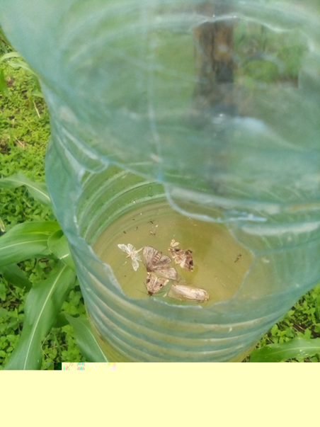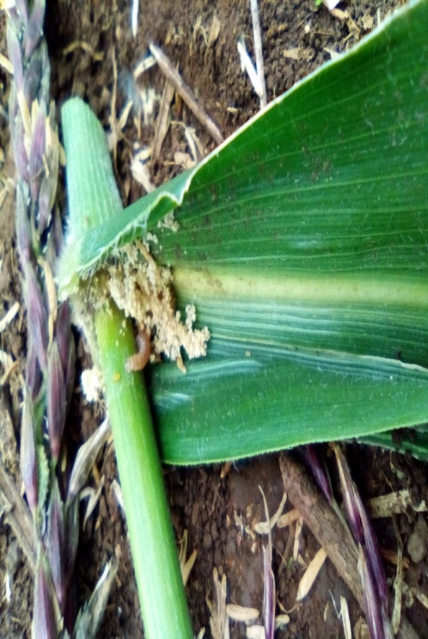

1. (b)

FIGURE 1: ( a) Local Trap for FAW and stemborers adults constructed from a 1.5-l plastic water bottle and (b) detasseled maize.

*2.3. Fall armyworm and Stem borers abundance and population dynamics in the study area*.

The numbers of adult FAW and stem borers in the maize plots over time was done by counting the insects caught in the baited trap set in each plot. The trap consisted of a 1.5 litre plastic bottle with two 2.5-3 cm diameter holes cut halfway on opposite sides of the bottle. Each trap contains half litre of locally produced bait; the trap was tied using a cord to a pole placed in the middle of each sub-plot and the cord adjusted such that the trap was suspending just above the canopy of the maize plants. Each trap was checked once each week to count the numbers of adult moths therein. Captured moth species were collected and counted, and the bait or attractant renewed once weekly for twelve weeks. The identification of species caught was done with the aid of field guide for the identification of Insect Pests of maize, by Alejandro Ortega of the Maize Program, CIMMYT. The numbers of each insect species collected each week were summed up and recorded to give the weekly abundance and population dynamics over time. Distributional pattern of species was assessed using the method as described by Isah, M. D.,Abdullah. and Sastawa, B. M [7] ; that is, mean> variance (Clumped distribution), Mean<variance (regular distribution) and mean=variance (random distribution).

*2.4. Plant damage parameters*.Plant damage was assessed visually during the vegetative stage prior to tasselling stage, by counting damaged plants of each maize variety as well as at the reproductive stage. The insect exit holes on stems made by stem borer from the sampled plants were counted weekly as a stem borer damage index. For the assessment of damage caused by fall armyworm, plants in the evaluated area were scored from 0 (no damage) to 9 (totally destroyed whorl) as proposed by Davis and Williams [8], to assess the impact of leaf damage.

*2.5. Yield assessment*.

The yields for each treatment were calculated by weighing two dried husked maize cobs of each variety from the experimental plots using a domestic weigh scale [9].Weekly inspection was carried out as from two weeks after planting till harvest to count egg masses, the number of damaged plants based on, stem tunneling, exit hole on stem, leaf damage, cob damage. All observed insects were collected for identification and recording*. Spodoptera frugiperda* presence was determined using the following indicators: I. Presence of fresh frass in the leaf funnel; II. Presence of larvae on leaves or in the leaf funnel identifiable with the inverted Y-Shape in the head and the set of four dot forming a square on the upper surface of the last segment of its body [10] III. Irregular damage (cuts) on leaves and presence of egg mass. All stems with holes and frass were counted as damaged by stem borers. Each week, the number of plants damaged by stem borers and fall armyworm each were calculated. At 5 weeks after planting, then at physiological maturity and at dry harvest 5 plants from each sub-plot with stem borer damage were cut/harvested and the stems split open to identify the stem borers’ species therein.

*2.6.Study of over-seasoning population*.

Prior to land preparation for the second planting season, all maize residues (stems, cobs) in the field were carefully observed and the stems split open to observe for pupae and or larvae. Grasses with succulent stems in the surroundings of the field were similarly observed. Thereafter, ten spots in the field were randomly chosen and the top soil in each of these spots dug up to about 10cm and carefully observed for pupae. All collected pupae were taken to the lab and kept for the emergence of adults for positive identification.

*2.7. Data Analysis*.

The data obtained from this study was analyzed with the use the Statistical Package for Social Sciences (20) and Microsoft Excel 2016. Descriptive statistics was used to compute the mean, variance, standard error of the data (Central tendency and data dispersion). One Way ANOVA and Least Significant difference (LSD) was used to separate the means for this study which was done at α=0.05 (95% confidence interval) to evaluate the significance of the results. Distributional pattern of species was assessed using the method as described by Isah et al. [7]; that is, mean> variance (Clumped distribution), Mean<variance (regular distribution) and mean=variance (random distribution).

**3. Results**

*3.1. Fall Armyworm abundance, and population dynamics at different growth stages of maize.*

TABLE 2: Distributional pattern of fall armyworm on UBMS0001 and CMS8704 maize.

|  |  |  |  |
| --- | --- | --- | --- |
| Maize variety | Mean | Variance | Distributional pattern |
| UBMS0001 | 16±2 | 38 | Contagious (clumped) |
| CMS8704 | 15±2 | 13 | Regular |

When variance < mean = regular distribution.

When variance > mean = contagious distribution.

When variance = mean = random distribution.

Based on the distributional pattern of fall armyworm, the mean of UBMS0001 of 16 was less than the variance of 38 which implies that the distributional pattern of fall army worm had a clumped or contagious distribution. whereas the mean of CMS8704 of 15 was greater than the variance of 13 which implies that the distributional pattern (Table 2).

Figure 2 below shows the differences in the mean abundance of fall armyworm in UBMS0001 and CMS8704maize wherein, more insects were found in UBMS0001 (89 insects) compared to CMS8704 (79 insects) in both seasons.

FIGURE 2: Mean of fall armyworm during the different seasons for UBMS0001 and CMS8704.

Figure 3 below gives a graphical presentation of the abundance and dynamics of fall armyworm for the different treatments from weeks 1-12. Across the three treatments, there was a general decrease in the abundance of fall armyworm from week 9 to week 12 when the plants were getting more mature and readier for harvest. The highest numbers were in week 2-4 when the plants had more luxurious growth and had started flowering. Generally, more fall armyworms were found for plants treated with Trap +wood ash compared to plots with Traps only and the Trap +detasseled plants.

CMS870 Rainy Season

Figure 3: Fall Armyworm abundance, and population dynamics at different growth stages of maize.

# *3.2. Stem borers abundance and population dynamics at different growth stages of Maize.*

# From Table 3 below for UBMS0001, more stem borers adults were found for plots treated with Trap +wood ash (5) compared to plots treated with Traps only (4) and Trap +detasseling (1); the difference in the means were statistically significant (P=0.021).

# The results from Table 4, more stem borers were found for plots treated with “Trap +wood ash” (4 insects) compared to plots treated with “Traps only” (3 insects) and Trap +detasseling (0) though, the difference in the means were not statistically significant (Table 4).

Based on the results in Table 5 “CMS8704’’, “Trap + wood ash” and “Traps only” both had a total of 2:1 mean number of stem borers throughout the study period (Weeks 1-12). However, “Trap + detasseling” had a mean number of stem borers of 0. The difference in the means across treatments was not statistically significant (0.06).

Based on the mean numbers of adult Stem borer caught over time in baited traps in a CMS8704 Maize field in the rainy season showed that “Trap+Woodash” had the highest mean number of Stem borers of 10 adults. On the other hand, “Trap + detasseling” had an average of 0 individual; the difference in the means was statistically significant (p<0.0001).

Figure 4 shows the differences in the mean abundance of stem borers in UBMS0001 and CMS8704maize. Generally, more stem borers were found in UBMS0001 (17insects) compared to CMS8704 (15 insects). This gives an indication that UBMS0001 maize was more affected by stem borers compared to CMS8704 maize.

FIGURE 4: Mean of stem borer during the different seasons for UBMS0001and CMS870.

TABLE 4: Mean numbers (±SE) of adult Stem borers caught over time in baited traps in a UBMS0001 maize field with different treatments in the dry season.

treatments in the dry season

TABLE 3 : Mean numbers (±SE) of adult Stem borers caught over time in baited in a UBMS0001 maize field with different treatments in the rainy season.

treatments in the dry season

|  |  |  |  |  |  |  |  |  |  |
| --- | --- | --- | --- | --- | --- | --- | --- | --- | --- |
| Weeks of sampling | Traps only | Traps + Detassing | Trap +woodash | **P-value** | Weeks of sampling | Traps only | Traps + Detassing | Trap +woodash | **P-value** |
| 1 | 0±0 | - | 0±0 | **-** | 1 | 0±0 | - | 0±0 | - |
| 2 | 0±0 | - | 0±0 | **-** | 2 | 0±0 | - | 0±0 | - |
| 3 | 0±0 | - | 1±1 | **-** | 3 | 1±1 | - | 1±1 | - |
| 4 | 1±0 | - | 0±0 | **-** | 4 | 1±0 | - | 1±0 | - |
| 5 | 1±1 | - | 0±0 | **-** | 5 | 0±0 | - | 0±0 | - |
| 6 | 0±0 | - | 0±0 | **-** | 6 | 0±0 | - | 1±1 | - |
| 7 | 0±0 | - | 1±0 | **-** | 7 | 1±0 | - | 1±1 | - |
| 8 | 1±1 | - | 1±1 | **-** | 8 | 0±0 | - | 0±0 | - |
| 9 | 1±0 | - | 1±0 | **-** | 9 | 0±0 | - | 0±0 | - |
| 10 | 0±0a | 0±0a | 0±0a | **0.63** | 10 | 0±0a | 0±0a | 0±0a | 1 |
| 11 | 0±0a | 1±0a | 1±1a | **0.492** | 11 | 0±0a | 0±0a | 0±0a | **1** |
| 12 | 0±0a | 0±0a | 0±0a | **0.422** | 12 | 0±0a | 0±0a | 0±0a | **1** |
| **Total** | **4±2b** | **1±0c** | **5±3a** | **0.021\*** | Total | 3±1a | 0±0a | 4±33a | **0.233** |

TABLE 6: Mean numbers (±SE) of adult Stem borer caught over time in baited traps a CMS8704 maize fields with different treatments in the rainy season .

TABLE 5: Mean numbers (±SE) of adult Stem borer caught over time in baited traps in a CMS8704 Maize field with different treatments in the dry season.

|  |  |  |  |  |  |  |  |  |  |
| --- | --- | --- | --- | --- | --- | --- | --- | --- | --- |
| Weeks of Sampling | Traps only | Trap +Detassing | Trap+Wood ash | **P-Value** | Weeks of Sampling | Traps only | Trap +Detassing | Trap+Woodash | **P-Value** |
| 1 | 0±0 | - | 0±0 | **-** | 1 | 0±0 | - | 1±0 | - |
| 2 | 0±0 | - | 0±0 | **-** | 2 | 0±0 | - | 1±0 | - |
| 3 | 0±0 | - | 0±0 | **-** | 3 | 1±1 | - | 1±1 | - |
| 4 | 0±0 | - | 0±0 | **-** | 4 | 0±0 | - | 1±1 | - |
| 5 | 0±0 | - | 0±0 | **-** | 5 | 1±0 | - | 1±1 | - |
| 6 | 0±0 | - | 0±0 | **-** | 6 | 0±0 | - | 1±1 | - |
| 7 | 0±0 | - | 1±0 | **-** | 7 | 0±0 | - | 1±1 | - |
| 8 | 1±0 | - | 1±1 | **-** | 8 | 0±0 | - | 0±0 | - |
| 9 | 0±0 | - | 0±0 | **-** | 9 | 0±0 | - | 0±0 | **-** |
| 10 | 0±0a | 0±0a | 0±0a | **1** | 10 | 0±0a | 0±0a | 1±1a | **0.422** |
| 11 | 0±0a | 0±0a | 0±0a | **1** | 11 | 0±0a | 0±0a | 1±1a | **0.422** |
| 12 | 0±0a | 0±0a | 0±0a | **1** | 12 | 0±0a | 0±0a | 1±1a | **0.422** |
| **Total** | **1±0a** | **0±0a** | **2±1a** | **0.064** | Total | **2±1b** | **0±0c** | **10±8a** | **p<0.0001** |

Least Significant Difference (LSD) was used to separate means at P of 0.05. Values with the same letters in a row are not significantly different p<0.05

*3.3. Distributional pattern of stem borers on UBMS0001 maize and CMS8704 maize*.

Based on the distributional pattern of stem borers, the means for both UBMS0001 and CMS8704 were similar which therefore indicates a random distribution of stem borers on the species (Table 7).

TABLE 7: Distributional pattern of Stem borers.

|  |  |  |  |
| --- | --- | --- | --- |
| Maize variety | Mean | variance | Distribution |
| UBMS0001 maize | 4±1 | 4 | Random |
| CMS8704 maize | 3±1 | 3.0 | Random |

When variance < mean = regular distribution.

When variance > mean = contagious distribution.

When variance = mean = random distribution.

# *3.4. Differences in the mean abundance of damaged plants in UBMS0001 and CMS8704 maize across seasons*.

Figure 6 below shows the differences in the mean abundance of damaged plants in UBMS0001 and CMS8704 maize across seasons. Generally, more damaged plants were found in UBMS0001 compared to CMS8704 and there was a higher number of damaged plants (78) in the rainy season compared to 55 in the dry season. This gives an indication that UBMS0001 maize was more affected by fall armyworm compared to CMS8704 maize. Figure 5 shows the damage caused by fall armyworm larvae.

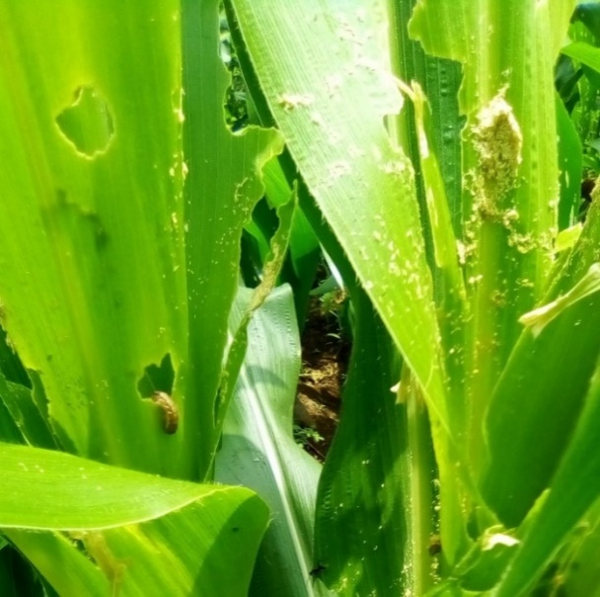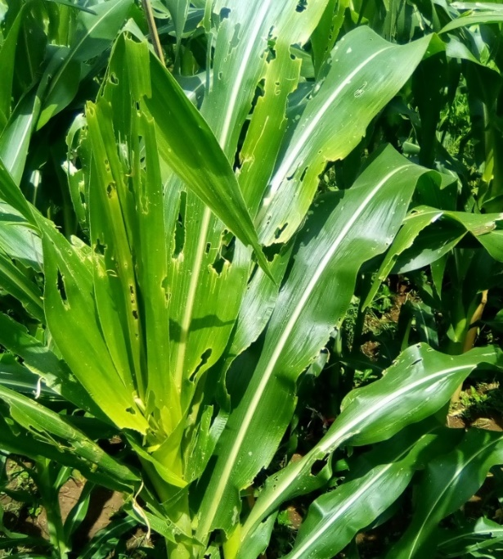

FIGURE 5 : Typical damage from *Spodoptera frugiperda* on maize.

FIGURE 6 : Mean of plants damaged by fall armyworm during the different seasons on UBMS0001 and CMS8704.

# *3.5. Differences in mean numbers of plants damaged by stem borers for UBMS0001and CMS8704 maize varieties*.

Figure 8 shows the differences in the mean abundance of damaged plants in UBMS0001 and CMS8704 maize across seasons. Generally, more damaged plants were found in UBMS0001 compared to CMS8704 and there was a higher number of damaged plants (19) in the rainy season compared to 10 in the dry season. This gives an indication that UBMS0001 maize was more affected by stem borers compared to CMS8704 maize. Figure 7 shows an early (a) and an advanced damage stage (b) caused by stem borers larvae on maize.

1. 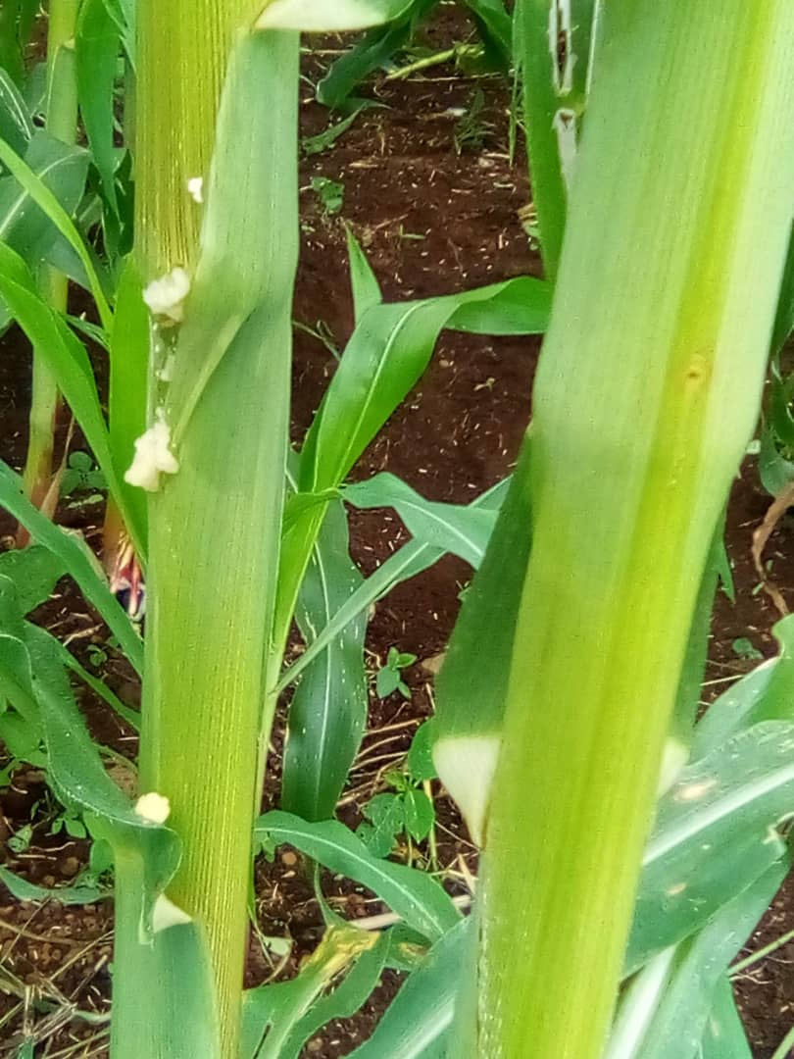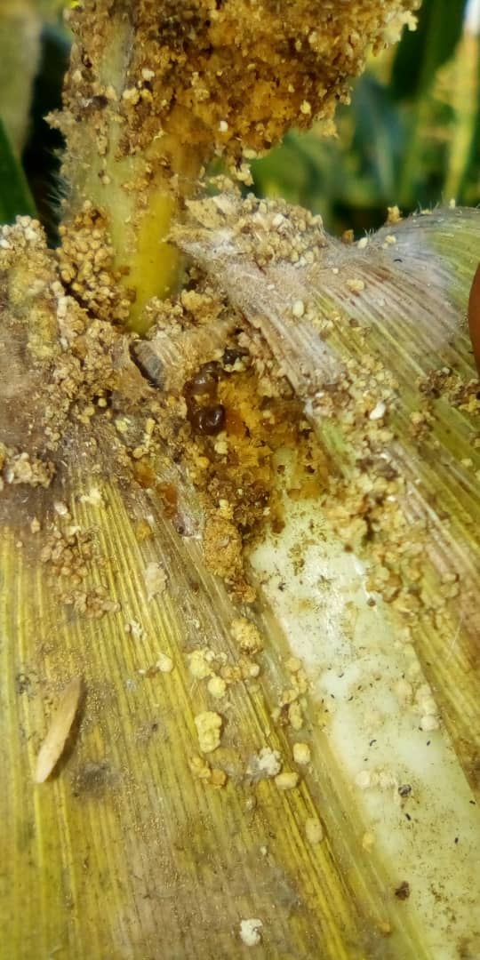 (b)

FIGURE 7: (a) and (b) shows typical damage from stem borers on maize.

FIGURE 8: Mean of plants damaged by fall armyworm on UBMS0001 and CMS8704 maize varieties.

# *3.6. Types of larvae found in UBMS0001 and CMS8704 maize stems after harvest*.

The larvae of three species which affects the growth and development of maize were observed in the stems of both maize varieties at harvest the whitish purple *Busseola fusca* larvae, the dark to blackish *Eldana saccharina* and the pink *Sesamia calamistis* larvae (Figure 9).

1. 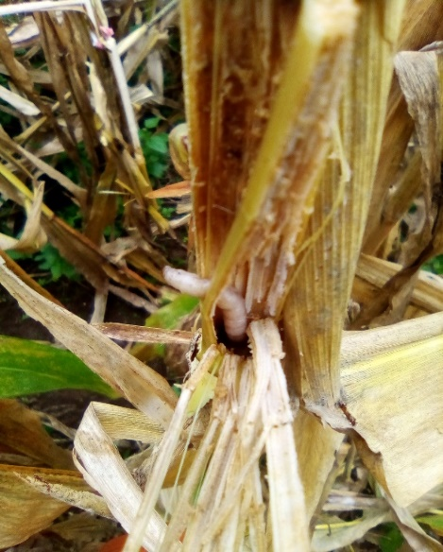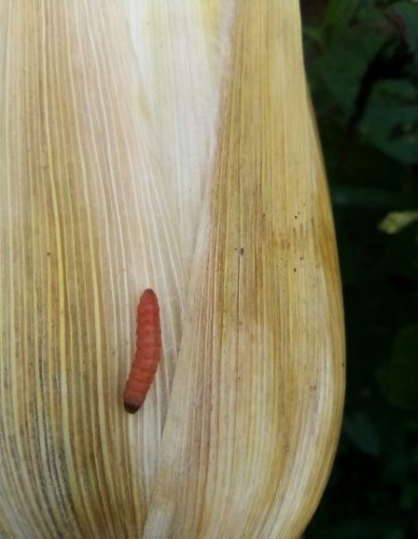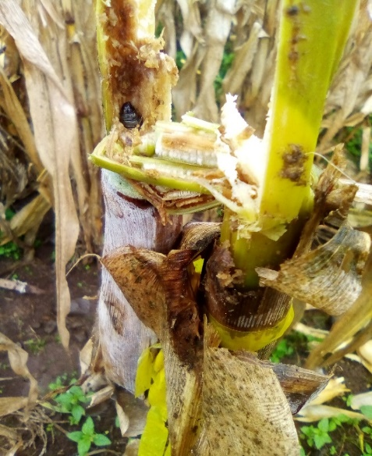 (b) (c)

FIGURE 9: (a) *Busseola fusca* (b) *Eldana Saccharina* and (c) *Sesamia calamistis*.

# *3.7. Differences in larvae found in UBMS0001 and CMS8704 maize at harvest*.

Figures 10 illustrate the differences in the numbers of larvaein both maize varieties

In the rainy season, UBMS0001 was seen to have a higher mean number of *Busseola fusca* larvae (4) compared to 1 larva in CMS8704. This is therefore evidence that UBMS0001 was more affected by *Busseola fusca* as compared to CMS8704.

In the dry season, UBMS0001 was seen to have a higher mean number of *Busseola fusca* larvae of 5 compared to 0 in CMS8704. This therefore evidence that UBMS0001 was equally more affected by *Busseola fusca* compared to CMS8704.

FIGURE 10: Differences in *Busseola fusca larvae* in UBMS0001 and CMS8704 at harvest.

Figures 11 show the difference in *Eldana saccharina*in both UBMS0001 and CMS8704.

In the rainy season, UBMS0001 had higher numbers of *Eldana saccharina*larvae. On the other hand, CMS8704 had few numbers of the larvae. This indicates that UBMS0001 was more affected by *Eldana saccharina*compared to CMS8704 (Figure 11).

In the dry season, UBMS0001 had higher numbers of *Eldana saccharina* larvae. On the other hand, CMS8704 had few numbers of larvae. This is therefore evidence that UBMS0001 was equally more affected by *Eldana saccharina* as oppose to CMS8704.

FIGURE 11: Differences in numbers of *Eldana saccharina* larvae in UBMS0001 and CMS8704 at harvest.

Figure 12 below shows the difference in *Sesamia calamistis*in UBMS0001 and CMS8704.

In the rainy season, only 1 larva was found in UBMS0001 and was completely absent in CMS8704. However, none was recorded in the dry season.

FIGURE 12: Differences in numbers of *Sesamia calamistis* larvae in UBMS0001 and CMS8704 at harvest.

# *3.8. Yield*.

For UBMS0001 in the dry season, Trap+ detasseling which had the lowest number of affected plants, had the highest mean yield of 0.75 kg followed by Trap+ Wood ash with an average yield of 0.72 kg and lastly by Traps only with an average of 0.52 kg. These differences in yield across treatments were not statistically significant (p=0.130) (Table 8). Based on the yield for CMS8704, Trap+ detasseling which also had the lowest number of affected plants, had the highest mean yield of 0.60 kg followed by Trap+ Wood ash with an average yield of 0.55kg and lastly by Traps only with an average of 0.0.48 kg.

TABLE 8: Yield for UBMS0001 and CMS8704 maize in the dry season.

|  |  |  |
| --- | --- | --- |
| Treatment | CMS8704 (Kg) | UBMS0001(Kg) |
| Traps only | 0.48±0.22a | 0.52±0.07a0 |
| Trap +Detasseling | 0.60±0.10a | 0.75±0.03a |
| Trap+Woodash | 0.55±0.10a | 0.72±0.10a |
| P-value | 0.657 | 0.130 |

Least Significant Difference (LSD) was used to separate means at P=0.05.

Values with the same letters in arrow are not significantly different p<0.05.

Based on the yield for UBMS0001 in the rainy season, “Trap+ detasseling” had the highest mean yield of 0.87 kg. The difference in the yield across treatments were not statistically significant (p=0.359) (Table 9). For CMS8704, “Trap+ detasseling” had the highest mean yield of 0.66 kg. These differences in yield across treatments was not statistically significant (p=0.672) (Table 9).

TABLE 9: Yield for UBMS0001 and CMS8704 maize in the rainy season.

|  |  |  |
| --- | --- | --- |
| Treatment | UBMS0001(Kg) | CMS8704 (Kg) |
| Traps only | 0.73±0.11 | 0.56±0.03 |
| Trap +Detasseling | 0.87±0.05 | 0.66±0.07 |
| Trap +Wood ash | 0.74±0.08 | 0.62±0.10 |
| P-value | 0.359 | 0.672 |

Least Significant Difference (LSD) was used to separate means at P=0.05. Values with the same letters in arrow are not significantly different p<0.05.

# 

# 4. Discussion

Based on the results of this study on the abundance and population dynamics of fall armyworm at different maize growth stages, there was a general decrease in the numbers of fall armyworm from week nine after planting to the last weeks when the plants were getting mature and ready for harvest. Moth catches increased from the early vegetative growth stages when the traps were deployed and the highest observed within the first four weeks after planting till flowering. These results are in agreement with those of Murua *et al*. [11] who found FAW infestations to be plant age-dependent with the early vegetative stages being the most preferred stages, i.e., younger stages of maize were found to be more infested than older stages. Reay-Jones, [12] reported that FAW prefers to lay eggs and feed on vegetative stage corn. These studies show that FAW infestation can occur beyond the early vegetative growth stage but it is significantly lower after the early vegetative stages. After the ninth week, most maize plants were in the reproductive stages. At this stage, few tender leaves are on the maize plants to support the growth of neonates that hatch from eggs, resulting in few moths visiting the maize field at this stage to lay their eggs. Consequently, the reduction in moth catches over time during this growth stage. These findings suggest that management practices that target the adult moths that visit the field have to be concentrated within the first four to six weeks of maize germination. Therefore, baited traps that catch the adult moths should be set-up within this period.

The findings of this study indicate that, more insects (fall armyworm adults) were found on the maize variety UBMS0001 compared to CMS8704. Cumulatively, the mean number of plants damaged by fall armyworm was higher for UBMS0001 compared to CMS8704. The reasons could be due to differences in chemical characteristics of the varieties including such as host-plant odour. Undamaged corn plants release linalool, which is likely the compound responsible for female moth attraction[13]. Host selection by FAW moths and larvae was reported to be affected by plant volatiles emissions [14]. Host selection by female moth is crucial for offspring performance as newly hatching larvae are not able to actively search for hosts due to their restricted mobility. Their host preference could be dose-dependent of linalool, which is emitted by both plants.

The spatial distribution pattern of individuals in a population may conform to any one of several broad types, such as random, regular, or contagious (clumped) Evans et al .[15] The results show that, the adults of fall armyworm were regularly distributed on CMS8704 and followed a contagious pattern on UBMS 0001 while the stem borers showed a random distribution for both maize varieties. Hernandez-Mendoza [16] indicated that *S. frugiperda* showed a random spatial distribution in maize grown in Mexico, as previously reported by Faris et al. [17] and Melo et al. [18] in Brazil, and Serra and Trumper [19] in Argentina. Knowing the spatial and temporal distributions of *S. frugiperda* and stem borerin maize will facilitate the development of integrated control strategies, improve existing sample techniques, allowing estimations of the economic losses caused by FAW, when population density decreases*, S. frugirperda* shows a random distribution, but when density increases, an aggregated distribution. The random distribution is due to several factors, such as high dispersion capability, natural mortality, migration for host plants and /or the impact of natural enemies (Serra and Trumper, [19] Melo *et al.*, [18]. Clumped distributions of insects can result from response of individuals to environmental conditions or resources, including food, potential mates and sites for laying eggs (oviposition).

The main stem borer species found on the plots were *E. saccharina, B. fusca and Sesamia calamistis.* These findings are similar to that of Hordzi et al. [20] who reported that the major stem borer species found infesting maize plants in farms in southern Ghana were these same species. There was a general increase in adult populations from week 2 to 7 and damage observed during the reproductive stage. This agrees with Abang et al. [21] who reported stem borers infestations during the reproductive crop stages. Stem borers were reported to have an oviposition preference for to 3-6 weeks old maize plants [22] .

The results showed that more stem borers were found on UBMS0001 compared to CMS8704 indicating that UBMS0001 was more affected by stem borers than CMS8704. Host selection in phytophagous insects is generally determined by adults [22] . These Lepidopterous insects employ various sensory cues in host plant location and acceptance, cues may derived from plant size, plant volatiles, presence of nutrient levels or plant texture [14] .Plant size is a more important stimulus because larger plants receive more eggs than small plants regardless of plant secondary metabolites [23]. As in other moths’ species, general orientation of the stem borers towards UBMS0001 may be triggered by plant size, plants with vigorous growth result in larger size and should be favourable to stemborers.

# From the results of this study, the combined effect of trapping and detasseling (Trap Detass) against fall armyworm and stem borers was significantly better than most of the other treatments and had the lowest number of affected plants, and highest mean yield for both maize varieties. This was followed by Traps+Wood ash which registered a lower plant damage compared to the control plots (Traps only). Wood ash has been reported to have insecticidal properties as it was noticed to reduce insects’ populations, number of leaves damaged and number of holes in maize and yam farm [24]. Traps, in general, serve to determine insect movement, to estimate temporal and spatial distribution of insects; and to evaluate need for control and effectiveness of control measure. The concept of mass trapping using food/host attractants, to attract insects to a trap where they would be confined and die control insects for population suppression [25]. The key objective of trapping in pest management is to capture enough insects in the treated area before they reproduce or damage crops. Detasseling is the removal of corn tassels. It helps minimize corn borer infestation since the larva wants to stay first in the tassels before going into the ear .The findings of this study are further supported by Felkl. [26] who confirmed that detasselling 75% of maize plants reduced infestation and larval tunneling, primarily by removing larvae feeding in the tassels and secondarily by reducing survival of larvae because of reduced amounts of pollen as food, and resulted in an almost 100% yield gain

In our study, we recorded a higher number of FAW, Stem borers and damaged plants during the rainy season compared to the dry season. Some studies [27] have identified weather conditions as the key determinant factors for abundance of most insects, including the FAW. For the FAW and Stem borers, rainfall results in luxurious growth of its preferred host plants, thus creating conditions for the thriving of pests’ population [28].

# 5. Conclusions and Recommendations

# The world is already facing food security challenges resulting from biotic constraints to crop production. This study effectively confirms that the abundance and population dynamics of FAW as well as damage caused by the pest varied with the growth stages of the maize plant as well as stem borer species. In this study, trapping + detasseling showed good results in terms of damage reduction and yield increase. To control the pest effectively, farmers need to scout their maize crop daily to be able to detect the pest early.

# Managing these pests in the study area will therefore require targeting management actions to the first 2-6 weeks after emergence (that is, the vegetative growth stages). Moth abundance declined steadily after this stage. Farmers should burn maize stands after harvest because they are potential sources of infestation of stem borers for the next planting season. Farmers should use improve maize varieties so that they can have a greater yield at the end of the production process.

**References**

[1] Macauley, H., & Ramadjita, “Cereal crops: Rice, maize, millet, sorghum, wheat

.Proceedings of Abdou Diouf ,” International Conference Center,2015.

[2]. MINEPAT. Rapport d’etude sur le fillier mais. Pp.110,2008.

[3] Nicklin, J. Mycology lecture course. School of Biological and chemical sciences.

University of, London: Birkbeck College 27-29, 2004.

[4] Abu, G.A., Demo-Choumbou, R.F., Okpacu, S.A., “ Evaluating the constraints and

opportunities of maize production in the west region of Cameroon for sustainable

development,” *Journal of Sustainable Development in Africa* 13, 189-197,2011.

[5] Folifac F, Lifongo L, Nkeng G, Gaskin , “ Municipal drinking water source protection

In low income countries: Case of Buea municipality-Cameroon,”*J. Ecol. Nat.*

*Environ*.1(4):73-84, 2009.

[6] Nboyine, J. A., Kusi, F., Abudulai, M., Badii, B.K., Zakaria, M., Adu, G.B.,& Yahaya,

“ A new pest, Spodoptera frugiperda ( JE Smith), in tropical Africa: Its seasonal

dynamics and damage in maize fields in northern Ghana,” *Crop protection,* 127,

104960, 2020.

[7] Isah, M. D., Abdullahi, G. and Sastawa, “ Distribution Patterns of Insect Pests

Infesting Some Field and Stored Commodities in Maiduguri, North-Eastern Nigeria:

Implications for their Management,” *International Journal of Applied Research*

*and Technology*. 1(6): 227 – 232., 2012.

[8] Davis, F. M.; Ng, S. S., Williams, W. P. Visual rating scales for screening whorl-

stage corn for resistance to fall armyworm. Technical bulletin, (186), 1-9, 1992.

[9] Ndemah, R., and Schulthess, “Yield of maize in relation to natural field infestations

and damage by lepidopteran borers in the forest and forest/ savanna transition

zones of Cameroon, *“International Journal of Tropical Insect Science,* 22(3), 183-

192,2002.

[10] Prasanna, B.M., Huesing, J.E., Eddy, R., & Peschke, V.M. Fall armyworm in Africa:

a guide for integrated pest management,2019.

[11] Murúa, G., Molina-Ochoa, J., & Coviella, “ Population dynamics of the fall

armyworm, Spodoptera frugiperda (Lepidoptera: Noctuidae) and its parasitoids in

northwestern Argentina*,” Florida* *Entomologist*. 89(2), 175–183,2006.

[12] Reay-Jones, F. Fall Armyworm as a Pest of Corn. Land – Grant Press By Clemson

Extension. LGP 1025. http//Igpress.Clemson.edu/publication/fall-armyworm-as-a-

pest- of-corn,2019.

[13] D’Alessandro M, Turlings TCJ, Advances and challenges in the identification of

volatiles that mediate interactions among plants arthropods. Analyst 131:24-

32,2006.

[14] Rojas JC, Virgen A & Cruz-Lopez, “Chemical and tactile cues influencing

oviposition of a generalist moth, Spodoptera frugirperda (Lepidoptera:

Noctuidae)”, *Environmental Entomology, 2003.*

[15] Evans, F. C. (2021). Population dispersion. Access Science.

https://doi.org/10.1036/1097-8542.538000

[16] Hernández-Mendoza, “Spatial distribution of Spodoptera frugiperda

(Lepidoptera: Noctuidae) in maize landraces grown in Colima, Mexico”,

*International Journal of Tropical Insect Science*, 28(3), 126-129,2008.

[17] Farias, P. R. S., Barbosa, J. C. and Busoli, Distribuc¸a ˜o espacial da

lagarta-do-cartucho, Spodoptera frugiperda (J.E.Smith).(Lepidoptera:Noctuidae),

na cultura do milho. Neotropical Entomology, 30, 681–689, 2001.

[18] Melo E.P., Fernandez M.G., Degrande P.E.,Cessa M.A.,Salomao J.L. and

Nogueira R. F. Distribuicao especial de plantas infestadas por Spodoptera

frugirperda(J.E. Smith) (Lepidoptera:Noctuidae), na culturado milho. *Neotropical*

*Entomology* 35, 689-697,2006.

[19] Serra G.V. and Trumper E. V.Muestreo secuencial de larvas de Spodoptera

frugiperda (Smith) con distintos tamanos de unidad muestral Available from :

http:// www.cricyt.edu.ar/eco2004/resumenes/PT%20L.htm.2004.

[20] Hordzi, W.H.K. “Lepidopterous stem borers of maize (Zea mays): Agro-ecological

and regional composition and distribution of their parasitoids in Southern

Ghana,” *J. Biosci. Biotechnol*. Discov, 3, 46-58,2018.

[21] Abang, A.F., Nanga, S.N., Fotso kuate, A., Kouebou, C., Masso, C., & Fiaboe,

K.K.M. Natural Enemies of Fall Armyworm Spodoptera frugirperda

(Lepidoptera: Noctuidae) in Different Agro-Ecologies. Insects, 12(6). 509,2021.

[22] Calatayud, P.A., Bruno, P.R., Van den Berg, J., & Schulthess, “ Ecology of the

African Maize Stalk Borer, Busseola fusca (Lepidoptera: Noctuidae) with

special reference to insect-plant interactions, *” Insects*, 5(3), 539-563,2014.

[23] Reudler, T.J.H., Biere, A., Harvey, J.A., & Van Nouhuys, “ Oviposition cues for

specialist butterfly-plant chemistry and size, *”Journal of Chemical Ecology*,

34(9), 1202-1212,2008.

[24] Boiteau, G., Singh, R.P., McCarthy,P.C.,& Mackinley, P.D.” Wood ash potential for

Colorado potato beetle control,” American journal of potato research, 89(2), 129-

135,2012

[25] El-Sayed,A.M., Suckling, D. M., Wearing, C.H., & Byers, J.A. “Potential of mass

trapping for long-term pest management and eradication of invasive species,”

*Journal of economic entomology*, 95(5),1550-1564,2006.

[26] Felk, G. “Economic aspects of detasseling corn plants and insecticide use to

control Asian corn borer, Ostinia furnacalis Guenee (Lep., Pyralidae), in the

Philipines,”*Journal of Applied Entomology*, 105(1-5), 379-386,1988.

[27] Intachat,J.,Holloway, J.D.,&Staines, “ Effects of weather and phenology on the

abundance and diversity of geometroid moths in a natural Malaysian tropical

rain forest,” *Journal of Tropical Ecology*, 17(3), 411-429,2001.

[28] Sparks, A.N. A review of the biology of the fall armyworm. Florida Entomologist,

82–87,1979.