**Original Research Article**

**Estimation of Variability in Body Morphometric Measurements using Principal Component analysis in Mehsana Goats**

.

**ABSTRACT**

|  |
| --- |
| **Aims:** The study was conducted on Mehsana breed of goats which were selected randomly from their breeding tract in Gujarat State, India with an aim to estimate the Variability in Body Morphometric Measurements using Principal Component analysis.  **Study design:** The principal component analysis (PCA) was used to characterize the most important component of variables from morphometric traits.  **Place and Duration of Study:** Department of Animal Genetics and Breeding, College of Veterinary Science and Animal Husbandry, Kamdhenu University erstwhile S.D. Agricultural University, Sardarkrushinagar, Gujarat, India-385 5063 during 2019-20.  **Methodology:** A total of 118 Mehsana goats were randomly selected for this study from 13 villages of 3 districts. The data on body weight (BW) as well as measures of different body parts (in centimetre) namely, Heart girth (HG), Height at Withers (HW), Height at Rump (HR), Shoulder width (SW), Body length (BL), Tail length (TL) and Paunch girth (PG) were collected.  **Results:** The accuracy (R2) was estimated up to 70% (Heart girth) when body weight was predicted using single variable. Increase in coefficient of determination (R2) was observed as the number of independent variables in the equation increases. Inclusion of all the independent variables in prediction equation fetched accuracy up to76%. Out of eight principal components, the first two components explained cumulative percentage of variance of 70.967%. The first principal component (PC1) contributed 57.875% of total variation whereas; second component (PC2) explained 13.092% of the total variance. Varimax rotation was used for rotation of principal factors through the transformation of the factors to approximate a simple structure and inferred that HW (0.883), HR (0.848), BL (0.807) and HG (0.761) had significantly higher loadings in the first PC1 and the PC2 mainly contain the significantly higher loadings for TL (0.794).  **Conclusion:** The study indicated that principal components can be used effectively for multivariate analysis in Mehsana goats based body measurers and body morphometric traits. |

***Keywords****: Mehsana Goats, Morphometric traits, Principal component, Regression equation*

1. INTRODUCTION

India stands second in world’s goat population, with 148.88 million head count having 34 well recognized breeds (DAHD, 2023). The Mehsana is a medium to large sized domestic goat breed having breeding tract in the Gujarat state of India (Gupta *et al.,* 2016). Live goats are traded mainly on the basis of live body weight. The goat traders often visit the goat keeper’s flock for purchasing animals and in the absence of a reliable weight measuring methods; goat rearers are forced to sell goat on the weight assessed by traders which is mostly on lower side. The conditions for accurate weighing are rarely met in the field. Regression of body weight on certain body characteristic is an appropriate alternative method of weighing animals without using scales. This procedure is often breed-specific and is currently not studied for determining the body weight of Mehsana goat. Considering all these facts, the study was carried out to find the best prediction equations of body weight for Mehsana goats on the basis of different body measurements and application of PCA to establish the relationships between multiple variables and representing more number of variables with a few components related to morphometric traits.

2. material and methods

Live body weight can be estimated without using weighing balance in which live body weight is regressed on selected body measurements. Heart girth, body length and height at wither are the most important linear body traits for estimation of live body. In present study samples of body morphometric traits were collected in such a way that it covered the goal from whole of the breeding tract including the Banaskantha, Mahesana and Patan Districts.

***2.1 Data collection***

A total of 118 Mehsana goats were randomly selected for this study from 13 villages of 3 districts (Fig.1). The study was carried out using measuring tape and the hanging electronic weighing balance. The data on body weight(BW) as well as measures of different body parts (in centimetre)namely, Heart girth (HG), Height at Withers (HW), Height at Rump (HR), Shoulder width (SW), Body length (BL), Tail length (TL) and Paunch girth (PG) were collected. Arrangements were made to stand the animal on even surface and in normal position at the time of recording body measurement. These measures and weights were taken as, BW (kg): Live body weight in kilograms; HG(cm): Circumference of the chest circumference of the body immediately behind the shoulder blades in a vertical plane, perpendicular to the long axis of the body; HW (cm): It is the vertical distance measured from highest point immediately behind the shoulder to the ground; HR (cm): It measured as the vertical distance from the ground to the rump; SW (cm): It was measured as distance between the shoulders, i.e. widest point of shoulders; BL (cm): It is the horizontal distance measured between the anterior points of the shoulder to the posterior extremity of the pin bone of the same side; TL(cm): It is measured from tail head to the end of switch of tail. PG (cm): Belly measurement (circumference in front of the sacrum).

***2.2 Statistical Analysis***

The general linear model (GLM) procedure of R programme (R core team, 2024) was used to predict the live body weight of Mehsana goats with different body measures using stepwise simple and multiple regression. The model utilised was: $\hat{Y}=a+ b_{1}x_{1}+b_{2}x_{2}+…+b_{n}x_{n}$ where, = Predicted body weight; a = Intercept value; b = Regression coefficient of BW on body measurement traits; x = Morphometric traits ($x_{1}, x_{2},x_{3},….., x_{n})$. The accuracy of fitting regression models was determined based on different criteria *viz;* Coefficient of determination (R2), Adjusted R2, Akaike information criterion (AIC), Bayesian information criterion (BIC), RMSE and p value of F statistics.

Bartlett’s test of sphericity was used for testing the validity of data set whereas; its suitability to proceed for PCA was examined with use of Kaiser-Meyer-Olkin (KMO). The Kaiser criterion (Kaiser 1960) and Scree plot methods were used to identify the Principal Component (PC) to be retained as predictors using SPSS software. The factor score values for first two major PCs were selected and multiple regressions were performed considering these as explanatory variable for the prediction of live body weight.

3. results and discussion

***3.1 Predication of live body weight using different morphometric traits***

The correlation coefficients among various body measures, live weight along with scatter plot diagram and histogram are presented in Fig. 2. Range of such correlation coefficients were from lowest as 0.067 (HW and TL) to highest as 0.841 (BW and HG) among various traits. Live body weight can be predicted by regressing live body weight on selected body measures. Total Seven linear body measurements were applied to a model and stepwise elimination procedure was adopted to arrive at conclusion that heart girth has best fitted in to the model. This finding implies that heart girth may be well utilised for the prediction of live body weight in Mehsana goats. Taye *et al.* (2012) reported similar findings and state that body weight is best explained by the HG in Farta sheep. Moreover, Matsebulla *et al*. (2013) also found the coefficient of determination of 0.92 for the prediction of BW, when HG alone was taken as independent variable in the model in Swazi Goats. In general there was increase in coefficient of determination (R2) with increase in the number of independent variables. This increase in R2 indicates that how well the prediction equation is fitting for predication of live body weight. The prediction equation, BW= 0.29 TL + 0.32 PG + 0.03 SW + 0.23 HR + 0.58 HG – 59.29 developed using tail length, paunch girth, shoulder width, height at rump and heart girth, fetched 76.1% of accuracy (R2) (Table 1). Similarly, Perez *et al.* (2016) noted that the BL, HG and HR traits can be used efficiently and conveniently in the regression formula for body weight prediction in goats. This finding is in line with the reports of Khargharia *et al.* (2015) in Assam Hill goats, Seifemichael *et al.* (2014) in Afar goats and Birteeb and Lomo (2015) in West African Dwarf goats.

***3.2 Principal component analysis in Mehsana goats***

The high measure of correlations, estimated among different variables gives indication about the presence of problem of multicolinearity. Variance Inflation Factor (VIF) was calculated to assess the problem of multicolinearity. In order to reduce the total number of variable and also to identify the few variables accounted for maximum variation, principal component analysis (PCA) with correlation matrix was used. The Kaiser-Meyer-Olkin (KMO) estimate for the present data set was 0.858 which revealed that the causal factors were responsible for significant share of the variance in body weight and different body measures and this further guide us towards factor analysis. Moreover, Kaiser (1974) suggested that value of KMO over 0.8 is meritorious and adequate for undertaking factor analysis. Further, Bartlett’s test of sphericity was used for testing the correlation matrix significance for all the traits (χ2 = 644.103, p ≤ 0.001) and was found as highly significant. This entails that correlation matrix formed was not a unitary matrix and there is ample correlation among the variables which warrants for factor analysis of data. The Scree plot of the principal components, also distinguishes the two extracted components by presence of “big gaps” (Fig. 3). The extracted two components together were able to explain more than 70 % of the variance. Out of total variation that exists, first PC was accounted for 57.875% which was having strong, positive and high impact for body measures viz. HW, HR, BL and HG (Table 2). Tail length was having high impact on second PC which accounted for 13.092% of the total variance.

Varimax rotation factor solutions were utilised in yielding the principal components which are given in table 3. The cut off critical value for factor solution in the present study was fixed as 0.75. It is inferred from the investigation conducted here that HW (0.883), HR (0.848), BL (0.807) and HG (0.761) had strong contribution in the first PC and higher effect of TL (0.794) was visible in the second PC. Further, communalities are the share of variance of all the variables which is being elucidated by the principal components. Communalities (h2) are referred as variance of the variables attributed to the common factors. In PCA, how well a model was able in explaining the variance can be obtained from communalities. The communalities of different traits ranged from lowest of 0.488 for SW to highest of 0.868 for HR (Table 3). High communalities of HG, HW, HR and BL (>0.70) indicated maximum variability of these traits are through common factors. PCA performed for body measures of Malabari goats by Valsalan *et al.* (2020) further reports the major portion of the total variance (28.024%) and there was higher impact of various body heights at 9, 12 and at 6 months of age. Moreever, total 40.37% variance contributed by the first PC was reported by Khargharia *et al.* (2015) in Assam Hill goat had significant loadings of BL and HG. Similar trend of higher loadings of BL and HG in first PC was also reported by Okpeku *et al*. (2011) and Perez *et al*. (2016) in West African Dwarf female goats and Dudusola *et al.* (2019) in native goats of Philippines.

The coefficients of the two major factors were extracted by PCA, and were used as explanatory variables for predicting body weights of the Mehsana goats. Approximately 74% and 7% of the total variation was accounted by both first and second major components, respectively. Both the major PCs could explain about 82% of the total variation of body weight and therefore, may be treated as the best prediction model for live body weight in Mehsana goats. So, a combination of principal components (PC1 and PC2) using various body measures may act as efficient judging factor (explanatory variable) for live body weight with 82% accuracy than the multiple regression of all original traits combinations (R2 =76%). The obtained results here was in concordance to those of Birteeb and Lomo (2015) in West African Dwarf goats; Khargharia *et al.* (2015) in Assam Hill goats and Valsalan *et al* (2020) in Malabari goats.

4. Conclusion

In present study Mehsana goats were selected randomly from their breeding tract with an aim to associate various body morphometric traits with body weight. Multiple linear regression analysis was used to predict live body weight of Mehsana goats using the variability in different body measures. Additionally, PCA was used to characterize the most important component of variables from morphometric traits. The accuracy (R2) was estimated up to 70% (Heart girth) when body weight was predicted using single variable. R2 increases as the number of independent variables in the equation increases. Inclusion of all the independent variables in prediction equation fetched accuracy up to 76%. Multiple linear regression analysis technique was widely in practices to predict live body weight. However, PCA is a technique to reduce the dimensionality of a dataset without loss of variability. The variance of about 70.967% was explained by the two major components, out of total eight principal components extracted. PC1 contributed 57.875% of total variation whereas; PC2 explained 13.092% of the total variance. Principal components factors inferred that HW (0.883), HR (0.848), BL (0.807) and HG (0.761) had appreciably significant impacts in the first two PCs (PC1 and PC2) mainly contain the significantly higher loadings for TL (0.794). About 82% of coefficient of determination could be achieved with combination of PC1 and PC2 using various morphometric traits which is a better estimate in comparison of the accuracy achieved with all the original morphometric traits (76%). The principal components are more efficient in selection of Mehsana goats particularly when selection is based on more than one trait which are related with each other and thereby facilitate the evaluation of this breed.

**Table 1 Relationships between body weight and different morphometric traits of Mehsana goats**

|  |  |  |  |  |  |  |  |  |
| --- | --- | --- | --- | --- | --- | --- | --- | --- |
| **Independent** | **Regression equation** | **R2** | **Adjusted**  **R2** | **AIC** | **BIC** | **REMS** | ***P value*** | ***VIF*** |
| **Equation with highest R2 in all combinations of original body measurements** | | | | | | | |  |
| HG | BW=1.151 HG– 50.32 | 70.70 | 70.40 | 670.61 | 678.92 | 4.08 | ** |  |
| HG and PG | BW=0.263 PG + 0.803 HG – 46.89 | 74.10 | 73.70 | 657.98 | **669.06** | 3.85 | ** |  |
| HG, PG and TL | BW=0.29 TL + 0.29 PG + 0.74 HG – 50.02 | 75.10 | 74.42 | 655.51 | 669.36 | 3.79 | ** |  |
| HG, PG, TL and HR | BW=0.29 TL + 0.32 PG + 0.24 HR + 0.58 HG – 59.11 | 76.00 | **75.18** | **652.90** | 669.53 | **3.74** | ** |  |
| HG, PG, TL, HR and SW | BW=0.29 TL + 0.32 PG + 0.03 SW + 0.23 HR + 0.58 HG – 59.29 | **76.10** | 74.98 | 654.77 | 674.17 | 3.75 | ** |  |
| HG, PG, TL, HR, SW and BL | BW=0.22 HR + 0.03 SW + 0.02 BL + 0.30 TL + 0.32 PG + 0.57 HG – 59.55 | **76.10** | 74.76 | 656.75 | 678.92 | 3.77 | ** |  |
| HG, PG, TL, HR, SW, BL and HW | BW=0.32 PG + 0.31 TL + 0.01 BL + 0.03 SW + 0.18 HR + BW=0.07 HW + 0.56 HG – 60.00 | **76.10** | 74.57 | 658.57 | 683.50 | 3.78 | ** |  |
| **Equation with orthogonal traits** | | | | | | | |  |
| PC1 | BW=3.01 PC1 - 36.39 | 74.30 | 74.10 | 655.23 | 663.54 | 3.82 | ** | 1 |
| PC2 | BW=2.05 PC2 – 36.39 | 07.80 | 6.99 | 805.87 | 814.18 | 7.24 | ** | 1 |
| PC1 and PC2 | BW=3.01 PC1 + 2.05 PC2 - 36.39 | **82.10** | **81.80** | **614.69** | **625.78** | **3.21** | ** | 1 |

**Table 2 Total variance explained by different components in Mehsana goats**

|  |  |  |  |  |  |  |  |  |  |
| --- | --- | --- | --- | --- | --- | --- | --- | --- | --- |
| Component | **Initial Eigen values** | | | **Extraction Sums of Squared Loadings** | | | **Rotation Sums of Squared Loadings** | | |
| Total | %  of Variance | Cumulative % | Total | %  of Variance | Cumulative  % | Total | % of Variance | Cumulative % |
| 1 | 4.630 | 57.875 | 57.875 | 4.630 | 57.875 | 57.875 | 4.037 | 50.464 | 50.464 |
| 2 | 1.047 | 13.092 | 70.967 | 1.047 | 13.092 | 70.967 | 1.640 | 20.503 | 70.967 |
| 3 | 0.909 | 11.358 | 82.325 |  |  |  |  |  |  |
| 4 | 0.590 | 7.381 | 89.706 |  |  |  |  |  |  |
| 5 | 0.355 | 4.437 | 94.143 |  |  |  |  |  |  |
| 6 | 0.175 | 2.189 | 96.332 |  |  |  |  |  |  |
| 7 | 0.164 | 2.055 | 98.387 |  |  |  |  |  |  |
| 8 | 0.129 | 1.613 | 100.000 |  |  |  |  |  |  |

**Table 3 Component matrix and varimax rotated component matrix of different factors for different traits in Mehsana goats**

|  |  |  |  |  |  |
| --- | --- | --- | --- | --- | --- |
| **Traits** | **Component matrix** | | **Varimax rotated component matrix** | | **Communalities** |
| **Component** | | **Component** | |
| **1** | **2** | **1** | **2** |
| BW | 0.862 | 0.279 | 0.674 | 0.605 | 0.689 | |
| HG | **0.914** | 0.181 | **0.761** | 0.537 | 0.731 | |
| HW | 0.809 | -0.354 | **0.883** | 0.006 | 0.821 | |
| HR | 0.818 | -0.247 | **0.848** | 0.107 | **0.868** | |
| SW | 0.646 | -0.266 | 0.698 | 0.020 | 0.488 | |
| BL | 0.817 | -0.149 | **0.807** | 0.196 | 0.780 | |
| TL | 0.227 | **0.768** | -0.105 | **0.794** | 0.661 | |
| PG | 0.770 | 0.262 | 0.596 | 0.552 | 0.641 | |

Fig. 1 Different places of Mehsana goat breeding tract from where body measures were taken

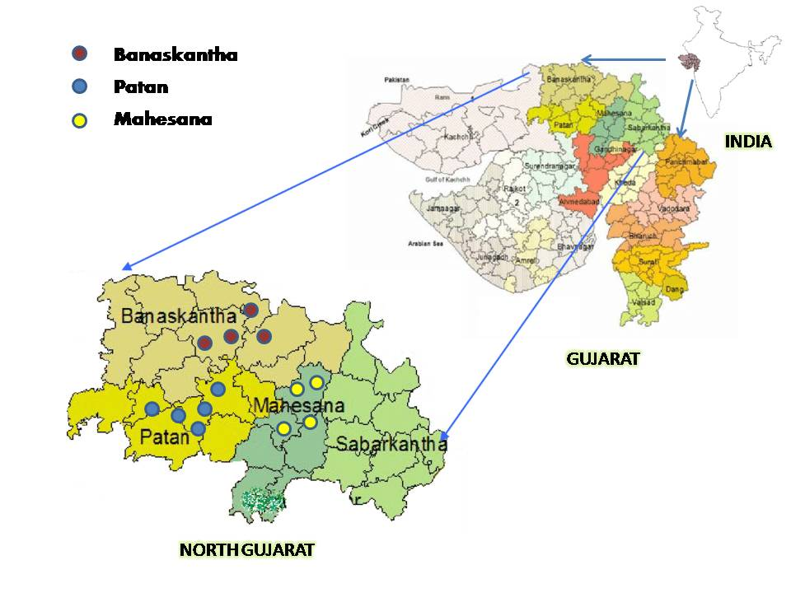

Fig. 2 Measures of coefficients of correlation among various body measure traits along with their histograms

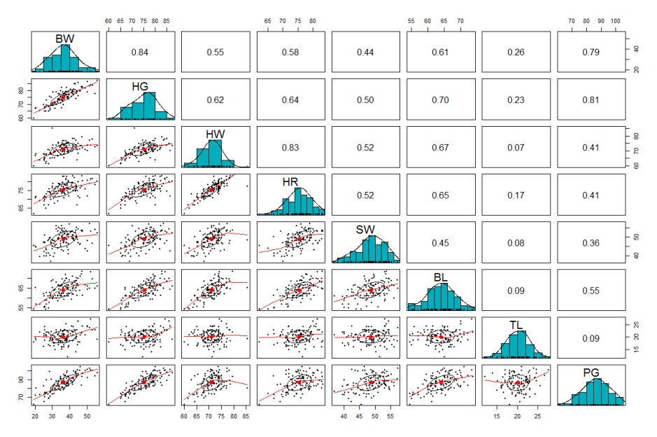

Fig. 3 Scree plot showing principal component number with eigen values

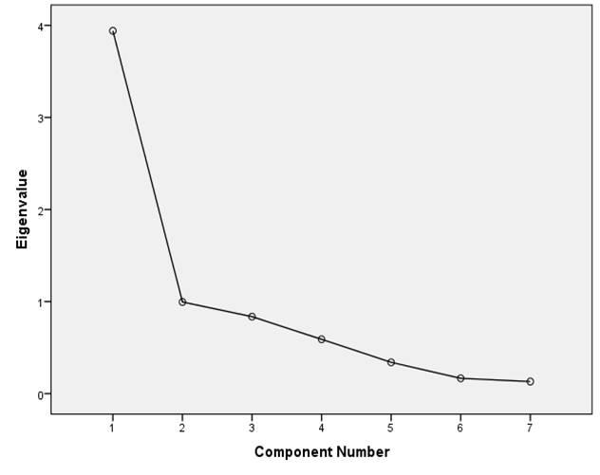

**COMPETING INTERESTS DISCLAIMER:**

Authors have declared that they have no known competing financial interests OR non-financial interests OR personal relationships that could have appeared to influence the work reported in this paper.

References

Birteeb P T and Lomo R. 2015. Phenotypic characterization and weight estimation from linear body traits of West African Dwarf goats reared in the transitional zone of Ghana. *Livestock Research for Rural Development.* **27**: 1–11.

DAHD. 2023. Annual Report 2020-21, Department of Animal Husbandry, Dairying and Fisheries, Ministry of Agriculture and Farmers Welfare, Govt. of India.

Dudusola I O, Oseni S O, Popoola M A and Jenyo A. 2019. Principal Component Analysis of Morphometric Traits of West African Dwarf Goats. *Nigerian Annals of Pure and Applied Sciences.* **1**(1): 26–32.

Gupta J P, Pandey D P and Shah R R. 2016. Genetic studies on growth traits of Mehsana goat of Gujarat, India. *Indian Journal of Animal Research* **50:** 164–167.

Kaiser H F. 1960. The Application of Electronic Computers to Factor Analysis. *Educational and Psychological Measurement.* **20**: 141–151.

Kaiser H F. 1974. An index of factorial simplicity. *Psychometrika* **39**: 31–36.

Khargharia G, Kadirvel G, Kumar S, Doley S, Bharti P K and Das M. 2015. Principal component analysis of morphological traits of Assam hill goat in eastern Himalayan India. *Journal of Animal and Plant Sciences* **25**: 1251–1258.

Matsebula M, Bhebhe E, Mupangwa J F and Dlamini B J. 2013. Prediction of live weight from linear body measurements of indigenous goats of Swaziland. *Livestock Research for Rural Development* **25**: 1–8.

Okpeku M, Yakubu A, Peters S O, Ozoje M O, Ikeobi C O N, Adebambo O A and Imumorin I G. 2011. Uporaba multivariatne analize glavnih komponent pri morfološki karakterizaciji avtohtonih koz v južni Nigeriji. *Acta Agriculturae Slovenica* **98:** 101–109.

Perez Z O, Ybañez A P, Ybañez R H D and Sandoval J F G J. 2016. Body weight estimation using body measurements in goats (Capra hircus) under field condition. *The Philippine Journal of Veterinary and Animal Sciences.* **42**(1): 1–7.

R Core Team. 2024. R: A language and environment for statistical computing. R Foundation for Statistical Computing, Vienna Austria. <http://www.R-project.org/>

Seifemichael M, Kefelegn K and Negassi Amaha, A. B. 2014. Variability in Linear Body Measurements and their Application in Predicting Body Weight of Afar Goats in Ethiopia. *International Journal of Interdisciplinary and Multidisciplinary Studies.* **1**: 17–25.

Taye M, Bimerow T, Yitayew A, Mekuriaw S H and Mekuriaw G. 2012. Estimation of Live Body Weight From Linear Body Measurements for Farta Estimation of Live Body Weight From Linear Body. *Online Journal of Animal and Feed Research.* **2:** 98–103.

Valsalan J, Sadan T and Venketachalapathy T. 2020. Multivariate principal component analysis to evaluate growth performances in Malabari goats of India. *Tropical Animal Health and Production.* **52:** 2451–2460.