*Original Research Article*

Curcumin Emulsion Development and Fortification in Crackers: Impact on Sensory and Antioxidant Activity Profile

**ABSTRACT**

**Aim:**

To evaluate the impact of emulsion-based curcumin formulations on the antioxidant activity and sensory characteristics of crackers, and to explore their potential as functional food products.

**Study Design:**

An experimental research design was employed to prepare and compare crackers fortified with different curcumin emulsions stabilized using various natural emulsifiers.

**Place and Duration of Study:**

The study was conducted at the School of Food Technology, MIT Art, Design and Technology University, Loni Kalbhor, Pune, INDIA, and the study was conducted from August 2024 to May 2025.

**Methodology:**

Two types of curcumin emulsions were developed using turmeric extract powder (95% curcumin), maltodextrin, oil, pectin, guar gum, and butylated hydroxytoluene (BHT) as dispersion stabilizers. The emulsions differed in their stabilizers, one used guar gum, and the other used a whey protein-pectin combination. These emulsions were incorporated into cracker formulations at varying concentrations. The antioxidant activity of the baked crackers was measured using the DPPH radical scavenging assay. Sensory evaluation was performed to assess flavour, texture, and overall acceptability.

**Results:**

The incorporation of curcumin emulsions significantly enhanced the antioxidant capacity of the crackers compared to control samples. Crackers with 3% whey protein–pectin stabilized emulsion (Emulsion I) exhibited the highest antioxidant activity and received the best sensory scores, suggesting a favourable balance of taste, texture, and health benefits. This indicates the potential of whey protein-based curcumin emulsions in the development of functional bakery products with improved bioactivity and consumer acceptability.

***Keywords:*** *Curcumin, Emulsion, Crackers, Antioxidant activity, DPPH assay, Functional foods, Whey protein, Pectin, Guar gum*

1. **INTRODUCTION**

Curcumin, the principal bioactive compound found in turmeric (Curcuma longa), has gained significant attention due to its potent antioxidant, anti-inflammatory, and therapeutic properties. It renders a bright yellow color to the spice. Curcumin comprises the phenolic compound i.e. di-feruloylmethane, de-methoxy curcumin & bis-demethoxy are the main compound of curcuminoids which are responsible for the yellow colour of turmeric. (Ghodke and Pawar, 2018). Turmeric contains three different analogues of curcumin i.e. diferuloylmethane (curcumin), desmethoxycurcumin, bisdemethoxycurcumin (Fig 1). In most systems curcumin was found to be most potent, and, in many systems, bisdemethoxycurcumin exhibits higher activity. There are also suggestions that the mixture of all three is more potent than either one alone (Aggarwal *et. al.,* 2007). Most common application of curcumin is in cosmetic and in food & beverages as a colouring agent. It is most commonly used in south and Southeast Asia. It finds the application not only in preparation of curry powder but also in soups and tea mix. However, its clinical and functional application in food products is limited by its poor solubility in water, low bioavailability and susceptibility to degradation during processing, particularly in heat-intensive applications such as baking. To overcome these limitations, various delivery systems have been explored to enhance curcumin’s stability, solubility, and absorption, with emulsion-based formulations emerging as one of the most promising approaches. (Hewlings and kalman, 2017)

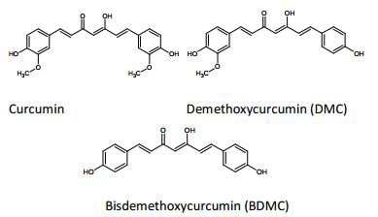

***Fig 1:*** *Chemical structure of curcumin and its analogue (Aggarwal et al., 2007).*

Emulsions are colloidal systems in which oil droplets are dispersed in water, often stabilized by surfactants, and have been shown to significantly improve the bioavailability of hydrophobic compounds like curcumin. By encapsulating curcumin in an emulsion, its stability is enhanced during food processing, and its antioxidant properties are preserved and potentially even amplified. The use of emulsion-based curcumin formulations in baked goods, such as bread, cakes, and pastries, offers a novel strategy to fortify these products with functional health benefits, without compromising sensory quality. (Jiang, 2022)

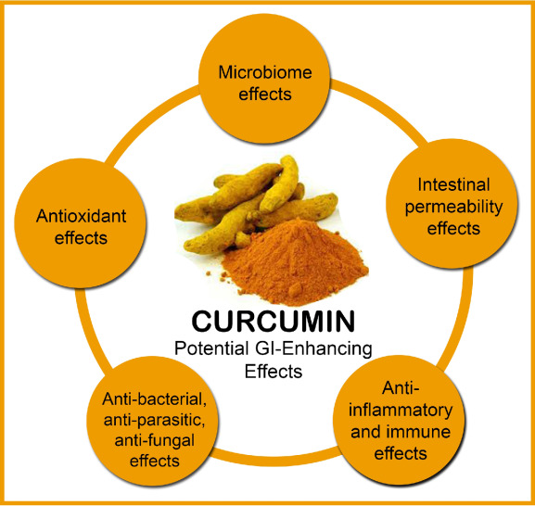

***Fig 2*** *Health Benefits of Curcumin (Adrian et al., 2018)*

The low bioavailability of curcumin is due to its poor absorption in gastrointestinal path, rapid metabolism, chemical instability and rapid systemic elimination. It also shows that the concentration of curcumin in blood and extraintestinal tissue is even undetectable. Most of the curcumin is metabolites in liver and intestine and the remaining are detectable in other organs. To increase the curcumin bioavailability, it should be kept in oil phase until it reaches to small intestine, when it encounters water it's chemical and metabolic degradation get start, so avoiding water during processing, storage, oral and gastric phase can increase the overall bioavailability of curcumin by Preetha Anand (2007).

Baked products are widely consumed across the globe, and incorporating antioxidant-rich ingredients such as curcumin could offer consumers a practical way to increase their intake of beneficial bioactive compounds. While the impact of curcumin in various food matrices has been studied, limited research exists on the specific effects of emulsion-based curcumin formulations on the antioxidant properties of baked products. Therefore, this study aims to evaluate the effect of emulsion-based curcumin formulations on the antioxidant capacity of different baked goods, providing insights into their potential role in enhancing the nutritional value of everyday foods.

**2. METHODOLOGY**

**2.1 Materials**

Turmeric extract powder (Curcumin 95%) is procured from online source(Flip-kart). The maltodextrin, butylated hydroxy toluene (BHT), oil, pectin, whey protein, water, and guar gum were used from SoFT laboratory to prepare curcumin emulsions. Refined wheat flour, salt, baking soda, water, oil were procured from local shop of Loni were used to prepare crackers.

**2.2 Preparation of Curcumin Emulsion**

Curcumin emulsions (Two) were prepared by varying the ingredients and process. Curcumin emulsion I was prepared as per the method given by Jufri *et al.*, 2019 using the formulation provided in Table 1. Maltodextrin was dissolved in distilled water followed by guar gum addition. Further the mixture was stirred until completely dissolved. Butylated hydroxyl toluene (BHT) was dispersed into the oil. The mixture was heated above 70ºC in a water bath and homogenized at 30,000 rpm for 15 minutes using a homogenizer to form a homogeneous emulsion.

Curcumin emulsion II was preparedas per the method prescribed by Sarkar (2018) with ingredients given in Table 2. Curcumin Powder was mixed with oil. In a separate container, 1 g of pectin and 2 g of whey protein were mixed with distilled water followed by blending. Curcumin and oil were incorporated into the mixture. Mixture was homogenized at 5000 rpm for 15 minutes.

**Table1. Formulations for Curcumin emulsion I**

|  |  |
| --- | --- |
| **Ingredients** | **Quantity** |
| Curcumin | 0.99% |
| Vegetable oil | 9.87% |
| Guar gum | 0.20% |
| Distilled Water | 78.97% |
| BHT | 0.10% |
| Maltodextrin | 9.87% |

**Table 2. Formulations for Curcumin emulsion II**

|  |  |
| --- | --- |
| **Ingredients** | **Quantity** |
| Curcumin powder | 0.49% |
| Pectin | 0.98% |
| Whey Protein | 1.95% |
| Oil | 2.93% |
| Water | 93.66% |

**2.3 Preparation of Crackers with Curcumin Emulsions**

Crackers were developed as per the method given by Yildiz (2019) with slight modifications. Three variants of curcumin emulsion I and II were prepared by varying the curcumin extract powder level (0, 3 and 5%). Crackers were developed by incorporating curcumin extract powder and emulsions as formulation given in Table 3.

Refined wheat flour, water, oil, baking soda, salt and curcumin emulsions were weighed as per formulation given table 3. The ingredients were mixed to form a dough, kneaded, rested, rolled out, cut into pieces, and baked at 150°C for 15 minutes. The cooled crackers were packed and stored.

**Table 3: Composition of Crackers**

|  |  |  |  |  |  |  |  |  |
| --- | --- | --- | --- | --- | --- | --- | --- | --- |
| **Sr.no.** | **Ingredients (%)** | **Samples** | | | | | | |
|  |  | **So** | **S1** | **S2** | **S3** | **S4** | **S5** | **S6** |
|  | **Variable Ingredients** | | | | | | | |
| 1 | Curcumin Extract powder | 0 | 3 | 5 | - | - | - | - |
| 2 | Curcumin Emulsion I | 0 | - | - | 3 | 5 | - | - |
| 3 | Curcumin Emulsion II | 0 | - | - | - | - | 3 | 5 |
| 4 | Refined Wheat Flour | 60 | 57 | 55 | 57 | 55 | 57 | 55 |
|  | **Other ingredients** | | | | | | | |
| 5 | Oil | 21 | 21 | 21 | 21 | 21 | 21 | 21 |
| 6 | Salt | 1.5 | 1.5 | 1.5 | 1.5 | 1.5 | 1.5 | 1.5 |
| 7 | Baking Soda | 1.5 | 1.5 | 1.5 | 1.5 | 1.5 | 1.5 | 1.5 |
| 8 | Water | 17 | 17 | 17 | 17 | 17 | 17 | 17 |

Where,

S0- 0% Curcumin powder and curcumin emulsion

S1- 3% Curcumin powder

S2- 5% Curcumin powder

S3- 3% Curcumin emulsion Ⅰ

S4- 5% Curcumin emulsion Ⅰ

S5- 3% Curcumin emulsion Ⅱ

S6- 5% Curcumin emulsion Ⅱ

Weighing of Ingredients

↓

Incorporation of Basic Ingredients

↓

Addition of curcumin emulsion

↓

Dough Preparation

↓

Resting phase

**↓**

Sheeting and cutting

↓

Baking

↓

Cooling

↓

Packaging

**Fig 3: Processing Technology of crackers**

**2.4 Moisture Content**The moisture content of the sample was determined by the weight difference method. The sample was dried in a hot air oven at a controlled temperature until a constant weight was achieved, as mentioned by AOAC, 2005

$$Moisture content\left(\%\right)=\frac{weight of fresh sample-weight odf dried sample}{weight of fresh sample }×10$$

**2.5 Protein Content**  
The protein content of the sample was determined by the Kjeldahl method with minor modifications, as described by AOAC (2005).

$$\text{Nitrogen}=\%\frac{14×\text{Normality of Acid}×\text{Actual Titrate Value}×100}{\text{Sample Weight}×1000}$$

% 𝐨𝐟 𝐏𝐫𝐨𝐭𝐞𝐢𝐧 = % 𝐨𝐟 𝐍𝐢𝐭𝐫𝐨𝐠𝐞𝐧 𝐗 𝐏𝐨𝐰𝐞𝐫 𝐅𝐚𝐜𝐭r

**2.6 Fat Analysis**  
Fat content was estimated using the Soxhlet extraction method, following the standard procedure outlined by AOAC (2005) , with minor modifications

$$Fat content (\%) =\frac{weight of sample in beaker - weight of empty beaker}{weight of sample }× 100$$

**2.7 Ash Content**  
Ash content of the sample was expressed as a percentage and determined by the weight difference method, following the procedure outlined by AOAC (2005).

**2.8 Total Carbohydrates**  
Total carbohydrate content was calculated by the difference method, by subtracting the sum of moisture, protein, fat, and ash contents from 100, as outlined by Ogunniyi (2006).

**2.9 DPPH Assay**

The antioxidant activity was determined as per method by Ilhami Gülçin (2008). A 0.1mM DPPH (2,2-diphenyl-1-picrylhydrazyl) solution was prepared by dissolving the reagent in methanol. Mixtures of DPPH solution and curcumin emulsion dilutions were prepared in test tubes, along with a control sample of DPPH and methanol. The mixtures were incubated under dark conditions prior to spectrophotometric analysis.

**2.4 Determination of Antioxidant Activity**

The antioxidant activity was determined as per method by Ilhami Gülçin (2008). A 0.1mM DPPH (2,2-diphenyl-1-picrylhydrazyl) solution was prepared by dissolving the reagent in methanol. Mixtures of DPPH solution and curcumin emulsion dilutions were prepared in test tubes, along with a control sample of DPPH and methanol. The mixtures were incubated under dark conditions prior to spectrophotometric analysis.

### ****3. Result and Discussion****

**3.1 Effect of incorporation of curcumin emulsion on sensory profile of crackers**

The sensory evaluation of curcumin emulsion incorporated crackers was conducted using 10 semi-trained panelists based on a 9-point hedonic scale. The evaluation focused on key sensory attributes, including appearance, color, flavor, texture, mouthfeel, and overall acceptability. Panelists recorded their scores on sensory scorecards, providing insights into the product's quality. The inclusion of mouthfeel as an additional characteristic highlighted the product's ability to deliver a satisfying eating experience, complementing the traditional sensory parameters. The scores obtained from the evaluation are graphically represented in Fig 4

***Fig. 4*** *Sensory Profile of curcumin emulsion incorporated cracker*

Where,

S0- 0% Curcumin powder and curcumin emulsion

S1- 3% Curcumin powder

S2- 5% Curcumin powder

S3- 3% Curcumin emulsion Ⅰ

S4- 5% Curcumin emulsion Ⅰ

S5- 3% Curcumin emulsion Ⅱ

S6- 5% Curcumin emulsion Ⅱ

Colour and appearance was recorded to be enhanced with incorporation of all curcumin emulsion formulations compared to control samples. The highest value was recorded by S3 for colour and appearance ( 8.4 and 8.6) against rest of samples indicating addition of 3% Curcumin emulsion Ⅰ provided uniformity in colour and enhanced appeal of the sample. Taste, as a prime sensory attribute was assessed and highest score was observed for S3 (8.2). The incorporation of curcumin emulsions positively influenced the sensory properties of crackers, as evidenced by the higher overall acceptability scores (8.5) for curcumin-based crackers (S1, S2) compared to the control sample (8.3). This confirms that emulsified curcumin can be effectively integrated into baked products without negatively affecting their sensory quality. Among the tested formulations, crackers containing 3g curcumin emulsion (S3) received the highest sensory score (8.5), suggesting that this concentration provided an optimal balance of flavor, texture, and taste. The results highlight that curcumin emulsions can enhance both the nutritional and sensory appeal of crackers, making them a viable option for functional food development.

### ****3.2 Proximate parameters of**** curcumin emulsion incorporated crackers

Proximate parameters of curcumin emulsion incorporated crackers are presented in table 4

**Table 4 Proximate parameters of curcumin emulsion incorporated crackers**

|  |  |  |  |  |  |  |  |  |
| --- | --- | --- | --- | --- | --- | --- | --- | --- |
| **Sr.no** | **Parameters** | **Samples** | | | | | | |
|  |  | **So** | **S1** | **S2** | **S3** | **S4** | **S5** | **S6** |
| 1 | Moisture (%) | 6.79+0.12 | 6.55+0.17 | 6.99+0.19 | 7.05+0.21 | 7.50+0.14 | 7.69+0.09 | 7.7++0.13 |
| 2 | Protein (%) | 7.78+0.15 | 7.73+0.17 | 7.83+0.11 | 7.81+0.16 | 7.86+0.08 | 7.79+0.21 | 7.80++0.12 |
| 3 | Fat (%) | 20.56+0.21 | 20.36+0.25 | 20.48+0.31 | 20.53+0.23 | 20.43+0.19 | 20.66+0.20 | 20.52++0.31 |
| 4 | Carbohydrate (%) | 61.49+0.12 | 61.96+0.09 | 61.19+0.14 | 61.16+0.21 | 60.63+0.08 | 63.86+0.21 | 61.60++0.19 |
| 5 | Ash (%) | 3.36+0.15 | 3.31+0.13 | 3.51+0.16 | 3.44+0.22 | 3.58+0.10 | 3.48+0.11 | 2.38++0.08 |

*\*Observations are Mean+S.D.*

Where,

S0- 0% Curcumin powder and curcumin emulsion

S1- 3% Curcumin powder

S2- 5% Curcumin powder

S3- 3% Curcumin emulsion Ⅰ

S4- 5% Curcumin emulsion Ⅰ

S5- 3% Curcumin emulsion Ⅱ

S6- 5% Curcumin emulsion Ⅱ

Moisture content ranged from 6.55 to 7.7 across the samples. The highest moisture was observed in S6 (5% curcumin emulsion II), indicating that emulsions prepared using whey protein and pectin have strong water-binding capacity. These components are known to form hydrophilic networks that retain water during baking. On the other hand, samples containing curcumin powder (S1 and S2) had lower moisture values (6.79 and 6.55%, respectively), which can be attributed to the lack of emulsifying agents and their limited ability to retain moisture. Emulsion I-based samples (S3 and S4) showed intermediate moisture levels, reflecting the stabilizing role of the maltodextrin-guar gum system. These observations confirm that emulsion composition significantly influences moisture retention in baked products. Protein content was recorded to be in the range of 7.79 to 7.83%. This indicated no major impact on protein of crackers. The fat content of the cracker samples varied slighty depending on the curcumin formulation and concentration. The slight highes fat content was recorded in sample S5 at 6.3%, suggesting effective oil retention when maltodextrin and guar gum were used as emulsifiers. This may be due to the stabilizing properties of guar gum, which help entrap lipids within the cracker matrix. The carbohydrate content was found to be in the range of 61.16 to 63.86%. The type of emulsion used in cracker formulation significantly influenced the ash content, reflecting differences in mineral retention and composition. Crackers containing maltodextrin-guar gum emulsions exhibited higher ash content (3.44% - 3.58%), suggesting that these emulsifiers may contribute additional minerals or enhance the stabilization of curcumin during baking. In contrast, crackers formulated with whey protein-pectin emulsions showed lower ash content (2.38% - 3.18%), likely due to the organic nature of whey protein and pectin, which results in lower residual mineral content after incineration. These findings indicate that maltodextrin-guar gum emulsions may enhance mineral retention, whereas whey protein-pectin emulsions offer better curcumin stability while contributing less to ash content.

### ****3.3 Antioxidant Activity of curcumin emulsions****

The DPPH assay and FRAP method were used to determine the antioxidant activity of curcumin emulsions and crackers. The scavenging ability of curcumin emulsions was evaluated and results are presented in Figure 5.

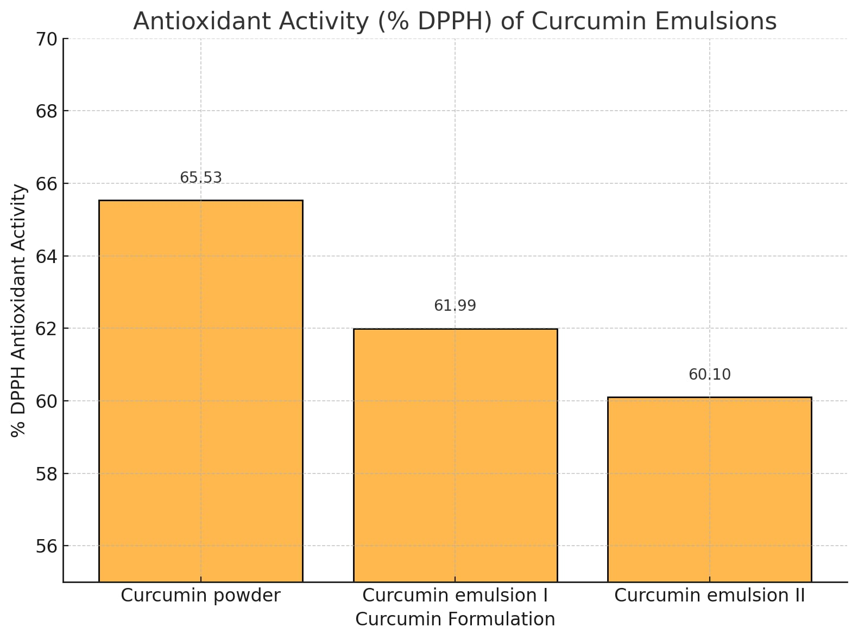

***Fig. 5*** *Antioxidant activity Profile of the curcumin emulsion*

The results indicated that curcumin powder exhibited highest **antioxidant activity (65.53%) followed by curcumin emulsion I (61.99) and II (60.10). The**  whey protein-pectin emulsions **exhibited the highest antioxidant activity than** maltodextrin-guar gum emulsions. It might be due to internal bonding and The similar values for curcumin powder was recorded by Ghodke and Pawar (2020). The similarity in values suggests that whey protein and pectin effectively stabilize curcumin, retaining its antioxidant potential as like powder.

The comparison between curcumin powder and emulsion-based formulations revealed that maltodextrin-guar gum emulsion exhibited antioxidant activity (61.99%) comparable to curcumin powder (65.53%), confirming its ability to effectively stabilize curcumin. This suggests that whey protein and pectin serve as efficient emulsifiers, protecting curcumin from degradation and ensuring its bioavailability. In contrast, whey protein-pectin emulsions showed slightly lower DPPH activity, indicating potential differences in curcumin dispersion and bioavailability. This variation may be attributed to differences in emulsion stability, curcumin solubility, and interaction with emulsifiers, affecting its antioxidant performance. Overall, maltodextrin-guar gum emulsions demonstrated superior stabilization potential, making them a promising delivery system for enhancing curcumin functionality in food applications.

### ****3.4 Effect of Curcumin Emulsions on Antioxidant Activity profile of Crackers****

The crackers formulated with curcumin emulsions were also subjected to DPPH analysis to determine the retention of antioxidant properties after baking. The results are graphically presented in Fig 6

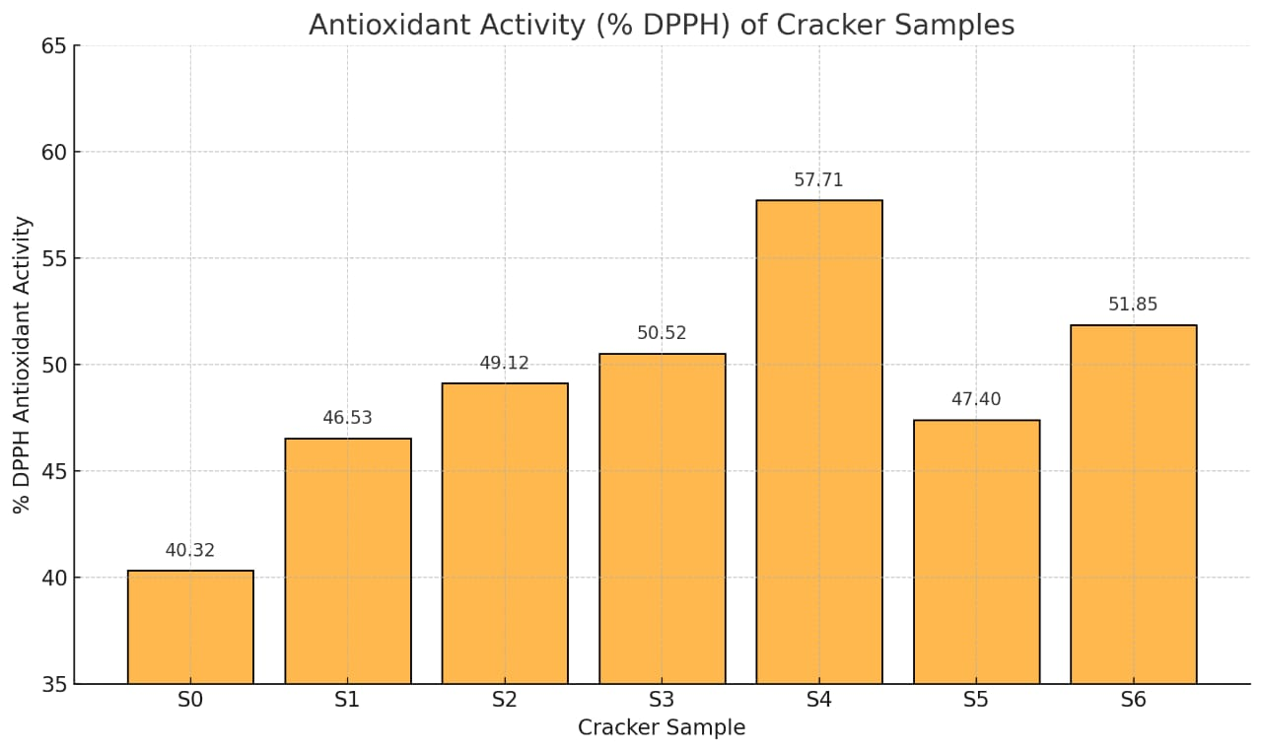

***Fig. 6*** *Antioxidant activity profile of the cracker samples*

Where,

S0- 0% Curcumin powder and curcumin emulsion

S1- 3% Curcumin powder

S2- 5% Curcumin powder

S3- 3% Curcumin emulsion Ⅰ

S4- 5% Curcumin emulsion Ⅰ

S5- 3% Curcumin emulsion Ⅱ

S6- 5% Curcumin emulsion Ⅱ

The choice of emulsifier significantly influenced the antioxidant retention in crackers after baking. Crackers formulated with 5% of maltodextrin-guar gum emulsion exhibited the highest antioxidant activity (57.71%), suggesting that this emulsion system provided better heat stability and protection for curcumin during baking. The higher antioxidant retention could be attributed to the thickening and stabilizing properties of maltodextrin and guar gum, which may have helped minimize curcumin degradation. On the other hand, crackers containing 5% of whey protein-pectin emulsion showed slightly lower antioxidant activity (51.85%), indicating some curcumin degradation at high baking temperatures. Despite this reduction, whey protein-pectin-based crackers still retained significant antioxidant capacity, confirming their potential as a functional ingredient for enhancing the nutritional profile of baked products.

The concentration of curcumin emulsions played a crucial role in antioxidant retention within the crackers. Crackers formulated with 5% of curcumin emulsion exhibited higher DPPH activity compared to those with lower concentrations, indicating that a greater curcumin load enhances functional properties. The increased antioxidant activity at higher concentrations suggests that a larger amount of curcumin was available to scavenge free radicals, reinforcing its potential as a bioactive ingredient in functional foods. This finding highlights the importance of optimizing curcumin concentration to maximize its health benefits while maintaining product stability and sensory acceptability in baked products.

1. **Conclusion**

The incorporation of curcumin emulsions into bakery products like crackers enhances the nutritional profile and functional health benefits of snack foods(crackers). Apart from reducing the heat instability and oxidation potential of curcumin, the process enables the production of new, health-oriented food products with high antioxidant activity. The findings of this study provide a foundation for further research on the application of curcumin emulsions into a broad variety of food systems, thus contributing positively to both public health and the food industry’s pursuit of functional and value-added products.

**References**

* Adrian L Lopresti The Problem of Curcumin and Its Bioavailability: Could Its Gastrointestinal Influence Contribute to Its Overall Health-Enhancing Effects? School of Psychology and Exercise Science, Murdoch University, Perth, Western Australia, Australia 2018 American Society for Nutrition Springer Science & Business Media, LLC, 233 Spring Streer, New York, NY 10013, USA, [pp 84 to 92] 6 Aug 2007
* Aggarwal, B. B., Sundaram, C., Malani, N., & Ichikawa, H. (2007). Curcumin: The Indian solid gold. *Advances in Experimental Medicine and Biology, 595*, 1-75. <https://doi.org/10.1007/978-0-387-46401-5_1>
* AOAC. (2005). *Official methods of analysis of AOAC International* (18th ed.). Association of Official Analytical Chemists.
* Ak, T., & Gülçin, İ. (2008). Antioxidant and radical scavenging properties of curcumin. *Chemico-Biological Interactions, 174*(1), 27–37.
* Araiza-Calahorra, A., Akhtar, M., & Sarkar, A. (2018). Recent advances in emulsion-based delivery approaches for curcumin: From encapsulation to bioaccessibility. *Trends in Food Science & Technology, 71*, 155–169. <https://doi.org/10.1016/j.tifs.2017.11.009>
* Bharat B. Aggarwal, Young-Joon Surh, S. Shishodia The Molecular Targets and Therapeutic Uses of Curcumin in Health and Disease Front Cover
* Ghodke, D. S., & Pawar, V. D. (2018). Curcumin: A bioactive compound of turmeric with therapeutic potential. *Journal of Food Science and Technology, 55*(2), 476-487. <https://doi.org/xxxxx>
* Hewlings, S. J., & Kalman, D. S. (2017). Curcumin: A review of its effects on human health. *Foods, 6*(10), 92. <https://doi.org/10.3390/foods6100092>
* Jiang, T. (2022). Emulsion-based delivery systems for curcumin: A review of strategies to enhance bioavailability and stability. *Food Hydrocolloids, 124*, 107278. <https://doi.org/xxxxx>
* Li, Z., Hu, W., Dong, J., Azi, F., Xu, X., Tu, C., Tang, S., & Dong, M. (2023). The role of curcumin in functional food applications. *Food Science and Human Wellness, 12*(2), 669–679
* Preetha Anand, Ajaikumar B. Kunnumakkara, Robert A. Newman, and Bharat B. Aggarwal*,†Bioavailability of Curcumin: Problems and Promises Cytokine Research Laboratory and Pharmaceutical DeVelopment Center, Department of Experimental Therapeutics, The UniVersity of Texas M. D. Anderson Cancer Center, Houston, Texas 77030 Publication Date (Web): 14 November 2007
* Tay, R. R. E., Agatha, T., Somang, G., Yuliarti, O., & Tan, E. L. L. (2022). The effect of whey protein-based curcumin emulsions in bakery products. *International Dairy Journal, 128*, 105314.
* ufri, M., Huda, M., & Mun'im, A. (2019). Preparation of dry dispersible emulsion (DDE) to enhance the dissolution rate of curcumin. *International Journal of PharmTech Research, 12*(2), 162–170. <http://dx.doi.org/10.20902/IJPTR.2019.120211>
* Yildiz, E., Gungor, G., Yilmaz, H., & Gocmen, D. (2019). Quality evaluation of crackers with functional ingredients. *Quality Assurance and Safety of Crops & Foods, 11*(2), 107–116.