Original Research Article
Precision Agriculture for Sustainable Development: Environmental Gains in Brazilian Soybean Production

ABSTRACT

Aims: As a global leader in soybean production, Brazil faces intensifying environmental challenges driven by conventional agricultural practices. This underscores the need for sustainable intensification strategies.
Study design: This study employed Life Cycle Assessment to compare the environmental performance of soybean cultivation under precision agriculture (PA)-based fertility management with conventional systems.
Place and Duration of Study: Conducted in Mato Grosso do Sul over a five-year period (2019–2023).
Methodology: The analysis used a cradle-to-farm gate approach, with 1 kg of soybean grain as the functional unit. Primary data were collected from a commercial farm utilizing PA, while benchmark data from Embrapa represented the conventional system. Environmental impacts were assessed in four categories: global warming potential (GWP), acidification potential (AP), eutrophication potential (EP), and human toxicity potential (HTP). Monte Carlo simulations and sensitivity analyses ensured result robustness.
Results: PA significantly reduced environmental impacts: −60.84% (EP), −31.79% (AP), −28.65% (GWP), and −19.54% (HTP). The planting and fertilization stages were the primary contributors to overall impacts.
Conclusion: The findings highlight PA as a promising strategy for sustainable intensification, improving environmental outcomes and resource efficiency. This evidence supports climate-smart agricultural policies and underscores LCA's value in evaluating crop production sustainability.

Keywords: Precision Agriculture, Life Cycle Assessment, Sustainability, Fertility Management, Soybean Production.

1 INTRODUCTION

Soybean plays a pivotal role in addressing the rising global demand for food, with the world population projected to reach 9.7 billion by 2050 (OECD/FAO, 2024). As one of the leading global soybean producers, Brazil benefits from favorable climatic conditions, abundant water resources, and extensive arable land, positioning the country as a strategic contributor to future global food security (Sader & Engelke, 2024). In 2024 alone, Brazil produced approximately 168 million metric tons of soybeans across more than 47 million hectares in diverse biomes, including the Pampa, Atlantic Forest, Cerrado, and Amazon (CONAB, 2025).
Although deforestation linked to agricultural expansion has declined in key biomes, due to a combination of regulatory policies and private sector commitments (INPE, 2023), pressure on natural ecosystems remains high, underscoring the urgent need for sustainable intensification.
Among the strategies gaining prominence, Precision Agriculture (PA) has emerged as a promising approach to enhance resource use efficiency and reduce the environmental footprint of crop production. Studies across various agricultural systems consistently show that PA technologies can significantly reduce greenhouse gas emissions, acidification, and eutrophication potentials, while optimizing resource use (Jensen et al., 2012; Gasso et al., 2014; Balafoutis et al., 2017; Hedayati et al., 2019). These environmental benefits, along with productivity and labor efficiency gains, highlight PA’s relevance for sustainable intensification, particularly in large-scale soybean production systems (Bottega et al., 2017; Topa et al., 2025).
Despite its potential, PA adoption in Brazil remains limited. According to a recent McKinsey & Company study (2024), only 50–55% of producers currently employ PA techniques, and just 40–45% own the necessary equipment. This indicates a substantial gap between technological availability and on-farm implementation (Molin, 201). Barriers include high initial investment costs, the need for specialized technical knowledge, and a perceived lack of quantifiable environmental benefits (Pereira & Braga, 2018; Kang et al., 2019; Inácio et al., 2021). This study seeks to address these knowledge gaps by providing robust, quantitative evidence of PA's environmental advantages to support broader adoption and policy initiatives (Fartek et al, 2016; Kumar et al., 2018).
Similar adoption barriers exist globally, often stemming from limited awareness of PA's environmental and economic benefits, along with restricted access to financing and technical training (Gonzales-Gemio & Sanz-Martín, 2025; Pereira & Braga, 2018).
PA enables site-specific crop management by integrating tools such as GPS, sensors, software, and variable-rate applicators (Kumar et al., 2018; Lima et al., 2019). These technologies facilitate more precise input use, especially for fertility management, which has been shown to reduce greenhouse gas emissions from agriculture by 10–28% compared to conventional practices (Mgendi, 2024; Getahun et al., 2024; Petrovic & Csambalik, 2025). Beyond yield optimization, PA can deliver co-benefits such as enhanced labor efficiency, biodiversity conservation, and improved socioeconomic outcomes for smallholder farmers (FAO, 2017c; Makate et al., 2019; Getahun et al., 2024; Xu et al., 2024).
Assessing the environmental performance of such innovations requires comprehensive analytical tools. Life Cycle Assessment (LCA) is a robust methodology that quantifies environmental impacts across all stages of a product's life cycle, from resource extraction to the farm gate, enabling the identification of best practices for low-impact agricultural production (ISO 14040, 2006; Nemecek et al., 2015).
This study addresses a critical knowledge gap by evaluating the environmental performance of PA-based fertility management in soybean production. Using four key impact categories, global warming potential (GWP), acidification potential (AP), eutrophication potential (EP), and human toxicity potential (HTP), the study compares PA with conventional practices and examines the contribution of each operational stage. The findings aim to inform policy development and support sustainable intensification strategies at the farm level.

2 MATERIALS AND METHODS
This study assessed the environmental impacts of soybean production systems using either conventional practices or PA-based fertility management. A Life Cycle Impact Assessment (LCIA) was performed in accordance with ISO 14040 and ISO 14044 standards.

2.1 Study Area

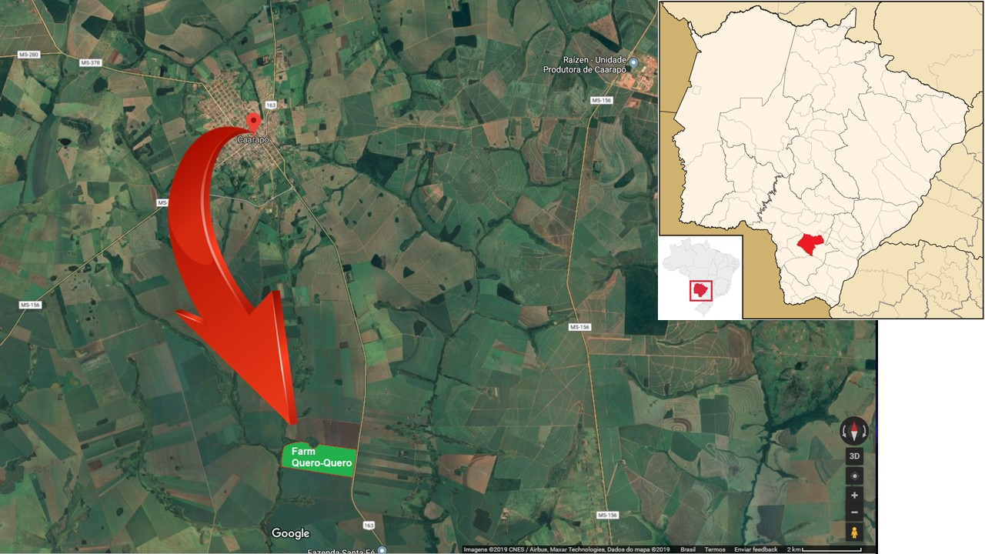
The analysis was conducted using data from a commercial farm located in Caarapó, Mato Grosso do Sul, Brazil (22°44′1.14″S, 54°47′52.26″W) (Figure 1). The farm operates under a no-tillage, rainfed soybean–maize rotation system across 218.02 hectares of Oxisol soil, with an average annual precipitation of 1,547 mm. Precision Agriculture (PA) practices were implemented over a five-year period (2019–2023), with technical support provided by Aggis Integrated Technologies.

Figure 1. Delimitation of the area destined to the cultivation of transgenic soybean using the precision system. Satellite image showing the boundaries of the field.
Source: courtesy of Agges Integrated solution Company (2024).

To operationalize the PA management approach, the farm was subdivided into two fields: T01 (126.98 ha) and T02 (91.04 ha), where PA technologies were adopted in 2018 and 2019, respectively (Figure 1). The PA system integrates auto-guidance technology, variable-rate fertilizer applicators, and soil sensors. Annual geo-referenced soil sampling in 5-hectare grids, comprising 20 to 24 sampling points per field, supports site-specific recommendations for lime and nutrient application via specialized software tools.

2.2 Precision Agriculture

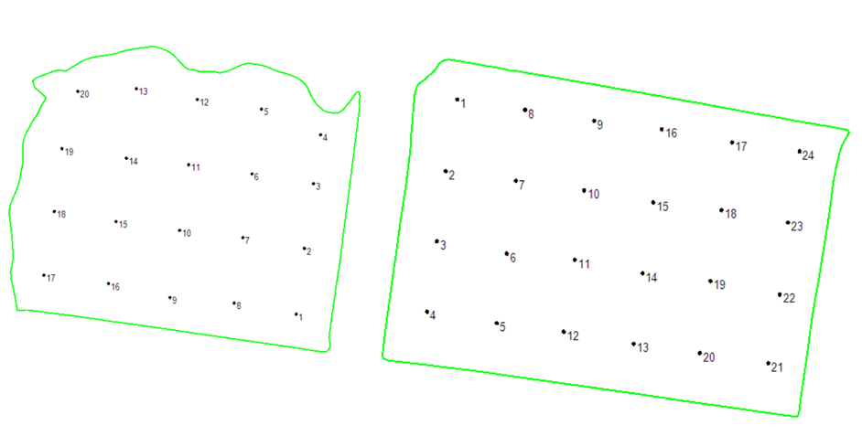
To evaluate fertility requirements and manage nutrient use over time, both fields were subdivided into geo-referenced 5-hectare grids, with 24 sampling points in T01 and 20 in T02 (Figure 2).
T 01
T 02

Figure 2: Geo-referenced Grid and Spatial Distribution of Soil Sampling Points.

Nutrient recommendations adhered to PA guidelines from key Brazilian institutions: the Precision Agriculture Laboratory (LAP) at the University of São Paulo (Colaço & Molin, 2015), EMBRAPA (Broch & Ranno, 2012), and the Ministry of Agriculture (MAPA, 2013).
Soil fertility mapping influences both fertilizer rates and fuel consumption throughout production (Balafoutis et al., 2017; Getahun et al., 2024; Mgendi, 2024; Vullaganti et al., 2025). Thus, the environmental contribution of each operational stage was included in the LCA.

2.3 Conventional Practices

The conventional system was based on data from an EMBRAPA study conducted in Mato Grosso do Sul between 2016 and 2020. This dataset, which does not incorporate PA technologies, reports an average soybean yield of 3,000 kg ha⁻¹ and includes input data for seeds, mineral fertilizers, and pesticides. To enable a fair comparison, the life cycle inventory was adjusted to ensure system equivalence in the comparative analysis.

Figure 3. System Boundaries of Soybean Production from Cradle to Farm Gate.
Note: Diagram of life cycle stages included in the LCA, covering all agricultural inputs, operations, and machinery, excluding grain drying

2.4 Scope

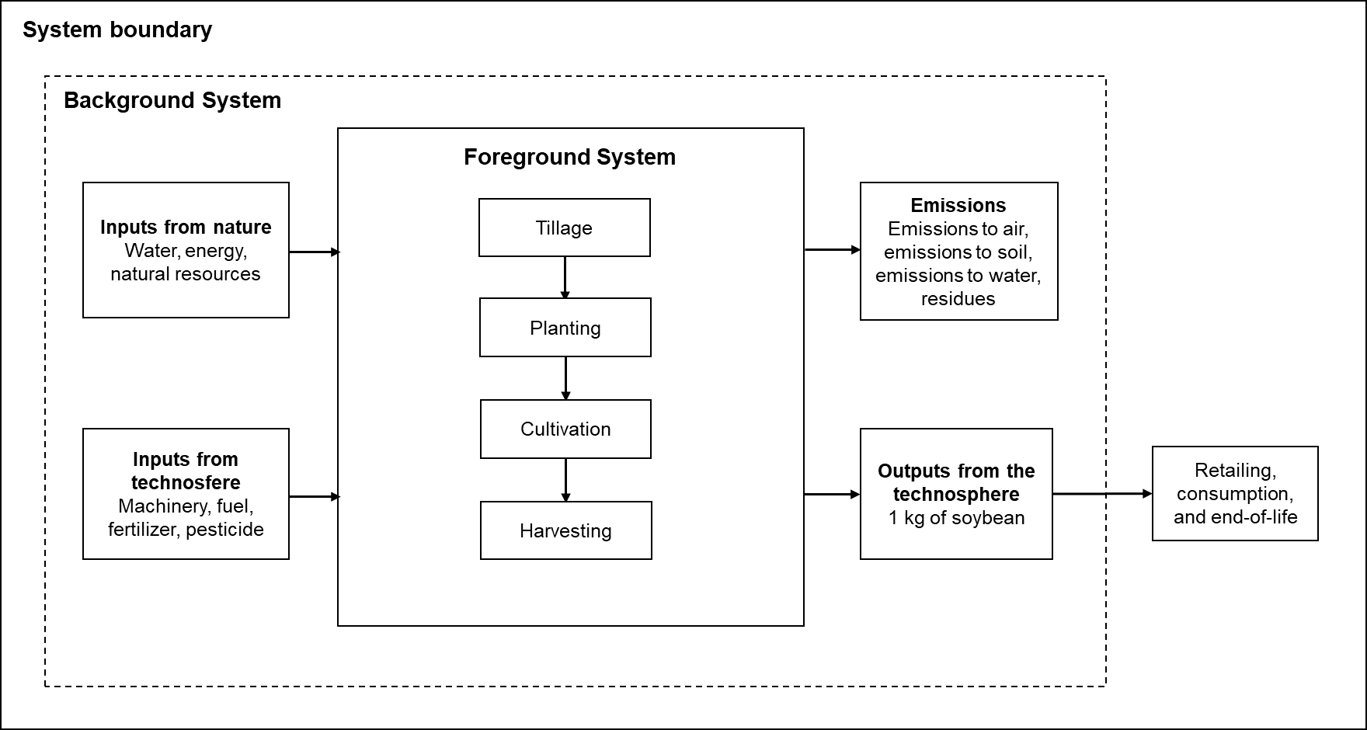
The system boundaries (Figure 3) were defined from cradle to farm gate, encompassing indirect emissions associated with farm inputs, including fertilizers, pesticides, seeds, machinery, fuel, and infrastructure. Grain drying was excluded from the analysis. The functional unit (FU) was defined as 1 kilogram of soybean grain with 13% moisture content at post-harvest.
.

2.5 Life Cycle Inventory

Data for the PA system was obtained through direct cooperation with the farm (field-level nutrient inputs) and from EMBRAPA sources (chemical input data). The life cycle inventory (LCI) includes all foreground input and output data (Table 1) and direct field emissions were estimated using IPCC (2006, Tier 1) emission factors. It was assumed that 1% of the applied nitrogen is emitted as N₂O-N, in addition to volatilization and leaching estimates based on standard methodologies. This allowed for a more realistic assessment of the additional impact on GWP. This approach aligns with streamlined LCA practices in agricultural settings, where comparative attributional assessments emphasize foreground process data and upstream input manufacturing impacts (ISO 14044, 2006; Nemecek et al., 2015). By standardizing emission assumptions across both systems, the analysis maintains methodological consistency and highlights the environmental benefits attributable to site-specific fertility management under PA.
For the conventional system, the LCI was based on Ecoinvent data calibrated by Brazilian Agricultural Research Corporation (EMBRAPA) and aligned with methodological guidelines from Agroscope (Nemecek & Schnetzer, 2012; Nemecek et al., 2015).
Pesticide use was standardized across both systems to isolate the environmental effects of fertility management. Lime and gypsum application rates were adjusted annually according to crop requirements. Phosphorus (monoammonium phosphate) and potassium (potassium chloride) applications followed crop-specific recommendations. Although seed and micronutrient inputs were higher per hectare under the PA system, their relative environmental impact was lower when normalized per unit of output.

Table 1. Comparative Input and Output Data per Hectare for Precision and Conventional Systems.
Parameter | Input/Output ha⁻¹ | Unit | PA | Conventional | Source  (PA)
Tillage | Lime (CaCO₃) | kg | 84,67 | 130,00 | measured
Tillage | Gypsum (CaSO₄) | kg | 100,00 | 130,00 | measured
Tillage | 2,4 D | kg a.i. | 0,90 | 0,00 | measured
Tillage | Glyphosate | kg a.i. | 0,80 | 0,80 | Folegatti-Matsuura et al., 2018
Tillage | Paraquat | kg a.i. | 0,40 | 0,40 | Folegatti-Matsuura et al., 2018
Tillage | Fuel | l | 3,15 | - | measured
Planting | P₂O₅ | kg | 51,88 | 70,00 | measured
Planting | Seed | kg | 55,00 | 50,00 | measured
Planting | Fuel | l | 5,89 | - | measured
Cultivation | K₂O | kg | 51,88 | 70,00 | measured
Cultivation | Molybdenum | kg | 0,025 | 0,020 | measured
Cultivation | Cobalt | kg | 0,0050 | 0,0025 | measured
Cultivation | Copper | kg | 0,03 | 0,02 | measured
Cultivation | Carbendazim | kg a.i. | 0,501 | 0,501 | Folegatti-Matsuura et al., 2018
Cultivation | Azoxystrobin | kg a.i. | 0,12 | 0,12 | Folegatti-Matsuura et al., 2018
Cultivation | Thiamethoxam | kg a.i. | 0,0333 | 0,0333 | Folegatti-Matsuura et al., 2018
Cultivation | Lambda-cyhalothrin | kg a.i. | 0,0125 | 0,0125 | Folegatti-Matsuura et al., 2018
Cultivation | Cyproconazole | kg a.i. | 0,048 | 0,048 | Folegatti-Matsuura et al., 2018
Cultivation | Mineral oil | kg a.i. | 0,642 | 0,642 | Folegatti-Matsuura et al., 2018
Cultivation | Fipronil | kg a.i. | 0,03 | 0,03 | Folegatti-Matsuura et al., 2018
Cultivation | Pyraclostrobin (prop) | kg a.i. | 0,003 | 0,003 | Folegatti-Matsuura et al., 2018
Cultivation | Thiophanat-methyl | kg a.i. | 0,027 | 0,027 | Folegatti-Matsuura et al., 2018
Cultivation | Thiodicarb | kg a.i. | 0,096 | 0,096 | Folegatti-Matsuura et al., 2018
Cultivation | Chlorimuron-ethyl | kg a.i. | 0,025 | 0,025 | Folegatti-Matsuura et al., 2018
Cultivation | Bifenthrin | kg a.i. | 0,020 | 0,020 | Folegatti-Matsuura et al., 2018
Cultivation | Imidacloprid | kg a.i. | 0,0999 | 0,0999 | Folegatti-Matsuura et al., 2018
Cultivation | Glyphosate | kg a.i. | 2,16 | 2,16 | Folegatti-Matsuura et al., 2018
Cultivation | Paraquat | kg a.i. | 0,30 | 0,30 | Folegatti-Matsuura et al., 2018
Cultivation | Fuel | l | 3,25 | - | measured
Harvesting | Grain production | kg | 3780,00 | 3000,00 | measured
Harvesting | Fuel | l | 3,00 | - | measured
Note: Comparative data on fertilizer, pesticide, seed, and fuel use in both systems, based on primary field data (PA) and secondary data from EMBRAPA (conventional system).

Fuel consumption per hectare was reportedly lower in the PA system compared to the conventional system, primarily due to the use of auto-guidance technology, which reduces overlapping passes and optimizes field traffic patterns. Although the conventional system lacks this operational efficiency, the observed reduction in fuel use under PA is supported both by farmer reports and by findings in the literature (Gasso et al., 2014b; Li et al., 2016; Balafoutis et al., 2017; Petrovic & Csambalik, 2025; Jensen & Tullberg, 2025).

2.6 Life Cycle Impact Assessment

The environmental impact assessment was performed using the CML-IA baseline 2000 method (version 3.2) implemented in SimaPro 9.2 software (Pré Consultants). The impact categories analyzed included EP, GWP, HTP, and AP. All impacts were calculated per kilogram of soybean grain, standardized at 13% post-harvest moisture content.
Temporal variation over the five-year period was analyzed using Monte Carlo simulation techniques. A total of 10,000 iterations were conducted to estimate empirical distributions for the environmental impact indicators (AP, EP, GWP, HTP), based on the means and standard deviations observed in the study years. The analysis was implemented in R software (v4.3) using tidyverse, EnvStats, and mc2d packages. Results are reported as means with 95% confidence intervals (2.5th and 97.5th percentiles).

3 RESULTS AND DISCUSSION

The PA system required fewer inputs than conventional methods, leading to lower environmental impacts across all categories analyzed (Table 2). These results demonstrate how optimized fertilizer application through precision fertility management can effectively reduce environmental burdens and contribute to more sustainable farming practices.

Table 2. Life Cycle Environmental Impact Indicators per Kilogram of Soybean Grain under Conventional and Precision Agriculture Systems.
Impact Category | Unit | Conventional (avegare [CI 95%]) | PA (average [CI 95%]) | Reduction (%)
Acidificação (AP) | kg SO₂ eq | 0,00151 [0,00147–0,00155] | 0,00103 [0,00100–0,00107] | −31,79%
Eutrofização (EP) | kg PO₄ eq | 0,00549 [0,00534–0,00565] | 0,00215 [0,00208–0,00222] | −60,84%
Aquecimento Global (GWP) | kg CO₂ eq | 0,185 [0,181–0,189] | 0,132 [0,128–0,136] | −28,65%
Toxicidade Humana (HTP) | kg 1,4-DB eq | 0,0783 [0,0758–0,0807] | 0,0630 [0,0609–0,0651] | −19,54%
Note: Life Cycle Assessment results for four impact categories, normalized per 1 kg of soybean grain (13% moisture), considering cradle-to-farm-gate system boundaries.

The results, presented in Table 2, reflect the mean values estimated over the study period (2019–2023) and include 95% confidence intervals derived from Monte Carlo simulations with 10,000 iterations based on the annual variability of primary data (Figure 4).

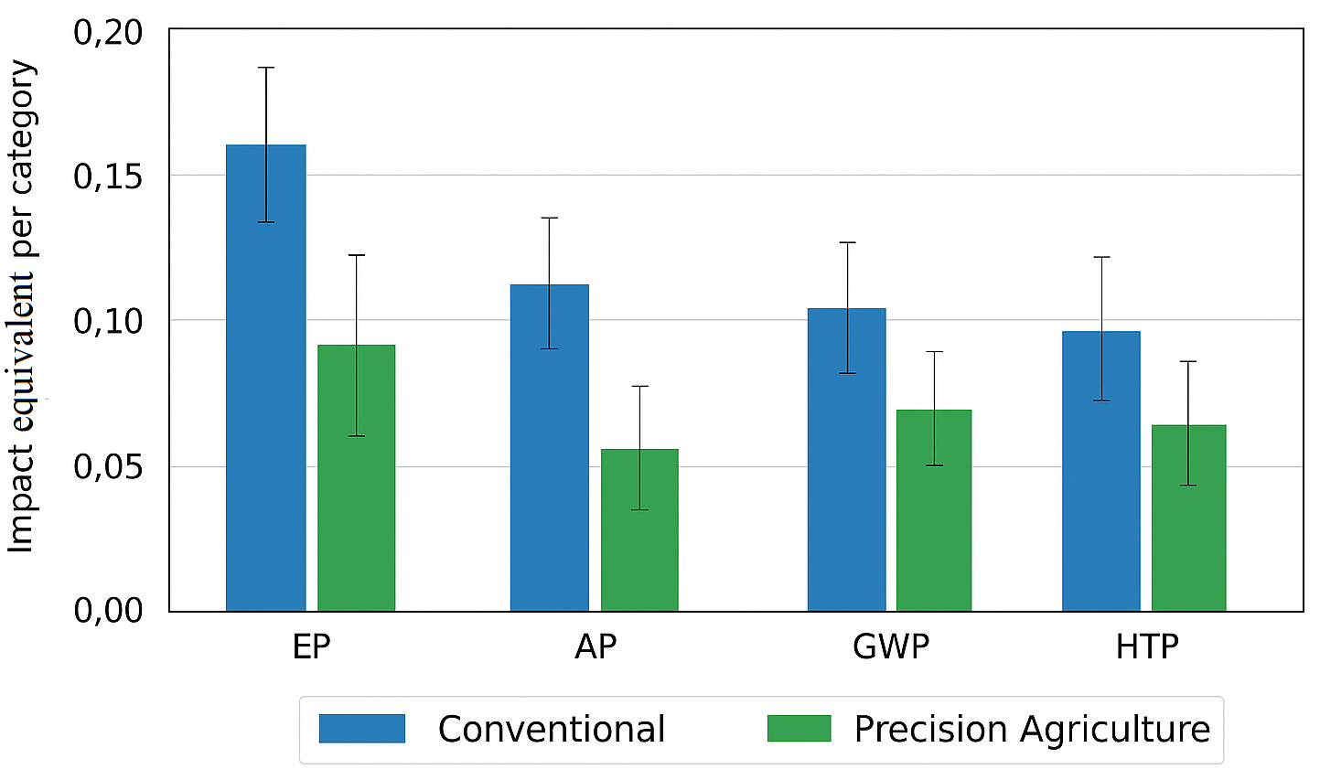
Figure 4. Confidence Intervals for Environmental Impacts from Monte Carlo Simulations (Soybean, 2019–2023).
Note: The confidence intervals are described in Table 2.

The LCA of soybean production under PA practices revealed reductions of 31.79% in AP, 60.84% in EP, 28.65% in GWP, and 19.54% in HTP. As illustrated in Figure 5, the greatest gains were observed in the eutrophication and global warming categories, underscoring the role of PA in optimizing fertilizer use and reducing fossil fuel consumption through technologies such as auto-guidance and prescription mapping. By enhancing the spatial precision of fertilizer application, PA effectively lowers environmental burdens and facilitates the transition to more sustainable agricultural systems (Jensen et al., 2012; Adewuyi et al., 2024; Galati et al., 2025).
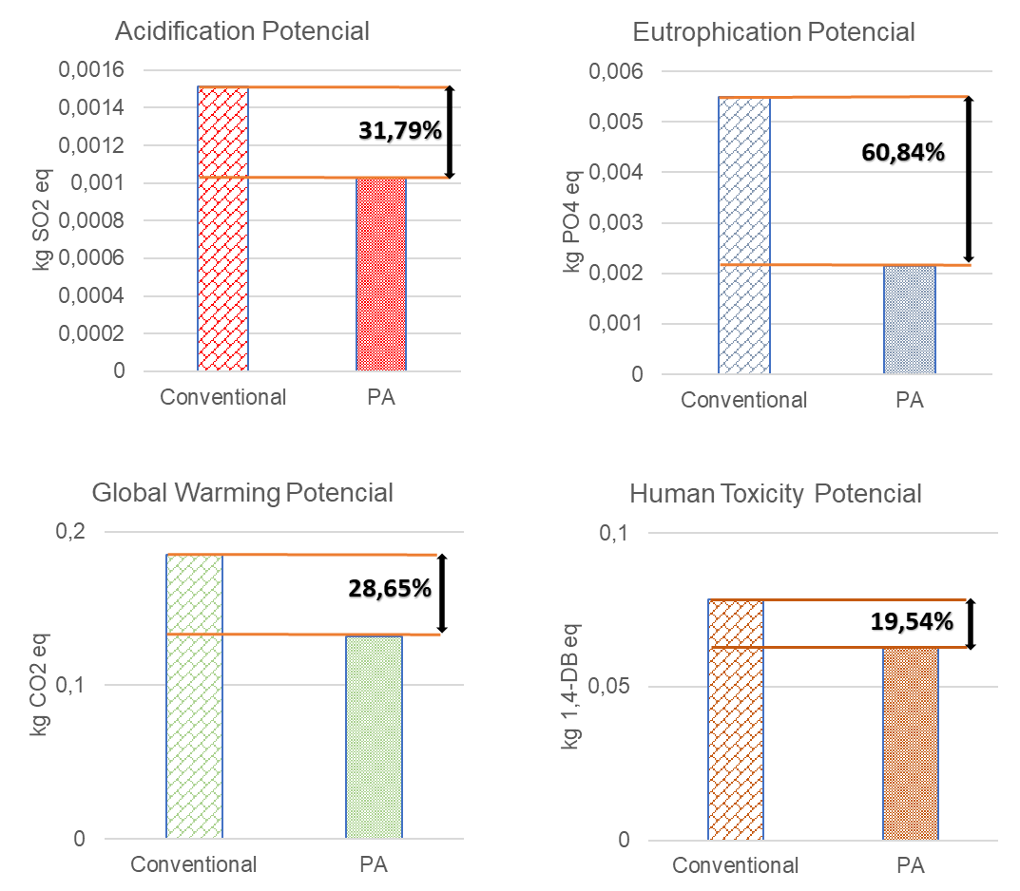

Figure 5. Percentage Reduction in Environmental Impact Categories from Conventional to Precision Agriculture (per 1 kg of Soybean).
Note: Comparative reduction in Acidification Potential, Eutrophication Potential, Global Warming Potential, and Human Toxicity Potential per kg of soybean under PA versus conventional practices.

The impact assessment findings of this study are consistent with results from other research employing LCA methodologies to evaluate the environmental effects of PA technologies across various cropping systems. For instance, Gasso et al. (2014) and Milindi et al. (2024) reported substantial reductions in wheat and sugarcane production using controlled traffic farming, including 50% in GWP, 33% AP, 29% in EP, and between 3% and 15% in HTP. In sugarcane systems, the adoption of controlled traffic farming enabled an additional harvest cycle and led to reductions of 0.86% in GWP and 8.99% in HTP compared to conventional practices (Chagas et al., 2012; Milindi et al., 2024; Papadopoulos et al., 2024). In maize production, nitrogen application guided by canopy sensors and variable-rate technology resulted in GWP, AP, and EP reductions of 10%, 22%, and 16%, respectively (Li et al., 2016; Medel-Jiménez et al., 2024; Chang et al., 2025). Similarly, in viticulture, the implementation of PA techniques, including site-specific fertility management, nitrogen application via remote sensing, and variable-rate irrigation, yielded GWP reductions of 25–28%, effectively lowering the carbon footprint of grape production (Balafoutis et al., 2017; Soto et al., 2019).
While the system-wide results presented in Table 2 clearly demonstrate that PA technologies reduce environmental impacts, a disaggregated LCA analysis offers deeper insights. By examining the individual contributions of each operational stage, it becomes possible to identify targeted opportunities for further improvement. In both systems (Figure 6), the planting operation accounted for the largest share of impacts in the AP and GWP categories, 41.13% in the PA system and 49.18% in the conventional system. This predominance is primarily attributed to the environmental burden associated with seed production. Soybean seeds carry an embedded life cycle from prior cultivation stages, encompassing all related inputs and emissions, which are incorporated into the LCA (. This highlights the importance of considering the upstream impacts of seed production in agricultural LCAs and suggests that future research or sustainability efforts could focus on developing lower-impact seed production systems or alternative seed sources (Costantini & Bacenetti, 2021; Medel Jiménez et al., 2024).
Although the PA system involved a slightly higher seed input (Table 1), its 26% higher yield diluted this effect, resulting in a comparatively lower relative contribution of the planting stage. Specifically, the planting operation in the PA system exhibited approximately 13% lower environmental impact than in the conventional system.
Cultivation and harvesting stages represented substantial contributions to AP and Global GWP, driven by embodied energy in machinery manufacturing and fossil fuel consumption. The implementation of PA for fertility management resulted in estimated reductions of 10–20% in these impacts. These gains are attributed to optimized input-use efficiency, through site-specific application (GPS, sensors, variable-rate technology), and reduced field traffic and fuel consumption (Gasso et al., 2016; Li et al., 2016; Jensen & Tullberg, 2025), facilitated by auto-guidance technologies that minimize overlapping passes (Section 2.5). PA, therefore, demonstrates itself as an effective strategy for sustainable intensification, mitigating the environmental footprint and soil compaction (Kumar et al., 2018; Mgendi, 2024).
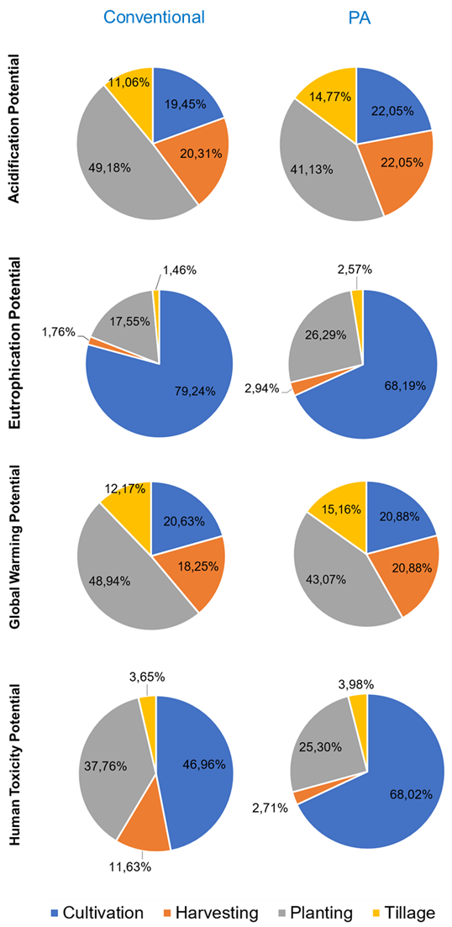

Figure 6. Relative Contribution of Production Stages to Environmental Impacts in Conventional and Precision Agriculture Systems.
Note: Share of environmental impacts attributed to each stage (tillage, planting, cultivation, harvesting), highlighting efficiency gains achieved through PA).

Given the widespread use of no-tillage systems in soybean production, tillage operations are no longer a dominant environmental hotspot (Telles et al., 2018; Possamai et al., 2022). Within the tillage stage, the most impactful processes were the application of plant protection products via field sprayers (accounting for 20–50% of the stage’s impacts) and fertilizer broadcasting (2–5%). PA technologies reduced these impacts by approximately 20% through more precise input targeting and application.
The cultivation stage had a particularly strong influence on EP and HTP, which is consistent with LCA expectations due to the intensive use of fertilizers and agrochemicals during this phase. In the PA system (Villagrán et al., 2024), reductions of approximately 10–20% were observed across key unit processes. This highlights how improvements in a single production stage can have cascading benefits throughout the agricultural value chain (Plouffe et al., 2011; Talaviya et al., 2020; Monteiro et al., 2021; Sanyaolu & Sadowski, 2024). The main driver of these impacts during the cultivation stage is the interaction between applied nutrients, heavy metals, and pesticides with soil and water systems (Nemecek et al., 2015; Balafoutis et al., 2017; Avellaneda-Torres et al., 2022).

3.1 Sensitivity Analysis

The sensitivity analysis showed that eutrophication potential was most affected by variations in phosphorus and potassium rates, while GWP was primarily influenced by diesel use. Simulated variations of ±20% confirmed the robustness of PA’s benefits, with comparative impact differences remaining under 10%. Even with increased direct emissions from nitrogen fertilizers, PA maintained about 25% lower total GWP per kilogram of soybean.

3.2 Complementary Statistical Analysis: Simulation and Comparative Inference

To reinforce the robustness of the LCA results and incorporate variability associated with fertilizer use, we conducted a Monte Carlo simulation with 10,000 iterations for the global warming potential (GWP, kg CO₂ eq per kg of soybean), based on the observed means and standard deviations for both the conventional and PA systems.
In addition, we tested the sensitivity of the PA system to a simulated 20% increase in nitrogen application, following scenario analysis guidelines (Figure 7). The parameters used were as follows: GWP (Conventional): mean = 0.185 kg CO₂ eq, standard deviation = 0.004; GWP (PA): mean = 0.132 kg CO₂ eq, standard deviation = 0.004, and GWP (PA +20% N): adjusted mean = 0.145 kg CO₂ eq, standard deviation = 0.0044. We simulated three normal distributions and compared the scenarios using statistical tests: Welch’s t-test for unequal variances; Mann-Whitney U test (non-parametric) and Kolmogorov-Smirnov test for full distribution comparison.

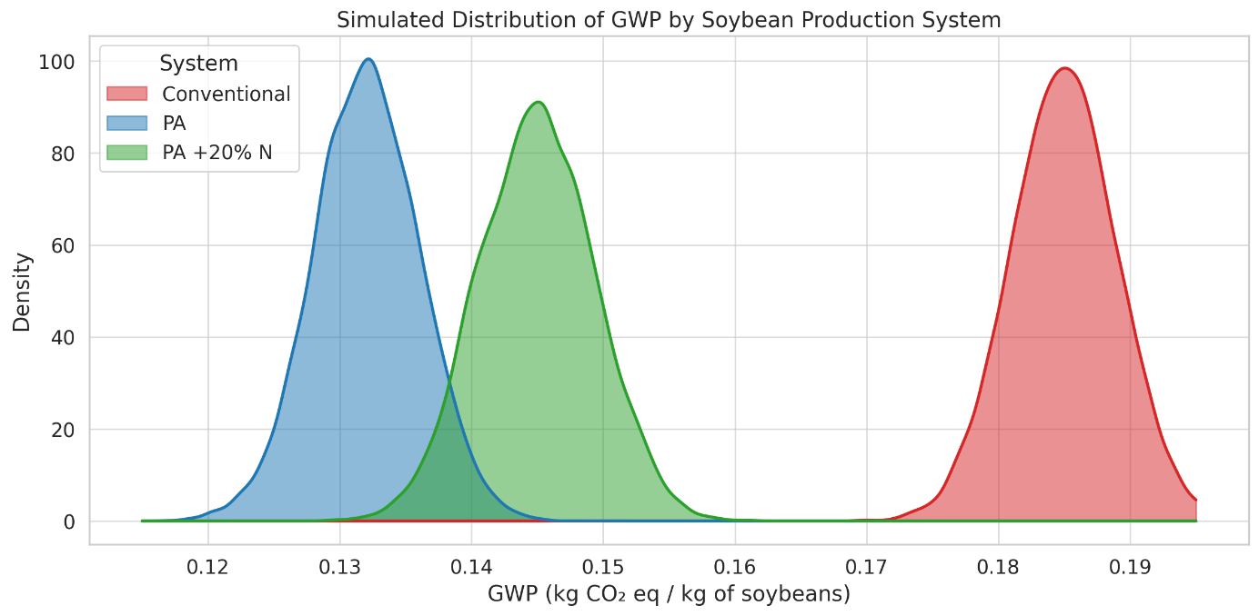
Figure 7. Probability Density Functions of Global Warming Potential for Soybean Production Systems under Conventional and Precision Agriculture Scenarios

The results revealed statistically significant differences (p < 0.001) between the conventional and PA systems, as well as between PA and PA with +20% N, across all comparisons. This confirms the environmental robustness of the PA system even under increased nitrogen input scenarios.
Furthermore, visualizations of the simulated distributions (density plots) showed that the PA system not only achieved a lower mean impact but also exhibited reduced variability, further reinforcing its environmental viability.

3.3 Operational Implications and Policy Relevance

Analyzing environmental impacts by stage highlights planting and cultivation as key contributors. PA technologies reduced these impacts through targeted input applications based on spatial fertility data. Despite a slight increase in seed use, higher yields under PA ensured superior environmental performance.
These quantitative findings support policies to scale PA adoption in Brazil, where usage remains limited. Besides environmental benefits, input optimization can enhance economic performance and agricultural competitiveness.

3.4 Limitations and Extrapolation of Findings
Although this study provides compelling evidence of the environmental benefits of PA for site-specific fertility management in soybean systems, some limitations should be acknowledged regarding the extrapolation of these results to other agricultural contexts.
The study was conducted on a commercial farm in Caarapó, Mato Grosso do Sul, characterized by high-clay Oxisol soils, a soybean–maize crop rotation, and no-tillage practices. These edaphoclimatic conditions, along with annual precipitation levels and farm-level management strategies, can influence the effectiveness of PA technologies. As such, the environmental performance gains observed here may not be fully replicable in regions with different soil textures (e.g., sandy soils with lower nutrient retention), water constraints, or in agroecosystems subject to greater climatic variability.
Moreover, the studied farm benefits from high mechanization levels and access to technical support, which may not reflect the realities of small- and medium-sized farms, where capital and digital infrastructure are often more limited. These structural differences may affect both the adoption and the effectiveness of PA practices.
It is also important to note that this study focused exclusively on fertility management. Other components of crop production, such as pest management, irrigation, or harvesting logistics, also contribute substantially to environmental impacts and may interact with PA tools in complex ways.
Finally, the quasi-experimental design, while reinforced by five years of primary data and Monte Carlo simulations, does not include spatial replications across multiple farms or biomes. Thus, generalizations to other Brazilian regions, such as the Amazon, Caatinga, or Pantanal, or to diversified farming systems (e.g., polycultures, agroforestry) should be approached with caution.

4 CONCLUSIONS

This study provides compelling evidence that Precision Agriculture technologies significantly enhance the environmental sustainability of soybean production systems. By improving fertility management through spatially explicit input use, PA reduced key environmental impacts, including global warming, eutrophication, acidification, and human toxicity potentials, compared to conventional practices. Estimates of direct emissions and the sensitivity analysis further reinforced the robustness of the findings. The results demonstrate that even under input variability scenarios, PA consistently outperforms conventional management in terms of environmental performance.
The consistent reductions across multiple impact categories reinforce PA's role as a viable strategy for sustainable intensification, especially in large-scale farming operations. Beyond environmental gains, the optimized use of inputs also implies potential economic efficiencies that could strengthen the business case for broader PA adoption in Brazil and beyond.
Importantly, PA should not be viewed in isolation but as part of a broader transition toward climate-smart and resource-efficient agriculture. The integration of PA with supportive policies, inclusive financing mechanisms, and capacity-building programs could accelerate its adoption and maximize its environmental and socio-economic benefits.
Future research should explore the long-term effects of PA adoption across different agroecosystems, and assess trade-offs related to energy use and system resilience. Moreover, investigating PA's impacts on biodiversity, soil health, and rural livelihoods would provide a more holistic understanding of its role in sustainable agriculture.
Ultimately, fostering a knowledge-based transition supported by empirical evidence, such as this study, can enable producers, policymakers, and stakeholders to align agricultural productivity with global sustainability goals.

COMPETING INTERESTS DISCLAIMER:
Authors have declared that they have no known competing financial interests OR non-financial interests OR personal relationships that could have appeared to influence the work reported in this paper.

5 REFERENCES
OECD/FAO (2024). OECD FAO agricultural outlook 2024–2033. DOI: 10.1787/4c5d2cfb-en
Sader V. & Engelke P. (2024). Brazil 2050: A vision for global food security. Atlantic Council.
Conab (2025). Acompanhamento da safra brasileira.
Instituto Nacional de Pesquisas Espaciais (INPE) (2023). Projeto de Monitoramento do Desmatamento na Amazônia Legal por Satélite (PRODES). Ministério da Ciência, Tecnologia e Inovações.
Jensen H.G. et al. (2012). Socioeconomic impact of widespread adoption of precision farming and controlled traffic systems in Denmark. Precision Agriculture, 13(6), 661–677. DOI: 10.1007/s11119-012-9276-3
Gasso V. et al. (2014). An environmental life cycle assessment of controlled traffic farming. Journal of Cleaner Production, 73, 175–182. DOI: 10.1016/j.jclepro.2014.03.040
Balafoutis A.T. et al. (2017). Life cycle assessment of two vineyards after the application of precision viticulture techniques: A case study. Sustainability, 9(11). DOI: 10.3390/su9111997
Hedayati M. et al. (2019). Farm level strategies to reduce the life cycle greenhouse gas emissions of cotton production: An Australian perspective. Journal of Cleaner Production, 212, 974–985. DOI: 10.1016/j.jclepro.2018.11.190
Bottega, E. L., de Queiroz, D. M., de Carvalho Pinto, F. A., Valente, D. S. M., & de Souza, C. M. A. (2017). Precision agriculture applied to soybean: Part III – Spatial and temporal variability of yield. Australian Journal of Crop Science, 11(7), 799–805. DOI: 10.21475/ajcs.17.11.07.pne383
Țopa D.C. et al. (2025). Sustainable practices for enhancing soil health and crop quality in modern agriculture: A review. Agriculture, 15(9), 998. DOI: 10.3390/agriculture15090998
McKinsey & Company (2024). Mente do agricultor. mente-do-agricultor.mckinsey.com
Molin J.P. (2017). Agricultura de precisão: números do mercado brasileiro. Agricultura de Precisão: boletim técnico, 3, 7.
Pereira Lavorato, M., & Braga, M. J. (2018). Risk and return of soybeans precision production: a case study in Mato Grosso do Sul state, Brazil1. Italian Review of Agricultural Economics (REA), 73(1), 27–36. DOI: 10.13128/REA-23577
Kang Y. & Özdoğan M. (2019). Field level crop yield mapping with Landsat using a hierarchical data assimilation approach. Remote Sensing of Environment, 228, 144–163. DOI: 10.1016/j.rse.2019.04.005
Inácio C.M., de Moura M.R., Silva A.R.C. da & Guimarães P.H.S. (2021). Barriers to the adoption of precision agriculture in Brazil. Revista de Economia e Sociologia Rural, 59(2), e224976. DOI: 10.5539/jas.v8n11p89
Fartek C.P., Schmidt L.M., Gröngröft A. & Don A. (2016). Precision farming enables climate smart agriculture: Case study for a barley field in NE Germany. Biofuels, Bioproducts and Biorefining, 10(3), 275–286. DOI: 10.1002/bbb.1623
Kumar V. et al. (2018). Can productivity and profitability be enhanced in intensively managed cereal systems while reducing the environmental footprint of production? Assessing sustainable intensification options in the breadbasket of India. Agriculture, Ecosystems & Environment, 252, 132–147. DOI: 10.1016/j.agee.2017.10.006
Gonzales Gemio C. & Sanz Martín L. (2025). Socioeconomic barriers to the adoption of carbon farming in Spain, Italy, Egypt, and Tunisia: An analysis based on the diffusion of innovations model. Journal of Cleaner Production, 498, 145155. DOI: 10.1016/j.jclepro.2025.145155
Lima M. et al. (2019). Demystifying sustainable soy in Brazil. Land Use Policy, 82, 349–352. DOI: 10.1016/j.landusepol.2018.12.016
Mgendi G. (2024). Unlocking the potential of precision agriculture for sustainable farming. Discover Agriculture, 2, 87. DOI: 10.1007/s44279-024-00078-3
Getahun S., Kefale H. & Gelaye Y. (2024). Application of precision agriculture technologies for sustainable crop production and environmental sustainability: A systematic review. The Scientific World Journal, 2024, 2126734. DOI: 10.1155/2024/2126734
Petrovic B. & Csambalik L. (2025). Enhancing precision agriculture for climate change mitigation in Visegrad countries: Factors shaping adaptation. Land, 14(2), 399. DOI: 10.3390/land14020399
FAO (2017c). Strategic work of FAO for inclusive and efficient food systems.
Makate C. et al. (2019). Increasing resilience of smallholder farmers to climate change through multiple adoption of proven climate smart agriculture innovations: Lessons from Southern Africa. Journal of Environmental Management, 231, 858–868. DOI: 10.1016/j.jenvman.2018.10.069
Xu Y., Li Y., Zhang M. & Zhang S. (2024). Sustainable agriculture in the digital era: Past, present, and future trends by bibliometric analysis. Heliyon, 10(14), e34612. DOI: 10.1016/j.heliyon.2024.e34612
International Organization for Standardization (2006). ISO 14040 – Environmental management – Life Cycle Assessment – Principles and framework.
Nemecek T. et al. (2015). World Food LCA Database – Methodological guidelines for the life cycle inventory of agricultural products. Version 3.0, p. 84.
International Organization for Standardization (2006). ISO 14044 – Environmental management – Life Cycle Assessment – Requirements and guidelines.
Colaço A.F. & Molin J.P. (2015). Amostragem georreferenciada. In Agricultura de precisão – Boletim Técnico 02 (p. 4).
Broch D.L. & Ranno S.K. (2012). Fertilidade do solo, adubação e nutrição da cultura da soja. In Tecnologia de produção de soja e milho 2008/2009 (pp. 240–252).
MAPA (2013). Agricultura de precisão.
Vullaganti N., Ram B.G. & Sun X. (2025). Precision agriculture technologies for soil site specific nutrient management: A comprehensive review. Artificial Intelligence in Agriculture, 15(2), 147–161. DOI: 10.1016/j.aiia.2025.02.001
Nemecek T. & Schnetzer J. (2012). Methods of assessment of direct field emissions for LCIs of agricultural production systems. Agroscope Reckenholz-Tänikon Research Station, 15, 34.
Folegatti-Matsuura, M. I. S.; Picoli, J. F.(2018). Life cycle inventories of agriculture, forestry and animal husbandry - Brazil. Jaguariúna: Embrapa Meio Ambiente.143 p.
Li A. et al. (2016). A case study of environmental benefits of sensor based nitrogen application in corn. Journal of Environmental Quality, 45(2), 675. DOI: 10.2134/jeq2015.07.0404
Jensen T.A., Antille D.L. & Tullberg J.N. (2025). Improving on farm energy use efficiency by optimizing machinery operations and management: A review. Agricultural Research, 14, 15–33. DOI: 10.1007/s40003-024-00824-5
Adewuyi A., Anyibama B., Adebayo K., Kalinzi J., Adeniyi S. & Wada I. (2024). Precision agriculture: Leveraging data science for sustainable farming. International Journal of Science and Research Archive, 12(2), 1122–1129. DOI: 10.30574/ijsra.2024.12.2.1371
Galati A., Sofia S. & Crescimanno M. (2025). Economics and barriers of precision viticulture technologies: A comprehensive systematic literature review. Information Processing in Agriculture. Advance online publication. DOI: 10.1016/j.inpa.2025.04.001
Milindi P.S., Nsenuka E.E. & Chopra S.S. (2024). Driving sustainability in the sugarcane industry: Life cycle assessment of conventional and emerging spraying technologies in Tanzania. Science of the Total Environment, 955, 176963. DOI: 10.1016/j.scitotenv.2024.176963
Papadopoulos G. et al. (2024). Economic and environmental benefits of digital agricultural technologies in crop production: A review. Smart Agricultural Technology, 8, 100441. DOI: 10.1016/j.atech.2024.100441
Medel Jiménez F., Krexner T., Gronauer A. & Kral I. (2024). Life cycle assessment of four different precision agriculture technologies and comparison with a conventional scheme. Journal of Cleaner Production, 434, 140198. DOI: 10.1016/j.jclepro.2023.140198
Chang W. et al. (2025). Yield increase and emission reduction effects of alfalfa in the Yellow River irrigation district of Gansu Province: The coupling mechanism of biodegradable mulch and controlled release nitrogen fertilizer. Plants, 14(13), 2022. DOI: 10.3390/plants14132022
Soto I. et al. (2019). The contribution of precision agriculture technologies to farm productivity and the mitigation of greenhouse gas emissions in the EU. EUR. Publications Office of the European Union, Luxembourg. DOI: 10.2760/016263
Costantini, M., & Bacenetti, J. (2021). Soybean and maize cultivation in South America: Environmental comparison of different cropping systems. Cleaner Environmental Systems, 2, 100017. DOI: 10.1016/j.cesys.2021.100017
Telles T.S., Reydon B.P. & Maia A.G. (2018). Effects of no tillage on agricultural land values in Brazil. Land Use Policy, 76, 124–129. DOI: 10.1016/j.landusepol.2018.04.053
Possamai E.J. et al. (2022). Adoption of the no tillage system in Paraná State: A (re)view. Revista Brasileira de Ciência do Solo, 46, e0210104. DOI: 10.36783/18069657rbcs20210104
Villagrán E. et al. (2024). Life cycle assessment in protected agriculture: Where are we now, and where should we go next? Horticulturae, 10(1), 15. DOI: 10.3390/horticulturae10010015
Plouffe S. et al. (2011). Economic benefits tied to ecodesign. Journal of Cleaner Production, 19, 573-579. DOI: 10.1016/j.jclepro.2010.12.003
Talaviya T. et al. (2020). Implementation of artificial intelligence in agriculture for optimisation of irrigation and application of pesticides and herbicides. Artificial Intelligence in Agriculture, 4, 58–73. DOI: 10.1016/j.aiia.2020.04.002
Monteiro A., Santos S. & Gonçalves P. (2021). Precision agriculture for crop and livestock farming – Brief review. Animals (Basel), 11(8), 2345. DOI: 10.3390/ani11082345
Sanyaolu M. & Sadowski A. (2024). The role of precision agriculture technologies in enhancing sustainable agriculture. Sustainability, 16(15), 6668. DOI: 10.3390/su16156668
Avellaneda Torres L.M., Núñez A.P.P., Pérez L.D.J. & Buitrago B.A. (2022). Heavy metals and pesticides in soils under different land use patterns in neotropical high Andean Páramos. Revista Brasileira de Ciência do Solo, 46, e0210135. DOI: 10.36783/18069657rbcs20210135

