**Review Article**

**Trade competitiveness and strategic imperatives for Indian sericulture in the global silk economy**

.

ABSTRACT

|  |
| --- |
| Silk retains global importance as a premium, eco-friendly fibre, with India positioned as the second-largest producer after China. This review examines India’s status within the global silk market, highlighting production and trade patterns, structural strengths, and competitiveness challenges. India’s sericulture sector, characterised by biodiversity and its role in rural livelihoods, faces limitations due to quality inconsistencies, outdated processing technologies, weak branding, and climate-related vulnerabilities. A comparative analysis with China reveals productivity and quality gaps that hinder India’s export competitiveness. However, opportunities exist in adopting advanced technologies, ensuring quality certification, integrating climate-resilient practices, and leveraging digital platforms for direct global market access. Aligning India’s sericulture with rising global demand for sustainable, traceable silk products, coupled with policy support and public-private partnerships, is essential for enhancing market positioning. Strategic interventions focusing on technological modernisation, premium branding, and sustainable practices can transform Indian sericulture into a globally competitive and resilient sector. Strengthening India’s role in the global silk value chain will support rural incomes while meeting international demand for high-quality silk, positioning India as a key player in sustainable silk production and trade. |

*Keywords: Global silk market, trade competitiveness, rural livelihoods, technological innovation, export potential*

1. NTRODUCTION

Silk has long held global prestige for its lustre, strength, and cultural significance, with trade in silk deeply rooted in the historic Silk Road. China pioneered sericulture and remains the leading producer, while India holds a significant position in the global silk market [1,2]. The Silk Road not only facilitated the trade of silk but also enabled the exchange of cultural and technological advancements between East and West [3,4]. Today, China maintains its leadership in production using advanced sericulture practices, while India, as the second-largest producer, offers diverse silk varieties such as Tussar and Muga [3,5]. Other countries, including Uzbekistan and Thailand, also contribute to the global silk supply, enhancing its diversity.

Recent production data reflect significant changes in the global silk landscape. Global raw silk production currently stands at approximately 91,221 metric tons annually, with China accounting for around 54.8% and India nearly 40.1% based on 2022 data [6]. India’s growth in the sector is evident, with raw silk production rising from 31,906 MT in 2017–18 to 38,913 MT in 2023–24, accompanied by improved export performance. Exports of silk and silk goods increased from ₹1,649.48 crores in 2017–18 to ₹2,027.56 crores in 2023–24, while India exported 3,348 MT of silk waste in 2023–24, indicating its growing share in global silk production [7].

Despite the dominance of synthetic fibres in the global textile industry, silk retains a niche due to its eco-friendly, biodegradable nature and premium standing in textiles, fashion, and technical applications [5,8]. In India, sericulture has historical roots dating back to the Indus Valley Civilization and remains a vital agro-based, labour-intensive rural industry, providing livelihoods to nearly nine million people, including a significant proportion of women and marginal farmers [5]. India is unique in producing all four commercially recognised silk varieties (mulberry, eri, tasar, and muga), with mulberry silk comprising over 70% of its output, thereby supporting rural incomes while preserving cultural heritage [9,10].

However, India faces challenges in establishing a strong competitive position within the global market. Inconsistent quality, inadequate post-cocoon infrastructure, limited adoption of advanced reeling and processing technologies, and weak branding and certification frameworks restrict the growth of India’s silk exports [10]. As global demand shifts towards sustainably produced, certified, and traceable silk, aligning India’s production and marketing strategies with these evolving consumer preferences will be critical.

The global silk trade has also witnessed fluctuations due to price volatility, competition from synthetic fibres, and disruptions caused by global events such as the COVID-19 pandemic [11,12]. Nevertheless, rising interest in sustainable natural fibres has renewed demand for silk in premium and eco-conscious markets. While China has strengthened its dominance through technological innovations and strategic branding, India’s adoption of similar initiatives has been limited [5]. Aligning Indian sericulture practices with global standards presents an opportunity to enhance competitiveness while supporting rural livelihoods.

Additionally, India’s sericulture sector faces challenges such as traditional reeling methods, variability in product quality, inadequate market linkages, and limited adoption of certification systems like the Silk Mark, alongside insufficient promotion in international markets [5,10]. Climate variability and pest infestations exacerbate these challenges by affecting cocoon production, thereby disrupting supply consistency and quality [5]. Addressing these interconnected issues requires a systematic assessment of India’s current standing in the global silk trade to identify targeted interventions that enhance quality, strengthen competitiveness, and build resilience in alignment with evolving global market demands.

This review aims to critically assess India’s role within the global silk market by examining production and trade patterns while identifying opportunities for strengthening competitiveness. It will explore technological advancements, policy frameworks, sustainability practices, and branding strategies to support India’s positioning within the global market. Additionally, it will consider value addition, diversification into premium segments, and the adoption of climate-resilient sericulture practices to align with evolving global expectations. By systematically analysing trends, challenges, and future prospects, this review seeks to guide researchers, policymakers, and stakeholders in formulating strategies to enhance India’s competitiveness in the global silk trade.

1. **GLOBAL SILK MARKET: TRENDS AND DYNAMICS**

The global silk market is defined by clear patterns of production and consumption, key exporting and importing countries, and fluctuating price dynamics. India, as the second-largest producer and consumer of silk, plays a significant role alongside China, which dominates the industry. Asia remains the global hub, accounting for approximately 98% of the world’s silk output, with China and India together contributing over 95% of this production [10,12]. Despite silk comprising only about 0.5% of the global textile trade, its cultural and economic significance remains substantial within luxury and traditional textile markets [12].

Global raw silk production has witnessed a declining trend over the past decade, with a reduction of approximately 30%, primarily due to decreased output in China, reflecting potential shifts in the market [10]. China currently produces around 78% of the world's raw silk, while India contributes approximately 18% [10,12]. Notably, while China has experienced a production decline due to rising labour costs and shifting land use priorities, India has demonstrated steady growth during this period, supported by government initiatives to enhance sericulture practices and expand mulberry cultivation [13]. The distribution of global raw silk production among major producing countries is illustrated in Figure 1, highlighting the significant contributions of China and India within the global market.

India’s silk production primarily focuses on mulberry silk, with Karnataka leading the country’s output, while high domestic demand often necessitates imports to meet consumption needs [14]. China and India remain the primary exporters in the global silk trade, with India’s exports focused significantly on silk garments, carpets, and fabrics, contributing notably to export earnings while supporting rural livelihoods [14]. Major importers of silk products include the USA, Italy, and France, reflecting stable demand in luxury markets [12].

Price trends within the silk market are shaped by high production and processing costs, labour-intensive cultivation, and demand fluctuations. As of recent data, raw silk typically trades in the range of USD 45–55 per kg depending on quality and origin, although prices fluctuate with market conditions [11,15]. Premium branding and positioning silk as a luxury, eco-friendly fabric offers opportunities to command higher market prices and build consumer trust. Leveraging digital platforms for global marketing and e-commerce can enhance market reach, allowing producers to directly connect with consumers in international markets [12].

Emerging markets in Southeast Asia, including Vietnam and Thailand, demonstrate potential for expanded silk production and consumption, driven by rising disposable incomes and evolving consumer preferences for sustainable textiles [15]. Additionally, a growing emphasis on environmentally sustainable practices, organic silk certification, and eco-labelling within the global textile industry is influencing the silk trade, offering opportunities for Indian sericulture to align with these trends and strengthen its market positioning. However, challenges such as high production costs, non-tariff trade barriers, competition from synthetic fibres, and declining production in key regions continue to constrain the growth of the global silk market.

*Figure-1 Global raw silk production distribution in 2022–2023, illustrating China’s 53% and India’s 42% contributions within the total global production of 93,986 MT*

1. **INDIAN SERICULTURE: STATUS, STRENGTHS, AND STRUCTURAL CHALLENGES**
   1. **Historical and Current Status**

Indian sericulture, with its deep historical roots, remains a significant component of the rural economy, providing livelihoods to approximately 9 million people, including a substantial proportion of women and marginal farmers [16,17,18]. The sector sustains rural incomes while preserving rich cultural traditions associated with silk rearing and weaving across diverse regions. India uniquely produces all four commercially recognised silk varieties—mulberry, eri, tasar, and muga—catering to diverse domestic and international markets [17,18,19]. Trends in raw silk production and employment over the past two decades illustrate the steady growth of the sector, supported by targeted policy initiatives and the expansion of mulberry cultivation (Table 1).

Despite this growth, India continues to import high-quality bivoltine silk to meet domestic demand, reflecting gaps in the quality standards required for premium export markets [17]. Indian silk exports primarily include fabrics, garments, carpets, and waste silk, which contribute significantly to export revenues while supporting artisanal industries [17,19].

**Table-1 Trends in Raw Silk Production and Employment in India (2000–01 to 2023–24)**

|  |  |  |  |  |  |
| --- | --- | --- | --- | --- | --- |
| **Year** | **Raw Silk Output (MT)** | **Employment (Persons)** | **Year** | **Raw Silk Output (MT)** | **Employment (Persons)** |
| 2000-01 | 15857 | 5400000 | 2012-13 | 23679 | 7653000 |
| 2001-02 | 17351 | 5500000 | 2013-14 | 26480 | 7850000 |
| 2002-03 | 16319 | 5600000 | 2014-15 | 28708 | 8030000 |
| 2003-04 | 15742 | 5650000 | 2015-16 | 28523 | 8250000 |
| 2004-05 | 16500 | 5800000 | 2016-17 | 30348 | 8510000 |
| 2005-06 | 17305 | 5950000 | 2017-18 | 31906 | 8604000 |
| 2006-07 | 18475 | 6003000 | 2018-19 | 35468 | 9178000 |
| 2007-08 | 18320 | 6120000 | 2019-20 | 35820 | 9430000 |
| 2008-09 | 18370 | 6310000 | 2020-21 | 33770 | 8730000 |
| 2009-10 | 19690 | 6817000 | 2021-22 | 34903 | 8780000 |
| 2010-11 | 20410 | 7250000 | 2022-23 | 36582 | 9220000 |
| 2011-12 | 23060 | 7560000 | 2023-24 | 38913 | 9480000 |

**Source**: Central Silk Board, Bengaluru and https://www.indiastat.com/

* 1. **Strengths**

India’s sericulture sector benefits from biodiversity, multi-silk production capacity, and its role in generating rural employment, particularly empowering women through self-help groups and cottage-based reeling and weaving units [20,21]. Government initiatives under the Central Silk Board, cluster development programmes, and targeted technology demonstrations have facilitated modernisation in selected areas [17,21]. Traditional knowledge and craftsmanship further add artisanal value to Indian silk products, enhancing their potential in niche luxury export markets [17,19].

**Table-2 Annual Production Trends of Different Silk Varieties in India (2000–01 to 2024–25)**

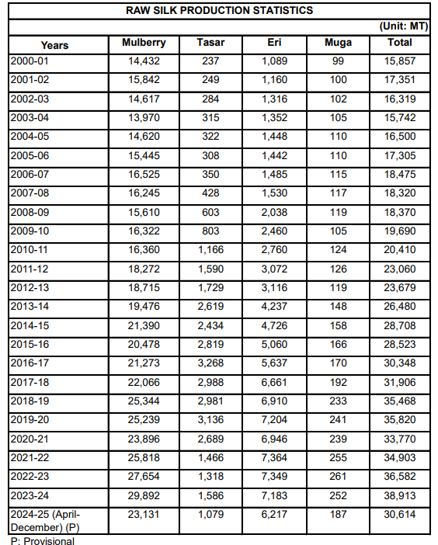

**Source:** Central Silk Board, Bengaluru

This table highlights India’s consistent multi-silk production capacity across mulberry, tasar, eri, and muga, underscoring its biodiversity and strength in catering to diverse markets.

* 1. **Structural Challenges**

Several structural challenges however constrain India’s competitiveness in the global silk trade. Quality inconsistencies persist due to the reliance on traditional reeling and manual processing methods, affecting the uniformity demanded by high-end international buyers [17,18]. Outdated post-cocoon infrastructure, including limited access to advanced reeling, twisting, and dyeing technologies, restricts productivity improvements [19]. Cocoon yields and reeling efficiency remain lower than in countries like China, attributed to differences in silkworm breed quality, rearing practices, and farm management systems [15].

The sector also faces challenges in branding and certification, with limited adoption of systems such as the Silk Mark and underutilisation of Geographical Indication (GI) tags, which hampers positioning in premium markets [17,22]. Inadequate international marketing, low digital trade integration, and limited participation in global trade fairs reduce India’s visibility in competitive export markets [17,23]. Climate variability and pest infestations further affect mulberry cultivation and silkworm rearing, leading to inconsistent cocoon supply and increased production risks [17,20]. Additionally, the slow adoption of modern reeling machines, cocoon sorting devices, and advanced rearing technologies constrains quality and productivity gains [17,24].

Addressing these challenges is essential for aligning India’s sericulture sector with global standards to enhance competitiveness and sustainability. Strategic interventions focusing on technological modernisation, quality standardisation, infrastructure upgrades, and market diversification will be critical for transforming Indian sericulture into a globally competitive sector capable of meeting evolving consumer demands for high-quality, traceable, and sustainable silk products [17,19,24].

1. **COMPARATIVE ANALYSIS: INDIA’S POSITION IN THE GLOBAL SILK TRADE**

India holds a significant position in the global silk trade as the second-largest producer, contributing approximately 18% to global silk production. This comparative analysis explores India’s performance across key dimensions of silk production and trade relative to leading producers, particularly China, covering aspects of raw silk yield, quality consistency, cost structures, branding strategies, and policy frameworks that shape competitiveness within the sector [10,12,15].

India’s annual raw silk production is around 36,453 metric tonnes, with notable growth reported in mulberry silk production during 2022-23 [14]. However, despite this progress, cocoon productivity in India remains lower than in China, which continues to dominate the sector with 78% of global silk output [13]. Although reeling efficiency in India is gradually improving due to technology interventions and skill development programs, it still lags behind the advanced reeling and processing technologies prevalent in China [20].

With regard to quality consistency and technological integration, India predominantly produces multivoltine silk, whereas China specializes in bivoltine silk, known for its superior quality and uniformity [12]. Although the adoption of modern rearing and reeling technologies is gradually increasing in India, traditional practices continue to dominate production systems, leading to variations in the quality of raw silk produced [20].

Considering cost structures and export competitiveness, India benefits from lower labour costs relative to China, providing a potential advantage in production economics. However, high input costs coupled with lower production efficiency limit the country’s ability to enhance its competitive position in the global market [25]. Furthermore, the export unit value of Indian silk remains lower than that of China, reflecting the need for stronger branding and improved quality assurance mechanisms to increase the perceived value of Indian silk products internationally (Table 3) [12].

**Table-3 Export earnings from silk and silk products in India in India (2017–18 to 2024–25 Provisional)**

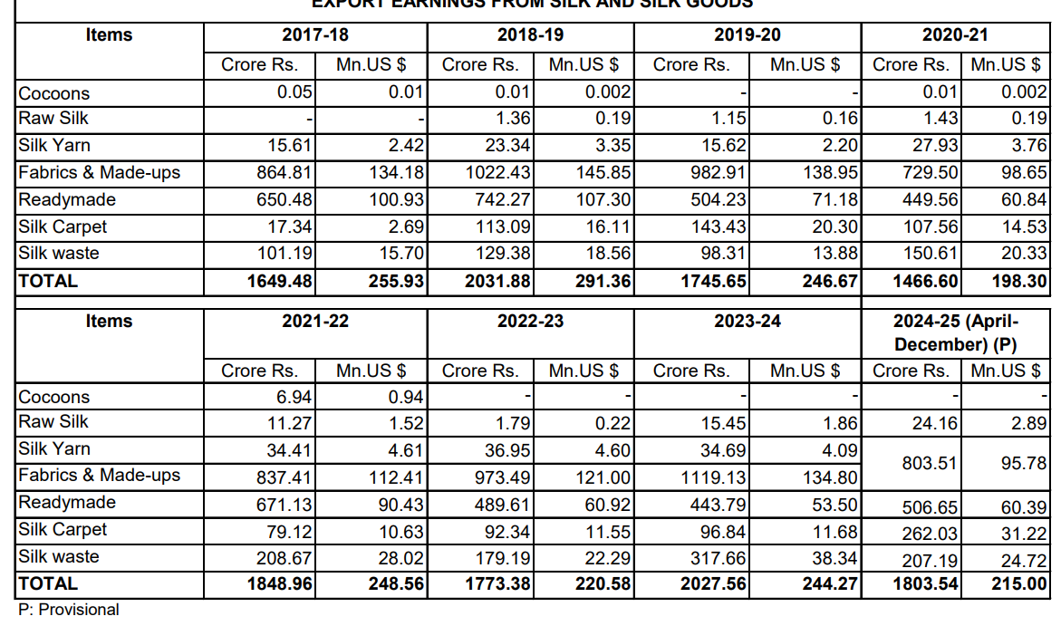

**Source:** DGCI&S, Kolkata

**Compiled by:** Central Silk Board, Bengaluru

India’s export earnings from silk and silk products, detailed in Table 3, illustrates its consistent contribution to foreign exchange while highlighting opportunities for market expansion. The data underscores the need for quality standardisation, branding, and technological upgrades to enhance India’s competitiveness and capture premium global markets.

To address these challenges, India has implemented initiatives such as the Silk Mark and Geographical Indication (GI) tags to promote its silk, contrasting with China’s high-end branding strategies that have enabled its dominance in the luxury silk market [26,27]. While India’s branding initiatives continue to develop, they primarily emphasize traditional craftsmanship and heritage branding rather than targeting broader market penetration and premium positioning [12].

In terms of policy frameworks and government support, India’s sericulture sector is supported by the Central Silk Board through technology missions and cluster development initiatives aimed at improving productivity and farmer livelihoods. However, these efforts lack the extensive and structured subsidy frameworks that are available in China, which significantly strengthen its silk industry [13,28]. China’s government policies continue to provide robust support to its sericulture sector, granting it a competitive advantage within global silk markets [20].

**Table-4 Import of silk and silk goods in India (2017–18 to 2024–25 Provisional)**

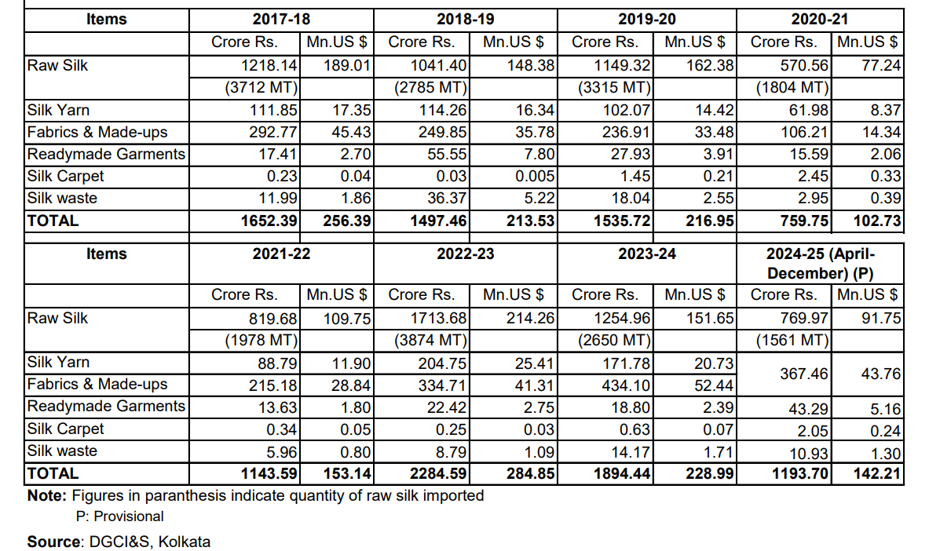

**Source:** DGCI&S, Kolkata

**Compiled by:** Central Silk Board, Bengaluru

While India is a significant exporter of silk and silk products, it continues to rely on imports to meet domestic demand, reflecting gaps in domestic production quality and the need for specific silk types to cater to premium markets. Table 4 outlines the trends in India’s import of silk and silk goods, illustrating the country’s trade patterns within the global silk market.

India demonstrates considerable potential within the global silk trade but continues to face challenges related to productivity, quality consistency, and branding when compared to China. Addressing these interconnected challenges through enhanced technological adoption, consistent quality improvement, and targeted branding strategies will be essential for India to strengthen its competitiveness and expand its market share in the global silk industry.

1. **OPPORTUNITIES FOR ENHANCING INDIA’S GLOBAL COMPETITIVENESS**

India’s global competitiveness in the silk industry can be advanced through a series of integrated strategic interventions, including technological modernisation, quality assurance frameworks, market diversification, climate-resilient practices, supportive policy measures, and the utilisation of digital platforms for global marketing. Collectively, these approaches are critical for positioning India as a competitive leader within the international silk market.

Technological modernisation offers considerable potential to improve productivity and quality in India’s silk sector. The integration of biotechnology for genetic enhancement in silkworm breeds has been shown to improve silk yield and quality consistency, while the adoption of automated technologies and climate-controlled rearing systems streamlines production processes and enhances operational efficiency [29,30]. Additionally, expanding the utilisation of silk fibroin in sectors such as biomedical and cosmetic industries contributes to value addition, supporting diversification and increased economic returns [31].

Quality control and certification frameworks play an essential role in elevating the perception of Indian silk in global markets. Systems such as Silk Mark certification and Geographical Indication (GI) tagging provide assurances of quality and authenticity to consumers, thereby strengthening trust and market positioning [12]. Coupled with enhanced branding and targeted promotion strategies, these measures can facilitate the positioning of Indian silk products within premium international markets, enabling higher price realisation.

Expanding into eco-conscious markets is another promising pathway for strengthening competitiveness. By aligning production practices with the increasing global emphasis on sustainability, including organic sericulture and environmentally friendly processing methods, India’s silk industry can effectively cater to environmentally conscious consumers [31]. Leveraging the biodegradable nature of silk further aligns with emerging trends in sustainable fashion and luxury textiles, positioning Indian silk as a desirable alternative to synthetic fibres.

Climate-resilient sericulture practices are essential to ensuring the sector’s long-term viability amid increasing climate variability. The adoption of integrated pest management strategies and organic cultivation practices can mitigate the environmental impacts of sericulture while promoting sustainability within production systems [30]. Developing climate-adaptable rearing and cultivation techniques will further support consistent production under changing environmental conditions [31].

Policy support and improved market linkages are critical enablers for enhancing competitiveness within the sector. Targeted government initiatives can provide essential support in the form of financial incentives, training, and infrastructural development, facilitating better market access for sericulture farmers [12]. Strengthening supply chain management and promoting cooperative models can also contribute to improved market connectivity and value chain efficiency, enhancing the sector’s resilience and market responsiveness.

Leveraging digital platforms and global marketing strategies is increasingly vital for the silk sector to expand its international footprint. The integration of digital technologies can streamline operations while enhancing visibility and reach, enabling direct engagement with global consumers [32]. E-commerce platforms offer opportunities for Indian silk producers to directly access international markets, reducing dependency on intermediaries and increasing profitability. Furthermore, the implementation of customer relationship management (CRM) systems can aid in understanding and responding to consumer preferences, enhancing customer engagement and retention [32,33]. The adoption of targeted digital marketing strategies further improves brand recognition, positioning Indian silk products effectively in diverse markets [33]. Digitalisation also contributes to operational cost reductions, allowing for competitive pricing in international trade [14,33]. However, challenges related to digital literacy and infrastructural limitations must be addressed to fully capitalise on the benefits of digital transformation within the silk sector.

While these strategies offer substantial opportunities to strengthen India’s position in the global silk industry, challenges such as fluctuating global demand and competition from synthetic fibres may constrain progress. Addressing these barriers through innovation, investment in technology, and adaptive strategic planning will be essential for maintaining and enhancing India’s competitive edge in the global silk market.

1. **FUTURE PROSPECTS AND STRATEGIC ROADMAP**

The future of sericulture is poised for significant transformation through the adoption of advanced technologies, sustainable practices, and strategic integration into global markets. This evolution is essential for enhancing productivity, meeting eco-conscious consumer demands, and positioning India as a leader in the silk economy.

The adoption of advanced technologies in sericulture, including artificial intelligence (AI) and automation, offers the potential to streamline operations and reduce labour costs while improving productivity and quality. The industry faces challenges across its production stages, including egg counting, disease detection, cocoon deformity identification, and environmental control, all of which directly influence the quantity and quality of raw silk production. Conventional methods to address these challenges incur substantial labour costs, making the integration of AI a critical intervention, as it has already demonstrated its capacity to improve production and management within various agricultural sectors [34,35]. Precision agriculture, through the deployment of automated systems for mulberry cultivation and climate-controlled rearing environments, can further optimise conditions for silkworm development, ensuring consistent cocoon yield and quality [30].

Sustainability and organic silk production have become central themes in the evolving global silk market. Expanding organic mulberry cultivation and adopting integrated pest management practices align with the global shift towards eco-friendly textiles, appealing to environmentally conscious consumers while enhancing the sector’s marketability [30]. Achieving sustainable certification for organic silk can facilitate access to premium pricing within international markets. Technological developments such as automated silk reeling machines and climate-controlled rearing houses have reduced labour requirements while ensuring consistent quality, while digital monitoring systems enable real-time tracking of silkworm health and environmental parameters, supporting data-driven decision-making for improved farm management [16,36]. Genetic advancements, including the development of high-yield and disease-resistant silkworm strains, have significantly enhanced silk productivity and quality, while innovations in naturally coloured silk production through genetic modification have reduced the environmental footprint of dyeing processes. These advancements, combined with biotechnology applications such as engineered silk proteins and transgenic silkworms for medical and industrial uses, are transforming sericulture into a more efficient and sustainable industry, benefiting rural livelihoods and supporting global market demands [36,37].

Strategic integration into global luxury textile value chains is critical for enhancing India’s positioning within premium garment and home textile markets. By leveraging high-quality silk production and aligning with international standards, India can meet the growing demand for sustainably produced luxury textiles [29]. Building climate-resilient supply chains in sericulture, through the development of adaptive practices in mulberry cultivation and silkworm rearing, will be vital for maintaining consistent cocoon yields amidst climate variability and ensuring the stability of production systems [31].

Public-private partnerships hold considerable potential for advancing sericulture, fostering innovations in silkworm genetics, reeling technologies, and market development. Collaborative efforts between research institutions, government bodies, and private sector actors can drive technological modernisation and enhance India’s competitiveness in export markets [29]. By prioritising high-quality, sustainable silk production and aligning sericulture practices with evolving global standards, India can strengthen its role in the global silk economy, contributing to rural income generation and broader economic development [30].

While these advancements provide a clear pathway for transforming sericulture, challenges such as market volatility and competition from synthetic fibres remain persistent barriers to sustainable growth. Addressing these issues through targeted interventions will be essential for India to capitalise on emerging opportunities and to establish itself as a global leader in sustainable, high-quality silk production.

1. Conclusion

India’s sericulture sector holds a significant position in the global silk market, supported by biodiversity, rural employment generation, and a diverse silk portfolio. However, challenges such as inconsistent quality, limited technological adoption, and weak branding constrain its global competitiveness. Aligning with evolving consumer demands for traceable, eco-friendly silk requires the integration of advanced technologies, quality certification frameworks, and climate-resilient practices within production systems. Opportunities exist in expanding premium, sustainable markets and leveraging digital platforms for global marketing, enhancing India’s positioning in the luxury silk segment. Policy support and public-private partnerships are critical to driving technological modernisation and market diversification, ensuring consistent quality and value addition. By systematically addressing productivity gaps, branding limitations, and climate-related vulnerabilities, India can transform its sericulture sector into a globally competitive and resilient industry. This will contribute to rural livelihoods while strengthening India’s role within the global silk value chain, meeting the rising demand for sustainable, high-quality silk in international markets. Strategic investments in research, technology, and market development are essential to realise this vision, enabling India to emerge as a leader in sustainable silk production and trade.

References

1. Xia N. The Silk Road and Silk from the Han to the Tang. InStudies in Silk Road Archaeology 2024 Apr 1 (pp. 333-347). Singapore: Springer Nature Singapore.
2. Peters MA. The ancient Silk Road and the birth of merchant capitalism. Educational Philosophy and Theory. 2021 Jul 23;53(10):955-61.
3. K S S, K S NR, Kotipalli M, Morabad PB. From Ancient Threads to Colonial Commerce: The Evolution of West Bengals Silk Industry from Mythical Origins to Independence.
4. Whitfield S. Was there a silk road?. Asian Medicine. 2007 Oct 16;3(2):201-13.
5. Kumar S, Kumar M. Exploring the relationship between raw silk production and employment growth in the Indian sericulture Sector. Journal of Livestock Science (ISSN online 2277-6214). 2024 Jan 1;15:337-43.
6. POPESCU A, ŞERBAN V, CIOCAN HN. NEW TRENDS IN THE GLOBAL SILK PRODUCTION IN THE PERIOD 2011-2022. Scientific Papers Series Management, Economic Engineering In Agriculture & Rural Development. 2024 Jan 1;24(1).
7. Press Information Bureau (PIB), Government of India. (2025, April 11). *Magic of Indian silk production*. [Press release]. Retrieved from <https://www.pib.gov.in/PressReleasePage.aspx?PRID=2120877>
8. Nayak R, Jajpura L, Khandual A. Traditional fibres for fashion and textiles: Associated problems and future sustainable fibres. InSustainable fibres for fashion and textile manufacturing 2023 Jan 1 (pp. 3-25). Woodhead Publishing.
9. Central Silk Board. (2023). *Annual Report 2022-23*. Ministry of Textiles, Government of India. Retrieved from <https://csb.gov.in>
10. Dandin SB. Silk-a Global Textile. GAMANAM: Global Advances in Multidisciplinary Applications in Next-Gen and Modern Technologies. 2025 Jan 12;1(1):32-7.
11. Chamuah P, Borah D, Donaj S. A Review on Effect of Covid-19 on Indian Sericulture Sector.
12. Kanchan SG, Hebbar CK. The silk industry: india’s role in the global landscape and financial decision-making dynamics. EPRA international journal of research & development. 2024;395–401.
13. Roy SK. An outline of the indian raw silk production from global perspective. Asian J. Multidimens. Res.. 2022;11(2):95-101.
14. Rebasiddanavar RM, Relekar SP, Allahham N, Purada S. Karnataka and India’s Silk Industry: A Comprehensive Analysis of Sericulture Dynamics. Journal of Experimental Agriculture International. 2024 Aug 31;46(9):274-93.
15. Babu KM. Silk–production and future trends. InHandbook of Natural Fibres 2020 Jan 1 (pp. 121-145). Woodhead Publishing.
16. Attri K, Vakayil S, Shruthi G, Parmar S, Harika KR, Teja KS, Panigrahi CK. Integrative approaches in sericulture from traditional practices to modern technologies sericulture and its contribution to biodiversity conservation. J Adv Biol Biotechnol. 2024 Jul 23;27(8):480-90.
17. Pavithra A, Rajashekar J, Saikrishna K, Shreya B, Pramod Kumar M, Thanuja A, Hariharan S. The evolution of the sericulture industry in India: from tradition to modernity. Journal of Scientific Research and Reports. 2024 Aug 30;30(9):282-91.
18. Anitha R. Indian silk industry in the global scenario. International Journal of Multidisciplinary management studies. 2011 Dec;1(3):100-10.
19. Hazarika S, Saikia B. Sericulture in the Lakhimpur District of Assam: Unravelling the Threads of Tradition and Development. International journal of agriculture extension and social development. 2024;
20. Walia SS, Kaur T. Sericulture. InBasics of integrated farming systems 2023 Dec 5 (pp. 105-108). Singapore: Springer Nature Singapore.
21. Sharma K, Kapoor B. Sericulture as a profit-based industry—a review. Indian journal of pure and Applied biosciences. 2020;8(4):550-62.
22. Walia Y, Kumar S. The Success and Failure of Gi Tag in India: a Critical Analysis of the Working of Geographical Indications of Goods (Registration and Protection) Act, 1999. Assam. E-Journal of Academic Innovation and Research in Intellectual Property Assets E-JAIRIPA. 2020;1(1):232-54.
23. Joshi RM, Nag B, Symss J, Taneja MR, Yadav MD. Challenges and Strategies to Promote India as a Sourcing Destination.
24. Gowrisankar R, Dasari S, Anas M. Silk reeling techniques: Exploring Traditional and advanced methods. Journal of Experimental Agriculture International. 2023;45(9):91-9.
25. Sharanadavar SB. Production and Export Performance of Indian Silk Industry: An Economic Analysis.
26. Gowda HR, Ranjan P. Geographical indication and its implications in silk sector. Indian Silk. 2009;48(6):16-9.
27. Tiwari S, Rosak-Szyrocka J, Bharali D, Akoijam SL, TA B. Demystifying the sustainable competitive advantage of sualkuchi silk products: Perspectives of buyers and sellers. Sustainability. 2023 Jan 6;15(2):1110.
28. Mushtaq R, Qadiri B, Lone FA, Raja TA, Singh H, Ahmed P, Sharma R. Role of sericulture in achieving sustainable development goals. Problemy Ekorozwoju. 2023;18(1):199-206.
29. Kalpana R, Mithilasri M, Karthick Mani Bharathi B, Susikaran S, Sabarish M, Parthiban KT. BRIDGING TRADITION WITH INNOVATION: REVOLUTIONZING SERICULTURE THROUGH BIOTECHNOLOGICAL ADVANCEMENTS.
30. Fatimaa+ S, Isharb AK, Jeeva PS, Devi HD, Rajeswari SU, Kumari B. Recent Innovations in Sericulture: A Comprehensive Review of Advancements in Silk Production and Quality Enhancement. UTTAR PRADESH JOURNAL OF ZOOLOGY. 2024 Dec 18;45(23):75-83.
31. Altman GH, Farrell BD. Sericulture as a sustainable agroindustry. Cleaner and Circular Bioeconomy. 2022 Aug 1;2:100011.
32. Fatorachian H, Ramesh S. Leveraging digital transformation platforms to strengthen market position in India’s textile industry. Cogent Business & Management. 2025 Dec 12;12(1):2527220.
33. Sen G, Bingqin L. The digital silk road and the sustainable development goals.
34. Raju CG, Sarkar S, Canamedi V, Parameshwaranaik J, Sarkar S. A Review of Silk Farming Automation Using Artificial Intelligence, Machine Learning, and Cloud-Based Solutions. InInternational Conference on DATA ANALYTICS & LEARNING 2022 Dec 30 (pp. 101-116). Singapore: Springer Nature Singapore.
35. Pal P, Singh D, Singh R, Gehlot A, Akram SV. Role of Artificial Intelligence, Machine Learning, Deep Learning for Sericulture: A Technological Perspective. In2023 International Conference on Artificial Intelligence and Smart Communication (AISC) 2023 Jan 27 (pp. 352-356). IEEE.
36. Kiruba M, Mangammal P, Anand G, Sakila M, Kumar P, Senthilkumar T. Innovations in Sericulture an Advancements in Silk Production and Quality Improvement. Uttar Pradesh Journal of Zoology. 2024 Sep 17;45(18):553-62.
37. Wang F, Xu H, Wang Y, Wang R, Yuan L, Ding H, Song C, Ma S, Peng Z, Peng Z, Zhao P. Advanced silk material spun by a transgenic silkworm promotes cell proliferation for biomedical application. Acta biomaterialia. 2014 Dec 1;10(12):4947-55.