Original Research Article
Level of knowledge of orthodontists regarding the indication for traction or extraction of impacted maxillary canines (IMC): observational research and literature review

.
ABSTRACT

Aims: To analyze the level of orthodontists’ knowledge regarding the indication of orthodontic traction or extraction of impacted maxillary canines (IMC) using panoramic radiographs (PRs) and contextualize the findings with current literature.
Study design: original research article.
Place and Duration of Study: Specialization course in Orthodontics at the Paulo Picanço College located in Fortaleza, state of Ceará, and to orthodontists in Ceará, between April 2009 and May 2023.
Methodology: A survey was carried out with 151 orthodontists in the state of Ceará using the Google Forms online form. The results were evaluated based on the conclusions generated by descriptive statistical and frequency analysis carried out in SPSS 20.0 version software.
Results: It was evidenced that most orthodontists consider themselves unable to determine the location of a IMC through PR, and factors such as overlap of the canine crown on adjacent teeth, vertical height of the canine crown, angulation of the canine in relation to the midline, position of the apex of the canine root horizontally, as well as the presence of changes, anomalies and pathological lesions were aspects considered for planning and deciding on treatment.
Conclusion: It was concluded that the PR contains advantageous information to be considered in the evaluation, planning and indication of the treatment of IMC teeth, which allows the adoption of appropriate preventive and therapeutic strategies, in addition to justifying the request for cone-beam computed tomography (CBCT).

Keywords: Cone-beam computed tomography. Diagnosis. Impacted tooth. Orthodontist. Panoramic radiography. Planning techniques.

1. INTRODUCTION

Determining the need for orthodontic traction or removal of an impacted maxillary canine tooth (IMC) is a task that requires specific theoretical and practical knowledge from the orthodontist. According to Motamedi et al. (2009), when considering the exposure or removal of this tooth, it is essential to rely on clinical and radiographic information.

Some aspects of the IMC to be evaluated include how horizontally overlaps the adjacent incisor, the vertical height of the crown, the angulation in relation to the midline and the position of the root apex in the horizontal plane (Counihan; Al-Awadhi, Butler, 2013). An integrated approach to clinical and imaging factors is essential for indicating and defining treatment.

In Dentistry, the standard method for locating an impacted tooth is the cone-beam computed tomography (CBCT), known for its ability to provide a precise three-dimensional location, in addition to offering detailed information about possible pathological characteristics associated with that tooth (Katsnelson et al., 2010). However, this imaging test entails high costs and greater radiation exposure compared to panoramic radiography (PR).

In this context, during the first clinical consultations, it is advantageous for the orthodontist to conduct a preliminary analysis and consider the possible indication of treatment based on the criteria established for IMC using PR (Katsnelson et al., 2010). Subsequently, the suggestion of complementary exams, such as CBCT, should be made to ensure an efficient approach to diagnosis and planning.

Therefore, the objective of this work was to analyze the level of knowledge of orthodontists regarding decision-making on the indication of orthodontic traction or extraction of IMC through PR.

2. material and methods

2.1 Study planning

This is an observational, quantitative and cross-sectional study, which analyzed the level of knowledge of orthodontists regarding decision-making on the indication of orthodontic traction or IMC extraction with the use of panoramic radiography. The instructions for observational research proposed by the Strengthening the Reporting of Observational Studies in Epidemiology (STROBE) (Von Elm et al., 2008) initiative were followed.

2.2 Context and participants

Electronic forms were sent to orthodontists trained in the specialization course in Orthodontics at the Paulo Picanço College located in Fortaleza, state of Ceará, and to orthodontists in Ceará. Were followed all ethical aspects expressed in the:
i) resolution No. 466 of 2012 of the National Health Council/Ministry of Health, which provides Guidelines and Standards for research with human beings in accordance with the National Research Ethics Commission;
ii) “Guidelines on Ethics in Research in Virtual Environments” documentation, prepared by the Research Ethics Committee of the Sergi Arouca National School of Public Health, of the Oswaldo Cruz Foundation;
iii) circular letter no. 1/2021 - Ministry of Health/Executive Secretariat of the National Health Council/National Research Ethics Commission entitled “Guidelines for procedures in research with any stage in a virtual environment.

This study had minimal risk, if the interviewee could feel embarrassed by a question and give up the research. The benefit involved the contribution to scientific development on the topic addressed. To maintain ethical and legal principles, the identities of the participants were preserved.

2.3 Data sources and measurement

The form for data acquisition and measurement was made available through Google Forms. The database is made up of the answers provided by volunteers. The questionnaire had fields for filling in the Free and Informed Consent Form, identification data and professional details. Then, the participant filled out elaborated questions based on the work of Arriola-Guíllen et al. (2019), Ericson and Kurol (1988), Katsnelson et al. (2010), Mitchell (2019) and Smith et al. (2012) to determine the criteria used for the diagnostic analysis of the IMC, followed by 04 digital panoramic radiographic images provided by the Dental Specialty Center of the Microregion of Russas (Centro de Especialidade Odontológica da Microrregião de Russas/CEO-R) for analysis regarding the indication of orthodontic traction or extraction.

2.4 Bias

We avoided inducing participants to observe specific points in the PR.

2.5 Number of participants

151 orthodontists participated in this study.

2.6 Statistical methods

SPSS version 20 software was used to carry out descriptive frequency analyses, measures of central tendency, mean and standard deviation.

3. results and discussion

151 orthodontists participated in this study. Of these, 62 (41.1%) were men and 89 (58.9%) women, aged between 26 and 74 years (Avg = 38.25; SD = 8.92). Regarding education, 101 (66.9%) had specialization/residency; 37 (24.5%) had master's degrees and 13 (8.6%) had doctorates. Regarding time as orthodontists, 67 (44.4%) had between 0 and 5 years of specialty; 33 (21.9%) were between 6 and 10 years and 51 (33.8%) were over 10 years of experience.

To evaluate the knowledge of the orthodontists regarding the indication for traction of the IMC through PR, the question was about the ability to determine its location (buccal, palatal or bicortically centered in the maxilla). It was observed that 7 (4.6%) indicated positively, 115 (76.2%) indicated negatively and 29 (19.2%) indicated perhaps.

Regarding the angulations evaluated by the participants to indicate traction or extraction related to the long axis of the IMC, it was noted that 25 (16.6%) indicated the long axis of the canine with an occlusal plane; 17 (11.3%) the long axis of the canine with the midline; 102 (67.5%) both above and 7 (4.6%) that the long axis of the retained canine and the reference lines do not interfere in the decision-making.

Regarding the overlapping of IMC in relation to adjacent teeth, the question was about which characteristics they consider important. Of all participants, 34 (22.5%) responded the overlap between the canine and the root of the adjacent lateral incisor; 11 (7.3%) the overlap between the canine and root of the adjacent lateral and central incisors; 97 (64.2%) both above; 7 (4.6%) that overlaps do not interfere in the decision-making and 2 (1.3%) indicated other characteristics.

When asked about the relevance of the position of the IMC apex to indicate traction or extraction in relation to the IMC long axis, most of the participants – 132 (87.4%) – said yes, and 19 (12.6%) said no.

Regarding the characteristics they considered important for deciding between orthodontic treatment or tooth extraction, the participants could select more than one alternative. The results indicated that 120 (79.5%) indicated the proximity of the crown/cusp of the canine to the apex of the root of the adjacent incisors; 85 (56.3%) the proximity of the crown/cusp of the impacted canine to the midline; 82 (54.3%) the proximity of the crown/cusp of the impacted canine to the occlusal plane; 79 (52.3%) the anteroposterior position of the IMC root apex in relation to the normal location in the arch; 6 (4%) pointed out that the proximity do not interfere in the decision-making and 7 pointed out other answers.

When asked which changes associated with IMC could contribute to their decision, the orthodontists could select more than one alternative. Of these, 138 (91.4%) indicated the degree of external root resorption (ERR) of adjacent teeth caused by IMC; 121 (80.1%) indicated the presence of associated cysts or other pathologies; 57 (37.7%) gyroversion; 90 (59.6%) transposition; 117 (77.5%) indicated the presence of root anomalies in the IMC; 1 (0.7%) responded that no dental anomaly interferes in the decision-making and 3 indicated other answers.

About other factors that may influence their decision, orthodontists could select more than one alternative. The results indicated that 105 (68.5%) stated the patient's age; 13 (8.6%) the gender; 81 (53.6%) the orthodontist's experience; 89 (58.9%) the possibility of extracting other dental elements and 132 (87.4%) the adequate space to receive the IMC after traction or the possibility of achieving it with planned orthodontic procedures.

Afterwards, participants were shown x-rays and asked what course of action they would recommend.

Regarding the first imaging exam presented, referring to a “female patient, 19 years old”:

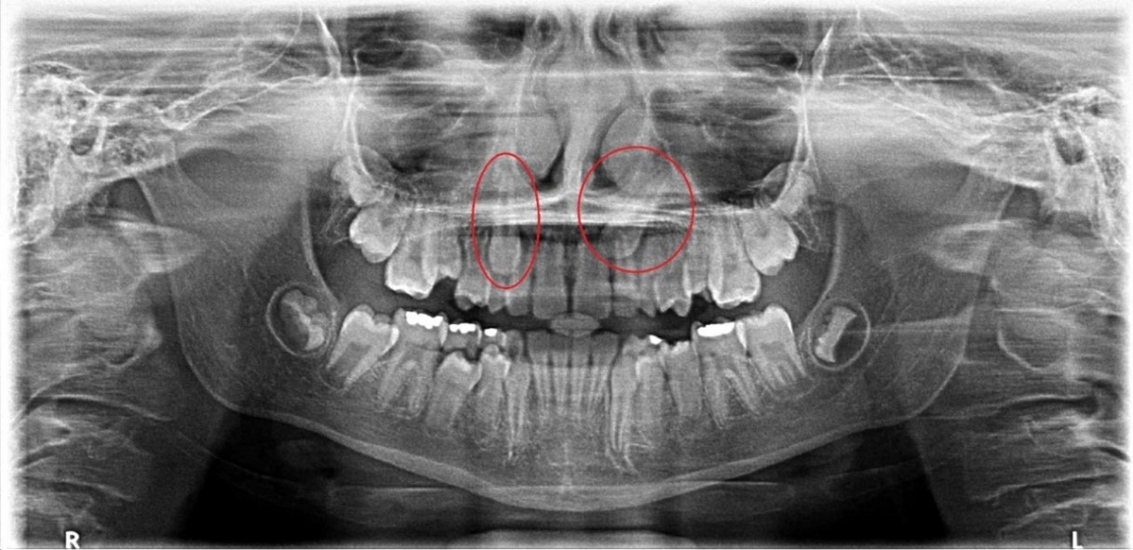
Fig. 1. Female patient, 19 years old.

107 (70.9%) orthodontists would recommend orthodontic traction of teeth 13 and 23; 2 (1.3%) extraction of 13 and 23; 40 (26.5%) traction of 13 and extraction of 23; and 2 (1.3%) extraction of 13 and traction of 23.

In this image, there is a bilateral canine impaction of teeth 13 and 23. Tooth 13 has a slight angulation of the long axis, overlap less than half the width of the lateral incisor, cusp tip at the level of the middle third of the adjacent root and apex at the proper alveolar bone region, with space for traction despite crowding, favorable prognosis for traction. Tooth 23 has a moderate angulation of the long axis, complete overlap with the root of the lateral and central incisor, tip of the cusp at the level of the apical third of the adjacent root and apex between the first and second premolar; unfavorable prognosis for traction, suggesting a greater possibility of extraction.

Regarding the second image exam presented, of a “male patient, 19 years old”:

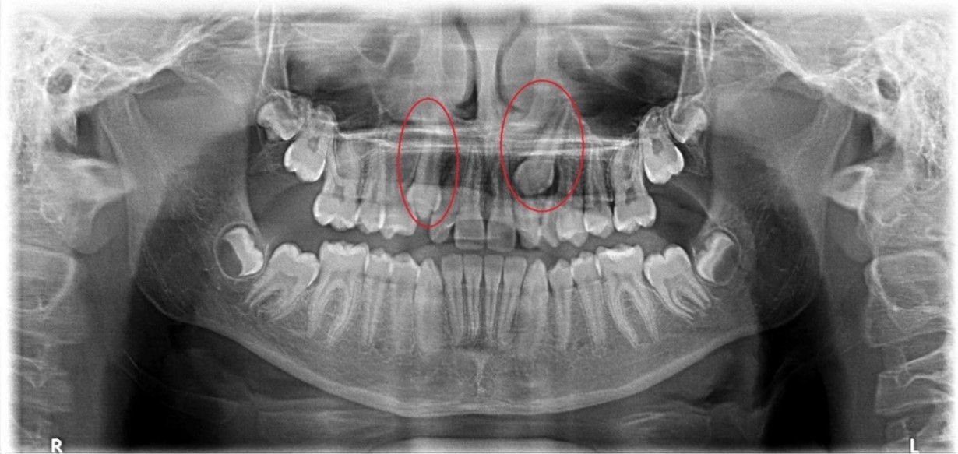
Fig. 2. Male patient, 19 years old.

108 (71.5%) orthodontists would recommend orthodontic traction of teeth 13 and 23; 1 (0.7%) would indicate extraction of 13 and 23; 42 (27.8%) traction of 13 and extraction of 23.

In this examination, a bilateral canine impaction of teeth 13 and 23 was evident. Tooth 13 has a slight angulation of the dental axis, overlapping less than half the width of the lateral incisor, tip of the cusp at the level of the cementoenamel junction of the lateral incisor and apex in the proper alveolar bone region, indicating a favorable position and space for traction. Tooth 23 has a moderate angulation of the long axis, overlap of half the width of the lateral incisor, tip of the cusp at the level of the middle third of the root of the lateral incisor and apex in the alveolar bone region of the first premolar, unfavorable for traction and greater possibility of extraction.

The third exam referred to a “female patient, 21 years old”:

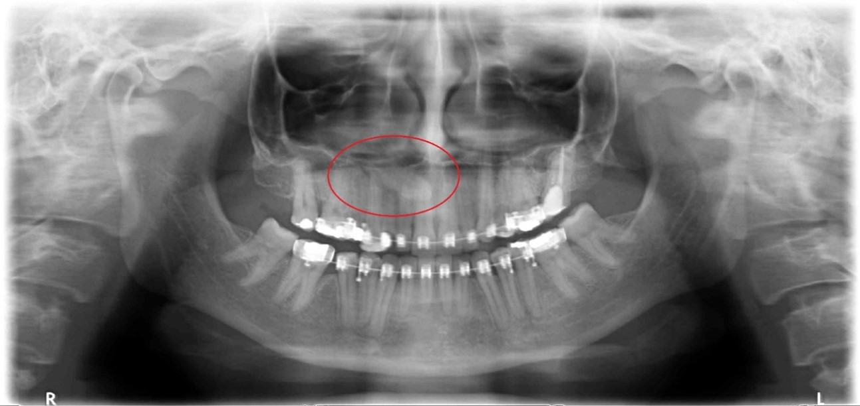
Fig. 3. Female patient, 21 years old.

25 (16.6%) of the respondents would recommend orthodontic traction of tooth 13 and 126 (83.4%) would recommend extraction.

Tooth 13 is in a horizontal position, associated with palatal impactions due to the anatomy of the maxilla with reduced vertical dimension. It presents an angulation of the long axis greater than 45º in relation to the median sagittal plane, complete overlap of the root of the lateral and central incisor, tip of the cusp at the level of the apical third of the root of the central incisor and apex in the alveolar bone region of the second premolar. These characteristics indicate an unfavorable prognosis for traction and suggest a greater possibility of extraction.

The fourth and final exam referred to a “female patient, 22 years old”:

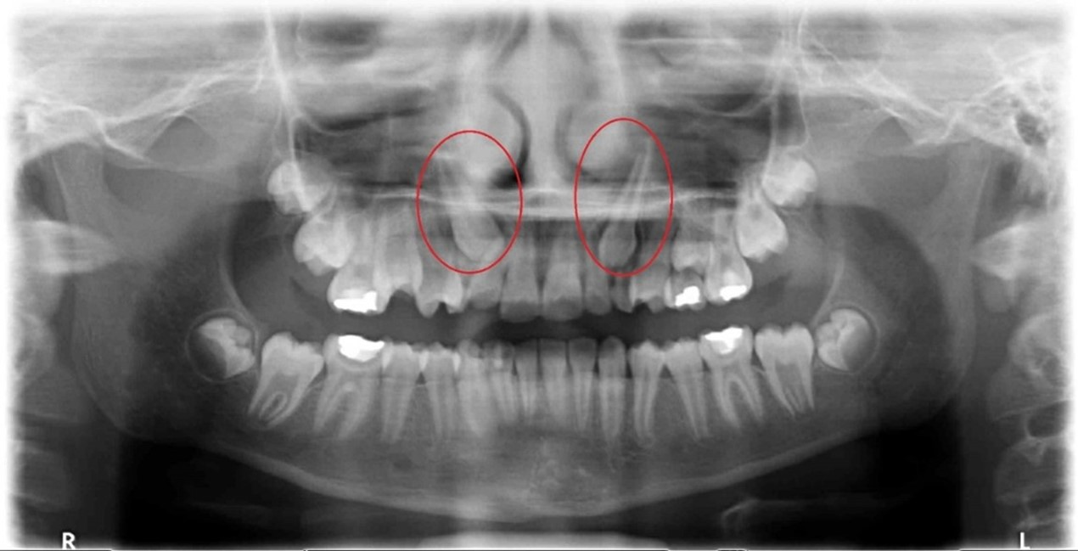
Fig. 4. Female patient, 22 years old.

In this case, 101 (66.9%) orthodontists would recommend orthodontic traction of teeth 13 and 23; 19 (12.6%) would recommend extraction of 13 and 23; 13 (8.6) traction of 13 and extraction of 23; and 18 (11.9%) extraction of 13 and traction of 23.

In this case, there is a bilateral canine impaction with both teeth in a favorable position for traction. Tooth 13 presents a moderate angulation of the long axis between 30º and 45º in relation to the median sagittal plane, overlapping in half the width of the lateral incisor, tip of the cusp in the apical third of the root of the adjacent incisor and apex in the proper alveolar bone region with slight tendency towards the first premolar region. Tooth 23 has a slight angulation of the long axis less than 30º in relation to the median sagittal plane, overlap of less than half the width of the lateral incisor, tip of the cusp in the middle third of the root of the lateral incisor and apex in the alveolar bone region with discrete inclination towards the first premolar region.

The IMC alignment is a challenge for orthodontists (Ali-Turaihi, 2020). The decision-making to choose treatment requires a precise assessment of its position and its interaction with other teeth (Christell et al., 2018; Manne et al., 2012). Possibilities of intervention are considered, such as: surgical exposure of the impacted tooth, followed by orthodontic traction to guide and align it with the dental arch, or IMC extraction associated with prosthetic replacement (Stivaros; Mandall, 2000). Any conduct to be carried out in patients who have IMC is considered complex (Alhammadi; Asiri; Almashraqi, 2018). Therefore, to assist with the initial diagnosis and treatment planning, the use of imaging tests is advantageous.

Among the imaging exams requested, PR is a two-dimensional exam used for initial diagnosis, maxillofacial overview, prediction and monitoring of tooth eruption. It allows the identification of the location of the IMC in terms of position, angulation and orientation and it is the standard screening exam (Alhammadi; Asiri; Almashraqi, 2018; Alqerban et al., 2016; Baidas et al., 2022, Senisik et al., 2019).

The CBCT, a three-dimensional examination, offers greater precision in identifying the location of IMC related to adjacent teeth, provides non-overlapping images with a 1:1 ratio, allows the assessment of lesions in the roots of teeth adjacent to IMC and provides greater reliability to the treatment plan, although it requires a higher radiation dose (Alqerban et al., 2016; Senisik et al., 2019; Alqerban et al., 2013; Alqerban et al., 2014; Cruz, 2019). According to the ALARA (As Low As Reasonably Achievable) dose optimization principles and the SedentexCT guidelines, the CBCT exam should not be used indiscriminately, being recommended in selected orthodontic cases in which PR does not provide sufficient information (European Comission, 2012).

The information from 3D images is superior to 2D and influences the indication of treatment (Alqerban et al., 2016). However, the research indicates that the indication of treatment for IMC does not present significant differences between them (Alqerban et al., 2016; Baidas et al., 2022, Senisik et al., 2019; Alqerban et al., 2013; Alqerban et al., 2014).

Christell et al. (2018) showed that most orthodontists opted for the same treatment alternative, regardless of the type of imaging exam used, PR or CBCT. CBCT did not offer significant benefits in terms of influencing the treatment decision, confidence in the decision remained the same. Therefore, the choice of imaging exam is influenced by characteristics of the diagnostic method, the quality of the information obtained, the interpretation and experience of professionals, the clinical history and the patient's collaboration (Christell et al., 2018; Baidas et al., 2022).

In PR, the sagittal locations of the IMC are predicted (Counihan; Al-Awadhi; Butler, 2013; Senisik et al., 2019; Pitt; Hamdan; Rock, 2006). In this study, most orthodontists did not consider themselves capable of determining the sagittal location of an IMC tooth through PR. According to Counihan, Al-Awadhi and Butler (2013), identifying and recognizing positioning through PR is difficult for orthodontists, but possible, being related to the professional's experience. Senisik et al. (2019) explain that evaluating the panoramic examination with the naked eye, without measurement, reduces the orthodontist's confidence.

The orthodontist's choice to pull or remove an IMC, based on information in the PR, is influenced by its bucco-palatal location, its angulation in relation to the occlusal plane and the midline, as well as the reference lines (Pitt; Hamdan; Rock, 2006). In the present study, the angulation of the long axis of the IMC with the occlusal plane (vertical height) and the long axis of the IMC with the midline were factors considered important by orthodontists, to the point of interfering in the indication.

Due to the technique for obtaining radiographs, the image of the IMC crown located buccally is projected onto the apex of the lateral incisor root (Senisik et al., 2019). Another study showed that 83.78% of buccal IMC and 50% of palatal IMC are positioned in the cervical third of the root (Chalakkal; Thomas; Chopra, 2009).

In the literature, the importance of the relationship between the vertical position and the angulation with the midline of the IMC stands out, as well as the difficulty of treatment and its duration. Pitt, Hamdan and Rock (2006) and Counihan, Al-Awadhi and Butler (2013) indicate that the higher the IMC is in relation to the occlusal plane, the worse the prognosis for orthodontic traction and alignment. Stewart et al. (2001) observed a significant increase in the duration of active treatment with increasing distance from the occlusal plane, a phenomenon that McSherry (1998) described as “the vertical rule of thirds”.

Treatments with cusp tips less than 14 mm above the occlusal plane last an average of 24 months, while those above 14 mm increase to 31 months (Stewart et al., 2001). Therefore, the vertical height of the IMC in relation to the occlusal plane is directly associated with the difficulty and duration of treatment (Counihan, Al-Awadhi; Butler, 2013; Ali-Turaihi et al., 2020; Alhammadi; Asiri; Almashraqi, 2018; Baidas et al., 2022; Pitt; Hamdan; Rock, 2006; Kocyigit et al., 2019). It is imperative that the orthodontist can identify vertical positioning through PR. The treatment decision is influenced by vertical position, with most cases requiring surgical removal rather than forced eruption if the cusps are at the apical level of the incisor root (Gunardi et al., 2022).

Considering the degree of horizontal overlap of canine crowns in relation to adjacent incisors, it is crucial to understand the level of knowledge of orthodontists regarding this positioning in PR. In the study, respondents considered that the overlap between the canine and the root of the adjacent lateral and central incisors interferes in the decision-making.

The position of the IMC is a factor in the predictability and prognosis of its alignment regarding the amount of overlap of the incisor roots in the horizontal plane (Motamedi et al., 2009; Stivaros; Mandall, 2000; Kocyigit et al., 2019). The relationship of the canine with the root of the lateral incisor (LI) is categorized: absence of horizontal overlap (grade 1), overlap of less than half the width of the LI root (grade 2), overlap of more than half the width (grade 3) or total overlap involving the entire width of the LI root (grade 4). Teeth that present grade 3 or 4 overlap are not favorable to conservative treatments and the possibility of full recovery using only interceptive treatment is reduced (Motamedi et al., 2009; Counihan, Al-Awadhi; Butler, 2013; Ali-Turaihi et al., 2020; Stivaros; Mandall, 2000, Kocyigit et al., 2019; Castro; Silva; Sousa, 2020; Power; Short, 1993).

Ericson and Kurol (1988) explain that, when the canine cusp is positioned mesially to the lateral incisor, the risk of complications triples, representing around 40% of the observed variation. The risk of external root resorption (ERR) increases by 50% when the mesial slope of the rash exceeds 25°. The closer the canine is to the midline, the worse the prognosis for alignment. No horizontal overlap with the adjacent incisor suggests a good prognosis (Counihan; Al-Awadhi; Butler, 2013; Pitt; Hamdan; Rock, 2006; McSherry, 1998).

About the orientation of the long axis of the canine in relation to the midline, canines angled towards the horizontal show management challenges and an unfavorable prognosis for traction and alignment (Counihan; Al-Awadhi; Butler, 2013), as the angulation towards the midline increases, the probability of removal increases (Counihan; Al-Awadhi; Butler, 2013, Stivaros; Mandall, 2000; Alhammadi; Asiri; Almashraqi, 2018). If orthodontic traction and alignment is chosen, the total treatment time is extended and the complexity of the treatment increases (Kocyigit et al., 2019).

Regarding the knowledge of orthodontists on the position of the IMC apex in PR, the majority of participants indicated that the position of the root apex is relevant.

In the literature, one of the criteria for evaluating interceptive treatment is the position of the IMC root apex in the horizontal plane. When the apex is positioned in its normal location, the prognosis for alignment is favorable; if the apex is above the region of the first premolar, intermediate, and, if it is located above the second premolar, unfavorable (Motamedi et al., 2009; Counihan, Al-Awadhi; Butler, 2013; Ali-Tureihi et al., 2020; Alhammadi; Asiri; Almashraqi, 2018). This assessment of the position of the root apex, through PR, offers insights into the best indication of the treatment to be performed.

Certain changes associated with IMC influence in the decision-making of the treatment. In this study, participants indicated that the degree of ERR of adjacent teeth caused by IMC, associated cysts, gyroversion and transposition, as well as root anomalies in IMC interfere in the decision-making.

The choice of treatments such as IMC extraction occurs in situations in which there is ERR, root dilaceration, presence of ankylosis, satisfactory functional occlusion in which the first premolar occupies the place of the canine and when there is the presence of pathological changes (Shafer; Hine; Levy, 1963; Gomes; Barbosa; Bittencourt, 2021).

The most frequently change found in the literature is ERR of adjacent teeth (Counihan, Al-Awadhi; Butler, 2013; Smith et al., 2012; Christell et al., 2018; Cruz, 2019; Kocyigit et al., 2019; Castro; Silva; Sousa, 2020; Gomes; Barbosa; Bittencourt, 2021; Arriola-Guillén et al., 2019; Ericson; Kurol, 1987; Ericson; Kurol, 2000; Litsas; Acar, 2011). Counihan, Al-Awadhi and Butler (2013) highlight that ERR influences the strategies for carrying out tooth extraction treatment. When it is diagnosed before the start of orthodontic treatment, the decision regarding removal of the resorbed tooth can be chosen and followed by orthodontic alignment of the IMC, space closure and reanatomy.

Arriola-Guillén et al. (2019) explained that the location of the IMC (palatal, buccal or bicortical) and the proximity to the roots of the upper incisors increase the risk of ERR due to direct contact during the traction process (Chaushu et al., 2015; Yan et al., 2012). Several classifications have been proposed to quantify the severity of canine impaction, allowing the orthodontist to estimate how complex the treatment could be (Al-Zoubi et al., 2017).

The external root resorption is asymptomatic and diagnosed based on imaging tests. For diagnostic evaluation, Ericson and Kurol (1987) claim that approximately 37% of lateral incisors with ERR appear normal in PR. According to the literature, this percentage increases through CBCT (Kocyigit et al., 2019; Ericson; Kurol, 2000; Liu et al. 2008; Hadler-Olsen et al., 2015; Ericson; Bjerklin; Falahat, 2002).

Most respondents to this study stated that some factors influence the treatment decision, such as: sex, age of the patient, perimeter of the dental arch, possibility of extracting other dental elements, experience of the orthodontist and collaboration of the patient.

Regarding sex, the literature demonstrated a higher frequency of IMC in females (Motamedi et al., 2009; Ericson; Kurol, 1988; Smith et al. 2012; Ali-Turaihi et al.; 2020; Manne et al., 2012; Alhammadi; Asiri; Almashraqi, 2018; Alqerban et al., 2016; Baidas et al., 2022; Cruz, 2019; Litsas; Acar, 2011; Al-Zoubi et al., 2017; Ericson; Kurol, 1986; Alassiry, 2020), which has a higher rate of ERR (Alqerban et al., 2016; Litsas; Acar, 2011). Prevalence varies, with female to male ratios of 2.26:1 in Saudi Arabia (Alhammadi; Asiri; Almashraqi, 2018), 2.3:1 in the United States, 2.5:1 in Israel (Becker; Chaushu, 2005) and 2.4:1 in Greece (Fardi et al., 2011).

Studies by Smith et al. (2012) and Baidas et al. (2022) indicated that palatal impaction is more prevalent than buccal impaction and the female predisposition is attributed to variations in craniofacial growth, developmental influences, aesthetic demands and genetic factors (Motamedi et al., 2009; Baidas et al., 2022). Al-Abdallah et al. (2018) identified that women tend to have larger impaction angles and greater severity of impaction.

Regarding age, orthodontic traction treatment has a better prognosis during childhood and adolescence; with increasing age, the IMC can develop ankylosis (Koutzoglow; Kostaki, 2013) and greater angulation in relation to the midline (Castro; Silva; Sousa, 2020), factors that make this type of treatment more difficult (Koutzoglow; Kostaki, 2013).

Ericson and Kurol (1988) carried out a prospective study with 35 children and adolescents (10-13 years old), showing 78% success in the spontaneous eruption of IMC in 6-12 months after extraction of primary canines. The position of the IMC crown in relation to the incisor root affected the success rate: 91% with a crown located distal to the incisor root and 64% with a crown mesially. Power and Short (1993) corroborated these findings in a 2-year study, highlighting the importance of horizontal overlap with the lateral incisor in canine eruption.

Olive (2002) conducted a study involving 28 children (average of 13.5 years) with 32 IMC per palate to evaluate the success rate of canine eruption without surgical intervention. Primary canines were removed and an orthodontic treatment to create space for permanent canines was delayed for at least six months if the IMC was the primary reason for treatment. Otherwise, treatment was initiated according to the patient's needs. 75% of canines erupted successfully and, in 94% of cases, the severity of impaction decreased after primary canine extraction and subsequent orthodontic treatment.

Cappellette et al. (2008) reported that canine teeth can be brought into the arch by orthodontic traction after a surgical procedure in patients aged 13 to 19 years. The success in adult and elderly patients is lower due to the risk of ankylosis. Orton, Garvey and Pearson (1995) indicate that the duration of treatments started after the end of the pubertal growth period is longer.

Regarding the possibility of extracting other dental elements, IMC treatment presents several approaches. When a primary canine remains in place of the IMC, removal and surgical exposure associated with orthodontic alignment are viable. However, when the clinical plan is to perform the extraction of the permanent first premolar to make room, it is considered a risky treatment option (Motamedi et al., 2009). The possibility of extracting other teeth, such as premolars, should not be carried out until conservative planning and conduct are executed (Manne et al., 2012).

It is essential for orthodontist professionals to develop treatment plans in the patient's best interest, considering the variety of available options correlated with complementary imaging exams (Counihan; Al-Awadhi; Butler, 2013).

This research had limitations: reduced sample size due to low adherence to electronic questionnaires, the limited availability of imaging exams may have affected the analysis, and the difficulty in enlarging the images. Finally, the research instrument only presented orthodontic traction and extraction of the impacted canine, excluding other orthodontic interventions. However, the proposed objectives were achieved. With the results acquired, we seek to stimulate and encourage future research related to the interpretation of the decision-making of IMC by orthodontists through two-dimensional and three-dimensional imaging exams.

4. Conclusion

The study revealed that most orthodontists did not feel able to determine the precise location of IMC in the maxilla using PR. There was a preference for orthodontic traction, except for the case referring to the female patient, 21 years old.

The criteria considered important included the proximity of the canine crown to the roots of adjacent incisors, presence of root resorption, cysts and other pathologies, in addition to root anomalies. The angulation in relation to the midline, the height of the IMC, the overlap in relation to the adjacent teeth and the position of the apex are factors to be analyzed in PR.
The study highlights the criteria and preferences of orthodontists in evaluating IMC through PR, in the indication of the treatment to be performed, before requesting CBCT.

Consent

All authors declare that they have obtained written informed consent from the participants for the publication of this original observational research and the accompanying images. A copy of the online consent is available for review by the Editorial Board/Editor-in-Chief/Editorial Board members of this journal.

Ethical approval

Approval by the Research Ethics Committee (CEP). Name of the ethics committee: CENTRO AVANCADO DE ORTODONTICA PAULO PICANCO S/S LTD. Opinion Number: 4,594,622. Certificate of Presentation for Ethical Assessment (CAAE): 44168621.0.0000.9267

COMPETING INTERESTS DISCLAIMER:
Authors have declared that they have no known competing financial interests OR non-financial interests OR personal relationships that could have appeared to influence the work reported in this paper.

References

Motamedi, M. H., Tabatabaie, F. A., Navi, F., Shafeie, H. A., Khosravani, F., & Hayati, Z. (2009). Assessment of radiographic factors affecting surgical exposure and orthodontic alignment of impacted canines of the palate: a 15-year retrospective study. Oral Surg Oral Med Oral Pathol Oral Radiol Endod, 107(6):772-775. https://doi.org/10.1016/j.tripleo.2008.12.022.

Counihan, K., Al-Awadhi, E. A., & Butler, J. (2013). Guidelines for the assessment of the impacted maxillary canine. Dent Update, 40(9):770-777. https://doi.org/10.12968/denu.2013.40.9.770.

Katsnelson, A., Flick, W. G., Susarla, S., Tartakovsky, J. V., & Miloro, M. (2010). Use of panoramic X-ray to determine position of impacted maxillary canines. J Oral Maxillofac Surg, 68(5):996-1000. https://doi.org/10.1016/j.joms.2009.09.022.

Von Elm, E., Altman, D. G., Egger, M., Pocock, S. J., Gøtzsche, P. C., Vandenbroucke, J. P. et al. (2008). The Strengthening the Reporting of Observational Studies in Epidemiology (STROBE) statement: guidelines for reporting observational studies. J Clin Epidemiol. 61(4):344-349. https://doi.org/10.1016/j.jclinepi.2007.11.008.

Arriola-Guíllen, L. E., Castillo, A. A., Ruíz-Mora, G. A., Rodríguez-Cárdenas, Y. A., & Silveira, H. L. D. (2019). Influence of maxillary canine impaction characteristics and factors associated with orthodontic treatment on the duration of active orthodontic traction. Am J Orthod Dentofacial Orthop, 156(3):391-400. https://doi.org/10.1016/j.ajodo.2018.10.018.

Ericson, S., & Kurol, J. (1988). Early treatment of palatally erupting maxillary canines by extraction of the primary canines. Eur J Orthod, 10(4):283-295. https://doi.org/10.1093/ejo/10.4.283.
Mitchell, L. Canines. (2019). In Littlewood, S. J. & Mitchell, L, An introduction to orthodontics. (p. 176-184). United Kingdom: Oxford University Press.
Smith, B., Stewart, K., Liu, S., Eckert, G., & Kula, K. (2012). Prediction of orthodontic treatment of surgically exposed unilateral maxillary impacted canine patients. Angle Orthod. 82(4):723-731. https://doi.org/10.2319/070511-431.1.
Ali-Turaihi, B. A., Ali, I. H., Alhamdani, G. M., & Alam, M. K. (2020). Patterns of Maxillary Canine Impaction in Iraqi Population. Pesqui Bras Odontopediatria Clín Integr, 20:1-12. https://doi.org/10.1590/pboci.2020.120.
Christell, H., Birch, S., Bondemark, L., Horner, K., Lindh, C., & SEDENTEXCT consortium. (2018). The impact of Cone Beam CT on financial costs and orthodontists' treatment decisions in the management of maxillary canines with eruption disturbance. Eur J Orthod, 40(1):65-73. https://doi.org/10.1093/ejo/cjx039.

Manne, R., Gandikota, C., Juvvadi, S. R., Rama, H. R. M., & Anche, S. (2012) Impacted canines: Etiology, diagnosis, and orthodontic management. J Pharm Bioallied Sci, 4(2):S234-238. https://doi.org/10.4103/0975-7406.100216.

Stivaros, N., & Mandall, N. A. (2000). Radiographic factors affecting the management of impacted upper permanent canines. J Orthod, 27(2):169-173. https://doi.org/10.1093/ortho/27.2.169.

Alhammadi, M. S., Asiri, H. A., & Almashraqi, A. A. (2018). Incidence, severity and orthodontic treatment difficulty index of impacted canines in Saudi population. J Clin Exp Dent, 10(4):e327-e334. https://doi.org/10.4317/jced.54385.

Alqerban, A., Jacobs, R., Fieuws, S., & Willems, G. (2016). Predictors of root resorption associated with maxillary canine impaction in panoramic images. Eur J Orthod, 38(3):292-299. https://doi.org/10.1093/ejo/cjv047.

Baidas, L. F., Alshihah, N., Alabdulaly, R., & Mutaieb, S. (2022). Severity and Treatment Difficulty of Impacted Maxillary Canine among Orthodontic Patients in Riyadh, Saudi Arabia. Int J Environ Res Public Health, 19(17):10680. https://doi.org/10.3390/ijerph191710680.

Senisik, N. E. U., Karacin, G., Yildirim, D., & Cesur, M. (2019). The Reliability of Panoramic Radiographs in the Evaluation of Location for Impacted Maxillary Canine Teeth: Comparison of Prediction Methods. J Clin Diagn Res, 13(7):18-24. http://dx.doi.org/10.7860/JCDR/2019/40940.13000.

Alqerban, A., Hedesiu, M., Baciut, M., Nackaerts, O., Jacobs, R., Fieuws, S. et al. (2013) Pre-surgical treatment planning of maxillary canine impactions using panoramic vs cone beam CT imaging. Dentomaxillofac Radiol, 42(9):1-7. https://doi.org/10.1259/dmfr.20130157.

Alqerban, A., Willems, G., Bernaerts, C., Vangastel, J., Politis, C., & Jacobs, R. (2014). Orthodontic treatment planning for impacted maxillary canines using conventional records versus 3D CBCT. Eur J Orthod, 36(6):698-707. https://doi.org/10.1093/ejo/cjt100.

Cruz, R. M. (2019). Orthodontic traction of impacted canines: Concepts and clinical application. Dental Press J Orthod, 24(1):74-87. https://doi.org/10.1590/2177-6709.24.1.074-087.bbo.

European Commission. (2012). Cone Beam CT for Dental and Maxillofacial Radiology: Evidence-Based Guidelines. Publications Office.

Pitt, S., Hamdan, A., & Rock, P. (2006). A treatment difficulty index for unerupted maxillary canines. Eur J Orthod, 28(2):141-144. https://doi.org/10.1093/ejo/cji068.

Chalakkal, P., Thomas, A. M., & Chopra, S. (2009). Reliability of the magnification method for localization of ectopic upper canines. Aust Orthod J, 25(1):59-62. https://pubmed.ncbi.nlm.nih.gov/19634465/.

Stewart, J. A., Heo, G., Glover, K. E., Williamson, P. C., Lam, E. W., & Major, P. W. (2001) Factors that relate to treatment duration for patients with palatally impacted maxillary canines. Am J Orthod Dentofacial Orthop, 119(3):216-225. https://doi.org/10.1067/mod.2001.110989.

McSherry, P. F. (1998) The ectopic maxillary canine: a review. Br J Orthod, 25(3):209-216. https://doi.org/10.1093/ortho/25.3.209.

Kocyigit, S., Oz, A. A., Bas, B., Arici, N., & Karahan S. (2019). Are age and radiographic features effective on orthodontic alignment of palatally impacted maxillary canines? A retrospective study. Eur Oral Res, 53(3):132-136. https://doi.org/10.26650/eor.20190055.

Gunardi, O. J., Danudiningrat, C. P., Rizqiawan, A., Mulyawan, I., Amir, M. S., Kamadjaja, D. B. (2022). Decision-making Criteria of Odontectomy or Surgical Exposure in Impacted Maxillary Canine Based on Treatment Difficulty Index Modification. Eur J Dent, 16(4):796-802. https://doi.org/10.1055/s-0041-1739447.

Castro, L. M. S. R. R., Silva, F., & Sousa, G. A. (2020). Criteria for canine treatment decision included: Exodontia versus Traction. Brazilian Journal of Health Review, 3(6):15872-15878. https://doi.org/10.34119/bjhrv3n6-020.

Power, S., & Short, M. (1993). An investigation into the response of palatally displaced canines to the removal of deciduous canines and an assessment of factors contributing to favourable eruption. Br J Orthod, 20(3):217-223. https://doi.org/10.1179/bjo.20.3.215.

Shafer, W. G., Hine, M. K., & Levy, B. M. (Eds.). (1963). A textbook of oral pathology (2nd ed.). Philadelphia: WB Saunders.

Gomes, A. P. A., Barbosa, C. G. C., & Bittencourt, P. A. P. (2021). Potencial de impacção dos caninos superiores: estudo radiográfico. Clin Lab Res Den, 10(4):1-7. http://dx.doi.org/10.11606/issn.2357-8041.clrd.2021.182404.

Arriola-Guillén, L. E., Ruíz-Mora, G. A., Rodríguez-Cárdenas, Y. A., Castillo, A. A. D., Boessio-Vizzotto, M., & Silveira, H. L. D. (2019). Influence of impacted maxillary canine orthodontic traction complexity on root resorption of incisors: A retrospective longitudinal study. Am J Orthod Dentofacial Orthop, 155(1):28-39. https://doi.org/10.1016/j.ajodo.2018.02.011.

Ericson, S., & Kurol, J. (1987). Radiographic examination of ectopically erupting maxillary canines. Am J Orthod Dentofacial Orthop, 91(6):483-492. https://doi.org/10.1016/0889-5406(87)90005-9.

Ericson, S., & Kurol, J. (2000). Resorption of incisors after ectopic eruption of maxillary canines: a CT study. Angle Orthod, 70(6):415-423. https://doi.org/10.1043/0003-3219(2000)070%3C0415:roiaee%3E2.0.co;2.

Litsas, G., & Acar, A. (2011). A review of early displaced maxillary canines: etiology, diagnosis and interceptive treatment. Open Dent J, 5:39-47. https://doi.org/10.2174/1874210601105010039.

Chaushu, S., Kaczor-Urbanowicz, K., Zadurska, M., & Becker, A. (2015) Predisposing factors for severe incisor root resorption associated with impacted maxillary canines. Am J Orthod Dentofacial Orthop, 147(1):52-60. https://doi.org/10.1016/j.ajodo.2014.09.012.

Yan, B., Sun, Z., Fields, H., & Wang, L. (2012) Maxillary canine impaction increases root resorption risk of adjacent teeth: a problem of physical proximity. Am J Orthod Dentofacial Orthop, 142(6):750-757. https://doi.org/10.1016/j.ajodo.2012.07.016.

Al-Zoubi, H., Alharbi, A. A., Ferguson, D. J., & Zafar, M. S. (2017) Frequency of impacted teeth and categorization of impacted canines: a retrospective radiographic study using orthopantomograms. Eur J Dent, 11(1):117–121. https://doi.org/10.4103/ejd.ejd_308_16.

Liu, D. G., Zhang, W., Zhang, Z., Wu, Y., & Ma, X. (2008). Localization of impacted maxillary canines and observation of adjacent incisor resorption with cone-beam computed tomography. Oral Surg Oral Med Oral Pathol Oral Radio, 105(1):91-98. https://doi.org/10.1016/j.tripleo.2007.01.030.

Hadler-Olsen, S., Pirttiniemi, P., Kerosuo, H., Limchaichana, N. B., Pesonen, P., Kallio-Pulkkinen, S. et al. (2015). Root resorptions related to ectopic and nor mal eruption of maxillary canine teeth - A 3D study. Acta Odontol Scand, 73(8):609-615. https://doi.org/10.3109/00016357.2015.1020339.

Ericson, S., & Kurol, J. (1986). Longitudinal study and analysis of clinical supervision of maxillary canine eruption. Community Dent Oral Epidemiol, 14(3):172-176. https://doi.org/10.1111/j.1600-0528.1986.tb01526.x.

Ericson, S., & Kurol, J. (1986). Radiographic assessment of maxillary canine eruption in children with clinical signs of eruption disturbance. Eur J Orthod, 8(3):133-140. https://doi.org/10.1093/ejo/8.3.133.

Becker, A., & Chaushu, S. (2005) Long-term follow-up of severely resorbed maxillary incisors after resolution of an etiologically associated impacted canine. Am J Orthod Dentofacial Orthop, 127(6):650-654. https://doi.org/10.1016/j.ajodo.2004.03.031.

Ericson, S., Bjerklin, K., Falahat, B. (2002). Does the canine dental follicle cause resorption of permanent incisor roots? A computed tomographic study of erupting maxillary canines. Angle Orthod, 72(2):95-104. https://doi.org/10.1043/0003-3219(2002)072%3C0095:dtcdfc%3E2.0.co;2.

Alassiry, A. (2020) Radiographic assessment of the prevalence, pattern and position of maxillary canine impaction in Najran (Saudi Arabia) population using orthopantomograms—A cross-sectional, retrospective study. Saudi Dent J, 32(3):155-159. https://doi.org/10.1016/j.sdentj.2019.08.002.

Fardi, A., Kondylidou-Sidira, A., Bachour, Z., Parisis, N., & Tsirlis, (2011). A. Incidence of impacted and supernumerary teeth - a radiographic study in a North Greek population. Med Oral Patol Oral Cir Bucal, 16(1):56-61. https://doi.org/10.4317/medoral.16.e56.

Al-Abdallah, M., AlHadidi, A., Hammad, M., & Dar-Odeh, N. (2018). What factors affect the severity of permanent tooth impaction?. BMC Oral Health, 18(1):184. https://doi.org/10.1186/s12903-018-0649-5.

Koutzoglou, S. I., & Kostaki, A. (2013). Effect of surgical exposure technique, age, and grade of impaction on ankylosis of an impacted canine, and the effect of rapid palatal expansion on eruption: A prospective clinical study. Am J Orthod Dentofacial Orthop, 143(1):342-352. https://doi.org/10.1016/j.ajodo.2012.10.017.

Olive, R. J. (2002). Orthodontic treatment of palatally impacted maxillary canines. Aust Orthod J, 18(2):64-70. https://pubmed.ncbi.nlm.nih.gov/12462682/.

Cappellette, M., Cappellette Junior, M., Fernandes, L. C. M., Oliveira, A. P., Yamamoto, L. H., Shido, F. T. et al. (2008). Palatine impacted permanent maxillary canines: diagnose and therapeutics. Revista Dental Press de Ortodontia e Ortopedia Facial, 13(1):60-73. https://doi.org/10.1590/S1415-54192008000100008.

Orton, H. S., Garvey, M. T., & Pearson, M. H. (1995) Extrusion of the ectopic maxillary canine using a lower removable appliance. Am J Orthod Dentofacial Orthop, 107(4):349-359. https://doi.org/10.1016/s0889-5406(95)70087-0.

