Original Research Article
Bio-efficacy of ethanol based botanical extracts against Bipolaris maydis causing Maydis Leaf Blight in Maize (Zea mays L.)

ABSTRACT
Maydis leaf blight of maize caused by Bipolaris maydis has been observed as an alarming problem in maize growing regions leading to significant damage to crop and ultimately reducing grain yield production. This disease is most prevalent under humid and warm maize-growing areas worldwide. The alcoholic leaf extracts of four plants viz., Ageratum conyzoides, Lantana camera, Eucalyptus sp. and Melia azedarach were evaluated at different concentrations for their efficacy against B. maydis under in vitro conditions. Among all extracts, Lantana camera had maximum mycelial inhibition of 100 per cent followed by Eucalyptus sp. having 92.80 per cent of inhibition at 5 per cent test concentration, respectively. Thus, among all test botanicals, Lantana camera was found the most efficient against B. maydis. These findings suggest that Lantana camera extracts could be used as eco-friendly alternatives to control the maydis leaf blight of maize.
Keywords: Bipolaris maydis, maize, alcoholic botanicals, maydis leaf blight.

- INTRODUCTION
Maize (Zea mays L.) is one of the most versatile emerging crops having wider adaptability under varied agro-climatic situations. In India, maize is known as the “Queen of Cereals” because it has the highest genetic yield capacity among cereals and have many uses such as food (23%), feed (63%), starch industries (12%), seed and other purpose (2%) (Manzar et al. 2022). Two important amino acids i.e., lysine and tryptophan, are abundant in high-quality protein maize, which makes it crucial for improving the nutritional value of the daily diet (Malik et al. 2018; Haque et al. 2022). Maize is one of the primary crops of choice for industrial usage because of its versatility in agro-ecological and climatic conditions. In India, maize is the third-most important food crop after rice and wheat (Bharti et al. 2020).
In India, maize is cultivated over an area of 9957950 hectares, production of 33729540 tonnes with a productivity of 33872 kg/ha benefiting from diverse soil types, climates, biodiversity and management practices (FAOSTAT, 2022a), whereas, In Himachal Pradesh, maize is mainly cultivated during kharif season under an area of 255.54 thousand hectares with a production of 708.42 thousand metric tonnes and a productivity of 2772.24 kg/ha (HPDOA, 2022b).
Amongst biotic stresses, Maydis Leaf Blight (MLB), caused by Bipolaris maydis (Nisik and Miyake) Shoemaker, (telomorph: Cochliobolus heterostrophus) is a serious fungal disease of maize throughout the world where maize is grown under humid and warm conditions (Kutawa et al. 2021). The disease is most common under warm, humid, temperate to tropical regions that have temperatures between 20 and 30°C throughout the cropping season (Bharti et al. 2017; Chandra et al. 2020; Vanlalhruaia et al. 2022). The disease has become well-known in India and has expanded throughout the plains, highlands and even certain areas of the peninsula (Kumar et al., 2022).
Frequent use of fungicides for disease management results in adverse effect and has led to various problems. The heavy reliance on chemical fertilizers can negatively impact soil health, raise environmental concerns, and diminish economic returns due to the high costs of inputs (Chen et al. 2022). Kursa et al. (2022) evaluated four ethanolic plant extracts against genus Fusarium, a major cereal pathogen. The extracts were used at concentrations of 5, 10 and 20 per cent. Out of four different ethanolic botanicals, the extract of sage (Salvia officinalis L.) and tansy (Tanacetum vulgare L.) demonstrated strong inhibitory effect of 83.53 per cent and 72.58 per cent against test pathogen at 20 per cent concentration, respectively. Pathak et al. (2020) evaluated various weed ethanolic extracts against Rhizoctonia Root rot (Rhizoctonia solani) in buckwheat and found that out of 4 ethanolic extracts evaluated, Solanum nigrum showed the highest inhibition (88%) at 500 ppm followed by Tridax procumbens (85%) and Datura metel (80%).
Ethanolic extracts alone or used in combination of fungicides can be proven an effective strategy for sustainable agricultural production systems. It can hold promise for developing biological, eco-friendly and non-hazardous antifungal products from various plant material. Hence, the present investigation was carried out to evaluate various ethanolic based botanical extracts against Bipolaris maydis.
- MATERIALS AND METHODS
The present investigation was carried out in the laboratory at the Department of Plant Pathology, COA, Chaudhary Sarwan Kumar Himachal Pradesh Krishi Vishvavidyalaya, Palampur, Himachal Pradesh.
2.1 Isolation and purification of the pathogen
Under standard isolation protocol, leaves of maize plants exhibiting symptoms of Maydis leaf blight were collected from maize-growing regions and isolation was done from infected samples on potato dextrose agar (PDA) medium. Inoculated plates were incubated for 7-10 days at 27±1⁰C to allow the fungal pathogen to grow. The pure colonies that developed from the bits were transferred to PDA slants and incubated at room temperature for 15 days. Pure culture of the fungus was maintained at 4°C for further studies.
2.2 In vitro evaluation of ethanolic botanical extracts against Bipolaris maydis
2.2.1 Preparation of ethanol extract
Freshly harvested leaves of botanicals, namely, Ageratum conyzoides, Lantana camera, Eucalyptus sp. and Melia azedarach were thoroughly rinsed with tap water to remove impurities and were dried separately under the shade with occasional up and down mixing for 18-21 days. Subsequently, the dried leaves of each extract were finely powdered and kept in an airtight container. Ethanol was used as a solvent for the preparation of crude extract. 50 g powder of each leaf was soaked in 200 ml of solvent in 250 ml conical flask and it was kept on the rotary shaker at 150 rpm at room temperature for one day and then allowed to stand to settle the leaves debris. After the leaf debris settled on the bottom of the flask supernatant from each flask was filtered through Whatman No. 1 filter paper and evaporated at room temperature in warm water to completely remove the solvent. Concentrated air-dried extracts were then transferred into small vials and stored for further use at 4°C.
2.2.2 In vitro evaluation of ethanol extract
The antifungal effect of alcoholic-based extracts of four botanicals viz., Ageratum conyzoides, Lantana camera, Eucalyptus sp. and Melia azedarach were evaluated in vitro At 5 concentrations (1, 2, 3, 4 and 5%) for their efficacy on inhibition in growth of B. maydis by Poisoned Food Technique (Falck, 1907). The experiment was conducted in a completely randomized design and each treatment was replicated thrice. The desired concentration of the crude extract was prepared by mixing it with the required quantity of sterilized PDA medium. Petri plates containing PDA medium without any amendments were served as control. After solidification of the medium, Seven-day-old mycelial bits of 5 mm of B. maydis were placed in the center of plates and incubated at 27±1°C. The radial growth of the fungal colony in each Petri plate was measured and per cent inhibition was calculated by using the formula given by Vincent (1947):
Mycelial growth inhibition (%) = {(C-T)/C} x 100
Where, I = Per cent mycelial inhibition of test pathogen,
C = Radial growth of pathogen (mm) in control
T = Radial mycelial growth of pathogen (mm) in treatment
2.3 Statistical Analysis
The data of the experiment was pooled and subjected to appropriate statistical analysis. All the data were analysed in two-way analysis (ANOVA) using OPSTAT software. The significance of treatments was taken at 5 per cent level of significance. CD (Critical difference) is used to compare means of different treatments that have an equal number of replications.
- RESULTS AND DISCUSSION
3.1 Identification of Pathogen
Isolation was made from disease samples of maydis leaf blight of maize collected from maize fields near the vicinity of Palampur. Based on morphological, cultural, and pathogenic characteristics, Bipolaris maydis was identified as the causal agent of maydis leaf blight of maize.

3.2 In vitro evaluation of ethanolic extracts against the pathogen
The alcoholic leaf extracts of four botanicals viz., Ageratum conyzoides, Lantana camera, Eucalyptus sp. and Melia azedarach were evaluated at different concentrations i.e. 1, 2, 3, 4 and 5 per cent for their antifungal properties through Poisoned Food Technique against B. maydis. The data in the Table 1 revealed that alcoholic extracts of all the botanicals were found effective against the pathogen to a varying extent. Antifungal activities of all phytoextracts increased significantly with the increase in the concentration from 1 to 5 per cent. The alcoholic plant extracts of all botanicals proved to be effective against the pathogen at 5 per cent concentration resulted in more than 80 per cent mycelial inhibition. Among all four, Lantana camera was found best with mycelial inhibition of 100 per cent against B. maydis followed by Eucalyptus sp. (92.80%), Ageratum conyzoides (90.43%) and Melia azedarach (84.91%) at 5 per cent test concentration. The results obtained above have also been depicted in the bar diagram (Figure 1).
The results of these findings show the effectiveness of the extracts, the concentration-dependent response, and the relative performance of each botanical. All botanical extracts showed antifungal properties against B. maydis as indicated by the reduction in mycelial growth compared to the control (untreated). This reaffirms the potential of natural plant extracts as alternatives to synthetic fungicides in managing fungal pathogens. There was a noticeable trend of increasing antifungal activity with higher concentrations of the extracts.
Table 1: In vitro efficacy of alcoholic extract of botanicals against Bipolaris maydis
Botanical | Radial growth (mm) |  |  |  |  | Inhibition in mycelial growth (%)
 | Concentration (%) |  |  |  |  | Concentration (%)
 | 1 | 2 | 3 | 4 | 5 | 1 | 2 | 3 | 4 | 5
Ageratum conyzoides | 31.69  (5.71)* | 23.46  (4.94) | 15.47  (4.05) | 11.52  (3.53) | 8.61  (3.09) | 64.79 | 73.94 | 82.81 | 87.20 | 90.43
Lantana camera | 22.40  (4.83) | 18.56  (4.42) | 13.54  (3.81) | 8.61  (3.09) | 0.00  (1.00) | 75.11 | 79.38 | 84.96 | 90.43 | 100.0
Eucalyptus sp. | 30.57  (5.61) | 22.35  (4.83) | 18.58  (4.42) | 8.44  (3.07) | 6.48  (2.72) | 66.03 | 75.16 | 79.36 | 90.63 | 92.80
Melia azedarach | 55.56  (7.52) | 30.50  (5.61) | 23.70  (4.96) | 20.55  (4.64) | 13.58  (3.81) | 38.26 | 66.11 | 73.67 | 77.16 | 84.91
Control | 90.00  (9.53) | 90.00  (9.53) | 90.00  (9.53) | 90.00  (9.53) | 90.00  (9.53) | 0.00 | 0.00 | 0.00 | 0.00 | 0.00
 | CD (p=0.05)
Botanicals (A) | 0.078
Concentrations (B) | 0.078
Factor (A×B) | 0.174
* Figures in the parentheses are angular transformed values

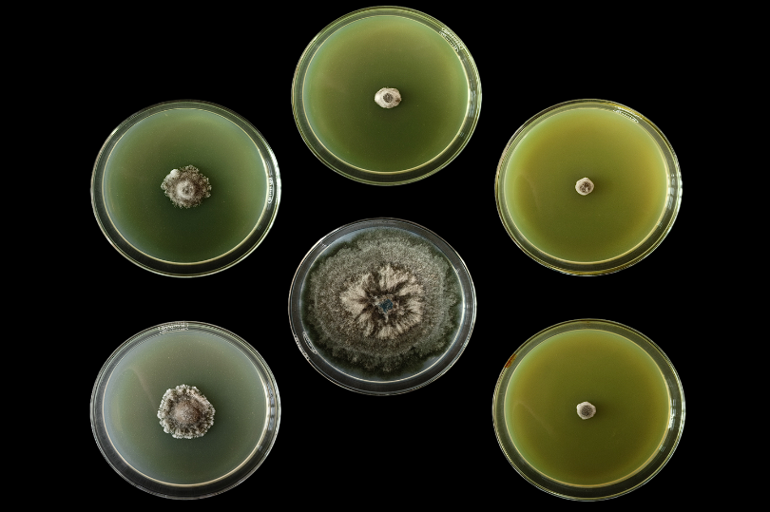 | 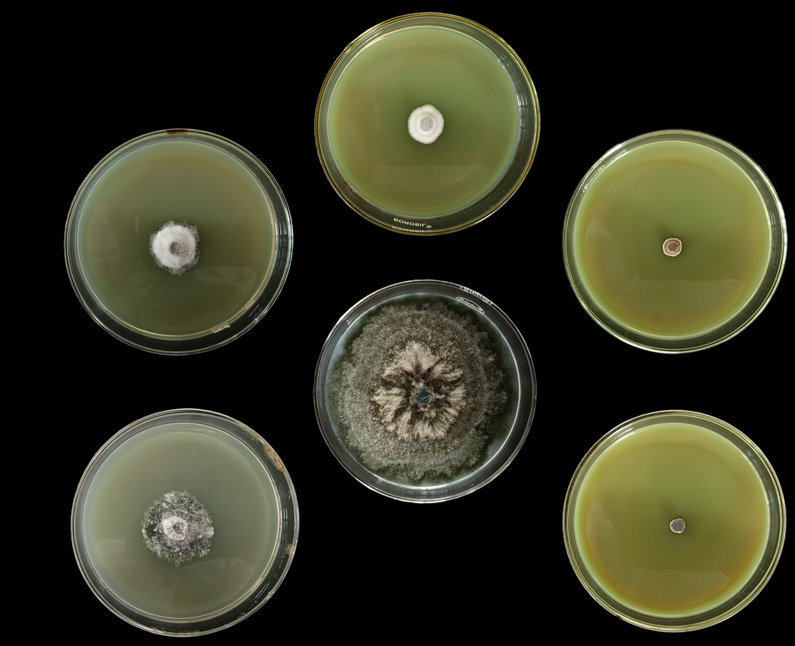
Ageratum conyzoides | Eucalyptus sp.
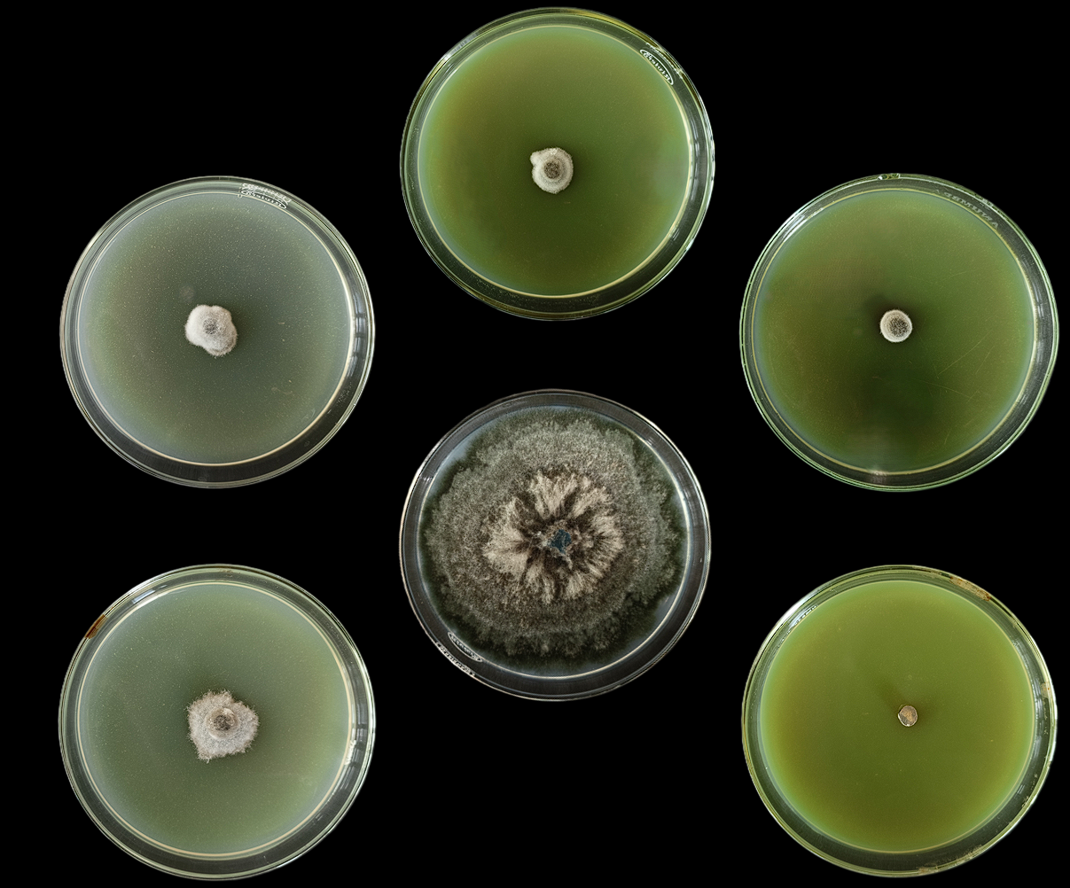 | 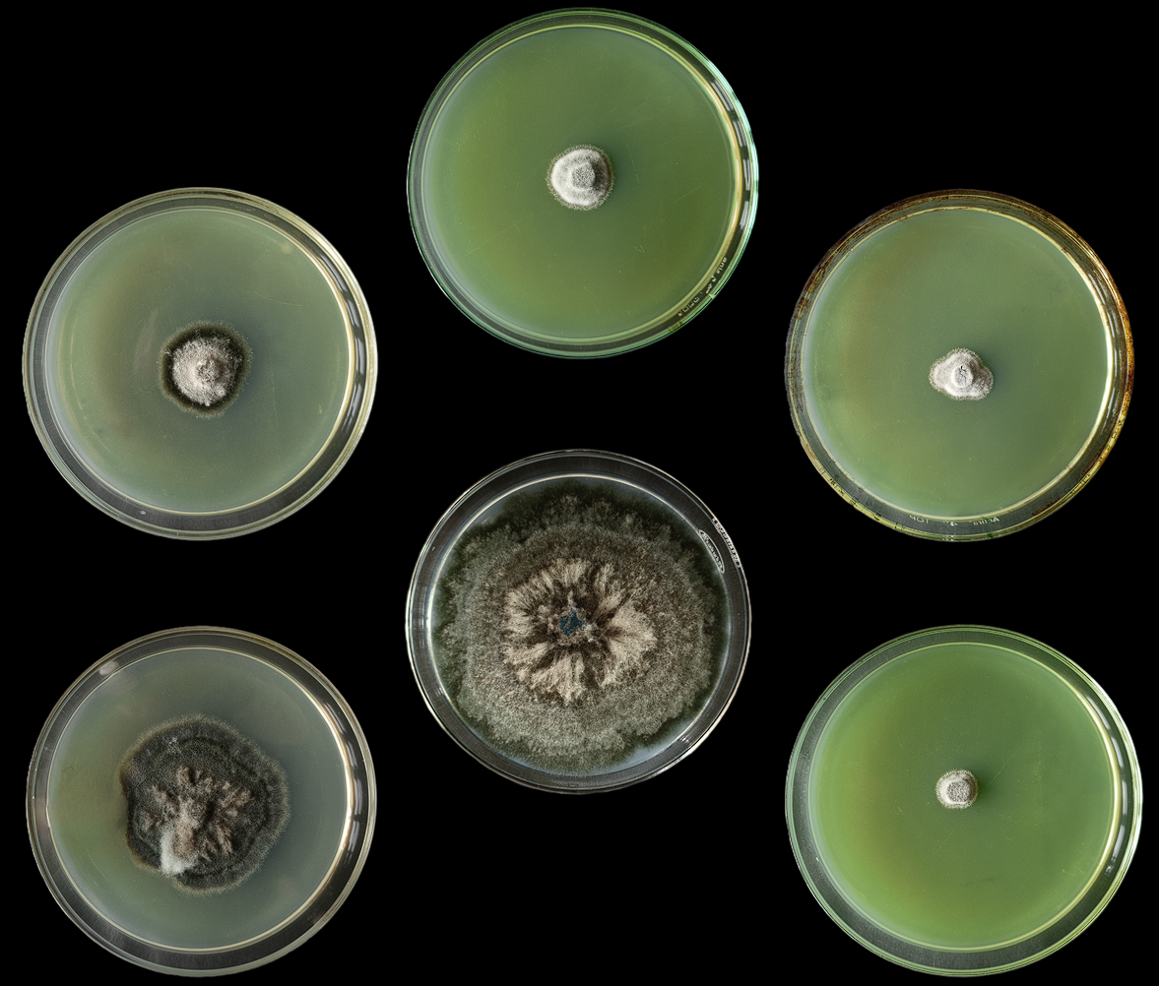
Lantana camera | Melia azedarach
Fig 1. Mycelial inhibition of Bipolaris maydis with alcoholic extract of botanicals

Fig 2. Mycelial inhibition (%) of the different treatments at varying concentrations on the growth of Bipolaris maydis
This concentration-dependent response suggests a dose-response relationship, where higher concentrations of the extracts led to greater inhibition of fungal growth. This aligns with the principle that higher concentrations of bioactive compounds present in the extracts can exert stronger inhibitory effects on the pathogen. So, among the four botanicals tested, Lantana camera emerged as the most effective, demonstrating the highest mycelial inhibition of 100 per cent at the 5 per cent concentration. This suggests that Lantana camera possesses potent antifungal compounds that are particularly effective against B. maydis. The antifungal potential of aqueous and crude extracts of botanicals against pathogens have also been reported by various workers in the recent past.
Rehena et al. (2022) evaluated eight ethanolic plant extracts for controlling wheat blast caused by Magnaporthe oryzae and recorded that the lowest mycelial growth was recorded with Aloe vera extracts and Nigella sativa (black cummin seeds) extracts at 1:1 w/v and 1:0,25 w/v, respectively at 7 days after inoculation. Chhabra and Sharma (2023) evaluated two botanicals with two different solvents i.e., aqueous and 50% ethanol against sheath blight of rice and recorded that ethanolic extracts have higher number of secondary metabolites than aqueous one. Kaur et al. 2024 test botanicals, under which Eupatorium adenophorum was found the most efficient against F. solani f. sp. pisi. These results highlight the potential of these botanical extracts as natural antifungal agents for managing B. maydis. However, further studies are required to elucidate the specific bioactive compounds responsible for the observed antifungal activity and to assess their efficacy under field conditions.
- CONCLUSION
The present investigation highlighted the potentialities of ethanolic leaf extracts in managing Maydis leaf blight of maize. Increasing concentrations of the extracts correlated with higher efficacy, having Lantana camera exhibiting the most significant inhibition of mycelial growth. The management of Maydis leaf blight in maize through ethanolic extracts may offers a sustainable and environmentally responsible alternative to conventional chemical control methods. Due to increasing regulatory and consumer-driven demand for sustainable agriculture, the integration of ethanolic based plant extracts may act as a viable long-term strategy for effective MLB and other fungal diseases management in agriculture.
REFERENCES
Bharti, P., Chand, P., & Gupta, P. K. (2020). Effective chemical protection against Maydis Leaf Blight of Maize incited by Helminthosporium maydis under the in-vitro and in-vivo condition. International Journal of Current Science and Research, 8(3), 742-748.
Bharti, P., Chand, P., Jha, P. K., Rai, B., & Gupta, P. K. (2017). Sources of resistance against maydis leaf blight of maize caused by Helminthosporium maydis. Bulletin of Environmental Pharmacology and Life Science, 6(5), 475-478.
Chandra, P. B., Naik B. S., & Hooda K. S. (2020). Reaction of maize inbred lines to Maydis leaf blight incited by Bipolaris maydis. International Journal of Current Microbiology and Applied Sciences, 9(10), 4067-4072.
Chen, Y., Fu, X., & Liu, Y. (2022). Effect of farmland scale on farmers’ application behavior with organic fertilizer. International Journal of Environmental Research and Public Health, 19(9), 4967. https://doi.org/10.3390/IJERPH19094967
Chhabra, R., & Sharma, R. (2023). Qualitative phytochemical screening of botanical extracts and their effect on yield parameters of rice against sheath blight. Annals pf Plant and Soil Research, 25(4), 672-680.
Falck, R. (1907). Wachtumgesetze, wachstum Laktorehnund temperature wertder hilzersterenden. Myceture, 32, 38-39
FAOSTAT. (2022a). https://www.fao.org/faostat/en#data/QCL.
Haque, M. A., Marwaha, S., Arora, A., Deb, C. K., Misra, T., Nigam, S., & Hooda, K. S. (2022). A lightweight convolutional neural network for recognition of severity stages of maydis leaf blight disease of maize. Frontiers in Plant Science, 13, 1077568.
HPDOA. (2022b). https://agriculture.hp.gov.in/en/production-2.
Kaur, K., Thakur, B. R., & Dhillon, K. S. (2024). Bio-efficacy of Alcoholic Extracts of Botanicals to Mitigate Pea Root Rot Caused by Fusarium solani f. sp. pisi. Journal of Advances in Microbiology, 24(3), 30-35.
Kumar, B., Choudhary, M., Kumar, K., Kumar, P., Kumar, S., Bagaria, P. K., Sharma, M., Lahkar, C., Singh, B. K., Pradhan, H., & Jha, A. K. (2022). Maydis leaf blight of maize: Update on status, sustainable management and genetic architecture of its resistance. Physiological and Molecular Plant Pathology, 121, 101889.
Kursa, W., Jamiolkowska, A., Wyrostek, J., & Kowalski, R. (2022). Antifungal effect of plant extracts on the growth of the cereal pathogen Fusarium spp.-An in vitro study. Agronomy, 12(12), 3204.
Kutawa, A. B., Ahmad, K., Ali, A., Hussein, M. Z., Wahab, M. A. A., & Sijam, K. (2021). State of the art on southern corn leaf blight disease incited by Cochliobolus heterostrophus: detection, pathogenic variability and novel control measures. Bulgarian Journal of Agricultural Science, 27(1), 147-155.
Malik, V. K., Singh, M., Hooda, K. S., Yadav, N. K., & Chauhan, P. K. (2018). Efficacy of newer molecules, bioagents and botanicals against maydis leaf blight and banded leaf and sheath blight of maize. The Plant Pathology Journal, 34(2), 121-125.
Manzar, N., Kashyap, A. S., Maurya, A., Rajawat, M. V. S., Sharma, P. K., Srivastava, A. K., Roy, M., Saxena, A. K., & Singh, H. V. (2022). Multi-gene phylogenetic approach for identification and diversity analysis of Bipolaris maydis and Curvularia lunata isolates causing foliar blight of Zea mays. Journal of Fungi, 8(8), 802.
Pathak, N., Prajneshu, M., Ahmad, S., Kumar, L., Bhaduri, A., Dhandapani, A., & Sharma, O. P. (2020). Phytochemical analysis and antifungal activity of weed extracts against Rhizoctonia root rot in buckwheat (Fagopyrum tataricum). Biopesticides International, 16(2), 125.
Rehena, M. K., Aminuzzaman, F. M., Ashrafi, M. L., Chowdhury, M. S. M., Habiba, U. A., Nazifa, Z., & Ahmed, M. (2022). Efficacy of ethanol extract of botanicals in controlling wheat blast fungus Magnaporthe oryzae triticum in vitro. Nepal Journal of Biotechnology, 10(2), 77-84.
Vanlahruaia, S., Mahapatra, S., Chakraborty, S., & Das, S. (2022). Prevalence of southern leaf blight of maize in two major maize producing states of India. Journal of Cereal Research, 14(2), 161-167.
Vincent, J. M. (1947). Distortion of fungal hyphae in the presence of certain inhibitors. Nature, 159, 850.

