*Original Research Article*

Impact of 90-day curing time on mechanical resistance: case of composites designed at the LBTP laboratory located in Abidjan Zone 4

.

ABSTRACT

|  |
| --- |
| In the context of combating climate change and reducing the carbon footprint of the construction sector, this study focuses on the evaluation of the mechanical performance of Stabilized Compressed Earth Blocks (SCEB) incorporating banana stem powder (BSP) as a partial alternative to cement. The main objective is to analyze the impact of an extended curing time of 90 days on the mechanical strength of laboratory-made SCEBs. Two formulations were studied: earth + sand + BSP and earth + sand + cement, with stabilizer dosages ranging from 2% to 10% and a water content between 9% and 14%. The results show that the formulation with 2% PTB and 13% water offers the best mechanical performances after 90 days of curing, reaching 1.89 ± 0.01 MPa in flexion and 6.84 ± 0.12 MPa in compression, a significant improvement compared to the performances observed at 28 days (0.82 ± 0.10 MPa in flexion and 3.91 ± 0.58 MPa in compression). On the other hand, an increase in the PTB rate beyond 2% leads to a significant decrease in strength. Conversely, cement-based formulations exhibit a linear performance evolution, reaching 4.02 ± 0.07 MPa in flexure and 18.77 ± 0.36 MPa in compression at 10% cement and 13% water, compared to 2.59 ± 0.31 MPa and 12.32 ± 0.66 MPa respectively at 28 days. This study demonstrates that the use of 2% PTB with a 90-day curing time is an optimal solution, combining mechanical efficiency, low environmental impact and the recovery of agricultural waste, thus contributing to the promotion of sustainable and ecological construction materials. |

*Keywords: SCEB,* BSP*, Mechanical Resistance, Curing Time.*

1. INTRODUCTION

In a global context marked by the climate emergency and the need to reduce the carbon footprint of the construction sector, compressed and stabilized earth blocks (CSEBs) are emerging as a sustainable, ecological and economical alternative, effectively valorizing local resources and agricultural waste such as banana trunk powder **(Arduin *et al.,* 2022)**. These materials are fully in line with sustainable construction approaches, making it possible to limit the use of conventional materials with high carbon emissions while offering a second life to agricultural waste **(Jaafar *et al.,* 2023)**. Indeed, the integration of SCEB responds to the environmental challenges linked to rapid urbanization and contributes to the reduction of environmental impacts **(Droutsa *et al.,* 2023)**. However, the mechanical performance and durability of these materials are highly dependent on the curing time, a key parameter that determines the effectiveness of stabilization reactions, the reduction of porosity and, consequently, the improvement of mechanical resistance **(Arairo *et al.,* 2023)**. Several studies have demonstrated that a prolonged curing time, particularly 90 days, significantly improves compressive and flexural strength, making these materials more suitable for the structural requirements of modern constructions **(Abouhelal *et al.,* 2023; Ait *et al.,* 2023)**. This observation highlights the importance of controlling the duration of treatment to guarantee the performance of SCEB **(Iwuanyanwu *et al.,* 2024)**. The problem of this study is therefore based on understanding the impact of a 90-day curing time on the evolution of the mechanical properties of SCEB, in order to maximize their durability and structural reliability. The general objective is to evaluate the influence of a prolonged curing time on the mechanical performance of SCEB designed in the laboratory, and the specific objective aims to precisely analyze the evolution of compressive and flexural strength as a function of this duration, in order to propose optimized, sustainable construction solutions that comply with eco-responsible construction standards.

2. material and methods

**2.1 Study site**

The work was carried out in the autonomous district of Abidjan, more precisely in the commune of Cocody, particularly in the Palmeraie district, bordered by the zones of Riviera, Angré, Cocody Centre and II-Plateaux. The study also extended to the Lagunes district, in the Agnéby-Tiassa region, covering the localities of Tiassalé, located 120 km from Abidjan with approximately 60,000 inhabitants (coordinates: 5°53' N, 4°49' W), N'Douci, positioned between Tiassalé and Agboville, with nearly 40,000 inhabitants (coordinates: 6°03' N, 5°01' W), and Agboville, north of Tiassalé, with a population of approximately 120,000 inhabitants (coordinates: 5°56' N, 4°13' W). These areas, easily accessible thanks to a well-developed road network, are of major strategic interest on the economic, agricultural and cultural levels, which justifies their selection for the realization of this study.

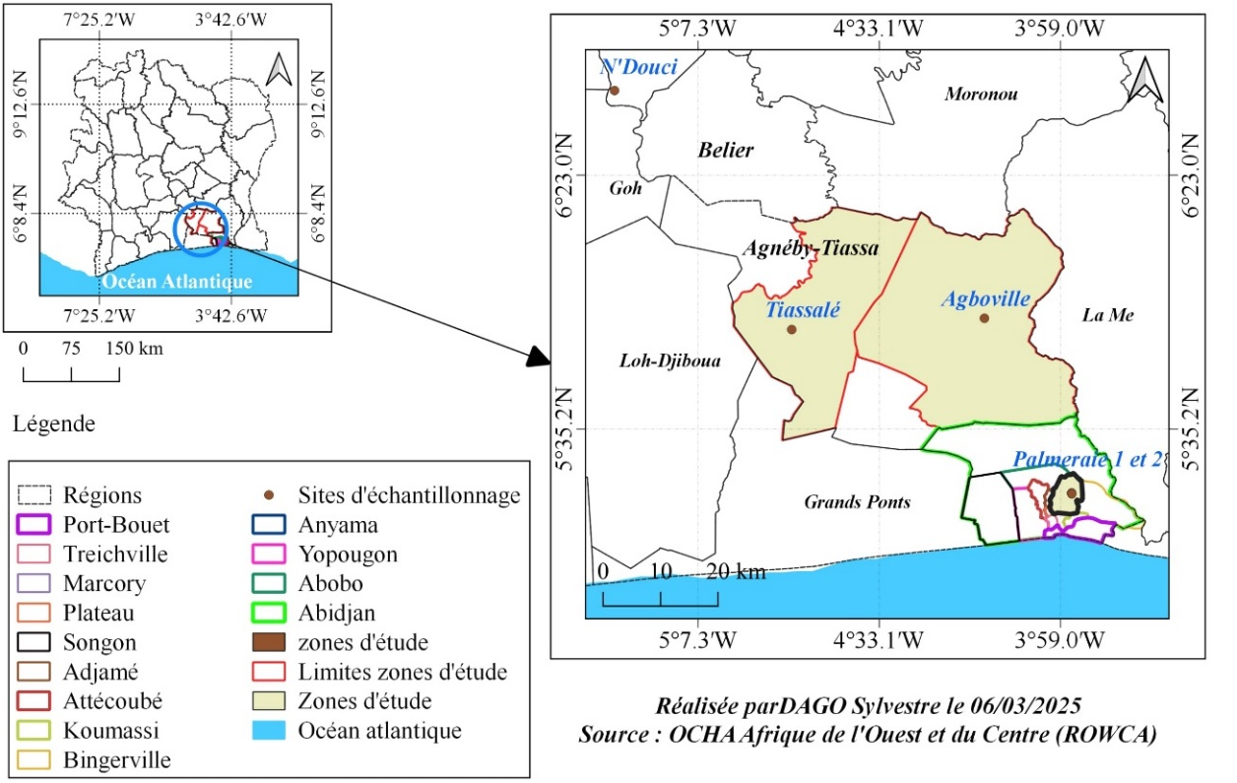

**Fig. 1. Location of study areas**

**2.2 Study materials**

The study involved samples of soil and plantain trunks from four major localities: Cocody palm grove, Agboville, Tiassalé, and N'douci. Sample collection took place from March **2024 to February 2025**.

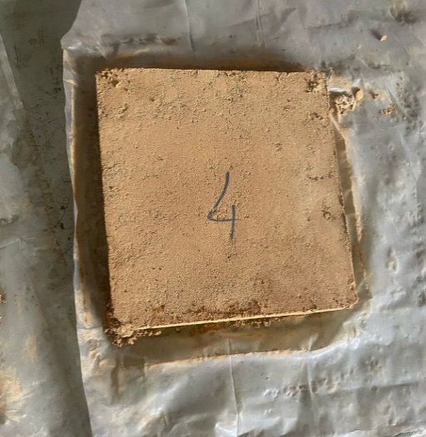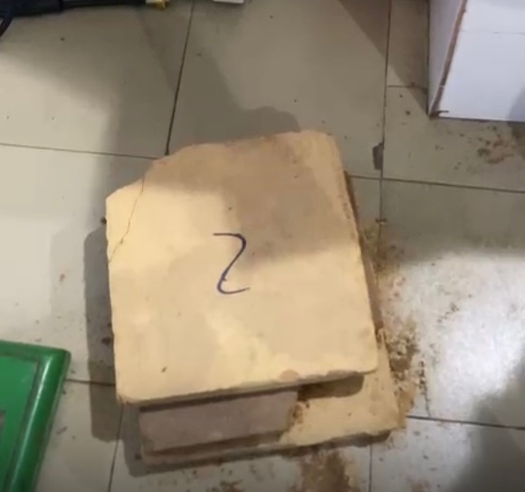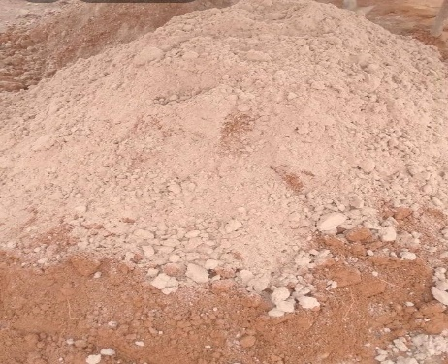

**Earth + Sand**

SCEBwithBSP

**Banana powder after processing**

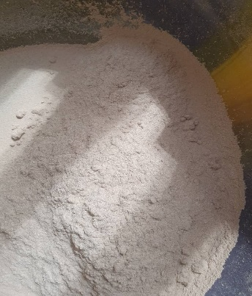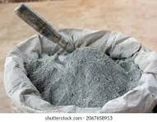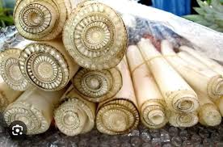

**Collected banana tree trunks**

**Cement extra**

SCEB with cement

**Fig.2. Photographs of soil samples, banana trunk and SCEB**

**2.3 Technical equipment**

SCEB production relies on a set of specialized equipment that guarantees the quality and precision of the tests. For sample production, a mixer ensures the homogeneity of the mixes, while a SCEB mold is used to obtain blocks with standardized dimensions. The flexural press and the hydraulic compression press, equipped with load sensors, are used to evaluate the flexural and compressive strength respectively. Proctor and CBR tests require specific molds, compaction rams, and a CBR press to measure the bearing capacity of the materials. An oven is essential for drying and determining the optimal humidity, supplemented by a precision balance for mass control. Measuring instruments such as a caliper, a thermometer, and a hygrometer ensure control of dimensions and ambient conditions, while simple tools such as a wheelbarrow facilitate material logistics on the construction site. All of this equipment ensures the reliability, reproducibility, and performance of the manufactured SCEB.

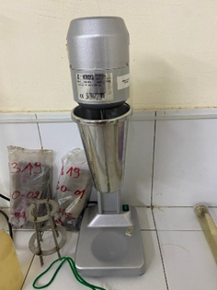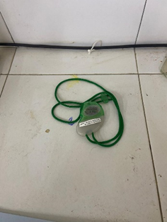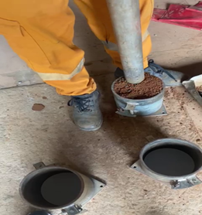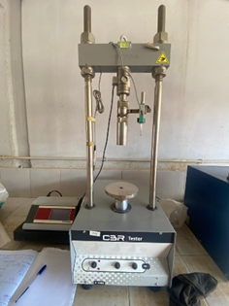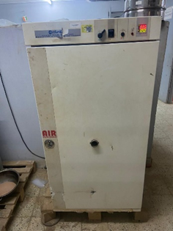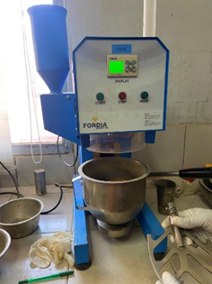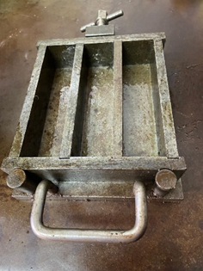

Mold

Mixer

Etuve

Press at CBR

Stopwatch

Mold + Lady Proctor

Electric Stirrer

Balance



Fig. 3. Some illustrations of the technical equipment used

**2.4 Choice of sampling areas and sites**

Soil and banana trunk samples for the production of SCEB were collected in four locations in Côte d'Ivoire: Cocody-Palmeraie, Agboville, Tiassalé, and N'Douci. These sites were selected for their soil quality, pedoclimatic diversity, and strong agricultural potential, particularly for plantain cultivation. Cocody-Palmeraie, despite its urban character, has suitable agricultural pockets, while Agboville stands out for its fertile soils and favorable climate. Tiassalé, with its hydromorphic soils and streams, benefits from constant humidity, and N'Douci has rich soils associated with a humid climate. This diversity ensures representative samples, while taking into account the influence of soil types and climatic conditions on SCEB performance. Finally, the good road accessibility of these sites facilitates transport to the laboratories and ensures the rigor of the study.

**2.5** **Sample collection**

Sampling was carried out at one site per study area, with the selection of specific plots. Four soil samples and four banana trunk samples were randomly collected from each site, carefully packaged in new bags and labeled to ensure their traceability. Three sampling campaigns were carried out over an eleven-month period, from March 2024 to February 2025, resulting in a total of 30 composite samples. All samples were transported to the Cocody-Palmeraie site for treatment and to the LBTB laboratory for analysis.

**2.6** **Processing process of plantain trunks collected from the study sites**

After collecting the plantain trunks from the study sites, a treatment was carried out to ensure the quality of subsequent analyses. The fibers were first extracted, carefully cleaned, and then cut into homogeneous fragments to facilitate the following steps. These samples were then placed in an oven at 105 °C to eliminate any residual moisture, thus preventing any alteration that could affect the analytical results. Once dried, they were ground using a laboratory mill until a fine and homogeneous powder was obtained, essential to ensure the reproducibility of the analyses. The powder thus obtained was carefully packaged in airtight bags to preserve its physicochemical properties before being subjected to the various planned analyses.

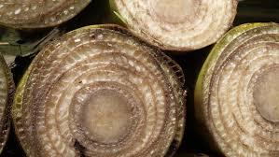

Banana tree trunk

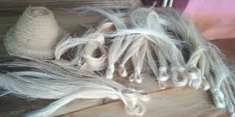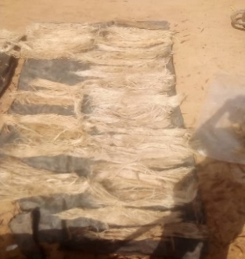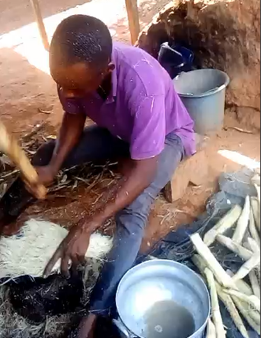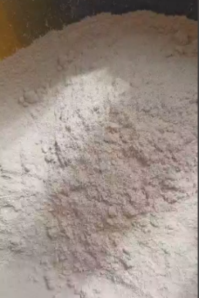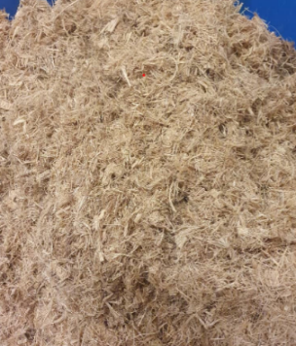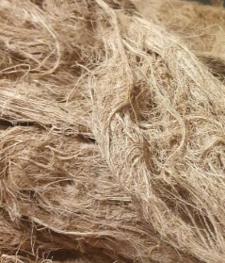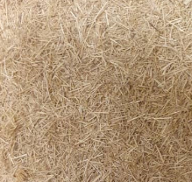

Banana trunk powder

Fresh fiber

Drying

Storage

Fiber extraction

Fibre fine

Cutting

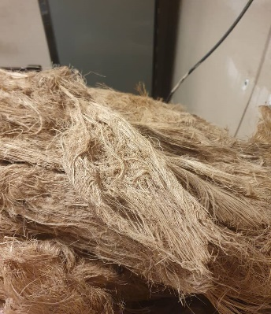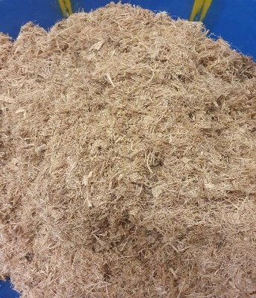

A

B1

C

B2

**Fig.4. Banana trunk powder production flow chart**

**2.7 Choice of mixing plan**



A

B1

C

B2



A

B1

C

B2

The mixing plan was developed using the factorial design of experiments method, in accordance with ISO 16269-8, to optimize binder proportions. Design-Expert 3 software was used to generate a rigorous plan comprising 30 tests per mix, i.e. 60 tests. Two formulations were studied: earth + sand + banana trunk powder and earth + sand + cement. This experimental strategy makes it possible to determine the optimal compositions, by evaluating the mechanical performance of the composites, to meet the requirements of durability and quality in construction.

Table 1. Mixing plan for material with banana trunk powder

|  |  |  |  |  |  |  |  |  |  |  |  |  |  |
| --- | --- | --- | --- | --- | --- | --- | --- | --- | --- | --- | --- | --- | --- |
| **Test** | **Component 1 A: Clay + Sand %** | **Component 2 B: Plantain banana trunk powder %** | **Component 3 C: Water %** | **Component 1 A: Clay + Sand %** | **Component 2 B: Plantain banana trunk powder %** | **Component 3 C: Water %** | **Test** | **Component 1 A: Clay + Sand %** | **Component 2 B: Plantain banana trunk powder %** | **Component 3 C: Water %** | **Component 1 A: Clay + Sand %** | **Component 2 B: Plantain banana trunk powder %** | **Component 3 C: Water %** |
| 1 | 13.5 | 0.27 | 1.215 | 100% | 2% | 9% | 16 | 13.5 | 0.81 | 1.62 | 100% | 6% | 12% |
| 1 | 1350 | 27 | 121.5 | 1350 | 27 | 121.5 | 16 | 1350 | 81 | 162 | 1350 | 81 | 162 |
| 2 | 13.5 | 0.27 | 1.35 | 100% | 2% | 10% | 17 | 13.5 | 0.81 | 1.755 | 100% | 6% | 13% |
| 2 | 1350 | 27 | 135 | 1350 | 27 | 135 | 17 | 1350 | 81 | 175.5 | 1350 | 81 | 175.5 |
| 3 | 13.5 | 0.27 | 1.465 | 100% | 2% | 11% | 18 | 13.5 | 0.81 | 1.89 | 100% | 6% | 14% |
| 3 | 1350 | 27 | 146.5 | 1350 | 27 | 146.5 | 18 | 1350 | 81 | 189 | 1350 | 81 | 189 |
| 4 | 13.5 | 0.27 | 1.62 | 100% | 2% | 12% | 19 | 13.5 | 1.08 | 1.215 | 100% | 8% | 9% |
| 4 | 1350 | 27 | 162 | 1350 | 27 | 162 | 19 | 1350 | 108 | 121.5 | 1350 | 108 | 121.5 |
| 5 | 13.5 | 0.27 | 1.755 | 100% | 2% | 13% | 20 | 13.5 | 1.08 | 1.35 | 100% | 8% | 10% |
| 5 | 1350 | 27 | 175.5 | 1350 | 27 | 175.5 | 20 | 1350 | 108 | 135 | 1350 | 108 | 135 |
| 6 | 13.5 | 0.27 | 1.89 | 100% | 2% | 14% | 21 | 13.5 | 1.08 | 1.465 | 100% | 8% | 11% |
| 6 | 1350 | 27 | 189 | 1350 | 27 | 189 | 21 | 1350 | 108 | 146.5 | 1350 | 108 | 148.5 |
| 7 | 13.5 | 0.54 | 1.215 | 100% | 4% | 9% | 22 | 13.5 | 1.08 | 1.62 | 100% | 8% | 12% |
| 7 | 1350 | 54 | 121.5 | 1350 | 54 | 121.5 | 22 | 1350 | 108 | 162 | 1350 | 108 | 162 |
| 8 | 13.5 | 0.54 | 1.35 | 100% | 4% | 10% | 23 | 13.5 | 1.08 | 1.755 | 100% | 8% | 13% |
| 8 | 1350 | 54 | 135 | 1350 | 54 | 135 | 23 | 1350 | 108 | 175.5 | 1350 | 108 | 175.5 |
| 9 | 13.5 | 0.54 | 1.465 | 100% | 4% | 11% | 24 | 13.5 | 1.08 | 1.89 | 100% | 8% | 14% |
| 9 | 1350 | 54 | 146.5 | 1350 | 54 | 148.5 | 24 | 1350 | 108 | 189 | 1350 | 108 | 189 |
| 10 | 13.5 | 0.54 | 1.62 | 100% | 4% | 12% | 25 | 13.5 | 1.35 | 1.215 | 100% | 10% | 9% |
| 10 | 1350 | 54 | 162 | 1350 | 54 | 162 | 25 | 1350 | 135 | 121.5 | 1350 | 135 | 121.5 |
| 11 | 13.5 | 0.54 | 1.755 | 100% | 4% | 13% | 26 | 13.5 | 1.35 | 1.35 | 100% | 10% | 10% |
| 11 | 1350 | 54 | 175.5 | 1350 | 54 | 175.5 | 26 | 1350 | 135 | 135 | 1350 | 135 | 135 |
| 12 | 13.5 | 0.54 | 1.89 | 100% | 4% | 14% | 27 | 13.5 | 1.35 | 1.465 | 100% | 10% | 11% |
| 12 | 1350 | 54 | 189 | 1350 | 54 | 189 | 27 | 1350 | 135 | 146.5 | 1350 | 135 | 148.5 |
| 13 | 13.5 | 0.81 | 1.215 | 100% | 6% | 9% | 28 | 13.5 | 1.35 | 1.62 | 100% | 10% | 12% |
| 13 | 1350 | 81 | 121.5 | 1350 | 81 | 121.5 | 28 | 1350 | 135 | 162 | 1350 | 135 | 162 |
| 14 | 13.5 | 0.81 | 1.35 | 100% | 6% | 10% | 29 | 13.5 | 1.35 | 1.755 | 100% | 10% | 13% |
| 14 | 1350 | 81 | 135 | 1350 | 81 | 135 | 29 | 1350 | 135 | 175.5 | 1350 | 135 | 175.5 |
| 15 | 13.5 | 0.81 | 1.465 | 100% | 6% | 11% | 30 | 13.5 | 1.35 | 1.89 | 100% | 10% | 14% |
| 15 | 1350 | 81 | 146.5 | 1350 | 81 | 148.5 | 30 | 1350 | 135 | 189 | 1350 | 135 | 189 |

**Table 2. Mixing plan for material with cement**

|  |  |  |  |  |  |  |  |  |  |  |  |  |  |
| --- | --- | --- | --- | --- | --- | --- | --- | --- | --- | --- | --- | --- | --- |
| **Test** | **Component 1 A: Clay + Sand %** | **Component 2 B:Cement %** | **Component 3 C: Water %** | **Component 1 A: Clay + Sand %** | **Component 2 B:Cement %** | **Component 3 C: Water %** | **Test** | **Component 1 A: Clay + Sand %** | **Component 2 B:Cement %** | **Component 3 C: Water %** | **Component 1 A: Clay + Sand %** | **Component 2 B:Cement %** | **Component 3 C: Water %** |
| 1 | 13.5 | 0.27 | 1.215 | 100% | 2% | 9% | 16 | 13.5 | 0.81 | 1.62 | 100% | 6% | 12% |
| 1 | 1350 | 27 | 121.5 | 1350 | 27 | 121.5 | 16 | 1350 | 81 | 162 | 1350 | 81 | 162 |
| 2 | 13.5 | 0.27 | 1.35 | 100% | 2% | 10% | 17 | 13.5 | 0.81 | 1.755 | 100% | 6% | 13% |
| 2 | 1350 | 27 | 135 | 1350 | 27 | 135 | 17 | 1350 | 81 | 175.5 | 1350 | 81 | 175.5 |
| 3 | 13.5 | 0.27 | 1.465 | 100% | 2% | 11% | 18 | 13.5 | 0.81 | 1.89 | 100% | 6% | 14% |
| 3 | 1350 | 27 | 146.5 | 1350 | 27 | 146.5 | 18 | 1350 | 81 | 189 | 1350 | 81 | 189 |
| 4 | 13.5 | 0.27 | 1.62 | 100% | 2% | 12% | 19 | 13.5 | 1.08 | 1.215 | 100% | 8% | 9% |
| 4 | 1350 | 27 | 162 | 1350 | 27 | 162 | 19 | 1350 | 108 | 121.5 | 1350 | 108 | 121.5 |
| 5 | 13.5 | 0.27 | 1.755 | 100% | 2% | 13% | 20 | 13.5 | 1.08 | 1.35 | 100% | 8% | 10% |
| 5 | 1350 | 27 | 175.5 | 1350 | 27 | 175.5 | 20 | 1350 | 108 | 135 | 1350 | 108 | 135 |
| 6 | 13.5 | 0.27 | 1.89 | 100% | 2% | 14% | 21 | 13,5 | 1.08 | 1.465 | 100% | 8% | 11% |
| 6 | 1350 | 27 | 189 | 1350 | 27 | 189 | 21 | 1350 | 108 | 146.5 | 1350 | 108 | 148.5 |
| 7 | 13.5 | 0.54 | 1.215 | 100% | 4% | 9% | 22 | 13.5 | 1.08 | 1.62 | 100% | 8% | 12% |
| 7 | 1350 | 54 | 121.5 | 1350 | 54 | 121.5 | 22 | 1350 | 108 | 162 | 1350 | 108 | 162 |
| 8 | 13.5 | 0.54 | 1.35 | 100% | 4% | 10% | 23 | 13.5 | 1.08 | 1.755 | 100% | 8% | 13% |
| 8 | 1350 | 54 | 135 | 1350 | 54 | 135 | 23 | 1350 | 108 | 175.5 | 1350 | 108 | 175.5 |
| 9 | 13.5 | 0.54 | 1.465 | 100% | 4% | 11% | 24 | 13.5 | 1.08 | 1.89 | 100% | 8% | 14% |
| 9 | 1350 | 54 | 146.5 | 1350 | 54 | 148.5 | 24 | 1350 | 108 | 189 | 1350 | 108 | 189 |
| 10 | 13.5 | 0.54 | 1.62 | 100% | 4% | 12% | 25 | 13.5 | 1.35 | 1.215 | 100% | 10% | 9% |
| 10 | 1350 | 54 | 162 | 1350 | 54 | 162 | 25 | 1350 | 135 | 121.5 | 1350 | 135 | 121.5 |
| 11 | 13.5 | 0.54 | 1.755 | 100% | 4% | 13% | 26 | 13.5 | 1.35 | 1.35 | 100% | 10% | 10% |
| 11 | 1350 | 54 | 175.5 | 1350 | 54 | 175.5 | 26 | 1350 | 135 | 135 | 1350 | 135 | 135 |
| 12 | 13.5 | 0.54 | 1.89 | 100% | 4% | 14% | 27 | 13.5 | 1.35 | 1.465 | 100% | 10% | 11% |
| 12 | 1350 | 54 | 189 | 1350 | 54 | 189 | 27 | 1350 | 135 | 146.5 | 1350 | 135 | 148.5 |
| 13 | 13.5 | 0.81 | 1.215 | 100% | 6% | 9% | 28 | 13.5 | 1.35 | 1.62 | 100% | 10% | 12% |
| 13 | 1350 | 81 | 121.5 | 1350 | 81 | 121.5 | 28 | 1350 | 135 | 162 | 1350 | 135 | 162 |
| 14 | 13.5 | 0.81 | 1.35 | 100% | 6% | 10% | 29 | 13.5 | 1.35 | 1.755 | 100% | 10% | 13% |
| 14 | 1350 | 81 | 135 | 1350 | 81 | 135 | 29 | 1350 | 135 | 175.5 | 1350 | 135 | 175.5 |
| 15 | 13.5 | 0.81 | 1.465 | 100% | 6% | 11% | 30 | 13.5 | 1.35 | 1.89 | 100% | 10% | 14% |
| 15 | 1350 | 81 | 146.5 | 1350 | 81 | 148.5 | 30 | 1350 | 135 | 189 | 1350 | 135 | 189 |

**2.8 Production stage**

The production of stabilized compressed earth blocks (CSEB) follows a rigorous protocol starting with the preparation of 1350 g batches, weighed according to ISO 11464, then homogenized in accordance with ISO 17892-2 before molding into standardized shapes. The samples are then subjected to controlled curing in a climatic cabinet, under precise temperature and humidity conditions, for 28 and 90 days according to ISO 12571, simulating the progressive hardening of the material. At the end of each period, mechanical bending and compression tests, carried out according to ISO 679, make it possible to evaluate the capacity of the CSEB to withstand mechanical stress, thus guaranteeing the reliability and durability of the materials obtained.

3. results and discussion

The results of the 90-day curing tests show that the mechanical strength of SCEB increases significantly with maturation time. The addition of banana trunk powder improves compressive and flexural strength at low dosages, while enhancing durability against climatic aggressions. This development confirms that curing time is a determining parameter for optimizing the mechanical and environmental performance of SCEB, promoting their use as a sustainable alternative to conventional materials.

**3.1 Results**

**3.1.1 90-day formulations with added banana trunk powder fiber**

Analysis of the mechanical performance of BTCS formulated with soil, sand and banana tree trunk powder (BTP) shows that the curing time strongly influences the strength. At 2% BTP, the mixture shows the best performance, reaching 1.89 ± 0.01 MPa in bending and 6.84 ± 0.12 MPa in compression after 90 days of curing, compared to 0.82 ± 0.10 MPa in bending and 3.91 ± 0.58 MPa in compression at 28 days, i.e. a near doubling of the strengths. In contrast, increasing the PTB content to 10% results in a significant deterioration in properties, with strengths reduced to 0.35 ± 0.02 MPa in bending and 0.27 ± 0.01 MPa in compression at 90 days, compared to 0.22 ± 0.00 MPa in bending and 0.62 ± 0.02 MPa in compression at 28 days. This drop reflects a negative effect of fiber overload on the long-term cohesion of the material. These results demonstrate that the combination of an optimal dosage of 2% PTB and a curing time of 90 days significantly improves the mechanical performance of SCEB, while excessive dosages impair their durability.

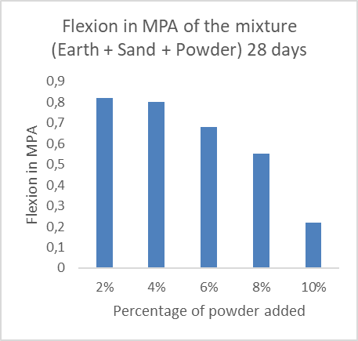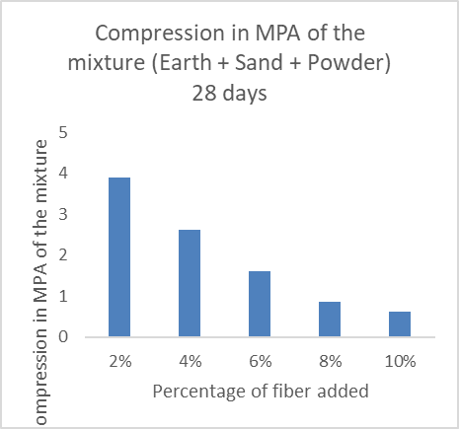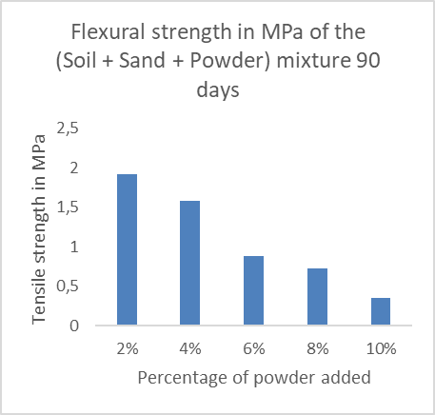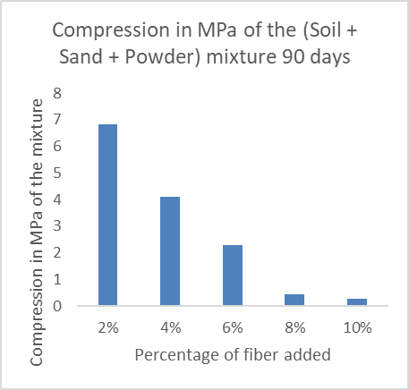

**Fig.5. Flexural and compression values of powder percentages 28 and 90 days of curing**

**3.1.2 formulations with added banana trunk powder fiber**

The performance analysis of SCEB based on earth, sand and cement shows a linear evolution of the mechanical resistance as a function of the cement content and the curing time. At 2% cement, the resistances increase from 0.51 ± 0.06 MPa in flexion and 2.51 ± 0.07 MPa in compression at 28 days, to 0.55 ± 0.04 MPa in flexion and 2.58 ± 0.12 MPa in compression at 90 days, i.e. a moderate progression. On the other hand, at 10% cement, the performances improve significantly, reaching 2.59 ± 0.31 MPa in flexion and 12.32 ± 0.66 MPa in compression at 28 days, then 4.02 ± 0.07 MPa in flexion and 18.77 ± 0.36 MPa in compression at 90 days, which represents a significant improvement over time. This regular progression confirms the effectiveness of cement as a hydraulic binder, particularly at high dosages, allowing the resistance of SCEB to be optimized over the long term. The extension of the curing time to 90 days thus considerably amplifies the mechanical performances, consolidating the essential role of cement in the formulation of stabilized materials.

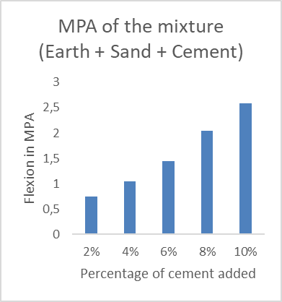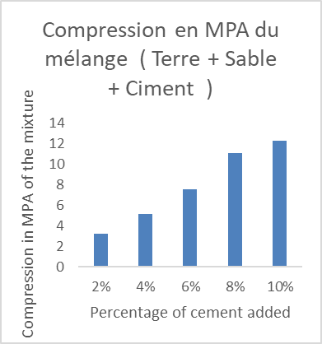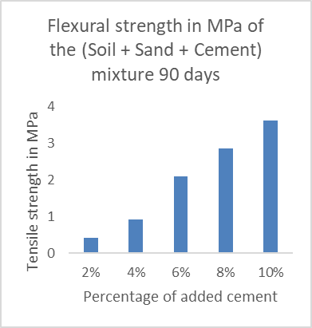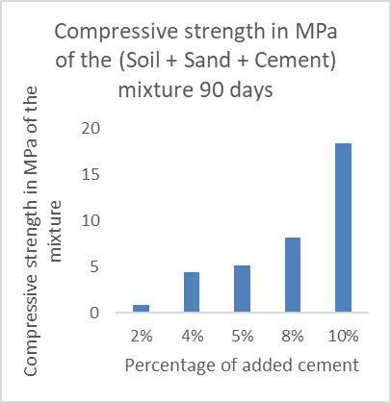

Fig.6. Flexural and compressive values of cement percentages 28 and 90 days of curing

**3.2 Discussion**

Overall, the results clearly highlight the determining impact of the 90-day curing time on the mechanical performance of compressed and stabilized earth blocks (CSEBs), whether formulated with banana trunk powder (BTB) or cement. For CSEBs incorporating PTB, the results confirm that an optimal dosage of 2% coupled with prolonged curing significantly improves the flexural and compressive strength compared to the values recorded at 28 days. This improvement can be explained by the better internal cohesion and densification of the material under the effect of slow drying and stress redistribution, in agreement with several studies on bio-based composites, although there are variations in the results depending on the formulations used and the types of fibers **(Soumaila *et al.,* 2022)**. However, beyond 2%, particularly at 10%, the fiber overload weakens the matrix, reduces compactness and leads to a significant deterioration in performance, a phenomenon also documented in the literature on the limits of incorporation of plant fibers **(Guemidi *et al.,* 2024; Belaribi *et al.,* 2024)**. This highlights the importance of a strictly controlled dosage combined with sufficient curing time to ensure an optimal balance between mechanical strength and durability.

For cement-based SCEB, the performance evolution is linear and proportional to the cement content. At low levels (2%), the increase in strength between 28 and 90 days remains moderate, indicating that the hydration process is less efficient at low concentrations **(Goutsaya *et al.,* 2022; Hall *et al.,* 2022)**. In contrast, at 10% cement, mechanical performance increases significantly, reaching 4.02 MPa in flexure and 18.77 MPa in compression after 90 days, compared to 2.59 MPa and 12.32 MPa at 28 days, respectively. This improvement is due to the continuation of hydration reactions that lead to the formation of CSH gels, the main contributors to the strength of the material, in accordance with current observations on cementitious materials **(Achour *et al.,* 2024; Kushi, 2022)**. However, this increase in performance is potentially accompanied by an increased environmental impact, particularly in terms of CO₂ emissions and thermal conductivity, raising the question of the trade-off between mechanical resistance and ecological sustainability, a subject which is often discussed in the literature **(Skałba, 2022; Morin, 2022)**.

4. Conclusion

Ultimately, the comparative analysis of the two formulations shows that the extended 90-day cure optimizes the performance of SCEB, with maximum efficiency for 2% PTB, which offers a good balance between durability, strength, and low environmental impact. Conversely, although high-content cement ensures superior mechanical performance, it remains penalized by its environmental effects. These results confirm the importance of combining a reasonable dosage of binders with an adequate curing time to promote sustainable, high-performance construction materials that respect current climate issues.

**DISCLAIMER (ARTIFICIAL INTELLIGENCE)**

Author(s) hereby declares that NO generative AI technologies such as Large Language Models (ChatGPT, COPILOT, etc) and text-to-image generators have been used during writing or editing of this manuscript.

References

* **Abouhelal , D., Kamel, W., & Bassioni, H. (2023).** Informatic analysis and review of literature on the optimum selection of sustainable materials used in construction projects. International Journal of Sustainable Construction Engineering Technology, 14(1).
* **Achour, M., Belas, N., & Sadok, R. (2024).** The effect of incorporating calcined sediments and perlite as a partial replacement for cement on the behavior of mortars. The Journal of Engineering and Exact Sciences, 10(2), 18696.
* **Ait Salem, A. A., Benchouk, A., & Belayachi, N. (2023).** Influence of silica fume on the mechanical, thermal and water absorption behavior of compressed earth bricks. *MRS Advances*, *8*(17), 976-981.
* **Arairo, W., Daher, N., Bachawati, M., Absi, J., & Saba, M. (2023).** Alternative stabilisation method for unfired earth blocks. E3s Web of Conferences, 436, 08002.
* **Arduin , D., Caldas, L., Paiva, R., & Rocha, F. (2022).** Life cycle assessment ( LCA ) in earth construction: a systematic literature review considering five construction techniques. Sustainability , 14(20), 13228.
* **Belaribi , O., Safer, O., Belas, N., Belguesmia , K., & Sadok, R. (2024).** Influence of perlite on the mechanical behavior, capillary absorption and thermal conductivity of mortars. The Journal of Engineering and Exact Sciences, 10(3), 18800.
* **Droutsa, K., Balaras, C., Dascalaki, E., Kontoyiannidis, S., Moro, A., & Bazzan, E. (2023).** Key performance indicators for sustainable mediterranean buildings and cities. Iop Conference Series Earth and Environmental Science, 1196(1), 012076.
* **Goutsaya, J., Ntamack, G. E., & d’Ouazzane, S. C. (2022).** Damage Modelling of Compressed Earth Blocks Stabilised with Cement. *Advances in Civil Engineering*, *2022*(1), 3342661.
* **Guemidi , I., Taleb, H., & Abdelaziz, Y. (2024).** Effect of w/c ratio on the rheological and physico-mechanical behavior of high-performance concrete made from natural pozzolan. The Journal of Engineering and Exact Sciences, 10(2), 17490.
* **Hall, E., Pulatsu , B., Erdogmus , E., & Skourup, B. (2022).** Compression, tension, and fracture energy properties of compressed cement-stabilized earth blocks. *Journal of Architectural Engineering* , *28* (1), 06021005.
* **Iwuanyanwu , O., Gil- Ozoudeh , I., Okwandu , A., & Ike, C. (2024).** The role of green building materials in sustainable architecture: innovations, challenges, and future trends. International Journal of Applied Research in Social Sciences, 6(8), 1935-1950.
* **Jaafar, A., Abbas, Z., & Allawi, A. (2023).** Studying sustainable concrete block production efficiency: a review. Journal of Engineering, 29(09), 134-149.
* **Kushi , C. (2022).** Effect of acid chemical activation on the adsorption properties of some clay materials from the south-east of the Democratic Republic of Congo . Congolese Journal of Sciences & Technologies, 2(4), 469-477.
* **Morin, J. (2022).** Smartphone applications for performance analysis: a laboratory in your pocket. Movement & Sport Sciences - Science & Motricité, (118), 61-68.
* **Skałba , A. (2022).** What can the translation of the mental representation of syntactic structures reveal? The case of the past composed of the present perfect . SHS Web of Conferences , 138, 09009.
* **Soumaila, B., Koné, B., Honore, K., & Alex, M. (2022).** Characterization and reinforcement of properties Geotechnical properties of earth bricks with the addition of rice straw. European Scientific Journal Esj, 8, 230.