**Original Research Article**

**Covid-19 epidemiology in the southern Brazilian states from 2020 to 2024**

.

ABSTRACT

|  |
| --- |
| **Aims:** analyze the epidemiology of Covid-19 in southern Brazil from 2020 to 2024  **Study design:** this is an epidemiological, descriptive and cross-sectional study.  **Place and Duration of Study:** Brazil. held from April to June 2024.  **Methodology:** used data from the Department of Informatics of the Unified Health System. The incidence, mortality and lethality rates for Covid-19 in the states and municipalities of the southern region of Brazil were calculated.  **Results:** Paraná recorded the highest mortality (410,1) and lethality (1,6%) from Covid-19 among the three states. Cases and deaths were more concentrated in the international border regions with Argentina and Paraguay and on the national borders with the states of Mato Grosso do Sul and São Paulo, as well as in the coastal regions.In 2022, the highest incidence was recorded in all the states in the region, while the highest lethality and mortality rates occurred in 2021.  **Conclusion:** Covid-19 mortality and lethality were not homogeneous among the states of the Southern region. The distribution of mortality and lethality in the region, in each year evaluated, may be due to the stage of immunization of the population and the predominant variant. |

*Keywords: Coronavirus; Lethality; Mortality; Pandemic; Epidemiology.*

1. INTRODUCTION

The novel coronavirus is a strain of the coronavirus family, first identified in humans in December 2019 in Wuhan, China (OPAS, 2023). SARS-CoV-2 causes COVID-19, an acute, potentially severe, and highly transmissible infectious disease. On January 30, 2020, the World Health Organization declared COVID-19 a public health emergency of international concern, and on March 11, 2020, it declared it a pandemic due to its widespread global distribution. In Brazil, the first case of Covid-19 was reported on February 26, 2020, and as of March 17, 2023, the country had record 37,145,514 cases and 699,634 deaths (Brasil, 2024).

The Brazilian epidemiological scenario regarding Covid-19 is complex due to the country’s vast territorial extent and the climatic, environmental, cultural, and socioeconomic heterogeneity characteristic of each region. Therefore, it is evident that the distribution of cases and deaths across the various Brazilian regions and states did not occur uniformly, varying according to the factors described above (Brito *et al*., 2023).

The southern region of Brazil comprises the states of Santa Catarina, Paraná, and Rio Grande do Sul and has the highest Human Development Indexes in the country. According to the data, Santa Catarina, Rio Grande do Sul, and Paraná have Human Development Indexes of 0.792, 0.771, and 0.769, respectively. Among the studies conducted in the southern region that aimed to compare the prevalence of Covid-19 cases and deaths among its states, two were based solely on data from 2020 (Lopes *et al*., 2020 and Klokner *et al*., 2021). Another study compared data between Santa Catarina and Paraná for the period from 2020 to 2022 (Brito *et al*., 2023). These data are considered partial, as the international public health emergency due to Covid-19 was only declared over in May 2023, and the pandemic situation has not yet been eradicated (Klokner *et al*., 2021 and Brito *et al.,* 2023).

Thus, despite the lower severity of cases and the significant reduction in the number of deaths, epidemiological studies on COVID-19 are essential to provide public health indicators that support disease monitoring, tracking and planning for the management of current and future pandemics. In this context, this study analyzed Covid-19 epidemiological data from the states of southern Brazil available at the Department of Informatics of the Unified Health System, covering the period from 2020 to 2024.

2. methodology

**2.1 Study characteristics**

Epidemiological, cross-sectional, descriptive study.

**2.2 Data collection**

Data were collected from the interactive panel of the Department of Informatics of the Unified Health System, covering epidemiological weeks 13 of 2020 through 17 of 2024. The variables collected included the number of cases and deaths for the three states in the southern region of Brazil, as well as for each of the 1.191 municipalities within region.

The incidence, mortality, and lethality rates were calculated and stratified for each year from 2020 to 2024, for each of the three states and for each of the 1.191 municipalities in the southern region. Population data from the Brazilian Institute of Geography and Statistics were used for these calculations, considering each year from 2020 to 2024 and each state in the southern region. The data were organized and analyzed using Microsoft Excel.

**2.3 Data analysis**

Data on incidence, mortality, and case fatality rates for both states and municipalities were analyzed from an epidemiological perspective. The Kruskal–Wallis test was used to compare and correlate incidence, mortality, and case fatality rates across the three states in the southern region. A significance level of p <0,005 were considered. The association between variables was assessed using the Chi-square test in the Past software.

Maps illustrating the spatial distribution of incidence and mortality in the region were created using the Matlab program. The 1.191 municipalities were grouped into four categories based on incidence: 0-5.000, 5.001-20.000, 20.001- 40.000, and more than 40.000 cases per 100.000 inhabitants. For mortality, municipalities were stratified into the following categories: 0-100, 101-200, 201-500, and over 500 COVID-19 deaths per 100.000 inhabitants.

3. results

Rio Grande do Sul (RS) recorded the highest incidence of Covid-19 during the evaluated period, with 28,886.6/100.000 inhabitants, followed by Santa Catarina (SC), with 27,353.8 cases per 100.000 inhabitants. Paraná (PR) had the lowest incidence at 26,367.3 cases per 100.000 inhabitants but exhibited the highest mortality rate at 410,1 deaths per 100.000 inhabitants and the highest case fatality rate at 1,6%. Rio Grande do Sul had a mortality rate of 374,4 deaths per 100.000 inhabitants in a case fatality rate of 1,4%. Among the three stats, Santa Catarina had the lowest mortality rate at 303,5 deaths per 100.000 inhabitants and the lowest case fatality rate at 1,1%.

Regarding the distribution of cases over the analyzed period, it was found that in 2020, Santa Catarina had a higher incidence than the other states, with 6.792,2 case per 100.000 inhabitants, while Rio Grande do Sul registered 3.936,6 and Paraná 3.617,0. In 2021, Santa Catarina also had the higher disease incidence (10,233.0 cases), but the difference compared to the other states was smaller. In 2022, Rio Grande do Sul led the region in the number of cases, with an incidence of 11.825,8, followed by Paraná with 10.906,1. In 2023, incidence rates declined significantly across all three states (Figure 1A).

The highest mortality and lethality rates were recorded between 2020 and 2021, with 2021 standing out as the most critical year of the pandemic. In 2022, despite the higher incidence, there was a decline in both mortality and lethality. From 2023 onwards, mortality rates decreased in the three states, while lethality showed a slight increase compared to 2022. By epidemiological week 17 of 2024, lethality in the three southern states was already comparable to that recorded in the previous year (Figures 1B and 1C).

Despite the higher incidence in 2020 and 2021, Santa Catarina had lower mortality and lethality rates compared to the other evaluated states. In 2020, the mortality rate was 72,5 and the lethality rate was 1,1%. Rio Grande do Sul had a mortality rate of 77,7 and a lethality rate of 2,0%, while Paraná had a mortality rate of 69,2 and a lethality rate of 1,9%. In 2021, Paraná had a mortality rate of 283,4 and a lethality rate of 2,8%, Rio Grande do Sul had a mortality rate of 240,5 and a lethality rate of 2,6%, and Santa Catarina had a mortality rate of 203,5 and a lethality rate of 2,0% (Figures 1B and 1C).

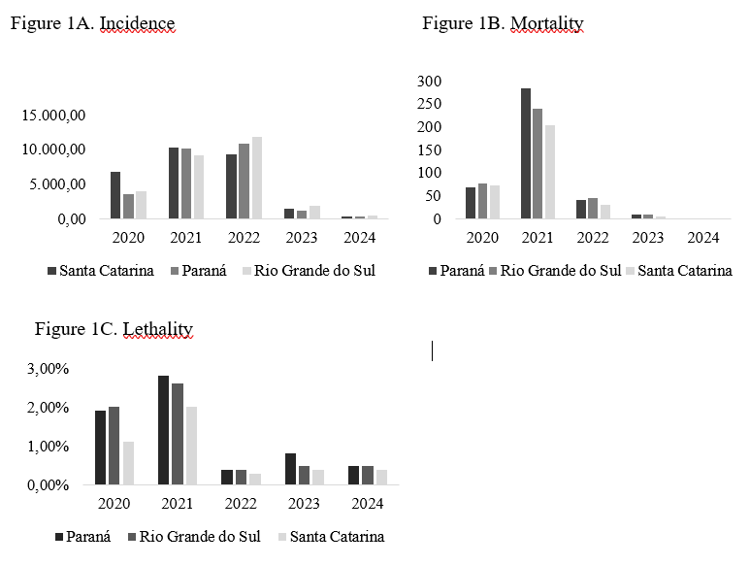

**Figure 1. Incidence, mortality, and lethality rates of COVID-19 in the states of southern Brazil from 2020 to 2024**

No significant differences were observed in the incidence of COVID-19 among the three states of the Southern region (p-value = 0.07) (Figure 2).

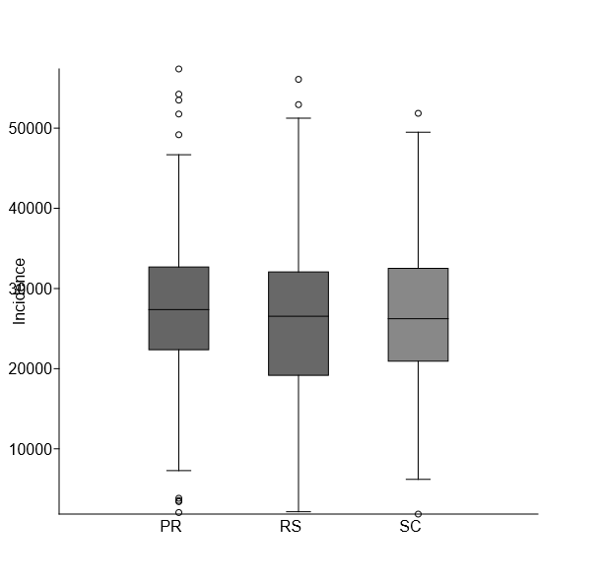

**Figure 2. Comparison of the incidence of COVID-19 in the states of the Southern region of Brazil from 2020 to 2024**

The mortality rate was significantly higher in Paraná (p-value < 0,001), as was the case fatality rate (p-value < 0,001) (Figures 3 and 4).

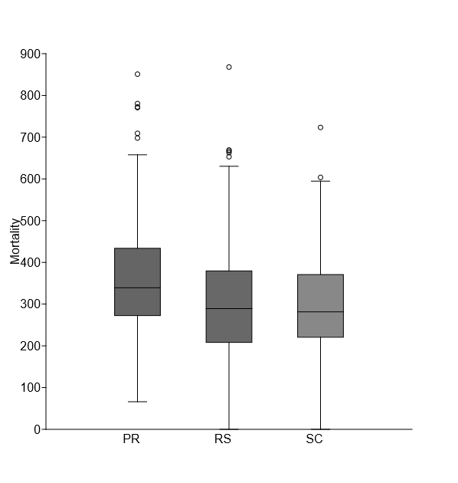

**Figure 3. Comparison of Covid-19 mortality in the states of southern Brazil from 2020 to 2024**

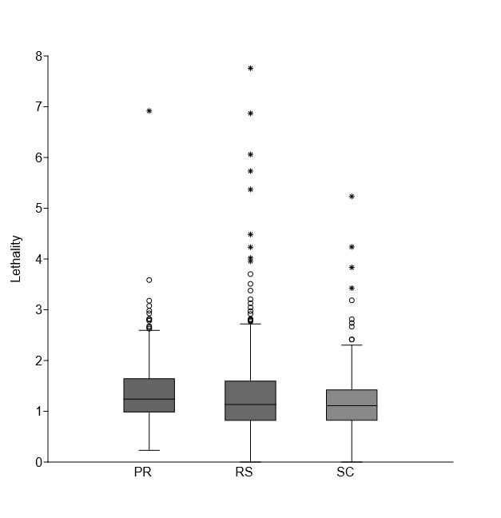

**Figure 4. Comparison of Covid-19 mortality rates in the states of southern Brazil from 2020 to 2024**

The incidence and mortality rates for COVID-19 exhibited similar distribution patterns. It was observed that both cases an deaths were concentrated in municipalities situated in regions bordering Argentina and Paraguay, as well as in areas bordering the states of Mato Grosso do Sul and São Paulo, along with coastal regions (Figure 5).

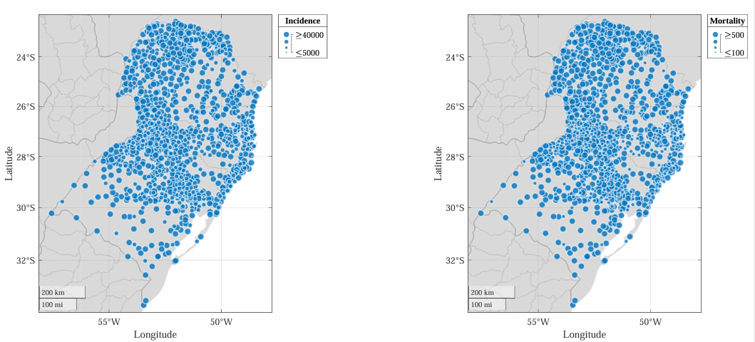

**Figure 5. Distribution of Covid-19 incidence and mortality among the states of southern Brazil from 2020 to 2024**

**4 DISCUSSION**

It was found that, although the southern states varied in the strictness of measures to contain the spread of the pandemic, they generally followed the national trend. The only period during pandemic that involved a significant decrease in human mobility due to restrictions and lockdown measures was between April and May 2020 (Nagamine *et al*., 2020 and Razafindrakoto *et al*., 2024). Additionally, it is also important to consider the underreporting of cases resulting from reduced testing in the states, especially in the first year of the pandemic. This underreporting should therefore be acknowledged as a limitation.

The higher mortality and lethality rates observed in Paraná, along with the differences between them, indicate that the pandemic impacted the state more severely than others. During the pandemic, Paraná had the lowest rate of intensive care unit (ICU) beds dedicated exclusively to COVID-19 (8,99 per 100.000 inhabitants), whereas Santa Catarina had the highest (12,82 per 100.000 inhabitants), followed by Rio Grande do Sul (9,59 per 100.000 inhabitants) (Covre *et al*., 2022). The lower proportion of ICU beds may have contributed to some severe cases not receiving adequate treatment, potentially leading to death (Razini *et al.*, 2021 and Oliveira *et al*., 2022). Factors such as the speed of viral spread, population size, and population density may also explain the severity of the impact on the state. Paraná's population exceeds that of other states in the region and its population density of 57,42 inhabitants per square kilometer is higher than both the national average of 23,86 inhabitants/km2 and in the regional average of 51,0 inhabitants/km2 (Bezerra *et* al., 2020 and IBGE, 2023).

Data on the profile of cases that resulted in death from COVID-19 in the region could contribute to understanding the variations in COVID-19 lethality and mortality among the southern states. It is well established that the disease was more lethal among individuals over 60 years of age, those with comorbidities, and males (Klokner *et al*., 2021; Renck *et al*., 2021 and Oliveira *et al*., 2022). The population of Paraná comprises approximately 16% elderly individuals, whereas in Rio Grande do Sul, this percentage is around 18% (IBGE, 2022). Additionally, literature reports mortality rates between 65% and 70% among populations over 60 years of age in the southern states, particularly in Rio Grande do Sul (Paraná, 2024; Rio Grande do Sul, 2024 and Santa Catarina, 2024). However, the absence of detailed data limited the scope of this analysis. Furthermore, it is not possible to attribute Paraná’s higher mortality and lethality rates solely to a single factor. These outcomes are likely influenced by a combination of factors, including more relaxed prevention measures, higher population density, reduced availability of health services through the Unified Health System (SUS), and a higher proportion of elderly resident in the region.

When comparing Paraná with other regions of the country, it is evident that mortality in Paraná was similar to that in the Midwest (411,3 per 100.000 inhabitants) and higher than in the Southeast (388,2 per 100.000 inhabitants), which recorded the highest mortality rates for the period evaluated. Conversely, the lethality rates in the Southern states were lower than those observed in Brazil most affected regions, such as the Southeast (2,2%), Northeast (1,8%), and North (1,7%) (Brasil, 2024). It is possible that the pandemic manifested less severely in the South due to the greater availability and quality of healthcare services to meet demands (Razini *et al.,* 2021). Nonetheless, it is important to not that Paraná’s mortality rates approached those of the North and Northeast regions, underscoring the severity with which the pandemic particularly impacted the state.

Furthermore, Paraná is located in a geographical area that borders Argentina and Paraguay. Maps depicting the distribution of Covid-19 cases and deaths in the region show a higher concentration of incidence and mortality in the border areas. These border regions are characterized by commuter migration, with increased movement of people for work, tourism, consumption, and use of public services and education. Although these borders were closed for a certain period during the pandemic, economic necessity prompted many individuals to resume their work activities early, as the state’s mitigation measures to reduce the economic impact were insufficient (Silva-Sobrinho *et al*., 2021). Additionally, it should be noted that the border region is heavily influenced by informal economy activities, which involve workers traveling to sell products and services and are often characterized by a lack of social security coverage (Oliveira Neto; Garcia; Spinussi, 2020).

Borders are political territorial boundaries; therefore, neighboring territories may share public health challenges that require coordinated management among municipalities for the development of health surveillance actions. However, this shared management is often difficult, particularly due to differences between the health systems of each country (Santos-Melo *et al*., 2023). During the pandemic, it was observed that joint management of Covid-19 health surveillance between municipalities along international borders did not occur, which contributed to increased contamination and viral spread in these areas (Nagamine *et al*., 2020).

Coastal regions also exhibited a significant concentration of Covid-19 cases, which is believed to be due to the density, concentration, multiplicity, multidirectionality of flows, as well as the large number of people moving within these areas. Additionally, it was observed that the locations with the highest concentrations of incidence and mortality on the maps include inland cities, corroborating data from the literature indicating that inland cities experienced higher numbers of cases and deaths compared to capital cities. This may be related to premature decisions by municipalities to relax social distancing measures, without a basis in state and federal guidelines or in accordance with local realities (Nagamine *et al*., 2020).

The distribution of mortality and lethality in the region across each year evaluated may be influenced by population immunization levels and the predominant viral variant. The highest lethality observed in 2021 reached figures similar to those recorded worldwide, which ranged from 2,0% to 4,2%. In that year, Brazil experienced its second wave of COVID-19, with the Gamma variant predominating (Baethgen *et al.*, 2023). Additionally, social isolation measures were relaxed, while immunization efforts only began to take effect in the second quarter of that year, reaching only 60% of the population. Furthermore, the economically active population was required to return to work despite not yet being fully immunized (Lima *et al*., 2023).

Following national trends in 2022, the southern region recorded more cases of the disease compared to previous years, although mortality rates decreased. In 2022, the third wave of COVID-19 occurred due to the emergence of the more transmissible Omicron variant, which may have contributed to the significant increase in cases (Baethgen *et al.*, 2023). Conversely, the reduction in mortality and lethality is also related to milder symptoms associated with the Omicron variant, as well as widespread immunization efforts that protected the population against complications and death from the disease (Renck *et al*., 2021; Siqueira Junior *et al*., 2021; Brito *et al*., 2023 and Lima *et al*., 2023). In 2022, nearly 80% of Brazilians completed the vaccination schedule (Razafindrakoto *et al*., 2024). In 2023 and 2024, despite ongoing vaccination campaigns, lethality rates increased compared to 2022. This may be due to non-adherence to booster doses, influenced by a wave of misinformation and denialism vaccine efficacy and safety (Baethgen *et al.*, 2023). The complete vaccination schedule is associated with lower mortality rates than incomplete vaccination, regardless of age (Paludetto Junior *et al*., 2023).

5. Conclusion

It can be concluded that Covid-19 mortality and lethality rates were not homogeneous across the three states in the southern region. The distribution of deaths was also not proportional to the number of cases during 2021 and 2022. These findings underscore the importance and necessity of coordinating management of public health emergencies at the federal level. Additionally, they highlight the relevance of non-pharmacological prevention measures, as well as the critical of vaccines in controlling infection, reducing disease severity and decreasing mortality from Covid-19. Therefore, it is essential to invest in health education campaigns aimed at the population to counteract vaccine denialism, which limits vaccination coverage and allows controlled diseases to resurface.

Consent (where ever applicable)

does not apply

Ethical approval (where ever applicable)

does not apply

**COMPETING INTERESTS DISCLAIMER:**

Authors have declared that they have no known competing financial interests OR non-financial interests OR personal relationships that could have appeared to influence the work reported in this paper.

References

Baethgen LF, Veiga ABG, Salvato RS, Carvalho TG, Rispoldi T, & Shiefelbein et al. (2023). SARS-CoV-2 laboratory surveillance during the first year of the COVID-19 pandemic in southern Brazil. Journal of the Brazilian Society of Tropical Medicine, 56: 1-9.

Bezerra ECD, Santos PS, Lisbinski FC, & Dias LC (2020). Spatial analysis of COVID-19 coping conditions: a proposal for a Brazilian Health Infrastructure Index. Ciência e Saúde Coletiva, 25 (12): 4957-4967.

Brazil (2024). Weekly Covid-19 reports. https://www.gov.br/saude/pt-br/assuntos/coronavirus/informes-semanais-covid19/covid-19-situacao-epidemiologica-do-brasil-ate-a-se-10-de-202.

Brazil (2024). Coronavirus Dashboard. https://covid.saude.gov.br/.

Brito AS, Abreu LC, Estrada DA, Cavalcantti MPE, Campos MF, & Carvalho AAS (2023). Three years of the Covid-19 pandemic: comparative analysis of incidence, lethality, and mortality among the states of the southern region of Brazil. J Hum Growth Dev., 33 (3): 1-13.

Covre ER, Pereira, ND, Oliveira, NN, Charlo PB, Oliveira MLF, & Oliveira RR et al. (2022). Spatial correlation of covid-19 with intensive care unit beds in Paraná. Public Health Journal, 56 (14): 1-11.

Brazilian Institute of Geography and Statistics (2023). 2022 Census: Paraná has the 12th highest density in Brazil, with 57.42 inhabitants per square kilometer. https://www.aen.pr.gov.br/Noticia/Censo-2022-Parana-tem-12a-maior-densidade-do-Brasil-com-5742-habitantes-por-km-quadrado#:~:text=O%20Estado%20do%20Paran%C3%A1%20tem,m%C3%A9dia%20da%20regi%C3%A3o%20Sul%2C%2051.

Brazilian Institute of Geography and Statistics (2023). Cities. https://cidades.ibge.gov.br/brasil/sc/sul-brasil/panorama.

Klokner SGM, Luz RA, Araújo PHM, Knapik J, Sales SS, & Torrico G et al. (2021). Epidemiological profile and predictors of risk factors for Covid-19 in the Southern region of Brazil. Research, Society and Development, 10 (3): 1-13.

Lima BDS, Fogaça-Rabito LB, Nishikawa-Yagi MC, Giorio-Dutra-Kreling MC, Rocha LF, & Eiko-Karino M. (2023). Clinical-epidemiological profile of patients with covid-19 admitted to a reference university hospital. Quarterly electronic journal of nursing, (70): 271-283.

Lopes LFD, Faria RM, Lima MP, Kirchhof RS, Almeida DM, Moura GL (2020). Description of the epidemiological profile of COVID-19 in the Southern Region of Brazil. Hygeia, 16:188-198.

Nagamine L, Ferreira G, Kruger C, & Moura R. (2020). Spread of COVID-19 in the land and coastal border areas of Brazil. Tempo do mundo, 23: 204-233.

Oliveira RA, Santos Neto M, Ferreira AGN, Pascoal LM, Bezerra JM, & Dutra, RP et al. (2022). Risk factors and spatial distribution of deaths from COVID-19: an integrative review. Journal of Epidemiology and Infection Control, 2 (1): 1-21.

Oliveira Neto T, Garcia, TSL, & Spinussi, E. (2020). COVID-19 pandemic, borders around the world and air transport in Italy Pandémie de COVID-19, borders in the world and air transport in Italy. Open Edition Journals, (44).

Pan American Health Organization (2023). Coronavirus. https://www.paho.org/pt/topicos/coronavirus?adgroupsurvey={adgroupsurvey}&gad_source=1&gclid=Cj0KCQjwltKxBhDMARIsAG8KnqUhqgOs8298IgPcO6v0clVPK77C6ltZxad8v0chrRQFHrXqaEeLSZcaAlvaEALw_wcB.

Paludetto Junior M, Olak AS, Passarelli-Araújo H, Susuki AM, Aschner M, & Pott-Junior H et al. (2023). COVID-19 vaccination and case fatality rates: a case report in a Brazilian municipality. Cadernos de Saúde Pública, 39 (3): 1-12.

Paraná (2024). Coronavirus epidemiological report bulletin. https://www.saude.pr.gov.br/Pagina/Coronavirus-COVID-19.

Razafindrakoto M, Roubaud F, Castilho MR, Pero V, & Saboia J. (2024). Investigating the ‘Bolsonaro effect’ in the spread of the Covid-19 pandemic: An empirical analysis of observational data in Brazil. Plos One, 1-29.

Razini OT, Bastos LSL, Gelli JGM, Marchesi JF, Baião F, & Hamacher S et al. (2021). Characterisation of the first 25,0000 hospital admissions for COVID-19 in Brazil: a retrospective analysis of nationwide data. Lancet, 9: 407-418.

Renck E, Zipper CB, Fabrino Junior MR, Salgado LAT, Rowe A, & Helena, ETS (2024). Vaccine effectiveness in preventing deaths in people with severe acute respiratory syndrome due to covid-19 in Blumenau, 2021. Epidemiology and Health Services, 33: 1-12.

Rio Grande do Sul (2024). Rio Grande do Sul coronavirus panel. https://ti.saude.rs.gov.br/covid19/.

Santa Catarina (2024). Coronavirus: information and bulletins. https://www.coronavirus.sc.gov.br/boletins/.

Santos-Melo GZ, Andrade SR, Cosme KO, Pereira TCL, Monteiro AX, & Rineiro GMA et al. (2023). Importance and challenges of health surveillance in an international border region: a case study. Health and Society, 32 (3): 1-10.

Silva-Sobrinho RA, Zylli A, Silva RMM, Arcoverde MAM, Deschutter EJ, & Palha PF et al. (2021). Coping with COVID-19 in an international border region: health and economy. Latin American Journal of Nursing, 29: 1-11.

Siqueira Junior D, Morais TC, Portugal I, Cavalcanti MPE, Daboin BEG, & Raimundo RD et al. (2021). Trends in mortality and case fatality due to COVID-19 in the State of Paraná, Southern Brazil: spatiotemporal analysis of one year of the Pandemic. J Hum Growth Dev., 31 (3): 1-14.