Original Research Article
EFFECT OF FOLIAR APPLICATION OF NUTRIENTS ON KERNEL CHARACTERISTICS and COST ECONOMIC RETURNS OF CASHEW (Anacardium occidentale L.) CV. ULLAL-1

Abstract
A field experiment was carried out during 2023-24 at Krishi Vigyan Kendra, Brahmavara, Udupi. The experiment was laid out in Randomized Complete Block Design comprising of nine treatments, each replicated thrice. Results revealed that trees treated with RDF + Nano urea @ 4ml/L + Borax @ 0.1 % + ZnSO4 @ 0.2 % (T9) recorded maximum Shelling percentage (29.64%), Kernel length (24.83 mm), Kernel width (15.88 mm), Kernel weight (2.62 g), Number of kernels per pound (197.67), Kernel grade (WW-180), yield (0.68 t/ha), Cost of treatment (7105 Rs/ha), Total expenditure (31693 Rs/ha), Gross returns (74800 Rs/ha), Net returns (43107 Rs/ha) and B: C ratio (1.36) .Whereas, minimum was observed in control (T1).

Keywords : Cashew, forceps, nano urea, perfect flowers, panicle, raw nut yield.

Introduction
Cashew (Anacardium occidentale L.), a native of Brazil, was introduced to India by the Portuguese in the 16th century primarily for afforestation and soil conservation (Johnson, 1973). Over time, it evolved into a vital plantation crop, significantly contributing to India’s economy through exports. India pioneered international trade in cashew kernels in the early 20th century and remains one of the top global exporters. During 2022–23, the country produced 7.81 lakh tonnes of raw cashew nuts from 11.92 lakh hectares, yet only meets around 50% of the demand for processing, necessitating large-scale imports (DCCD, 2023).
Cashew kernels are prized globally for their high nutritional value, consisting of approximately 48.3% fat, 21.3% protein, and 20.5% carbohydrates. They are rich in unsaturated fatty acids (≈80%) and essential minerals like potassium, phosphorus, magnesium, and iron (Rico et al., 2016). Kernel quality traits such as kernel weight, size, shelling percentage, and oil content are critical determinants of market value. Thus, enhancing these traits through agronomic practices is central to increasing profitability and economic returns for cashew farmers and processors.
Among various agronomic inputs, foliar nutrition using macro- and micronutrients has shown potential in improving flowering, fruit set, and kernel quality. Foliar sprays ensure rapid nutrient absorption and direct utilization in metabolic processes (Ravishankar et al., 2010). Key nutrients like nitrogen, zinc, and boron are known to influence flower induction, nut development, and kernel filling (Marschner, 1995; Abdul Salam, 1997; Kannan et al., 2002). Despite this, limited studies have explored the direct impact of foliar nutrient application on kernel characteristics and economic outcomes, especially under the agro-climatic conditions of coastal Karnataka.
Considering the growing demand for high-quality cashew kernels and the need to enhance domestic productivity, the present investigation was undertaken to study the effect of foliar application of nutrients on the kernel characteristics, cost of cultivation, and economic returns of cashew cv. Ullal-1. The study also aimed to evaluate the benefit-cost (B:C) ratio to assess the economic feasibility of foliar nutrient application. Findings from this research are expected to offer region-specific recommendations to optimize nutrient use efficiency and enhance farmer profitability in cashew production systems.

Material and Methods

The present investigation was conducted at Krishi Vigyan Kendra, Brahmavara, Udupi district, Karnataka, which falls under the Coastal Zone-10 of the state, situated at 13°42′ N latitude and 74°76′ E longitude. The experimental site experiences a hot and humid climate with an average annual rainfall of 3,760.30 mm, predominantly received during June to September. The average maximum and minimum temperatures recorded were 32.52°C and 22.03°C, respectively. The study was carried out on a 10-year-old cashew plantation of variety Ullal-1 using a Randomized Complete Block Design (RCBD) with nine treatments replicated three times. Treatments included foliar application of macro and micronutrients in addition to the recommended dose of fertilizers (RDF), comprising T1: RDF (control), T2: RDF + Urea @ 2%, T3: RDF + Nano urea @ 4 ml/L, T4: RDF + Urea @ 2% + Borax @ 0.1%, T5: RDF + Nano urea @ 4 ml/L + Borax @ 0.1%, T6: RDF + Urea @ 2% + ZnSO₄ @ 0.2%, T7: RDF + Nano urea @ 4 ml/L + ZnSO₄ @ 0.2%, T8: RDF + Urea @ 2% + Borax @ 0.1% + ZnSO₄ @ 0.2% and T9: RDF + Nano urea @ 4 ml/L + Borax @ 0.1% + ZnSO₄ @ 0.2%. Foliar sprays were applied during flushing and 50% flowering stages using a petrol-operated sprayer to ensure uniform canopy coverage. Kernel quality parameters such as shelling percentage, kernel length, width, and weight were measured, with kernel grades classified based on the number of whole kernels per pound (WW-180 to WW-320). Economic analysis included cost of cultivation based on actual input and labor costs, gross income estimated from prevailing market prices of kernels, and net income derived by subtracting total cost from gross returns. The benefit-cost (B:C) ratio was calculated for each treatment to evaluate economic viability.

Result and Discussion

Shelling percentage
The data presented in Table 1. illustrate the effect of various treatments on the shelling percentage of cashew. Foliar application of nutrients significantly influenced the shelling percentage during the study. Treatment T9, which included the Recommended Dose of Fertilizer (RDF) along with Nano urea @ 4 ml/L, Borax @ 0.1%, and ZnSO₄ @ 0.2%, recorded the highest shelling percentage of 29.64%, significantly outperforming all other treatments. In contrast, the lowest shelling percentage of 29.20% was observed in the untreated control (T1). The improvement in shelling percentage under T9 is likely due to the synergistic effects of nano urea, boron, and zinc, which enhance nutrient uptake efficiency, promote pod development, and improve seed quality. These findings align with previous studies by Yamakanamardi (2019), Lakshmipathi et al. (2015), and Gawankar et al. (2010), who also found that foliar nutrient application effectively increased the shelling percentage in cashew.
​Kernel length
Statistical differences were observed among the treatments with respect to kernel length during the investigation. The data presented in Table 1 revealed that the average kernel length of cashew (in mm) was significantly influenced by foliar application of various nutrients across different cashew cultivars. The maximum kernel length (24.83 mm) was recorded in treatment T9 (RDF + Nano urea @ 4 ml/L + Borax @ 0.1% + ZnSO₄ @ 0.2%), which was significantly higher than all
other treatments. In contrast, the minimum kernel length (24.16 mm) was observed in T1 (Control). The increased kernel length in T9 may be attributed to the enhanced nutrient uptake and physiological efficiency brought about by the combined application of nano urea, boron, and zinc, which are known to play a crucial role in cell elongation and seed development. These findings are in close agreement with those of Murali et al. (2015), Rao and Ramana (2017), who reported similar improvements in kernel characteristics of cashew through foliar nutrient application.

Kernel width
Statistical differences were observed among the treatments with respect to kernel width during the investigation. The data presented in Table 1. indicated that the average kernel width of cashew (in mm) was significantly influenced by the foliar application of various nutrients across different cashew cultivars. The maximum kernel width (15.88 mm) was recorded in treatment T9 (RDF + Nano urea @ 4 ml/L + Borax @ 0.1% + ZnSO₄ @ 0.2%), which was significantly higher than all other treatments. In contrast, the minimum kernel width (15.17 mm) was observed in T1 (Control). The increase in kernel width under T9 may be attributed to the synergistic effect of nano urea, boron, and zinc in enhancing nutrient availability, cell expansion, and seed development. These findings are in close agreement with the results reported by Wang et al. (2010), Palsande et al. (2013) and Gajbhiye (2014), who also observed improvement in kernel dimensions of cashew with foliar application of micronutrients.

Kernel weight
The data presented in Table 1. revealed that the average kernel weight of cashew was significantly influenced by the foliar application of various nutrients across different cashew genotypes. The highest kernel weight (2.62 g) was recorded in treatment T9 (RDF + Nano urea @ 4 ml/L + Borax @ 0.1% + ZnSO₄ @ 0.2%), which was significantly superior to the other treatments. In contrast, the lowest kernel weight (1.95 g) was observed in T1 (Control). The increase in kernel weight under T9 may be attributed to the combined effect of nano urea, boron, and zinc, which are essential for enhancing nutrient uptake, photosynthetic efficiency, and overall seed development. These results are in close agreement with the findings of Anand et al. (2015), Lakshmipathi et al. (2015), Gajbhiye et al. (2018), Lakshmipathi et al. (2018) and Ramteke et al. (2022), who also reported improved kernel weight in cashew due to foliar application of micronutrients.

Tr. No | Treatment details | Shelling percentage (%) | Kernel length (mm) | Kernel width (mm) | Kernel weight (g)
T1 | RDF (Control) | 29.20 | 24.16 | 15.17 | 1.95
T2 | RDF + Urea @2% (Check) | 29.22 | 24.34 | 15.43 | 2.07
T3 | RDF + Nano urea @ 4ml/L | 29.48 | 24.39 | 15.52 | 2.09
T4 | RDF + Urea @ 2% + Borax @ 0.1% | 29.51 | 24.45 | 15.56 | 2.21
Ts | RDF + Nano urea @ 4ml/L + Borax @ 0.1% | 29.54 | 24.52 | 15.60 | 2.27
T6 | RDF + Urea @ 2% + ZnSO4 @ 0.2% | 29.46 | 24.55 | 15.62 | 2.24
T7 | RDF + Nano urea @ 4ml/L + ZnSO4 @ 0.2% | 29.47 | 24.48 | 15.68 | 2.34
Ts | RDF + Urea @ 2% + Borax @ 0.1% + ZnSO4 @ 0.2% | 29.52 | 24.77 | 15.84 | 2.48
T9 | RDF + Nano urea @ 4ml/L + Borax @ 0.1% + ZnSO4 @ 0.2% | 29.64 | 24.83 | 15.88 | 2.62
S.Em ± |  | 0.06 | 0.01 | 0.01 | 0.03
C.D. @5% |  | 0.18 | 0.03 | 0.03 | 0.09

Table 1. Effect of foliar application of nutrients on kernal charactertics in cashew cv. Ullal-1

Note: RDF- 500:250:250 g NPK plant⁻¹ + FYM 50 kg plant⁻¹ per year

​Number of kernels per pound and kernel grade
The data presented in Table 2. revealed that the foliar application of different treatments significantly influenced the export kernel grade (number of kernels per pound) of cashew cultivar Ullal-1. The best grade, characterized by the minimum number of kernels per pound (197.67), corresponding to WW–180, was recorded in treatment T9 (RDF + Nano urea @ 4 ml/L + Borax @ 0.1% + ZnSO₄ @ 0.2%). In contrast, the maximum number of kernels per pound (231.00), corresponding to WW–240, was observed in the control treatment T1. The superior grade in T9 may be attributed to the improved kernel development and filling, influenced by the enhanced nutrient uptake and utilization due to the synergistic effect of nano urea, boron, and zinc. These nutrients play vital roles in seed size, weight, and quality. The elite WW–180 grade is typically associated with larger, well-developed kernels, reflecting higher market and export value. Similar observations were reported by Rajamanickam et al. (2023) and Lakshmipathi et al. (2018), who found that foliar nutrient application improved kernel grading in cashew.

Effect of foliar application of nutrients on economics of cashew cv. Ullal-1
The effect of foliar application of nutrients on the economics of cashew cultivar Ullal-1 was evaluated and is presented in Table 2. The highest gross income (₹74,800/ha) and net income (₹43,107/ha) were recorded in treatment T9 (RDF + Nano urea @ 4 ml/L + Borax @ 0.1% + ZnSO₄ @ 0.2%), whereas the lowest gross income (₹45,100/ha) and net income (₹20,512/ha) were recorded in T1 (Control). Similarly, the maximum benefit-cost ratio (1.36) was observed in T9, while the minimum B:C ratio (0.83) was obtained in the control treatment.
Economic viability is a critical factor in farmers’ decision-making when adopting new technologies. Therefore, a comprehensive financial analysis was conducted for each treatment, including cultivation cost, gross income, net income, and benefit-cost ratio (BCR). This analysis provided a clear understanding of the profitability and cost-effectiveness of each treatment, equipping farmers with the necessary information to make informed decisions.

Table 2. Effect of foliar application of nutrients on kernal grade in cashew cv. Ullal-1

Note: RDF- 500:250:250 g NPK plant⁻¹ + FYM 50 kg plant⁻¹ per year
Tr. No | Treatment details | Number of kernels per pound | Kernel grade
T1 | RDF (Control) | 231.00 | WW- 240
T2 | RDF + Urea @2% (Check) | 221.00 | WW- 240
T3 | RDF + Nano urea @ 4ml/L | 213.33 | WW- 210
T4 | RDF + Urea @ 2% + Borax @ 0.1% | 213.00 | WW- 210
Ts | RDF + Nano urea @ 4ml/L + Borax @ 0.1% | 208.00 | WW- 210
T6 | RDF + Urea @ 2% + ZnSO4 @ 0.2 % | 213.00 | WW- 210
T7 | RDF + Nano urea @ 4ml/L + ZnSO4 @ 0.2% | 207.67 | WW- 210
Ts | RDF + Urea @ 2% + Borax @ 0.1% + ZnSO4 @ 0.2 % | 201.00 | WW- 210
T9 | RDF + Nano urea @ 4ml/L + Borax @ 0.1%+ZnSO4@0.2% | 197.67 | WW- 180
 | S.Em ± | 0.82 | -
 | C.D. @ 5 % | 2.47 | -


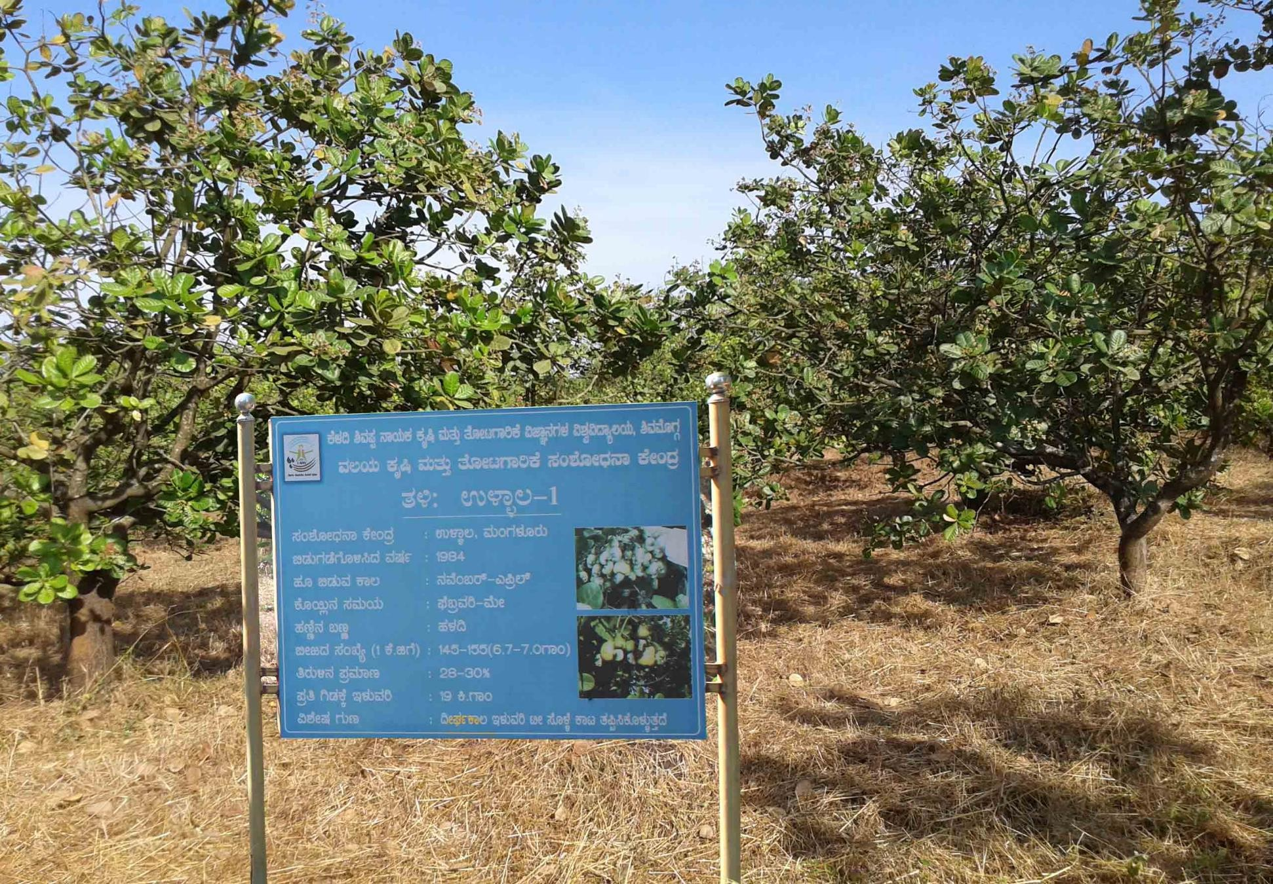
Plate 1. General view of the experimental plot


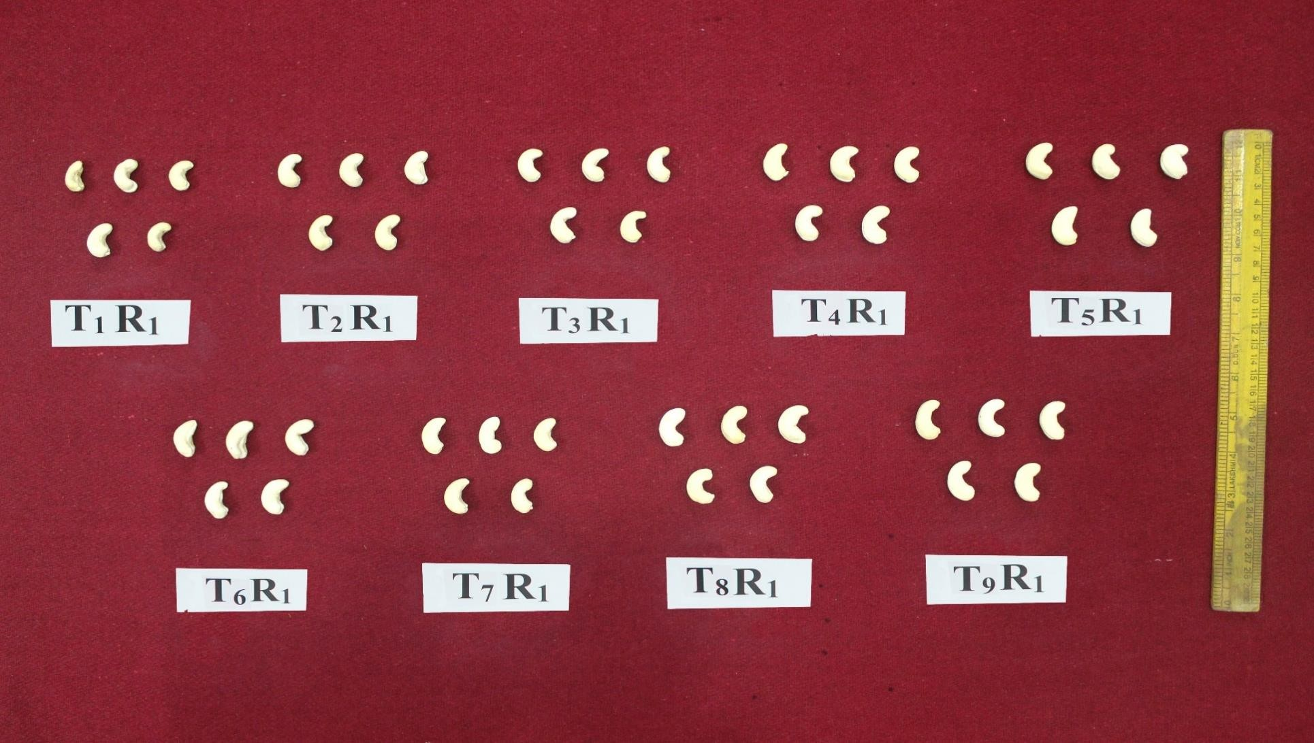

Plate 2. Effect of foliar application of nutrients on kernel characteristics in cashew cv. Ullal-1

The superior economic returns in T9 can be attributed to the enhanced productivity and quality resulting from the synergistic effects of nano urea, boron, and zinc. Nano urea, in particular, offers multiple advantages—it significantly reduces the requirement for conventional urea, lowers input costs, enhances nutrient efficiency, and improves crop output, soil health, and produce quality. During the study, foliar application of Nano urea @ 4 ml/L + Borax @ 0.1% + ZnSO₄ @ 0.2% was carried out at two critical stages: before flushing and at 50% flowering. This timely application likely contributed to the superior economic performance of T9. These findings align with those reported by Patel et al. (2010) and Bauri et al. (2014) in banana, Guvvali et al. (2017) in sapota, and Yamakanamardi (2019) in cashew, all of whom noted enhanced returns and better cost-benefit ratios following the use of micronutrient foliar sprays.
Conclusion
The study revealed that foliar application of RDF+ Nano urea @ 4 ml/L + Borax @ 0.1% + ZnSO₄ @ 0.2% at pre-flushing and 50% flowering stages significantly improved kernel characteristics such as shelling percentage, kernel size, and weight. These improvements contributed to a higher proportion of premium kernel grades like WW-180 and WW-210, enhancing the market value. Economically, this treatment resulted in the highest gross and net income due to superior yield and quality. The increased profitability was reflected in the highest benefit-cost (B:C) ratio among all treatments. This nutrient combination proved highly effective in improving both productivity and returns in cashew cultivation.
Treatment | Yield (t/ha) | Cost of treatment (₹/ha) | Total expenditure (₹/ha) | Gross returns (₹/ha) | Net returns (₹/ha) | B:C
T1 | 0.41 | 0 | 24588 | 45100 | 20512 | 0.83
T2 | 0.45 | 196 | 24784 | 49500 | 24716 | 1.00
T3 | 0.49 | 2205 | 26793 | 53900 | 27107 | 1.01
T4 | 0.48 | 896 | 25484 | 52800 | 27316 | 1.07
T5 | 0.51 | 2905 | 27493 | 56100 | 28607 | 1.04
T6 | 0.54 | 4396 | 28984 | 59400 | 30416 | 1.05
T7 | 0.57 | 6405 | 30993 | 62700 | 31707 | 1.02
T8 | 0.62 | 5096 | 29684 | 68200 | 38516 | 1.30
T9 | 0.68 | 7105 | 31693 | 74800 | 43107 | 1.36

Table 3. Effect of foliar application of nutrients on economics of cashew cv. Ullal-1

Note: RDF- 500:250:250 g NPK plant⁻¹ + FYM 50 kg plant⁻¹ per year

COMPETING INTERESTS DISCLAIMER:
Authors have declared that they have no known competing financial interests OR non-financial interests OR personal relationships that could have appeared to influence the work reported in this paper.

References
ABDULSALAM, M., 1997, Cashew- a nitrogen lover. Cashew bull., 34(8): 1-5.
ANAND, A., SAHU, G. S. AND MISHRA, N., 2015, Physico-chemical characteristics of Cashew. Res. J. Agri. Sci., 6(3): 656-658.
BAURI, F. K., MISRA, D. K., BANDOPADHYAY, B., DEBNATH, S., SARKAR, S. K. AND AVANI, P., 2014, Improving yield and quality of banana cv. Martaman (Musa AAB, Silk) through micronutrient and growth regulator application. J. Crop Weed., 10(2): 316-319.
GAJBHIYE, R. C., 2014, Foliar application of nutrients on cashew (Anacardium occidentale L.) cv. Vengurla-4 with reference to growth, yield and quality. Ph.D. Thesis, College of Horticulture and Forestry Navsari, Agricultural University Navsari, India. Punjab Agri. Univ., 24: 411-422.
GAJBHIYE, R. C., PAWAR, S. N., SALVI, S. P., ZOTE, V. K. AND
GAWANKAR, M. S., PAWAR, S. N., SAWALE, R. D. AND CHAVAN, S. A., 2010, Effect of foliar sprays of nutrients on nut yield of cashew in the Coastal Zone of Maharashtra. J. Indian Soc. Coastal Agric. Res., 28(2): 25-28.
GUVVALI, T., SAMPATH, P. M., SHIROL, A. M., RAO, B., NIRMALA, B. AND KOULAGI, S., 2017, Influence of micronutrients on growth, yield and economy of sapota cv. Kalipatti under HDP system. Inter. J. Agril. Sci. and Res., 7(3): 401-408.
HALDAVANEKAR, P. C., 2018, Performance of different cashew (Anacardium occidentale L.) genotypes under Konkan region of Maharashtra. Int. J. Chem. Stud., 6(5): 1939-1942.
JOHNSON, D., 1973, The botany, origin and species of cashew (Anacardium occidentale L.) J. Plant Crops., 1: 1-7.
KANNAN, T., SINGH, S. N. AND RATTANPAL, H. S., 2002, Effect of foliar and soil application of urea on vegetative growth and budding success of citrus nursery. Indian J. Hort., 59(4): 367-372.
LAKSHMIPATHI, ADIGA, J. D., KALAIVANAN D., MOHANA, G. S. AND MEENA, R. K., 2015, Effect of foliar application of micronutrients on reproductive growth of cashew (Anacardium occidentale L.) under south west coast region of Karnataka, India. Trends Biosciences, 8(2): 447- 449.
LAKSHMIPATHI, ADIGA, J. D., KALAIVANAN D., MOHANA, G. S. AND MEENA, R. K., 2015, Effect of foliar application of micronutrients on reproductive growth of cashew (Anacardium occidentale L.) under south west coast region of Karnataka, India. Trends Biosciences, 8(2): 447- 449.
LAKSHMIPATHI, ADIGA, J. D., KALAIVANAN, B. M., MURALIDHARA, N. H., AND PREETHI, N. P., 2018, Effect of zinc and boron application on leaf area, photosynthetic pigments, stomatal number and yield of cashew. Int. J. Curr. Microbiol. App. Sci., 7(1): 1786-1795.
MARSCHNER, H., 1995, Mineral nutrition of higher plants. Academic Press, London.
MURALI, K., KUMAR, P. P. AND RANI, M. S. A., 2015, Effect of tertiary shoot pruning and foliar spray of nutrients on flowering and yield of cashew (Anacardium occidentale L.) under high-density planting system. Bioscan., 10(1): 411-415.
nutrient management in mango and guava. Indian J. Fert., 6(11): 12-21.
PALSANDE, V. N., DABKE, D. J., KASTURE, M. C., KHOBRAGADE, N. H. AND PATIL, S. D., 2013, Effect of urea, potassium nitrate and insecticides through the foliar application on growth, yield and quality of cashew nut. BIOINFOLET., 10(1): 347-349.
PATEL, A. R., SARAVAIYA, S. N., PATEL, A. N., DESAI, K. D., PATEL, N. M. AND PATEL, J. B., 2010, Effect of micronutrients on yield and fruit quality of banana (Musa paradisiaca L.) cv. Basrai under pair row planting method. Asian J. Hort., 5(1): 245-248.
Pp. 887.
RAJAMANICKAM, C., BASKARAN, A. AND MURALIDHARAN, B., 2023, Studies on the effect of foliar application of micronutrients for growth, yield, economic traits and leaf nutrient content in Cashew (Anacardium occidantale L.) var. VRI 3. Int. J. Plant Soil Sci., 35(22) :46-56.
RAO, V. G. AND RAMANA, P. V., 2017, Effect of critical micronutrients foliar application on yield of cashew (Anacardium occidentale L.) under agency tracts of rampachodavaram, Andhra Pradesh, Indian Plant archives., 17(2): 1201-1203.
RAVISHANKAR, H., KUMAR, K., SINGHA, A. AND ADAK, T., 2010, Integrated
WANG, J., LIANG, I., HUANG, W., ZHANG, Z. AND HUANG, H., 2010, Effects of nitrogen, phosphorus and potassium on recovery growth and fruiting of cold-injured cashew. Ecol. Environ. Sci., 19(1): 188-190.
YAMAKANAMARDI., 2019, Effect of foliar application of nutrients on yield and quality of cashew (Anacardium occidentale L.) genotypes under hill zone of Karnataka. M. Sc. (Hort) Thesis, Keladi Shivappa Nayaka University of Agricultural and Horticultural Sciences, Shivamogga, Karnataka.

