Original Research Article

MONITORING OF FLUORIDE CONTENT IN WATER SUPPLIED FOR HUMAN CONSUMPTION IN MUNICIPALITIES IN CEARÁ: SPATIAL ANALYSIS FOR 2024

.
ABSTRACT

Aims: The study aims to assess the fluoride level in drinking water at the state level.
Methodology: This is an ecological study obtained from information available in Sisagua, in 2024, for the 184 municipalities of the state of Ceará. The data were analyzed by calculating the fluoride level per liter, followed by spatial autocorrelation analysis and the creation of thematic maps.
Results: The average fluoride level for the state of Ceará was 0.083 mg per liter (ppm). The municipalities of Tianguá and Maracanaú presented the highest fluoride content values, 1 mg/l, 0.89 mg/l, respectively. The municipalities of Carnaubal, Umirim, Boa Viagem and Viçosa do Ceará were the only ones that presented fluoride levels considered ideal, with 0.70 mg/l, 0.72 mg/l, 0.75 mg/l, 0.77 mg/l, respectively. The overall Moran index was 0.483 (p<0.05) in 2024 with the formation of two clusters of municipalities, one of the high-high type, in the northwest portion of the northern part of the state and one of the low-low type, covering the municipalities of the southern region of the state. Eleven municipalities with zero values ​​were detected
Conclusion: There is a spatial dependence of fluoride levels with a higher concentration in the north and northeast regions of the state considering the period evaluated, while the municipalities of the southern region mostly present lower values. There is an urgent need for measures to ensure efficient monitoring of the fluoride levels provided to the population, given that less than 3% of municipalities have acceptable fluoride levels.

Keywords: Fluoride; Spatial Analysis; Water Quality; Surveillance.

1. INTRODUCTION

Fluoridation of water supplies is an important guiding principle of the National Oral Health Policy, which encompasses the construction of healthy public policies and the development of strategies aimed at all people, expanding the concept of health beyond the merely technical dimension of the dental sector, integrating oral health with other collective health practices. (1,2)
Among the water quality parameters, fluoride content is one of the most important for preventing and reducing the incidence of tooth decay on a large scale. Although it can be made available topically in toothpastes and in dental offices, the systemic route through water fluoridation has shown the greatest success in preventing public health problems, with the best cost-benefit in preventing tooth decay. (3).
Dental decay affects approximately 2.43 billion people (36% of the world population). The difficulty in preventing such diseases entails significant personal, social and economic costs (4). In this regard, water fluoridation is one of the main measures responsible for reducing the prevalence of tooth decay worldwide. Water fluoridation has been considered one of the greatest public health achievements of the 20th century. Evidence-based studies confirm this action as an effective and socially equitable method of offering the preventive benefits of fluoride against tooth decay, as it reaches people regardless of age, educational and social level (5).
Since 1974, Federal Law 6,050, which requires the existence of water fluoridation units in all new and/or renovated water treatment plants, has led the Brazilian government to invest in actions related to water fluoridation (6). The Brazilian option to use fluoride in public supply systems is due to its territorial extension, low cost and the benefits occurring regardless of the socioeconomic conditions of the population. However, for this benefit to be effective, fluoride must be at ideal levels at all times (7). The ideal doses of fluoride in drinking water are described in the literature based on the annual average of the maximum daily temperature. According to the temperatures in Brazilian locations, fluoride levels should be between 0.6 and 0.8 mg F/l in order to prevent tooth decay (8). Levels below the ideal are ineffective in preventing tooth decay, while levels above the ideal increase the risk of dental and bone fluorosis (9).
In Brazil, fluoridation of public water supplies began in 1953, in the municipality of Baixo Guandu/ES, and became a federal law in 1974. 4 In that year, Law 6,050 was enacted, which provides for the fluoridation of water supplies in places where there is a treatment plant. This law was regulated by Decree 76,872, of December 22, 1975, and the guidelines were also expanded to places where there are no treatment plants (10,11). In Brazil, the impact of fluoridation was evident in the change in the oral epidemiological profile, characterized by a reduction in the prevalence and severity of dental caries in children and adolescents. Fluoridation of public water supplies intensified in the 1980s and, in 2006, benefited approximately 100 million people. Currently, Brazil has the second largest public water supply fluoridation system in the world and one of the largest population groups of fluoridated toothpaste consumers. In addition, a large part of the population is exposed to multiple sources of fluoridated products (1).
Thus, in Ceará, VIGIAGUA was implemented in 2005, and is coordinated and monitored by the Environmental Surveillance Unit (CEVAM) of the Coordination of Environmental Health Surveillance and Workers' Health (COVAT) of the Secretariat of Health Surveillance and Regulation (SEVIR), of the Health Secretariat of the State of Ceará. This program aims to guarantee the population access to quality water that meets the potability standard, as well as to assess the risks that it poses to health (12). However, despite the structuring of VIGIAGUA in Ceará, this program is still not very effective in monitoring ideal fluoride levels, since it was only since 2014 that laboratory control of its levels was possible. Additionally, it is not known whether there are variables that mediate a possible variance between municipalities, and over time in each municipality (13).
Despite efforts to implement surveillance programs, constant monitoring of fluoridation equipment and maintenance of fluoride concentrations within recommended standards is a constant problem in water supply systems (14). Thus, given the importance of controlling fluoride levels in reducing dental caries rates and ensuring safety against dental skeletal fluorosis, the need for strict control of fluoride levels in drinking water is evident. Furthermore, it is important to study its distribution, as this will indicate the locations where the parameters are higher or lower, directing more effective public policies, especially for locations with the greatest perceived need. The objective of this study was to evaluate the fluoride levels in drinking water supplies in the 184 municipalities of the state of Ceará.

2. methodology

This is an ecological study, with data from the analysis of secondary data from the Water Quality Surveillance Information System for Human Consumption (SISAGUA) and the Brazilian Institute of Geography and Statistics (IBGE) of the Municipalities of Ceará surveyed in the period of 2024, in the state of Ceará. For a better understanding, Figure 1 shows the flowchart with the methodological steps followed in the preparation of this study.
Figure 1 – Flowchart of the methodological steps of the research.

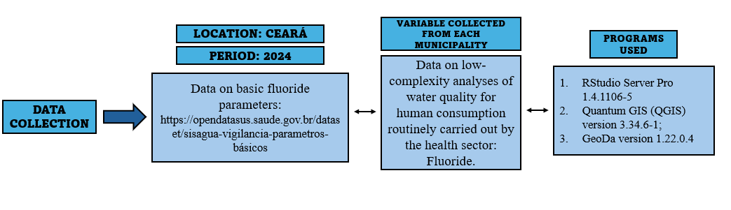
Source: Prepared by the authors

After data collection, the average value of the fluoride content present in water for human consumption in the state of Ceará in 2024 was calculated. Thus, thematic maps were constructed from such data, with a view to better presenting the fluoride content in water for human consumption during 2024 by municipality. Subsequently, a spatial autocorrelation analysis was performed with calculation of the Global Moran Index (I).
For this purpose, the first-order contiguity neighborhood matrix (queen) was used, with a significant spatial pattern p < 0.05. Where values ​​of I > 0 indicate a direct spatial correlation, that is, a positive correlation of the data, thus, most neighboring polygons will have values ​​on the same side of the mean and the index will be positive; values ​​of I > 0 indicate a negative correlation, where most neighboring polygons will have attribute values ​​on opposite sides of the mean; values ​​of I < 0 indicate the absence of spatial correlation (inverse spatial correlation). Thus, the correlation value generated was evaluated as positive or negative, as well as weak (< 0.3), moderate (0.3–0.7) or strong (> 0.7), as also used in the statistical test in the evaluation of Pearson's correlation. Local indicators of spatial association (LISA) were also adopted to identify clusters in the study site and their statistical significance, with graphical representation (LISAMap) by spatial correlation maps. Clusters were defined and presented – high-high; low-low; high-low; low-high – in the form of scatterplots with a statistically significant difference of p < 0.05 (15).
The interpretation of (clusters) 2020 was considered, where: (1) not significant: territories that did not enter the formation of clusters, because their differences were not significant; (2) high-high: regions formed by municipalities with high frequencies of the dependent variable and high frequencies of the independent variable; (3) low-low: regions formed by municipalities with low frequencies of the dependent variable and low frequencies of the independent variable; (4) high-low: regions formed by municipalities with high frequencies of the dependent variable and low frequencies of the independent variable; (5) low-high: regions formed by municipalities with low frequencies of the dependent variable and high frequencies of the independent variable (15).
The values ​​of very high or very low clusters resulting from each round of permutations were considered statistically significant: 0 [not significant]; 1 [p-value = 0.05] or confidence level equal to 95%; 2 [p-value = 0.01] or confidence level equal to 99%; 3 [p-value = 0.001] or confidence level equal to 99.9% (15).
As this is a study that used public domain data and without individual identification, its assessment by the CEP/CONEP system (Research Ethics Committee/National Research Ethics Commission) is not required, in accordance with Resolution No. 510/16 of the National Health Council.

3. results

Based on data obtained by the Brazilian Institute of Geography and Statistics - IBGE, the state of Ceará has a population of 9,233,656 inhabitants (2024) distributed among 184 municipalities, throughout its 148,894.447 km² of territorial extension. The average value of fluoride content for the state of Ceará was 0.083 mg per liter (ppm). The municipalities of Tianguá and Maracanaú had the highest values ​​of fluoride content, 1 mg/l, 0.89 mg/l, respectively (Figure 2).
Figure 2 – Map showing the spatial distribution of the average value of fluoride content per liter (ppm) in water supplies for human consumption, Ceará, Brazil – 2024.

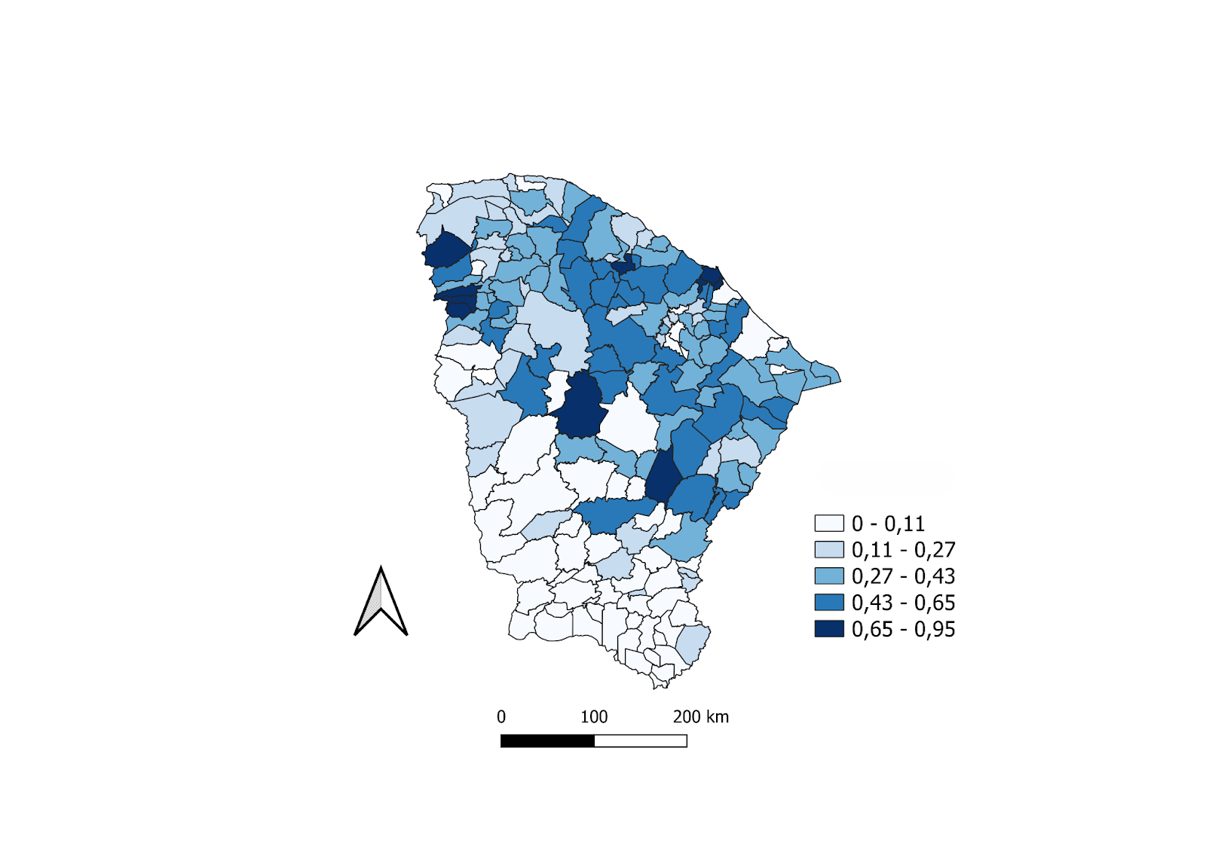
Source: Prepared by the authors using QGIS software (2025).
Through the spatial autocorrelation analysis, it is possible to observe, according to the map above (Figure 2), the spatial distribution of the average value of the fluoride content per liter (ppm) in the water supply for human consumption, Ceará, Brazil, highlighting the municipalities of Carnaubal, Umirim, Boa Viagem and Viçosa do Ceará, which were the only ones to present fluoride levels considered ideal. According to Sisagua, the maximum value of fluoride allowed in water for consumption in Brazil is 1.5 mg per liter (ppm), with the ideal level being 0.7 mg per liter (ppm), with 0.70 mg/l, 0.72 mg/l, 0.75 mg/l, 0.77 mg/l, respectively.
Figure 3 - Moran scatter diagram for fluoride content per liter (ppm) in water supplies for human consumption, Ceará, Brazil – 2024.

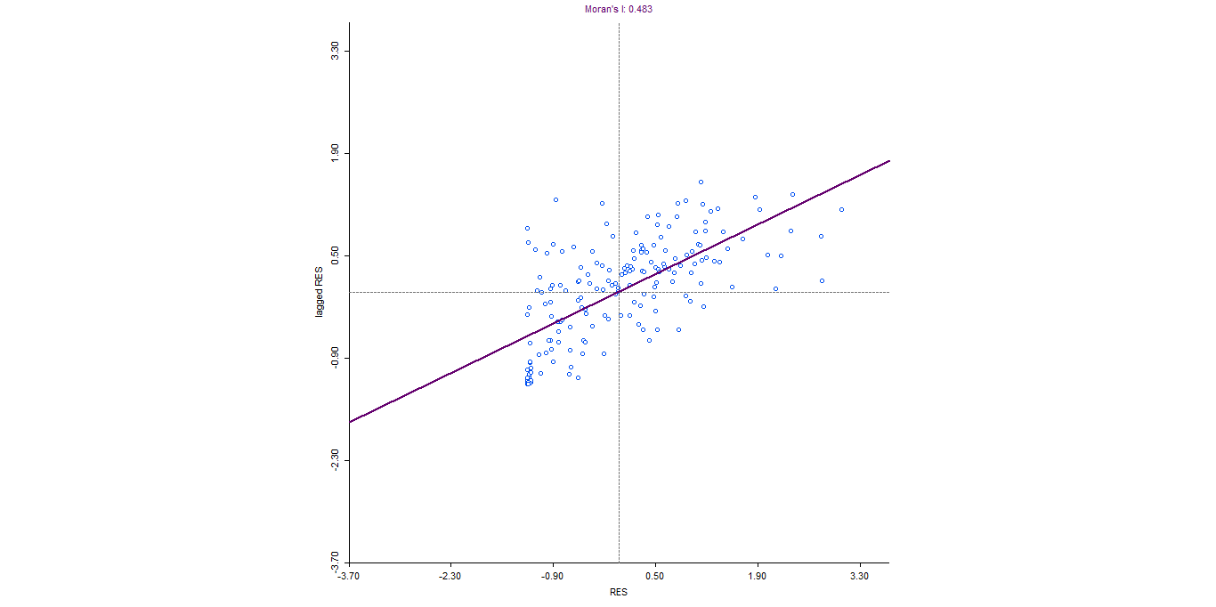
Source: Prepared by the authors using GeoDA software (2025).

In the autocorrelation analysis, the global Moran index was 0.483 (p<0.05) (See Figure 3) with the formation of two clusters of municipalities, one of the high-high type, covering municipalities in the northeast and central-west regions of the state, and one of the low-low type, formed by municipalities in the southern region of the state.
Figure 4 – Map of significant aggregates (clusters) for fluoride content per liter (ppm) in water supplies for human consumption, Ceará, Brazil – 2024.

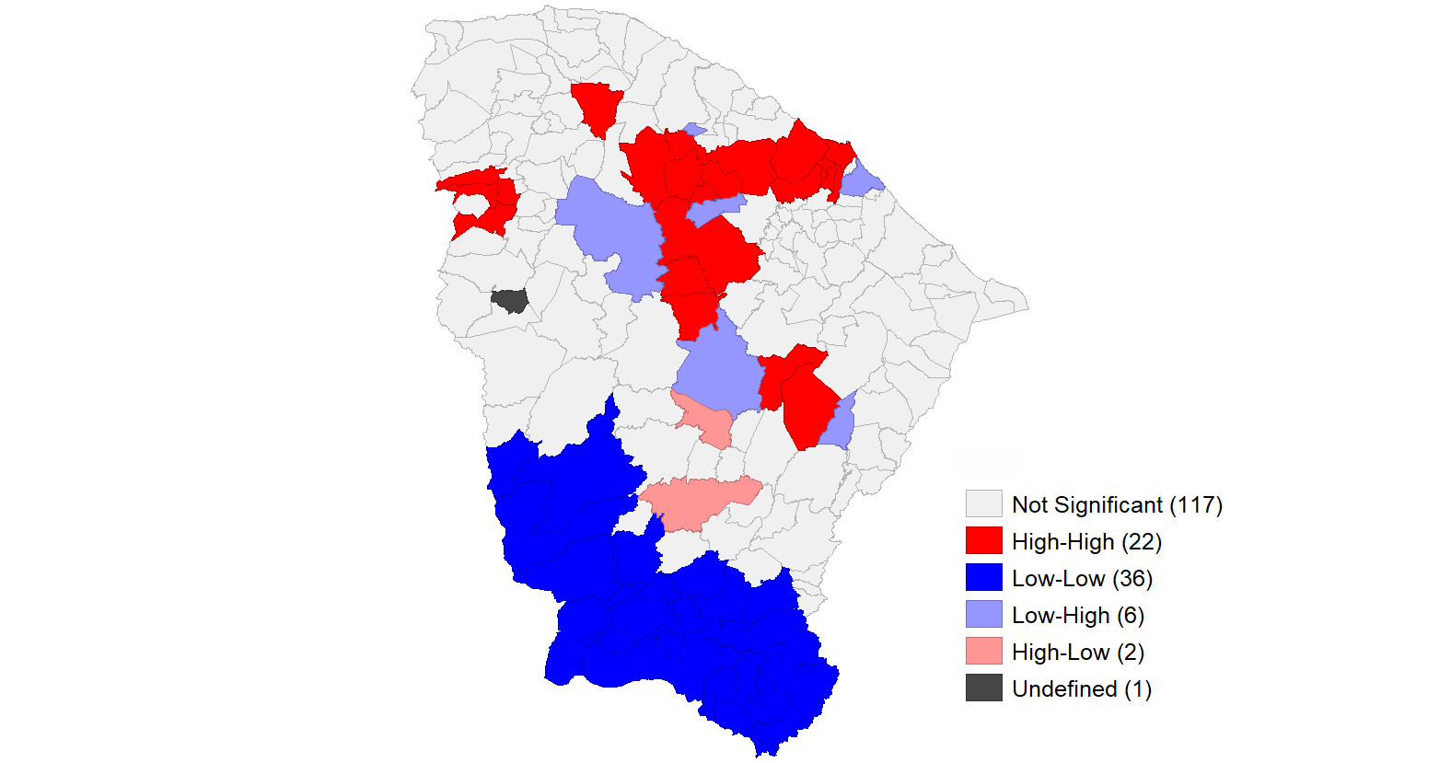
Source: Prepared by the authors using GeoDA software (2025)
Regarding the geographic distribution of the analysis of the spatial autocorrelation of the fluoride content present in water for human consumption in the state of Ceará, in the year 2024, the value of I = 0.483 (Global Moran Index) was obtained, which formed a high-high cluster in the northeast and center-west of the state, covering the municipalities of: Fortaleza, Caucaia, Maracanaú, Pacatuba, Itaitinga, Maranguape, Pentecoste, Apuiares, General Sampaio, Tejucuoca, Itapajé, Irauçuba, Canindé, Itatira and Madalena (15 municipalities). Finally, there was the formation of a low-low cluster in the southern portion of the state, covering 33 municipalities in this region of the state, such as Tauá, Salitre, Lavras da Mangabeira, Santana do Cariri and Penaforte (in the extreme south).
The statistical significances, with graphical representation through the LISAMAP of spatial correlation, can be observed in Figure 5 below. Where the municipalities with darker tones represent greater values ​​of significant differences between the others.
Figure 5 - Significance map for aggregates for fluoride content per liter (ppm) in water supplies for human consumption, Ceará, Brazil – 2024.

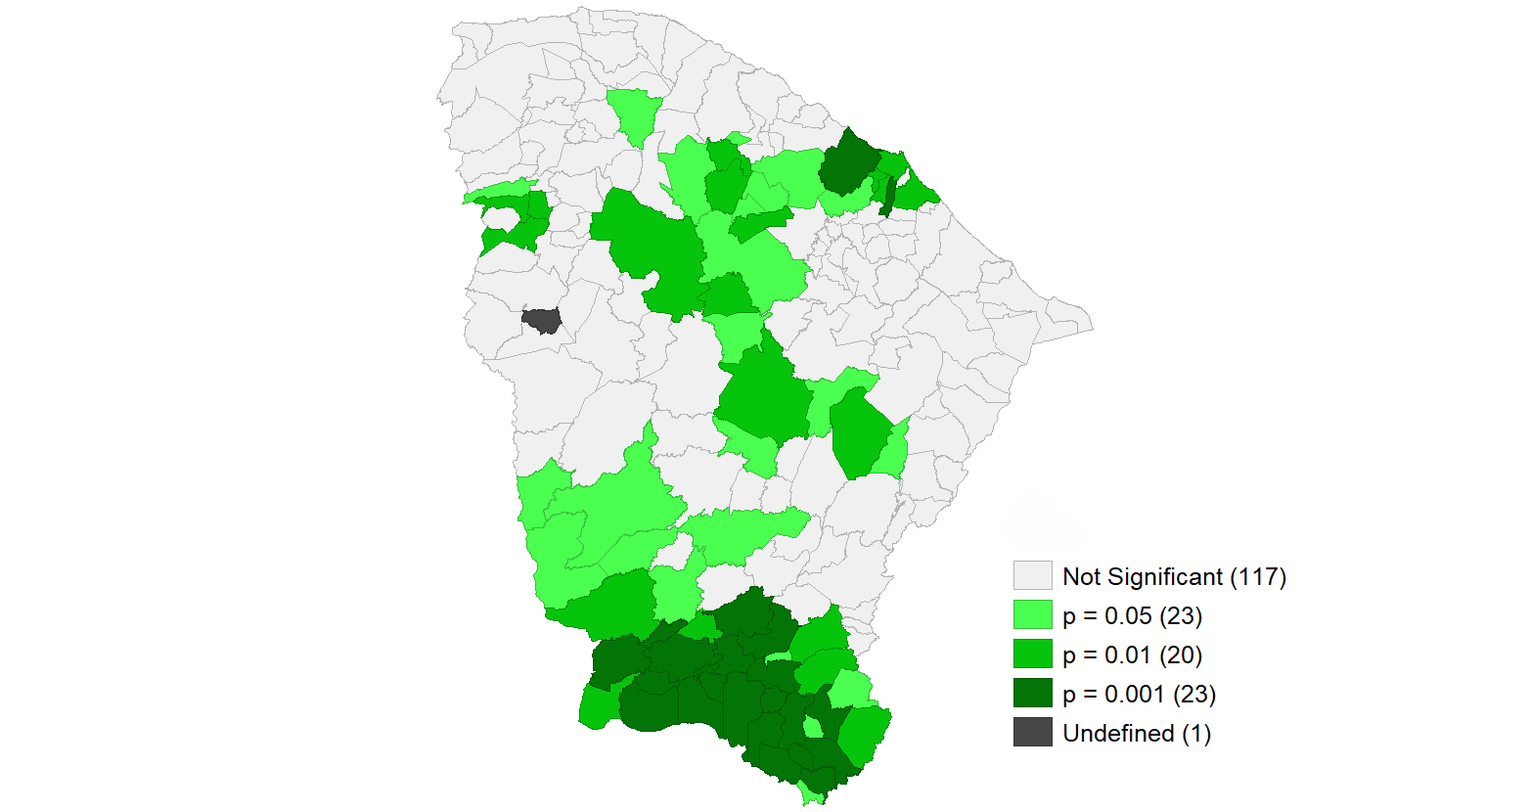
Source: Prepared by the authors using GeoDA software (2025).
The thematic map in Figure 5 above shows the “p” values ​​of the spatial autocorrelation analysis for the fluoride content per liter (ppm) in water supplies for human consumption, Ceará, Brazil – 2024, where, according to the LISA clusters, it showed the existence of some municipalities with significance, being in the northeast of the state corresponding to the municipalities of Caucaia and Itaitinga (darker) (p-value < 0.001), and another 21 in the south of the state, covering the municipalities of Campos Sales, Antonina do Norte, Jati, Santana do Cariri, Crato, Cariús, Assaré, among others. The municipality of Ararendá, in the north of the state, was the only municipality that did not present any fluoride content value.

4. discussion

Although the water fluoridation policy is mandatory and extremely efficient, it has been found that fluoridation of public water supplies is not yet a reality in the state of ceará. In this regard, the average fluoride content for the state of ceará was 0.083 mg per liter (ppm) for the year 2024. Only 5% of ceará's municipalities have fluoride levels considered acceptable. According to the water quality surveillance information system for human consumption (sisagua), the maximum fluoride level permitted in drinking water in brazil is 1.5 mg per liter (ppm), with the ideal level being 0.7 mg per liter (ppm) in waters in the northeast. It is worth noting that the ideal fluoride levels vary according to the average local temperature, since in warmer climates, such as the northeast, water consumption tends to be higher, thus requiring lower fluoride concentrations. In this sense, considering the expansion of the national water fluoridation program to regions with typically tropical climates, and the discrepancies between information and values ​​regarding the use of fluoride at different temperatures, the authors' suggestion regarding the need to review ordinance gm/ms no. 635/19758 (16) is reinforced.
Therefore, the importance of monitoring fluoride levels in water supplies to ensure their quality and safety for the population is supported by an extensive history of scientific research (17). This need is reflected in both international water quality guidelines (18) and national regulations established by the ministry of health. It is also worth noting that since 2000, responsibility for monitoring fluoridation — including the preparation and implementation of a specific sampling plan — has been assigned to municipal health authorities (19), remaining a constant normative obligation in the legal instruments that govern environmental health surveillance actions in brazil.
Fluoridation of public water supplies is recognized as one of the most successful public policies worldwide, with its effectiveness and safety in preventing dental caries in adults and children widely proven by the best available scientific evidence (20). Thus, fluoridation is a fundamental strategy for promoting oral health and reducing inequalities in oral health. In australia, a population study involving 24,667 children aged between 5 and 14 years showed that shorter periods of exposure to fluoridated water were associated with higher prevalence and severity of caries, both in primary and permanent teeth, in addition to demonstrating a direct relationship between lower exposure to fluoride and lower socioeconomic levels (21).
In this sense, according to a study carried out in canada, which compared two cities with school-age populations, an increase in the number of teeth affected by cavities was observed, particularly in the deciduous dentition, in the location where water fluoridation was suspended, compared to the city that maintained the measure (22). In this regard, fluoride is recognized worldwide as one of the most effective, safe and cost-effective public health interventions in reducing dental caries, promoting a positive impact on the oral health of millions of people, especially in vulnerable populations, such as the population of northeastern brazil.
A study carried out in 2016 shows that most of the municipalities in ceará had the majority of samples collected with fluoride levels below the ideal (66.5%), 32 municipalities had the majority of samples with ideal fluoride levels (16.7%) and 24 municipalities had the majority of samples with fluoride levels above the ideal (12.5%) (23). In this context, it is clear that there has been a worsening in water fluoridation over the years, considering that, according to the research carried out in 2024, only 4 municipalities (2.17%) presented fluoride levels considered ideal by sisagua, which demonstrates inefficient surveillance related to fluoride levels in the water supply provided to the population.
The municipalities in the north and northeast regions of the state have better fluoride levels when compared to the rest of the state, which indicates that these municipalities perform better in terms of water fluoridation and, consequently, in combating tooth decay. Considering the advances in knowledge about the effectiveness of toothpastes in preventing tooth decay, consolidated by narvai (24), discussions have arisen about the need to maintain investments in water fluoridation (25,26). However, according to horowitz (1996), this preventive measure remains effective, especially for populations in situations of greater vulnerability, such as the brazilian northeast, a region that has one of the worst epidemiological indicators of tooth decay in the country (27,28).
Furthermore, the inequality of water fluoridation in the state is evident, indicating that the southern region of the state lacks more assertive monitoring and fluoridation, which contrasts with the situation in brazil. In this sense, it is reported that, in the brazilian case, water fluoridation coverage is extremely unequal, indicating that the intervention has advanced more in the southern and southeastern states, where most of the country's wealth is concentrated, and is insufficient in the northern and northeastern regions (29).
Despite advances in public oral health policies and increased access to fluoridated toothpastes, tooth decay remains a major public health problem in the state of ceará. It is recommended that research on water supply fluoridation be continued in order to monitor and strengthen strategies to control and prevent the disease. It is expected that this study will help guide public policies to promote oral health, considering that, by mapping the areas with the lowest fluoridation coverage, it will be possible to target specific actions to each municipality. A spatial dependence on fluoride levels was observed, with higher concentrations in the north and northeast regions of the state during the period analyzed, while the municipalities in the south region, for the most part, had lower levels.

5. Conclusion

Even with advances in water fluoridation over time, the State still lacks measures that ensure efficient monitoring of fluoride levels provided to the population, given that less than 3% of municipalities have acceptable fluoride levels. The clusters found become an important tool for more effective targeting of public policies to areas of higher and lower risk.
The most vulnerable municipalities were those inhabiting the southern regions of the state, indicating a widespread problem in this region. There is an urgent need to intensify surveillance and effectively implement fluoridation of public water supplies in Ceará, as a fundamental strategy for promoting oral health and reducing regional inequalities in the control of dental caries.

COMPETING INTERESTS DISCLAIMER:
Authors have declared that they have no known competing financial interests OR non-financial interests OR personal relationships that could have appeared to influence the work reported in this paper.

References

- Brazil. Ministry of Health. General Coordination of Oral Health. Guide of recommendations for the use of fluorides in Brazil. Brasília: Ministry of Health; 2009.
- Brazil. Ministry of Health. Secretariat of Health Care. Department of Primary Care. National Coordination of Oral Health. Guidelines of the National Oral Health Policy. Brasília: Ministry of Health; 2004.
- BARREIRA FILHO, Edenilo Baltazar et al. SPATIAL DISTRIBUTION OF RISK FACTORS AND FLUORIDE CONTENT IN PUBLIC WATER SUPPLY ON A MUNICIPAL SCALE. Mercator , Fortaleza, v. 21, Feb. 2023. ISSN 1984-2201. Available at: < http://www.mercator.ufc.br/mercator/article/view/e21021 >. Access date: May 5, 2021. 2025. doi: https://doi.org/10.4215/rm2022.e21021 .
- Schluter PJ, Lee M. Water fluoridation and ethnic inequities in dental caries profiles of New Zealand children aged 5 and 12–13 years: analysis of national cross-sectional registry databases for the decade 2004–2013. BMC Oral Health. 2016;16(1):21. http://dx.doi.org/10.1186/s12903-016-0180-5. PMid:26887965.
- Ditterich RG, Buffon MCM, Assaf AV, Gonçalves RN, Piorunneck CMO, Lima MCD, et al. Analysis of fluoride content in public water supply in a municipality in the metropolitan region of Curitiba/PR: twelve months of external control. Cad Saúde Colet, 2022; 30(4) 595-605. https://doi.org/10.1590/1414-462X202230040115
- BRAZIL. Law No. 6,050, of May 24, 1974. Provides for the fluoridation of water in supply systems when there is a treatment plant. Available at: http://www.planalto.gov.br/ccivil03/LEIS/L6050.htm. Accessed on: May 5, 2026.
- KOZLOWSKI, F. C.; PEREIRA, A. C. Methods for the use of systemic fluoride. In: PEREIRA, A. C. et al. Dentistry in Public Health: planning actions and promoting health. Porto Alegre: Artmed, 2003. p. 265-274.
- FRAZÃO, P.; PERES, M. A.; CURY, J. A. Quality of water for human consumption and fluoride concentration. Public Health Journal, São Paulo, v. 45, n.5, 964-73, 2011.
- NORO, L. R. A.; OLIVEIRA, A. G. R. C.; LEITE, J. The challenge of oral health surveillance in the Unified Health System. In: Dias, A. A. et al. Public oral health: work methodology and practices. São Paulo: Santos, 2006. p. 187-210.
- Brazil. Law No. 6,050 of May 24, 1974. Establishes the mandatory fluoridation of water in supply systems. Official Gazette of the Union, Brasília, July 27, 1975; Section 1.
- Brazil. Ministry of Health. Ordinance No. 635 of December 26, 1975. Approves norms and standards on the fluoridation of water in public supply systems. Official Gazette of the Union, Brasília, January 30, 1976; Section 1.
- XAVIER, V. C. O.; COSTA, M. T. P.; FRAGA, A. C. A.; BURGOA, M. I. R.; ALMEIDA, L. C.; VASCONCELOS, M. P.; COSTA, T. E. S. Analysis of fluoride in the supply system of Ceará. Cadernos ESP, Fortaleza, v.13, n.2, p.12-23, 2019.
- RAMIRO; A. P.; SOUSA, C. F. S.; TEIXEIRA, R. O.; BRITO, O. A. F. A.; MARTOREL, L. B.; JORDÃO, L. M. R. Evaluation of fluoride concentration in water supply to Municipal Early Childhood Education Centers: an exploratory study. Scientific Investigation in Dentistry, Anápolis, v.23, n.1, p.2-6, 2018.
- Ramires I, Maia LP, Rigolizzo DS, Lauris JRP, Buzalaf MAR. Heterocontrol of fluoridation of public water supply in Bauru, SP, Brazil. Rev Saude Publica. 2006;40(5):883-9.http://dx.doi.org/10.1590/S0034-89102006000600019. PMid:17301911.
- Maciel JAC, Castro-Silva II, Farias MR. Initial analysis of the spatial correlation between the incidence of COVID-19 and human development in the municipalities of the state of Ceará in Brazil. Rev Bras Epidemiol. 2020;23:e200057. doi:10.1590/1980-549720200057. Accessed on: May 5, 2025.
- Brazil. Ministry of Health (MS). Ordinance No. 635, of December 26, 1975. Approves norms and standards on water fluoridation in public supply systems, intended for human consumption. Brasília: MS; 2011. Official Gazette of the Union 1975; 26 Dec.
- LACERDA, A. P. A. G. et al. Water fluoridation in the ten largest municipalities in the state of Tocantins, Brazil. Ciên Saúde Col, v. 25, n. 4, p. 1507-1518, 2020.
- Frazão P, Ely HC, Noro LRA, Pinheiro HHC, Cury JA. The water surveillance model and the dissemination of fluoride concentration indicators. Saúde Debate 2018; 42:274-86.
- World Health Organization. Guidelines for drinking-water quality. Fourth edition. Gene - va: World Health Organization; 2011.
- Ministry of Health. Ordinance No. 1,469, of December 29, 2000. Establishes the procedures and responsibilities related to the control and monitoring of the quality of water for human consumption and its potability standard, and contains other provisions. Official Gazette of the Union 2001; January 2.
- FRAZÃO, P.; NARVAI, P. C. Coverage and monitoring of water fluoridation in Brazil: municipalities with more than 50 thousand inhabitants. São Paulo: School of Public Health of USP, 2017.
- SPENCER, A. J. et al. Contemporary evidence on the effectiveness of water fluoridation in the prevention of childhood caries. Comm Dent Oral Epidemiol., p. 1-9, apr. 2018.
- MCLAREN, L. et al. Exploring the short-term impact of community water fluoridation cessation on children ’ s dental caries : a natural experiment in Alberta, Canada. Public Health, v. 146, p. 56-64, 2017.
- NARVAI, P. C.; FRIAS, A. C.; FRATUCCI, M. V. B.; ANTUNES, J. L. F.; CARNUT, L.; FRAZÃO, P. Water fluoridation in Brazilian capitals at the beginning of the 21st century: the effectiveness in question. Saúde em Debate, Rio de Janeiro, v.38, n.102, p.562-571, 2014.
- FEATHERSTONE, J. D. Prevention and reversal of dental caries: role of low level fluoride. Community Dental Oral Epidemiology, v.27, n.1, p. 31-40, 1999.
- NADANOVSKY, P.; SHEIHAM, A. Relative contribution of dental services to the changes in caries levels of 12-year-old children in 18 industrialized countries in the 1970s and early 1980s. Community Dental Oral Epidemiology, v.23, n.6, p. 331-339, 1995.
- HOROWITZ, H. S. The effectiveness of community water fluoridation in the United States. Journal of Public Health Dentistry, New York, v.56, n.5, p.253-258, 1996.
- SAINTRAIN, M. V. L.; CORREA, C. R. S.; SAINTRAIN, S. V.; NUTO, S. A. S.; VIEIRA‐MEYER, A. P. G. F. Brazilian adolescents’ oral health trends since 1986: an epidemiological observational study. BMC Research Notes, v.8, p.554, 2015.
- ANTUNES, J. L. F.; NARVAI, P. C. Oral health policies in Brazil and their impact on health inequalities. Journal of Public Health, São Paulo, v.44, n.2, p.360-365, 2010.
- HOROWITZ, H. S. The effectiveness of community water fluoridation in the United States. Journal of Public Health Dentistry, New York, v.56, n.5, p.253-258, 1996.

