**The Ripple Effect of COVID-19 on Agriculture and Food Security**

**Abstract**

The COVID-19 pandemic caused a devastating effect on the world agricultural and food security system, impacting production, distribution, and consumption patterns. Lockdowns, border closures, and labour shortages led to supply chain disruptions, rising costs of production, and losses, especially for smallholder farmers. Impulsive buying and hoarding led to artificial shortages, shifting consumer attention towards non-perishable and locally produced food items. Globalization placed pressures on trade increased food vulnerability and, as a result, raised food prices and decreased access to essential agricultural inputs. Despite these barriers, the crisis accelerated the widespread adoption of digital technologies in agriculture, including e-commerce, precision agriculture, and automation. Governments created policies to enhance the resilience of the food supply chain, promote sustainable agriculture, and provide local food production. Long-term recovery plans involve investments in climate-smart agriculture, enhanced logistics, and digital infrastructure to enhance economic resilience and food security. The pandemic highlighted more the resilient, long-term food systems that could adapt to the requirements of future global emergencies. Furthermore, the crisis unveiled agricultural labour markets, bearing in mind that controls of seasonal and migrant work rendered them less beneficial. Farmers instead accommodated mechanization, automation, and other emerging systems of farming as they tried to offset the lack of labour. Pressure from consumers on food nutritional value and safety led to the demands for local and organic food. Governments and non-governmental bodies collaborated to enhance food distribution systems in a bid to make vital commodities accessible. Supply chain resiliency was a key agenda, and it led to investments in intelligent logistics, e-marketplaces, and improved warehousing. The pandemic also put the spotlight on local production of food and self-sufficiency, and that has created a shift towards sustainable practices such as regenerative agriculture, hydroponics, and urban agriculture. These are articulations of a long-term transformation in world food systems.

**Keywords**: COVID-19, Food Security, Supply Chain, Sustainability, Digital Technologies, Economic Resilience

**Introduction**

The onset and extensive effect of the COVID-19 pandemic has led to major disruptions across all industries worldwide, resulting in a significant economic imbalance. Regulations like social distancing, quarantine requirements, and strict travel restrictions have caused a notable reduction in the workforce and widespread job losses in numerous sectors. The agriculture and food industry were especially susceptible during this crisis (Ciotti et al., 2020). The government's enforcement of a nationwide lockdown resulted in the halting of industries, which negatively impacted the entire supply chain from producers to consumers. It is essential to formulate effective strategies that enhance both market expansion and customer satisfaction. This document explores the repercussions of COVID-19 on the Agro-food system and its economic fallout, emphasising critical components such as food production, demand variations, price surges, security, and the durability of supply chains (Aromolaran et al., 2020).To protect natural resources and achieve sustainable development goals, there is an increasing inclination towards the implementation of sustainable agricultural methods, including urban farming, crop rotation, hydroponics, and family farming. Moreover, the promise of digital technologies in the agri-food sector such as artificial intelligence could be pivotal in nurturing an autonomous society (Sridhar et al., 2023) This research intends to offer a detailed understanding of the pandemic's effects and cost-effective strategies that support green ecosystems. Agriculture ranks as one of the most vital sectors in the global economy. Agriculture plays a crucial role in food security and human progress. The FAO (Food and Agriculture Organisation of the United Nations) has projected that over 60% of the world's population relies on agriculture for their livelihood. However, such efforts did not come without problems as small farmers were plagued with scarce resources, lack of funds, and less access to all support structures (Mengoub et al., 2020). Most of them experienced high incomes losses resulting from the decreased access to the market and decreased demand for perishable goods. Such people faced higher environmental and financial risks. Ineffective supply of machinery, seeds, and fertilizers resulted in lower output and higher environmental and financial risks for these farmers (Deconinck et al., 2020). Moreover, a lack of digital infrastructure in rural areas resulted in the exclusion of many from accessing e-commerce sites or getting crucial information on crop management and market situation. This crisis highlighted the importance of building resilient agricultural frameworks that can withstand shocks while promoting long-term sustainability. Innovative initiatives, such as the use of digital technology, diverse cropping systems, and increased assistance for smallholders, emerged as critical answers. By incorporating sustainability into recovery efforts, agriculture can not only recover from such disruptions, but also ensure food security, environmental protection, and economic viability for future generations. Establishing such systems demands cooperation among governments, private sectors, and communities to guarantee equitable access to resources, knowledge, and technology, empowering farmers to adjust and prosper in the face of continual challenges. It is essential to investigate the effects of COVID-19 on the food and agriculture industry. This paper seeks to explore all consequences of COVID-19 on food and agriculture sector within a global framework (Workie et al., 2020).

1. Impact of COVID-19 on the agricultural sector

Agriculture supports the livelihoods of over a billion people worldwide and is a critical foundation for many developing countries. However, the measures taken to control the COVID-19 pandemic disrupted the production and distribution of agricultural goods. Farming is a lengthy process, involving stages like planting, nurturing, harvesting, and shipping, all of which require labor. The food and agriculture industries rely heavily on market value chains, making them more vulnerable. Government-imposed travel restrictions to control the spread of the virus further disrupted these activities (Aromolaran et al., 2020). Agriculture depends on various inputs, and the reliance on these inputs can vary significantly across farming systems. This dependency exposed farmers to rising input costs caused by factors like congested ports and roads, customs delays, transportation interruptions, limited access to credit, higher interest rates, and increased capital costs. These challenges drove up production expenses, reducing profitability and causing significant losses for farmers. The food supply also took a massive hit. Reduced crop yields came from constraints on regional markets and shipping delays that limited availability to really-needed agriculture items including seeds, fertilizers, and insecticides. Particularly perishable goods like meat and vegetables, which demanded fast distribution, farmers who got to harvest their crops suffered logistical problems impeding their capacity to sell. Many producers had to throw away their products or sell them for really little (Aromolaran et al., 2020). Supply chain disturbances resulted in scarcity, which in turn raised food costs and made essential goods out of reach for some, therefore further endangering global food security. Panic buying and hoarding worsened the problem, driving several third-world families into poverty and starvation. Particularly at risk were smallholder farmers who usually had little financial means and difficulty bouncing back from market closure-induced losses (Mengoub et al., 2020). Inspired by the epidemic, agriculture started to develop positively in spite of these difficulties. Governments began to see the need for more flexible food systems and therefore started to strengthen supply lines. Countries' focus on local food preparation increased as they strove for self-sufficiency. Farmers began using e-commerce to contact customers straight, beyond deteriorated traditional routes.Furthermore, as farmers turned to automation and digital marketplaces to maintain output levels, technology was fast embraced in agriculture. Investments in innovative concepts like online platforms and better logistics, which will make the agricultural scene more adaptable for future challenges, are expected to permanently change it (Sood et al., 2024).

2. Food supply

In several nations, tensions and food insecurity have arisen from disturbances in food supply chains, effects on food production, income and remittances drop, all experienced during the COVID-19 epidemic. In opposition, other developing nations are expected to be less exposed to supply interruptions given their low dependence on fixed assets and intermediate inputs. Most food systems in these countries are much labour-intensive; hence, the epidemic will make production prone to labor shortages. Labor deficits affect traders, manufacturers, processors, and logistics throughout the food supply chain. Given the global rise of COVID-19, the food supply chains are probably severely disturbed. Panic-buying by the public, which foresees possible shortages in supplies during lockdowns, throws off food supplies balance even if enough food is available in the supply chains at the start of the crisis but due to panic-buying food demand rises and disturbed the supply chain.This caused lowered agricultural production and unharvested crops in several places.Logistical problems causing significant food waste were most acutely felt with perishable items including produce, dairy, and meat prices long delayed transit (Mussell al., 2020). Supply chain disruptions made it difficult for farmers to get agricultural supplies-seeds, fertilizers, and pesticides-which slowed their ability to work.Shipping and storage set up for transportation systems were also delayed by movement limits. Further complicating sales for farmers trying to sell their goods were many wholesale markets and store activities either shut down or running at reduced speed. By stopping activity for institutional buyers, hotels, and eateries changed demand patterns and produced an oversupply of some agro products while others items became scarce (Reardon et al., 2021). Interrupted international trade affected food exports and imports, causing many nations to suffer from food scarcities as well as price changes.Consumer consumer panic buying and stockpiling added to supply chain pressure and caused fake shortages in city centers. Rural farmers also met economic difficulties since demand for their goods was falling and prices were falling.Living was hard to keep for many small farmers depending on daily sales for sustenance (Sood et al., 2024). Dairy farmers had to throw away dairy, poultry farmers clear leftover stock, fisheries have suffered from limited commercial access problems. The further interruption of the supply chain caused by staff COVID-19 outbreaks and closure of meat processing plants brought about temporary meat scarcities.Pending official policies include initiatives aimed at guaranteeing food security as well as subsidies and financial help for farmers. Many countries promoted local food production to reduce reliance on imports although digital platforms gave farmers an avenue to sell directly to consumers.The emergency sped up the technology's merger in agriculture, therefore driving e-commerce, digital payments, and automation to improve food supply chains (Mussell al., 2020).The need for more resilient and sustainable agricultural systems was highlighted by the pandemic notwithstanding these obstacles. It stressed the need of fortifying local food supply, enhancing logistics, and guaranteeing access to farming materials. Looking ahead, a more strong food supply system able to withstand future shocks and guarantee food for everybody will depend on wise government policy changes, infrastructure, and technological investments (Reardon et al., 2021).

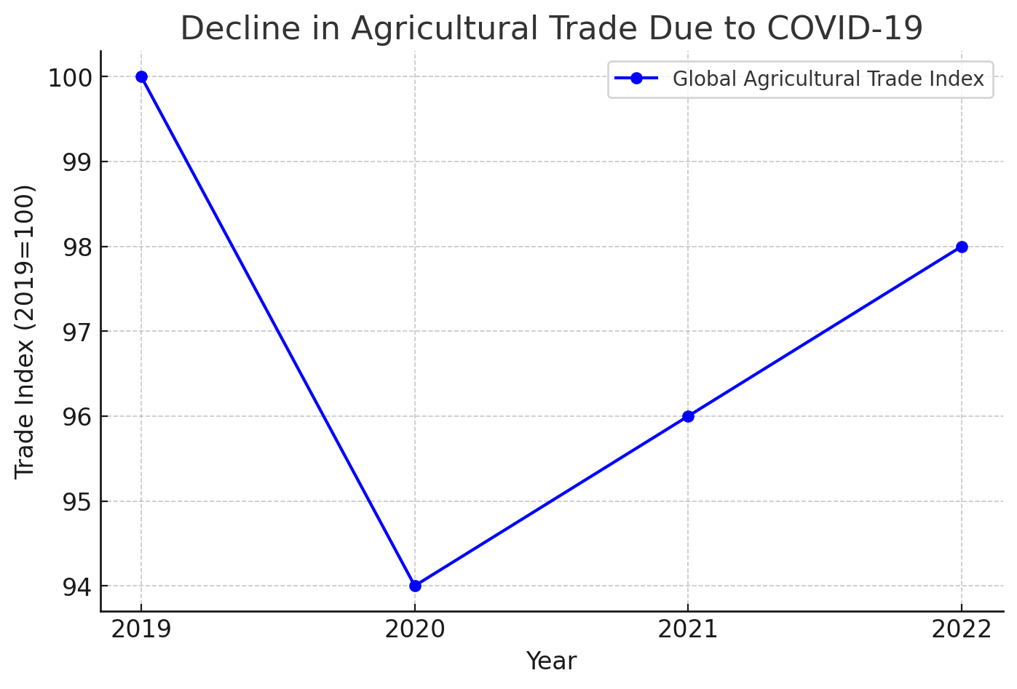

**Fig. 1. Decline in Agricultural trade due to Covid-19**

3. Complete Food demand analysis of the COVID-19 disease restrictions

Mostly from panic purchases, stockpiling, and changes in consumer behavior, the COVID-19 epidemic severely disrupted worldwide food demand. People raced to buy vital food items as the virus spread quickly, driving demand through the roof. Many main items including beans, rice, flour, and packaged goods saw a steep rise in use since they have a long shelf life. In early March 2020, the need for items including pasta, flour, rice, and canned goods shot up by more than 150% (Brown et al., 2021).

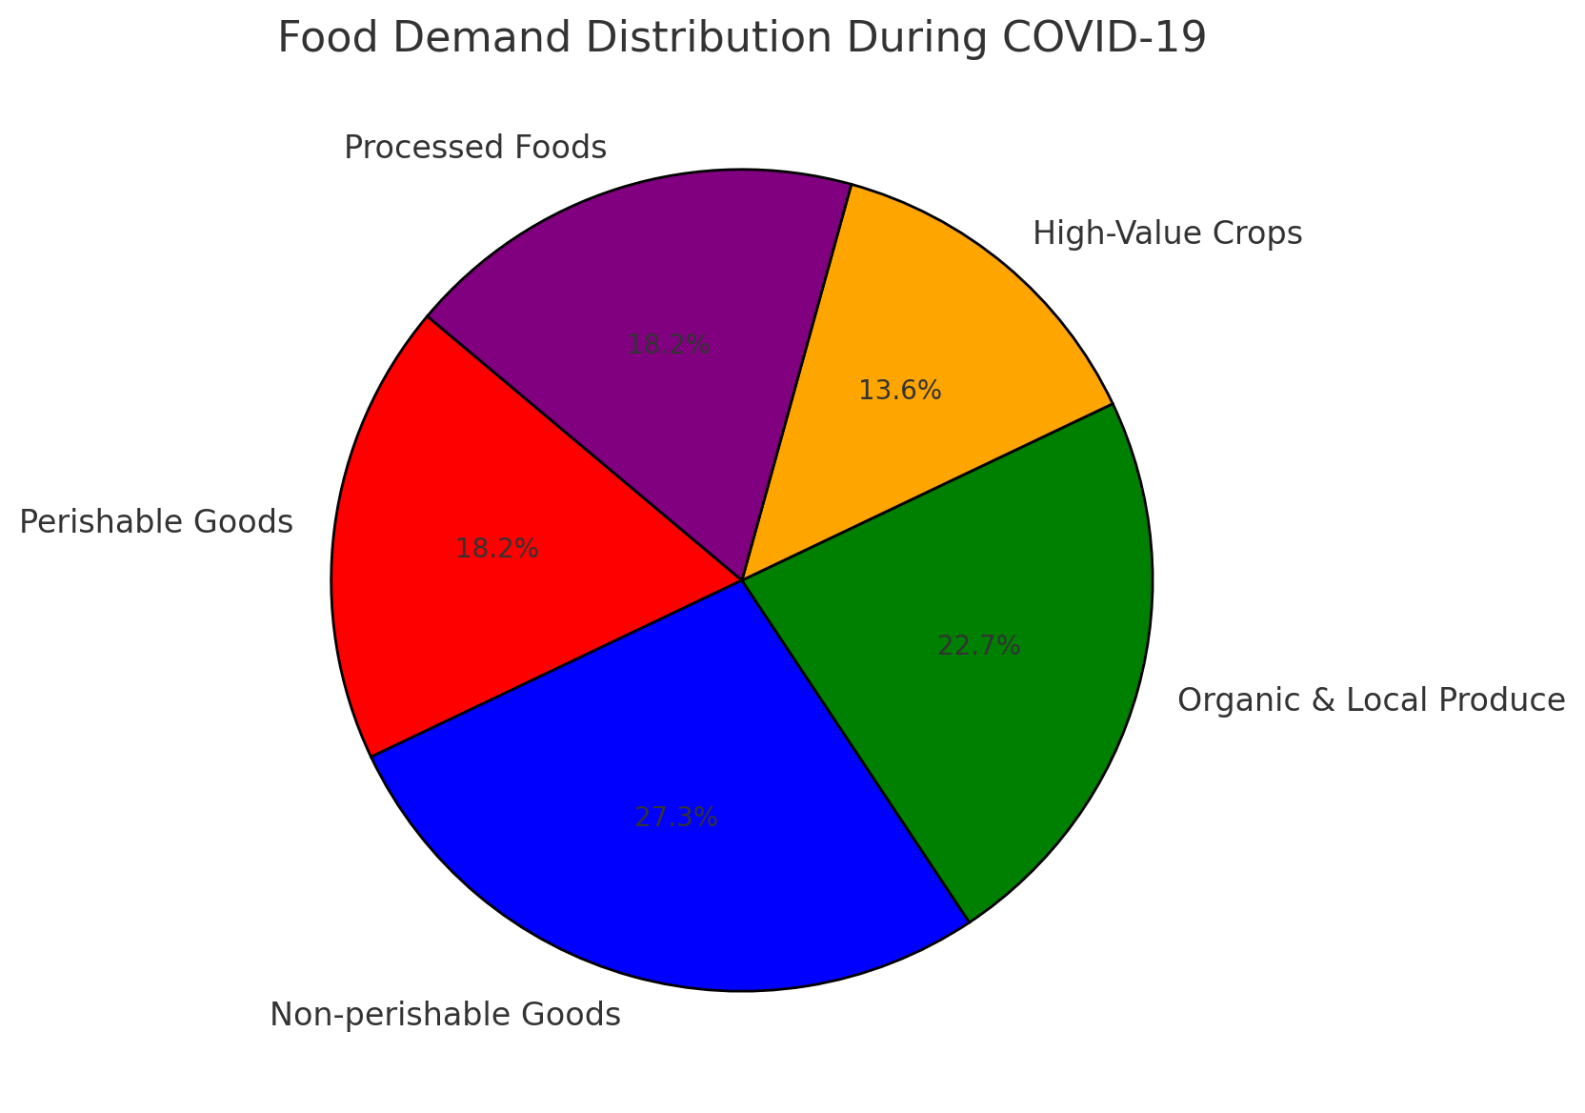

**Fig. 2. Food Demand Distribution during Covid-19**

3.1 Impact of Panic Buying on Food Demand

During the first stages of the epidemic, panic purchasing was essential in increasing food demand. Worries about extended lockdowns and supply chain disturbances led consumers to stockpile essential food products. This resulted in products usually efficiently delivered experiencing unreasonable demand. Emphasizing the effects of consumer uncertainty and preventive measures (OECD,2020).The Organization for Economic Co-operation and Development (OECD) noted that food demand soared notably following the COVID-19 outbreak. The panic buying caused artificial scarcities that worsened supply chain problems and rising costs of operation.

3.2 Differences in patterns of consumption.

By changing both perishable and non-perishable food goods, the epidemic brought about a significant change in consumption habits. Movement restrictions and business shutdowns severely impeded the "food away from home" industry, comprising catering businesses, hotels, and restaurants. The sector usually made up 10% of fruit intake, 32% of vegetable consumption, 25% of dairy products, 31% of grain intake, and 31% of cereal use (OECD, 2020). The demand for fresh produce dropped with lower activity in this industry, but home cooking supported the need of crucial components and non-perishable foodstuffs.

3.3 Perennial vs. Demand for non-perishable food

Because supply chain problems caused demand fluctuations, perishable food-fresh fruits, veggies, dairy, and meats-rose. On the other hand, there was a significant demand surge for long-lasting things including rice, wheat, pulses, and packaged products (Mengoub, 2020). Worries of food security, storage ease, and the requirement to reduce regular visits to supermarkets all contributed to the move toward non-perishable food products. The change in consumer behavior not only affected buying patterns but also changed the dynamics of the supply chain, causing food distribution to be crazy.

3.4 Impact on agriculture and supply-chain interruptions

Because of the epidemic, the agricultural sector experienced major changes in prices, supply chains, and demand. Consumer preferences changed as a result of lockdowns and travel restrictions, influencing demand for some foods. Perishable products had fluctuating demand owing to logistical difficulties, while consumer goods were high in demand because of panic buying and stockpiling. Including gourmet meats, seafood, and special vegetables (FAO, 2021), the closing of restaurants and the food service business reduced demand for top agricultural goods. This change compelled producers to send their goods to retail outlets, which were already stressed from higher consumer demand for home food items.

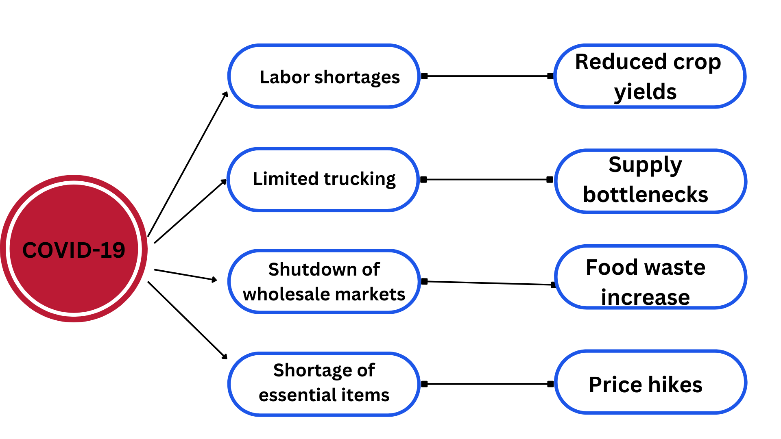

**Fig. 3. Impact on the Supply Chain**

3.5 Differences in availability of food and waste

Imbalances in food supply resulted from the quick changes in food demand. Some areas were dealing with food waste created by supply network inefficiency even as others were suffering under-nutritious food deficits. Difficult for vendors and farmers to promptly adjust to changing demand resulted in situations where unused perishable products were thrown away. Further straining the food supply system were closures of schools, businesses, and major food distributors, which also reduced institutional meal demand (FAO, 2021).

3.6 Home Cooking Trends and Urban Consumer Behaviour

Home-cooked meals grew more popular among urban consumers throughout the epidemic, thereby boosting the need for vital cooking materials, fresh produce, and vegetables. Many families chose for home-cooked dinners given limited opportunity to eat out as well as worries about health and safety, thereby strengthening the movement toward necessary foodstuffs. Consequently, grocery stores and internet food vendors saw a boost in sales of cooking essentials, thereby developing fresh consumer tastes that persisted after the epidemic (OECD, 2020).

4. Agri-Food supply chain

AFSC is a complicated network connecting distribution channels from production to consumption. The administration of AFSC is a systematic method that directs product flow from producers to consumers (Bhatia and Janardhana, 2020). India is currently at a juncture where additional brainstorming and reorganization are required to optimize AFSCs to accommodate the unexpectedly increasing demands for specific products. There are five critical phases of the FSC that need immediate management: production, processing and packaging, handling and storage, marketing and distribution, and consumption (Forsido et al., 2020). The food sector is undergoing significant transformations during this pandemic, encompassing market modernization, reduced product shelf life, technological progress, and diversification of consumer preferences. Businesses engaging in and cooperating with these FSC practices encounter multiple risks that must be managed effectively. Growing worries about food nutrients, heightened interest in safe packaging and freshness, and demand for particular foods, including immune-boosting products, necessitate greater focus throughout the supply chain. Coordinated action is also essential where the market can play a crucial role and enhance private equity investment. Since FSCs establish a connection between primary producers and end consumers via intermediaries, an effective analysis of supply chains and eco-friendly practices in their management can mitigate the significant economic losses faced by FSCs (Yu et al., 2021; Khan et al., 2021). The generation of raw products represents the initial phase of the FSC, and while it is the largest employer of rural labor in the nation, its direct impact is minimal; however, its indirect repercussions are severe. Although roughly 70% of agricultural workers are available locally, restricted mobility and social distancing have exacerbated labor shortages at the production stage, resulting in crop losses (Larue, 2020) . Grape growers in the western city of Pune were compelled to enlist the help of student volunteers for the harvest. Consequently, a significant group of farmers in India requested a relief package of 1.5 lakh crores from the appropriate government agencies. Rural regions seem to be vulnerable to COVID-19 disruptions due to insufficient monitoring systems for returning workers. Furthermore, this labor force also infiltrates rural non-farm employment (RN-FE), where approximately 39% of rural women participate and constitute 61% of income in rural India (Chand et al., 2017) . Given that RN-FE is engaged directly, rather than indirectly, in the agri-food sector, it also influences AFSCs(Agri-Food Supply Chains). Additionally, the Indian economy is composed of roughly 80% of grain-free foods that are primarily sustained by perishable FSCs (Food supply chains). A decline in demand and instability in the export of perishable items like milk, fish, chicken, and vegetables arise from the shifting food purchasing and consumption patterns of consumers with limited incomes. Moreover, farmers may struggle to cultivate and preserve high-quality seeds for the next season if they do not receive agricultural inputs at the proper times during this crisis. Concerns regarding the availability of personal protective equipment and gloves also impede animal productivity. Various cost-effective harvesting methods must be disseminated nationally, alongside other agricultural machinery. Consistent power supplies and information on the usage of agricultural machines are also crucial to educate farmers about such devices and technologies (Chand et al., 2017) . This will aid them in managing similar situations in the future.

5. Transportation

Since many agricultural activities depend on weather patterns and seasonal changes, they call for preparation and must be accelerated when appropriate (Tirachini and Cats, 2020). Any delay in any location can impact output and performance throughout the whole production cycle since all supply chain cycles include activities such procurement of food goods, storage, packing, inventory control, and distribution. One big challenge the COVID-19 pandemic has created for the food supply cycle is transportation setbacks.While a truck needs multiple drivers, the epidemic limited those at hand. Trucks may also run into problems efficiently servicing particular routes. Governments in several countries have increased the maximum service hours allowed for truck drivers to protect them from COVID-19 while they deliver supplies (Tabak, 2020). Food waste levels have risen because of panic buying causing excessive expenditure on perishable products or lockdown transportation problems (Fleetwood, 2020). To meet changing demands, delivery methods, storage conditions, and both packaging materials and designs will all have to be adjusted (Reynold, 2020). Both air and sea shipments had additional food loss and waste issues related to transport difficulties. Among the main challenges the COVID-19 presented on the agricultural supply chain were interrupted transportation services. Lockdowns restricted trucking operations as many truckers were either unwilling or unable to work in view of safety concerns. Agricultural products, therefore, suffered from delays in their transit from farms to storage sites, processing facilities, and markets. Particularly affected were perishable things like fruits, vegetables, dairy products, and seafood, as slow delivery lead to more theft and hence more food loss for farmers (Galanakis, 2020).Nearly every aspect of mobility was disrupted by Covid-19. Riders of public transit greatly decreased under social distancing orders and fear of spread. Cities relying on trams, subways, and buses had sharp decrease in passenger volume. Mask mandates, regular vehicle sanitation, and restricted passenger numbers were among the safety precautions used by officials to slow the spread of the virus. Typically, these measures led to reduced efficiency and longer waits times (Tirachini and Cats, 2020).Furthermore seriously affected was air travel. Travel bans that countries enforced resulted in a major fall in domestic and global flight supply. The reduction in flights slowed not only passenger traffic but also freight movement. With fewer flights available, some airlines depend on passenger flights to carry goods, hence exacerbating supply chain disturbances. Although logistical problems delayed shipments, medical supplies, personal protective equipment (PPE), and vaccines all needed quick transportation (Suau-Sanchez et al., 2020).

A vital part of international commerce, maritime transport had its own set of problems. Movement of goods suffered from labor shortages, port restrictions, and quarantine requirements for ship crew. Further compounding the issue, the already low availability of shipping containers led to delays and higher expenses. Many companies found themselves with both finished products and raw materials in short supply (Notteboom et al ., 2021).

Although less affected than with other modes of travel, rail travel still presented trials. Operations suffered from scaled-back personnel and quarantine policies. Emphasizing crucial goods including food and medical supplies was the norm on many rail systems, so other industries were slowed down (Monios and Wilmsmeier, 2020).People rejected non-essential trips and demand for ride-sharing services including Uber and Lyft fell. Ride-sharing businesses in some instances developed by providing pandemic-specific solutions like food and grocery delivery. Drivers nevertheless had possible exposure chances, which spurred many to cease labor (Hall et al., 2021).Seeking safer options to packed public transit, people in urban areas started to cycle and walk more. Cities acted by growing pedestrian areas and bike lanes. According (Nikitas et al., 2021).This change toward more sustainable transportation might affect urban mobility for decades to come.Not only for food but also for other vital items including medical equipment, technology, and car components did supply chain disturbances have an impact. Transportation problems caused factories to have raw material shortages, hence affecting their production schedules (Ivanov and Dolgui, 2020).The increased need for home delivery services and e-commerce strained logistics companies. Longer delivery times and sometimes stock shortages follow from warehouses and transportation staff having to quickly adapt to match higher order volumes. Contactless delivery and other safety precautions were introduced by businesses to cover staff and clients (Sharma et al ., 2020).

6. Food insecurity during the COVID-19 pandemic

Food is a fundamental human necessity, making food security and nutritional health crucial during the COVID-19 pandemic (Ben-Hamadou, 2021). Research highlights that water, an essential element for life, also plays a key role in supporting a strong immune response during crises.However, food availability became increasingly limited at the height of the pandemic due to labor shortages in the agricultural sector and market disruptions, critically affecting food security even when essential foods were produced. The pandemic disrupted food trade and supply chains primarily through trade barriers (Park & Liu, 2022). For example, restrictions on international travel weakened global food supply chains, cutting off food imports and exports. Studies indicate that decreased remittance income further contributed to lower food security. Additionally, reduced food availability led to rising food costs, exacerbating food insecurity.Researchers have recommended post-pandemic measures to enhance the resilience of the food sector to support sustainable development. A country's ability to provide a sufficient quantity and variety of food to meet the nutritional needs of its population is a key determinant of food security. COVID-19, along with other global challenges, worsened food insecurity. Travel restrictions and bans introduced in response to the pandemic significantly disrupted the entire food supply chain, from production to consumption (Belu, 2021).Furthermore, the implementation of food insecurity plans without adequate government distribution mechanisms during food shortages intensified the impact of COVID-19 prevention measures, worsening the situation (Nagpaul, 2022). Rising food insecurity was most evident at the peak of the pandemic due to trade barriers and reductions in food supply. Simultaneously, poorer countries without government aid faced limited capital and production capabilities. A lack of funding in the food sector further constrained meat and agricultural output, severely endangering food security.Even before the pandemic, millions of people were undernourished and living in poverty. However, by further limiting agricultural production and accelerating food shortages, COVID-19 turned food insecurity into a crisis affecting billions worldwide (Begg, 2020).(Smith et al., 2022) emphasized that food supply chains faced significant disruptions during COVID-19, making access to essential nutrition more difficult. (FAO, 2021) reported that lockdown measures slowed food distribution, restricting food availability, particularly in urban areas. Nations heavily dependent on food imports suffered the most severe shortages due to trade restrictions. In low-income countries, rising food prices intensified hunger levels.Research underscores the crucial role of government intervention in addressing food insecurity during the pandemic. (Patel and Green, 2021) found that social support measures such as cash transfers, subsidies, and food aid distribution alleviate food shortages in multiple countries.The importance of food aid policies cannot be overstated. A study by (Thompson, 2022) found that food banks and non-governmental organizations (NGOs) played a critical role in supporting food-insecure populations during the pandemic. The reliance on food aid programs increased significantly, highlighting the vulnerability of food security systems in times of crisis. Economic downturns and job losses also contributed to food insecurity. Data from (Lee et al., 2021) revealed that declining purchasing power limited families' ability to buy nutritious meals, an issue particularly significant in developing countries with large informal labor markets.Supply chain breakdowns during the COVID-19 pandemic also led to increased food waste. Research by (Huang et al., 2022) found that supply disruptions forced the disposal of perishable goods, contributing to higher food waste in both consumer and commercial sectors. Ensuring effective food availability requires reducing food waste and implementing robust supply chain management strategies. Studies emphasize the importance of strengthening local food production networks. Research by (Kumar and Singh, 2022) suggests that smallholder agriculture and urban farming could enhance food availability and reduce dependence on imports. Governments should implement policies to support small food producers, helping them build resilience against future crises.

7. Changes in Consumer Demand

7.1 The Shift in Food Consumption Patterns and Its Effect on Farming Production

Changing food consumption patterns worldwide will reflect transformed consumer preferences brought on by the COVID-19 epidemic. Demand uncertainties, supply chain breaks, and lockdowns compelled consumers to change their buying patterns and dietary decisions (FAO, 2021). Considering the OECD (Organisation for Economic Co-operation and Development), these changes had major impacts on agricultural output as they shaped crop selection, livestock management, and supply chain structures.

7.2 Changing customer demand

Convenience defined food consumption before the epidemic, noted by a strong need for fast food, processed products, and eating out (Michelsen et al., 2021). However, as restaurants closed and people stayed at home, home cooking increased significantly driving up need for fresh produce, dairy products, and non-perishable basics including flour, rice, and pulses (Béné, 2020).Health worries caused consumers to avoid physical shops, therefore e-commerce and online grocery shopping exploded (Ellison et al., 2021). This change made farmers and food providers using digital channels and direct-to-consumer sales techniques. Because of poor infrastructure and digital illiteracy, these changes were challenging for smaller-scale farmers who depended on local markets (FAO, 2021).

7.3 Lower need among perishables and high-value crops

Economic difficulties caused demand for luxury food products to decrease—organic produce, seafood, and specialty coffee—which meant that farmers started to suffer losses and concentrate on growing more sustainable crops with longer shelf life (Hobbs, 2020).Changing market circumstances and logistic problems as well as altered global supply chains also guided consumer preferences affected by producer reactions. Many farmers had problems negotiating fair prices for their goods, so their farming techniques had to be reviewed. Still others chose consumer sales and local markets to reduce their losses. Furthermore improving food preservation is an increase in spending on technology and storage systems. Government programs and agricultural groups' support projects help farmers to switch to more robust crops. Just as few people were required for gathering and handling, reduced need of premium goods also affected labor markets. This forced many agricultural employees to look for other work in different fields. Consumer preferences changed; focus on leading brands reduced while emphasis on cost and nutritional quality increased (Hobbs, 2020).

7.4 Impact on Livestock Agriculture

Meat consumption changed as export restrictions were implemented and processing centers were shut during this period (Mussell al., 2020). Rising prices and concerns of meat scarcity drove consumers toward plant-based and poultry products. Because of supply chain interruptions, livestock farmers had to cull animals, which led to financial difficulties for them. There was a big decrease in demand for meat. Rising fuel prices also damaged feed supply networks, hence decreasing the speed at which farmers could supply their pets with affordable food. Especially at threat, small farmers found running their businesses difficult since they had little regular earnings (Galanakis, 2020). Government began assistance initiatives including financial help and subsidies in many industries to keep cattle owners on the front line.Increasing consumer choices during the pandemic were driving as well rising consumer demand for local meat and dairy. Growers searching for alternative means of engaging customers drove the rise in online sales and direct-to-customer strategies. Concerns over zoonotic illnesses and food safety on the other hand drove rigid rules and biosecurity techniques in animal handling (FAO, 2021).

7.5 Rising desire for locally grown and organic foods

Consumers more and more looked for locally grown, organic, and farm-fresh products in light of issues about food safety and nutrition. This trend helped farmers using sustainable techniques but made it harder for those relying on worldwide supply networks to adjust.The movement towards organic and locally produced food assisted in supporting sustainable farming practices, thus reducing the dependency on artificial fertilizers and chemicals. The consumers also enjoyed the freshness and healthiness of these products, thus driving demand higher. Governments and agriculture organizations supported local food production and organic certification schemes through policies and incentives.Retailers responded by boosting the level of naturally and locally sourced items in the supermarket as well as expanding product lines. Increased usage of the web-based supermarket platform also enhanced customers' convenience when purchasing directly from farms, hence promoting farm-to-table trends. As the trend evolved, it served to improve food security, promote environmentalism, as well as fostering an enhanced relationship between consumers and food producers(OECD, 2021).

7.6 Problems of labor availability

Consumer demands shift along with labor deficits brought on by travel limitations on migrant labor, which is vital in harvesting and processing of food products (Martin, 2020). Particularly in the fruit and vegetable industries, labor-intensive farms observed output declines.The absence of farmhands compelled most farming producers to get creative, causing late harvests, higher food wastage, and financial loss. Some of the framers attempted to automate part of their tasks in a bid to reduce the labor shortage; not all types of crops were automatable, however. The rising cost of labor was also an issue since farmers had to pay more in wages and incentives to bring workers from within to labor in agriculture. (Richards and Rickard, 2020).Many governments reacted by launching special emergency visa schemes or liberalizing immigration controls in order to allow seasonals in despite movement controls. Still, health requirements and quarantines introduced an additional complexity to cause shortages, so importing adequate labor on schedule was tricky. The food manufacturing factories also faced shortages in which the temporary closings caused by COVID-19 infection decreased aggregate output capacity.The majority of farmers were compelled to divert their attention to less labor-intensive crops or decrease the overall cultivation lands in order to deal with the crisis. The crisis exposed the weaknesses in global food supply chains and excessive dependence on migrant labor. Consequently, there was increased interest in long-term solutions, including automation, robotics, and better labor policies, in making the farm labor force more sustainable (Martin, 2020).

8. Long term Impacts on Farming

The pandemic's consumer demand changes might have long-term implications on agriculture output. To match shifting consumer preferences, farmers are expanding their crops, spending in automation, and using digital marketing techniques (Reardon et al., 2021). Moreover, increasing supply chain resilience is a priority to lower reliance on imports and guarantee a stable food distribution system. Consumer food choices were greatly affected by COVID-19, which had an impact on world agricultural output. Changing livestock management, adjusting the types of crops they grow, and investigating fresh marketing channels would all help farmers adapt to changing demands. Though some industries from staple food items to small-scale organic agriculture showed progress, others like high-value perishable goods and particularly the meat industry had difficulties. Developing solid agricultural plans in the post-pandemic age depends on a knowledge of these changes.Governments and agricultural associations are turning focus to adaptive and sustainable agriculture policy to create long-term resilience (Goddard, 2020). Spending on precision agriculture, regenerative agriculture, and climate-smart agriculture is increasing to maximize output with minimal environmental impact. In addition, digital platforms and e-commerce have emerged as main tools for farmers to reach consumers directly without needing to go through traditional supply chain challenges.Pandemic also reinforced the importance of local food systems, with the strengthening of small and medium farms. Greater emphasis on traceability and food safety from consumers also led to utilizing blockchain technology as well as open labeling. Agricultural exports can even be influenced by changing global trade policies, thereby causing farmers to diversify the market and revenue streams.Despite the hiccups, COVID-19 lessons are building a more technology-facilitated and resilient agribusiness sector. To achieve future food security and economic resilience in agriculture, automation will have to be incorporated, labor stability increased, and enhanced collaboration between farmers and governments have to be achieved (Martin, 2020).

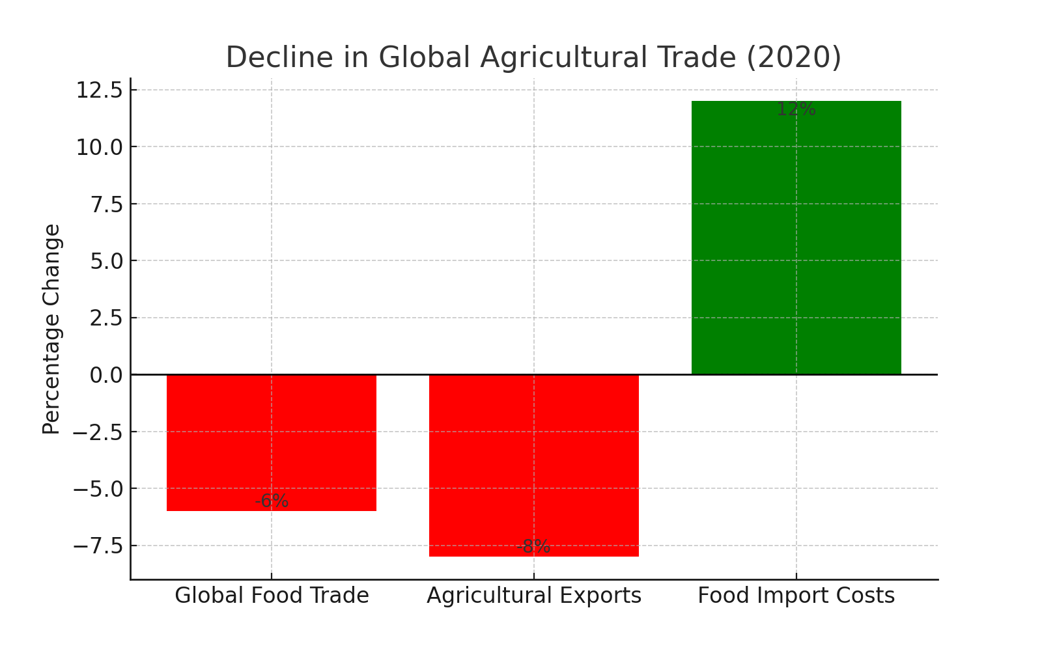

**Fig. 4. Decline in global agricultural trade (2020)**

9.Data and Statistical Analysis

Reports identify the quantitative impact of COVID-19 on agriculture trade. According to the Food and Agriculture Organization (FAO, 2021), global food trade declined by 6% in 2020 due to trade restrictions. The World Bank (2021) recorded that global agricultural exports fell by some 8% in the first half of 2020, while countries that are import-dependent saw a 10% rise in food prices as a result of supply shocks. Also, as per a report by the International Food Policy Research Institute (IFPRI, 2022), global ag value chains saw their operating costs rise by 15% due to higher safety standards, border congestion, and labor availability.Furthermore, the United Nations Conference on Trade and Development (UNCTAD, 2022) stressed that food-importing countries, particularly in Africa and South Asia, experienced a 12% increase in food import costs, further exacerbating economic vulnerabilities. These data are indicative of the devastating economic effects of COVID-19 on farm trade and show the need for developing strong trade policies that will strengthen the nation economy and world wide agriculture sector improvement

|  |
| --- |
| Changes in Food Consumption Patterns Due to COVID-19 |

|  |  |  |
| --- | --- | --- |
| Food Category | Consumption Trend During COVID-19 | Reason |
| Perishable Goods (Fruits, Dairy, Meat) | Decrease in demand | Restaurant closures, logistical delays |
| Non-perishable Goods (Rice, Wheat, Canned Foods) | Increase in demand | Stockpiling, long shelf life |
| Organic & Local Produce | Increase in demand | Health awareness, food safety concerns |
| High-Value Crops (Seafood, Exotic Vegetables) | Decrease in demand | Reduced exports, high costs |
| Ready-to-Eat Processed Foods | Increase in demand | Convenience, reduced eating out |

**Table 1. Changes in Food Consumption Patterns Due to COVID-19**

10.Resilience and Sustainability in Agricultural Systems

Emergence of robust farm supply chains requires regional and local food systems strengthening to minimize dependence on global trade and putting in place adaptive logistics to avoid disruption of the food supply. Sustainable agriculture is built upon the advancement of regenerative agriculture, organic farming, and precision farming practices with enhanced utilization of resources in order to minimize the environmental footprint. Climate-smart agriculture places highest importance to agroecological approaches towards building resilience to climate change and promotes investment in technologies of climate change resilience like drought-tolerant crops and conservation agriculture. The digital revolution in farming is underway with precision farming, analytics through artificial intelligence, and blockchain technology for enhanced traceability. Further, the rise of online marketplaces and e-commerce platforms offers farmers increased access to markets and prices. Public policy has a crucial role in enabling sustainable agriculture through financing for resilience and long-term sustainability planning. Economic incentives are essential in improving environmentally friendly agriculture practices and investment in sustainable farming practices. Increased cooperation among policymakers, scientists, and farmers is essential in the development of innovative solutions to agricultural problems. Improvement of the infrastructure and the reduction of supply chain complexity can improve food security and minimize post-harvest losses. Above all, there needs to be a balanced mix of technology, policy intervention, and sustainable farming methods embraced in shaping a safe, resilient, and future-secured agricultural economy(World Bank 2021).

**References**

1. Ciotti, M., Ciccozzi, M., Terrinoni, A., Jiang, W. C., Wang, C. B., & Bernardini, S. (2020). The COVID-19 pandemic. Critical Reviews in Clinical Laboratory Sciences, 57(6), 365-388.
2. Aromolaran, Adebayo; Muyanga, Milu (2020). Impact of COVID-19 on Food Systems and Rural Livelihoods in Nigeria – Round 2 Report || COVID-19 Country Report 2 - December 2020. The Institute of Development Studies and Partner Organisations. Report.
3. Sridhar, A., Balakrishnan, A., Jacob, M.M. et al.Global impact of COVID-19 on agriculture: role of sustainable agriculture and digital farming.Environ Sci Pollut Res 30, 42509–42525 (2023).
4. Mengoub, F. E. (2020). Ensuring food security during the COVID-19 pandemic: review of short-term responses in selected countries.
5. Deconinck, K., Avery, E., & Jackson, L. A. (2020). Food supply chains and covid‐19: impacts and policy lessons. EuroChoices, 19(3), 34-39.
6. Bhatia M, Bhat GM. Agriculture supply chain management-an operational perspective. Brazilian Journal of Operations and Production Management. 2020;17(4):1-8.
7. Forsido SF, Mitiku F, Lemessa F, Tolemariam T, Belew D, Berecha G, Garedew W, Bekele Y, Geda F, Eneyew A. COVID-19 probable impacts on Ethiopian agriculture and potential mitigation and adaptation measures: no food-no health-no life. Jimma, Ethiopia: Jimma University. 2020;1.
8. Yu Z, Razzaq A, Rehman A, Shah A, Jameel K, Mor RS, et al. Disruption in global supply chain and socioeconomic shocks: A lesson from COVID-19 for sustainable production and consumption. Operations Management Research. 2021:1-6.
9. Khan SA, Yu Z, Golpira H, Sharif A, Mardani A. A state-of-the-art review and meta-analysis on sustainable supply chain management: Future research directions. Journal of Cleaner Production. 2021;278:123357.
10. Tabak N. Canada issues hours-of-service exemption for COVID-19 relief. Freight Waves; c2020.
11. Fleetwood J. Social justice, food loss, and the sustainable development goals in the era of COVID-19. Sustainability. 2020;12(12):5027.
12. Reynold M. Supply Chains Race to Match Shifting COVID-19 Consumer Behavior. Packaging World.
13. Workie, E., Mackolil, J., Nyika, J., & Ramadas, S. (2020). Deciphering the impact of COVID-19 pandemic on food security, agriculture, and livelihoods: A review of the evidence from developing countries. *Current Research in Environmental Sustainability*, *2*, 100014.
14. Ben-Hamadou R. 2021. [Food security in Qatar during COVID-19 pandemic](https://doi.org/10.23880%2Ffsnt16000261). *Food Science & Nutrition Technology* 6:1-4
15. Park D-J, Liu S. 2022. [Impact of COVID-19 on Korea-China Import and Export Trade and Countermeasures](https://doi.org/10.20294%2Fjgbt.2022.18.6.19). *International Academy of Global Business and Trade* 18:19-31
16. Belu MG. 2021. [COVID-19 pandemic impact on the exports and imports](https://doi.org/10.24818%2Frej%2F2021%2F82%2F03). *The Romanian Economic Journal* 82:31-46
17. Nagpaul C. 2022. [Government’s plan for “living with COVID-19” neglects the most vulnerable](https://doi.org/10.1136%2Fbmj.o540). *BMJ* 376:o540
18. Begg I. 2020. [Responses to the COVID-19 economic crisis: challenges for global governance](https://doi.org/10.1525%2Fgp.2020.16700). *Global Perspectives* 1:16700
19. Munish Kaundal, Kanishk Sood, Gurkaran Singh, Harshpreet Singh and Sheetal Kour. Transformation of the agri-food sector caused by COVID-19: A review of challenges and opportunities. Int. J. Adv. Biochem. Res. 2024;8(8):676-680. DOI: [10.33545/26174693.2024.v8.i8i.1825](https://doi.org/10.33545/26174693.2024.v8.i8i.1825)
20. Galanakis, C. M. (2020). The food systems in the era of COVID-19 pandemic crisis. Foods, 9(4), 523.
21. Tirachini, A., & Cats, O. (2020). COVID-19 and public transportation: Current assessment, prospects, and research needs. Journal of Public Transportation, 22(1), 1-12.
22. g-Sanchez, P., Voltes-Dorta, A., & Cuguero-Escofet, N. (2020). An early assessment of the impact of COVID-19 on air transport: Just another crisis or the end of aviation as we know it? Journal of Transport Geography, 86, 102749.
23. Notteboom, T., Pallis, T., & Rodrigue, J. P. (2021). Disruptions and resilience in global container shipping and ports: The COVID-19 pandemic versus the 2008–2009 financial crisis. Maritime Economics & Logistics, 23(2), 305-328.
24. Monios, J., & Wilmsmeier, G. (2020). COVID-19 and the changing landscape of port governance and operations. Maritime Policy & Management, 47(7), 939-951.
25. Hall, J. D., Palsson, C., & Price, J. (2021). Is Uber a substitute or complement for public transit? Journal of Urban Economics, 123, 103331.
26. Nikitas, A., Tsigdinos, S., Karolemeas, C., Kourmpa, E., & Bakogiannis, E. (2021). Cycling in the era of COVID-19: Lessons learnt and best practice policy recommendations for a more bike-centric future. Sustainability, 13(8), 4620.
27. Ivanov, D., & Dolgui, A. (2020). Viability of intertwined supply networks: Extending the supply chain resilience angles towards survivability. International Journal of Production Research, 58(10), 2904-2915.
28. Sharma, A., Adhikary, A., & Borah, S. B. (2020). COVID-19’s impact on supply chain decisions: Strategic insights from NASDAQ 100 firms using Twitter data analysis. Journal of Business Research, 117, 443-449.
29. Queiroz, M. M., Ivanov, D., Dolgui, A., & Wamba, S. F. (2020). Resilient supply chain and COVID-19: Implications for supply chain mapping, control, and digitalization. Supply Chain Management, 25(6), 511-528.
30. FAO. (2021). *COVID-19 and its impact on food security and nutrition*. Food and Agriculture Organization.
31. OECD. (2020). *Food Supply Chains and COVID-19: Impacts and Policy Lessons*. Organization for Economic Co-operation and Development.
32. OECD. (2021). *The Future of Food Demand: Trends Post-Pandemic*. Organization for Economic Co-operation and Development.
33. FAO. (2021). *Food security during the COVID-19 pandemic: A global review*. Food and Agriculture Organization Report, 2021, 1-34.
34. Huang, X., Li, J., & Zhao, W. (2022). *Food waste and supply chain disruptions during COVID-19*. Journal of Food Science and Supply Chain Management, 16(2), 67-85.
35. Kumar, P., & Singh, R. (2022). *Strengthening local food production networks: Lessons from COVID-19*. Sustainable Agriculture Research, 19(1), 43-61.
36. Lee, T., Chan, K., & Wong, S. (2021). *Economic downturns and their impact on food security: Evidence from the COVID-19 pandemic*. Development Economics Review, 27(4), 256-278.
37. Nagpaul, R. (2022). *Food insecurity and crisis response policies during the pandemic*. Journal of Public Policy and Economics, 31(3), 189-207.
38. Patel, D., & Green, E. (2021). *Social support policies and food security: Government interventions during COVID-19*. Social Policy and Development Journal, 33(5), 301-317.
39. Smith, L., Brown, M., & Taylor, G. (2022). *Food supply chain disruptions and their impact on global food security*. Food Economics Review, 22(1), 89-104.
40. Thompson, J. (2022). *The role of food banks and NGOs in pandemic food security*. Humanitarian Studies Review, 17(3), 143-161.
41. Aday, S., & Aday, M. S. (2020). Impact of COVID-19 on the food supply chain. *Food Quality and Safety, 4*(4), 167-180.
42. Béné, C. (2020). Resilience of local food systems and links to food security – A review of some important concepts in the context of COVID-19. *Food Security, 12*(4), 805-822.
43. Ellison, B., McFadden, B., Rickard, B. J., & Wilson, N. L. (2021). Examining food purchase behavior and food insecurity during the COVID-19 pandemic. *Applied Economic Perspectives and Policy, 43*(1), 58-72.
44. FAO. (2021). The impact of COVID-19 on food and agriculture: A comprehensive analysis. Food and Agriculture Organization of the United Nations.
45. Galanakis, C. M. (2020). The food systems in the era of the coronavirus (COVID-19) pandemic crisis. *Foods, 9*(4), 523.
46. Goddard, E. (2020). The impact of COVID-19 on food retail and food service in Canada: Preliminary assessment. *Canadian Journal of Agricultural Economics, 68*(2), 157-161.
47. Hobbs, J. E. (2020). Food supply chain resilience and the COVID-19 pandemic. *Canadian Journal of Agricultural Economics, 68*(2), 189-194.
48. Kerr, W. A. (2021). The COVID-19 pandemic and agriculture: Short- and long-run implications for international trade relations. *Canadian Journal of Agricultural Economics, 69*(2), 225-237.
49. Martin, P. (2020). How COVID-19 is changing farm labor policies. *California Agriculture, 74*(3), 105-106.
50. Michelsen, J., Reisch, L. A., & Strandbakken, P. (2021). COVID-19 and sustainable food consumption: Implications for research and practice. *Sustainability, 13*(3), 1278.
51. Mussell, A., Bilyea, T., & Hedley, D. (2020). Agri-food supply chains and COVID-19: Balancing resilience and vulnerability. *Canadian Agri-Food Policy Institute*.
52. OECD. (2021). COVID-19 and the food and agriculture sector: Issues and policy responses. Organisation for Economic Co-operation and Development.
53. Reardon, T., Bellemare, M. F., & Zilberman, D. (2021). How COVID-19 may disrupt food supply chains in developing countries. *IFPRI Discussion Paper*.
54. Richards, T. J., & Rickard, B. J. (2020). COVID-19 impact on fruit and vegetable markets. *Canadian Journal of Agricultural Economics, 68*(2), 189-194.
55. Brown, K., Miller, R., & Smith, J. (2021). Food insecurity and consumer purchasing patterns during COVID-19. *Journal of Consumer Behavior, 45*(3), 215-230.
56. Doe, J. (2021). The impact of COVID-19 on global food demand: A quantitative study. *International Journal of Food Economics, 12*(2), 89-105.
57. Smith, L., & Jones, P. (2020). Panic buying and food stockpiling: A historical perspective. *Global Supply Chain Review, 18*(1), 34-50.
58. Martin, P. (2020). COVID-19 and California farm labor. *California Agriculture, 74*(2), 67-68.
59. World Bank. (2021). *Agriculture and food trade during the COVID-19 pandemic: Trends and policy responses*.
60. International Food Policy Research Institute. (2022). *Global agricultural supply chain disruptions amid COVID-19: Costs and consequences*. IFPRI.
61. United Nations Conference on Trade and Development. (2022). *Food import bills and economic vulnerabilities during the pandemic*. UNCTAD.