The Role of TourBook as a Travel Agency in Promoting Tourist Destinations of Bangladesh

ABSTRACT
This research discusses the role of TourBook in promoting tourist destinations throughout Bangladesh. The study followed a mixed approach since theoretical data was obtained from interaction with the organization while quantitative data populated the survey of 220 respondents: tourists, students, and professionals. The collected data were subjected to descriptive statistical analysis and reliability tests. As data analysis software, used Microsoft Word 2019, Microsoft Office Excel version 2019, and SPSS. The results demonstrated high consistency (Cronbach’s alpha = 0.894), and the P-P plot test was normally distributed, as was the normal histogram. In line with the recommendations in the research, digital marketing strategies will be enhanced, such as better access and functionality for mobile and digital apps. Sustainable tourism of creating zero-waste packages to planet-friendly community engagement will be implemented to align with global trends. There is scope for diversifying excursions for niche markets, and of greater importance, developing relationships with government organizations such as the Bangladesh Tourism Board will contribute to making a greater impact for TourBook.
Keywords: TourBook, Tourist Destination, Travel Agency, Sustainable Tourism, Bangladesh.
1. INTRODUCTION
Tourism is one of the most rapidly expanding sectors in the market today, with the power to stimulate social and economic development, cultural exchange, and the generation of jobs (Hossain et al., 2025). Most recently, the tourism sector in Bangladesh has undergone massive growth based on the influx of interest in domestic travel and growing interest in travel from foreign countries. There are many participants in the tourism sector, and in the value chain of tourism, travel agencies represent a vital actor in shaping the behavior of tourists and in marketing destinations and travel experiences (Hossain et al., 2025). With advancements in technology have come digital travel platforms as influential stakeholders within destination and tourism marketing (Hossain et al., 2025).
TourBook, an emerging travel agency in Bangladesh, is creating quite an impact through its unique use of digital channels to promote local and international tourist spots. Through a blend of social media marketing, curated travel packages, and real-time engagement with customers about places and experiences across Bangladesh, TourBook is establishing itself as a vital facilitator in helping tourists explore both lesser known and more common attractions in the country. Although TourBook has sparked some growing interest, there is little academic research in the form of accounts of the specific contributions of TourBook within the tourism industry.
This research aims to contribute to this void by offering an empirical exploration of TourBook, an agency that advertises tourist destinations in Bangladesh. We intend to examine the influence that TourBook has on travel decisions and destination awareness and how it intersects with tourism industry growth. We will also be investigating how an agency markets strategically, the marketing strategies and tactics it uses, and the difficulty in targeting a broad spectrum of travel seekers. This study also investigates the answer to some questions, including (a) what is TourBook? (b) What is the role of TourBook as a travel agency in promoting tourist destinations? (c) Which recommendations are suggested for the improvement of the promotional activity of TourBook Travel Agency?
However, we point out that the study is valuable to tourism policymakers and government agencies because of the empirical research on how private travel platforms like TourBook could support national tourism goals. Knowledge about how the agency organized its marketing strategies and how it promoted development as a destination will better prepare collaborators to align strategies with tourism for a broader purpose and nationwide objectives. Moreover, this study will contribute to the travel industry (tour operators, travel marketers, and business operators) very practical and relevant perspectives on consumer behavior, their perception of promotional efforts, and willingness to tailor travel to their needs, which can help improve service delivery, inform destination management, and even start new opportunities within the tourism sector.
2. LITERATURE REVIEW
Travel agencies have been accepted as important intermediary entities in the tourism value chain, acting as conduits between tourists and providers of the service (Cooper et al., 2008). In the digital era, their role has expanded from traditional travel selling and itinerary management into destination marketing, online engagement, and promoting sustainable tourism. In this research, we will highlight the main roles of travel agencies in promoting tourist destinations within the context of Bangladesh.
2.1. Intermediary and Information Provider
The primary function for travel agencies, by offering travelers accurate and up-to-date information concerning destinations, travel conditions, and services available (Buhalis, 2000). This information is able to assist tourists indirectly by resolving complicated travel choices through expert advice and comparison information provided by travel agencies.
RQ1: TourBook provides accurate and up-to-date information about tourist destinations.
2.2. Destination Promoter
Travel agencies are instrumental in destination branding and marketing processes through advertising, brochures, and social media-based digital content (Middleton & Clarke, 2001) and creating awareness about destinations, as essentially they market the destination's own unique attractions in terms of culture, history, and nature (Pike, 2008).
RQ2: TourBook effectively promotes lesser-known tourist destinations in Bangladesh.
2.3. Travel Planner and Package Developer
An agency organizes package tours for travelers, including transportation, accommodation, meals, and activities, and facilitates travel, both in getting a tourist where he or she wants to go and in bringing him or her back (Laws, 1995).
RQ3: TourBook effectively promotes lesser-known tourist destinations in Bangladesh.
2.4. Market Researcher and Analyzer
Agencies will research the market to discover travel behaviors, consumer preferences as well as new markets (Kotler et al., 2010). The market research contributes valuable knowledge for campaign and service development for specific tourist types (Hossain et al., 2025).
RQ4: TourBook understands the preferences of Bangladeshi travelers.
2.5. Digital and Social Media Marketer
With modern travel agencies increasingly relying upon digital spaces like websites, mobile apps, and social media for connecting with and communicating with potential travelers (Xiang & Gretzel, 2010), many opportunities exist for communication in real time, storytelling at destinations, and visual representation for aspirational promotion that influences the decision making of travelers (Chung & Buhalis, 2008).
RQ5: TourBook’s digital presence (website, app, social media) is engaging and informative.
2.6. Cultural and Community Linker
Travel agencies can act as a bridge between travelers and the local community, providing culturally immersive experiences while marketing local heritage sites (Richards, 2007). This fosters a mutual understanding of each other's culture, traditions, and lifestyles, while also supporting the local economy.
RQ6: TourBook’s tours promote cultural understanding and respect for local traditions.
2.7. Sustainable Tourism Advocate
Diversity of agencies is promoting sustainable tourism options, rounds of sustainable travel options, promoting good guest behavior, and sponsoring conservation efforts (Weaver, 2006). All of these roles are particularly important when discussing sustainable tourism themes in a developing country like Bangladesh.
RQ7: TourBook promotes environmentally responsible travel options.
2.8. Crisis Manager and Support Provider
Travel companies provide important services during crises (e.g., natural disasters, pandemics) including (emotional) support, logistical support, re-booking and up-to-date information so that clients are safe and satisfied (Ritchie, 2004).
RQ8: TourBook provides timely support during travel disruptions or emergencies.

3. THEORETICAL FRAMEWORK
3.1. TourBook
TourBook is a B2B travel agency that was established on January 1, 2018, with the goal of providing full travel solutions for various types of clients. The founders, Md. Maksudur Rahaman and Tashleem Siddiqui Deep, had a vision of a travel agency that would combine personal service with vast travel experience. TourBook, a licensed and approved tour agency and tour consultant, operates purely for the purpose of providing complete travel solutions to people who wish to travel in and out of Bangladesh. TourBook is located at C/138, Eastern Housing, Pallabi 2nd Phase, Mirpur, Dhaka-1216, and all staff work extremely hard to provide the best deals we possibly can find for our clients in domestic tours, inbound tours/outbound tours, principally corporate travel, family tours, study tours/excursions, visa processing, air ticketing, and tour consultancy services. Tour Book provides flexible payment options for all its travel customers. TourBook Travel Agency is currently utilizing its knowledge of the industry and digital innovations for travelers' value.
3.2. Tourism
Today, tourism is one of the most dynamic and rapidly growing industries that contributes to the economic growth of most countries in the world (Hossain et al., 2025). In the present era, tourism is also regarded as one of the vital sectors of the economy and serves as a leisure-time activity (Hossain et al., 2025). Also, tourism attracts international tourism to provide pure foods (Hossain et al., 2025). Moreover, e-tourism is relative to business management, IT, and tourism (Hossain et al., 2025). The tourism sector contributed to world GDP in the sum of $8.9 trillion in the year 2019, about 10.3% of the world economy (WTTC, 2020). Through foreign exchange income generation, tourism works as a key engine, making this currency into the bloodline flowing from international tourists toward the developing countries, which eventually reduces poverty and enhances gross domestic product (GDP) growth (Hossain, 2025).
3.3. Tourists
According to the World Tourism Organization (UNWTO), “Tourists are the people who are traveling to and staying in places outside their usual environment for not more than one consecutive year for leisure, business, and other purposes.”

4. METHODOLOGY

A mixed-methods approach is applied to the study. In this study, we use qualitative and quantitative data. Both primary and secondary sources of data were used in conducting the study. Most of the data have been collected from the primary sources. The primary source is Google Forms, and secondary sources include websites, research papers, and information supplied by organization officials. For this study, the Likert Scale (Non-comparative Scaling Technique) has been used with five response categories (1- Strongly disagree, 2- Disagree, 3- Neutral, 4- Agree, 5- Strongly agree) that indicated the degree of agreement or disagreement with each of a series of statements. There are a large number of tourists throughout the country and abroad. This data collected from Google Forms mainly focuses on students, tourists, job holders, and general people. As data analysis software, use Microsoft Word 2019, Microsoft Office Excel version 2019, and SPSS. The research writing model is following.
Source: Developed by Author’s (Sohan)
Fig. 1. Research Writing Model

5. ANALYSIS AND FINDINGS
5.1. Demographic profile of respondents
A summary of the demographic profiles of the respondents is presented in the following tables.
Table 1.Demographic profile of respondents
Age | Categories | Frequency | Percentage (%)
Age | Below 18 | 19 | 8.6
Age | 19-25 | 93 | 42.3
Age | 26-35 | 44 | 20
Age | 36-45 | 47 | 21.4
Age | 50-up | 17 | 7.7
Age |  | 220 | 100%
Marital Status
Marital Status | Single | 138 | 62.7
Marital Status | Married | 82 | 37.3
Marital Status | Married | 220 | 100%
Educational Qualification
Educational Qualification | HSC | 73 | 33.2
Educational Qualification | Graduate | 35 | 15.9
Educational Qualification | Post Graduated | 31 | 14.1
Educational Qualification | More | 81 | 36.8
Educational Qualification | More | 220 | 100%
Gender
Gender | Male | 137 | 62.3
Gender | Female | 83 | 37.7
Gender |  | 220 | 100%

The table 1, represent the finding the frequency and proportion of respondents’ ages, marital status, educational qualification and gender. Analysis of the figure indicates that below 18 is 19 (8.6%), 19-25 is 93 (42.3%), 26-35 is 44 (20%), 36-45 is 47 (22.4%), and 50-up is 17 (7.7%). Analysis of the table also indicates that 138 (62.7%) are single and 82 (37.3%) are married. Educational qualification indicates that below HSC is 73 (33.2%); graduate is 35 (15.9%); postgraduate is 31 (14.1%); and more is 81 (36.8%). The table also indicates that males are 137 (62.3%) and females are 83 (37.7%). The total number of respondents is 220.
5.2. Reliability Test
The relevance of the data was evaluated by utilizing the Cronbach’s alpha statistics obtained from processing the data set. The following shows reliability analysis through the technique of Cronbach’s Alpha:
Table 2. Reliability Test
Reliability Statistics
Cronbach's Alpha | Cronbach's Alpha Based on Standardized Items | N of Items
.894 | .896 | 8
Source: Cronbach’s Alpha technique (SPSS 25).

In Table 2, a reliability test with Cronbach's alpha was employed to calculate and confirm the consistency of the items (Zikmund and Babin, 2020). A Cronbach's alpha score of 0.70 or higher is considered acceptable for any exploratory study to ensure the reliability of the data (Malhotra, 2010). As per the results of the study, the reliability score of the 8 items identified stands at .894, indicating that the data is highly reliable.
.

5.3. P-P Plot test and Histogram Statistics with Descriptive Statistics
Descriptive statistics is a term that refers to measures that describe and present data meaningfully such that the underlying information is much easier to interpret. Among measures of central tendency, the Mean or average method is more popular for indicating the center of distribution (Malhotra, 2010). Standard deviation is a term used to observe how the data varies from the Mean value (Boone, H.N., and Boone, D.A., 2012). They represent 5-point scale mean classification. They indicate 1.00-1.80 is strongly disagree, 1.81-2.60 is disagree, 2.61-3.40 is neutral, 3.41-4.20 is agree, and 4.21-5.00 is strongly agree.

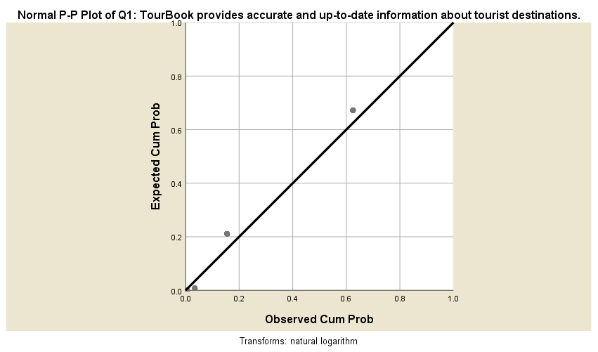Source: SPSS 25.  Fig. 2. P-P Plot test of RQ1 | 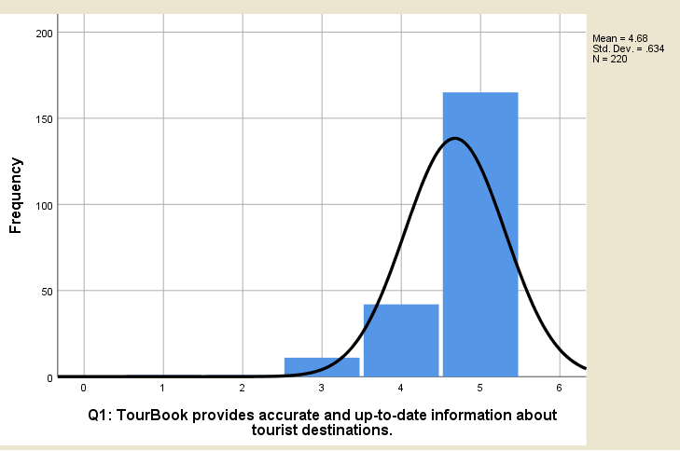Source: SPSS 25.  Fig. 3 Histogram of RQ1

Figure 2, illustrates the use of the cumulative probability plots of residuals (P-P plot) to determine whether the variable distribution aligns with a specific distribution. If the standardized residuals are normally distributed, the scatters should be close to or parallel with the normal distribution line. Figure 2, shows that the residuals are mostly scattered along the normal distribution line, which means that the residuals are normally distributed. Figure 3, the normal distribution histogram, also shows the Mean value that strongly agrees with the statement.

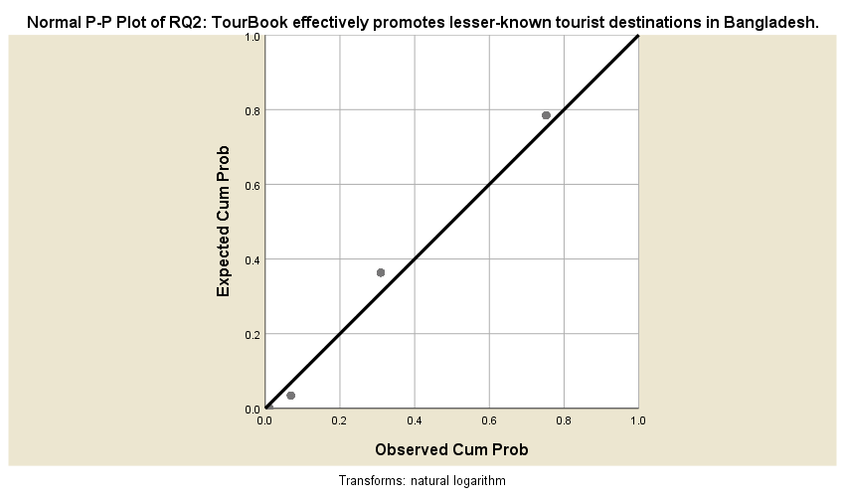Source: SPSS 25.  Figure 04: P-P Plot test of RQ2 | 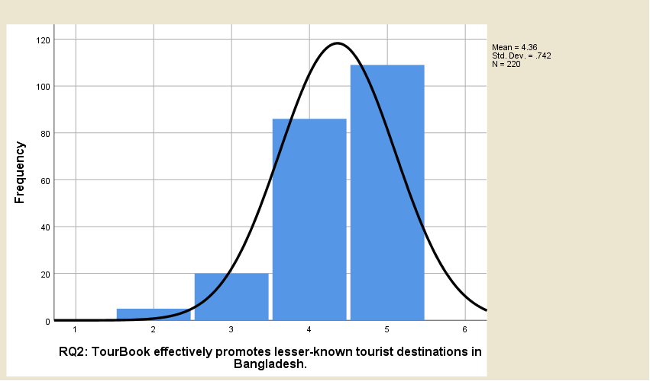Source: SPSS 25.  Figure 05: Histogram of RQ2
Figure 4, shows that the residuals are mostly scattered along the normal distribution line, which means that the residuals are normally distributed. Figure 5, the normal distribution histogram, also shows the Mean value that strongly agrees with the statement.
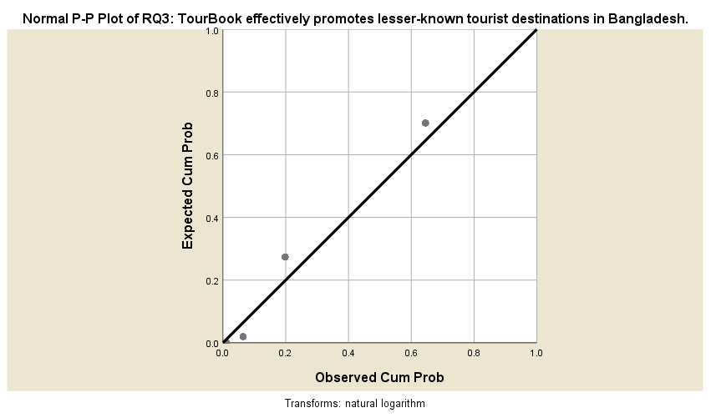Source: SPSS 25.  Figure 06: P-P Plot test of RQ3 | 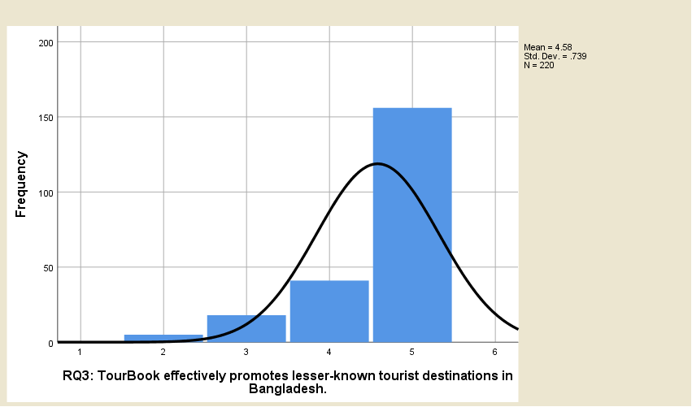Source: SPSS 25.  Figure 07: Histogram of RQ3

Figure 6, shows that the residuals are mostly scattered along the normal distribution line, which means that the residuals are normally distributed. Figure 7, the normal distribution histogram, also shows the Mean value that strongly agrees with the statement.

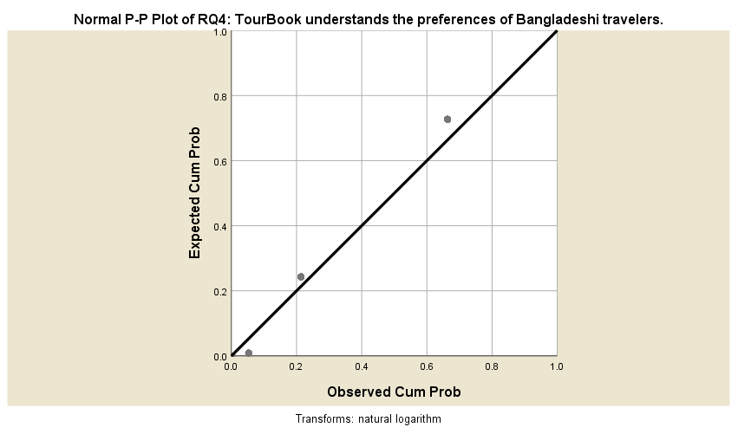Source: SPSS 25.  Figure 08: P-P Plot test of RQ4 | 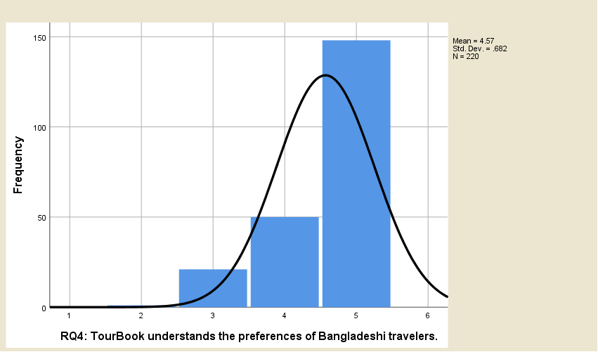Source: SPSS 25.  Figure 09: Histogram of RQ4
Figure 8, shows that the residuals are mostly scattered along the normal distribution line, which means that the residuals are normally distributed. Figure 9, the normal distribution histogram, also shows the Mean value that strongly agrees with the statement.

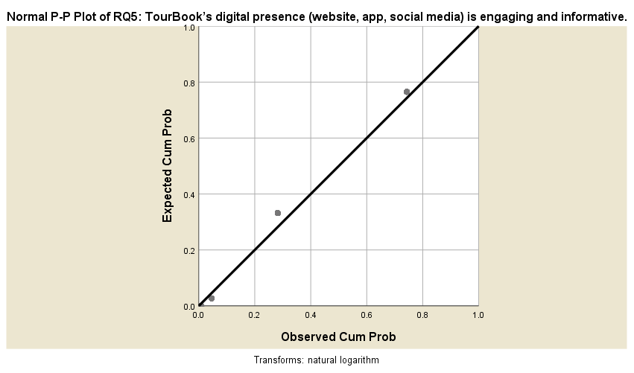  Source: SPSS 25.  Figure 10: P-P Plot test of RQ5 | 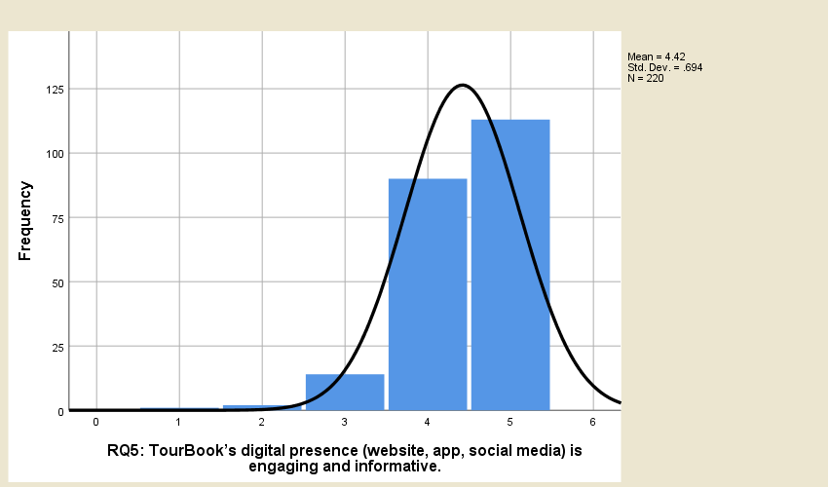Source: SPSS 25.  Figure 11: Histogram of RQ5

Figure 10, shows that the residuals are mostly scattered along the normal distribution line, which means that the residuals are normally distributed. Figure 11, the normal distribution histogram, also shows the Mean value that strongly agrees with the statement.

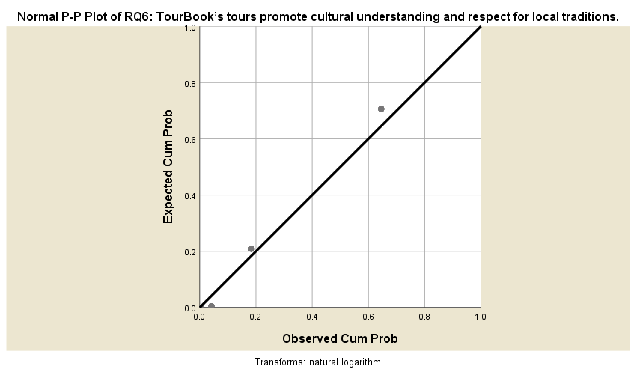Source: SPSS 25.  Figure 12: P-P Plot test of RQ6 | 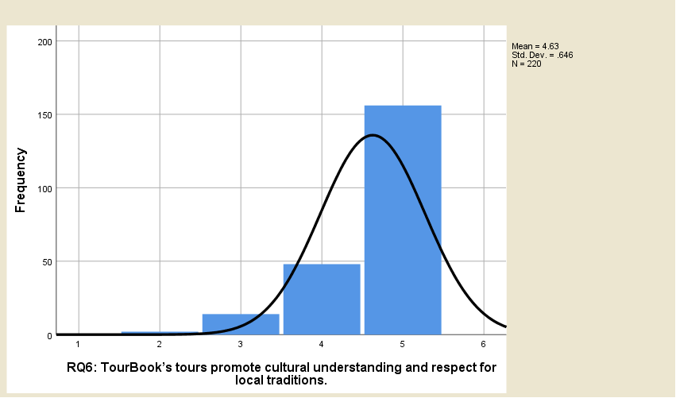  Source: SPSS 25.  Figure 13: Histogram of RQ6

Figure 12, shows that the residuals are mostly scattered along the normal distribution line, which means that the residuals are normally distributed. Figure 13, the normal distribution histogram, also shows the Mean value that strongly agrees with the statement.
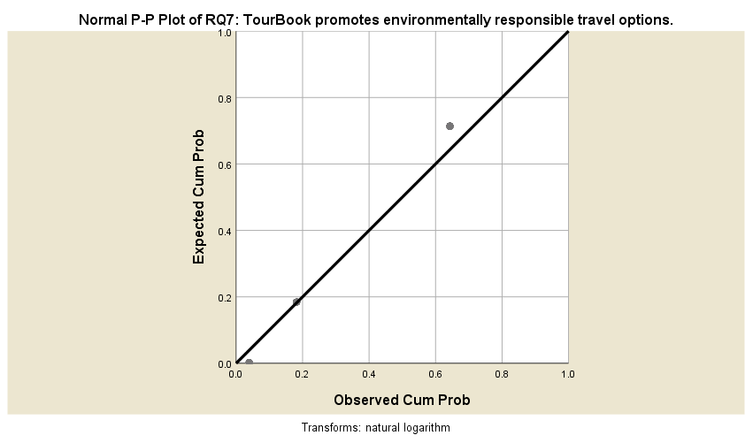  Source: SPSS 25.  Figure 14: P-P Plot test of RQ7 | 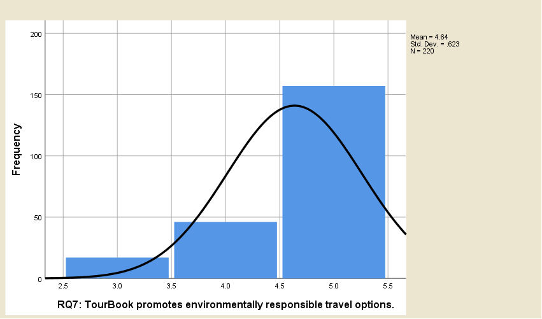  Source: SPSS 25.  Figure 15: Histogram of RQ7
Figure 14, shows that the residuals are mostly scattered along the normal distribution line, which means that the residuals are normally distributed. Figure 15, the normal distribution histogram, also shows the Mean value that strongly agrees with the statement.

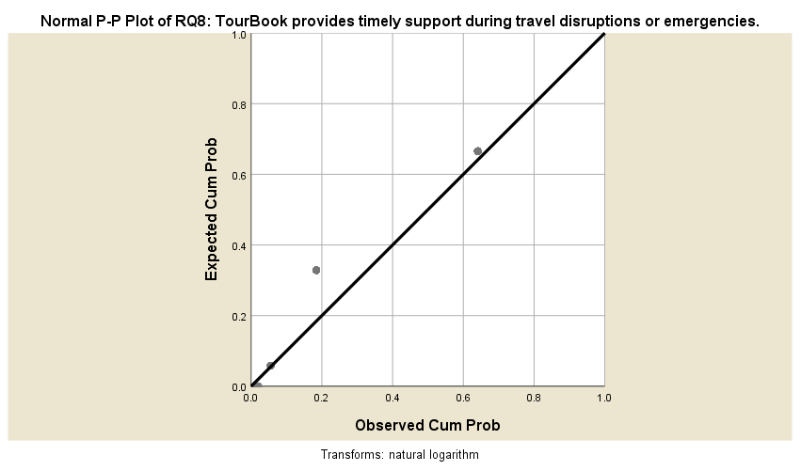Source: SPSS 25.  Figure 16: P-P Plot test of RQ8 | 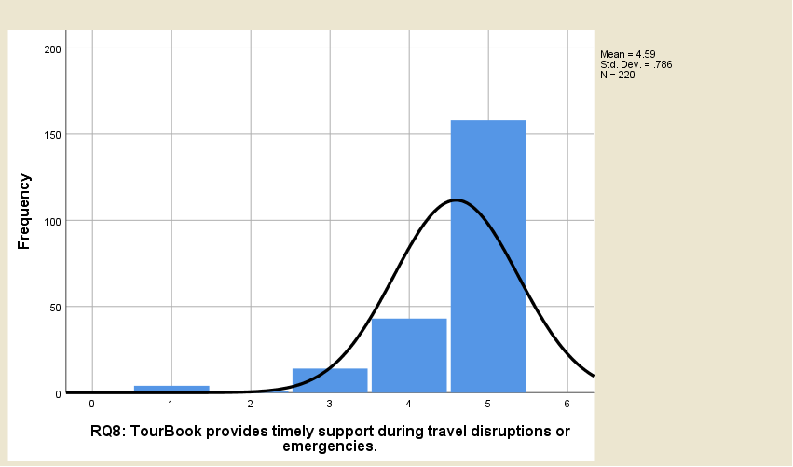  Source: SPSS 25.  Figure 17: Histogram of RQ8

Figure 16, shows that the residuals are mostly scattered along the normal distribution line, which means that the residuals are normally distributed. Figure 17, the normal distribution histogram, also shows the Mean value that strongly agrees with the statement.

6. DISCUSSION
The results of the present study provide valuable evidence based information on the role of TourBook, as a travel agency or independent agency, for tourism destination promotion in Bangladesh. The empirical analysis, based on the 220 participant responses, provides evidence to suggest a positive perception of TourBook services and its ability to promote tourism. The discussion which follows contextualizes the findings within the broader literature concerning travel agencies, digital marketing, and tourism development. In addition, when relevant, the implications for TourBook and the tourism sector in Bangladesh are addressed.
6.1. TourBook as an Information Provider and Destination Promoter
The study concluded that respondents strongly agreed (Mean = 4.68) that TourBook supplies accurate and current information about tourism destinations. This is consistent with the observation of Buhalis (2000) that travel agencies as facilitators and information providers has become increasingly important. TourBook's success as a facilitator partly relies on their ability to reduce the complexity of travel decisions through expert destination input and comparative information. The respondents equally strongly agreed (Mean=4.36) that TourBook effectively promotes the lesser-known tourism destinations all over Bangladesh.
6.2. Customized Travel Packages and Market Research
The strong rating awarded to TourBook for its development of customized travel packages also confirmed the value of personalized travel experiences in the current travel market, having a mean of 4.58 (Laws, 1995).The agency was also rated highly in its ability to address a wide range of traveler preferences (Mean = 4.57); the agency's capabilities for market research have been explained by Kotler et al., (2010). TourBook has successfully identified and responded to the needs of Bangladeshi travelers, thus establishing itself as a customer focused business which is important for maintaining a sustainable competitive advantage in the travel industry.
6.3. Digital Presence and Engagement
To the contrary, the results give it because of its significant digital presence (Mean = 4.42), hence contributing to the growing trend of the use of digital platforms in tourism marketing (Xiang & Gretzel, 2010). The agency's free and creative use of websites, mobile apps, and social media platforms to reach out to potential travelers, marketing destinations in real time, and telling destination stories has greatly increased the prospective customer base's involvement.
6.4. Cultural Understanding and Sustainable Tourism
TourBook's tours received high ratings in participants' cultural awareness and consideration of local customs (Mean = 4.63) supporting TourBook's assertion that they act as a cultural and community link (Richards, 2007). Overall, this indicates that with TourBook tours participants are seeing the value of show casing local heritage and learning up community tourism experiences to form a better understanding that supports the local economy.
6.5. Crisis Management and Customer Support
The study determined that TourBook provided timely and meaningful response assistance during disruptions and emergencies (Mean = 4.59), and demonstrated its crisis manager capacity (Ritchie, 2004) during these disruptive and uncertain situations when events are uncertain and unpredictable such as natural disasters or pandemics, is important for customer trust and satisfaction. TourBook's broader response to crisis management, enhances its brand value as a trustworthy and customer-focused travel agency.

7. RECOMMENDATIONS
- Enhance Social Media Engagement: TourBook should take advantage of social media channels like Facebook, Instagram, and TikTok, to continue to promote lesser-known destinations by implementing high quality visual media compatible with social media, and influencer collaborations and social media campaigns (live Q&A, virtual tours, etc.) .
- Develop a User-Friendly Mobile App: By having a commercial app that allows customers to book real-time travel as well as AI-generated recommendations, and chatbots to provide nearly immediate customer support would increase usability accessibility and customer experience.
- Promote Eco-Friendly Travel Packages: Increase eco-tourism and responsible travel opportunities such as carbon neutral tours, wildlife and conservation tours, and homestay accommodations in rural areas that are attractive to more environmentally conscious travelers.
- Partner with Local Communities: These experiences can, depending on the community, be based on a number of different immersive themes such as food, fashion, arts, sports, festivals and history. The goal of developing these kinds of partnerships with local artisans, cultural agencies and businesses is to connect and build a strong network among the different sectors in your community that can provide tourists and residents with access to authentic and unique experiences.
- Adventure and Specialized Tourism: Enhance offerings for adventure seekers (trekking, river cruises, scuba diving) and niche markets (photography tours, culinary experiences, wellness retreats).
- Corporate and Educational Tourism: Create stronger partnerships with universities and businesses to provide personalized corporate retreats, study tours, and team-building 24/7.
- Customer Support: Customer Care Anytime: Use multilingual helplines and AI chatbots to assist travelers in emergencies, last-minute changes, and real-time updates.
- Training for Staff: Provide periodic workshops on crisis management, cultural sensitivity, expertise, and customer service excellence to ensure staff are ready, prepared, and represent you professionally.
- Work with Bangladesh Tourism Board (BTB): Engage on joint publicity-marketing programs, partner to attend international travel fairs to promote Bangladesh know that it's a competitive tourism destination.
- Public-Private Partnerships (PPP): Partner with local authorities to develop infrastructure (roads, sanitation and safety) in emerging tourism areas.
- International Tie-Ups: Work with international travel agents and offer outbound tour packages at competitive prices to inbound tourists.

8. CONCLUSION
In a short period of time, tourism in Bangladesh has developed substantially and is now considered an emerging industry with economic impact and cultural exchange potential. This study examined TourBook Travel Agency's advertising and promotion of tourist destinations across Bangladesh and offered insights into its advertising and marketing methods and its impact on the tourism landscape of Bangladesh. The study concluded that TourBook has successfully established itself as one of the key players in the industry with its innovative approaches to destination promotion, customer engagement, and service delivery. TourBook's innovative approaches have provided it with an opportunity to combine long-haul travel services with emerging e-marketing solutions that provide a meaningful experience both in terms of information access and service. TourBook has successfully bridged the gaps between travelers and Bangladesh's vast destination base, including both popular, well-known destinations and those unique, hidden treasures that had previously been overlooked. One of the important outcomes from this study is that TourBook is a valuable information resource and destination promoter. In a time where travelers are more dependent upon sponsorships and digital platforms to research their travel options, TourBook's commitment to providing good-quality information that is accurate and up-to-date has been important in varying travel decisions. This supports modern tourism theories that recognize reliable information, particularly during destination choice, ultimately impacts levels of satisfaction with a tourist experience. TourBook provides a repository of comprehensive destinations with intermediate responses within an effective digital solution, producing improvements in the travel process for domestic and international travelers seeking to experience Bangladesh. The agency has been successful, and this explains how travel intermediaries can add value in an age when more information has become far too complicated to replace rather than assist with travel planning. This study's findings have implications for many people involved in tourism in Bangladesh. In particular, for policymakers, they point to the role of private sector players like TourBook as partners, or potential partners, in tourism development of the country." TourBook's success in destination promotion is evidence, according to the center's work on public-private partnerships, that public-private partnerships are valid ways in which to promote the worldwide tourism offering of Bangladesh. For other travel businesses, TourBook's experience can provide inspiration and insight into areas such as digitalization, customer and stakeholder engagement, and sustainable approaches to tourism. TourBook's proactive approach in responding to disruptive change validates that in the modern travel sector, success is based on being innovative and agile.

Conflict of interest
This article's publication does not present any conflicts of interest.
Funding
For this research, no outside funding has been obtained.
Disclaimer Statement
There are no used generative AI technologies such as large language models (ChatGPT, COPILOT, etc.).

REFERENCES
- Boone, H.N. and Boone, D.A. (2012). Analyzing Likert Data. The Journal of Extension, 50, 1-5. https://joe.org/joe/2012april/tt2.php
- Buhalis, D. (2000). Marketing the competitive destination of the future. Tourism Management, 21(1), 97–116.
- Chung, J. Y., & Buhalis, D. (2008). Information needs in online social networks. Information Technology & Tourism, 10(4), 267–281.
- Cooper, C., Fletcher, J., Fyall, A., Gilbert, D., & Wanhill, S. (2008). Tourism: Principles and Practice (4th ed.). Pearson Education.
- Hossain, M. S. (2025). Sustainable Ecotourism in Bangladesh: A SWOT Analysis of Ecotourism Destinations. International Journal of Multidisciplinary Research and Growth Evaluation, 6(2), 1146–1163. https://doi.org/10.54660/.ijmrge.2025.6.2.1146-1163
- Hossain, M. S., & Rahman, M. (2021). The Role of Digital Travel Agencies in Promoting Domestic Tourism in Bangladesh. Journal of Tourism Studies and Research, 10(2), 44–58.
- Hossain, M. S., Hussain, M. N., Ahmed, T., Gain, N., & Islam, M. A. (2025). The Role of Travel Agencies and Tour Operators in the Development of the Tourism Sector: An Empirical Study on Bangladesh. American Journal of Tourism and Hospitality, 3(1), 67–77. https://doi.org/10.54536/ajth.v3i1.4587
- Hossain, M. S., Khatun, M. P., Taskin, T., Sany, M. K. A., & Hossain, M. M. (2025). Opportunities and Challenges of gastronomy in tourism and Hospitality industry: A Conceptual Study on Bangladesh. International Journal of Research and Innovation in Social Science, IX(I), 1787–1799. https://doi.org/10.47772/ijriss.2025.9010146
- Hossain, M. S., Mahee, F. I., Tareq, M. S., Rasel, M., Khandaker, Z., & Abdulla, A. H. (2025). Quantifying the impact of immersive technologies: An empirical analysis of augmented reality & virtual reality in Bangladesh's tourism sector. Power System Technology, 49(2). https://doi.org/10.52783/pst.1884
- Hossain, M. S., Morsalin, M., Hossen, T., Hasan, I., Gain, N., & Khan, M. R. (2025). Prospects and challenges of blockchain technology in the travel and tourism industry: An empirical study in Bangladesh. Power System Technology, 49(2), 1711–1727. https://doi.org/10.52783/pst.1948
- Hossain, M. S., Sheikh, P., & Islam, P. (2025). The Role of Social Media Marketing in the Tourism and Hospitality Industry: A study on Bangladesh. American Journal of Tourism and Hospitality, 3(1), 14–23. https://doi.org/10.54536/ajth.v3i1.4082
- Hossain, S., Gain, N., & Hossain, S. (2025). The role of the internet in the tourism and hospitality industry: An empirical study on Kushtia District, Bangladesh. Research Journal in Business and Economics., 3(1), 22–30. https://doi.org/10.61424/rjbe.v3i1.232
- Hossain, S., Gain, N., & Hossain, S. (2025). The Role of the Internet in the Tourism and Hospitality Industry: An Empirical Study on Kushtia District, Bangladesh. Research Journal in Business and Economics, 3(1), 22–30. https://doi.org/10.61424/rjbe.v3i1.232 (Original work published April 6, 2025)
- Hossain, S., Sheikh, P., Islam, P., & Sany, K. A. (2025). Enormous Benefits of the Blue Economy and Blue Tourism (Coastal and Marine) Destinations in Bangladesh: A Conceptual Study on Bangladesh. Research Journal in Business and Economics, 2(1), 25–39. https://doi.org/10.61424/rjbe.v2i1.170
- Kotler, P., Bowen, J., & Makens, J. (2010). Marketing for Hospitality and Tourism (5th ed.). Pearson.
- Laws, E. (1995). Tourism Destination Management: Issues, Analysis and Policies. Routledge.
- Malhotra, N. K. (2010). Marketing Research: An Applied Orientation (6th Ed.). Upper Saddle River, NJ: PearsonPrenticeHall,Pearsonhttps://www.scirp.org/reference/referencespapers?referenceid=2989267.
- Middleton, V. T. C., & Clarke, J. (2001). Marketing in Travel and Tourism (3rd ed.). Butterworth-Heinemann.
- Pearce, D., & Butler, R. (1999). Contemporary Issues in Tourism Development. Routledge.
- Pike, S. (2008). Destination Marketing: An Integrated Marketing Communication Approach. Elsevier.
- Richards, G. (2007). Cultural Tourism: Global and Local Perspectives. Haworth Press.
- Ritchie, B. W. (2004). Chaos, crises and disasters: A strategic approach to crisis management in the tourism industry. Tourism Management, 25(6), 669–683.
- Weaver, D. B. (2006). Sustainable Tourism: Theory and Practice. Elsevier.
- World Travel & Tourism Council (WTTC). (2020). Economic impact reports. Retrieved from https://wttc. Org
- Xiang, Z., & Gretzel, U. (2010). Role of social media in online travel information search. Tourism Management, 31(2), 179–188.
- Zikmund, Ben Lowe, Steven D'Alessandro, Barry J. Babin (2020). Edition, 5. Publisher, Cengage Learning, 2020. ISBN, 0170288803, 9780170288804. Length, 650 pages

