**Original Research Article**

**Molecular docking studies of SOME designed siderophore-conjugated meropenem derivatives for combating Multidrug resistant-TB**

**ABSTRACT:**

**Aim:** The rise of multidrug-resistant tuberculosis (MDR-TB) presents a significant challenge to existing treatment approaches, highlighting the urgent need for innovative therapeutic strategies. This research focused on designing siderophore-conjugated meropenem derivatives to target the iron acquisition pathways of M. tuberculosis and tested using docking techniques (IrtAB, PDB ID: 7WIV).

**Methods:** A hydroxamate group was attached to meropenem using various linkers, including disulfide, quaternary ammonium, alkyl, and triazole, to facilitate Fe³⁺ chelation. The docking studies were performed using PyRx software and visualized in Chimera and Biovia Discovery Studio. Initially, meropenem alone was docked to evaluate its interaction with the receptor IrtAB, followed by docking studies with beta-lactamase to assess the compound's resistance to enzymatic degradation, and finally with serine/threonine-protein kinase (PDB ID: 4OW8) to evaluate its antibacterial potential. Later, the derivatives with siderophore were docked against the IrtAB receptor for evaluating permeability.

**Results:** Meropenem exhibited favorable results in all cases except binding with IrtAB which is due to its hydrophilic nature. Subsequently, docking studies on siderophore-conjugated meropenem derivatives indicated high binding affinities. These affinities increased further upon Fe³⁺ attachment. Compounds with quaternary ammonium group and triazole group as linkers show the best interaction (SW-4A and SW-10A). After the hydroxamate group chelates ferric ions in the body, the IrtAB receptor facilitates the transport of the siderophore-conjugated meropenem-ferric complex through the mycolic acid layer.

**Conclusion:** This study provides valuable insights into the potential of siderophore-conjugated meropenem derivatives as a novel therapeutic approach for multidrug-resistant tuberculosis. This mechanism potentially overcomes the less-permeability of meropenem caused by its hydrophilic nature and, with the help of its resistance to beta-lactamase enzyme, presents a promising avenue for MDR-TB treatment. Furthermore, the meropenem demonstrated resistance against beta-lactamase and proved antibacterial activity by interacting with PknA, a key regulatory protein.

*Keywords:* *Siderophore, Meropenem, Molecular Docking, Tuberculosis, Mycobactin*

1. **INTRODUCTION**

Tuberculosis comes under the category of a chronic infectious disease caused by the bacteria mycobacterium tuberculosis. TB makes the list of the top 10 deaths caused by a single infectious disease. When the TB caused by mycobacterium strains with resistance to isoniazid and rifampicin is called a multidrug resistance TB (MDR TB). MDR TB can happen due to relapse regimens and short course of treatment, spontaneous mutations, low quality drugs.1 once someone is infected with this MDR TB, first line drugs, which were considered to be efficient and have less adverse effects, show less to no effect over TB bacteria. Due to the failure of first line drugs, the second line drugs like ethionamide, amikacin, kanamycin, and linezolid will be prescribed, but these drugs are more toxic, less tolerable, and should be used for a longer time will lead to many problems.2

Siderophores are small molecules secreted by microbes like bacteria and fungi to scavenge iron from their surroundings. They have a strong attraction to ferric iron (Fe³⁺), which is vital for growth but often hard to access, especially in places like the human body, where iron is tightly bound to proteins. Siderophores form stable bonds with Fe³⁺ and help transport it into the microbial cells, ensuring their survival. This process is especially important for disease-causing bacteria, as they rely on siderophores to steal iron from their host, making them more effective at causing infections.3,4

Mycobacterium tuberculosis (Mtb), relies heavily on siderophores for its survival and pathogenicity. These small, iron-chelating molecules, specifically mycobactins (Fig. 1) and carboxymycobactins, allow Mtb to acquire iron, an essential nutrient that is tightly regulated and restricted by the host immune system.5 By hijacking iron from host proteins such as transferrin and lactoferrin, siderophores ensure that Mtb can sustain its growth and metabolism, even within the iron-deprived environment of human macrophages. This iron acquisition mechanism plays a critical role in Mtb’s ability to persist, proliferate, and cause disease.6

Multidrug-resistant tuberculosis (MDR-TB) is a growing global health crisis, and finding new ways to treat it is essential. One innovative solution is using siderophore-conjugated antibiotics. These drugs combine a siderophore, which bacteria use to steal iron, with an antibiotic. By mimicking the natural process of iron uptake, these conjugates act like a "Trojan horse," sneaking the antibiotic into the bacterial cell. This approach not only improves how well the drug gets inside the bacteria but also helps overcome resistance, offering a promising new way to fight MDR-TB.7, 8

The primary challenge with using beta-lactam antibiotics to treat tuberculosis (TB) lies in their hydrophilic nature, which limits their ability to penetrate the lipophilic mycolic acid layer of Mycobacterium tuberculosis (Mtb). Additionally, Mtb produces the beta-lactamase enzyme, which efficiently breaks the beta-lactam ring, rendering these antibiotics ineffective. Meropenem, a carbapenem antibiotic within the beta-lactam class, has shown promise as it is more resistant to beta-lactamase compared to other beta-lactams.



**Fig. 1:** structure of siderophore - mycobactin (Hydroxamate) with iron binding sites (red)

The literature survey has shown that meropenem can be used as second line drug for the treatment of TB, given with beta-lactamase inhibitors. This research aims to establish meropenem with Siderophore conjugation as a potential solution for multidrug-resistant TB (MDR-TB) using molecular docking as an efficient tool. To overcome its permeability limitations, the study proposes developing a siderophore-conjugated version of meropenem, enabling it to effectively cross the mycolic acid barrier and enhance its antibacterial activity.9, 10

1. **METHODOLOGY**

Software tools employed in this study are freely available on the internet. ChemSketch was used to design the molecular structures of the ligands. PyRx 0.8 facilitated energy minimization, ligand conversion to pdbqt format, and molecular docking simulations. Target protein preparation and visualization of protein-ligand interactions were performed using BIOVIA Discovery Studio. Additionally, UCSF Chimera (version 1.18) was utilized to prepare protein-ligand complexes post-docking and to visualize metal coordination interactions involving the Fe³⁺ complexes.

**2.1 Preparation of ligands**

Meropenem, a carbapenem antibiotic, was selected as the core drug molecule for conjugation with siderophore moieties via various linkers. The hydroxamate group was chosen as the siderophore component due to its critical role in iron chelation and transport in *Mycobacterium tuberculosis*, mimicking the native siderophore mycobactin. Four types of linkers were employed: disulfide (SW-2A & SW-3A), quaternary ammonium salt (SW-4A & SW-5A), alkyl chain (SW-8A & SW-9A), and a triazole moiety (SW-10A & SW-11A), the latter of which can be synthesized through click chemistry. Both the linker and siderophore moieties were attached to meropenem via amide bonds. The chemical structures of the designed compounds are illustrated in Figure 2. All structures were constructed using ChemSketch and saved in MOL file format.

**2.2 Protein selection and preparation**

The proteins selected based upon the extensive literature survey, namely, **Iron-Regulated Transporter-Associated Binding protein (IrtAB) (PDB ID: 7WIV), beta-lactamase (BlaC)** (PDB ID: 7A5T), and Serine/threonine-protein kinase (PknA) PDB ID: (4OW8) downloaded from the RCSB protein data bank ([www.pdb.org](http://www.pdb.org)). The Biovia Discovery Studio was used to prepare the proteins by deleting the existing heteroatoms, and the polar hydrogens were added at the end. The prepared proteins were saved in PDB format. Along with that, the Ramachandra plot analysis was also done in the same software for all proteins.

**2.3 Molecular docking**

The molecular docking was performed in PyRx with the help of the protocol provided by Trott and Olson with modifications.11 The PyRx uses AutoDock Vina for docking analysis. The prepared protein structure was uploaded into the software, selected as a macromolecule. The ligands were selected from the open babel option. The ligand energies were minimized and converted into pdbqt format. The grid was drawn around the protein molecule, and the docking was initiated. The lowest binding energy was considered to be most optimal for our study. In this study, the exhaustiveness of 8 was used for docking as it provides accurate results. The docking complexes were saved into the respective folders, later visualized in Chimera and Biovia Discovery Studio.

 

 

 

 



**Fig. 2:** Structures of designed siderophore conjugated meropenams with linkers (meropenam: blue, linker: black, siderophore (hydroxamate): red)

1. **RESULTS AND DISCUSSION**

In this study, siderophore-conjugated meropenem derivatives were docked against the Iron-Regulated Transporter-Associated Binding protein (IrtAB) of *Mycobacterium tuberculosis* to systematically investigate their interactions with the iron uptake machinery. The design incorporated a hydroxamate moiety, known for its strong Fe³⁺ chelation capability, structurally mimicking the iron-binding domain of mycobactin, the native siderophore of *M. tuberculosis*. To optimize lipophilicity and facilitate passage through the mycolic acid-rich cell envelope, a chlorine atom was also introduced. Upon entry into the host system, the hydroxamate group is expected to chelate Fe³⁺ ions, forming a siderophore-iron complex that interacts with the bacterial transporter to mediate iron uptake. Additionally, meropenem derivatives lacking the siderophore moiety were docked separately against β-lactamase (BlaC) and serine/threonine-protein kinase (PknA), reflecting the anticipated intracellular hydrolysis that cleaves the siderophore-linker segment. This dual docking approach allowed evaluation of the compounds’ ability to resist enzymatic degradation and maintain antimicrobial activity through interactions with PknA. Docking scores for all compounds are summarized in Tables 1 and 2.

**Table 1:** Binding affinities of siderophore conjugated meropenam with TB siderophore (mycobactin) mediating protein IrtAB (PDB ID: 7WIV)

|  |  |  |  |
| --- | --- | --- | --- |
| **Compound code** | **Docking scores (Kcal/mol)** | | |
| **IrtA (chain-A)** | **IrtB (Chain-B)** | **IrtAB (both A and B)** |
| **SW-1A** | -6.8 | -6.3 | -7.1 |
| **SW-2A** | -7.8 | -7.1 | -8.6 |
| **SW-3A** | -8.0 | -7.6 | -8.9 |
| **SW-4A** | -7.6 | -7.7 | -9.4 |
| **SW-5A** | -8.2 | -8.3 | -9.9 |
| **SW-8A** | -8.5 | -7.5 | -10.4 |
| **SW-9A** | -7.8 | -7.3 | -9.9 |
| **SW-10A** | -8.1 | -7.1 | -9.0 |
| **SW-11A** | -7.5 | -8.4 | -9.6 |

**Table 2:**  Binding affinities of siderophore conjugated meropenam with **beta-lactamase (BlaC)** (PDB ID: 7A5T) and Serine/threonine-protein kinase (PknA) PDB ID: (4OW8)

|  |  |  |
| --- | --- | --- |
| **Compound code** | **Docking scores (Kcal/mol)** | |
| **BlaC** | **PknA** |
| **SW-1A** | -6.9 | -7.8 |

Docking results indicate that SW-1A (meropenem without siderophore conjugation) exhibits weaker binding affinities, with scores of 6.8 kcal/mol and 6.3 kcal/mol against the IrtA and IrtB chains individually, and 7.1 kcal/mol against the full IrtAB complex. As a β-lactam antibiotic, meropenem does not benefit from interaction with the bacterial iron uptake system, leading to relatively lower binding affinity compared to its siderophore-conjugated counterparts. However, docking studies against β-lactamase and serine/threonine-protein kinase (PknA) showed more promising results, with binding scores of –6.9 kcal/mol and –7.8 kcal/mol, respectively. These findings suggest that, once internalized, meropenem retains its β-lactamase resistance and potential antibacterial activity. Nonetheless, co-administration with a β-lactamase inhibitor such as clavulanic acid is recommended to maximize therapeutic efficacy. The interaction profiles are illustrated in Figures 3 and 4.

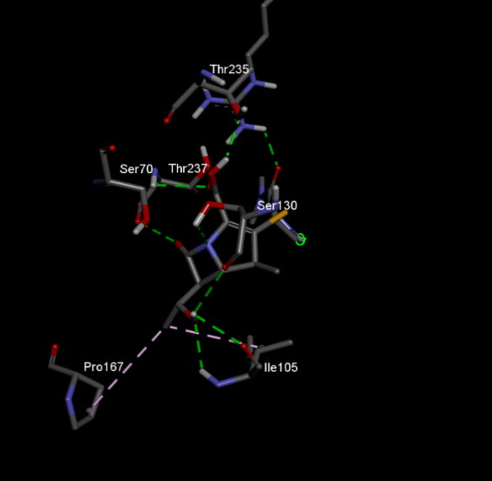 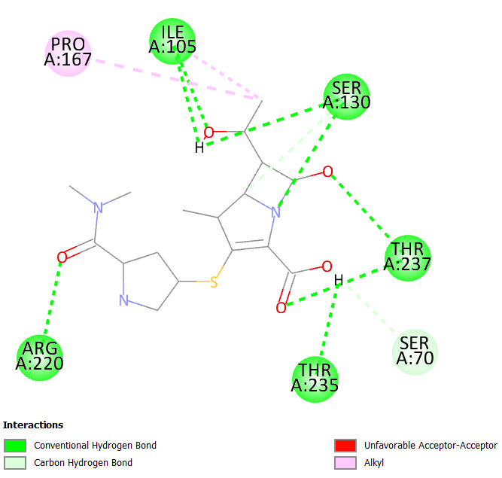

**Fig no. 3:** Protein ligand interaction of SW-1A against protein beta-lactamase

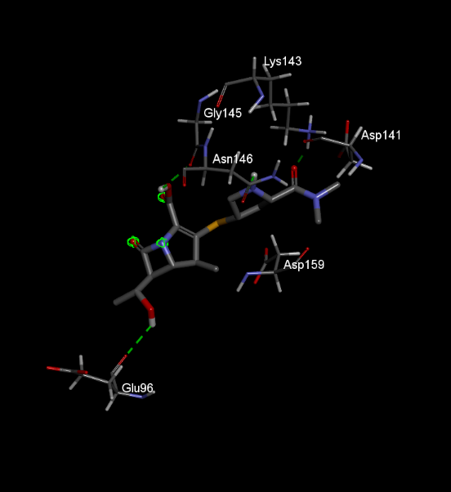 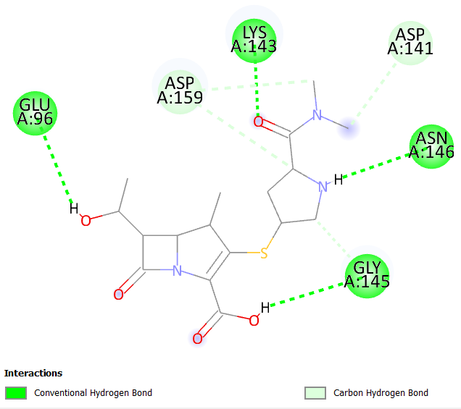

**Fig no. 4:** Protein ligand interaction of SW-1A against protein Serine/threonine-protein kinase

Various linkers were utilized to conjugate siderophores to meropenem derivatives, and their influence on docking interactions with the IrtAB transporter was systematically evaluated. In the case of compounds SW-2A and SW-3A, a disulfide linkage was incorporated, which yielded favorable docking results for both the non-chelated (SW-2A) and Fe³⁺-chelated (SW-3A) forms. The docking scores were –8.9 kcal/mol for SW-2A and –8.6 kcal/mol for SW-3A, indicating slightly improved binding upon iron chelation. Analysis of the 2D and 3D interaction diagrams (Figures 5 and 6) reveals that additional stabilizing interactions are formed in the chelated complex. Notably, new bonds with ASP182 and ALA178 emerge post-chelation, supporting the enhanced affinity and suggesting that the disulfide linker contributes positively to complex stability with the transporter.

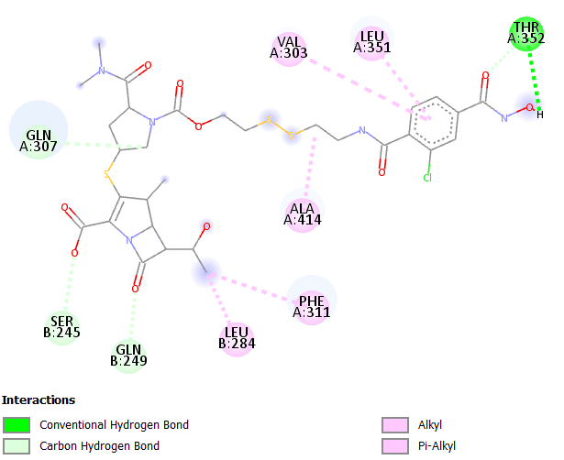

**Fig. 5:** Protein ligand interaction of SW-2A against protein IrtAB

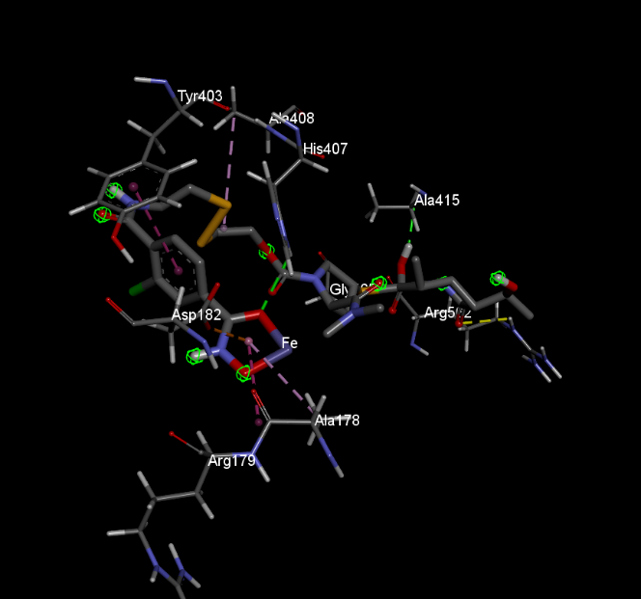 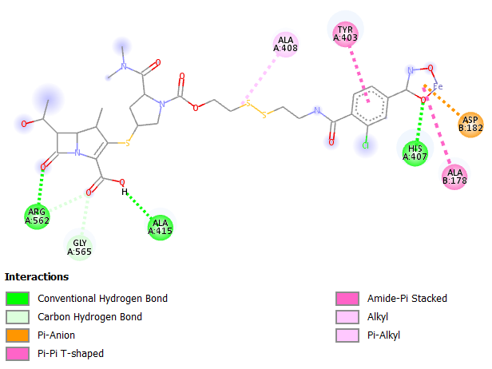

**Fig. 6:** Protein ligand interaction of SW-3A against protein IrtAB

For compounds SW-4A and SW-5A, a quaternary ammonium salt was employed as the linker. Uniquely, this moiety functions not only as a linker but also as an integral structural component of the drug, as it remains bound post-cellular uptake. This feature contributes to the stabilization of the meropenem core within the bacterial cell, thereby enhancing its antibacterial activity. The docking scores for SW-4A and SW-5A were –9.4 kcal/mol and –9.9 kcal/mol, respectively, suggesting that the quaternary ammonium linker supports a stable and favorable binding conformation. The 2D interaction analyses reveal several significant interactions involving the quaternary ammonium group, indicating its active role in binding. Additionally, following Fe³⁺ chelation, a π–lone pair interaction is observed at the chelation site with the amino acid THR300. These interactions are illustrated in Figures 7 and 8.

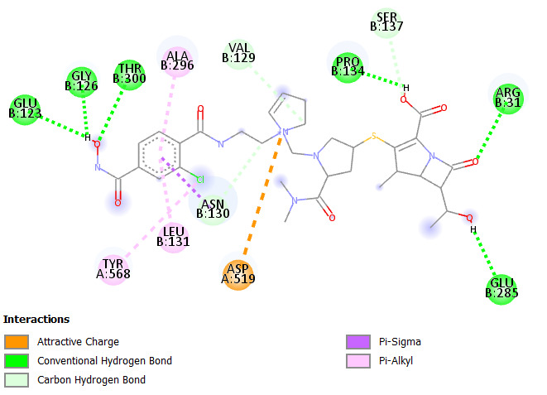

**Fig no. 7:** Protein ligand interaction of SW-4A against protein IrtAB

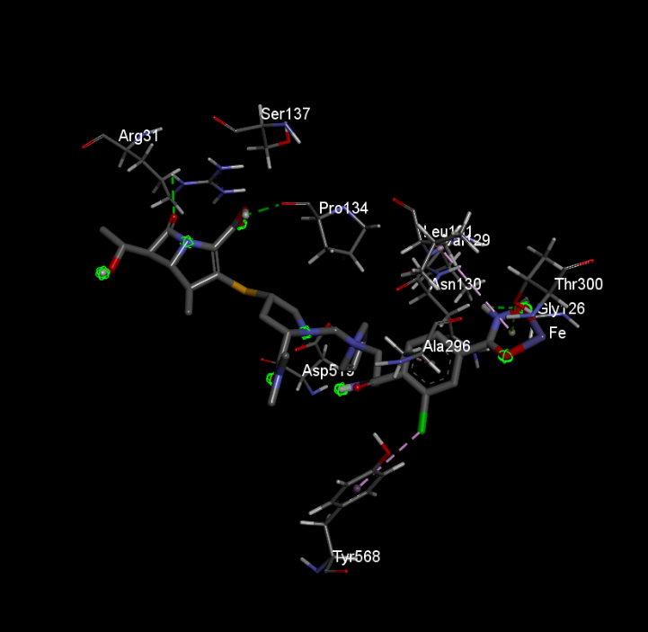 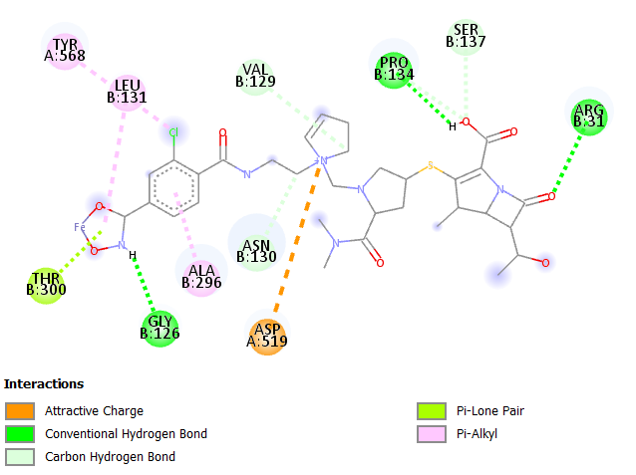

**Fig. 8:** Protein ligand interaction of SW-5A against protein IrtAB

In contrast, docking studies with a simpler amide linker containing a three-carbon chain revealed that compound SW-8A exhibited the highest binding affinity of –10.4 kcal/mol. However, upon Fe³⁺ chelation, the binding affinity of the resulting complex (SW-9A) decreased notably to –9.9 kcal/mol. This decline contrasts with the general trend observed in other Fe³⁺-chelated compounds, where binding affinity typically improves post-chelation, and may suggest suboptimal interaction. Analysis of the 2D and 3D interaction diagrams reveals that SW-9A fails to form new interactions after Fe³⁺ chelation, likely due to the structural limitations of the chosen linker. The absence of additional stabilizing interactions may explain the reduced affinity. These structural interactions are illustrated in Figures 9 and 10.

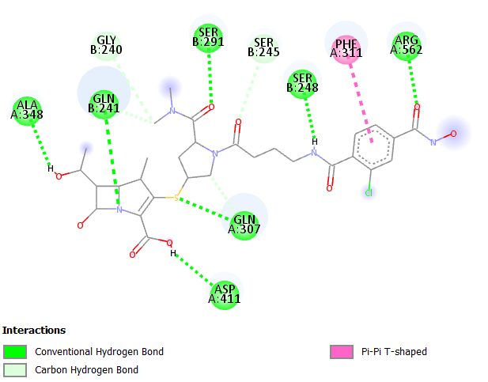

**Fig. 9:** Protein ligand interaction of SW-8A against protein IrtAB

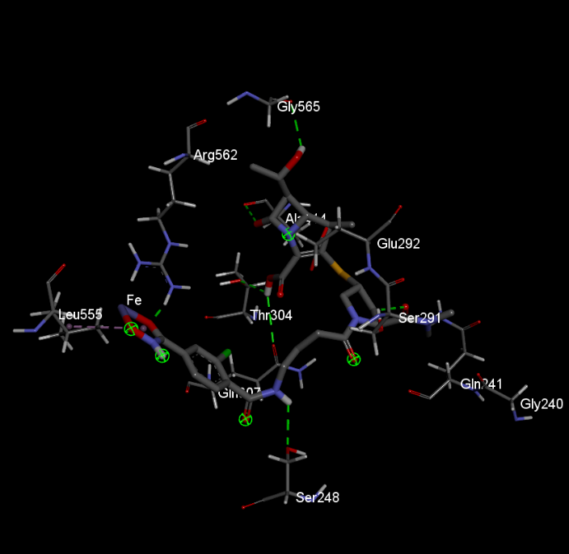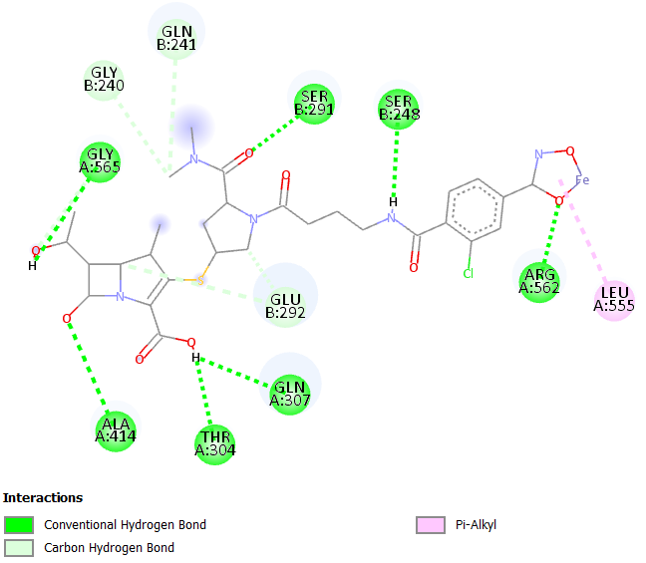

**Fig. 10:** Protein ligand interaction of SW-9A against protein IrtAB

The results for SW-10A and SW-11A compounds showed a good binding after iron chelation, with docking scores of –9.0 kcal/mol and –9.6 kcal/mol, respectively. This suggests that Fe³⁺ chelation strengthens the interaction between the siderophore-metal complex and the target protein. The increased affinity can be attributed to the presence of a triazole ring in the linker, which contributes to structural stabilization and improved binding post-chelation. Notably, the triazole ring, which can be synthesized via click chemistry, enhances the interaction network. The 2D interaction map of SW-10A indicates minimal binding at the siderophore and linker site; however, upon Fe³⁺ binding (as in SW-11A), interaction increases significantly. This is due to the triazole ring facilitating alkyl and π-alkyl interactions with ALA561 and PRO286, along with a hydrogen bond with GLU285. These interactions are illustrated in Figures 11 and 12.

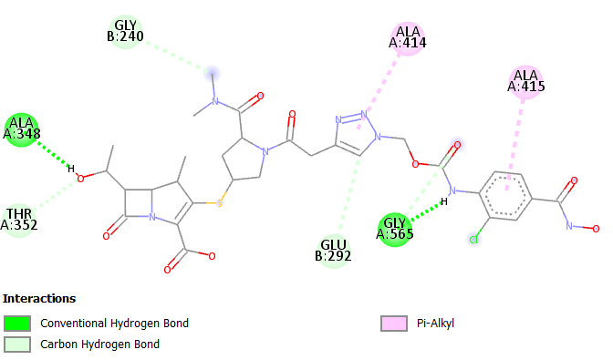

**Fig. 11:** Protein ligand interaction of SW-10A against protein IrtAB

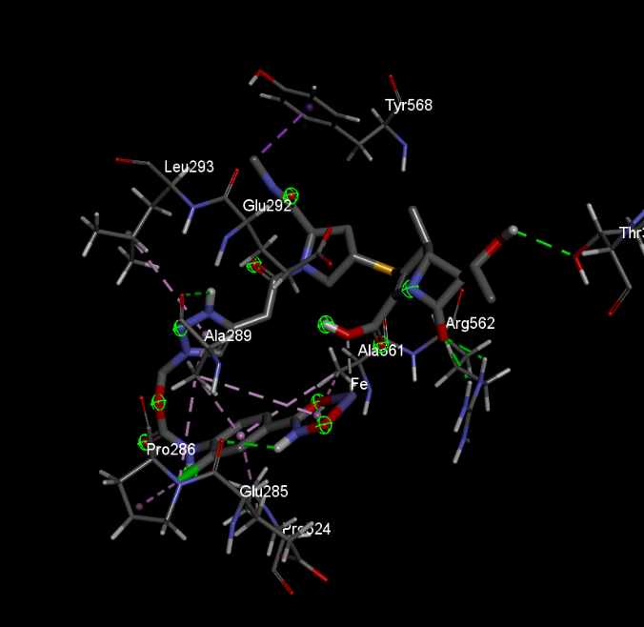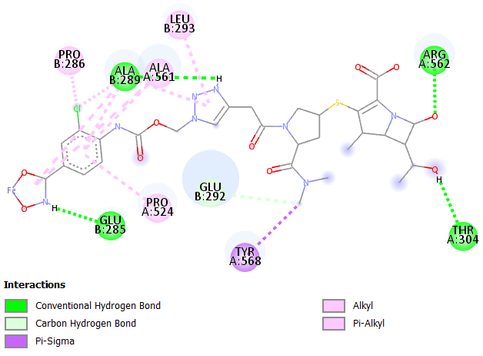

**Fig. 12**: Protein ligand interaction of SW-11A against protein IrtAB

Molecular docking studies were performed on the individual chains of the IrtAB transporter—namely, IrtA and IrtB—as well as on the full heterodimeric complex to evaluate the binding affinities and potential interaction sites of the designed compounds. The docking results, presented in Table 1, show consistent trends across both isolated chains and the complete transporter, suggesting that the compounds are capable of interacting with both subunits. Of the two, IrtB plays a more critical role due to its function as the transmembrane domain responsible for the translocation of the siderophore-iron complex across the bacterial membrane. It not only facilitates the passage of this complex but also selectively recognizes iron-loaded siderophores and contributes to the reduction of ferric ion (Fe³⁺) to the bioavailable ferrous form (Fe²⁺), which is essential for bacterial metabolic processes.

Although IrtA primarily provides ATP hydrolysis to power transport, assessing compound interactions with this subunit is also important, as it may influence transporter regulation via cytoplasmic interactions. Among the tested compounds, SW-4A demonstrated the highest binding affinity, followed by SW-10A. The superior performance of SW-4A is attributed to its quaternary ammonium group and hydrophobic alkyl chains, structural features that resemble those found in Cefiderocol—a clinically evaluated siderophore-conjugated antibiotic. SW-10A also showed favorable docking interactions, likely due to its triazole ring, which contributes to both binding strength and inherent biological activity. These findings highlight the potential of the designed compounds, particularly SW-4A and SW-10A, as promising candidates for targeting bacterial iron uptake systems via the IrtAB transporter, with IrtB emerging as the more crucial binding site for functional inhibition.

This study highlights the potential of siderophore-conjugated meropenem derivatives as a promising strategy for combating multidrug-resistant tuberculosis (MDR-TB). By exploiting the bacterial iron acquisition pathway through the IrtAB transporter, these compounds facilitate targeted intracellular delivery while maintaining potent anti-mycobacterial activity. Additionally, interactions with key regulatory proteins such as PknA suggest a dual mechanism of action that may enhance therapeutic efficacy. The siderophore-based approach also addresses key limitations of meropenem, particularly its hydrophilicity and poor membrane permeability. With further experimental validation and structural optimization, this strategy could represent a significant advancement in the development of effective treatments against drug-resistant *Mycobacterium tuberculosis*.

1. **CONCLUSION**

This study provides important insights into the potential of siderophore-conjugated meropenem derivatives as a novel therapeutic strategy against multidrug-resistant tuberculosis (MDR-TB). By incorporating a hydroxamate moiety capable of chelating Fe³⁺, these compounds effectively mimic the native siderophore, mycobactin, thereby hijacking the iron acquisition pathway of *Mycobacterium tuberculosis*. Among the designed derivatives, SW-4A and SW-10A demonstrated superior docking interactions with the IrtAB transporter, particularly with the IrtB subunit, which plays a critical role in translocating iron across the mycobacterial membrane. These findings suggest that targeted delivery via the siderophore-mediated uptake system may enhance drug permeability and efficacy, offering a promising direction for the development of next-generation anti-TB agents.

Furthermore, the meropenem core exhibited resistance to β-lactamase degradation and demonstrated antibacterial activity through predicted interactions with PknA, a key serine/threonine protein kinase involved in cell division and morphogenesis in *Mycobacterium tuberculosis*. These findings underscore the potential of siderophore-conjugated meropenem derivatives as promising candidates for addressing drug resistance in MDR-TB. The study also highlights the significance of innovative linker designs—such as quaternary ammonium groups and triazole rings—which contributed to improved binding affinity and may enhance cellular uptake and target specificity. While the in silico results are encouraging, further experimental validation is essential to evaluate the pharmacokinetics, toxicity, and therapeutic efficacy of these compounds for clinical application in MDR-TB treatment.

**COMPETING INTERESTS DISCLAIMER:**

Authors have declared that they have no known competing financial interests OR non-financial interests OR personal relationships that could have appeared to influence the work reported in this paper.

**DISCLAIMER (ARTIFICIAL INTELLIGENCE)**

Author(s) hereby declare that generative AI technologies such as Large Language Models, etc. have been used during the writing or editing of manuscripts. This explanation will include the name, version, model, and source of the generative AI technology and as well as all input prompts provided to the generative AI technology

Details of the AI usage are given below:

1. ChatGPT

2. Perplexity

**References:**

1. Peloquin, C. A., & Davies, G. R. (2021). The treatment of tuberculosis. *Clinical Pharmacology & Therapeutics*, *110*(6), 1455-1466. https://doi.org/10.1002/cpt.2261
2. Sun Q, Li S, Gao M, Pang Y. Therapeutic Strategies for Tuberculosis: Progress and Lessons Learned. Biomed Environ Sci. 2024 Nov 20;37(11):1310-1323. doi: 10.3967/bes2024.168
3. Schalk, I. J. (2024). Bacterial siderophores: diversity, uptake pathways and applications. *Nature Reviews Microbiology*, 1-17. https://doi.org/10.1038/s41579-024-01090-6
4. Luo VC, Peczuh MW. Location, Location, Location: Establishing Design Principles for New Antibacterials from Ferric Siderophore Transport Systems. Molecules. 2024 Aug 16;29(16):3889. doi: 10.3390/molecules29163889
5. Gokhale, K. M., & Iyer, A. M. (2022). Deployment of iron uptake machineries as targets against drug resistant strains of mycobacterium tuberculosis. *Indian Journal of Pharmacology*, *54*(5), 353-363. 10.4103/ijp.IJP_667_20
6. Shankar G, Akhter Y. Stealing survival: Iron acquisition strategies of Mycobacterium tuberculosis. Biochimie. 2024 Dec;227(Pt A):37-60. doi: 10.1016/j.biochi.2024.06.006
7. Kumar, G., & Adhikrao, P. A. (2023). Targeting Mycobacterium tuberculosis iron-scavenging tools: A recent update on siderophores inhibitors. *RSC Medicinal Chemistry*, *14*(10), 1885-1913. https://doi.org/10.1039/D3MD00201B
8. Mayegowda SB, Gadilingappa MN. Microbial Siderophores: A New Insight on Healthcare Applications. BME Front. 2025 Mar 21;6:0112. doi: 10.34133/bmef.0112
9. Gonzalo, X., & Drobniewski, F. (2022). Are the newer carbapenems of any value against tuberculosis. *Antibiotics*, *11*(8), 1070. https://doi.org/10.3390/antibiotics11081070
10. Levine SR, Beatty KE. Investigating β-Lactam Drug Targets in *Mycobacterium tuberculosis* Using Chemical Probes. ACS Infect Dis. 2021 Feb 12;7(2):461-470. doi: 10.1021/acsinfecdis.0c00809. Epub 2021 Jan 20. Erratum in: ACS Infect Dis. 2021 Apr 9;7(4):937. doi: 10.1021/acsinfecdis.1c00111
11. Trott, O. & Olson, A.J., (2010). AutoDock Vina: improving the speed and accuracy of docking with a new scoring function, efficient optimization, and multithreading. *Journal of computational chemistry*, *31*(2), pp. 455-461. https://doi.org/10.1002/jcc.21334