Assessment of Immunological Characterization of the Serum of Mole Crab Emerita asiatica

ABSTRACT
Aim: To examine the mole crab's immune reaction and to determine the hemagglutinin value of the Emerita asiatica.
Methodology: For the purpose of serum separation and microbe agglutinating activity, hemagglutination and cross adsorption experiments have been conducted in this study. All of the investigated bacterial species responded with the agglutinin that has extracted from the infected microorganisms. The mole crab's defensive system against bacterial infection has shown by bacterial inhibition and bacterial agglutination. Various RBC are used in Hemagglutination. Various Bacteria are used in Bacterial Agglutination and Inhibition. Yeast and trypsinized yeast are used in Yeast Agglutination.
Results: When tested with Buffalo RBC, tripsinized yeast, and Bacillus subtilis, the serum produced the highest HA titer. The trypsinized yeast has a higher titer value for agglutination compared to the native yeast. It was discovered that the hemagglutinating activity was strong between temperatures of 20 and 50 ̊C.
Conclusion: Based on its physicochemical study, HA is thermally stable, pH-stable (between 7 and 9), and activity-dependent on the presence of Ca2^{+.} The HA titers of serum samples tested against buffalo RBC were reduced after extensive dialysis in a divalent cation-free buffer. Serum calcium levels in mole crabs ranged from 0.9 to 1.9 mg/ml. Serum of Emerita asiatica with erythrocytes had the highest HA activity. Emerita asiatica serum hemagglutinating activity was unaffected by biochemical factors such water, protein, and calcium content.
Keywords: Agglutinin, Emerita asiatica, Hemagglutination, Immunology.

1. Introduction

  - Background

Emerita asiatica Milne Edwards is only species of genus living in wave-washed sandy beaches of the Madras coast (Subramoniam, 1979). Recently, the study on these animals in another place is scanty. Because of the huge variation in low tide and high tide level in sea shore, over the exploitation by climate change and fisherman, sand crab population is mostly decreased. Because of these reasons, marine ecosystem has faces the huge change in its natural situation. There has the paucity in study population dynamics of sand crab, E. asiatica in the previous decade. Hence, the study (Domingos et al., 2021) attempted to study E. asiatica population density in Kovalam beach. Asian seabass (Lates calcarifer) is the euryhaline carnivore and it has increased in every year round in the floating cages or ponds, and makes it as the probable choice for the aquaculture in the South East Asia, particularly in Malaysia. Because of its financial welfares, the Asian seabass cage farms were gaining the attention among the marine species (FAO, 2015). Due to the rising demand as the desired seafood dish in the several North American nations and European, the Asian seabass aquaculture has became rapid developing industry (HARRISON et al.,).
In the current decades, the production of these species were risied dramatically globally, and it has projected that these rising trend will evolve (FAO, 2018). Columnaris, Aeromonas infestations and Vibriosis, are considered as the highly prevalent bacterial infections. A. salmonicida is considered as the, facultatively anaerobic Gram-negative bacterium (Zhou et al., 2025).

Although, the niche specifications, and the ecological relations such as parasitism, competition, and predation, and the anthropogenic pressures limited to the creation of populations and the better colonization (Begon & Townsend, 2020). Accordingly, the incident anthroprogenic pressures, and local environmental characteristic populations has simply established on the particular beaches, and it acts as source for these species, where the other beaches can acts as the sinks on the basis of the recolonization from the source habitats(Abude et al., 2024).
The population density, species, and peak recruitment occurred in the summer and spring. Moreover, the mid-term population failure indicated that species are specifically threatened and vulnerable. Hence, the valuation of conservation status of Emerita has specifically challenging owed to inherent complexities in finding its peaks and reproductive cycles which need the prior and the extensive knowledge and also monitors the generations and populations in life cycle (i.e.) pelagic and benthic (Cardoso, Veloso, & Caetano), and the diversity of the stressors and the anthropogenic influences on marine environments and beaches, where creating the distinctions within the effects and causes is complex (Costa et al., 2022).

The study isolate the serum from Mole Crab (Emerita asiatica) and to characterize it. It further study its antibacterial and antifungal properties which could be explored in combating microbial infections. It also provides the valuable insights into the immune system of the mole crab Emerita asiatica. The findings are important for researchers in aquaculture and marine biologist.

  - Literature review

Pillai and Munusami (2017), examined key findings in the immunological study of E. asiatica, and is the presence of natural hemagglutinins in the serum, which are involved in the agglutination of erythrocytes. These hemagglutinins show significant variation in activity corresponding to different moulting stages, with peak activity observed during the intermoult phase. The agglutinins are reported to be calcium- and magnesium-dependent and exhibit carbohydrate-binding specificity, suggesting lectin-like behavior. Additionally, their stability across a broad pH range (6.0–8.0) and temperatures (20°C–50°C) makes them robust candidates for further immunological applications.

In the study (Impellitteri et al., 2022), the hemocytes of E. asiatica have demonstrated essential roles in cellular immunity. These cells maintain viability under laboratory conditions and show rapid attachment and protoplasmic extension, indicating a capacity for phagocytic and encapsulation responses. The variation in hemocyte activity is often linked to the presence of opsonic molecules in the serum, which also fluctuate with the moulting cycle. It suggested that E. asiatica has a dynamic immune system capable of responding to environmental and physiological changes.

Mantelatto et al., (2023), examined the agglutination capabilities, and the hemolymph of E. asiatica possesses antimicrobial properties. Hemocyanin, a respiratory protein present in the serum, has been implicated in immune defense, functioning as an antimicrobial agent in addition to its oxygen-transport role. Studies have shown that heat-treated hemolymph exhibits inhibitory effects on bacterial growth, suggesting its potential use in bioactive compound development for aquaculture

Recent investigations in the study (Devaraj et al., 1995) have also focused on the glycoprotein composition of E. asiatica, particularly in embryonated eggs. Lipovitellin, a high molecular weight glycoprotein, has been isolated and characterized, showing involvement in both reproductive physiology and immune function. The dual role of such molecules indicates a complex interplay between immunity and reproduction, warranting further exploration in the context of crustacean biology.

Despite these findings, there remain significant gaps in understanding the molecular mechanisms regulating immune responses in E. asiatica. Most existing studies are limited to functional assays and basic protein characterizations. Advanced molecular techniques such as transcriptomic or proteomic profiling are needed to uncover the full range of immune-related genes and their regulatory networks.

2. Materials and Methods

2.1 Experimental animal: Collection and Maintenance
A total of ten Emerita asiatica mole crabs, weighing an average of twenty-two grammes, were rounded up in the coastal area around Chennai. Before being used, these mole crabs were brought to the lab in plastic buckets equipped with battery-operated aerators and allowed to acclimatise in salt water with constant aeration. The mole crab was given feed regularly and water was changed daily. Before being employed for further research, it was kept in the lab to acclimatise for three days.

2.2 Serum collection
The first step was to place each animal in a glass of salt water and let it sit at room temperature for one minute. Centrifuging the clotted serum allowed for the collection of serum, which was then kept at -20°C and given a date.

2.3 Preparation of RBC Suspension
Blood samples from humans and other mammals were collected via venous puncture and transferred into sterile Alsever's solution containing 10 μg/ml streptomycin. The red blood cells (RBCs) were then washed once with TBS-II and three times with 0.9% saline through centrifugation at 400 × g for 5 minutes at room temperature. Unless specified otherwise, the resulting RBC pellet was resuspended in TBS-II to prepare a 1.5% (v/v) suspension.
2.4 Hemagglutination assay
For the hemagglutination assay, blood was collected from a range of animals including rats, rabbits, dogs, cows, buffalo, horses, donkeys, pigs, sheep, and goats, with blood drawn from the neck. Erythrocytes were directly collected in a modified Alsever's medium. The suspended erythrocytes were washed three times with ten volumes of Tris-buffered saline (TBS) and then resuspended in TBS to a final concentration of 5%. Hemagglutination assays involving mole crab serum lectin were performed using Falcon microtiter plates, provided the procedure that was followed for the adsorption testing.
2.5 Cross Adsorption Assay
The adsorption tests were conducted according to the protocols laid forth by (Hall & Rowlands Jr, 1974). The serum samples, which were 300 μl each, were combined with equivalent volumes of cleaned RBCs from either humans, buffalo, horses, or rats. The mixture was incubated at room temperature for one hour with occasional shaking. Following incubation, the suspension was centrifuged under the same conditions, the supernatant was collected, and the adsorption process was repeated. All four kinds of red blood cell (RBC) HA activity tests were performed on the serum that had been adsorbed three times.

2.6 Preparation of Bacterial Suspension
The Serum was injected into TBS-I and left to incubate for 6 hours. Next, the broth cultures were spun in a centrifuge for 10 minutes at 5,000 xg. After collecting the pellet, it was centrifuged three times with TBS-I to wash it. Prior to usage, the concentration was fine-tuned in TBS-I to 1x10⁸ cells ml⁻¹. Serum samples were serially diluted in TBS-I two times. Next, a bacterial suspension of 25 µl was treated with 25 µl of each serum dilution. The combination undergoes incubation at a temperature of 20 ± 2°C for a duration of 1 hour. The next step was to use a 40x microscope to document the presence of bacterial aggregates. Equal parts bacterial suspension and TBS-I made up the negative controls.

2.7 Bacterial agglutination assays
The cells from the stock culture, which were kept at 4°C in nutrient agar, were transferred to nutrient broth that included bacteria in order to prepare the active cultures (Jayaraj et al 2008). The experiment was conducted using the agar disc diffusion technique. The bacteria were heat-killed to a concentration of 5% in an autoclave and then utilised as bacterial agglutination titers in 96-well plates.
2.8 Preparation of Yeast Suspension
A 100 mg sample of commercial-grade baker's yeast (Saccharomyces cerevisiae) was purchased from the local market and suspended in 10 ml of 0.9% saline. The suspension underwent centrifugation at 400 × g for 5 minutes at room temperature and was thoroughly washed with saline. The yeast was then resuspended in the original medium. To heat-inactivate the cells, the yeast suspension was autoclaved for 15 minutes at 15 psi. After cooling to room temperature, the inactivated yeast cells were rinsed with 0.9% saline and subsequently resuspended in 0.5% TBS-I (v/v).
2.9 Trypsinization of yeast cells
To achieve a final concentration of 0.5%, 5 μl of washed yeast cells were suspended in 1 ml of TBS-I containing 0.5% trypsin. The mixture was incubated at 37°C for one hour with occasional gentle shaking. Following incubation, the yeast cells were centrifuged at 400 × g for 5 minutes at room temperature to remove any residual trypsin. The pellet was then resuspended in TBS-I to a final concentration of 0.5% (v/v).
2.10 Yeast agglutination assays
Approximately 100 milligrams of baker’s yeast were heat-inactivated using an autoclave. Following inactivation, the yeast cells were washed with 0.9% saline and resuspended in 0.5% TBS-I. To trypsinize the cells, trypsin was added to 1 ml of TBS-II, and the yeast suspension was incubated at room temperature for one hour. After incubation, the cells were centrifuged at 400 × g for 5 minutes at room temperature, then resuspended in TBS-I to achieve a final concentration of 0.5%.
Saccharomyces cerevisiae cells were cultured in 100 ml of bacterial growth medium supplemented with 2% Difco peptone and incubated at 37°C for 16 hours with continuous shaking. The cells were then harvested by centrifugation at 1500 × g for 10 minutes using phosphate-buffered saline (PBS, pH 7.4) prepared in distilled water. For the agglutination assay, the yeast cells were heat-killed using a Bunsen burner. Agglutination titres were determined using V-bottom microtiter plates. A total of 25 µl of blood sample was serially diluted with an equal volume of TBS-I in each well. After dilution, 25 µl of the yeast cell suspension was added to each well, and the plates were incubated at 26°C for 45 minutes. The agglutination was then observed under a microscope at 40X magnification, and the titre was recorded as the reciprocal of the highest dilution showing visible agglutination.
2.11 Antibacterial activity
The sterilisation procedure required the undisturbed dissolution of about 3.8g of Muller-Hinton agar medium in 100ml of distilled water. The medium was left to solidify in a sterile petri dish for one hour. The inoculum was dispersed on this solidified agar medium using a moistened brush that contained bacteria. After adding 20, 40, 50, and 60 µl of the sample and 20 µl (20 µg) of streptomycin, the positive control, the wells were incubated at 37°C for 24 hours. In order to determine the size of the microorganisms, scientists evaluated the inhibitory zone diameter.
2.12 Antifungal activity
The sterilisation method required the undisturbed suspension of about 4.4g of Potato Dextrose agar medium in 100ml of distilled water. The medium was left to solidify in a sterile petri dish for one hour. This hardened agar media was inoculated with yeast using a moistened swab. The wells were incubated at 37°C for 24 hours after each of the following volumes of sample, negative control (DMSO), and positive control (ketocanzole 1 mg/ml-20 µl) were added: 20, 40, 60, and 800 µl. To find out how big the microbes became, scientists measured the diameter of the inhibitory zone.
2.13 pH and temperature
The hemagglutination (HA) assay involved pre-incubating the serum at specific pH levels (ranging from 5 to 10) or temperatures (between 10°C and 50°C) for one hour before adding the erythrocyte suspension. This approach was used to evaluate the pH and temperature sensitivity of the agglutinin. To assess the stability of serum HA activity across a broader pH spectrum, 300 μl serum samples were dialyzed against various buffers with pH values ranging from 3 to 12. The buffers used included 0.2 M acetate buffer (pH 3–6), 0.2 M Tris-HCl buffer (pH 7–9), and 0.1 M glycine-NaOH buffer (pH 10–12), as per the protocols of Lillie (1954) and Pearse (1968). After dialysis, all samples were re-equilibrated in TBS-I, and HA titers were determined using rabbit erythrocytes.To investigate thermal stability, a separate set of 300 μl serum samples was exposed to temperatures ranging from 10°C to 100°C for 30 minutes. Following heat treatment, the samples were centrifuged, and their HA activity was assessed using rabbit red blood cells.
2.14 Divalent Cation
The HA experiments were conducted in TBS (pH 8) depending on whether Ca²⁺, Mg²⁺, and Mn²⁺ ions were present or not. Prior to adding the erythrocyte suspension, the serum was pre-incubated for 1 hour at a particular concentration of cations. In order to test for cation dependence, 300 µl of serum samples were dialysed extensively at 20 °C against divalent cation-free TBS-II (50 mM tris-HCl, 135 mM NaCl, 300 mOsm) or in TBS-III containing 50 mM EDTA (50 mM tris-HCl, 72 mM NaCl, 40 mM CaCl2, 300 mOsm).
2.15 EDTA, EGTA and Dose dependent effect of calcium ions
In order to determine the impact of EDTA, the serum was first incubated with EDTA and EGTA at different concentrations (0-50 mM) for one hour prior to the addition of the erythrocyte suspension. The serum, which had a molecular weight exclusion limit less than 10,000 Da, was diluted in a series of 25 µl volumes against TBS-I and then centrifuged for 5 minutes. The hemagglutinating activity of the serum which was produced in the presence of TBS-II containing 10, 20, 30, 50, or 100 mM of CaCl₂ was determined using buffalo red blood cells. Dialysis in TBS-II was used to re-equilibrate the samples that had been dialysed against TBS-III. Afterwards, the dialysates were all spun in a centrifuge at 400 x g for 10 minutes at 20°C. Using rabbit RBCs, the hemagglutinating activity of the supernatant was examined.
2.16 Levels of total Calcium
Flame photometer was used to determine the levels of total and free calcium in the serum.
2.17 Hemagglutination inhibition (HA) assay
A 25 µl serial dilution of TBS with 25 µl of inhibitors (glycoproteins, mono-, di, and oligosaccharides) of known concentrations was performed. I next incubated 25 µl of serum at room temperature for one hour after diluting it to a concentration below the agglutination threshold in TBS (with a HA titer of 4). After mixing and incubating a solution containing about 25 µ1 of a 1.5% erythrocyte suspension, the hemagglutination inhibition titers were recorded.

3. Results and Discussion

3.1 Hemagglutination assay
E. asiatica, a serum sample from a mole crab, clumped together all eleven kinds of red blood cell (RBC) tested from mammals. Serum from all animals tested showed strong HA activity against buffalo RBC (HA titer 128) and showed no discrimination against human blood cell types, according to Table 1. No matter what kind of erythrocytes were examined, serum from crabs often showed reduced hemagglutination titers.

Table 1: Hemagglutination activity against various mammalian erythrocyte
Erythrocyte Tested | TITER
Buffalo | 128
Ox | 64
Human O | 64
Human B | 64
Human A | 64
Horse | 32
Rat | 32
Mice | 4
Sheep | 4
Rabbit | 4
Goat | 4

3.2 Cross adsorption assay
Table 2 shows that the hemagglutination test lost agglutinin after the fourth cycle of adsorption, but the cross-adsorption assay found a single agglutinin in the serum.

Table 2: Cross adsorption test on Emerita asiatica serum for Hemagglutination titer against RBC types examined

Serum adsorbed | Human A | Human B | Human O | Ox | Buffalo
None | 64 | 64 | 64 | 128 | 128
Human A | 0 | 0 | 2 | 0 | 16
Human B | 0 | 0 | 2 | 0 | 16
Human O | 0 | 0 | 0 | 2 | 8
Ox | 0 | 0 | 0 | 0 | 4
Buffalo | 0 | 0 | 0 | 8 | 0

3.3 Bacterial agglutination assays
The agglutinin that was extracted from the infected germs was able to bind to every kind of bacteria that were examined. Although there was a wide range of titers seen in the reactions between the six bacterial species and the agglutinin extracted from agglutinated microorganisms (Table 3). Agglutinin from agglutinated Bacillus subtilis had a maximum titer of 16, whereas Streptococcus pyrogens had a titer of 1. At an 8-fold titer, the isolated agglutinins agglutinated Pseudomonas aeruginosa and Salmonella paratyphii (Figure 2). Figure 3 shows that the isolated agglutinins had almost little agglutinating action against E. coli and Staphylococcus auraeus, two of the other examined microorganisms.

Table 3: Bacterial Agglutination of Serum Samples

Cultures | Agglutination (Titer)
Bacillus subtilis | 16
Streptococcus pyrogens | 16
Salmonella paratyphi | 8
Pseudomonas aeruginosa | 8
Escherichia coli | 4
Staphylococcus auraeus | 4

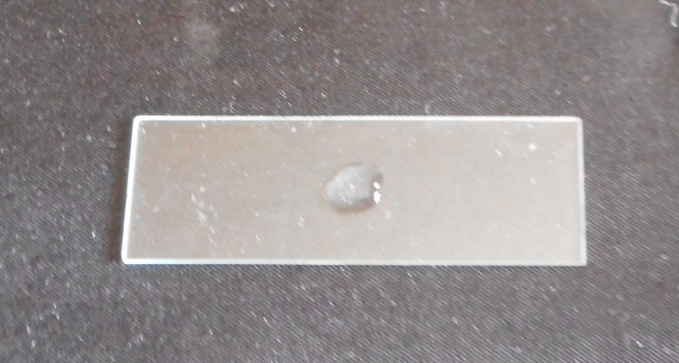

Streptococcus pyrogens

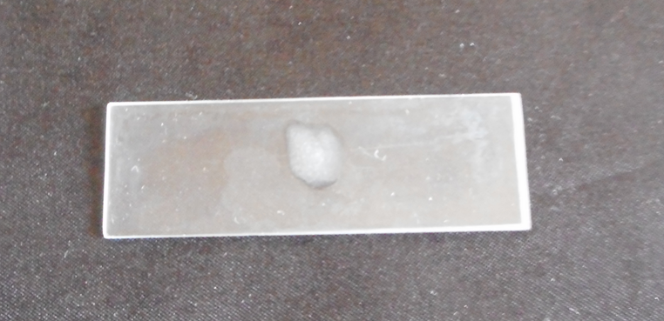

Bacillus subtilis

Figure 1. High Agglutination against Bacteria

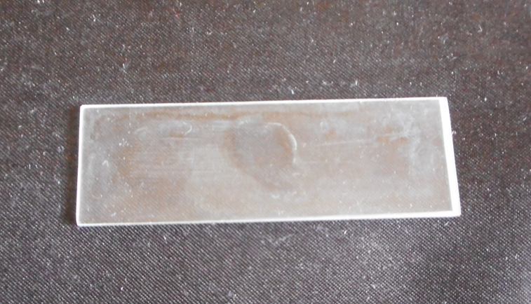

Pseudomonas aeruginosa

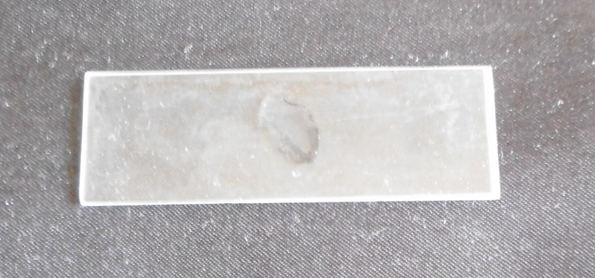

Salmonella paratyphi

Figure 2. Moderate Agglutination against Bacteria.

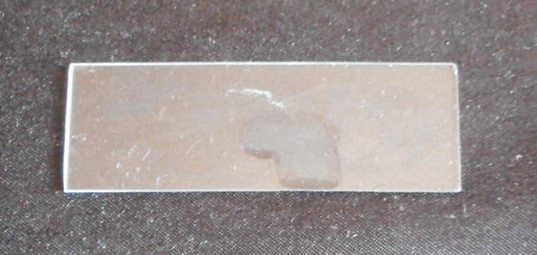

Escherichia coli

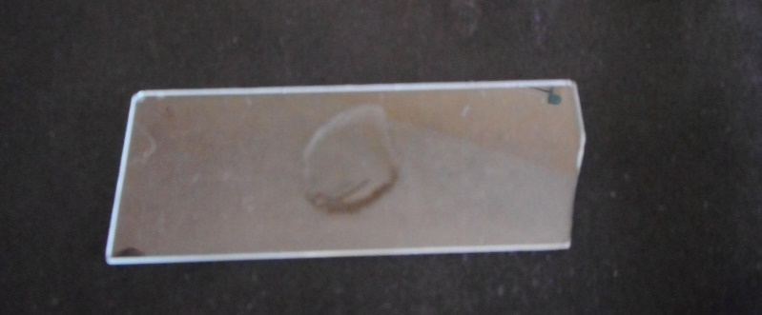

Staphylococcus auraeus

Figure 3. Least Agglutination against Bacteria

3.4 Yeast agglutination assay

Titer value for agglutination of trypsinized yeast was 128 and native yeast was 64 (Table 4).

Table 4: Yeast Agglutination of Serum Sample

S.No | Yeast | Titer
1 | Trypsinized | 128
2 | Native | 64

3.5 Analysis of Bacterial zone of inhibition
Figure 4 and Table 5 show the inhibition against Staphylococcus auraeus and Escherichia coli in 20µl in a 6 mm zone". In Figure 5, the suppression of Salmonella paratyphi and Pseudomonas aeruginosa in 40µl in a 7 mm zone is shown. The 60µl sample of Bacillus subtilis and Streptococcus pyrogens at a 10 mm zone of inhibition is shown in Figure 6. As a control, a maximum of 26 mm of Streptomycin (20 µg) is used.

Table 5: Bacterial Inhibition of Serum Samples
Haemolymph serum | Zone of Inhibition in mm
 | 20 µl | 40 µl | 60 µl | 80 µl | Streptomycin  (20µg)
Microorganisms
E.coli | 6 | 7 | 8 | 9 | 19
Staphylococcus auraeus | 6 | 7 | 8 | 9 | 17
Salmonella paratyphi |  | 7 | 7 | 7 | 26
Pseudomonas aeruginosa |  | 7 | 7 | 7 | 15
Bacillus subtilis |  |  | 10 | 12 | 15
Streptococcus pyrogens |  |  | 10 | 12 | 22

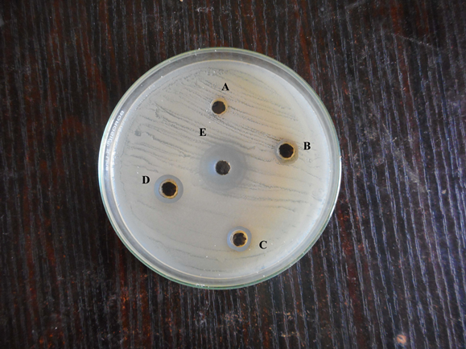

Escherichia coli

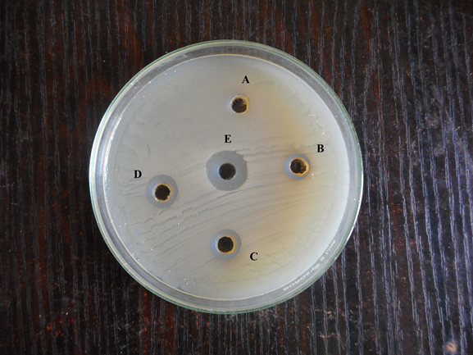

Staphylococcus auraeus

Figure 4. Inhibition against Bacteria

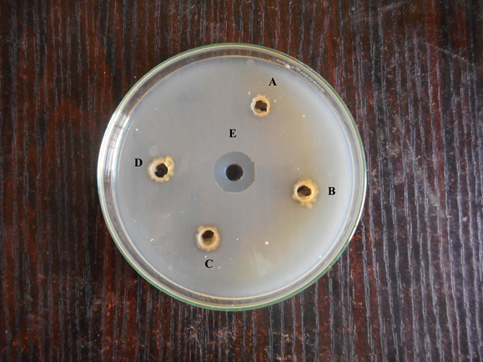

Salmonella paratyphi

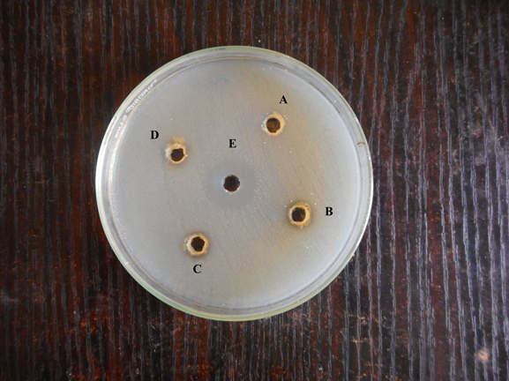

Pseudomonas aeruginosa

Figure 5. Bacterial inhibition of S. paratyphi and P. aeruginosa

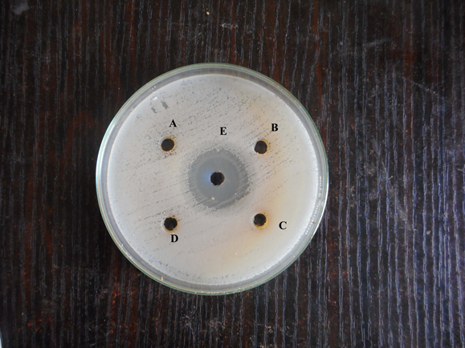

Bacillus subtilis

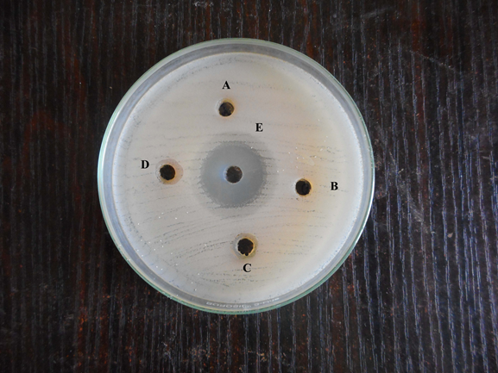

Streptococcus pyrogens

Figure 6. Bacterial inhibition zone of Bacillus subtilis and Streptococcus pyrogens

(ZONE A: 20µl of sample, ZONE B: 40 µl of sample, ZONE C: 60 µl of sample, ZONE D: 80 µl of sample, ZONE E: 20 µg of Streptomycin)

3.6 Analysis of fungal zone of inhibition
The inhibition against Candida albicans and Aspergillus niger in 20µl in a 6 mm zone is shown in Table 6 and Figure 7. Figure 8 displays the suppression of Rhizopus sp and Mucor sp in 40µl at a 7 mm zone, as well as the inhibition of Aspergillus fumigatus and Aspergillus flavus in 40l at a 9 mm zone. For the control, a maximum of 26 mm of ketocanzole (20 µl) is used.

Table 6: Fungal Inhibition of Serum Samples
Haemolymph serum | Zone of Inhibition in mm
 | 20 µl | 40 µl | 60 µl | 80 µl | Ketocanzole  (20µg)
Microorganisms
Candida albicans | 6 | 7 | 8 | 9 | 15
Aspergillus niger | 6 | 7 | 8 | 9 | 17
Mucor sp |  | 7 | 8 | 9 | 26
Rhizopus sp |  | 7 | 8 | 9 | 17
Aspergillus flavus |  | 9 | 10 | 12 | 19
Aspergillus fumigatus |  | 9 | 10 | 12 | 23

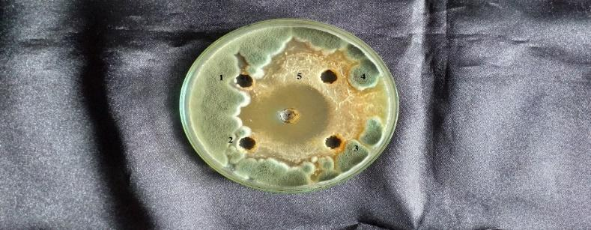

Candida albicans

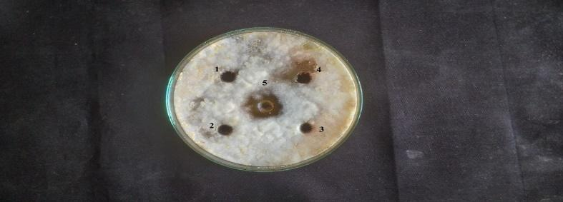

Aspergillus niger

Figure 7. Inhibition against Fungi Candida albicans and Aspergillus niger

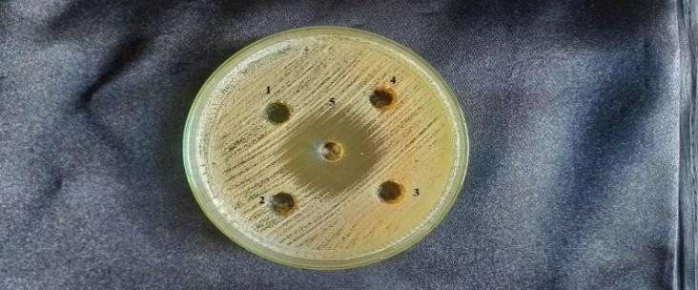

Mucor sp

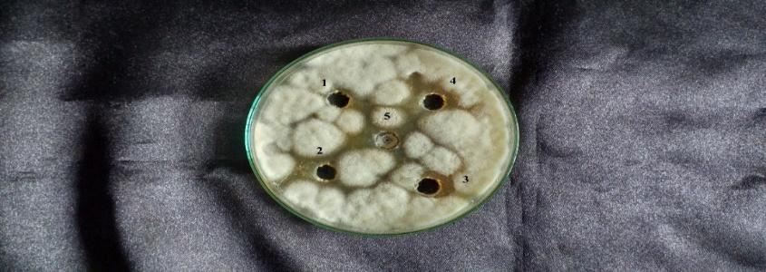

Rhizopus sp

Figure 8. Fungal inhibition of Mucor sp. and Rhizopus sp

(ZONE 1: 20µl of sample, ZONE 2: 40 µl of sample, ZONE 3: 60 µl of sample, ZONE 4: 80 µl of sample, ZONE 5: 20 µL of ketocanzole)

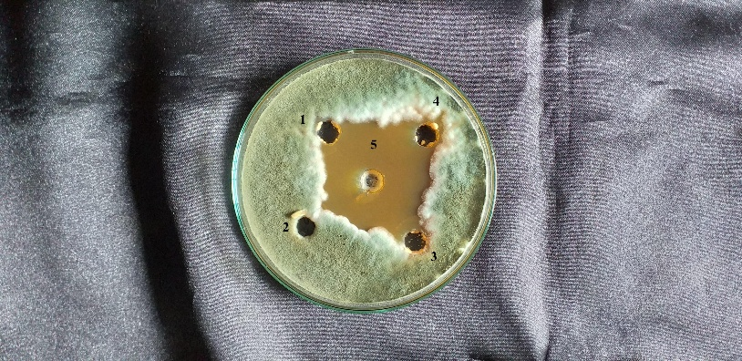

Aspergillus flavu
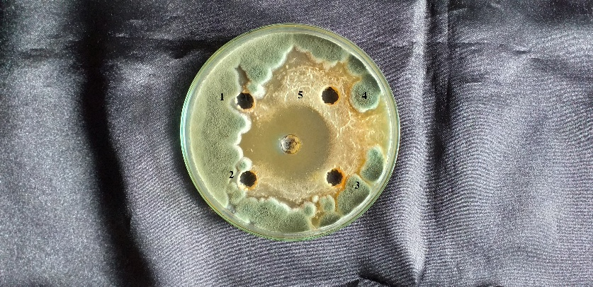

Aspergillus fumigatus

Figure 9: Fungal inhibition of Aspergillus flavu and Aspergillus fumigatus

3.7 pH and temperature
Figure 10 demonstrates that the HA activity of crab serum was consistently high throughout the temperature range of 20 to 30°C and pH range of 7 to 8.

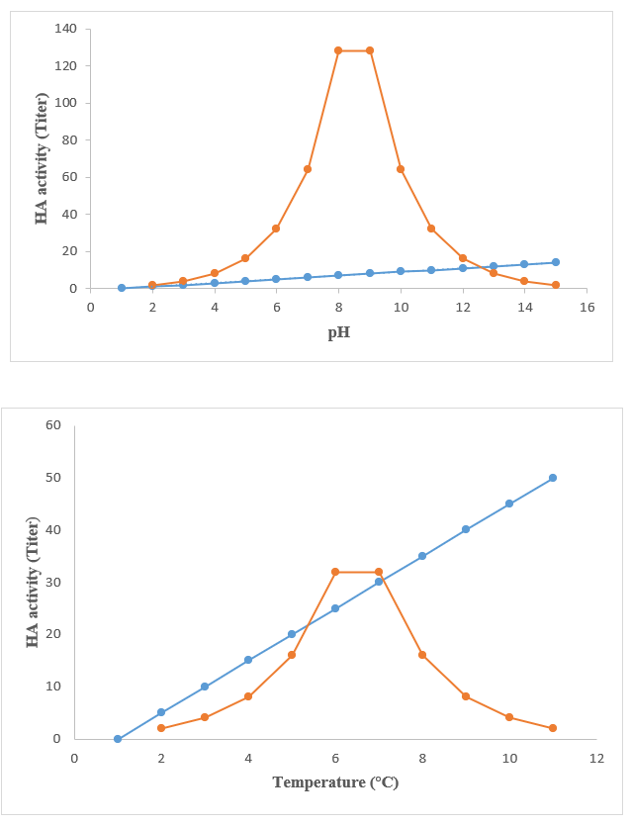

Figure 10. pH And Thermal Stability of Serum Sample of Emerita asiatica

3.8 Divalent Cation
Table 7 shows that 128 of the dialysates tested against buffalo RBC had their HA titers reduced after extensive dialysis against a divalent cation-free buffer. The test solution was supplemented with 10 mM of Ca²⁺, Mg²⁺, or Sr²⁺ (as chloride salts) and the titers rose to 128 for each salt, with Ca²⁺showing a significant improvement in the serum agglutinating activity on both crabs. The HA activity of both serum samples was preserved when dialysed against a solution containing 10 mM CaCl₂. Both serum samples showed comparable results when dialysed against the divalent cation chelator.

Table 7: Divalent cation dependency and EDTA sensitivity of the hemagglutinating activity of the serum of Emerita asiatica.

Serum samples | Divalent cations tested | Hemagglutination titer
Serum | CaCl₂ | 128
Divalent cation | CaCl₂ | 128
 | MgCl₂ | 128
 | SrCl₂ | 64
TBS + 10 mM CaCl₂ | CaCl₂ | 64
 | MgC_{l2} | 64
 | SrCl₂ | 64
TBS + 50 mM EDTA | CaCl₂ | 32
 | MgC_{l2} | 32
 | SrCl₂ | 32

3.9 EDTA, EGTA and dose dependant effect of calcium ions
A substantial decrease in HA activity (HA titer-32) was seen in the serum sample when 50 mM EDTA was used, although the same serum showed HA activity against buffalo RBC when 10 mM EGTA and a specific calcium chelator were used. Serum from crabs had a HA activity value of 64 titer when tested in TBS with 10 mM CaCl₂. Increasing the CaCl₂ concentration to 100 mM resulted in an even higher HA activity value of 512 titer (Figure 11). Experiments using crab serum demonstrated a similar trend, with a HA titer of 128 at 10 mM CaCl₂ and a rise in HA activity with higher CaCl₂ concentrations, peaking at 1024 with 100 mM CaCl₂ in the test medium.

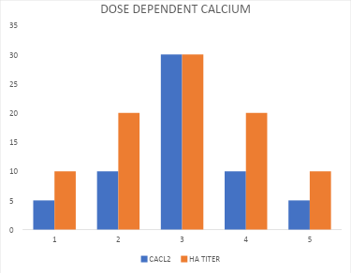
Figure 11. Dose dependent effect of calcium on the HA activity of serum of Emerita asiatica
3.10 Levels of total calcium
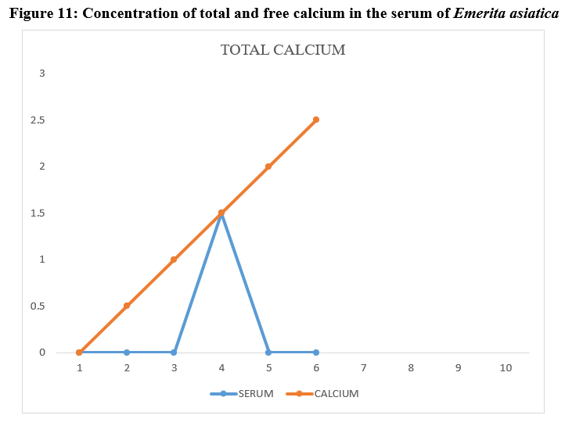
Figure 12 shows that the total calcium levels in E. asiatica serum were regulated, ranging from 1.3 to 1.9 mg ml-1. Blood calcium levels in crabs were found to vary between an initial estimate of 1.3 mg ml-1 to a maximum of 1.9 mg ml-1. eventually, serum total calcium levels started to decline and eventually reached 1.4 mg/ml or below. Statistical analysis using the one-way ANOVA test revealed a significant outcome (p<0.05) for the data. In a similar vein, E. asiatica serum had free calcium levels between 0.9 and 1.7 mg/ml, making up around 80 to 89% of the total calcium. Serum free calcium levels in crabs ranged from 0.9 mg/ml at the beginning of the experiment to 1.7 mg/ml at the end. A lower amount of serum free calcium was detected later on.

Figure 12. Concentration of total and free calcium in the serum of Emerita asiatica
3.11 Hemagglutination-inhibition
Multiple HA-inhibition experiments were conducted against buffalo RBCs utilising a panel of carbohydrates and a glycoprotein to investigate the qualitative nature of agglutinins in crab serum. The inhibitory efficacy on the HA activity of crab serum is exclusively shown by the N-acetylated analogues of the three hexosamines, out of all the simple sugars that were studied (Table 8).

Table 8: Inhibition of hemagglutinating activity of Emerita asiatica by simple sugars, polysaccharides and a glycoprotein

S.No | Substances | Maximum concentration tested | Minimum inhibitory concentration
N-acetyl aminosugars (Mm)
1 | N-acetylglucosamine (GlcNAc) | 200 | 25
2 | N-acetylgalactosamine (GalNAc) | 200 | 25
3 | N-acetylmannosamine (ManNAc) | 200 | 6.25
Polysaccharides (mg/ml )
4 | Mannan | 1 | 0.25
5 | β-1,3 glucan | 1 | 0.25
6 | Lipopolysaccharide (LPS) | 1 | 0.25
7 | Colominic acid | 10 | 2.5
Sialic acid (mM)
8 | N-acetylneuraminic acid | 20 | 10
Glycoproteins (mg/ml )
9 | Bovine submaxillary mucin | 10 | 0.039
10 | Fetuin | 10 | 0.156
11 | Porcine thyroglobulin | 10 | 0.156

3.12 Discussion

The oxygen, which dissolved in the water is considered as the essential parameter in the water analysis it acts as the indicator of biological, physical, and chemical activities of water body. 2 main sources of the dissolved oxygen are the diffusion of oxygen from photosynthetic activity and air. The Oxygen is the main regulating factor in the water bodies with the high concentration of the organic materials (Vijayakumar, Rajesh, & Mendon xxxx).

Dissolved oxygen in water of study area has shown the higher values in months from Jan and Feb of 2014. In these period many juveniles and females were recorded and hence it suggested the increased rate of the reproductive activity. experiential DO were above 4 mg/l and it has reported early in the Arabian Sea (Sivakumar et al., 2014) and in the Gulf of Kacchchh.

DO was low in the period of March 2014 and then many males were recorded. Due to the DO level among 4 mg/l level COD and BOD were less and it has been reflected in study. The inverse relation within the BOD and DO, COD within the BOD (Laishram & Dey) were considered as natural process. BOD was high in the period of December 2013, in that period many females also were recorded followed by males and juveniles. The BOD was lower during February 2014, during this period than the males were recorded by following the juveniles and females. It was indicated that the BOD created the impacts in the population density of these species. variation was noted in the population density of the E. asiatica and it has shown that there has the relation within the oxygen demand fluctuations and it has concluded, that the oxygen demands the fluctuations has impacts in the population of these species in the area of the Kovalam beach. Thus, rather stable oxygen demanded in the year and changes in the sea water will be conducive to the above mentioned population density of the E. asiatica. Several crustacean physiologists examined the hemolymph of the decapods due to the ranges of the variation occurred in its contents. The Proteins in the crustacean hemolymph differ on the basis of the bioactivity and nutritional status. Inspite of their possibility in the pharmaceutical usages, the research into natural compounds bioactivity was received the huge interest in the current years.
In the study, the Asian seabass larvae has been immunized against the A. salmonicida infection with the help of using the crude hemolymph of sand crab i.e. (E. asiatica). The combined in-vivo and in-vitro investigations with the help of utilizing the crude hemolymph of E. asiatica has revealed substantial antibacterial activity. The RPS value of 80 percent has been noted against bacteria in challenge study with the Asian seabass larvae. The research findings were demonstrated degree of efficiency of the sand crab's haemolymph against A. salmonicida. Hemolymph have strengthened larvae's defenses against the bacterial pathogens and it accelerated larval progress phase in the Asian seabass. The group larvae has larger and it has entered into their next development phase and ahead of positive control group. The deep analysis may provide the clear perception. Similarly, many studies were conducted and many early investigations of the antibacterial activities of several crab species were held (Velayutham & Munusamy, 2016) (Fredrick & Ravichandran, xxxx).

4. Conclusion

The study is about the Immunological Characterization of the Serum of the Mole Crab Emerita asiatica. Likewise, the study examined the mole crab's immune reaction and determined the hemagglutinin value of the Emerita asiatica. Also, the study conducted the hemagglutination and the cross adsorption experiments for the serum separation and the microbe agglutinating activity. The mole crab's defensive system against the bacterial infection has been exposed by the bacterial inhibition and the bacterial agglutination. By utilizing the human RBC, the variety of bacteria, and the yeast as the indicator cells, the naturally occurring hemagglutinin (HA) with action against the bacteria and yeast cells was discovered in the serum of the mole crabs. The study also analysed the Bacterial zone of the inhibition and the fungal zone of the inhibition. Also, the study provided the better results and the valuable insights about the Immunological Characterization of the Serum of Mole Crab Emerita asiatica.

5. COMPETING INTERESTS DISCLAIMER:
Authors have declared that they have no known competing financial interests OR non-financial interests OR personal relationships that could have appeared to influence the work reported in this paper.

Disclaimer (Artificial intelligence)
Option 1:
Author(s) hereby declare that NO generative AI technologies such as Large Language Models (ChatGPT, COPILOT, etc.) and text-to-image generators have been used during the writing or editing of this manuscript.
Option 2:
Author(s) hereby declare that generative AI technologies such as Large Language Models, etc. have been used during the writing or editing of manuscripts. This explanation will include the name, version, model, and source of the generative AI technology and as well as all input prompts provided to the generative AI technology
Details of the AI usage are given below:
1.
2.
3.

6. References

Abude, R. R. S., Hajdu, G. L., Moreira, D. A., & Cabrini, T. M. B. (2024). Sandy beach mole crabs (Decapoda: Hippidae: Emerita): A systematic review of the anthropic impacts, populations density, and conservation strategies. Marine Environmental Research, 106745.
Begon, M., & Townsend, C. R. (2020). Ecology: from individuals to ecosystems: John Wiley & Sons.
Cardoso, R. S., Veloso, V. G., & Caetano, C. H. S. Life History of Emérita Brasiliensis (Decapoda: Hippidae) on Two Beaches With Different Morphodynamic Characteristics.
Costa, L. L., Constantino, W. D., de Aquino Ferreira, K., Zalmon, I. R., & Soares-Gomes, A. (2022). Sandy beach ecology in the Anthropocene: Ghost shrimp (Crustacea: Callianassidae) as a study model. Estuarine, Coastal and Shelf Science, 275, 107999.
Devaraj, H., Kumar, D. S., Thanislass, J., & Niranjali, S. (1995). Isolation and characterization of high molecular weight glycoproteins from embryonated eggs of Emerita asiatica. Comparative Biochemistry and Physiology Part B: Biochemistry and Molecular Biology, 110(1), 175-181.
Domingos, J. A., Goldsbury, J. A., Gomes, G. B., Smith, B. G., Tomlinson, C., Bade, T., . . . Jerry, D. R. (2021). Genotype by environment interactions of harvest growth traits for barramundi (Lates calcarifer) commercially farmed in marine vs. freshwater conditions. Aquaculture, 532, 735989.
Fredrick, W. S., & Ravichandran, S. Hemolymph proteins in marine crustaceans.
Hall, J. L., & Rowlands Jr, D. T. (1974). Heterogeneity of lobster agglutinins. I. Purification and physicochemical characterization. Biochemistry, 13(4), 821-827.
HARRISON, P., BERRY, P., SIMPSON, G., HASLETT, J., BLICHARSKA, M., BUCUR, M., . . . GEAMĂNĂ, N. Linkages between biodiversity attributes and ecosystem services: A systematic review. Ecosystem services.
Impellitteri, F., Curpăn, A.-S., Plăvan, G., Ciobica, A., & Faggio, C. (2022). Hemocytes: A Useful Tool for Assessing the Toxicity of Microplastics, Heavy Metals, and Pesticides on Aquatic Invertebrates. International Journal of Environmental Research and Public Health, 19(24), 16830. Retrieved from https://www.mdpi.com/1660-4601/19/24/16830
Jayaraj, S. S., Thiagarajan, R., Arumugam, M., & Mullainadhan, P. (2008). Isolation, purification and characterization of β-1, 3-glucan binding protein from the plasma of marine mussel Perna viridis. Fish & Shellfish Immunology, 24(6), 715-725.
Laishram, J., & Dey, M. Water Quality Status of Loktak Lake, Manipur, Northeast India and Need for Conservation Measures: A Study on Five Selected Villages.
Mantelatto, F. L., Paixão, J. M., Robles, R., Teles, J. N., & Balbino, F. C. (2023). ﻿ Evidence using morphology, molecules, and biogeography clarifies the taxonomic status of mole crabs of the genus Emerita Scopoli, 1777 (Anomura, Hippidae) and reveals a new species from the western Atlantic. ZooKeys, 1161, 169.
Pillai, A., & Munusami, A. (2017). Isolation and characterisation of moult related agglutinins from the serum at intermoult (C) and postmoult (A 2 ) stages of the intertidal mole crab Emerita asiatica.
Sivakumar, J., Nappinai, B., Jayanthi, J., & Gurunathan, M. (2014). Population Density of Emerita asiatica (H. Milne Edwards, 1837) in Relation to Oxygen Demand in the Kovalam Beach, East Coast, Kanchipuram District of Tamil Nadu, India. Journal of Modern Biotechnology, 3(3), 30-34.
Subramoniam, T. (1979). Some aspects of reproductive ecology of a mole crab Emerita asiatica Milne Edwards. Journal of Experimental Marine Biology and Ecology, 36(3), 259-268.
Velayutham, M., & Munusamy, A. (2016). Humoral immune responses of antibacterial hemocyanin (Ab-Hcy) in mud crab, Scylla serrata. Aquaculture, 464, 428-433.
Vijayakumar, S., Rajesh, K., & Mendon, R. xxxx Seasonal distribution and behaviour of nutrients with reference to tidal rhythm in the Mulki Estuary, South-West Coast of India.
Zhou, P., Yang, P., Zhang, K., Guo, H., Du, J., Huang, L., . . . Li, J. (2025). Discovery and engineering of the asiaticoside, madecassoside and asiaticoside B biosynthetic pathway. Plant Physiology and Biochemistry, 223, 109864.

