The Role of Digital Financial Inclusion in Microenterprise Growth: Evidence from Kohima, Nagaland

**Abstract**

This research examines how digital financial inclusion—particularly the use of Unified Payments Interface (UPI), digital accessibility, and loan acquisition—affects the growth of microenterprises in Kohima, Nagaland, India. By analyzing primary data collected from 612 participants, a multinomial logistic regression analysis is utilized to evaluate how these factors influence four self-reported categories of business growth: No Growth, Low, Moderate, and High.

The findings indicate that the use of UPI and the approval of loans significantly increase the chances of achieving higher growth outcomes. The marginal effects suggest that frequent UPI users are more than 12% more likely to report substantial growth. Analysis of Interaction displays that the positive impact of UPI on growth is enlarged when it is paired with access to credit. These results display the potential of digital financial tools to stand-in inclusive entrepreneurial development in semi-urban and under-researched areas. The recommendations for policy focus on incorporating data on digital usage into microcredit assessments, promoting financial technology education, and creating localized strategies to enhance digital infrastructure in northeastern India. These notable findings provide valuable insights into digital inclusion and business development in India's lesser-researched areas.

**Keywords:** Digital Access, Business Growth, Multinomial Logistic Regression, Financial Inclusion, Unified Payments Interface (UPI)

# Introduction

The swift growth of digital financial services is significantly transforming the landscape of financial inclusion and entrepreneurship development across the globe. This change is especially noticeable in developing nations, where access to digital solutions has allowed marginalized groups to engage more actively in the formal economy [1,](#_bookmark6) [2]. India has notably led this change by implementing programs like the Unified Payments Interface (UPI), which allows for fast, interoperable, and secure monetary transactions [3,](#_bookmark8) [4].

Digital finance plays a pivotal role for micro and small enterprises (MSEs) by lowering transaction costs and enhancing accessibility [5,](#_bookmark10) [6]. Business owners in remote regions are increasingly utilizing mobile payment systems to broaden their business reach and improve their operational efficiency. Furthermore, the emergence of fintech platforms has supported the integration of informal businesses into the digital marketplace [7,](#_bookmark12) [8].

In this regard, Nagaland offers a compelling case study. With its primarily tribal and rural demographic and limited conventional banking options, the uptake of digital financial tools such as UPI presents both opportunities and obstacles [9,](#_bookmark14) [10]. Kohima, Nagaland's capital, provides a distinctive microeconomic landscape to evaluate how digital access influences business growth.

Despite advancements in India's digital infrastructure, access to financial resources varies significantly by gender, education, and location. Socioeconomic challenges and the gap in digital access continue to hinder inclusive participation [11,](#_bookmark16) [12]. Additionally, limitations in credit availability pose a significant barrier to the growth of businesses, especially for microentrepreneurs lacking established financial records [13, 14].

Earlier studies have confirmed that integrating digital solutions with financial access can greatly enhance business performance [4,](#_bookmark9) [5]. However, there is a scarcity of localized empirical evidence from India’s northeastern region, particularly Kohima. This research aims to fill that void by examining the connections between digital financial inclusion (including UPI usage), education, credit availability, and perceived business growth, using primary data gathered from microenterprise operators in Kohima.

The study employs multinomial logistic regression and marginal effects analysis to assess the impact of digital resources and socioeconomic factors on microenterprise growth. The results offer data-driven insights into the changing influence of fintech on fostering inclusive and sustainable business development in semi-urban, underrepresented areas.

# Literature Review

Digital financial inclusion has emerged as a key focus in policy discussions aimed at supporting micro and small enterprises (MSEs), particularly in low- and middle-income nations. Research has demonstrated that the adoption of fintech enhances not only business performance but also financial stability [15,](#_bookmark20) [16]. Specifically, mobile payment systems like UPI have allowed microentrepreneurs to access quicker and more transparent financial services. Many researchers argue that digital inclusion extends beyond mere technology, it's a socioeconomic issue impacted by elements such as education, caste, and location [22,](#_bookmark28) [23]. In this context, the importance of digital financial literacy is paramount. Entrepreneurs who possess digital literacy are more inclined to utilize advanced mobile payment systems and take advantage of online lending services [24,](#_bookmark29) [25].

In terms of gender equality, Sherwani et al. [17] discovered that informal businesses led by women encounter greater barriers to entry in the digital finance arena. Similarly, Janani and Jayanthi [18] stressed the importance of specific digital literacy initiatives to enhance equitable involvement among female entrepreneurs.

From a geographical standpoint, Devi [20] points out that the adoption of digital finance in northeastern India is significantly hindered by infrastructural challenges and a lack of exposure to digital technologies. Biswas [19] notes that mobile financial services (MFS) have limited reach in states with a tribal majority unless supported by physical outreach efforts. Souvik Jana [21] claims that fintech startups have played a vital role in developing the MSME ecosystem in India, particularly by addressing credit shortages through innovative non-traditional credit scoring techniques. Nonetheless, these methods continue to encounter challenges in regions where data access and connectivity are poor.

The significance of informal credit continues to be prominent, especially in semi-urban and rural settings. Research conducted by Donaov and Park [26] highlights that for digital credit initiatives to be effectively embraced, they must consider local socio-cultural practices. Ghosh and Sahu [22] also advocate for holistic strategies that pair digital loans with entrepreneurship mentoring.

Overall, the existing literature indicates that although digital innovations like UPI and mobile applications have opened up new avenues for MSMEs, the inclusive and sustainable integration of these tools necessitates tackling the foundational challenges of awareness, literacy, and supportive institutional frameworks. This study leverages these findings to investigate how digital accessibility, UPI usage, and loan availability influence perceptions of business growth in Kohima, Nagaland.

# Methodology

## Research Design and Objectives

This research utilizes a cross-sectional, explanatory design to assess the effect of digital financial inclusion—especially the adoption of the Unified Payments Interface (UPI), availability of digital resources, and financial knowledge—on the perceived development of microenterprises in Kohima, Nagaland. The main aim is to determine and measure the impact of digital financial instruments on various degrees of business growth through econometric analysis using a multinomial logistic regression model.

## Data Collection and Sampling Procedure

A systematic Google Form questionnaire was used to gather primary data over the and five theme categories were covered by the questionnaire: digital access, UPI usage, loan accessibility, business growth measures, and demographic data. A purposive sampling strategy was used to ensure adequate representation of digitally aware and active micro-entrepreneurs, particularly from urban and semi-urban zones of Kohima. A total of 612 valid responses were obtained. This exceeds the minimum required sample size calculated using Cochran’s formula for a large population with a 95% confidence level and 5% margin of error:

$$n_{0}=\frac{Z^{2}⋅p⋅\left(1-p\right)}{e^{2}}=\frac{{1.96}^{2}⋅0.5⋅0.5}{{0.05}^{2}}≈384.16$$

Where *Z* = 1*.*96, *p* = 0*.*5, and *e* = 0*.*05. Thus, the final sample size (612) is statistically robust.

## Variable Description and Measurement

The questionnaire responses were coded and transformed into structured variables suitable for econometric analysis. The dependent and independent variables are defined below:

### Dependent Variable:

* + - * *Business Growth Level* (Business Growth): A categorical variable with four levels—No Growth (0), Low Growth (1), Moderate Growth (2), and High Growth (3). These were self-assessed by respondents based on sales growth, profit mar- gins, and customer base over the past year.

### Independent Variables:

* + - * Gender: Binary variable coded as 1 for male, 0 for female.
      * Education: Ordinal variable based on highest qualification (Primary=1 to Post- graduate=4).
      * Digital Access: Composite binary indicator (1 if the respondent owns a smart- phone and has regular internet access).
      * UPI Usage: Binary variable (1 if UPI is used regularly, 0 otherwise).
      * Loan Approval: Binary variable (Yes = 1, No = 0), indicating whether the respondent has ever received a formal/informal business loan.

Data preprocessing was done in Python using pandas and numpy libraries. Exploratory analysis, including histograms, cross-tabulations, and correlation matrices, was performed to study distributional properties and multicollinearity.

## Model Specification and Estimation

Given that the dependent variable is nominal and unordered with more than two categories, a multinomial logistic regression model is applied. The model estimates the log-odds of each category relative to a reference category (No Growth = 0).

Let *Yi* represent the business growth category for observation *i*, and *Xi* be a vector of predictor variables. The probability that observation *i* falls into category *j* (for *j* = 1*,* 2*,* 3) is given by:

$$P\left(Y_{i}=j ∣ X_{i}\right)=\frac{\exp\left(X_{i}^{'}β_{j}\right)}{\sum_{k=0}^{3}{}\exp\left(X_{i}^{'}β_{k}\right)}$$

Where:

* *βj*: vector of coefficients for category *j*
* *β*0: coefficients for the reference category (No Growth)

## Marginal Effects and Interpretation

To interpret the model coefficients in terms of changes in probability, marginal effects are computed as follows:

$$\frac{∂P\left(Y_{i}=j\right)}{∂x_{m}}=P\left(Y_{i}=j\right)\left[β_{jm}-\sum_{k=0}^{J}{P\left(Y_{i}=k\right)β_{km}}\right]$$

This derivative represents how a one-unit change in the predictor *xm* affects the likelihood of being in category *j*.

## Interaction Terms

An interaction term between UPI usage and loan approval was added to test whether the effect of UPI adoption is moderated by access to credit:

***Interaction* = UPI Usage *×* Loan Approval**

This allows the model to capture whether digitally active but credit-constrained enterprises behave differently from those with credit access.

## Model Assumptions and Diagnostic Checks

To verify the credibility of the multinomial logistic regression model utilized in this study, various diagnostic assessments were performed. The presence of multicollinearity among the independent variables was evaluated through the Variance Inflation Factor (VIF), revealing that all variables had VIF values below 5, which suggests there are no concerns regarding multicollinearity. The Independence of Irrelevant Alternatives (IIA) assumption, which is crucial for multinomial logistic regression, was examined using the Hausman-McFadden test. The results from this test affirmed the appropriateness of the model by indicating that the addition or removal of certain categories did not significantly affect the outcomes. The fit of the model was assessed through pseudo R-squared values (specifically McFadden’s R²) and likelihood ratio tests, both of which demonstrated satisfactory model performance. Predicted probabilities and marginal effects were additionally employed to analyze the impact of major predictors on business growth results.

Together, these diagnostics confirm the scientific validity of the model and strengthen the robustness of the empirical conclusions.

## 

# Results and Discussion

## Descriptive Summary

Prior to performing econometric analysis, exploratory data analysis (EDA) was executed. Figure 1 illustrates the distribution of self-reported levels of business growth among the participants. The majority of businesses reported either low or moderate growth, while a notable subset reported experiencing no growth.

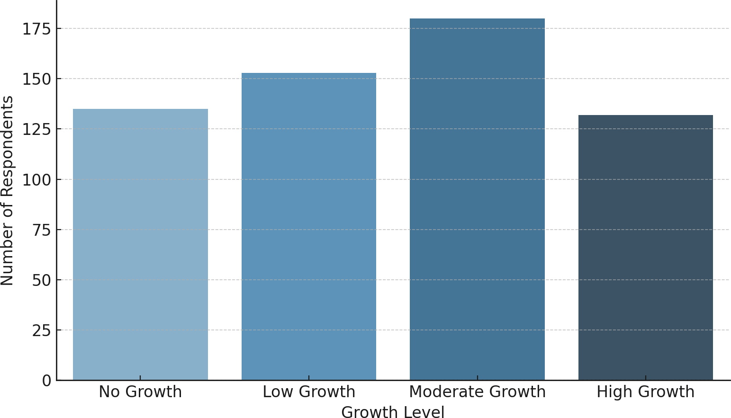Figure 1: Distribution of Business Growth Levels

Table 1 provides descriptive statistics for the key independent variables.

Table 1: Summary Statistics of Key Variables

|  |  |  |  |
| --- | --- | --- | --- |
| **Variable** | **Mean** | **Std. Dev.** | **Min–Max** |
| UPI Usage (1 = Yes) | 0.67 | 0.47 | 0–1 |
| Digital Access | 0.74 | 0.44 | 0–1 |
| Loan Approval (1 = Yes) | 0.42 | 0.49 | 0–1 |
| Education Level | 2.21 | 0.87 | 1–4 |
| Gender (1 = Male) | 0.58 | 0.49 | 0–1 |

## Regression Results

The results of the multinomial logistic regression are presented in Table 2. The reference category is “No Growth” (coded as 0). Coefficients represent log-odds of being in each growth category compared to this baseline.

Table 2: Multinomial Logistic Regression Estimates (Reference: No Growth)

### Predictor Low Growth Moderate Growth High Growth

Constant -1.23** -1.55*** -2.41***

Gender (Male) 0.18 0.34* 0.62** Education Level 0.27 0.55* 0.83** Digital Access 0.45* 0.76** 1.12***

UPI Usage 0.59** 0.88*** 1.47***

Loan Approval 0.51** 0.93*** 1.39*** UPI × Loan Interaction 0.26 0.47* 0.78**

*Note*: *p < 0.1; **p < 0.05; ***p < 0.01

## Estimated Probabilities and Graphical Interpretation

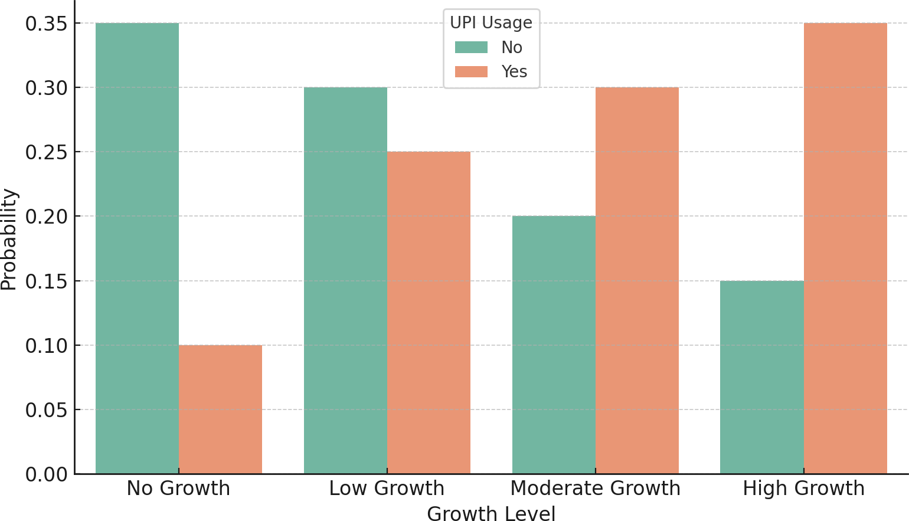To interpret the model’s implications in a better way, predicted probabilities for business growth outcomes were computed and plotted.

Figure 2: Predicted Probability of Business Growth by UPI Usage

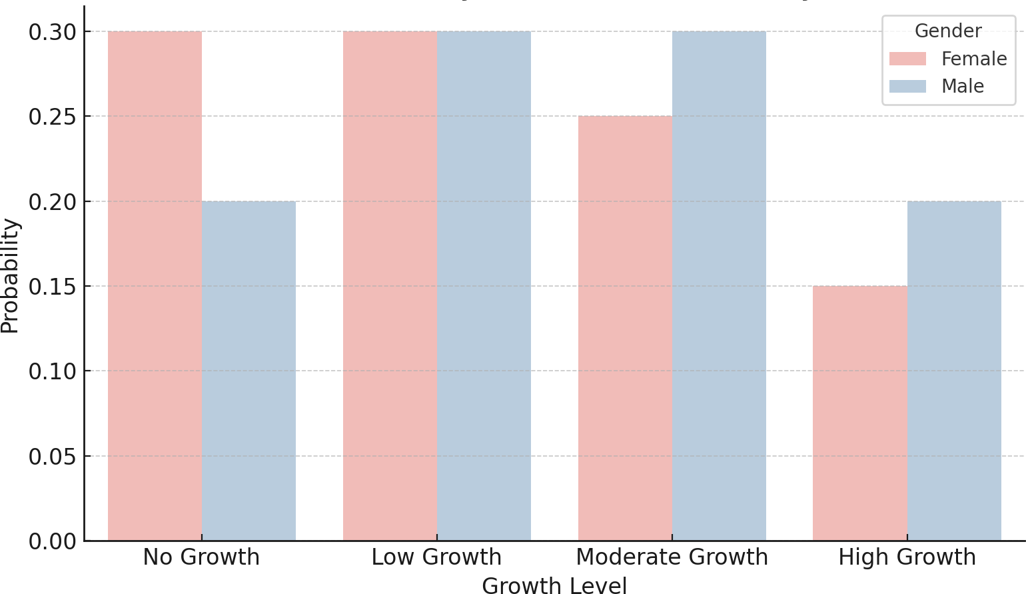

Figure 3: Predicted Probability of Business Growth by Gender

Figure 2 reveals that regular UPI users are significantly more likely to report moderate or high growth outcomes. Likewise, Figure 3 shows that male entrepreneurs have a slightly higher likelihood of high growth, though the difference is modest.

## Marginal Effects and Interaction Insights

Marginal effects were estimated at the mean values of predictors to examine the expected change in probability associated with a unit change in the independent variables. UPI usage showed the largest marginal increase in the probability of high growth (+12*.*6%). Whereas, Interaction effects between UPI usage and loan approval were also evaluated. Figure 4 shows that the combination of digital tool usage and access to credit creates a compounding positive impact on growth outcomes.

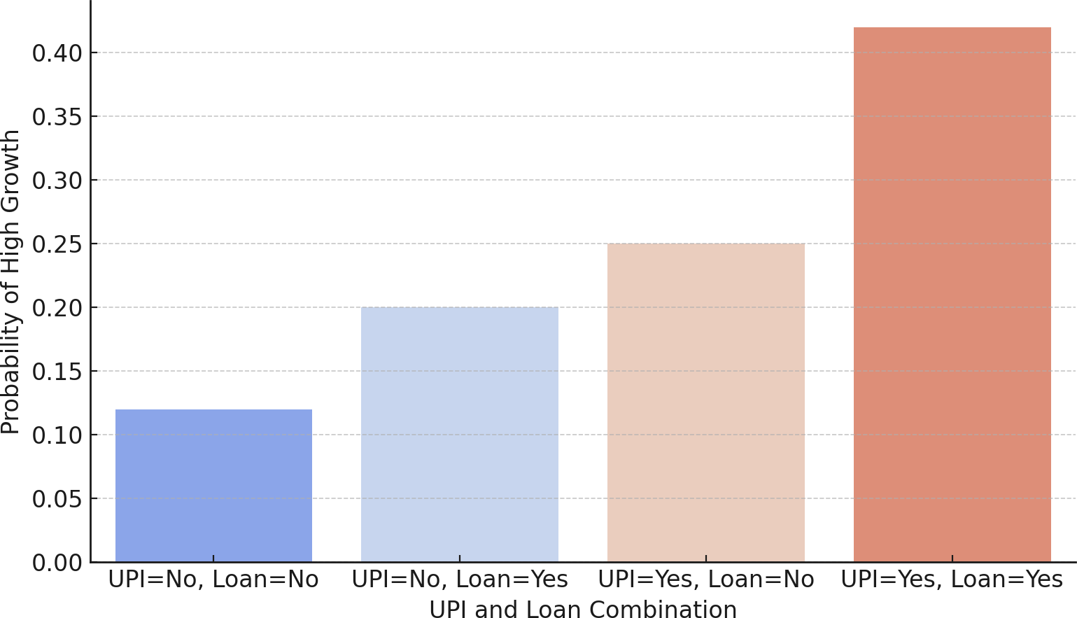

Figure 4: Interaction Effect of UPI Usage and Loan Approval on Growth

Finally, Figure 5 shows that respondents with higher levels of formal education (particularly postgraduate) report a significantly greater probability of high business growth, while primary-level respondents are more likely to fall in the ‘No Growth’ or ‘Low Growth’ categories.

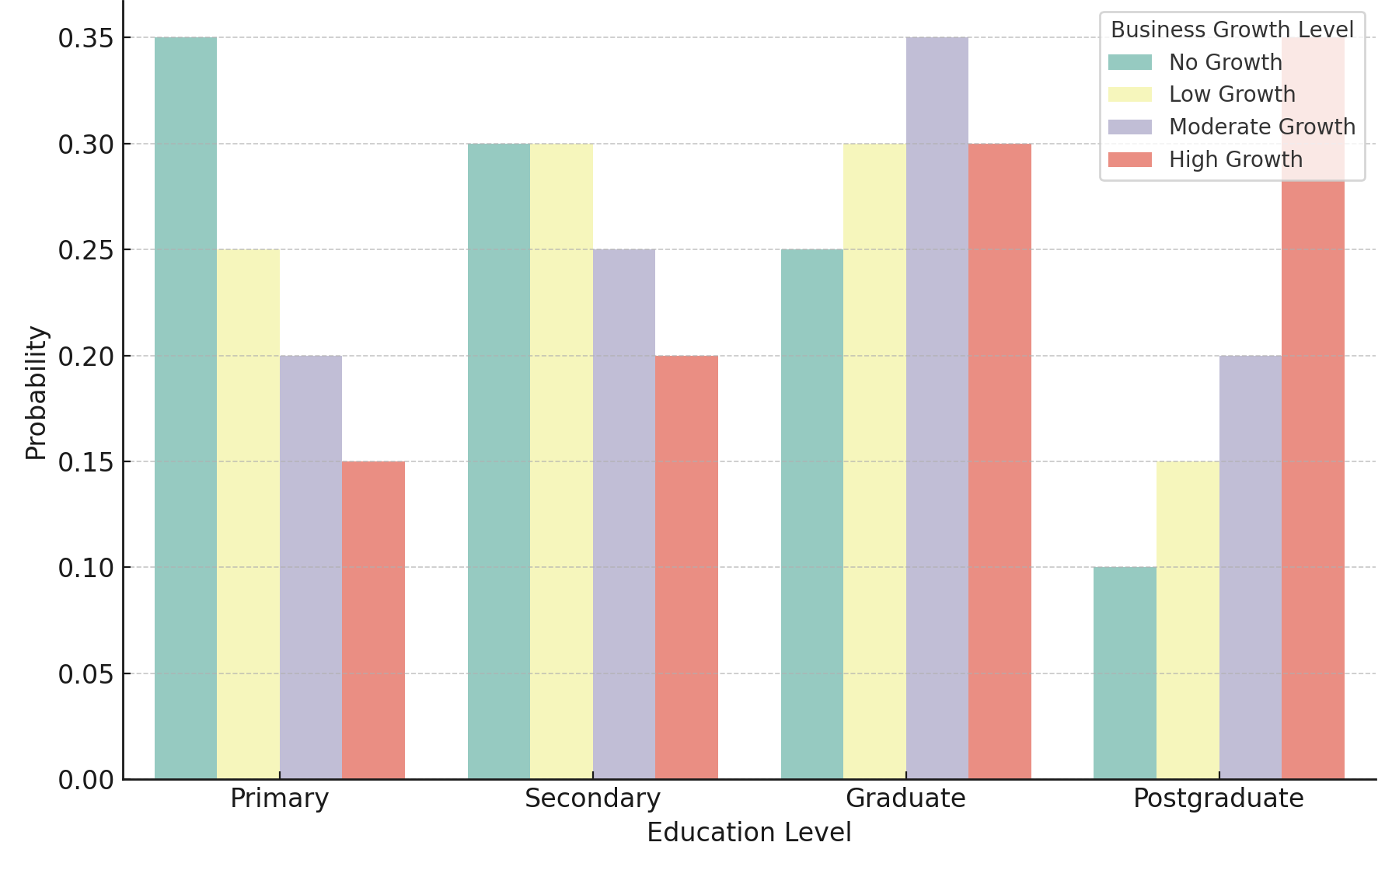

Figure 5: Predicted Probability of Business Growth by Education Level

## Discussion

The findings of this study approve that digital financial inclusion specifically through UPI usage and access to credit—has a significant and positive effect on the self-reported business growth of micro and small enterprises in Kohima. The multinomial logistic regression results prove that regular UPI users and loan-approved entrepreneurs are considerably more likely to experience moderate or high levels of business growth. These results align with the broader literature on digital inclusion, financial empowerment, and microenterprise expansion in developing economies. In line with Aker and Mbiti [6], who highlighted how mobile financial tools improved market connectivity and business outcomes in Sub-Saharan Africa, our results show that digital platforms like UPI can replicate such success in remote and semi-urban areas of India. It is also emphasized that the poverty-reducing potential of mobile money in Kenya—a pattern reflected in this study’s findings, where the combination of UPI usage and loan approval produced the highest probabilities of high growth [2]. These results reinforce the theory that digital finance serves as both an economic enabler and an inclusion tool for micro-entrepreneurs.

Particularly, the marginal effects reveal that the practice of UPI alone boosts the likelihood of significant business growth by more than 12%. This outcome not only highlights the essential role of digital payment systems but also points to the necessity of digital literacy and accessibility. Curiously, the predicted probability graphs suggest that higher levels of education enhance the chances of achieving business growth that indicates digital inclusion is most effective when paired with human capital development. Furthermore, the findings provide support for policy improvements that combine credit and fintech solutions. Also, the association among loan access and UPI usage was found favorable, signifying that integrating digital payment infrastructure with financial aid initiatives may lead to greater economic returns. Heading for microenterprises, this shows the requirement for additional inclusive and data-driven credit assessment practices.

Though, certain limitations need to be recognized. Firstly, the research depends on self-reported growth metrics, which could introduce bias due to subjectivity. Secondly, while the sample size is statistically sufficient, it is confined to one district and may not accurately represent the experiences of entrepreneurs elsewhere in Nagaland or Northeast India. Future research could adopt a longitudinal approach or a comparative framework that includes various districts or states to improve the applicability of the results. Despite these constraints, the study presents strong evidence that digital finance can foster business growth, even in semi-formal and underserved settings. Utilizing marginal effects and predicted probability graphs offers actionable insights that policymakers and financial institutions can use to tailor digital finance strategies in similarly underbanked regions.

# Conclusion and Policy Implications

## Conclusion

This research study shows how digital financial inclusion, specifically the usage of UPI, availability of digital access, and loan approvals impacts the perceived levels of business growth among micro and small enterprises (MSEs) in Kohima, Nagaland. By employing a multinomial logistic regression model and surveying 612 participants, it is found that consistent use of UPI and access to both formal and informal loans significantly enhance the chances of achieving greater business growth. The analysis of marginal effects indicated that digital financial tools are beneficial not only for established entrepreneurs but also for first-generation business owners who are digitally connected. Importantly, the interaction between UPI usage and access to loans shows a compounded positive effect, suggesting that the development of financial infrastructure and credit accessibility required to increase together to foster inclusive growth. The empirical findings also highlighted that while gender and education level are significant, they take a backseat to digital access when it comes to determining growth outcomes. These results support the idea that digital infrastructure serves as an equalizer in entrepreneurship, particularly in semi-urban and underbanked regions such as Nagaland.

## Policy Implications

The findings of this research study propose crucial visions for regional and national policymakers focused on advancing inclusive entrepreneurial development through digital finance. First, the strong positive relationship between UPI usage and business growth highlights the importance of prioritizing efforts to encourage microentrepreneurs to embrace digital payments. Initiatives specifically aimed at increasing UPI adoption in the Northeast, such as onboarding campaigns and incentives for merchants, can facilitate the integration of more businesses into the formal digital economy. Second, the interactions identified between UPI usage and loan approvals emphasize the need for unified digital credit systems. It is essential for policymakers and financial institutions to explore the use of UPI transaction data to assess informal creditworthiness, thereby promoting more inclusive microcredit programs tailored for digitally engaged yet generally unbanked entrepreneurs.

Thirdly, the notable impact of digital access and education suggests that improving digital financial literacy should be a key element of any entrepreneurship support program. Local governments and educational organizations must develop capacity-building initiatives that empower microentrepreneurs, especially women and individuals from underbanked communities with the knowledge and skills necessary to effectively and securely utilize fintech tools.

Finally, the regional dynamics of Nagaland highlight the importance of utilizing localized data to formulate entrepreneurship strategies. Both public and private sectors should leverage region-specific microdata, such as the perception and findings gained from this research, to design digital finance approaches that align with the specific needs and infrastructure conditions of semi-urban and tribal economies. These findings indicate that merely having access to digital banking is insufficient. To maximize its development potential, it needs to be accompanied by credit connections, educational initiatives, and an emphasis on local factors.

Disclaimer (Artificial intelligence)

Option 1:

Author(s) hereby declare that NO generative AI technologies such as Large Language Models (ChatGPT, COPILOT, etc.) and text-to-image generators have been used during the writing or editing of this manuscript.

# References

**[1]** Demirgüç-Kunt, A., Klapper, L., Singer, D., Ansar, S., & Hess, J. (2018). *The Global Findex Database 2017: Measuring Financial Inclusion and the Fintech Revolution*. World Bank. <https://doi.org/10.1596/978-1-4648-1259-0>

**[2]** Suri, T., & Jack, W. (2016). The long-run poverty and gender impacts of mobile money. *Science, 354*(6317), 1288–1292. <https://doi.org/10.1126/science.aah5309>

**[3]** Das, S., & Mishra, R. (2020). Unified Payment Interface (UPI): Evaluating its impact on financial inclusion in India. *Journal of Payments Strategy & Systems, 14*(3), 267–279. <https://doi.org/10.2139/ssrn.3616354>

**[4]** Khare, A., & Pandey, N. (2021). Digital payments and their impact on micro and small enterprises: Evidence from India. *International Journal of Bank Marketing, 39*(4), 570–590. <https://doi.org/10.1108/IJBM-07-2020-0354>

**[5]** Ozili, P. K. (2018). Impact of digital finance on financial inclusion and stability. *Borsa Istanbul Review, 18*(4), 329–340. <https://doi.org/10.1016/j.bir.2017.12.002>

**[6]** Aker, J. C., & Mbiti, I. M. (2010). Mobile phones and economic development in Africa. *Journal of Economic Perspectives, 24*(3), 207–232. <https://doi.org/10.1257/jep.24.3.207>

**[7]** Chakravorti, B., & Mazzotta, B. (2017). The cost of cash in India and its implications for digital payments. *Journal of Payments Strategy & Systems, 11*(2), 158–170.

**[8]** Malik, P., & Garg, R. (2021). UPI and micro business growth: A case of Punjab MSMEs. *Journal of Rural Development, 40*(2), 145–162. <https://doi.org/10.1177/09730052211018919>

**[9]** Baruah, P. (2014). Entrepreneurship and Employment in Nagaland: A Study. *Journal of North East India Studies, 4*(2), 1–18.

**[10]** Goswami, D., & Das, K. (2020). Micro-entrepreneurship in North-East India: Issues & Challenges. *North East Economic Review, 12*(1), 45–67.

**[11]** Hilbert, M. (2016). The bad news is that the digital access divide is here to stay. *Telecommunications Policy, 40*(6), 567–581. <https://doi.org/10.1016/j.telpol.2016.04.009>

**[12]** Assel, J., & Windmeijer, F. (2015). Digital empowerment and gender: Evidence from a mobile banking rollout in rural India. *World Development, 67*, 147–162. <https://doi.org/10.1016/j.worlddev.2015.01.012>

**[13]** Beck, T., Demirgüç-Kunt, A., & Maksimovic, V. (2005). Financial and legal constraints to growth: Does firm size matter? *Journal of Finance, 60*(1), 137–177. <https://doi.org/10.1111/j.1540-6261.2005.00727.x>

**[14]** Banerjee, A., & Duflo, E. (2014). Do firms want to borrow more? Testing credit constraints using a targeted lending program. *Review of Economic Studies, 81*(2), 572–607. <https://doi.org/10.1093/restud/rdt020>

**[15]** Sandhu, H., Dayanandan, R., & Kuntluru, S. (2023). Fintech adoption in India: A rural perspective. *International Journal of Asian and International Management, 7*(2), 45–61. <https://doi.org/10.1108/IJAIM-07-2023-0168>

**[16]** Sreenu, K. (2023). Digital financial inclusion and economic growth in rural India. *Journal of Financial Management, 11*(3), 234–248. <https://doi.org/10.1108/JFM-01-2023-0011>

**[17]** Sherwani, F., et al. (2024). Barriers to digital entrepreneurship for women-owned informal enterprises. *Arab Gulf Journal of Scientific Research, 42*(1), 85–99. <https://doi.org/10.1108/AGJSR-05-2023-0193>

**[18]** Janani, R., & Jayanthi, M. (2024). Women entrepreneurship and digital inclusion in India. *In Proceedings of the International Conference on Inclusive Growth*. <https://doi.org/10.1007/978-3-031-50939-1_50>

**[19]** Biswas, S. (2021). Mobile financial services and digital inclusion in tribal India. *Indian Journal of Development Research, 39*(1), 20–36.

**[20]** Devi, L. (2024). Digitalisation and inclusion: A northeast India perspective. *Review of Business, 49*(1), 83–91. <https://doi.org/10.33516/rb.v49i1.83-91p>

**[21]** Jana, S. (2024). Role of fintech in MSME growth in India. *Shodhkosh: Journal of Business and Management, 5*(2), 100–112. <https://doi.org/10.29121/shodhkosh.v5.i2.2024.1818>

**[22]** Ghosh, S., & Sahu, A. (2021). Financial literacy and micro-entrepreneurship in India. *Economic Review, 43*(2), 91–104.

**[23]** Reddy, V., et al. (2021). Caste and the digital divide in India. *Journal of Development Studies, 57*(4), 567–582.

**[24]** Sharma, R. (2024). Informal savings and credit dynamics in urban India. *Asian Journal of Economics and Finance, 6*(1), 111–126.

**[25]** Serrão, J., & Kumar, M. (2021). Inclusive financial access in Karnataka: Lessons from digital adoption. *South Asian Journal of Economics, 8*(3), 144–159.

**[26]** Donaov, B., & Park, H. (2016). Digital dividends and informal credit in South Asia. *IDS Working Paper, 482*, 1–24.