Bacillus mycoides protects archeological artifacts from fungal invasion: A possible mechanism as observed in ancient remains of Lal Masjid at Khasbalanda, Haroa, North 24 Parganas, West Bengal, India

Abstract
Lal Masjid is located in Haroa area of North 24 Parganas, West Bengal, India in the territory of the ancient port city of Chandraketugarh, flourished long ago in between 600 BCE to 1250 CE, perhaps representing the Gangaridai of Greaco-Roman accounts. Originally it was a Buddhist Stupa,which waslater, converted into a Masjid,popularly known as Lal Masjid.The ruins are neither protected nor under routine surveillance; however, is fungal invasionlacking.This initiates our quest to find out any persisting antifungal activity amongst the ruins.The surface materials of the artifacts in the ruins were collected with the help of sterile swabs on a bright sunny day. The swab culture revealed the presence of a rhizoid bacterium with creamy white colour opaque colony and further investigations with 16srRNA gene sequencing revealed the bacterium to be Bacillus mycoides strain S77.3 having anti-fungal property as reported earlier.
Key words
Bacillus mycoides, Lal Masjid, Antifungal activity, 16srRNA sequencing.

1.INTRODUCTION
All over the Indian subcontinent we still find remains of various ancient habitations with their glorified but forgotten histories which are yet to reveal from eternal darkness - the port city Chadraketugarh may demand further exploration in this regard. The Lal Masjid(Fig.1) lies in HaroagunjKhasbalanda village amongst the archeological ruins (latitude 22.606800, longitude 88.678596). There are several controversies regarding the Lal Masjid amongst the common people. Some people say it belongs to Hindus, some says it is a Buddhist Stupa and some people offer insights that it is a masjid belonging to the muslims (Chowdhury, 1999).
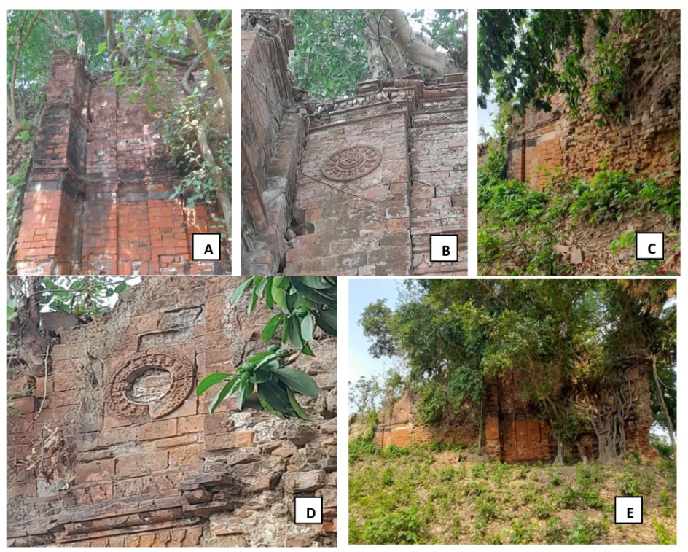
Fig. 1: Pictures of Lal Masjid from different sides representing A-E..
The then port city Chandraketugarh, 2500 years ago, was situated on the banks of the river Bidyadhari, which made economically connected the Gangaridaiwith the other parts of the different countries. Megasthenes mentioned Sandrocottus in his classical script Indica (302-298 BCE), the name has recently deciphered to be king Chandraketu of Chandraketugarh (Chakraborty, 2000).
Near the Berachampa and Haroa Road railhead, Chandraketugarh is situated next to the Bidyadhari River in North 24 Parganas, approximately 35 km northeast of Kolkata. Chandraketugarh was unintentionally found while building nearby highways (Das et al., 2019). The artefacts that unearthed drew the attention of a local doctor named Tarak Nath Ghosh in 1905, who corresponded with the British art historian and archaeologist Albert Henry Longhurst (1876 – 1955). It is reported that when renowned archaeologist Dr. Rakhaldas Banerji personally visited the site in 1909, he was astounded by the extraordinary quantity and variety of items he saw there. Ten years later, a report was released by Rao Bahadur Kashinath Narayan Dikshit (1889 – 1946) , the Archaeological Survey of India's the then-superintendent of the eastern circle (Das, et al., 2019). The historians and archaeologists of Ashutosh Museum of Art at Calcutta University took the initiative to begin excavations there in 1955. A vast post-Gupta temple complex was discovered at Khana MihirerDhipi, a five-meter-tall mound at Berachampa's northeast corner, as a result of extensive excavation work conducted there between 1955 and 1967. The results demonstrated the presence of a thriving prehistoric society that lasted six periods, from pre-Maurya to the Pala dynasty (Chattopadhyay et al., 2017).The Archaeological Survey of India, the West Bengal Heritage Commission, and the State's department of archaeology all reopened excavation in the year 2000. The area was designated as a heritage zone by the state government, and Chandraketugarh's 2,500-year history is protected by the Heritage Commission's efforts to get the city certified by UNESCO (Chattopadhyayet al., 2017).
Relics of Northern Black Polished Ware (NBPW), subsequent wares from roughly 400 BC to 100 BC, approximately contemporaneous with the Mauryan period, and more recent Kushanas and Gupta periods were found. Buddhist stupas and figures, Pala era artistic designs, Gupta and Kushana period coins, various types of beads, terracotta seals, bricks, and plaques with scenes from Jataka tales, as well as figurines from the Sunga, Maurya, Kushana, and Gupta periods are among the other discoveries. In order to conserve these unique antique artifacts, the state government has completed plans to establish a museum at Berachampa (Chowdhury, 1999). An unfinished mosque constructed at Haroa by Pir Gorachand and his adherents. According to historians, the mosque was constructed 1300 years ago on the site of a Buddhist Stupa. There is also a Pir Gorachand "dargah" close to the Haroa bus stop. Additionally, one can go to the Bidyadhari Bridge and Lal Masjid for a beautiful view of the river.
In the present study we have collected swab sample from the walls and crevices of Lal Masjid and wanted to study the predominant microorganism present over there.
2. MATERIALS AND METHODS
2.1 Collection of Samples:
The microbial remnants from the walls and crevices of the Lal Masjid were collected using sterile cotton swab sticks wearing sterile latex gloves on 6th May 2024 in between 2-4 P.M. The swab sticks were rotated clockwise and anti-clockwise about 10 times within the crevices and stroked over the wall surfaces uni-directionally to collect the microbial populations. Ten samples were collected from different surfaces. After collection all the samples were transported in sterile containers to prevent any contaminations. After collection they were directly inoculated in different media within 4 hours. We did not use any transport medium due to the risk of contamination during opening of the media vials in windy atmosphere.
2.2 Culturing of Micro-organisms:
The swab sticks were cultured on Columbia sheep blood agar and nutrient agar. After inoculation the plates were kept at 25ºC for 72 hours. Thereafter, the plates were observed and pictures were taken.

2.3 Gram Staining of Micro-organisms:
After the swab samples were collected, possible presence of microorganisms was detected. To do this gram staining was done to those that showed distinct colonies. The protocol was followed for staining step wise, including smear preparation followed by heat fixation. Then crystal violet, iodine solution, decolourizer and safranin were added accordingly. Once the stains dried up it was observed under the microscope at 1000x magnification. This allowed us to suspect the rhizoid colony observed was of a bacterium is Bacillus mycoides.
2.4 16SrRNA gene Sequencing
DNA was isolated from the culture of the bacteria using HiPura bacterial genomic DNA purification kit (MB505-50PR HiMedia Pvt. Ltd.). The quality of the DNA was estimated by 1% agarose gel where a single band of the high molecular weight DNA has been observed. The fragment of the 16SrRNA was amplified using 16SrRNA-F and 16SrRNA-R primers given below.
Forward Seq data
CCCCTTACGATGAGTGCTAGTGTTAGAGGGTTTCCGCCCTTTAGTGCTGAAGTTAACGCATTAAGCACTCCGCCTGG GGAGTACGGCCGCAAGGCTGAAACTCAAAGGAATTGACGGGGGCCCGCACAAGCGGTGGAGCATGTGGTTTAATT CGAAGCAACGCGAAGAACCTTACCAGGTCTTGACATCCTCTGACAACCCTAGAGATAGGGCTTCTCCTTCGGGAGCA GAGTGACAGGTGGTGCATGGTTGTCGTCAGCTCGTGTCGTGAGATGTTGGGTTAAGTCCCGCAACGAGCGCAACCC TTGATCTTAGTTGCCATCATTAAGTTGGGCACTCTAAGGTGACTGCCGGTGACAAACCGGAGGAAGGTGGGGATGA CGTCAAATCATCATGCCCCTTATGACCTGGGCTACACACGTGCTACAATGGACGGTACAAAGAGCTGCAAGACCGC GAGGTGGAGCTAATCTCATAAAACCGTTCTCAGTTCGGATTGTAGGCTGCAACTCGCCTACATGAAGCTGGAATCGC TAGTAATCGCGGATCAGCATGCCGCGGTGAATACGTTCCCGGGCCTTGTACACACCGCCCGTCACACCACGAGAGTT TGTAACACCCGAAGTCGGTGGGGTAACCTTTTGGAGCCAGCCGCCTAAGGTGGGACAGATGATTGGGGTGAAGTC GTACAAGGGTAACCGAAATGGCAA
Reverse Seq Data
TAGGACGTACTCGCCAGGCGGAGTGCTTAATGCGTTAACTTCAGCACTAAAGGGCGGAAACCCTCTAACACTTAGC ACTCATCGTTTACGGCGTGGACTACCAGGGTATCTAATCCTGTTTGCTCCCCACGCTTTCGCGCCTCAGTGTCAGTTA CAGACCAGAAAGTCGCCTTCGCCACTGGTGTTCCTCCATATCTCTACGCATTTCACCGCTACACATGGAATTCCACTTT CCTCTTCTGCACTCAAGTCTCCCAGTTTCCAATGACCCTCCACGGTTGAGCCGTGGGCTTTCACATCAGACTTAAGAA ACCACCTGCGCGCGCTTTACGCCCAATAATTCCGGATAACGCTTGCCACCTACGTATTACCGCGGCTGCTGGCACGT AGTTAGCCGTGGCTTTCTGGTTAGGTACCGTCAAGGTGCCAGCTTATTCAACTAGCACTTGTTCTTCCCTAACAACAG AGTTTTACGACCCGAAAGCCTTCATCACTCACGCGGCGTTGCTCCGTCAGACTTTCGTCCATTGCGGAAGATTCCCTA CTGCTGCCTCCCGTAGGAGTCTGGGCCGTGTCTCAGTCCCAGTGTGGCCGATCACCCTCTCAGGTCGGCTACGCATC GTTGCCTTGGTGAGCCGTTACCTCACCAACTAGCTAATGCGACGCGGGTCCATCCATAAGTGACAGCCGAAGCCGCC TTTCAATTTCGCACCATGCGGTGCAAAATGTTATCCGGTATTAGCGCCGGTTTCCCGGAGTTATCCCAGTCTTATGGG CAGGTTACCCACGTGTTACTCACCCGTCCGCCGCTAACTTCATAAGAGCAAGCTCTTAATCCATTCGCTCGACTTGCA TGTATTAGGCACGCCGCCAGCGTTCATCCTGAGCAGAGAAAAAAATTAAAAAACCTCT
A discrete single band of amplicon of size 1500 bp was observed on agarose gel. This PCR band was purified from the gel to remove any contaminants. The forward and reverse DNA sequencing of the amplicon was done using using 16SrRNA-F and 16SrRNA-R primers by BDT v3.1 Cycle sequencing kit ( detailed program is given in the kit manusal) on ABI 3730xl Genetic Analyzer. The 16SrRNA gene sequence was determined by forward and reverse sequence data using aligner software. BLAST was carried out using ‘nr’ database of NCBI GenBank database of the 16S rRNA gene sequence. Determining the maximum identity score the first 10 sequences were chosen and it was aligned using themultiple aligning software Clustal W. The distant matrix and the phylogenetic tree was constructed using MEGA 10 software.

3. RESULTS
Cultural examination of the samples revealed growth of a bacterium with peculiar rhizoid colonies (Fig.2 A), in 100x magnification the colonies showed curved filamentous like growths (Fig. 2 C). After Gram’s staining they were Gram variable bacilli with occasional spores (Fig.2 B). Following 16srRNA sequencing ( Table 1, Fig. 3) the bacterium was identified as Bacillus mycoides which is well known to have strong antifungal activities.
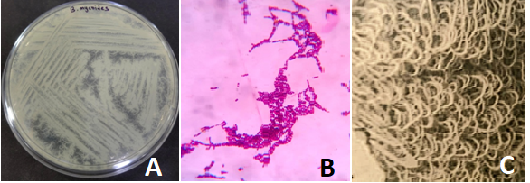
Fig.2: Rhizoid colonies of Bacillus mycoides (A), Gram’s stain showing Gram variable bacilli with occasional spores (B), rhizoid colony structure under magnification (100x) (C).
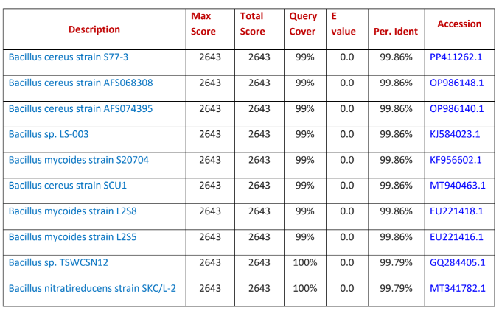
Table 1: Sequences producing significant alignments with the isolate.
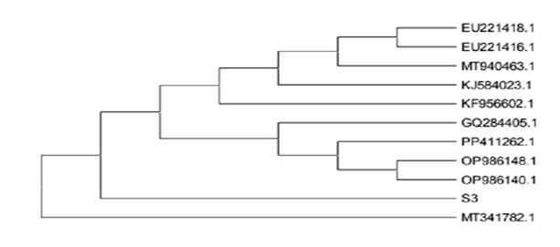
Fig 3: The strain has 99.86% homology with the bacteria Bacillus mycoides strain S77.3. The evolutionary history was referred by using the maximum likelihood method and Tamura-Nei model. The tree with the highest log likelihood (-2027.10) is shown. Initial tree(s) for the heuristic search were obtained automatically by applying Neighbor-Join and BioNJ algorithms to a matrix of pairwise distances estimated using the Tamura-Nei model, and then selecting the topology with superior log likelihood value. This analysis involved 11 nucleotide sequences. Codon positions included were 1st+2nd+3rd+Noncoding. There were a total of 1441 positions in the final dataset. Evolutionary analyses were conducted in MEGA11.
4. DISCUSSION
The absence of fungus around the artifacts in the ruins of Chandraketugarh made us curious about its reason. It was evident that despite the place being abandoned with moderate sunlight and moist surroundings, which are deemed ideal for the growth of fungus, there were none. This led us to dig deep into the reason and find out the agent that was acting as an effective antifungal. With gene isolation and sequencing of the samples collected from the ruins, we finally came across the presence of a microbe that has major antifungal activity. This was identified to be Bacillus mycoides from the family of B. cereus and an effective antifungal agent. It was due to the presence of this bacterium there may be no fungus was able to grow on the artifacts from the ruins.
Bacillus mycoides is phenotypically very much similar to Bacillus cereus. It is distinct due to its rhizoidal colonies and the bacterium is non-motile. The bacterium is facultatively anaerobic with maximum temperature for growth around 35 to 40ºC and the minimum temperature for growth is 10 - 15ºC. The colony characteristics is white to creamy colour and opaque rhizoidal colony (Fig1 A and C) (Andriani, et al., 2017).
Bacillus mycoides showed positive biochemical results for enzyme catalase, hydrolyses starch, casein, esculin, gelatin, can reduce nitrate to nitrite, positive result for Voges-Proskauer test, egg yolk reactivity, forms alkali in litmus milk test, produces acid from glucose, N-acetyl-D-glucosamine, glycerol, starch, trehalose and glycogen, arabinose, adonitol, D or L arabitol, dulcitol, erythritol, D or L fucose, beta gentibiose, meso-inositol, gluconate, inulin -2 or 5 keto gluconate, xylose, lactose, maltose, mannitol, D-mannose, alpha-metyl D manoside, melibiose, raffinose, rhamnose, sorbitol, xylose, xylitol, methyl-beta xyloside. The bacterium showed negative result for oxidase, produces gas from carbohydrates, causes deamination of phenylalanine (Di Franco, et al., 2002).
When studied about the plant growth promoting activities of the bacterium, isolated from the bamboo rhizosphere, Bacillus mycoides strain A3 (BmA3) demonstrated phosphate solubilisation and radical scavenging capabilities in addition to producing phytohormones such as gibberellic acid (GA) and indole-3-acetic acid (IAA) (Kurniawan et al., 2022; Turchi et al., 2012). BmA3-inoculated A. thaliana seedlings showed changed root architecture, including more lateral roots and root hairs. Likewise, the BmA3-treated seedlings showed increased plant size and fresh weight, as well as improved photosynthetic efficiency due to the deposition of larger quantities of starch and chlorophyll. By boosting the activities of catalase (CAT), guaiacol peroxidase (GPX), ascorbate peroxidase (APX), and phenylalanine ammonia-lyase (PAL), this bacterial inoculation activated the antioxidant defence system. Higher quantities of secondary metabolites, such as flavonoids, phenolic compounds, and glucosinolates, were produced in the plants treated with BmA3. An efficient and sustainable substitute for chemical pesticides is the biological management of soil-borne plant diseases through the use of beneficial bacteria and their active metabolites (Yi2018; Nakamura et al., 1995). Bacterial strains from the genus Bacillus, including Bacillus subtilis, Bacillus velezensis, and Bacillus amyloliquefaciens, are among these helpful microorganisms that have been widely used for their capacity to treat soil-borne fungal illnesses (Khan et al., 2022, Blake et al., 2021,Hashem et al., 2019). Additionally, it has been found that Bacillus mycoidesand B. amyloliquefaciens release volatile organic compounds (VOCs) that prevent the spore germination and mycelial growth of F. oxysporum and S. sclerotiorum (Mazzola, et al.,2017, Bonaterra, et al., 2022; Wu, 2020, Massawe, et al., 2018). Bacillus species produce these extracellular lipopeptides and volatile organic compounds (VOCs), which have the potential to be used as biopesticides to control soil-borne crop illnesses (Yuan et al., 2012; Everts et al., 2015).
Different bacterial and fungal strains were isolated from the archeological sites time to time. In the age of high-throughput sequencing, microbial archaeology is thriving and uncovering the agents responsible for catastrophic past plagues, therefore, reconstructing the ancestral human microbiota, and figuring out the mysterious spreads of infections in prehistoric times. A study shown that soil samples were collected from pottery in the vicinity of Lecce, Italy, and Lubaantun, Belize. The soil from each site was well mixed, dissolved in phosphate buffer, and then examined according to normal procedures for microscopy and culture. At 22°C and 35°C, cultures of aerobic and anaerobic bacteria, fungi, actinomycetes, and acid-fast bacilli were studied. Gram, methylene blue, calcofluor white, trichrome, Ziehl-Neelsen, modified acid-fast, Grocott-Gomori methenamine-silver, and iodine stains were performed. Gram-positive bacilli were the only microorganisms visible in the Lecce soil (Southern, 2008). Numerous Bacillus species were found. Aspergillus niger, A. versicolour, Clostridium bifermentans, C. butyricum, Mycobacterium avium, Aeromonas caviae complex, and a number of unknown fungi were found. Rare gram-positive bacilli were observed under a microscope in Lubaantun soil. The following microorganisms were isolated in culture: Chaetomium sp., Penicillium sp., Chrysosporium sp., Acremonium sp., Gordonia sp., Streptomyces sp., Bacillus cereus group, Pantoeaagglomerans, Aspergillus flavus, and Clostridium bifermentans. The flora from the Lubaantun site was more complex, despite the fact that the microbial flora of the soil from these two archaeological sites produced results in cultures and microscopy were essentially comparable (Southern, 2008). In another study we observed that one of the common issues in archaeological site museums is microbial decay, which has a major impact on displays and safety. The Dadiwan No. 901 site museum, a representative archaeological site of prehistoric Yangshao culture, was the subject of a systematic investigation and surroundings of microbial outbreaks in this research (Xu, et al., 2024). Using microscopic methods, the overall bacterial morphology and detrimental traits were examined. UV exposure effect on microorganisms was also studied (Xu, et al., 2024). The interior of the Dadiwan F901 site museum was systematically examined in this investigation. The field examination revealed that the microbial colonies on the Dadiwan F901 site's wall surfaces were apparent to the unaided eye and showed white filaments under microscopic observation, some of which were combined with white or dirt dust particles (Xu, et al., 2024). By comparing the microbiological conditions on the site's surfaces before and after protective measures were put in place, the extracted data aid in the cultural protection. Consequently, this suggests that bacteria have contaminated the entire site museum, including the glass curtain wall and the cement building wall. The development of a large number of microorganisms on cement wall surfaces was most likely brought on by the nutrients that came from oil ingredients on the concrete pouring moulds. Microbial plaques were mostly found in areas where fingerprints were visible on the glass curtain wall. It was hypothesized that field workers unintentionally left lipids and perspiration on the glass, which served as nourishment for microbes. As a result, foreign substances particularly organic ones may offer nutrients for the growth of microorganisms (Xu, et al., 2024). In another study on the preservation of Liangzhu City's archaeological ruins, analysing the microflora that colonizes these earth artefacts is crucial for the continued preservation of these cultural relics (Sun, et al., 2020). This was accomplished by obtaining samples with microbial features and analysing them using metagenomic sequencing and SEM to determine the composition of the microflora. The researchers made two types of media to separate microorganisms from the soil samples taken from the Archaeological Ruins of Liangzhu City: potato dextrose agar (PDA) medium and malt extract agar (MEA) medium treated with 50 mg/mL chloramphenicol to prevent bacterial growth (Sun, et al., 2020). The susceptibility test was conducted using the potato dextrose agar (PDA) medium. Degradation testing of protective materials was conducted using potato dextrose (PD) medium supplementation. The adhesive tape samples' optical microscope studies showed the presence of both fungal and algal structures. Numerous algae cells and analogues of fungal hyphae are visible in the scanning electron microscope image taken from the south wall. Fungal spores and various analogues of fungal hyphae are visible in images. Several algal cell analogues are visible in the photos (Sun, et al., 2020). The researchers tried to extract the dominant fungi in order to examine their properties after the high-throughput sequencing findings showed that Lepidostroma was the most prevalent among the six samples. Some colonies grew after six days of incubation on potato dextrose agar (PDA) plates at 28°C. From the samples, 19 types of colonies were isolated. Next, they sequenced the 19 colonies by ITS1–5.8S rRNA-ITS2 gene areas. Lepidostroma, which displayed the highest content, was not successfully cultured. Penicillium oxalicum, Aspergillus aculeatus, Fusarium oxysporum, and Aspergillus nomius were separated by pure culturing, and the results were in line with the high-throughput results (Sun, et al., 2020).
Newer technical developments also bring new difficulties. Sorting, assessing, validating, and interpreting the hundreds of millions of DNA sequences that are now routinely produced by both genomics and paleogenomics labs requires specific tools and methods (Warinner, et al., 2017). Although there are many different protocols, scripts, pipelines, and computational environments, as well as a large number of genetic and genomic databases, the quick development of these tools has left many people unsure of which ones to use and when. For instance, microbial community reconstruction may be significantly impacted by the choice between alignment-based and alignment-free taxonomic classifiers (Warinner, et al., 2017). Archaeological sample analysis is essential to the recording, significance, and multidisciplinary understanding of archaeological remains. However, conducting a comprehensive and scientifically informed study becomes extremely challenging due to the lack of integration between the two fields, namely microbiology and archaeology. Numerous samples discovered at different archaeological sites, such as mummies, bones, organic archaeological remains, grave goods, etc., have led to a new approach in analysis that has fundamentally altered how knowledge and hypotheses are developed (Garg, et al., 2017). There are sufficient records of these observations derived from the examination of samples taken from excavations as well as other artefacts and archaeological remains from around the globe. In order to take a more thorough and scientific approach, we should now focus on doing microbiological analyses on these uncommon archaeological samples and attempting to justify the necessity of such integration (Garg, et al., 2017).

5. CONCLUSION
The predominant microorganism is Bacillus mycoides Strain S77.3 which may be responsible for the absence of fungal invasion of the artifacts in the ruins.
Disclaimer (Artificial intelligence)
Author(s) herebydeclare thatNO generative AI technologies suchas LargeLanguage Models (ChatGPT, COPILOT, etc) and text-to-image generators havebeen usedduring writing or editing of this manuscript.

COMPETING INTERESTS DISCLAIMER:
Authors have declared that they have no known competing financial interests OR non-financial interests OR personal relationships that could have appeared to influence the work reported in this paper.

REFERENCES
Andriani, Y., Rochima, E., Safitri, R., Rahayuningsih, S. R. (2017). Characterization of Bacillus megaterium and Bacillus mycoides bacteria as probiotic bacteria in fish and shrimp feed. KnE Life Sciences, 127-135.
Di Franco, C., Beccari, E., Santini, T., Pisaneschi, G., Tecce, G. (2002). Colony shape as a genetic trait in the pattern-forming Bacillus mycoides. BMC microbiology, 2, 1-15.
Kurniawan, A., Chuang, H. W. (2022). Rhizobacterial Bacillus mycoides functions in stimulating the antioxidant defence system and multiple phytohormone signalling pathways to regulate plant growth and stress tolerance. Journal of applied microbiology, 132(2), 1260–1274. https://doi.org/10.1111/jam.15252
Turchi, L., Santini, T., Beccari, E., Di Franco, C. (2012). Localization of new peptidoglycan at poles in Bacillus mycoides, a member of the Bacillus cereus group. Archives of microbiology, 194, 887-892.
Yi, Y. (2018). Bacillus mycoides: novel tools for studying the mechanisms of its interaction with plants.
Nakamura, L. K., Jackson, M. A. (1995). Clarification of the taxonomy of Bacillus mycoides. International Journal of Systematic and Evolutionary Microbiology, 45(1), 46-49.
Chakraborty, S. (2000). Chandraketugarh--a cultural and archaeological study (500 BC to 500 AD). Bulletin of the Deccan College Research Institute, 60, 483-488.
Das, S., Srivastava, T. (2019). The Heritage of Chandraketugarh: A Report.
Chattopadhyay, S., Roy Chowdhury, A. (2017). Southern Bengal Delta—A Hub of ancient civilization and cultural assimilation: A case study of Chandraketugarh and allied sites. Heritage: Journal of Multidisciplinary Studies in Archaeology, 5, 283-299.
Chowdhury, S. R. (1999). A group of unique plaques from Chandraketugarh. East and West, 49(1/4), 293-296.
Khan, A. R., Mustafa, A., Hyder, S., Valipour, M., Rizvi, Z. F., Gondal, A. S., ... Daraz, U. (2022). Bacillus spp. as bioagents: uses and application for sustainable agriculture. Biology, 11(12), 1763.
Blake, C., Christensen, M. N., Kovács, Á. T. (2021). Molecular aspects of plant growth promotion and protection by Bacillus subtilis. Molecular Plant-Microbe Interactions, 34(1), 15-25.
Hashem, A., Tabassum, B., Abd_Allah, E. F. (2019). Bacillus subtilis: A plant-growth promoting rhizobacterium that also impacts biotic stress. Saudi journal of biological sciences, 26(6), 1291-1297.
Luo, L., Zhao, C., Wang, E., Raza, A., Yin, C. (2022). Bacillus amyloliquefaciens as an excellent agent for biofertilizer and biocontrol in agriculture: An overview for its mechanisms. Microbiological research, 259, 127016.
Mazzola, M., & Freilich, S. (2017). Prospects for biological soilborne disease control: application of indigenous versus synthetic microbiomes. Phytopathology, 107(3), 256-263.
Bonaterra, A., Badosa, E., Daranas, N., Francés, J., Roselló, G., & Montesinos, E. (2022). Bacteria as biological control agents of plant diseases. Microorganisms, 10(9), 1759.
Wu, J. J., Huang, J. W., Deng, W. L. (2020). Phenylacetic acid and methylphenyl acetate from the biocontrol bacterium Bacillus mycoides BM02 suppress spore germination in Fusarium oxysporum f. sp. lycopersici. Frontiers in microbiology, 11, 569263.
Massawe, V. C., Hanif, A., Farzand, A., Mburu, D. K., Ochola, S. O., Wu, L., ... & Gao, X. (2018). Volatile compounds of endophytic Bacillus spp. have biocontrol activity against Sclerotinia sclerotiorum. Phytopathology, 108(12), 1373-1385.
Yuan, J., Raza, W., Shen, Q., Huang, Q. (2012). Antifungal activity of Bacillus amyloliquefaciens NJN-6 volatile compounds against Fusarium oxysporum f. sp. cubense. Applied and environmental microbiology, 78(16), 5942-5944.
Everts, K. L., & Himmelstein, J. C. (2015). Fusarium wilt of watermelon: Towards sustainable management of a re-emerging plant disease. Crop Protection, 73, 93-99.
Southern Jr, P. M. (2008). Archeology meets clinical microbiology: analysis of the microbial content of soil from archeological sites in Italy and Belize. Laboratory Medicine, 39(10), 601-602.
Xu, R., Chen, Y., He, D., Zhang, G., Luo, Q., Zhan, H., Wu, F. (2024). Preliminary Study on Microbial Deterioration Control and Effectiveness Evaluation in the Neolithic Prehistoric Archaeological Site of Dadiwan, Northwest China. Coatings, 14(1), 100.
Sun, M., Zhang, F., Huang, X., Han, Y., Jiang, N., Cui, B., ... Pan, J. (2020). Analysis of microbial community in the archaeological ruins of Liangzhu city and study on protective materials. Frontiers in Microbiology, 11, 684.
Warinner, C., Herbig, A., Mann, A., Fellows Yates, J. A., Weiß, C. L., Burbano, H. A., ... Krause, J. (2017). A robust framework for microbial archaeology. Annual review of genomics and human genetics, 18(1), 321-356.
Garg, P., and Shukla, P. (2017). Archaeology vis-à-vis Microbiology: Discovering the Vistas of Interdisciplinary Research. In Frontier Discoveries and Innovations in Interdisciplinary Microbiology (pp. 213-219). New Delhi: Springer India.

