**Endosymbionts in Insects: Functional Roles and Applications in Pest Management.**

**Abstract:**

The mutualistic relationship in which one organism resides inside another is known as endosymbiosis. Insects with a wide range of abundance and relative diversity have endosymbionts in many body regions, especially in the digestive tract. Insect Nutrition, nitrogen recycling, secondary metabolite detoxification, amino acid supply, and plant phenotypic alteration are all greatly aided by these endosymbionts. They also have positive impact on pest management as they manipulate pest’s reproduction. The study of endosymbionts has major challenges as the symbiotic relationships are complicated and the host interactions are unclear, necessitating the development of new advanced techniques and interdisciplinary methodologies. Additionally, this provides crucial information for sustainable agriculture and efficient pest control methods. The importance of endosymbionts in insect biology, as well as their roles, approaches to managing pests, difficulties, and future prospects, are the main insights of this paper.

**Keywords:** *endosymbionts, ecological impact, insect-microbe interactions, insect-plant interactions, insect nutrition, insect adaptations, nutrient provisioning pest management, symbiotic relationships and sustainable agriculture*

**Introduction:**

In 1879, Anton De Bary coined the term *‘Symbiosis’* is derived from the Greek word ‘SIMBIOS’ meaning to live together. As per De Bary, Symbiosis is referred as the permanent coexistence of two or more different organisms at least during a part of their complete lifecycle [**Gil et al. 2004, Koch,1967**]. *Endosymbiotic theory* clarifies the fact that the formation of complex cellular organelles from the ancestral eukaryotic cells. As per the theory it assumes that the organelles such as mitochondria and chloroplasts were free living bacteria which were swallowed eventually by the eukaryotic cells. It also indicates that over due course of time these engulfed bacteria developed mutualistic benefitting relationship with the host as a result of which these cell organelles were formed [**Martin et al. 2015**]. In contrast, certain studies indicate that these symbiotic bacteria reside in the surface of host or specialised tissues establishing localised interactions [**Paracer and Ahmadjian, 2000 ; Danu et al. 2023 ; Karki et al. 2023**]. De-bary referred Parasitism as a special type of symbiosis and the balance between the symbiosis and the parasitic relationship depends upon the environment and its relative conditions [**Kikuchi, 2009**]. The key factor for insect abundance and highly successful lifestyle is related to its diets and nutrition. Endosymbionts are located in various regions such as midgut, reproductive organs, haemolymphs and bacteriocytes [**Marubayashi et al. 2014**]. Nutrient recycling is the process by which organisms such as bacteria or fungi preserve waste products (mostly nitrogenous) from the diets or metabolism and convert it to insect accessible form. Nitrogen fixation by bacteria produces nitrogen which can be used by the insects. In Amino acid provisioning, these symbionts synthesise essential amino acids and their respective precursors addressing amino acid balance. Some intracellular symbionts of hemipterans play a major important role in amino acid biosynthesis without explicating nitrogen fixation or recycling [**Hansen et al. 2020**]. Microbial symbionts protect the insect from toxins by detoxifying them. In Aphids the bacteria *Hamiltonella defensa* a facultative endosymbiont offers defense against parasitoids [**Bosch and Welte, 2017, Lukasik et al. 2013**]. Endosymbionts also have a wide implication in pest management strategies such as reproductive manipulation, nutrient mutualism, sterility induction, RNAi and population monitoring [**Rupawate et al. 2023**]. Despite of these considerations, there are still several obstacles to the use of endosymbionts, such as host specificity, ecological effect, ethical issues, regulatory frameworks, resistance management, and technical developments. When using endosymbionts as a pest management strategy, these factors should be properly taken into account. The significance of endosymbionts, their kinds, and their roles in feeding, pesticide detoxication, pest management techniques, difficulties, and future approaches are the primary topics of this paper.

**Figure 1: Symbionts and its further classification**

|  |  |  |
| --- | --- | --- |
| **Type of Relationship** | **Effect on Host** | **Effect on Symbionts** |
| **Parasitism** A relationship in which one organism (the parasite) gains an advantage over the other (the host), without killing the host outright | ***Negative*** | ***Positive*** |
| **Mutualism** A relationship in which the interaction is advantageous to both species. | ***Positive*** | ***Positive*** |
| **Commensalism** A relationship in which one organism gains while the other is neither aided nor hindered. | ***None*** | ***Positive*** |
| **Amensalism**  A relationship in which in which one organism suffers while the other remains unscathed. | ***Negative*** | ***None*** |
| **Synnecrosis**  An uncommon interaction in which both organisms suffer injury. | ***Negative*** | ***Negative*** |
| **Neutralism** A relationship in which neither creature influences the other. | ***None*** | ***None*** |

**Table 1**: Depicting the influence of symbiotic relationships between endosymbionts and their insect hosts.

1. **Types of Insect Endosymbionts**
   1. **Primary, secondary (Facultative), mutualistic and Parasitic endosymbionts**

**Primary endosymbionts** have obligatory associations with their hosts for extensive periods. They reside within the bacteriocytes exhibiting exact co-evolutionary patterns with their hosts, being essential to the host's fitness, and maternal transmission [**Bordenstein and Wernegreen, 2004**]. Aphid- *Buchnera*, *Wigglesworthia* in tsetse flies, *Baumannia* in sharpshooters, *Carsonella* in psyllids, *Tremblaya* in mealybugs, *Blochmannia* in carpenter ants, and *Nardonella* in weevils are the main symbionts that cannot be cultivated outside of their host environments.

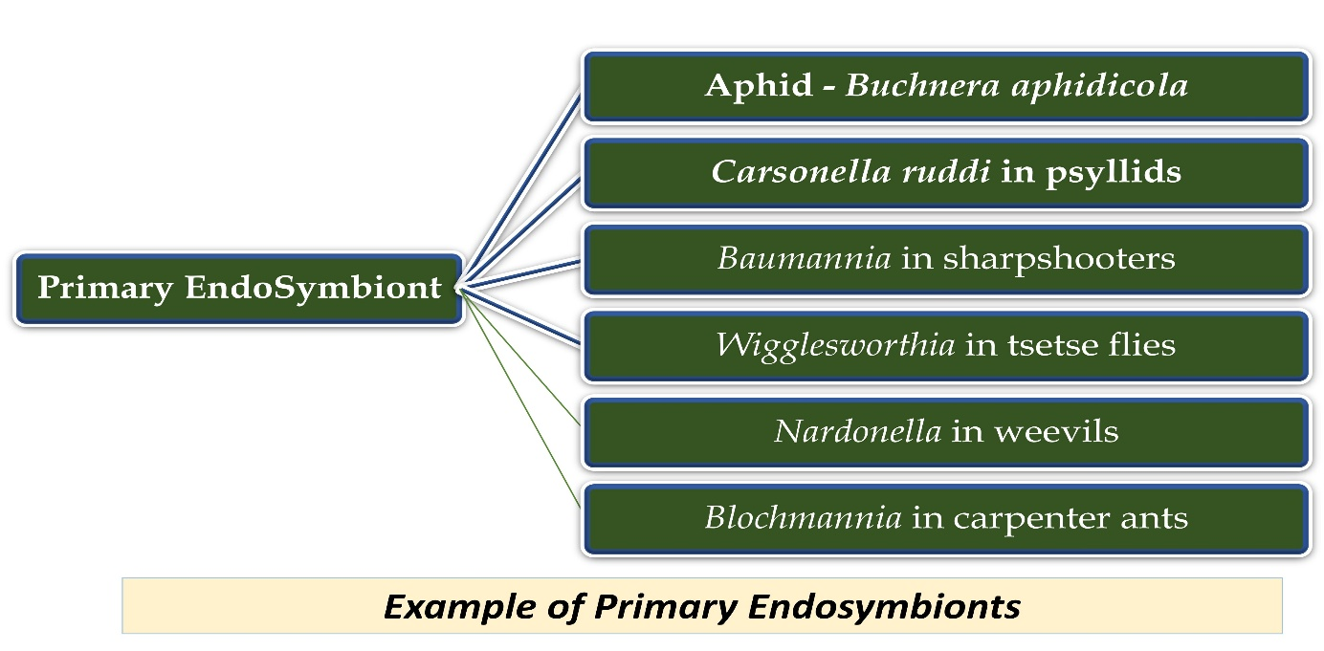

**Figure 2 : Example of Primary Endosymbionts** [**Bordenstein and Wernegreen, 2004**].

**Secondary symbionts,** on the contrary hand, recently evolved and establish facultative connections. They can circulate horizontally from one host to another, reside within the gut or haemolymph (in contrast to specializing bacteriocytes), and are essential for defensive mechanisms, stress tolerance, reproduction, and protection [**Bordenstein and Wernegreen, 2004**].

In contrast to primary symbionts, secondary endosymbiont cultures, such as those of *Wolbachia*, *Spiroplasma, Hamiltonella defensa* and *Sodalis glossinidius* are easily accessible [**Feldhaar and Gross, 2009**]. In insects, Secondary endosymbionts are commonly found in addition to Primary bacteriocyte endosymbionts. These endosymbionts are linked to bacteriocytes and might be extracellular or intracellular [**Baumann, 2005**]. Unlike primary endosymbionts, these bacteria may penetrate host tissues on their own and frequently grow outside of their host environment. *Sodalis glossinidius* is a well-researched secondary symbiont that is vertically transported and coexists with *Wigglesworthia* in tsetse flies. Improvements in the lifetime of tsetse flies have indicated that this *bacterium* has a positive impact on host biology when eliminated selectively [**Baumann, 2005**].

**Figure 3: Example of Secondary Endosymbionts** [**Bordenstein and Wernegreen, 2004**].

Insect hosts and endosymbionts have mutualistic interactions, which are defined by benefits for both sides. In insects, *Wolbachia* is a prominent endosymbiont that frequently displays mutualistic connections. The host may benefit from it in ways like improved ability to reproduce or defense against certain infections. The parasite gains an advantage over the other the host in parasitic symbiosis harming the host in the process. Insect hosts can develop parasitic associations with *Spiroplasma* bacteria. They might interfere with the host's ability to reproduce or result in abnormalities that would reduce the host's fitness.

1. **Functional Role of Endosymbionts** 
   1. **Nutrient Recycling**

In termites and shield bugs, nutrient recycling is facilitated by the symbiotic microbes from stored uric acid. Uric acid fermentation and further transportation from fat bodies into acetate, ammonia and CO2 is seen in the bacteria found in the hindgut of *Reticulitermes flavipes* [**Potrikus and Breznak, 1980**]. In cockroaches, *Blattabacterium* sp is found in the uric acid deposits is said to have active role in nitrogen recycling [**Sabree et al. 2009**]. Many arboreal ants feed on nitrogen poor diets [**Moreau and Bell, 2013**] which symbolize that these herbivorous ants require symbiotic bacteria for their nutrition [**Mcgovern and Hellberg, 2003**] but the carpenter ants having *Blochmannia* as its symbionts exemplify this statement [**Degnan et al. 2004 ; Sauer et al. 2000 ; Werenegreen et al. 2009**]. During the genomic study of *Blochmannia* it was seen that it has the ability to synthesis the essential amino acids and aids in conversion of urea to ammonia. In some strains of *Blochmannia*, glutamine synthetase loss is seen and this loss marks the inability to assimilate ammonia from the urea catabolism [**Hammer and Moran, 2019**] Another important source of nitrogen that helps compensate for dietary nitrogen deficits is the consumption of fungal tissue by beetles, which harbor fungal mutualists. *Erwinia dacicola*, a common symbiont in olive fruit flies, is essential to nitrogen recycling because it enables the hosts to use nitrogen from waste in their diet [**Hammer and Moran, 2019; Estes et al. 2009**].

* 1. **Amino Acid Production**

**Table 2 : Insect–microbe symbiotic systems and amino acid production**

|  |  |  |
| --- | --- | --- |
| **Sl No.** | **Organisms** | **Features** |
|  | Aphids and *Buchnera* | Bacteria collaborate to synthesize essential amino acids within specialized cells called bacteriocytes. In particular, *Buchnera* depends on the aphid for amino acid routes that are not essential and the aphid depends on *Buchnera* for amino acid pathways that are necessary and are encoded by the bacterium. |
|  | *Serratia symbiotica* | Previously considered a facultative symbiont as Buchnera is unable to produce tryptophan, it becomes vital in *Cinara cedri*. It is essential for host life because it supplements nutrients. |
|  | *Auchenorrhyncha* | It shows how symbionts from various lineages are metabolically dependent on one another. Eight essential amino acids are provided by the obligatory symbiont *Sulcia.* By providing the final two amino acids, as well as necessary vitamins and cofactors, *Hodgkinia* enhances *Sulcia*. This *Sulcia* influences the genome of *Hodgkinia* by maintaining a cobalamin-dependent methionine synthase. *Hodgkinia's* genome shrinks as a result of this dependence. 7% of *Hodgkinia's* genome is devoted to the cobalamin production pathway [**Skidmore and Hansen, 2017**]. |
|  | *Carsonella ruddii*  (γ-proteobacteria): | Essential *psyllid* endosymbiont. encodes essential mechanisms for the production of amino acids and is essential to the nutrition of the host. |

## Impact on insect’s fitness and development

*Hamiltonella defensa* shields pea aphids against hymenopterous parasitoids and is extensively found in *Aphis pisum* populations [**Oliver et al. 2003**]. It also protects the black bean aphid, *Aphis fabae*. Additionally, there is evidence that *Hamiltonella defensa* may be able to defend the cowpea aphid, *Aphis craccivora*. *Sodalis glossinidius* is a well-studied secondary symbiont that co-resides with *Wigglesworthia* in tsetse flies and is vertically transmitted [**Richmond and Smith, 2007**]. Selective elimination of this bacteria has been shown to affect the longevity of tsetse flies, indicating that it has a favorable effect on host biology. Numerous insect hosts harbor the symbiotic bacterium *Wolbachia*, which has been shown to affect a variety of behaviors, such as aggression, feeding, mating, sleep, learning and memory, and more [**Bi and Wang, 202**0]

# Endosymbionts in plant feeding insects

**3.1 Aphids and *Buchnera* symbiosis**

Intracellular bacteria, *Buchnera* is frequently found in aphids and its symbiotic interaction is essential for both organisms. The bacteria are essential for the aphid growth and reproduction and are vertically transmitted by the ovary of the aphid. Without these microorganisms, aphids grow slowly and produce a few progeny. *Buchnera* has a crucial nutritional role even though it cannot be cultured outside of aphids as it provides essential amino acids. Role of bacteria in aphid’s lipid and sterol feeding is not well supported, despite its little contribution to nitrogen recycling [**Scarborough et al. 2005**]. *Buchnera* is believed to facilitate circulative viral transmission in aphids. This implies similarities between other insect symbioses involving internal microbes and the nutritional dynamics of the *Aphid - Buchnera* connection [**Douglas, 1998**].

**3.2 Whiteflies and *Portiera* symbiosis**

*Portiera aleyrodidarum*, the primary endosymbiont present in all whitefly species, is necessary for supplying its host with carotenoids, critical amino acids, and other vital metabolites **[Gueguen et al. 2010].** Since whiteflies are unable to synthesis these nutrients themselves or obtain them from their diet or other symbiotic partners, they are considered as important.

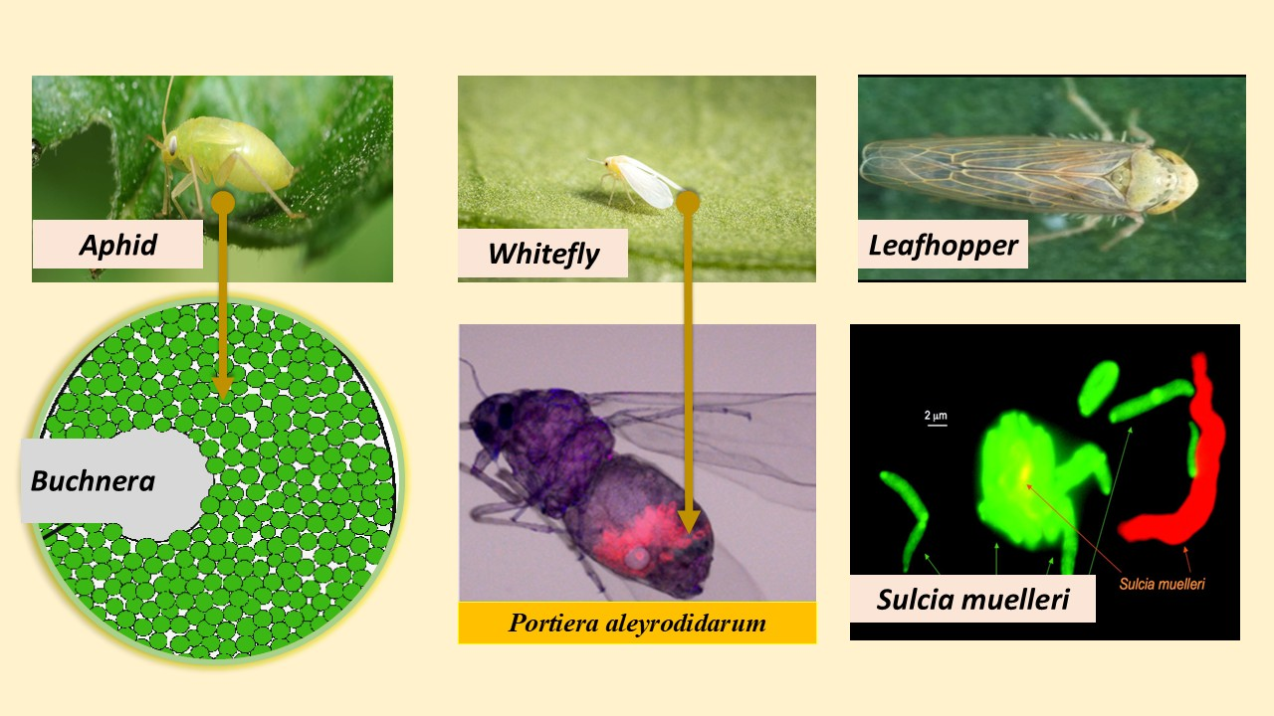

**Fig.4 Indicating the symbiotic relation of Aphid with *Buchnera aphidicola ,* Whitefly with *Portiera aleyrodidarum* and Leafhopper with *Sulcia muelleri***

**3.3 Leafhoppers and *Sulcia-Muelleri* symbiosis**

Numerous sap-feeding hemipteran insects, such as planthoppers, cicadas, spittle bugs, leafhoppers, and treehoppers, harbor the major endosymbiotic bacterium *Candidatus sulcia muelleri* also referred to as *Sulcia* [**Moran et al. 2005**]. In the insect's abdomen, these bacteria and other major endosymbionts exist in specialized cell clusters known as bacteriomes, where they exchange nutrients with the host. For these endosymbionts, vertical transmission—transmitted from parent to offspring is the main mechanism of transmission.

1. A**pplication in Pest Management**

Insect symbionts offers a potential remedy to the increasing need for innovative pest management strategies driven by the effects of global climate change and expanding human populations [**Engel and Moran,2013; Kashkouli et al. 2021**]. Four key approaches with an abundance of prospects are the addition of heterologous microorganisms, para-transgenesis, the insect incompatibility method (IIT), and the destruction of microbial symbionts that are critical to insect pests [**Berasategui et al. 2016**]. With a focus on combating disease pathogens that are spread by insect vectors, these strategies are currently being researched. This discussion will focus on significant instances and advancements in the implementation of these strategies for managing vector-borne diseases, within the broader context of the increasing demand for sustainable and efficient methods of controlling insect pests in an environmentally friendly approach.

* 1. 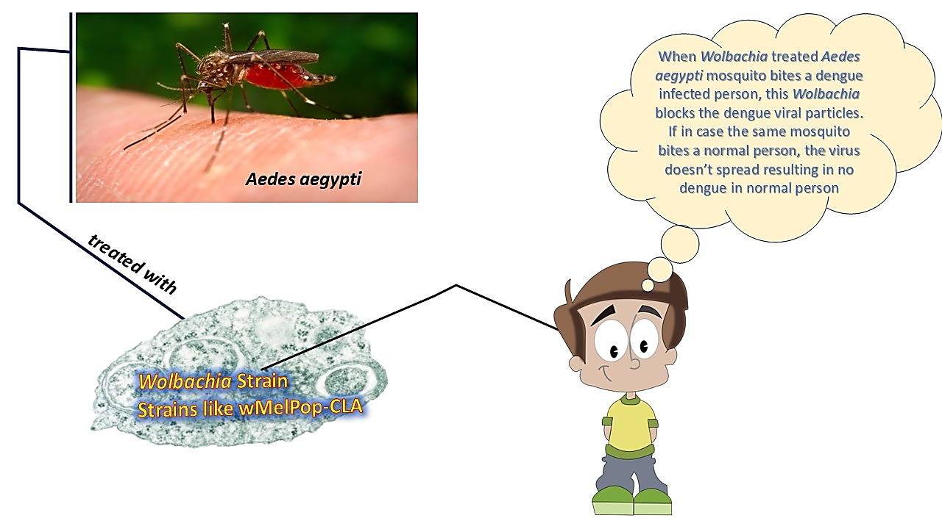 **Use of Non-Native (Heterologous) Symbionts**

**Fig.5: Dengue transmission control using *Wolbachia*-infected *Aedes aegypti* mosquitoes**

A promising approach to manage insect-borne disorders like dengue, malaria, yellow fever, and chagas is *Wolbachia* trans-infection. Transferring *Wolbachia* strains from one species to another is the goal of this method, especially into important disease vectors like *Anopheles* and *Aedes aegypti* mosquitoes, which do not normally harbor *Wolbachia* [**Osei-Poku et al. 2012**]. It has been discovered that the presence of *Wolbachia* in transinfected mosquitoes disrupts the transmission of several diseases. According to studies, *Wolbachia*, especially strains like wMelPop that diminish the lifespan of the mosquito, can drastically lower the spread of disease by eliminating older individuals, which are essential for the spread of pathogens. Furthermore, a combination of immunological and metabolic mechanisms, including ROS [*Reactive Oxygen Species*] generation and immune system priming, are responsible for *Wolbachia's* antiviral effects in heterologous relationships. The utilization of *Wolbachia* in insect pest management, specifically through the trans-infection of *Aedes aegypti* mosquitoes, has emerged as a promising strategy highlighting the potential of *Wolbachia*-based strategies in controlling vector-borne diseases by taking advantage of heterologous associations in different mosquito species [**Zug and Hammerstein, 2018; Arora and Douglas, 2017**]. The. Strains like wMelPop-CLA, which were first introduced through a meticulous two-step process that involved adaptation in mosquito cell culture and subsequent microinjection into *Aedes aegypti* embryos, have shown great promise in lowering these mosquitoes' vector competence for pathogens like dengue virus. Additionally, *Wolbachia* is used against mosquito vectors other than *Aedes aegypti*, including *Anopheles* spp., *Plasmodium* parasite transmission may be decreased by introducing *Wolbachia* into *Anopheles* mosquitoes, which are historically known to transmit malaria. Research has shown that *Wolbachia* strains such as wMelPop and wAlbB can effectively prevent *Plasmodium* spp. from developing in *Anopheles* mosquitoes, opening up a new line of treatment for malaria [**Bian et al. 2013**]. Stable vertical transmission and the generation of cytoplasmic incompatibility in natural mosquito populations are still major challenges to address for the successful implementation of *Wolbachia*-based control measures. These developments demonstrate how effective *Wolbachia* trans-infection can be in preventing mosquito-borne illnesses in both agricultural and human health scenarios. Furthermore, as demonstrated by the effective introduction of *Wolbachia* strain wStri into the brown planthopper, *Nilaparvata lugens*, current efforts have expanded the use of heterologous relationships to agricultural pest management [**Guo et al. 2023**]. In addition to induce large levels of cytoplasmic incompatibility, this intervention prevented the spread of the rice ragged stunt virus, indicating a new approach to managing significant agricultural pests and the diseases that are linked to them [**Gong et al. 2020**].

* 1. **Paratransgenesis: Engineering symbionts to disrupt pathogen transmission**

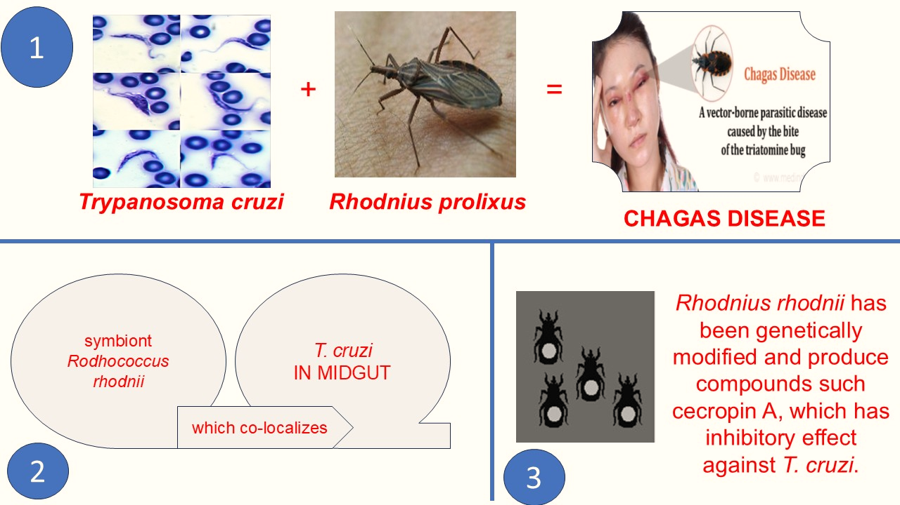

**Fig.6: Engineering symbionts to disrupt pathogen transmission**

It alters insect characteristics by genetically modifying related microorganisms has emerged as a promising approach to insect pest management, particularly with regard to agricultural pests and human disease vectors. By engineering gut bacteria to produce proteins that impede pathogen development and insect fitness, para-transgenesis addresses problems such as low transgene fitness outside of the laboratory and inefficiency in introducing transgenes into natural vector populations, in contrast to direct genetic manipulation of insects. The ability to cultivate, transform, and reintroduce microbial partners into insect hosts is a crucial prerequisite for successful paratransgenesis. Considering their genetic amenability and insect-specificity, gut bacteria such as *Sodalis glossinidius, Asaia* sp., and *Pantoea agglomerans* make excellent prospects. This approach has demonstrated its potential for integrated pest management in both human health and agriculture by being used against a variety of disease vectors, such as the glassy-winged sharpshooter *Homalodisca vitripennis* for Pierce's disease of grapes, the triatomine *Rhodnius prolixus* for Chagas disease, anopheline mosquitoes for malaria, and tsetse flies for sleeping sickness [**Wang and Wu, 2017 ; Arora et al. 2016**]. As it is the process of altering the gut microbiota of insects. It was first used in the triatomine bug *Rhodnius prolixus*, which is a vector for *Trypanosoma cruzi* that causes Chagas disease. According to [**Beard et al. 2001**], the symbiont *Rodhococcus rhodnii*, which co-localizes with *T. cruzi* in the midgut, is essential to the bug's growth and development. According to [**Beard et al. 1992]** *Rhodnius rhodnii* has been genetically modified to produce anti-trypanosomal compounds such cecropin A, which exhibit strong inhibitory effect against *T. cruzi*. *T. cruzi* has been reduced or eliminated as a result of the introduction of these altered bacteria into insects, frequently lowering ranges to undetectable proportions [**Beard et al. 2001**]. Furthermore, as described by [**Beard et al. 2001**], transformation using an anti-trypanosome single-chain antibody has demonstrated a significant reduction in parasite load.

* 1. **Incompatible Insect Technique (IIT): Leveraging symbiont-induced reproductive barriers**

By using the mechanism of *Wolbachia*-induced cytoplasmic incompatibility (CI) to influence natural populations of pests through embryonic mortality, the Incompatible Insect Technique (IIT) presents a promising method for controlling insect pests. With either unidirectional or bidirectional CI, target populations are suppressed by effect of incompatible matings that result in embryonic mortality. *Wolbachia*-based IIT offers a species-specific and eco-friendly substitute for conventional IIT techniques, which involve mass-rearing and inundative discharges of sterile males, much like the sterile insect technique (SIT). However, critical evaluations of the genotype of IIT insects, the effect of *Wolbachia* on host fitness, and the stability of the relationship are required prior to field use. Numerous studies have investigated the use of IIT against different mosquito species, including *Aedes albopictus* and *Culex pipiens*, showing that combined SIT/IIT protocols are feasible and the required target populations can be successfully suppressed. By combining SIT with strains of *Wolbachia* that have high CI effects require lower irradiation doses to achieve female sterility. Feasibility tests have demonstrated encouraging results for controlling mosquito populations. Furthermore, IIT has demonstrated efficacy against agricultural pests such as *Ephestia cautella* and *Ceratitis capitata*, wherein the release of incompatible males and mass production of these insects successfully decreased insect populations. This suggests that *Wolbachia*-induced CI may be an environmentally friendly method of pest control. These results demonstrate IIT's adaptability and promise for managing agricultural and vector pests [**de Carvalho et al. 2021; Nikolouli et al. 2020; Moreau, 2020]** Eliminating the microorganisms essential for the insects' growth, reproduction, and survival as well as preventing symbiont transmission to the following host generation are two ways to manipulate insect-associated symbionts [**Berasategui et al. 2016; Salem et al. 2015**]. Heat treatment and the use of particular symbiocides are two techniques which may be used for this [**Arora et al. 2016**]. As was covered in earlier sections, heat treatment has an indirect effect on insects by influencing their microbes. Symbiocides are another technique for disrupting or getting rid of symbionts; these work especially well for insects that depend on obligatory bacteria that are spread vertically. Although prokaryotic bacteria from a variety of insect species have been routinely eradicated with antibiotics, their usage is restricted due to environmental concerns and their toxicity to the host insect [**Arora and Douglas, 2018]**]. With the possibility of heterologous expression in crops, antimicrobial peptides (AMPs) have also been investigated for manipulating insect symbionts [**Qadri et al. 2020**]. Damage to other organisms is still a concern however, these days, the emphasis is on creating targeted and affordable strategies to break insect-symbiont relationships, especially nutrition transfer between the insect and its microbial partners [**Price et al. 2014**]. One effective way to prevent symbiont transmission to the next generation is to surface sterilize eggs. Sterilizing treatments like formaldehyde or bleach can be used to remove the bacteria from the egg surface, preventing freshly emerged nymphs from acquiring symbiotic bacteria [**Prado and Almeida. 2009; Taylor et al. 2014**]. This technology has been used as a pest management strategy to target numerous stinkbug species [**Prado and Almeida,2009; Hosokawa et al. 2013**].

**Conclusion**

In a number of ecological environments, endosymbionts have a complicated impact on the nutritional ecology, fitness, and relationships of insects with plant hosts. By mediating insect adaptations to plant defense mechanisms, endosymbionts help insects overcome a variety of obstacles caused by their plant hosts. Insects can flourish on plants that use chemical defenses as protective mechanisms because of this symbiotic interaction. It is currently demonstrated that insect endosymbionts are extremely effective at modifying plant phenotypes to their hosts. There is encouraging potential for improving current pest management techniques by studying the microbiome of agriculturally important insects. Possibilities include anticipating host traits, reducing vector competence, and employing the host's microbiome to directly target the disease. As microbes evolve more quickly than insects, pest insects can quickly adapt to plant secondary metabolites through symbiotic interactions. Due to population expansion and climate change, there is an increasing need for creative ways to manage insect pests, and symbiotic microbes may be capable assist. The sterile insect technique is now the sole approach frequently employed in symbiont-based pest management; continued advancements in paratransgenesis are hampered by the need for genetic alteration. If symbiont genotype impacts insect pest status, this could help identify or choose genotypes that support particular pest management plans, preferably with low-tech methods. Resolving the complexity of ecological networks and creating conservation and pest management plans require an understanding of the role endosymbionts participating in these interactions. In conclusion, endosymbionts have exciting potential applications in pest management in the future, providing creative answers to critical problems in public health, agriculture, and environmental preservation. Effective pest control methods and the advancement of sustainable pest management strategies require ongoing research and development in this area.

Disclaimer (Artificial intelligence)

Author(s) hereby declare that NO generative AI technologies such as Large Language Models (ChatGPT, COPILOT, etc.) and text-to-image generators have been used during the writing or editing of this manuscript.

**Authorship Contributions:**

CKP, SNS, SP and BA: Writing and analysis of the review with Editing of the Manuscript.

CKP, SNS, SP and BA: Conceptualisation of the work.

CKP, MP, AV, PM, BRD, AC, DS, PD, RSP and JG: Supervision, Revision and Correction.

CKP, SP, RSP, PD and DS **:** Preparation of Graphical presentations

CKP: Preparation of Final Draft.

Acknowledgements

Authors would like to express their sincere gratitude to Dr. Sangeeta Panigrahi of Utkal University for her valuable guidance and insightful overview on the topic "Endosymbionts in Insects: Functional Roles and Applications in Pest Management." Her expertise input greatly enhanced the understanding of the subject and contributed significantly to the direction and depth of this work.

**References**

1. Arora, A. K., & Douglas, A. E. (2017). Hype or opportunity? Using microbial symbionts in novel strategies for insect pest control. *Journal of insect physiology*, *103*, 10-17.
2. Arora, M., Saxena, P., Choudhary, D. K., Abdin, M. Z., & Va r m a , A . ( 2 0 1 6 ) . D u a l s y m b i o s i s b e t w e e n Piriformospora indica and Azotobacter chroococcum enhances the artemisinin content in Artemisia annua L. *World Journal of Microbiology and Biotechnology*, *32*, 1-10.
3. Baumann, P. (2005). Biology of bacteriocyte-associated endosymbionts of plant sap-sucking insects. *Annu. Rev. Microbiol.*, *59*, 155-189.
4. Beard, C. B., Dotson, E. M., Pennington, P. M., Eichler, S., Cordon-Rosales, C., & Durvasula, R. V. (2001). Bacterial symbiosis and paratransgenic control of vector-borne Chagas disease. *International journal for parasitology*, *31*(5-6), 621-627.
5. Beard, C. B., Mason, P. W., Aksoy, S., Tesh, R. B., & Richards,F. F. (1992). Transformation of an insect symbiont and expression of a foreign gene in the Chagas' disease vector Rhodnius prolixus. *The American journal of tropical medicine and hygiene*, *46*(2), 195-200.
6. Berasategui, A., Shukla, S., Salem, H., & Kaltenpoth, M. (2016). Potential applications of insect symbionts in biotechnology. *Applied microbiology and biotechnology*, *100*, 1567-1577.
7. Bi, J., & Wang, Y. F. (2020). The effect of the endosymbiont Wolbachia on the behavior of insect hosts. *Insect science*, *27*(5), 846-858.
8. Bian, G., Zhou, G., Lu, P., & Xi, Z. (2013). Replacing a native Wolbachia with a novel strain results in an increase in endosymbiont load and resistance to dengue virus in a mosquito vector. *PLoS Neglected Tropical Diseases*, *7*(6), e2250.
9. Bordenstein, S. R., & Wernegreen, J . J . ( 2004 ) . Bacteriophage flux in endosymbionts (Wolbachia): infection frequency, lateral transfer, and recombination rates. *Molecular biology and evolution*, *21*(10), 1981-1991.
10. Danu, N., Paschapur, A., Subbanna, A. R. N. S., Stanley, J., Singh, A. K., Bisht, I., & Gupta, J. P. (2023). Molecular characterization and estimation of cellulolytic potential of gut bacteria isolated from four white grub species native to Indian Himalayas. *Journal of Asia-Pacific Entomology*, *26*(1), 102036.
11. de Carvalho, R. V., Lima-Junior, D. S., de Oliveira, C. V., & Zamboni, D. S. (2021). Endosymbiotic RNA virus inhibits Leishmania-induced caspase-11 activation. *Iscience*, *24*(1).
12. Degnan, P. H., Lazarus, A. B., Brock, C. D., & Wernegreen, J. J. (2004). Host–symbiont stability and fast evolutionary rates in an ant–bacterium association: cospeciation of Camponotus species and their endosymbionts, Candidatus Blochmannia. *Systematic biology*, *53*(1), 95-110.
13. Dimopoulos, G. (2019). Combining sterile and incompatible insect techniques for Aedes albopictus suppression. *Trends in parasitology*, *35*(9), 671-673.
14. Douglas, A. E. (1998). Nutritional interactions in insect- microbial symbioses: aphids and their symbiotic bacteria Buchnera. *Annual review of entomology*, *43*(1), 17-37.
15. Engel, P., & Moran, N. A. (2013). The gut microbiota of insects–diversity in structure and function. *FEMS microbiology reviews*, *37*(5), 699-735.
16. Estes, A. M., Hearn, D. J., Bronstein, J. L., & Pierson, E. A. (2009). The olive fly endosymbiont,“Candidatus Erwinia dacicola,” switches from an intracellular existence to an extracellular existence during host insect development. *Applied and environmental microbiology*, *75*(22), 7097-7106.
17. Feldhaar, H., & Gross, R. (2009). Insects as hosts for mutualistic bacteria. *International Journal of Medical Microbiology*, *299*(1), 1-8.
18. Gil, R., Latorre, A., & Moya, A. (2004). Bacterial endosymbionts of insects: insights from comparative genomics. *Environmental microbiology*, *6*(11), 1109-1122.
19. Gong, J. T., Li, Y., Li, T. P., Liang, Y., Hu, L., Zhang, D., ... & Xi, Z. (2020). Stable introduction of plant-virus-inhibiting Wolbachia into planthoppers for rice protection. *Current Biology*, *30*(24), 4837-4845.
20. Gueguen, G., Vavre, F., Gnankine, O., Peterschmitt, M., Charif, D., Chiel, E., ... & Fleury, F. (2010). Endosymbiont metacommunities, mtDNA diversity and the evolution of the Bemisia tabaci (Hemiptera: Aleyrodidae) species complex. *Molecular Ecology*, *19*(19), 4365-4376.
21. Guo, Y., Meng, L., Wang, M., Zhong, Z., Li, D., Zhang, Y., ... & Liu,S. (2023). Hologenome analysis reveals independent evolution to chemosymbiosis by deep-sea bivalves. *BMC biology*, *21*(1), 51.
22. Hammer, T. J., & Moran, N. A. (2019). Links between metamorphosis and symbiosis in holometabolous insects. *Philosophical Transactions of the Royal Society B*, *374*(1783), 20190068.
23. Hansen, A. K., Pers, D., & Russell, J. A. (2020). Symbiotic solutions to nitrogen limitation and amino acid imbalance in insect diets. In *Advances in insect physiology* (Vol. 58, pp. 161-205). Academic Press.
24. Hosokawa, T., Hironaka, M., Inadomi, K., Mukai, H., Nikoh, N., & Fukatsu, T. (2013). Diverse strategies for vertical symbiont transmission among subsocial stinkbugs. *PLoS One*, *8*(5), e65081.
25. Karki, N., Paschapur, A. U., Subbanna, A. R., Stanley, J., Singh, K., Bisht, I., & Gupta, J. P. (2023). Identification and characterization of chitinase-producing bacteria from gut of pleurostict scarab beetle grubs ( Coleoptera: Scarabaeidae). *International Journal of Tropical Insect Science*, *43*(5), 1539-1551.
26. Kashkouli, M., Mehrabadi, M., & Fathipour, Y. (2021). The symbionts. *Microbial approaches for insect Pest management*, 217-269.
27. Kikuchi, Y. (2009). Endosymbiotic bacteria in insects: their diversity and culturability. *Microbes and Environments*, *24*(3), 195-204.
28. Koch, A. N. T. O. N. (1967). Insects and their endosymbionts.*Symbiosis*, *2*, 1-106.
29. Lukasik, P., Guo, H., Van Asch, M., Ferrari, J., & Godfray, H. C. J. (2013). Protection against a fungal pathogen conferred by the aphid facultative endosymbionts Rickettsia and Spiroplasma is expressed in multiple host genotypes and species and is not influenced by co-infection with another symbiont. *Journal of Evolutionary Biology*, *26*(12), 2654- 2661.
30. Martin, W. F., Garg, S., & Zimorski, V. (2015). Endosymbiotic theories for eukaryote origin. *Philosophical Transactions of the Royal Society B: Biological Sciences*, *370*(1678), 20140330.
31. Marubayashi, J. M., Kliot, A., Yuki, V. A., Rezende, J. A. M., Krause-Sakate, R., Pavan, M. A., & Ghanim, M. (2014). Diversity and localization of bacterial endosymbionts from whitefly species collected in Brazil. *PloS one*, *9*(9), e108363.
32. Mcgovern, T. M., & Hellberg, M. E. (2003). Cryptic species, cryptic endosymbionts, and geographical variation in chemical defences in the bryozoan Bugula neritina. *Molecular Ecology*, *12*(5), 1207-1215.
33. Moran, N. A., Russell, J. A., Koga, R., & Fukatsu, T. (2005). Evolutionary relationships of three new species of Enterobacteriaceae living as symbionts of aphids and other insects. *Applied and Environmental Microbiology*, *71*(6), 3302-3310.
34. Moreau, C. S. (2020). Symbioses among ants and microbes. *Current Opinion in Insect Science*, *39*, 1-5.
35. Moreau, C. S., & Bell, C. D. (2013). Testing the museum versus cradle tropical biological diversity hypothesis: phylogeny, diversification, and ancestral biogeographic range evolution of the ants. *Evolution*, *67*(8), 2240-2257.
36. Nikolouli, K., Sassù, F., Mouton, L., Stauffer, C., & Bourtzis, K. (2020). Combining sterile and incompatible insect techniques for the population suppression of Drosophila suzukii. *Journal of pest science*, *93*, 647-661.
37. Oliver, K. M., Russell, J. A., Moran, N. A., & Hunter, M. S. (2003). Facultative bacterial symbionts in aphids confer resistance to parasitic wasps. *Proceedings of the National Academy of Sciences*, *100*(4), 1803-1807.
38. Osei-Poku, J., Han, C., Mbogo, C. M., & Jiggins, F. M. (2012). Identification of Wolbachia strains in mosquito disease vectors. *PLoS One*, *7*(11), e49922.
39. Paracer, S., & Ahmadjian, V. (2000). *Symbiosis: an introduction to biological associations*. Oxford University Press, USA
40. Potrikus, C. J., & Breznak, J. A. (1980). Uric acid in wood- eating termites. *Insect Biochemistry*, *10*(1), 19-27.
41. Prado, S. S., & Almeida, R. P. (2009). Phylogenetic placement of pentatomid stink bug gut symbionts. *Current microbiology*, *58*, 64-69.
42. Price, D. R., Feng, H., Baker, J. D., Bavan, S., Luetje, C. W., & Wilson, A. C. (2014). Aphid amino acid transporter regulates glutamine supply to intracellular bacterial symbionts. *Proceedings of the National Academy of Sciences*, *111*(1), 320-325.
43. Qadri, M., Short, S., Gast, K., Hernandez, J., & Wong, A. C. N. ( 2020). Microbiome innovation in agriculture: development of microbial based tools for insect pest management. *Frontiers in Sustainable Food Systems*, *4*, 547751.
44. Ratcliffe, N. A., Furtado Pacheco, J. P., Dyson, P., Castro, H. C., Gonzalez, M. S., Azambuja, P., & Mello, C. B. (2022). Overview of paratransgenesis as a strategy to control pathogen transmission by insect vectors. *Parasites & Vectors*, *15*(1), 112.
45. Richmond, G. S., & Smith, T. K. ( 2007). A novel phospholipase from Trypanosoma brucei. *Molecular microbiology*, *63*(4), 1078-1095.
46. Rupawate, P. S., Roylawar, P., Khandagale, K., Gawande, S., Ade, A. B., Jaiswal, D. K., & Borgave, S. (2023). Role of gut symbionts of insect pests: A novel target for insect-pest control. *Frontiers in Microbiology*, *14*, 1146390.
47. Sabree, Z. L., Kambhampati, S., & Moran, N. A. (2009). Nitrogen recycling and nutritional provisioning by Blattabacterium, the cockroach endosymbiont. *Proceedings of the National Academy of Sciences*, *106*(46), 19521-19526.
48. Salem, H., Onchuru, T. O., Bauer, E., & Kaltenpoth, M. (2015). Symbiont transmission entails the risk of parasite infection. *Biology Letters*, *11*(12), 20150840.
49. Sauer, C., Stackebrandt, E., Gadau, J., Hölldobler, B., & Gross, R. (2000). Systematic relationships and cospeciation of bacterial endosymbionts and their carpenter ant host species: proposal of the new taxon Candidatus Blochmannia gen. nov. *International Journal of Systematic and Evolutionary Microbiology*, *50*(5), 1877-1886.
50. Scarborough, C. L., Ferrari, J., & Godfray, H. C. J. (2005). Aphid protected from pathogen by endosymbiont. *Science*, *310*(5755), 1781-1781.
51. Schmid, M., Sieber, R., Zimmermann, Y. S., & Vorburger, C. (2012). Development, specificity and sublethal effects of symbiont-conferred resistance to parasitoids in aphids. *Functional Ecology*, *26*(1), 207-215.
52. Skidmore, I. H., & Hansen, A. K. (2017). The evolutionary development of plant-feeding insects and their nutritional endosymbionts. *Insect science*, *24*(6), 910-928.
53. Taylor, C. M., Coffey, P. L., DeLay, B. D., & Dively, G. P. (2014). The importance of gut symbionts in the development of the brown marmorated stink bug, Halyomorpha halys (Stål). *PLoS One*, *9*(3), e90312.
54. Van Den Bosch, T. J., & Welte, C. U. (2017). Detoxifying symbionts in agriculturally important pest insects. *Microbial biotechnology*, *10*(3), 531-540.
55. Wang, Z., & Wu, M. (2017). Comparative genomic analysis of Acanthamoeba endosymbionts highlights the role of amoebae as a “melting pot” shaping the Rickettsiales evolution. *Genome Biology and Evolution*, *9*(11), 3214-3224.
56. Wernegreen, J. J., Kauppinen, S. N., Brady, S. G., & Ward, P. S. (2009). One nutritional symbiosis begat another: phylogenetic evidence that the ant tribe Camponotini acquired Blochmannia by tending sap-feeding insects. *BMC evolutionary biology*, *9*, 1-18.
57. Zabalou, S., Charlat, S., Nirgianaki, A., Lachaise, D., Merçot, H., & Bourtzis, K. (2004). Natural Wolbachia infections in the Drosophila yakuba species complex do not induce cytoplasmic incompatibility but fully rescue the wRi modification. *Genetics*, *167*(2), 827-834.
58. Zhang, Y. K., Ding, X. L., Rong, X., & Hong, X. Y. (2015). How do hosts react to endosymbionts? A new insight into the molecular mechanisms underlying the W olbachia–host association. *Insect molecular biology*, *24*(1), 1-12.
59. Zug, R., & Hammerstein, P. (2018). Evolution of reproductive parasites with direct fitness benefits. *Heredity*, *120*(3), 266- 281.