**Experimental study of the compensation of the variability of solar pumping power over the sun without storage using supercapacitors in the context of Burkina Faso**

**Abstract**

Based on experimental results, we have demonstrated the ability of supercapacitors to provide the power needed to initiate the start-up of a pump during low solar irradiation. The objective of this study is to optimize solar pumping over the sun by compensating for power variability for better efficiency. In order to ensure the continuity of power for a permanent operating system, the use of supercapacitors would be a necessity.

To this end, we first carried out an experimental study of direct charging of supercapacitors by solar irradiation. On the other hand, we carried out an experiment of discharging the supercapacitors by direct power supply of the solar pump. The results obtained show that for fluctuations of a duration of 7 minutes corresponding to a stored energy of 21.715 Wh for a pump with a power of 180 W, the supercapacitors correctly ensure the compensation of the variability of the power by a continuity of power supply of the pump.

They can provide the power needed to start the pump in case of low solar irradiation or serve as an energy source in the case of short cloudy periods. This system can be used for agricultural production to obtain better yields.

**Keywords:** supercapacitors, power, variability, irradiation, pump.

**Introduction**

The increase in the consumption of fossil fuels, the problem of the availability of reserves and their high costs make solar energy a necessity with many advantages nowadays. Therefore, the production of electrical energy from clean, non-polluting and renewable sources is a necessity of both national and global interest in our society. Burkina Faso has a significant solar resource of 5.5 to 6 kWh/m2/day, or nearly 3,000 hours of sunshine per year [1][2][3]. This significant production of solar radiation could be used for various applications. In view of this energy potential, solar energy has occupied a prominent place in the country's energy policy for the past ten years [1][2][4][5]. Since this energy is intermittent, its storage is necessary to ensure continuity in some applications. However, storing electrical energy remains very expensive in renewable energy production systems today. For this reason, storage batteries are most commonly used to store electrical energy in photovoltaic applications. However, with technological advancement, there are nowadays modern energy storage systems such as supercapacitors which have a high number of charge and discharge cycles compared to batteries. The complementary use of supercapacitors and batteries makes it possible to improve power sources in power equipment [6][7] [8].

It is with this in mind that we looked into the problem of energy storage using supercapacitors for better efficiency during photovoltaic solar pumping, in the case of a country with high solar radiation potential like Burkina Faso.

The objective of this study is to propose a solution to improve solar pumping by boosting the start-up of pumps during low sunlight. Hence the need to propose solutions to determine the additional power due to the variability of sunlight, which will be provided by supercapacitors, for the operation of solar pumping systems in the Sahelian climate context.

**Methodology:**

1**. EXPERIMENTAL DESIGN AND MEASUREMENTS**

**1.1. Experimental Design**

The site defined for our experimental study is located within the Joseph KI-ZERBO University of the UFR/SEA (Training and Research Unit in Exact and Applied Sciences) in Ouagadougou, Burkina Faso, with the following geographic coordinates:

Longitude 1o30’W

Latitude 12o22’N

Altitude 291.96 m

The experimental setup consists of:

* two packs of six (06) 3000F/2.7V supercapacitors
* two 100Ah batteries
* a complete 180W submersible pump kit, nominal / maximum flow rate (0.8/2.7m3/h), pump height 520 mm, outlet/diameter 25/75 m
* two photovoltaic solar panels, each with a power of 150 W
* a pyranometer with a sensitivity of 7~14μV.m²/W; a spectral range of 0.3-3μm, a measurement range of 0-2000W/m², and a resolution of 1W/m²

- current, voltage, and power measuring devices

**1.2. Characteristics of the Supercapacitors**

Supercapacitors are electronic components used as direct electrostatic and electrochemical energy storage devices. Their high-power densities make them power sources [8][10]. The supercapacitors used for our experiment are composed of two installation packs of six (06) supercapacitors (Figure 1). Each supercapacitor is interconnected in series by printed circuit boards with voltage management circuits, buses, washers, rivets and fixing nuts. They come from the manufacturer Maxwell Technologies [9] and each has a capacitance of 3000F of 2.7V. Figure 1 shows the two supercapacitor packs studied. The principle of calculating the maximum power and the energy stored by a supercapacitor is expressed respectively by the formulas (1) and (2):

$P_{max }=\frac{V^{2}}{4. {ESR}_{DC}. mass}$ (1)

With: ESRDC: internal resistance of the supercapacitor in ohms

$E_{stockée }=\frac{\frac{1}{2}.C.V^{2}}{3600}$ (2)

Any variation in the energy of the supercapacitors corresponds to a variation in the voltage across their terminals. The maximum usable energy is calculated between the maximum and minimum operating voltages. The expression for the variation in energy is expressed by the following formula (3):

$E_{pack}$ = $\frac{1}{2}C_{pack }$ ($V_{max}^{2}-V_{min}^{2}$) (3).

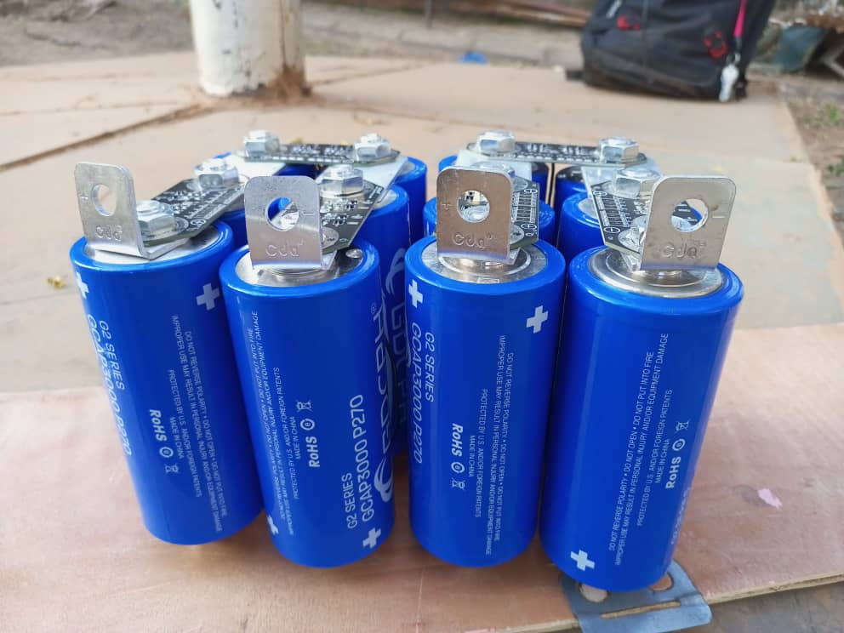

**Figure 1: Two supercapacitor packs**

Figure 2 shows the experimental setup consisting of a pump kit, two supercapacitor packs, and batteries.

Figure 3 shows the installation setup consisting of the pyranometer and panels.

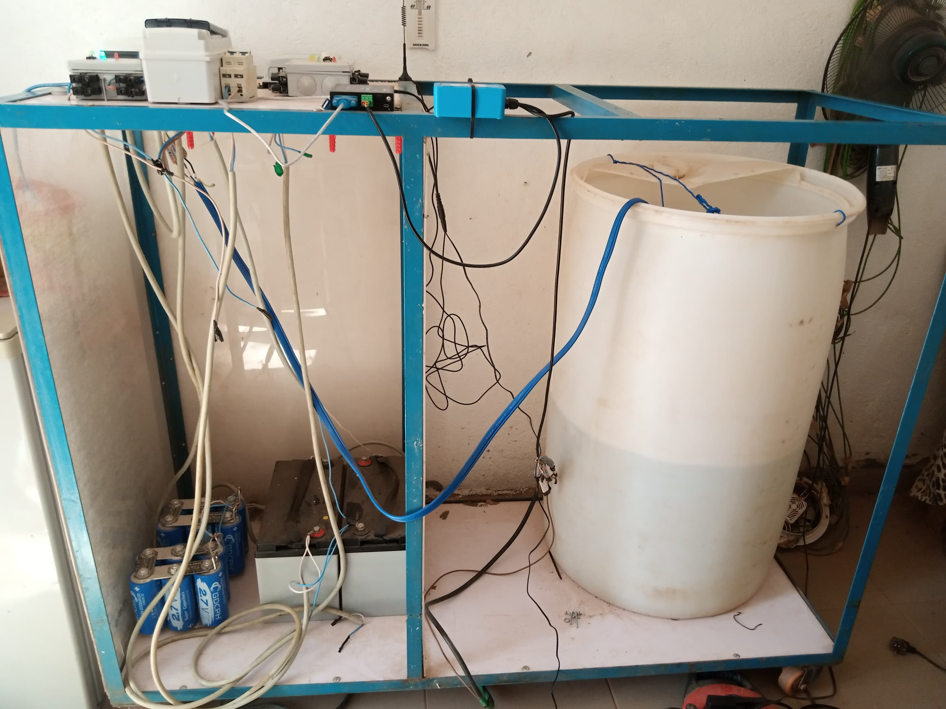

Command and control device

Supercapacitor

Pumping kit

Batteries

**Figure 2: Pumping kit, supercapacitor packs and batteries**

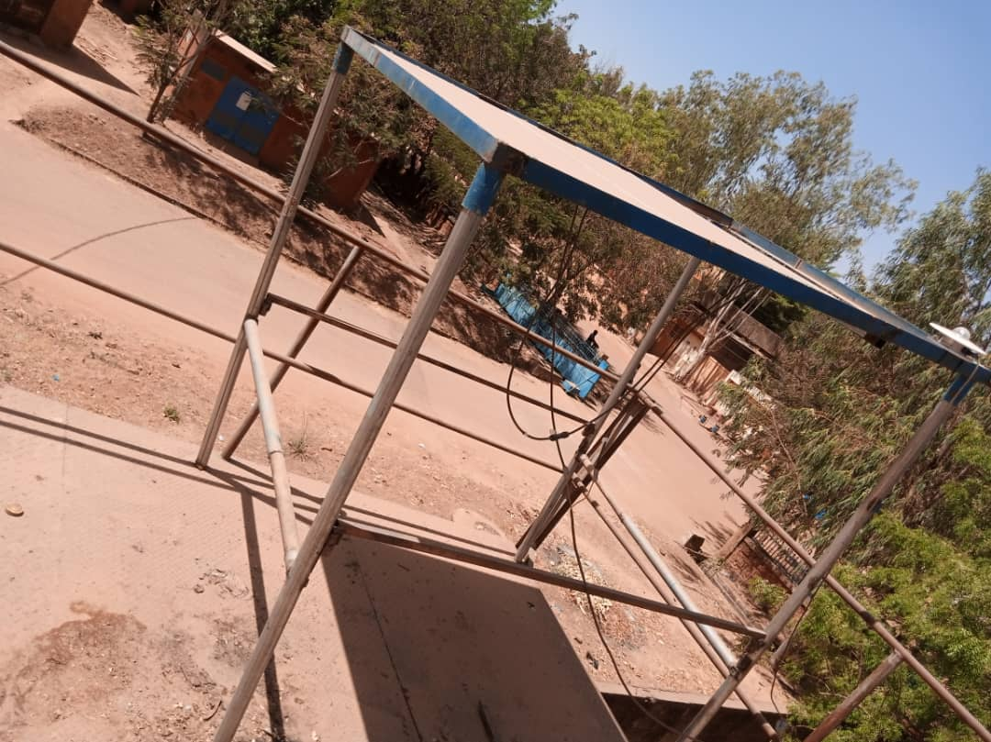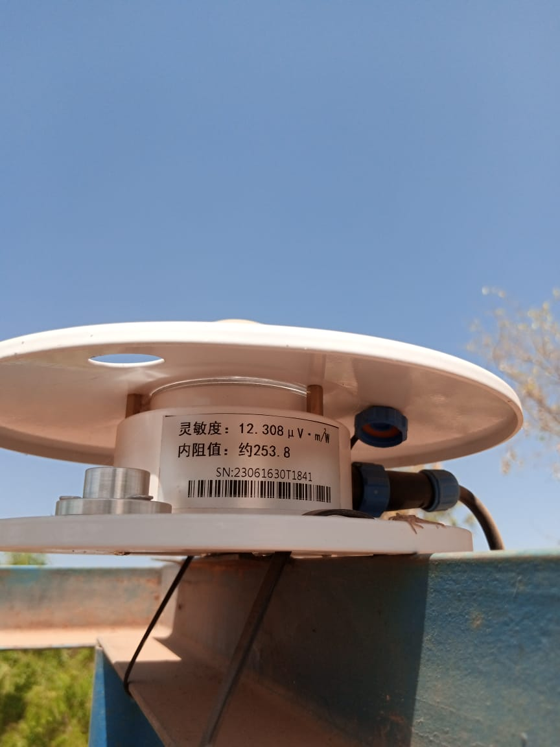

Solar panel

Pyranometer

**Figure 3: Pyranometer and solar panels**

The experimental setup composed of the above elements served as a framework for our experiment. The principle of the experiment consists of recording the characteristic quantities every 10 seconds. We recorded the characteristics of the solar system (irradiation) using a pyranometer. The voltage and current values ​​at the output of the solar panels are measured using the MPPT regulator. The characteristics of the pump (rotation speed, current, voltage, power) are measured using the MPPT controller.

For supercapacitors, voltage and current values ​​are measured using a multimeter and a DC clamp meter, respectively.

**1.3. Experimental Measurements**

The experiment first involves directly measuring the charge values ​​of the supercapacitors through solar radiation. Then, once charged, we proceeded to directly discharge them through the solar pump. The objective of the experiment is to operate the pump directly over time. When voltage dips preventing normal system operation are observed, supercapacitors are used to ensure operation during the disruption period. In the second operating case, during low irradiation, the supercapacitors will be used again to boost the pump startup. To materialize our experiment, we recorded the voltage and current values ​​of the supercapacitors through solar irradiation as we went along. For the case of the discharge principle, it consists of powering the pump through the supercapacitors. We noted on the one hand the values ​​of the voltage and those of the discharge current of the supercapacitors. On the other hand, we also proceeded to the readings of the characteristics of the motor pump. This experimental device is materialized by a functional diagram represented by figure 4 followed by a diagram of carrying out the experiment represented by figure 5.

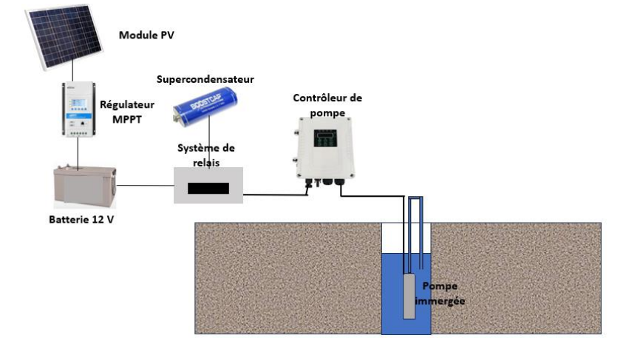

**Figure 4: Schematic diagram of the experimental device**

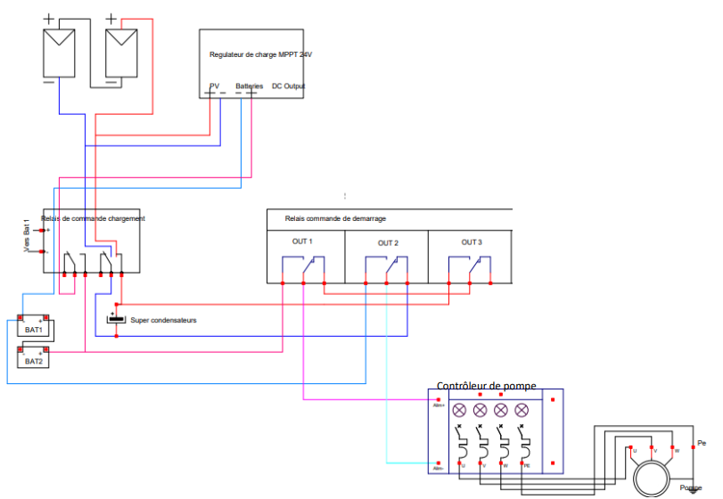

**Figure 5: diagram of the experimental device**

**2. RESULTS**

The results obtained allowed us to draw the following experimental curves for January 30, 2025

**Fig 6: Curve of solar irradiation during the day of 01/30/2025**

Figure 6 above shows the evolution of solar irradiation during the day of January 30, 2025 in Burkina Faso. We observe decreases in solar irradiation. This is explained by a cloudy period during the measurement period.

Figure 7 shows the charging voltage and current profiles of the supercapacitors as a function of charging time. The shape of the current curve indicates a significant charge of the supercapacitor from the first second to the 650th second, corresponding to a charging time of 10 minutes and 40 seconds. From this date, a significant drop in charge occurs until the 960th second due to low solar irradiation, at which point the supercapacitors reach their maximum charge at 980 seconds. This is explained by a significant passage of clouds and the harmattan dust attenuating the effect of solar irradiation for a duration of 310 seconds, or 5 minutes 10 seconds. The supercapacitors were able to power the pump during the period of declining solar irradiation. This charge can be rapid for periods without fluctuations in solar irradiation.

**Figure 7: Supercapacitor Charging Profile**

Figure 8 shows the motor rotation speed profile as a function of current I during daytime operation. For rotation speeds below 3000 rpm, the pump flow rate is lower than the minimum pumping flow rate specified by the pump manufacturer (2 $,2*{10}^{-4} \frac{m^{3}}{s}$). This flow rate varies depending on the engine rotation speed. The results of the experiment show that for an irradiation of 450W/ $m^{2}$, the engine rotation speed is of the order of 1750tr/min corresponding to a flow rate of 2 $,12*{10}^{-4} \frac{m^{3}}{s}$. For an irradiation of 934W/ $m^{2}$ with an engine rotation speed of 3350tr/min the flow rate is of the order of 3 $*{10}^{-4} \frac{m^{3}}{s}$. The results obtained show that the greater the solar irradiation, the engine rotation speed increases, leading to an increase in the pumping flow rate.

**Figure 8: Motor rotation speed profile versus current**

Figure 9 shows the motor current profile versus pump power input during daytime operation. The results obtained showed that for a pump power input of 115 W and a rotation speed of 3210tr/min, the pumping flow rate is acceptable.

**Figure 9: Motor current profile as a function of power**

Figure 10 shows the profile of the motor rotation speed as a function of the current during the discharge of the supercapacitors. Unlike the direct power supply of the pump by the sun, the discharge of the supercapacitors on the pump leads directly to its operation corresponding to a good flow rate for a rotation speed greater than 3000 tr/min.

**Figure 10: Motor rotation speed profile as a function of current.**

Figure 11 shows the motor current profile as a function of the power absorbed during operation by discharging the supercapacitors. The current curve as a function of power shows that between the maximum charge voltage of the supercapacitors 32.4V and the threshold voltage of 19.6V the pump receives the power necessary for its operation.

**Figure 11: Motor current profile as a function of power**

Figure 12 shows the discharge voltage and current profiles of the supercapacitors as a function of the charging time. The results obtained from this experiment give a discharge threshold value of 20 V. So, for a charging voltage between 19.6 V and 32.4 V corresponding to an energy of 21.715 Wh, the supercapacitors correctly ensure the power supply of the solar pump. We note that despite the small variations in current, the pump receives enough of the energy necessary for its operation.

This discharge lasts 8 minutes 59 seconds. Referring to the charging system, we obtained a disturbance of 5 minutes 10 seconds due to fluctuations in solar irradiation against the discharge time of the supercapacitors. These results show that the supercapacitors can ensure the continuity of the load power supply up to a maximum duration of 8 minutes.

**Figure 12: Discharge curve of supercapacitors through the load**

**3. DISCUSSION**

**3.1. Calculation of the Average Solar Power Variability Error**

For our study, we defined the average power variability error to assess the pump flow rate changes as a function of solar irradiation. Based on the experimental results, this error is the power difference calculated between the pump's nominal power of approximately 180W and the power absorbed by the pump as a function of solar irradiation over time.

• From 6:00 a.m. to 10:20 a.m., we observed a low power production due to the absence or low solar irradiation. This low power production is characterized by an average power variability error of approximately 80.26W.

• From 10:20 a.m. to 1:20 p.m.: We have significant power production due to high solar irradiation. This is characterized by an average power variability error of around -27.742.

• From 1:20 p.m. to 1:50 p.m. (cloudy period): We observe a decrease in irradiation due to a significant cloudy period. This decrease in solar production is characterized by an average power variability error of around 23.02.

• From 1:50 p.m. to 5:00 p.m.: decrease in solar irradiation due to sunset. This significant decrease in production is due to a decrease in solar irradiation corresponding to sunset. The average error of this decrease in solar production is around 75.70.

Figure 13 illustrates the calculation results of the average error in power variability as a function of time and solar irradiation.

**Figure 13: Profile of the average power variability error as a function of time and solar irradiation**.

**3.2. Calculation of the average power variability error due to supercapacitor discharge**

Figure 14 illustrates a profile of the evolution of supercapacitor charging over time. A rapid increase in power is observed over time. The higher the power, the greater the average power variability error due to supercapacitor charging. In the case of our study, particularly for the month of January with low solar irradiation, the supercapacitor charging time is 16 minutes.

**Figure 14: Supercapacitor charge evolution profile over time**

**3.3. Calculation of the average power variability error due to supercapacitor discharge**

The average power variability error due to supercapacitor discharge is defined by calculating the difference between the nominal power of around 180W and the discharge power of the supercapacitor powering the pump. For a charging voltage between 19.6V and 32.4V, corresponding to an energy of 21.715 Wh, the supercapacitors ensure the correct power supply to the solar pump. The curve representing the variability error is in the negative portion and is ascending. This means that the energy stored by the supercapacitors provides the power necessary for the pump to operate properly. The shapes of the power curves and the power variability error are asymptotic with respect to the time axis.

Figure 15 illustrates the profile of the evolution of the supercapacitor discharge as a function of time. The interval cited corresponds to a duration of 8 minutes 49 seconds. This corresponds to a power supply phase of the pump. In the context of our experiment, for two packs of 12 supercapacitors of 3000 Farad and 2.7 V voltage at the terminals of each, the maximum discharge duration is 9 minutes 30 seconds. The supercapacitors can compensate for the variability of the solar irradiation of the 180W pump during this indicated period. This discharge duration can be increased depending on the number of supercapacitors. The two packs have an equivalent capacity of 250 Farad and a maximum voltage of 32.4 V. This means that for dips or fluctuations in solar irradiation, cloud passages, wind movements on the solar panels, whose durations are less than 9 minutes 30 seconds, the continuity of the power supply to the system could be ensured.

**Figure 15: Evolution profile of the discharge of supercapacitors as a function of time.**

Thanks to their high-power density and rapid charging and discharging, supercapacitors can perfectly compensate for power fluctuations. They ensure the pump operates smoothly until the stored energy is exhausted. Supercapacitors are considered as instantaneous storage means with high specific power and low specific energy, covering high power demands, as in the case of our pumping device. This shows that the profiles of the power variability error and the pump power have the same order of magnitude.

**CONCLUSION**

We concluded from this study that supercapacitors can compensate for the power variability of the 180W solar pump for a duration of at least 7 minutes to power the solar pumping system. Their ability to charge quickly, even under low solar radiation, is one of the main advantages of this component compared to other energy sources (capacitor, battery). For electric motors with positive current (DC or AC) requiring high starting current and high power during the transient start-up phase, this phenomenon can be absorbed by supercapacitors (bicycles, cranes, motor vehicles) [11][12][13][14]. The same applies to temporary maintenance of the installation system, for periods of less sunny day (early morning and sunset), and also for temporary grid disruptions. Supercapacitors allow for better management and improvement of agricultural production yield. This experiment will be validated by a numerical study.

**Disclaimer (Artificial intelligence)**

Option 1:

Author(s) hereby declare that NO generative AI technologies such as Large Language Models (ChatGPT, COPILOT, etc.) and text-to-image generators have been used during the writing or editing of this manuscript.

Option 2:

Author(s) hereby declare that generative AI technologies such as Large Language Models, etc. have been used during the writing or editing of manuscripts. This explanation will include the name, version, model, and source of the generative AI technology and as well as all input prompts provided to the generative AI technology

Details of the AI usage are given below:

1.

2.

3.

**REFERENCES**

[1] : Ahmed Ousmane BAGRE. Optimisation du couplage de centrales photovoltaïques aux réseaux publics instables : application au réseau national du Burkina Faso. Energie électrique. Université du Havre, 2014. Français. NMT : 2014LEHA0017, Tel-01256023

[2] KY J. B. | Tissologo M. | Ouedraogo S. | Nikiema O. | Ouattara F. "Comparative Study of Electricity Production Cost of Energy Mix of Burkina Faso" Published in International Journal of Trend in Scientific Research and Development (ijtsrd), ISSN: 2456-6470, Volume-7 | Issue-6, December 2023, pp.29-36, IJTSRD60085 URL: [www.ijtsrd.com/papers/ijtsrd60085.pdf](http://www.ijtsrd.com/papers/ijtsrd60085.pdf)

[3] Ousmane Nikiema, Seydou Ouedraogo, Damgou Mani Kongnine, Emmanuel Nanema, Adekunlé Akim Salami. Analysis of the Complementarity Between Solar and Wind Energy in the Perspective of Installing a Hybrid System: Case Study in the Sahel of Burkina Faso. International Journal of Energy and Power Engineering. Vol. 12, No. 3, 2023, pp. 41-46. doi: 10.11648/j.ijepe.20231203.12 Received: July 16, 2023; Accepted: August 9, 2023; Published: August 22, 2023

[4] Ousmane Nikiema1, Damgou Mani Kongnine1, Seydou Ouedraogo2,*, Emmanuel Nanema3 and Adekunlé Akim Salami1.Diagnosing Photovoltaic Power Plant Injection decoupling in Burkina Faso Journal of Engineering Science and Technology Review 16 (5) (2023) 69 – 75

[5] Abdoulaye ZONGO, Daouda KONANE, Frédéric OUATTARA (2022). Modeling of residential photovoltaic (PV) systems connected to the low- voltage (BT) grid : application to public distribution network of Burkina Faso, Laboratoire de Recherche en Énergétique et Météorologie de l’Espace (LAREME), UFR – ST, Université Norbert ZONGO, Koudougou, Burkina Faso2 :Laboratoire de Matériaux et Environnement (LAME), Université Joseph KI- ZERBO, Ouagadougou, Burkina Faso Advances in Materials Physics and Chemistry, 12, 69-81. <https://doi.org/10.4236/ampc.2022.125006>

[6] Yasser Ghoulam. Modélisation multi-physique et gestion intelligente de l’énergie d’un système de stockage hybride de type batterie li-ion/supercondensateur pour des applications de véhicules élec triques. Autre. Université de Strasbourg, 2023. Français.NNT: 2023STRAD069. tel-04633983

[7] : BELHACHEMI Farid : Modélisation et caractérisation des supercondensateurs à couche double électrique utilisés en électronique de puissance, Institut National Polytechnique de Lorraine, 2001

[8]Mohamed Ansoumane Camara. Modélisation du stockage de l’énergie photovoltaïque par supercondensateurs. Autre. Université Paris-Est, 2011. Français. NNT : 2011PEST1071, tel-00673218

[9] Maxwell Technologies, Maxwell K2series_DS_1015370-4-117973, https://www.mouser.com/datasheet/2/257/Maxwell_K2Series_DS_1015370-4-1179730.pdf?srsltid=AfmBOoqDdjs4jga-lCLPc--1OgdjxneN_jfTA9ZnddVv5TLVgKmrIGm_

[10] Nathalie Devillers. Caractérisation et modélisation de composants de stockage électrochimique et électrostatique. Autre. Université de Franche-Comté, 2012. Français. NNT : 2012BESA2003. Tel 00838733

[11] Emmanuel Hoang, Bertrand Revol,Gilles Feld, Denis Pénard, Eléments d’étude d’un système de stockage de « énergie électrique » : le supercondensateur. La revue 3E.I,2007, pp.20hal-00533011

[12] Nassim RIZOUG ; Modélisation électrique et énergétique des supercondensateurs et méthode de caractérisation : application au cyclage d’un module de supercondensateurs basse tension en grande puissance

[13] Edgar Tournon. Conception optimale d’un vélo à architecture hybride série et à base de super condensateurs. Energie électrique. Université Claude Bernard Lyon 1, 2020. Français. NNT:tel-03120708

[14] Thomas Pavot. Commande avancée d’une source d’énergie hybride pile à combustible- batterie- supercondensateur pour un drone de longue endurance. Autre. Université de Strasbourg, 2024. Français. NNT: 2024STRAD064. tel-05031093