QUANTITATIVE ANALYSIS OF TEA FARMING SOIL USING TRICHODERMA AS A BIOCONTROL AGENT

ABSTRACT
An experiment was been done using tea garden soil under three different treatments:Control – untreated soil, S+T – soil treated with Trichoderma, S+T+VC – soil treated with Trichoderma and vermicompost
A method called serial dilution was done to count the number of microorganisms like bacteria, fungi, and Trichoderma in the soil. The results showed that the highest growth of Trichoderma was found in the soil treated only with Trichoderma. Adding of vermicompost along with it led to slightly lower in growth.
This study shows that Trichoderma is very useful in tea farming. It helps to control diseases, improves plant growth, and supports healthy soil. However, combining it with vermicompost didn’t increase its growth, so more research is further needed in order to understand how to use both together most effectively.

Keywords: Tea farming, Trichoderma,Biocontrol agent, Vermicompost

INTRODUCTION

Tea is a popular drink which is made from the leaves of the Camellia sinensis plant. After water, it is the most widely consumed drink in the world. It is said to be likely started in northeast India, northern Myanmar, or southwest China. People in China have been drinking tea for over 5,000 years. Besides tasting good, tea is known to be healthy as it helps to reduce inflammation, works as an antioxidant, and may also help with weight loss.
Tea is known to grow best in tropical and subtropical regions with warm and humid weather conditions. The ideal temperature for tea is between 20°C and 30°C. Too much heat (over 35°C) or cold (below 10°C) is not preferable and it can harm the plants. Tea needs a lot of rain—about 150 to 300 cm a year—and it should be spread out through the year.Tea plants need slightly acidic soil with a pH ranging between 4.5 and 5.5. The soil should be fertile, well-drained, and not too sandy nor too clayey. A depth of at least 1.5 meters is preferable so that the roots can grow well. Shallow soil limits root development. Using too many chemical fertilizers and pesticides, along with growing only one type of crop for many years, can damage the soil and environment. That is why eco-friendly solutions are becoming more and more important.
Tea farming provides work to millions, especially in the villages and hilly areas.Countries like India, China, Sri Lanka, and Kenya earns a lot of money by selling tea to other countries. Many small farmers grow tea and they are dependend on it to make a living. Tea farms often bring roads, schools, and health centers to remote areas,thus helping the community grow. It can also be seen that many women get jobs in tea farming, which helps them earn money and become more independent.
Nowadays it is been seen that using too many chemical fertilizers, cutting down trees, and bad farming methods is leading to the soil loses its natural health thus, making it harder to grow crops. Using of harmful chemicals such as pesticides or factory waste products get into the soil and thus makes the soil toxic, which in turn can harm plants, animals, and even the water underground. Too much of salt (salinity) builds up in the soil from over-watering or due to poor drainage facilities and this causes difficulties, plants can't take in water properly because of this, so there growth rate reduces or completely stops.
Trichoderma is a type of helpful fungus which is used in farming. It fights harmful plant diseases, especially those present in soil, and it can also improve plant growth, help plants to absorb nutrients better, and reduce pollution caused by chemical use. It’s safe, affordable, and also good for the environment.

The biological control agents (BCAs) like the species of Trichoderma, Beauveria, and Metarhizium are reported to be safer and promising components of integrated pest and disease management (IPDM) strategies, which have been adopted in various crops including tea [Hall and Papierok (1982)]. Although research works have been carried out in this direction [Debnath 1996; Babu and Kumhar (2013, 2014)].

Trichoderma is an effective biocontrol agent for plants grown in greenhouse as well as fields, showing antifungal properties as well as promoting growth and inducing plant resistance against pathogenic microorganisms[Zhang FG et al., (2013)].

Soil, is the soul of infinite life that promotes diverse microflora. Soil bacteria viz., Bacillus, Pseudomonas and Streptomyces etc., are prolific producers of secondary metabolites which act against numerous co-existing phytopathogeic fungi and human pathogenic bacteria [Pathma et al.,( 2011b)]. Earthworms are popularly known as the “farmer’s friend” or “nature’s plowman”. Earthworm influences microbial community, physical and chemical properties of soil. They breakdown large soil particles and leaf litter and thereby increase the availability of organic matter for microbial degradation and transforms organic wastes into valuable vermicomposts by grinding and digesting them with the help of aerobic and anaerobic microbes [Maboeta and Van Rensburg(2003)]. Earthworms activity is found to enhance the beneficial microflora and suppress harmful pathogenic microbes. Soil wormcasts are rich source of micro and macro-nutrients, and microbial enzymes [Lavelle and Martin (1992)]. Vermicomposting is an efficient nutrient recycling process that involves harnessing earthworms as versatile natural bioreactors for organic matter decomposition.

Earthworm’s ability to increase plant nutrient availability is likely to be dependent on the activity of earthworm gut microflora. Earthworms indirectly influence the dynamics of soil chemical processes, by comminuting the litter and affecting the activity of the soil micro-flora [Petersen and Luxton (1982); Lee (1985); Edwards and Bohlen (1996)].

Earthworms increased the number of microorganisms in soi1 as much as five times and the number of bacteria and ‘actinomycetes’ contained in the ingested material increased upto 1,000 fold while passing through their gut [Edwards and Fletcher (1988)]. Similar increase was observed in plate counts of total bacteria, proteolytic bacteria and actinomycetes by passage through earthworms gut [ Devliegher and Verstraete (1995)].

Trichoderma plays a very important role in soil health management.It is seen that the use of Trichoderma as a biocontrol agent offers a sustainable alternative to the use of chemical pesticides, which often leads to soil, water pollution, pesticide resistance,etc. Trichoderma is an essential component of modern, sustainable agriculture. It is multifunctional, which makes it a highly effective and environmentally friendly biocontrol agent. The importance of Trichoderma will only increase in the years to come.

MATERIALS REQUIRED AND METHOD

MATERIALS REQUIRED:
- Sterile sample collection polythene bags
- Spatula
- Burner
- Pots
- Water sprayer
- Vermi compost
- Trichoderma
- Cotton
- Marker
- Alcohol
- Distilled water
- Glasswares:
- Petri plates
- Conical Flask
- Pipette
- Dilution bottles
- Measuring cylinder
- Funnel
- Instruments:
- Shaker
- Weighing machine
- Autoclave
- Laminar Air flow
- Hot air oven

- Media

PDA( Potato Dextrose Agar):
Potato Dextrose Agar (PDA) was been used for the cultivation of fungi. Potato Dextrose Agar (PDA) is a general purpose medium for yeasts and molds that can be supplemented with acid or antibiotics to inhibit bacterial growth. It is been recommended for plate count methods for foods, dairy products and testing cosmetics.
The nutritionally rich base (potato infusion) encourages mold sporulation and pigment production in some dermatophytes.

Composition of the media:
- Potatoes peeled and dried - 200g
- D-glucose - 20g
- Agar - 15g
- Distilled water - 1L

- Sample:

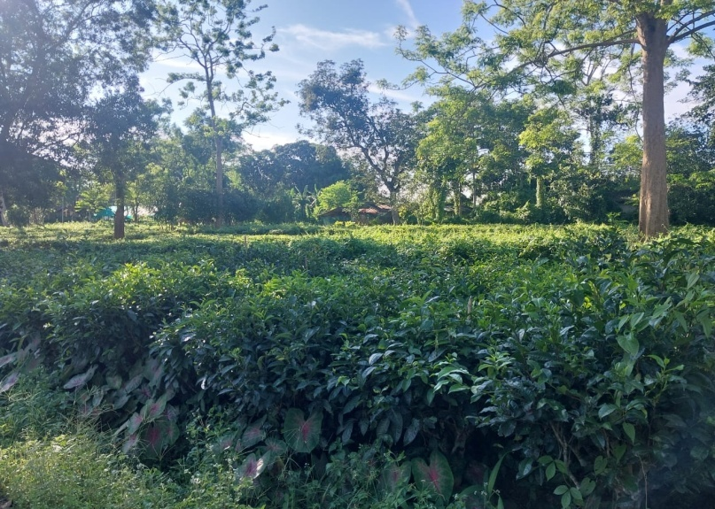

Picture 1 : Soil sample collected from tea garden(TTRI campus)

METHOD:

Collection of soil sample:
Tea soil was collected from the garden in the campus itself.
- Keeping in mind the basic principles of microbiology, the collected soil sample was been sterilized using autoclavable bags in the autoclave at 121degree Celsius for around one hour.
- Then after sterilization was done, the pot trial layout was been set up. Three set ups were made.
The first layout had only the sterilized soil sample i.e, Control (C).
The second layout had sterilized soil and Trichodermai.e,( S+T)
The third layout had sterilized soil,trichoderma and vermi compost i.e, (S+T+VC)
- Triplicates of each individual layout was made.
- In the first layout, 2500g of only sterilized soil was weighed and divided equally into three pots.
- In the second layout, 2500g of sterilized soil was weighed and mixed with 125ml of Trichoderma and then again mixed well and equally divided into three pots.
- Similarly in the third layout, 2500g of sterilized soil and 125ml of trichoderma was weighed and mixed well with 125g of vermi compost and was equally divided among three pots.
- This set was kept in a clean environment without any hindrance for the study. Water was sprayed at regular intervals in order to keep the soil moistened. And the observations were taken in the 7th, 12th, 15th and 21st day of the samples.

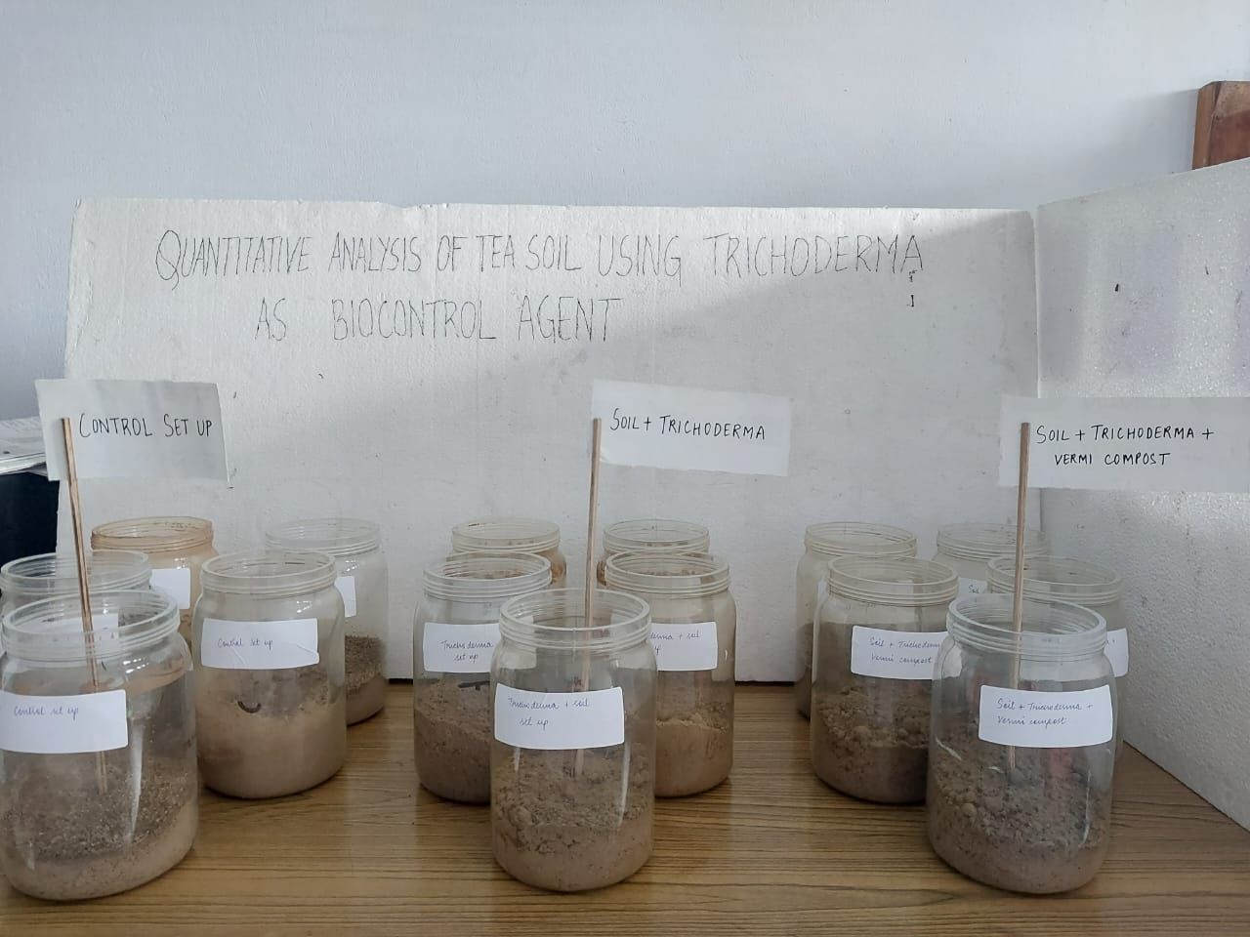
Picture 2 :Three set ups were kept

PDA media preparation:
- First 200g of fresh cleaned and dried potatoes were taken and finely chopped into pieces.
- These were then taken in a vessel and to this 1L of distilled water is added and kept in a stove to boil for around an hour until the potatoes get cooked.
- Then the extract was collected in a measuring cylinder with the help of a funnel and muslin cloth. The remaining volume in the cylinder was filled upto 1000ml again by adding distilled water to it.
- As per convenience, the extract solution which was collected was been equally divided into two conical flasks (500ml in each).
- Then to one of the flask, 20g of D- glucose was measured and mixed into it. And to the other flask 15g of agar was measured and added.
- Both the flasks were heated in the flame until they dissolved evenly.
- These were then mixed together to form a homogeneous mixture.
- Then the media was been poured into small 250ml conical flasks, plugged with non absorbant cotton, covered with paper and tied with rubber bands and were labeled.
- Finally these flasks were autoclaved at 121 degree Celsius for around 1 hour for sterilization.

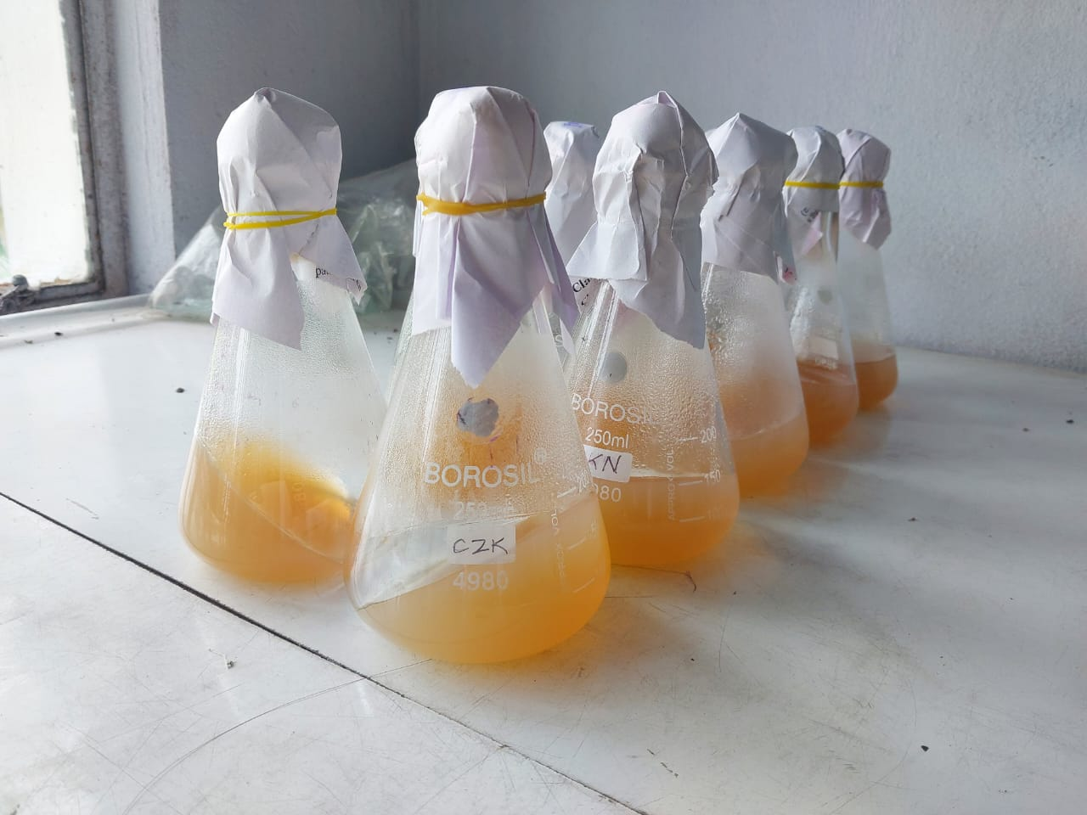
Picture 3 :Potato Dextrose Agar media (PDA)

For this work serial dilution technique was used.

SERIAL DILUTION:

- A composite mixture of 10g of the soil of the triplicates from each layout was weighed in an electric meter and was taken in 100ml dilution bottle.
- The three 100ml dilution bottles along with 10g of weighed soil sample were placed in a shaker for around ½ hour, so that it gets homogenized and mixed well.
- Overall dilutions upto 10⁻⁷ was done.
- After the 100ml bottles were well shaken, 10ml from each bottle was been pipetted out and put in the dilution bottle of 90ml. Similarly the process was been carried out until 10^{-7th} dilution.
- For each layout one 100ml dilution bottle and seven 90ml bottles were used.
- Then after the dilution was done 1ml of dilution suspension from 10⁻¹, 10⁻⁵, 10⁻⁶ and 10⁻⁷ was been pipette out in the respective petri plates for each triplicate.
- For each individual layout again triplicates of each dilution was taken.
- Finally after serial dilution was done in all the plates, PDA( Potato Dextrose Agar) media was melted and poured into the plates.
- Then the petri plates were kept in a sterilized place for further observation.
- This process was first done on the 7th day of set up then it was again repeated in the following days of the set up- 12th, 15th and 21st day.

The method and formula for Bacterial Count is as follows:
• The sample was diluted in a series of test tubes using normal sterile water.
• Then plating was done in a measured volume of each dilution onto the prepared agar plates.
• Then the plates were incubated at an appropriate temperature (usually 35–37°C) for 24–48 hours.
• And finally the colonies are counted on the plate with 30–300 colonies (ideal range for accuracy).
Then the count is calculated using the formula:

CFU/g or mL=Number of colonies ×Dilution factor​
Volume plated (in mL)

The same above mentioned method and formula implies for fungal count as well.
Trichoderma colonies were confirmed by observing the fast growing colony that were white in colour initially then turing green with age, looking into the cottony and woolly texture.

OBSERVATION AND RESULTS

Observation of Bacteria, Fungi and Trichoderma count in tea soil:

- For Sterilized soil(Control):

DAY | DILUTIONS |  | BACTERIA (CFU/g) |  | FUNGI  (CFU/g) | TRICHODERMA  (CFU/g)
7th | 10⁻¹ |  | 1 |  | 0 | 5.5
7th | 10⁻⁵ |  | 0 |  | 41.3 | 41
7th | 10⁻⁶ |  | 0 |  | 18.3 | 19
7th | 10⁻⁷ |  | 2.6 |  | 10 | 9.6
12th | 10⁻¹ |  | 0 |  | 0 | 0
12th | 10⁻⁵ |  | 0 |  | 76.3 | 3.2
12th | 10⁻⁶ |  | 0 |  | 63 | 2.2
12th | 10⁻⁷ |  | 0 |  | 53.3 | 2.6
15th | 10⁻¹ |  | 0 |  | 0 | 0
15th | 10⁻⁵ |  | 100 |  | 104 | 3
15th | 10⁻⁶ |  | 74 |  | 78.3 | 6
15th | 10⁻⁷ |  | 59.3 |  | 62.3 | 6.3
21st | 10⁻¹ |  | 0 |  | 0 | 0
21st | 10⁻⁵ |  | 0 |  | 103 | 2.5
 |  | 10⁻⁶ |  | 0 | 77.3 | 7
 |  | 10⁻⁷ |  | 0 | 78.3 | 4.6

Table:1 Fungal and bacterial count

From table 1: it is observed that the fungal count is comparitively higher than the bacterial and trichoderma count.

Taking the average of the values from table 1 a bar graph was plotted which is as follows:-

Table 2. Bacteria, Fungi and Trichoderma count in tea soil
DAYS | BACTERIA | FUNGI | TRICHODERMA
7th | 0.9 | 18.7 | 18.7
12th | 0 | 48.2 | 2
15th | 58.3 | 61.1 | 3.8
21st | 0 | 64.6 | 3.5

Fig1: Graph for the Control setup containing only sterilized soil

From the above fig1 it is clearly seen that the overall count for all the no. of days that was considered, the fungal count was seen more than bacteria and trichoderma.

- For sterilized soil and Trichoderma set up(S+T):

DAY | DILUTIONS |  | BACTERIA  (CFU/g) |  | FUNGI  (CFU/g) | TRICHODERMA  (CFU/g)
7th | 10⁻¹ |  | 0 |  | 0 | 0
7th | 10⁻⁵ |  | 0 |  | 0 | 11.3
7th | 10⁻⁶ |  | 0 |  | 0 | 13.3
7th | 10⁻⁷ |  | 0 |  | 0 | 10
12th | 10⁻¹ |  | 0 |  | 0 | 1.5
12th | 10⁻⁵ |  | 0 |  | 0 | 20.3
12th | 10⁻⁶ |  | 0 |  | 0 | 12.2
12th | 10⁻⁷ |  | 0 |  | 0 | 12.6
15th | 10⁻¹ |  | 0 |  | 0 | 0
15th | 10⁻⁵ |  | 3.6 |  | 0 | 14.6
15th | 10⁻⁶ |  | 3.5 |  | 3.5 | 13
15th | 10⁻⁷ |  | 0 |  | 7.6 | 9.6
21st | 10⁻¹ |  | 0 |  | 0 | 1.6
21st | 10⁻⁵ |  | 6.6 |  | 4.6 | 13.6
 |  | 10⁻⁶ |  | 6.3 | 5.5 | 7.2
 |  | 10⁻⁷ |  | 8.6 | 8.3 | 4.5
Table:3 Count in sterilized soil

From table 3: it is observed that the trichoderma count is comparatively higher than bacteria and fungus.

Taking the average of the values from table 2 a bar graph is plotted which is as follows:-

Table 4. Bacteria, Fungi and Trichoderma count in soil

DAY | BACTERIA | FUNGI | TRICHODERMA
7th | 0 | 0 | 2.1
12th | 0 | 0 | 11.6
15th | 1.7 | 2.7 | 9.3
21st | 5.3 | 4.6 | 6.7

Fig2: Graph for S+T setup having only soil and trichoderma

From the above graph it can be clearly seen that the overall count of trichoderma considered for the no. of days is more as compared to bacteria and fungus.
- For Sterilized soil, Trichoderma and Vermi compost set up:-

DAY | DILUTIONS |  | BACTERIA  (CFU/g) |  | FUNGI  (CFU/g) | TRICHODERMA  (CFU/g)
7th | 10⁻¹ |  | 0 |  | 0 | 0
7th | 10⁻⁵ |  | 38.8 |  | 0 | 1
7th | 10⁻⁶ |  | 52.1 |  | 0 | 5.3
7th | 10⁻⁷ |  | 58.8 |  | 0 | 8.3
12th | 10⁻¹ |  | 0 |  | 0 | 0
12th | 10⁻⁵ |  | 37.3 |  | 0 | 0
12th | 10⁻⁶ |  | 36.8 |  | 7 | 1
12th | 10⁻⁷ |  | 46.6 |  | 7.7 | 1
15th | 10⁻¹ |  | 0 |  | 0 | 0
15th | 10⁻⁵ |  | 71.3 |  | 0 | 16.6
15th | 10⁻⁶ |  | 35 |  | 0 | 33.6
15th | 10⁻⁷ |  | 36.6 |  | 2 | 18
21st | 10⁻¹ |  | 0 |  | 0 | 0
21st | 10⁻⁵ |  | 40.3 |  | 0 | 7.8
 |  | 10⁻⁶ |  | 14 | 0 | 8
 |  | 10⁻⁷ |  | 4.6 | 0 | 10.6

Table:4 bacterial microbes count in soil

From table 4: it is observed that the bacterial microbes count is comparitively more than fungal and trichoderma count.

Taking the average of the values from table 3 a bar graph is plotted which is as follows:-

Table:5 Soil, Trichoderma and Vermi compost in soil

DAY | BACTERIA | FUNGI | TRICHODERMA
7th | 37.4 | 0 | 3.6
12th | 30.1 | 3.6 | 0.5
15th | 35.7 | 0.5 | 17
21st | 14.7 | 0 | 6.6

Fig3: Graph showing the S+T+VC setup having a mixture of soil, trichoderma and vermin compost

From the above fig it can be said that, the bacterial count considered for the no. of days is more than the trichoderma and fungal count.

Day wise comparison of Bacteria, Fungi and Trichoderma count from the aforesaid three set ups:-

- Bacterial count from all the three set ups:

- Fungal count from all three set ups:

- Trichoderma count from all the three set ups:

Plate 1 :PICTURES OF THE OBSERVATIONS TAKEN DAY WISE

- 12th Day-
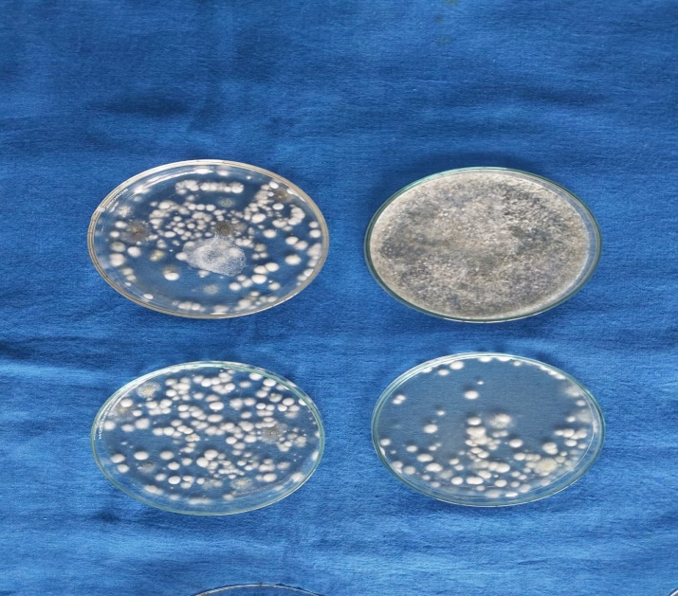
Soil

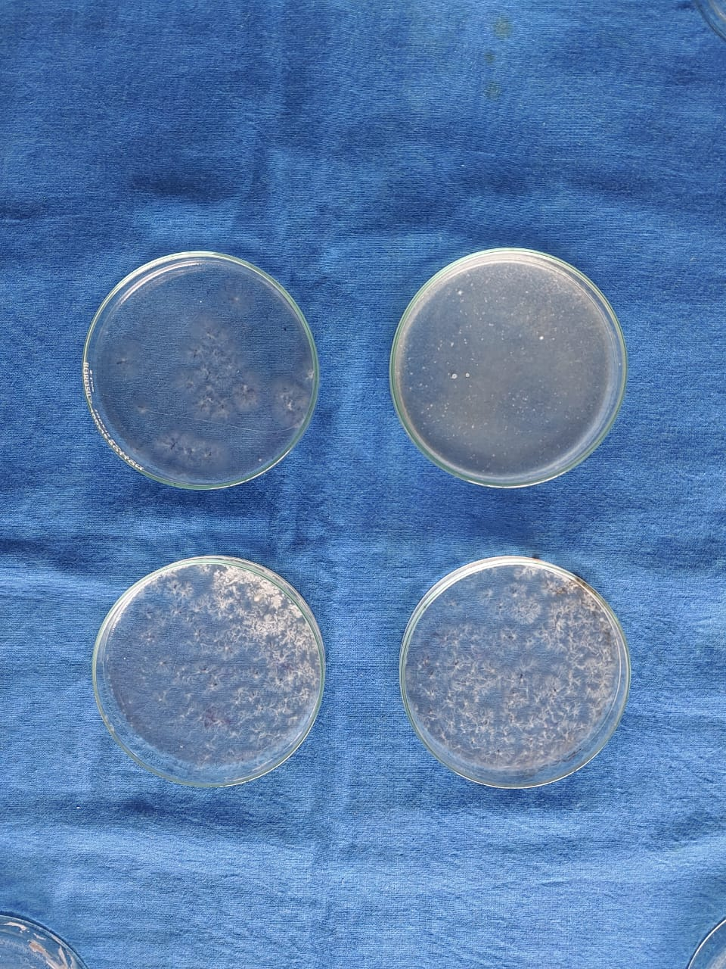
Soil and Trichoderma

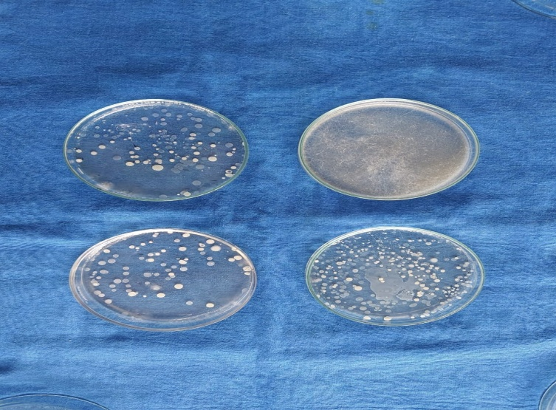
Soil, Trichoderma and Vermi compost

- 15th Day-
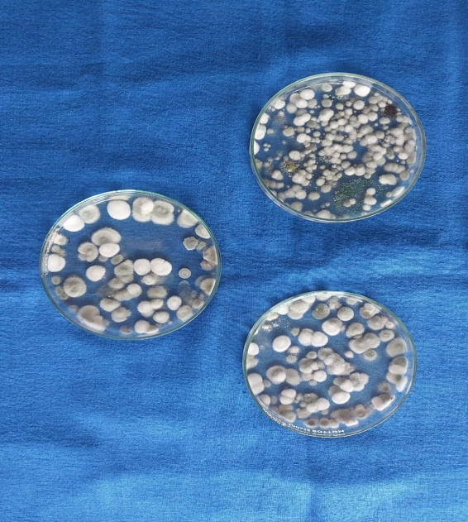
Soil
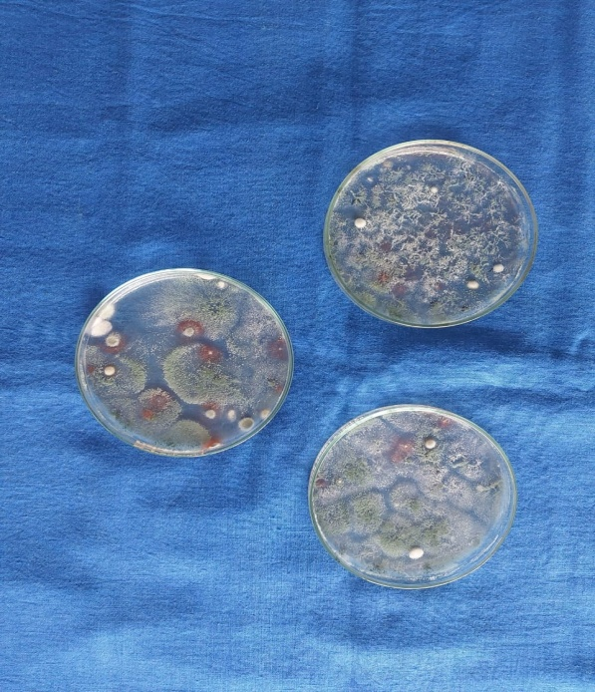
Soil and Trichoderma
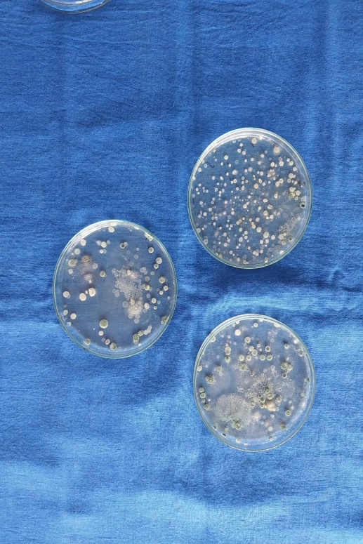
Soil, Trichoderma and Vermicompost

- 21st Day-

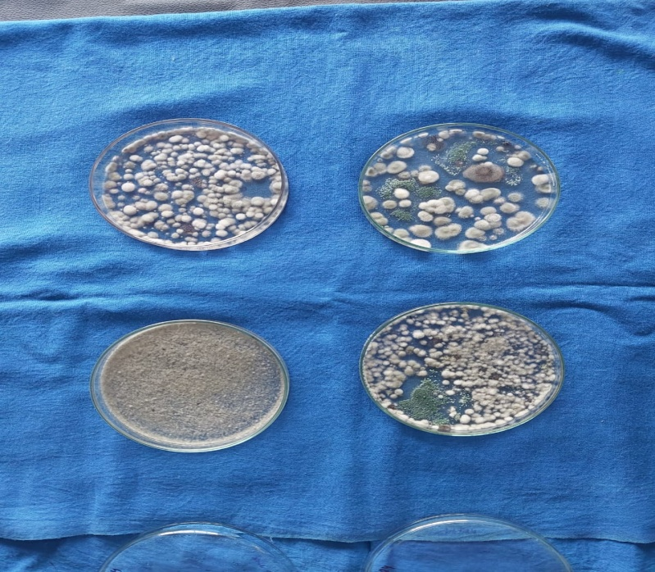

Soil

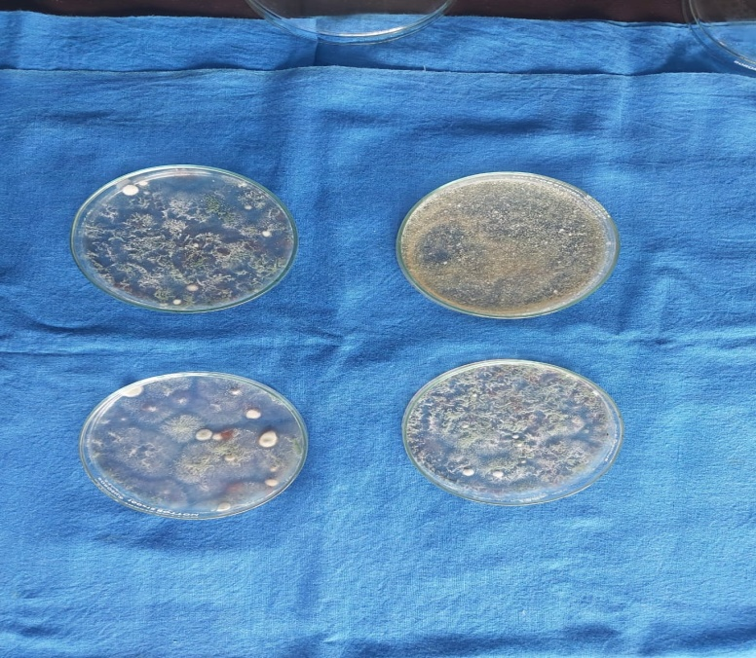

Soil and Trichoderma

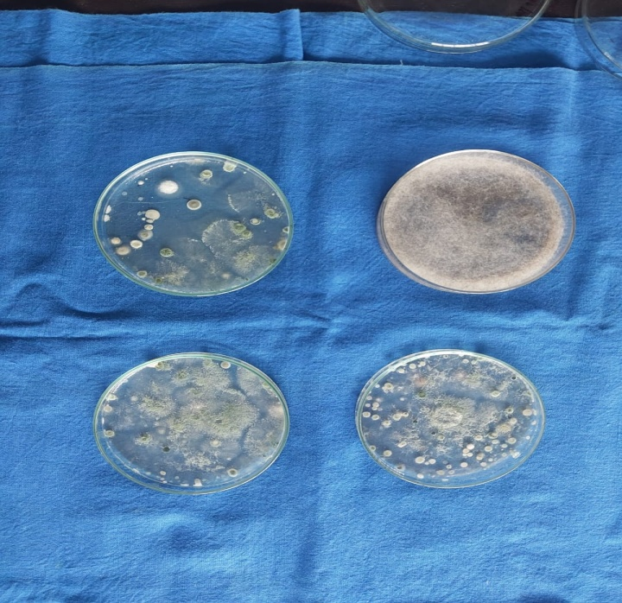
Soil, Trichoderma and Vermicompost

DISCUSSION

Tea, next to water is the cheapest beverage that humans consume. Drinking tea as a beverage has been considered a health-promoting habit since ancient times. The modern medicinal research is providing a scientific basis for this belief. As we all know the benefits of tea we should be able to maintain the soil in which tea is grown for its proper efficient growth. There are different kinds of microbes present in soil that gives positive impact on the growth of the plant.

Biocontrol agents applied after fumigation plays an important role to the soil microenvironment. Genetic analysis indicated that Trichoderma applied after fumigation significantly increased the relative abundance of Pseudomonas, Humicola and Chaetomium, and significantly decreased the relative abundance of the pathogens such as Fusarium spp. and Gibberella spp., which may help to control the pathogens and enhanced the ecological functions of the soil.

In addition to microbial biocontrol, vermicomposting have also demonstrated significant positive impacts on plant growth and soil health. It involves the breakdown of organic material by earthworms, resulting in the production of vermicompost. This material has high porosity, good aeration, drainage, and water-holding capacity. It also contains a rich community of microorganisms and nutrients that improve soil fertility. As a result, the use of vermicompost is seen to contribute to healthier plants, increased yields, and reduced crop losses.

Trichoderma is an effective biocontrol agent for plants grown in greenhouse as well as fields, showing antifungal properties as well as promoting growth and inducing plant resistance against pathogenic microorganisms. It is well documented that Trichoderma effectively controlled soil-borne pathogens such as Fusarium spp. and Phytophthora spp. Adding Trichoderma to fumigated soil can prolong the fumigant’s control of soil-borne pathogens when populations increase over time, compared with fumigation alone which becomes ineffective against pathogens as concentrations decline over time.
Recently in studies it has also been shown that Trichoderma can stimulate plant immune responses, a process known as induced systemic resistance (ISR). It plays a key role in soil health management. From an environmental perspective use of Trichoderma as a biocontrol agent offers a sustainable alternative to chemical pesticides. It is multifunctional and is highly effective and environment friendly biocontrol agent.

CONCLUSION

Tea requires a moderately hot and humid climate. Climate influences yield, crop distribution and quality. Tea grows best on well-drained fertile acid soil on high lands. Tea grows well on high land well drained soils having a good depth, acidic pH in the range of 4.5 to 5.5 and more than 2% organic matter. Shallow and compact sub-soils limit root growth. Tea plants growing on such soils are liable to suffer from draught during dry period and water logging during the rainy months.
Different kinds of microbes such as Bacteria, Fungi, etc has both positive as well as negative impact on growth of the plant.In the traditional crop cultivation process, the excessive use of pesticides and chemical fertilizers, as well as the long-term large-scale planting of a single crop, has led to the destruction of the farmland. Trichoderma spp. also behaves as a safe, low-cost, effective, eco-friendly biocontrol agent for different crop species land ecological environment. Trichoderma is mainly used to control soil-borne diseases as well as some leaf and panicle diseases of various plants. Trichoderma can not only prevent diseases but also promotes plant growth, improves nutrient utilization efficiency, enhances plant resistance, and improves agrochemical pollution environment.
Vermicomposting is also an efficient way of growing healthy pesticide free crops.Vermicompost enhances soil biodiversity by promoting the beneficial microbes.
After undertaking the quantitative estimation of the trichodermalcolony count from the tea soil taken from pot trial, it was observed that the trichodermalcolony flourished maximum in the tea soil treated with only trichodermathan in the tea soil treated with trichoderma along with vermi compost.

Disclaimer (Artificial intelligence)
Option 1:
Author(s) hereby declare that NO generative AI technologies such as Large Language Models (ChatGPT, COPILOT, etc.) and text-to-image generators have been used during the writing or editing of this manuscript.
Option 2:
Author(s) hereby declare that generative AI technologies such as Large Language Models, etc. have been used during the writing or editing of manuscripts. This explanation will include the name, version, model, and source of the generative AI technology and as well as all input prompts provided to the generative AI technology
Details of the AI usage are given below:
1.
2.
3.

REFERENCES

Babu, A., & Kumhar, K. C. (2013). New record of two fungal pathogens of red slug caterpillar. Tocklai News, Tea Research Association, Tocklai Experimental Station, 19, 2–3.
Babu, A., & Kumhar, K. C. (2014). Pathogenicity of indigenous Beauveria bassiana (BKN 20) against tea mosquito and its compatibility with a few insecticides. Two and a Bud, 61(1–2), 64–67.
Cao, A. C., Liu, X. M., Guo, M. X., Wang, Q. X., Li, Y., Ouyang, C. B., et al. (2017). Harm and control technology of crop soil-borne diseases. Plant Protection, 43(2), 6–16.
Edwards, C. A., & Fletcher, K. E. (1988). Interaction between earthworms and microorganisms in organic matter breakdown. Agriculture, Ecosystems & Environment, 20, 235–249. https://doi.org/10.1016/0167-8809(88)90069-2
Gaikwad, N., & Verma, S. (2024). Effect of Trichoderma harzianum on Growth of Corn under Water Stress Condition. International Journal of Plant & Soil Science, 36(8), 447–454. https://doi.org/10.9734/ijpss/2024/v36i84874
Hall, R. A., & Papierok, B. (1982). Fungi as biological control agents of arthropods of agricultural and medical importance. Parasitology, 84, 205–240.
Koffi, A. L. F. H., Koutoua, S., & Yao, W. J. (2025). Use of Trichoderma spp. as Biocontrol Agents to Enhance Disease Tolerance in Tomatoes. Journal of Experimental Agriculture International, 47(5), 192–203. https://doi.org/10.9734/jeai/2025/v47i53408
Lavelle, P., & Martin, A. (1992). Small-scale and large-scale effects of endogeic earthworms on soil organic matter dynamics in soils of the humid tropics. Soil Biology and Biochemistry, 12, 1491–1498. https://doi.org/10.1016/0038-0717(92)90138-N
Lee, K. E. (1985). Earthworms: Their ecology and relationships with soils and land use. Sydney: Academic Press.
Mukhtar, H., & Ahmad, N. (2000). Tea polyphenols: Prevention of cancer and optimizing health. American Journal of Clinical Nutrition, 71, 1698S–1702S. https://doi.org/10.1093/ajcn/71.6.1698s
Pathma, J., Rahul, G. R., Kamaraj Kennedy, R., Subashri, R., & Sakthivel, N. (2011). Secondary metabolite production by bacterial antagonists. Journal of Biological Control, 25, 165–181.
Petersen, H., & Luxton, M. A. (1982). A comparative analysis of soil fauna populations and their role in decomposition process. Oikos, 39, 287–388.
Roy, S., Mukhopadhyay, A., & Gurusubramanian, G. (2011). Resistance to insecticides in field-collected population of tea mosquito bug (Helopeltis theivora Waterhouse) from the Dooars (North Bengal, India) tea cultivations. Journal of Entomological Research Society, 13(2), 37–44.
Zhang, F. G., Zhu, Z., Yang, X. M., Ran, W., & Shen, Q. R. (2013). Trichoderma harzianum T-E5 significantly affects cucumber root exudates and fungal community in the cucumber rhizosphere. Applied Soil Ecology, 72, 41–48. https://doi.org/10.1016/j.apsoil.2013.05.016

