Physicochemical and Molecular Characterization of Biosurfactant-Producing Bacteria Isolated from Hydrocarbon-Impacted Aquatic Environments within the Niger Delta of Nigeria

Abstract
The Niger Delta is one of the world’s most significant hydrocarbon-rich regions, harbouring vast oil reserves that have been exploited for decades. Oil exploration in Nigeria's Niger Delta has led to extensive hydrocarbon contamination, severely impacting aquatic ecosystems and necessitating effective remediation strategies. Indigenous microbial communities in these environments have adapted, with certain bacterial strains demonstrating the capacity to produce biosurfactants—amphiphilic molecules that enhance the bioavailability and biodegradation of hydrophobic pollutants. This study aimed to characterize biosurfactant-producing bacteria isolated from hydrocarbon-impacted aquatic environments in the Niger Delta and their biosurfactants. Samples from selected sites underwent physicochemical and microbiological profiling, revealing dynamic variations in pH, salinity, and nutrient availability influenced by hydrocarbon presence. High-yielding biosurfactant producers were screened and identified through molecular techniques, showing relationships to Pseudochrobactrum sp., Bacillus albus, Pseudomonas aeruginosa, Alcaligenes faecalis, Alcaligenes ammonioxydans, and Cupriavidus malaysiensis. The highest emulsification index recorded was 96% which was produced by isolate code SC24- identified as Alcaligenes ammonioxydans. These findings underscore the potential of these indigenous bacterial strains and their biosurfactants for sustainable bioremediation and industrial applications, particularly in mitigating oil pollution in challenging environments. This research contributes novel insights into the unique metabolic capabilities of these adaptable microorganisms and supports the development of eco-friendly solutions.
Keyword: Molecular characterisation, biosurfactant, characterization, aquatic environment, hydrocarbon impacted.

Introduction

Background to the Study
Nigeria’s Niger Delta, a region abundant in petroleum hydrocarbons, has harbored vast oil reserves that have been exploited for decades. However, this exploitation has led to extensive oil contamination and severe impact on the aquatic and terrestrial ecosystems in the Niger Delta (Fenibo et al., 2019a; Onyena & Sam, 2020; Osadebe, et al., 2023). Frequent oil spills and continuous discharges of petroleum hydrocarbons have disrupted the physicochemical balance of local water bodies, resulting in long-term ecological imbalances and a significant decline in biodiversity (Aa et al., 2022). This environmental degradation has also fostered the development of unique microbial communities that are exceptionally resilient and adaptive to these harsh, contaminated conditions (Maduwuba & Ubani, 2025; Muhammad et al., 2024).
In response to these challenges, recent research has increasingly focused on leveraging the potential of indigenous bacteria for environmental remediation. Certain bacterial strains native to the Niger Delta are capable of producing biosurfactants, amphiphilic molecules that decrease the interfacial tension and surface tension between non-miscible phases, significantly enhancing the bioavailability and biodegradation of hydrophobic pollutants (Okafor et al., 2021; Osadebe et al., 2023). These biosurfactants help to break down contaminants and serve as promising agents in mitigating the adverse impacts of oil spills (Patel et al., 2023; Shuai et al., 2019). Biosurfactants are advantageous substitutes to chemical surfactants due to their lower toxicity, higher biodegradability, and stable performance under extreme environmental conditions (Nikolova & Gutierrez, 2021; Twigg et al., 2021) Their unique properties also make them particularly suitable for enhanced oil recovery (EOR), where they help mobilize and recover trapped hydrocarbons in oil fields (Mishra et al., 2022; Sahoo et al., 2022).
Despite these promising applications, a significant gap remains in optimizing the production of these bioactive molecules using bacteria
indigenous to hydrocarbon-impacted environments, particularly in regions like the Niger Delta. The aquatic systems in Nigeria’s Niger
Delta are characterized by dynamic variations in salinity, temperature, and nutrient availability, presenting both challenges and
opportunities for biotechnological interventions (Odesa et al., 2024; Aransiola, et al., 2024) Bacterial strains
that have evolved under these fluctuating and often extreme conditions possess unique metabolic pathways that could be harnessed to
maximize biosurfactant production. A comprehensive understanding of the physicochemical and microbiological profiles of these
hydrocarbon-impacted environments is crucial for effective isolation, screening, and subsequent optimization of high-yielding
biosurfactant-producing bacteria.
The global shift toward sustainable industrial practices further emphasizes the importance of developing green alternatives for various industrial applications, especially in the oil and gas sector. Optimizing biosurfactant production enhances remediation technologies and facilitates their application in enhanced oil recovery and other industrial processes, significantly reducing reliance on chemical surfactants and decreasing the environmental footprint of industrial operations (Fenibo et al., 2019b; Ma et al., 2023). This study is rooted in the interplay between environmental contamination, microbial adaptation, and biotechnological innovation, aiming to develop sustainable and economically viable solutions for ecological challenges and industrial needs in the Niger Delta (Osadebe et al., 2023).

Statement of the Problem
The Niger Delta has long been afflicted by extensive petroleum hydrocarbon contamination, leading to severe ecological degradation and significant health hazards for local communities. Repeated oil spills and continuous discharges have resulted in the accumulation of toxic compounds in aquatic and soil environments, compromising ecosystems and degrading land quality (Onyena & Sam, 2020; Okafor et al., 2021). This disruption of the natural environmental balance causes biodiversity decline and exposes populations to harmful, often carcinogenic, substances. The persistent environmental stress has profoundly affected natural habitats and created socioeconomic challenges for communities dependent on these resources (Fenibo et al., 2019a)
Conventional remediation techniques, such as physical removal, chemical dispersants, and thermal treatments, have been applied to address oil spills in southern Nigeria. However, these methods often prove inadequate due to limited efficacy, high operational costs, and the potential to generate additional environmental problems, such as further ecological disturbance and hazardous byproducts (Fenibo et al., 2019; Okafor et al., 2021) Consequently, there is increasing interest in bioremediation strategies that harness the natural degradative capabilities of indigenous microorganisms, offering more sustainable and environmentally friendly approaches to break down complex hydrocarbon molecules into less harmful substances (Okafor et al., 2021; Osadebe et al., 2023).
Central to many bioremediation strategies is the production of biosurfactants, which enhance the bioavailability of hydrophobic pollutants by reducing interfacial and surface tension (Mishra et al., 2022). While indigenous bacteria in the Niger Delta show promise in biosurfactant production, their output under natural conditions is typically suboptimal (Maduwuba & Ubani, 2025). Variable environmental parameters in the region, including fluctuations in pH, temperature, salinity, and nutrient availability, significantly inhibit optimal biosurfactant synthesis (Ae et al., 20202) Without systematic optimization, the yield of these bioactive compounds remains insufficient for fully mobilizing and degrading recalcitrant hydrocarbons at contaminated sites.
The absence of a comprehensive strategy to optimize biosurfactant production under these challenging conditions represents a critical bottleneck. Enhanced biosurfactant yield is essential for effective environmental remediation and industrial applications like enhanced oil recovery. This research is therefore focused on addressing the critical need for enhanced biosurfactant production from indigenous bacteria isolated from hydrocarbon-impacted aquatic environments in the Niger Delta. Through optimizing production parameters, this study aims to develop a cost-effective and eco-friendly biotechnological solution that significantly improves bioremediation processes and supports industrial oil field applications, mitigating adverse environmental and health impacts while contributing to sustainable industrial practices.
The primary aim of this research was to characterise biosurfactant-producing bacteria isolated from hydrocarbon-impacted aquatic environments within the Niger Delta, focusing on their physicochemical and molecular properties, thereby supporting potential industrial and oil field applications.

Literature Review
Biosurfactants are surface-active compounds produced by living organisms, exhibiting both hydrophilic and hydrophobic domains, which enable them to reduce surface and interfacial tension between different phases (Nikolova & Gutierrez, 2021). Their production is often a response to environmental stress, linking their synthesis to microbial survival mechanisms (Nikolova & Gutierrez, 2021). Biosurfactants are generally classified based on their molecular composition into glycolipids, lipopeptides, and polymeric biosurfactants (Mandalenaki et al., 2021; Sahoo et al., 2022). Glycolipids, such as rhamnolipids and sophorolipids, feature carbohydrate moieties linked to fatty acid chains, while lipopeptides, including surfactin, comprise cyclic peptides bonded to lipid tails (Sahoo et al., 2022; Darwiche et al., 2024). Polymeric biosurfactants are high-molecular-weight substances with complex macromolecular structures (Darwiche et al., 2024). Although these classifications provide a structured framework, overlapping features and hybrid structures often blur strict boundaries. Some literature also advocates for functional classification based on application-specific properties, such as efficacy in emulsification and solubilization (Gurkok & Ozdal, 2023).
The molecular structure of biosurfactants underpins their amphiphilic nature, which is critical to their functionality. Hydrophilic head groups and hydrophobic tail groups interact to reduce surface tension (Marchant & Banat, 2012; Darwiche et al., 2024). Minor variations in molecular structure can lead to significant changes in activity. Physicochemical properties such as critical micelle concentration (CMC), stability across varying pH, temperature, and salinity, and the ability to form micelles are central to their activity (Nikolova & Gutierrez, 2021; Gurkok & Ozdal, 2023). Low CMC values correlate with high efficiency, which is crucial for industrial applications (Mandalenaki et al., 2021). Biosurfactants demonstrate remarkable stability under extreme environmental conditions, making them suitable for various applications (Darwiche et al., 2024).
A compelling advantage of biosurfactants over synthetic counterparts is their environmental friendliness. They are inherently biodegradable and exhibit low toxicity, essential attributes for sustainable industrial practices (Nikolova & Gutierrez, 2021). Biosurfactants can be degraded by natural microbial communities without leaving harmful residues, unlike synthetic surfactants (Gurkok & Ozdal, 2023). Their environmental compatibility is further enhanced by their renewable nature, often derived from waste materials or inexpensive feedstocks (Darwiche et al., 2024). While some challenges exist in scaling production and achieving competitive yields compared to synthetic surfactants, the dual benefits of biodegradability and reduced environmental footprint continue to drive research (Marchant & Banat, 2012).
Biosurfactants have been extensively studied for their role in bioremediation, particularly for pollutants. Their ability to enhance the solubility and bioavailability of hydrophobic contaminants makes them invaluable in the cleanup of oil spills and contaminated soils (Nikolova & Gutierrez, 2021; Osadebe et al., 2023). Studies have shown that biosurfactants significantly improve the degradation rate of petroleum hydrocarbons in contaminated water bodies and soil (Mandalenaki et al., 2021). They are also critical in enhanced oil recovery (EOR), facilitating the mobilization of trapped oil by reducing interfacial tension (Mishra et al., 2022; Sahoo et al., 2022). Beyond environmental remediation and EOR, biosurfactants find diverse applications in pharmaceuticals, cosmetics, and agriculture as emulsifiers and cleansing agents (Mandalenaki et al., 2021).
Hydrocarbon contamination in the Niger Delta primarily stems from oil spills and industrial discharges (Onyena & Sam, 2020). The region's complex geological framework, extensive sedimentary basins, river channels, and wetlands facilitate both oil extraction and pollutant dispersion. Hydrological dynamics, including seasonal fluctuations in river flow and tidal movements, influence the accumulation and dispersal of petroleum hydrocarbons. The primary contaminant is crude oil, a complex mixture including recalcitrant fractions, though lower molecular weight fractions are more amenable to microbial degradation. The environmental impacts are profound, affecting water quality, biodiversity, and critical habitats, with severe socioeconomic consequences for local communities dependent on fishing and agriculture (Onyena & Sam, 2020; Mandalenaki et al., 2021). Conventional remediation efforts have shown limited efficacy, leading to increased interest in microbial bioremediation, which leverages indigenous microorganisms' degradative capabilities (Fenibo, 2019; Osadebe et al., 2023).
Microbial communities in hydrocarbon-contaminated waters exhibit remarkable diversity, dominated by phyla such as Proteobacteria, Actinobacteria, and Firmicutes, which are crucial for hydrocarbon degradation (Domingues et al., 2020). These communities display dynamic composition, adapting to varying pollutant loads. Symbiotic relationships and metabolic cooperation among different bacterial groups enhance overall hydrocarbon degradation efficiency (Chuah et al., 2022). Microorganisms have evolved sophisticated adaptation and survival mechanisms, including altered membrane composition and upregulation of stress response genes, enhancing resistance to hydrophobic pollutants. Genetic and metabolic resilience, including the presence of multiple gene clusters for hydrocarbon degradation and biosurfactant production, also play pivotal roles (Sahoo et al., 2022). Biosurfactant production increases in response to hydrocarbon stress, facilitating pollutant uptake and degradation (Dai et al., 2023).
The isolation and enrichment of hydrocarbon-degrading bacteria are fundamental. Researchers use various sampling strategies, including systematic collection of water and sediment samples (Sahoo et al., 2022). Hydrocarbon-supplemented media are routinely employed to enrich for bacterial strains with high degradation potential, though this can favor fast-growing opportunistic bacteria. Morphological and biochemical characterization, using standard biochemical tests and examination of cell and colony characteristics, are essential for identifying and selecting strains (Sahoo et al., 2022).

Methodology

Sampling and Environmental Characterization
Systematic sampling was conducted across multiple hydrocarbon-impacted water bodies in the Niger Delta. Water and sediment samples were collected and stored at 4°C, then transported to the laboratory. Each sample underwent detailed physicochemical analyses to develop a comprehensive environmental profile, assessing parameters such as pH, electrical conductivity, total solids, nutrient concentrations (e.g., nitrogen, phosphorus), and levels of oil and grease (hydrocarbon contaminants) using standard laboratory technique. This data was crucial for understanding the conditions influencing microbial survival and activity in these settings.

Isolation, Screening, and Biochemical Characterization of Bacterial Strains
Bacterial isolates were enriched using hydrocarbon-supplemented media. A series of qualitative and quantitative assays were employed to screen for biosurfactant production, including drop collapse, emulsification index (E24), and oil spreading tests (Sahoo et al., 2022). Selected strains demonstrating promising biosurfactant activity were then characterized morphologically, biochemically, and physiologically to identify high-yield biosurfactant producers. Morphological profiling included examining cell shape, size, and colony characteristics. Biochemical analyses involved standard tests such as catalase and oxidase assays, alongside carbohydrate fermentation profiles, to differentiate bacterial isolates and gain insights into their metabolic capabilities.

Molecular Identification
To accurately identify the biosurfactant-producing strains, 16S rRNA gene sequencing was utilized. Genomic DNA was extracted from the selected high-yielding bacterial isolate. The 16S rRNA gene was amplified using polymerase chain reaction (PCR). The amplified DNA products were then purified and sequenced. The sequences obtained were compared against existing databases (e.g., GenBank) to determine the phylogenetic relationships and species identity of the isolates.

Results
Table 1: Sample Locations and Types
S/N | Sample Location | GPS Coordinates | Sample Code | Sample Type
1 | B-Dere (Ogoni) | 4.658958°N, 7.243900°E | SW1 | Salt Water 1
2 | Near Bolo 1 (Ogoni) | 4.668979°N, 7.239876°E | SW2 | Salt Water 2
3 | K-Dere (Ogoni) | 4.657298°N, 7.245457°E | FW | Fresh Water
4 | B-Dere (Ogoni) | 4.658958°N, 7.243900°E | SWS1 | Salt Water Sediment 1
5 | K-Dere (Ogoni) | 4.657298°N, 7.245457°E | FWS | Fresh Water Sediment
6 | Near Bolo 1 (Ogoni) | 4.668979°N, 7.239876°E | SWS2 | Salt Water Sediment 2
7 | Woji Creek | 4.800143°N, 7.033460°E | SW3 | Salt Water 3
8 | Woji Creek-Jetty | 4.800143°N, 7.033460°E | SW4 | Salt Water 4
9 | Bonny River | 4.451600°N, 7.170739°E | SWS3 | Salt Water Sediment 3
10 | Bonny River | 4.451600°N, 7.170739°E | SW5 | Salt Water 5

Table 2: Physicochemical Profile of the Crude Oil-impacted Aquatic Environments
Physicochemical  Parameter | Sample Type
Physicochemical  Parameter | SW1 | SW2 | SW3 | SW4 | SW5 | FW1 | SWS1 | SWS2 | SWS3 | FWS1
pH | 9.31 | 9.09 | 5.74 | 8.57 | 8.20 | 9.18 | 9.38 | 8.15 | 7.43 | 9.59
E.C (µS/cm) | 510.32 | 590.21 | 90.54 | 28.13 | 17.52 | 210.87 | 360.19 | 490.17 | 390.82 | 410.52
Nitrate (ppm) | 48.26 | 57.83 | 26.19 | 86.21 | 89.47 | 62.37 | 92.46 | 64.19 | 33.72 | 50.89
Nitrite (ppm) | 24.87 | 37.69 | 12.75 | 27.38 | 62.73 | 43.15 | 57.87 | 43.07 | 15.83 | 39.14
Sulphate (ppm) | 210.54 | 163.42 | 69.34 | 240.01 | 170.98 | 108.89 | 196.22 | 143.84 | 113.57 | 181.92
Chloride (ppm) | 584.69 | 570.28 | 159.21 | 726.91 | 514.37 | 319.46 | - | - | - | -
Acidity (ppm) | 1760.52 | 1720.11 | 350.49 | 1620.81 | 1780.95 | 1770.61 | - | - | - | -
Alkalinity (ppm) | 80.73 | 120.54 | 150.62 | 60.31 | 50.73 | 110.21 | - | - | - | -
TDS (ppm) | 306.192 | 351.26 | 54.324 | 16.878 | 10.512 | 126.522 | - | - | - | -
TS (ppm) | 311.855 | 351.784 | 57.142 | 18.136 | 17.29 | 134.178 | - | - | - | -
TSS (ppm) | 5.663 | 3.658 | 2.818 | 1.258 | 6.778 | 7.656 | - | - | - | -
O&G (ppm) | 210.42 | 245.61 | 0.010 | 178.93 | 294.16 | 130.84 | 362.08 | 415.95 | 0.013 | 322.47
Ammonium (ppm) | 20.36 | 24.19 | 1.62 | 18.19 | 12.84 | 0.543 | 25.36 | 21.72 | 17.94 | 13.52

Table 3: Hydrocarbon Utilising Bacterial (HUB) Counts in Crude Oil and Paraffin Enriched Media inoculated with Crude Oil-impacted Water and Sediment Samples
S/N | Sample Location | GPS Coordinates | Sample Code | Sample Type | HUB Count in the Crude Oil Impacted Water Samples Before Enrichment (10² CFU/ml) | HUB Count in Crude Oil Enriched Medium (1ml in 100ml) x10⁵ CFU | HUB Count in Paraffin Enriched Medium (1ml in 100ml) x10⁵ CFU
1 | B-Dere (Ogoni) | 4.658958°N, 7.243900°E | SW1 | Salt Water 1 | 107 | 131 | 435
2 | Near Bolo 1 (Ogoni) | 4.668979°N, 7.239876°E | SW2 | Salt Water 2 | 246 | 279 | 269
3 | K-Dere (Ogoni) | 4.657298°N, 7.245457°E | FW | Fresh Water | 298 | 247 | 224
4 | B-Dere (Ogoni) | 4.658958°N, 7.243900°E | SWS1 | Salt Water Sediment 1 | 322 | 295 | 255
5 | K-Dere (Ogoni) | 4.657298°N, 7.245457°E | FWS | Fresh Water Sediment | 285 | 181 | 24
6 | Near Bolo 1 (Ogoni) | 4.668979°N, 7.239876°E | SWS2 | Salt Water Sediment 2 | 341 | 272 | 421
7 | Woji Creek | 4.800143°N, 7.033460°E | SW3 | Salt Water 3 | 114 | 85 | 70
8 | Woji Creek-Jetty | 4.800143°N, 7.033460°E | SW4 | Salt Water 4 | 397 | 400 | 28
9 | Bonny River | 4.451600°N, 7.170739°E | SWS3 | Salt Water Sediment 3 | 408 | 315 | 286
10 | Bonny River | 4.451600°N, 7.170739°E | SW5 | Salt Water 5 | 412 | 454 | 183

Table 4a: Biochemical and Morphological Characteristics of Bacteria Isolated from Various Hydrocarbon-Impacted Aquatic Environments After Enrichment
Sample Source | Isolate Code | Catalase | Citrate | Oxidase | Indole | Lactose | Glucose | MR | VP | TSIA |  |  |  | Elevation | Edge | Shape | Surfaces | Pigmentation | Cell shape | Grain | Isolated Organism
 |  |  |  |  |  |  |  |  |  | Butt | Slant | H₂S | Gas
SW1 | SC1 | + | - | - | + | + | + | + | - | B | B | - | - | Flat | Entire | Round | Smooth | White | Cocci | + | Staphylococcus sp
SW2 | SC2 | - | - | - | - | + | + | - | + | A | B | - | - | Raised | Entire | Round | Smooth | Cream | Cocci | + | Enterococcus sp
FW1 | SC3 | - | - | - | + | + | + | - | + | A | B | - | - | Flat | Entire | Regular | Smooth | Cream | Rod | - | Escherichia coli
FW1 | SC4 | + | - | - | + | + | + | + | - | B | B | - | - | Flat | Entire | Round | Smooth | White | Cocci | + | Staphylococcus sp
FW1 | SC5 | - | + | + | - | + | + | - | + | A | B | - | + | Flat | Entire | Regular | Smooth | Blue-green | Rod | - | Pseudomonas sp
SWS1 | SC6 | + | - | + | + | - | + | - | + | B | B | - | - | Flat | Entire | Round | rough | White | Cocci | + | Bacillus sp
SWS2 | SC8 | + | - | - | + | + | + | + | - | B | B | - | - | Flat | Entire | Round | Smooth | White | Cocci | + | Staphylococcus sp
SWS2 | SC9 | + | - | + | + | - | + | - | + | B | B | - | - | Flat | Entire | Round | rough | White | Cocci | + | Bacillus sp
SW3 | SC10 | + | - | - | + | + | + | + | - | B | B | - | - | Flat | Entire | Round | Smooth | White | Cocci | + | Staphylococcus sp
SW3 | SC11 | - | - | - | - | + | + | - | + | A | B | - | - | Raised | Entire | Round | Smooth | Cream | Cocci | + | Enterococcus sp

Table 4b: Biochemical and Morphological Characteristics of Bacteria Isolated from Various Hydrocarbon-Impacted Aquatic Environments After Enrichment (Cont.)
Sample Source | Isolate Code | Catalase | Citrate | Motility | Oxidase | Indole | Lactose | Glucose | Sucrose | MR | VP | TSIA |  |  |  | Elevation | Pigmentation | Shape | Texture | Size (mm) | Cell shape | Grain | Isolated Organism
 |  |  |  |  |  |  |  |  |  |  |  | Butt | Slant | H₂S | Gas
SW5 | SC13 | + | - | + | + | - | - | + | + | - | + | Y | R | - | - | Flat | Cream | Round | Smooth | 6 | Rods | + | Bacillus sp
SWS3 | SC15 | - | - | - | - | - | + | + | - | + | + | Y | R | - | - | Raised | Golden | Round | Smooth | 2 | Cocci | + | Enterococcus sp
SWS3 | SC16 | + | - | + | - | - | - | + | + | - | + | Y | R | - | - | Raised | Yellow | Round | Smooth | 1 | Rods | - | Serratia sp
SW4 | SC17 | - | + | + | - | - | + | + | + | - | + | Y | Y | - | - | Raised | Golden | Round | Smooth | 4 | Rod | - | Klebsiella sp
SW4 | SC18 | + | - | - | - | - | + | + | + | + | + | Y | Y | - | - | Raised | Golden | Round | Smooth | 2 | Cocci | + | Staphylococcus sp
SW3 | SC19 | + | + | + | + | - | - | - | - | - | + | R | R | - | - | Flat | Cream | Round | Smooth | 5 | Rod | - | Pseudomonas sp
FW1 | SC21 | - | - | - | - | + | + | + | - | + | - | R | Y | - | - | Flat | Cream | Regular | Smooth | 5 | Rod | - | Escherichia coli
FWS2 | SC23 | - | - | - | - | + | + | + | - | + | - | R | Y | - | - | Flat | Cream | Regular | Smooth | 4 | Rod | - | Escherichia coli
FW1 | SC25 | - | + | + | - | - | + | + | + | - | + | Y | Y | - | - | Raised | Golden | Round | Smooth | 3 | Rod | - | Klebsiella sp
FWS1 | SC26 | + | - | - | - | - | + | + | + | + | + | Y | Y | - | - | Raised | Cream | Round | Smooth | 5 | Cocci | + | Staphylococcus sp
SWS2 | SC27 | + | - | + | + | - | - | + | + | - | + | Y | R | - | - | Raised | Golden | Round | Smooth | 1 | Rods | + | Bacillus sp
SW1 | SC28 | + | - | - | - | - | + | + | + | + | + | Y | Y | - | - | Raised | Cream | Round | Smooth | 1.5 | Cocci | + | Staphylococcus sp
SWS1 | SC29 | - | - | - | - | - | + | + | - | - | + | Y | R | - | + | Raised | Yellow | Round | Smooth | 1 | Cocci | + | Enterococcus

Table 5: Screening Results for Biosurfactant-Producing Bacterial Isolates
Isolate Code | Haemolytic Activity | Drop Collapse Test | Oil Spread (mm) | Emulsification Index (%)
SC12 | α | + | 15 | 88
SC14 | α | + | 18 | 75
SC20 | β | + | 16 | 52
SC22 | β | + | 23 | 48
SC24 | α | + | 25 | 96
SC7 | β | + | 20 | 71

Table 6: Morphological and Biochemical Characteristics of Biosurfactant-Producing Bacterial Isolates
Code | Citrate | Mannitol | Catalase | Oxidase | Glucose | Lactose | Indole | MR | VP | TSIA | H₂S | Gram Stain | Colour | Size (mm) | Elevation | Surface | Margin | Opacity | Form | Probable Organism
SC12 | + | - | + | + | + | - | - | - | + | AG | - | - Rod | Cream | 2 | Flat | Smooth | Entire | Opaque | Circular | Pseudochrobactrum sp.
SC14 | + | - | + | - | + | - | - | + | - | AG | - | + Rod | White | 3 | Raised | Smooth | Entire | Opaque | Circular | Bacillus sp.
SC20 | + | + | + | + | + | - | - | - | - | AG | - | - Rod | Yellowish | 3 | Flat | Smooth | Entire | Translucent | Circular | Pseudomonas sp.
SC22 | + | - | + | + | + | - | - | - | - | AG | - | - Rod | Grayish | 2 | Flat | Smooth | Entire | Translucent | Circular | Alcaligenes sp.
SC24 | + | - | + | + | + | + | - | - | - | AG | - | - Rod | Yellowish | 4 | Flat | Smooth | Irregular | Translucent | Irregular | Alcaligenes sp.
SC7 | + | - | + | + | + | - | - | - | - | AG | - | - Rod | Cream | 2 | Flat | Smooth | Entire | Opaque | Circular | Cupriavidus sp.

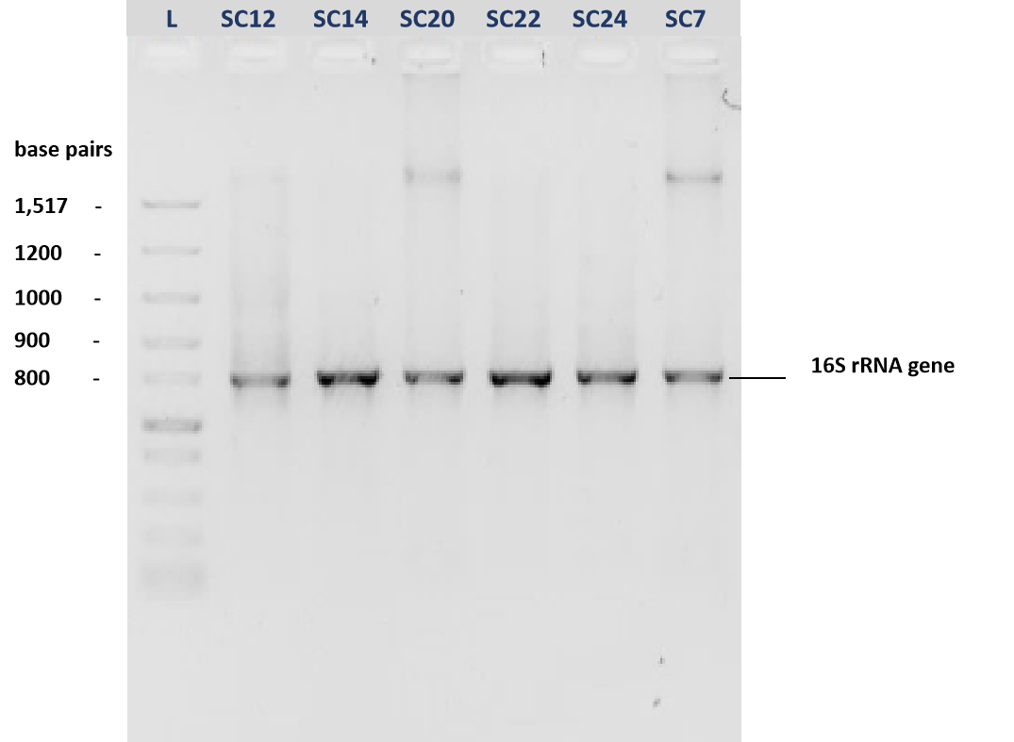
Plate 1: Agarose gel electrophoresis of the 16S rRNA gene amplicons from the bacterial isolates

Table 7 : NanoDrop spectrometry characteristics of the DNA from the isolates
S/N | Isolate code | A260 | A280 | Purity ($\frac{A260}{A280}$) | DNA Concentration (ng/μl)
1 | SC12 | 7.33 | 3.87 | 1.89 | 366.5
2 | SC14 | 7.17 | 3.89 | 1.84 | 358.6
3 | SC20 | 1.92 | 4.97 | 1.92 | 475.9
4 | SC22 | 5.85 | 3.12 | 1.88 | 292.6
5 | SC24 | 2.90 | 1.63 | 1.78 | 144.8
6 | SC7 | 1.40 | 0.77 | 1.82 | 70.2

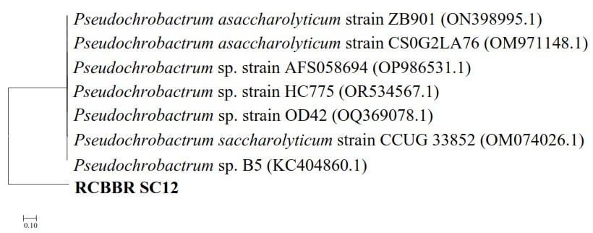
Figure 1: Neighbour-joining evolutionary relationship of isolate RCBBR_SC12 with the GenBank closest matches

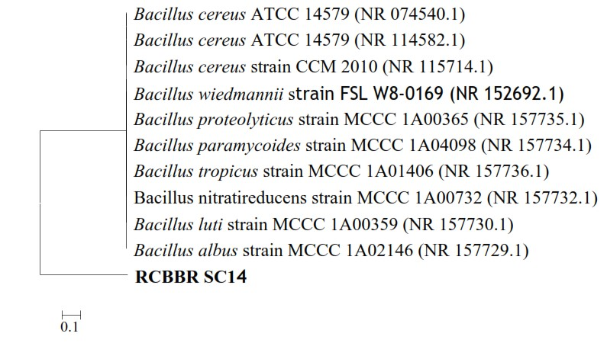
Figure 2: Neighbour-joining evolutionary relationship of isolate RCBBR_SC14 with the GenBank closest matches

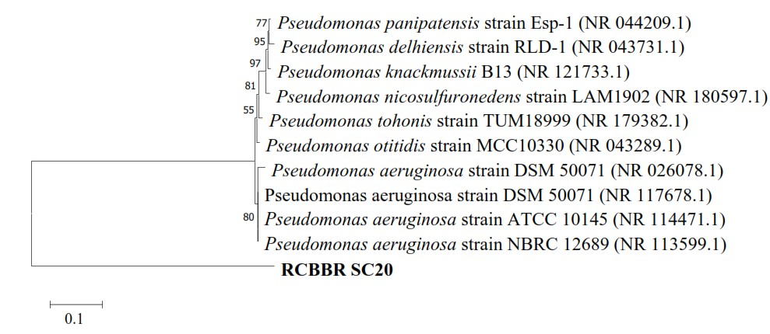
Figure 3: Neighbor-joining evolutionary relationship of isolate RCBBR_SC20 with the GenBank closest matches

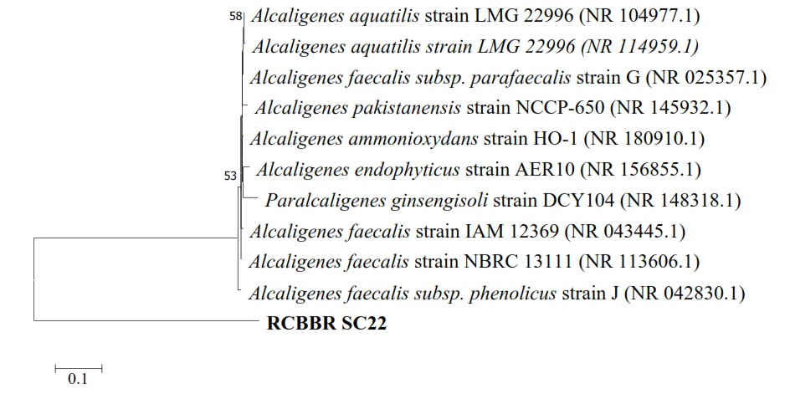
Figure 4: Neighbor-joining evolutionary relationship of isolate RCBBR_SC22 with the GenBank closest matches
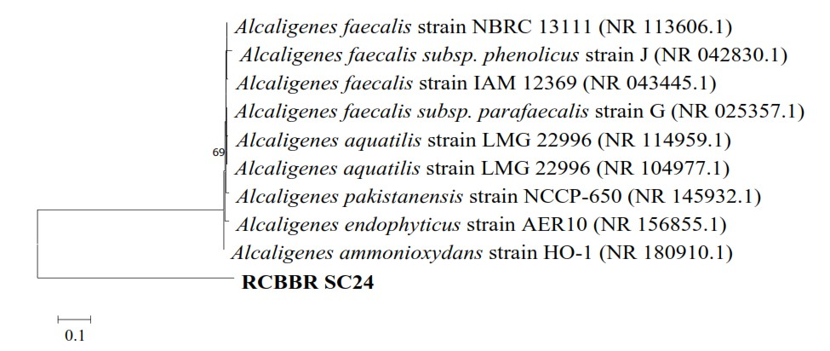
Figure 5: Neighbor-joining evolutionary relationship of isolate RCBBR_SC24 with the GenBank closest matches

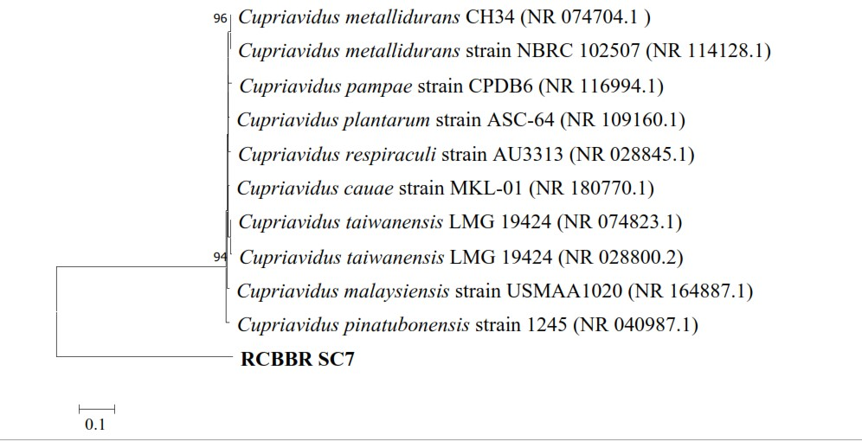
Figure 6 : Neighbor-joining evolutionary relationship of isolate RCBBR_SC7 with the GenBank closest matches
Table 8. The bacterial isolates and their closest GenBank matches
S/N | Location | Strain | Organism | Closest GenBank Match | Similarity (%) | Accession No
1 | SW2 | RCBBR_SC12 | Pseudochrobactrum sp. | Pseudochrobactrum sp. B5 | 82.31
2 | SW2 | RCBBR_SC14 | Bacillus albus | Bacillus albus strain MCCC IA02146 | 99.88 | PQ350377
3 | FWS1 | RCBBR_SC20 | Pseudomonas aeruginosa | Pseudomonas aeruginosa strain NBRC 12689 | 99.52 | PQ350378
4 | SW1 | RCBBR_SC22 | Alcaligenes faecalis | Alcaligenes faecalis subsp phenolicus strain J | 96.94 | PQ350379
5 | SWS1 | RCBBR_SC24 | Alcaligenes ammonioxydans | Alcaligenes ammonioxydans strain HO-1 | 96.91 | PQ350380
6 | SWS2) | RCBBR_SC7 | Cupriavidus pinatubonensis | Cupriavidus malaysiensis strain USMAA 1020 | 99.88 | PQ350381

Results

Physicochemical and Microbial Profile of Hydrocarbon-Impacted Aquatic Environments
The analysis of the sampled aquatic environments revealed significant variations in physicochemical parameters influenced by hydrocarbon contamination. Observed pH fluctuations indicated the presence of both acidic and alkaline conditions, likely a result of hydrocarbon degradation processes. Elevated electrical conductivity in specific samples (e.g., SW2 and SWS2) suggested an increased ionic content, potentially attributable to hydrocarbon contamination and mineral dissolution. High levels of oil and grease in sediments further confirmed the persistence of hydrocarbon pollutants, providing a substrate for hydrocarbon-degrading microorganisms. These physicochemical properties align with previous research on hydrocarbon-impacted environments in the Niger Delta, which reported similar pH fluctuations and elevated electrical conductivity due to chemical alterations induced by pollutants.
Microbiologically, the study observed an adaptive response in the microbial community. Increased hydrocarbon-utilizing bacteria (HUB) counts post-enrichment highlighted the presence of bacterial communities capable of thriving in contaminated conditions. Genera such as Staphylococcus sp., Enterococcus sp., and Pseudomonas sp. were identified as playing key roles in hydrocarbon degradation within these environments (Muhammad et al., 2024)

Molecular Identification of High-Yielding Biosurfactant-Producing Bacterial Isolates
Molecular identification via 16S rRNA gene sequencing successfully confirmed the identity of the high-yielding biosurfactant-producing bacterial isolates. DNA concentrations ranged from 358.6 to 475.9 ng/μl, with purity (A260/A280) between 1.78 and 1.92, indicating good quality DNA for sequencing.
Phylogenetic analysis revealed the close relationships of the isolated strains:
- RCBBR_SC12 was closely related to Pseudochrobactrum sp. (82.31%).
- RCBBR_SC14 was identified as Bacillus albus (99.88%).
- RCBBR_SC20 showed close relation to Pseudomonas aeruginosa (99.52%).
- RCBBR_SC22 was closely related to Alcaligenes faecalis (96.94%).
- RCBBR_SC24 was identified as Alcaligenes ammonioxydans (96.91%).
- RCBBR_SC7 was closely related to Cupriavidus malaysiensis (99.88%).
These identifications, supported by GenBank accession numbers, validate the strains for further biosurfactant research and industrial applications. This confirms that specific bacterial strains, particularly from the genera Alcaligenes, Pseudomonas, Cupriavidus, Bacillus, and Pseudochrobactrum, exhibited high biosurfactant-producing abilities.

Discussion
The results revealed notable variations in the physicochemical properties of water and sediment samples across different locations. pH values ranged from acidic (5.74 in SW3) to highly alkaline (9.59 in FWS1), indicating diverse environmental conditions. Electrical conductivity was highest in SW2 (590.21 µS/cm), while nitrate, nitrite, and sulphate levels varied significantly, with the highest nitrate concentration recorded in SWS1 (92.46 ppm). Oil and grease (O&G) contamination was particularly high in sediment samples, with SWS2 showing the highest concentration (415.95 ppm). The microbiological assessment demonstrated substantial HUB activity, with significant increases in bacterial counts after enrichment, particularly in crude oil-enriched media. The highest HUB count after enrichment was observed in SW5 (454 × 10⁵ CFU/ml), indicating substantial microbial adaptation to hydrocarbon presence.
The findings of this study significantly advance our understanding of biosurfactant-producing bacteria in the hydrocarbon-impacted aquatic environments of the Niger Delta. The observed physicochemical characteristics of the sampled sites, including variations in pH and elevated electrical conductivity, corroborate previous research indicating that hydrocarbon contamination profoundly alters environmental conditions. The persistence of oil and grease confirms the ongoing challenge of pollution, but also highlights the ecological niche available for hydrocarbon-degrading microorganisms. The increased counts of hydrocarbon-utilizing bacteria (HUB) after enrichment, particularly the prevalence of Staphylococcus sp., Enterococcus sp., and Pseudomonas sp., underscore the adaptive capacity of indigenous microbial communities in response to pollutant stress (Muhammad et al., 2024). This aligns with literature suggesting that specific bacterial phyla like Proteobacteria and Firmicutes dominate hydrocarbon-contaminated ecosystems due to their degradative capabilities (Muhammad et al., 2024).
The results identified six bacterial isolates (SC12, SC14, SC20, SC22, SC24, and SC7) as high biosurfactant producers based on various screening assays. The isolate SC24 exhibited the highest emulsification index (96%) and oil spread diameter (25 mm), suggesting strong biosurfactant activity. Other isolates, such as SC12 (88% emulsification index) and SC14 (75% emulsification index), also demonstrated significant potential. The biochemical characterisation indicated that these isolates belonged to diverse genera, including Pseudochrobactrum, Bacillus, Pseudomonas, Alcaligenes, and Cupriavidus, with Gram-negative rods dominating the group.
The screening assays confirmed that these isolates possess the capability to synthesise biosurfactants, as evidenced by positive haemolytic activity, drop collapse tests, and significant emulsification indices. SC24, which exhibited the highest emulsification index and oil spread, is likely the most efficient biosurfactant producer. The presence of Pseudomonas and Bacillus species among the isolates aligns with previous studies which highlighted these genera as prolific biosurfactant producers. The differences in oil spread and emulsification index among the isolates suggest variability in biosurfactant composition and efficiency, probably influenced by genetic and environmental factors.
The findings are consistent with earlier studies, which indicate that Pseudomonas and Bacillus species are among the most effective biosurfactant producers (Agarry et al., 2015; Ndlovu et al., 2017). Studies by Varjani and Upasani (2019) demonstrated that Pseudomonas aeruginosa strains produced biosurfactants with emulsification indices exceeding 90%, similar to SC24 in this study.

Agarose gel electrophoresis confirmed the successful extraction of high-quality genomic DNA from all bacterial isolates. NanoDrop spectrometry indicated varying DNA concentrations, with SC20 exhibiting the highest concentration (475.9 ng/μl) and purity ratios (A260/A280) ranging from 1.78 to 1.92, suitable for sequencing. Phylogenetic analysis based on 16S rRNA sequencing identified the closest GenBank matches for each isolate, revealing high genetic similarities. RCBBR_SC12 was closely related to Pseudochrobactrum sp. (82.31%), RCBBR_SC14 to Bacillus albus (99.88%), RCBBR_SC20 to Pseudomonas aeruginosa (99.52%), RCBBR_SC22 to Alcaligenes faecalis subsp. phenolicus (96.94%), RCBBR_SC24 to Alcaligenes ammonioxydans (96.91%), and RCBBR_SC7 to Cupriavidus malaysiensis (99.88%).
The identification of these bacterial species provides crucial insights into their biosurfactant-producing capabilities. Pseudomonas aeruginosa is a well-known biosurfactant producer, particularly rhamnolipids, which are widely applied in bioremediation and industrial applications. Similarly, Bacillus albus is associated with the production of lipopeptide biosurfactants, which have applications in agriculture and pharmaceuticals. The presence of Alcaligenes and Cupriavidus species further confirms their potential role in hydrocarbon degradation and environmental remediation, given their metabolic versatility. The variation in similarity percentages (82.31% to 99.88%) suggests that some isolates may represent novel strains or exhibit genetic divergence from their closest known relatives.
These findings align with previous studies on biosurfactant-producing bacteria. Gidudu and Chirwa (2022) identified Pseudomonas aeruginosa and Bacillus species as dominant biosurfactant producers in hydrocarbon-contaminated environments. Similarly, Wang et al. (2024) reported Bacillus species as major producers of lipopeptides with strong emulsification properties. The detection of Alcaligenes species supports research by Mahjoubi et al. (2019), which highlighted their role in hydrocarbon biodegradation. However, the identification of Pseudochrobactrum sp. with a lower similarity percentage (82.31%) suggests possible genetic variation or novel biosurfactant-producing capabilities, warranting further investigation. Discrepancies in genetic similarities with previous studies may result from regional strain variations, environmental adaptations, or methodological differences in DNA sequencing.

The molecular identification of high-yielding biosurfactant producers is crucial for targeted biotechnological applications. The identification of strains closely related to Pseudochrobactrum sp., Bacillus albus, Pseudomonas aeruginosa, Alcaligenes faecalis, Alcaligenes ammonioxydans, and Cupriavidus malaysiensis provides novel insights into the specific bacterial diversity contributing to biosurfactant production in the Niger Delta. The presence of Pseudomonas aeruginosa and Bacillus species among the high-yielders is consistent with numerous studies reporting these genera as prolific biosurfactant producers (Mishra et al., 2022; Sahoo et al., 2022). The identification of Alcaligenes and Cupriavidus species further expands the known repertoire of biosurfactant-producing bacteria from this ecologically sensitive region. This genetic validation is fundamental for leveraging these strains in future bioremediation and industrial efforts.
This study underscores the critical interplay between environmental contamination, microbial adaptation, and biotechnological innovation; providing detailed physicochemical and molecular characterization, this research addresses a significant knowledge gap regarding optimal production parameters for biosurfactants from indigenous bacteria in the Niger Delta. The integration of physicochemical profiling, bacterial isolation, molecular identification, and chemical characterization provides a robust framework for developing cost-effective and environmentally friendly biotechnological solutions for oil pollution.

Conclusion
This research successfully characterized biosurfactant-producing bacteria isolated from hydrocarbon-impacted aquatic environments in the Niger Delta, highlighting their potential for environmental and industrial applications. The study confirmed that specific bacterial strains, particularly from the genera Alcaligenes, Pseudomonas, Cupriavidus, Bacillus, and Pseudochrobactrum, exhibited high biosurfactant-producing abilities. Molecular characterization validated the identity of these strains, providing the genetic basis for their biosurfactant-producing capabilities. this study provides valuable insights into the physicochemical and molecular properties of indigenous biosurfactant-producing bacteria from the Niger Delta, laying a crucial foundation for developing sustainable solutions for managing hydrocarbon pollution and supporting industrial applications.

Recommendations
Based on the findings of this study, the following recommendations are proposed:
- Genetic and Genomic Studies: Conduct whole-genome sequencing and transcriptomic studies on high-yielding bacterial strains to identify specific biosurfactant synthesis genes and regulatory pathways. This will facilitate genetic engineering approaches aimed at further enhancing biosurfactant yields.

Disclaimer (Artificial intelligence)
Option 2:
Author(s) hereby declare that generative AI technologies such as gemini 2.5 flash
have been used during the editing of this.
The input promt was
1)“ Proofread the following sentence”.
2)Arrange the following references using APA 7th edition.
3) Ensure consistency in the reference found in the text and reference section,
however, this prompt inserted some references into the work and generated non existing references; it was counterproductive as I had to revert back to manually editing the errors.

References
Aa, A. L., Ijah, U. J. J., & Ukhurebor, K. E. (2022). Bioremediation potentials of crude oil polluted soil using sawdust and poultry droppings. Journal of Applied Sciences and Environmental Management, 26(3), 523–529.

Aransiola, S. A., Zobeashia, S. L. T., Ikhumetse, A. A., Musa, O. I., Abioye, O. P., Ijah, U. J. J.,
& Maddela, N. R. (2024). Niger Delta mangrove ecosystem: Biodiversity, past and present
pollution, threat and mitigation. Regional Studies in Marine Science, 103568.

Agarry, S. E., Salam, K. K., Arinkoola, A., & Aremu, M. O. (2015). Biosurfactant production by
indigenous Pseudomonas and Bacillus species isolated from auto-mechanic soil environment
towards microbial enhanced oil recovery. European Journal of Engineering and Technology, 3(6),
27 – 39.

Chuah, L. F., Chew, K. W., Bokhari, A., Mubashir, M., & Show, P. L. (2022). Biodegradation of
crude oil in seawater by using a consortium of symbiotic bacteria. Environmental Research, 213,
113721.
Dai, X., Lv, J., Zhang, Z., & Wang, H. (2023). Bioremediation of heavy oil-contaminated intertidal
zones using slow-release nutrients and rhamnolipid biosurfactants. Journal of Environmental
Chemical Engineering, 11(2), 109323.

Darwiche, N., Dufresne, C., Chartier, A., Claude, B., Colas, C., Fougère, L., & Nehmé, R. (2024).
Glycolipid and Lipopeptide Biosurfactants: Structural Classes and Characterization—
Rhamnolipids as a Model. Critical Reviews in Analytical Chemistry, 1-21.

Domingues, P. M., Oliveira, V., Serafim, L. S., Gomes, N. C., & Cunha, Â. (2020). Biosurfactant
production in sub-oxic conditions detected in hydrocarbon-degrading isolates from marine and
estuarine sediments. International Journal of Environmental Research and Public Health, 17(5),
1746.

Fenibo, E. O., Ijoma, G. N., Selvarajan, R., & Chikere, C. B. (2019a). Microbial surfactants: the
generation multifunctional biomolecules for applications in the petroleum industry and its
associated environmental remediation. Microorganisms, 7(11), 581.

Fenibo, E. O., Douglas, S. I., & Stanley, H. O. (2019b). A Review on Microbial Surfactants: Production,
Classifications, Properties and Characterization. Journal of Advances in Microbiology, 18(3), 1–22.
https://doi.org/10.9734/jamb/2019/v18i330170

Gurkok, S., & Ozdal, M. (2023). Screening Methods for Biosurfactant-Producing
Microorganisms. In Multifunctional Microbial Biosurfactants (pp. 1-24). Cham: Springer Nature
Switzerland.

Gidudu, B., & Chirwa, E. M. (2022). Diversity of marine biosurfactant-producing bacteria and
their role in the degradation of heterogenous petrochemical hydrocarbons. In Marine Surfactants
(pp. 163-183). CRC Press.

Ma, J., Zhuang, Y., Wang, Y., Zhu, N., Wang, T., Xiao, H., & Chen, J. (2023). Update on new
trend and progress of the mechanism of polycyclic aromatic hydrocarbon biodegradation by
Rhodococcus, based on the new understanding of relevant theories: A review. Environmental
Science and Pollution Research, 30(41), 93345-93362.
Maduwuba, N. O., & Ubani, O. C. (2025). Assessment of microbial diversity in hydrocarbon-polluted aquatic environments of the Niger Delta. Journal of Environmental Science and Health, Part A, 60(1), 1–10.

Mandalenaki, A., Kalogerakis, N., & Antoniou, E. (2021). Production of high purity biosurfactants
using heavy oil residues as carbon source. Energies, 14(12), 3557.

Mahjoubi, M., Aliyu, H., Cappello, S., Naifer, M., Souissi, Y., Cowan, D. A., & Cherif, A. (2019).
The genome of Alcaligenes aquatilis strain BU33N: Insights into hydrocarbon degradation
capacity. PLoS One, 14(9), e0221574.
Mishra, R., Sahoo, N. K., & Pradhan, S. (2022). Biosurfactant production by bacteria isolated from petroleum contaminated soil and their application in enhanced oil recovery. Journal of Petroleum Science and Engineering, 216, 110756.

Ndlovu, T., Rautenbach, M., Vosloo, J. A., Khan, S., & Khan, W. (2017). Characterisation and
antimicrobial activity of biosurfactant extracts produced by Bacillus amyloliquefaciens and
Pseudomonas aeruginosa isolated from a wastewater treatment plant. Amb Express, 7, 1-19.

Nikolova, C., & Gutierrez, T. (2021). Biosurfactants and Their Applications in the Oil and Gas Industry: Current State of Knowledge and Future Perspectives. Frontiers in Bioengineering and Biotechnology, 9, 626639. https://doi.org/10.3389/fbioe.2021.626639

Odesa, G. E., Ozulu, G. U., Eyankware, M. O., Mba-Otike, M. N., & Okudibie, E. J. (2024). A
holistic review of three-decade oil spillage across the Niger Delta Region, with emphasis on Its
impact on soil and water. World Science. News, 190, 119-139.
Onyena, A. P., & Sam, K. A. (2020). Crude oil pollution and its environmental impacts on the Niger Delta region of Nigeria. Journal of Environmental Science and Management, 23(2), 145–154.

Osadebe, A. U., Ogugbue, C. J., & Okpokwasili, G. C. (2023). Diversity and degradative potency
of extant autochthonous crude oil-metabolizing species in a chronically polluted river. Pollution,
9(2), 795-809.

Patel, V., Shah, S., Patel, K., & Sharma, M. (2023). Biosurfactants: A green solution for sustainable bioremediation of hydrocarbon polluted sites. Environmental Science and Pollution Research, 30(35), 83457–83472.

Sahoo, N. K., Mishra, R., & Pradhan, S. (2022). Isolation, screening and characterization of biosurfactant producing bacteria from petroleum contaminated soil and their application in enhanced oil recovery. Journal of Petroleum Science and Engineering, 216, 110756.

Shuai, Y., Zhou, H., Mu, Q., Zhang, D., Zhang, N., Tang, J., & Zhang, C. (2019). Characterization
of a biosurfactant-producing Leclercia sp. B45 with new transcriptional patterns of alkB gene.
Annals of Microbiology, 69, 139-150.

Twigg, M. S., Baccile, N., Banat, I. M., Déziel, E., Marchant, R., Roelants, S., & Van Bogaert, I.
N. (2021). Microbial biosurfactant research: time to improve the rigour in the reporting of
synthesis, functional characterization and process development. Microbial Biotechnology, 14(1),
147-170.

Varjani, S., & Upasani, V. N. (2019). Evaluation of rhamnolipid production by a halotolerant novel
strain of Pseudomonas aeruginosa. Bioresource Technology, 288, 121577.

Wang, M., Zhang, W., He, T., Rong, L., & Yang, Q. (2024). Degradation of polycyclic aromatic
hydrocarbons in aquatic environments by a symbiotic system consisting of algae and bacteria:
green and sustainable technology. Archives of Microbiology, 206(1), 10.

