MAXILLARY ACTINOMYCOSIS IN A CROSSBRED COW: A CASE REPORT ON DIAGNOSIS AND TREATMENT UNDER RESOURCE CONSTRAINTS
Abstract
Bovine actinomycosis, or lumpy jaw, in cattle is caused by Actinomyces bovis, which produces chronic rarefying osteomyelitis of facial masticatory bones. This leads to painful swelling, dysphagia, and weight loss, significantly impacting the animal's health and productivity. A 3.5-year-old crossbred cow with a history of gradually increasing swelling on the left maxillary region with decreasing feed intake was presented for treatment at Veterinary Clinical Complex, Veterinary College and Research Institute, Theni, Tamil Nadu. Clinical examination revealed a hard, painful, immovable mass with no discharge. Hence, for diagnosis, fine needle aspiration biopsy (FNAB) was taken, and the smear was stained with Gram stain. This revealed filamentous Gram-positive bacteria with surrounding Gram-negative club-shaped structures characteristic of actinomycosis. After confirming actinomycosis, the animal was treated with antibiotics, non-steroidal anti-inflammatory drugs, and iodides. Additionally, TissueAid bolus was advised for oral administration along with topical application with glycerine and magnesium sulphate. The animal exhibited symptomatic improvement during subsequent visits, with a gradual enhancement in feed intake and reduction in swelling following the treatment.
Introduction
Actinomycosis is a less commonly reported bacterial infection, that affects the bones of the skull, especially the mandible and maxilla. Bovine actinomycosis, also called Lumpy Jaw, is primarily caused by a gram-positive, microaerophilic to anaerobic, filamentous bacterium called Actinomyces bovis (Willey et al., 2017). They are normal inhabitants of the oronasal, upper respiratory and digestive tracts (Roa et al., 2012). Animals are predisposed to actinomycosis either through the mucosal damage by sharp objects ingested along with feed, through oral ulcers induced by viral infections or due to dental problems. Following the entry and colonization of the bacteria, localized inflammation and tissue necrosis occur. This creates a conducive environment for bacterial proliferation and persistence, leading to chronic, granulomatous osteomyelitis. The lesion may also extend deep into the bony tissues and the adjacent soft tissue. Bovine actinomycosis is characterized by hard, painful swelling, accompanied by a fistulous tract that discharges pus resembling sulfur granules. The bacterium is also known to produce chronic nodular suppurative lesions in soft tissue at various anatomical sites (Gensa, 2018).
A tentative diagnosis of the disease is made based on the physical examination and clinical signs (Radostits et al., 2007). The preferred direct identification technique is gram staining of the pus or the biopsy samples, bacterial isolation can be attempted using anaerobic culture media, but it is challenging. Imaging techniques such as radiography and ultrasonography are useful in determining the extent of the lesion and its progression. However, bacterial isolation and imaging may not always be possible in resource-limited settings. We report a case of maxillary actinomycosis in a crossbred cow, which was diagnosed based on clinical observations and simple procedures. This manuscript highlights the practical approach to diagnosing and treating maxillary actinomycosis in cattle under resource-limited conditions. The successful use of fine needle aspiration biopsy and basic Gram staining offers a cost-effective diagnostic alternative for under-equipped veterinary settings. It also emphasizes the efficacy of a simple therapeutic protocol. It contributes to the existing knowledge on bovine actinomycosis and supports the development of accessible veterinary care in low-resource areas.
Case presentation and diagnosis
A 3.5-year-old crossbred cow was presented to the Veterinary Clinical Complex, Veterinary College and Research Institute, Theni with a history of swelling in the left maxillary region for the past 6 months without any discharge and decreasing feed intake. The vital parameters such as rectal temperature was 104.1⁰F and heart rate was 68 beats/ min. Clinical examination revealed a left distorted jaw carrying an asymmetrical hard mass. The mass felt firm, immovable and painful on palpation. The mass was irregularly polygonal, measuring 111.6 mm in length medially and 57.47 mm laterally. Its width ranged from 124.37 mm at the widest point to 116.05 mm at the narrowest region (Fig. 1). The animal remained alert with excessive lacrimation, salivation and enlarged left submandibular lymph node. Oral examination revealed the absence of any foreign body or feed impaction. Sample was collected using a fine needle by aspiration and sent for cell cytology and microbiological investigation. Cell cytology was performed to differentiate the mass, providing critical data to rule out tumors or other inflammatory conditions.
Results
Cytology revealed the presence of lymphocytes, mature neutrophils, mesenchymal and osteocytes suggestive of chronic infection. Gram staining of the smear from fine needle aspiration (FNAB) revealed the presence of Gram-positive, purple-coloured, long filaments and short V, Y and T-shaped structures (Fig. 2). They were surrounded by club-shaped structures that stained Gram-negative. This is characteristic of Actinomyces or ray fungus.
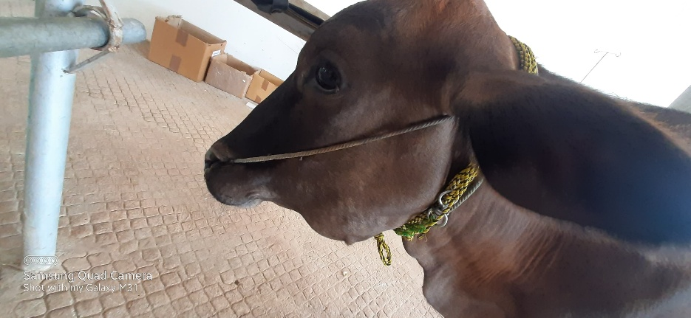 | 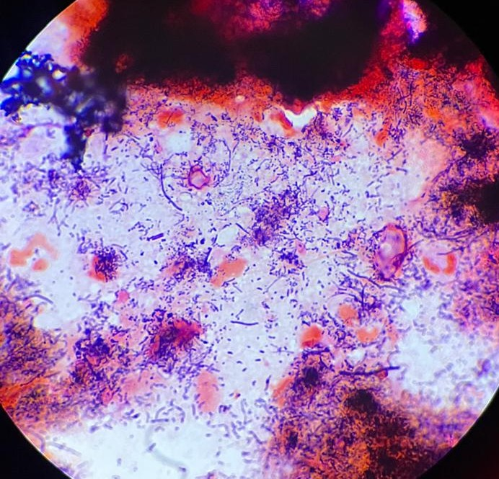
Fig. 1: 3.5-year-old crossbred cow showing hard mass in the left maxillary region. | Fig. 2: Gram staining of smear obtained through FNAB revealing long filaments and short V, Y and T shaped gram-positive bacteria with surrounding Gram-negative club shaped structures.

Treatment
The cow received an injection of Benzathine penicillin at 15 mg/kg body weight, an injection of Flunixin at 2 mg/kg, and an injection of Chlorpheniramine maleate at 10 mg/kg intramuscularly for 5 days. Additionally, it was given bolus Tissue Aid and a bolus containing Meloxicam, Paracetamol, and Serratopeptidase at 1 bolus per day for 3 days. The latter one contained 100 mg of Meloxicam, 1800 mg of Paracetamol, and 50 mg of Serratopeptidase in each bolus. Along with this, Potassium Iodide at 10 gm daily for 10 days was administered. Glycerine and Magnesium sulfate were recommended for topical application.
Discussion
Lumpy jaw, a chronic rarefying osteomyelitis of the jaw bone in cattle, results from an endogenous infection caused by the commensal bacterium Actinomyces bovis. Actinomyces belongs to the family Actinomycetaceae within the order Actinomycetales, which also includes the Corynebacteriaceae, Mycobacteriaceae, and Nocardiaceae families. Most bacteria in this order possess mycolic acid in their cell walls, although the level varies, leading to acid-fast or non-acid-fast classifications. Actinomyces are non-acid-fast bacteria with lower levels of mycolic acid in their cell walls. They are Gram-positive, non-motile, non-spore-forming, filamentous bacteria, representing a transitional form between bacteria and fungi.
Actinomyces bovis is the most prevalent species in cattle, followed by Actinomyces israelii in humans, with rare occurrences in pigs and cattle, and A. viscosus in dogs (Könönen and Wade, 2015; Mohamed et al., 2011). Actinomycosis occurs sporadically but is common in cattle and has been reported worldwide, though it is infrequently seen in pigs, dogs, horses, goats, and humans. In cattle, the common areas of infection include the cheek muscles, mandible, and maxillary bones. In pigs, the udder is commonly affected, while in horses, the withers and poll are typically involved.
Actinomycosis of jaw bones may induce pain, further interfering with prehension, mastication, proper digestion and respiration. Eventually leading to dyspnoea, partial starvation, progressive loss of condition, weight loss with intermittent diarrhoea, bloat etc. contributing to significant economic loss. The condition has to be differentiated from abscesses of the cheek muscles and throat region, actinobacillosis, neoplasm of bones, tooth infection, fractures of jaw bones and bone sinusitis (Radostits et al., 2007). In case of abscess or actinobacillosis, the mass is movable and generally localized in soft tissue. The consistency of the pus varies depending on the duration of infection. Whereas in the case of actinomycosis, the mass is immovable and the pus discharged is yellow, resembling sulphur granules.
Actinomyces establishes a chronic, suppurative, granulomatous infection. Unlike the classical pathogens, Actinomyces do not produce any exotoxins, but they are capable of evading the host immune response by producing biofilms, cell-associated /extracellular polymers such as dextran, levan, N-acetylglucosamine-rich slime polysaccharides enabling them to attach to the adjacent bacteria or foreign surfaces (Gajdács and Urbán, 2020). Additionally, they possess certain types of fimbriae for adhesion and for co-aggregation with other bacteria in soft tissue lesions.
The most preferred samples for the diagnosis of Actinomycosis are smears from aspiration biopsy and crushed pus. Fine needle aspiration biopsy (FNAB) is more safer, quicker, convenient, inexpensive and less invasive technique that can be performed with minimal facilities (Wong et al., 2011). Biopsy samples are generally more effective for diagnosing actinomycosis since the lesion is sterile in approximately 50% of cases, rendering swab samples less reliable. Diagnosis is based on clinical examination, Gram staining of the biopsy, microbial culture, cytology, and imaging techniques. Among them, Gram staining is considered the gold standard test and a more sensitive test with most of clinical forms (Valour et al., 2014). The bacteria appear as Gram-positive tangled filaments surrounded by Gram-negative club-shaped structures which protect them from phagocytosis, thereby establishing a chronic infection (Wong et al., 2011).
Mandibular actinomycosis in bovines has been reported from various parts of India in recent years (Rajesh kumar and Archanakumari, 2017; Dhillon et al., 2020; Ganapathi et al., 2022). Renu Singh et al., (2017) reported a nasal form of actinomycosis. In most of the cases, diagnosis is based on clinical examination and staining characteristics.
Penicillin, streptomycin, oxytetracycline, bacitracin, cloxacillin, dicrystin-DS, and isoniazid are effectively used to treat actinomycosis in bovines (Ganapathi et al., 2022). In this case study, an intramuscular injection of benzathine penicillin, along with an injection of flunixin and chlorpheniramine maleate, was administered for five days. Tissue aid and potassium iodide were also administered orally. Tissue Aid, a proprietary ayurvedic product, is known to reduce inflammation. Additionally, bolus containing Meloxicam, Paracetamol, and Serratopeptidase was given and reduce the inflammatory process Potassium iodide, considered the treatment of choice for actinomycosis, was given until the animal developed iodism, with a maximum duration of ten days (Radostits et al., 2007). Glycerine and magnesium sulfate were advised for topical application to reduce swelling. Bovine actinomycosis was successfully treated by parenteral administration of penicillin and streptomycin, along with oral administration of potassium iodide, as reported by Pal et al., 2008 and Patel et al., 2016. Constable et al., 2017, and others reported that the slow intravenous administration of a 10% solution of sodium iodide at 70 mg/kg was also effective. Surgical debridement and cryotherapy, using liquid nitrogen, may be effective in advanced cases and for poor responders.
Prompt treatment intervention is crucial for managing actinomycosis before the lesion progresses and becomes fibrosed. Early diagnosis and treatment are important, as the onset of the disease may not be readily apparent. Proactive measures, such as preventing oral injuries from sharp items or dental problems, can significantly reduce the risk of actinomycosis. Furthermore, isolating animals with pus discharge is advisable, even though the disease is generally not contagious and primarily linked to predisposing oral wounds, thereby minimizing environmental contamination. Proper preventive measures and proactive management are key to addressing this challenging condition effectively. The animal exhibited symptomatic improvement during subsequent visits, with a gradual enhancement in feed intake and reduction in swelling following the treatment.
Conclusion
Bovine actinomycosis or lumpy jaw occurs as a chronic, endogenous, suppurative infection affecting the bones of mastication in cattle. It is an economically important disease, especially in dairy cattle, because it interferes with prehension and mastication leading to reduced feed intake and production. The condition is effectively diagnosed based on the staining of pus or smears from samples obtained through FNAB. Combining FNAB with Gram staining helps in rapidly diagnosing actinomycosis in field conditions, particularly in resource-constrained areas where access to advanced diagnostics may be limited. This approach offers a cost-effective, easily implementable, and sensitive means for diagnosis. This also enables early diagnosis and further treatment of actinomycosis cases, which is crucial to prevent severe bone damage, deformity, and minimize economic impacts, as well as to reduce animal suffering and improve recovery. Successful management of actinomycosis using conventional therapy with antibiotics and iodides is highly effective, easily accessible, and readily administered, making it an ideal approach compared to cryotherapies or surgical debridement procedures. The strategy outlined above has broader implications for veterinary practice, particularly in resource-constrained rural settings.
DISCLAIMER (ARTIFICIAL INTELLIGENCE)

Author(s) hereby declare that NO generative AI technologies such as Large Language Models (ChatGPT, COPILOT, etc.) and text-to-image generators have been used during the writing or editing of this manuscript.
ACKNOWLEDGEMENT
The authors thank Tamil Nadu Veterinary and Animal Sciences University for the financial support to carry out this research work.
COMPETING INTERESTS
Authors have declared that no competing interest exist.
REFERENCES
Constable, P. D., Hinchcliff, K. W., Done, S. H., Grünberg, W. (2017). Veterinary Medicine: A Textbook of the Diseases of Cattle, Horses, Sheep, Pigs, and Goats. W.B. Saunders Ltd.
Dhillon, K. S., Kaur, S. J., Khanmotra, A. (2020) Actinomycosis in a Holstein heifer: Diagnosis, treatment and management. Journal of Entomology and Zoology Studies. Journal of Entomology and Zoology Studies 2020; 8(3): 104-106
Gajdács, M., Urbán, E. (2020). The Pathogenic Role of Actinomyces spp. and Related Organisms in Genitourinary Infections: Discoveries in the New, Modern Diagnostic Era. Antibiotics, 9(8), 524.
Ganapathi, D. P., Hariharan, D. T., Subash, D. R., Kavithaa, D. N. (2022). Treatment of bovine actinomycosis in crossbred cow: A case report. The Pharma Innovation Journal 2022; SP-11(3): 609-611
Gensa, U. (2018). Review on Actinomycosis in Cattle. Journal of Biology, Agriculture and Healthcare, 8(13), 60.
Könönen, E., Wade, W. G. (2015). Actinomyces and Related Organisms in Human Infections. Clinical Microbiology Reviews, 28(2), 419–442. https://doi.org/10.1128/CMR.00100-14
Mohamed, T., Al-Sobayil, F., Kurwasawa, T., Nakade, T., Floeck, M. (2011). Computed tomographic findings in a calf with actinomycosis: A case report. Veterinární Medicína, 56(5), 255–259.
Pal B, Mandial RK, Wadhwa DR, Thakur YP, Dhar P. (2008) Actinomycosis in Cattle and its Clinical Management; Intas Polivet ; Vol. 9 No. II:253-254
Patel BR, Patel JS, Parmar SC. (2016) Clinico-Therapeutic Management of Actinomycosis in a Buffalo. Intas Polivet; 17:575-577.
Radostits OM, Gay CC, Blood DC, Hinchcliff KW. (2007) Veterinary Medicine, 9th ed, 1045-1046. London.W.B.Saunders.
Rao, J.U., Rash, B.A., Nobre, M.F., Da Costa, M.S., Rainey, F.A., Moe, W.M. (2012) Actinomyces naturae sp. nov., the first Actinomyces sp. isolated from a non-human or animal source. Antonie Van Leeuwenhoek, 101(1), pp.155-168.
Renu Singh, G. A. C., Satbir Sharma, S. S., Rath, A. P. (2017). Nasal Granuloma in Buffalo: An Unusual Case of Actinomycosis. International Journal of Current Microbiology and Applied Sciences, 6(4), 762–765.
Rajesh Kumar, Archanakumari (2017) Clinical management of actinomycosis in bovines. Journal of Pharmacognosy and Phytochemistry 2017; SP1: 509-510.
Valour, F., Sénéchal, A., Dupieux, C., Karsenty, J., Lustig, S., Breton, P., Gleizal, A., Boussel, L., Laurent, F., Braun, E., Chidiac, C., Ader, F., Ferry, T. (2014). Actinomycosis: Etiology, clinical features, diagnosis, treatment, and management. Infection and Drug Resistance, 7, 183–197.
Willey, J. M., Sherwood, L., Woolverton, C. J. (2017). Prescott’s Microbiology. McGraw-Hill Education.
Wong, V. K., Turmezei, T. D., Weston, V. C. (2011). Actinomycosis. BMJ (Clinical Research Ed.), 343, d6099.

