***Case report***

**Sudden Death in a Buffalo Due to Pulmonary Tuberculosis: Diagnostic and Zoonotic Implications**

ABSTRACT

Bovine tuberculosis (bTB), primarily caused by Mycobacterium bovis, is a chronic infectious disease of domestic and wild animals with significant zoonotic implications. This report describes a fatal case of pulmonary tuberculosis in a buffalo (Bubalus bubalis), emphasizing the diagnostic challenges and public health concerns associated with the disease. A adult female buffalo was brought to the Veterinary Clinical Complex (VCC) with clinical signs including anaemia, anorexia, respiratory distress, poor body condition, severe weight loss and exercise intolerance. The animal was admitted to the In-Patient Department (IPD) for symptomatic treatment. Despite supportive care, the buffalo collapsed and died suddenly on the second day of hospitalization. Post-mortem examination revealed multiple caseous and calcified granulomas in the whole thoracic cavity. Histopathological analysis showed granulomatous inflammation with Langhans giant cells. Ziehl-Neelsen staining confirmed the presence of acid-fast bacilli (AFB), consistent with Mycobacterium bovis infection. These findings led to a definitive diagnosis of pulmonary tuberculosis. This case highlights the importance of including tuberculosis in the differential diagnosis of buffaloes presenting with chronic wasting and respiratory signs. Early detection and confirmation through post-mortem and laboratory diagnostics are critical on order to prevent further spread. Given its zoonotic potential, this report highlights the importance of regular surveillance, public health awareness and coordinated One Health strategies for the effective management of bovine tuberculosis (bTB) in livestock.

Key words: tuberculosis, Mycobacterium bovis, buffalo, Langhans giant cells, acid fast bacilli

INTRODUCTION

Tuberculosis is a chronic, progressive, granulomatous and infectious disease caused by microorganisms belonging to the *Mycobacterium tuberculosis* complex (MTC) and can affect human beings and various animal species. Among these, *Mycobacterium bovis* is an important pathogen, resulting in zoonotic tuberculosis in humans and bovine tuberculosis (bTB) in animals, and is currently endemic in many parts of the world. In India, the prevalence of bTB in cattle is estimated to be 7.3%, i.e., around 21.8 million cattle are affected with bovine tuberculosis. This burden is expected to eventually rise in the upcoming years due to several contributing factors like the rapid intensification of the dairy industry, enhanced cattle rearing methods and growing focus on improving the per-animal productivity (Srinivasan et al., 2018). In areas of endemicity, infection can spill over to cattle, other domestic animals, vulnerable wildlife species and humans (Zachary et al., 2017). Due to its zoonotic potential, *M. bovis* results not only in significant sources of infection but also has a substantial impact on economics and trade barriers of countries where bTB is widespread, primarily in Africa and Southeast Asia (WHO, 2017). Due to a lack of routine surveillance data, the actual burden of zoonotic TB is likely underestimated. Nonetheless, in 2016 there were an estimated 147,000 new cases of zoonotic TB in humans, and 12,500 related deaths globally (WHO, 2017). India particularly bears a heavy toll of tuberculosis; according to the Global Tuberculosis Report 2021, about 26% of the TB cases reported worldwide in 2020 were from India and 34% of TB deaths globally in humans in 2020, the highest of any nation (WHO, 2021). Furthermore, the National Tuberculosis Prevalence Survey (2019–2021) reported a TB prevalence of 3,120 cases per million population in India for the year 2021.

In a country with such a high human TB burden, it is imperative to implement effective strategies to curb the spread of the disease as early as possible. In buffaloes, the disease often manifests subclinically, making detection and control challenging but advanced stages may show signs of debilitation and respiratory distress. Water buffaloes are susceptible to a range of infectious diseases including foot-and-mouth disease, bovine viral diarrhea, brucellosis, leptospirosis, fasciolosis, babesiosis, theileriosis, and tuberculosis - all of which have significant economic implications. Moreover, buffaloes also play a role in transmitting zoonotic diseases like schistosomiasis (Batista et al., 2020, Villanueva et al., 2018), human Q fever, *Coxiella burnetii* in milk (Khademi et al., 2019), and Mycobacterium bovis, further contributing to the zoonotic spread of tuberculosis. Bovine tuberculosis remains a big obstacle to achieving the universal control program that aims to end tuberculosis by 2030 (WHO, 2019). Human infection with *M. bovis* has been documented since the 19th and early 20th centuries and primarily linked to the consumption of raw or unpasteurized milk (Thoen et al., 2007). Despite advancements in food safety and veterinary practices, zoonotic transmission of M. bovis continues to pose a challenge, particularly in low- and middle-income countries where routine surveillance and pasteurization practices may be inadequate. The causative agent of bovine tuberculosis is *Mycobacterium bovis*, a member of Mycobacteriaceae family and the genus Mycobacterium. The bacteria is short, non-capsulated, not flagellated, non-motile, facultative intracellular, and aerobic (Andreazza et al., 2015). Transmission occurs primarily through aerosolized particles released when infected animals cough or sneeze. Moreover, the digestive and respiratory systems serve as the basic route of infection. However, aerosol exposure to *M. bovis* is considered to be the most frequent route of infection among cattle, but infection by ingestion of contaminated feed or water, direct contact with infected animals or interaction with wildlife reservoirs can also occur (OIE Manual. 2016). It is characterized by the development of non-vascular granulomas or tubercles which occur most frequently in lungs, lymph nodes, liver, intestine, and kidney. Clinical signs typically include emaciation, chronic coughing, and progressive weight loss. Furthermore, beef and/or [buffalo](https://www.sciencedirect.com/topics/veterinary-science-and-veterinary-medicine/buffalo) meat consumption in India is 42g/capita/month (NSSO, 2014). India is also the second largest exporter of meat products in the world. About 1.5 million tons of buffalo meat is produced in India annually, accounting for about 30% of total meat production (CPCB, 2017). This highlights the importance of buffalo health to the Indian economy and human health.

**History and Clinical Presentation:**

A seven years old female buffalo was presented to the Veterinary Clinical Complex (VCC) with symptoms of anaemia, anorexia, respiratory distress, poor body condition and exercise intolerance. The owner reported progressive weight loss and reduced productivity. The animal had been exhibiting these signs for an unspecified period prior to its presentation. Clinical examination revealed emaciation, dullness, open mouth breathing (Fig.1) and mild tachypnea.

No specific localized lesion or abnormality was detected externally. Due to the severity of its condition, it was admitted to the **In-Patient Department (IPD)** for close monitoring and treatment. The buffalo was managed **symptomatically** upon admission, with supportive treatment aimed at stabilizing its condition. However, no significant clinical improvement was observed. On the **second day of hospitalization**, the buffalo **suddenly collapsed** and **died within minutes**, despite emergency intervention. Given the unexpected nature of the death, a **post-mortem examination** was conducted.

MATERIAL AND METHODS

Suspected tuberculosis lesions from tissue segments were collected and kept in 10% formalin. Samples were trimmed into small specimens containing tubercles. The samples were sent to the pathology laboratory for further processing. All samples were routinely processed by histological technique, sectioned at 4- 5µm, stained with Haematoxylin and Eosin, and examined under light microscopy connected to a camera and image analyzer. The microscopic examination of the tissue sections confirmed the features of tuberculosis granulomatous lesions. The lesions appeared as oval or round with a non-regular central area of mineralized necrotic caseous substance covered by a solid broad layer of collagenous connective tissue invaded by diverse inflammatory cells. The granular necrotic caseous substance stained weakly to moderately eosinophilic, accompanied by the focal accumulation of basophilic chromatin debris that appeared as dotting of diffuse zones. Moreover, numerous neutrophils and degenerated leucocytes were scattered throughout the necrotic foci, accompanied by small or large mineralized foci. Layers of inflammatory cells circumscribed caseous necrotic lesions were seen that was invaded with numerous epithelioid macrophages, multinucleated cells, lymphocytes, macrophages, and Langhan's giant cells that were enclosed completely by solid collagenous connective/fibrous capsule. For microbiological investigation, a group of tubercles were collected, kept in a sterile container, and transferred to the clinical pathology laboratory. The sheath of the tubercles was removed, and the contents were homogenized manually using a sterile glass mortar. The homogenized tissue was suspended in 10 ml of 4% NaOH in a test tube, shaken thoroughly, and settled for 10 minutes. Finally, the sample was centrifuged for 10 minutes at 3000 rpm, and then sediment was collected after the supernatant was discarded. Thereafter, sterile normal saline was added and appropriately mixed with sediment and centrifuge at 3000 rpm for 10 minutes. This process was repeated 3 times to neutralize the sample completely. The supernatant was removed, and direct smears were prepared from the sediment on a cleaned glass slide, stained with conventional acid-fast stain (Ziehl Neelsen staining). The slides were allowed to air-dry and examined with a light microscope under an oil immersion objective lens (X100) to investigate the presence of acid-fast bacilli, which is considered a primary diagnostic tool. The examination of slides revealed somewhat curved and red rods that were seen alone or aggregated as clusters, indicating the tuberculosis bacilli.

RESULTS AND DISCUSSION

The necropsy revealed the following findings suggestive of **Tuberculosis** (Fig. 2,3,4,5,6).

* **Multiple caseous granulomas** in the lungs and associated lymph nodes (mediastinal and bronchial),
* **Adhesions and fibrosis** in pleural surfaces,
* **Firm, enlarged lymph nodes** with central necrosis,
* **Extensive nodules** scattered throughout lung parenchyma,
* On histopathology, **granulomatous lesions** with central necrosis surrounded by epithelioid macrophages and Langhans giant cells,
* **Acid-fast bacilli (AFB)** were demonstrated in tissue samples using **Ziehl-Neelsen staining.**

Tuberculosis in buffaloes is often misdiagnosed due to its slow progression and the presence of non-specific clinical signs. In this case, Sudden death in this case was likely due to acute respiratory failure resulting from extensive pulmonary compromise. Necropsy revealed massive granulomatous lesions occupying large areas of lung parenchyma, impairing gas exchange. Additionally, rupture or coalescence of necrotic lesions may have contributed to rapid decompensation. The progressive hypoxia and inability to compensate under minimal stress could have precipitated sudden cardiopulmonary collapse. Given the non-specific clinical signs such as anorexia, anaemia, respiratory distress, exercise intolerance and progressive weight loss, several differential diagnoses were considered in this case. Conditions like theileriosis, known to cause anaemia and emaciation; pasteurellosis, which often presents with acute respiratory signs and fever; pericarditis, which may lead to respiratory difficulty due to cardiac compression; chronic parasitic infestations, particularly lungworm infections; and bovine leukosis, were included as potential causes. However, the absence of hemoparasites on blood smear, lack of typical cardiac auscultatory findings or distension indicative of pericardial involvement, and unresponsiveness to antiparasitic and antibiotic therapy reduced the likelihood of these conditions. The diagnosis of tuberculosis was based on the presence of characteristic gross and microscopic lesions attributed to Mycobacterium bovis. This disease poses a major economic burden on the livestock industry, including carcass condemnation and reduced milk yield. Beyond these direct losses, tuberculosis presents a significant public health threat, and the cost of eradication programs is substantial (Buddle et al., 2015). Mycobacterium bovis is a member of the Mycobacterium tuberculosis complex, a group of closely related pathogens of critical clinical importance responsible for tuberculosis in both animals and humans. While M. tuberculosis is the predominant cause of human TB, zoonotic tuberculosis is attributed to animal-associated species such as M. bovis, M. caprae, M. orygis, M. microti, M. canettii, M. pinnipedii, M. suricattae, and M. mungi, though these are less well understood (Olea-Popelka et al., 2017). In this case study, clinical signs were largely non-specific and became evident only upon postmortem examination and histopathological investigation, which confirmed the disease as tuberculosis. Gross lesions revealed thousands of variably sized tubercles, from small miliary foci to large, caseated and calcified tubercles surrounded by dense connective tissue infiltrated with inflammatory cells. Some lesions contained mineralized material arranged in a lamellar pattern beneath a fibrous capsule. Granulomatous lesions were widespread in the lungs and thoracic lymph nodes, consistent with tuberculosis. Histopathological examination corroborated the gross findings. Furthermore, Ziehl-Neelsen (Z-N) staining of tissue smears revealed red, straight or slightly curved acid-fast bacilli, seen singly or in clusters, indicative of Mycobacterium spp. However, despite the suggestive nature of these findings, the diagnostic methods employed—namely gross pathology, histology, and Z-N staining—have notable limitations. These techniques, while supportive, are not definitive for tuberculosis because other organisms such as Nocardia spp. or Rhodococcus equi may produce similar granulomatous lesions and can also appear acid-fast under Z-N staining (Thoen et al., 2006; Quinn et al., 2011). Thus, while Z-N staining confirms the presence of acid-fast bacilli, it cannot distinguish between different species within or outside the Mycobacterium genus. Ante-mortem diagnosis of bTB in buffaloes is notoriously difficult. The tuberculin skin test, though widely used, has low sensitivity in buffaloes and may yield false negatives in advanced or immuno-suppressed cases. In this case, no ante-mortem diagnostics were feasible due to the animal’s critical state. Definitive diagnosis ideally requires more specific methods such as bacterial culture or molecular techniques like polymerase chain reaction (PCR), which provide species-level identification. However, such advanced diagnostics are often not feasible in resource-limited settings due to their high cost, need for specialized infrastructure, and longer turnaround time (de la Rua-Domenech, 2006). Following this case, an epidemiological inquiry was conducted. No formal screening (e.g., tuberculin testing) of in-contact animals was undertaken, highlighting a gap in farm-level disease containment practices. In endemic regions, herd testing and isolation of positive animals are essential to prevent ongoing transmission. Given the high prevalence of bovine tuberculosis in many endemic regions, preliminary findings such as those in this case should serve as a strong alert to veterinary and public health authorities. They underscore the urgent need for improved diagnostic infrastructure, routine surveillance, and public health education under the One Health framework to mitigate zoonotic transmission and economic losses. Under this approach we have to establish partnerships between **public health departments, veterinary services, wildlife agencies**, and **environmental bodies**. Besides that we should share data and resources on disease outbreaks, surveillance, and health trends.

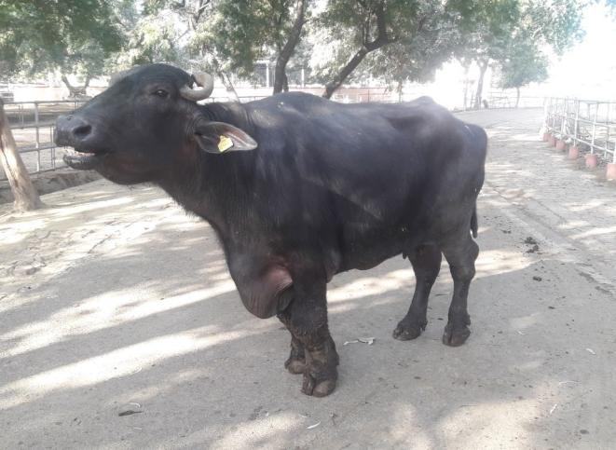

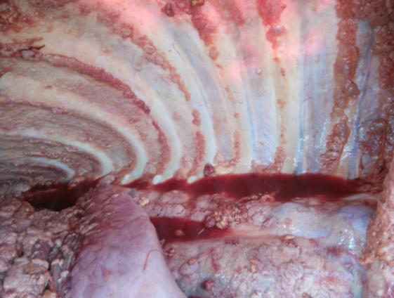

Fig. 2. Presence of multiple nodules in the thoracic cavity.

Fig. 1. Open mouth breathing in the animal.

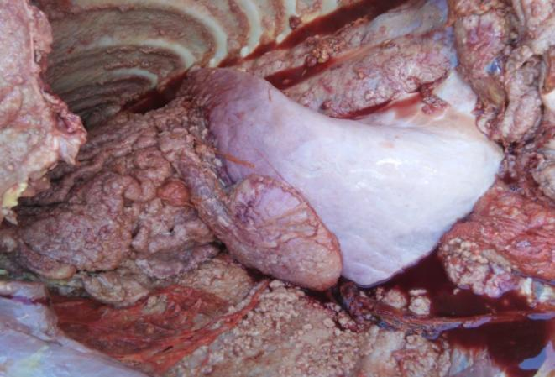

Fig. 3. Presence of caseated nodules with adhesions in lungs in the thoracic cavity.

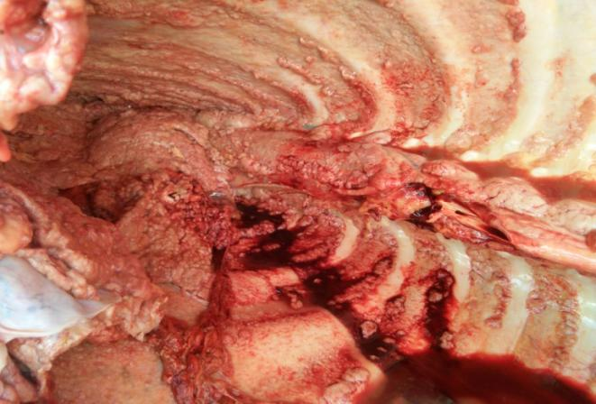

Fig. 4. Showing the thoracic cavity with the tubercles.

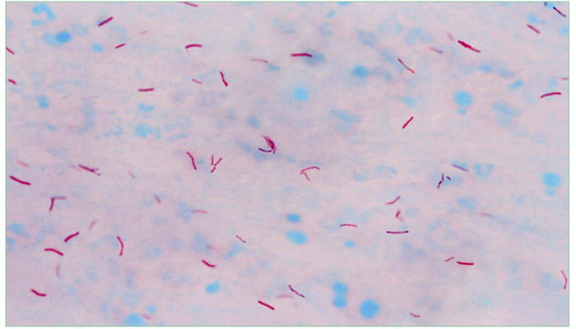 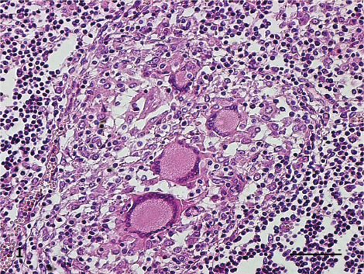

Fig. 6. G**ranulomatous lesions** with central necrosis surrounded by epithelioid macrophages and Langhans giant cells.

Fig. 5. Ziehl-Neelsen stain showing red acid-fast bacilli (*M. bovis*) under oil immersion (100x).”

CONCLUSIONS

This case highlights the importance of considering **tuberculosis** in buffaloes with chronic weight loss, respiratory distress, weakness and exercise intolerance. Timely diagnosis through necropsy and laboratory confirmation is essential to control transmission and protect both animal and human health. Bovine TB is a silent threat with serious public health implications. Recognizing clinical signs early and enforcing biosecurity measures can prevent outbreaks.

**Recommendations:**

* **Veterinarians:** Promote regular screening (e.g. tuberculin testing) in herds, especially where animals show signs of emaciation or respiratory issues.
* **Farmers:** Avoid close contact with sick animals, ensure milk is boiled or pasteurized before consumption, and isolate or cull suspected cases promptly.
* **Authorities:** Strengthen surveillance and implement a One Health approach involving both veterinary and human health sectors.

REFERENCES

Andreazza, D., Boos, G. S., Boabaid, F. M., Wouters, A. T. B., Wouters, F., Souza, S. O., Menegat, M. B., & Driemeier, D. (2015). Caracterização histológica e imuno-histoquímica das lesões de tuberculose em bovinos e de linfadenite granulomatosa em suínos. Pesquisa Veterinária Brasileira, 35(2), 129–136.

Batista, H. R., Passos, C. T. S., Nunes Neto, O. G., Sarturi, C., Coelho, A. P. L., Moreira, T. R., et al. (2020). Factors associated with the prevalence of antibodies against Brucella abortus in water buffaloes from Santarém, Lower Amazon region, Brazil. Transboundary and Emerging Diseases, 67, 44–48.

Buddle, B. M., de Lisle, G. W., Griffin, J. F., & Hutchings, S. A. (2015). Epidemiology, diagnostics, and management of tuberculosis in domestic cattle and deer in New Zealand in the face of a wildlife reservoir. New Zealand Veterinary Journal, 63(Suppl 1), 19–27.

Central Pollution Control Board. (n.d.). Revised comprehensive industry document on slaughter houses.2001.https://cpcb.nic.in/openpdffile.php?id=TGF0ZXN0RmlsZS8xNzVfMTUxMTI2NDE0MV9tZWRpYXBob3RvODkzOS5wZG

de la Rua-Domenech, R. (2006). Human Mycobacterium bovis infection in the United Kingdom: Incidence, risks, control measures and review of the zoonotic aspects of bovine tuberculosis. Tuberculosis, 86(2), 77–109. <https://doi.org/10.1016/j.tube.2005.05.002>

Khademi, P., Ownagh, A., Mardani, K., & Khalili, M. (2019). Prevalence of Coxiella burnetii in milk collected from buffalo and cattle dairy farms in Northwest Iran. Comparative Immunology, Microbiology and Infectious Diseases, 67, 101368.

National Tuberculosis Prevalence Survey. (2021). 2019–2021 Report.

NSSO. (2014). Household consumer expenditure, NSS 68th round Sch1.0 Type 1: July 2011—June2012.http://mospi.nic.in/sites/default/files/publication_reports/Report_no558_rou68_30june14.pdf

OIE. (2016). Manual of Diagnostic Tests and Vaccines for Terrestrial Animals: Chapter 2.4.6. Bovine Tuberculosis.

Olea-Popelka, F., Muwonge, A., Perera, A., et al. (2017). Zoonotic tuberculosis in human beings caused by Mycobacterium bovis—a call for action. The Lancet Infectious Diseases, 17(1), e21–e25. https://doi.org/10.1016/S1473-3099(16)30139-6

Quinn, P. J., Markey, B. K., Leonard, F. C., Hartigan, P., Fanning, S., & FitzPatrick, E. S. (2011). Veterinary Microbiology and Microbial Disease (2nd ed.). Wiley-Blackwell.

Srinivasan, S., Easterling, L., Rimal, B., Niu, X. M., Conlan, A. J. K., Dudas, P., & Kapur, V. (2018). Prevalence of bovine tuberculosis in India: A systematic review and meta-analysis. Transboundary and Emerging Diseases, 65(6), 1627–1640.

Thoen, C. O., LoBue, P. A., & de Kantor, I. N. (2006). The importance of Mycobacterium bovis as a zoonosis. Veterinary Microbiology, 112(2–4), 339–345. <https://doi.org/10.1016/j.vetmic.2005.11.047>

Thoen, C. O., LoBue, P., Enarson, A. D., Kaneene, B. J., & de Kantor, N. I. (2007). Tuberculosis: A re-emerging disease of animals and humans. Veterinaria Italiana, 45(1), 135–181.

Villanueva, M. A., Mingala, C. N., Tubalinal, G. A. S., Gaban, P. B. V., Nakajima, C., & Suzuki, Y. (2018). Emerging infectious diseases in water buffalo: An economic and public health concern. In Emerging Infectious Diseases in Water Buffalo (IntechOpen). https://doi.org/10.5772/intechopen.78971

WHO. (2017). Roadmap for zoonotic tuberculosis. <https://www.who.int/tb/publications/2017/zoonotic_TB/en/>

WHO. (2018). The End TB Strategy. <https://www.who.int/tb/strategy/en/>

WHO. (2021). Global Tuberculosis Report 2021. <https://www.who.int/publications/i/item/9789240037021>

Zachary, J. F., Huff, T. G., & Britton, R. (2017). Pathologic Basis of Veterinary Disease (6th ed.). Elsevier.