Original Research Article

Optimization of Blade Geometry in Air-Assisted Sprayer Fans Using Computational Fluid Dynamics

Abstract
The blower impeller is a vital component of an air-assisted sprayer, as it generates the necessary air velocity and discharge required to direct spray droplets from the nozzle onto the target surfaces, including both the upper and lower sides of plant leaf canopies. To better understand and optimize this process, a Computational Fluid Dynamics (CFD) model was developed to analyze the air velocity distribution produced by the impeller and blower system. Three impeller diameters—95 mm, 115 mm, and 127 mm—were selected for evaluation at three rotational speeds: 2000, 4000, and 6000 rpm. The CFD analysis revealed that the 127 mm impeller consumed the highest power at each speed: 35 W at 2000 rpm, 39 W at 4000 rpm, and 47 W at 6000 rpm. This trend is attributed to the increased air suction that occurs with higher impeller speeds, resulting in greater power demand. Furthermore, the 127 mm diameter impeller exhibited superior performance, producing a maximum discharge of 154 m³/h, a velocity of 27 m/s, and a pressure of 640 Pa. The minimum values observed for the same impeller were 92 m³/h, 14 m/s, and 340 Pa, respectively. Overall, the impeller with a 127 mm diameter at 6000 rpm demonstrated the best results in terms of air discharge, velocity, pressure, and overall efficiency, confirming its suitability for achieving optimal spray coverage in air-assisted sprayer applications.

Keywords: Blower impeller, Velocity, Pressure, Discharge, Power consumption, CFD Analysis, Air assisted sprayer

1. Introduction
Traditional spraying methods in agriculture are riddled with inefficiencies. Manual sprayers require excessive water, exceeding 400 liters per hectare, especially straining farmers in arid regions. Additionally, these methods lead to uneven distribution of chemicals, requiring large quantities and causing unwanted run-off. Even with proper application, a significant portion, over 80%, of the spray is wasted due to factors like drift. This not only translates to financial burden due to rising chemical costs but also poses a serious threat to the environment. Spraying technology aims to effectively and economically application of the precise quantity of the chemical to the set target with minimum threat for the environmental pollution ^{[1].} Conventional agricultural pesticide application practices have developed a contradiction among the yield enhancement, cost effectiveness and environmental protection ^{[2].}
Therefore, there's a pressing need for advancements in sprayer technology. Ideally, these advancements should focus on minimizing water usage, ensuring precise application to reduce wastage, and limiting environmental impact through reduced reliance on chemicals. The structural design of a sprayer is reflected in its operational parameters. Based on these, issues related to the design of a sprayer can be identified and necessary modifications can affect accordingly. Specific tests and field measurements are made to analyze these parameters, which are laborious, expensive and time consuming. To circumvent the problems encountered with the generation of experimental and field data, the use of CFD modelling can be a viable option. For modelling flow in or around objects in the area of fluid dynamics, there are numerous commercial computational fluid dynamics tools available ^{[3]}. Prior to the drift field testing, the spray properties of the applied nozzles and the sprayer's velocity distribution were measured and used as inputs for the CFD model ^{[4]}. Computational Fluid Dynamics has successfully contributed to the prediction of flow-through blowers and enhancement of their design ^{[5]}.
1.1 CFD analysis of impeller
CFD models provide a complete knowledge on the shape of blades and the flow angles, rotational speed of blades, and flow velocities for radial blowers and fans
Computational Fluid Dynamics approach has recommended the use of simulation of solid works flow to look into the flow of centrifugal pump impeller using Solid Works Flow Simulation. Musiu et al ^{[6]}. examined the complex dynamics of air assist sprayers, particularly the impacts of fluid environment around the spraying before and after it breaks up and inter-droplet dynamics that contribute to development of an optimal CFD sprayer modelling as a reliable design tool. The travel of spray droplets from the sprayer to the targets, which combines fluid fluxes, heat transfer and mass flow, is the main area of CFD simulation. Jayapragasan et al ^{[7]} studied the outer diameter, number of the blades and width of fan being used in solid works and CFD analysis. The optimum combinations for analytical results are outer diameter 190 mm and 8 blades fixed at an angle of 60 degree, whereas the optimum combinations for experimental results are 190 mm outer diameter, 80-degree blade angle and 8 blades. The deviation between the experimental and predicted values was less than 5%.
Hong et al ^{[8]} developed a CFD model to analyze the distribution of air velocity within and discharged around tree canopies by an air-assisted sprayer. This CFD model computed complex airflow patterns caused by the sprayer's strong air jets, integrating sprayer motion and the influence of tree canopies on air momentum and turbulence quantities using the Mesh sliding technique. An analysis of blower mass flow and air flow demonstrated that performance of the curves obtained through CFD have a good correlation with the experimental performance curves ^{[9]}.
Impeller is one of the important components of blower which rotates at a high speed and acts as a propeller to increase the pressure and flow rate. The impeller draws the air inside and transfers to the other side which increases the air velocity at the discharge outlet. The efficiency and performance of the centrifugal pump can be enhanced by optimizing certain design parameters of the impeller using CFD Analysis. The use of computational fluid dynamics in blower design reduces the cost of simulation and allow for uninterrupted geometry changes in a way to provide accurate findings from the simulation technique. Hence, it is planned to develop a blower impeller attachment to brush cutter for effective spraying. Brush cutters are highly driven with the engine capacity load that reduces or minimizes the efforts of the farmer and provide an efficient working environment, it can be utilized in places where larger machines can't perform. Now a days commercially available brush cutters are offered in 5 in 1 attachment that may be utilized for a variety of tasks like crop harvesting, weeding and grass cutting etc. Subsequently, it performs well and requires only little maintenance. This reduces the cost for the operator as the farmers doesn’t need to buy different tools for different operations. With the above objective this research is aimed to study the performance of blower impellers with selected diameters using Computational Fluid Dynamics analysis
2. Materials and methods
2.1 Theoretical design consideration for optimizing the design of blower impeller
In all agricultural mist blowers, centrifugal types of impellers were used to accelerate a mass of air flow to the desired velocity. For achieving best results as there is a light rise in gas or air velocity across blower impeller. Fig 1. shows details of basic parameters of Impeller. The flow is axial, or parallel to the axis of rotation, in an axial flow blower. The blower's impeller is made up of blades mounted on a disc. The velocity at the impeller's edge or vane tip corresponds to the amount of kinetic energy imparted to the air.
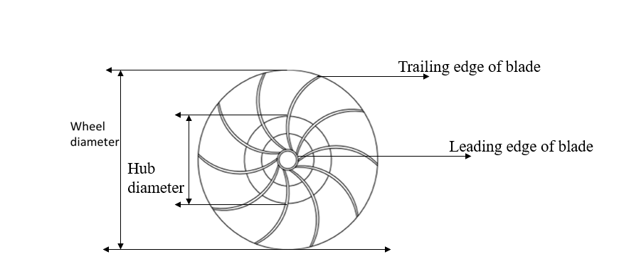
Fig 1. Basic dimensional parameters of blower impeller
2.2 Specific speed and Optimum Geometry
Optimization of blower impeller geometry in ways of best efficiency point (BEP) specific speed has taken place empirically and analytically from the history of blower development. An approximate illustration of the results of this process for impellers is depicted in Fig 2. Not only does the geometry emerge from the optimization process but also the head, flow, and power coefficients for each shape as well.
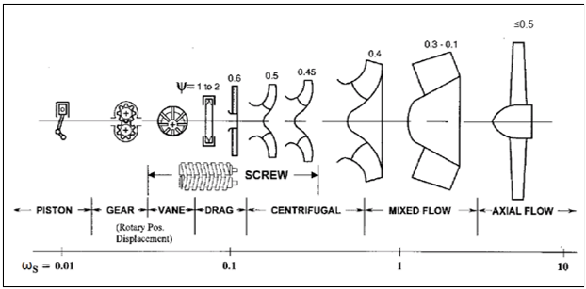
Fig 2. Optimum geometry as a function of BEP specific speed
For the calculation of specific speed, N (rpm), the volume flow rate (Q) and the total head rise Δ(H)_{tot} values are needed. The approach of selecting an impeller type can be summarized as follows: The blower specific speed at the design flow rate
- Choose a rpm value
- Estimate the head change
- Based on the specific speed value decide an impeller type
One assumes that effect of the exit velocity has been included in the pressure rise value that is utilized in the calculations. The following values are chosen:
- N = 6000 rpm
- Q =0.05 Kg/s
- ΔP_{Total} = 1000 Pa
- ρ = 1.225 kg/m³ (Bleier (2018))
- ΔZ_{e} = 0 (we are dealing with air, so elevation head is negligible compared with pressure and velocity heads)
Therefore,
ΔH_{tot ~} ΔH_{stat} =$\frac{1000 Pa}{\left(1.225\frac{kg}{m3}\right)*(9.8\frac{m}{s^2})}$ + 0 =83.3m
and,
N_{s} = $\frac{N \sqrt{Q}}{H^3/4}$ = 0.42
This value of specific speed corresponds to a centrifugal type impeller
2.3 Selection of blower Impeller
The blower performance parameter is higher in the closed impeller when compared to semi-open impeller ^{[10]} and the open impeller consumes more power when compared to closed ^{[11]}. The straight blades, cannot lead properly the flow and a large recirculation zone is formed at the pressure side in agreement with the theory, since the volume flow rate is much lesser than optimal as per ^{[12]}. Based on the reviews the closed impeller with backward curved blades was selected for this investigation.
2.4 Selection of blower Impeller diameter
The optimum diameter of high-efficiency fans may be determined in the Cordier diagram at a certain operating point. An empirical diagram based on measurements is the Cordier diagram. The relationship between flowrate, pressure, rotation speed and diameter is provided ^{[13]}. The Cordier diagram, however, includes no necessary information on the geometry of the blade (viz., the angles and the blade width). The response, which is the ratio between static and the total pressure increasing from the impeller's input to its output, is one often used performance parameter. Cordier Diagram is represented in Fig 3.
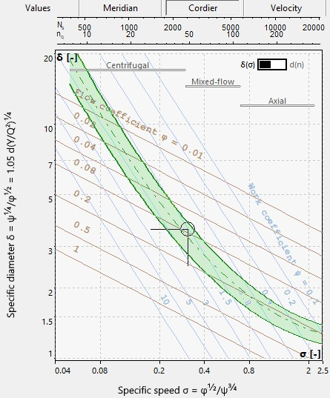
Fig 3. Cordier curve (manual.cfturbo.com)
In this method, the Cordier curve, a very well-defined curve for all conventional impeller types can be obtained. Through tests on various fans and blowers, Cordier was able to demonstrate that axial turbomachines had high speed numbers σ and low diameter numbers δ, while radial turbomachines are characterized by low-speed numbers σ and high diameter numbers δ. The specific diameter of impeller is 4.1 mm and the range of outer diameter is between 90 to 130 mm.
2.5 Blower impeller for Air-Assisted Sprayer using Solid works and flow analysis by CFD
2.5.1 Mesh Generation
Geometry gets meshed by clicking on "Generate mesh”. Meshing should be done properly so the result gets accurate. It’s the most important step in a FE Analysis. The Software will solve each element for converging to a particular solution. The more the number of elements better will be the accuracy of the results. There are different types of mesh, a tetrahedral mesh often offers a more automated method for volume meshing with the option to apply mesh controls to enhance the accuracy in crucial areas. A hexahedral mesh, on the other hand, often offers a more precise solution but is more difficult to construct ^{[16]}. Apply a tetrahedral mesh for the complete impeller assembly. To create a mesh more efficiently, an unstructured mesh was used rather than a structured mesh. Additionally, for greater flow resolution, unstructured mesh helped in placing cells in the required essential flow regions. Structured mesh does not provide this flexibility. Unstructured grid systems have the benefit of being highly automated and requiring minimal human time or effort. The meshing of the 2D blower models is carried out with ANSYS Workbench is shown in Fig 4. It was chosen over hyper mesh for 2D models because the workbench's mesh manufacturing process was so much faster. Furthermore, there wasn't much of a change among the mesh quality and solution results produced by any of these applications.
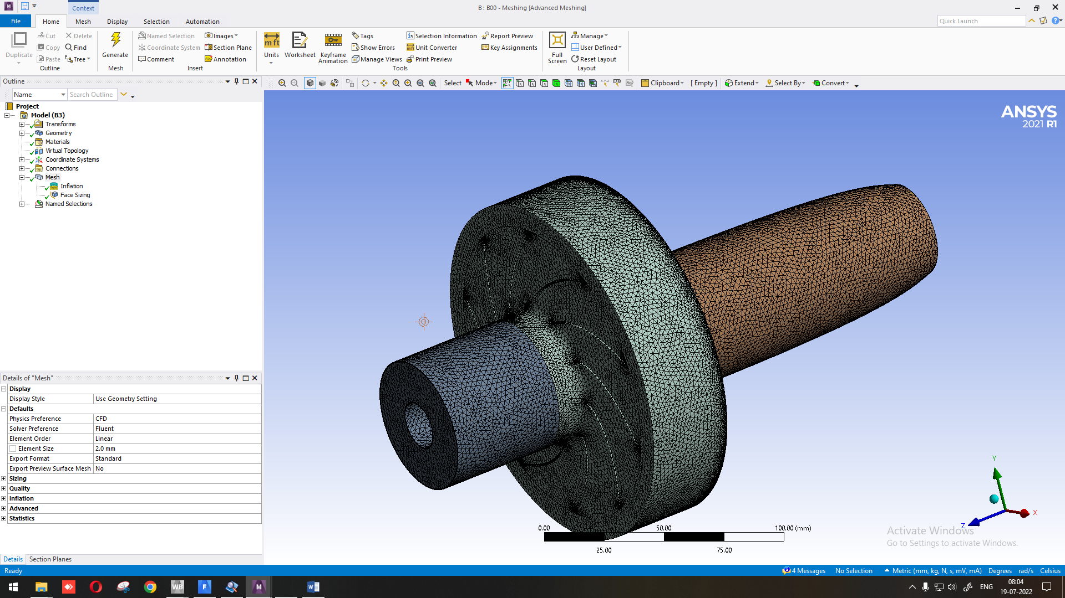
Fig 4. Meshing of 3D Geometry
MESH module for discretization of the model into a small number of domains known as elements or cells. Nodes are the locations where the elements are come to joined to one another. Each node is connected to two or more elements, and the collection of these components is known as a mesh. Meshing was done to divide the model into number of equal parts for analysis having 1206558 nodes and 3454023 elements.
2.5.2 Pressure contour/ pressure stream line of blower impeller
In pressure contours there will be a difference in pressure between front and back side of the blades because front side exerts more thrust and pressure when compared to the back side. The pressure stream line or pressure contour will indicate the dynamic head created by the rotating blower impeller which can be visible in the pressure contours as a consistent pressure rise from the leading edge to the trailing edge of the impeller. Hence CFD analysis has be carried out to study the pressure pattern of the impeller.
2.5.3 Velocity contour/ velocity stream line
Velocity contour plays a vital role in understanding the flow dynamics of blower impeller. Joining the same velocity points represents the velocity contour. During the static condition the velocity distribution in the impeller passage will be uniform where as in dynamic flow condition the impeller is composed of displacing air particles from the inlet towards the outlet section. Hence to analyse the velocity distribution during the real flow through impeller CFD study has been carried out.
2.6 Experimental statistical design
CFD analysis is carried by changing the design parameters like blower impeller diameter (D1, D2, D3), Speed (N1, N2, N3) for 3 replications with the total 27 treatments. The statistical techniques of Factorial Completely Random Design (FCRD) were adopted to optimize the parameters of speed of operation and diameter of impeller for obtaining desired quantity of air velocity.
3. Results and Discussions
The impeller, which provides energy to the air through centrifugal force, is made up of several rotating vanes sealed in a casing. In a blower, air is pushed into an impeller's vanes by atmospheric pressure, which propels the air at a greater speed. Through the use of a casing or a series of stationary diffusion vanes encircling the impeller periphery, this velocity is turned into pressure energy. Based on the theoretical design the following values were considered. In terms of performance, the impeller blades are important. For the impeller to operate more efficiently, air delivery from the blades and air suction are both crucial. The speed and impeller diameter are most important because it determines the flow and efficiency of the blower. A closed type Backward curved blades blower impeller was modelled using solid works software with three different diameters of 95 mm, 115 mm and 127 mm and simulated using CFD Analysis as presented in Fig. 4. For each speed and impeller diameter, the power consumption and air volume flow rate, the pressure developed were computed. The impact of the impeller diameter can only be measured experimentally because of a range of circumstances; however, this approach is expensive in ways of time, money, and materials. As a result, the ANSYS CFD FLUENT 2021 which is fluid simulation software is utilized to investigate these effects.
The flow is provided to the designer by the utilization of CFD in 3D simulations. With recent improvements in computational power, CFD can now solve such challenging 3D issues. CFD can help in understanding the actual flow path, mass flow rates, velocities, and pressures at various sections of the design by drastically reducing the number of experimental repetitions. To obtain the optimum variables like diameter and speed of the blower impeller, CFD analysis is essential.
3.1 Analysis of blower impeller characteristics using CFD
The analysis for blower impeller is carried out at two independent variables of speeds (2000,4000,6000 rpm) and diameters (95,115 and 127mm) along with the dependent variables like discharge(Q), Pressure (Pa), Velocity(m/s), and Power (W). The results of CFD analysis for blower impeller are discussed below.
3.1.1 Change of nozzle pressure on discharge by three different impellers propelling at different speeds.
The pressure rise at nozzle and results of air discharge for three impellers at three different speeds are presented in Fig 5.
95 mm: The mean air discharges were 33.96, 73.85 and 95.43 m³/h with a rise in mean nozzle pressure of 282, 406 and 450 Pa for a blower impeller with 2000,4000 rpm, 6000 rpm, respectively.
115mm: The mean discharges were of 44.08, and 95.75, 131.6 m³/h, with a rise in mean nozzle pressure of 346.16, 509, 573.5 Pa for an impeller with 2000 rpm, 4000 rpm, 6000 rpm, respectively.
127 mm: The mean discharges were 92.76 m³/h,125.11 m³/h,154.3 m³/h, with a rise in mean nozzle pressure of 640.3 pa, 494 pa, 340.16 pa for an impeller with 2000 rpm, 4000 rpm, 6000 rpm, respectively. The discharge obtained at 6000rpm is the highest for the 127mm diameter impeller when compared to 95mm and 115mm blower impellers.

Fig 5. Change of nozzle pressure on discharge by three different impellers working/propelling at different speeds.
The findings suggest that if diameter of the impeller is increased, the maximum discharge can be obtained. Further, if the speed of the impeller is increased, the discharge can be increased even by an impeller of lesser dia. This is evident from the findings that an almost equal volume (95.43 m³/h and 95.75 m³/h) of discharge can be obtained by impellers of 95mm (6000 rpm) and 115mm (4000 rpm) dia.
3.1.2 Quantum of power consumption for the discharge by three different impellers working at different speeds.
a. Discharge Versus Power Consumption
Power consumption increases with increases in rotational speed and diameter of impeller as shown in the Fig. 6. The maximum power consumed about 37W,42W,47Wfor 6000 rpm of 95, 115, 127mm diameter blower impeller and for 4000 rpm the power consumption is about 35W, 37W, 39W for blower impeller diameter of 95, 115, 127mm and for 2000 rpm 20W, 30W, 35W for blower impeller diameter of 95,115,127 mm. This obtained result demonstrates that with increase in rotational speed of impeller increases suction of air results in more power consumption. Similar results are being observed ^{[14]}. As per dimensionless pump numbers the power required get increases as there is increase in speed and also diameter.

Fig 6. Discharge Versus Power Consumption
b. Effect of impeller speed on air velocity and relationship between air velocity and Static pressure
There is an inverse relationship between static pressure and velocity and there is a speed dependent increase in velocity shown in Fig7. It is inferred that a rise in speed of impeller from 2000 to 6000 rpm resulted in an increase in velocity from 23 to 42 m/s. At the maximum static pressure (902) the generated velocity is less which varies from 3 m/s to 23 m/s for 2000 rpm, 11 to 37 m/s for 4000 rpm and for 6000 rpm the velocity is from 12 to 42 m/s for a static pressure of 902 to 300 Pa, respectively. This pressure difference is because change in increase in incoming velocity of air by inlet of the blower is responsible for the decrease in static pressure head. As a result, path to the impeller increases, and the pressure of air available decreases. In an earlier study the outcomes of numerical simulation revealed that when the air supply pressure is increased, the total pressure and air flow velocity inside the mixing chamber of the nozzle are rapidly increased ^{[19]}. Increase in speed results in rise of air velocity due to increased peripheral speed of impeller.

Fig 7. Static pressure Vs Velocity
Force acting on impeller cross section results in decreased static pressure. Regression Equations are being developed in a way for describing variations in air velocity and static pressure with speed. A similar observation has been reported by the authors ^{[15,5]}. These statistical data for air velocity and static pressure are presented in Table 1.
Table 1. Regression Equation for air velocity &Static pressure
S. No | RPM of Impeller | Air velocity |  | Static pressure
 |  | Regression Equation | Coefficient of Determination, R² | Regression Equation | Coefficient of Determination, R²
1. | 2000 | y = 11.243ln(x) + 1.6716 | R² = 0.8772* | y = -177.5ln(x) + 525.97 | R² = 0.9282*
2. | 4000 | y = 14.127ln(x) + 7.5088 | R² = 0.8729* | y = -225.4ln(x) + 769.17 | R² = 0.8264*
3. | 6000 | y = 16.391ln(x) + 9.0266 | R² = 0.9363* | y = -301.1ln(x) + 970.51 | R² = 0.849*

c. Effect of impeller speed on air discharge and the relationship between Discharge and pressure
Pressure fluctuation of the internal flow is known to play a crucial role in understanding and predicting the rate of flow ^{[16]}. Impact of speed impeller on air discharge and pressure is as shown in Fig 8.

Fig 8. Relation between Discharge and pressure
The air discharge measured at the outlet of blower varied from 14.3 to 44.1 m³/s at a static pressure of 902 Pa. The mean discharge values of 182.4, 226.2, 264.6 m³/h are increasing with increase in impeller speed 2000, 4000, 6000 rpm. The findings are comparable with earlier studies by others ^{[17]}. Accordingly, an increase in speed of impeller increases air discharge with a decrease in pressure. Regression Equations were developed to describe variations in air discharge with speed. The statistical data for air discharge are presented in Table 2.
Table 2. Regression equation for air discharge
S. No | RPM of Impeller | Regression Equation | Coefficient of Determination, R²
1. | 2000 | y = 94.44ln(x) - 10.79 | R² = 0.8837*
2. | 4000 | y = 104.33ln(x) + 10.717 | R² = 0.8885*
3. | 6000 | y = 120.47ln(x) + 22.246 | R² = 0.9363*
d. Effect of impeller speed on power consumption and relationship between discharge and power consumption
Power output is analysed to understand the changes in the system performance according to operating conditions. The results are depicted in Fig.9.

Fig 9. Relation between discharge and power consumption
The consumption of power increases slightly as impeller rotational speed increases. The increase might be due to an increase in inertia load and increase in speed and change in air flow dynamics. The power consumption of blower as per Fan law is linear proportional to cubic power of speed. Similar variation of increased efficiency of blower as an increase in blower speed was reported by Dhande ^{[18]}.
The increase in discharge from 14.3 to 182.4 m³/s results in an increase of power consumption from 20 to 35 W at 2000 rpm and from 36.3 m³/s to 226.2 m³/s with power consumption of 28 to 41 W at 4000 rpm and for 6000 rpm the increase in air discharge ranges from 44.1 to 264.6 m³/s with power consumption of 38 to 47 W. The amount of air generated in the impeller has increased because as the impeller rotates, the force those air particles exert on it varies, which causes changes in power usage. The blower's power consumption is generally influenced by the impellers' design, The Regression equation was developed and presented in Table 3.
Table 3. Regression equation for power consumption
S. No | RPM of Impeller | Regression Equation | Coefficient of Determination, R²
1. | 2000 | y = 8.6949ln(x) + 18.799 | R² = 0.7688*
2. | 4000 | y = 7.3285ln(x) + 26.964 | R² = 0.7865*
3. | 6000 | y = 4.9134ln(x) + 37.279 | R² = 0.8279*

3.2 Analysis of pressure and velocity distribution for blower and rotating impeller through Computational Fluid Dynamics
The dynamic head produced by the blower impeller's rotational motion is shown by the pressure stream line or pressure contour as a steady pressure rise from the impeller's leading edge to its trailing edge. A pressure and velocity distribution in the selected blower impeller (127mm) was studied through CFD analysis as it gives best efficiency when compared to 95- & 115-mm diameter impellers.
a. Pressure contour of blower
From the above analysis, it is found that high and low pressure areas in front and back in the impeller blades. The colours red and blue represent the highest and lowest pressures of blower. The relationship between the casing's design characteristics and the flow field pattern is resolved by this study. The maximum pressure was found on the pressure-side wall to the lower static pressures on the suction side of the impeller. The pressure is maximum at zone of diffuser is about 963.701 Pa and pressure at the end of nozzle is -120.499 Pa. It is being observed a minimum pressure at suction side of impeller is -430.270Pa. This could be because there is a slight decrease in static pressure in the trailing zone, which further decreases the air circumferential momentum. The similar results were reported by the author ^{[19]}. The pressure contour of a blower is analysed using CFD and the same is shown in Fig 10.
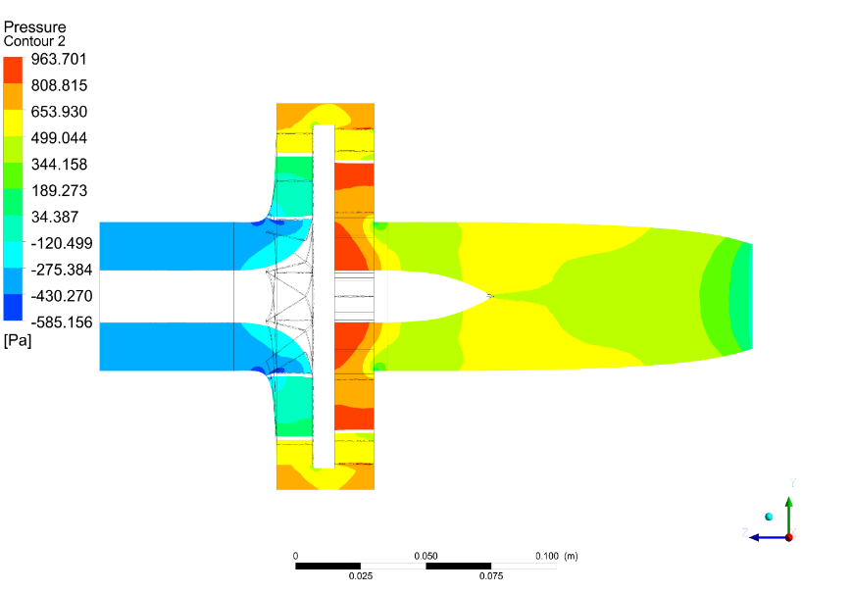
Fig 10. Pressure contour of blower
b. Velocity contour of blower
From the analysis it is found that velocity contours display the absolute velocity at the impeller channel. The impeller blades provide a flow pattern that impedes the main flow and lowers the pressure rise to increase the velocity. The velocity is high at end of convergent nozzle of 42 m/s and low velocity is observed at impeller and also diffuser zone due to transfer of more dynamic energy of air from impeller. This indicates that the total pressure and static pressure is converted to dynamic pressure at the end of nozzle. The velocity contour of a blower is analysed using CFD and the same is shown in Fig 11.
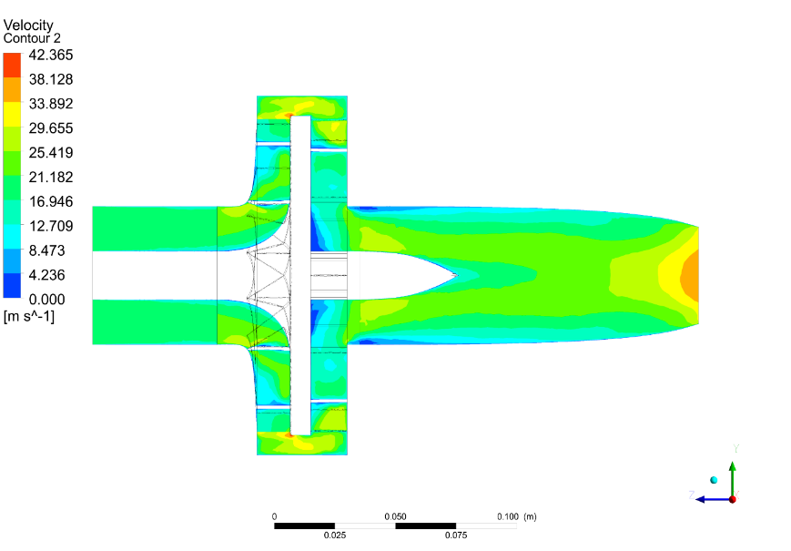
Fig 11. Velocity contour of blower
a. Pressure contour of rotating impeller
From the analysis it is observed that there was a decrease in pressure as it moved from suction to exit of the blower impeller. This may occur due to the dynamic head created by the revolving impeller. It has been noted as there is a continuous pressure rise at leading edge in impeller and also the overall pressure at the air exit in the impeller zone is more than suction side in blower impeller. From the pressure contour analysis, it is found that the maximum rise in pressure is 986.8 Pa at leading edge and 326.448Pa, at the trailing edge of impeller. The black colour indicates the air flow path. The total pressure pattern varies along the length of the blower impeller. The similar results was reported by the author ^{[20]}. The internal flow field's characteristics of impeller is given in Fig 12.
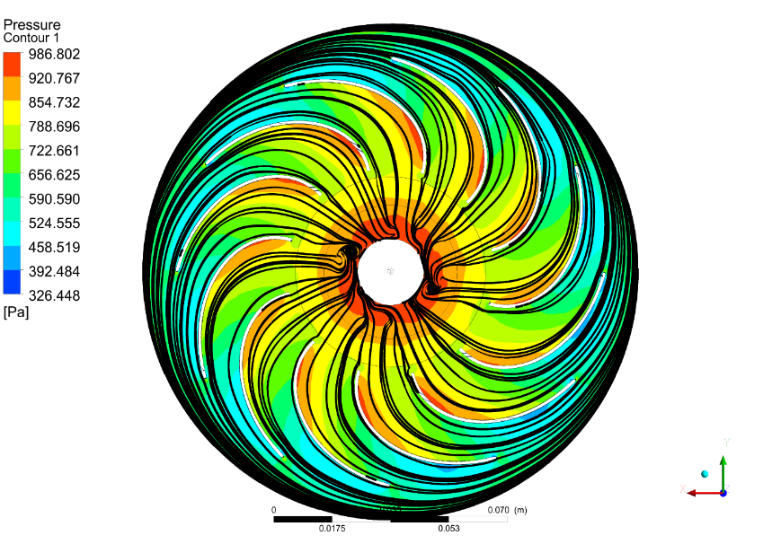
Fig 12. Pressure distribution of rotating impeller
b. Velocity contour for rotating impeller
The velocity distribution in the impeller passage is uniform and the velocity contour of rotating blower impeller is shown in Fig.13. From the figure it is found that the velocity flow is increased from leading edge to trailing edge, this is due to increase in mass flow rate. A high-velocity contour is found at the edge of impeller region, and low velocity is seen at the suction side of impeller due to impeller rotational speed. High-velocity contours become more pronounced as flow get far away from the suction side of impeller.
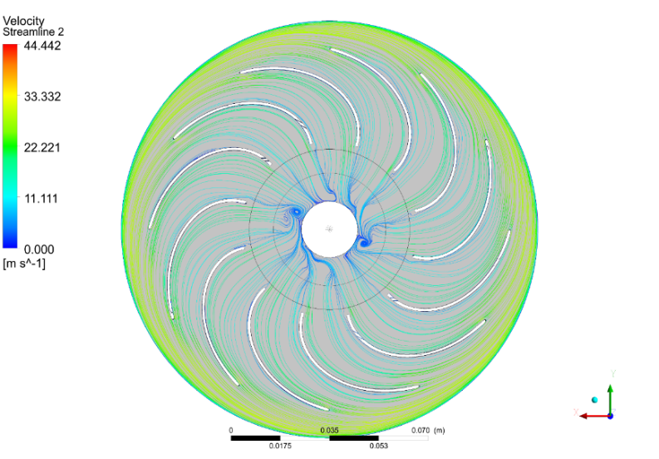
Fig 13. Velocity distribution of rotating impeller

Conclusions
Theoretical considerations were taken into account that affect the performance and efficiency of blower. The value of specific speed was 0.42, based on this it was concluded that the geometry of impeller was centrifugal type. Based on reviews the backward curved impeller blades was selected, because the efficiency of backward curved impeller was more than forward and straight blades. The impeller and blower were modelled using Solid works software and analyzed using CFD. The impeller with 95,115,127 mm was selected for analyzing using CFD at different rotational speed (2000,4000,6000 rpm) of impeller. From the analysis of CFD, it is concluded that the impeller with 127 mm at 6000 rpm generates more air velocity and air discharge of 47 m/s and 264.6 m³/h when compared to 95 and 115mm diameters. Based on the CFD analysis, closed type of impeller of diameter 127 mm with the back ward curved blade is more efficient when compared to other two types of impeller blowers. The pressure and velocity distribution inside the blower and impeller of 127 mm diameter is also analyzed to access the influence due to change of flow rate

Disclaimer (Artificial intelligence)
Author(s) hereby declares that NO generative AI technologies such as Large Language Models (ChatGPT, COPILOT, etc.) and text-to-image generators have been used during the writing or editing of this manuscript.

References
- Baio FHR, Silva EE, Vrech MA, Souza FHQ, Zanin AR, Teodoro PE (2018). Vegetation indices to estimate spray application rates of crop protection products in corn. Agron. J. 110: 1254-1259.
- Dou H, Zhang C, Li L, Hao G, Ding B, Gong W, Huang P (2018). Application of variable spray technology in agriculture. IOP Conf. Ser. Earth Environ. Sci. 186, doi:10.1088/ 1755-1315/186/5/012007.
- Tu J, Yeoh GH, Liu C (2018). Computational Fluid Dynamics: A Practical Approach, Third Edition. Butterworth-Heinemann, 1-498. ISBN: ISBN: 9780081011270.
- Duga D, Delele M, Ruysen K, Dekeyser D, Nuyttens D, Bylemans D, Nicolaï B, Verboven P (2017). Development and validation of a 3D CFD model of drift and its application to air-assisted orchard sprayers. Biosystems Engineering, 154: 62-75.
- Sreekanth M, Sivakumar R, Sai Santosh Pavan Kumar M, Karunamurthy K, Shyam Kumar M, Harish R (2021). Part A: Journal of Power, and Energy. Regenerative flow pumps, blowers and compressors–A review, 2021; 235 (8):1992-2013.
- Musiu E, Lijun Q (2016). Computational Fluid Dynamic Modeling Application as a Design Tool in Air Assisted Pesticide Sprayer Development. Innovative Systems Design and Engineering, 7(2):25-34
- Jayapragasan C, Reddy K (2017). Design optimization and experimental study on the blower for fluffs collection system. Journal of Engineering Science and Technology.12 (5):1318-1336.
- Hong S W, Zhao L, Zhu H (2018). CFD simulation of pesticide spray from air-assisted sprayers in an apple orchard: Tree deposition and off-target losses. Atmos. Environ. 175, 109–119.
- Charapale UD and Mathew AT (2018). Prediction of Flow in the Industrial Blower using Computational Fluid Dynamics. Materials Today: Proceedings.12311-12319.
- Mansour M, Wunderlich B, Thévenin D (2018). 2018. Experimental study of two-phase air/water flow in a centrifugal pump working with a closed or a semi-open impeller. Turbo Expo: Power for Land, Sea, and Air.
- Zariatin D, Chaeroni A (2020). Experimental analysis of semi-open impeller pump as turbine." IOP Conference Series: Materials Science and Engineering. 852(1):012069
- Anagnostopoulos, JSJC, Fluids (2009). A fast numerical method for flow analysis and blade design in centrifugal pump impellers. Computers & Fluids 38 (2):284-289.
- Epple P, Durst F, Delgado A (2011). A theoretical derivation of the Cordier diagram for turbomachines. Part C: Journal of Mechanical Engineering Science, 225 (2):354-368.
- Sagar S Punith G, Rakesh C, Prakash M, Lakshminarasimha N (2017), Design and development of trolley type agrochemical sprayer.^{th} National Conference on Topical Transcend in Mechanical Technology SJBIT Bangalore (TTMT-17), 1-6
- Singh RR, Nataraj M, (2014). Design and analysis of pump impeller using SWFS, World J. Model. Simul., 10(2):152–160
- Wagh S, Panchagade D, (2014). Analyzing effect of impeller width on mass flow rate of centrifugal blower using CFD, International Journal of Engineering and Advanced Technology, 3(5), 236-238.
- Wang Z, Qian Z, Lu J, Jie, Wu, Pengfei (2019). Effects of flow rate and rotational speed on pressure fluctuations in a double-suction centrifugal pump. Energy, 170(C), 212-227.
- Dhande K G. Design and development of centrifugal blower and rotary atomizer of air-assisted sprayer for Mango orchard. Agricultural and Food Sciences, 2014.
- Bach E, CO Paschereit, P Stathopoulos, MDJAJ Bohon (2021). Rotating detonation wave direction and the influence of nozzle guide vane inclination. AIAA Journal 59 (12):5276-5287.
- Muttalli RS, Agrawal S, Warudkar H (2014),. "CFD simulation of centrifugal pump impeller using ANSYS-CFX. Engineering and Technology, 3 (8):15553-15561.

