Original Research Article
Therapeutic Regimen for Chronic Enteropathy in Dogs at Aizawl, Mizoram
ABSTRACT
The objective of this study was to find out an effective therapeutic regimen for chronic enteropathy in canines. Dogs presented to TVCC, Selesih, Mizoram suspected for chronic gastroenteritis were screened based on various clinical signs such as diarrhoea, vomition with or without blood, inappetence, lethargy, anaemia and dehydration affecting the dogs. In this study, 12 cases were positive for Chronic enteropathy. The 12 positive cases were grouped into two groups where one group was given treatment with Metronidazole and Prednisolone and one group was given treatment with Metronidazole and Mesalazine.
Keywords: Canine; chronic enteropathy; metronidazole; prednisolone; mesalazine
1. INTRODUCTION
Studies shows that the main difficulties in treating dogs with CE, as in human medicine, stem from an incomplete understanding of the pathophysiological basis of these diseases; thus, it was not surprising that therapeutic protocols were frequently borrowed from those used in humans (Luckschander et al., 2010).
Generally, prebiotics, probiotics, antibiotics, and corticosteroids were typically used as the first line of treatment for dogs with CE after some dietary changes, and dietary modifications were made. Antibiotics was regarded as the first line of defense, and the gold standard for treating acute or chronic inflammation of the intestine, and they continue to be one of the mainstays of sequential therapy for CE in canines. According to Jergens and Heilmann (2022), the majority of dogs who initially react to an antibiotic trial will relapse after stopping treatment, antimicrobial treatment can have a permanent impact on the intestinal flora, and rising antimicrobial resistance is a serious global concern. The most popular antibiotics prescribed to treat GI diseases were metronidazole, and tylosin for 2 weeks (Alessandri et al., 2020).
The use of probiotics in veterinary practice had grown in recent years and was said to be useful in reducing inflammation, owing in part to increased understanding of the microbiome, and in part to a reluctance to use antibiotics long term. When administered in sufficient amounts, probiotics were live microorganisms that provide a health benefit to the host (Ciorba, 2012).
Probiotics can also be added to the treatment. Probiotics cause levels of the pro-inflammatory interleukin-6 to drop, and the anti-inflammatory interleukin-10 to rise (German et al., 2003).
- MATERIALS AND METHODS
The study was conducted at Department of Veterinary Medicine, and Veterinary Clinical Complex, Department of Veterinary Surgery and Radiology, College of Veterinary Sciences, and Animal Husbandry, Central Agricultural University, Selesih, Aizawl, Mizoram, and Veterinary dispensaries of Mizoram state. Where out of the 121 dogs that showed signs related with gastrointestinal disorder, 12 dogs were found to be positive for Chronic enteropathy (CE) using the CCECAI score, faecal examination, haemato-biochemical changes and disgnostic imaging.The 12 dogs diagnosed with CE were randomly grouped into two groups viz., Group I and Group II each having six animals. For comparison, six apparently healthy dogs were selected as Group III (Control group). Group I was given treatment with Metronidazole and Prednisolone @1mg/kg b.wt, PO, BID for first 7 days, followed by tapering dose along with supportive therapy. Group I was given treatment with Metronidazole and Mesalazine @12.5 mg/kg b.wt, PO, BID for three weeks along with supportive therapy required. Group III no treatment was given. The common supportive therapy given were fluid therapy (Lactate Ringer/DNS), antacid (Pantoprazole), probiotic (Guttypet, Immunogut), gastroprotectant (Sucralfate) and vitamins containing Vitamin B complex.
3. RESULTS
Therapeutic evaluation was done based on improvements of radiography evaluation, physical parameter evaluation, haematological evaluation, serum biochemistry evaluation and clinical score evaluation on 0th and 21st day of treatment.
Comparison was done among the groups with one way ANOVA and comparison between 0 and 21 day of treatment was done with paired t- test. When p≤0.05 it is considered as significant* and when p≤0.01 it is highly significant** and NS is for non-significant.
For finding the effective therapeutic regimen two drugs were chosen for comparison in dogs with chronic enteropathy. Prednisolone along with metronidazole was given for group I and Mesalazine along with metronidazole was given for group II. Evaluation was compared between 0th and 21st day of treatment.
3.1. Radio imaging Evaluation
3.1.1. USG Evaluation
The intestinal wall thickness was measured and compare to the reference range given (Table 1). (Sutherland‐Smith et al., 2007).
Table 1. Reference range of stomach and intestinal wall thickness
Organ | Reference
Stomach wall | 0.3-0.5 cm
Duodenal wall | ≤0.51 cm (less than 20kg)  ≤0.53 cm (20-29.9kg)  ≤0.6 cm (over 30 kg)
Small intestinal wall | ≤0.41 cm (less than 20 kg)  ≤0.44 cm (20-29.9 kg)  ≤ 0.47 cm (over 40 kg)
Colon wall | 0.2-0.3 cm
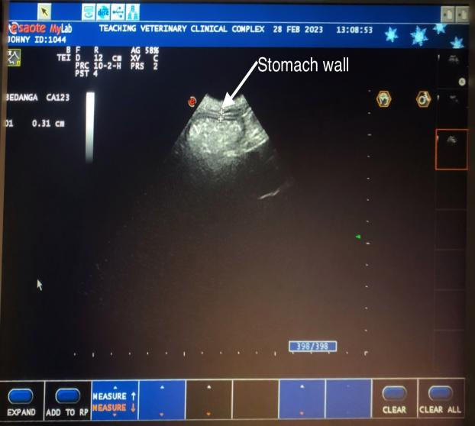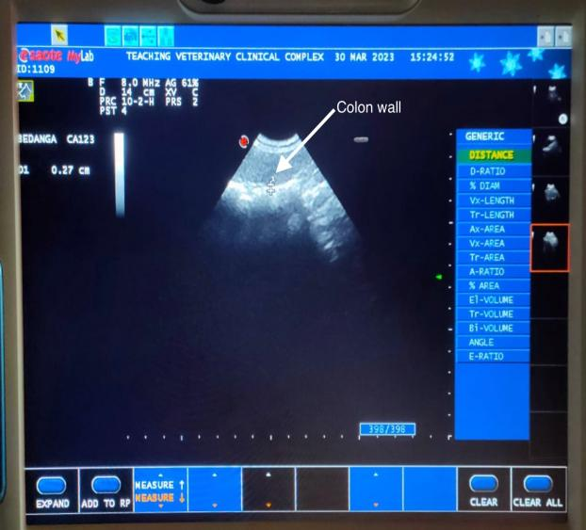
Fig 1. Normal stomach wall thickness (0.31 cm) Fig 2. Normal colon wall thickness (0.27 cm)
a)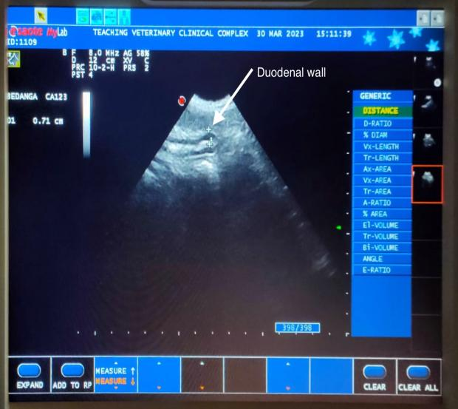 b)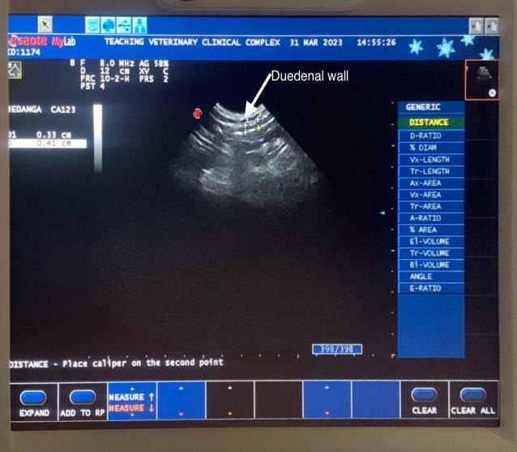
Fig. 3. Duodenal wall thickness
- Thickness is 0.71 cm which is higher than normal
- Thickness is 0.41 cm which is in normal range
3.1.2. X-Ray Evaluation
In this study intestinal measurement thickness was done according to Biery and Owens (1989) the maximum normal serosal-to-serosal diameter of the canine intestine was less than 1.6 times the height of the L5 vertebral body at its narrowest point, or less than twice the width of a rib is not considered to be inflamed.
a)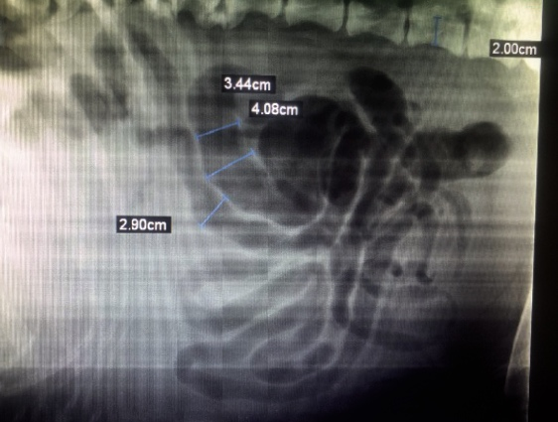 b)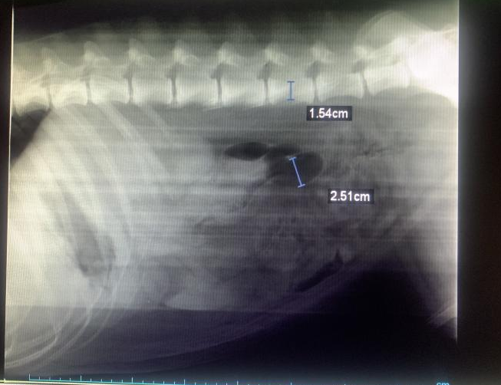
Fig 4. Measuring intestinal wall thickness before treatment
a) Intestinal thickness is greater than 3.2 cm
b) Intestinal thickness is greater than 2.4 cm
a)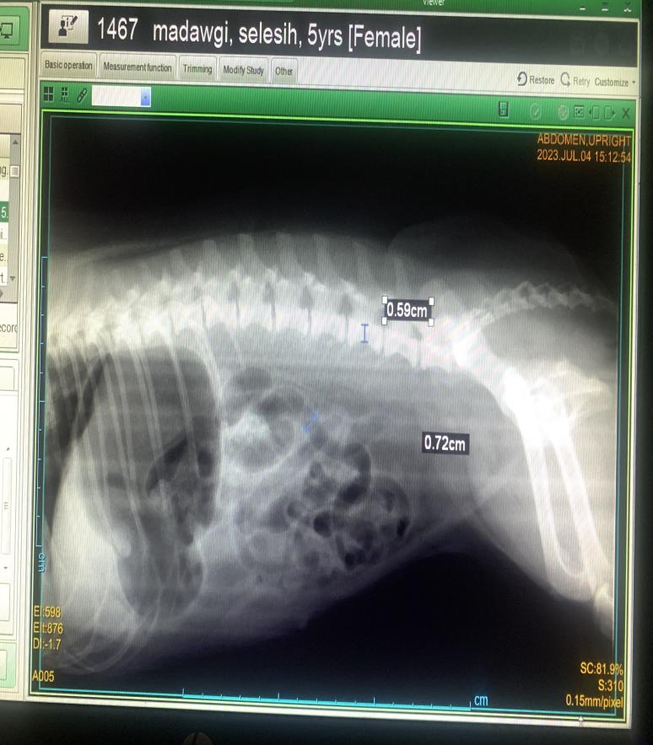b) 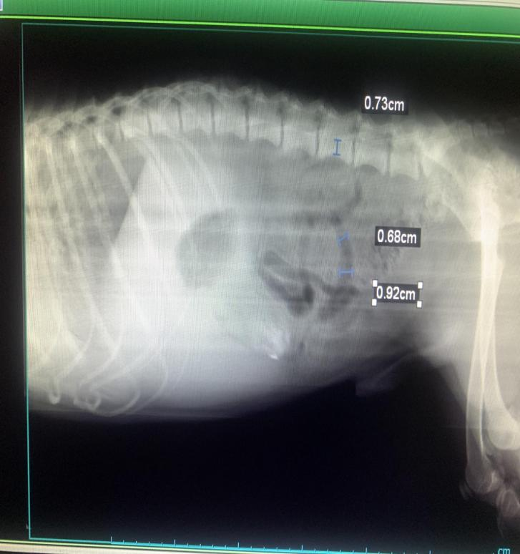
Fig 5. Measuring intestinal wall thickness after treatment
a) Intestinal thickness is lesser than 0.9 cm
b) Intestinal thickness is lesser than 1.2 cm
3.2. Physical Parameters Evaluation of Canine Chronic Enteropathy
Clinical parameters were measured from all chronic enteropathy positive dogs. Six animals in group I, six animals in group II and six animals were taken as control groups in group III. The results obtained were detailed below.
The following table and graph depict the non-significant changes between 0th and 21st day of treatment. In group I, II and III of CRT, STT, BCS there were significant changes between the positive group and apparently healthy group may be due to inappetence, anorexia, and dehydration of the CE positive animal.
Table 2. Physical parameters evaluation between chronic enteropathy positive dogs and healthy control
Parameters | Group | Day 0 | Day 21 | t value
Rectal Temperature(˚F) | Group I | 101.03±0.40 | 101.05±0.41 | 0.09^{NS}
Rectal Temperature(˚F) | Group II | 100.90±0.45 | 101.13±0.39 | 1.04^{NS}
Rectal Temperature(˚F) | Group III | 100.85±0.28 | 101.30±0.14 | 2.35^{NS}
Rectal Temperature(˚F) | F value | 0.06^{NS} | 0.14^{NS}
Heart Rate (bpm) | Group I | 118.67±9.02 | 120.00±9.00 | 2.00^{NS}
Heart Rate (bpm) | Group II | 133.33±7.70 | 130.00±7.17 | 2.33^{NS}
Heart Rate (bpm) | Group III | 107.33±1.76 | 106.67±2.11 | 1.00^{NS}
Heart Rate (bpm) | F value | 3.54^{NS} | 3.00^{NS}
Pulse Rate (/MIN) | Group I | 102.67±0.67 | 103.67±1.20 | 1.46^{NS}
Pulse Rate (/MIN) | Group II | 118.00±10.01 | 117.00±9.73 | 2.23^{NS}
Pulse Rate (/MIN) | Group III | 105.67±1.09 | 105.33±1.76 | 0.34^{NS}
Pulse Rate (/MIN) | F value | 1.94^{NS} | 1.59^{NS}
Respiration Rate(/MIN) | Group I | 21.67±0.61 | 22.00±1.03 | 0.54^{NS}
Respiration Rate(/MIN) | Group II | 26.67±2.29 | 26.00±2.07 | 1.00^{NS}
Respiration Rate(/MIN) | Group III | 43.00±12.62 | 42.67±12.69 | 1.00^{NS}
Respiration Rate(/MIN) | F value | 2.26^{NS} | 2.16^{NS}
Capillary Refill Time (CRT) | Group I | 2.17±0.17ª | 2.17±0.17ª | 0.00^{NS}
Capillary Refill Time (CRT) | Group II | 1.83±0.17ª | 2.00±0.00ª | 1.00^{NS}
Capillary Refill Time (CRT) | Group III | 1.00±0.00^{b} | 1.00±0.00^{b} | -
Capillary Refill Time (CRT) | F value | 19.50* | 43.00*
Skin Tenting Test (STT) | Group I | 2.17±0.17ª | 2.17±0.17ª | 0.00^{NS}
Skin Tenting Test (STT) | Group II | 2.33±0.21ª | 2.00±0.00ª | 1.58^{NS}
Skin Tenting Test (STT) | Group III | 1.00±0.00^{b} | 1.00±0.00^{b}
Skin Tenting Test (STT) | F value | 21.92* | 43.00*
Body condition score (BCS) | Group I | 5.00±0.45^{b} | 5.33±0.33^{b} | 1.58^{NS}
Body condition score (BCS) | Group II | 5.00±0.45^{b} | 5.17±0.40^{b} | 0.54^{NS}
Body condition score (BCS) | Group III | 7.33±.21ª | 7.33±.21ª | -
Body condition score (BCS) | F value | 12.25* | 13.77*
*Significant (p≤0.05); **Highly significant (p≤0.01); NS: Non-significant

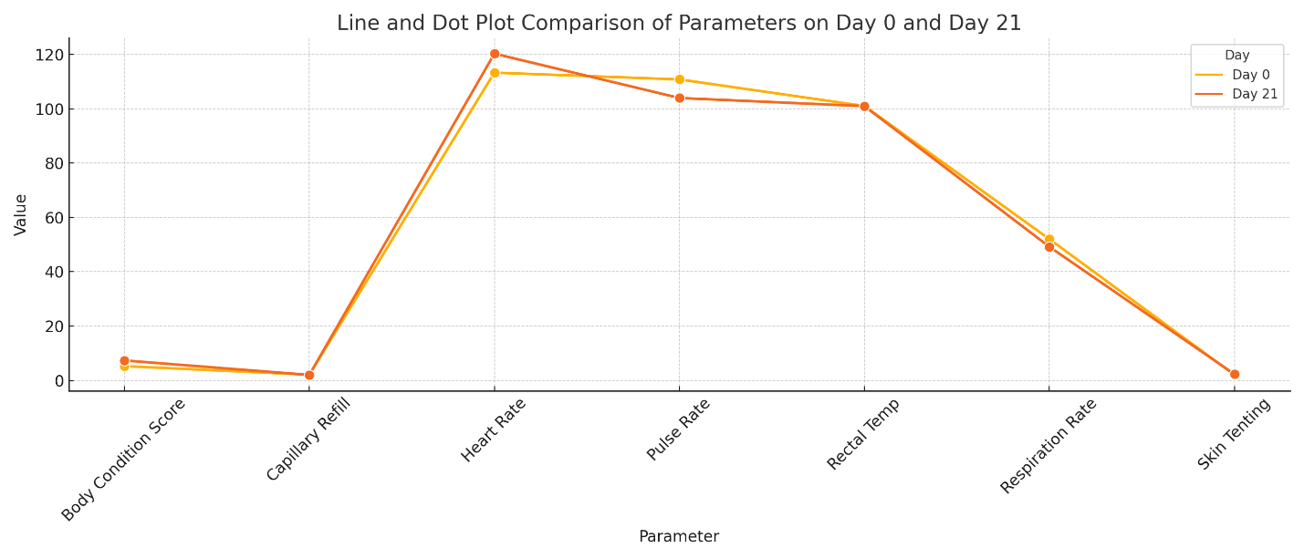
Fig 6. Graphical presentation of physical parameters evaluation between Group I, II, III and between 0 and 21 days
3.3. Haematological Evaluation of Canine Chronic Enteropathy
Complete blood count was done on Teaching Veterinary Clinical Complex, College of Veterinary Sciences and Animal Husbandry, Central Agricultural University, Selesih, Aizawl, Mizoram. Haematological parameters were measured from all chronic enteropathy positive dogs. Six animals in group I, six animals in group II and six animals were taken as control groups in group III. The results obtained were detailed below in table and the therapeutic evaluation in graphical presentation.
There were significant changes Hb, PCV, TEC, Monocyte and Eosinophil. The graphical presentation shows the significant improvement in the value before and after treatment.
Table 3. Haematological evaluation between chronic enteropathy positive dogs and healthy control
Parameters | Group | Day 0 | Day 21 | t value
Hb (g/dL) | Group I | 15.18±1.71 | 14.73±1.05 | 0.65^{NS}
Hb (g/dL) | Group II | 13.17±0.73 | 13.68±0.59 | 2.71*
Hb (g/dL) | Group III | 13.90±0.33 | 14.15±0.34 | 3.72**
Hb (g/dL) | F value | 0.89^{NS} | 0.53^{NS}
PCV (%) | Group I | 44.00±4.31 | 44.37±3.04 | 0.26^{NS}
PCV (%) | Group II | 40.45±2.31 | 40.63±0.40 | 0.25^{NS}
PCV (%) | Group III | 41.75±0.97 | 42.08±0.21 | 5.97**
PCV (%) | F value | 0.39^{NS} | 0.71^{NS}
TEC (10⁶/µL) | Group I | 7.68±0.45 | 7.92±0.36ª | 1.05^{NS}
TEC (10⁶/µL) | Group II | 6.45±0.40 | 6.57±0.39^{b} | 1.47^{NS}
TEC (10⁶/µL) | Group III | 6.90±0.21 | 7.00±0.17^{ab} | 1.07^{NS}
TEC (10⁶/µL) | F value | 2.86^{NS} | 4.50*
TLC (10³/µL) | Group I | 11.38±2.67 | 11.20±2.49 | 0.58^{NS}
TLC (10³/µL) | Group II | 9.58±1.03 | 9.70±1.09 | 0.98^{NS}
TLC (10³/µL) | Group III | 12.77±1.59 | 12.48±1.55 | 2.31^{NS}
TLC (10³/µL) | F value | 0.71^{NS} | 0.59^{NS}
Neutrophil (%) | Group I | 72.37±4.26 | 72.83±4.15 | 0.85^{NS}
Neutrophil (%) | Group II | 71.67±6.75 | 72.67±5.93 | 1.00^{NS}
Neutrophil (%) | Group III | 80.33±1.05 | 80.67±0.99 | 0.79^{NS}
Neutrophil (%) | F value | 1.07^{NS} | 1.17^{NS}
Lymphocyte (%) | Group I | 19.47±4.36 | 18.87±3.82 | 0.94^{NS}
Lymphocyte (%) | Group II | 17.15±5.39 | 16.65±4.95 | 1.01^{NS}
Lymphocyte (%) | Group III | 8.58±0.39 | 8.75±0.35 | 1.45^{NS}
Lymphocyte (%) | F value | 2.04^{NS} | 2.16^{NS}
Monocyte (%) | Group I | 2.73±1.27 | 3.25±1.39 | 2.64*
Monocyte (%) | Group II | 3.18±0.67 | 3.41±0.73 | 1.23^{NS}
Monocyte (%) | Group III | 1.93±0.25 | 1.93±0.23 | 0.00^{NS}
Monocyte (%) | F value | 0.57^{NS} | 0.79^{NS}
Eosinophil (%) | Group I | 5.08±1.32 | 2.78±0.92 | 3.42**
Eosinophil (%) | Group II | 7.45±1.96 | 5.50±1.11 | 2.26^{NS}
Eosinophil (%) | Group III | 3.20±0.45 | 3.08±0.41 | 1.11^{NS}
Eosinophil (%) | F value | 2.36^{NS} | 2.97^{NS}

*Significant (p≤0.05); **Highly significant (p≤0.01); NS: Non-significant
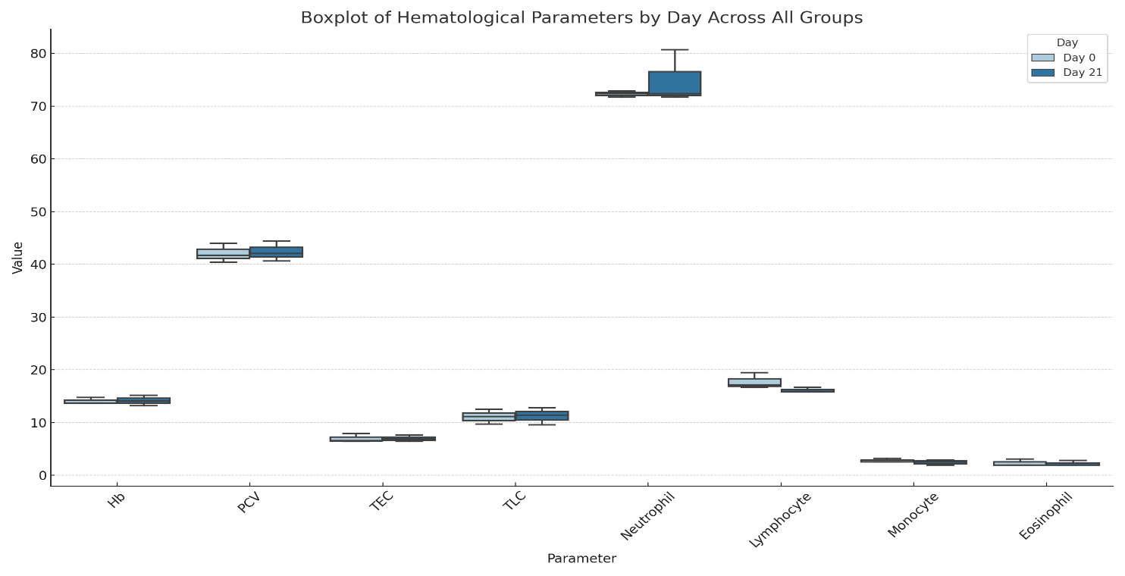
Fig 7. Graphical presentation of haematological evaluation between Group I, II, III and between 0 and 21 days
3.4. Serum Biochemistry Evaluation of Canine Chronic Enteropathy
The following table and graph depict the significant changes of serum biochemistry evaluation.
Table 4. Serum biochemistry evaluation of canine chronic enteropathy
Parameters | Group | Day 0 | Day 21 | t value
Protein (g/dL) | Group I | 5.65±0.57 | 6.21±0.36 | 0.79^{NS}
Protein (g/dL) | Group II | 6.08±0.25 | 6.30±0.19 | 1.85^{NS}
Protein (g/dL) | Group III | 6.78±0.16 | 6.85±0.16 | 2.00^{NS}
Protein (g/dL) | F value | 2.38^{NS} | 1.83^{NS}
Albumin (g/dL) | Group I | 2.10±0.23^{b} | 2.80±0.10^{b} | 3.79**
Albumin (g/dL) | Group II | 2.30±0.15^{b} | 2.58±0.09^{b} | 2.99**
Albumin (g/dL) | Group III | 3.06±0.02ª | 3.20±0.04ª | 4.00**
Albumin (g/dL) | F value | 10.30* | 14.47*
Globulin (g/dL) | Group I | 3.56±0.36 | 3.41±0.28 | 0.59^{NS}
Globulin (g/dL) | Group II | 3.78±0.15 | 3.72±0.16 | 0.65^{NS}
Globulin (g/dL) | Group III | 3.72±0.15 | 3.65±0.15 | 1.58^{NS}
Globulin (g/dL) | F value | 0.24^{NS} | 0.58^{NS}
CRP (mg/L) | Group I | 14.00±2.00ª | 0.00±2.00 | 7.00**
CRP (mg/L) | Group II | 16.0±2.52ª | 2.00±2.00 | 7.00**
CRP (mg/L) | Group III | 0.00±0.00^{b} | 0.00±0.00 | -
CRP (mg/L) | F value | 21.92* | 1.00^{NS}
*Significant (p≤0.05); **Highly significant (p≤0.01); NS: Non-significant
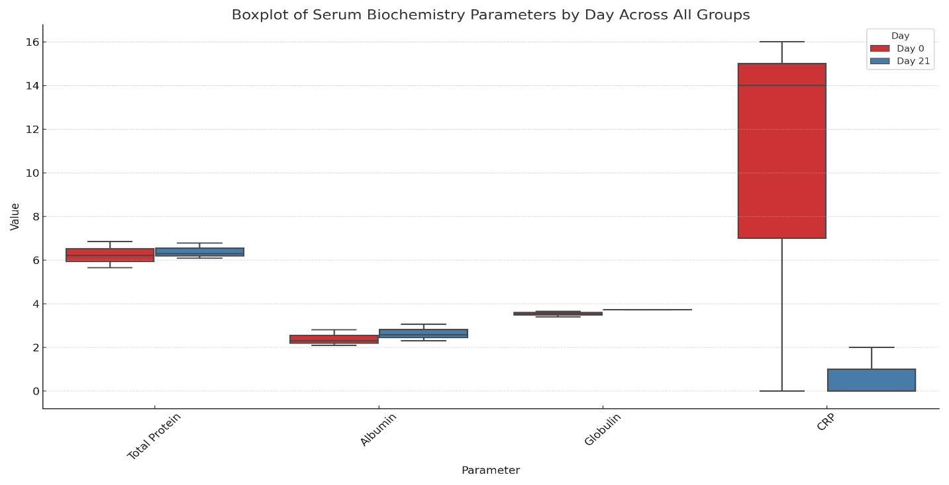
Fig. 8. Graphical presentation of serum biochemistry between Group I, II, III and between 0 and 21 days
Table 5. Therapeutic evaluation of serum biochemistry in group I (Metronidazole and Prednisolone)
Parameters | Group | Day 0 | Day 21 | t value
Protein (g/dL) | Group I | 5.65±0.57 | 6.21±0.36 | 0.79^{NS}
Albumin (g/dL) | Group I | 2.10±0.23^{b} | 2.80±0.10^{b} | 3.79**
Globulin (g/dL) | Group I | 3.56±0.36 | 3.41±0.28 | 0.59^{NS}
CRP (mg/L) | Group I | 14.00±2.00ª | 0.00±2.00 | 7.00**

Fig 9. Graphical presentation of therapeutic evaluation of serum biochemistry in group I
Table 6. Therapeutic evaluation of serum biochemistry in group II (Metronidazole and Mesalazine)
Parameters | Group | Day 0 | Day 21 | t value
Protein (g/dL) | Group II | 6.08±0.25 | 6.30±0.19 | 1.85^{NS}
Albumin (g/dL) | Group II | 2.30±0.15^{b} | 2.58±0.09^{b} | 2.99**
Globulin (g/dL) | Group II | 3.78±0.15 | 3.72±0.16 | 0.65^{NS}
CRP (mg/L) | Group II | 16.0±2.52ª | 2.00±2.00 | 7.00**

Fig 10. Graphical presentation of therapeutic evaluation of serum biochemistry in group II
3.5 Clinical Score Evaluation of Canine Chronic Enteropathy
The following table and graph depict the significant changes clinical score evaluation
Table 7. Therapeutic evaluation of Clinical Score in canine with CE
Parameters | Group | Day 0 | Day 21 | t value
Activity | Group I | 1.33±0.42ª | 0.00±0.00ª | 3.16**
Activity | Group II | 1.33±0.49ª | 0.00±0.00ª | 2.69*
Activity | Group III | 0.00±0.00^{b} | 0.00±0.00^{b} | -
Activity | F value | 4.21* | -
Appetite | Group I | 2.17±0.31ª | 0.33±0.21ª | 4.56**
Appetite | Group II | 1.83±0.40ª | 0.67±0.21ª | 3.79**
Appetite | Group III | 0.00±0.00^{b} | 0.00±0.00^{b} | -
Appetite | F value | 15.97* | 3.75*
Vomiting | Group I | 2.33±0.33ª | 0.00±0.00ª | 7.00**
Vomiting | Group II | 1.50±0.56ª | 0.00±0.00ª | 2.66*
Vomiting | Group III | 0.00±0.00^{b} | 0.00±0.00^{b} | -
Vomiting | F value | 9.81* | -
Stool consistency | Group I | 0.83±0.54 | 0.00±0.00 | 1.54^{NS}
Stool consistency | Group II | 1.16±0.60 | 0.00±0.00 | 1.94^{NS}
Stool consistency | Group III | 0.00±0.00 | 0.00±0.00 | -
Stool consistency | F value | 1.65^{NS} | -
Stool frequency | Group I | 0.17±0.17 | 0.00±0.00 | 1.00^{NS}
Stool frequency | Group II | 0.17±0.17 | 0.00±0.00 | 1.00^{NS}
Stool frequency | Group III | 0.00±0.00 | 0.00±0.00 | -
Stool frequency | F value | 0.50^{NS} | -
Weight loss | Group I | 0.50±0.34 | 0.00±0.00 | 1.46^{NS}
Weight loss | Group II | 0.67±0.21 | 0.00±0.00 | 3.16**
Weight loss | Group III | 0.00±0.00 | 0.00±0.00 | -
Weight loss | F value | 2.24^{NS} | -
Total score | Group I | 7.33±1.31ª | 0.33±0.21ª | 5.12**
Total score | Group II | 6.50±1.99ª | 0.66±0.21ª | 3.06**
Total score | Group III | 0.00±0.00^{b} | 0.00±0.00^{b} | -
Total score | F value | 8.49* | 3.75*

*Significant (p≤0.05); **Highly significant (p≤0.01); NS: Non-significant
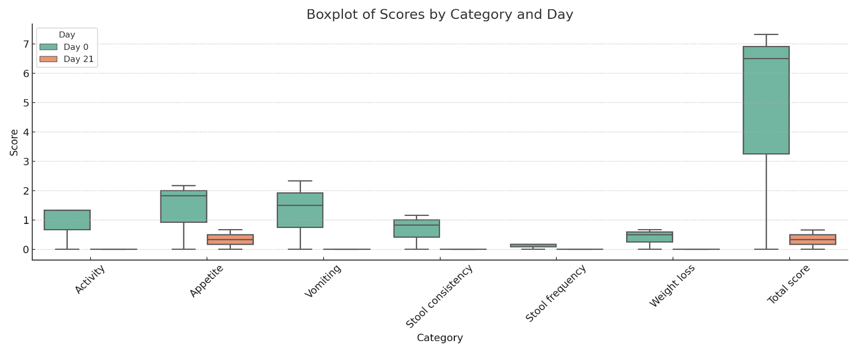
Fig 11. Graphical presentation of Clinical score between Group I, II, III and between 0 and 21 days
Table 8. Therapeutic evaluation of Clinical Score in Group I (Metronidazole and Prednisolone)
Parameters | Group | Day 0 | Day 21 | t value
Activity | Group I | 1.33±0.42ª | 0.00±0.00ª | 3.16**
Appetite | Group I | 2.17±0.31ª | 0.33±0.21ª | 4.56**
Vomiting | Group I | 2.33±0.33ª | 0.00±0.00ª | 7.00**
Stool consistency | Group I | 0.83±0.54 | 0.00±0.00 | 1.54^{NS}
Stool frequency | Group I | 0.17±0.17 | 0.00±0.00 | 1.00^{NS}
Weight loss | Group I | 0.50±0.34 | 0.00±0.00 | 1.46^{NS}
Total score | Group I | 7.33±1.31ª | 0.33±0.21ª | 5.12**

Fig. 12. Graphical presentation of Group I clinical evaluation on 0th and 21st day
Table 9. Therapeutic evaluation of Clinical Score in Group II (Metronidazole and Mesalazine)
Parameters | Group | Day 0 | Day 21 | t value
Activity | Group II | 1.33±0.49ª | 0.00±0.00ª | 2.69*
Appetite | Group II | 1.83±0.40ª | 0.67±0.21ª | 3.79**
Vomiting | Group II | 1.50±0.56ª | 0.00±0.00ª | 2.66*
Stool consistency | Group II | 1.16±0.60 | 0.00±0.00 | 1.94^{NS}
Stool frequency | Group II | 0.17±0.17 | 0.00±0.00 | 1.00^{NS}
Weight loss | Group II | 0.67±0.21 | 0.00±0.00 | 3.16**
Total score | Group II | 6.50±1.99ª | 0.66±0.21ª | 3.06**

Fig 13. Graphical presentation of Group I clinical evaluation on 0th and 21st day
Table 10. Therapeutic evaluation of the Total clinical Score
Parameters | Group | Day 0 | Day 21 | t value
Total score | Group I | 7.33±1.31ª | 0.33±0.21ª | 5.12**
Total score | Group II | 6.50±1.99ª | 0.66±0.21ª | 3.06**
Total score | Group III | 0.00±0.00^{b} | 0.00±0.00^{b} | -

Fig 14. Total score evaluation on 0 and 21 days between three group
Based on the overall observations between Group I, II and II and between 0th and 21st day of treatment, it was concluded that Group that was given treatment with Metronidazole and prednisolone showed better improvement than the Group given treatment with Metronidazole and prednisolone along with other supportive therapy required. This was concluded based on the improvement of intestinal inflammation measured in radiography, the improvement changes in the Hb, PCV, TEC and Eosinophil levels. The improvement changes in the Albumin, CRP level. Overall improvement in the clinical score and total score was noted.
4. DISCUSSIONS
4.1. Physical Parameters of Dogs with Chronic Enteropathy in Mizoram
Clinical parameters of dog with CE and control group were recorded. There was a significant difference between the parameters of healthy animals, and infected animals in condition like capillary refill time (CRT), skin tenting test (STT), and body condition score (BCS). This may be because most of the cases suffer from inappetence, anorexia and dehydration (Holmberg et al., 2022).
4.2. Haematological and Sero-biochemical Parameters of Dogs with Chronic Enteropathy in Mizoram
Haematological parameters were recorded in 6 apparently healthy animals (control group), and in 12 dogs diagnosed with canine CE which were grouped into two groups. Group I was with 6 positive cases and was given the combination drug viz., Metronidazole and Prednisolone. Group II was with another 6 positive cases and were given the combination drug viz., Metronidazole and Mesalazine.
Estimation of Haemoglobin (g/dL) level in group II and III shows significant changes between the 0th day and 21st day of treatment. There were changes and an increase in the level of Hb in between days. There was also an increase in the PCV (%) and TEC (10⁶/µL). According to Marchetti et al. (2010) anaemia, eosinophilia, lymphopenia, and thrombocytosis are changes that can be found in canine CE in the blood count. Anaemia is uncommon but typically mild. It can be brought on by an iron deficiency, chronic GI blood loss, or a persistent inflammatory state.
In group I there were significant changes in eosinophil and monocyte count. There was presence of eosinophilic enteritis which after treatment eosinophil has shown to decrease in the day after treatment. Sattasathuchana and Steiner (2014) said that eosinophilia could be detected in cases of eosinophilic enteritis, allergic forms of the condition, or parasitosis. In case of eosiniphilia, worm burden can be suspected, especially when the dog was young. Anthelmintic therapy maybe advocated in such cases. Presence of worms need not always lead to symptoms; hence a coprological examination might be required (Zanzani et al., 2014).
In group I, II and III there were significant changes in albumin level where lower values were observed in 0th day and after treatment on 21st day, there were higher values. Hypoalbuminemia might be a characteristic finding of PLE with an albumin value of <2g/L. As a result of lymphangiectasia, lymphopenia is frequently observed in dogs with PLE (Salavati et al., 2019). Other CE cases also might experience mild hypoalbuminemia, and during treatment, both CE and PLE cases may experience an increase in albumin values (Gianella et al., 2017). In this study also the albumin values showed an increase after treatment indicating that it has anti-inflammatory effect, the albumin production was reduced in inflammatory states.
In Group I and II there were significant changes in the CRP level. CRP level which occurs in inflammatory condition improved after the treatment. Group I showed complete absence of inflammatory condition. But Group II animals were showing mild inflammatory condition. Jergens (2004) said that the serum concentration of CRP rises in response to an inflammatory stimulus because it is a positive acute-phase protein. He found that dogs with moderate to severe CE had significantly higher serum CRP concentrations than a group of healthy dogs. He further showed that successful treatment led to a significant reduction in CRP concentrations. This indicates that determining the serum CRP concentration is useful in assessing the treatment response in canine patients with CE.
4.3. Diagnostic Imaging of Dogs with Chronic Enteropathy in Mizoram
In the present study, diagnosis was based on clinical signs and radiographic imaging. Jablonski et al. (2017) in their research reported that the diagnosis of CE was based on clinical signs and the exclusion of other etiologies.
In the present study comparison of diagnosis was done by X ray rather than USG. Watson et al. (2014) recorded that abdominal radiographic examination could disclose important changes caused by GI foreign bodies. Abdominal ultrasound examination was an essential step in identifying an enteropathic patient and for ruling out non-gastrointestinal pathologies. Hyperechogenicity of the mucosa, lymphangiectasia, abdominal lymphadenopathy, thicker intestinal walls, loss of stratigraphic distinction, and changes in peristalsis were among the ultrasound abnormalities that were frequently seen during CEs. Ultrasound could highlight the presence of free peritoneal fluid, which was typically linked to intestinal inflammation, or ascites. This might be due to hypoalbuminemia. Ultrasound was crucial to rule out GI tract tumours or specific types of CE like lipogranulomatous lymphangitis.

Table 11. Comparison of Ultrasound Changes on Day 0 and Day 21
Organ | Day 0 | Day 21
Duodenal wall thickness (cm) | 0.71 | 0.41
4.4. Therapeutic Evaluation of Clinical Score in Canine with CE
Based on the clinical score there were significant changes in the parameters between day 0 and day 21. In activity there were highly significant changes in Group I than Group II.
In appetite there were highly significant changes in Group I but significant changes in Group II too. In vomition there were highly significant changes in Group I and significant changes in Group II. In weight loss there was significant changes in Group II only. There were no significant changes in stool consistency and stool frequency in both the groups. Overall, in the total score there was significant improvement in Group I in comparison to Group II.
4.5. Effective Therapeutic Regimen of Dogs with Chronic Enteropathy in Mizoram
The dogs diagnosed with CE were randomly grouped into two groups each with six dogs. Group I animals were given Metronidazole + prednisolone and other supportive therapy. Group II animals were given Metronidazole + Mesalazine with other supportive therapy. Six apparently healthy dogs were grouped as Group III and were used for comparison.
The result of the treatment trial showed that the values of Hb, TEC, PCV, Monocyte, Eosinophil, Albumin, CRP, CRT, STT, BCS, Activity, Appetite, Vomition, Diarrhoea, Weight loss, were significantly improved in Group I. Based on these observations, it was concluded that the group where Metronidazole and prednisolone was given (Group I) showed better improvement than Group II.
The result showed that treatment with Prednisolone helped in reversing the symptoms and signs of gastroenteritis, and also helped in reducing the eosinophilic gastroenteritis. Further the serum albumin level returned to the reference range (Dandrieux et al., 2013).
5.CONCLUSIONS
CE was diagnosed by X- Ray, USG, and CCECAI along with other supportive test including physical examination, haematological examination, and serum biochemistry. Treatment given with Metronidazole and Prednisolone was more effective in treating canine chronic enteropathy than the treatment given with Metronidazole and Mesalazine.

Disclaimer (Artificial intelligence)
Author(s) hereby declares that NO generative AI technologies such as Large Language Models (ChatGPT, COPILOT, etc.) and text-to-image generators have been used during the writing or editing of this manuscript.
REFERENCES
Alessandri, G., Argentini, C., Milani, C., Turroni, F., Cristina, O. M., Van Sinderen, D., & Ventura, M. (2020). Catching a glimpse of the bacterial gut community of companion animals: a canine and feline perspective. Microbial Biotechnology, 13(6), 1708-1732. https://doi.org/10.1111/1751-7915.13656
Ciorba, M. A. (2012). A gastroenterologist's guide to probiotics. Clinical Gastroenterology and Hepatology, 10(9), 960-968. https://doi.org/10.1016/j.cgh.2012.03.024
Dandrieux, J. R., Noble P. J., Scase, T. J., Cripps, P. J., & German, A. J. (2013). Comparison of a chlorambucil-prednisolone combination, with an azathioprine-prednisolone combination for treatment of chronic enteropathy with concurrent protein-losing enteropathy in dogs: 27 cases (2007–2010). Journal of the American Veterinary Medical Association, 242(12), 1705-1714.
German, A.J., Hall, E.J., & Day, M. J. (2003). Chronic intestinal inflammation and intestinal disease in dogs. Journal of Veterinary Internal Medicine, 17(1), 8- 20. https://doi.org/10.1111/j.1939-1676.2003.tb01318.x
Gianella, P., Lotti, U., Bellino, C., Bresciani, F., Cagnasso, A., Fracassi, D. A., & Pietra, M. (2017). Clinicopathologic and prognostic factors in short-and long-term surviving dogs with protein-losing enteropathy. Schweizer Archiv Fur Tierheilkunde, 159(3), 163- 169. https://doi.org/10.17236/sat00108
Holmberg, J., Pelander, L., Ljungvall, I., Harlos, C., Spillmann, T., & Häggström, J. (2022). Chronic enteropathy in dogs—Epidemiologic aspects and clinical characteristics of dogs presenting at two swedish animal hospitals. Animals, 12(12), 1507. https://doi.org/10.3390/ani12121507
Jablonski, W. S. A., Priestnall, S. L., & Webb, C. B. (2017). Histopathologic characteristics of intestinal biopsy samples from dogs with chronic inflammatory enteropathy with and without hypoalbuminemia. Journal of Veterinary Internal Medicine, 31(2), 371-376. https://doi.org/10.1111/jvim.14669
Jergens, A. E. (2004). Clinical assessment of disease activity for canine inflammatory bowel disease. Journal of the American Animal Hospital Association. 40(6), 437-45. https://doi.org/10.5326/0400437
Jergens, A. E., & Heilmann, R. M. (2022). Canine chronic enteropathy—Current state-of-the-art and emerging concepts. Frontiers in veterinary science, 9, 923013.https://doi.org/10.3389/fvets.2022.923013
Luckschander, N., Allenspach, K., Hall, J., Seibold, F., Gröne, A., Doherr, M. G., & Gaschen, F. (2006). Perinuclear antineutrophilic cytoplasmic antibody and response to treatment in diarrheic dogs with food responsive disease or inflammatory bowel disease. Journal of Veterinary Internal Medicine. 20(2), 221-227.
https://doi.org/10.1111/j.1939-1676.2006.tb02849.x
Marchetti, V., Lubas, G., Lombardo, A., Corazza, M., Guidi, G., Cardini, G. (2010). Evaluation of erythrocytes, platelets, and serum iron profile in dogs with chronic enteropathy. Veterinary Medicine International, 28, 2010. https://doi.org/10.4061/2010/716040
Biery, D. N., & Owens, J. M. (1989). Radiographic interpretation for the small animal clinician. Enke. https://inis.iaea.org/records/se99d-0dj90. Accessed on 01/06/2025
Salavati, S. S., Gow, A., Bommer, N., Morrison, L, & Mellanby, R. (2019). Diagnostic features, treatment, and outcome of dogs with inflammatory protein‐los.ing enteropathy. Journal of Veterinary Internal Medicine, 33(5), 2005-13. https://doi.org/10.1111/jvim.15571

Sattasathuchana, P., & Steiner, J. M. (2014). Canine eosinophilic gastrointestinal disorders. Animal Health Research Reviews, 15(1), 76-86. https://doi.org/10.1017/S1466252314000012
Sutherland‐Smith, J. A. M. E. S., Penninck, D. G., Keating, J. H. and Webster, C. R. (2007). Ultrasonographic intestinal hyperechoic mucosal striations in dogs are associated with lacteal dilation. Vet. Radiol. Ultrasound, 48(1): 51-57.
Zanzani, S. A., Gazzonis, A.L., Scarpa. P., Berrilli, F., & Manfredi, M. T. (2014). Intestinal parasites of owned dogs and cats from metropolitan and micropolitan areas: prevalence, zoonotic risks, and pet owner awareness in northern Italy. BioMed Research International, 1, 696508. https://doi.org/10.1155/2014/696508

