Deciphering genetic association and discernment of yield traits through Correlation, Path and Principal Component Analyses in Sorghum (Sorghum bicolour L. Moench)
ABSTRACT
The agro-morphological characterization of breeding lines providing insight into existing diversity, enables the identification of desirable traits and enhances crop improvement. The present study was carried out in advanced cultures of summer sorghum . Fifteen yield contributing traits were evaluated for correlation, path and principal component analyses studies in twelve sorghum cultures. In present investigation there was existence of higher genotypic correlation when compared to phenotypic correlation that indicated the presence of inherent association among the characters. Significant and positive association was observed between single plant yield (g) and its yield contributing traits like plant height (cm), days to maturity, panicle width (cm) and panicle weight (g) whereas significant and negative association was observed between days to fifty percent flowering and its yield contributing traits like plant height (cm)and number of leaves. In this investigation path analysis at both genotypic and phenotypic levels for plant height (cm) plant height (cm), flag leaf length (cm), leaf length (cm), stem girth (cm), panicle weight (g) and seed index (g) exhibited , flag leaf length (cm), leaf length (cm), stem girth (cm), panicle weight (g) and seed index (g) exhibited positive direct effect on grain yield (g) there by it would play an important role in selection criteria for improving the grain yield. Principal component analysis (PCA) indicated that PC1 accounted for 33.863 % of total variance thereby indicating the largest variability and better performance. These results could be significant genetic assets for boosting sorghum productivity, particularly amidst the uncertainties of climate change.
Keywords: Agro-morphological characterization, sorghum, correlation, path analysis, Genetic stability and PCA
INTRODUCTION
Sorghum (Sorghum bicolor L. Moench), a resilient cereal belonging to the Poaceae family and the Andropogoneae tribe, is recognized as the fifth-most important cereal crop globally after rice, wheat, barley, and maize (Pezzali et al., 2020). Sorghum thrives on marginal soils, demands relatively low input, requires minimal fertilizer applications, and exhibits high water-use efficiency, making it an ideal crop for resource-poor farmers (Adebowale et al., 2020). Globally, sorghum plays a crucial role in ensuring food and nutritional security for over 500 million people, particularly in Sub-Saharan Africa and parts of Asia. Among producing nations, India holds the top position in global sorghum production, followed closely by Nigeria (Abah et al., 2020). Within India, sorghum is the third most important cereal crop after rice and wheat, forming a dietary staple and fodder source for millions, especially in semi-arid regions.
Beyond its role as a food grain, sorghum is a multipurpose crop valued for its use in the production of food, animal feed, fodder, and biofuels. Its grain is gluten-free and rich in dietary fibre, micronutrients (such as iron and zinc), and antioxidants. In fact, studies have indicated that sorghum possesses superior nutritional properties compared to major cereals like rice and maize (Pugahendhi et al., 2023). These attributes make it especially relevant in the context of developing functional and health-promoting foods for populations with special dietary needs.
Despite its advantages, sorghum cultivation in India remains largely dependent on rainfall, making it vulnerable to erratic monsoon patterns. This reliance underscores the need for developing genotypes that are both high-yielding and resilient to abiotic stresses, particularly drought. Therefore, understanding the genetic architecture and agro-morphological variability among Indian sorghum genotypes is crucial for breeding programs aimed at improving yield stability and stress tolerance in rainfed ecosystems (Sharma et al., 2006). India’s sorghum germplasm is marked by considerable genetic and phenotypic diversity, offering a valuable reservoir of traits that can be harnessed to enhance productivity and adaptability (Elangovan et al., 2009; Prasad & Sridhar, 2019). Understanding the genetic basis of yield and its component traits is fundamental to the success of crop improvement programs. Yield is a complex, polygenic trait that is influenced by multiple interrelated agro-morphological and physiological parameters. To dissect these relationships, correlation analysis serves as a primary tool to reveal the strength and direction of associations among traits. It enables breeders to identify positively or negatively correlated characters, guiding the selection of desirable traits that are associated with improved yield performance. However, correlation alone does not provide a complete picture, as it does not distinguish between direct effects of a trait on yield and indirect effects mediated through other traits. Therefore, path coefficient analysis is employed to partition the correlation coefficients into direct and indirect effects, offering deeper insight into the cause-and-effect relationships among traits. This analytical approach allows for the identification of traits that have a significant and direct influence on yield, thereby improving the efficiency of selection strategies. In addition, principal component analysis (PCA) is a robust multivariate technique used to reduce the dimensionality of complex datasets and to identify patterns of variation across genotypes. Together, these analytical tools—correlation, path analysis, PCA, and stability assessments—provide a comprehensive understanding of trait dynamics and facilitate the strategic selection of high-yielding, stable, and adaptable sorghum genotypes for future breeding efforts. Hence, this study was undertaken to assess the agro-morphological traits of diverse red sorghum genotypes, with the primary objective of identifying key traits contributing to yield and adaptation. By elucidating the phenotypic and genetic variability among these genotypes, the study aims to support the development of improved sorghum cultivars suitable for diverse environmental conditions and contribute to the broader goal of sustainable food security.
MATERIALS AND METHODS
The experimental materials consist of twelve sorghum cultures raised in randomized block design with two checks (Paiyur 2 and CO 34), and three replications. These genotypes were evaluated during summer 2024 at the Department of Millets, Tamil Nadu Agricultural University, and Coimbatore. Each genotype was raised in three rows of 4 meters each with spacing 45 cm and 15 cm. The experimental field was situated on well-drained red loamy soil with a neutral pH (6.8–7.2), moderate fertility, and good water-holding capacity. Prior to sowing, the field was ploughed thoroughly with a tractor-drawn disc plough followed by harrowing and levelling to create a fine tilth. Farmyard manure (FYM) was applied at the rate of 12.5 t/ha and incorporated into the soil 15 days before sowing. A basal dose of fertilizers was applied at 60:30:30 kg/ha (N:P₂O₅:K₂O), with nitrogen applied in two splits—half at sowing and the remaining half at 30 days after sowing (DAS). The crop was irrigated immediately after sowing and subsequently at critical growth stages such as seedling, panicle initiation, and flowering. Manual weeding was carried out at 20 and 40 DAS to keep the plot weed-free. Protective measures were taken to control pest and disease incidence as per standard agronomic practices recommended for sorghum cultivation in Tamil Nadu. Five randomly selected plants of each genotype were taken for observation of 15 quantitative traits. The degree of relationship between the characteristics under investigation was determined using correlation coefficients and path coefficient analyses. The correlation coefficient and path analyses were analyzed using TNAUSTAT software (Version 2.1). To calculate the path-coefficient, the average values of the characteristics were utilized. Principal component analysis (PCA) was employed to discern the principal morphological characters. The dimensionality of the dataset was decreased using PCA without sacrificing any crucial information. The loading plot, eigenvalues, and PCA-biplot were extracted from the PCA using the IBM SPSS software version 21.
RESULTS AND DISCUSSION
Correlation analysis
The characteristics of Pearson correlation analysis is displayed in table 1. Grain yield was shown to have positive and significant associations with a number of other variables, such as plant height (r=0.629*), days to maturity (r=0.602*), panicle width (r=0.599*), and panicle weight (r=0.887**). A robust positive link between the length of panicles and branch length (El-Din et al., 2012), and also discovered a substantial positive correlation between panicle length and grain yield. Prior studies have demonstrated that improving one desired feature might enhance other related qualities (Elangovan et al., 2020; Elangovan et al., 2009). Because of the high relationships found between these variables, it would be feasible to boost grain output by choosing genotypes with superior panicle width, panicle weight, plant height, days to maturity, and single plant yield. Panicle weight recorded a positive significant association with traits viz., single plant yield (r=0.887**), plant height (0.584*), panicle width (r=0.825**), days to fifty percent blooming (0.629*), and panicle length (0.629*). There was a substantial positive significant correlation between length of the leaf and flag leaf width (r=0.670*) and length (r=0.633*). The "multiplication and condensation hypothesis" (Harlan et al., 1973) is supported by the positive correlation between panicle qualities in sorghum, indicating that choosing these features would tangentially enhance yield performance. According to (Duncan et al., 1967; Kholová et al., 2014; Zhu et al., 2012) yield was influenced by leaf length, leaf breadth, and leaf count; all of which have an effect on food synthesis through photosynthesis in sorghum. Further evidences indicated that leaf characteristics might be crucial selection criteria for raising yield in sorghum breeding programs. Favorable correlations between plant height and yield was reported by (Gebre et al., 2024). Among quantitative traits of sorghum, (Elangovan et al., 2010) likewise found primarily favorable associations where correlation coefficients indicated that grain yield had a positive correlation with the number of leaves, plant height, and earhead width. Additionally, 100-seed weight showed a positive correlation with plant height, earhead width, and grain yield. The correlogram depicting the correlation association of the studied traits is shown in figure 1.

Table 1: Pearson correlation matrix of fifteen quantitative traits in sorghum genotypes
Traits | PH | NL | FLL | FLW | LL | LW | SG | DM | DFF | PL | PW | PWt | NPB | SI | SPY
PH | 1.000
NL | 0.462^{NS} | 1.000
FLL | -0.213^{NS} | 0.100^{NS} | 1.000
FLW | -0.423^{NS} | 0.028^{NS} | 0.939** | 1.000
LL | 0.015^{NS} | 0.474^{NS} | 0.633* | 0.670* | 1.000
LW | 0.105^{NS} | -0.065^{NS} | 0.182^{NS} | 0.243^{NS} | 0.191^{NS} | 1.000
SG | -0.231^{NS} | -0.354^{NS} | -0.346^{NS} | -0.166^{NS} | -0.322^{NS} | 0.470^{NS} | 1.000
DM | 0.321^{NS} | 0.056^{NS} | -0.137^{NS} | -0.250^{NS} | -0.429^{NS} | -0.158^{NS} | 0.269^{NS} | 1.000
DFF | -0.755** | -0.652* | 0.335^{NS} | 0.508^{NS} | 0.111^{NS} | 0.207^{NS} | 0.480^{NS} | -0.166^{NS} | 1.000
PL | -0.366^{NS} | -0.497^{NS} | 0.465^{NS} | 0.472^{NS} | 0.142^{NS} | 0.327^{NS} | 0.206^{NS} | -0.035^{NS} | 0.629* | 1.000
PW | 0.420^{NS} | -0.246^{NS} | -0.482^{NS} | -0.498^{NS} | -0.517^{NS} | 0.089^{NS} | 0.240^{NS} | 0.165^{NS} | -0.210^{NS} | -0.082^{NS} | 1.000
Pwt | 0.584* | 0.010^{NS} | -0.430^{NS} | -0.513^{NS} | -0.476^{NS} | -0.117^{NS} | 0.153^{NS} | 0.535^{NS} | -0.449^{NS} | -0.181^{NS} | 0.825** | 1.000
NPB | 0.470^{NS} | 0.198^{NS} | 0.250^{NS} | 0.176^{NS} | 0.328^{NS} | 0.335^{NS} | -0.242^{NS} | -0.240^{NS} | -0.318^{NS} | 0.257^{NS} | 0.421^{NS} | 0.416^{NS} | 1.000
SI | 0.046^{NS} | 0.145^{NS} | -0.165^{NS} | -0.070^{NS} | -0.352^{NS} | 0.063^{NS} | 0.126^{NS} | 0.267^{NS} | -0.246^{NS} | -0.506^{NS} | 0.361^{NS} | 0.375^{NS} | -0.07^{NS} | 1.000
SPY | 0.629* | 0.155^{NS} | -0.218^{NS} | -0.284^{NS} | -0.222^{NS} | -0.151^{NS} | 0.021^{NS} | 0.602* | -0.475^{NS} | -0.184^{NS} | 0.599* | 0.887** | 0.428^{NS} | 0.372^{NS} | 1.000

PH-Plant Height (cm), NL- Number of Leaves, FLL- Flag Leaf Length (cm), FLW- Flag Leaf Width (cm), LL- Leaf Length (cm), LW-Leaf Width (cm), SG-Stem Girth (cm), DM- Days to Maturity, DFF- Days to Fifty Percent Flowering, PL-Panicle Length (cm), PW- Panicle Width (cm), Pwt- Panicle Weight (g), NPB-Number of Primary Branches, SI-Seed Index (g), SPY- Single Plant Yield (g)

Figure 1: Correlogram of fifteen quantitative traits in sorghum genotypes

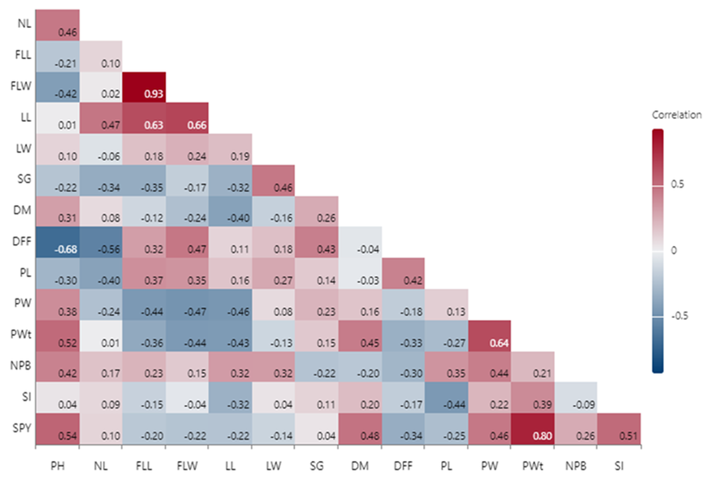
PH-Plant Height (cm), NL- Number of Leaves, FLL- Flag Leaf Length (cm), FLW- Flag Leaf Width (cm), LL- Leaf Length (cm), LW-Leaf Width (cm), SG-Stem Girth (cm), DM- Days to Maturity, DFF- Days to Fifty Percent Flowering, PL-Panicle Length (cm), PW- Panicle Width (cm), Pwt- Panicle Weight (g), NPB-Number of Primary Branches, SI-Seed Index (g), SPY- Single Plant Yield (g)
Path analysis
The genotypic associations between yield related traits of sorghum genotypes were used to divide the route coefficients into direct and indirect effects (Table 2). It was found that the panicle weight (0.94) had the greatest direct effect on the yield of a single panicle. This was followed by the panicle width (0.70), plant height (0.68), days to maturity (0.67), number of panicles per branch (0.54), seed index (0.26), number of leaves (0.18), and stem girth (0.03). (Prasad & Sridhar, 2020) discovered that plant height showed a positive direct relationship with yield per plant, which is the same conclusion as that reported by (Tiwari et al., 2024), who observed a positive direct influence on grain production for green fodder output at both genotypic and phenotypic levels. The analysis of genotypic path coefficients revealed that leaf area, panicle width, days to maturity, and 1000-grain weight positively and directly influenced grain yield per plant. Additionally, the analysis showed that days to flowering, leaf width, number of leaves per plant, leaf length, and panicle width had a notable and positive direct effect on dry fodder yield per plant (Goswami et al., 2020). At both the phenotypic and genotypic levels, the levels of residual effects were minimal, suggesting that the characters included in this study were adequate to explain the variability in yield of a single plant in sorghum genotypes.
Table 2: Genotypic path analysis with dependent variable in sorghum
Traits | PH | NL | FLL | FLW | LL | LW | SG | DM | DFF | PL | PW | PWt | NPB | SI | SPY
PH | 2.58 | -0.06 | 0.69 | -1.84 | -0.02 | -0.12 | -0.12 | -0.12 | -0.11 | -0.13 | -0.49 | 0.13 | 0.28 | 0.01 | 0.68
NL | 1.19 | -0.13 | -0.32 | 0.12 | -0.71 | 0.07 | -0.19 | -0.02 | -0.10 | -0.18 | 0.28 | 0.002 | 0.12 | 0.04 | 0.18
FLL | -0.55 | -0.01 | -3.24 | 4.08 | -0.95 | -0.21 | -0.19 | 0.05 | 0.05 | 0.18 | 0.55 | -0.10 | 0.14 | -0.04 | 0.18
FLW | -1.09 | -0.003 | -3.04 | 4.33 | -1.00 | -0.28 | -0.09 | 0.09 | 0.07 | 0.18 | 0.56 | -0.12 | 0.10 | -0.02 | -0.32
LL | 0.04 | -0.06 | -2.05 | 2.92 | -1.50 | -0.22 | -0.17 | 0.16 | 0.02 | 0.04 | 0.60 | -0.10 | 0.19 | -0.08 | -0.22
LW | 0.27 | 0.01 | -0.59 | 1.05 | -0.29 | -1.16 | 0.25 | 0.06 | 0.03 | 0.12 | -0.10 | -0.02 | 0.19 | 0.02 | -0.16
SG | -0.57 | 0.05 | 1.12 | -0.73 | 0.48 | -0.55 | 0.54 | -0.10 | 0.07 | 0.08 | -0.28 | 0.04 | -0.13 | 0.03 | 0.03
DM | 0.84 | -0.01 | 0.46 | -1.10 | 0.66 | 0.18 | 0.15 | -0.36 | -0.03 | -0.01 | -0.17 | 0.12 | -0.15 | 0.07 | 0.67
DFF | -2.06 | 0.09 | -1.12 | 2.31 | -0.17 | -0.25 | 0.27 | 0.09 | 0.14 | 0.26 | 0.25 | -0.11 | -0.19 | -0.07 | -0.57
PL | -0.10 | 0.07 | -1.80 | 2.50 | -0.20 | -0.44 | 0.14 | 0.01 | 0.11 | 0.31 | 0.30 | -0.02 | 0.10 | -0.12 | -0.14
PW | 1.14 | 0.03 | 1.63 | -2.22 | 0.83 | -0.11 | 0.14 | -0.06 | -0.03 | -0.09 | -1.10 | 0.20 | 0.22 | 0.10 | 0.70
PWt | 1.64 | -0.01 | 1.54 | -2.45 | 0.76 | 0.13 | 0.09 | -0.21 | -0.07 | -0.03 | -1.06 | 0.20 | 0.32 | 0.08 | 0.94
NPB | 1.28 | -0.02 | -0.85 | 0.84 | -0.50 | -0.40 | -0.13 | 0.09 | -0.05 | 0.06 | -0.45 | 0.12 | 0.56 | -0.01 | 0.54
SI | 0.13 | -0.02 | 0.59 | -0.40 | 0.57-0. | -0.08 | 0.07 | -0.11 | -0.04 | -0.18 | -0.52 | 0.07 | -0.03 | 0.21 | 0.26
PH-Plant Height (cm), NL- Number of Leaves, FLL- Flag Leaf Length (cm), FLW- Flag Leaf Width (cm), LL- Leaf Length (cm), LW-Leaf Width (cm), SG-Stem Girth (cm), DM- Days to Maturity, DFF- Days to Fifty Percent Flowering, PL-Panicle Length (cm), PW- Panicle Width (cm), Pwt- Panicle Weight (g), NPB-Number of Primary Branches, SI-Seed Index (g), SPY- Single Plant Yield (g)
Principal component analysis
A useful method for discriminating principal traits in any crop is principal component analysis (PCA), which identifies the critical traits that have a major influence on total genetic variation and their relative significance in a breeding program. (Brejda et al., 2000) suggested choosing characters with eigenvalues larger than one that accounts for a minimum of 10% of the variation. Through PCA analysis, five out of the fifteen had eigenvalues larger than one (Table 3), which was found that the first three components were essential for depicting variation patterns and that the traits associated with these components were the most helpful in differentiating them. The loadings (Eigenvectors) of correlation matrix for the principal components in sorghum is listed in table 4. Several parameters, including plant height, number of leaves, stem girth, days to maturity, panicle width, panicle weight, number of primary branches, seed index, and single plant yield, contributed much to the first principal component, which accounted for 5.079, the eigen value and 33.863 percentage of total variance. Seven characters viz., single plant yield, number of primary branches, plant height, number of leaves, flag leaf length, flag leaf width, and leaf length accorded for the second principal component. With the exception of the seed index and number of leaves, all characters exhibited a positive association in the third principal component. These three components viz., PC1, PC2 and PC3 had a major influence on yield and computed 69.160 % of cumulative variance, which were important considerations when choosing the features to enhance in sorghum breeding. As long as they have a positive effect, improving some features in one component will immediately boost other yield traits in the same component. The present discovery aligned with earlier research conducted by (Geetha & Divya, 2021), which documented notable genetic variation in many quantitative agro-morphological variables across sorghum accessions. A screeplot of the first two principal components for all 15 agro morphological parameters is displayed in Fig. 2. Based on these two principal components, which distilled the agro-morphological features for concurrent evaluation, the optimal genotypes were chosen. (Jain et al., 2011) estimated the genetic variety of sorghum using biplot analysis and discovered that genotypes were dispersed throughout the four quadrants, indicating a considerable genetic diversity. The loading plot and the biplot of PCA analysis of sorghum with the traits studied in shown in figure 3 and figure 4. These findings of the PCA for morphological characterization might pinpoint crucial traits that are responsible for boosting the yield parameters in sorghum.

Table 3: Eigenvalues of Correlation Matrix for the principal components in sorghum genotypes

Components | PC1 | PC2 | PC3 | PC4 | PC5
Eigenvalues | 5.079 | 2.991 | 2.304 | 1.363 | 1.250
% of variance | 33.863 | 19.938 | 15.360 | 9.088 | 8.336
Cumulative Percentage | 33.863 | 53.801 | 69.160 | 78.248 | 86.584

Figure 2: Scree plot of PCA analysis of sorghum genotypes
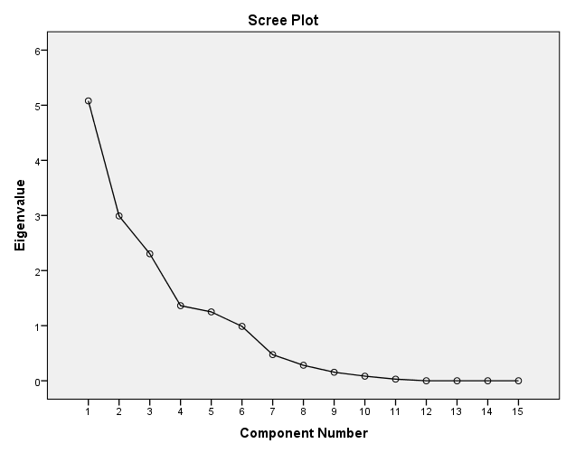

Table 4: Loadings (Eigenvectors) of Component Matrix for the principal components in sorghum genotypes

Component Matrix
 | Component
 | 1 | 2 | 3 | 4 | 5
PH | 0.686 | 0.521 | 0.185 | -0.140 | 0.024
NL | 0.181 | 0.784 | -0.264 | 0.165 | 0.297
FLL | -0.672 | 0.433 | 0.343 | 0.397 | -0.133
FLW | -0.765 | 0.294 | 0.340 | 0.410 | 0.026
LL | -0.574 | 0.682 | 0.139 | -0.007 | 0.119
LW | -0.194 | -0.048 | 0.596 | -0.148 | 0.679
SG | 0.065 | -0.718 | 0.293 | 0.089 | 0.436
DM | 0.510 | -0.198 | 0.073 | 0.664 | -0.206
DFF | -0.693 | -0.597 | 0.254 | 0.124 | -0.040
PL | -0.527 | -0.255 | 0.649 | -0.046 | -0.352
PW | 0.723 | -0.234 | 0.455 | -0.228 | 0.008
PWt | 0.883 | -0.041 | 0.380 | 0.088 | -0.162
NPB | 0.177 | 0.542 | 0.719 | -0.301 | -0.039
SI | 0.457 | -0.068 | -0.044 | 0.507 | 0.492
SPY | 0.779 | 0.178 | 0.380 | 0.307 | -0.201
PH-Plant Height (cm), NL- Number of Leaves, FLL- Flag Leaf Length (cm), FLW- Flag Leaf Width (cm), LL- Leaf Length (cm), LW-Leaf Width (cm), SG-Stem Girth (cm), DM- Days to Maturity, DFF- Days to Fifty Percent Flowering, PL-Panicle Length (cm), PW- Panicle Width (cm), Pwt- Panicle Weight (g), NPB-Number of Primary Branches, SI-Seed Index (g), SPY- Single Plant Yield (g)
Figure 3: Loading plot of PCA analysis of yield related traits in sorghum genotypes
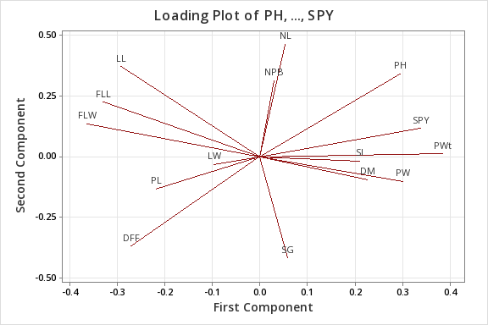
Figure 4: Biplot of PCA analysis of yield related traits in sorghum genotypes
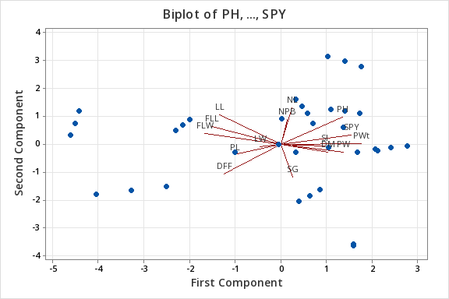
Conclusion
The agro-morphological characterization of twelve advanced cultures of summer sorghum genotypes revealed significant genotypic and phenotypic associations among various yield-contributing traits. The study demonstrated that traits such as plant height, days to maturity, panicle width, and panicle weight had a significant positive correlation with single plant yield,. Path analysis further highlighted that plant height, flag leaf length, leaf length, stem girth, panicle weight, and seed index had positive direct effects on grain yield, making them key selection criteria for crop improvement. Principal component analysis identified PC1 with traits viz., plant height, number of leaves, stem girth, days to maturity, panicle width, panicle weight, number of primary branches, seed index, and single plant yield accounted for the largest variability, underscoring the importance of these traits in enhancing sorghum productivity. These findings suggested that selecting for traits like plant height, panicle weight, and seed index could enhance yield performance in sorghum. The identified genotypes and key traits served as valuable inputs for breeding programs aimed at developing high-yielding and climate-resilient sorghum cultivars.
Disclaimer (Artificial intelligence) Option 1:
Author(s) hereby declare that NO generative AI technologies such as Large Language Models (ChatGPT, COPILOT, etc.) and text-to-image generators have been used during the writing or editing of this manuscript.

Reference
- Abah, C., Ishiwu, C., Obiegbuna, J., & Oladejo, A. (2020). Sorghum grains: nutritional composition, functional properties and its food applications. European Journal of Nutrition & Food Safety, 12(5), 101-111.
- Adebowale, O. J., Taylor, J. R., & de Kock, H. L. (2020). Stabilization of wholegrain sorghum flour and consequent potential improvement of food product sensory quality by microwave treatment of the kernels. Lwt, 132, 109827.
- Brejda, J. J., Moorman, T. B., Karlen, D. L., & Dao, T. H. (2000). Identification of regional soil quality factors and indicators I. Central and Southern High Plains. Soil Science Society of America Journal, 64(6), 2115-2124.
- Duncan, W. G., Loomis, R., Williams, W. A., & Hanau, R. (1967). A model for simulating photosynthesis in plant communities.
- El-Din, A. A. T., Hessein, E. M., & Ali, E. (2012). Path coefficient and correlation assessment of yield and yield associated traits in sorghum (Sorghum bicolor L.) genotypes. American-Eurasian Journal of Agricultural & Environmental Sciences, 12(6), 815-819.
- Elangovan, M., Annapurna, A., Patil, R., Pandey, S., & Pandey, C. D. (2020). Characterization of sorghum [Sorghum bicolor (L.) moench] germplasm for agro-morphological traits. Indian Journal of Plant Genetic Resources, 33(2), 172-178.
- Elangovan, M., Prabhakar, P., & Chandra Sekara Reddy, D. (2010). Characterization and evaluation of Sorghum [Sorghum bicolor (L.) Moench] germplasm from Karnataka, India. Karnataka Journal of Agricultural Sciences, 20(4).
- Elangovan, M., Tonapi, V. A., & Reddy, D. C. S. (2009). Collection and characterization of Indian sorghum landraces. Indian Journal of Plant Genetic Resources, 22(3), 173-181.
- Gebre, W., Mekbib, F., Tirfessa, A., & Bekele, A. (2024). Genetic Diversity, Association, and Regression Coefficient Analyses of Sorghum [Sorghum bicolor (L.) Monech] Genotypes. Available at SSRN 4861373.
- Geetha, K., & Divya, S. (2021). Principal component analysis of sorghum landraces for yield contributing traits. Electronic Journal of Plant Breeding, 12(3), 1033-1036.
- Goswami, S., Patel, P., Gami, R., Patel, R., & Khatri, A. (2020). Correlation and path analysis study of different characters for grain yield and fodder purpose in sorghum [Sorghum bicolor (L.) Moench]. Electronic Journal of Plant Breeding, 11(04), 1053-1061.
- Harlan, J. R., de Wet, J. M., & Price, E. G. (1973). Comparative evolution of cereals. Evolution, 311-325.
- Jain, S., Patel, P., & Elangovan, M. (2011). Variation and association among fodder yield and other traits in germplasm of forage sorghum (Sorghum bicolor (L.) Moench). Indian Journal of Plant Genetic Resources, 24(03), 327-331.
- Kholová, J., Murugesan, T., Kaliamoorthy, S., Malayee, S., Baddam, R., Hammer, G. L., McLean, G., Deshpande, S., Hash, C. T., & Craufurd, P. Q. (2014). Modelling the effect of plant water use traits on yield and stay-green expression in sorghum. Functional Plant Biology, 41(11), 1019-1034.
- Pezzali, J. G., Suprabha-Raj, A., Siliveru, K., & Aldrich, C. G. (2020). Characterization of white and red sorghum flour and their potential use for production of extrudate crisps. PLoS One, 15(6), e0234940.
- Prasad, B. V., & Sridhar, V. (2019). Diversity Studies in Yellow Pericarp Sorghum [Sorghum bicolor (L.) Moench] Genotypes for Yield Attributes. Int J Curr Microbiol Appl Sci, 8, 361-366.
- Prasad, B. V., & Sridhar, V. (2020). Assessment of variability, correlation and path analysis for yield and yield related traits in yellow pericarp sorghum germplasm lines [Sorghum bicolor (L.) Moench]. Journal of Pharmacognosy and Phytochemistry, 9(1), 870-873.
- Pugahendhi, N., Kumar, B. S., Elangovan, M., Venkatesh, K., & Rajendrakumar, P. (2023). Assessing the genetic diversity of Indian Kharif sorghum landraces through agro-morphological characterization (Sorghum bicolor L. Moench). Journal of Applied and Natural Science, 15(2), 624-638.
- Sharma, B. R., Sharma, B., Rao, K., Vittal, K., & Amarasinghe, U. (2006). Realizing the potential of rainfed agriculture in India. Draft prepared for the IWMICPWF Project on Strategic Analyses of India’s National River-Linking Project, Colombo, Sri Lanka: International Water Management Institute.
- Tiwari, M., Singh, S., Kumar, S., Chauhan, R. S., Tiwari, U., Pushpendra, P., & Singh, A. (2024). Study on Correlation and Path Analysis in Forage Sorghum [Sorghum bicolor (L.) Moench]. International Journal of Plant & Soil Science, 36(4), 52-59.
- Zhu, X.-G., Song, Q., & Ort, D. R. (2012). Elements of a dynamic systems model of canopy photosynthesis. Current opinion in plant biology, 15(3), 237-244.

