Original Research Article

Assessment of Biogas Yield Potential Based on Physicochemical and Biodegradability Characteristics of Mushroom Substrates
.
ABSTRACT

The growing global demand for sustainable and renewable energy has underscored the significance of biogas as an alternative to fossil fuels. This study evaluates the biogas production potential of four organic substrates: Button mushroom spent substrate (BMS), Oyster mushroom spent substrate (OMS), Wheat compost (WC) and Paddy compost (PC), with a focus on their physicochemical and biochemical characteristics. Standard protocols (APHA, 2022) were employed to analyze parameters including total solids (TS), volatile solids (VS), pH, alkalinity, biochemical oxygen demand (BOD), chemical oxygen demand (COD), nitrogen (N), phosphorus (P), potassium (K) and organic carbon (C). Results revealed that BMS and OMS had superior nutrient profiles with higher concentrations of N, P and K and favourable C:N ratios of 32.6:1 and 34.2:1 respectively, within the ideal range for anaerobic digestion. BMS showed the highest BOD (1024.3 mgL⁻¹) and COD (2976.67 mgL⁻¹), indicating high biodegradability and methane-generating potential. OMS exhibited the highest VS (66.83%) and VS/TS ratio (0.77), suggesting an abundant fraction of biodegradable organic matter. Although PC displayed the highest carbon content (32.98%), its high C:N ratio (57:1) indicated nitrogen deficiency and poor microbial degradation potential unless co-digested with nitrogen-rich substrates. WC and PC also demonstrated higher alkalinity but lower overall biogas potential. Statistical analysis (One-way ANOVA, Tukey b test, p<0.05) confirmed significant differences among substrates in key parameters influencing biogas yield. In conclusion, BMS emerged as the most promising substrate for biogas production, owing to its balanced pH, high organic load and ideal nutrient composition. OMS also showed excellent potential but may require pH correction or co-digestion strategies. Further research on kinetic modelling and reactor-scale validation is required to optimize substrate mixtures and improve energy recovery efficiency in anaerobic digesters.

Keywords: Biogas, Button Mushroom, Oyster Mushroom, Organic matter
1. INTRODUCTION
The need for sustainable energy sources is growing worldwide and biogas is already a leading renewable energy source. Anaerobic digestion of organic matter produces biogas, which has the twin benefits of generating energy and managing waste. Livestock manure, agricultural wastes and organic urban garbage are examples of traditional anaerobic digestion substrates. However, because feedstocks vary in terms of nutrient composition, biodegradability and chemical stability, the choice of feedstock has a substantial impact on the efficiency of methane production (Obileke et al., 2023).
Bioenergy, particularly biogas, is gaining popularity as a wonderful alternative to fossil fuels, all thanks to the increasing global demand for clean and renewable energy. Biogas mainly consists of methane (CH₄) and carbon dioxide (CO₂) and it is produced when certain bacteria break down organic materials without oxygen in a process called anaerobic digestion (AD). This natural method not only helps in managing and utilizing organic waste but also plays a key role in generating electricity sustainably
The spent mushroom substrates (SMS) left after growing mushroom are generally thrown away as garbage. Because of the high organic load these substrates are an excellent choice for bioenergy applications (Ravlikovsky et al., 2025). Likewise, biodegradable organic matter is abundant in agricultural composts, including paddy and wheat composts. Optimising anaerobic digestion procedures and raising methane yield can be achieved by being aware of the physicochemical characteristics of each substrate.
Getting to know the physicochemical and biochemical characteristics of these substrates is really important for making the anaerobic digestion process work better and for boosting methane production. Factors like total solids (TS), volatile solids (VS), biochemical oxygen demand (BOD), chemical oxygen demand (COD), total nitrogen (N), phosphorus (P), potassium (K) and organic carbon content are key in figuring out how well organic materials can break down and their energy potential (Meegoda et al., 2018).
The purpose of this research is to evaluate the comparative potential for biogas production of button mushroom spent substrate (BMS), oyster mushroom spent substrate (OMS), wheat compost (WC) and paddy compost (PC). The study makes the hypothesis that SMS perform better than conventional composts in terms of biogas yield because of their high volatile solids concentration and nutrient-rich profile. For the following purpose various biochemical parameters like Nitrogen, Phosphorus, Potassium, Carbon, BOD, COD, TS and VS were determined.
2. material and methods
2.1 Sample Collection and Preparation
Four different organic substrates were selected to evaluate their biogas potential: treated substrates (BMS and OMS) and untreated substrates (WC and PC). Samples were collected after harvest of mushroom from Mushroom Research and Training Centre, G.B. Pant University of Agriculture and Technology, Pantnagar.
Samples were homogenized, air-dried, ground and sieved through a 2 mm mesh before analysis to ensure that the particle size was uniform for accurate physicochemical assessment.
2.2 Analytical Methods
Analyses were conducted in triplicate following standard protocols (APHA, 2022):
    - Nitrogen (N): Nitrogen content was determined by Kjeldahl method (Sáez-Plaza et al., 2013). Concentrated sulphuric acid and a catalyst mixture (K₂SO₄ and CuSO₄) were used to digest the samples. They were then distilled with NaOH (40%) and titrated with 0.1 N HCl.
N(%)= $\frac{((R-B)×14×0.1×100)}{1000×sample weight (g)}$
Where,
R= H₂SO₄ used in sample (mL)
B=H₂SO₄ used in blank (mL)
    - Phosphorus (P): It was measured colourimetrically (Systronics Double Beam Spectrophotometer 2202) using the yellow colour method (Murphy and Riley, 1962). Diacid mixture was used for digestion and a standard graph was prepared. The observed optical density was used to obtain the phosphorus concentration in the sample.
P(%)= $\frac{R}{20}$
Where,
R= Concentration of phosphorus (ppm)
    - Potassium (K): The potassium content was determined using flame photometer (Systronics Flame Photometer 128) (Hanway and Heidel, 1952) for each working standard solution of K,. Standard graph was prepared using working standards adjusting the blank to zero and the highest concentration among the working standards to 50.
K(%)= $\frac{R×50×Dilution}{1000×sample weight(g)}$
Where,
R= Reading from flame photometer (ppm)
    - Carbon (C): Estimated by the Walkley and Black (1934) method. Potassium dichromate and concentrated sulphuric acid were used to oxidise organic carbon. To determine the carbon content, unreacted dichromate was titrated with ferrous ammonium sulphate. Methanogens use organic carbon as their main energy source and it is essential to the synthesis of methane.

Carbon(%)=$\frac{10×(B-T)×0.003×100}{B×sample weight(g)}$
Where,
B= volume of FAS used in blank (mL)
T= Volume of FAS used in sample (mL)
    - pH: Measured using a calibrated digital pH meter (Systronics, Model 372) (1:10 w/v sample to distilled water). pH affects microbial activity in anaerobic digestion and the ideal range for methanogenesis is usually between 6.5 and 7.8.
    - Alkalinity: The alkalinity was measured using standard APHA (2022) method. The 5 g of sample was diluted ten times and filtered sample were then titrated with 0.1 sulphuric acid to bring pH of sample to 4.3 as the endpoint.
Total Alkalinity= $\frac{50000×A×N×Dilution Factor}{V}$
Where,
A= Volume of standard acid used
N= Normality of acid used
V=Volume of sample (mL)
    - BOD: BOD was measured via 5-day incubation method (APHA, 2022). Sample was diluted (1:50 v/v sample to distilled water) and DO was measured initially using Winkler method (D₀). Also, same sample was incubated in BOD bottles at 20°C for five days (D₅) after which DO was measured again. Following formula was used to calculate BOD:
BOD (mgL⁻¹)= (D₀-D₅)×Dilution factor
    - COD: COD was measured using closed reflux titrimetric method (APHA, 2022). Potassium dichromate and concentrated sulphuric acid were used to digest the samples in sealed tubes at high temperatures. Using ferroin indicator, the remaining dichromate was titrated against ferrous ammonium sulphate.
COD (mgL⁻¹)= $\frac{(b-a)×N ×1000×8×Dilution factor}{mL of sample}$
Where,
b= FAS used in blank (mL)
a= FAS used in treatment sample (mL)
N= Normality of K₂Cr₂O₇
    - Total Solids (TS) and Volatile Solids (VS): The TS and VS were analyzed using the Standard Methods (APHA, 2022). To assess the TS content, sample was dried in an oven at 105°C for 24 hours and dry weight was measured. Afterward, the dried residue was combusted in a muffle furnace at 550°C for 4 hours to measure the weight loss at 550°C.
TS%= $\frac{Dry Weight }{Wet Weight}$×100
VS%= $\frac{Weight loss at 550°C}{Dry Weight}$×100
These values are crucial indicators of the biodegradability of substrate and methane-producing capacity since they display both the total and organic components of the sample.
  - Statistical Analysis : One-way ANOVA and Tukey b test (P≤0.05) were used to analyse the data and identify significant differences between treatments using IBM SPSS Statistics 22 and Origin 2025 software was used to plot the graphs.
3.0 results and discussion
3.1 Nutrient Composition:
The physicochemical characterization of the four substrates Wheat Compost, Paddy Compost, Button mushroom spent substrate and Oyster Mushroom spent substrate (WC, PC, BMS and OMS) is summarized below:
3.1.1 Macronutrient Composition (N, P, K)
Figure 1 indicates the higher nitrogen content in OMS and BMS as compared to WC and PC. Phosphorus and potassium levels were also notably higher in OMS and BMS (P=0.05), indicating that the macronutrient profile is more balanced. The availability of potassium and phosphorus is essential for microbial enzymatic activity. When combined with BMS or OMS, high potassium (2.03%) and low nitrogen content in PC can help balance nutrients and maximise microbial metabolism (Duguma et al., 2024). Gas quality and digestion efficiency can both be enhanced by such synergistic blending. The variation in the values is depicted in Table 1.
Table 1. Physicochemical properties and Elemental Ratio (N:P:K) of treated and untreated mushroom substrates
 | Nitrogen (%) |  | Phosphorus (%) | Potassium (%) | N:P:K
Wheat compost |  | 0.66^{bc}±0.14 | 0.21ª±0.003 | 0.54^{c}±0.014 | 3.17:1:2.6
Paddy compost |  | 0.58^{c}±0.02 | 0.2ª±0.006 | 2.03ª±0.025 | 2.86:1:10.03
Button spent |  | 0.82^{ab}±0.02 | 0.03^{b}±0.00 | 0.31^{d}±0.003 | 27.66:1:10.64
Oyster spent |  | 0.92ª±0.08 | 0.3ª±0.065 | 0.71^{b}±0.02 | 3.03:1:2.36

- Abbreviations: N:P:K, Nitrogen:Phosphorus:Potassium
- Values represent mean ± standard error. Parameters analyzed include macronutrient content (Nitrogen, Phosphorus, Potassium). Superscript letters (a–d) indicate significant differences (P ≤ 0.05) among means within columns
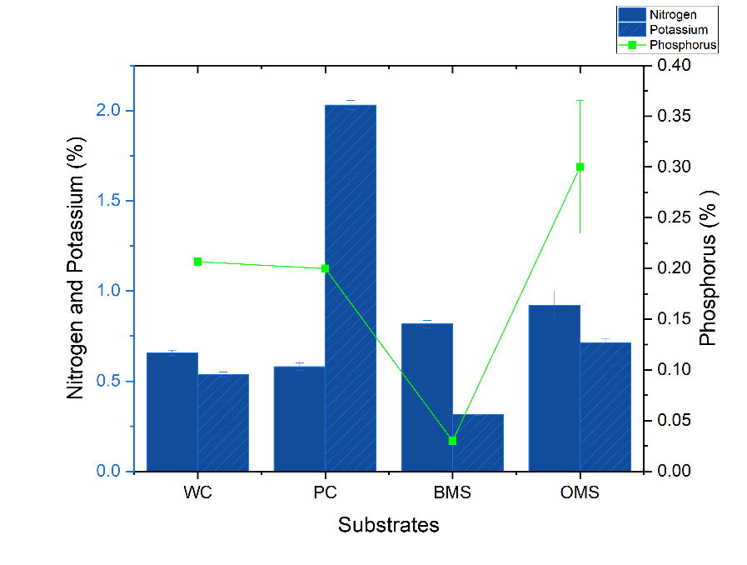
Figure 1. Macronutrients composition (N,P,K) of treated and untreated mushroom substrates (mean ± SE)

    - Organic Carbon and C:N Ratio
In anaerobic digestion (AD), the C:N ratio is a crucial metric. Anaerobic digestion, which is directly linked to biogas production, works best with C:N ratios between 20:1 and 30:1 (Gebreegziabher et al., 2025). BMS (32.6:1) and OMS (34.2:1) were within ideal ranges, while PC and WC had an excessively high ratio, as mentioned in Table 2. Figure 2 represents the variation in carbon content present in different substrates. Although paddy compost had the highest carbon content (32.98%), it also had the highest C:N ratio (57:1), indicating slower microbial decomposition. Its C:N ratio suggests a nitrogen shortage, which may prevent methane from being produced unless it is co-digested with nitrogen-rich substrates. Organic Carbon was found to be significantly different (P≤0.05) as shown in Table 2. Assuming sufficient biodegradability, oyster spent and paddy compost have a much greater carbon content and are more appropriate for producing biogas. The low carbon and high nitrogen content of button mushrooms can impair their ability to produce methane unless they are counterbalanced with carbon-rich additions. Although carbon content by itself is a good predictor of biogas potential, reactor conditions, degradability and total nutritional balance all affect the best yields of feedstocks (Ibro et al., 2022).
Table 2. Nutrient Composition and Elemental Ratio (Carbon and C:N) of treated and untreated mushroom substrates
Substrates | Carbon (%) |  | C:N
Wheat Compost | 28.41^{b}±0.86 |  | 43.3:1
Paddy Compost | 32.98ª±0.23 |  | 57:1
Button Mushroom Spent | 26.62^{b}±0.26 |  | 32.6:1
Oyster Mushroom spent | 31.39ª±0.82 |  | 34.2:1
- Abbreviations: C:N, Carbon: Nitrogen
- Values represent mean ± standard error. Parameters analyzed include Carbon and Carbon: Nitrogen ratio. Superscript letters (a–b) indicate significant differences (P ≤ 0.05) among means within columns
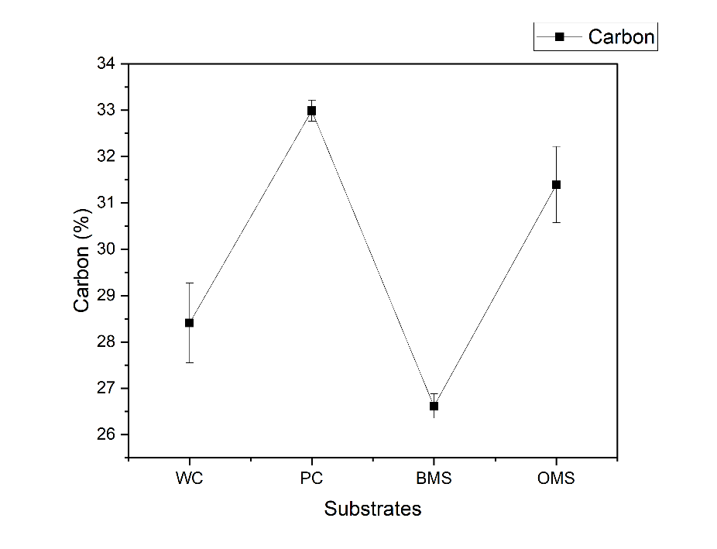
Figure 2. Carbon content in treated and untreated mushroom substrates (mean ± SE)
3.2 pH and Alkalinity
The variation in pH and alkalinity is presented in Figure 3. WC and PC were found to be alkaline, BMS was neutral (7.25) and OMS was slightly acidic (6.45). WC and PC demonstrated a steady buffering capability for anaerobic microorganisms with high alkalinity (541.67 mgL⁻¹ and 381 mgL⁻¹) and neutral to slightly alkaline pH (8.3 and 8.23). pH and alkalinity of untreated and treated substrates showed a significant difference (P≤0.05) as mentioned in Table 3. Low alkalinity and slightly acidic pH of OMS may cause acid buildup, requiring co-digestion techniques or pH correction (Pan et al., 2021).
Table 3. pH and alkalinity in treated and untreated mushroom substrates
 |  | pH | Alkalinity (mgL⁻¹ )
Wheat compost | 8.3ª±0.03 |  | 541.67ª±10.14
Paddy compost | 8.23ª±0.02 |  | 381^{b}±7.81
Button spent | 7.25^{b}±0.03 |  | 449^{c}±11.84
Oyster spent | 6.45^{c}±0.03 |  | 121.67^{d}±4.4
- Values represent mean ± standard error. Parameters analyzed include pH and alkalinity. Superscript letters (a–c) indicate significant differences (P ≤ 0.05) among means within columns

Figure 3. pH and alkalinity of treated and untreated mushroom substrates (mean ± SE)
3.3 Biodegradability Indicators (BOD & COD)
The variation in BOD and COD values of different substrates is graphically presented in Figure 4. BMS had extremely high BOD (1024.3 mgL⁻¹) and COD (2976.67 mgL⁻¹), followed by OMS (582.77 mgL⁻¹, 1288.33 mgL⁻¹). The BOD and COD of treated mushroom substrates were found to be significantly different (P≤0.05) as compared to the untreated mushroom substrates (Table 4). The high values of BOD and COD in BMS and OMS indicate a high biodegradable organic load. BMS has a significant amount of easily digestible organic materials, as indicated by its greatest BOD and COD. Given that higher microbial activity is correlated with more oxidisable organics, this is essential for a high methane output. BMS contains protein, cellulose and hemicellulose residues that support anaerobic microbial activity (Toufexis et al., 2024). Biodegradability index (BI) of BMS was 0.34, indicating good biodegradability. For methane generation, a BI greater than 0.3 is usually seen as advantageous.
Table 4. Biodegradability indices and solid content in untreated and treated mushroom substrates
 | BOD (mgL⁻¹ ) | COD (mgL⁻¹ )
Wheat Compost | 349.3^{c}±6.36 | 751.67^{d}±13.02
Paddy Compost | 366.2^{c}±9.24 | 881.67^{c}±7.26
Button Mushroom Spent | 1024.3ª±14.45 | 2976.67ª±14.53
Oyster Mushroom spent | 582.77^{b}±7.22 | 1288.33^{b}±7.26

- Abbreviations: BOD, Biochemical oxygen demand: COD, Chemical oxygen demand.
- Values represent mean ± standard error. Parameters analyzed include biochemical oxygen demand and chemical oxygen demand. Superscript letters (a–d) indicate significant differences (P≤ 0.05) among means within columns
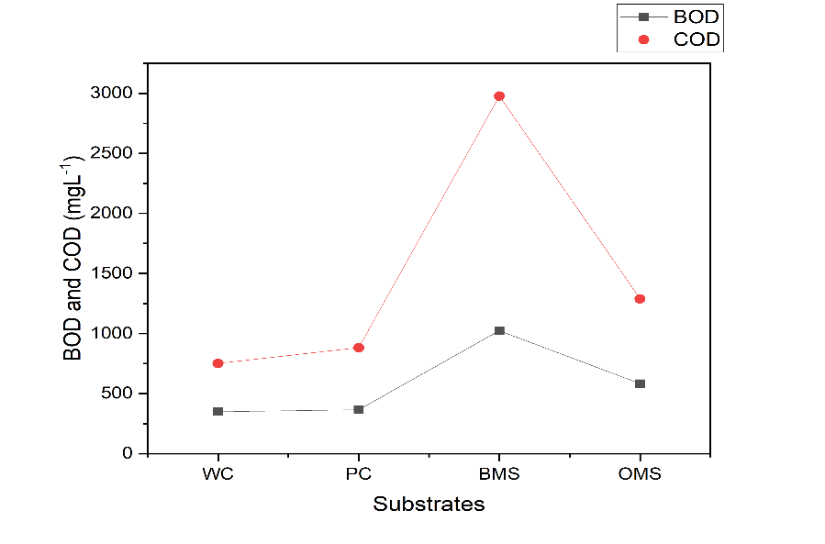
Figure 4. Biodegradability Indices (BOD and COD) of untreated and treated mushroom substrates (mean ± SE)
  - TS & VS
BMS displayed good VS (52.32%) and the greatest TS (89.91%). The variation in values is presented in Figure 5. OMS demonstrated the high potential for biogas with the highest VS (66.83%) and high VS/TS ratio (0.77) indicating a strong potential for methane. As mentioned in Table 5, significantly high (P≤0.05) volatile solids (VS) in BMS and OMS indicate more biodegradable material, which is consistent with the BOD and COD results. According to literature, high VS content and high percentage of VS in TS of OMS demonstrate exceptional energy potential (Vasilakis et al., 2023). The loading rate of the digester is controlled by the TS and VS contents. The biogas potential per unit mass was expected to be higher for BMS and OMS due to their high TS and VS (Panngoen et al., 2023).
Table 5. Solid content (Total solids and Volatile solids) in untreated and treated mushroom substrates
 | TS (%) | VS (%) | % of VS in TS (%)
Wheat Compost | 85.4^{b}±0.25 | 51.34^{b}±0.59 | 60.11^{ab}±0.59
Paddy Compost | 81.59^{c}±1.09 | 42.45^{ab}±0.62 | 52.06^{b}±1.33
Button Mushroom Spent | 89.91ª±0.17 | 52.32^{ab}±2.21 | 58.18^{ab}±2.39
Oyster Mushroom spent | 86.57^{b}±0.59 | 66.83ª±7.14 | 77.26ª±8.54
- Values represent mean ± standard error. Parameters analyzed include total solids (TS), volatile solids (VS) and percentage of volatile solids in total Solids. Superscript letters (a–c) indicate significant differences (P≤ 0.05) among means within columns.

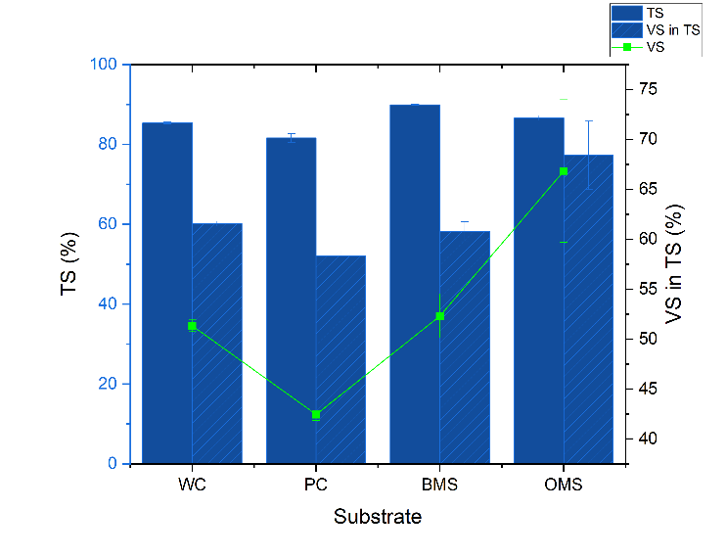
Figure 5. Total solids (TS), Volatile solids (VS) and VS in TS (%) of treated and untreated mushroom substrate (mean ± SE)
4. Conclusion
The physicochemical examination of WC, PC, BMS and OMS shows a great variation in their potential for the production of biogas and anaerobic digestion. The most advantageous profiles of the examined substrates are shown by BMS and OMS, which have balanced macronutrient composition, ideal C:N ratios (32.6:1 and 34.2:1, respectively) and good biodegradability indicators, such as high volatile solids content, BOD and COD. BMS is especially well-suited for high-yield anaerobic digestion due to its moderate C:N ratio and increased COD. This suggests a significant likelihood of methane production and microbial activity. VS/TS ratio of OMS (77.26%) and high COD (2976.67 mgL⁻¹) of BMS in particular demonstrate the quantity of digestible organic matter that supports effective biogas production. Collectively, Button spent emerges as the best single substrate due to ideal C:N ratio, highest BOD and COD, balanced pH and moderate alkalinity. OMS makes up for its lower alkalinity and pH with high VS and nutrient availability, though pre-treatment or co-digestion techniques might be helpful for improvement. Paddy and wheat composts, on the other hand, showed less balanced nutritional profiles and a lower organic load. Unless co-digested with nitrogen-rich substrates, the high C:N ratio of paddy compost may limit methanogenesis. In order to optimise substrate ratios and loading rates for maximal energy recovery, future research should concentrate on kinetic modelling and reactor-scale validations.

Disclaimer (Artificial intelligence)

Author(s) hereby declare that NO generative AI technologies such as Large Language Models (ChatGPT, COPILOT, etc.) and text-to-image generators have been used during the writing or editing of this manuscript.

References

- APHA-American Public Health Association (2022). Standard method for the examination of water and wastewater. American Public Health Association (APHA), American Water Works Association (AWWA) and Water Environment Federation (WEF), Washington DC, USA. 1546p.
- Duguma, A., Bekele, T., & Geda, A. (2024). Biogas production through anaerobic codigestion of distillery wastewater sludge and disposable spent yeast. International Journal of Chemical Engineering, 2024(1), 5510471. https://doi.org/10.1155/2024/5510471
- Gebreegziabher, B. W., Dubale, A. A., Adaramola, M. S., & Morken, J. (2025). Advancing Anaerobic Digestion of Biodiesel Byproducts: A Comprehensive Review. BioEnergy Research, 18(1), 15. https://doi.org/10.1007/s12155-025-10820-4
- Ibro, M. K., Ancha, V. R., & Lemma, D. B. (2022). Impacts of Anaerobic Co-Digestion on Different Influencing Parameters: A Critical Review. Sustainability, 14(15), 9387. https://doi.org/10.3390/su14159387
- Meegoda, J. N., Li, B., Patel, K., & Wang, L. B. (2018). A Review of the Processes, Parameters, and Optimization of Anaerobic Digestion. International Journal of Environmental Research and Public Health, 15(10), 2224. https://doi.org/10.3390/ijerph15102224
- Obileke, K., Makaka, G., & Nwokolo, N. (2023). Recent Advancements in Anaerobic Digestion and Gasification Technology. Applied Sciences, 13(9), 5597. https://doi.org/10.3390/app13095597
- Pan, S. Y., Tsai, C. Y., Liu, C. W., Wang, S. W., Kim, H., & Fan, C. (2021). Anaerobic co-digestion of agricultural wastes toward circular bioeconomy. iScience, 24(7), 102704. https://doi.org/10.1016/j.isci.2021.102704
- Ravlikovsky, A., Pinheiro, M. N. C., Kucheruk, P., & Symochko, L. (2025). Spent Mushroom Substrate as a Renewable Energy Resource: Evaluating Its Biogas Production Potential. Sustainability, 17(5), 1800. https://doi.org/10.3390/su17051800
- Toufexis, C., Makris, D. O., Vlachokostas, C., Michailidou, A. V., Mertzanakis, C., & Vachtsiavanou, A. (2024). Bridging the Gap between Biowaste and Biomethane Production: A Systematic Review Meta-Analysis Methodological Approach. Sustainability (2071-1050), 16(15). https://doi.org/10.3390/su16156433
- Vasilakis, G., Rigos, E.-M., Giannakis, N., Diamantopoulou, P., & Papanikolaou, S. (2023). Spent Mushroom Substrate Hydrolysis and Utilization as Potential Alternative Feedstock for Anaerobic Co-Digestion. Microorganisms, 11(2), 532. https://doi.org/10.3390/microorganisms11020532
- Sáez-Plaza, P., Navas, M. J., Wybraniec, S., Michałowski, T., & Asuero, A. G. (2013). An Overview of the Kjeldahl Method of Nitrogen Determination. Part II. Sample Preparation, Working Scale, Instrumental Finish, and Quality Control. Critical Reviews in Analytical Chemistry, 43(4), 224–272. https://doi.org/10.1080/10408347.2012.751787
- Hanway, J. J. (1952). Soil analysis methods as used in the iowa state college soil testing laboratory. Iowa agriculture, 57, 1.
- Murphy, J. A. M. E. S., & Riley, J. P. (1962). A modified single solution method for the determination of phosphate in natural waters. Analytica chimica acta, 27, 31-36 https://doi.org/10.1016/S0003-2670(00)88444-5
- Walkley, A. J., & Black, C. A. (1934). Estimation of soil organic C by the chromic acid titration method by the chromic acid titration method. Soil Science, 37, 29-38.
- Panngoen P, Leksawasdi N, Rachtanapun P, Chakrabandhu Y and Jinsiriwanit S (2023) Integration of white rot mushroom cultivation to enhance biogas production from oil palm kernel pulp by solid-state digestion. Front. Energy Res. 11:1204825. https://doi.org/10.3389/fsufs.2023.1234472

