Assessment of Wheat Yield Gaps and Potential for Yield Enhancement in Haryana, India

Abstract
This study analyzes wheat yield disparities in Haryana, India, using statistical and geographical methods to assess 15 years of district-level data from 2006 to 2020. In many areas, there is considerable underutilization of productivity potential, as demonstrated by the yield gap—defined as the difference between the observed average yield and the achievable yield (Olympic mean). Yield gaps exceeding 750 kg/ha were observed in districts such as Panchkula, Karnal, and Yamunanagar, indicating significant opportunities for agronomic improvement. In contrast, districts like Charkhi Dadri and Bhiwani exhibited performance levels approaching saturation. A Weather Risk Index was developed to address climatic variability, based on the standard deviation of de-trended yield. High-gap zones were visualized through spatial analysis using ArcMap 10.8, which enabled the classification of districts based on risk exposure and yield potential. The findings underscore the importance of district-specific strategies, suggesting that high-gap, low-risk regions require targeted inputs to enhance yield, while high-risk areas need interventions to strengthen resilience. This research presents a scalable model for strategic agricultural planning that enhances food security, reduces vulnerability, and boosts productivity.
Keywords: Wheat Production, Olympic Mean, Normal Yield, Yield Gap Whether Risk Index and Climate Resilience

Introduction
Agriculture is a crucial component of India's economy, contributing significantly to GDP, employment, and foreign exchange earnings. Forecasting plays a vital role for decision-makers in both economic and non-economic sectors, enabling accurate decisions regarding storage, distribution, pricing, marketing, and import-export activities. Crop productivity is influenced by factors such as precipitation fluctuations and economic conditions, which are important for evaluating production efforts and predicting future output levels (Kumar et al., 2019). Wheat, the most important food grain in India, is a staple for millions, especially in the northern and north-western regions. Significant increases in productivity have been observed in Haryana, Punjab, and Uttar Pradesh, with wider cultivation coverage reported in Madhya Pradesh (Kodan et al., 2012). The Green Revolution Programme (GRP) notably contributed to the growth of wheat cultivation in Haryana. India's total food grain production rose from 50.82 million tonnes in 1950–51 to 230.67 million tonnes in 2006–07. However, the country has yet to achieve a hunger-free status, which remains a significant challenge. The crop economy demands special attention in the global economic context, where consistent growth patterns, productivity variations, and cost structures enable farmers to increase profit margins without adversely affecting consumers. The government must make systematic efforts to ensure food security and increase exports while meeting domestic needs. Since the mid-1960s, the Indian economy—particularly in Haryana—has undergone notable changes due to the introduction of high-yielding wheat varieties (HYVs) (Nisha et al., 2019). A study analyzing the area, production, and yield of wheat in Uttar Pradesh from 1971 to 2010 revealed higher growth rates in productivity, attributed to increased rates in both area and yield (Handral et al., 2017). The cubic model was found to be the most effective for estimating wheat production in India. Haryana, a predominantly agricultural state, has witnessed a decline in pulse production, especially in regions influenced by the Green Revolution. The annual compound growth rate for cereal production in the country is estimated at 2%, while pulse production has increased at a slower rate of 1%. This decline in pulses raises concerns about nutritional security and reflects a structural transformation in state-level agriculture. The increased share of cereals in Haryana is largely due to improved irrigation facilities, enabling the cultivation of various crops (Ohlan, 2012). However, national or state-level information alone is insufficient for guiding effective human efforts due to regional differences in needs and resource availability. District-level agricultural planning is necessary to assess agricultural activities and design targeted, district-specific policies. Understanding long-term changes in cropping patterns is essential for effective planning. To meet the growing global demand for food, the productivity of agricultural commodities must increase. It is estimated that by 2050, an additional 1 billion metric tonnes of grain per year will be required, necessitating an increase in total production from 2.1 to 3.0 billion metric tonnes (Hatfield & Beres, 2019). This goal requires either bridging the gap between potential and actual yields or enhancing the potential yield itself. The concept of potential yield is critical in assessing the progress of crop management strategies. Many experts argue that narrowing the yield gap is more feasible than increasing the potential yield. Dadrasi et al. (2025) suggest that to achieve a 50% improvement in yield, a 40% increase in nitrogen application is required. Dey (2020) observed that the area under wheat cultivation in India has been more stable than production and yield. Growth in the area expanded faster than production, with yield demonstrating consistent positive growth throughout the study period. The export unit price for wheat showed positive growth during Period I, declined in Period II, and remained stable in the following three sub-periods and overall. However, production instability increased in Period III due to yield fluctuations. Hou et al. (2024) found that yield gaps are largely due to drought and soil moisture loss, which reduce productivity. Singh and Supriya (2017) assessed the growth of area, production, and productivity of wheat in India using various growth models. Wheat remains a crucial cereal crop, vital for meeting the nutritional needs of a growing population. The current study aims to contribute to future planning efforts to address food and nutritional security while meeting domestic demand. Devi et al. (2021) examined the instability and sustainability of wheat production in Haryana, using data from the Haryana Statistical Abstract (1980–81 to 2018–19). Their findings revealed an increasing trend in area, production, and yield, with Haryana ranking second after Punjab in yield sustainability. These insights are valuable for policymakers working in food and nutrition security, as they offer predictive value regarding production behavior. Kumar et al. (2019) forecasted wheat yields in Haryana using annual time-series data from 1980–81 to 2009–10. Several models were tested, and the ARIMA (0,2,2) model was identified as the best fit based on the Akaike Information Criterion (AIC). Forecasted yields ranged from 4,620.91 kg/ha in 2017 to 4,862 kg/ha in 2022. Singh et al. (2014) investigated yield gaps in wheat production after the Green Revolution. Their hybrid approach to quantifying the gap from 2001–02 to 2010–11 revealed a narrowing of yield gaps due to effective research and extension efforts. The study highlighted region-specific production constraints and recommended research priorities to address them. Daloz et al. (2021) studied the effects of climate change on wheat yields in the Indo-Gangetic Plain (IGP), a major wheat-producing region globally. Using a regional climate model and crop model, they analyzed the direct and indirect impacts across four sites in Punjab, Haryana, Uttar Pradesh, and Bihar. Results indicated direct climate impacts could reduce yields by 1% to 8%, while indirect effects such as reduced water availability may cause even greater losses. Shettigar et al. (2019) evaluated factors affecting wheat productivity in Haryana through surveys in five districts involving 100 farmers. Common crop rotations included rice–wheat, cotton–wheat, bajra–wheat, sorghum–wheat, and guar–wheat. Key challenges included limited availability of new varieties, lack of training, insufficient knowledge of plant protection and fertilizer dosages, high agrochemical costs, low risk-bearing capacity, erratic rainfall, and poor disease control measures. Although the existing literature provides substantial insights into wheat production patterns, development, and volatility in India—especially in Haryana—it mainly focuses on individual aspects such as climate change, technology adoption, policies, and forecasting models. A significant research gap persists in integrating socio-economic, technical, and climatic factors into a unified analytical framework to evaluate their combined effects on yield and sustainability. Moreover, there is a lack of recent, micro-level, farmer-centric research post-2020 that addresses emerging challenges such as input price volatility, labor shortages, and the use of digital technologies in wheat farming. Addressing this gap is essential for crafting targeted solutions to enhance productivity, sustainability, and resilience in wheat production systems. In this context, the present study aims to estimate the growth rates of wheat yield from 2006 to 2020, conduct a yield gap analysis, and identify areas with significant potential for yield improvement.
Materials
The yield data was downloaded for the 22 districts of Haryana state for Wheat crop from Directorate of Economics and Statistics website for the period 2006 to 2020 (https://data.desagri.gov.in/website/crops-apy-report-web). The Department of Agriculture, Haryana, as well as validated statistical summaries, were among the secondary sources that were used in order to ascertain the district-by- district wheat yield (in kilograms per hectare) and the seeded area (in hectares). And in order to map yield gaps in ArcGIS, statistical data was coupled to spatial boundaries by using a digital shapefile of Haryana districts.

Methodology
This research employs a quantitative and geospatial framework to assess disparities in wheat output across the districts of Haryana. ArcGIS is used in conjunction with time-series yield data, variability analysis, and spatial mapping to identify regions vulnerable to climate-related risks, yield instability, and underutilized production potential.
Study Area
The study covers all 22 districts of Haryana, a state located in northwestern India, known for its extensive wheat cultivation in semi-arid and subtropical climates. This research analyzes yield performance and the impacts of climate over a fifteen-year period, with a specific focus on the rabi seasons from 2006 to 2020.
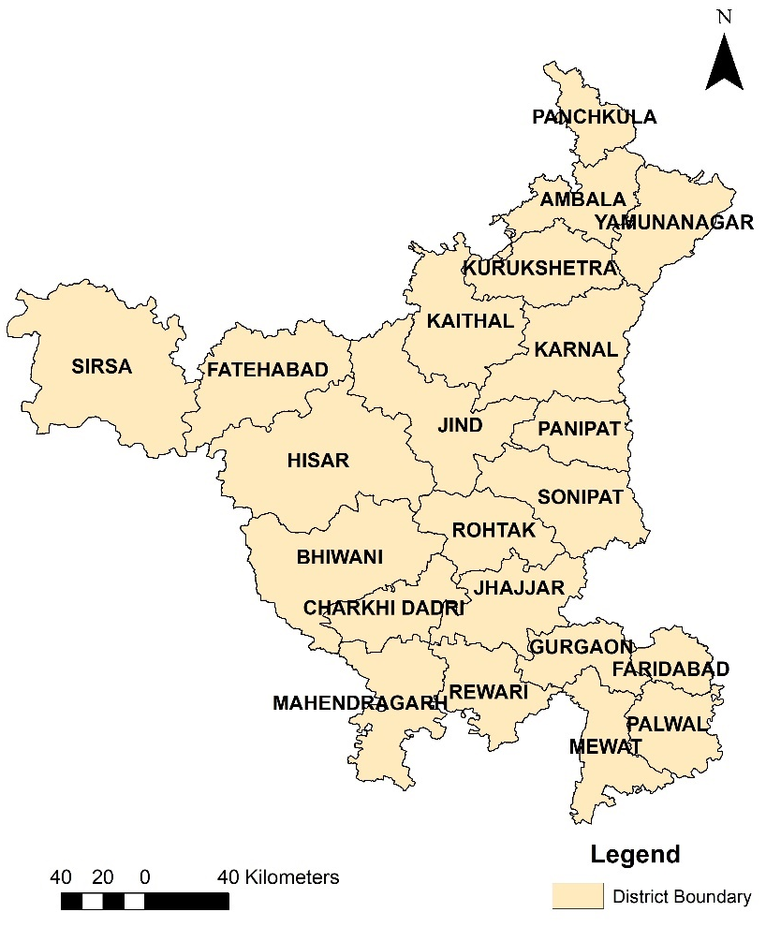

Fig. 1 Study Area
Yield Gap Analysis
The difference between each district's normal yield and Olympic mean yield was calculated as the Yield Gap (YG):

Yield Gap = Attainable Yield – Normal Yield
Normal Yield: The 15-year average of the annual wheat yields from 2006 to 2020.
The Olympic Mean, or Attainable Yield, is the mean of the three highest yields recorded over the same time period, excluding extreme outliers and representing performance that is close to optimal under ideal circumstances.

Scope for yield improvement
To quantify the extent to which current yields can be improved, the scope for yield improvement (%) was calculated as

𝑆𝑐𝑜𝑝𝑒 𝑜𝑓 𝑖𝑛𝑐𝑟𝑒𝑚𝑒𝑛𝑡 (%) = (
𝑌𝑖𝑒𝑙𝑑 𝑔𝑎𝑝

𝑂𝑙𝑦𝑚𝑝𝑖𝑐 𝑚𝑒𝑎𝑛

) × 100
This normalized metric enables comparison across district with different base yield and helps prioritize intervention zone based on their relative performance gaps.

Weather risk and yield variability analysis
Yield fluctuations often result from climatic variability rather than agronomic inefficiency. To isolate this influence:
- A de-trending process was applied to each district’s yield time series to eliminate technological and policy-based growth effect.
- The standard deviation of de-trended yields was used to compute the weather risk index (WRI)
𝑊𝑅𝐼 = 𝜎𝐷𝑒−𝑡𝑟𝑒𝑛𝑑𝑒𝑑 𝑦𝑖𝑒𝑙𝑑
Districts with high WRI values are considered more vulnerable to weather and require risk mitigation strategies.

Spatial analysis using ArcGIS
spatial analysis conducted using ArcGIS, where yield gap data was integrated with the Haryana district shape file to produce a series of thematic maps. These included district- wise Yield Gap Maps, Scope for Improvement Maps, and Weather Risk Overlay Maps. The visual outputs generated from this analysis provided policy-relevant insights by enabling the classification of districts into three key categories: High Gap – Low Risk (suitable for yield enhancement strategies), High Risk – Low Gap (demanding climate- resilient approaches), and Moderate Zones (requiring integrated interventions). This spatial mapping approach helped in identifying region-specific priorities for policy formulation and agricultural planning in Haryana.

Results And discussion
This section provides a thorough examination of Haryana's wheat cultivation trends, yield gaps, weather hazards, and spatial disparities across districts. In order to comprehend land-use consistency, the study first assesses the average area under wheat cultivation along with its variability using district-wise time-series data (2006–2020). The goal of the following analysis is to determine the yield gap, which is the difference between the normal yield (long-term average) and the achievable yield (Olympic mean of the top three years). An evaluation of weather risk, which is based on the variability of de-trended yield, and the potential for yield improvement, which is expressed as a percentage of the achievable yield, are added to this. Figures showing district-wise area variability (Figure 2), satellite derived classified Wheat area (Figure 3), Coefficient of Variation of Wheat yield (Figure 4), Average Wheat yield (Figure 5), yield gaps (Figure 6), and the correlation between weather risk and yield improvement potential (Figure 7) are used to visualize the results. Based on agroclimatic conditions and productivity potential, these findings collectively offer practical insights for region-specific interventions, aiding in the prioritization of districts for yield enhancement, risk management, or policy support.

Table 1 Average and Std Deviation od the District Wise in Area

Districts | Avg. of crop area in ha | Std deviation (SQ.M)
Ambala | 92690.5 | 22697
Bhiwani | 151207 | 30291.3
Charki dadri | 41147.5 | 24136.1
Faridabad | 45224.7 | 29898.6
Fatehabad | 187919 | 2261.72
Gurgaon | 47686.9 | 4035.55
Hisar | 225756 | 5674.74
Jhajjar | 101417 | 6152.1
Jind | 205858 | 32288.5
Kaithal | 173272 | 19926.3
Karnal | 165586 | 39091.2
Kurukshetra | 110203 | 7559.09
Mahendragarh | 55362.1 | 44929.8
Mewat | 77992.7 | 7901.97
Palwal | 87265.6 | 26709
Panchkula | 21930 | 18327
Panipat | 91815.9 | 22969.5
Rewari | 46448.1 | 4629.37
Rohtak | 99187.2 | 15931.4
Sirsa | 290211 | 12173.7
Sonipat | 144710 | 5168.1
Yamunanagar | 81293.9 | 18640.1

Table 1 presents the average area of wheat cultivation, expressed in hectares, along with the corresponding standard deviation, measured in square meters, for each district in Haryana over a 15-year period from 2006 to 2020. This table provides a quantitative framework for evaluating the extent and consistency of wheat cultivation across various regions. Sirsa, with an average area of 290,211 hectares, is the largest wheat-growing region, followed by Hisar at 225,756 hectares, Jind at 205,858 hectares, and Fatehabad at 187,919 hectares, as indicated by the analysis. These districts are the state's main wheat-producing areas due to their relatively flat terrain, access to irrigation, and established agricultural infrastructure. The wheat-growing areas in Panchkula (21,930 ha) and Charki Dadri (41,147 ha) are significantly smaller, likely due to geographic location, urban proximity, or crop diversification factors.

The standard deviation values indicate the year-to-year variability in cultivated area, thereby revealing the operational consistency of wheat farming across districts. Fatehabad exhibits the lowest variability (SD = 2,261.72) alongside the highest average area, suggesting a highly stable wheat farming system. Faridabad (SD = 29,898 ha) and Mahendragarh (SD = 44,930 ha) exhibit notable variability in area, potentially attributable to alternative crop selections, water scarcity, or changing land use patterns.
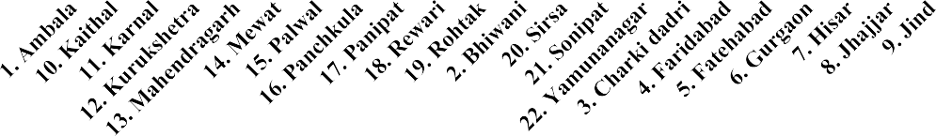
District wise Crop area and Std. Deviation
350000.00
300000.00
250000.00
200000.00
150000.00
100000.00
50000.00
0.00
Avg. of crop area in ha
Std deviation (SQ.M)

Fig. 2 District wise Crop area and Std. Deviation
Figure 2 illustrates the correlation between the average area and its standard deviation across districts. This visual comparison highlights the distinction between low-area- high-variability zones, such as Mahendragarh and Faridabad, and high-area-high- stability zones, including Sirsa and Fatehabad, thereby reinforcing the tabular findings. These differences necessitate localized planning strategies; yield enhancement can be focused on districts with stable areas, whereas risk mitigation and land-use rationalization may be required in districts with variable areas.

Table 2 District Wise data

District | Normal Yield | Olympic mean(max) | Yield Gap | Weather risk | Scope of Increment
Ambala | 4278 | 4890 | 612 | 8.37 | 14.31
Bhiwani | 4079.33 | 4403.33 | 324 | 6.24 | 7.94
Charki dadri | 4670 | 4853.33 | 183.33 | 32.64 | 3.93
Faridabad | 4333.33 | 4926.67 | 593.33 | 12.55 | 13.69
Fatehabad | 4986 | 5406.67 | 420.67 | 6.18 | 8.44
Gurgaon | 4465.33 | 4976.67 | 511.33 | 9.89 | 11.45
Hisar | 4582 | 5010 | 428 | 6.62 | 9.34
Jhajjar | 4370.67 | 4930 | 559.33 | 8.71 | 12.8
Jind | 4616 | 5176.67 | 560.67 | 8.46 | 12.15
Kaithal | 4725.33 | 5126.67 | 401.33 | 6.06 | 8.49
Karnal | 4746 | 5510 | 764 | 11.57 | 16.1
Kurukshetra | 4716.67 | 5183.33 | 466.67 | 6.78 | 9.89
Mahendragarh | 4468.67 | 4880 | 411.33 | 7.42 | 9.2
Mewat | 4046.67 | 4503.33 | 456.67 | 8.79 | 11.29
Palwal | 4480.77 | 4976.67 | 495.9 | 37.35 | 11.07
Panchkula | 3304.67 | 4136.67 | 832 | 11.09 | 25.18
Panipat | 4772.67 | 5323.33 | 550.67 | 9.18 | 11.54
Rewari | 4563.33 | 4986.67 | 423.33 | 9.34 | 9.28
Rohtak | 4228 | 4806.67 | 578.67 | 10.17 | 13.69
Sirsa | 4852 | 5280 | 428 | 7.26 | 8.82
Sonipat | 4673.33 | 5236.67 | 563.33 | 8.85 | 12.05
Yamunanagar | 4373.33 | 5123.33 | 750 | 11.34 | 17.15

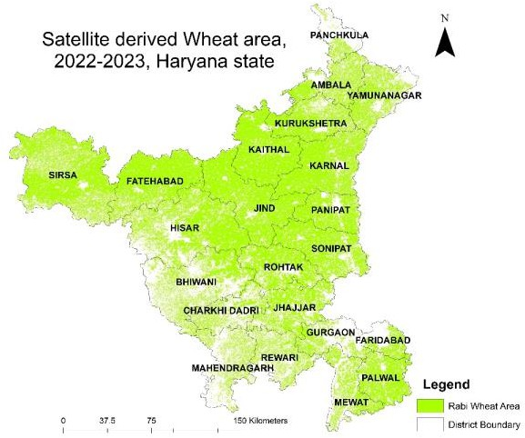

Fig. 3 Satellite derived Wheat Area, 2022 – 2023
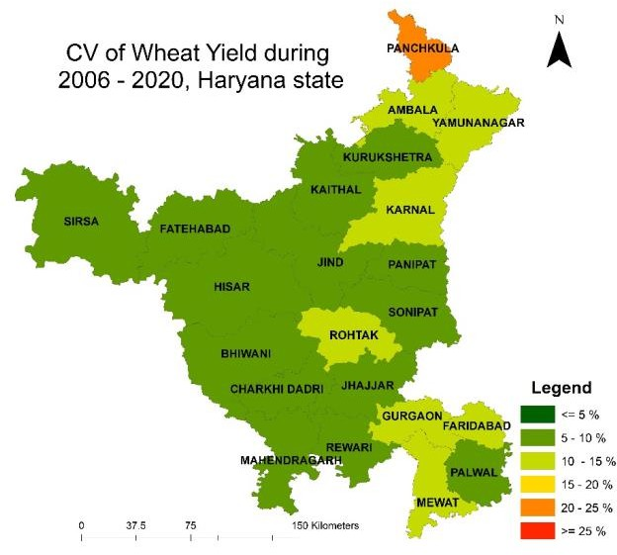
Fig. 4 Coefficient of Variation of Wheat Yield during 2006 – 2020, Haryana state

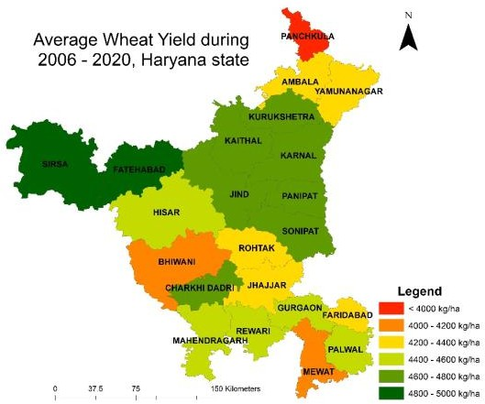

Fig. 5 Average Wheat Yield during 2006 – 2020, Haryana state

Table 2 provides a comparative analysis of wheat yield performance by district, presenting the normal yield, Olympic mean maximum yield, yield gap, weather risk, and potential for increment (%). This comprehensive evaluation facilitates the identification of districts exhibiting high potential alongside those that are underperforming. The Olympic mean, derived from the average of the top three yielding years, mitigates the influence of outliers and serves as a proxy for achievable yield, in contrast to the normal yield, which reflects the long-term average yield. The yield gap, representing the untapped potential within each district, is defined as the difference between these two yields. The districts exhibiting the largest absolute yield gaps are Panchkula (832 kg/ha), Karnal (764 kg/ha), and Yamunanagar (750 kg/ha), indicating substantial potential for productivity enhancement. These regions consistently underperform due to factors such as input availability, agronomic inefficiencies, and climate-related challenges, despite experiencing favorable conditions in certain years. Charki Dadri demonstrates the smallest yield gap (183.33 kg/ha), suggesting that yields align closely with their maximum potential, though they may be constrained by infrastructure or environmental factors. This analysis is enhanced by the weather risk index, which indicates the extent to which yield performance is affected by climatic variability. Districts such as Palwal (37.35%) and Charki Dadri (32.64%) exhibit high sensitivity to extreme weather events, including hailstorms, temperature stress, and irregular rainfall. Districts including Fatehabad (6.18%), Kaithal (6.06%), and Bhiwani (6.24%) demonstrate greater stability in performance, likely due to enhanced risk mitigation and irrigation coverage. The potential for improvement relative to theoretical limits is quantified by the scope for increment, represented as a percentage of the Olympic mean. This indicator is crucial for establishing policy priorities. The leading three regions—Panchkula (25.18%), Yamunanagar (17.15%), and Karnal (16.10%)—necessitate immediate intervention via extension services, improved seed varieties, and precision agriculture techniques.
Conversely, Charki Dadri (3.93%) and Bhiwani (7.94%) exhibit limited potential for enhancement, attributable to ecological limitations or the implementation of near- optimal practices.
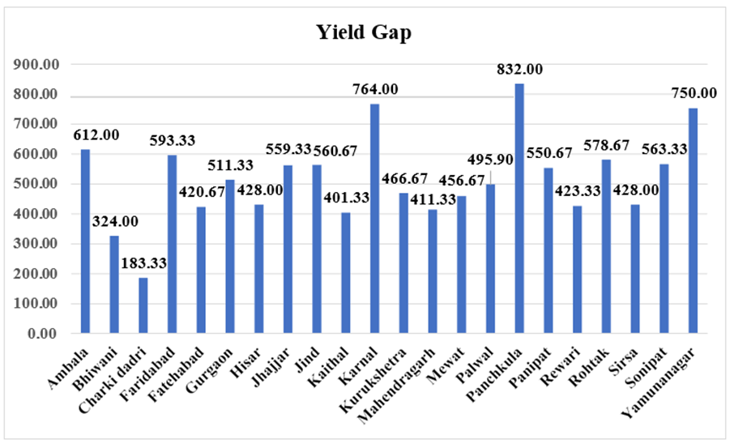

Fig. 6 Yield Gap district wise
Figure 6 illustrates the Yield Gap (Kg/ha) for wheat across the districts of Haryana, calculated by subtracting the normal yield (observed long-term average) from the Olympic mean yield (attainable). The Yield Gap metric quantifies unrealized productivity, offering a framework for assessing areas where strategic interventions may enhance wheat output. The figure indicates that Panchkula exhibits the largest yield gap at 832 kg/ha, followed by Karnal at 764 kg/ha and Yamunanagar at 750 kg/ha. The observed disparities indicate that, despite certain years exhibiting optimal soil and climate conditions (as demonstrated by Olympic yields), average productivity remains substantially below its potential. This indicates that suboptimal agronomic practices, irregular input application, or infrastructure bottlenecks may hinder consistent performance across all years. Districts classified in the second tier of intervention priority, such as Kurukshetra (466.67 kg/ha), Palwal (495.90 kg/ha), Rohtak (578.67 kg/ha), and Sonipat (563.33 kg/ha), demonstrate moderately high yield gaps. Improved extension services, the dissemination of technology (including real-time nutrient advisories and precision sowing), and timely access to high-quality inputs can significantly benefit these districts. Conversely, Charki Dadri (183.33 kg/ha), Bhiwani (324.00 kg/ha), and Kaithal (401.33 kg/ha) exhibit the smallest yield gaps. The narrower gaps in these regions may result from either near-optimal agronomic performance or inherent ecological constraints that limit significant yield increases. The focus in these areas should priorities yield stability preservation, reduction of production costs, and enhancement of input efficiency rather than aggressive intensification. The gap between districts' actual performance and their attainable

potential is an important insight derived from Figure 6. The significant yield gaps observed in the central and northern districts, including Karnal and Kurukshetra, indicate inconsistencies or suboptimal resource utilization, despite their established historical productivity. Despite historically low yields, certain southern districts, including Bhiwani and Charki Dadri, demonstrate relatively minor gaps, suggesting they are functioning close to their ecological limits.
This graph serves as a critical diagnostic tool for policy prioritization. Yield improvement programs should priorities districts such as Karnal and Panchkula, which exhibit significant yield gaps and stable weather conditions. Low-risk interventions, sustainability methods, and conservation agriculture should be implemented in low-gap districts. The figure highlights the importance of localized agronomic techniques in reducing the yield gap and enhancing wheat productivity sustainably.
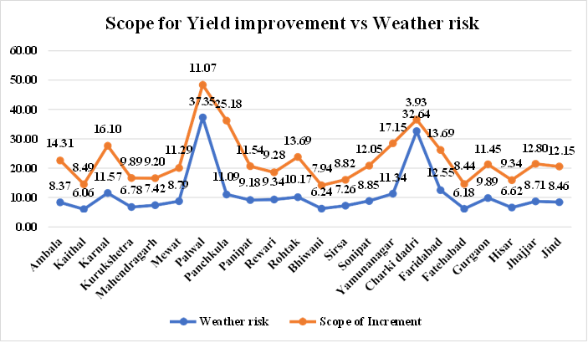

Fig. 7 Scope for Yield improvement vs Weather risk

The potential for yield enhancement (%) for each district, as indicated by Table 2, is compared to the associated Weather Risk Index (%) in Figure 7. This bivariate plot illustrates how climatic variability affects the potential to close yield gaps across the various agro-climatic zones of Haryana.
The analysis indicates a clear inverse relationship: districts experiencing moderate weather risk possess a greater capacity for yield enhancement via agronomic or policy interventions, while those facing higher weather risk generally exhibit limited potential for improvement. Panchkula exhibits the most significant potential for yield improvement at 25.18%, coupled with a moderate weather risk of 11.09%. Consequently, it is identified as a high-priority district for yield-maximization initiatives. Karnal (16.10% scope, 11.57% risk) and Yamunanagar (17.15% scope,

11.34% risk) are both situated in a strategically beneficial area, where substantial yield enhancements can be achieved under manageable climatic conditions. In contrast, Charki Dadri (3.93% scope, 32.64% risk) and Palwal (11.07% scope, 37.35% risk) occupy the high-risk–low-opportunity quadrant. Due to the extreme climatic variability in these districts, conventional intensification methods may not provide substantial practical advantages. Adaptive irrigation, climate-smart agriculture, and index-based weather insurance offer greater benefits for these regions compared to productivity models that depend significantly on inputs.
In districts like Kaithal (8.49% scope, 6.06% risk) and Fatehabad (8.44% scope, 6.18% risk), yield enhancement presents a low-risk opportunity, characterized by moderate improvement potential and relatively low weather risk. They may serve as the focal point for technology diffusion initiatives such as real-time crop monitoring, improved fertilizer application, and mechanized sowing.
Figure 7 serves as a diagnostic tool that effectively categorizes districts into four strategic groups. High scope and moderate risk indicate that yield scaling is suitable for Karnal, Yamunanagar, and Panchkula. Palwal advocates for innovations capable of withstanding significant risks. Limited Scope, Minimal Risk: Bhiwani, Kaithal: Efficiency optimization is necessary; however, the optimal yield has likely been attained. Charki Dadri presents a high-risk, low-scope scenario; therefore, the focus should be on enhancing resilience rather than intensification.

Conclusion
This study's focused evaluation of wheat yield variations throughout Haryana uncovers a substantial gap between actual on-field performance and agronomic potential. We assessed the yield gap between districts and identified regions with substantial agronomic limitations and considerable productivity potential via Olympic mean calculations and long-term production averages. The findings indicate that, despite optimal growing circumstances, regions such as Panchkula, Karnal, Yamunanagar, and Faridabad have significant yield discrepancies, sometimes exceeding 750 kg/ha. The primary reasons of these discrepancies are inefficient agricultural practices, inconsistent input utilization, and insufficient infrastructure. Charki Dadri and Bhiwani exhibit narrower gaps, suggesting that their production threshold is nearing or that yield increase is limited by ecological factors. The correlation between weather risk and the possibility of yield enhancement is a significant conclusion from the investigation. Districts exhibiting significant yield gaps, like Karnal and Panchkula, are well- positioned for yield-enhancement initiatives owing to their comparatively stable climatic conditions; conversely, districts facing greater weather risks, such as Palwal and Charki Dadri, necessitate adaptive, resilience-oriented strategies rather than mere input intensification. The yield gap distribution was effectively shown by the incorporation of ArcGIS-based spatial mapping, enabling targeted policy intervention. The paper recommends the immediate use of precision agricultural technology,

extension services, and advanced seed types to assist high-gap, low-risk regions. High- risk areas should focus on enhancing climate-resilient infrastructure, diversifying cropping systems, and implementing agricultural insurance mechanisms.
In summary, a district-specific, climate-conscious, and data-informed approach is essential to bridge the wheat production gap in Haryana. This methodology enhances yield results while promoting climate-smart agriculture, state-level food resilience, and farmer income security by aligning productivity measures with localized opportunities and limitations. The study's results and methods serve as a scalable paradigm for analogous evaluations of other crops and agroclimatic regions in India.

Disclaimer (Artificial intelligence)
NO AI USED

References
Dadrasi, A., Weinzettel, J., Wei, G., Vačkářová, D., & Frouz, J. (2025). Closing global yield gap of rainfed wheat by optimizing nitrogen and phosphorus inputs. Science of The Total Environment, 977, 179367.
Daloz, A. S., Rydsaa, J. H., Hodnebrog, Ø., Sillmann, J., van Oort, B., Mohr, C. W., ... & Zhang, T. (2021). Direct and indirect impacts of climate change on wheat yield in the Indo-Gangetic plain in India. Journal of Agriculture and Food Research, 4, 100132.
Devi, M., Kumar, J., Malik, D. P., & Mishra, P. (2021). Forecasting of wheat production in Haryana using hybrid time series model. Journal of Agriculture and Food Research, 5, 100175.
Dey, A., & Dinesh, R. (2020). Rice and wheat production in India: An overtime study on growth and instability. Journal of Pharmacognosy and Phytochemistry, 9(2), 158-161.
Handral, A. R., Singh, A. L. K. A., Singh, D. R., Suresh, A., & Jha, G. K. (2017). Scenario of changing dynamics in production and productivity of major cereals in India. Indian J Agric Sci, 87(10), 1371-1376.
Hatfield, J. L., & Beres, B. L. (2019). Yield gaps in wheat: path to enhancing productivity. Frontiers in plant science, 10, 1603.
Hou, M., Li, Y., Biswas, A., Chen, X., Xie, L., Liu, D., ... & Siddique, K. H. (2024). Concurrent drought threaten wheat and maize production and widen crop yield gaps in the future. Agricultural Systems, 220, 104056.
Kodan, A. S., Yadav, A., Kumar, V., & Mehra, S. (2012). Determinants of wheat productivity, with special reference to Haryana. IUP Journal of Agricultural Economics, 9(1), 20.
Kumar, A., Deepankar, P. K., PK, M., & Kumar, A. (2019). Wheat yield forecasting in Haryana: A time series approach. Bull. Env. Pharmacol. Life Sci, 8(3), 63-69.
Nisha, Nain, M., & Aneja, D. R. (2019). Growth analysis of area, production and productivity of wheat crop in Haryana and India.
Ohlan, R. (2012). Performance and Suitability of Growing Crops in Haryana: District-Level Analysis. Available at SSRN 2798010.
Shettigar, S., Shivaraj, K., & Shettigar, S. (2019). A study to assess the factors affecting adherence to exercise in the Indian population. Cureus, 11(11).
Singh, M., & Supriya, K. (2017). Growth rate and trend analysis of wheat crop in Uttar Pradesh, India. Int. J. Curr. Microbiol. Appl. Sci, 6(7), 2295-2301.

