Enhancing Growth and Yield of Spinach (Spinacia oleracea L.) with Natural Fertilizers in Organic Farming Systems

ABSTRACT
In organic agriculture, boosting plant growth and resilience with natural inputs is crucial for sustainable crop production. Organic extracts are effective, eco-friendly agents that can enhance crop performance across different field conditions. This experiment looks into how various organic extracts affect spinach by examining key growth, physiological, biochemical, and yield parameters. We conducted the study using a randomized block design featuring six treatments and three replications. We measured plant height, leaf area, number of leaves, relative water content (RWC), membrane stability index (MSI), and the levels of chlorophyll a, b, and total chlorophyll. The results showed that spinach treated with organic extracts demonstrated improved vegetative growth, better water retention, higher photosynthetic pigment levels, and enhanced membrane stability. These findings suggest that the plants had better physiological functioning and stress tolerance, especially those treated with panchgavya and seaweed. Overall, the results confirm that organic extracts can effectively promote sustainable spinach cultivation while also improving soil health and crop quality.
Keywords: Spinach, Organic farming, Membrane stability index, Relative water content, Chlorophyll content, Sustainable agriculture
Introduction
Spinach (Spinacia oleracea L.) is a leafy green powerhouse packed with nutrients, thriving in cooler climates. This makes it a perfect crop for the rabi season, typically sown between October and February in tropical and subtropical areas (Singh et al., 2018). With a quick growth cycle of just 30 to 45 days, farmers often plant it early in the season. After spinach, they usually follow up with nutrient-hungry crops like maize or pulses, which benefit from the enriched soil and improved structure that spinach cultivation provides (Kumar et al., 2020). It’s a key player in crop rotation systems. According to the Food and Agriculture Organization (FAO), global spinach production reached about 33.1 million tonnes in 2022, with China leading the charge by producing around 30.7 million tonnes, over 92% of the world’s total output. The United States, India, and Turkey also rank among the top producers. In India, spinach is cultivated across several states, including Uttar Pradesh, Maharashtra, and Gujarat. The country’s favourable climate and diverse agro-ecological zones allow for year-round cultivation, significantly boosting its contribution to global spinach production. The rising demand for this nutrient-rich leafy green underscores its importance in both local and international markets. Spinach also plays a vital role in enhancing soil health and structure. Its rapid growth and shallow root system provide excellent ground cover, which helps prevent soil erosion and stops weeds from spreading (Ghosh et al., 2020). As spinach leaves and roots decompose, they enrich the soil, improving its texture, water retention, and microbial activity, thus promoting long-term soil fertility (Kelley et al., 2022). When integrated into crop rotations or intercropping systems, spinach aids in nutrient cycling and minimizes nutrient leaching, making it an excellent choice for sustainable farming practices (FAO, 2022).
Spinach is a fantastic leafy green that’s packed with nutrients and is often celebrated for its health benefits. It contains about 2.9% protein, 3.6% carbohydrates, and just 0.4% fat, making it a low-calorie powerhouse. This vegetable is loaded with essential vitamins like A, C, K, and folate, along with important minerals such as iron, calcium, magnesium, and potassium (Tang et al., 2019). The Impact of Integrated Nutrient Management on Growth and Yield of Indian Spinach(M Vishwakarma and MV Rohit Chauhan 2023).These attributes make spinach a vital component of a healthy diet. It thrives in cooler temperate climates and is particularly well-suited for growing in semi-arid to sub-humid areas. Spinach prefers well-drained, loamy soil rich in organic matter and does best in temperatures between 15°C and 25°C (Chitwood et al., 2016). While it can handle light frost, extreme heat and dry spells can negatively affect its growth and the quality of its leaves. Adequate irrigation is essential, especially in semi-arid regions, to keep the soil moist and support quick plant growth (María José Delgado-Iniesta et al., 2023). Areas with limited winter rainfall but good irrigation systems provide the perfect environment for spinach cultivation. The key stages in its life cycle include germination, seedling establishment, and bolting. Germination is heavily influenced by soil temperature and moisture, with temperatures above 30°C significantly reducing germination rates (Gaikwad et al., 2023). During its early growth, the plant is vulnerable to water shortages and nutrient deficiencies, which can hinder root and leaf development. Bolting, a particularly sensitive phase, is triggered by longer daylight hours and rising temperatures; once it starts, the quality of the leaves tends to decline (Chenping Xu et al., 2016).
Organic farming offers some fantastic benefits for growing spinach. It not only boosts soil health but also increases the availability of nutrients, resulting in safer, chemical-free leafy greens. By adding organic materials like compost, vermicompost, and biofertilizers, we can enhance microbial activity and improve soil structure, which leads to better root development and nutrient absorption (Sarma et al., 2019). Spinach that grows without synthetic chemicals tends to have higher levels of antioxidants, vitamins, and minerals compared to its conventionally grown (Junejo et al., 2021). Also, organic farming practices reduce the presence of harmful chemicals, making spinach a top choice for those who care about their health and the environment. Using organic extracts such as panchgavya, vermicompost, biochar, neem extract, and seaweed in spinach cultivation brings a host of benefits for both the crops and the ecosystem. These inputs not only boost soil fertility but also stimulate microbial activity and promote sustainable plant growth. Panchgavya and vermicompost are rich in nutrients and beneficial microbes, which help improve soil structure and nutrient accessibility (Rawal and Joshi et al., 2024). Biochar enhances water retention and carbon sequestration, while neem extract acts as a natural pest repellent, reducing the need for chemical pesticides (Salma et al., 2021). Additionally, seaweed extracts have been shown to increase chlorophyll levels and stress resistance, leading to higher yields and better quality (Bhavaniramya et al., 2019).

MATERIALS AND METHODS
The study was conducted at the research farm of Amity Institute of Organic Agriculture, Amity University, Noida (Uttar Pradesh). The spinach variety All Green was used in the experiment. In the field, the experimental treatments were arranged following a randomized block design (RBD). The sowing was done with a row-to-row and plant-to-plant spacing of 15 cm × 15 cm and 6 cm × 6 cm, respectively, to maintain uniform crop stand and growth. Each experimental plot measured 2 × 2.18 meters. For field evaluation, spinach was sown using the line sowing method to maintain uniformity in plant spacing and growth. The experiment consisted of six treatments, viz., T₁, T₂, T₃, T₄, T₅, and T₆, which represent control, soil treatment with Panchgavya, Vermicompost, Biochar, Neem extract, and Seaweed, respectively. The experiment was laid out in a randomized block design with three replications per treatment for better precision in data analysis. All growth, physiological, and yield parameters were recorded under open field conditions to assess the effect of these organic extracts on spinach performance.
Field Parameters
The different field parameters were recorded at three intervals of vegetative growth, specifically at 15, 30, and 45 days after sowing (DAS). The recorded parameters included plant height (cm), measured using a scale; number of leaves per plant, counted manually; and leaf area (cm²), calculated using the graph paper method. In addition to these growth parameters, yield per plot and total yield were also recorded during harvesting and expressed in kilograms (kg) to assess the productivity.

Physiological Parameters
In addition to evaluating the stress tolerance and water retention capacity of spinach plants, the experiment also measured physiological parameters like membrane stability index (MSI%) and relative water content (RWC%). The assessment of cell membrane integrity was conducted to determine the plant's ability to withstand environmental stress, as shown by the readings obtained from MSI (Sairam et al., 1997). The water content of the plant tissues was estimated using RWC% to assess their hydration level and turgidity, which are essential for the proper functioning of the plant's physiological processes (Weatherley, 1950).
Chlorophyll Content
The estimation of chlorophyll was performed using the Arnon (1949) method, which entails the extraction of pigments using 80% acetone. Fresh leaf samples, approximately 0.5 grams, were collected from each treatment plot. These samples were then ground, using a pestle and mortar, and mixed with 6 ml of 80% acetone. Afterward, the mixture was centrifuged to obtain a clear extract. The absorbance of the liquid above was measured using a spectrophotometer at 645 nm, 663 nm, and 450 nm wavelengths. The chlorophyll a, chlorophyll b, and total chlorophyll content were determined using the following standard formulas:
Chl a = 12.9(Ab663) - 2.69 (Ab645) x V/1000 x W
Chl b = 22.9 (Ab645) -4.68 (Ab663) x V/1000 x W
Total Chl = Chl a + Chl b

Statistical Analysis
Morphological, physiological, and biochemical changes were obtained in spinach treated with different organic extracts. Analyses were done by using SPSS software, and significant differences between several treatments were identified at the 5% level of significance.

RESULT AND DISCUSSION
Natural extracts like panchgavya, vermicompost, biochar, neem extract, and seaweed have been found to boost soil fertility, encourage plant growth, and support the overall development of crops. These treatments play a crucial role in enriching the soil with essential nutrients, enhancing microbial activity, and improving soil structure and moisture retention. Neem extract acts as a natural pest repellent, protecting plants from soil-borne diseases, while seaweed helps improve plant metabolism and resilience to stress. Biochar helps retain nutrients by preventing leaching and supports root growth, whereas panchgavya and vermicompost add organic matter and beneficial microbes, ultimately leading to better crop performance and higher yield (Lehmann & Joseph, 2015).

Physiological Attributes
The growth of spinach plants showed a steady rise in height from 15 to 45 days after sowing (DAS) among all six treatments. At the 15 DAS, the T₁ (Control) had the shortest height of 9.8 cm and treatment, T₂ (Panchgavya) showed the highest early growth of 11.5 cm due to the presence of growth-promoting hormones in it, like auxins and gibberellins which is followed by T₃ (10.6 cm), T₆ (11.0 cm), T₄ (10.2 cm), and T₅ (9.9 cm), showing that all the organic treatments helped to boost early vegetative growth compared to the control (Fig. 1A). At 30 DAS, the differences in plant height became easily visible. T₁ (Control) still shows the shortest height at 10.5 cm, while T₂ (Panchgavya) has achieved the maximum height of 14.6 cm, followed by T₆ (13.7 cm), T₃ (12.8 cm), T₅ (12.4 cm), and T₄ (12.2 cm). Such increases reflect the progressive benefits of organic amendments in improving nutrient availability and supporting plant growth regulation (Fig. 1A). At 45 DAS, the plants reached their maximum heights, with T₁ (Control) at 21.4 cm, and T₂ (31 cm) showing the best result, followed by T₆ (28 cm), T₅ (26 cm), T₃ (24.5 cm), and T₄ (23.2 cm) (Fig 1A). This indicates the remarkable effects of Panchgavya and seaweed extract, along with the steady improvements offered by vermicompost, neem extract, and biochar.
Leaf area (cm²) directly influences photosynthetic activity and subsequent plant growth, and we monitored it at three important growth stages. The results revealed some interesting differences among the treatments. At 15 DAS, maximum leaf area was observed in T₆ (4.6 cm²) followed by T₅ (4.2 cm²), T₂ (4.1 cm²), and T₃ (3.8cm²), T1 (3.7 cm²) and T₄ (3.5 cm²) presented in Fig. 1B. At 30 DAS, we observed a positive result, with T₆ (13.3 cm²) again showing the best result, followed by T₂ (13.0 cm²), T₅ (12.3 cm²), T₃ (11.4 cm²), T₁ (11.3cm²) and T₄ (9.8 cm²). This indicates that leaf development was steadily improved (Fig. 1B). At 45 DAS, the leaf area had significantly increased among all treatments; T₂ showed the highest value of 56.7 cm², followed by T₆ (53.8 cm²), T₃ (51.3 cm²), T₅ (45.2 cm²), T₄ (41.9 cm²) and T₁ (31.6 cm²) demonstrated in Fig. 1B. This suggests that the various treatment combinations had a positive impact on foliage growth. Such increases in leaf area are crucial for enhancing photosynthetic efficiency, ultimately leading to better crop performance. This aligns with the findings from (Sharma and Meena et al., 2021), who showed how improved nutrient availability and plant growth stimulants can promote canopy expansion. The differences we noted confirm that each treatment uniquely influences the morpho-physiological traits, particularly in terms of leaf area development over time.
The number of leaves on each plant is a key morpho-physiological trait that directly impacts how effectively the crop can photosynthesize and its overall health. At 15 DAS), some variation in leaf count was noticed, T₄ having just 3 leaves while T₆ led the pack with 6 leaves, positioning it as the earliest in terms of leaf emergence. T₂ and T₅ both showed 5 leaves. Similarly, T1 and T3 had the same leaf count, which was three (Fig. 1C). By 30 DAS, we observed a significant increase in leaf production across all the treatments. T₆ continued to impress with 13 leaves, while T₅ and T₂ had 12 and 11 leaves, respectively, while T₃ had 9 leaves, followed by T₁ with 8 leaves, and T₄ with 7 leaves (Fig. 1C). This showed that these treatments enhanced vegetative growth. At 45 DAS, the leaf count kept on increasing, with T₆ recorded highest with 16 leaves, followed closely by T₅ with 15, T₂ with 14, T₃ with 12 leaves, T₁ with 11 leaves, and T₄ was at the lowest range with only 10 leaves (Fig. 1C). These consistent increases highlight how certain treatments can positively influence leaf growth, likely due to improved nutrient uptake, hormonal stimulation, or better soil conditions (Verma and Yadav, 2024). Having more leaves means a bigger surface area for photosynthesis, which is essential for strong growth and increased and uniform crop yield.
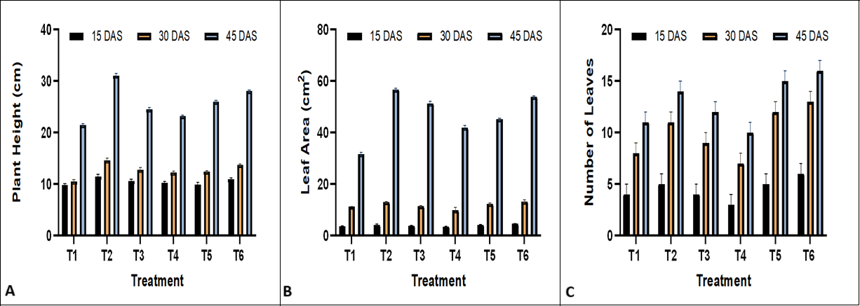
Fig.1. Effect of different treatments on growth characteristics of spinach; (A) Plant Height (cm), (B) Leaf area (cm²), Number of Leaves.

Chlorophyll a, Chlorophyll b and Total Chlorophyll (mg g⁻¹)
Chlorophyll is a crucial component of the photosynthetic pigment system, which is significantly influenced by the different treatments applied. The highest chlorophyll a content was observed in T₂ (16.6 mg g⁻¹ FW), followed by T₆ and T₃, containing 15.7 mg g⁻¹ FW and 14.8 mg g⁻¹ FW of chl a, respectively. This indicates that these treatments really enhanced the photosynthetic capabilities of plants. T₄ has 13.1 mg g⁻¹ FW of chl a content, while T₅ and T₁ were recorded with lower chlorophyll-a content of 11.8 mg g⁻¹ FW and 10.9 mg g⁻¹ FW respectively (Fig. 2A). The elevated pigment concentrations in T₂ (Panchgavya) and T₆ (Seaweed) likely resulted from improved nutrient uptake and a more conducive environment for chloroplast growth and function (Fig 2A). Generally, higher chlorophyll content translates to better light absorption and enhanced carbon assimilation (Lichtenthaler and Buschmann, 2001). Previous studies have also indicated that treatments promoting chlorophyll biosynthesis can lead to improved plant growth and yield (Anjum et al., 2011). The variations in chlorophyll a content clearly demonstrate how effective each treatment was in bolstering the photosynthetic machinery.
Chlorophyll b plays a vital role in capturing light and transferring energy to chlorophyll a during photosynthesis, and it displayed some interesting variations among the different treatments. The highest concentration of chlorophyll-b was observed in T₂ (18.02 mg g⁻¹ FW), followed T₆ (17.3 mg g⁻¹ FW) and T₃ (16.5 mg g⁻¹ FW). This suggests that these treatments might enhance the efficiency of chloroplasts and boost pigment production. T₄ and T₅ showed moderate levels of 14.9 mg g⁻¹ FW and 13.5 mg g⁻¹ FW chl b, respectively, while T₁ (9.9 mg g⁻¹ FW) had the lowest concentration (Fig 2B). The elevated chlorophyll-b levels in T₂ (Panchgavya) and T₆ (Seaweed) are helping for better nitrogen absorption and improved metabolic regulation of pigment synthesis, which ultimately supports overall photosynthetic performance (Fig. 2B). Similar observations were reported by Zhang et al., (2020), who demonstrated the positive correlation between enhanced chlorophyll content and nitrogen efficiency, and by Chandel and Kumar (2022), who highlighted the role of chlorophyll-b in optimizing light capture under nutrient-rich conditions. These results suggest that the treatments significantly influenced the photosynthetic system, with increased chlorophyll b levels indicating enhanced physiological adaptability and resource efficiency.
Total chlorophyll content, containing both chlorophyll a and b, shows how effectively a plant can photosynthesize and indicates its overall health. The findings showed that treatment T₂ (34.5 mg g⁻¹ FW) had maximum total chlorophyll content, followed by T₆ (33.0 mg g⁻¹ FW) and T₃ (31.7 mg g⁻¹ FW), indicating a notable increase in pigment accumulation with these treatments. T₄ and T₅ showed moderate levels of 28.0 mg g⁻¹ FW and 25.2 mg g⁻¹ FW of total chl, respectively, while T₁ had the lowest total chlorophyll content of 20.7 mg g⁻¹ FW (Fig 2C). The increased chlorophyll levels in T₂ and T₆ suggest better chloroplast development and greater nitrogen availability, both essential for chlorophyll production (Fig. 2C). When total chlorophyll levels are high, it typically means improved light absorption, enhanced photosynthetic efficiency, and increased biomass production. Additionally, Fageria et al., (2011) discovered that nutrient-rich treatments and those with biologically active components often lead to higher pigment concentrations, which can improve crop performance. These finding shows how specific treatments can effectively enhance plant health by promoting better chlorophyll synthesis.
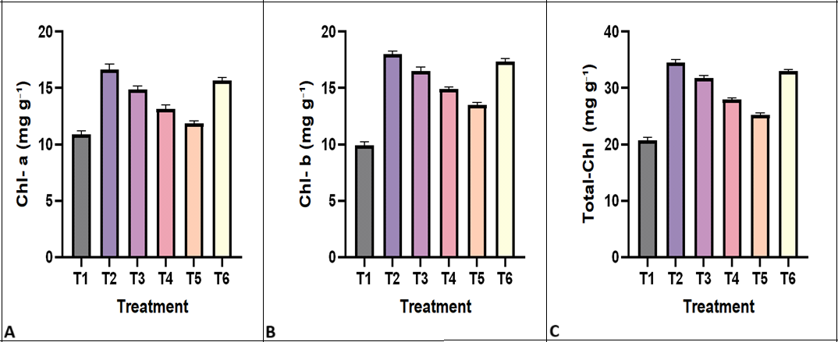
Fig.2. Result for chlorophyll levels in spinach under different treatments: (A) Chl-a (mg g⁻¹), (B) Chl-b (mg g⁻¹), (C) Total-Chl (mg g⁻¹).

Relative Water Content (RWC) % is a crucial measure of how effectively plants manage their water and maintain hydration at the cellular level. We assessed RWC to understand how various treatments influenced the ability of the leaves to retain water. Among all the treatments, T₅ (90.9%), showed the highest RWC; it significantly aids in cellular hydration and may enhance osmotic adjustment under the given conditions. T₅ was followed by T₃ and T₄ with RWC values of 87.2% and 86.9%, respectively, indicating that they also positively impact the water balance within the plant tissues. T₁ and T₂ showed moderate RWC values of 86.4% and 85.8% respectively, while T₆ recorded the lowest RWC of 84.6% (Fig. 3A). These results imply that the treatments played a vital role in the plant’s ability to retain water, which is essential for maintaining turgor pressure and facilitating key processes like stomatal regulation and photosynthesis (Blum, 2017). Generally, a higher RWC correlates with improved drought tolerance, enhanced cell membrane stability, and more efficient metabolic activity. The remarkable performance of T₅ (Neem extract) in this regard highlights its potential to enhance water-use efficiency and support plant growth, even in fluctuating environmental conditions (Fig. 3A).
The Membrane Stability Index (MSI) % is an indicator of how well cell membranes withstand stress or function under normal conditions. It shows cellular damage and membrane strength across various treatments. The results revealed that T₅ demonstrated the highest MSI of 68.7%, which depicts that T₅ has better membrane stability and experiences less electrolyte leakage. After T₅, treatments T₄ and T₆ showed good results with MSI values of 61.5% and 55.8%, respectively, indicating that they were also able to protect their cells from cellular leakages. T₃ had the lowest MSI value of 32.9%, which makes it significantly vulnerable to cellular leakages and membrane damage; Treatments T₁ and T₂ showed moderate stability, with MSI values of 45.4% and 45.9% respectively (Fig. 3B). Higher MSI values are a positive sign, reflecting better tolerance to environmental changes and are often associated with improved antioxidant activity and stress adaptation. These findings are consistent with previous research that shows how bio-based amendments or nutrient supplements can strengthen membrane structure and reduce oxidative damage, ultimately enhancing physiological efficiency (Nayyar and Gupta, 2006). The standout performance of T₅ (Neem extract) truly underscores its role in boosting cellular health and overall plant resilience (Fig. 3B).
The yield per plot (kg) serves as a direct indicator of treatment effectiveness on crop productivity, reflecting the cumulative impact of growth-promoting substances on physiological and biochemical processes, which ultimately results in enhanced crop yield. Among all the treatments, T₆ recorded the highest yield of 5.8 kg, suggesting a strong influence on nutrient uptake, hormone-like activity, and stress tolerance. T₆ was followed by treatment T₃ and T₄, which yielded 5.5 kg and 5.2 kg, respectively, highlighting their positive effect on soil structure, microbial activity, and root proliferation. T₂ also demonstrated substantial productivity with a yield of 5.0 kg, supporting its role as an organic stimulant rich in beneficial microbes and growth-promoting compounds. Moderate yield was observed under T₅, which recorded 4.7 kg, indicating decent plant performance likely due to its pesticidal and growth-enhancing properties. The lowest yield was observed in T₁, yielding only 3.8 kg, reflecting the importance of organic or bio-based inputs for achieving better agronomic outcomes (Fig. 3C). These findings align with the reports of Subramanian et al., (2015), who emphasized the role of bio-inputs in enhancing yield by improving nutrient efficiency, soil health, and plant metabolism. The notable performance of T₆ (Seaweed) reinforces its potential as a powerful bio stimulant in promoting growth and maximizing yield in sustainable crop production systems (Fig. 3C).
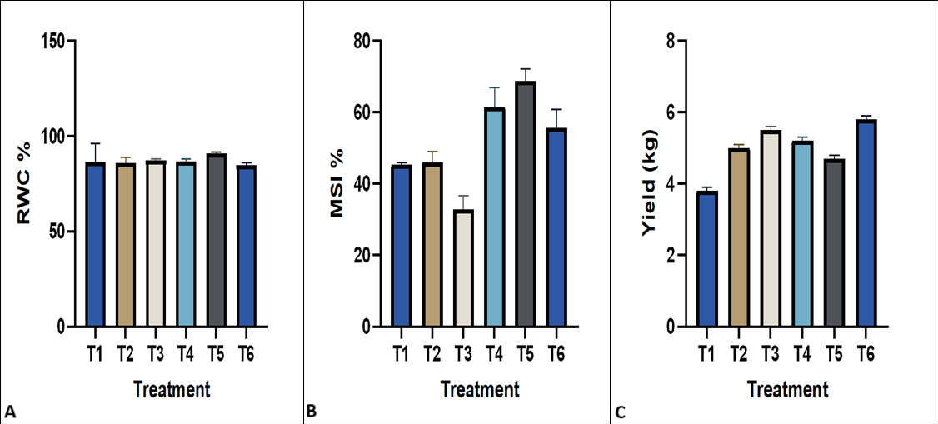
Fig.3. Physiological characteristics of spinach under various treatments: (A) RWC (%), (B) MSI (%), (C) Yield (Kg).

CONCLUSION
This study shows that using organic inputs like panchgavya, vermicompost, biochar, neem extract, and seaweed extract can really boost the growth, health, and yield of spinach. Treatments with panchgavya and seaweed extract led to better vegetative growth and increased chlorophyll levels, while neem extract helped with membrane stability and water retention, which means the plants can handle stress better. Biochar and vermicompost played a key role in improving nutrient availability and overall soil health. The treated plants also showed enhanced membrane stability index and relative water content, indicating better physiological efficiency. These results show how effective natural organic amendments can be in promoting sustainable spinach farming. The varying responses to different treatments suggest that their use should be customized based on specific growth objectives and local farming conditions. Therefore, opting for these eco-friendly alternatives to synthetic fertilizers is a smart way to enhance spinach production while also supporting environmental sustainability and soil conservation in organic and low-input farming systems.
HIGHLIGHTS
- Organic extracts enhance plant growth and stress tolerance in spinach under organic cultivation.
- Treatments included panchgavya, seaweed, and other organic inputs tested in a randomized block design.
- Spinach treated with organic extracts showed improved leaf area, plant height, and number of leaves.
- Increased chlorophyll content, RWC, and membrane stability index indicate better physiological functioning.
- Panchgavya and seaweed extracts proved especially effective in promoting yield and overall crop quality.

Disclaimer (Artificial intelligence)
Author(s) hereby declare that NO generative AI technologies such as Large Language Models (ChatGPT, COPILOT, etc.) and text-to-image generators have been used during the writing or editing of this manuscript.
References
Singh, A., Dubey, P. K., Chaurasiya, R., Mathur, N., Kumar, G., Bharati, S., & Abhilash, P. C. (2018). Indian spinach: an underutilized perennial leafy vegetable for nutritional security in developing world. Energy, Ecology and Environment, 3, 195-205.
10.1007/s40974-018-0091-1
Kumar, V., Thakur, R. K., & Kumar, P. (2020). Predicting heavy metals uptake by spinach (Spinacia oleracea) grown in integrated industrial wastewater irrigated soils of Haridwar, India. Environmental Monitoring and Assessment, 192, 1-13.
https://doi.org/10.1007/s10661-020-08673-9
Ghosh, S. M., & Chakraborty, G. (2020). Assessment of avoidable yield losses due to root-knot nematode, Meloidogyne incognita infesting Indian spinach (Basella alba L.) under West Bengal field conditions.
Kelley, A. J., Campbell, D. N., Wilkie, A. C., & Maltais-Landry, G. (2022). Compost composition and application rate have a greater impact on spinach yield and soil fertility benefits than feedstock origin. Horticulturae, 8(8), 688.
https://doi.org/10.3390/horticulturae8080688
FAO. 2022. FAOSTAT statistical database: Global spinach production data. Available at: https://www.fao.org/faostat
Tang, L., Hamid, Y., Sahito, Z. A., Gurajala, H. K., He, Z., Feng, Y., & Yang, X. (2019). Evaluation of variation in essential nutrients and hazardous materials in spinach (Spinacia oleracea L.) genotypes grown on contaminated soil for human consumption. Journal of Food Composition and Analysis, 79, 95-106.
https://doi.org/10.1016/j.jfca.2019.03.012
Vishwakarma, M., & RohitChauhan, M. V. (2023). The Impact of Integrated Nutrient Management on Growth and Yield of Palak (Indian Spinach). International Journal of Plant & Soil Science, 35(20), 763-772.
10.9734/ijpss/2023/v35i203863
Chitwood, J., Shi, A., Evans, M., Rom, C., Gbur, E. E., Motes, D., & Hensley, D. (2016). Effect of temperature on seed germination in spinach (Spinacia oleracea). HortScience, 51(12), 1475-1478.
https://doi.org/10.21273/HORTSCI11414-16
Delgado-Iniesta, M. J., Girona-Ruíz, A., & Sánchez-Navarro, A. (2023). Agro-ecological impact of irrigation and nutrient management on spinach (spinacia oleracea L.) grown in semi-arid conditions. Land, 12(2), 293.
https://doi.org/10.3390/land12020293
Gaikwad, D. J., Sahu, C., & Prasanth, S. (2023). Hydroponics vs Soil: An in-Depth Assessment of Morpho-physiological Traits in Spinach (Spinacia oleracea). Science Digest, 1(6), 6.
10.18805/ag.D-5928
Xu, C., & Mou, B. (2016). Responses of spinach to salinity and nutrient deficiency in growth, physiology, and nutritional value. Journal of the American Society for Horticultural Science, 141(1), 12-21.
https://doi.org/10.21273/JASHS.141.1.12
Sarma, U., & TR, B. (2024). Dietary phytonutrients in common green leafy vegetables and the significant role of processing techniques on spinach: A review. Food Production, Processing and Nutrition, 6(1), 10.
https://doi.org/10.1186/s43014-023-00192-7
Junejo, S. A., Rashid, A., Yang, L., Xu, Y., Kraithong, S., & Zhou, Y. (2021). Effects of spinach powder on the physicochemical and antioxidant properties of durum wheat bread. Lwt, 150, 112058.
https://doi.org/10.1016/j.lwt.2021.112058
Rawal, J. S., Joshi, G. R., Gurung, L., & Rc, P. (2024). Application Of Panchagavya In Agriculture: Practices and Benefits. INWASCON Technology Magazine (i-TECH MAG), 6(1), 57-62.
10.26480/itechmag.06.2024.44.49
Salma, M. U., & Hossain, S. (2021). Animal manure, neem cake, biochar, vermicompost or urea: Choosing the better option for Spinacia oleracea growth and soil fertility. American Journal of Plant Sciences, 12(8), 1259-1275.
10.4236/ajps.2021.128088
Bhavaniramya, S., Vishnupriya, S., Al-Aboody, M. S., Vijayakumar, R., & Baskaran, D. (2019). Role of essential oils in food safety: Antimicrobial and antioxidant applications. Grain & oil science and technology, 2(2), 49-55.
https://doi.org/10.1016/j.gaost.2019.03.001
Sairam, R. K., Deshmukh, P. S., & Shukla, D. S. (1997). Tolerance of drought and temperature stress in relation to increased antioxidant enzyme activity in wheat. Journal of Agronomy and Crop Science, 178(3), 171-178.
https://doi.org/10.1111/j.1439-037X.1997.tb00486.x
Weatherley, P. (1950). Studies in the water relations of the cotton plant. I. The field measurement of water deficits in leaves. New Phytologist, 81-97.
https://doi.org/10.1111/j.1469-8137.1950.tb05146.x
Arnon, D. I. (1949). Copper enzymes in isolated chloroplasts. Polyphenoloxidase in Beta vulgaris. Plant physiology, 24(1), 1.
10.1104/pp.24.1.1
Lehmann, J., & Joseph, S. (2015). Biochar for environmental management: an introduction. In Biochar for environmental management (pp. 1-13). Routledge.
https://doi.org/10.4324/9780203762264
Meena, D. K., Sharma, R. K., Kumar, A., Bhatnagar, A., Dawar, R., Glotra, A., & Singh, T. (2023). Impact of foliar spray of thiourea on growth attributes of two cultivars of soybean. Journal of Agriculture and Ecology, 15, 134-139.
http://doi.org/10.53911/JAE
Verma, A. K., & Yadav, M. K. An overview of the effect of integrated nutrient management on vegetable crops.
10.35248/0970-1907.24.40.1222-1225
Lichtenthaler, H. K., & Buschmann, C. (2001). Chlorophylls and carotenoids: Measurement and characterization by UV‐VIS spectroscopy. Current protocols in food analytical chemistry, 1(1), F4-3.
https://doi.org/10.1002/0471142913.faf0403s01
Anjum, S. A., Xie, X. Y., Farooq, M., Wang, L. C., Xue, L. I., Shahbaz, M., & Salhab, J. (2011). Effect of exogenous methyl jasmonate on growth, gas exchange and chlorophyll contents of soybean subjected to drought. African Journal of Biotechnology, 10(47), 9647-9656.
10.5897/AJB10.2641
Zhang, Y., Li, Y., Wang, R., Xu, L., Li, M., Liu, Z., & He, N. (2020). Spatial variation of leaf chlorophyll in northern hemisphere grasslands. Frontiers in Plant Science, 11, 1244.
https://doi.org/10.3389/fpls.2020.01244
Chandel, M., Thakur, M., Sharma, A., Pathania, D., Kumar, A., & Singh, L. (2022). Chlorophyll sensitized (BiO) 2CO3/CdWO4/rGO nano-hybrid assembly for solar assisted photo-degradation of chlorzoxazone. Chemosphere, 305, 135472.
https://doi.org/10.1016/j.chemosphere.2022.135472
Fageria, N. K., Moreira, A., & Coelho, A. M. (2011). Yield and yield components of upland rice as influenced by nitrogen sources. Journal of Plant nutrition, 34(3), 361-370.
https://doi.org/10.1080/01904167.2011.536878
Blum, A. (2017). Osmotic adjustment is a prime drought stress adaptive engine in support of plant production. Plant, cell & environment, 40(1), 4-10.
https://doi.org/10.1111/pce.12800
Nayyar, H., & Gupta, D. (2006). Differential sensitivity of C3 and C4 plants to water deficit stress: association with oxidative stress and antioxidants. Environmental and Experimental Botany, 58(1-3), 106-113.
https://doi.org/10.1016/j.envexpbot.2005.06.021
Subramanian, K. S., Manikandan, A., Thirunavukkarasu, M., & Rahale, C. S. (2015). Nano-fertilizers for balanced crop nutrition. Nanotechnologies in food and agriculture, 69-80.
10.1007/978-3-319-14024-7_3

