***Original Research Article***

**A study of Gamma Radiation and Health Risk from Historical Monuments in Rewari District, Haryana, India**

**ABSTRACT**

It is a systematic study of airborne radioactivity concentration in two historical monuments. The investigation was initiated in the Rewari district (southwest Haryana, India) in April,2024 to establish reliable baseline data on the ancient building air radiation level of the region. Country wide many areas have been found with elevated background gamma radiation, leading to several type of disorder in human beings effecting human health. The current study was undertaken as a precautionary measure and highlights the importance of radiation monitoring in non-industrial areas which could pose hidden health hazards. There are two natural sources of ionizing gamma radiation cosmic (solar or galactic) & terrestrial radiation. Isotopes of heavy elements & their decay products present in the earth’s crust are the major sources of terrestrial radiation. A portable radiation survey meter (Dosimeter) was employed to measure gamma radiation levels both indoors and outdoors. All dose rates displayed on the meter were recorded. The observed gamma radiation levels varied from 31 to 59 cpm (Counts Per Minute). The radiation dose rate measured for all the samples was lower than the reported UNSCEAR gamma dose rate range 20-200 nSv/h. AED was also found to be below the threshold of 1.0mSv/year as per ICRP. However, the estimated ELCR (Excess Lifetime Cancer Risk) was found to be higher than the global average value 0.290×10-3.

**KEYWORDS**  Activity Concentration of Air (Bq), Ancient Monument Activity Concentration Gamma Radiation in Air.

**Abbreviation**

**cpm-** counts per minute.

**ELCR**- Excess Lifetime Cancer Risk.

**AED**- Annual Effective Dose.

**Dout –** Absorbed Dose Rate.

1. **INTRODUCTION**

Naturally occurring radioactive materials (NORMs) are predominant in the environment, found in various natural components such as air, water, soil and food, as well as within living organisms. Radiation-level assessment provides us with baseline data (Lyngkhoi et al., 2020; H.U. Emelue et al., 2014) to examine the effects of radiation on humans. Human beings are continuously exposed to ionization radiation from naturally occurring materials, which originates from both UNSCEAR, (2000). Cosmic (solar or galactic) radiation, i.e. radiation entering the earth’s atmosphere from outer space: it increases slightly with latitude and markedly with altitude, Anjos, R.M. et al., (2011) and terrestrial radiation, i.e. radiation from the earth’s crust due to naturally occurring U, Th, their daughter products and singly occurring 40K and 226Ra: Gamma rays easily penetrate through the human body while a fraction of energy always absorbed by body tissues. Radiation-level assessment potentially leads to serious injury such as cancer (NJDHSS 2011; Sathishkumar et al., 2022).

Naturally occurring and artificially produced radio nuclides are classified into three categories- primordial, secondary and cosmogenic radionuclide (Billon S et al., 2022; Yukihisa Sanada et al., 2020). Primordial radionuclides are those which are produced during the formation of earth and boosting long half live, and existing even today (Bangotra et al., 2016; Qureshi A.A et al., 2014). Secondary radionuclides are radioactive isotopes produced due to the decay of primordial radionuclides. The half live of secondary radionuclides are shorter than those primordial. Cosmogenic radionuclides are continuously created in the atmosphere due to cosmic rays NRCC (1999).

In most regions globally, natural radioactivity levels exhibit relatively stable ranges, though significant deviations can occur, particularly in geological formations. For instance, igneous rocks generally contain higher levels of radioactivity compared to sedimentary rocks, except for shale and phosphate rocks, which occasionally exhibit elevated radionuclide content. Human beings are continuously and inescapably exposed to these radiations while being both indoors and outdoors (Dina N.T et al., 2022; Mekuanint et al., 2022). Furthermore, human activities contribute to environmental radiation levels. Studies specify that humans receive an average background ionizing radiation dose of approximately 0.274 microsieverts per hour, with 80% attributed to natural sources and the remaining 20% to anthropogenic sources (UNSCEAR, 2008; Fredrick O. et al., 2017). For many countries (either parts thereof or countrywide), measurement data of natural radioactivity as well as radiation exposure (both outdoors and inside dwellings) were published earlier (E.M. Ameral et al., 1992; H. Taskin et al., 2009). For India, data for a few sporadic locations in the country were reported in various publications Mitra. P et al., (2023). After, the discovery of radio nuclides, and subsequent identification of abnormal quantities in natural geological sources such as soil, mineral, water, air through testing created awareness on radiological safety among professional and public (Sahu et al., 2014; Eisenbud,1987; A.K. Mohantyt et al., 2004). Recent research conducted in Rewari, (Haryana) focused on assessing air radioactivity in ancient buildings, measuring ambient gamma dose rates in counts per minute (CPM), translating to activity concentrations in Becquerels (Bq) and Dout in (nGyh-1)

In summary, this study underscores the ubiquitous presence of natural radioactivity in the environment, its diverse sources, and the importance of assessing radiation levels to ensure safety and mitigate potential health risks. It supports the development of public health guides for safe access and ancient building usage. These readings fall within the safe range recommended by relevant standards, which is below 5 Bq.

1. **MATERIAL AND METHOD**

The aim of this study was to present the background indoor and outdoor radiation dose rates and estimate the annual effective dose and excess cancer risk to the residents of Rewari.

**2.1 STUDY AREA**

Haryana, in the northwestern region of India is located between 27°39′–30°35′N latitude and 74°28′–77°28′ longitude. For the study of air gamma radiation, two ancient buildings were selected from one district in the southwest of Haryana, i.e. Rewari (28.1920 °N, 76.6191°E).

**2.2 HISTORICAL BACKGROUND**

Rewari was accorded the status of district by the government of Haryana on November ,1,1989. Its geographical boundaries have district Jhajjar in its north, Mahendergarh district in its west. Prior to it, Rewari was a sub –division and tehsil head quarter of district Mahendergarh. Rewari is adjacent to Rajasthan and therefore, it has dust storms in summer. Rugged hilly terrain of Aravali ranges as well as sandy dunes in the district affect the city’s climate.

Rewari forms a part of National Capital Region. Rewari has average elevation of 245 meters (803 feet). The traditional industries are brass metalwork. The ancient buildings are made up of stone, small bricks, lime.

**2.3 METHOD**

For measurement purpose ancient buildings were taken and GM detector and the GQ Geiger Muller Counter 300E Plus were used. Specifically chosen to assess the health impacts of airborne radiation, the GMC-300E Geiger Muller Counter (Al-Jundi et al., 2006; Nageswara Rao et al., 1996), also known as a Dosimeter and manufactured in the USA, was utilized in this study. All dose rates on the display of the survey meter were recorded and all of the data in each building were taken in cpm and computed in becquerel (Bq) and then use the cpm value for the measurement of absorbed dose rate in air [Dout (nGy/h)] particularly of the buildings.

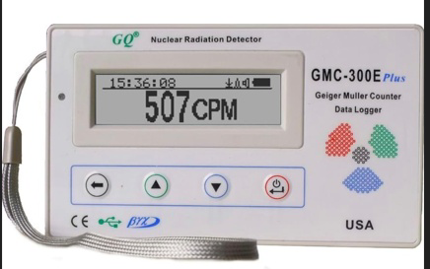

**Figure 1: Apparatus used for Radiation Detector.**

**Table 1: Readings for CPM and Becquerel of LAAL MASJID.**

| Sr. No. | Label of sample | Latitude | Longitude | CPM | Becquerel (Bq) |
| --- | --- | --- | --- | --- | --- |
| 1 | Sam A | 28°18ʹ84.7ʺN | 76°61ʹ18.5ʺE | 42 | 0.75471 |
| 2 | Sam B | 28°18ʹ86.5ʺN | 76°61ʹ19.2ʺE | 44 | 0.79065 |
| 3 | Sam C | 28°18ʹ98.0ʺN | 76°61ʹ19.7ʺE | 37 | 0.66486 |
| 4 | Sam D | 28°18ʹ78.2ʺN | 76°61ʹ18.9ʺE | 39 | 0.70080 |
| 5 | Sam E | 28°18ʹ84.3ʺN | 76°61ʹ18.7ʺE | 42 | 0.75471 |
| 6 | Sam F | 28°18ʹ83.5ʺN | 76°61ʹ16.8ʺE | 45 | 0.80862 |
| 7 | Sam G | 28°18ʹ84.9ʺN | 76°61ʹ16.9ʺE | 36 | 0.64690 |
| 8 | Sam H | 28°18ʹ84.6ʺN | 76°61ʹ17.2ʺE | 48 | 0.86253 |
| 9 | Sam I | 28°18ʹ83.7ʺN | 76°61ʹ18.5ʺE | 42 | 0.75471 |
| 10 | Sam J | 28°18ʹ83.4ʺN | 76°61ʹ18.6ʺE | 39 | 0.70080 |
| 11 | Sam K | 28°18ʹ83.9ʺN | 76°61ʹ18.4ʺE | 43 | 0.77268 |
| 12 | Sam L | 28°18ʹ83.4ʺN | 76°61ʹ18.7ʺE | 45 | 0.80862 |
| 13 | Sam M | 28°18ʹ84.2ʺN | 76°61ʹ18.5ʺE | 37 | 0.66486 |
| 14 | Sam N | 28°18ʹ83.9ʺN | 76°61ʹ18.7ʺE | 35 | 0.62893 |
| 15 | Sam O | 28°18ʹ84.5ʺN | 76°61ʹ18.3ʺE | 42 | 0.75471 |
| 16 | Sam P | 28°18ʹ84.3ʺN | 76°61ʹ18.5ʺE | 33 | 0.59299 |
| 17 | Sam Q | 28°18ʹ84.8ʺN | 76°61ʹ18.4ʺE | 31 | 0.55705 |
| 18 | Sam R | 28°18ʹ84.7ʺN | 76°61ʹ18.6ʺE | 35 | 0.62893 |
| 19 | Sam S | 28°18ʹ84.1ʺN | 76°61ʹ18.8ʺE | 37 | 0.66486 |
| 20 | Sam T | 28°18ʹ83.9ʺN | 76°61ʹ19.1ʺE | 34 | 0.61096 |

**Figure 2: Graphical Representation of Table 1.**

**Table 2: Readings for CPM and Becquerel of MUKTI HAVELI.**

| Sr. No. | Label of sample | Latitude | Longitude | CPM | Becquerel (Bq) |
| --- | --- | --- | --- | --- | --- |
| 1 | Sam A | 28°19ʹ31.64ʺN | 76°61ʹ93.05ʺE | 49 | 0.88050 |
| 2 | Sam B | 28°19ʹ31.60ʺN | 76°61ʹ93.04ʺE | 47 | 0.84456 |
| 3 | Sam C | 28°19ʹ31.59ʺN | 76°61ʹ93.01ʺE | 53 | 0.95238 |
| 4 | Sam D | 28°19ʹ31.57ʺN | 76°61ʹ92.97ʺE | 39 | 0.70080 |
| 5 | Sam E | 28°19ʹ31.65ʺN | 76°61ʹ93.09ʺE | 43 | 0.77268 |
| 6 | Sam F | 28°19ʹ31.50ʺN | 76°61ʹ93.04ʺE | 35 | 0.62893 |
| 7 | Sam G | 28°19ʹ31.53ʺN | 76°61ʹ93.08ʺE | 40 | 0.71877 |
| 8 | Sam H | 28°19ʹ31.55ʺN | 76°61ʹ93.09ʺE | 45 | 0.80862 |
| 9 | Sam I | 28°19ʹ31.59ʺN | 76°61ʹ93.11ʺE | 57 | 1.02425 |
| 10 | Sam J | 28°19ʹ31.64ʺN | 76°61ʹ93.16ʺE | 51 | 0.91644 |
| 11 | Sam K | 28°19ʹ31.61ʺN | 76°61ʹ93.19ʺE | 55 | 0.98831 |
| 12 | Sam L | 28°19ʹ31.57ʺN | 76°61ʹ93.24ʺE | 49 | 0.88050 |
| 13 | Sam M | 28°19ʹ31.55ʺN | 76°61ʹ93.15ʺE | 59 | 1.06019 |
| 14 | Sam N | 28°19ʹ31.54ʺN | 76°61ʹ93.17ʺE | 54 | 0.97035 |
| 15 | Sam O | 28°19ʹ31.50ʺN | 76°61ʹ93.11ʺE | 46 | 0.82659 |
| 16 | Sam P | 28°19ʹ32.59ʺN | 76°61ʹ92.94ʺE | 47 | 0.84456 |
| 17 | Sam Q | 28°19ʹ32.61ʺN | 76°61ʹ93.01ʺE | 45 | 0.80862 |
| 18 | Sam R | 28°19ʹ32.53ʺN | 76°61ʹ93.05ʺE | 39 | 0.70080 |
| 19 | Sam S | 28°19ʹ32.56ʺN | 76°61ʹ92.99ʺE | 44 | 0.79065 |
| 20 | Sam T | 28°19ʹ32.49ʺN | 76°61ʹ92.97ʺE | 51 | 0.91644 |

**Figure 3: Graphical Representation of Table 2.**

**Table 3: Readings for Absorbed dose rate of LAAL MASJID.**

| Sr. No. | Label of sample | Latitude | Longitude | CPM | Dout (nGy h-1) |
| --- | --- | --- | --- | --- | --- |
| 1 | Sam A | 28°18ʹ84.7ʺN | 76°61ʹ18.5ʺE | 42 | 0.0735 |
| 2 | Sam B | 28°18ʹ86.5ʺN | 76°61ʹ19.2ʺE | 44 | 0.0770 |
| 3 | Sam C | 28°18ʹ98.0ʺN | 76°61ʹ19.7ʺE | 37 | 0.06475 |
| 4 | Sam D | 28°18ʹ78.2ʺN | 76°61ʹ18.9ʺE | 39 | 0.06825 |
| 5 | Sam E | 28°18ʹ84.3ʺN | 76°61ʹ18.7ʺE | 42 | 0.0735 |
| 6 | Sam F | 28°18ʹ83.5ʺN | 76°61ʹ16.8ʺE | 45 | 0.07875 |
| 7 | Sam G | 28°18ʹ84.9ʺN | 76°61ʹ16.9ʺE | 36 | 0.0630 |
| 8 | Sam H | 28°18ʹ84.6ʺN | 76°61ʹ17.2ʺE | 48 | 0.0840 |
| 9 | Sam I | 28°18ʹ83.7ʺN | 76°61ʹ18.5ʺE | 42 | 0.0735 |
| 10 | Sam J | 28°18ʹ83.4ʺN | 76°61ʹ18.6ʺE | 39 | 0.06825 |
| 11 | Sam K | 28°18ʹ83.9ʺN | 76°61ʹ18.4ʺE | 43 | 0.07525 |
| 12 | Sam L | 28°18ʹ83.4ʺN | 76°61ʹ18.7ʺE | 45 | 0.07875 |
| 13 | Sam M | 28°18ʹ84.2ʺN | 76°61ʹ18.5ʺE | 37 | 0.06475 |
| 14 | Sam N | 28°18ʹ83.9ʺN | 76°61ʹ18.7ʺE | 35 | 0.06125 |
| 15 | Sam O | 28°18ʹ84.5ʺN | 76°61ʹ18.3ʺE | 42 | 0.0735 |
| 16 | Sam P | 28°18ʹ84.3ʺN | 76°61ʹ18.5ʺE | 33 | 0.05775 |
| 17 | Sam Q | 28°18ʹ84.8ʺN | 76°61ʹ18.4ʺE | 31 | 0.05425 |
| 18 | Sam R | 28°18ʹ84.7ʺN | 76°61ʹ18.6ʺE | 35 | 0.06125 |
| 19 | Sam S | 28°18ʹ84.1ʺN | 76°61ʹ18.8ʺE | 37 | 0.06475 |
| 20 | Sam T | 28°18ʹ83.9ʺN | 76°61ʹ19.1ʺE | 34 | 0.0595 |

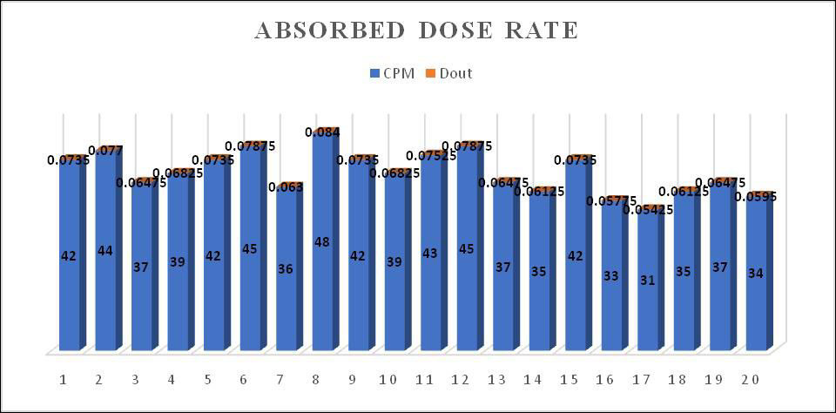

**Figure 4: Graphical Representation for CPM and dout of Table 3.**

**Table 4: Readings for Absorbed dose rate of MUKTI HAVELI.**

| Sr. No. | Label of sample | Latitude | Longitude | CPM | Dout (nGy h-1) |
| --- | --- | --- | --- | --- | --- |
| 1 | Sam A | 28°18ʹ84.7ʺN | 76°61ʹ18.5ʺE | 49 | 0.08575 |
| 2 | Sam B | 28°18ʹ86.5ʺN | 76°61ʹ19.2ʺE | 47 | 0.08225 |
| 3 | Sam C | 28°18ʹ98.0ʺN | 76°61ʹ19.7ʺE | 53 | 0.09275 |
| 4 | Sam D | 28°18ʹ78.2ʺN | 76°61ʹ18.9ʺE | 39 | 0.06825 |
| 5 | Sam E | 28°18ʹ84.3ʺN | 76°61ʹ18.7ʺE | 43 | 0.07525 |
| 6 | Sam F | 28°18ʹ83.5ʺN | 76°61ʹ16.8ʺE | 35 | 0.06125 |
| 7 | Sam G | 28°18ʹ84.9ʺN | 76°61ʹ16.9ʺE | 40 | 0.0700 |
| 8 | Sam H | 28°18ʹ84.6ʺN | 76°61ʹ17.2ʺE | 45 | 0.07875 |
| 9 | Sam I | 28°18ʹ83.7ʺN | 76°61ʹ18.5ʺE | 57 | 0.09975 |
| 10 | Sam J | 28°18ʹ83.4ʺN | 76°61ʹ18.6ʺE | 51 | 0.08925 |
| 11 | Sam K | 28°18ʹ83.9ʺN | 76°61ʹ18.4ʺE | 55 | 0.09625 |
| 12 | Sam L | 28°18ʹ83.4ʺN | 76°61ʹ18.7ʺE | 49 | 0.08575 |
| 13 | Sam M | 28°18ʹ84.2ʺN | 76°61ʹ18.5ʺE | 59 | 0.10325 |
| 14 | Sam N | 28°18ʹ83.9ʺN | 76°61ʹ18.7ʺE | 54 | 0.0945 |
| 15 | Sam O | 28°18ʹ84.5ʺN | 76°61ʹ18.3ʺE | 46 | 0.0805 |
| 16 | Sam P | 28°18ʹ84.3ʺN | 76°61ʹ18.5ʺE | 47 | 0.08225 |
| 17 | Sam Q | 28°18ʹ84.8ʺN | 76°61ʹ18.4ʺE | 45 | 0.07875 |
| 18 | Sam R | 28°18ʹ84.7ʺN | 76°61ʹ18.6ʺE | 39 | 0.06825 |
| 19 | Sam S | 28°18ʹ84.1ʺN | 76°61ʹ18.8ʺE | 44 | 0.0770 |
| 20 | Sam T | 28°18ʹ83.9ʺN | 76°61ʹ19.1ʺE | 51 | 0.08925 |

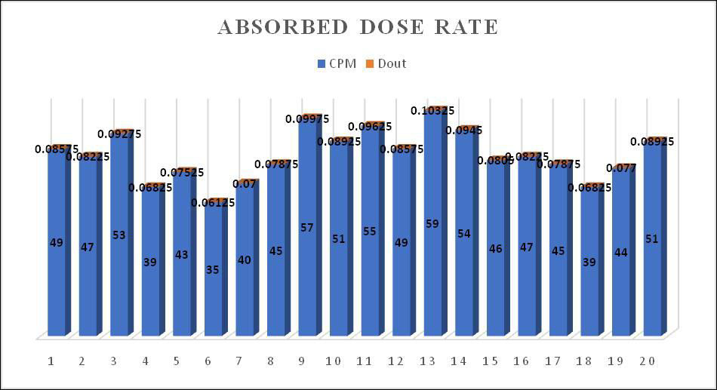

**Figure 5: Graphical Representation for CPM and dout of Table 4.**

1. **ESTIMATION OF ANNUAL EFFECTIVE DOSE**

The annual effective dose of background radiation was estimated as

AED = Dout DCFinout)-6, -equation (1)

Here AED is the external effective dose (mSv y-1), Dout is the absorbed dose rate in air (nGy h-1), DCF is the dose conversion factor from the dose rate to the annual effective dose for adults (0.7480SvGy-1) reported by the United Nation Scientific Committee on the effect of atomic radiation (UNSCEAR),T is 8766 hour per year, and Qin and Qout are indoor (0.6) and outdoor (0.4) occupancy factor respectively, R is the ratio of indoor and outdoor dose rate that is (1.11) .

1. **ESTIMATION OF EXCESS LIFE TIME CANCER RISK**

It is necessary to measure the excess lifetime cancer risk due to gamma radiations. Based on the annual effective dose, excess lifetime cancer risk includes the potential consequence such as the probability of cancer incidence in a population during a certain lifespan Sandeep Singh Duhan et al., (2022). It is calculated as

ELCR = AED $×$ ALD $×$ RF -equation (2)

Where ALD is the average life duration which is taken 65.8 year in India and RF denotes the risk factor 0.057.

**Table 5: Calculated Values of LAAL MASJID.**

| Sr. No. | Label of sample | CPM | Dout (nGy h-1) | AED×10-6 (mSv y-1) | ELCR×10-6 |
| --- | --- | --- | --- | --- | --- |
| 1 | Sam A | 42 | 0.0735 | 513.7449 | 1926.8517 |
| 2 | Sam B | 44 | 0.0770 | 538.2089 | 2018.6065 |
| 3 | Sam C | 37 | 0.06475 | 452.5848 | 1697.4646 |
| 4 | Sam D | 39 | 0.06825 | 477.0488 | 1789.2194 |
| 5 | Sam E | 42 | 0.0735 | 513.7449 | 1926.8517 |
| 6 | Sam F | 45 | 0.07875 | 550.4410 | 2064.4840 |
| 7 | Sam G | 36 | 0.0630 | 440.3528 | 1651.5872 |
| 8 | Sam H | 48 | 0.0840 | 587.1370 | 2202.1162 |
| 9 | Sam I | 42 | 0.0735 | 513.7449 | 1926.8517 |
| 10 | Sam J | 39 | 0.06825 | 477.0488 | 1789.2194 |
| 11 | Sam K | 43 | 0.07525 | 525.9769 | 1972.7291 |
| 12 | Sam L | 45 | 0.07875 | 550.4410 | 2064.4840 |
| 13 | Sam M | 37 | 0.06475 | 452.5848 | 1697.4646 |
| 14 | Sam N | 35 | 0.06125 | 428.1207 | 1605.7097 |
| 15 | Sam O | 42 | 0.0735 | 513.7449 | 1926.8517 |
| 16 | Sam P | 33 | 0.05775 | 403.6567 | 1513.9549 |
| 17 | Sam Q | 31 | 0.05425 | 379.1926 | 1422.2001 |
| 18 | Sam R | 35 | 0.06125 | 428.1207 | 1605.7097 |
| 19 | Sam S | 37 | 0.06475 | 452.5848 | 1697.4646 |
| 20 | Sam T | 34 | 0.0595 | 415.8887 | 1559.8323 |

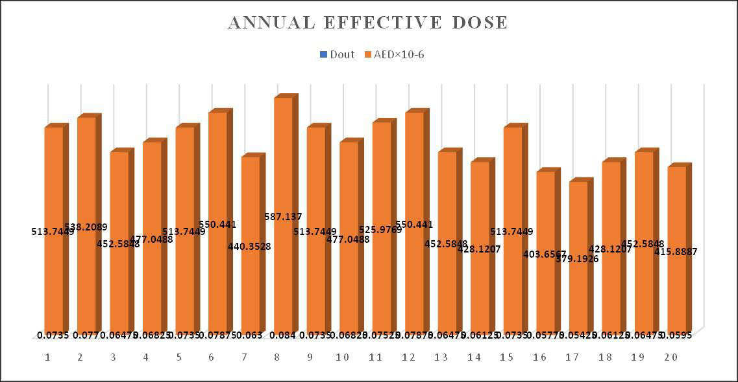

**Figure 6: Graphical Representation for dout and AED of Table 5.**

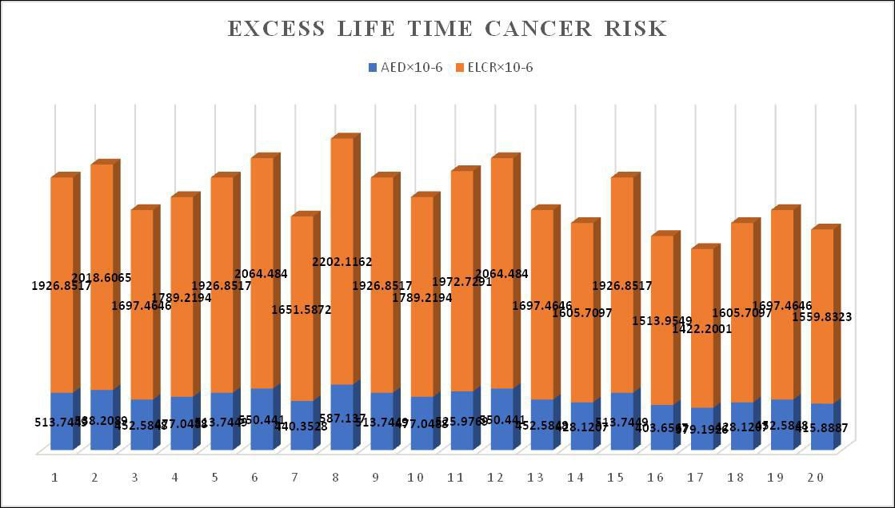

**Figure 7: Graphical Representation for AED and ELCR of Table 5.**

**Table 6: Calculated Values of MUKTI HAVELI.**

| Sr. No. | Label of sample | CPM | Dout (nGy h-1) | AED×10-6 (mSv y-1) | ELCR×10-6 |
| --- | --- | --- | --- | --- | --- |
| 1 | Sam A | 49 | 0.08575 | 599.3690 | 2247.9937 |
| 2 | Sam B | 47 | 0.08225 | 574.9050 | 2156.2388 |
| 3 | Sam C | 53 | 0.09275 | 648.2971 | 2431.5034 |
| 4 | Sam D | 39 | 0.06825 | 477.0488 | 1789.2194 |
| 5 | Sam E | 43 | 0.07525 | 525.9769 | 1972.7291 |
| 6 | Sam F | 35 | 0.06125 | 428.1207 | 1606.3103 |
| 7 | Sam G | 40 | 0.0700 | 489.2808 | 1835.0969 |
| 8 | Sam H | 45 | 0.07875 | 550.4410 | 2064.4840 |
| 9 | Sam I | 57 | 0.09975 | 697.2252 | 2615.0130 |
| 10 | Sam J | 51 | 0.08925 | 623.8331 | 2339.7485 |
| 11 | Sam K | 55 | 0.09625 | 672.7612 | 2523.2582 |
| 12 | Sam L | 49 | 0.08575 | 599.3690 | 2247.9937 |
| 13 | Sam M | 59 | 0.10325 | 721.6893 | 2706.7679 |
| 14 | Sam N | 54 | 0.0945 | 660.5292 | 2477.3808 |
| 15 | Sam O | 46 | 0.0805 | 562.6730 | 2110.3614 |
| 16 | Sam P | 47 | 0.08225 | 574.9050 | 2156.2388 |
| 17 | Sam Q | 45 | 0.07875 | 550.4410 | 2064.4840 |
| 18 | Sam R | 39 | 0.06825 | 477.0488 | 1789.2194 |
| 19 | Sam S | 44 | 0.0770 | 538.2089 | 2018.6066 |
| 20 | Sam T | 51 | 0.08925 | 623.8331 | 2339.7485 |

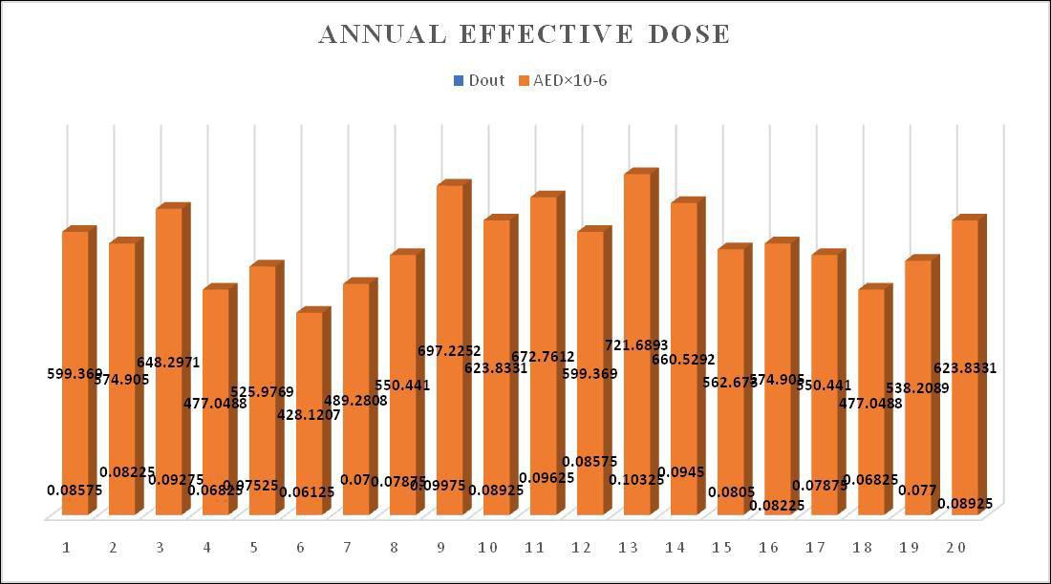

**Figure 8: Graphical Representation for dout and AED of Table 6.**

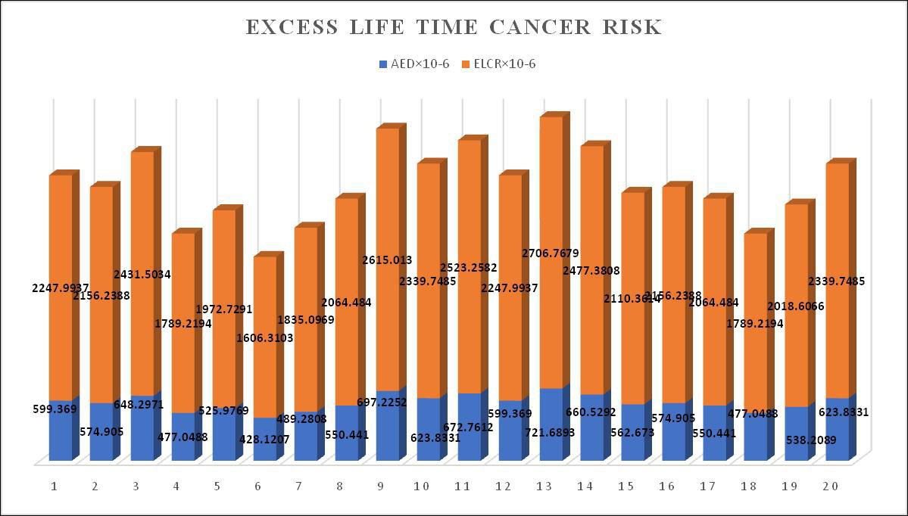

**Figure 9: Graphical Representation for AED and ELCR of Table 6.**

1. **RESULT AND DISCUSSION**

Table 1,2 shows the absorbed dose radiation in cpm and becquerel; table 3, 4 shows absorbed dose outside and inside gamma radiation in (nGy/h); table 5 and 6 shows AED and ELCR in 40 landmark measurements in southwest of Haryana during spring summer season (April). Gamma radiation ranged from 31 to 59 cpm and 0.55705 to 1.06019 becquerel with a mean value of 43.35 cpm and 0.77897 Bq respectively. The radiation ranged from 0.05425 to 0.10325 (nGy/h) with the mean value 0.1089375 (nGy/h). The gamma radiation exposure was found to be within normal range, as reported by UNSCEAR. This range is considered safe and well below levels that would pose a significant health risk. The UNSCEAR estimated that the global average outdoor dose rate due to natural background radiation is around 89 nGy/h. The annual effective dose (AED) lies in the range of 379.1926×10-6 to 721.6893×10-6 (mSv/y) and Excess life time cancer risk comes out to be in a range 1422.2001×10-6 to 2706.7679 ×10-6. The mean value of AED and ELCR is 530.25812×10-6 (mSv/y) and 1988.80124×10-6 respectively. The value of AED due to gamma radiation dose for all samples was below the permissible limit 1.0mSv/year, as per the International Commission on radiology protection (ICRP). The value of ELCR was higher than the average worldwide value of 0.290×10-3 Sandeep et al., (2022). The risk of cancer cases owing to radiation was found to be six cases per million population on average. So, chances of cancer due to radiation are increases. As it effects the DNA repair mechanism, genetic instability and effects overall immune response. It also impacts the lymph gland inflammation Mekuanint Lemlem Legasu et al., (2022).

1. **CONCLUSION**

The radiation dose rate measured concluded for all the sampling was lower than the UNSCEAR reported gamma dose rate range 20-200 nSv/h. AED was also found to be lower than the 1.0mSv/year as per ICRP. But the value of ELCR was found higher than the average worldwide value. Hence, it can be concluded that the radiation level measured in the present study poses a health risk.

**DISCLAIMER (ARTIFICAL INTELLIGENCE)**

Authors hereby declare that NO generative AI technologies such as Large Language Models (ChatGPT, COPILOT, etc) and text-to-images generators have been used during writing or editing of this manuscript.

**REFERENCES**

1. United Nations Scientific Committee on the Effects of Atomic Radiation (UNSCEAR), New York, NY (United States), (2000). Sources and effects of ionizing radiation. UNSCEAR 2000 report to the General Assembly, with scientific annexes. Volume I: Sources. UN.
2. Anjos, R. M., Juri Ayub, J., Cid, A. S., Cardoso, R., & Lacerda, T. (2011). External gamma-ray dose rate and radon concentration in indoor environments covered with Brazilian Granites. Journal of environmental radioactivity, 102(11), 1055-1061. <https://doi.org/10.1016/j.jenvrad.2011.06.001>
3. New Jersey Department of health and senior services (NJDHSS), (2011). <http://www.state.nj.us/health/er/documents/ki_faq.pdf>
4. National Research Council (US) Committee on Evaluation of EPA Guidelines for Exposure to Naturally Occurring Radioactive Materials. (1999). National Academies Press (US). e Evaluation of Guidelines for Exposures to Technologically Enhanced Naturally Occurring Radioactive Materials. National Academies Press (US).
5. E.M. Ameral, J.G. Alves, J.V. Carreiro, (1992), Doses to the Portuguese Population due to Natural Gamma Radiation, Radiation Protection Dosimetry, 45 (1-4), 541–543, <https://doi.org/10.1093/rpd/45.1-4.541>
6. Billon, S., Morin, A., Caër, S., Baysson, H., Gambard, J. P., Backe, J. C., Rannou, A., Tirmarche, M., & Laurier, D. (2005). French population exposure to radon, terrestrial gamma and cosmic rays. Radiation protection dosimetry, Radiation protection dosimetry, *113*(3), 314–320. <https://doi.org/10.1093/rpd/nch463>
7. Giorgia Cinelli, François Tondeur, Boris Dehandschutter, François Menneson, Jorge Rincones, (2022), Harmonization and mapping of terrestrial gamma dose rate data in Belgium, 248, 106885. <https://doi.org/10.1016/j.jenvrad.2022.106885>
8. Yukihisa Sanada, Kazuya Yoshimura, Yoshimi Urabe, Takeyuki Iwai, et al., (2020), Distribution map of natural gamma-ray dose rates for studies of the additional exposure dose after the Fukushima Dai-ichi Nuclear Power Station accident, Journal of Environmental Radioactivity, 223-224,106397. <https://doi.org/10.1016/j.jenvrad.2020.106397>
9. H.Taskin, M.Karavus, P.Ay, A.Topuzoglu, S.Hidiroglu et al.,(2009), Radionuclide concentrations in soil and lifetime cancer risk due to gamma radioactivity in Kirklareli, Turkey, Journal of Environmental Radioactivity, 100(1),49-53. <https://doi.org/10.1016/j.jenvrad.2008.10.012>
10. Mitra, P., Mishra, M. K., Reddy, G. P., Srivastava, S., Salunkhe, S. S., Kumari, A., Gavas, S. G., Ninawe, P. R., Thekkinkattil, M., Garg, S., & Kumar, A. V. (2023). Countrywide monitoring of absorbed dose rate in air due to outdoor natural gamma radiation in India.Radiation protection dosimetry, 199(12),1336-1350. <https://doi.org/10.1093/rpd/ncad185>
11. A.K. Mohanty, D. Sengupta, S.K. Das b, S.K. Saha b, K.V. Van c, (2004), Natural radioactivity and radiation exposure in the high background area at Chhatrapur beach placer deposit of Orissa, India, Journal of Environmental Radioactivity, 75(1),15-33. <https://doi.org/10.1016/j.jenvrad.2003.09.004>
12. Fredrick O. Ugbede, Eugene O. Echeweozo, (2017), Estimation of Annual Effective Dose and Excess Lifetime Cancer Risk from Background Ionizing Radiation Levels Within and Around Quarry Site in Okpoto-Ezillo, Ebonyi State, Nigeria, Journal of Environment and Earth Science, Vol.7, No.12.
13. Sathishkumar, K., Chaturvedi, M., Das, P., Stephen, S., & Mathur, P. (2022). Cancer incidence estimates for 2022 & projection for (2025): Result from National Cancer Registry Programme, India. The Indian journal of medical research, 156(4-5), 598–607. <https://doi.org/10.4103/ijmr.ijmr_1821_22>.
14. H. U. Emelue, N. N. Jibiri, B. C. Eke, (2014), Excess Lifetime Cancer Risk due to GammaRadiation in and Around Warri Refining andPetrochemical Company in Niger Delta, Nigeria, British Journal of Medicine & Medical Research, 4(13), 2590-2598.
15. Qureshi, A.A., Tariq,Waheed et al., (2014), Evaluation of excessive lifetime cancer risk due to natural radioactivity in the rivers sediments of Northern Pakistan, Journal of Radiation Research and Applied Sciences,7 (4),438-447. <https://doi.org/10.1016/j.jrras.2014.07.008>
16. Lyngkhoi B., Nongkynrih P. (2020). Radioactivity in building materials and assessment of risk of human exposure in the East Khasi Hills District, Meghalaya, India. Egyptian Journal of Basic and Applied Sciences, 7(1), 194- 209.

<https://doi.org/10.1080/2314808X.2020.1781747>

1. Estokova, A., Singovszka, E., & Vertal, M. (2022). Investigation of Building Materials’ Radioactivity in a Historical Building—A Case Study. Materials,15(19),6876. <https://doi.org/10.3390/ma15196876>
2. Nageswara Rao, M. V., Bhati, S. S., Rama Seshu, P., & Reddy, A. R. (1996). Natural radioactivity in soil and radiation levels of Rajasthan. Radiation Protection Dosimetry, 63(3), 207–216.
3. Al-Jundi, J., Salah, W., Bawa'aneh, M. S., & Afaneh, F. (2006). Exposure to radiation from the natural radioactivity in Jordanian building materials. Radiation protection dosimetry, *118*(1), 93–96. <https://doi.org/10.1093/rpd/nci332>
4. Dina, N. T., Das, S. C., Kabir, M. Z., Rasul, M. G., Deeba, F., Rajib, M., Islam, M. S., Hayder, M. A., & Ali, M. I. (2022). Natural radioactivity and its radiological implications from soils and rocks in Jaintiapur area, North-east Bangladesh. Journal of radioanalytical and nuclear chemistry,331(11),4457-4468. <https://doi.org/10.1007/s10967-022-08562-0>
5. Sandeep Singh Duhan , Pardeep Khyalia & Jintender Singh Laura, (2022), A comprehensive analysis of Health risk due to natural outdoor gamma radiation in southeast Haryana ,India, Current Science 123(2),169-176, DOI:[10.18520/cs/v123/i2/169-176](http://dx.doi.org/10.18520/cs/v123/i2/169-176)
6. Mekuanint Lemlem Legasu, A.k. Chaubey, (2022), Determination of dose derived from building materials and radiological health related effects from the indoor environment of Dessie city,Wollo, Ethiopia, Heliyon, 8(3), e09066. <https://doi.org/10.1016/j.heliyon.2022.e09066>
7. S.D.Takoukam Soh, Saidou, M.Hosoda, J.E. Ndjana Nkoulou N. Akata, et.al., (2018), Natural radioactivity measurements and external dose estimation by car –borne survey in Douala city, Cameroon, Radiation protection dosimetry, 53(4) 255 - 263. <https://doi.org/10.1051/radiopro/2018032>
8. Shanthi, G., Thampi Thanka Kumaran, J., Allen Gnana Raj, G., & Maniyan, C. G. (2010). Measurement of activity concentration of natural radionuclides for the assessment of radiological indices. Radiation protection dosimetry,141(1),90-96. <https://doi.org/10.1093/rpd/ncq142>
9. Bangotra, P., Mehra, R., Kaur, K., & Jakhu, R. (2016). Study of Natural Radioactivity (226ra, 232th and 40k) in Soil Samples for the Assessment of Average Effective Dose and Radiation Hazards. Radiation protection dosimetry,171(2),277-281. <https://doi.org/10.1093/rpd/ncw074>