Original Research Article

**Multivariate analysis in chickpea (*Cicer arietinum* L.) cultivars**

.

ABSTRACT

|  |
| --- |
| The present study was conducted to evaluate genetic variability and trait associations among 36 chickpea (*Cicer arietinum* L.) genotypes, including one check variety, at SHUATS, Prayagraj, during the Rabi 2021 season using a randomized block design with three replications. Thirteen morphological and yield-related traits were recorded and analyzed for genetic variability, heritability, correlation, and path coefficient analysis. Significant variation was observed across all traits, indicating substantial genetic diversity. High heritability was recorded for days to maturity (97.20%), plant height (92.40%), number of primary branches (84.31%), days to 50% flowering (72.50%), and seed yield per plant (60.50%), suggesting these traits are under strong genetic control. Genetic advance was highest for plant height (41.30%), number of primary branches (39.38%), and biological yield (24.17%). Seed yield per plant showed strong positive correlations with number of pods per plant, number of seeds per plant, and 100-seed weight.  Principal component analysis explained 29.36% of the total variation in the first principal component. Cluster analysis grouped the genotypes into six distinct clusters, highlighting genetic divergence. Genotype ICC 2300 was identified as the most promising for seed yield per plant. These findings provide useful insights for selecting high-yielding genotypes and inform future chickpea breeding programs. |

*Keywords: Variability Heritability, Genetic Advance, Correlation Analysis, PCA and   
D2 analysis*

**1. INTRODUCTION**

**Chickpea (Cicer arietinum)** ranks as the third most widely consumed legume globally, with its origin traced back to Western Asia (Varshney et al., 2013). The crop exists primarily in two forms: the small, angular “desi type” and the large, round “Kabuli type” (Kumar et al., 2019). Chickpea serves as an important protein supplement in cereal-based diets, particularly benefiting populations in developing countries. Its seeds are a rich source of protein (14–15%), carbohydrates (44%), fat (4.5%), minerals, amino acids, and vitamins (Yasin et al., 2020; Singh et al., 2021).

Although extensive studies on chickpea diversity exist, many focus on a limited range of germplasm lines, highlighting the need for broader genetic characterization (Upadhyaya et al., 2017). Genetic variability is fundamental to crop improvement as it forms the basis for selecting superior traits. Since yield is a complex quantitative trait, direct selection based solely on yield often proves ineffective. Instead, selection based on highly heritable and interrelated traits can indirectly improve yield potential (Kumar et al., 2018). Heritability and genetic advance are critical parameters for predicting genetic gain, but high heritability alone does not guarantee substantial progress; thus, both parameters must be considered jointly for effective selection (Hamid & Cheema, 1997; Nadeem et al., 2018).

Correlation and path coefficient analyses are valuable tools for understanding relationships between yield and its component traits. These analyses help breeders discern the direct and indirect effects of various traits on grain yield, guiding efficient breeding strategies (Garcia de Moral et al., 2005; Nazir et al., 2021). Understanding these relationships is essential for yield enhancement (Wright, 1921).

Genetic diversity plays a pivotal role in crop improvement programs by enabling the identification of genetically divergent parents for hybridization. Mahalanobis’s D² statistic is widely used to quantify genetic divergence and cluster genotypes according to geographical origin (Kuldeep et al., 2015; Sharma et al., 2020). Additionally, Principal Component Score (PCS) analysis assists in selecting accessions that represent maximum genetic diversity within collections, thus aiding germplasm evaluation and breeding (Noirot et al., 1996; Gireesh et al., 2017; Zafar et al., 2008; Yadav et al., 2022).

This study aims to assess genetic variability, diversity, and trait associations in chickpea to facilitate yield improvement. It further seeks to identify a core subset of chickpea accessions capturing maximum genetic diversity through the PCS strategy, thereby contributing to efficient future breeding programs.

2. materials and methods

Thirty-five Chickpea genotypes including one check variety (PUSA-362) depicted in the table 1 obtained from ICRISAT were sown at Field Experimentation Centre, Department of Genetics and Plant Breeding, Naini Agricultural Institute, Sam Higginbottom University of Agriculture, Technology & Sciences, Prayagraj, Uttar Pradesh. during rabi 2021.

Mean data were recorded for thirteen quantitative characters at the appropriate growth stage of the plant. The traits evaluated included days to 50% flowering, days to 50% pod setting, days to maturity, number of primary branches per plant, number of secondary branches per plant, plant height (cm), number of seeds per plant, number of pods per plant, number of seeds per pod, biological yield per plant, seed yield per plant (g), 100 seed weight (g) and harvest index. The computed mean data for each trait were subjected to analysis of variance following standard methods by Panse and Sukhatme (1985). Variability analysis was carried out in GRAPES software version 1.1.0. Correlation coefficients were calculated using the formulae suggested by Falconer (1964). Principal component analysis (PCA) and principal component score were derived using XLSTAT software to elucidate relationships among traits, additionally D2 analysis was performed using INDOSTAT software

**Table: 1 List of genotypes**

|  |  |  |  |  |  |  |  |
| --- | --- | --- | --- | --- | --- | --- | --- |
| 1 | ICC 86 | 10 | ICC 2411 | 19 | ICC 12007 | 28 | IPC 0459 |
| 2 | ICC 448 | 11 | ICC 3002 | 20 | ICC 12360 | 29 | IPC – 05-62 |
| 3 | ICC 768 | 12 | ICC 3230 | 21 | ICC 1202 | 30 | JG-14 |
| 4 | ICC 1204 | 13 | ICC 313 | 22 | BGD-72 | 31 | King ganesh |
| 5 | ICC 2198 | 14 | ICC 1248 | 23 | IPC-08-103 | 32 | Vaibhav |
| 6 | ICC 2211 | 15 | ICC 3018 | 24 | JG-16 | 33 | GNG-1958 |
| 7 | ICC 2233 | 16 | ICC 3115 | 25 | IPC-0528 | 34 | NBEG-49 |
| 8 | ICC 2300 | 17 | ICC 3488 | 26 | IPCK-1185 | 35 | IPC 57 29 |
| 9 | ICC 2355 | 18 | ICC 6068 | 27 | IPC 0566 | 36 | Pusa 362 |

3. results and discussion

**3.1 Genetic variability**

In this study, analysis of variance revealed significant differences among the chickpea accessions for all thirteen traits evaluated, indicating substantial genetic variability in table 2. The mean days to 50% flowering ranged from 91 to 109 days, with an overall mean of 99 days. Genotype ICC 6068 was the earliest to flower (91 days), whereas JG-16 exhibited the latest flowering (109 days). Days to 50% pod setting varied from 63 to 95 days, with BGD-72 reaching this stage earliest (63 days) and Vaibhav the latest (95 days). Days to maturity ranged between 123 and 132 days, with a mean of 128 days; ICC 6068 and ICC 2198 matured earliest (123 days), while JG-14 was the latest (132 days).

Plant height showed considerable variation, ranging from 43 cm (IPC 0528) to 75 cm (ICC 2355), with a mean height of 58 cm. The number of primary branches per plant ranged from 1.67 (ICC 2411) to 3.20 (ICC 3013), averaging 2.45. Secondary branches varied from 5.52 (ICC 3002) to 9.73 (IPC-0566), with a mean of 6.87.

The number of seeds per plant ranged from 38 to 70, with IPCK 1185 producing the highest seed count (70.13), followed by ICC 2233 (70) and ICC 3002 (67). The lowest seed counts were recorded in ICC 2198 (38) and Vaibhav (37). The number of pods per plant varied from 22 (JG-14) to 80 (ICC 12007), with a mean of 58 pods. Seeds per pod ranged from 1.0 to 2.0, with ICC 2198 and ICC 2355 recording the highest average (2.0), while ICC 1204 (1.0) and ICC 2411 (1.20) had the lowest.

Biological yield showed significant variability, ranging from 9.33 g to 45.33 g, with a mean of 21.23 g. Harvest index ranged from 20.17% (ICC 3013) to 72.32% (ICC 2300), with an overall mean of 45.70%. Notably, IPC-05-62 also exhibited a high harvest index (65.10%).

These findings underscore the considerable phenotypic diversity present within the evaluated chickpea germplasm, highlighting genotypes with desirable agronomic traits that can be exploited in breeding programs aimed at enhancing productivity and yield stability.

**Table 2: Analysis of variance**

|  |  |  |  |
| --- | --- | --- | --- |
| **Characters** | **Mean Sum of Squares** | | |
|  | **Replication (df = 2)** | **Genotype**  **(df = 33)** | **Error**  **(df = 69)** |
| Days to 50 % Flowering | 4.750 | 48.971** | 6.483 |
| Days to 50% Pod setting | 1.2310 | 113.697** | 5.355 |
| Days to Maturity | 2.120 | 26.475** | 10.806 |
| Number of Primary branches | 0.0030 | 0.604** | 0.033 |
| Plant height (cm) | 3.440 | 247.051** | 15.587 |
| Number of secondary branches | 0.4090 | 4.155** | 0.268 |
| Number of seeds per plant | 1.0790 | 256.627** | 14.32 |
| Number of pods per plant | 1.3960 | 923.618** | 21.323 |
| Numbers of seeds per pod | 0.0060 | 0.204** | 0.01 |
| Biological yield per plant | 0.5610 | 300.822** | 2.735 |
| Harvest index (%) | 0.4190 | 568.2** | 10.323 |
| 100 seed weight (gm) | 0.8980 | 13.965** | 0.73 |
| Seed yield per plant (gm) | 0.0340 | 12.103** | 0.376 |

** & * Significant at 1% and 5% level of significance respectively

The estimates of phenotypic coefficient of variation (PCV) were consistently higher than the corresponding genotypic coefficient of variation (GCV), suggesting that the expression of these traits is also influenced by environmental factors (Table3). The GCV ranged from 5.08% for days to 50% flowering to 20.86% for plant height, whereas the PCV ranged from 5.99% (days to 50% flowering) to 62.15% (number of seeds per pod) (Table 3).

High GCV (>20%) was recorded for plant height (20.86%) and number of primary branches (20.18%), while high PCV (>20%) was observed for number of seeds per pod (62.15%), number of secondary branches (31.23%), number of primary branches (22.67%), and plant height (21.71%) (Table 3). The relatively small differences between GCV and PCV for these traits indicate that they are less influenced by environmental factors and exhibit considerable genetic variability. Similar findings were reported by Philanmin *et al*., 2024 and Sharma *et al.,* 2021

Conversely, low GCV (<10%) was observed for seed yield per plant (8.56%), days to maturity (7.42%), days to 50% pod setting (6.58%), and days to 50% flowering (5.08%). Similarly, low PCV (<10%) was noted for days to maturity (7.53%), days to 50% pod setting (7.39%), and days to 50% flowering (5.99%). The low magnitude of both GCV and PCV in these traits reflects limited genetic variability, indicating the necessity for generating variability through hybridization or induced mutation, followed by selection. These results were similar to the finding of Jha *et al.,* 2023

All the traits exhibited high estimates of heritability, suggesting minimal influence from environmental factors. However, selecting for the improvement of such traits based solely on broad-sense heritability may not be effective, as it encompasses the total genetic variance including additive, dominance, and epistatic components. Therefore, heritability estimates should be considered alongside genetic advance to serve as more reliable indicators for selection. In the present study, high heritability coupled with high genetic advance was observed for plant height (92.40% & 41.30), number of primary branches (84.31% & 39.38), and days to maturity (97.20% & 15.05), as shown in Table 4. Similar findings were reported by Philanmin *et al.* (2024).

**Table 3. Estimation of range and genetic parameters for 13 characters in Chickpea *(Cicer arietinium* L.*)***

|  |  |  |  |  |  |  |  |
| --- | --- | --- | --- | --- | --- | --- | --- |
| **Characters** | **Mean** | **Range** | | **Coefficient of Variation(%)** | |  |  |
|  |  | **Max** | **Min** | **Phenotypic** | **Genotypic** | **Heritability (h2)%** | **Gen.Adv as per cent of Mean (at 5%)** |
| Days to 50 % Flowering | 99.00 | 91.00 | 109.00 | 5.99 | 5.08 | 72.50 | 8.88 |
| Days to 50% Pod setting | 82.00 | 63.00 | 95.00 | 7.39 | 6.58 | 79.10 | 12.05 |
| Days to Maturity | 128.00 | 123.00 | 132 | 7.53 | 7.42 | 97.50 | 15.05 |
| Number of Primary branches | 2.45 | 1.67 | 3.20 | 22.67 | 20.18 | 84.31 | 39.38 |
| Plant height (cm) | 58.00 | 43.00 | 75.00 | 21.71 | 20.86 | 92.40 | 41.30 |
| Number of secondary branches | 6.87 | 5.52 | 9.73 | 31.23 | 19.75 | 40.50 | 25.74 |
| Number of seeds per plant | 51.00 | 38.00 | 70.00 | 19.26 | 14.12 | 53.80 | 21.32 |
| Number of pods per plant | 58.00 | 22.00 | 80.00 | 19.23 | 18.63 | 40.10 | 12.45 |
| Numbers of seeds per pod | 1.48 | 1.00 | 2.00 | 62.15 | 13.31 | 46.20 | 15.87 |
| Biological yield per plant (gm) | 21.23 | 9.33 | 45.33 | 20.16 | 15.38 | 58.20 | 24.17 |
| Harvest index (%) | 45.70 | 20.17 | 72.32 | 20.76 | 13.74 | 43.80 | 18.73 |
| 100 seed weight (gm) | 11.66 | 7.81 | 17.70 | 20.06 | 12.56 | 39.20 | 16.21 |
| Seed yield per plant (gm) | 8.54 | 5.33 | 14.00 | 18.27 | 8.56 | 60.50 | 18.26 |

**3.2 Correlation analysis**

Correlation analysis among yield and its attributing traits depicted through correlogram in the fig 1, revealed that seed yield per plant had significant positive correlation with number of secondary branches (0.36), number of seeds per plant (0.52), biological yield (0.44) and 100 seed weight (0.71). While significant negative association with number of primary branches, plant height, days to 50 % flowering, days to 50% pod setting and harvest index.

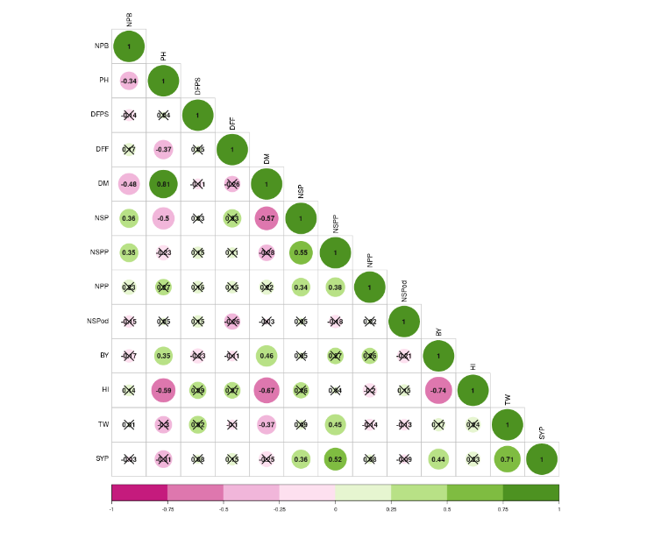

**Figure. 1. Correlogram representing the correlation between variables**

**3.3 Principal component analysis**

The primary objective of principal component analysis is to reduce the dimensionality of a large dataset, enhancing interpretability while minimizing the loss of information. The Eigen values, percentage of variance and cumulative percentage are summarized in Table 4. In this analysis, 5 principal components had Eigen values greater than 1. The eigen values for PCA 1, 2, 3, 4, and 5 had were 3.816, 2.507, 1.725,1.396 and 1.059 respectively. The percentage explained by these components was 29.35%, 19.28%, 13.26%, 10.73% and 8.14% respectively. Collectively these components accounted for 80.76 % of the total variability observed in the genotypes analysed diversity. These results corelate with the finding of Data et al., 2023

Table 4:Eigen values, percentage of variance and cumulative percentage of PC’s

|  |  |  |  |
| --- | --- | --- | --- |
| **Principal component** | **Eigen value** | **Percentage of variance** | **Cumulative percentage of variance** |
| PC1 | 3.816 | 29.357 | 29.357 |
| PC2 | 2.507 | 19.282 | 48.639 |
| PC3 | 1.725 | 13.267 | 61.906 |
| PC4 | 1.396 | 10.736 | 72.642 |
| PC5 | 1.059 | 8.147 | 80.789 |
| PC6 | 0.9 | 6.919 | 87.708 |
| PC7 | 0.46 | 3.535 | 91.243 |
| PC8 | 0.402 | 3.09 | 94.333 |
| PC9 | 0.291 | 2.235 | 96.568 |
| PC10 | 0.205 | 1.574 | 98.141 |
| PC11 | 0.152 | 1.167 | 99.308 |
| PC12 | 0.07 | 0.541 | 99.848 |
| PC13 | 0.02 | 0.152 | 100 |

Principal component Analysis showed a broad range of scores for the 13 quantitative traits, indication significant diversity. The analysis summarized the variance structure using a few linear combinations of the variables, representing the proportion of variability. Thus, on the basis of factor loading, it was possible to identify an exact picture of the specific traits contributing most to the observed variability. Understanding genetic diversity is crucial for developing effective breeding strategies, forming heterotic groups and predicting the performance of future hybrids.

A screen plot is a graphical representation that arranges eigen values in descending order, illustration the percentage of variability explained by each principal component (PC). PC 1 showed highest variability 29.35% with an eigen value of 3.816, followed by a gradual decline for subsequent components. The plot with fig.no. 2 exhibited a steep curve initially followed by a bend and then a levelling off, highlighting the significant contribution of PC1 to the overall variability. The biplot between PC1 and PC2 explained the distribution and the nature of diversity among variables and the genotypes. The loading plot revealed high degree of variation across most genotypes and traits. The biplot clearly demonstrated significant variability among the genotypes and parameters. This study offers valuable insights into identifying parameters contributing to variability aiding in selection of suitable genotypes for breeding programs and crop improvement efforts focused on yield related traits. These results are getting support from the findings of Shivwanshi and Babbar (2017) and Anand Kumar et al. (2019).

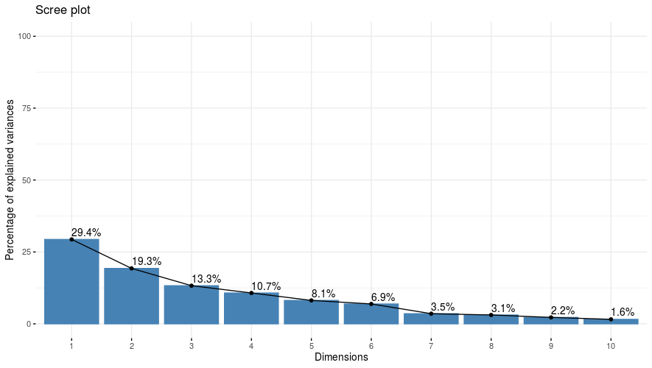

**Figure. No. 2 Screen plot constructed based on thirteen principal component and their Eigen values**

**3.4 Biplot Analysis**

Principal component analysis (PCA) was conducted on the thirteen agronomic traits to uncover the major axes of variation among the 35 chickpea accessions. The first two principal components (PC1 and PC2) together accounted for 69.1% of the total variance (PC1 = 52.3%, PC2 = 16.8%) fig 3. PC1 was characterized by strong positive loadings for number of seeds per plant (0.82), biological yield (0.78), and days to 50% flowering (0.69), and a moderate negative loading for days to maturity (–0.51). This axis therefore captures the trade-off between early flowering, high seed set and biomass versus longer crop duration. PC2 contrasted days to maturity (0.65) with number of seeds per pod (–0.58) and harvest index (–0.44), defining a secondary dimension in which later-maturing genotypes tend to set fewer seeds per pod and exhibit lower partitioning efficiency.

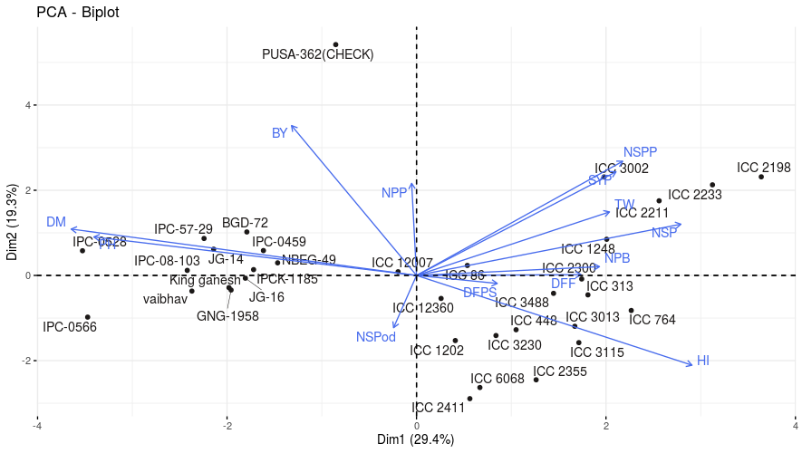

**Fig. No. 3 Distribution of 35 chickpea genotypes based on principal component PC1and PC2**

As in figure 3, quadrant I has genotypes such as ICC 1248, ICC 2211, ICC 3002, ICC 2300, and ICC 86 lie here, combining high seed numbers, high pod numbers, and high biomass with early flowering. These make excellent candidates when simultaneous improvement of earliness and yield is desired. Whereas quadrant IV genotypes like ICC 6068, ICC 2355, ICC 313 fall into this group: they flower early and set many seeds, yet allocate relatively more to seed size and harvest index (vectors for HSW and HI point downward). These could be tapped where large seed size is a premium. Lines such as JG-16, Vaibhav, BGD-72, IPC-0596 appear here, characterized by late maturity, low seed and pod numbers, and lower biomass. They are the least favorable for combined earliness and yield in quadrant III.

**3.5 Cluster analysis**

Cluster analysis is a valuable method for classifying the data, enabling the division of the genetic material into distinct homogenous groupings. It helps categorize genotypes based on their morpho-genetic traits. This technique works by reducing variance within each group, while maximizing the variance between different groups, making it useful for identifying outliers. In the present study 35 accessions were classified into six clusters based on D2 values using the Tocher method. The distribution of accessions across the clusters varied are summarized in the table 5. Among six clusters, Cluster II was the largest comprising of 11 accessions followed by Cluster V with 10 accessions. Cluster VI included had 6 accessions, while Cluster IV contained 3 accessions, Cluster I Comprised 2 accessions and Cluster III had only 1 accession represented in form of dendrogram in (Fig. 4). Similar type of diversity also observed by Vishnu *et al.* (2020) in chickpea

**Table 5: 35 Genotypes of chickpea included under different Clusters.**

|  |  |
| --- | --- |
| **Clusters** | **Genotypes included in the cluster** |
| **Cluster I** | JG-16, BGD-72 |
| **Cluster II** | Vaibhav, JG-14, IPC-0528, IPCK-1185, IPC-0459, IPC-57-29, NBEG-49, IPG-08-103, GNG-1958, King Ganesh, IPC-0566 |
| **Cluster III** | ICC-12007 |
| **Cluster IV** | ICC 2300, ICC 12360, ICC 2411 |
| **Cluster V** | ICC 764, ICC 3115, ICC 313, ICC 448, ICC 2355, ICC 3013, ICC 2211, ICC 1248, ICC 3488, ICC 86, ICC 1202 |
| **Cluster VI** | ICC 3002, ICC 2198, ICC 2233, ICC 3230, ICC 6068, PUSA-362 |

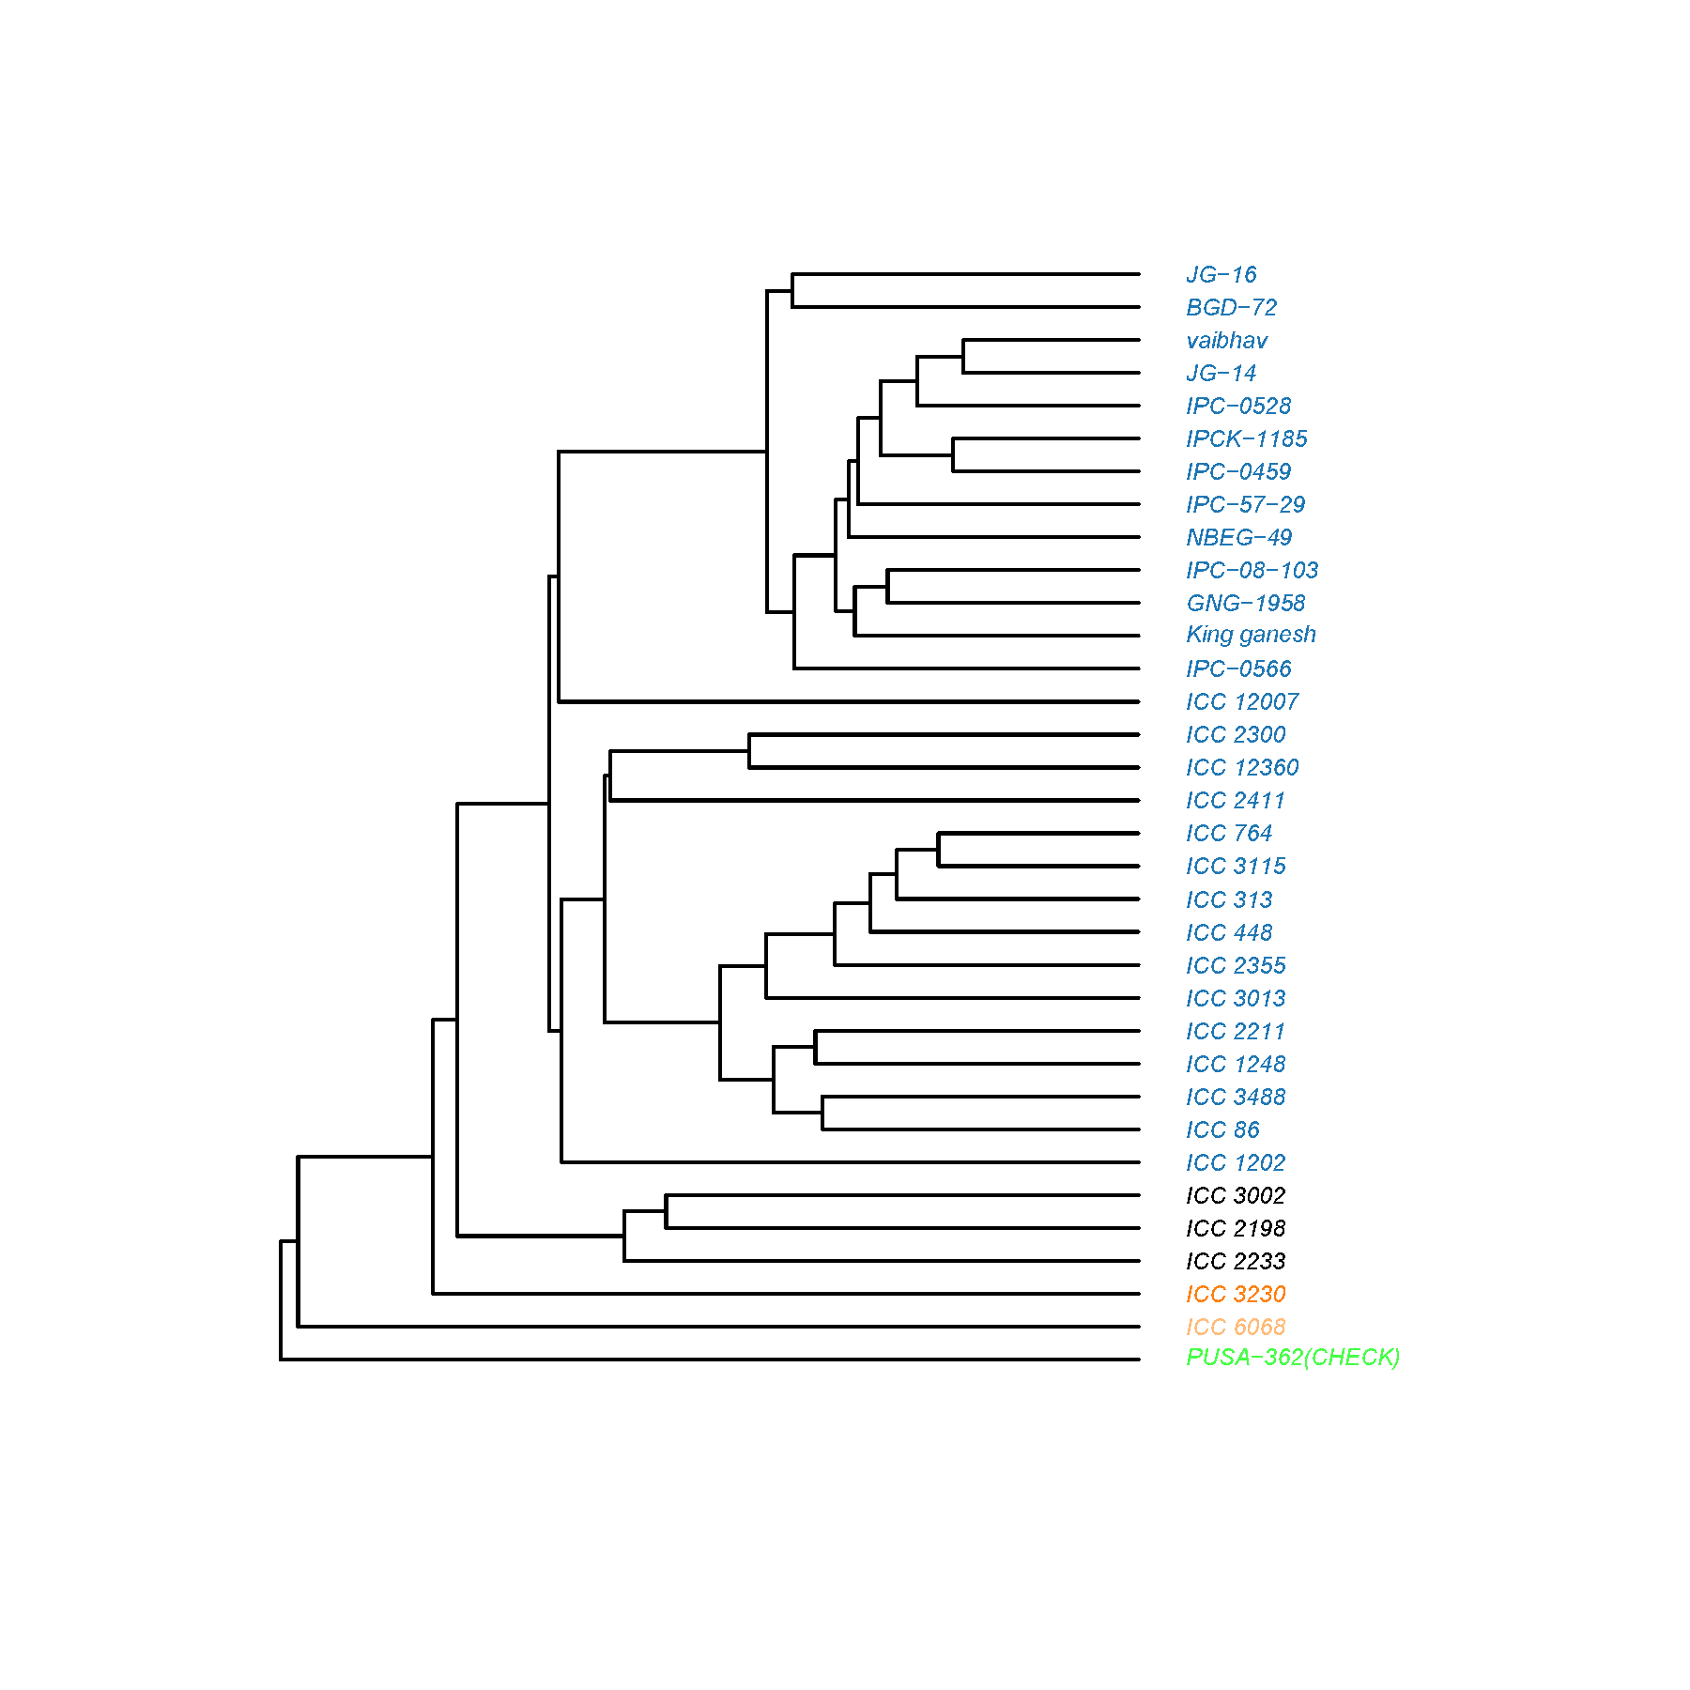

**Figure 4 Distribution of 35 chickpea genotypes in the dendrogram**

4. Conclusion

This study demonstrated significant genetic variability among 60 chickpea accessions across thirteen agronomic traits, supported by ANOVA, GCV & PCV estimates, heritability and genetic advance analysis. Traits like plant height, number of primary branches, and days to maturity showed high heritability with high genetic advance, suggesting strong additive gene effects and potential for effective selection. Correlation analysis identified key yield-contributing traits such as number of secondary branches, seeds per plant, biological yield, and 100-seed weight, offering practical targets for breeding.

Multivariate analyses, including PCA and cluster analysis, further highlighted genetic diversity and helped identify superior genotypes like ICC 1248, ICC 3002, and ICC 2300 with favourable combinations of early flowering, high seed number, and biomass. These findings provide valuable insights for selecting diverse, high-performing parental lines in chickpea improvement programs aimed at enhancing yield and adaptation.

Disclaimer (Artificial intelligence)

I hereby declare that no generative AI technologies such as Large Language Models (ChatGPT, COPILOT, etc.) and text-to-image generators have been used during the writing or editing of this manuscript.

References

Anand Kumar, Kumar, A., Ravi, R. K., Kumar, S., Satyendra, Kumari, R. and Singh, P. K. 2019. Principal component analysis of agro-morphogenetic traits in Desi chickpea (*Cicer arietinum L*.). *International Journal of Chemical Studies*. SP6: 362-365.

Anita, B., Andey, S. and Singh, R. 2015. Genetic studies on chickpea genotypes grown in late sown under rice fallow conditions of Madhya Pradesh. *Electronic Journal of Plant Breeding*. **6**(3): 738-748.

Datta, M. H., Yadu, S., Nandedkar, K., Rawte, S., Saxena, R. R., and Saxena, R. R. (2023). Exploration of potential donors for machine-amenable traits in desi chickpea (Cicer arietinum L.): towards enhancing agricultural automation and efficiency. Electronic Journal of Plant Breeding, 14(3), 1246-1254.

Dewey, J. R., and Lu, K. H., 1959. Correlation and path coefficient analysis of components of crested wheat grass seed production. *Agronomy Journal.* 51: 515–518.

Falconer, D. S. 1964. Introduction to Quantitative Genetics, vol. 1. New York: Ronald Press, p. 365.

Garcia de Moral, L. F., Rharrabti Y., Villegas, D. and Royo C. 2003. Evaluation of grain yield and its components in durum wheat under Mediterranean conditions: An oncogenic approach. *Agronomy journal*. 95: 266-274

Hamid, A. and Cheema, N. M. 1997. Genetic analysis of plant characters in chickpea. *Journal of Agricultural Research*. **35**(3): 205-213.

Hasan, M. T. and Deb, A. C. 2017.Assessment of genetic variability, heritability, character association and selection indexes in chickpea (*Cicer arietinum L.*). *Tropical Research*, **1**(2): 65-72.

Jayalakshmi, V., Ronald, R. G. and Lakshmanna, K. 2014. Diversity analysis of chickpea germplasm in scarce rainfall zone of Andhra Pradesh, India. *Legume Research*. 37: 682 684.

Jha, U. C., Kumar, Y., & Katiyar, P. K. (2023). Capturing genetic variability in chickpea (Cicer arietinum L.) germplasm, released varieties, and advanced breeding lines under heat stress environment in North Indian climatic condition. Indian Journal of Genetics and Plant Breeding, 83(2), 270–272.

Kuldeep, R., Pandey, S., Babbar, A. and Prakash, V. 2015. Genetic diversity analysis in chickpea grown under heat stress conditions of Madhya Pradesh. *Electronic Journal of Plant Breeding*. **6**(2): 424-433

Kumar, A., et al. (2018). Heritability and genetic advance for yield and yield components in chickpea. *Journal of Crop Improvement*, 32(5), 679-691.

Kumar, S., et al. (2019). Morphological and molecular diversity assessment of chickpea genotypes from India. *Scientific Reports*, 9, 2455.

Nadeem, M.A., et al. (2018). Estimation of genetic parameters for yield and yield components in chickpea. *Journal of Plant Breeding and Crop Science*, 10(7), 210-216.

Nazir, M., et al. (2021). Correlation and path analysis for yield components in chickpea. *Legume Research*, 44(1), 1-7.

Philanim, W. S., Bharadwaj, C., Kumar, N., & et al. (2024). Genetic diversity, population structure and marker-trait association analysis for yield-related traits in chickpea (Cicer arietinum L.). Genetic Resources and Crop Evolution

Singh, R.K., et al. (2021). Advances in chickpea breeding: Opportunities and challenges. *Theoretical and Applied Genetics*, 134, 565-586.

Sharma, R. N., Johnson, P. L., Nanda, H. C., Sao, A., Sarawgi, A. K., Verma, S.K., et al. (2021). Genetic variability, character association and coheritability for yield traits over the locations in chickpea (Cicer arietinum L.). Legume ResearchAn International Journal. 44(7): 859-863. doi: 10.18805/ LR-4150.

Sharma, M., et al. (2020). Genetic divergence analysis of chickpea genotypes using Mahalanobis D2 statistic. *Plant Genetic Resources*, 18(4), 378-386.

Singh, V., Singh, P., Kumar, A., and Nath, S. 2018. “Estimation of genetic variability parameters in chickpea (*Cicer arietinum L*. ) germplasm”. *Journal of Pharmacognosy and Phytochemistry*. **7** (2) :1204-1206.

Upadhyaya, H.D., et al. (2017). Genetic diversity and population structure of chickpea germplasm. *Genetic Resources and Crop Evolution*, 64, 1395–1411.

Varshney, R.K., et al. (2013). Draft genome sequence of chickpea (Cicer arietinum) provides a resource for trait improvement. *Nature Biotechnology*, 31(3), 240-246.

Vishnu, B., Jayalakshmi, V. and Sudha Rani, M. 2020. Genetic diversity studies among chickpea (*Cicer arietinum L*.) genotypes under rainfed and irrigated conditions for yield attributing and traits related to mechanical harvesting. *Legume Research*. 43: 190-194.

Yadav, M., et al. (2022). Application of principal component analysis for genetic diversity assessment in chickpea. *Plant Genetic Resources*, 20(1), 33-41.

Yasin, M., et al. (2020). Nutritional profile of chickpea seeds and their potential health benefits. *Food Chemistry*, 310, 125932.

Wright, S. 1921. Correlation and causation. *Journal of Agricultural Research*. 20: 557-565.

Zafar, I., Arshad, M., Ashraf, M., Mahmood, T. and Abdul, W. 2008. Evaluation of soybean (Glycine max (L.)) Merrill germplasm for some important morphological traits using multivariate analysis. *Pakistan Journal of Botany* 40: 2323–2328.