**Women’s Acceptance of Training in Clean Milk Production and Milk Processing**

**Abstract**

Milk production and processing play a vital role in the livelihood of rural households, especially in agrarian economies. Women, being primary contributors in dairy farming and milk handling, are key stakeholders in ensuring the quality and safety of milk. Training programs on clean milk production and milk processing are essential to enhance their knowledge and skills, leading to improved milk quality, reduced contamination, and increased income opportunities. However, the success of such initiatives largely depends on the acceptability and willingness of women to participate and apply the knowledge gained. Understanding the factors influencing women’s acceptance of training is crucial for designing effective capacity-building programs that empower them, promote hygienic practices, and ultimately contribute to sustainable dairy development. This study focuses on assessing the acceptability of training on clean milk production and milk processing among women, exploring their perceptions, challenges, and motivation to adopt improved practices.

Key words: Milk Production , Milk Processing, dairy farming **,** agrarian economies

### Introduction

Rural women play a critical role in India's livestock sector, particularly in dairy farming, which has become a major livelihood activity for millions of households. According to the **National Sample Survey Office (NSSO, 2013),** over 75% of rural women are involved in animal husbandry and related tasks, underscoring their indispensable contribution to the dairy economy. In states like Haryana, women are actively engaged in activities such as feeding, milking, cleaning of sheds, and basic animal healthcare. The increasing diversification of the rural economy has further highlighted the relevance of dairy as a sustainable income-generating activity for rural and tribal women (Reichler et al., 2020).

India continues to lead the world in milk production. According to the Basic Animal Husbandry Statistics 2024 released by the Department of Animal Husbandry and Dairying, India's milk output reached a record 239.30 million tonnes in the fiscal year 2023–24, reflecting a 3.78% increase over the previous year's 230.58 million tonnes. (Hindustan Time, 2025). India's dairy sector has demonstrated consistent growth, with milk production increasing from 146.3 million tonnes in 2014–15 to 239.3 million tonnes in 2023–24—a 63.55% rise over the decade. Unlike seasonal crops, dairy farming ensures a steady and daily cash flow, making it a reliable source of livelihood for small and marginal farmers. As a result, the contribution of the dairy sector to rural incomes and nutritional security has been growing steadily (Singh & Gupta, 2015).

To strengthen this sector, the **National Dairy Development Board (NDDB),** in collaboration with the **Government of India and the World Bank**, initiated the **National Dairy Plan Phase I (2012–2017),** aiming to enhance the productivity of milch animals and improve market access for rural milk producers (NDDB, 2014). With an investment exceeding ₹2,000 crore, the plan has emphasized infrastructure development, breed improvement, and training of dairy farmers, particularly women.( Thakur *et.al.* 2021)

In this scenario, training and awareness about clean milk production and value addition through milk processing become crucial. Training programs focused on hygienic milking, safe storage, and animal care practices help farmers produce high-quality milk that meets market standards, thereby fetching better prices. (Sharma *et. al.* 2025)Value addition through milk processing such as making paneer, ghee, yogurt, flavored milk, or ice cream opens new income avenues, as processed products often command higher returns. Training also empowers farmers, women’s groups, and youth to establish small-scale dairy enterprises, creating employment opportunities and fostering entrepreneurship. Moreover, awareness about food safety standards, packaging, and labeling enhances market access, while knowledge of government schemes and credit facilities further supports enterprise growth. By adopting safe practices, producers can reduce spoilage and losses, improve public health through the supply of safe and nutritious products, and contribute to the sustainability of the dairy sector. (Sharma and Kwatra, 2025). Overall, training in clean milk production and milk processing plays a pivotal role in strengthening rural livelihoods, enhancing income generation, and building a resilient dairy economy. However, effective communication and knowledge transfer are key challenges. The role of mass media, mobile-based advisories, and agricultural extension services has grown significantly in bridging the knowledge gap. As highlighted by **Singh and Meena (2015),** mass media and ICT tools have become vital in disseminating need-based, scientific information to rural women, thereby empowering them to make informed decisions.

Given this background, the present study was conducted in the **Udham Singh Nagar district of Uttarakhand,** focusing on **tribal women.** The study aimed to assess the **acceptability and impact of training on clean milk production and milk processing,** with an emphasis on how knowledge, attitudes, and practices are influenced by such capacity-building initiatives. This research is particularly relevant in regions where tribal women have limited access to formal education and extension services but remain central to dairy-based livelihood systems.

### ****Methodology****

The present study was conducted to examine the socio-economic profile and basic dairy farming practices of tribal dairy farmers in Udham Singh Nagar district of Uttarakhand. A descriptive research design was employed to gather accurate and meaningful insights from the selected respondents. The study was carried out in Sitarganj block, which has a significant tribal population engaged in agriculture and allied activities. Two villages: Jaganpuri and Sadhunagar from Udham Singh Nagar District were purposively selected based on the concentration of tribal households and the prevalence of dairy farming practices in these areas.

A multistage purposive sampling technique was adopted for the selection of respondents. From the selected villages, a total of 100 tribal dairy farmers were randomly chosen, ensuring fair representation from each village. Only those respondents who belonged to recognized Scheduled Tribes and were actively involved in dairy farming were included in the sample.

Primary data were collected using a well-structured and pre-tested interview schedule, which comprised two sections—socio-economic characteristics (such as age, education, occupation, landholding, family type, income, etc.) and Knowledge test of tribal women. The interviews were conducted in Hindi, the local language, to ensure clarity and comfort for the respondents.

The collected data were tabulated and analyzed using simple descriptive statistics such as frequency and percentage. The findings were systematically presented through tables to draw meaningful conclusions. Though every effort was made to ensure accuracy, the study was confined to selected villages of one block and based on self-reported responses, which may have limitations in terms of generalizability and objectivity.

**Table 1: Socio-economic characteristics of tribal dairy farmers (N = 100)**

|  |  |  |  |  |
| --- | --- | --- | --- | --- |
| **S. No.** | **Characteristics** | **Category** | **Number (N)** | **Percentage (%)** |
| 1 | Age Group | Young (18–35 years) | 22 | 22 |
|  |  | Middle (36–50 years) | 58 | 58 |
|  |  | Old (Above 50 years) | 20 | 20 |
| 2 | Caste Category | Tribal | 100 | 100 |
| 3 | Education Level | Illiterate | 18 | 18 |
|  |  | Primary | 32 | 32 |
|  |  | Secondary | 28 | 28 |
|  |  | Higher Secondary and Above | 22 | 22 |
| 4 | Family Type | Nuclear | 38 | 38 |
|  |  | Joint | 62 | 62 |
| 5 | Land Holding Size | Marginal (<1 ha) | 28 | 28 |
|  |  | Small (1–2 ha) | 52 | 52 |
|  |  | Medium and Above (>2 ha) | 20 | 20 |
| 6 | Main Occupation | Agriculture + Dairy + Labour | 64 | 64 |
|  |  | Only Agriculture + Dairy | 26 | 26 |
|  |  | Others | 10 | 10 |
| 7 | Annual Income from All Sources | Low (<₹50,000) | 20 | 20 |
|  |  | Medium (₹50,000–₹1,00,000) | 55 | 55 |
|  |  | High (>₹1,00,000) | 25 | 25 |

**Results and Discussion**

**Age Group:** The analysis of age distribution among respondents revealed that a majority (58%) belonged to the middle age group of 36–50 years. This was followed by 22% of respondents in the young age group (18–35 years) and 20% in the old age group (above 50 years). The dominance of middle-aged women indicates that this group is the most actively involved in dairy and milk processing activities. Their age bracket is generally considered to be productive and responsible, contributing significantly to household income and livelihood activities.

**Caste Category:** All the respondents in the study (100%) belonged to the tribal community. This is consistent with the objectives of the program, which focused on the empowerment and capacity building of tribal women through dairy-based livelihoods. The homogeneity in caste category also implies that any interventions or findings are specifically relevant and tailored for tribal populations.

**Education Level:** The educational background of the respondents showed that 32% had primary education, 28% had completed secondary education, and 22% had education up to higher secondary and above, while 18% were illiterate. This indicates that a significant number of tribal women have access to basic education, although a portion of them still remain illiterate. The educational level of the majority provides a foundation for training and skill development in dairy processing, though there remains a need for simplified and visually oriented training methods for those with limited literacy.

**Family Type:** With respect to family structure, 62% of the respondents were from joint families while 38% belonged to nuclear families. Joint families can be advantageous for managing dairy activities, as labor is often shared among family members. However, decision-making in joint families may be influenced by elders, which could sometimes limit women’s autonomy in implementing new practices learned through training programs.

**Land Holding Size:** The data revealed that 52% of the respondents were small landholders with 1–2 hectares of land, 28% were marginal landholders with less than 1 hectare, and 20% had medium or above landholdings. This implies that the majority of respondents operate on small and marginal landholdings, which is typical in tribal regions. The limited landholding size also highlights the importance of dairy as a supplementary source of income and livelihood diversification.

**Main Occupation:** The main occupation of 64% of respondents included agriculture, dairy, and labor work. Around 26% were engaged in agriculture and dairy only, while 10% were involved in other occupations. This reflects that dairy is an essential component of the livelihood strategy for tribal women, often combined with other forms of labor to sustain household income. The integration of agriculture and dairy provides resilience against income fluctuations due to seasonal farming.

**Annual Income from All Sources:** In terms of annual income, 55% of the respondents were in the medium-income category earning between ₹50,000 to ₹1,00,000, 25% had a high income of over ₹1,00,000, and 20% had low income below ₹50,000. This suggests that a majority of families manage to earn a modest income, though a significant portion still lives with financial constraints. Dairy-based entrepreneurship and value-added milk processing activities could play a crucial role in enhancing income levels and improving the economic condition of these families.

Overall, the socio-economic profile of the respondents shows that most tribal women are engaged in agriculture and dairy-based livelihoods, with a reasonable level of literacy and land ownership. These characteristics make them suitable beneficiaries for training programs aimed at clean milk production, value addition, and marketing. The findings underline the importance of empowering tribal women through targeted interventions that build skills, increase productivity, and ultimately contribute to economic development.

**Table 2: Knowledge test of respondents on value-added milk products (N=100)**

|  |  |  |  |
| --- | --- | --- | --- |
| **S. No.** | **Topic** | **Yes (%)** | **No (%)** |
| 1. | Knowledge of milk-based value-added products (paneer, ghee, curd, etc.) | 38% | 62% |
| 2. | Understanding of the milk processing methods | 34% | 66% |
| 3. | Hygienic practices | 42% | 58% |
| 4. | Awareness of shelf-life and preservation techniques for dairy products | 39% | 61% |
| 5. | Understanding of packaging and labelling techniques for dairy products | 37% | 63% |
| 6. | Awareness of government schemes for dairy entrepreneurs | 33% | 67% |
| 7. | Knowledge of milk chilling and storage facilities | 40% | 60% |
| 8. | Familiarity with local market demand for milk-based products | 36% | 64% |
| 9. | Awareness of pricing and cost calculation in dairy-based entrepreneurship | 35% | 65% |
| 10. | Knowledge of branding and promotion of milk-based value-added products | 32% | 68% |

**Interpretation and Description:**

Table 2 presents the knowledge levels of 100 respondents from the tribal community regarding various aspects of value-added milk products and their marketing. The findings indicate significant gaps in awareness and technical knowledge across all key areas:

1. **Knowledge of Milk-Based Value-Added Products**: Only 38% of the respondents had awareness of common dairy products such as paneer, ghee, curd, and khoa. The remaining 62% were unaware, indicating the need for basic orientation on milk product diversification.
2. **Milk Processing Methods**: About 34% of respondents had some understanding of milk processing techniques like pasteurization and fermentation, while 66% lacked knowledge, reflecting a critical need for technical training.
3. **Hygienic Practices**: While 42% of the participants were familiar with hygienic practices in milk product preparation, a significant 58% lacked this knowledge. This raises concerns about food safety and the need for hygiene education.
4. **Preservation Techniques**: Awareness of shelf-life and preservation methods such as refrigeration and the use of natural preservatives was reported by only 39%, whereas 61% lacked this crucial information.
5. **Packaging and Labelling**: Just 37% of respondents had any knowledge of proper packaging and labeling practices, which are essential for consumer appeal and compliance with food safety regulations.
6. **Government Schemes**: Only 33% were aware of schemes like the Dairy Entrepreneurship Development Scheme (DEDS) or NABARD support, while 67% had no awareness. This highlights a gap in knowledge about financial and policy support.
7. **Chilling and Storage Facilities**: Knowledge about the importance of chilling milk and cold storage was reported by 40%, with 60% lacking this understanding, which can directly impact product shelf-life and quality.
8. **Market Demand**: Only 36% had any familiarity with consumer preferences or demand for dairy products in local markets. This indicates the need for market exposure and training in consumer analysis.
9. **Pricing and Costing**: About 35% understood basic costing and pricing strategies. However, 65% had no knowledge of these entrepreneurial skills, which are vital for sustainable business planning.
10. **Branding and Promotion**: Just 32% were familiar with branding, packaging aesthetics, and promotional strategies, leaving 68% with no exposure to marketing literacy.

Overall, the table demonstrates that a majority of the tribal respondents lack essential knowledge and skills required to effectively engage in milk-based value-added product entrepreneurship. It underlines the importance of structured capacity-building programs focusing on technical know-how, marketing, hygiene, and awareness of government schemes.

Fig .1 Knowledge and awareness in milk-based value-added products

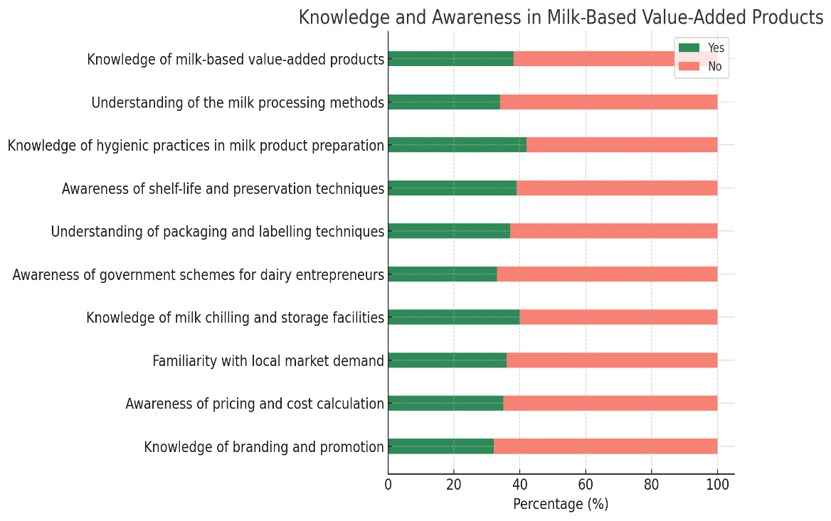

**Table 3: Weighted Mean Score (WMS) Analysis of Knowledge on Milk-Based Value-Added Products and Dairy Entrepreneurship among Respondents**

|  |  |  |
| --- | --- | --- |
| **S.No** | **Topic** | **WMS** |
| 1 | Knowledge of milk-based value-added products | 1.38 |
| 2 | Understanding of milk processing methods | 1.34 |
| 3 | Hygienic practices | 1.42 |
| 4 | Awareness of shelf-life and preservation techniques | 1.39 |
| 5 | Understanding of packaging and labelling techniques | 1.37 |
| 6 | Awareness of government schemes for dairy entrepreneurs | 1.33 |
| 7 | Knowledge of milk chilling and storage facilities | 1.40 |
| 8 | Familiarity with local market demand for milk-based products | 1.36 |
| 9 | Awareness of pricing and cost calculation in dairy entrepreneurship | 1.35 |
| 10 | Knowledge of branding and promotion of milk-based value-added products | 1.32 |

The Weighted Mean Scores (WMS) for the 10 knowledge items related to milk-based value-added products and dairy entrepreneurship range from 1.32 to 1.42 on a scale of 1 to 2, where:

* **1** represents the absence of knowledge (No response),
* **2** represents the presence of knowledge (Yes response).

This range indicates an overall low to moderate level of knowledge among respondents across all the topics assessed. Specifically:

* The highest WMS (1.42) was observed in Knowledge of hygienic practices in milk product preparation, suggesting this is the area where respondents showed comparatively better understanding.
* The lowest WMS (1.32) was for Knowledge of branding and promotion of milk-based value-added products, indicating this topic has the least awareness or understanding among respondents.
* Other topics such as shelf-life and preservation techniques (1.39), milk chilling and storage facilities (1.40), and knowledge of milk-based products (1.38) also showed moderate knowledge levels.
* The consistent range of scores around 1.3 to 1.4 implies a need for enhanced training and awareness programs to improve knowledge on various aspects of milk processing, packaging, government schemes, market demand, and entrepreneurship-related skills.

In summary, while some knowledge exists in the group, there is considerable scope for capacity building to strengthen understanding and practical skills in milk-based value addition and dairy entrepreneurship.

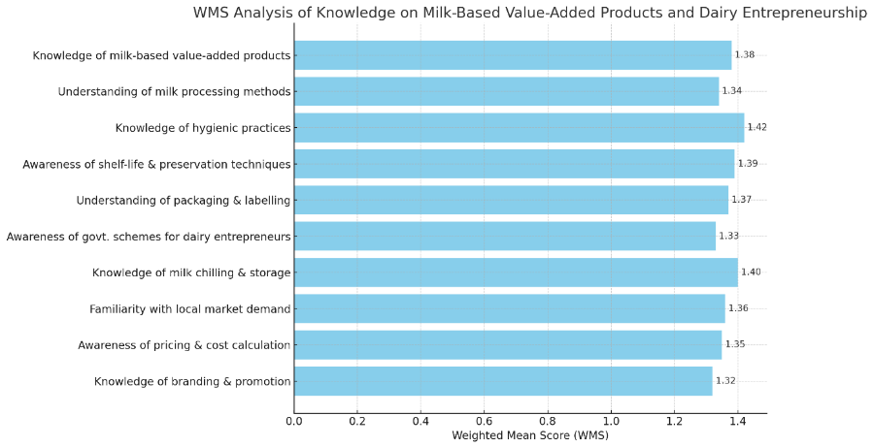**fig .2 WMS analysis of knowledge on milk-based value-added products and dairy entrepreneurship**

### ****Training: Empowering Tribal Women through Value Addition in Dairy****

After assessing the needs of tribal women, a focused training program was organized on value-added milk products, designed to enhance knowledge and practical skills in dairy entrepreneurship, particularly among tribal communities. The training aimed to build capacity in clean milk production, value addition, and safe processing practices, thereby promoting economic empowerment and rural development.

The program began with an inaugural session that introduced the training objectives, framework, and relevance for the participants. This was followed by expert-led lectures and hands-on demonstrations. The first lecture focused on entrepreneurial opportunities in milk-based products for tribal women, offering insights into market potential, product diversification, and value addition strategies. The second session covered the quality aspects of milk products, nutritional benefits, and food safety standards, equipping participants with the knowledge necessary to produce safe and hygienic dairy items. The third session emphasized animal care and best practices for clean milk production, highlighting the importance of maintaining quality at the source. In the post-lunch session, participants were introduced to innovative techniques such as making ice cream and finger millet (mandua) lassi, promoting the integration of traditional ingredients with modern processing methods. The day concluded with a practical session on preparing lassi, curd, cream, and ice cream, giving participants valuable hands-on experience. Raw materials such as sugar, khoya, cream, and milk were also distributed to participants, encouraging them to initiate their own micro-enterprises in dairy processing.

**Post Knowledge Test Assessment**

A post-knowledge assessment conducted after the training revealed a significant improvement in the participants’ understanding of key concepts. Over 90% of the women demonstrated enhanced knowledge in areas such as milk-based product preparation (paneer, ghee, curd, etc.), hygienic processing methods, packaging and labelling techniques, shelf-life and preservation methods, as well as pricing, branding, and market analysis. They also became aware of relevant government schemes supporting dairy entrepreneurs. This knowledge gain reflects the effectiveness of the training in building confidence and equipping tribal women with the necessary skills to venture into dairy-based micro-enterprises. The program has empowered participants to adopt best practices in milk processing, ensuring product safety, quality, and marketability, thereby creating new avenues for income generation and community development.

### C:\Users\User.DESKTOP-NC7QMQ4\Desktop\406889bf-536a-43b9-b531-cd4a1c840ac0

### ****Fig3: Pre and post knowledge test result****

The graph titled "Pre and Post Knowledge Test Results" visually presents the impact of a training program on the knowledge levels of tribal women in various aspects of dairy processing and value addition. The **x-axis** of the graph lists ten key knowledge areas, such as value-added product knowledge, milk processing methods, hygienic practices, shelf-life and preservation, packaging and labelling, government schemes awareness, chilling and storage, market demand familiarity, pricing and cost calculation, and branding and promotion. The **y-axis** represents the percentage of participants demonstrating knowledge in these areas, ranging from 0 to 100 percent. Two trend lines are shown one in red for **pre-training** results and another in green for **post-training** results. The graph clearly depicts a substantial increase in knowledge after the training. In the pre-training phase, participants exhibited limited awareness, with percentages generally ranging between 30% and 40% across the knowledge areas. This indicates a significant gap in understanding topics like safe milk processing, hygienic practices, marketing strategies, and the use of government schemes for dairy entrepreneurs. The **red line** on the graph remains relatively low and consistent, reflecting this limited knowledge base.

In contrast, the **green line** representing post-training results shows a steep rise across all areas, with knowledge levels consistently above 90%. This shift highlights the effectiveness of the training program, which successfully enhanced participants’ understanding of essential aspects such as hygienic milk processing, value addition techniques, safe storage, shelf-life extension, branding, market potential, and entrepreneurship opportunities in the dairy sector. The graph also suggests that practical exposure, hands-on activities, and expert-led lectures contributed to this dramatic improvement. The difference between the pre- and post-training knowledge levels demonstrates that the participants not only acquired new information but also felt confident in applying it to real-world situations, such as starting their own small-scale dairy enterprises.

Overall, the graph illustrates how a focused, hands-on training program can bridge knowledge gaps, empower women with practical skills, and promote self-reliance in the rural dairy sector. It also highlights the importance of continuous capacity-building efforts, tailored to the specific needs and backgrounds of tribal communities, to ensure lasting impacts on livelihoods and rural development.

### ****Conclusion****

The study clearly highlights the pivotal role of tribal women in dairy farming and the transformative impact of targeted training programs on their knowledge, skills, and entrepreneurial potential. The socio-economic profile of the participants indicates that most tribal women are in their productive age group, possess basic education, and are primarily engaged in agriculture and dairy-related activities. Despite this, the pre-training knowledge assessment revealed significant gaps in their awareness and understanding of clean milk production, hygienic processing techniques, value-added product development, packaging, branding, marketing, and market linkages. These findings underscore the urgent need for capacity-building programs that are context-specific, culturally sensitive, and designed to overcome literacy and accessibility challenges faced by tribal women.

The post-training knowledge assessment, however, demonstrated a remarkable improvement, with over 90% of participants showcasing enhanced understanding across key domains such as value-added product preparation (paneer, ghee, curd, etc.), hygienic practices, shelf-life and preservation techniques, packaging and labelling, market awareness, pricing strategies, and knowledge of government schemes supporting dairy entrepreneurship. The training provided hands-on learning opportunities, equipping participants with the confidence to initiate dairy-based micro-enterprises, diversify their income streams, and adopt safe, hygienic, and profitable dairy practices. The participants gained not only technical knowledge but also practical skills in making products like lassi, cream, curd, and ice cream using traditional and innovative methods, fostering a sense of ownership and empowerment. The distribution of raw materials such as sugar, khoya, cream, and milk further motivated participants to kickstart their own small-scale ventures. The success of this program demonstrates the immense potential of tribal women in contributing to the rural economy through dairy-based entrepreneurship. The training has not only enhanced their technical capacities but also instilled confidence, motivation, and a sense of self-reliance. Moving forward, it is crucial to ensure sustained support through continuous learning opportunities, follow-up mentorship, community-based extension services, and the integration of information and communication technologies (ICTs) to further empower women in dairy value chains.

In conclusion, empowering tribal women through specialized training in clean milk production and value addition is not just a pathway to improving milk quality and food safety, but also a strategic intervention for enhancing rural livelihoods, ensuring inclusive growth in the dairy sector, and fostering socio-economic development. Policymakers, extension agencies, and non-governmental organizations must collaborate to scale up such initiatives and ensure their long-term impact, creating a resilient, empowered, and self-sufficient tribal dairy community.

Disclaimer (Artificial intelligence)

Option 1:

Author(s) hereby declare that NO generative AI technologies such as Large Language Models (ChatGPT, COPILOT, etc.) and text-to-image generators have been used during the writing or editing of this manuscript.

Option 2:

Author(s) hereby declare that generative AI technologies such as Large Language Models, etc. have been used during the writing or editing of manuscripts. This explanation will include the name, version, model, and source of the generative AI technology and as well as all input prompts provided to the generative AI technology

Details of the AI usage are given below:

1.

2.

3.

**References**

1. Department of Animal Husbandry, Dairying and Fisheries. (2013). *Annual Report 2012–13*. Ministry of Agriculture, Government of India.
2. National Dairy Development Board (NDDB). (2014). *National Dairy Plan Phase I: Annual Report 2013–14*. Anand: NDDB.
3. National Sample Survey Office (NSSO). (2013). *Key Indicators of Employment and Unemployment in India 2011–12 (NSS 68th Round)*. Ministry of Statistics and Programme Implementation, Government of India.
4. Sharma, A. and Kwatra, J. (2025). Enhancing tribal dairy farming: From tradition to innovation. International Journal of Research in Agronomy. 8(5): 158-161.
5. Sharma, A. S., Kwatra, J., Bajpai, M. Goswami, P. and Joshi, A. (2025). Empowring tribal women through value addition: Impact of training on knolwdge, economic motivation and livelihood enhancement in Uttarakhand. Vol.8, Issue:3, pp: 277-282.
6. Singh, A. K., & Meena, M. S. (2015). Role of ICTs in empowering rural women: A review. *Indian Research Journal of Extension Education*, 15(2), 1–5.
7. Thakur, A., Dixit, A. K., Sharma, A. K., Kumar, S., Sendhil, R., & Singh, A. K. (2021). Adoption of food safety practices in the informal milk processing units of Haryana, India “A value chain approach. *Indian Journal of Dairy Science*, *74*(6).
8. Thakur, A., Dixit, A. K., Kumar, S., & Bhandari, G. (2021). Value chain analysis of informal dairy processing units in Haryana (India): A system dynamic approach. *Agricultural Research*, *10*, 307-313.
9. Reichler, S. J., Murphy, S. I., Erickson, A. W., Martin, N. H., Snyder, A. B., & Wiedmann, M. (2020). Interventions designed to control postpasteurization contamination in high-temperature, short-time-pasteurized fluid milk processing facilities: A case study on the effect of employee training, clean-in-place chemical modification, and preventive maintenance programs. Journal of dairy science, 103(8), 7569-7584.
10. Singh, V., & Gupta, J. (2015). Promoting clean milk production: The path for milk quality improvement. Journal of Community Mobilization and Sustainable Development, 10(2), 163-167.