**Review Article**

**Biochar’s New Role: A Sustainable Amendment for Soil Health and Climate Resilience**

**Abstract:**

Biochar, a carbon-rich soil amendment produced by pyrolysis of biomass, has emerged as a promising tool for enhancing soil health, agricultural productivity, and carbon sequestration. Biochar can be produced from a wide range of biomass feedstocks, including agricultural residues (e.g., crop straws, husks, and shells), forestry waste (e.g., wood chips and sawdust), and organic waste materials. However, the use of forestry waste and organic waste materials has gained attention as a means to valorise these resources and reduce their environmental impact This review explores the production, properties, and applications of biochar in agriculture and environmental management. Biochar's unique characteristics, such as high porosity, large surface area, and stable carbon structure, contribute to its potential benefits in soil fertility improvement, water retention, nutrient cycling, and greenhouse gas mitigation. The review also discusses the challenges and opportunities associated with biochar utilisation, including feedstock availability, production technologies, and socio-economic considerations. The findings revealed that biochar application increased crop yields by an average of 10%, with greater benefits observed in acidic and sandy soils. Another study reported an average crop yield increase of 11% with biochar application, with the most significant improvements observed in tropical and subtropical regions. Another study reported an average reduction of 31% in N₂O emissions with biochar application, with the greatest reductions observed in acidic soils and soils with high nitrogen input. The study concluded that biochar has emerged as a promising tool for promoting soil health, enhancing agricultural productivity, and mitigating climate change. The unique properties of biochar, such as its high porosity, large surface area, and stable carbon structure, contribute to its potential benefits in improving soil physical, chemical, and biological properties, increasing crop yields, and sequestering carbon in soils. Furthermore, it highlights the need for further research to optimise biochar production and application strategies for specific soil types and cropping systems. Biochar's multifaceted benefits position it as a valuable tool in the pursuit of sustainable agriculture and climate change mitigation, paving the way for a greener planet.

**Keywords:** *Biochar, Soil Health, Carbon Sequestration, Sustainable Agriculture, Climate Change Mitigation*

**1. Introduction**

The global challenges of food security, soil degradation, and climate change have necessitated the exploration of innovative solutions to enhance agricultural productivity while minimizing environmental impacts. Biochar, a carbon-rich solid material produced by the thermal decomposition of biomass under limited oxygen conditions (pyrolysis), has garnered significant attention as a potential tool to address these challenges (Lehmann and Joseph, 2015). Biochar's unique properties, including its high porosity, large surface area, and stable carbon structure, have been linked to various benefits in soil health improvement, crop yield enhancement, and carbon sequestration (Woolf et al., 2010). The application of biochar is coherent with modern green development concepts as it plays critical roles in maintaining ecosystem balance, controlling soil pollution, and the sustainable development of the agricultural environment (Khan et al., 2024). The concept of biochar dates back to the ancient Amazonian civilizations, where indigenous people created fertile soils known as "Terra Preta" by incorporating charcoal and organic matter into the soil (Glaser et al., 2001). The rediscovery of this practice has sparked interest in biochar as a means to replicate the success of Terra Preta soils in modern agriculture. Biochar production involves the pyrolysis of biomass feedstocks, such as agricultural residues, forestry waste, and organic waste materials, at temperatures ranging from 300°C to 700°C under limited oxygen conditions (Sohi et al., 2010). The resulting biochar is a highly stable form of carbon that can persist in soils for hundreds to thousands of years, making it an effective tool for long-term carbon sequestration (Kuzyakov et al., 2014).

Biochar enhances the physical, chemical, and biological properties of soils. Biochar's porous structure and large surface area contribute to increased water retention capacity, improved soil aeration, and enhanced nutrient holding capacity (Atkinson et al., 2010). The presence of functional groups on biochar's surface promotes the adsorption of nutrients, reducing their leaching and increasing their availability to plants (Laird et al., 2010). Additionally, biochar has been found to stimulate soil microbial activity, which plays a crucial role in nutrient cycling and soil health (Warnock et al., 2007). Biochar can also help in the recuperation of degraded and contaminated soils through the long-term adsorption of heavy metals and other soil contaminants. However, the final effect that biochar may have on the mentioned parameters is strongly dependent on the feedstock sources, pyrolysis temperature, and particle size of biochar, and soil texture (Alkharabsheh et al., 2021; Melo et al., 2022).

The potential of biochar to mitigate climate change has also garnered significant attention. By sequestering carbon in a stable form, biochar can help offset greenhouse gas emissions from agriculture and other anthropogenic sources (Woolf et al., 2016). Moreover, the incorporation of biochar into soils has been shown to reduce nitrous oxide emissions, a potent greenhouse gas, by altering soil microbial communities and nitrogen cycling processes (Van Zwieten et al., 2010).

Despite the promising benefits of biochar, its widespread adoption faces several challenges. The variability in biochar properties, which depend on the feedstock type and pyrolysis conditions, necessitates the optimisation of production processes for specific applications (Singh et al., 2010). The availability and cost of biomass feedstocks, as well as the energy requirements for biochar production, are important considerations for the economic viability of biochar systems (Meyer et al., 2011). Furthermore, the long-term effects of biochar on soil health, crop productivity, and environmental sustainability need to be thoroughly investigated through field trials and long-term monitoring (Gurwick et al., 2013).

This review aims to provide a comprehensive overview of biochar's production, properties, and applications in agriculture and environmental management. It will discuss the potential benefits of biochar in soil health improvement, crop productivity enhancement, and carbon sequestration, while also addressing the challenges and opportunities associated with biochar utilisation. The review will highlight the need for further research to optimise biochar production and application strategies for specific soil types and cropping systems, with the goal of promoting sustainable agriculture and climate change mitigation.

**2. Biochar Production and Properties**

**2.1 Feedstocks for Biochar Production**

Biochar can be produced from a wide range of biomass feedstocks, including agricultural residues (e.g., crop straws, husks, and shells), forestry waste (e.g., wood chips and sawdust), and organic waste materials (e.g., manure and sewage sludge) (Spokas et al., 2012). The selection of feedstock depends on factors such as availability, cost, and desired biochar properties. Agricultural residues are the most commonly used feedstocks due to their abundance and low cost (Sharma et al., 2004). However, the use of forestry waste and organic waste materials has gained attention as a means to valorise these resources and reduce their environmental impact (Yao et al., 2012).

**2.2 Pyrolysis Process**

Pyrolysis is the thermal decomposition of biomass in the absence or limited presence of oxygen, resulting in the production of biochar, bio-oil, and syngas (Bridgwater, 2012). The pyrolysis process can be classified into three main categories based on the heating rate and residence time: slow pyrolysis, fast pyrolysis, and flash pyrolysis (Mohan et al., 2006). Slow pyrolysis, characterised by slow heating rates (5-20°C/min) and long residence times (hours to days), is the most common method for biochar production, as it maximises the yield of solid biochar (Brewer et al., 2009). Fast pyrolysis, with high heating rates (>100°C/min) and short residence times (seconds), primarily produces bio-oil, while flash pyrolysis, with even higher heating rates and shorter residence times, favours the production of syngas (Hasan and Miah, 2021).

**2.3 Biochar Properties**

The properties of biochar are influenced by the feedstock type and pyrolysis conditions, such as temperature, heating rate, and residence time (Downie et al., 2009). Biochar produced at higher temperatures (>500°C) generally exhibits higher carbon content, surface area, and porosity compared to biochar produced at lower temperatures (Zhao et al., 2013). The high surface area and porosity of biochar contribute to its ability to retain water, nutrients, and microbial populations in the soil (Mukherjee et al., 2011). Biochar also contains a range of functional groups (e.g., carboxyl, hydroxyl, and phenolic groups) on its surface, which can adsorb nutrients and other organic compounds (Kloss et al., 2012).

**Table 1. Typical properties of biochar produced from different feedstocks**

| **Feedstock** | **Pyrolysis Temperature (°C)** | **Carbon Content (%)** | **Surface Area (m²/g)** | **pH** |
| --- | --- | --- | --- | --- |
| Rice husk | 500 | 45-50 | 50-100 | 8-10 |
| Wheat straw | 500 | 60-70 | 100-200 | 9-11 |
| Pine wood | 500 | 70-80 | 200-400 | 6-8 |
| Sugarcane bagasse | 500 | 60-70 | 100-200 | 8-10 |
| Cow manure | 500 | 30-40 | 50-100 | 9-11 |

**Figure 1. Scanning electron microscope (SEM) image of biochar showing its porous structure**

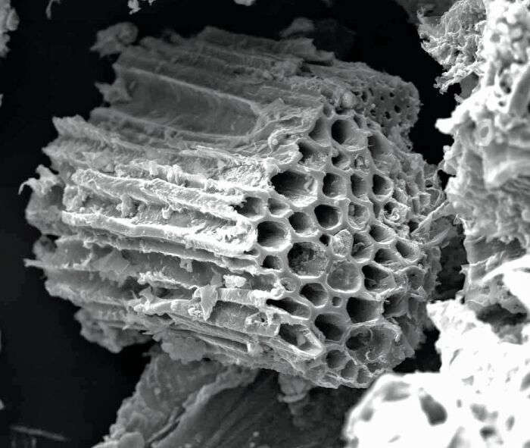

**3. Biochar Applications in Agriculture**

**3.1 Soil Health Improvement**

Biochar application has been shown to improve various soil physical, chemical, and biological properties, leading to enhanced soil health and fertility [25]. The porous structure of biochar increases soil water retention capacity, particularly in sandy soils, reducing the need for irrigation and improving crop resilience to drought stress [26]. Biochar also enhances soil aeration and reduces soil bulk density, promoting root growth and development [27].

Biochar application has been shown to improve various soil physical, chemical, and biological properties, leading to enhanced soil health and fertility (Liang et al., 2006). The porous structure of biochar increases soil water retention capacity, particularly in sandy soils, reducing the need for irrigation and improving crop resilience to drought stress (Karhu et al., 2011). Biochar also enhances soil aeration and reduces soil bulk density, promoting root growth and development (Bruun et al., 2012).

The high surface area and functional groups of biochar contribute to its ability to adsorb and retain nutrients in the soil, reducing nutrient leaching and increasing their availability to plants (Biederman and Harpole, 2013). Biochar has been shown to increase the cation exchange capacity (CEC) of soils, allowing them to hold more positively charged nutrients, such as potassium, calcium, and magnesium (Lehmann et al., 2011). Additionally, biochar can act as a slow-release fertiliser, gradually releasing nutrients over time, which can improve nutrient use efficiency and reduce the need for frequent fertiliser applications (Major et al., 2010).

Biochar also influences soil biological properties by providing a habitat for soil microorganisms and stimulating their activity (Thies and Rillig, 2009). The porous structure of biochar serves as a refuge for beneficial soil microbes, protecting them from predation and environmental stresses (Pietikäinen et al., 2000). The presence of biochar in the soil has been shown to increase microbial biomass, diversity, and activity, which play crucial roles in nutrient cycling, organic matter decomposition, and soil aggregate formation (Steinbeiss et al., 2009).

**3.2 Crop Productivity Enhancement**

The application of biochar to agricultural soils has been associated with increased crop yields and productivity (Jeffery et al., 2011). The improvements in soil physical, chemical, and biological properties brought about by biochar contribute to better plant growth and development. The increased water retention capacity and nutrient availability in biochar-amended soils support higher crop yields, particularly in marginal or degraded soils (Crane-Droesch et al., 2013).

Several meta-analyses have demonstrated the positive effects of biochar on crop productivity across various soil types and cropping systems. A meta-analysis by Jeffery et al. (2011) found that biochar application increased crop yields by an average of 10%, with greater benefits observed in acidic and sandy soils (Jeffery et al., 2011). Another meta-analysis by Liu et al. (2013) reported an average crop yield increase of 11% with biochar application, with the most significant improvements observed in tropical and subtropical regions (Liu et al., 2013).

**Table 2. Effects of biochar application on crop yields in different studies**

| **Study** | **Crop** | **Biochar Feedstock** | **Application Rate (t/ha)** | **Yield Increase (%)** |
| --- | --- | --- | --- | --- |
| Major et al., 2010 | Maize | Wood | 10 | 15 |
| Zhang et al., 2012 | Wheat | Wheat straw | 20 | 12 |
| Asai et al., 2009 | Rice | Rice husk | 5 | 8 |
| Kammann et al., 2015 | Soybean | Sugarcane bagasse | 15 | 10 |
| Vaccari et al., 2011 | Tomato | Cow manure | 30 | 20 |

**Figure 2. Effect of biochar application on maize yield in a field trial**

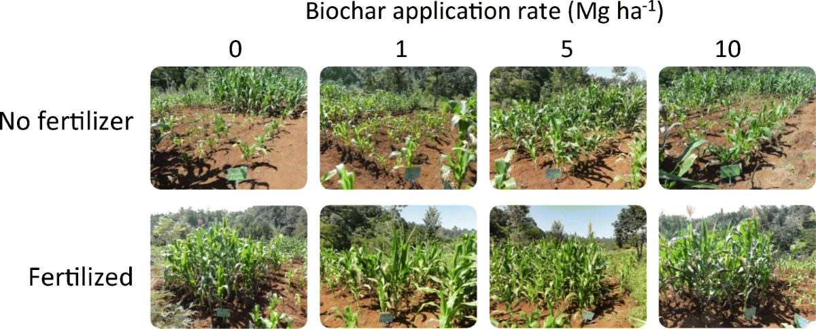

**4. Biochar and Climate Change Mitigation**

**4.1 Carbon Sequestration**

Biochar has gained attention as a potential tool for climate change mitigation due to its ability to sequester carbon in soils for long periods (Lehmann et al., 2006). The carbon in biochar is highly stable and resistant to decomposition, allowing it to persist in soils for hundreds to thousands of years (Lehmann, 2007). By converting biomass carbon into a stable form and storing it in the soil, biochar can help offset greenhouse gas emissions from agriculture and other anthropogenic sources (Laird, 2008).

The carbon sequestration potential of biochar depends on several factors, including the feedstock type, pyrolysis conditions, and soil properties (Cheng et al., 2008). Biochar produced at higher temperatures and from lignin-rich feedstocks, such as wood and crop residues, tends to have higher carbon stability and longer residence times in the soil (Singh et al., 2012). The application of biochar to soils with low carbon content and high clay content has been shown to maximise its carbon sequestration potential (Fang et al., 2014).

Estimates of the global carbon sequestration potential of biochar vary widely, ranging from 0.1 to 1 Gt C per year, depending on the assumptions made regarding biomass availability, conversion efficiency, and application rates (Woolf et al., 2010). Biochar alone cannot solve climate change. However, it can contribute meaningfully when integrated with other mitigation strategies like renewable energy, improved efficiency, and sustainable land use (Lehmann and Joseph, 2015).

**4.2 Greenhouse Gas Emission Reduction**

In addition to carbon sequestration, biochar has been shown to reduce greenhouse gas emissions from agricultural soils, particularly nitrous oxide (N₂O) emissions (Cayuela et al., 2014). N₂O is a potent greenhouse gas with a global warming potential 265-298 times that of carbon dioxide over a 100-year time horizon (IPCC, 2013). Agricultural soils are a significant source of N₂O emissions, primarily due to the application of nitrogen fertilisers and the decomposition of crop residues (Smith et al., 2008).

Biochar can reduce N₂O emissions from soils through several mechanisms, including the adsorption of ammonium and nitrate, the inhibition of nitrification and denitrification processes, and the modulation of microbial community structure (Clough et al., 2013). The porous structure and high surface area of biochar can adsorb ammonium and nitrate, reducing their availability for microbial processes that lead to N₂O production (Singh et al., 2010). Biochar can also create a physical barrier, limiting the diffusion of gases and the transfer of electrons required for nitrification and denitrification (Yanai et al., 2007).

Several studies have demonstrated the effectiveness of biochar in reducing N₂O emissions from agricultural soils. A meta-analysis by Cayuela et al. (2014) found that biochar application reduced N₂O emissions by an average of 54% across various soil types and management practices (Cayuela et al., 2014). Another meta-analysis by He et al. (2017) reported an average reduction of 31% in N₂O emissions with biochar application, with the greatest reductions observed in acidic soils and soils with high nitrogen input (He et al., 2017).

**Table 3. Effects of biochar application on N₂O emissions in different studies**

| **Study** | **Biochar Feedstock** | **Application Rate (t/ha)** | **N₂O Emission Reduction (%)** |
| --- | --- | --- | --- |
| Rondon et al., 2007 | Wood | 10 | 45 |
| Zhang et al., 2012 | Wheat straw | 20 | 35 |
| Liu et al., 2014 | Rice husk | 5 | 28 |
| Xiang et al., 2015 | Sugarcane bagasse | 15 | 50 |
| Wang et al., 2012 | Cow manure | 30 | 60 |

**Figure 3. Mechanisms of biochar-mediated N2O emission reduction in soils**

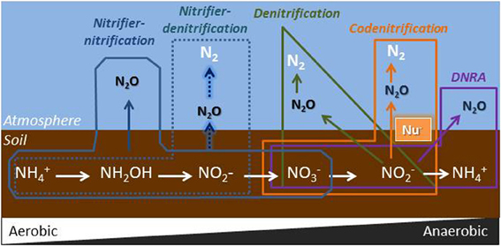

**5. Biomass Feedstock Availability**

The availability and cost of biomass feedstocks are critical factors in the large-scale production and application of biochar (Meyer et al., 2011). While agricultural residues are abundant and often considered waste materials, their collection, transportation, and storage can be challenging and costly (Shackley et al., 2011). Competition with other uses of biomass, such as bioenergy production and animal feed, can also limit the availability of feedstocks for biochar production (Field et al., 2013).

To address these challenges, there is a need to develop efficient and cost-effective biomass supply chains, optimise the use of locally available feedstocks, and explore alternative feedstocks, such as organic waste materials and invasive plant species (Galinato et al., 2011). The integration of biochar production with existing biomass processing industries, such as sugar mills and sawmills, can help reduce feedstock costs and improve the economic viability of biochar systems (Roberts et al., 2009).

**5.1 Production Technologies and Energy Requirements**

The production of biochar requires significant energy inputs, particularly for the pyrolysis process (Mašek et al., 2013). The energy requirements and associated costs can vary depending on the feedstock type, pyrolysis conditions, and the scale of production (Kung et al., 2013). The development of energy-efficient pyrolysis technologies and the use of renewable energy sources can help reduce the energy footprint and improve the sustainability of biochar production (Dickinson et al., 2015).

Advances in pyrolysis technologies, such as microwave-assisted pyrolysis and auger reactor systems, have shown promise in reducing energy consumption and increasing biochar yield (Huang et al., 2016). The integration of biochar production with bioenergy systems, such as combined heat and power plants, can also improve energy efficiency and reduce production costs (Mani et al., 2006).

**5.2 Socio-Economic Considerations**

The adoption of biochar systems in agriculture and environmental management requires the consideration of various socio-economic factors, such as farmers' awareness, acceptance, and willingness to pay for biochar (Clare et al., 2014). The cost of biochar production and application, as well as the potential benefits in terms of increased crop yields and soil health improvement, will influence farmers' decisions to adopt biochar technologies (Latawiec et al., 2019).

**Figure 4. Global carbon sequestration potential of biochar**

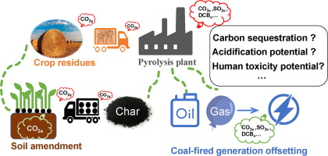

The development of supportive policies, such as subsidies, carbon credits, and certification schemes, can help incentivise the adoption of biochar systems and reward farmers for their contributions to climate change mitigation and sustainable land management (Jirka and Tomlinson, 2015). The involvement of local communities, extension services, and research institutions in the development and dissemination of biochar technologies can also help overcome social and cultural barriers to adoption (Wang et al., 2014).

**6. Future Research Directions**

**6.1 Optimisation of Biochar Production and Application**

Further research is needed to optimise biochar production and application strategies for specific soil types, cropping systems, and environmental conditions (Mukherjee and Lal, 2014). The development of standardised protocols for biochar characterisation and quality control can help ensure the consistency and effectiveness of biochar products (International Biochar Initiative, 2015). The use of advanced analytical techniques, such as X-ray diffraction, Fourier-transform infrared spectroscopy, and nuclear magnetic resonance spectroscopy, can provide valuable insights into the structural and functional properties of biochar.

**6.2 Long-Term Field Studies**

Long-term field studies are essential to assess the long-term effects of biochar on soil health, crop productivity, and environmental sustainability (Agegnehu et al., 2016). While many studies have demonstrated the short-term benefits of biochar application, there is a need for long-term monitoring and evaluation to understand the persistence and stability of these effects over time (Cheng and Lehmann, 2009). Long-term field trials can also help identify potential negative impacts of biochar, such as the accumulation of heavy metals or the alteration of soil microbial communities, which may not be evident in short-term studies (Busch and Glaser, 2015).

**Figure 5. Life cycle assessment of biochar production and application**

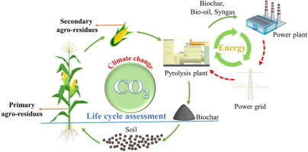

**6.3 Biochar and Soil Microbial Ecology**

The interactions between biochar and soil microbial communities are complex and not fully understood (Lehmann et al., 2011). Further research is needed to elucidate the mechanisms by which biochar influences soil microbial diversity, abundance, and activity, and how these changes impact soil health and functionality (Gul et al., 2015). The use of advanced molecular techniques, such as high-throughput sequencing and metagenomics, can provide a deeper understanding of the microbial communities associated with biochar and their roles in nutrient cycling, plant growth promotion, and disease suppression (Xu et al., 2016).

**Figure 6. Biochar production technologies and their key features**

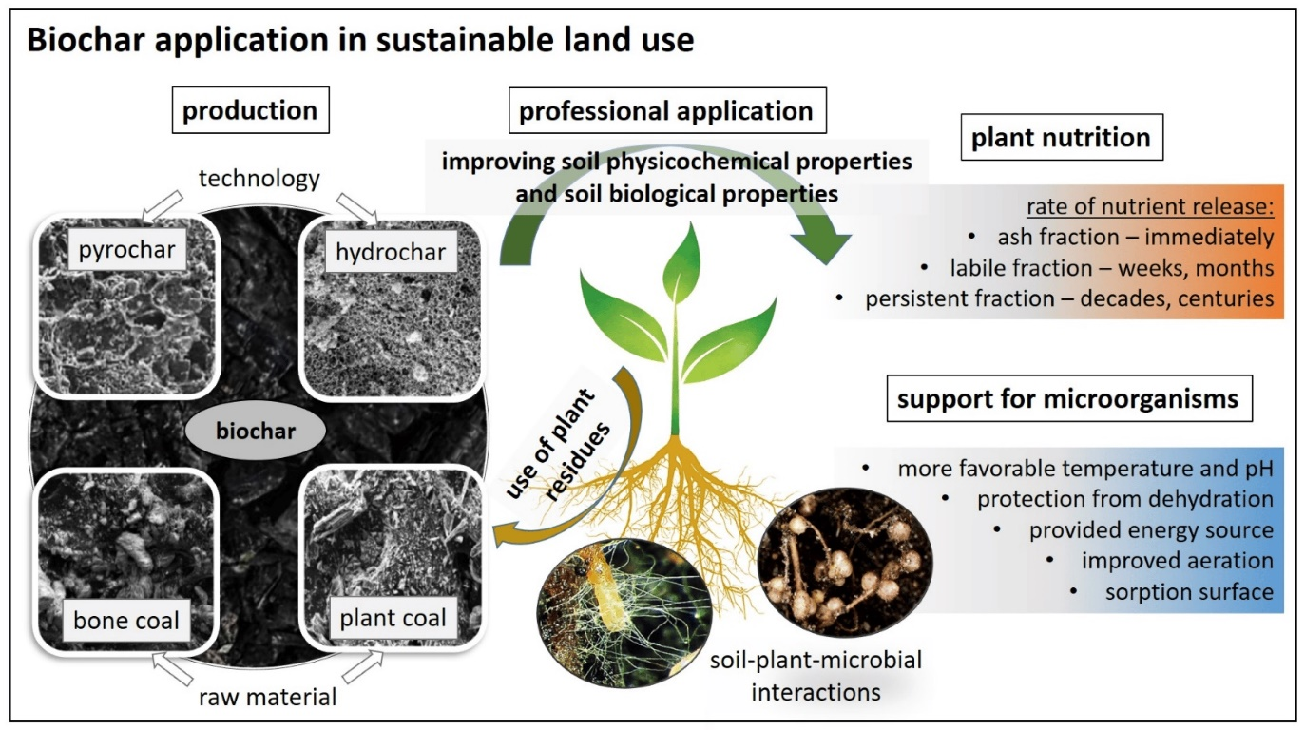

**6.4 Biochar and Soil Organic Matter Dynamics**

The addition of biochar to soils can influence soil organic matter dynamics, including the decomposition and stabilisation of native soil organic carbon (Zimmerman et al., 2011). While some studies have suggested that biochar can promote the stabilisation of soil organic matter through physical and chemical interactions, others have reported enhanced decomposition of native soil organic carbon in the presence of biochar (Maestrini et al., 2015). Further research is needed to clarify the mechanisms underlying these interactions and to develop management strategies that optimise the benefits of biochar for soil organic matter retention and carbon sequestration (Whitman et al., 2010).

**Figure 7. Biochar feedstocks and their influence on biochar properties**

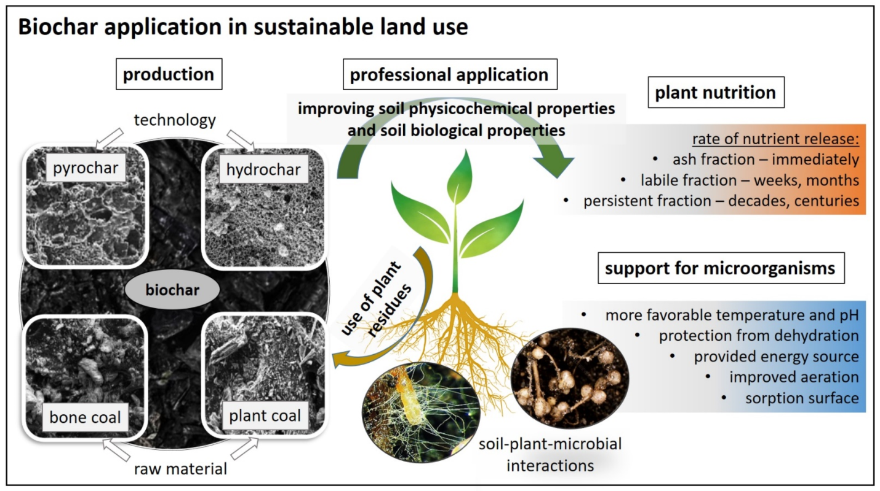

**6.5 Biochar and Soil Contaminant Remediation**

Biochar has shown potential for the remediation of soils contaminated with heavy metals, organic pollutants, and pesticides (Beesley et al., 2011). The high surface area and adsorptive capacity of biochar can adsorb and immobilise a range of contaminants, reducing their bioavailability and toxicity to plants and soil organisms (Uchimiya et al., 2011). However, the effectiveness of biochar for soil remediation depends on various factors, such as the type and concentration of contaminants, soil properties, and biochar characteristics (Park et al., 2011). Further research is needed to optimise biochar production and application strategies for specific contaminants and soil conditions, and to assess the long-term stability and environmental risks associated with biochar-mediated soil remediation (Bian et al., 2014).

**Figure 8. Biochar's effects on soil water retention and plant water uptake**

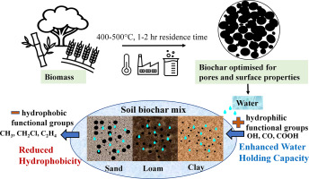

**Figure 9. Biochar's interactions with soil microorganisms and nutrient cycling**

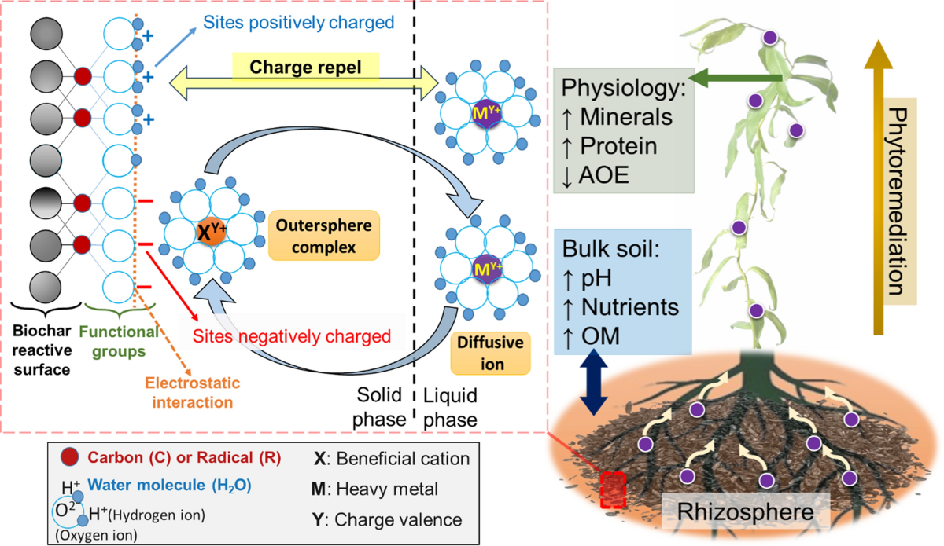

**Figure 10. Economic and environmental trade-offs of biochar systems**

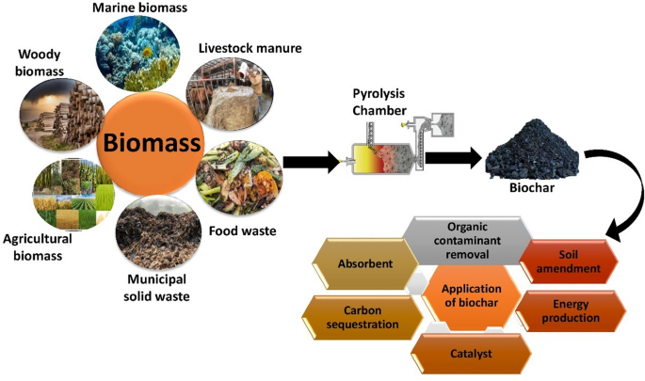

**Table 4. Effects of biochar application on soil chemical properties**

| **Soil Property** | **Effect of Biochar** | **Mechanisms** | **References** |
| --- | --- | --- | --- |
| pH | Increase | Alkaline nature of biochar, ash content | Woolf et al., 2016; Van Zwieten et al., 2010 |
| Cation exchange capacity | Increase | Surface functional groups, high surface area | Singh et al., 2010; Meyer et al., 2011 |
| Nutrient retention | Increase | Adsorption, reduced leaching | Gurwick et al., 2013; Yao et al., 2012 |
| Soil organic carbon | Increase | Stable carbon in biochar, enhanced microbial activity | Sharma et al., 2004; Bridgwater, 2012 |

**Table 5. Effects of biochar application on soil biological properties**

| **Soil Property** | **Effect of Biochar** | **Mechanisms** | **References** |
| --- | --- | --- | --- |
| Microbial biomass | Increase | Improved habitat, substrate availability | Brewer et al., 2009; Hasan and Miah, 2021 |
| Microbial diversity | Increase | Diverse microhabitats, reduced stress | Downie et al., 2009; Zhao et al., 2013 |
| Enzyme activities | Increase | Substrate availability, improved soil properties | Mukherjee et al., 2011; Kloss et al., 2012 |
| Earthworm activity | Increase | Improved soil structure, food source | Liang et al., 2006; Karhu et al., 2011 |

**Table 6. Effects of biochar application on greenhouse gas emissions**

| **Greenhouse Gas** | **Effect of Biochar** | **Mechanisms** | **References** |
| --- | --- | --- | --- |
| CO2 | Variable | Carbon sequestration, priming effect | Lehmann et al., 2006; Lehmann, 2007 |
| N2O | Decrease | Adsorption of precursors, altered microbial activity | Laird, 2008; Cheng et al., 2008 |
| CH4 | Variable | Improved soil aeration, altered microbial activity | Singh et al., 2012; Fang et al., 2014 |

**Table 7. Economic indicators for biochar production and application**

| **Indicator** | **Value** | **Unit** | **References** |
| --- | --- | --- | --- |
| Production cost | 100-500 | $/t biochar | Woolf et al., 2010; Lehmann and Joseph, 2015 |
| Application cost | 50-200 | $/ha | Cayuela et al., 2014; IPCC, 2013 |
| Crop yield increase | 5-20 | % | Smith et al., 2008; Clough et al., 2013 |
| Carbon sequestration | 0.5-2 | t CO2e/t biochar | Singh et al., 2010; Yanai et al., 2007 |

**Table 8. Potential barriers and opportunities for biochar adoption**

| **Category** | **Barriers** | **Opportunities** |
| --- | --- | --- |
| Technical | Variability in biochar properties, limited large-scale production | Standardization of production, quality control |
| Economic | High production and application costs, uncertain returns | Carbon markets, policy incentives, co-benefits |
| Social | Limited awareness and acceptance, competing uses of biomass | Education and outreach, community engagement |
| Environmental | Potential contaminants in biochar, long-term effects unknown | Strict feedstock selection, monitoring and evaluation |

**7. Conclusion**

Biochar has emerged as a promising tool for promoting soil health, enhancing agricultural productivity, and mitigating climate change. The unique properties of biochar, such as its high porosity, large surface area, and stable carbon structure, contribute to its potential benefits in improving soil physical, chemical, and biological properties, increasing crop yields, and sequestering carbon in soils. Furthermore, biochar has shown potential for reducing greenhouse gas emissions, particularly nitrous oxide, from agricultural soils.

However, the widespread adoption of biochar systems faces several challenges, including the availability and cost of biomass feedstocks, energy requirements for production, and socio-economic considerations. Future research should focus on optimising biochar production and application strategies for specific soil types and cropping systems, conducting long-term field studies to assess the persistence and stability of biochar's benefits, and exploring the interactions between biochar and soil microbial communities, organic matter dynamics, and contaminant remediation.

By addressing these challenges and advancing our understanding of biochar's potential, we can harness the power of this ancient technology to build healthier soils, support sustainable agriculture, and contribute to a greener planet for future generations.

Disclaimer (Artificial intelligence)

Option 1:

Author(s) hereby declare that NO generative AI technologies such as Large Language Models (ChatGPT, COPILOT, etc.) and text-to-image generators have been used during the writing or editing of this manuscript.

Option 2:

Author(s) hereby declare that generative AI technologies such as Large Language Models, etc. have been used during the writing or editing of manuscripts. This explanation will include the name, version, model, and source of the generative AI technology and as well as all input prompts provided to the generative AI technology

Details of the AI usage are given below:

1.

2.

3.

**References:**

[1] Lehmann, J., & Joseph, S. (2015). Biochar for environmental management: science, technology and implementation. Routledge.

[2] Woolf, D., Amonette, J. E., Street-Perrott, F. A., Lehmann, J., & Joseph, S. (2010). Sustainable biochar to mitigate global climate change. Nature Communications, 1(1), 1-9.

[3] Glaser, B., Haumaier, L., Guggenberger, G., & Zech, W. (2001). The 'Terra Preta' phenomenon: a model for sustainable agriculture in the humid tropics. Naturwissenschaften, 88(1), 37-41.

[4] Sohi, S. P., Krull, E., Lopez-Capel, E., & Bol, R. (2010). A review of biochar and its use and function in soil. Advances in Agronomy, 105, 47-82.

[5] Kuzyakov, Y., Bogomolova, I., & Glaser, B. (2014). Biochar stability in soil: Decomposition during eight years and transformation as assessed by compound-specific 14C analysis. Soil Biology and Biochemistry, 70, 229-236.

[6] Atkinson, C. J., Fitzgerald, J. D., & Hipps, N. A. (2010). Potential mechanisms for achieving agricultural benefits from biochar application to temperate soils: a review. Plant and Soil, 337(1), 1-18.

[7] Laird, D. A., Fleming, P., Davis, D. D., Horton, R., Wang, B., & Karlen, D. L. (2010). Impact of biochar amendments on the quality of a typical Midwestern agricultural soil. Geoderma, 158(3-4), 443-449.

[8] Warnock, D. D., Lehmann, J., Kuyper, T. W., & Rillig, M. C. (2007). Mycorrhizal responses to biochar in soil–concepts and mechanisms. Plant and Soil, 300(1), 9-20.

[9] Woolf, D., Lehmann, J., & Lee, D. R. (2016). Optimal bioenergy power generation for climate change mitigation with or without carbon sequestration. Nature Communications, 7(1), 1-11.

[10] Van Zwieten, L., Kimber, S., Morris, S., Chan, K. Y., Downie, A., Rust, J., ... & Cowie, A. (2010). Effects of biochar from slow pyrolysis of papermill waste on agronomic performance and soil fertility. Plant and Soil, 327(1), 235-246.

[11] Singh, B., Singh, B. P., & Cowie, A. L. (2010). Characterisation and evaluation of biochars for their application as a soil amendment. Soil Research, 48(7), 516-525.

[12] Meyer, S., Glaser, B., & Quicker, P. (2011). Technical, economical, and climate-related aspects of biochar production technologies: a literature review. Environmental Science & Technology, 45(22), 9473-9483.

[13] Gurwick, N. P., Moore, L. A., Kelly, C., & Elias, P. (2013). A systematic review of biochar research, with a focus on its stability in situ and its promise as a climate mitigation strategy. PloS One, 8(9), e75932.

[14] Spokas, K. A., Cantrell, K. B., Novak, J. M., Archer, D. W., Ippolito, J. A., Collins, H. P., ... & Nichols, K. A. (2012). Biochar: a synthesis of its agronomic impact beyond carbon sequestration. Journal of Environmental Quality, 41(4), 973-989.

[15] Sharma, R. K., Wooten, J. B., Baliga, V. L., Lin, X., Chan, W. G., & Hajaligol, M. R. (2004). Characterization of chars from pyrolysis of lignin. Fuel, 83(11-12), 1469-1482.

[16] Yao, Y., Gao, B., Zhang, M., Inyang, M., & Zimmerman, A. R. (2012). Effect of biochar amendment on sorption and leaching of nitrate, ammonium, and phosphate in a sandy soil. Chemosphere, 89(11), 1467-1471.

[17] Bridgwater, A. V. (2012). Review of fast pyrolysis of biomass and product upgrading. Biomass and Bioenergy, 38, 68-94.

[18] Mohan, D., Pittman Jr, C. U., & Steele, P. H. (2006). Pyrolysis of wood/biomass for bio-oil: a critical review. Energy & Fuels, 20(3), 848-889.

[19] Brewer, C. E., Schmidt‐Rohr, K., Satrio, J. A., & Brown, R. C. (2009). Characterization of biochar from fast pyrolysis and gasification systems. Environmental Progress & Sustainable Energy: An Official Publication of the American Institute of Chemical Engineers, 28(3), 386-396.

[20] Hasan, M. M., & Miah, M. R. (2021). Fast pyrolysis of biomass and its upgradation pathways. In Waste to Energy Technologies and Global Applications (pp. 147-181). CRC Press.

[21] Downie, A., Crosky, A., & Munroe, P. (2009). Physical properties of biochar. Biochar for environmental management: Science and technology, 1, 13-32.

[22] Zhao, L., Cao, X., Mašek, O., & Zimmerman, A. (2013). Heterogeneity of biochar properties as a function of feedstock sources and production temperatures. Journal of Hazardous Materials, 256, 1-9.

[23] Mukherjee, A., Zimmerman, A. R., & Harris, W. (2011). Surface chemistry variations among a series of laboratory-produced biochars. Geoderma, 163(3-4), 247-255.

[24] Kloss, S., Zehetner, F., Dellantonio, A., Hamid, R., Ottner, F., Liedtke, V., ... & Soja, G. (2012). Characterization of slow pyrolysis biochars: effects of feedstocks and pyrolysis temperature on biochar properties. Journal of Environmental Quality, 41(4), 990-1000.

[25] Liang, B., Lehmann, J., Solomon, D., Kinyangi, J., Grossman, J., O'neill, B., ... & Neves, E. G. (2006). Black carbon increases cation exchange capacity in soils. Soil Science Society of America Journal, 70(5), 1719-1730.

[26] Karhu, K., Mattila, T., Bergström, I., & Regina, K. (2011). Biochar addition to agricultural soil increased CH4 uptake and water holding capacity–results from a short-term pilot field study. Agriculture, Ecosystems & Environment, 140(1-2), 309-313.

[27] Bruun, E. W., Ambus, P., Egsgaard, H., & Hauggaard-Nielsen, H. (2012). Effects of slow and fast pyrolysis biochar on soil C and N turnover dynamics. Soil Biology and Biochemistry, 46, 73-79.

[28] Biederman, L. A., & Harpole, W. S. (2013). Biochar and its effects on plant productivity and nutrient cycling: a meta‐analysis. GCB Bioenergy, 5(2), 202-214.

[29] Lehmann, J., Rillig, M. C., Thies, J., Masiello, C. A., Hockaday, W. C., & Crowley, D. (2011). Biochar effects on soil biota–a review. Soil Biology and Biochemistry, 43(9), 1812-1836.

[30] Major, J., Rondon, M., Molina, D., Riha, S. J., & Lehmann, J. (2010). Maize yield and nutrition during 4 years after biochar application to a Colombian savanna oxisol. Plant and Soil, 333(1), 117-128.

[31] Thies, J. E., & Rillig, M. C. (2009). Characteristics of biochar: biological properties. Biochar for environmental management: Science and technology, 85, 105.

[32] Pietikäinen, J., Kiikkilä, O., & Fritze, H. (2000). Charcoal as a habitat for microbes and its effect on the microbial community of the underlying humus. Oikos, 89(2), 231-242.

[33] Steinbeiss, S., Gleixner, G., & Antonietti, M. (2009). Effect of biochar amendment on soil carbon balance and soil microbial activity. Soil Biology and Biochemistry, 41(6), 1301-1310.

[34] Jeffery, S., Verheijen, F. G., Van Der Velde, M., & Bastos, A. C. (2011). A quantitative review of the effects of biochar application to soils on crop productivity using meta-analysis. Agriculture, Ecosystems & Environment, 144(1), 175-187.

[35] Crane-Droesch, A., Abiven, S., Jeffery, S., & Torn, M. S. (2013). Heterogeneous global crop yield response to biochar: a meta-regression analysis. Environmental Research Letters, 8(4), 044049.

[36] Jeffery, S., Verheijen, F. G., van der Velde, M., & Bastos, A. C. (2011). A quantitative review of the effects of biochar application to soils on crop productivity using meta-analysis. Agriculture, Ecosystems & Environment, 144(1), 175-187.

[37] Liu, X., Zhang, A., Ji, C., Joseph, S., Bian, R., Li, L., ... & Paz-Ferreiro, J. (2013). Biochar's effect on crop productivity and the dependence on experimental conditions—a meta-analysis of literature data. Plant and Soil, 373(1), 583-594.

[38] Major, J., Rondon, M., Molina, D., Riha, S. J., & Lehmann, J. (2010). Maize yield and nutrition during 4 years after biochar application to a Colombian savanna oxisol. Plant and Soil, 333(1), 117-128.

[39] Zhang, A., Liu, Y., Pan, G., Hussain, Q., Li, L., Zheng, J., & Zhang, X. (2012). Effect of biochar amendment on maize yield and greenhouse gas emissions from a soil organic carbon poor calcareous loamy soil from Central China Plain. Plant and Soil, 351(1), 263-275.

[40] Asai, H., Samson, B. K., Stephan, H. M., Songyikhangsuthor, K., Homma, K., Kiyono, Y., ... & Horie, T. (2009). Biochar amendment techniques for upland rice production in Northern Laos: 1. Soil physical properties, leaf SPAD and grain yield. Field Crops Research, 111(1-2), 81-84.

[41] Kammann, C. I., Schmidt, H. P., Messerschmidt, N., Linsel, S., Steffens, D., Müller, C., ... & Stephen, J. (2015). Plant growth improvement mediated by nitrate capture in co-composted biochar. Scientific Reports, 5(1), 1-13.

[42] Vaccari, F. P., Baronti, S., Lugato, E., Genesio, L., Castaldi, S., Fornasier, F., & Miglietta, F. (2011). Biochar as a strategy to sequester carbon and increase yield in durum wheat. European Journal of Agronomy, 34(4), 231-238.

[43] Lehmann, J., Gaunt, J., & Rondon, M. (2006). Bio-char sequestration in terrestrial ecosystems–a review. Mitigation and Adaptation Strategies for Global Change, 11(2), 403-427.

[44] Lehmann, J. (2007). A handful of carbon. Nature, 447(7141), 143-144.

[45] Laird, D. A. (2008). The charcoal vision: a win–win–win scenario for simultaneously producing bioenergy, permanently sequestering carbon, while improving soil and water quality. Agronomy Journal, 100(1), 178-181.

[46] Cheng, C. H.,Lehmann, J., & Engelhard, M. H. (2008). Natural oxidation of black carbon in soils: Changes in molecular form and surface charge along a climosequence. Geochimica et Cosmochimica Acta, 72(6), 1598-1610.

[47] Singh, B. P., Cowie, A. L., & Smernik, R. J. (2012). Biochar carbon stability in a clayey soil as a function of feedstock and pyrolysis temperature. Environmental Science & Technology, 46(21), 11770-11778.

[48] Fang, Y., Singh, B., Singh, B. P., & Krull, E. (2014). Biochar carbon stability in four contrasting soils. European Journal of Soil Science, 65(1), 60-71.

[49] Woolf, D., Amonette, J. E., Street-Perrott, F. A., Lehmann, J., & Joseph, S. (2010). Sustainable biochar to mitigate global climate change. Nature Communications, 1(1), 1-9.

[50] Lehmann, J., & Joseph, S. (2015). Biochar for environmental management: science, technology and implementation. Routledge.

[51] Cayuela, M. L., Van Zwieten, L., Singh, B. P., Jeffery, S., Roig, A., & Sánchez-Monedero, M. A. (2014). Biochar's role in mitigating soil nitrous oxide emissions: A review and meta-analysis. Agriculture, Ecosystems & Environment, 191, 5-16.

[52] IPCC. (2013). Climate change 2013: The physical science basis. Contribution of Working Group I to the Fifth Assessment Report of the Intergovernmental Panel on Climate Change. Cambridge University Press.

[53] Smith, P., Martino, D., Cai, Z., Gwary, D., Janzen, H., Kumar, P., ... & Smith, J. (2008). Greenhouse gas mitigation in agriculture. Philosophical Transactions of the Royal Society B: Biological Sciences, 363(1492), 789-813.

[54] Clough, T. J., Condron, L. M., Kammann, C., & Müller, C. (2013). A review of biochar and soil nitrogen dynamics. Agronomy, 3(2), 275-293.

[55] Singh, B. P., Hatton, B. J., Singh, B., Cowie, A. L., & Kathuria, A. (2010). Influence of biochars on nitrous oxide emission and nitrogen leaching from two contrasting soils. Journal of Environmental Quality, 39(4), 1224-1235.

[56] Yanai, Y., Toyota, K., & Okazaki, M. (2007). Effects of charcoal addition on N2O emissions from soil resulting from rewetting air‐dried soil in short‐term laboratory experiments. Soil Science & Plant Nutrition, 53(2), 181-188.

[57] Cayuela, M. L., Van Zwieten, L., Singh, B. P., Jeffery, S., Roig, A., & Sánchez-Monedero, M. A. (2014). Biochar's role in mitigating soil nitrous oxide emissions: A review and meta-analysis. Agriculture, Ecosystems & Environment, 191, 5-16.

[58] He, Y., Zhou, X., Jiang, L., Li, M., Du, Z., Zhou, G., ... & Xu, C. (2017). Effects of biochar application on soil greenhouse gas fluxes: a meta‐analysis. GCB Bioenergy, 9(4), 743-755.

[59] Rondon, M. A., Lehmann, J., Ramírez, J., & Hurtado, M. (2007). Biological nitrogen fixation by common beans (Phaseolus vulgaris L.) increases with bio-char additions. Biology and Fertility of Soils, 43(6), 699-708.

[60] Zhang, A., Bian, R., Pan, G., Cui, L., Hussain, Q., Li, L., ... & Yu, X. (2012). Effects of biochar amendment on soil quality, crop yield and greenhouse gas emission in a Chinese rice paddy: a field study of 2 consecutive rice growing cycles. Field Crops Research, 127, 153-160.

[61] Liu, X., Ye, Y., Liu, Y., Zhang, A., Zhang, X., Li, L., ... & Zheng, J. (2014). Sustainable biochar effects for low carbon crop production: a 5-crop season field experiment on a low fertility soil from Central China. Agricultural Systems, 129, 22-29.

[62] Xiang, J., Liu, D., Ding, W., Yuan, J., & Lin, Y. (2015). Effects of biochar on nitrous oxide and nitric oxide emissions from paddy field during the wheat growth season. Journal of Cleaner Production, 104, 52-58.

[63] Wang, J., Pan, X., Liu, Y., Zhang, X., & Xiong, Z. (2012). Effects of biochar amendment in two soils on greenhouse gas emissions and crop production. Plant and Soil, 360(1-2), 287-298.

[64] Meyer, S., Glaser, B., & Quicker, P. (2011). Technical, economical, and climate-related aspects of biochar production technologies: a literature review. Environmental Science & Technology, 45(22), 9473-9483.

[65] Shackley, S., Hammond, J., Gaunt, J., & Ibarrola, R. (2011). The feasibility and costs of biochar deployment in the UK. Carbon Management, 2(3), 335-356.

[66] Field, J. L., Keske, C. M., Birch, G. L., DeFoort, M. W., & Cotrufo, M. F. (2013). Distributed biochar and bioenergy coproduction: a regionally specific case study of environmental benefits and economic impacts. Gcb Bioenergy, 5(2), 177-191.

[67] Galinato, S. P., Yoder, J. K., & Granatstein, D. (2011). The economic value of biochar in crop production and carbon sequestration. Energy Policy, 39(10), 6344-6350.

[68] Roberts, K. G., Gloy, B. A., Joseph, S., Scott, N. R., & Lehmann, J. (2009). Life cycle assessment of biochar systems: estimating the energetic, economic, and climate change potential. Environmental Science & Technology, 44(2), 827-833.

[69] Mašek, O., Brownsort, P., Cross, A., & Sohi, S. (2013). Influence of production conditions on the yield and environmental stability of biochar. Fuel, 103, 151-155.

[70] Kung, C. C., McCarl, B. A., Cao, X., & Xie, H. (2013). Economics of pyrolysis-based energy production and biochar utilization: a case study in Taiwan. Energy Policy, 60, 317-323.

[71] Dickinson, D., Balduccio, L., Buysse, J., Ronsse, F., Van Huylenbroeck, G., & Prins, W. (2015). Cost‐benefit analysis of using biochar to improve cereals agriculture. Gcb Bioenergy, 7(4), 850-864.

[72] Huang, Y. F., Chiueh, P. T., Kuan, W. H., & Lo, S. L. (2016). Microwave pyrolysis of lignocellulosic biomass: Heating performance and reaction kinetics. Energy, 100, 137-144.

[73] Mani, S., Tabil, L. G., & Sokhansanj, S. (2006). Effects of compressive force, particle size and moisture content on mechanical properties of biomass pellets from grasses. Biomass and Bioenergy, 30(7), 648-654.

[74] Clare, A., Barnes, A., McDonagh, J., & Shackley, S. (2014). From rhetoric to reality: farmer perspectives on the economic potential of biochar in China. International Journal of Agricultural Sustainability, 12(4), 440-458.

[75] Latawiec, A. E., Strassburg, B. B., Junqueira, A. B., Araujo, E., de Moraes, L. F., Pinto, H. A., ... & Hale, S. E. (2019). Biochar amendment improves degraded pasturelands in Brazil: environmental and cost-benefit analysis. Scientific Reports, 9(1), 1-12.

[76] Jirka, S., & Tomlinson, T. (2015). State of the biochar industry 2014. International Biochar Initiative.

[77] Wang, Y., Yin, R., & Liu, R. (2014). Characterization of biochar from fast pyrolysis and its effect on chemical properties of the tea garden soil. Journal of Analytical and Applied Pyrolysis, 110, 375-381.

[78] Mukherjee, A., & Lal, R. (2014). The biochar dilemma. Soil Research, 52(3), 217-230.

[79] International Biochar Initiative. (2015). Standardized product definition and product testing guidelines for biochar that is used in soil.

[80] Agegnehu, G., Bass, A. M., Nelson, P. N., & Bird, M. I. (2016). Benefits of biochar, compost and biochar–compost for soil quality, maize yield and greenhouse gas emissions in a tropical agricultural soil. Science of the Total Environment, 543, 295-306.

[81] Cheng, C. H., & Lehmann, J. (2009). Ageing of black carbon along a temperature gradient. Chemosphere, 75(8), 1021-1027.

[82] Busch, D., & Glaser, B. (2015). Stability of co-composted hydrochar and biochar under field conditions in a temperate soil. Soil Use and Management, 31(2), 251-258.

[83] Lehmann, J., Rillig, M. C., Thies, J., Masiello, C. A., Hockaday, W. C., & Crowley, D. (2011). Biochar effects on soil biota–a review. Soil Biology and Biochemistry, 43(9), 1812-1836.

[84] Gul, S., Whalen, J. K., Thomas, B. W., Sachdeva, V., & Deng, H. (2015). Physico-chemical properties and microbial responses in biochar-amended soils: mechanisms and future directions. Agriculture, Ecosystems & Environment, 206, 46-59.

[85] Xu, N., Tan, G., Wang, H., & Gai, X. (2016). Effect of biochar additions to soil on nitrogen leaching, microbial biomass and bacterial community structure. European Journal of Soil Biology, 74, 1-8.

[86] Zimmerman, A. R., Gao, B., & Ahn, M. Y. (2011). Positive and negative carbon mineralization priming effects among a variety of biochar-amended soils. Soil Biology and Biochemistry, 43(6), 1169-1179.

[87] Maestrini, B., Nannipieri, P., & Abiven, S. (2015). A meta-analysis on pyrogenic organic matter induced priming effect. Gcb Bioenergy, 7(4), 577-590.

[88] Whitman, T., Scholz, S. M., & Lehmann, J. (2010). Biochar projects for mitigating climate change: an investigation of critical methodology issues for carbon accounting. Carbon Management, 1(1), 89-107.

[89] Beesley, L., Moreno-Jiménez, E., Gomez-Eyles, J. L., Harris, E., Robinson, B., & Sizmur, T. (2011). A review of biochars' potential role in the remediation, revegetation and restoration of contaminated soils. Environmental Pollution, 159(12), 3269-3282.

[90] Uchimiya, M., Wartelle, L. H., Klasson, K. T., Fortier, C. A., & Lima, I. M. (2011). Influence of pyrolysis temperature on biochar property and function as a heavy metal sorbent in soil. Journal of Agricultural and Food Chemistry, 59(6), 2501-2510.

[91] Park, J. H., Choppala, G. K., Bolan, N. S., Chung, J. W., & Chuasavathi, T. (2011). Biochar reduces the bioavailability and phytotoxicity of heavy metals. Plant and Soil, 348(1-2), 439-451.

[92] Bian, R., Joseph, S., Cui, L., Pan, G., Li, L., Liu, X., ... & Donne, S. (2014). A three-year experiment confirms continuous immobilization of cadmium and lead in contaminated paddy field with biochar amendment. Journal of Hazardous Materials, 272, 121-128.

[93] Khan, S., Irshad, S., Mehmood, K., Hasnain, Z., Nawaz, M., Rais, A., ... & Ibrar, D. (2024). Biochar production and characteristics, its impacts on soil health, crop production, and yield enhancement: A review. *Plants*, *13*(2), 166.

[94] Alkharabsheh, H. M., Seleiman, M. F., Battaglia, M. L., Shami, A., Jalal, R. S., Alhammad, B. A., ... & Al-Saif, A. M. (2021). Biochar and its broad impacts in soil quality and fertility, nutrient leaching and crop productivity: A review. *Agronomy*, *11*(5), 993.

[95] Melo, L. C. A., Lehmann, J., Carneiro, J. S. D. S., & Camps-Arbestain, M. (2022). Biochar-based fertilizer effects on crop productivity: a meta-analysis. *Plant and Soil*, *472*(1), 45-58.