**HERBAL COSMETICS AND COSMECEUTICALS: A NATURAL APPROACH TO SKIN, HAIR, AND ORAL CARE**

**Review article**

**ABSTRACT**

The demand for beauty and personal care products has increased therefore consumers look towards alternatives in recent years, thereby increasing the popularity of herbal cosmeceuticals arise because they are safe and natural. Herbal extracts are infused with cosmetics or bases which serve the dual purpose of enhancing beauty while providing therapeutic benefits and devoid of the side effects that come with chemicals. This review analyzes the various types of herbal cosmetic products available for skin care, hair care, oral hygiene, and other applications of beauty. It also focuses on some important herbs and their scientifically proven methods of action, such as turmeric for psoriasis, aloe-vera for eczema, tea tree oil for acne, and licorice for hyperpigmentation. Furthermore, this paper draws attention to the value of herbal medicine in several skin diseases by highlighting the product features of these medicines, such as anti-inflammatory, antimicrobial, antioxidant, and healing properties. Also, the review discusses the advantages of the herbal cosmetics, like hypoallergenic, cruelty-free, eco-friendly, and nutrient-rich and yet are associated with cons like lack of a legal framework and unwarranted standardization as well as allergen potential. An analysis of the global and Indian herbal market trends indicates increasing demand and economic usefulness of these products. Moreover, the document describes global and domestic measures aimed at controlling the quality, safety, and effectiveness of herbal cosmetics. In the end, the patents highlight developments and active studies in this field. This review draws attention to the neglected body of scientific cosmeceuticals based on herbs and emphasizes the need for further research to substantiate claims on safety and efficacy, alongside enhanced regulatory frameworks to safeguard user trust and ensure product reliability.

**Keywords:** Herbal Cosmetics, Regulation, Extracts, Diseases, Treatment

**INTRODUCTION**

Herbal cosmetics are defined as products that use cosmetic ingredients to form a base, in which one or more herbal ingredients are incorporated to treat different skin ailments and for beautification purposes.[1]

Herbal cosmetics like creams, perfumes, and lotions enhance beauty and protect the skin without causing harm. The word "cosmetic" has its roots in the Greek term "kosmtikos," which signifies decorating skills and power. [1,2]

Herbalists today emphasize achieving better health through natural methods. When incorporated into daily routines, herbs initiate a gentle cleansing process, aiding the body in detoxification. Unlike synthetic drugs, which may cause various side effects, herbs work by naturally strengthening the body's defences and fostering harmony with nature. While not providing immediate results, they support the body’s natural healing processes. For millennia, herbs have been used in diverse ways—enhancing culinary flavours, creating perfumes, disinfecting, protecting against germs, and serving as remedies for illnesses**.[1]**

The U.S. FDA points out that the term "cosmeceuticals" has no legal definition, and products are classified as drugs, cosmetics, or both. Although these products undergo safety testing, manufacturers are not required to prove that their claims about ingredient effectiveness are accurate. While herbal cosmetics may include vitamins, botanical extracts, and oils, producers cannot claim these productsgo deeper than the skin's surface or provide medical benefits. To ensure consumer trust and product reliability, thorough testing and strict quality assurance are critical.[2]

**ADVANTAGES OF HERBAL COSMETICS**

* **Natural Products:** Free from harmful synthetic chemicals, containing beneficial nutrients like Vitamin E, Aloe vera, and coconut oil.
* **Safe to Use:** Hypoallergenic, dermatologist-tested, and free from harmful chemicals like BHA and BHT, ensuring no skin irritations or allergic reactions.[13]
* **Suitable with All Skin Types:** Appropriate for all skin tones and types, with safer natural colours compared to coal tar-derived ones.
* **Wide Selection:** Variety of naturally formulated beauty products, including foundation, eye shadow, lipstick, blush, mascara, and concealer.
* **Fits Your Budget:** Often more affordable than synthetic products, with discounted prices during sales.
* **Not Tested on Animals:** Laboratory-tested without involving animals, ensuring ethical practices.
* **No Side Effects:** Free from parabens and harsh chemicals, preventing skin irritation, pimples, and other issues.
* **Nutrition Rich:** Contains essential fatty acids and antioxidants from ingredients like cocoa butter, apricots, green tea, pomegranate seeds, and grapes, helping nourish and protect the skin. [3,4]

**DISADVANTAGES OF HERBAL COSMETICS**

* Because of their limited availability, the public is less interested in herbal pills than in allopathic drugs, and the flavor and fragrance of herbal tablets are challenging to hide.
* No pharmacopeia tells natural beautification merchants to employ particular ingredients or techniques.[9]
* Organic cosmetic makers sometimes do not have the exact components needed to fit a given skin type.
* Because scents can cause allergic reactions, organic product makers have to do more studies to find the most suitable ingredients for their clients.[9]

**STATISTICS**

The herbal market has experienced an upsurge due to the growing demand for natural alternative medicines. The market for herbal items has been expanding at a rate of 5% every year. The trade of medicinal plants in India alone is estimated at Rs. 5.5 billion. By 2050, according to the World Health Organization (WHO), the value of the worldwide market for herbal products will reach $5 trillion. Europe and the United States represent the two largest markets for herbal products worldwide, accounting for a market share of 41 percent and 20 percent, respectively.[6]

Indian Herbal Products Market Growth (2014–2024F): Regional Breakdown (Fig [1]) [7]

* The total market size has shown steady growth from around ₹4 billion in 2014 to a projected ₹8.5+ billion by 2024.
* South India dominates the market consistently throughout the years, contributing the largest share.
* North India holds the second-largest market share, showing moderate and steady growth.
* West and East India have smaller contributions but are gradually increasing their market presence.

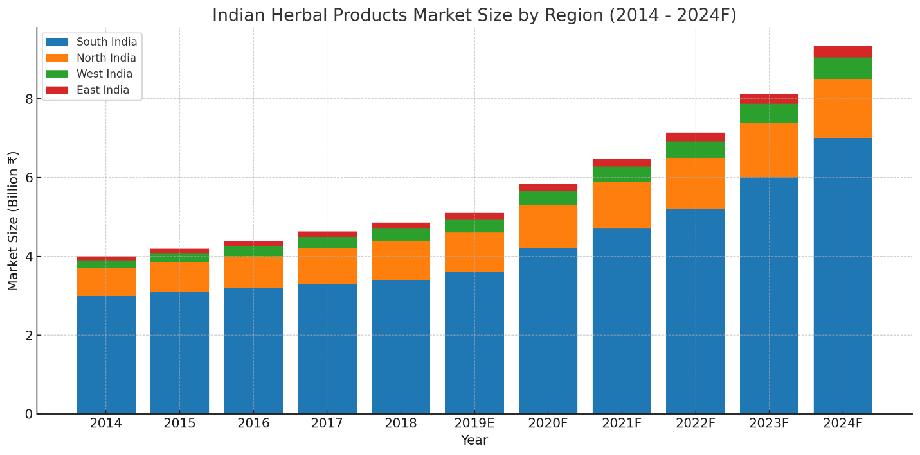

*Fig [1] Indian Herbal Products Market Size By Region (2014 – 2024F)*

**REGULATORY STATUS OF HERBAL PRODUCTS**

The **WHO guidelines** emphasize shared responsibility between manufacturers and regulatory bodies to ensure the quality of herbal products.

Regulatory authorities must establish guidelines for quality assurance, data evaluation, and compliance with Good Manufacturing Practice (GMP) standards. Manufacturers must adhere to good agricultural and collection practices (GACP), Good Laboratory Practice (GLP) standards, and GMP maintaining thorough documentation. Incentives for GACP implementation can include technical and logistical support. Quality control departments ensure adherence to official pharmacopoeia and monographs, employing various analytical techniques.[1]

Detailed product information, including ingredients, manufacturing details, and usage instructions, is essential for registration. The safety and effectiveness of herbal products are monitored by pharmacovigilance centers.[5]

**REGULATORY PROVISIONS IN INDIA**

The herbal drug market in India is regulated by AYUSH, under the Ministry of Ayurveda, Naturopathy, Yoga, Siddha, Homeopathy, and Unani systems. The **Drugs and Cosmetic Act (C&D) 1940** and the **rules of 1945** set the regulations. Manufacturers must follow AYUSH guidelines for composition, formulation, labelling, manufacturing, and packing. **Schedule-T** outlines Good Manufacturing Practices (GMP) established in 2016. [8,10]

some of the regulatory bodies are shown in the Fig [2]

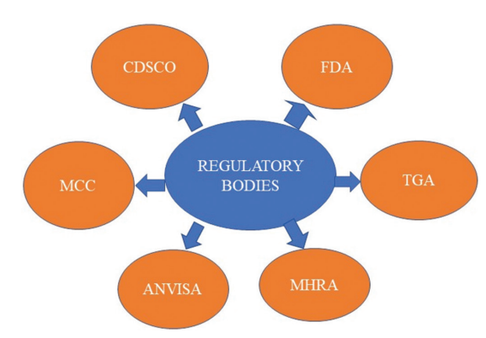

*Fig [2] Different regulatory bodies in worldwide*

**CLASSIFICATION OF HERBAL COSMECEUTICAL PRODUCTS**

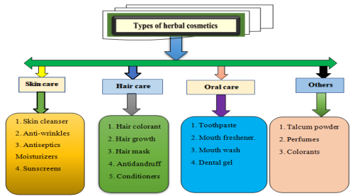Herbal cosmetics are products formulated using natural ingredients obtained from plants, minerals, and occasionally animal sources. These products are designed to enhance and maintain the well-being and appearance of various body parts. Herbal cosmetics can be divided into 4 categories based on the part of the body to be applied for.[9] (Fig [3])

Fig [3] Types Of Herbal Cosmetics

**A. HERBAL COSMETICS FOR SKIN**

These products aim to cleanse, nourish and protect the skin using natural ingredients. [11,12]

* **Powders**: Herbal powders such as face powders and talcum powdersoften contain ingredients like sandalwood and turmeric, known for their aromatic and skin-beneficial properties.
* **Creams:** Herbal creams, including cold creams and vanishing creams, are emulsions designed to moisturize and protect the skin. They may incorporate plant-based ingredients that offer cosmetic benefits.

***Ingredients:*** Aloe Vera, Tulsi, Neem, and Bees Wax.

* **Deodorants**: Herbal deodorants utilize natural extracts to neutralize body odour and may include essential oils for fragrance.
* **Lotions**: Herbal lotions are liquid emulsions applied to the skin for hydration and nourishment, often containing plant extracts known for their skin-conditioning properties. [11,12]

***Ingredients:*** Psoralea polyfolia (Babchi oil), Aloe barbadensis (Aloe Vera leaves), Azadirachta indica (Neem leaves), Curcuma longa (Turmeric rhizomes), Osmium sanctum (Tulsi leaves)

* **Bath and Cleansing Products:** These include soaps and body washes formulated with herbal ingredients to cleanse the skin while providing additional benefits like moisturization and soothing effects.
* ***Ingredients:*** Multani Mitti, Turmeric, Aloe Vera, Sandalwood, Lemon Peel, Rose Petal Powder, Manjistha, Lodhra, and Gram Flour.

**HERBAL TREATMENTS FOR SKIN DISEASES**

1. **Psoriasis**

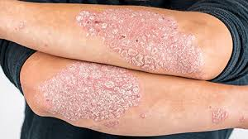Flaky red skin patches covered with silver scales are characteristic of psoriasis.  
It may be seen on the knees, elbows, and lower back, and it might be painful, sore, and uncomfortable. It negatively affects their quality of life. Patients with psoriasis often undergo episodes of little or no symptoms. Numerous herbs can aid in alleviating psoriasis symptoms by diminishing inflammation or slowing skin cell proliferation.[14]Fig[4]

Fig [4]Psoriasis showing flaky red patches with silver scales

**Herb:** *Curcumin longa*

Curcumin (Fig [5]), a compound from turmeric, treats psoriasis via several mechanisms:

1. 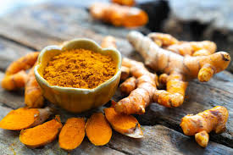**TNF-α Suppression**: Inhibits TNF-α production, binds its receptors to block NF-κB activation, and modulates TLRs to reduce inflammation.

Fig [5] Curcumin

1. **Phosphorylase Kinase (PhK) Inhibition**: Acts as a non-competitive PhK inhibitor, reducing keratinocyte-related issues and T-cell density in psoriatic plaques.
2. **Potassium Channel (Kv1.3) Modulation**: Inhibits Kv1.3 channels in T cells, lowering inflammation.[15]
3. **Cytokine Regulation**: Reduces pro-inflammatory cytokines (e.g., IL-17, TNF-α), curbing inflammation and keratinocyte overgrowth.
4. 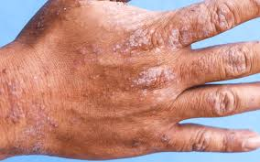**Eczema**

Atopic eczema (Fig [6]) is a long-lasting, recurrent, inflammatory skin disorder linked to dysfunction of the epidermal barrier that leads to inflammation, redness, and itching. It can impact individuals of all ages, although it frequently starts in childhood.[16]

Fig [6] Atopic eczema marked by inflamed, itchy, and red skin

**Herb:** *Aloe vera* (Fig [7]) [17]

1. 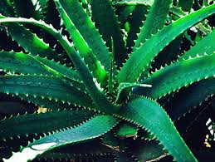Healing Properties

Fig [7] Aloe vera

1. UV and Gamma Radiation Protection
2. Anti-inflammatory Action
3. Immune Effects
4. Laxative Effects
5. Antiviral & Antitumor Activity
6. Moisturizing & Anti-aging
7. Antiseptic Properties
8. **Vitiligo**

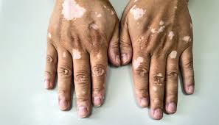Vitiligo is a persistent skin disorder marked by the disappearance of pigment-producing cells known as melanocytes. This leads to the emergence of white patches on the skin. The patches may occur on different areas of the body, such as the face, hands, arms, legs, and even within the mouth or on the hair, resulting in white pigmentation in the affected regions. Fig [8] The precise cause is not completely understood, but it is thought to involve a mix of genetic, autoimmune, and environmental influences. In certain situations, the immune system erroneously targets melanocytes, resulting in their damage.[18]

Fig [8] Vitiligo characterized by white skin patches

**Herb:** *Ginkgo biloba*

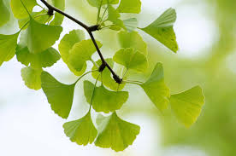*Ginkgo biloba* (Fig [9]) aids vitiligo treatment through:

1. **Oxidative Stress Reduction**: Neutralizes reactive oxygen species (ROS), protecting melanocytes from damage.[19]

Fig [9] *Ginkgo biloba*

1. **Immunomodulatory Effects**: Regulates the immune system, potentially preventing autoimmune attacks on melanocytes.
2. **Anti-inflammatory Properties**: Reduces inflammation, supporting melanocyte survival and repigmentation.
3. **Repigmentation Support**: Helps halt depigmentation and promotes skin repigmentation.
4. **Clinical Improvement**: Improves depigmentation scores (e.g., VASI), showing significant results in studies.
5. **Acne vulgaris**

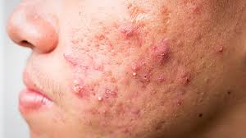Acne vulgaris is a prevalent skin disorder marked by the occurrence of different types of lesions, such as comedones (whiteheads and blackheads), papules, pustules, and in more serious instances, nodules and cysts. It primarily affects the face, back, and shoulders, particularly in adolescents and young adults, although it can persist into adulthood.[20] Fig [10]

Fig [10] Acne vulgaris showing comedones, papules, and pustules.

**Herb:**Tea tree

Tea tree oil, (Fig [11]) extracted from the leaves of the *Melaleuca alternifolia* plant, has several mechanisms of action that contribute to its effectiveness in the treatment of acne vulgaris:[21]

1. 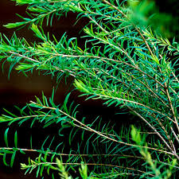**Antimicrobial Properties**: Tea tree oil has broad-spectrum antimicrobial activity. It is effective against *Propionibacterium acnes*, the bacterium commonly associated with acne. By inhibiting the growth of this bacterium, tea tree oil helps to reduce the inflammatory response and the severe manifestations of acne lesions.[22]

Fig [11] Tea tree

1. **Anti-inflammatory Effects**: The components of tea tree oil, particularly terpinen-4-ol, have been shown to possess anti-inflammatory properties. This aids in soothing the redness and inflammation linked to acne breakouts, ultimately lessening the intensity of inflammatory acne.
2. **Reduction of Sebum Production**: Although less directly documented, it is believed that tea tree oil may help regulate sebum production (the oil that clogs pores), which is a contributing factor in the development of acne.
3. **Promotion of Wound Healing**: Tea tree oil has been suggested to facilitate the healing process of the skin and minimize post-acne scarring. This can be beneficial for patients dealing with acne-related skin damage.
4. **Hyperpigmentation**

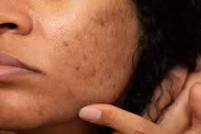Hyperpigmentation (Fig [12]) is a skin condition characterized by dark patches or spots on the skin, which occur when an excess of melanin (the pigment that gives skin its colour) is produced. This can happen for various reasons, including Sun Exposure, Hormonal Changes, Post-Inflammatory, Hyperpigmentation and Age.

**Herb:** Liquorice

Fig [12] Hyperpigmentation resulting from excessive melanin production

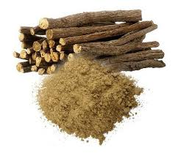Licorice (Fig [13]) extract reduces hyperpigmentation by distributing themelanin, blocking melanin production, and reducing cyclooxygenase activity, which consequently lowers free radical generation. Glabridin, a polyphenolic flavonoid, is the primary ingredient in licorice extract. Research has demonstrated that glabridin inhibits Ultraviolet B (UVB) induced pigmentation and provides anti-inflammatory benefits by suppressing superoxide anion and cyclooxygenase activity.[23]

Fig [13] Liquorice

**B. HERBAL COSMETICS FOR HAIR**

Hair Care Products Hair serves as a particularly significant and unique aspect that plays an integral role in self-image. To a degree, it conveys our identity and who we are. Hair is among the few physical traits we can smoothly alter. Its length, color, and shape can be changed to achieve different styles. These different styles can be employed for seduction, conformity, or to make a statement. Despite hair lacking a key function, its immense significance is often harshly realized by individuals dealing with alopecia. Hair loss is a widespread issue for many men and women. Numerous factors can contribute to hair loss, including genetics, vitamin deficiencies, and hormonal changes. Some medical conditions, like thyroid disease, may also lead to hair thinning or loss. Plants have served as a provider of nourishment and medicinal benefits for an extended period. An extensive variety of plant oils is utilized in cosmetic and toiletry formulations. Hair is a crucial part of the body, mirroring a person’s personality. For a lengthy duration, plant materials have been employed for hair care. A multitude of cosmetics is available for hair care.[24]

* Hair Oil
* Hair Colorant
* Hair Cream
* Shampoo

**Hair Oils:** Hair oils, also known as hair tonics, consist of herbal extracts blended with a carrier oil base. Some hair oils contain a combination of multiple herbs and carrier oils. Carefully weigh all dried and fresh herbs such as Amla, Almond oil, coconut oil, castor bean oil, Olive oil, Vitex negundo, False daisy, Jatamansi, Neem, Gmelina, Butterfly Pea, Bacopa monnieri, Camphor, and Pudina, grind them together in a mixture, and combine them with 63% Til oil.[9]

**Hair Colorants:** Since ancient times, various plant-based materials such as Henna, Chamomile, and Indigo have been used to naturally dye grey hair, achieving a deep black shade. Leaves from Henna, Indigo, Brahmi, Tea, and Bhringraj, along with fruits like Amla, Shoeflowers, and Cinnamon bark, were gathered from different regions and dried in the shade. These dried ingredients were then ground into powders for hair colorant preparation. Additionally, aqueous herbal extracts from Jatamansi rhizome (Nardostachysjatamansi), Gudhal leaves (Hibiscus rosa-sinensis), Kuth roots (Saussurealappa), Amla dried fruit (Emblica officinalis), and Kattha (Acacia catechu) were formulated. Coffee powder (Coffea arabica), Henna powder (Lawsonia inermis), and Beetroot were also utilized to create herbal hair dyes from these dried extracts and powders.[25]

**Herbal Shampoo:** Traditional hair care often incorporates shampoos made from natural minerals and plant-based ingredients. Bentonite powder, a mineral soap, is commonly used in shampoo formulations for its cleansing properties and ability to enhance thickness. Herbal shampoo formulations were developed using natural coconut oil and sesame oil. The rise of synthetic detergents contributed to the popularity of shampoos as a distinct product category. There are anti dandruff shampoos in which ingredients like Neem, Kapoor (naphthalene), Behada, Henna, and Hirda are used.[9]

**HAIR CONDITIONS THAT CAN BE TREATED WITH HERBAL INGREDIENTS**

1. 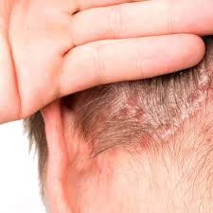**Scalp psoriasis**

Scalp psoriasis is a chronic condition that causes a dry, itchy accumulation of skin cells that can break and bleed. It causes flaking and can appear on various parts of the body, with nearly half of affected individuals experiencing it on their scalp. Fig [14]

Fig [14] Scalp psoriasis featuring dry, flaky skin

***Herb: Mahonia aquifolium***

* *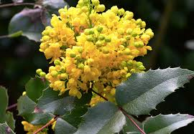Mahonia aquifolium*,(Fig [15]) a flowering plant derived from the mahonia shrub, is also known as **Oregon grape**.
* Traditionally, it has been used to manage inflammatory conditions like psoriasis.
* The presence of **berberine** in *Mahonia aquifolium* helps alleviate irritation associated with psoriasis.

Fig [15] Mahonia aquifolium

* It possesses **antiproliferative properties**, meaning it can slow down excessive cell growth.
* According to the **National Center for Complementary and Integrative Health (NCCIH)**, *Mahonia aquifolium* has strong scientific backing for its effectiveness.[26]

1. **Dandruff**

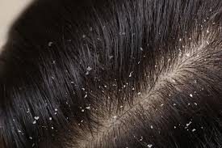Tiny skin fragments may shed from your scalp, leaving noticeable white specks on your shoulders. This can result from excessively dry or oily skin, underlying health conditions such as HIV or Parkinson’s disease, or reactions to specific soaps, shampoos, or scalp fungi.[27] Fig [16]

Fig [16] Dandruff

***Herb: Rosmarinus officinalis***

Rosemary (Fig [17] is a powerful herb known for its numerous benefits in hair and scalp care. It has been widely used in traditional medicine for centuries to improve scalp health, promote hair growth, and reduce dandruff. Its natural antifungal, anti-inflammatory, and antioxidant properties make it an excellent remedy for maintaining a healthy scalp.[28]

* 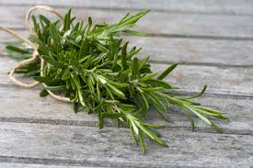**Antifungal Action:** Inhibits *Malassezia* fungus, reducing dandruff.
* **Soothes Inflammation:** Relieves redness, itching, and irritation.

Fig [17] Rosemary

* **Boosts Circulation:** Enhances blood flow for a healthier scalp.
* **Balances Sebum:** Prevents excessive dryness or oiliness.
* **Cleanses Scalp:** Removes buildup, dirt, and excess oil to prevent dandruff recurrence.

1. **Scalp Ringworm**

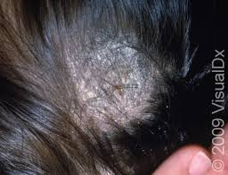Although its name suggests otherwise, this condition does not involve worms. Instead, it is a fungal infection that affects the skin or scalp, leading to **itchy, scaly, and bald patches**. It is highly contagious and frequently occurs in toddlers and children.[29] Fig [18]

Fig [18] Scalp ringworm presenting as itchy, scaly bald patches

***Herb: Tea tree oil***

* 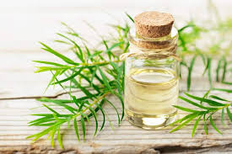Tea tree oil (Fig [19]) is one of the most effective natural remedies for ringworm due to its potent antifungal, antibacterial, and anti-inflammatory properties. It helps kill the fungus (Tinea) responsible for ringworm while soothing itching and inflammation.

Fig [19] Tea tree oil

* Antifungal Action – Tea tree oil contains terpinen-4-ol, a compound known to destroy fungi, including those causing ringworm.
* Reduces Inflammation – It soothes redness, irritation, and swelling, providing relief from itching.
* Prevents Spread – Its antimicrobial properties help prevent secondary infections and stop the fungus from spreading to other areas.
* Speeds Up Healing – It promotes skin regeneration, helping affected areas heal faster.

1. **Alopecia areata**

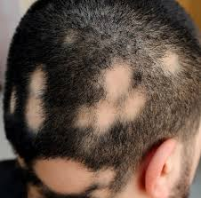Alopecia areata is an immune system disorder that mistakenly targets hair follicles, leading to **patchy hair loss** on the scalp and other areas of the body. It can occur at any age and may be triggered by stress, genetics, or other immune disorders. While hair may regrow on its own herbal remedies such as onion juice and rosemary oil can help stimulate regrowth.[30] Fig [20]

Fig [20] Alopecia areata with patchy hair loss

***Herb: Allium cepa*** (Fig [21])

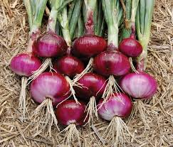Onion juice is a powerful natural remedy for hair loss, particularly Alopecia Areata. Rich in essential nutrients, it stimulates hair follicles, reduces inflammation, and strengthens hair strands.

* **Sulfur for hair strength** – Supports keratin production, boosts blood flow, and aids collagen formation for new hair growth.

Fig [21] Onion

* **Enhances Blood Circulation** – Dilates blood vessels, delivering oxygen and nutrients to dormant follicles, promoting regrowth.
* **Antimicrobial & Antifungal** – Fights infections, maintaining a healthy scalp environment for stronger hair.
* **Anti-Inflammatory & Antioxidant** – Rich in quercetin, reducing scalp inflammation and oxidative stress that cause hair thinning.
* **Blocks Hair Loss Hormones** – Inhibits DHT, preventing follicle shrinkage and hair loss.[30]

**C. HERBAL COSMETICS FOR TEETH AND MOUTH**

Aimed at maintaining oral hygiene and freshness using natural substances. Oral health is vital to general well-being as it can cause significant pain and discomfort if neglected. Using natural herbs in dental care can promote and maintain oral health with minimal side effects. These herbs, either alone or in combination, are effective in managing various oral issues like halitosis, bleeding gums, mouth ulcers, and dental caries. Unlike many over-the-counter products, herbal items are typically free from alcohol and sugar, reducing gum inflammation, rebuilding and healing gum tissue, and eliminating bad breath. Essential oils and botanical extracts like **Red Thyme, Cinnamon Bark, Eucalyptus, Lavender, and Peppermint**, along with organically cultivated Echinacea and Gotu Kola, are highly regarded for their antibacterial, anti-inflammatory, antimicrobial, and antifungal effectsWhen combined, they reduce oral bacteria and gum inflammation, heal tissues, and freshen breath. Common herbal oral care products include toothpaste, dental cream, and mouthwash.

**Herbal Toothpaste:** Herbal toothpaste addresses issues like bad breath, tooth decay, gum disease, sensitivity, calculus, dental caries, and plaque by cleaning tooth surfaces, removing food particles, reducing plaque, polishing teeth, and refreshing breath.

***Ingredients***

Clove, Neem, Sunthi, Mentha, Aloe Vera, Kapoor, Babul,Tulsi, mango, bay.[31]

**Herbal Mouthwash:** Herbal mouthwash, an aqueous solution often used to control plaque, eliminates oral pathogens through swishing. These natural herbs, with no reported side effects, help control dental plaque and gingivitis and are used as adjuncts to brushing and flossing.

***Ingredients***

Eucalyptus Oil, Clove oil, Neem oil, Tea tree oil, Wintergreen oil, Peppermint oil, Guava, Aloe vera, Curcumin, Tulsi oil, Pineapple, Grape seed extract, and Cardamom oil have anti-inflammatory effects and prevent bleeding, contributing to better oral hygiene and health.[32]

**DENTAL CONDITIONS THAT CAN BE TREATED WITH HERBAL INGREDIENTS**

1. **Periodontitis**

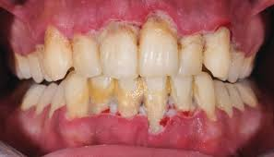If not addressed, gingivitis can advance into periodontitis (Fig [22]), a more serious gum disease that harms the soft tissue and bone structure supporting the teeth, potentially resulting in tooth loss.​[33]

Fig [22] Periodontitis showing receding gums and tooth instability

**Symptoms:** Gum recession, development of deep spaces between teeth and gums, unstable or moving teeth, and ongoing bad breath.

**Herb:**Azadirachta indica

Neem's (Fig [23]) multifaceted properties make it a valuable agent in the prevention and treatment of dental disorders:​

* 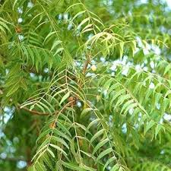**Antimicrobial**: Targets and inhibits periodontal pathogens.

Fig [23] Neem

* **Anti-inflammatory**: Reduces gum inflammation and bleeding.
* **Antioxidant**: Protects oral tissues from oxidative stress.
* **Clinical Validation**: Proven efficacy in clinical settings comparable to standard treatments.

1. **Dental Caries**

Dental caries, (Fig [24]) commonly known as **tooth decay** or **cavities**, is a widespread chronic disease that damages the hard tissues of the teeth. Bacteria in the mouth break down sugars from food and beverages, releasing acids that gradually wear away the tooth enamel. 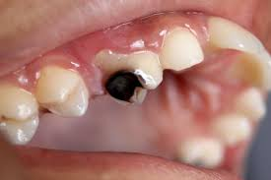 If left untreated, this process can lead to holes in the teeth, pain, infection, and even tooth loss.[33]

Fig [24] Dental caries

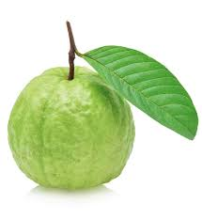**Herb:** Psidium guajava (Fig [25])

* **Antimicrobial Activity:** Inhibits the growth of *Streptococcus mutans* and *Lactobacillus acidophilus.* Reduces risk of enamel demineralization and cavity formation
* **Biofilm Inhibition**: Prevents the formation and adherence of bacterial biofilms on teeth. Limits acid production and bacterial colonization

Fig [25] Psidium guajava

* **Rich Phytochemical Composition**: Contains quercetin, guaijaverin, and other flavonoids. Provides antimicrobial, anti-inflammatory, and healing benefits for oral tissues

**D. OTHER HERBAL PRODUCTS**

**Perfumes:** Natural fragrances are aromas made from elements found in nature, encompassing trees, plants, and those obtained from animals. The floral and musky fragrances you enjoy are frequently sourced from these natural elements.

Nevertheless, natural scents have a shorter duration.There are numerous cost-effective and easy natural methods to maintain body odor without relying on daily showers, these include consuming antioxidant-rich foods, wearing breathable natural fabrics, using essential oils, opting for shampoos and moisturizers with natural fragrances, and staying hydrated. Ingredients like Musk, Civet, Ambergris, and Castoreum can also contribute to maintaining a pleasant scent.[34]

Ingredients: Eugenol, Farnesal, Rose oxide, Citral, Limonene, Rose and Jasmine, Citrus, Oriental, Fruity, etc.

**Talcum Powder-**Herbal powders, rich in vitamins, are believed to benefit the skin in many ways.They are commonly incorporated into soaps and cosmetics, serving both functional and aesthetic purposes by providing natural color. Activated charcoal, for example, is widely used for its cleansing properties. Additionally, herbal powders like **khus, peppermint, lavender, chamomile, rose, and marigold** can be utilized in both skincare and food applications, enhancing their versatility.[11]

**Other coloring agents**- "Natural Colors" are typically obtained from fruits, vegetables, and minerals. Unlike FD&C colors, they do not require batch certification.However, the **FDA** has approved only a limited number of ingredients for use as food colorants. IFC Solutions offers one of the largest collections of FDA-approved natural food colors, providing assistance in selecting the right options for your products.[11]

**PATENTED PRODUCTS**

**Table 1 : Herbal Cosmetics (Patented) in International Market[2]**

|  |  |  |
| --- | --- | --- |
| Product | Patent number | Country |
| Herbal cream (*Aloe vera, Allium sativum, Gymnema syllvestra, Tridax procumbens, Gum olibanum)* | US6200570 B1 | USA |
| Herbal preparation(*Bacopa monnieri, Camellia sinensis, Curcuma longa, Silybum marianum, Withania somnifera)* | EP1825845 A1 | Europe |
| Herbal cosmetic formulations incorporate a blend of surfactants, essential oils, and botanical extracts, carefully selected for their beneficial properties. These compositions often feature *Chamomile, Rosemary, Mint, Sage, Lavender, Citron, Bergamot, Juniper, Rose, Lime (Linden), Stinging Nettle, and Witch-Hazel* | DE4133085 A1 | Germany |
| Dry herbal, cleaning compositions ( *Bassica malabarica, cocoa nucifera sapindus trifoliatus, hibiscus rosa sinesis, trigonella foenum graeceum*) | EP0908171 A1 | Europe |
| A cosmetic or dermatological formulation that includes at least one ginsenoside-type saponin, primarily designed for hair care applications. | WO1994006402 A2 | World Intellectual Property Organisation (Wipo) |

**CONCLUSION**

The combination of classical herbal medicine and modern science is evident in herbal cosmeceuticals, which provide safe and effective environmental alternatives to personal care products. And although these products have the potential to enhance skin, hair, and oral health, issues of scientific validation, standardization, and regulatory frameworks continue to add challenges. The capabilities of herbal cosmetics can be leveraged through further scientific research, supportive policies, and stringent quality regulations. Given the increasing awareness and consumption of natural products herbal medicine promises, herbal cosmeceuticals are set to transform the future of the beauty and wellness industries.

Disclaimer (Artificial intelligence)

Author(s) hereby declare that NO generative AI technologies such as Large Language Models (ChatGPT, COPILOT, etc.) and text-to-image generators have been used during the writing or editing of this manuscript.

**REFERENCES**

1. Bijauliya RK, Alok S, Kumar M, Chanchal DK, Yadav S. A comprehensive review on herbal cosmetics. Int J Pharm Sci Res. 2017;8(12):4930–4949.
2. Joshi LS, Pawar HA. Herbal cosmetics and cosmeceuticals: an overview. Nat Prod Chem Res. 2015;3(2):170–178.
3. Fatima A, Alok S, Agarwal P, Singh PP, Verma A. Benefits of herbal extracts in cosmetics: a review. Int J Pharm Sci Res. 2013;4(10):3746–3760.
4. Pal M, Pushpendra, Saxena R, et al. A detailed analysis of herbal cosmetics. NeuroQuantology. 2022;20(15):6367–6381.
5. Sindhura SDK, Jain V. Challenges in formulating herbal cosmetics. Int J Appl Pharm. 2018;10(6):47–53.
6. Ashawat MS, Banchhor M, Saraf S, Saraf S. Herbal cosmetics: trends in skin care formulation. Phcog Rev. 2009;3(5):82–89.
7. Polshettiwar SA, Sawant DH, Abhale NB, et al. Regulation of herbal products used as medicine across the globe: a case study on turmeric—golden medicine. Biomed Pharmacol J. 2022;15(3):1227–1237.
8. Singh A, Saharan VA, Kharb V, Bhandari A. Current status of regulations for herbal medicines in Europe, United States and India. J Nat Conscient. 2011;2(3):406–422.
9. Suman, Saddam, Alok S. An overview of herbal cosmetics and their applications. Int J Pharm Sci Res. 2023;14(5):2214–2226.
10. Sahane MB, Basarkar GD. A review of herbal regulations and approval process in India and Europe. Int J Drug Regul Aff. 2023;11(4):25–33.
11. Chandini V, Kumar NU, Rani TM, Yadav KJ, Siva M, Babu MK. Herbal cosmetics and cosmeceuticals—a review in new technology of cosmetology. World J Pharm Pharm Sci. 2023;12(4):930–951.
12. Nidhi S, Yogita B, Archana R, Deepika J, Bhavna S. Usage of natural plants in herbal cosmetics. JOJ Dermatol Cosmet. 2021;4(2):555635.
13. Arora R, Aggarwal G, Dhingra GA, Nagpal M. Herbal active ingredients used in skin cosmetics. Asian J Pharm Sci. 2019;12(9):7–15.
14. National Psoriasis Foundation. What Is Psoriasis? [Internet]. Available from: <https://www.psoriasis.org/about-psoriasis/>
15. Bahraini P, Rajabi M, Mansouri P, Sarafian G, Chalangari R, Azizian Z. Turmeric tonic as a treatment in scalp psoriasis: a randomized placebo-control clinical trial. J Cosmet Dermatol. 2018;17(3):461–466.
16. National Eczema Association. What is Atopic Dermatitis? [Internet]. Available from: <https://nationaleczema.org/eczema/types-of-eczema/atopic-dermatitis/>
17. Zhao C, Wu S, Wang H. Medicinal plant extracts targeting UV-induced skin damage: molecular mechanisms and therapeutic potential. Int J Mol Sci. 2025;26(5):2278.
18. American Academy of Dermatology Association. Vitiligo: Overview. [Internet]. Available from: <https://www.aad.org/public/diseases/color-problems/vitiligo>
19. Mulianto N, Kariosentono H, Purwanto B, Indarto D, Soetrisno S. The effect of Ginkgo biloba extract on oxidative stress, anti-inflammatory and antiapoptotic in vitiligo treated with topical desoxymethasone. Evol Stud Imaginative Cult. 2024;8(2):1580–1590.
20. Zaenglein AL, Pathy AL, Schlosser BJ, Alikhan A, Baldwin HE, Berson DS, et al. Guidelines of care for the management of acne vulgaris. J Am Acad Dermatol. 2016;74(5):945–73.
21. Enshaieh S, Jooya A, Siadat AH, Iraji F. The efficacy of 5% topical tea tree oil gel in mild to moderate acne vulgaris: a randomized, double-blind placebo-controlled study. Indian J Dermatol VenereolLeprol. 2007;73(1):22–50.
22. Carson CF, Hammer KA, Riley TV. Melaleuca alternifolia (tea tree) oil: a review of antimicrobial and other medicinal properties. Clin Microbiol Rev. 2006;19(1):50–62.
23. Simmler C, Pauli GF, Chen SN. Phytochemistry and biological properties of glabridin. Fitoterapia. 2013;90:160–184.
24. Bhalerao P, Jadhav B, Gulave D, Jangle M. Hair structure and care: a review of herbal hair care cosmetics. Int J Pharm Sci. 2024;2(10):1676–1686.
25. Singh A, Duggal S. Indian medicinal plants used in hair care cosmetics: a short review. Pharmacogn J. 2010;2(10):361–364.
26. Janeczek M, Moy L, Lake EP, Swan J. Review of the efficacy and safety of topical Mahonia aquifolium for the treatment of psoriasis and atopic dermatitis. J Clin Aesthet Dermatol. 2018;11(12):42–47.
27. Seborrheic Dermatitis: What Is It, Diagnosis & Treatment. Cleveland Clinic. [Internet]. Available from: <https://my.clevelandclinic.org/health/diseases/14403-seborrheic-dermatitis>
28. Head & Shoulders. Can rosemary oil help in getting rid of dandruff? [Internet].Available from: <https://www.headandshoulders.co.in/en-in/healthy-hair-and-scalp/dandruff/dandruff-home-remedies/rosemary-oil-for-dandruff>
29. Cleveland Clinic Staff. Tinea Capitis: Symptoms, Causes & Treatment. Cleveland Clinic. [Internet]. Available from:<https://my.clevelandclinic.org/health/diseases/22449-tinea-capitis>
30. Madani S, Shapiro J. Onion juice (Allium cepa L.), a new topical treatment for alopecia areata. J Dermatol. 2002;204(4):268–269.
31. Wadhwa S, Sethiya S. Preparation and evaluation of herbal toothpaste. Asian J Pharm Res Dev. 2016;4(1):1–5.
32. Shahidulla SM, Ghori MD, Saleh M. Herbal mouthwash: an innovative approach. Int J Pharm Sci Med. 2022;7(11):51–58.
33. Chandra Shekar BR, Nagarajappa R, Suma S, Thakur R. Herbal extracts in oral health care—a review of the current scenario and its future needs. Pharmacogn Rev. 2015;9(18):87–92.
34. Jellinek P. Perfume materials reminiscent of human body odor. In: The Psychological Basis of Perfumery. Dordrecht, The Netherlands: Springer; 1997:40–45
35. Latest Technology Advances in Cosmaceuticals
36. Nageen Arora, Shilpi Agarwal,
37. Latest Technology Advances in Cosmaceuticals
38. Nageen Arora, Shilpi Agarwal,
39. Latest Technology Advances in Cosmaceuticals
40. Nageen Arora, Shilpi Agarwal,
41. Latest Technology Advances in Cosmaceuticals
42. Nageen Arora, Shilpi Agarwal,
43. Latest Technology Advances in Cosmaceuticals
44. Nageen Arora, Shilpi Agarwal,
45. Latest Technology Advances in Cosmaceuticals
46. Nageen Arora, Shilpi Agarwal,
47. Latest Technology Advances in Cosmaceuticals
48. Nageen Arora, Shilpi Agarwal,
49. Latest Technology Advances in Cosmaceuticals
50. Nageen Arora, Shilpi Agarwa
51. Latest Technology Advances in Cosmaceuticals
52. Nageen Arora, Shilpi Agarwa