**DEVELOPMENT OF EFFECTIVE DIETARY INTERVENTIONS FOR PROMOTING HEALTHY AGING AND RELATED DISEASES: A BRIEF OVERVIEW**

**ABSTRACT**

Attention-Deficit/Hyperactivity Disorder (ADHD) and age-related cognitive decline are distinct yet overlapping conditions with neurobiological, nutritional, and inflammatory components. This review synthesizes current research on the role of dietary interventions and nutritional supplements in mitigating symptoms of ADHD and promoting healthy cognitive aging. It presents evidence-based discussion on dietary components such as omega-3 fatty acids, herbal supplements, antioxidants, and structured dietary patterns like the Mediterranean diet. By analyzing shared mechanisms like oxidative stress, neurotransmitter dysregulation, and Neuroinflammation, we propose integrative strategies that leverage nutritional therapies to improve executive function, emotional regulation, and long-term brain resilience. The review underscores the need for multidisciplinary, individualized approaches to enhance cognitive health across the lifespan.

**KEYWORDS**:-

ADHD, Cognitive Health, Dietary Interventions, Healthy Aging, Neurodevelopmental Disorders, Nutritional Strategies, Mild Cognitive Impairment, Oppositional Defiant Disorder, Executive Function, Neuroinflammation, Psychopharmacology, Herbal Supplements

**INTRODUCTION**

ADHD is a well-established psychiatric disorder that disrupts attention, emotional regulation, and impulse control. Historically classified into Attention Deficit Disorder (ADD) and ADHD, the Diagnostic and Statistical Manual of Mental Disorders (DSM-IV) merged these into one condition with three subtypes: inattentive, hyperactive-impulsive, and combined.

The symptoms—such as distractibility, disorganization, forgetfulness, and difficulty completing tasks—must begin before the age of 12, last at least six months, and occur in multiple settings to qualify for a diagnosis. ADHD is linked to dysfunctions in executive processes, often associated with the frontal lobe, and is commonly seen in children who experience social difficulties and behavioral challenges.

Fig 1- Evidence of inflammation in ADHD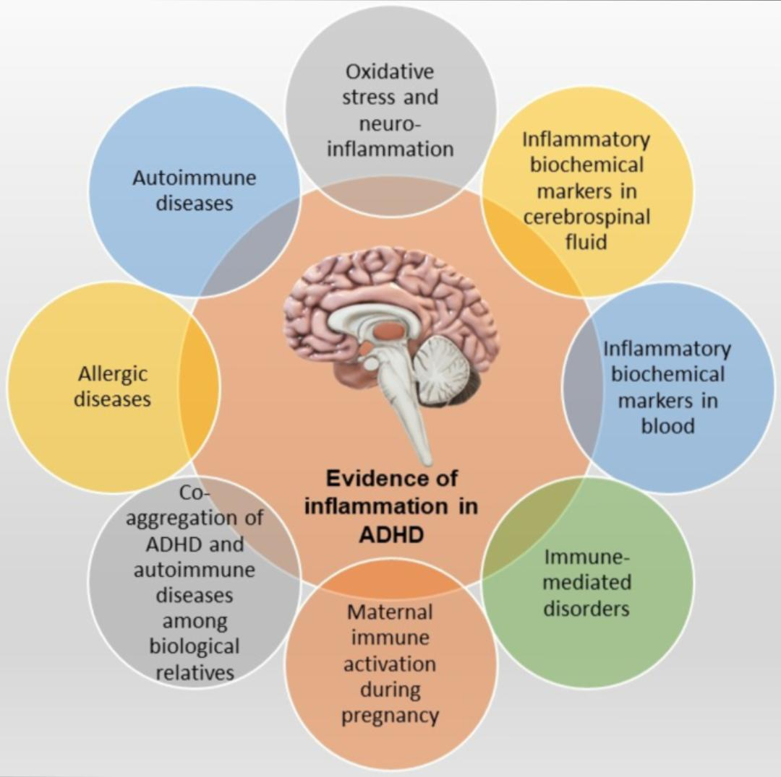

**CLASSIFICATION OF ADHD**

According to DSM-5, ADHD can be classified into:

1. Predominantly Inattentive Type
2. Predominantly Hyperactive-Impulsive Type
3. Combined Type

**ETIOLOGY**

ADHD is a multifactorial disorder with strong genetic heritability. Monozygotic twins exhibit higher concordance than dizygotic twins. Environmental risk factors—such as prenatal exposure to tobacco, alcohol, nutritional deficiencies, and infections—also play a role.

Dysfunction in dopaminergic and noradrenergic systems has been identified, particularly in the prefrontal cortex, which governs attention and executive function.

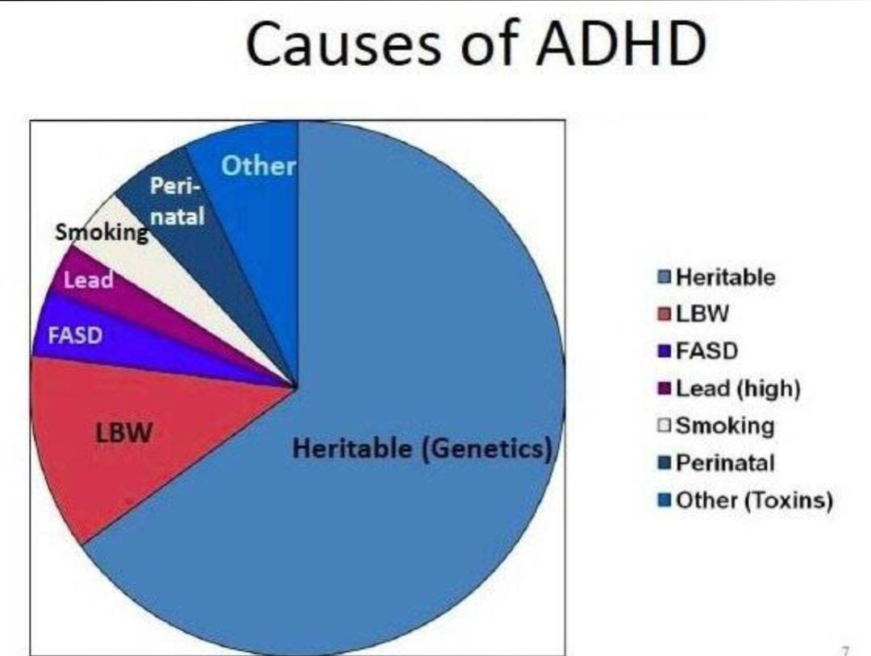

**Fig 2- causes of ADHD**

**EPIDEMIOLOGY**

ADHD affects 5–7% of children and about 2.5% of adults globally. It is more frequently diagnosed in males, with a 2:1 male-to-female ratio. The inattentive subtype is more prevalent among females, while the combined and hyperactive types are more commonly seen in males.

**PATHOPHYSIOLOGY**

Neuroimaging has revealed changes in the prefrontal cortex, anterior cingulate, and basal ganglia of individuals with ADHD. These regions are involved in goal-directed behavior, impulse regulation, and attention. fMRI studies show reduced activity in frontostriatal circuits, confirming the neurological basis of the disorder.

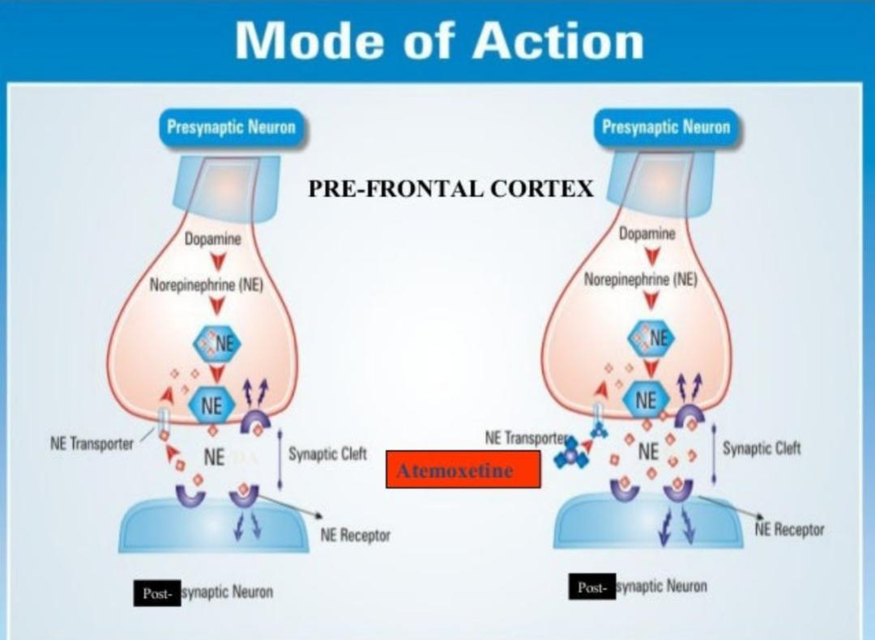

Fig 3- Mode of action

**TREATMENT OF ADHD**

Stimulants, such as methylphenidates and amphetamines, are the primary treatment and work by enhancing dopamine and norepinephrine availability. They are effective in up to 70% of cases. Side effects may include appetite loss, insomnia, and blood pressure changes.

Non-stimulant medications, including atomoxetine, are alternatives for those with anxiety or poor stimulant tolerance. Other options like bupropion and TCAs are less commonly used.

Alpha-2 agonists (clonidine, guanfacine) help in younger children or those with tics, though side effects like sedation and low blood pressure are common.

Behavioral therapies, such as CBT, parent training, and educational support, are essential for comprehensive management. Trigeminal nerve stimulation devices have recently been approved as non-drug treatments for pediatric ADHD.

**RELATED DISEASES:**

1. **OPPOSITIONAL DEFIANT DISORDER**

Oppositional Defiant Disorder is a behavioral condition typically diagnosed in childhood, characterized by frequent temper outbursts, defiance toward authority figures, and deliberately provocative behavior. While often seen in children, symptoms can persist into adulthood.

**ETIOLOGY**:

The development of ODD is believed to stem from a combination of genetic vulnerability, environmental stressors, and family dynamics.

The DSM-5-TR highlights two major conceptual frameworks:

the bifactor model, which categorizes symptoms as irritable and defiant, and the trifactor model, which expands to include a vindictive dimension.

**EPIDEMIOLOGY**:

The prevalence of ODD is estimated at around 3.3% in the general population, though clinical samples report much higher rates, ranging from 2.6% to 15.6%, depending on the setting and diagnostic criteria. The disorder is more commonly diagnosed in boys during early childhood, although this gender gap appears to narrow with age.

**PATHOPHYSIOLOGY:**

ODD is associated with deficits in emotional regulation and executive function, particularly in how individuals process punishment and rewards. Neurobiological studies suggest involvement of the autonomic nervous system, with altered levels of cortisol, serotonin, and norepinephrine. Individuals with ODD often struggle to recognize anger in others, show poor fear conditioning, and are more likely to engage in future antisocial behavior if left untreated.

**TREATMENT**:

Effective management of ODD requires a multidisciplinary approach, including collaboration between healthcare providers, schools, families, and communities. Interventions include Parent Management Training (PMT), individual child therapy, family therapy, and school-based behavioral programs. Identifying and managing comorbidities such as depression, anxiety, and substance use is critical for successful outcomes.

1. **MILD** **COGNITIVE** **IMPAIRMENT**

Mild Cognitive Impairment represents a transitional state between normal aging and dementia, often involving memory lapses, reduced mental clarity, or difficulty with complex tasks. Unlike dementia, MCI does not significantly impair daily functioning

**ETIOLOGY** :The strongest risk factor for MCI is advancing age. Other contributors include male sex, family history of dementia, and the presence of the APOE ε4 allele, which is linked to increased progression to Alzheimer’s disease. However, the predictive value of genetic testing remains limited in clinical practice.

**PATHOPHYSIOLOGY**:

MCI is a heterogeneous condition. Some individuals progress to dementia, while others remain stable or even revert to normal cognition. Structural changes in the hippocampus and cerebral cortex, coupled with neuropsychiatric symptoms and poor cognitive test performance, are associated with a higher risk of developing dementia. Functional impairment and imaging biomarkers like hippocampal atrophy may indicate underlying neurodegen

**TREATMENT :**

Management focuses on identifying and addressing reversible causes, such as sleep apnea, depression, vitamin deficiencies, and medication side effects. Controlling vascular risk factors like hypertension, diabetes, and hyperlipidemia may help slow cognitive decline. Currently, no medications are FDA-approved for MCI, but various agents—such as acetylcholinesterase inhibitors, B-vitamins, antioxidants, and nutraceuticals—have been investigated with mixed results.

**DIETARY SUPPLEMENTS AND HERBAL INTERVENTIONS**

Dietary supplements play a growing role in the complementary management of ADHD and cognitive decline. Many plant-based and nutraceutical compounds possess antioxidant, anti-inflammatory, or neuroregulatory effects that may benefit attention, emotional regulation, and memory function.

1. **Ashwagandha** : Ashwagandha (Withania somnifera), also known as Indian ginseng or winter cherry, is a prominent herb in Ayurvedic medicine. Ashwagandha has antioxidant properties. It contains several bioactive compounds, including withanolides, alkaloids, and sitoindosides,

Fig 5- Ashwagandha (*Withania somnifera*)

**Dosage**: 300-600 mg/day

**Effects**: Reduces cortisol, promotes calmness

**Caution**: Avoid during pregnancy or autoimmune illness

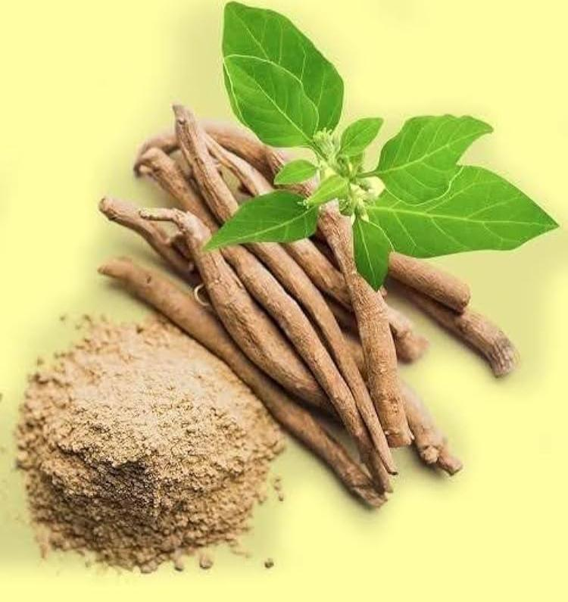**Benefit**: Reduces stress hormones (cortisol), promotes calmness

**Note**: Use root extract (KSM-66 or Sensoril): safe for long-term use

**Brand name**:-Dr. Botanical Health Ashwagandha

**B. Passionflower**: Passionflower (genus Passiflora) is a plant known for its calming effects, commonly used in traditional medicine and modern herbal supplements. The most frequently used species for medicinal purposes is Passiflora incarnata. It has an antioxidant properties .

Fig 6- Passionflower (genus Passiflora)

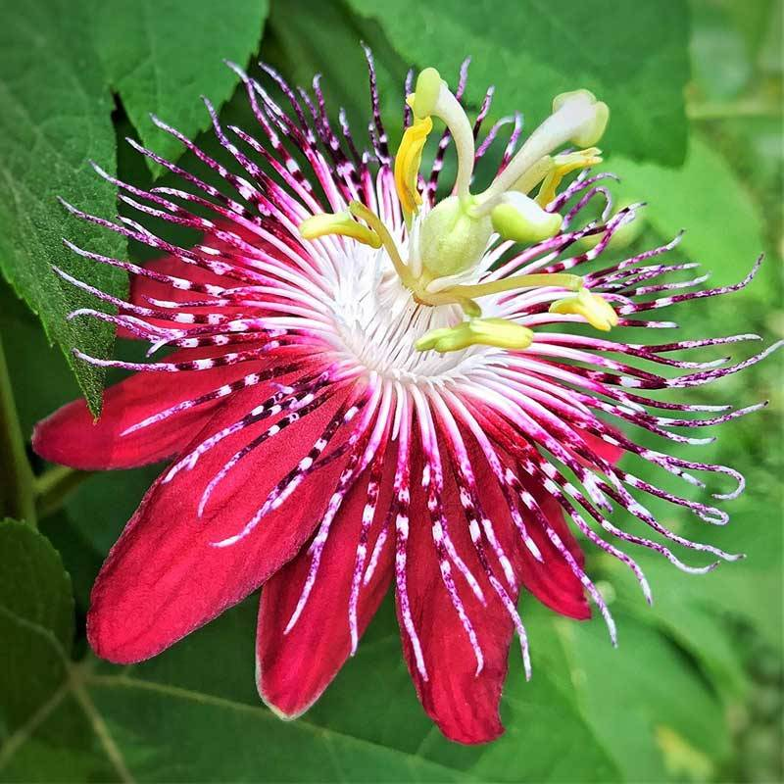**Dosage**: 250-500 mg/day

**Effects**: Calms nervous system, reduces anxiety

**Benefit**: Calms the nervous system, reduces restlessness

**Interactions**: Chamomile may interact with blood thinners (e.g., warfarin) due to its mild anticoagulant effects.

**Note**: May interact with blood thinners

**Brand name**-Nature’s Way Passionflower

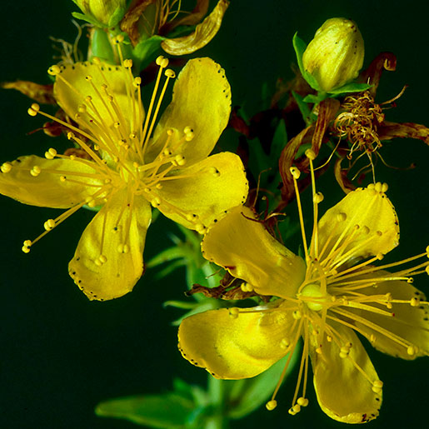

**Fig 7-:** St. John’s Wort (*Hypericum perforatum*)

**C.St. John’s Wort**: St. John’s Wort (Hypericum perforatum) is a flowering plant widely used in herbal medicine, primarily for its

antidepressant and neuroprotective effects.

**Dosage**: 300 mg three times/day

**Effects**: Enhances mood

**Caution**: Interacts with many drugs

**Benefit**: Improves mood by increasing serotonin levels

**Note**: Standardized to 0.3% hypericin; interacts with many medications

**Brand name**:-Blossom Nature’s St. John’s Wort

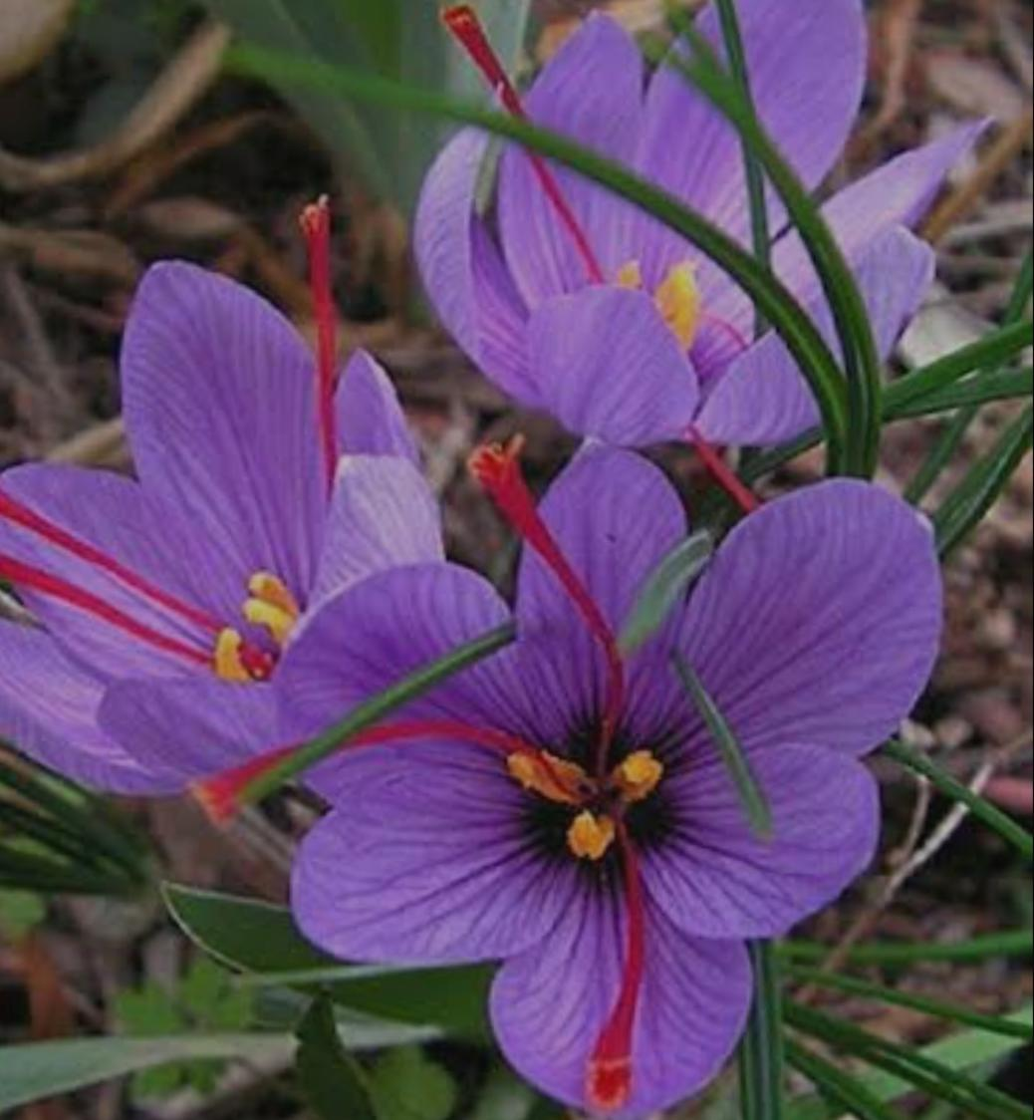

**Fig 8-** Saffron (*Crocus sativus*)

**D. Saffron**: Saffron (Crocus sativus) is a well-known spice with a rich history in culinary and medicinal uses. It is valued for its antioxidant, anti-inflammatory, and neuroprotective properties.

**Dosage**: 30 mg/day (15 mg twice daily)

**Effects**: Improves mood, antioxidant

**Note**: Use standardized extracts

**Benefit**: Enhances mood and emotional balance

**Note**: Use standardized extract; results seen in 4-6 weeks

**Brand name**: himaliyan Elevation and Zaffrus

**F. Omega-3 (from flaxseed oil)**

**Dosage**: 1000-2000 mg/day (ALA form)

**Effects**: Supports attention, mood regulation

**Benefit**: Improves mood regulation and reduces aggression

**Note**: Plant-based omega-3 (ALA) helps support brain function

**Brand name:**- TrueBasics Omega-3, WOW Life Science

**E. Ginkgo Biloba:** Ginkgo biloba is one of the most well-researched medicinal plants, traditionally used to enhance cognitive function and circulation. It also exhibits antioxidant and anti-inflammatory properties that contribute to its neuroprotective and therapeutic effects

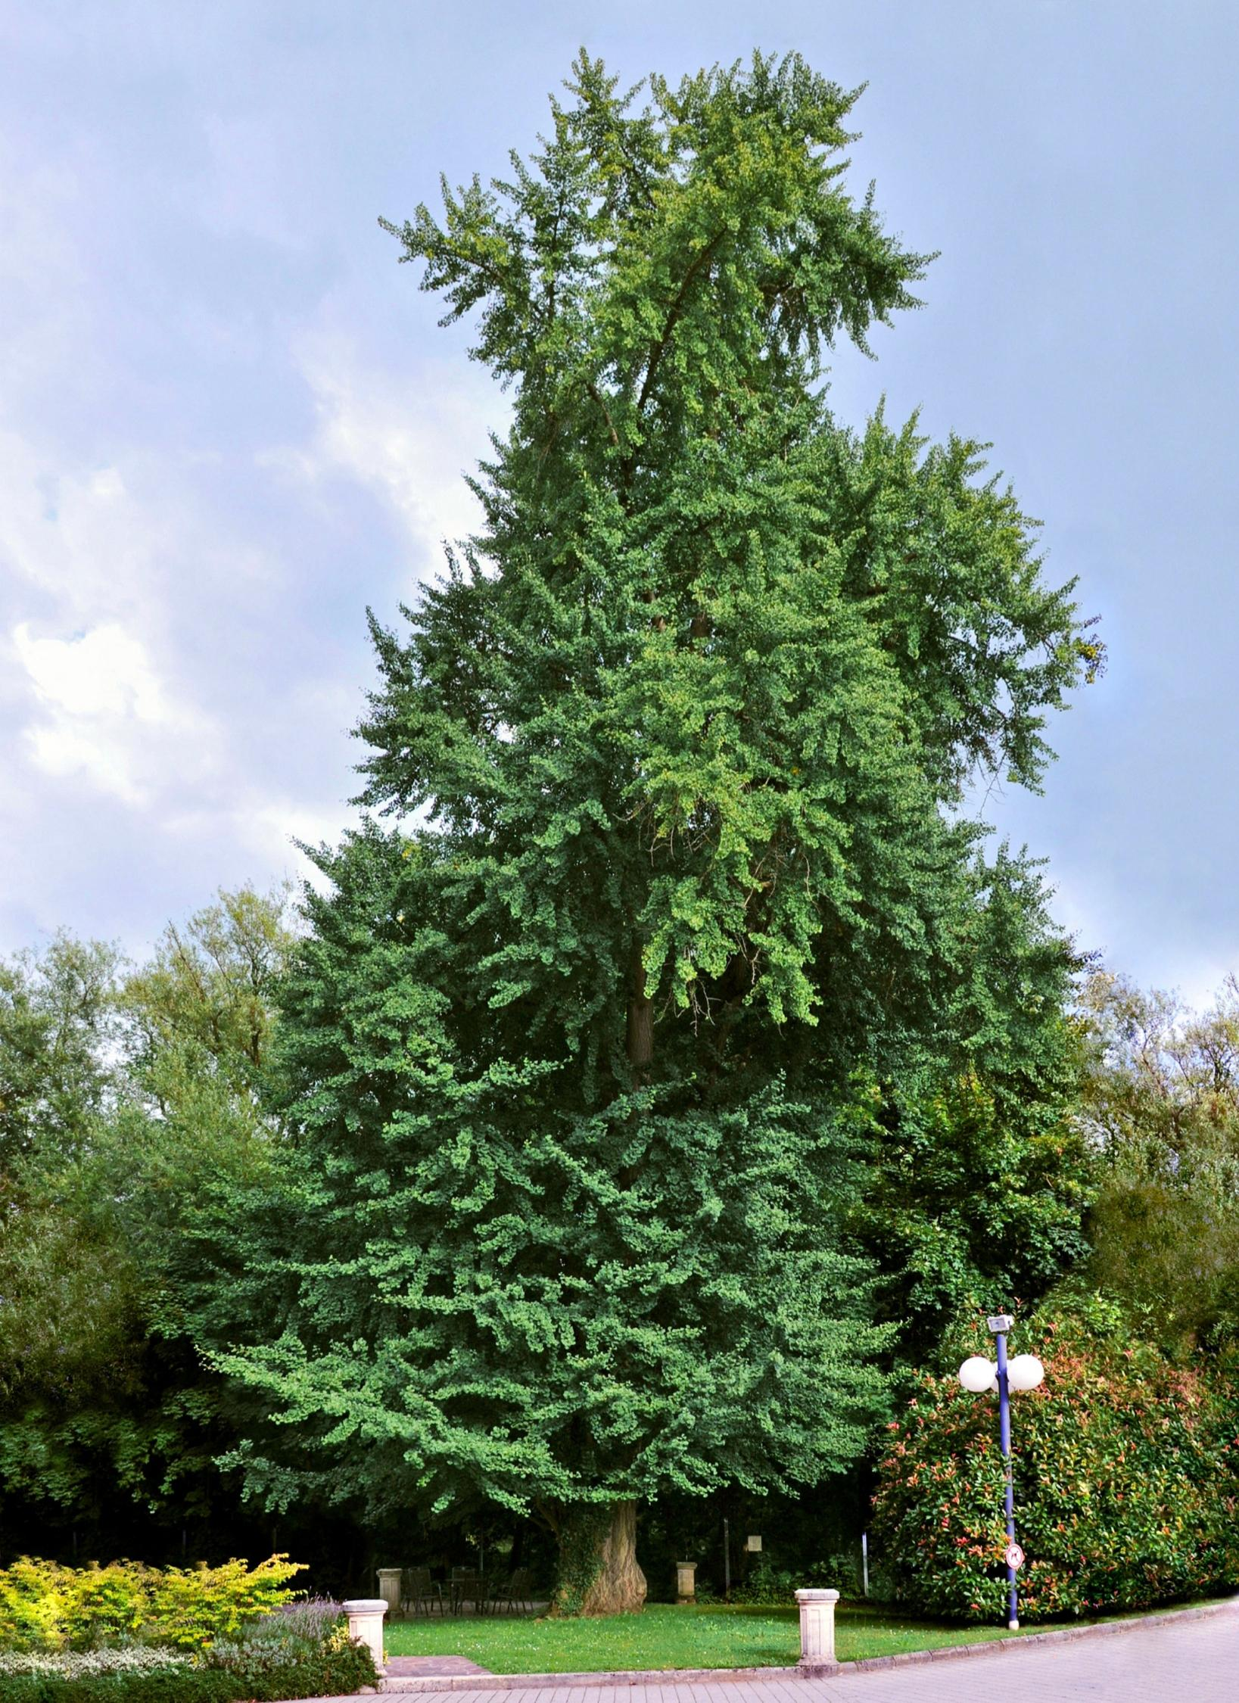

**Fig 9-** Ginkgo Biloba

**Dosage**: 120-240 mg/day

**Effects**: Improves memory, cognitive function

**Benefit**: Enhances cognitive function and behavioral control

**Note**: Use extract with 24% flavone glycosides

**Brand name:-**Himalaya Ginkgo, Ginkgold

**F. Chamomile** : Chamomile (Matricaria chamomilla or Chamaemelum nobile) is a widely used herb with a long history in traditional medicine, known for its calming, anti-inflammatory, and antioxidant properties.



**Fig 10-** **Chamomile (*Matricaria chamomilla*)**

**Dosage**: 300-500 mg/day (or 2-3 cups of tea)

**Effects**: Reduces agitation, supports relaxation

**Benefit**: Calms agitation and supports emotional regulation

**Note**: Useful for anxiety-linked behavioral outbursts

**Extended Dietary Interventions and Recommendations**

**1.Sample Diet Plan from Breakfast to Dinner**

A structured diet plan tailored for individuals with ADHD and to promote healthy aging should emphasize low-glycemic, nutrient-dense foods.

Breakfast:

* Whole-grain oats with chia seeds and berries
* Boiled egg or almond butter on whole-grain toast
* Green tea or warm water with lemon

Mid-morning Snack:

* Handful of unsalted mixed nuts

One banana or apple

Lunch:

* Grilled chicken/fish or tofu with mixed vegetable salad(olive oil dressing)
* Brown rice or quinoa
* Water or buttermilk

Afternoon Snack:

* Greek yogurt with flaxseeds or a smoothie (spinach, banana, almond milk)

Dinner:

* Steamed vegetables with lentil soup or grilled paneer
* Small portion of whole wheat roti or millet
* Herbal tea (chamomile or ginger)

**2.Dietary Do’s and Don’ts**

Do’s:

* Include omega-3 rich foods like flaxseed, walnuts, and fish.
* Focus on whole grains, fresh fruits, and vegetables.
* Use herbs like turmeric, ginger, and ashwagandha for anti-inflammatory support.

Don’ts:

* Avoid processed and sugary foods.
* Limit artificial colorants and preservatives.
* Minimize intake of high-fat, fried, and junk foods.

**3.Impact of Sugar Intake in Pediatric Population**

High sugar consumption in children can lead to hyperactivity, mood swings, and poor attention span. Excessive sugar intake may exacerbate ADHD symptoms due to insulin spikes and subsequent crashes, affecting behavior and concentration. A diet with controlled sugar intake, especially refined sugars, is crucial for better behavioral outcomes in pediatric groups.

**4.Gluten-Free Foods and Dietary Fibers**

Some studies suggest a gluten-free diet may help in managing ADHD symptoms, particularly in children with gluten sensitivity or celiac disease. Gluten-free grains like quinoa, rice, and buckwheat are preferred. Additionally, dietary fiber from fruits, vegetables, legumes, and whole grains supports gut health, which is closely linked to brain function and inflammation control.

**5.Maternal Diet and Its Impact During Pregnancy**

A mother’s diet during pregnancy significantly influences fetal brain development. Nutrients such as folic acid, iron, omega-3 fatty acids, and choline are essential for neural development. Avoiding alcohol, excess caffeine, and highly processed foods is crucial. A well-balanced maternal diet may reduce the risk of neurodevelopmental disorders like ADHD in offspring.

**CONCLUSION**:

As ADHD continues to be diagnosed across the lifespan, attention is turning to integrated, long-term strategies to manage its impact and promote healthy aging. Nutritional approaches targeting neuroinflammation, oxidative stress, and dopamine imbalance may improve symptoms and support cognitive resilience.

Nutrients like omega-3s, zinc, iron, magnesium, and polyphenols show promise in enhancing executive function. Mediterranean and DASH diets offer systemic benefits that may protect against cognitive decline.

However, personalized nutrition strategies are essential due to individual variability. When used alongside traditional treatments, dietary interventions may significantly enhance both ADHD symptom control and overall lifespan brain health.

Disclaimer (Artificial intelligence)

Option 1:

Author(s) hereby declare that NO generative AI technologies such as Large Language Models (ChatGPT, COPILOT, etc.) and text-to-image generators have been used during the writing or editing of this manuscript.

**REFERENCE**

1.Matas M. Approach to attention deficit disorder in adults. Can Fam Physician. 2006 Aug;52(8):961-4.

2.Pary R, Lewis S, Matuschka PR, Rudzinskiy P, Safi M, Lippmann S. Attention deficit disorder in adults. Ann Clin Psychiatry. 2002 Jun;14(2):105-11.

3.Millichap JG. Etiologic classification of attention-deficit/hyperactivity disorder. Pediatrics. 2008 Feb;121(2):e358-65.

4.Salvi V, Migliarese G, Venturi V, Rossi F, Torriero S, Viganò V, Cerveri G, Mencacci C. ADHD in adults: clinical subtypes and associated characteristics. Riv Psichiatr. 2019 Mar-Apr;54(2):84-89.

5.Kates N. Attention deficit disorder in adults. Management in primary care. Can Fam Physician. 2005 Jan;51(1):53-9.

6.Wilens TE, Spencer TJ. Understanding attention-deficit/hyperactivity disorder from childhood to adulthood. Postgrad Med. 2010 Sep;122(5):97-109.

7. Brikell I, Chen Q, Kuja-Halkola R, D’Onofrio BM, Wiggs KK, Lichtenstein P, Almqvist C, Quinn PD, Chang Z, Larsson H. Medication treatment for attention-deficit/hyperactivity disorder and the risk of acute seizures in individuals with epilepsy. Epilepsia. 2019 Feb;60(2):284-293.

8.Fosi T, Lax-Pericall MT, Scott RC, Neville BG, Aylett SE. Methylphenidate treatment of attention deficit hyperactivity disorder in young people with learning disability and difficult-to-treat epilepsy: evidence of clinical benefit. Epilepsia. 2013 Dec;54(12):2071-81.

9.Osland ST, Steeves TD, Pringsheim T. Pharmacological treatment for attention deficit hyperactivity disorder (ADHD) in children with comorbid tic disorders. Cochrane Database Syst Rev. 2018 Jun 26;6(6):CD007990.

10.Geffen J, Forster K. Treatment of adult ADHD: a clinical perspective. Ther Adv Psychopharmacol. 2018 Jan;8(1):25-32.

11.Han DH, McDuff D, Thompson D, Hitchcock ME, Reardon CL, Hainline B. Attention-deficit/hyperactivity disorder in elite athletes: a narrative review. Br J Sports Med. 2019 Jun;53(12):741-745.

12.Hawes DJ, Gardner F, Dadds MR, Frick PJ, Kimonis ER, Burke JD, Fairchild G. Oppositional defiant disorder. Nat Rev Dis Primers. 2023 Jun 22;9(1):31.

13.Burke JD, Boylan K, Rowe R, Duku E, Stepp SD, Hipwell AE, Waldman ID. Identifying the irritability dimension of ODD: Application of a modified bifactor model across five large community samples of children. J Abnorm Psychol. 2014 Nov;123(4):841-51.

14.Stringaris A, Goodman R. Three dimensions of oppositionality in youth. J Child Psychol Psychiatry. 2009 Mar;50(3):216-23.

15.Boylan K, Vaillancourt T, Boyle M, Szatmari P. Comorbidity of internalizing disorders in children with oppositional defiant disorder. Eur Child Adolesc Psychiatry. 2007 Dec;16(8):484-94.

16.Demmer DH, Hooley M, Sheen J, McGillivray JA, Lum JA. Sex Differences in the Prevalence of Oppositional Defiant Disorder During Middle Childhood: a Meta-Analysis. J Abnorm Child Psychol. 2017 Feb;45(2):313-325.

17.Matthys W, van Goozen SH, Snoek H, van Engeland H. Response perseveration and sensitivity to reward and punishment in boys with oppositional defiant disorder. Eur Child Adolesc Psychiatry. 2004 Dec;13(6):362-4.

18.Sanford AM. Mild Cognitive Impairment. Clin Geriatr Med. 2017 Aug;33(3):325-337.

19.Ghosh S, Libon D, Lippa C. Mild Cognitive Impairment: A Brief Review and Suggested Clinical Algorithm. Am J Alzheimers Dis Other Demen. 2014 Jun;29(4):293-302.

20.Roberts R, Knopman DS. Classification and epidemiology of MCI. Clin Geriatr Med. 2013 Nov;29(4):753-72.

21.Edward M. Hallowell and John J. Ratey: This book is considered a cornerstone in ADHD literature, exploring the diverse manifestations of ADHD, dispelling myths, and offering support strategies.

22.Russell A. Barkley: This book “Taking Charge of Adult ADHD” provides a deep dive into the challenges and strategies for managing ADHD as an adult, offering practical advice and evidence-based information.

23. Sari Solden and Michelle Frank: This book “A Radical Guide for Women with ADHD” addresses the unique challenges and experiences of women with ADHD, offering tailored support and guidance.