Design of Metformin with Glibenclamide Controlled release osmotic capsules

.

ABSTRACT

|  |
| --- |
| **Aims**: This article aims to target the improvement for treatment of people suffering from Diabetes. Rather than using multiple doses and dosage forms for effective treatment, the author provides a robust solution in the form a combination of drugs as an osmotic capsule which have a controlled release pattern and aims at treating the disease effectively. This article also presents for the first time a compatibility study using a non-destructive methodology with Raman spectrometer, which can be considered as the article’s novelty  **Significance**: Diabetes represents a global health challenge. In 2021, it was estimated that 536.6 million people suffered this disease. Today, a wide range of drugs is available for the treatment of Type 2 Diabetes Mellitus. In 2022, in Mexico, the most cost-effective intervention for Type 2 Diabetes was a combined oral treatment of metformin and glibenclamide, with a total cost of $951.75 USD, an effectiveness rate of 42.30%, and an effectiveness coefficient of 2.25. Osmotic systems offer clear advantages over conventional pharmaceutical forms, as they allow for the maintenance of constant plasma concentrations over long periods  **Study design:** A compatibility drug-excipient with Raman spectroscopy study at 50°C during four weeks. A **32 experimental design** was successfully developed to obtain controlled release osmotic capsules containing metformin/Glibenclamide.  **Place and Duration of Study:** Pharmaceutical Technology Laboratory, College of Pharmacy Universidad Autonoma del Estado de Morelos. 2013-2015  **Methodology:** Compatibility study between Metformin and Glibenclamide with 15 excipients using Raman spectrofotometer during 4 weeks at 50C, then manual encapsulation of the 9 formulations and coating with cellulose acetate in acetone and finally release study in two steps 2.5 hours in gastric medium and ten hours in enteric medium for a total of 12.5 hrs of release study.  **Results:** Capsules free of excipient incompatibilities, with a constant release rate over 12.5 hours, independent of pH and stirring speed. These controlled-release osmotic capsules were sealed and coated with a cellulose acetate membrane, with a weight gain of 3% and a release hole of 635 μm. The best formulation exhibited lag times of 2.09 hours for metformin and 0.18 hours for glibenclamide.  **Conclusion:** For first time presented a compatibility study using a non destructive methodology with Raman spectrometer. The capsules presented constant release for 12.5 hours, The best lag time was 2.09 hours for metformin and 0.18 hours for Glibenclamide, the mixture 1:1 sorbitol– mannitol presented a reduction in osmotic potential. The limited release rate of glibenclamide may be attributed to its solubility constraints. The combination of a high amount of sorbitol as the osmotic agent, along with the use of non-disintegrating capsules, effectively reduced the system's lag time. |
|  |

*Keywords: Controlled release osmotic capsules, Diabetes, Osmotic pumps, Osmotic agents, Zero order release, Lag time*

1. INTRODUCTION

Diabetes represents a global health challenge; WHO data indicated that in 1995 there were 30 million people with diabetes worldwide. It was estimated that 536.6 million people suffer from this disease in 2021, approximately half of this population is undiagnosed [1].

The ENSANUT 2012 data identifies 6.4 million Mexican adults with diabetes, that is, 9.2% of adults in Mexico have already received a positive diagnosis. In Mexico, the National Health Survey (ENSANUT) carried out in 2020-2023, the prevalence of Diabetes Type 2 was 18.4% (12.4% diagnosed and 6.0% undiagnosed) [2].

Diabetes mellitus (DM) is a disorder of hydrocarbon metabolism characterized by chronic hyperglycemia, although lipid and protein metabolism are also affected. Underlying its pathophysiology is a deficit in insulin secretion or action, or there may be a simultaneous deficit in both insulin secretion and activity [3].

Today, there is a wide range of drugs for the treatment of Type 2 Diabetes Mellitus (Figure 1), finding drugs such as metformin in the group of biguanides, glibenclamide in sulfonylureas, repaglinide in meglitinides, pioglitazone in thiazolidinediones, sitagliptin in the group of DPP-4 inhibitors and acarbose in alpha glucosidase inhibitors [4]



**Figure 1 Drugs for diabetes mellitus 2, classified for chemical group.**

Regarding the participation of hypoglycemic agents in the mexican market, it is observed that the group with the highest participation is the combination of sulfonylureas (glibenclamide) with biguanides (metformin), maintaining stable sales during the period from 1999 to 2003, which range from 57.33 to 56.03 respectively [5].

In 2022 in México, the most cost-effective intervention for Diabetes T2 was based on a combined oral treatment of metformin with glibenclamide, obtaining a total cost of $951.75 USD, with an effectiveness rate of 42.30% and an effectiveness coefficient of 2.25.[6]

Osmotic systems have clear advantages in relation to conventional pharmaceutical forms, allow to maintain constant plasma concentrations for long periods. As a result, variations in the level of the active ingredient prevent adverse effects and patient intervention. The market for osmotic pumps is expected to reach USD 8.5 billion in 2024. Between 2024 and 2034, it is projected that the revenue will expand at a CAGR of 7.9% per annum. By 2034, it is estimated that the industry will reach USD 18.2 billion. [7]. In the market of osmotic systems there are several elementary osmotic pumps and push-pull osmotic systems [8]. There are several studies with metformin in osmotic systems. [9,10, 11, 12, 13]

Because, there are not a controlled release systems to reduce the number of dosifications and improve the patient adherence to the treatment. It is possible to develop a formulation for the production of controlled-release osmotic capsules containing two active ingredients, without incompatibilities with excipients, and enabling a constant release rate over a 12-hour period, independent of pH and stirring speed. Our approach was based on using hard gelatin capsules, sealed and coated with a semipermeable cellulose acetate membrane, with a weight gain of 3-5% and a release hole of 635 μm, to create an osmotic system. This design aims to achieve a short lag phase and prevent the disintegration process observed in compressed cores.

2. material and methods

The materials used in this work were: Metformin HCl (DVA), Glibenclamide and Cellulose acetate (Sigma-Aldrich), Avicel pH 101 (FMC Biopolymer) Hipromellose capsules (Capsugel) PEG-E-4000 and hard capsules (Droguería Cosmopolita) Manitol, Sorbitol, Aerosil and Magnesium stearate (CEDROSA, México)

**2.2 Drug-excipient compatibility study**

Mixtures drug-excipient were prepared until 28 formulation samples, 21 correspond to 1:1 mixtures of the drug-excipient and 7 correspond to the raw materials (2 drugs and 5 excipients). These samples were maintained at 50°C during 4 weeks. Each week during 4 weeks were read with handheld Raman spectrometer (TruScan® Thermo Scientific ) to analysis and followed compatibility. The mixtures for this study are show in the table 1:

**Table 1: Drug excipient compatibility study**

|  |  |  |  |  |  |  |  |
| --- | --- | --- | --- | --- | --- | --- | --- |
| Material | Metformin | Glibenclamide | Manitol | Sorbitol | MCC | Aerosil 200 | Magnesium stearate |
| Metformin | **1** | **1:1** | **1:1** | **1:1** | **1:1** | **1:1** | **1:1** |
| Glibenclamide |  | **1** | **1:1** | **1:1** | **1:1** | **1:1** | **1:1** |
| Manitol |  |  | **1** | **1:1** | **1:1** | **1:1** | **1:1** |
| Sorbitol |  |  |  | **1** | **1:1** | **1:1** | **1:1** |
| Microcrystalline Cellulose |  |  |  |  | **1** | **1:1** | **1:1** |
| Aerosil200 |  |  |  |  |  | **1** | **1:1** |
| Magnesium stearate |  |  |  |  |  |  | **1** |

**\*MCC:** Microcrystalline Cellulose

**2.3 Mixing**

The excipients and active ingredients were introduced into a V-shaped acrylic mixer with a 100 mL capacity, operating at 50% of its total volume. The ingredients were mixed in two stages: the first stage included 23.7% of the formulation, incorporating the active ingredient present in the smaller amount (Glibenclamide, 5 mg), and was mixed for 15 minutes. The second stage included the second active ingredient (Metformin, 500 mg) and was mixed for 20 minutes.

**2.4 Capsule filling and sealing**

Initially, two types of capsules (hard gelatin and Hypromellose) were evaluated for subsequent coating. However, the first dissolution tests revealed a fracture at the junction between the body and the cap. Therefore, a sealing process was performed, and the model that demonstrated the best results was selected for use throughout the rest of the study.

**2.5 Experimental design**

Experimental design 32 (three levels and two factors), the quantity (low level "25 mg", medium level "50 mg" and high level "100 mg per capsule") and the type of osmotic agent were evaluated (mannitol, sorbitol and 1:1 mixture), (table 2). Maintaining the percentage in continuous weight gain, and as response variables, the percentage of metformin and Glibenclamide released at 12.5 h, the release rate given by the slope and the delay time (lag phase) of the nine experiments performed were analyzed, in triplicate. The results were treated with DesingExpert8 ® software to obtain response surface graphs and analysis of variance (ANOVA) of each response with respect to the experimental design.

**Table 2: Experimental design 32 (3 levels of osmotic agent quantity and 3 types of osmotic agent).**

|  |  |  |  |  |  |  |  |  |  |
| --- | --- | --- | --- | --- | --- | --- | --- | --- | --- |
| Material | Fa | Fb | Fc | Fd | Fe | Ff | Fg | Fh | Fi |
| Metformin | 500 | 500 | 500 | 500 | 500 | 500 | 500 | 500 | 500 |
| Glibenclamide | 5 | 5 | 5 | 5 | 5 | 5 | 5 | 5 | 5 |
| Microcrystalline Cellulose 101 | 80 | 80 | 80 | 80 | 80 | 80 | 80 | 80 | 80 |
| Manitol/Sorbitol 1:1 | 25 | 50 | 100 |  |  |  |  |  |  |
| Manitol |  |  |  | 25 | 50 | 100 |  |  |  |
| Sorbitol |  |  |  |  |  |  | 25 | 50 | 100 |
| Aerosil | 6 | 6 | 6 | 6 | 6 | 6 | 6 | 6 | 6 |
| Magnesium stearate | 10 | 10 | 10 | 10 | 10 | 10 | 10 | 10 | 10 |
| Weight/capsule (mg) | 626 | 651 | 701 | 626 | 651 | 701 | 626 | 651 | 701 |

Furthermore, the capsules were sealed using a 12.5% w/v solution of the same hard gelatin material. The caps were used to identify the seal, and the solution was prepared by dissolving them in distilled water at a temperature of 35-38 °C under continuous stirring.

Next step, the capsules were individually placed on a motorized support rotating at 9 rpm. Two layers of the sealing solution were applied between the body and the cap using a double-zero brush, followed by drying at room temperature for 20 minutes.

**2.6 Coating**

The coating system consisted of a hot air inlet, an air extraction duct, and a coating gun.The drum's inclination angle was set between 25° and 45°. The distance from the gun to the drum was 15 cm, and four baffles were used. The drum rotated at 38 rpm, with an inlet air temperature of 28-30 °C, a coating pressure of 25 psi, and a total load of approximately 20 g. Finally, the orifice was drilled on the coated capsule by dental drill of 600 mm.

**2.7 Chromatographic method to determine Metformin-Glibenclamide**

A Hitachi Lachrom Ultra® high-performance liquid chromatograph with diode array detector was used. Using the following conditions: Zorbax XDB-C18 column, 4.6 mm IDx250 mm, with an oven temperature of 40 °C. The mobile phase was buffer (10 mM Na2HPO4 and 10 mM SDS, pH 7.5) and acetonitrile in a 68:32 v/v ratio. The flow of the mobile phase was 1 mL / min and the injection volume was made taking 10 μl of sample. Thus, all the injected samples were filtered with 0.45 μm membranes. Both analytes were detected at 226 nm [14]. [

**2.8 Drug Release Profiles**

Using a PharmaTest® dissolution apparatus USP 1, under the following stirring and temperature conditions: 100 rpm and 37.5 ° C; Release profiles were carried out in 0.1N HCl during the first 2.5 hours and pH 6.8 buffer (10 mM phosphates) during the rest of the test (12.5 h). Sampling was carried out every 2.5 h and 5 mL of sample were taken through cannulas with adapted filters. Additionally, the 5 mL of medium were replaced with the same solution, which was at the same temperature. Thus, the corresponding cannula was purged between each sample collection.

3. results and discussion

**3.1 Drug-Excipient Compatibility Study:**

The Raman spectra of the samples did not show any changes, indicating that no chemical modifications occurred. No new signals appeared, nor were any eliminated in any of the samples compared to the reference spectrum at time zero. A representative analysis of two separate samples and their mixture is shown below. Figure 2.

|  |  |
| --- | --- |
|  |  |
|  | |

**Figure 2 Raman spectra of Metformin upper left, Mannitol upper right, mixture 1:1 metformin: mannitol lower.**

**\* M1, M2, M3 and M4 are for the weeks of the sample**

As a positive control, an Aspartame sample was introduced. In Figure 3, it can be observed that by week 4, the sample exhibited significant differences compared to the spectrum at time zero. Specifically, several peaks were eliminated (492, 632, and 824 cm⁻¹), signaled with circles in the wave number and the signal at 1033 cm⁻¹ decreased in intensity. Additionally, the intensity of the signal at 192 cm⁻¹ increased from 6000 to 12000. These findings suggest possible thermal degradation of Aspartame, as it has been reported that the optimal storage temperature is 20-25 °C, with a maximum stability threshold of 30 °C [15].

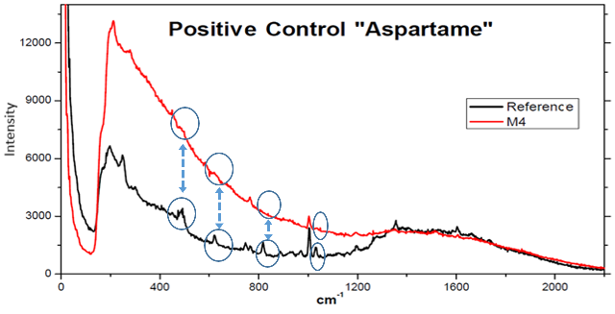**Figure 3 Aspartame Raman spectra comparison between reference al time 0 and at 4 weeks (M4).**

**3.2 Chromatographic method to determine Metformin-Glibenclamide**

It was possible to achieve the simultaneous quantification of both analytes, (Figure 4), under the specified conditions, with retention times of 2.5 minutes for Glibenclamide and 5.2 minutes for Metformin. While the blanks showed no signs of interference, a triplicate calibration curve was also performed, incorporating the formulation excipients in the intended proportions. This calibration was conducted based on dilution relative to the dissolution profile volume, with no significant variations observed in retention times.

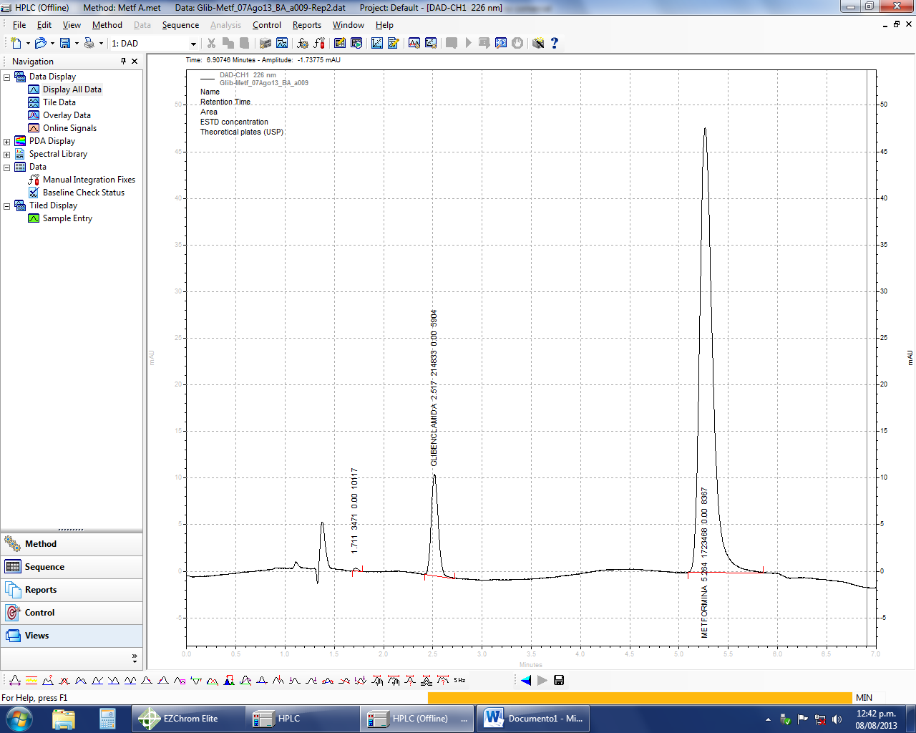

**Figure 4: Glibenclamide and Metformin chromatogram. Retention times of 2.5 min for Glibenclamide and 5.2 min for Metformin.**

**3.3 Effect of coating weight gain**

The first parameter evaluated was the effect of coating weight gain. For this purpose, three batches of 24 capsules of the FB formulation were coated with a 3% w/v cellulose acetate solution in acetone, each with different weight gains (3%, 5%, and 8%) (figure 5). An orifice of **635 ± 15 μm** was created in the osmotic systems using mechanical drilling. Figure 5 shows the osmotic capsule systems with different weight gains. The release profile obtained from this experiment indicates that weight gain impacts drug release: the higher the percentage of weight gain, the longer the lag time (**T lag**), increasing from 1.5 to 2 hours (Figure 6). However, the release rate remained linear and within an appropriate range, so a 3% weight gain was selected for the rest of the experimental design.

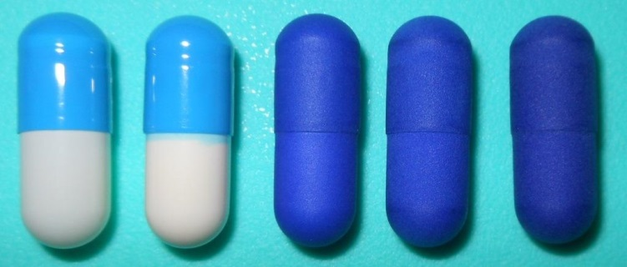

**Figure 5. Weight gain. From left to right, normal, sealed, 3%, 5% and 8%.**

For practical purposes, only the results for 3% and 5% weight gain are shown, as an 8% weight gain resulted in a delayed release time of over 6 hours. In this context, a similar study reported that with a 50 mg coating weight gain, 57% of Metformin was released at 6 hours, whereas with a 30 mg weight gain, 86% was released at 6 hours. Based on these findings, a 2% (30 mg) weight gain of cellulose acetate was selected for the remainder of their study [16].

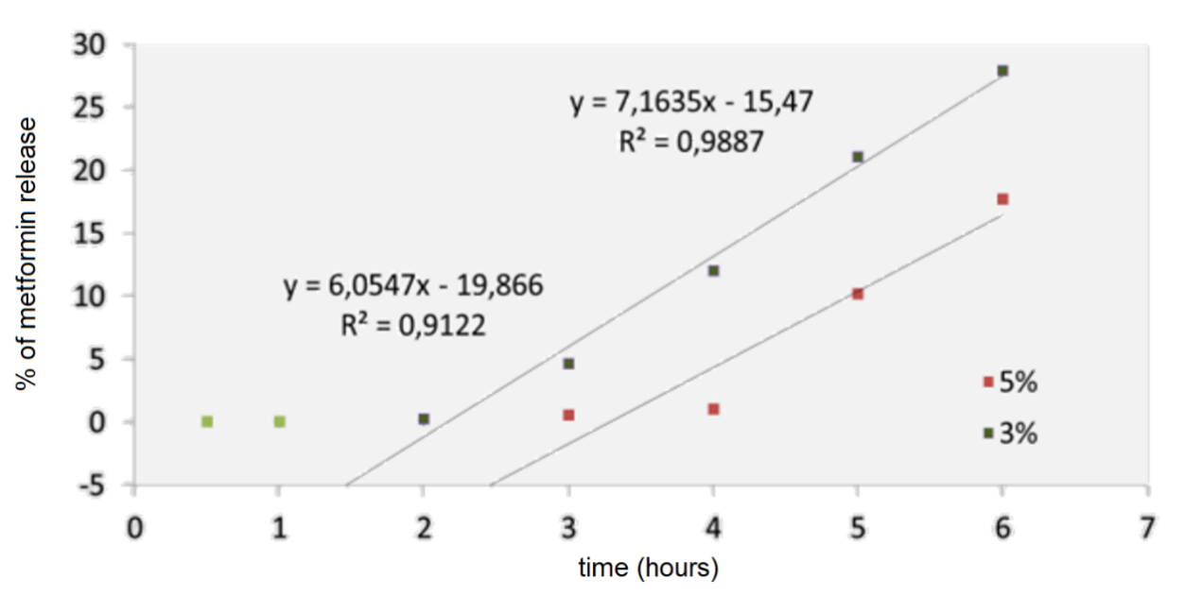

**Figure 6. Release rate of Metformin released as a function of weight gain (3% and 5%). See the impact in the lag time of the systems. The green points were not included in the reggresion analysis**

**3.4 Effect of Variation in the Amount and Type of Osmotic Agent on Release Mannitol-Sorbitol Mixture**

In Figure 7a, it can be observed that the release of Glibenclamide is influenced by the amount of the osmotic agents. The drug release percentages were 21.45% in 12.5 hours for the low level (25 mg/capsule), 28.53% for the medium level, and 32.20% for the high level. Additionally, the lag phases were also affected by the amount of osmotic agent, with a shorter lag phase at the high level.

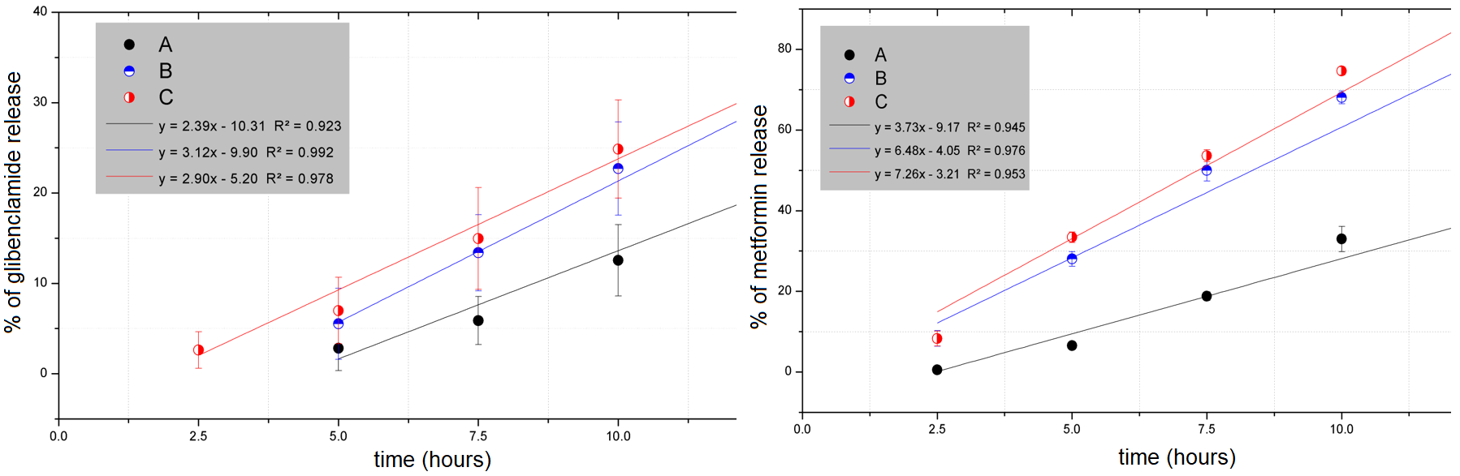

**Figure 7. Effect of osmotic agent concentration on the release of a) Glibenclamide, b) Metformin. With 25 (●), 50 ( )and 100 mg ( ) of osmoitic agent respectivelly**

**Table 3. Responses of the osmotic pumps: % release at 12.5 h, release rate and Lag time. For the Metformin and for Glibenclamide results.**

|  |  |  |  |  |
| --- | --- | --- | --- | --- |
| 1. **Glibenclamide** | | | | |
| **Formulation** | **Level** | **% release at 12.5 h** | **Slope (release rate)** | **Lag time(h)** |
| **A** | Low (25 mg) | 21.45 | 2.39 | 4.31 |
| **B** | Medium (50 mg) | 28.53 | 3.12 | 3.17 |
| **C** | High (100 mg) | 32.20 | 2.90 | 1.79 |
| 1. **Metformin** | | | | |
| **Formulation** | **Level** | **% release at 12.5 h** | **Slope (release rate)** | **Lag time(h)** |
| **A** | Low (25 mg) | 46.39 | 3.73 | 2.45 |
| **B** | Medium (50 mg) | 77.22 | 6.48 | 0.625 |
| **C** | High (100 mg) | 82.42 | 7.26 | 0.44 |

With Mannitol alone, the release percentage was lower, but it increased when Sorbitol was used as the osmotic agent or when the osmotic agent amount was high. The best condition was achieved with a combination of Sorbitol and a high amount of osmotic agent (Figure 8).

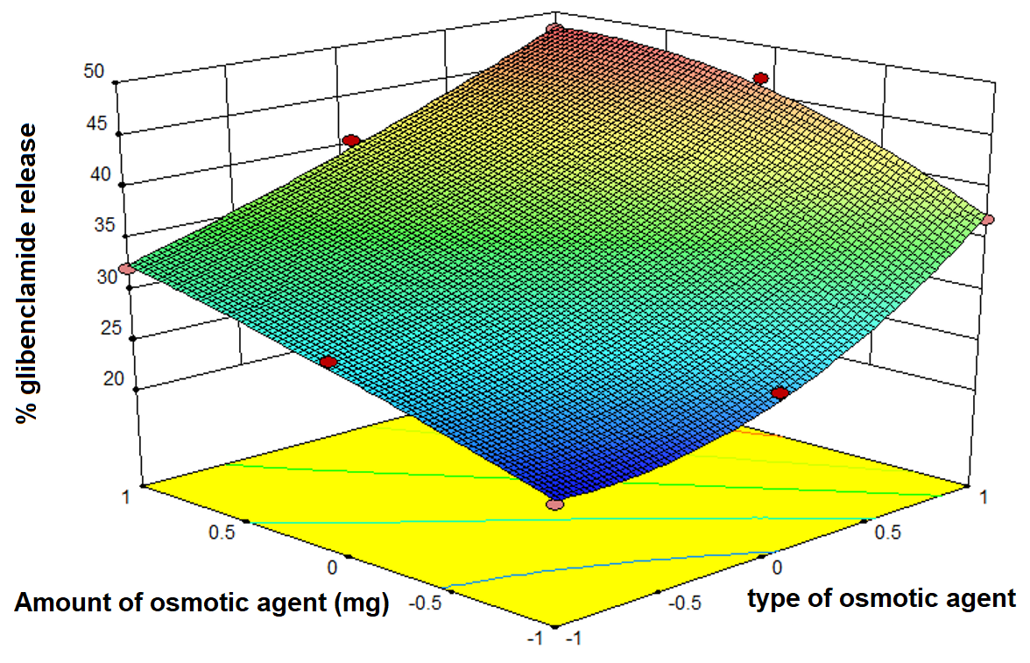

**Figure 8. Percentage of Glibenclamide released according to type and amount of osmotic agent (Formulation; -1=mixture 1:1, 0=mannitol, 1=sorbitol)**

The 1:1 Mannitol-Sorbitol mixture in this study showed a reduction in osmotic potential, with Mannitol exhibiting lower osmotic potential and Sorbitol providing the highest osmotic potential, as seen in Figure 9. The optimal lag time was achieved when both the highest level of osmotic agent (Sorbitol) and the highest amount (100 mg) were present in the osmotic system.

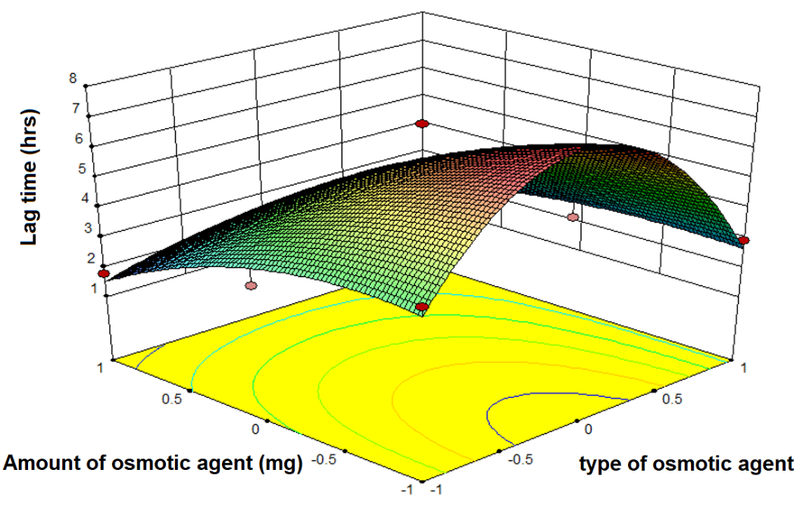

**Figure 9. Lag time depending on type and amount of osmotic agent**

|  |  |
| --- | --- |
|  |  |

**Figure 10a. Percentage of Metformin released according to type and amount of osmotic agent. 10b Percentage of Glibenclamide released according to type and amount of osmotic agent**

**3.5 Optimal formulation**

**Table 4. Graphical optimization for Metformin** **with conditions like metformin better release rate and the lower Lag time, in all the range of quantity and type of osmotic agent**

|  |  |
| --- | --- |
| **Conditions/ Response** | **Desirability answer** |
|  | |

**Table 5. Graphical optimization for Glibenclamide** **with conditions like Glibenclamide better release rate, the lower Lag time, Sorbitol level (+), in all the range of quantity of osmotic agent**

|  |  |
| --- | --- |
| **Conditions/ Response** | **Desirability answer** |
|  | |

**4. Discussion**

The results from the compatibility study, all of the excipients selected were compatible and possible to use inside of the osmotic capsule. The use of aspartame like a positive control was a good option to demonstrate the compatibility and stability of mixtures under the accelerated conditions. In a recent study by Nilsson, 2023 [17], the use of Raman in compatibility studies is a very good option because do not use solvents and the samples cold be the same because the technique is not destructive. Raman spectroscopy could prove a powerful tool for studying compatibility in complex infusion regimens, especially precipitations originating from incompatibilities. Recent development of handheld instrumentation opens up an attractive opportunity to bring vibrational spectroscopy into a hospital setting.

Raman spectroscopy in the chemical analysis the detection and identification of drug traces in particular [18]. Raman hyperspectral imaging data was used to reliable spectral identification of complex pharmaceutical formulations [19]. The Raman imaging technique can obtain spatial and chemical information that is useful for characterizing drug quality [20]. Raman spectroscopy can be used to identify counterfeits and quantify drug content [21].

The chromatographic method obtained a good retention times for both drugs, this method allowed to quantify both drugs with excellent resolution. The coating weight gain showed that the 3% was the better result, the better release profiles and reduced lag times. The 8% of weight gain delayed the start of the release for more than 6 hours.

It is worth noting that there was a strong similarity between the high and medium levels in terms of release behavior, with a 3.67% difference in Glibenclamide release, a 0.22 difference in release rate, and a 1.38-hour difference in the lag phase. Specifically, for Glibenclamide, the release percentage followed a linear pattern, as expected.

The most important findings indicate that the release rate for both drugs remained linear for 12.5 hours, with the lag time being close to zero (Table 3).

The lag time in the systems was better when the highest level of osmotic agent (sorbitol) and the highest amount of the osmotic agent (100 mg) were present in the osmotic system.

**Optimal formulation by statistical analysis**

According to the graphical optimization generated by the Design Expert software, when the criteria included a higher amount of osmotic agent, the use of Sorbitol as the osmotic agent, and the highest percentage of Metformin, the desirability was close to 0.8 or higher. Running a second optimization, when the highest release rate for Metformin was considered optimal, the desirability increased to 0.935. Finally, when the lag phase was included, defining the lowest value as optimal, a desirability region of 0.928 was obtained (Table 4).

Similarly, the same optimization procedure was applied for Glibenclamide. The desirability reached 1.0 with a higher quantity of osmotic agent (100 mg) and Sorbitol, as well as the percentage release of Glibenclamide. When the Glibenclamide release rate was considered, the desirability decreased to 0.891, with optimal prediction found using Sorbitol and an amount ranging of 0.61. Finally, when the lag time was added, the desirability increased to 0.894.

The highest percentage of Metformin release was observed when a high amount of osmotic agent was used, particularly when Sorbitol was the osmotic agent. Thus, the optimal Metformin release was achieved with a combination of Sorbitol and a high amount of osmotic agent (Figure 10a). As shown in Figure 10b, the highest level of osmotic agent (Sorbitol) and the highest amount (100 mg) resulted in the best release rate. In our study, the percentage of drug release was 48.08% for Glibenclamide and 83.56% for Metformin.

The osmotic agents Mannitol and Sorbitol exhibited low osmotic pressure in the range of 38-84 atm. These agents were chosen considering that patients with metabolic syndrome or hypertension could safely use these oral osmotic systems without activating the reninangiotensin system, which is triggered by micro- and even nano-molar amounts of sodium chloride [22].

Based on the results of the experimental design, the formulation that exhibited the best performance for the release of both Glibenclamide and Metformin was the **FI** experiment. Comparatively, data from Ouyang [16] demonstrated an optimal formulation of an elementary osmotic pump, which released 94% of Glipizide and 95% of Metformin over 10 hours at pH 6.8, with correlation coefficients (**r²**) of 0.9472 and 0.9795, respectively.

There are many studies with osmotic pumps, but almost all of them ignores the relevance of the Lag time. In comparison with Hu et al [23], they made a sandwich osmotic pump capsule they obtain zero order release for metformin and glicazide, they obtained better release but design a more complicated system and they need a solid self-microemulsion technology to solve the problem of drug solubility. But, never mentioned the lag time in their study, and in some cases the lag time were more than 2 hours.

In the study of Kulvanich, 2022[24] using crosslinked gelatin capsule to study the delivery of drugs with different water solubilities, but the authors never mentioned the lag time of their osmotic systems and presented lag times between 2 or 4 hours, that results were worst than presented in this study. In the study of Rongfeng Hu, 2020 [25] using Novel Colon-Specific Osmotic Pump Capsule to study the delivery of Compound Danshen, but the authors never mentioned the lag time of their osmotic systems and presented lag times between 2 or 8 hours, that results were worst than presented in this study, their optimal systems presented 3 hours to start the release.

In the study of Rongfeng Hu, 2019 [26] using novel enteric positioning osmotic pump capsule to study the delivery of sinomenine hydrochloride, but the authors never mentioned the lag time of their osmotic systems and presented lag times between 2 or 4 hours, that results were worst than presented in this study, their optimal systems presented 2 hours to start the releaseand when obtain the Plasma concentration–time curves their system star release at 3 hours and a Cmax in 7 hours.

In the study of Ashish Manigauha, 2010 [27] using Osmotic Capsular Pump to study the delivery of Diclofenac Sodium, but the authors never mentioned the lag time of their osmotic systems and presented lag times between 2 or 3 hours, that results were worst than presented in this study, their optimal systems used sodium lauryl sulphate provided sustained release for 7 hour. In the study of Kenneth C. Waterman, 2011 [28] using Osmotic Capsules like a Universal oral dosage dorm, but the authors never mentioned the lag time of their osmotic systems and long duration systems presented lag times between 1 to 3 hours, that results were worst than presented in this study, their optimal systems presented 1 hours to start the releaseand needed to add 1% SLS for drugs with low solubility (carbamazepine).

In the study of Yang Lui, in 2021[29] using osmotic pump capsules containing polyoxyethylene and pH modifier to study the delivery of nifedipine, but the authors never mentioned the lag time of their osmotic systems and presented lag times between 1 or 2 hours, that results were worst than presented in this study, their optimal systems using citric acid presented 2-3 hours to start the release. In our study the size of the orifice were 600 mm, so the size of the orifice could reduce the rate of delivery. In a recent study with push-pull osmotic pump tablets and modelling with discrete element method, Yanping in 2024 [30] found that enlarged delivery orifice significantly increases both the total drug release and the drug release rate. This study has the problem that presented burst effect and a 15% of release of the drug at the beginning of the release.

In a study with the novel enteric osmotic pump capsule for Metfomin, Rongfeng [31] found linear release, but the lag time was in average of 2 hours for the 17 systems studied.

For future development, osmotic capsules containing Metformin and Glibenclamide may require a higher amount of osmotic agent to enhance prolonged performance or increase the orifice size. Additionally, incorporating a surfactant in the osmotic core could improve the solubility of Glibenclamide, facilitating and increasing its release An study with a Novel Colon-Specific Osmotic Pump Capsule developed by Ronfeng [32] to deliver herbal extract found lag times between 2 to 6 hours but used several solubility enhancers like a HP-b-cyclodextrin, b-cyclodextrin, SDS and F68. The better solubility enhancer was the HP-b-cyclodextrin, so this is an alternative to increase the solubility of our system and increase the release rate.

There are one study where consider to report the lag times and their results were as good as our results, this study was developed by Kushner et al. [33] using the extrudable core system osmotic delivery technology. The only system to presented a lower lag times than our systems was the Dry powder coated osmotic drug delivery system developed by Jesse,2018 [34].

5. Conclusion

The Raman compatibility study proved to be adequate and complementary, providing chemical-structural information on possible interactions under heat stress conditions. It is also a versatile, inexpensive, and non-destructive method compared to other techniques.

The filling, sealing, and coating processes for hard gelatin capsules were effective in creating osmotic systems, as these processes were uniform, viable, and reproducible, facilitating the formation of a semipermeable membrane for controlled-release osmotic capsules. A 3% weight gain was determined to be the most suitable for the experimental design. The FI formulation delivered 48.08% of the Glibenclamide dose and 83.56% of the Metformin dose over 12.5 hours, with release rates of 4.44%/hr and 7.16%/hr, respectively. The best formulation also exhibited lag times of 2.09 hours for Metformin and 0.18 hours for Glibenclamide, indicating that the release is dependent on the amount and type of osmotic agent used in the formulation. The developed osmotic system serves as a robust starting point, achieving the highest release value, the shortest lag time, and demonstrating zero-order behavior over the 12.5-hour release period. The limited release rate of Glibenclamide may be attributed to its solubility constraints.

The 1:1 Sorbitol:Mannitol mixture led to a reduction in osmotic potential. The combination of a high amount of Sorbitol as the osmotic agent, with the use of capsules that did not disintegrate, effectively reduced the lag time of the systems. The desirability obtained for metformin and glibenclamide was higher than 0.8, so the experimental design meets the conditions to ensure the better osmotic capsule formulation.

COMPETING INTERESTS DISCLAIMER:

Authors have declared that they have no known competing financial interests OR non-financial interests OR personal relationships that could have appeared to influence the work reported in this paper.

Disclaimer (Artificial intelligence)

Option 1:

Author(s) hereby declare that NO generative AI technologies such as Large Language Models (ChatGPT, COPILOT, etc.) and text-to-image generators have been used during the writing or editing of this manuscript.

Option 2:

Author(s) hereby declare that generative AI technologies such as Large Language Models, etc. have been used during the writing or editing of manuscripts. This explanation will include the name, version, model, and source of the generative AI technology and as well as all input prompts provided to the generative AI technology

Details of the AI usage are given below:

1.

2.

3.

References

1 Fleck A. **Diabetes Cases Are Climbing.** International Diabetes Federation.https://www.statista.com/chart/23491/share-of-adults-with-diabetes-world-region/

2 Basto-Abreu A., Reyes-Garcia A., Stern D. 2010. [**Type 2 diabetes screening and care cascades in Mexico]**. Salud Publica Mex. 2024;66:530-538**.** [***https://doi.org/10.21149/16209***](https://doi.org/10.21149/16209)

3 Lorenzo-Fernández P., Alfaro Ramos MJ., Lizasoain Hernández I., et al. 2008. **Velázquez; Farmacología Básica y Clínica**, 18a ed. Farmacología Básica y Clínica. Madrid, España. 621.

4 Joslin Diabetes Center. 2014. URL <https://joslin.org/news-stories/all-newsstories/> education/2020/03/what-type-2-diabetes

5 Altagracia Martínez M., Kravzov Jinich J., Moreno Santamaría MR., et al. [**Type 2 diabetes mellitus: sales of oral hypoglycemic agents and costs of pharmacological treatments in Mexico].** Revista Mexicana de Ciencias Farmacéuticas. 2007. 38: 27–28.

6 Figueroa-Gaspar M., Marín-Mendoza E., Chávez-Briseño É. et al. **Cost Effectiveness of type 2 diabetes treatment at first level of care**. Horizonte sanitario / *vol. 21, no. 2,* mayo - agosto 2022. 204- 213.

7 Sabyasachi G. Osmotic Pump Market Growth – Trends & Forecast 2024-2034. <https://www.futuremarketinsights.com/reports/osmotic-pumps-market>

8 Almoshari Y**. Osmotic Pump Drug Delivery Systems—A Comprehensive Review. Pharmaceuticals 2022, 15, 1430.** [**https://doi.org/10.3390/ph15111430**](https://doi.org/10.3390/ph15111430)

9 Manman L., Qiang S., Wenjie L. et al. **Development and evaluation of controlled release of metformin hydrochloride for improving the oral bioavailability based on a novel enteric osmotic pump capsule**. Journal of Drug Delivery Science and Technology Vol. 60, Dec. 2020, 102054. <https://doi.org/10.1016/j.jddst.2020.102054>

10 Chao Q., Wei H., Chunli Z. et al. **Controlled release of metformin hydrochloride and repaglinide from sandwiched osmotic pump tablet**. International Journal of Pharmaceutics Volume 466, Issues 1– 2, 15 May 2014, Pages 276-285. <https://doi.org/10.1016/j.ijpharm.2014.03.002>

11Hanan M. H., Aya R. A., Nesrin F.T. et al. **Formulation and stability studies of metformin hydrochloride in a controlled porosity osmotic pump system**. Journal of Applied Pharmaceutical Science Vol. 10(04), pp 100-112, April, 2020. DOI: 10.7324/JAPS.2020.104013.

12 Saurabh G., Neelesh C., Vihangesh K.D. et al. **Development of osmotic controlled release formulation of an antidiabetic drug metformin hydrochloride**. International Journal of Pharma Sciences and Research: 2020, *Vol. 11(12): 6475-6480.*

13 García-Flores M., Melgoza-Contreras LM. and Hernández-Baltazar E. **Critical Factors for Metformin Osmotic Controlled Release Pump**. *Journal of Pharmaceutical Research International. 32(35): 1-12, 2020; Article no.JPRI.63216*

14 Cazes Jack. 2010. **Metformin and Glibenclamide: HPLC Determination, in: Encyclopedia of Chromatography**. CCR Press, Taylor and Francis Group. 1474–1477.

15 Navarro Miguel. 2012. [**Bromatological and toxicological aspects of sweeteners]** . Toxicología Alimentaria. Ediciones Díaz de Santos. Madrid, España. 481.

16 Ouyang D., Nie S., Li W., et al. 2005b. **In vitro and in vivo evaluation of two extended release preparations of combination metformin and glipizide**. Drug Development and Industrial Pharmacy. 31(7): 677-685.

17 Nilsson N., Nezvalova K., Botker J., et al. **Co-administration of Intravenous Drugs: Rapidly Troubleshooting the Solid Form Composition of a Precipitate in a Multi-drug Mixture Using On-Site Raman Spectroscopy**. *Mol. Pharmaceutics* 2023, 20, 2853−2863. <https://doi.org/10.1021/acs.molpharmaceut.2c00983>

18 Amin M., Al.Hetlani E., and Lednev I. **Detection and identification of drug traces in latent fingermarks using Raman spectroscopy. *Scientific Reports* (2022)volumen 12, Article number: 3136.** 19 Coic L., Sacre P.I., Dispas A. et al. **Pixel-based Raman hyperspectral identification of complex pharmaceutical formulations**. Analytica Chimica Acta 1155 (2021) 338361. <https://doi.org/10.1016/j.aca.2021.338361>

19 Coic L., Sacre P.I., Dispas A. et al. **Pixel-based Raman hyperspectral identification of complex pharmaceutical formulations**. Analytica Chimica Acta 1155 (2021) 338361. https://doi.org/10.1016/j.aca.2021.338361

20 Tang Y., Wang X., Shou G., et al. **Research Progress of Raman Spectroscopy and Imaging Techniques for the Pharmaceutical Analysis**. Journal of Analysis and Testing (2025) 9:136–152. <https://doi.org/10.1007/s41664-024-00327-w>

21 Zeng Q., Wang l., Wu S., et al. **Research progress on the application of spectral imaging technology in pharmaceutical tablet análisis**. International Journal of Pharmaceutics 625 (2022) 122100. <https://doi.org/10.1016/j.ijpharm.2022.122100>

22 Lorenzo Fernández P., Alfaro Ramos M. J. Lizasoain Hernández I., et al. 2008. **Velázquez; [Basic and Clinical Pharmacology]** , 18a ed. Farmacología Básica y Clínica. Madrid, España. 621.

23 Song Gaoa, Yanjun Chena, Rongfeng Hua, et al. **Visualized analysis and evaluation of simultaneous controlled release of metformin hydrochloride and gliclazide from sandwiched osmotic pump capsule**. Drug Development and Industrial Pharmacy. 2020, VOL. 46, NO. 11, 1776– 1786. <https://doi.org/10.1080/03639045.2020.1821047>

24 Chaowalit Monton, Poj Kulvanich. **Push‑Pull Osmotic Pumps Using Crosslinked Hard Gelatin Capsule as a Structural Assembly for Delivery of Drugs with Different Water Solubilities**. Journal of Pharmaceutical Innovation (2022) 17:791–805. <https://doi.org/10.1007/s12247-021-09562-5>

25 Song G., Yanjun C, Hu R. et al. **Visualized analysis and evaluation of simultaneous controlled release of metformin hydrochloride and gliclazide from sandwiched osmotic pump capsule**. Drug Development and Industrial Pharmacy. 2020, VOL. 46, NO. 11, 1776–1786. <https://doi.org/10.1080/03639045.2020.1821047>

26 Suna Y., Shuangshuang Z., Wenjie L., et al. **A novel enteric positioning osmotic pump capsulebased controlled reléase system of sinomenine hydrochloride: *In vitro and in vivo* evaluation**. Journal of Drug Delivery Science and Technology 49 (2019) 188–194. <https://doi.org/10.1016/j.jddst.2018.11.005>

27 Chandy A., Jharia M. and Manigauha A. **Fabrication and evaluation of osmotic capsular pump for controlled drug delivery**. International Journal of Pharmacy and Pharmaceutical Sciences. Vol 2, Issue 1, 2010. 99-103.

28 Waterman KC., Goeken G.S. , Konagurthu S., et al. **Osmotic capsules: A universal oral, controlledrelease drug delivery dosage form**. Journal of Controlled Release 152 (2011) 264–269. doi:10.1016/j.jconrel.2011.02.001

29 Jiaojiao Y., Meng X., Dong X. et al. **Synthesis and characterization of osmotic pump capsules containing polyoxyethylene and pH modifier to control the release of nifedipine**. European Journal of Pharmaceutics and Biopharmaceutics 163 (2021) 102–108. <https://doi.org/10.1016/j.ejpb.2021.03.014>

30 Jiawei H., Ling Z., Yanping H., et al. **Modelling the controlled drug release of push-pull osmotic pump tablets using DEM**. International Journal of Pharmaceutics 660 (2024) 124316. <https://doi.org/10.1016/j.ijpharm.2024.124316>

31 Manman L., Qiang S., Rongfeng H. et al. **Development and evaluation of controlled release of metformin hydrochloride for improving the oral bioavailability based on a novel enteric osmotic pump capsule**. Journal of Drug Delivery Science and Technology 60 (2020) 102054. <https://doi.org/10.1016/j.jddst.2020.102054>

32 Xiangjiang N. Bin W., Rongfeng H. **Development and Evaluation of Controlled and Simultaneous Release of Compound Danshen Based on a Novel Colon-Specific Osmotic Pump Capsule**. AAPS PharmSciTech (2020) 21: 38. DOI: 10.1208/s12249-019-1603-9.

33 Kushner J, Lambaa M., Stock T. **Development and validation of a Level A *in-vitro in-vivo* correlation for tofacitinib modified-release tablets using extrudable core system osmotic delivery technology**. European Journal of Pharmaceutical Sciences 147 (2020) 105200. <https://doi.org/10.1016/j.ejps.2019.105200>

34 Qingliang Y., Yingliang M., Jesse Z. **Dry powder coated osmotic drug delivery system**. European Journal of Pharmaceutical Sciences 111 (2018) 383–392. <http://dx.doi.org/10.1016/j.ejps.2017.10.001>