Review Article

# 

**Traditional and Pharmacological Properties of Anti-Malarial Plant Species of Jharkhand, India**

**Abstract**

Malaria is one of the major **vector-borne diseases** in Jharkhand and other states of India with significant morbidity and mortality. The challenge of drug resistance to anti-malarial medicines has been a major obstacle controlling malarial disease. The National Vector Borne Disease Control Programme has formulated new treatment guidelines for malaria that recommend phytochemical constituent artemisinin based combination therapy as the first-line drugs for *P.falciparum* malaria. The demand of plant based anti malarial drugs has been increased in the world. Therefore, it is important to find out effective plant species which are traditionally used by the tribal and rural people since time immemorial. The present review work aims to identify plants with Anti-malarial properties which were used by the tribal and local communities by applying prevalent traditional knowledge system.

**Keyword:** Anti-Malarial Plants, Traditional and Pharmacological Uses, Vector Borne Disease, Jharkhand

**Introduction**

Romans and Greeks postulated that intermittent fevers were due to the 'bad odour' coming from the marshy areas and thus gave the name 'malaria' ('mal'=bad + 'air') to intermittent fevers. Malaria is an acute febrile illness caused by Plasmodium parasites, which are spread to people through the bites of infected female Anopheles mosquitoes. Five species of parasites can cause malaria in humans and two of these species are *Plasmodium falciparum* and *Plasmodium vivax* pose the greatest threat. There are over 400 different species of *Anopheles* mosquitoes of which around 40 are known as vector species, can transmit the disease. It is both preventable and curable. However, without prompt diagnosis and effective treatment, a case of uncomplicated malaria can progress to a severe form of the disease, which is often fatal without treatment. Malaria is a life-threatening disease primarily found in tropical and subtropical countries. This risk of infection is higher in some areas than others depending on multiple factors, including the type of local mosquitoes. It may also vary according to the season, the risk being highest during the rainy season in tropical countries (WHO).

Nearly half of the world’s population is at risk of malaria. In 2022, an estimated 249 million people contracted malaria in 85 countries. Infants and children under 5 years of age, pregnant women and patients with HIV/AIDS are more susceptible to developing severe malaria than others. Malaria is a treatable disease. Artemisinin-based combination therapies (ACTs) are the most effective antimalarial medicines available today and the mainstay of recommended treatment for *Plasmodium falciparum* malaria, the deadliest malaria parasite globally. ACTs combine two active pharmaceuticals with different mechanisms of action, including derivates of artemisinin extracted from the plant *Artemisia annua* and a partner drug. Over the last decade, [parasite](https://www.who.int/publications/m/item/WHO-UCN-GMP-2020.07) [resistance to antimalarial medicines](https://www.who.int/publications/m/item/WHO-UCN-GMP-2020.07) has emerged as a threat in the fight against malaria (WHO).

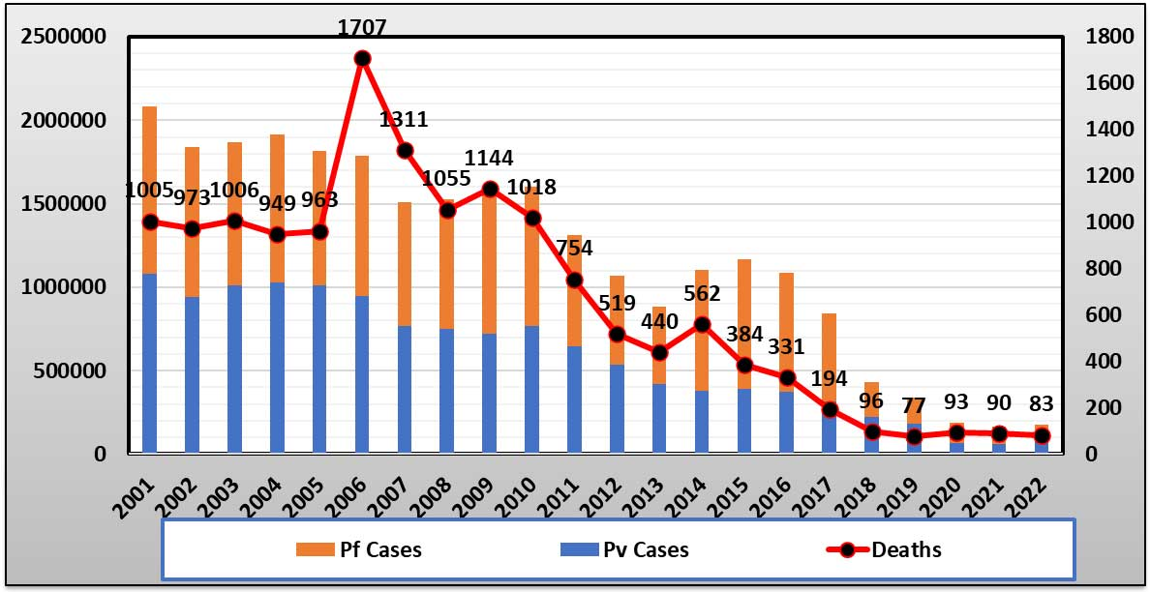Malaria has been a major public health problem in India intermittent fever with high incidence during the rainy season. About 95% population in the country resides in malaria endemic areas and 80% of malaria reported in the country is confined to areas consisting 20% of population residing in tribal, hilly, difficult and inaccessible areas.

Fig1:Magnitude of Malaria in India (NCVBDC)

Today, malaria and other vector-borne diseases are the most widespread cause of death, disability and economic loss in India especially among the poor who have limited access to timely and effective treatment. Malaria also contributes to maternal deaths, stillbirths, and low birth weight in infants as young children and pregnant women have little or no immunity to the disease. Moreover, a severe and often fatal form of malaria that accounts for almost all malaria-related deaths *Plasmodium falciparum* has been rising rapidly in India since the 1980s. Some analysts estimate that the total number of malaria cases in India could well range between 60-75 million each year. The most malaria-prone areas in India are also among its poorest. While malaria is now on the rise in urban India, nearly half of all malaria cases are reported from Orissa, Jharkhand, and Chhattisgarh which have sizeable tribal populations living in the remote rural areas as well as West Bengal (https://[www.worldbank.org).](http://www.worldbank.org/) The Government of India, in 2016, adopted a framework for Malaria Elimination in India covering the period 2016 to 2030. This was based on WHO’s Global Technical Strategy for Malaria, covering the same period, adopted in 2015 and updated in 2021(WHO 2016).

In India, tribal communities and particularly vulnerable tribal groups (PVTGs) live in inaccessible forests, hills, valleys, and perennial streams. This topography and environmental potential for vector growth and the proliferation of parasite is susceptible to the human population that has resulted in a strong transmission of malaria (Singh 1996). Jharkhand state in the eastern region of India contributes 6.8% of PVTGs to the overall population of PVTGs living in India and is considered as one of the hot spots for malaria infection (MoTA 2015). The number of malaria cases across the state of Jharkhand in 2022 amounted to over 14.6 thousand, down from about

36.65 thousand malaria cases in 2020. A linear fall in malaria cases was noted across the state over the years from 2014, except for the rise in 2016. According to the most recent data available on the National Vector-Borne Disease Control Programme, the Annual Parasite Incidence for Jharkhand was 1.46. However, by going through the data for Jharkhand, it is seen that the Malaria problem is not equally distributed in the districts; it is focal as can be seen from the following information (NVBDCP).

Fig 2: **Number of malaria cases across Jharkhand from 2014 to 2022**

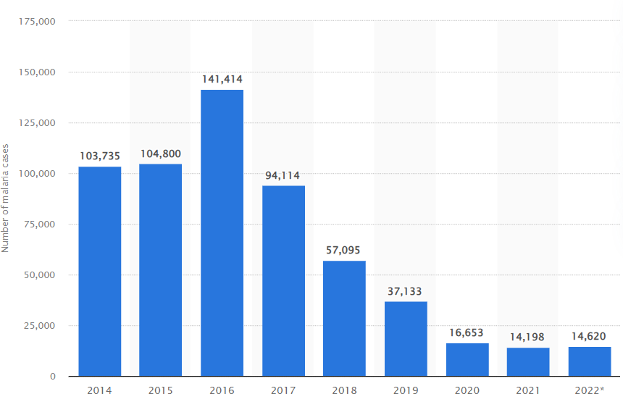

Number of malaria cases across Jharkhand from 2014 to 2022 **Source: Statistic 2024**

The modern drugs have been removed from folklore and traditional medicines. However, the perishing knowledge of herbal medicines is still being practiced by *Vaidyas* and *Hakims* in the rural areas as an art of herbal healing systems. The Ethno-medicinal studies have offered immense scope and opportunities for the development and synthesis of new drugs (Verma et al. 2007). In recent studies, chloroquine-resistant P. falciparum malaria has been observed with increasing incidence in the whole country, while it was effective for treating nearly all cases of malaria in the past (NVBDCP) 2009). As an alternative plant *Artemisia annua* is being used called artemisinin combination therapy (Qayum et al. 2015). The commercial industry on antimalarial drug is facing huge a challenge primarily due to development of drug resistance of malarial parasites. And, hence biodiscovery of antimalarial plants has become inevitable towards discovering a novel plant in order to find a lead compound towards malaria medication efforts. It is very likely that in times to come sustainable harvesting of this natural wealth needs to be done to meet the public health demands. In this circumstance, ethnopharmacological study of antimalarial plants is highly required. The native communities have been using their unique traditional knowledge (TK) system, culture, indigenous skills and expertise since the ancient times towards the disease control. TK refers to the ancient and non-conventional practices towards disease control mechanism. Local knowledge of a community is spread across various diseases and masses from developing countries utterly rely on the herbal treatment methods (Gupta et al. 2014). Jharkhand has witnessed its legacy from the ancient times for traditional knowledge for antimalarial activities of various medicinal plants. Considering the high time demand of antimalarial plant it has become inevitable to find and locate them for its optimal extraction for antimalarial actions. There are many plant species have been used for the treatment of malaria since ancient times and have established a process of Ethnopharmacological study for the disease (Bahekar and Kale 2013). The objective of the current study is to find all possible plants species of Jharkhand with antimalarial response which have been used by the local and the tribal communities. At the same time documentation of respective traditional knowledge and review of pharmacological properties of the plant species are equally important for its scientific validation. The present study will drive attention towards the conservation of valuable plant species which are on the verge of either extinction, critically endangered or vulnerable.

## Antimalarial Plant Species

The present study brings out information on different medicinal plants used in various parts of Jharkhand for the treatment of malaria according to the investigation each plant has gone through. A total of 35 most effective medicinal plants have been recorded herein for their use as antimalarials in Jharkhand folk medicine. Pharmacological study of the plants mentioned below have been tested and validated with antimalarial activity by different researchers. The phytochemical constituents of the plants could be useful in the development of antimalarial drugs to overcome the increasing resistance of *Plasmodium* to available antimalarials.

**Table 1: Anti-malarial Plant Species of Jharkhan**

|  |  |  |  |  |
| --- | --- | --- | --- | --- |
| **S. No.** | **Botanical Name** | **LocalName** | **Family** | **PartUsed** |
| 1. | *AchyranthesasperaLinn.* | Chirchita | Amaranthaceae | Root |
| 2. | *AcoruscalamusL.* | Bach | Acoraceae | Rhizome |
| 3. | *AdhatodavasicaNees* | Bakas | Acanthaceae | Root |
| 4. | *AgeratumconyzoidesL.* | Gandhri | Asteraceae | Whole plant |
| 5. | *Alstoniascholaris(L.)R.Br.* | Chhatiyan | Apocyanaceae | Leaf,Flower,Bark |
| 6. | *AndrographispaniculataWall.*  *ex Nees* | Kalmegh | Acanthaceae | Leaf |
| 7. | *AzardirachtaindicaA.Juss* | Neem | Meliaceae | Leaf,Fruit,Bark |
| 8. | *BauhiniavariegataLinn.* | Kachnar | Fabaceae | Leaf,Bark,Root |
| 9. | *BoerhaaviadiffusaL.nom.cons.* | Gadapurna/  Punarnava | Nyctaginaceae | Root |
| 10. | *CaricapapayaLinn.* | Papita | Caricaceae | Leaf |
| 11. | *Cassiafistula Linn.* | Amaltas | Fabaceae | Fruits |

|  |  |  |  |  |
| --- | --- | --- | --- | --- |
| 12. | *CissampelospareiraL* | Guapada | Menispermaceae | Root |
| 13. | *ClitoriaternateaL.* | Aprajita | Leguminosae | Leaf |
| 14. | *CorchorusolitoriusL.* | Kadoyaghas | Malvaceae | Seed |
| 15. | *CrinumasiaticumL.* | BanPyaj, | Amaryllidaceae | Bulb |
| 16. | *CurculigoorchioidesGaertn* | ChhotaMusli | Hypoxidaceae | Rhizome |
| 17. | *CuscutareflexaRoxb.* | Amarbel | Convolvulaceae | Tendril |
| 18. | *Ecliptaprostrata(Linn.)Linn* | Bhringraj | Asteraceae | Leaf,Root,Stem |
| 19. | *Elephantopusscaber L.* | Ishwarjata | Compositae | Leaf |
| 20. | *Ficus racemosa* | Dumar/Gular | Moraceae | Bark |
| 21. | *Holarrhenapubescens* | Indrajau | Apocynaceae | Seed |
| 22. | *Lantanacamara Linn* | Putus | Verbenaceae | Fruit |
| 23. | *Leucas aspera* | Dron Puspi | Lamiaceae | Whole plant |
| 24. | *Madhucalongifolia* | Mahua | Sapotaceae | Seed |
| 25. | *Nyctanthesarbor-tristisLinn.* | Harsingar | Oleaceae | Leaf, Fruit |
| 26. | *OcimumsanctumLinn.* | Tulsi | Lamiaceae | Leaf, Seed |
| 27. | *Piperlongum Linn.* | Pipri/Pipli | Piperaceae | Fruits |
| 28. | *Pongamiapinnata (L.)* | Karanj | Fabaceae | Kernel |
| 29. | *Shorearobusta* | Sal/Sakhua | Dipterocarpaceae | Resin |
| 30. | *SolanumindicumLinn.* | Banbhanta | Solanaceae | Fruit,Root |
| 31. | *SolanumnigrumLinn.* | Banphutka | Solanaceae | Fruit |
| 32. | *Soymida febrifuga* | Rohini | Meliaceae | Bark |
| 33. | *SwertiachirataBuch.Ham* | Chirayta | Gentianaceae | Whole plant |
| 34. | *Syzygiumjambos* | Jamun | Myrtaceae | Seed |
| 35. | *Tinosporacordifolia(Thunb.)*  *Miers.* | Grudch/Giloi | Menispermaceae | Stem |

**Table 2 :**

**Traditional Uses**

|  |  |  |
| --- | --- | --- |
| **Botanical Name** | **Uses** | **Photographs** |
| *Achyranthes aspera* | The dried root of the plant is grinded with black pepper and mixed in a cup of water.  (KitikarandBasu1975) |  |
| *Acorus calamus* | Rhizome is pasted and applied to the entire body to cure malarial fever. The odorous fresh rhizomes are kept in their huts as a mosquito repellent.  (Kitikar and Basu 1987) |  |
| *Adhatoda vasica* | The whole plant is boiled for 30 minutes and the resultant decoction is given (1 spoonful) orally twice a day in the treatment of malaria. Leaf juice (1 spoonful) is given orally with honey for 1 week in the treatment of cerebral malaria.  (Sampath et al. 2010) |  |
| *Alstonia scholaris* | The root of the plant is boiled in water. Decoction is used in the treatment of malaria.  (Kitikar and Basu 1975) |  |
| *Andrographis paniculata* | The whole plant is dried and made into powder. The powder (one teaspoonful per day) is given orally to all members of the family continuously for 30 days to prevent malaria.  (Kitikar and Basu 1975) |  |

|  |  |  |
| --- | --- | --- |
| *Azardirachta indica* | Wood or branches with leaves are burnt and the smoke is used to ward off the mosquitoes from their huts/premises. Flower of the neem is soaked in a glass of water and taken to the patient early morning for five days.  (Kitikar and Basu 1975) |  |
| *Bauhinia variegata* | Decoction of leaf and flowers are given to the malarial patient for three days.  (Kitikar and Basu 1975) |  |
| *Boerhaavia diffusa* | Whole plant part is washed and grinded with water and a pinch of salt. Given to the patient for five days.  (Kitikar and Basu 1975) |  |
| *Carica papaya* | Decoction of fresh leaf is grinded along with pepper and water. The preparation is given to the patient every morning.  (Kitikar and Basu 1975) |  |
| *Cassia fistula* | Fruit of the plant species is used after decoction. (Kitikar and Basu 1975) |  |
| *Cissampelo spareira* | Roots are washed properly and soaked in milk and given daily in the treatment of malarial fever. Leaf juice is also given twice a day to a patient of malaria till relieved.  (Kumari et al. 2021) |  |

|  |  |  |
| --- | --- | --- |
| *Clitoria ternatea* | Leaf extract is poured into nostrils of the patient in the treatment of malaria fever.  (Malabadietal.2005) |  |
| *Corchorus olitorius* | Seeds are pasted with water and the preparation is given for 5 days in the treatment of malaria.  (Nakaziba,Rebecca,etal.2020) |  |
| *Crinum asiaticum* | Bulbs juice is extracted and given orally in the treatment of malaria.  (Taek et al. 2018) |  |
| *Curculigo orchioides* | Rhizomes of the plant are grinded and given in the treatment of malaria.  (KitikarandBasu1975) |  |
| *Cuscuta reflexa* | Tendril (20 gm) of the *Cuscuta* is grinded with water and black peppers. Given to the patient every morning and evening.  (Kitikar and Basu 1975) |  |
| *Eclipta prostrata* | Whole plant is grinded in paste form and mixed with water. It is used by the malarial patients.  (Kitikar and Basu 1975) |  |
| *Elephantopus scaber* | Leaves of the herb are pasted and taken with water in empty stomach daily in the treatment of malarial fever.  (Avani and Neeta 2005) |  |

|  |  |  |
| --- | --- | --- |
| *Ficus racemosa* | The bark of the plant is mixed with different parts of 40 other plants and made a remedy, which is given daily up to cure in the treatment of malaria.  (Rahuman et al. 2008) |  |
| *Holarrhena pubescens* | Seed oil (10 ml) is taken orally for 5 days in the treatment of malarial fever.  (Verma et al. 2011) |  |
| *Lantana camara* | Decoction of the plant parts is used by malarial patient.  (Kitikar and Basu 1975) |  |
| *Leucas aspera* | Whole plant extract (5 ml) is given with honey in the treatment of malarial fever with a migraine.  (Das et al. 2012) |  |
| *Madhuca longifolia* | Seed oil is applied immediately on mosquito bitten part of the body to avoid malaria.  (KitikarandBasu1975) |  |
| *Nyctanthe sarbor-tristis* | Decoction of seed is used by malarial patient. (Kitikar and Basu 1975) |  |
| *Ocimum sanctum* | Decoction of whole plant parts is taken every morning and evening to the patient.  (Pandey and Tripathi 2010) |  |

|  |  |  |
| --- | --- | --- |
| *Piper longum* | The fruit of piper is grinded with water and given 10 ml every morning to the patient suffering from malaria.  (Kitikar and Basu 1975) |  |
| *Pongamia pinnata* | Decoction of fruit pills is given to the patient. (Kitikar and Basu 1975) |  |
| *Shorea robusta* | Resin of sal tree is collected and burnt to repel mosquitoes from their huts and premises.  (Local Tribal Knowledge) |  |
| *Solanum indicum* | Ripened fruits are directly given to the patient. Root is grinded with water and given to the malarial patient.  (Kitikar and Basu 1975) |  |
| *Solanum nigrum* | Ripe fruit juice of Solanum nigrum is given in case of malaria.  (Rahman and Husen 2024) |  |
| *Soymida febrifuga* | Bark powder of *Soymida febrifuga* is given orally in the treatment of malarial fever up to cure.  (Lee 2002) |  |

|  |  |  |
| --- | --- | --- |
| *Swertia chirata* | Swertia chirata is used as a preventative measure for malaria during epidemics. Whole plant decoction is given every morning and evening.  (Kumaretal. 2010) |  |
| *Syzygium jambos* | Seeds powder is soaked in a cup of water and used a preventive herbal medicine for malaria and other diseases.  (Maroy2018) |  |
| *Tinospora cordifolia* | Root and stem decoction is effective in case of malaria.  (Kitikar and Basu 1975) |  |

**Pharmacological Properties**

The fast spread of drug resistance encourages the search for new active compounds. There are some plant species which are traditionally used as a potential source of new drugs for malarial disease as they contain different phytochemicals with effective pharmacological activities. A large number of antimalarial compounds have been extracted from different plant species that can play a role in the development of new antimalarial drugs. Ethnopharmacological approaches appear to be promising way to find plant metabolites that could be used as templates for designing new derivatives with improved properties. These phytoconstituents belong to different classes such as [flavonoids,](https://www.sciencedirect.com/topics/chemistry/flavonoid) alkaloids and [terpenoids**.**](https://www.sciencedirect.com/topics/chemistry/terpenoid)

Flavonoids: Kolaviron is a kind of [biflavonoid](https://www.sciencedirect.com/topics/chemistry/biflavonoid) isolated from some antimalarial plant species including Garcinia. This phytoconstituent has potent antimalarial activity against *P. berghei* infection. This compound is compared with [chloroquine](https://www.sciencedirect.com/topics/chemistry/chloroquine) that has 86% suppression. Other flavonoids, such as tectochrysin, 3′-formyl-2′,4′-dihydroxy-6′-methoxychalcone, Apigenin 7-*O*- glucoside, and 8′-formyl-7-hydroxy-5-methoxyflava-none and [luteolin](https://www.sciencedirect.com/topics/chemistry/luteolin) 7-*O*-glucoside are potentially significant anti-plasmodial compouns (Joanne et al. 2009).

Alkaloids: Quinine was the first antimalarial alkaloid drug isolated from the barks of *Cinchona* species. Different alkaloids such as 7-methoxymukonal, clauraila D, [carbazole and](https://www.sciencedirect.com/topics/chemistry/carbazole-alkaloid) [Mukonal](https://www.sciencedirect.com/topics/chemistry/carbazole-alkaloid) extracted plant species of Rutaceae. Generally root of the family Rutaceae has antimalarial properties against *P. falciparum*. Other alkaloids such as 5-hydroxy-6- methoxyonychine and [acronycine](https://www.sciencedirect.com/topics/chemistry/acronycine) expressed effective antimalarial activity (Joanne et al. 2009).

Terpenes: Artemisinin, 1,2,4-trioxane [sesquiterpene](https://www.sciencedirect.com/topics/chemistry/sesquiterpene) extracted from *Artemisia annua* has effective natural potent against vector born diseases. Several [artemisinin derivatives](https://www.sciencedirect.com/topics/chemistry/artemisinin-derivative) have been tested to avoid upcoming malarial drug-resistance. The most important derivatives are [ferrocene](https://www.sciencedirect.com/topics/chemistry/ferrocene), [betulinic](https://www.sciencedirect.com/topics/chemistry/betulinic-acid) [acid,](https://www.sciencedirect.com/topics/chemistry/betulinic-acid) tormentic, [cucurbitacins](https://www.sciencedirect.com/topics/chemistry/cucurbitacin) and ferrocene-based phytochemicals which have good antimalarial response (Joanne et al. 2009).

Some steroidal [glycosides](https://www.sciencedirect.com/topics/chemistry/glycoside), such as β-sitosterol and gongroneside A have been tested and confirmed to have antimalarial properties. [Xanthones](https://www.sciencedirect.com/topics/chemistry/xanthone), such as mckeanianones and bannaxanthones as well as [neolignan](https://www.sciencedirect.com/topics/chemistry/neolignan) glycosides, such as rouremin and rourinoside have also effective antimalarial properties (Joanne et al. 2009).

**Structural formula ofthedifferentAnti-malarial phytochemicals**

fig3:

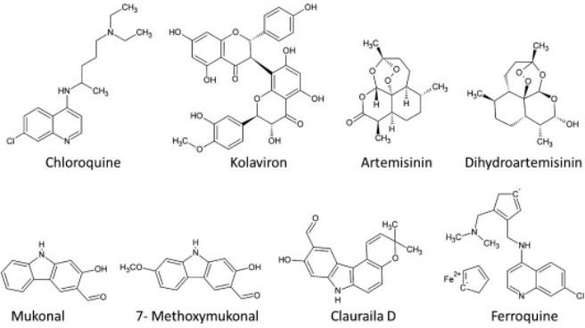

**Conclusion**

It has been reviewed that a large number of antimalarial phytoconstituents with a wide variety of structures have been extracted from medicinally important plant species that can be used in the development of new anti-plasmodial drugs. Ethnopharmacological approach is a promising alternative to search plant metabolites that could be applied in developing new drugs with effective properties. The local and tribal traditional knowledge (TK) along with modern technologies makes the study highly useful. The lack of community level awareness gives signs of over harvesting of the plant species. It has been reported that some of the plant species are in endangered condition. This review work addresses the issue of making public the availability of information of antimalarial plants for its effective and sustainable use for malaria cure locally as well as opens new ways for further research and development work.

## Future work

A detailed research work is required on the comparative analysis of different antimalarial plant species of Jharkhand for its scientific validation. The antimalarial plant species listed above can be potentially used for extracting effective phytochemiclas for the vector born diseases including malaria. The plant species can be further evaluated across its family to establish antimalarial activity relationship of various families and correlation based study can also be done to develop coefficient of correlation for a particular plant family as an antimalarial. The present findings can be extended to develop a complete roadmap of geographical health of antimalarial plants in terms of IUCN criteria of red list and for detailed ethnoecological work.

Disclaimer (Artificial intelligence)

Option 1:

Author(s) hereby declare that NO generative AI technologies such as Large Language Models (ChatGPT, COPILOT, etc.) and text-to-image generators have been used during the writing or editing of this manuscript.

Option 2:

Author(s) hereby declare that generative AI technologies such as Large Language Models, etc. have been used during the writing or editing of manuscripts. This explanation will include the name, version, model, and source of the generative AI technology and as well as all input prompts provided to the generative AI technology

Details of the AI usage are given below:

1.

2.

3.

References

Anonymous. 2015. Report of the Scheme for Development of Particularly Vulnerable Tribal Groups (PVTGS), Ministry of Tribal Affairs, Govt. of India.

Avani K, Neeta S. 2005. A study of the antimicrobial activity of *Elephantopus scaber*. *Indian J. Pharmacol* 37: 126-128.

Bahekar S, Kale R. 2013. Herbal plants used for the treatment of malaria, a literature review. *J Pharmacognosy Phytochem* 1(6):141–6.

Das S.N., Patro V.J., Dinda S.C. 2012. A review: Ethnobotanical survey of genus *Leucas*.

*Pharmacogn Rev* 6: 100-106.

Gupta A, Singh A.K., Qayum A. 2014. Evaluating ancient Indian history and culture towards malaria control measures based on traditional knowledge system. *Int J Interdiscip Multidiscip Stud* 1(8):181–90.

Joanne Bero, Michel Frédérich, Joëlle Quetin-Leclercq. 2009. Antimalarial compounds isolated from plants used in traditional medicine, *Journal of Pharmacy and Pharmacology* 61: 11: 1401–1433.

Kitikar K.R., Basu B.D. 1975. *Indian Medicinal Plants* III, Periodical experts Delhi.

Kumar K.S., Bhowmik D., Chandira M. 2010. *Swertia chirayita*: a traditional herb and its medicinal uses. *J Chem Pharm Res* 2(1):262–6.

Kumari S, Anmol, Bhatt V, Suresh P.S, Sharma U. 2021. *Cissampelos pareira* L.: A review of its traditional uses, phytochemistry, and pharmacology. *J Ethnopharmacol* 28:274:113850.

Lee, M R. 2002. Plants against malaria. Part 1: Cinchona or the Peruvian bark, *J. R. Coll.*

*Physicians Edinb* 32:189–96:191–2.

Malabadi R.B, Mulgund G.S, Nataraja K. 2005. Screening of antibacterial activity in the extracts of *Clitoria ternatea*. *J Med Arom Plant Sci* 127(1):26–29.

Maroyi, A. 2018. *Syzygium cordatum* hochst. ex Krauss: An overview of its ethnobotany, phytochemistry and pharmacological properties. *Molecules* 23(5).

National Vector Borne Disease Control Programme (NVBDCP 2009), Guidelines for diagnosis and treatment of malaria in India.

Nakaziba, Rebecca, et al. 2020. Traditional uses of *Corchorus olitorius* L in Oyam District, Northern Uganda: A cross-sectional ethnobotanical survey.

Pandey A.K., Tripathi N.N. 2010. Diversity and distribution of aromatic plants in forests of Gorakhpur division, U.P., India. *Biol Forum Int J.* 2(2):25–33.

Qayum A., Arya R., Kumar P., Lynn A.M. 2015. Socio-economic, epidemiological and geographic features based GIS-integrated mapping to identify malarial hotspot. *Malaria J.* 14:192.

Rahman S. and A. Husen. 2024. Antimalarial response, traditional and other potential uses of *Solanum* genus. Antimalarial Medicinal Plants 17:11, *Taylor & Francis Group*, CRC Press; https://doi.org/10.1201/9781003378396-17.

Rahuman, A.A., Venkatesan, P., Geetha, K*.* 2008. Mosquito larvicidal activity of gluanol acetate, a tetracyclic triterpenes derived from *Ficus racemosa* Linn. *Parasitol Res* 103: 333–339.

Singh, N., O.P. Singh, V.P. Sharma. 1996. Dynamics of malaria transmission in forested and deforested region of mandla district, Central India, Madhya Pradesh. *J Am Mosq Contr Assoc* 12:225-234.

Sampath K.P.K., B. Debjit, P.T. Chiranjib, T. Pankaj and K. Rakesh. 2010. Indian traditional herbs

*Adhatoda vasica* and its medicinal application. *J. Chem. Pharm. Res.* 2: 240-245.

Taek, Maximus M. Bambang, Prajogo E.W., Agil, Mangestuti. 2018. Plants used in traditional medicine for treatment of malaria by Tetun ethnic people in West Timor Indonesia. *Asian Pacific Journal of Tropical Medicine* 11(11):630-637.

Verma A.K., Kumar M., Bussmann R.W. 2007. Medicinal plants in an urban environment: the medicinal flora of Banares Hindu University, Varanasi, Uttar Pradesh. *J Ethnobiol Ethnomed* 3:35.

Verma, G., Dua, V.K., Agarwal, D.D. 2011. Anti-malarial activity of *Holarrhena antidysenterica* and *Viola canescens*, plants traditionally used against malaria in the Garhwal region of north-west Himalaya. *Malar J* 10:20.

World Health Organization, editor. Global Technical Strategy for Malaria 2016 – 2030 [monograph on the Internet]. Geneva.

https:/[/www.who.in](http://www.who.in/) https://ihip.mohfw.gov.in/malaria https:/[/www.worldbank.org](http://www.worldbank.org/)

Declaration of Interest Statement

**Declaration of interests**

☒ The authors declare that they have no known competing financial interests or personal relationships that could have appeared to influence the work reported in this paper.

☒ The author is an Editorial Board Member/Editor-in-Chief/Associate Editor/Guest Editor for *[Journal name]* and was not involved in the editorial review or the decision to publish this article.

☒ The authors declare the following financial interests/personal relationships which may be considered as potential competing interests: