*Original Research Article*

Naturopathic and Herbal Education in Africa: Academic and Legal Perspectives

# ABSTRACT

Background

The evolution of naturopathic and herbal education in Africa is gaining renewed attention amid growing global interest in the integration of complementary and alternative medicine (CAM) with conventional biomedical systems. As African countries seek to formalize and legitimize traditional health knowledge, naturopathic and herbal medicine education emerges as a vital component in reimagining public health systems rooted in cultural relevance and sustainability.

Aim of the Study

This study critically examines the academic and legal dimensions shaping the current landscape of naturopathic and herbal medicine education across Africa. It investigates how curriculum structures, institutional development, and regulatory frameworks influence the professionalization and public health impact of these disciplines.

Methodology and Methods

The study adopted a qualitative research design using a desk-based/secondary research approach, drawing on documentary analysis of institutional records, policy documents, academic curricula, national qualification frameworks, and relevant legislation across selected African countries. Sampling was purposive, targeting leading institutions, regulatory bodies, and policy frameworks in Ghana, South Africa, Nigeria, The Gambia, and Kenya. Data were analyzed thematically to identify patterns, gaps, and opportunities in educational and regulatory systems, employing a comparative legal and policy analysis lens.

Results and Findings

Findings reveal a fragmented yet evolving landscape where significant strides have been made in countries like Ghana and South Africa through the development of national occupational standards, TVET-based frameworks, and institutional accreditation. However, the study identifies regulatory ambiguity in several jurisdictions where naturopathy and herbal medicine remain inadequately distinguished from general traditional medicine. The absence of harmonized legal definitions and inconsistent practitioner titles undermines credibility and mobility. Furthermore, curricula often lack integration between Indigenous epistemologies and biomedical sciences, limiting interdisciplinary acceptance. National qualification frameworks and occupational standards, when properly implemented, were found to enhance legitimacy and practitioner accountability.

Conclusion and Recommendations

The study concludes that while progress is evident, the full integration of naturopathic and herbal medicine into African health and educational systems requires harmonized policy development, curriculum reform, and institutional capacity building. It recommends that African governments adopt clear legislative frameworks recognizing CAM modalities, encourage regional curriculum harmonization, and invest in educator training. Academic institutions are urged to collaborate with traditional knowledge holders and biomedical professionals to ensure culturally grounded and scientifically robust training. These steps are essential in positioning naturopathic and herbal medicine education as a foundational pillar in Africa’s pursuit of health sovereignty and self-reliant development.

**Keywords: Naturopathic education, Herbal medicine, Africa, Legal frameworks, Traditional medicine**

**1. INTRODUCTION**

This section explores the historical and contemporary relevance of naturopathy and herbal medicine within African healthcare systems. It underscores the socio-cultural significance, accessibility, and policy recognition of traditional medical practices as integral to primary healthcare delivery across the continent.

Naturopathy and herbal medicine form a foundational and enduring pillar of healthcare systems across Africa, intricately embedded in the social, cultural, and spiritual lives of numerous communities (Ikhoyameh et al., 2024; World Health Organization [WHO], 2019). In sub-Saharan Africa, traditional health practitioners (THPs)—including herbalists, spiritual healers, and community-based naturopathic practitioners—continue to serve as a primary source of healthcare for many populations. In some rural areas, the ratio of traditional practitioners to formally trained medical doctors can reach as high as 100 to 1, underscoring the accessibility, affordability, and cultural relevance of traditional medicine in these settings (Wikipedia, 2025; WHO, 2019; Wankhede et al. 2021 ). Recognizing this potential, the African Union (AU) declared 2001–2010 the Decade for African Traditional Medicine, an initiative aimed at integrating indigenous health systems into national healthcare strategies, contingent upon adherence to standards of safety, efficacy, and quality (Wikipedia, 2025).

Despite this rich heritage and widespread use, the transformation of naturopathic and herbal medicine from community practice into structured, academically grounded professions has been uneven. While some African nations have initiated pilot training programs, higher education partnerships, and regulatory frameworks, others lag in formalization and legal clarity (Ikhoyameh et al., 2024; Obu, 2025). This divergence reflects variations in political will, academic capacity, and public health priorities across the continent.

**Historical and Global Context**

Over the past two decades, traditional, complementary, and integrative medicine (TCIM) has experienced a significant resurgence globally. According to the World Health Organization’s 2019 global report, 124 out of 194 Member States—approximately 64%—reported having enacted legislation or regulatory frameworks governing herbal medicines (WHO, 2019). Within the WHO African Region, about 43% of countries have specific regulatory provisions, reflecting gradual yet uneven progress across the continent (WHO, 2019). While the expansion of national policies supporting TCIM is notable, many countries still lack comprehensive legal frameworks that delineate professional scopes of practice, educational standards, or licensure requirements for naturopathic and herbal medicine practitioners (WHO, 2019). This regulatory gap hinders professional recognition and limits the integration of these systems into formal healthcare and academic structures.

**The African Academic Landscape**

In response to growing demand, several African nations have begun formalizing naturopathic and herbal medicine education through strategic policy and institutional reforms. Ghana stands at the forefront of this movement. Nyarkotey University College of Holistic Medicine & Technology (NUCHMT), for instance, has pioneered competency-based Technical and Vocational Education and Training (TVET) programs in naturopathy and holistic health. The institution offers a structured educational ladder—from certificates and national diplomas to postgraduate degrees—that integrates naturopathic principles with public health and clinical sciences (Nyarkotey, 2025; Ikhoyameh et al., 2024). Notably, NUCHMT developed the first-ever National Occupational Standard for naturopathy in Ghana, enabling its graduates to sit for the Professional Qualifying Examination (PQE) and register with the Traditional Medicine Practice Council (TMPC), a key regulatory body under Ghana’s Ministry of Health (Nyarkotey, 2025).

In South Africa, naturopathic and integrated medicine programs are embedded within public higher education institutions. The University of the Western Cape, through its School of Natural Medicine, provides structured training primarily at the undergraduate and professional degree levels (Ikhoyameh et al., 2024). Elsewhere, countries like Kenya, Uganda, and Nigeria are making strides through national university collaborations, ministry-led pilot programs, and private colleges offering accredited herbal and naturopathic training. These efforts reflect growing institutional interest but also highlight disparities in regulatory oversight, clinical exposure, and curriculum depth.

Despite these advances, the development of a harmonized continental curriculum remains a major challenge. Educational pathways across the continent vary widely—from short-term certificate programs in herbal materia medica to full-fledged postgraduate degrees such as MSc, MTech, DTech, and PhD in naturopathy and herbal medicine. Ghana, in particular, provides a diverse spectrum of qualifications under its national TVET framework, including National Proficiency (NP), National Certificate (NC), Higher National Diploma (HND), Bachelor’s degrees (BSc/BTech), and postgraduate programs (MTech/MSc, DTech/PhD) (Nyarkotey, 2025). By contrast, Nigeria’s landscape is dominated by privately run institutions, many of which lack standardized curricula or requirements for supervised clinical training. South Africa, while university-based, offers a different academic and regulatory model, further reflecting the fragmented state of naturopathic education across the continent.

**Legal Framing: Recognition and Regulation**

The legal recognition and regulation of naturopathy and herbal medicine across Africa remain highly inconsistent, resulting in fragmented policy environments that directly affect public health integration and service delivery. Ghana stands out as a frontrunner with the enactment of the *Traditional Medicine Practice Act* (Act 575, 2000), which, although originally designed to govern traditional herbalists, has provided a limited yet functional legal basis for the inclusion of naturopathy (Obu, 2025). Ongoing advocacy efforts have led to the drafting of a proposed *Traditional and* *Alternative Medicine Bill*, anticipated in 2025, which seeks to formally distinguish and regulate complementary modalities such as naturopathy, homeopathy, Ayurveda, and osteopathy under a new merged statutory framework (Obu, 2025).

In The Gambia, traditional healers are registered under the Traditional Medicine Programme Office within the Ministry of Health. While a regulatory bill is currently being drafted to provide formal legal recognition for traditional healers, the existing framework remains primarily focused on indigenous herbal and spiritual practitioners. Naturopaths, by contrast, receive only limited and informal recognition, resulting in regulatory ambiguity for emerging complementary and naturopathic medicine practitioners (Obu, 2025).

In contrast, South Africa has established a more structured and inclusive legal system. The *Allied Health Professions Council of South Africa* (AHPCSA) provides full statutory recognition and licensure for naturopaths, clearly defining their professional scope, education requirements, and ethical obligations (Ikhoyameh et al., 2024). This positions South Africa as one of the few African nations to offer legal clarity and public accountability for naturopathic practice.

Conversely, Nigeria lacks statutory regulation specific to naturopathy. While the Federal Ministry of Health promotes the use of traditional medicine, it has yet to develop legislative provisions or a regulatory body that explicitly recognizes naturopathic medicine (African Medicines Agency, 2025).

Uganda has enacted the *Traditional and Complementary Medicine Act, 2019*, providing a legal foundation for the recognition and regulation of traditional and complementary health practices. However, despite this legislative advancement, the implementation remains limited. Similarly, other East African countries, such as Kenya, have adopted national policies promoting traditional, complementary, and integrative medicine (TCIM). Yet, in many cases, these policies are still aspirational, lacking the necessary enforceable legal frameworks, regulatory authorities, and licensing mechanisms. Consequently, there is insufficient legal protection for practitioners and little assurance of safety, quality control, or ethical standards for consumers.

These legal inconsistencies have profound implications for population health. In regions where regulatory frameworks are absent or poorly defined, unqualified individuals may operate as practitioners without oversight, increasing the risk of misdiagnosis, unsafe therapies, and adverse health outcomes. Furthermore, the lack of formal licensure and scope of practice guidelines undermines public trust, restricts integration with national healthcare systems, and weakens efforts to monitor the quality of care delivered by naturopathic and herbal professionals. Regulatory fragmentation also impedes cross-border collaboration, professional mobility, and the development of harmonized educational standards—all of which are essential to building robust and culturally relevant health systems across Africa. Strengthening legal frameworks, therefore, is not merely a professional or academic necessity—it is a public health imperative.

**Challenges and Rationale for Study**

Despite pockets of progress, African and global naturopathy confronts a series of challenges. These include:

1. **Academic Standardization Gaps**: Absence of consistent curricula, disparities in program quality, and limited access to clinical training across institutions (Nyarkotey, 2025).
2. **Research Deficiencies**: Minimal infrastructure and funding for methodologies, efficacy studies, and pharmacovigilance in herbal medicine ( Ikhoyameh et al., 2024; Nyarkotey, 2025).
3. **Professional Marginalization**: Persisting perceptions of naturopathy as non-scientific, compounded by weak recognition of practitioners within health systems.
4. **Regulatory Fragmentation**: Variation between countries in licensure, institutional mandates, and definitions of naturopathy versus traditional healing, causing legal ambiguity and overlapping duties between health and education ministries.
5. **Protection of Indigenous Knowledge**: Lack of adequate intellectual property protections and benefit-sharing arrangements (Ikhoyameh et al., 2024).

Given these intersecting academic and legal deficits, a comprehensive examination of the current landscape is essential. Such analysis will contribute to policy coherence, harmonized training programs, and effective regulation of naturopathy and herbal medicine across the region. Approaches that combine education policy and legal analysis are valuable for reinforcing Africa’s health sovereignty and optimizing culturally rooted healthcare pathways.

**The aims of the Study**

Drawing on multidisciplinary insights and empirical case studies from Ghana, South Africa, Nigeria, Uganda, Kenya, and The Gambia, the aims of this study are:

* **Examine** the historical evolution and current status of naturopathic and herbal education in Africa.
* **Map** existing curricula, accreditation processes, and institutional structures, assessing alignment with international professional standards.
* **Analyze** the legal frameworks that govern naturopathic and herbal practices, evaluating capacities for licensure, malpractice regulation, and professional scope.
* **Identify** critical gaps in training, research, regulation, and intellectual property protection and offer strategic recommendations to strengthen system coherence.

**The study Significance**

By blending academic scrutiny with legal analysis, this research seeks to foster sustainable integration of naturopathic and herbal medicine into mainstream healthcare systems rife with cultural context. Improvements in curricular rigor, professional standards, and regulatory clarity will not only protect public health but also enhance practitioner legitimacy, public confidence, and global recognition of African naturopathic systems.

**2. Statement of the Problem**

Despite the growing global acknowledgment of traditional, complementary, and integrative medicine (TCIM), the academic and legal formalization of **naturopathy and herbal medicine in Africa** remains fragmented and inconsistent. While indigenous healing systems have long served as primary healthcare for a significant portion of Africa’s population—particularly in rural and underserved areas (WHO, 2019)—there is a pronounced disconnect between traditional practice and structured educational or legal systems. This disconnect undermines the credibility, efficacy, and integration of these health systems into formal public health and academic frameworks.

A major challenge confronting the development of naturopathy and herbal medicine in Africa is the absence of a harmonized continental curriculum or qualification framework. Across the continent, training programs vary significantly in scope, content, and duration—ranging from informal, apprenticeship-based learning models to structured diploma, bachelor's, and postgraduate degree programs (Nyarkotey, 2025; Ikhoyameh et al., 2024). This lack of standardization has led to substantial disparities in practitioner competency, with some graduates receiving rigorous clinical and theoretical training while others operate with minimal formal education or supervision.

The implications of this fragmentation extend beyond academic inconsistencies. It undermines the credibility and professional identity of naturopathic and herbal practitioners, impedes cross-border recognition of credentials, and restricts practitioner mobility within the African region. More critically, the absence of uniform training standards poses significant public health risks. Patients may be exposed to unqualified or poorly trained practitioners, increasing the likelihood of misdiagnosis, harmful interventions, or delays in accessing appropriate care. Without a common benchmark for quality assurance, national health systems face difficulty integrating these practitioners safely and effectively into primary healthcare delivery. A harmonized educational framework is therefore essential not only for academic coherence and professional legitimacy but also for safeguarding population health and improving healthcare outcomes across Africa.

Secondly, regulatory ambiguity continues to pose challenges. Many African countries conflate naturopathy with broader traditional or complementary practices, leading to overlapping mandates among ministries of health, education, and science (WHO, 2019; Nyarkotey, 2025). In countries like Nigeria and Uganda, there is no statutory law recognizing naturopathy as a distinct profession. In others, such as Ghana, legal provisions exist for herbalists under the Traditional Medicine Practice Act 575 (2000), but naturopaths remain excluded despite their growing presence and contribution to healthcare (Nyarkotey, 2025).

Thirdly, legal identity and protection for practitioners and indigenous knowledge remain weak. Naturopathic and herbal medicine practitioners often operate in a legal vacuum, leaving them vulnerable to accusations of quackery, lack of malpractice protection, and limited access to research funding or professional development opportunities ( Ikhoyameh et al., 2024; WHO, 2019). Intellectual property rights for traditional medicinal knowledge are also inadequately protected, enabling exploitation and biopiracy of indigenous plant-based formulations without benefit-sharing mechanisms for local communities (UNCTAD, 2007).

Lastly, there is a lack of clinical infrastructure and research investment in naturopathic and herbal medicine across most African countries. Few institutions are equipped to conduct rigorous scientific validation of traditional remedies, and the limited academic literature emerging from African scholars restricts global acceptance and peer-reviewed evidence of efficacy and safety (Abdullahi, 2011; Ikhoyameh et al., 2024). This has contributed to the continued marginalization of these modalities within the dominant biomedical paradigm, despite their popularity and long-standing cultural legitimacy.

Without coherent academic policies, unified regulatory frameworks, and investment in research and infrastructure, the development of naturopathic and herbal medicine as viable, recognized healthcare and academic professions in Africa remains hindered. Therefore, this study is vital to identify the existing barriers and propose practical strategies for policy reform, educational standardization, and legal recognition which in turn removes the existing barriers.

**3. Research Objectives**

**RO1**:To critically examines the current academic structures, curriculum models, and institutional frameworks supporting naturopathic and herbal medicine education in a selected few African countries.

**RO2**: To analyze the existing legal and regulatory provisions governing the recognition, accreditation, and professional scope of naturopathy and herbal medicine in Africa.

**RO3:** To identify the key challenges and gaps in harmonizing academic standards and legal frameworks for naturopathic and herbal practices across the continent.

**RO4:** To propose strategic recommendations for policy reform, legal integration, and curriculum development that promote the institutionalization and legitimacy of naturopathy and herbal medicine in Africa.

**4. Research Questions**

**RQ1**: What are the prevailing academic models and curriculum structures for naturopathic and herbal medicine education in Africa?

**RQ2**: How do national legal frameworks regulate the practice and education of naturopathy and herbal medicine across the selected few African countries?

**RQ3:** What are the major challenges hindering standardization, accreditation, and legal recognition of naturopathic and herbal education in Africa?

**RQ4:**To recommend context-specific policy reforms, legal frameworks, and curriculum development strategies that enhance the academic recognition, institutional integration, and legal legitimacy of naturopathy and herbal medicine across Africa.

**5. Literature Review**

This section provides a critical examination of existing literature on Traditional, Complementary, and Integrative Medicine (TCIM), with a specific focus on naturopathy and herbal medicine in Africa. It explores key themes such as educational pathways, regulatory frameworks, policy integration, and institutional legitimacy. The review aims to identify gaps, highlight best practices, and provide a foundation for understanding how TCIM can be effectively mainstreamed into Africa’s healthcare and educational systems.

**5.1 Overview of Traditional, Complementary, and Integrative Medicine (TCIM) Education and Regulation in Africa**

Traditional, Complementary, and Integrative Medicine (TCIM), encompassing both naturopathy and herbal medicine, plays a pivotal role in healthcare delivery across Africa. According to the World Health Organization (WHO, 2019), TCIM forms the bedrock of primary healthcare for many African communities, especially in rural zones. Despite its widespread use, scholarly work has repeatedly highlighted the heterogeneity of academic training pathways and the frailty of regulatory structures, which impede professional consolidation and inter-country recognition (Dunn et al., 2021; WHO, 2019).

**5.2 Academic Development**

**5.2.1 Curriculum Design and Benchmarking**

Educational institutions in Africa have begun aligning naturopathic and herbal curricula with international benchmarks. Ghana’s Nyarkotey University College of Holistic Medicine & Technology (NUCHMT) offers competency-based TVET programs with structured progression from certificate to doctoral levels. These curricula are aligned with WHO recommendations and accredited by national TVET bodies ( Nyarkotey. P, 2025).

In South Africa, complementary medicine degrees at institutions like the University of the Western Cape have been analytically compared with global standards. Results indicate a strong theoretical foundation but indicate a need for improved clinical exposure (Wendy et al., 2021; Dunn et al., 2021).

The comparative examination of Ghana’s and India’s naturopathy models has also revealed Ghana meets essential global training standards, indicating a substantial step toward global qualification comparability ( Obu and Aggrey-Bluwey, 2022).

**5.2.2 Institutional Capacity Gaps**

Notwithstanding these strides, acute infrastructural weaknesses persist. Many institutions lack adequate clinical training facilities, standardized assessments, and integration with broader public health curricula (Wendy et al., 2021; WHO, 2019). Moreover, few African nations have supported postgraduate education or research systems to advance evidence-based practice, causing a continued reliance on informal traditional knowledge transmission.

**5.3 Legal and Regulatory Frameworks**

**5.3.1 National Policy and Legal Recognition**

Regulatory recognition of naturopathy and herbal medicine in Africa presents a fragmented landscape. South Africa’s Traditional Health Practitioners Act (2007) and oversight by the Allied Health Professions Council offer structured pathways for training, registration, and standard enforcement. Conversely, Ghana’s Traditional Medicine Practice Act (Act 575, 2000) provides a legal basis primarily for herbalists, leaving naturopaths in a legal grey zone. Legislative efforts are underway to enhance naturopathic professional recognition in Ghana (Nyarkotey, P. 2025). In Nigeria, Uganda, Kenya, and The Gambia, TCIM is addressed in policy frameworks without robust legal enforcement or clear professional scope (Nyarkotey, P. 2024; WHO, 2019).

**5.3.2 Quality Assurance and Enforcement**

Even where policies exist, governments struggle with enforcement. Studies in Ethiopia reveal national regulatory bodies lack the capacity and authority for proper practice oversight, pharmacovigilance, or quality standards (Mekasha et al., 2025). Additionally, policy documents from the SADC and AU call for Nagoya Protocol compliance, but most national systems lag in effective enactment (Knight et al. 2023).

**5.4 Indigenous Knowledge, Intellectual Property, and Biopiracy**

**5.4.1 Intellectual Property Challenges**

Indigenous knowledge of African traditional medicine lacks adequate legal protection. Scholars highlight that standard IP regimes (e.g., TRIPS) are poorly suited to traditional collective knowledge: such systems often hinge on novelty, disqualification criteria, and cost, factors that disenfranchise communal medicinal traditions (Ngang, 2018; Lewinski, 2004). For instance, Cameroon has initiated IPR frameworks, but the protection remains inadequate (Ngang, 2018). ARIPO’s Swakopmund Protocol (2010) and OAPI’s regional IP systems aim to incorporate traditional knowledge yet struggle with member-state ratification and implementation (Wikipedia ARIPO/OAPI, 2025).

A notable case is the Hoodia cactus, where South African indigenous knowledge was patented globally without prior consent, raising ethical and legal concerns over biopiracy (Arewa, 2006; Wikipedia GLOBAL IP, 2025). These events underscore the need for African-led sui generis IP laws to protect collective community rights.

**5.4.2 International Frameworks: Nagoya Protocol & GRATK Treaty**

The Nagoya Protocol (2014) mandates prior informed consent and benefit-sharing for access to genetic resources and associated traditional knowledge, including medicinal plants (Wikipedia Nagoya, 2025). As of 2022, 48 African countries are parties to the Protocol; however, only some SADC nations and the AU have harmonized implementation strategies (SADC study, 2023; AU Practical Guidelines, 2015). Researchers note weak implementation and frequent sidelining of local communities in benefit-sharing designs (Knight et al., 2022).

The recently adopted WIPO GRATK Treaty (2024) presents hope by establishing global norms for disclosure in patent applications involving traditional knowledge. Signatories include many African countries, highlighting a growing legal infrastructure to safeguard indigenous medicinal knowledge (Wikipedia GRATK, 2025).

**5.5 African Regional Regulatory Harmonization**

The establishment of the African Medicines Agency (AMA) in 2021 marks an effort to unify medicine regulation across Africa, including traditional medicine (Wikipedia AMA, 2025). While the AMA primarily focuses on pharmaceuticals and devices, its mandate includes harmonizing TCIM regulation. However, most TCIM regulation remains the purview of national bodies, leading to fragmented educational accreditation and legal frameworks.

**5.6 Conceptual Framework**

This study adopts an Institutional Systems Framework for integrating academic and regulatory domains:

* **Educational Inputs**: Institutional strength, curriculum rigor, faculty competence.
* **Legal Inputs**: National policy, professional licensure, IP protections.
* **Outputs**: Graduate competence, practitioner recognition, IP safeguarding.
* **Outcomes**: Integration into healthcare systems, regional coherence, and public trust.

By mapping these domains through comparative case analysis, the study explores how legal systems and academic structures mutually reinforce or hinder the professionalization of naturopathy and herbal medicine in Africa.

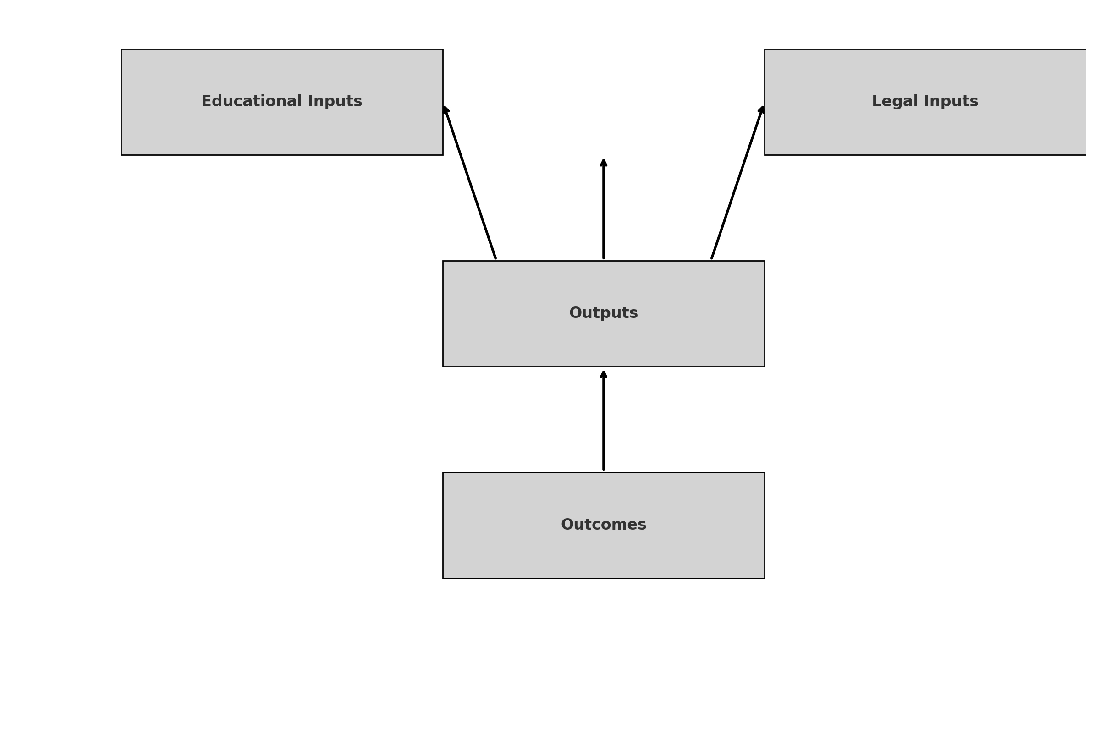

*Fig 1: Author’s Construct: presents the interaction between Educational Inputs and Legal Inputs, which flow into Outputs (e.g., competent practitioners, recognized programs), ultimately leading to Outcomes such as integration into national health systems and increased public trust.*

**5.7 Theoretical Frame: Institutional Theory & Legal Pluralism**

**5.7.1 Institutional Theory**

Derived from Scott’s framework, institutional theory explains curriculum and regulatory convergence through mimetic isomorphism. African universities in Ghana and South Africa, for instance, emulate WHO standards, showcasing academic alignment. Yet institutions with weaker governance show slower policy adoption (Scott, 2004; Dunn et al., 2021).

**5.7.2 Legal Pluralism and Rights-Based Analysis**

Legal pluralism acknowledges both formal statutory law and informal norms coexisting in governance. Many African countries engage in dual systems: registered TCIM under statutory law, and traditional practitioners under communal norms (Tamanaha, 2012). Rights-based discourse, particularly regarding the Nagoya Protocol and the African Charter, emphasizes community rights over medicinal knowledge and their role in redistributive justice (Ngang, 2018; Arewa, 2006).

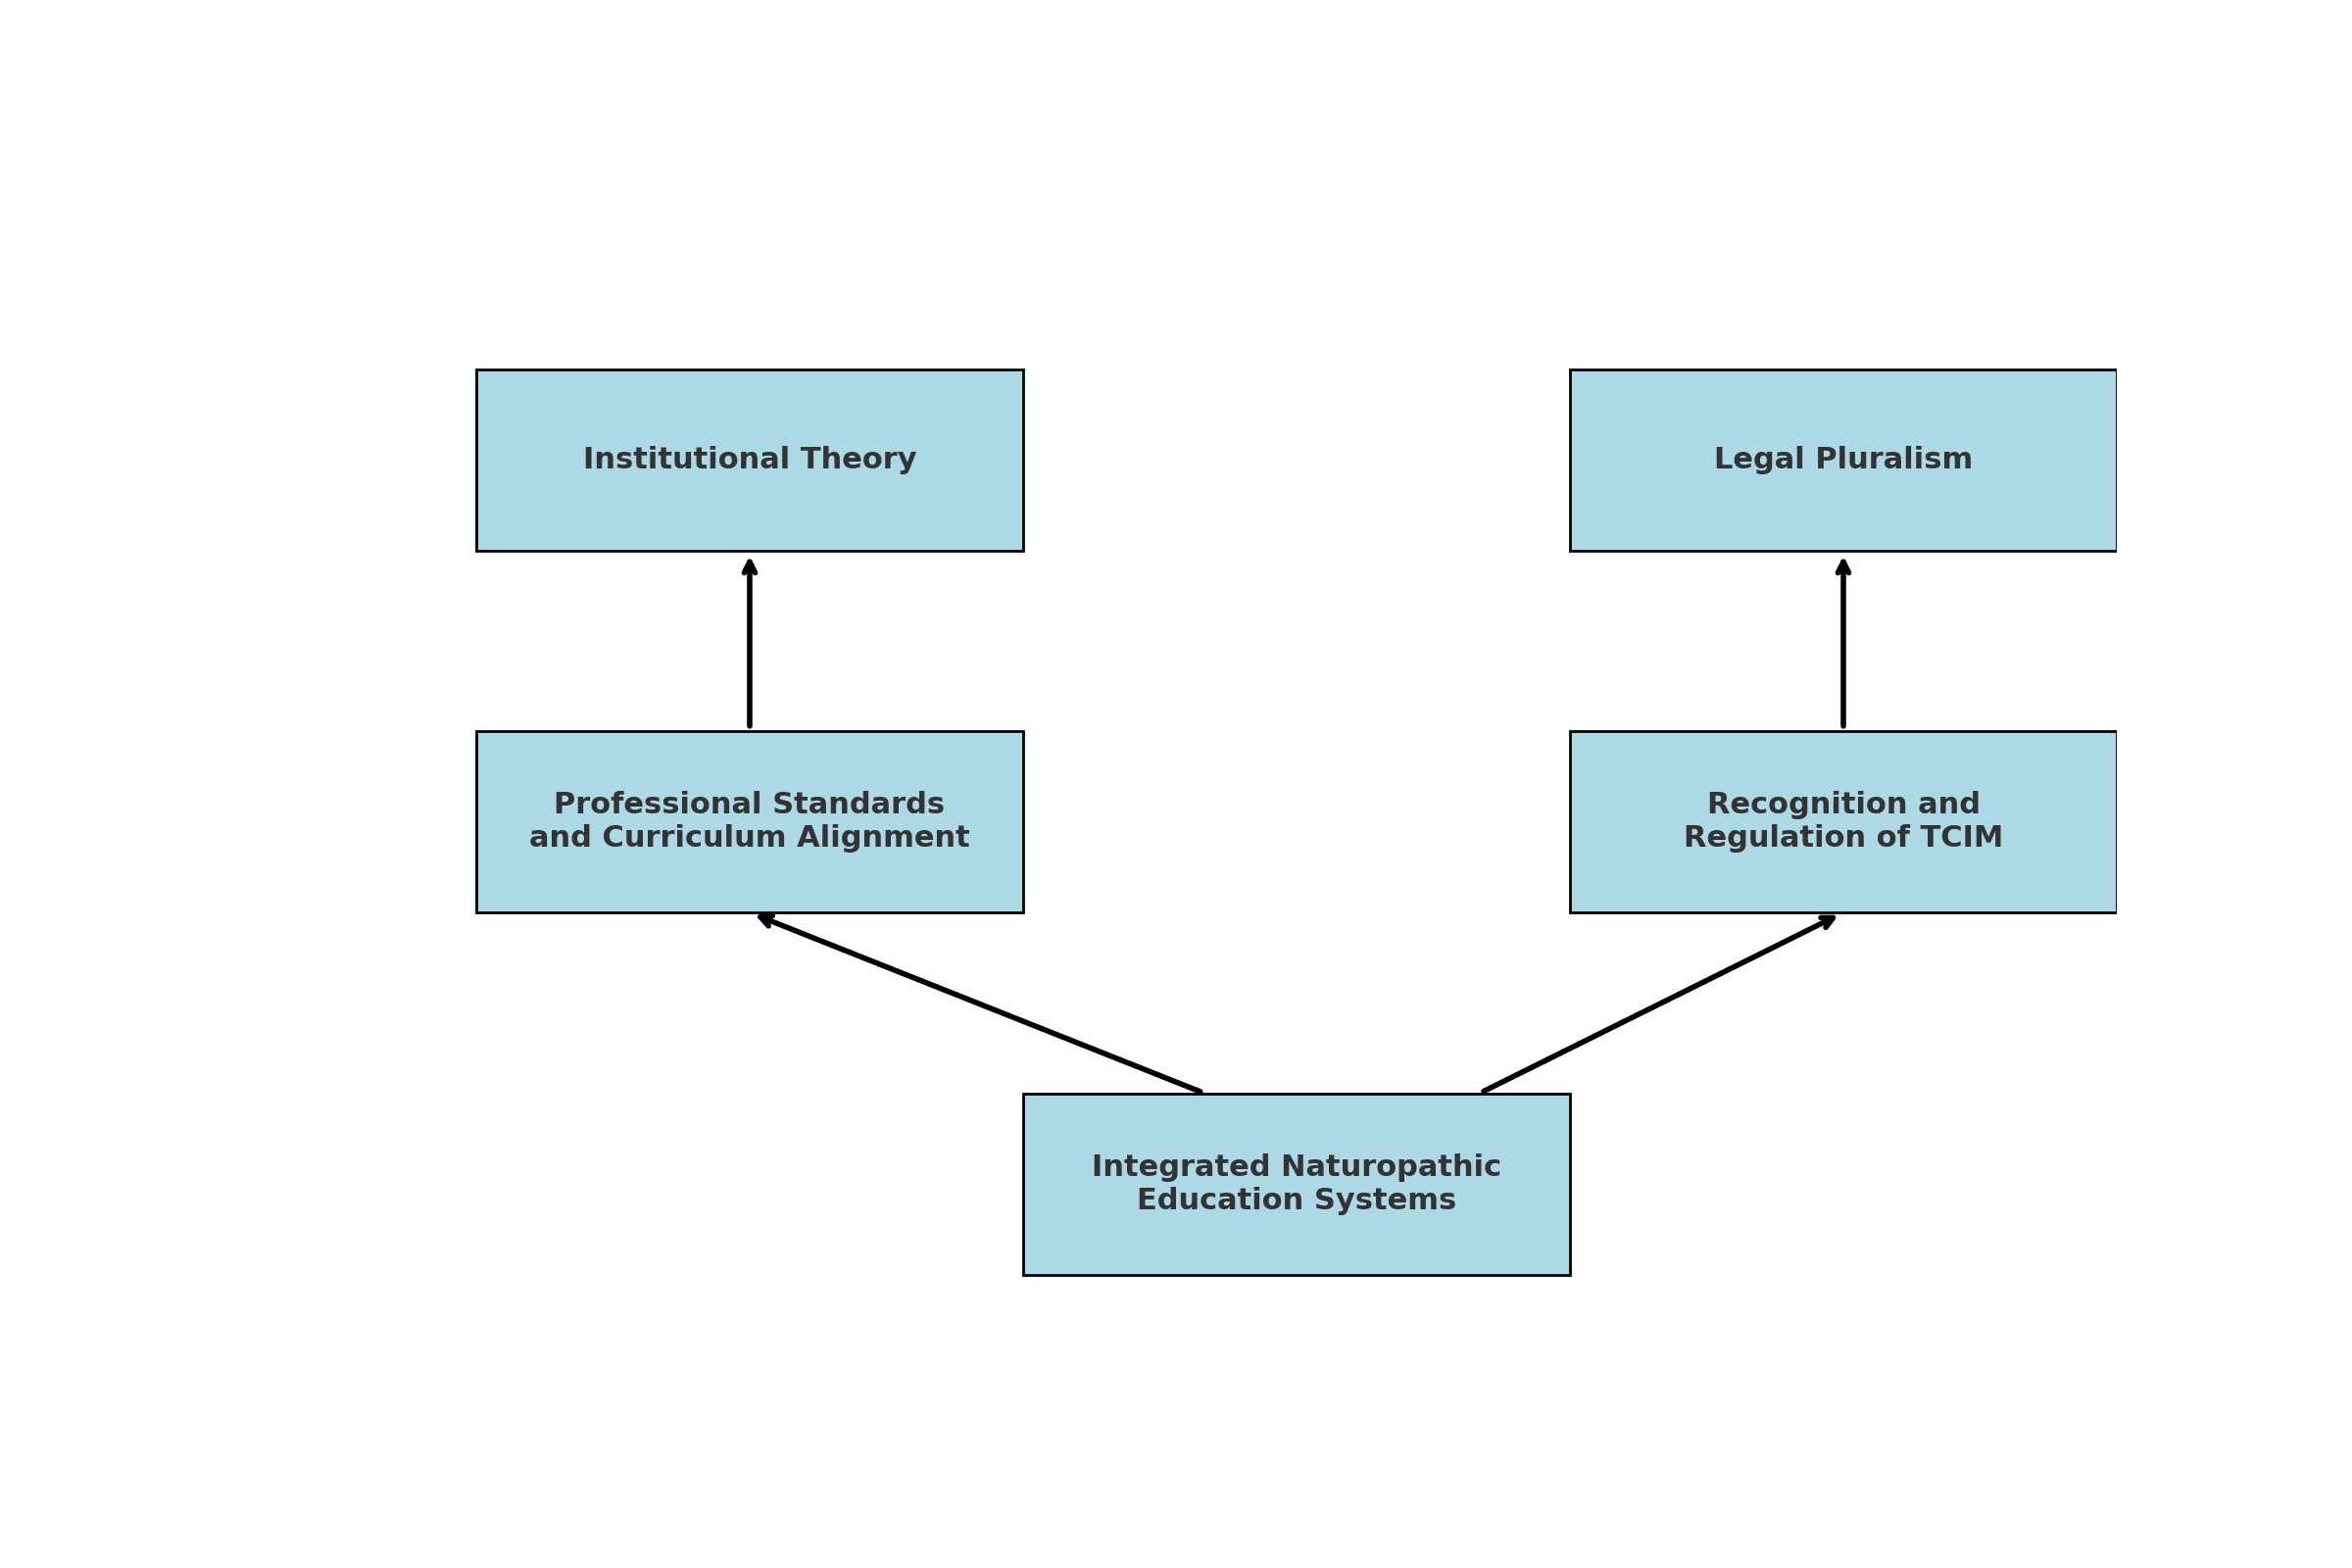

*Fig 2: Author’s Construct: The* ***Theoretical Framework*** *illustrates how* ***Institutional Theory*** *explains curriculum and professional standardization through global influence, while* ***Legal Pluralism*** *accounts for the coexistence of formal law and traditional norms—together guiding the development of integrated naturopathic education systems through aligned regulation and academic recognition.*

**5.8 Research Gaps**

Key areas identified in the literature include:

1. **Academic Weaknesses**: Clinical training deficits and lack of cohesive postgraduate systems.
2. **Regulatory Deficiencies**: Weak enforcement of policy frameworks and misaligned institutional mandates.
3. **IP Vulnerabilities**: Biopiracy incidents and lack of consent frameworks for knowledge use.
4. **Implementation Lag**: Difficulty in turning regional treaties into effective national laws.
5. **Limited Africa-Led Research**: Few indigenous-led studies on efficacy and pharmacovigilance.

The literature demonstrates that while Ghana and South Africa have made concrete progress in establishing academic and regulatory frameworks for naturopathic and herbal medicine, most African countries lag. The conceptual and theoretical lenses indicate that integrated institutional and legal approaches are essential for sustainable professionalization, public health integration, and intellectual property protection.

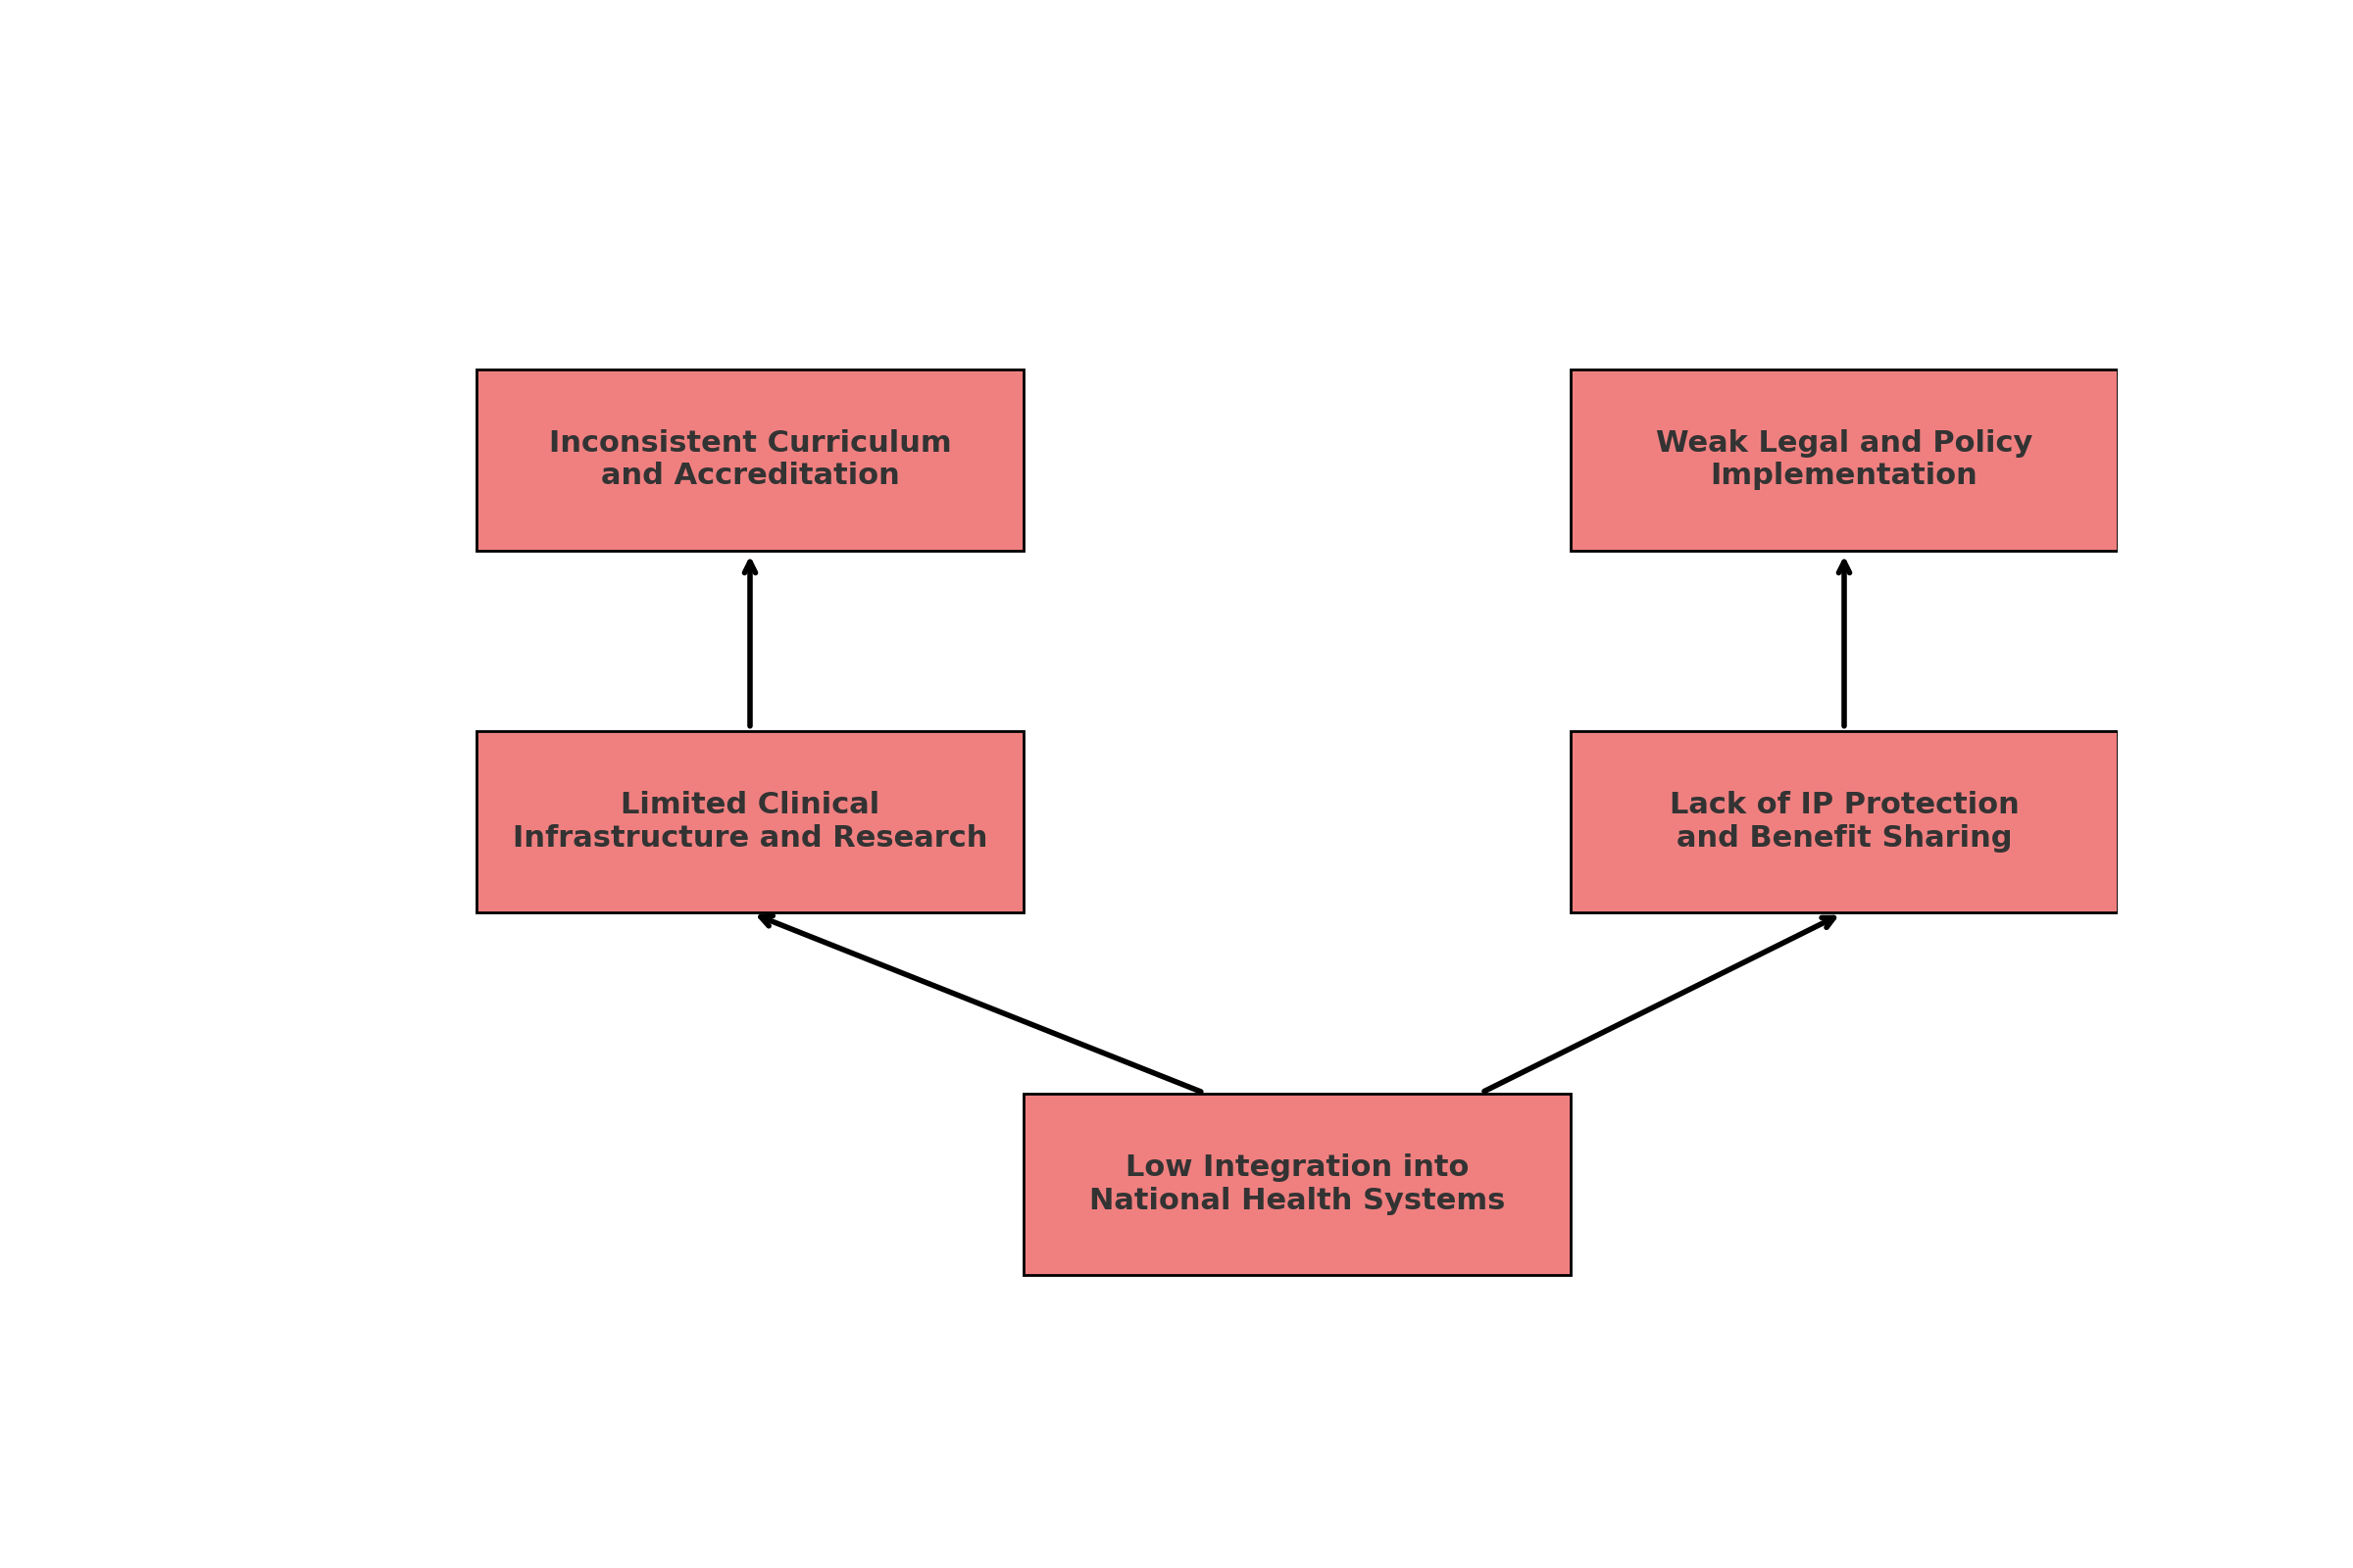

*Fig 3: Author’s Construct: The* ***Research Gaps Framework*** *illustrates five critical deficiencies—fragmented curricula, weak policy enforcement, limited clinical and research infrastructure, inadequate intellectual property protection, and poor integration into national health systems—that collectively hinder the formalization and advancement of naturopathic and herbal medicine education in Africa.*

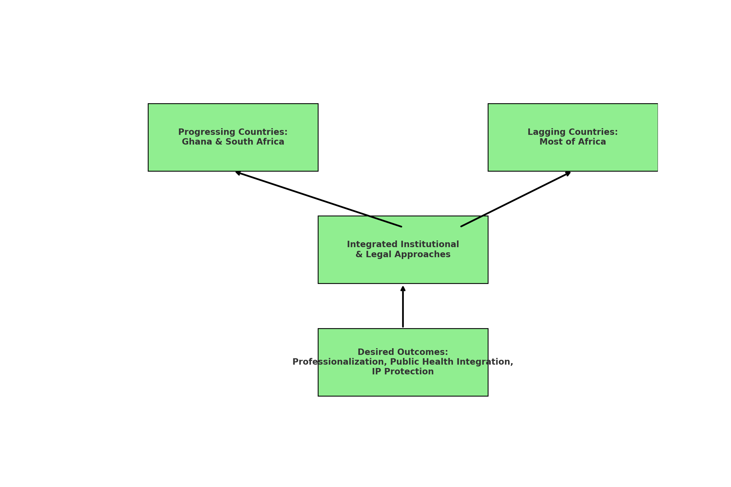

# *Fig 4: Author’s Construct: visually shows the progress in Ghana and South Africa versus lagging regions, emphasizing that integrated academic and legal approaches are necessary to achieve professionalization, health system integration, and protection of indigenous knowledge.*

**6. Methodology**

This section outlines the methodological approach adopted in the study and explains how the research process was organized. It opens with the research design and rationale for using a qualitative, desk-based approach and proceeds to detail the criteria for country selection, document sourcing, and data analysis procedures. The methodology is structured into three sub-sections: 6.1 Research Design, 6.2 Data Collection and Document Sourcing, and 6.3 Data Analysis.

**6.1 Research Design**

This study employed a qualitative, multi-case analysis methodology, anchored in desk research, legal doctrinal analysis, and comparative policy review. The goal was to critically assess the academic and legal frameworks shaping naturopathy and herbal medicine education and regulation in Africa.

The research adopted an exploratory design due to the evolving nature of the field and the absence of harmonized or centralized data across the continent. This design allowed for flexibility in identifying emerging patterns and variations across jurisdictions (Tamanaha, 2012; WHO, 2019).

**6.2 Data Collection and Document Sourcing**

**Country and Institutional Selection Justification**

The study purposively selected **Ghana** and **South Africa** as the **primary case studies** due to their relatively advanced engagement with TCIM education and regulation:

* **Ghana** was selected because it hosts Africa’s first national occupational standards for naturopathy and holistic medicine under the Commission for Technical and Vocational Education and Training (CTVET). Ghana also represents a hybrid system that recognizes both traditional and complementary medicine, yet operates under dual governance.
* **South Africa** offers a distinct regulatory framework through the Allied Health Professions Council of South Africa (AHPCSA), which legally recognizes naturopathy and several complementary modalities, providing insight into institutional legitimacy and professional licensing.

**Secondary countries**—**Nigeria**, **Kenya**, **Uganda**, and **The Gambia**—were selected to reflect a diversity of approaches within the continent. These countries demonstrate emerging legal and academic trends, varying degrees of policy development, and cultural reliance on traditional systems.

**Document Sourcing and Search Strategy**

The research relied on secondary data sources, including institutional documents, national laws, academic curriculum outlines, and regulatory policies. To ensure relevance and credibility, documents were obtained through a systematic and targeted search involving the following strategies:

1. **Official Institutional Websites and Repositories**:
   * Ghana's CTVET and Traditional Medicine Practice Council (TMPC)
   * South Africa’s AHPCSA and the Department of Higher Education and Training
   * The African Medicines Agency (AMA) and African Union Health Division
   * Ministries of Health and national herbal/traditional medicine departments
2. **University Program Outlines and Curricula**:
   * Sourced from official websites of:
     + Nyarkotey University College of Holistic Medicine and Technology (Ghana)
     + University of the Western Cape (South Africa)
3. **Legal and Policy Databases**:
   * World Health Organization Global Atlas on TCIM
   * African Union and WHO AFRO health policy portals
   * UNESCO TVET database and Research4Life for peer-reviewed and grey literature
   * National legislative repositories such as Kenya Law, South African Government Gazette, and Laws of The Gambia
4. **Search Terms and Filtering:**  
   Searches were conducted using combinations of the following terms:  
   *"naturopathy regulation in Africa"*, *"herbal medicine education policy"*, *"CTVET Ghana curriculum"*, *"AHPCSA naturopathy"*, *"TCIM legal framework"*, *"African Medicines Agency documents"*, and *"Traditional Medicine Training Africa."*
5. **Inclusion Criteria**:
   * Documents published between 2010 and 2025
   * Authored or endorsed by governmental, intergovernmental, or accredited educational bodies
   * Relevant to policy, regulation, education, or professional practice

**6.3 Data Analysis**

The collected documents were subjected to qualitative content analysis. This involved thematic coding to identify patterns related to:

* Regulatory Frameworks and professional titles
* Curriculum structure, duration, and scope
* Legal definitions and practitioner legitimacy
* Alignment with international TCIM frameworks (e.g., WHO, WNF)

Comparative analysis was then employed to highlight similarities and differences across countries, drawing policy insights and best practices. Analytical categories were informed by the research questions and objectives

**6.4 Validation and Credibility of Sources**

Although this study did not involve primary data collection or fieldwork, measures were taken to ensure the credibility, rigor, and consistency of the secondary data used. To enhance the trustworthiness of the findings, a form of documentary triangulation was employed. This involved cross-referencing and comparing information across multiple authoritative sources, such as:

* **International frameworks** (e.g., WHO Traditional Medicine Strategy 2014–2023; WHO, 2019),
* **National legislation and policy documents** from health ministries and regulatory bodies,
* **University curriculum and institutional reports**, particularly from Nyarkotey University College of Holistic Medicine & Technology (NUCHMT) and the University of the Western Cape,
* And **peer-reviewed academic literature**, which was prioritized over grey literature to enhance scholarly robustness.

Rather than using data collection instruments, this study used systematic document selection criteria (outlined in Section 6.2) and relied on established analytical frameworks to interpret and compare policy and academic developments across countries.

In terms of interpretative reliability, theoretical constructs such as institutional theory guided the analysis of policy diffusion and curriculum reform trends, while the lens of legal pluralism helped contextualize the coexistence of statutory laws with customary and community-based regulatory systems in the African TCIM context.

By applying these layered analytical strategies and ensuring that all sources were verifiable and current, the study aimed to maintain a high standard of methodological integrity, despite the absence of primary empirical data.

**6.5 Limitations**

This study, while comprehensive in its desk-based approach, is subject to several limitations inherent in secondary research and documentary analysis.

First, the absence of primary data means that the study did not benefit from firsthand perspectives of practitioners, policymakers, or educators within the Traditional, Complementary, and Integrative Medicine (TCIM) sector. As a result, insights into the practical challenges and lived experiences of implementing regulatory and educational reforms are inferred rather than directly observed.

Second, variability in data availability and transparency across countries limited the comparative depth. While Ghana and South Africa provided relatively accessible institutional and policy documents, data from countries like The Gambia, Uganda, and Nigeria were less comprehensive, potentially creating imbalances in the richness of analysis.

Third, the reliance on publicly available documents and online sources introduces a risk of excluding unpublished policies, internal guidelines, or recent regulatory developments that are not digitized or disclosed publicly.

Fourth, although every effort was made to ensure accuracy through document triangulation and cross-referencing, the study remains susceptible to interpretive bias due to its qualitative nature. The selection and interpretation of materials may reflect the researcher’s theoretical lens, particularly with the use of institutional theory and legal pluralism.

Finally, language and regional limitations meant that documents were reviewed primarily in English, potentially excluding relevant francophone African country data that could have broadened the continental perspective.

Despite these limitations, the study offers a valuable foundation for understanding the policy, legal, and educational dynamics of naturopathy and herbal medicine in Africa, and can inform future empirical investigations that include stakeholder engagement and field validation.

**7. Results and Discussion**

This section presents the key findings of the study and interprets them in light of the research objectives and guiding questions. The analysis focuses on four main areas: (1) the academic structuring of naturopathic and herbal medicine education, (2) the legal and regulatory frameworks that support or hinder professional recognition, (3) the identification of major policy and institutional gaps, and (4) strategic recommendations to enhance the academic and legal legitimacy of Traditional, Complementary, and Integrative Medicine (TCIM) across Africa.

Findings are drawn from a synthesis of documentary sources, including national legislation, institutional curricula, regulatory guidelines, and international policy frameworks. The analysis is structured thematically, aligning each section with one of the research objectives and its corresponding question. Ghana and South Africa serve as primary case studies due to their relatively advanced regulatory and educational environments, while supplementary insights from Nigeria, Kenya, Uganda, and The Gambia provide a broader continental perspective.

By contextualizing these findings within institutional theory and legal pluralism, the discussion illuminates how fragmented governance, inconsistent educational standards, and limited legal protections continue to affect the professionalization of naturopathy and herbal medicine in Africa.

**7.1 Academic Structures & Curriculum Models (RQ1)**

**RQ1:** *What are the prevailing academic models and curriculum structures for naturopathic and herbal medicine education in Africa?*

Ghana and South Africa emerge as leading examples of formalized naturopathic education systems in Africa, albeit through different structural and regulatory approaches.

In Ghana, the Nyarkotey University College of Holistic Medicine and Technology has implemented a competency-based educational framework that spans from certificate to doctoral levels, aligned with WHO-recommended training standards (Nyarkotey, 2025; Obu & Aggrey-Bluwey, 2022). The program is structured under the Commission for Technical and Vocational Education and Training (CTVET) and guided by a nationally approved National Occupational Standard (NOS) for naturopathy and holistic medicine. This model permits multiple entry and exit points, allowing learners to begin at National Proficiency Level I (NP I) and progress through NP II, National Certificate (NC), Higher National Diploma (HND), and ultimately the Bachelor of Technology (BTech) degree, which aligns with NQF Level 6. This system is designed to accommodate both formal learners and traditional practitioners through recognition of prior learning and structured clinical training.

By contrast, South Africa follows a more academically rigid but internationally benchmarked model regulated by the Allied Health Professions Council of South Africa (AHPCSA). The naturopathic qualification pathway is divided into two phases under the National Qualifications Framework (NQF). Students first complete a three-year Bachelor of Science in Complementary Health Sciences, which lays the biomedical and diagnostic foundation. This is followed by a two-year Bachelor of Complementary Medicine, with a major in Naturopathy, classified at NQF Level 8—equivalent to an honors or postgraduate-level qualification. Admission to the second phase requires a background in biomedical sciences, such as the aforementioned BSc, or a clinical qualification like the MBChB. AHPCSA registration is mandatory for progression.

While South Africa’s model ensures a high scientific threshold and alignment with global naturopathic standards, it may pose barriers for grassroots practitioners who lack biomedical prerequisites. Conversely, Ghana’s inclusive, modular, and competency-based approach enhances access for a broader segment of learners and reflects a public health-centered model of TCIM workforce development.

This distinction becomes particularly relevant given that most African countries—including Nigeria, Kenya, and Uganda—still maintain fragmented and poorly regulated educational pathways. In Nigeria, for example, training is dominated by unaccredited private institutions and informal foreign correspondence programs (Obu & Aggrey-Bluwey, 2022). In Kenya and Uganda, programs exist at variable certificate and diploma levels, with little alignment with national health systems. This disparity in training quality results in inconsistent learning outcomes, unequal practitioner competencies, and ultimately, public health risks due to inadequate clinical, ethical, and diagnostic skills among practitioners. These weaknesses compromise public trust and hinder efforts to integrate naturopathy and herbal medicine into formal healthcare systems.

Ghana’s development of a National Occupational Standard addresses these challenges by defining the competency benchmarks for each academic level and aligning training with expected healthcare service roles. This has enhanced public health protection by ensuring a standardized and regulated naturopathic workforce capable of delivering safe and effective care. Additionally, the Ghanaian model’s alignment with the African Continental Qualifications Framework (ACQF)—an African Union initiative promoting harmonization, transparency, and mobility—positions the country as a continental leader in establishing qualifications that are comparable and mutually recognized across borders.

In doing so, Ghana not only strengthens national public health systems, but also contributes to regional workforce mobility and integration, setting a precedent for harmonized education and regulation in the Traditional, Complementary, and Integrative Medicine (TCIM) sector across Africa.

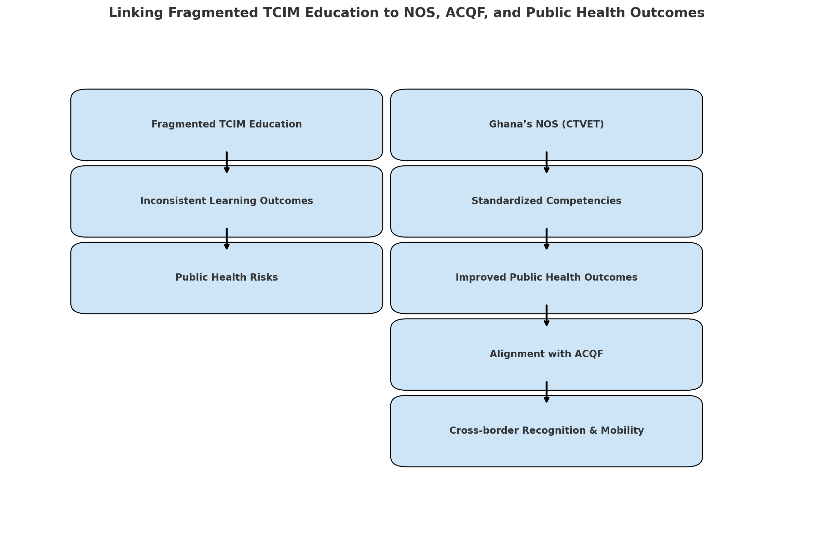

*Fig 5: Author’s Construct: conceptual diagram illustrating how fragmented TCIM education leads to public health risks—and how Ghana’s National Occupational Standard (NOS), when aligned with the African Continental Qualifications Framework (ACQF), helps standardize competencies, improve health outcomes, and support cross-border recognition and mobility.*

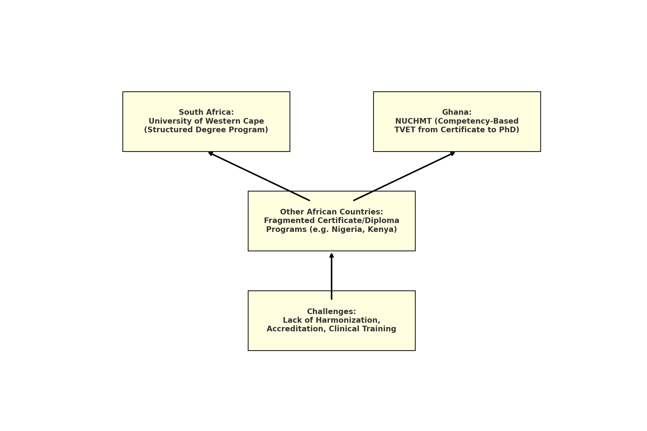

***Fig 6: Author’s Construct: This diagram compares Ghana and South Africa’s structured approaches with fragmented systems in other countries, culminating in the shared challenges.***

**7.2 Legal Frameworks & Regulation (RQ2)**

**RQ2:** *How do national legal frameworks regulate the practice and education of naturopathy and herbal medicine across different African countries?*

Ghana’s Traditional Medicine Practice Act (Act 575, 2000) legally registers herbalists, but naturopaths remain unregulated pending passage of the Alternative Medicine Bill (Obu et al, 2022; Nyarkotey. P, 2025). South Africa provides a stronger model: its Traditional Health Practitioners Act and registration via the Allied Health Professions Council (AHPCSA) explicitly cover naturopathy and herbalists under defined professional standards (Wikipedia. 2025).

However, regulatory oversight is weak in nations like Nigeria, where the Federal Ministry of Health supports TCIM but does not legally recognize naturopathy, creating a vacuum in training standards and professional oversight (WHO, 2019). Countries such as Kenya, Uganda, and The Gambia have developed TCIM policies, but enforcement is often symbolic. Research on Ethiopia highlights limited regulatory capacity, insufficient pharmacovigilance, and institutional fragmentation as hindrances to safe practice( Mekasha YT, et al., 2025; Steel et al. 2025).

These observations align with RQ2’s premise that legal recognition of naturopathy varies continentally: South Africa and Ghana show formal inclusion, whereas others rely on informal policy frameworks. As per WHO recommendations, legal frameworks should clearly define practitioner scope, standards, and accountability systems (WHO, 2019), yet such clarity is often absent beyond a few nations.

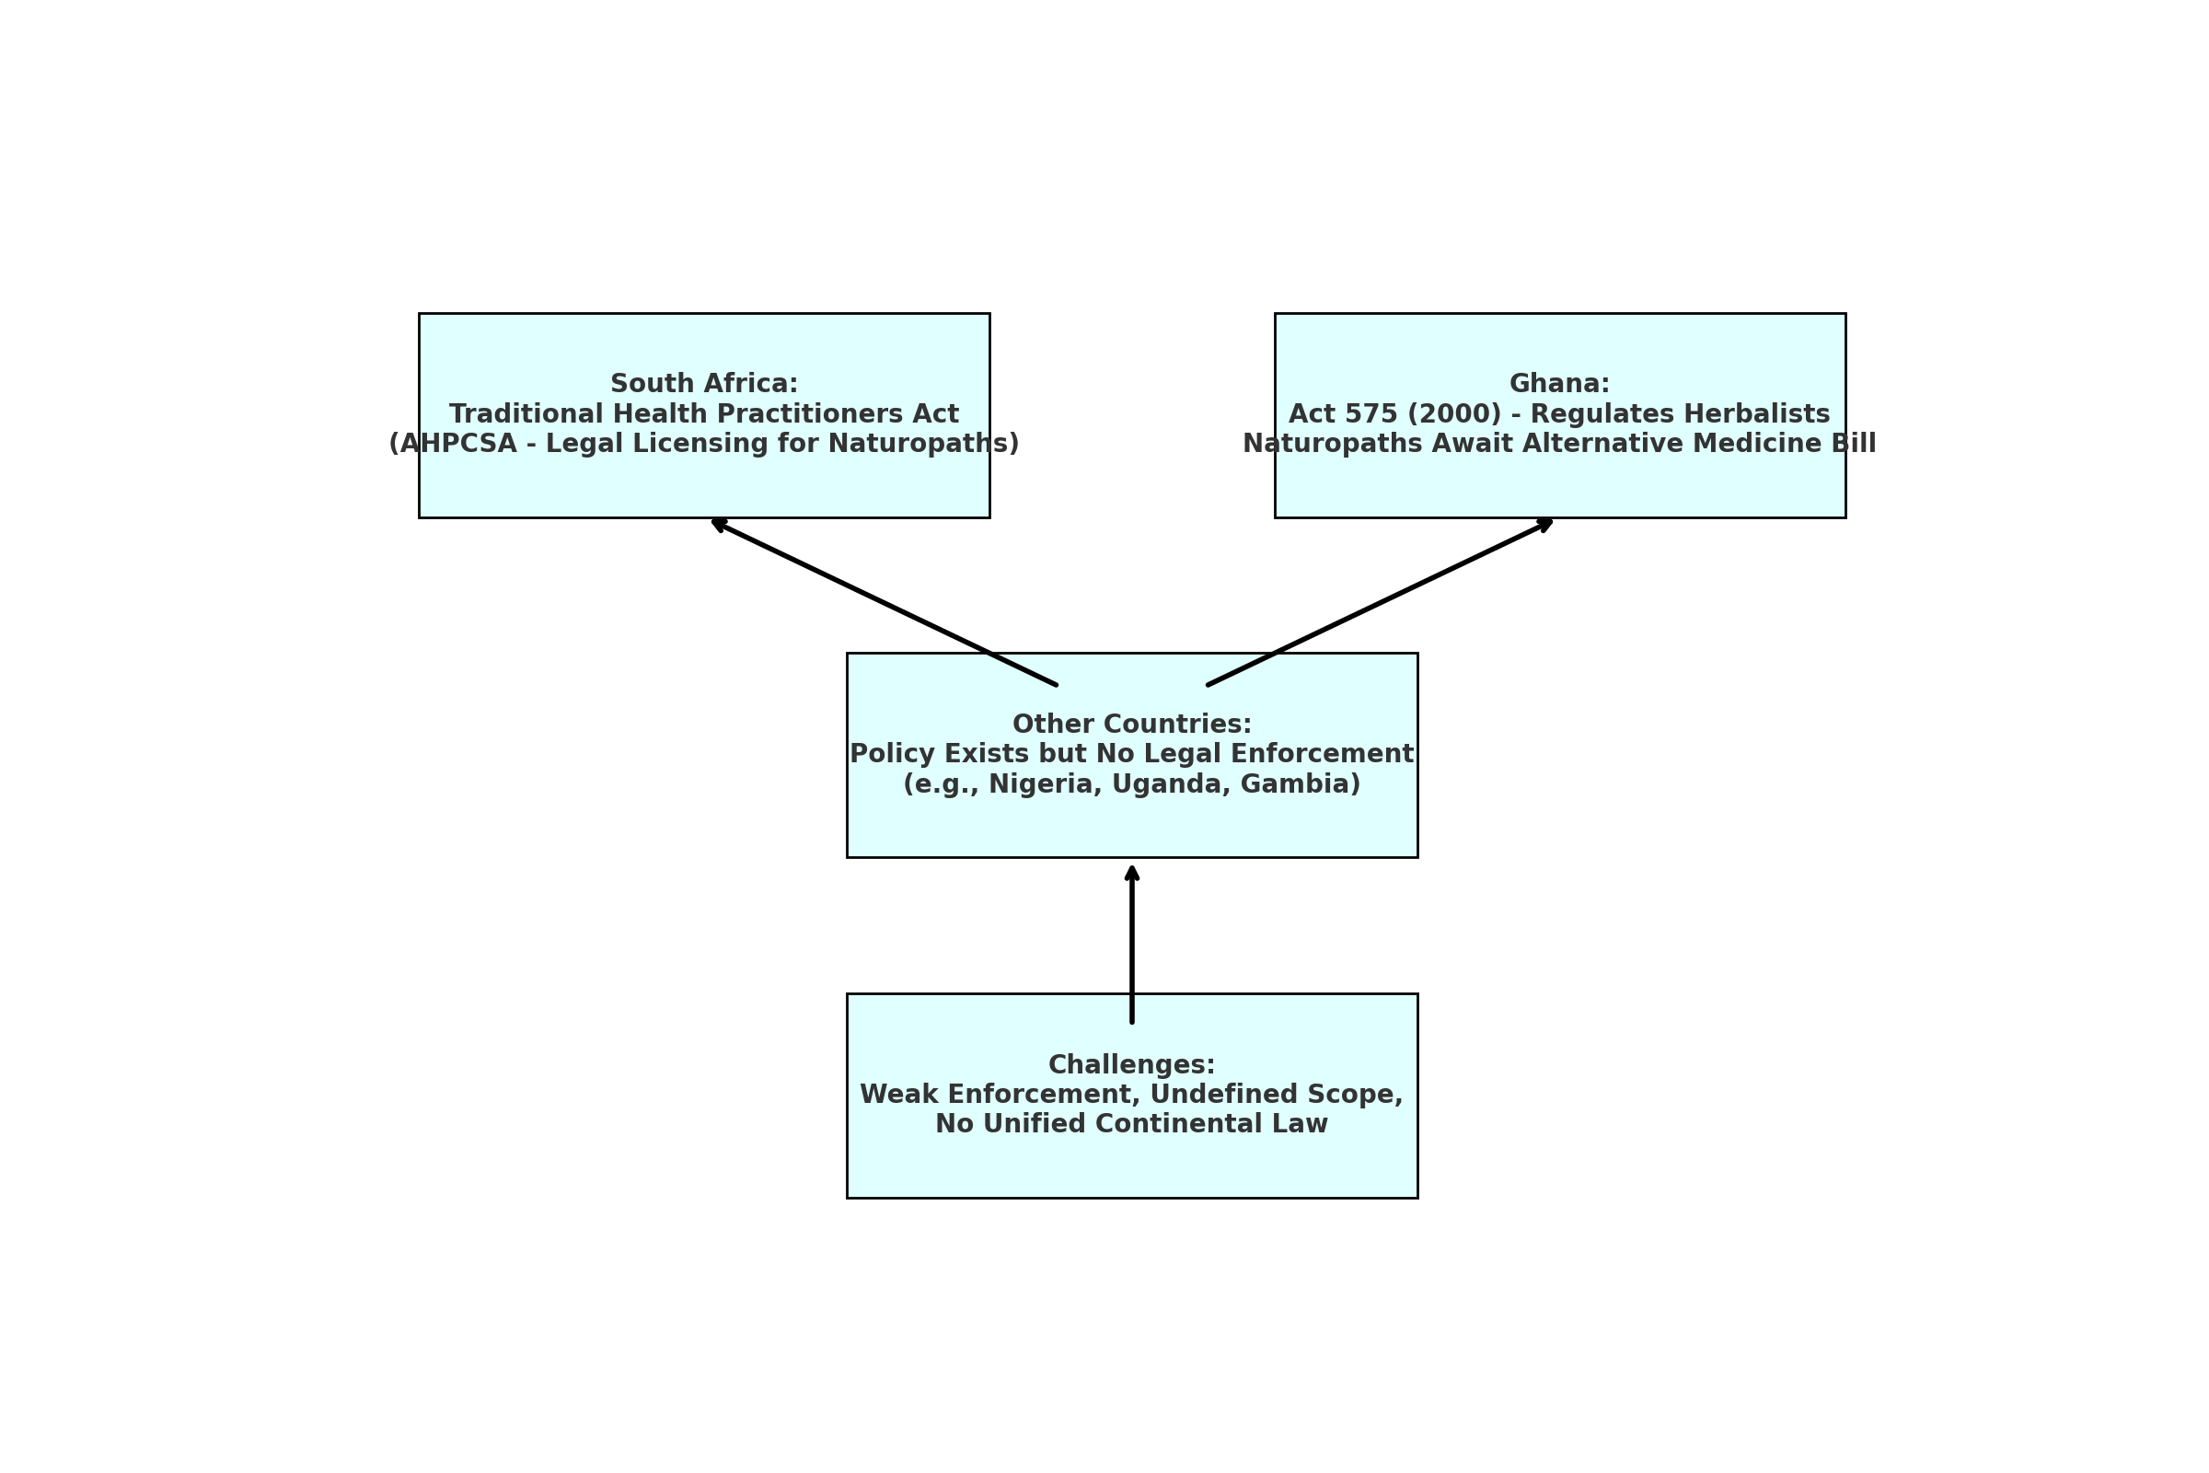

***Fig 7: Author’s Construct: This diagram contrasts South Africa and Ghana’s regulatory models with other African nations, highlighting the common challenge of legal ambiguity and enforcement gaps***

**7.3 Key Challenges Hindering Standardization (RQ3)**

**RQ3:** *What are the major challenges hindering standardization, accreditation, and legal recognition of naturopathic and herbal education in Africa?*

Three recurring challenges emerged:

1. **Curriculum Standardization Deficits**  
   Fragmented educational initiatives undermine consistency. Even Ghana’s advanced model lacks continent-wide recognition. Similarly, limited clinical training and postgraduate research create competency gaps (Wendy et al., 2021; Dunn et al., 2021; Obu R N and Bluwey L A, 2022).
2. **Regulatory Weakness**  
   Regulatory enforcement of naturopathy and herbal medicine across Africa remains weak and fragmented. Even in relatively progressive contexts like **Ghana,** ministerial regulations have faced **legal challenges,** revealing the unstable and contested nature of the current regulatory landscape (Obu et al., 2022). Additionally, in **West Africa,** the **misclassification of naturopathy under traditional medicine** continues to blur its identity as a distinct healing system. This lack of legal clarity not only affects professional recognition but also contributes to **tensions with traditional healers,** who often perceive naturopaths as competitors rather than collaborators within the broader TCIM ecosystem.

At the continental level, **efforts to harmonize regulatory frameworks** remain in their infancy. While the **African Medicines Agency (AMA)** represents a significant institutional milestone, its operational structures are still being developed, and its mandate regarding Traditional, Complementary, and Integrative Medicine (TCIM) is not yet clearly articulated. The recent appointment of its **Director-General** marks a step forward, but **meaningful integration of TCIM into AMA’s regulatory purview** is still a work in progress. Until such frameworks are formalized, the legal and institutional support for naturopathy and herbal medicine will remain uneven, limiting their full contribution to public health and regional healthcare integration.

1. **Intellectual Property Gaps & Benefit-Sharing**  
   Biopiracy and lack of sui generis IP systems remain concerns. South Africa’s Hoodia case exemplifies the exploitation of indigenous knowledge under weak global IP regimes (Arewa, 2006). TRIPS and regional frameworks offer limited safeguards absent rigorous national legislation (Ngang, 2018; Adekola, T. A. (2019)
2. **Infrastructure & Research Limitations**  
   TCIM research funding remains minimal. Studies show only 0.17% of U.S. NIH funding goes to integrative medicine; Africa lags further (Raja et al. 2024). Local institutional research is scaled back, with few randomized controlled trials or clinical outcomes studies (Raja et al. 2024; Pratt and Frost, nd). The lack of trained research faculty intensifies this gap.
3. **Siloed Health Governance**  
   TCIM often operates adjunct to rather than integrated within national health systems, without public financing or inclusion in UHC benefits (Pratt and Frost, nd) Even countries with formal policies struggle to move from governance frameworks to functional health integration, reinforcing RQ3’s identification of structural barriers.

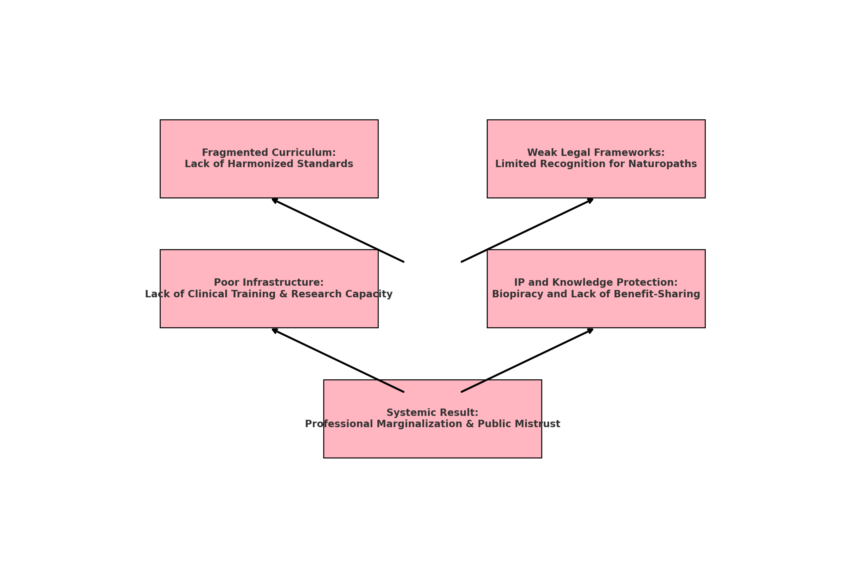*Fig 8: Author’s Construct: presents four critical challenges that funnel into the core issue of professional marginalization and public mistrust*

**7.4 Strategic Recommendations (RQ4)**

**RQ4:** *What policy and institutional strategies can be adopted to strengthen the academic and legal legitimacy of naturopathic and herbal medicine across the continent?*

**a. Harmonized Curriculum Standards & Accreditation**  
African education bodies should collaborate to develop regionally standardized accreditation frameworks. Models from Ghana’s competency-based training and South Africa’s regulatory alignment with WHO could form the basis for continental curricula spanning levels from certificate to doctoral. Institutional Theory supports such alignment by encouraging mimicry of global norms (Scott, 2004; Obu, Raphael Nyarkotey, 2024 ).

**b. Comprehensive Legal Recognition & Regulation**  
Governments must enact legislation granting naturopathy a clear professional identity, scope, and accountability through professional councils and licensure boards. Ghana’s Alternative Medicine Bill is a positive step; Nigeria could follow such models. Legal pluralism theory reinforces the need to integrate statutory recognition with traditional social norms, preserving cultural heritage while asserting legal clarity (Tamanaha, 2012).

**c. Strengthened IP Protection & Community Rights**  
To tackle biopiracy and protect indigenous knowledge, African nations should adopt sui generis IP systems acknowledging collective knowledge and benefit-sharing. Regional treaties like ARIPO’s Swakopmund Protocol and the Nagoya Protocol’s implementation could be enforced more stringently (Ngang, 2018; Knight et al., 2022).

**d. Investment in TCIM Research & Clinical Infrastructure**  
Governments and development partners should designate funding for TCIM investigations, clinical trials, and pharmacovigilance. Partnerships with WHO’s EVIPNet could enable knowledge translation from evidence to policy (Raja et al. 2024). Embedding TCIM training within broader public health and health systems curricula will cultivate future academic and regulatory leadership.

**e. Integration into National Health Systems & Financing**  
Integration requires more than policy—it calls for health budget inclusion, health insurance coverage, and patient data systems that include TCIM modalities. WHO’s report argues that TCIM must be incorporated within UHC frameworks rather than treated as siloed offerings (Pratt and Frost, nd). South Africa's AHPCSA system demonstrates structured professional regulation; similar approaches could be scaled continent-wide.

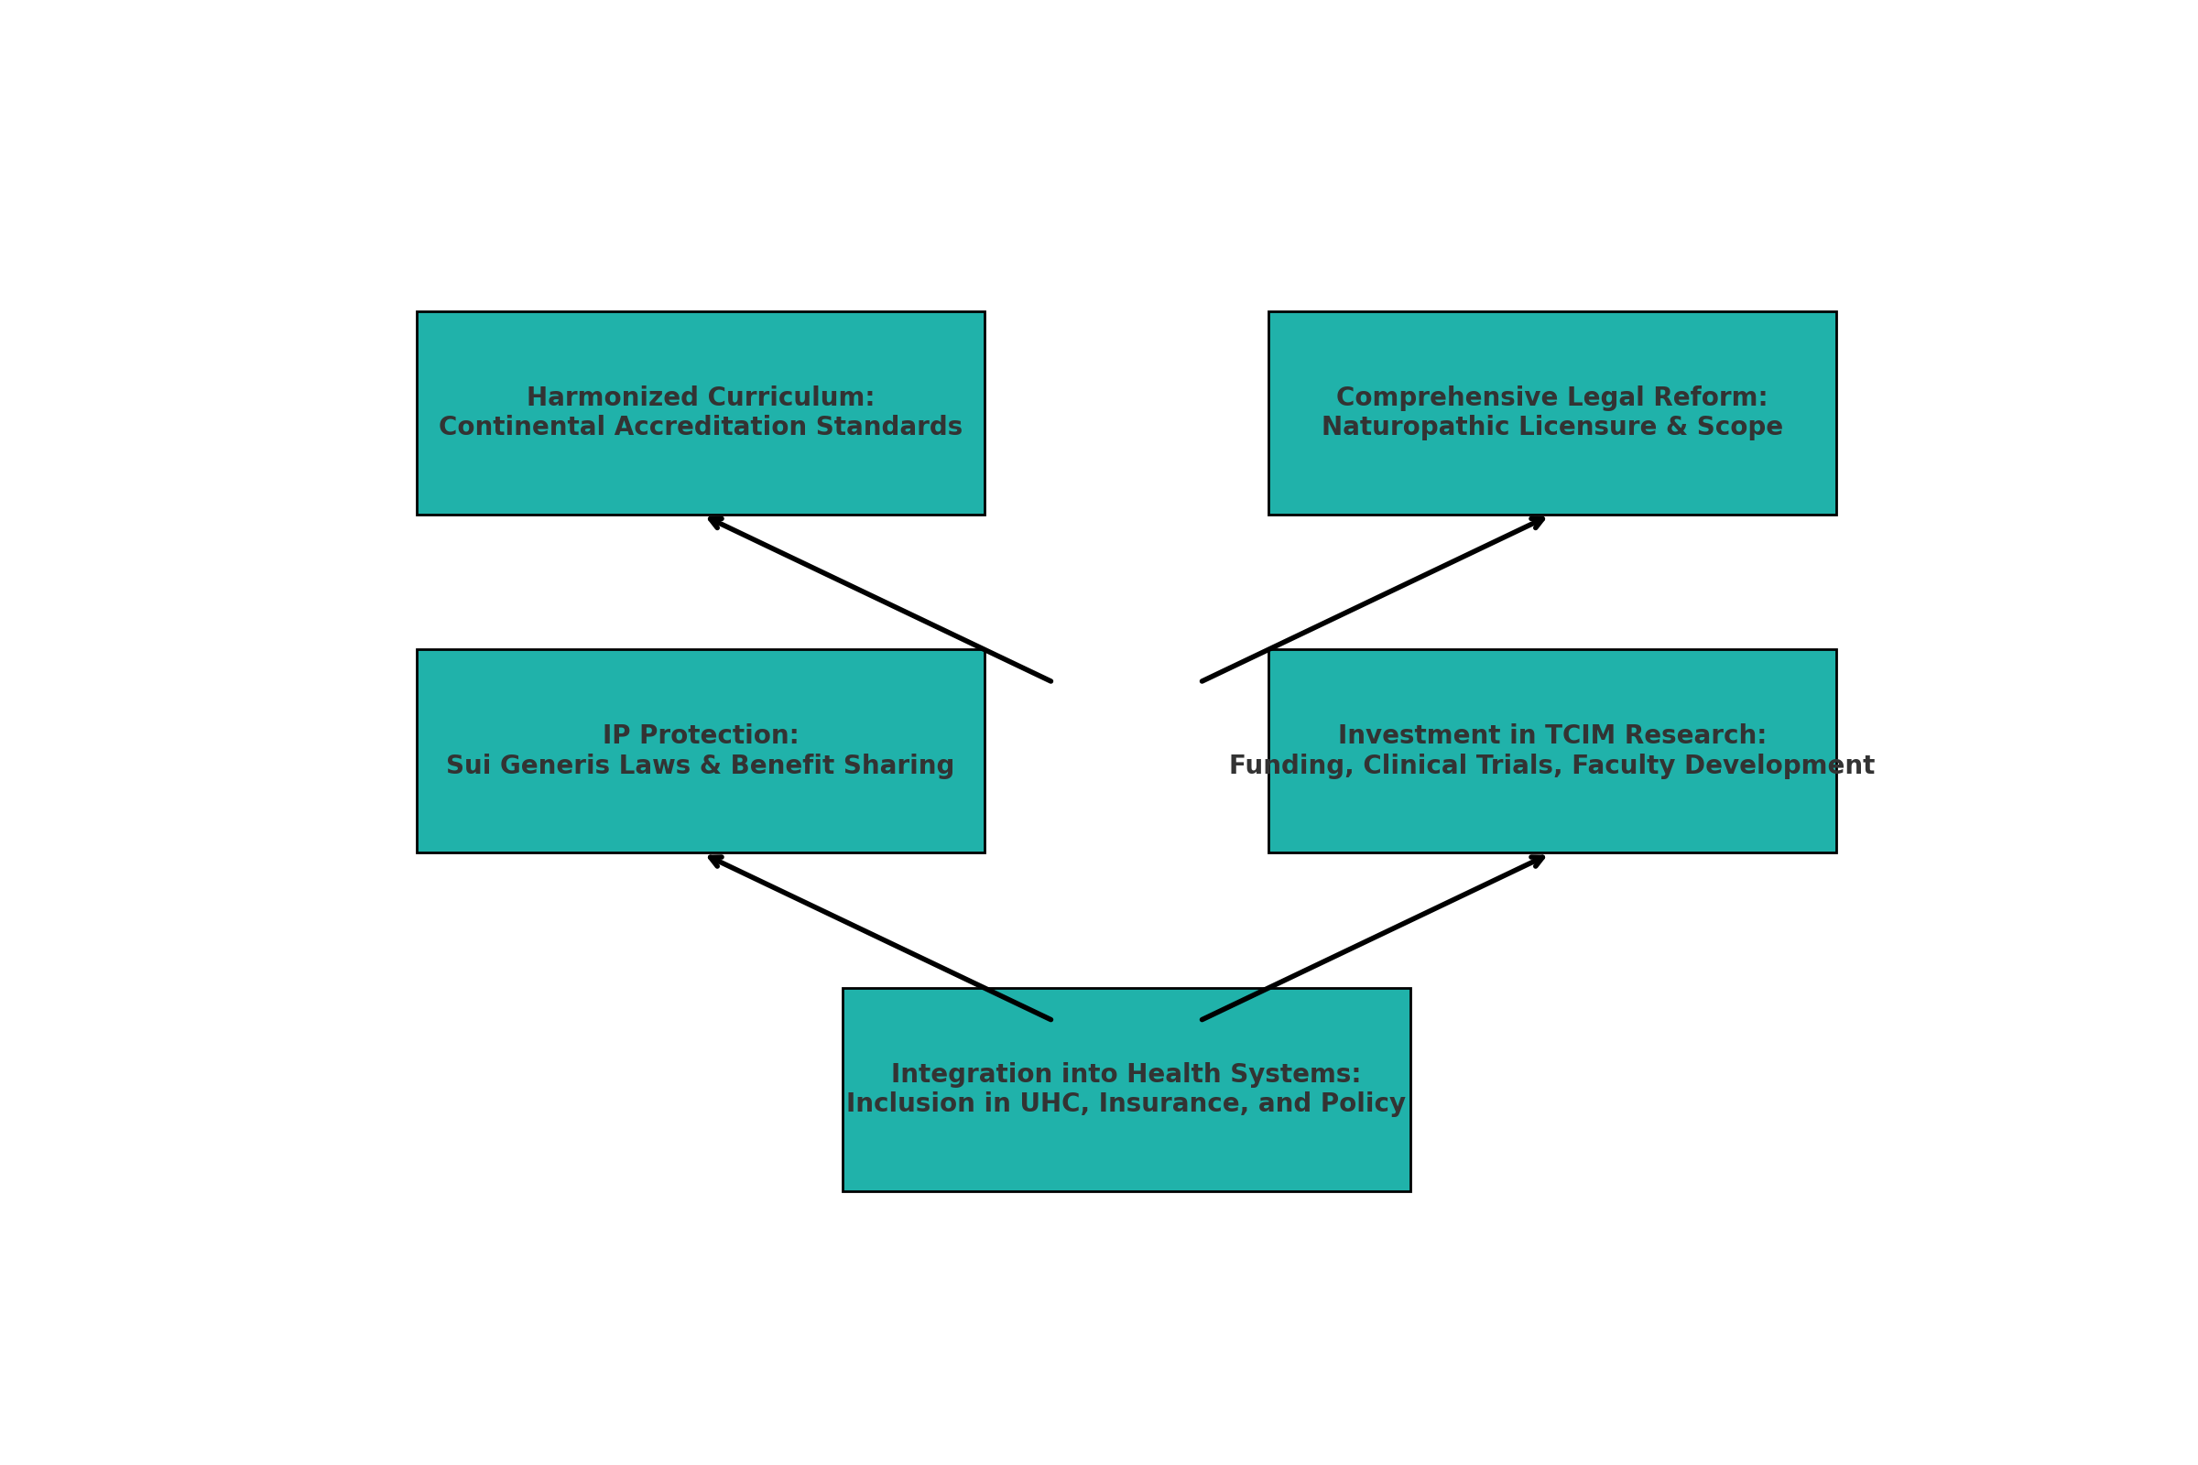

*Fig 9: Author’s Construct:**strategic recommendations to strengthen the academic and legal legitimacy of naturopathic and herbal medicine in Africa.*

**7.5 Linking Objectives, Questions, and Scholarly Evidence**

The findings across items directly address the initial objectives and research questions:

* **Academic examination (Objective 1, RQ1)** reveals pockets of excellence in Ghana and South Africa, but wider fragmentation.
* **Regulatory analysis (Objective 2, RQ2)** shows formal legal pathways exist inconsistently, with Ghana and South Africa leading while others lag.
* **Identified challenges (Objective 3, RQ3)** align with research: curriculum fragmentation, weak regulation, IP insecurity, research deficiency, and siloed healthcare inclusion.
* **Strategic recommendations (Objective 4, RQ4)** highlight frameworks for harmonization, legal reform, IP protection, research investment, and health system integration.

**7.6 Implications & Theoretical Integration**

This discussion supports the use of Institutional Theory and Legal Pluralism as analytical lenses. Institutional Theory helps explain curriculum and regulatory adoption in countries like Ghana and South Africa, whereas Legal Pluralism explains the parallel existence of traditional community norms and statutory regulation. The proposed reforms draw directly from both theories, recommending mimetic policy adoption and integrated statutory-traditional governance pathways.

**8. Conclusion**

This final section presents a synthesis of the study’s main findings concerning its research aim and four specific objectives. It begins by revisiting the objectives to determine whether they have been achieved through the research process. The conclusion then reflects on the broader implications of the findings for policy, regulation, and educational reform in the field of naturopathy and herbal medicine across Africa. Finally, the section emphasizes the strategic importance of institutionalizing these traditional and complementary health systems as part of Africa’s journey toward health equity and epistemological sovereignty. The discussion is structured to flow logically from evaluation to insight, offering a clear narrative of how the research contributes to ongoing continental discourse and transformation in Traditional, Complementary, and Integrative Medicine (TCIM).

**Synthesis and Evaluation**

This study set out to critically examine the academic and legal frameworks governing naturopathy and herbal medicine in Africa, with the overarching aim of recommending policy, legal, and curricular strategies to support their institutionalization and legitimacy. Through a qualitative, multi-case analysis centered on Ghana and South Africa—alongside comparative insights from Nigeria, Kenya, Uganda, and The Gambia—the study has fulfilled its four core objectives:

1. It **analyzed the academic structures** and educational pathways for naturopathy and herbal medicine, identifying fragmented learning outcomes across most countries, and highlighting Ghana and South Africa as emerging leaders with formalized, structured systems.
2. It **examined existing regulatory provisions**, revealing widespread legal gaps, contested jurisdiction, and a general lack of clear recognition for naturopathy as a distinct healing system—particularly in West Africa.
3. It **identified critical challenges**, including limited continental harmonization, weak enforcement mechanisms, and poor alignment between traditional knowledge systems and formal regulatory frameworks.
4. It **proposed context-specific policy, legal, and curricular recommendations**, such as the adoption of national occupational standards (e.g., Ghana’s NOS), alignment with the African Continental Qualifications Framework (ACQF), and the inclusion of TCIM in future mandates of institutions like the African Medicines Agency (AMA).

**Implications and Closing Reflection**

The findings confirm that while Africa’s naturopathic and herbal medicine education landscape is undergoing a promising transformation—fueled by public demand, institutional innovation, and policy momentum—full academic standardization, legal clarity, and professional legitimacy remain aspirational. The journey toward institutionalization is ongoing and demands a coordinated, multisectoral approach involving governments, academic institutions, regulatory councils, professional associations, and custodians of Indigenous knowledge.

By embedding naturopathy and herbal medicine into national qualification frameworks, enacting dedicatedregulatory legislation, and protecting traditional knowledge through appropriate intellectual property mechanisms, African countries can lay the groundwork for a culturally rooted and evidence-informed healthcare system. Such a system has the potential not only to improve public health outcomes but also to assert Africa’s epistemological sovereignty within global health discourse.

Ultimately, this research confirms that the institutionalization of naturopathic and herbal medicine in Africa is more than an academic exercise—it is a strategic pathway toward inclusive development, health equity, and the affirmation of Africa’s pluralistic medical heritage.

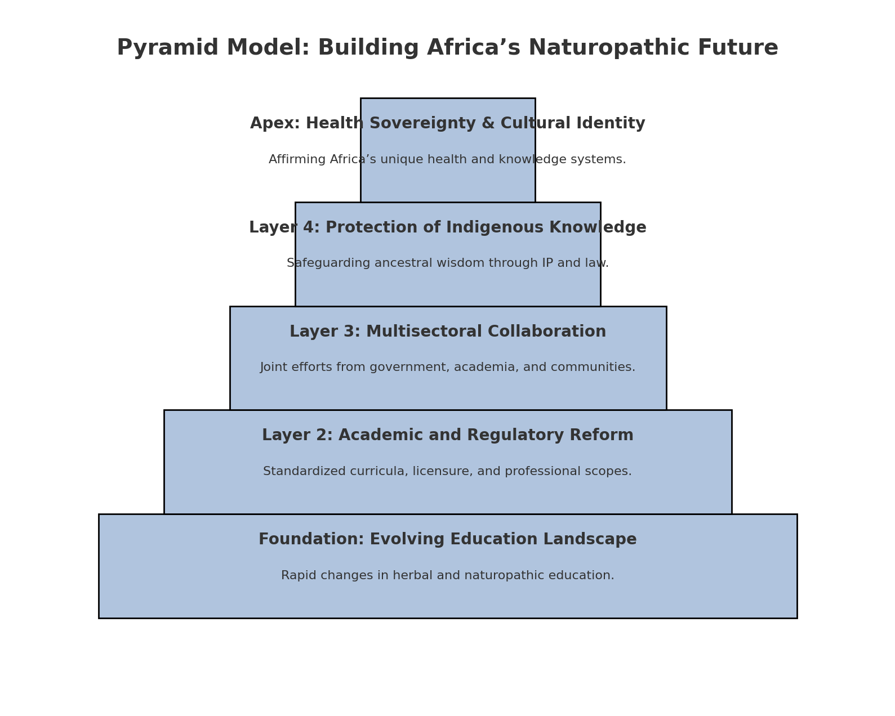

*Fig 10: Author’s Construct: This model layers the foundational needs—educational reform and regulation—up to the apex goal of achieving health sovereignty and cultural affirmation.*

**9. Strategic Opportunities and Policy Recommendations**

Despite the challenges revealed in this study, the current environment also presents unique opportunities to advance the institutionalization and integration of naturopathic and herbal medicine in Africa. These strategic opportunities can be leveraged by policymakers, educational institutions, and professional bodies through coordinated and multi-sectoral action.

**1. Standardized Accreditation and Curriculum Harmonization**

Africa lacks a unified educational system for naturopathy and herbal medicine. However, Ghana’s Competency-Based Training (CBT) model under the Commission for Technical and Vocational Education and Training (CTVET), and South Africa’s university-based programs serve as strong templates. These models should inform the development of:

* A **continental accreditation framework** aligned with National Qualification Frameworks (NQFs);
* A **harmonized Competency-Based Curriculum (CBC)** guided by National Occupational Standards (NOS);
* Integration of **African traditional healing systems, indigenous epistemologies, and biomedical science** in formal education.

Regional coordination through entities such as the African Union (AU), the African Medicines Agency (AMA), and the Southern African Development Community (SADC) is essential for cross-border recognition of qualifications and institutional credibility (WHO, 2019; Dunn et al., 2021).

**2. Legislative and Regulatory Reform**

Legal ambiguity remains one of the greatest barriers to professional legitimacy. Countries like Ghana and Nigeria must move beyond generic traditional medicine laws to enact **specific legislation for naturopathy and complementary medicine**. This includes:

* Enactment of **standalone Alternative Medicine Acts**;
* Establishment of **dedicated regulatory councils** for naturopathy and related disciplines;
* Clear definition of **professional scope, licensing requirements, and ethical standards**;
* Institutionalization of **inter-ministerial collaboration**, particularly among health, education, and science ministries.

Such reforms will provide legal clarity, strengthen accountability, and ensure safety in practice ( Obu, Raphael Nyarkotey, 2024; Ngang, 2018).

**3. Protection of Indigenous Knowledge and Intellectual Property**

Africa is rich in traditional knowledge, yet poor in mechanisms to protect it. To safeguard community heritage and promote benefit-sharing, countries should implement:

* Full enforcement of the **Nagoya Protocol** and the **WIPO Genetic Resources and Traditional Knowledge (GRATK) Treaty**;
* Establishment of **community-led Access and Benefit Sharing (ABS) frameworks**;
* National registries of traditional knowledge and pharmacopeia;
* Legal mechanisms for **sui generis intellectual property protection** reflecting collective ownership norms.

These actions will address biopiracy and ensure that local knowledge holders are equitably compensated (Arewa, 2006; Knight et al., 2022).

**4. Research and Clinical Infrastructure Development**

Naturopathic and herbal medicine education lacks robust research and clinical components. Strategic investments are needed to:

* Establish research funding schemes targeting TCIM clinical trials and safety studies;
* Build university-affiliated herbal clinics, laboratories, and diagnostic units;
* Support faculty development programs and North-South academic exchanges;
* Embed naturopathic and herbal medicine into national innovation and research policies.

This will enable the development of an evidence base to validate traditional systems and support integration into mainstream healthcare ( Obu et al., 2023; WHO, 2019).

**5. Integration into Public Health and Universal Health Coverage (UHC)**

To move beyond policy rhetoric, countries must institutionalize naturopathic and herbal medicine within public health delivery and financing mechanisms. This involves:

* Inclusion of TCIM services in national health insurance schemes;
* Recognition of licensed naturopathic clinics as public health service providers;
* Development of integrated referral systems between conventional and naturopathic practitioners;
* Compilation of national formularies of essential herbal medicines for safe public use.

Integration promotes patient choice, reduces costs, and improves culturally sensitive care (WHO, 2019).

**8. Development Issues**

The successful implementation of the above policy recommendations must also address several structural and systemic development challenges that currently impede progress in the field.

**1. Human Capital Development**

There is a serious shortage of qualified academic staff, curriculum developers, clinical supervisors, and researchers in the naturopathic and herbal medicine ecosystem. Most educators have little exposure to international best practices or interdisciplinary collaboration. Thus, efforts must be prioritized:

* Capacity-building programs for academic and clinical educators;
* International exchange fellowships and training partnerships;
* Incentive structures to retain professionals in academia.

**2. Institutional Infrastructure**

Many training institutions lack the physical and technological infrastructure to support comprehensive education. Essential facilities such as herbal gardens, botanical labs, libraries, diagnostic units, and simulation centers are often absent. Governments and development partners must:

* Offer capital grants for infrastructure development;
* Establish regional centers of excellence in naturopathy and herbal medicine;
* Promote digitally enabled learning systems for accessibility and scale.

**3. Equity and Accessibility**

Naturopathic and herbal education remains concentrated in urban centers, with limited access for rural populations and marginalized groups. Given that these groups are often the most reliant on traditional medicine, policies should:

* Introduce rural scholarship schemes and community-based training;
* Expand access through satellite campuses and mobile clinics;
* Foster public-private partnerships for outreach and inclusivity.

**4. Gender and Indigenous Participation**

Women and indigenous communities are the traditional custodians of African healing knowledge, yet remain underrepresented in formal regulatory and academic spaces. Development strategies should ensure:

* Gender-sensitive training models and leadership pipelines;
* Legal protections for communal knowledge and bio-cultural rights;
* Inclusive policy-making platforms that elevate indigenous voices.

**5. Data Systems and Monitoring**

There is limited data to assess the efficacy of naturopathic programs, patient outcomes, and the socio-economic impact of herbal medicine. As a result, policy remains speculative. Countries must:

* Integrate TCIM indicators into national health information systems;
* Establish routine program monitoring and evaluation systems;
* Collaborate regionally to build a continental TCIM observatory.

The strategic recommendations and development issues identified in this study reflect the dual necessity of policy innovation and structural reform to advance naturopathic and herbal medicine in Africa. By harmonizing academic standards, enacting robust legal frameworks, protecting indigenous knowledge, investing in infrastructure and research, and promoting inclusive participation, African states can transform a culturally rich but institutionally neglected sector into a cornerstone of holistic, resilient, and equitable healthcare systems.

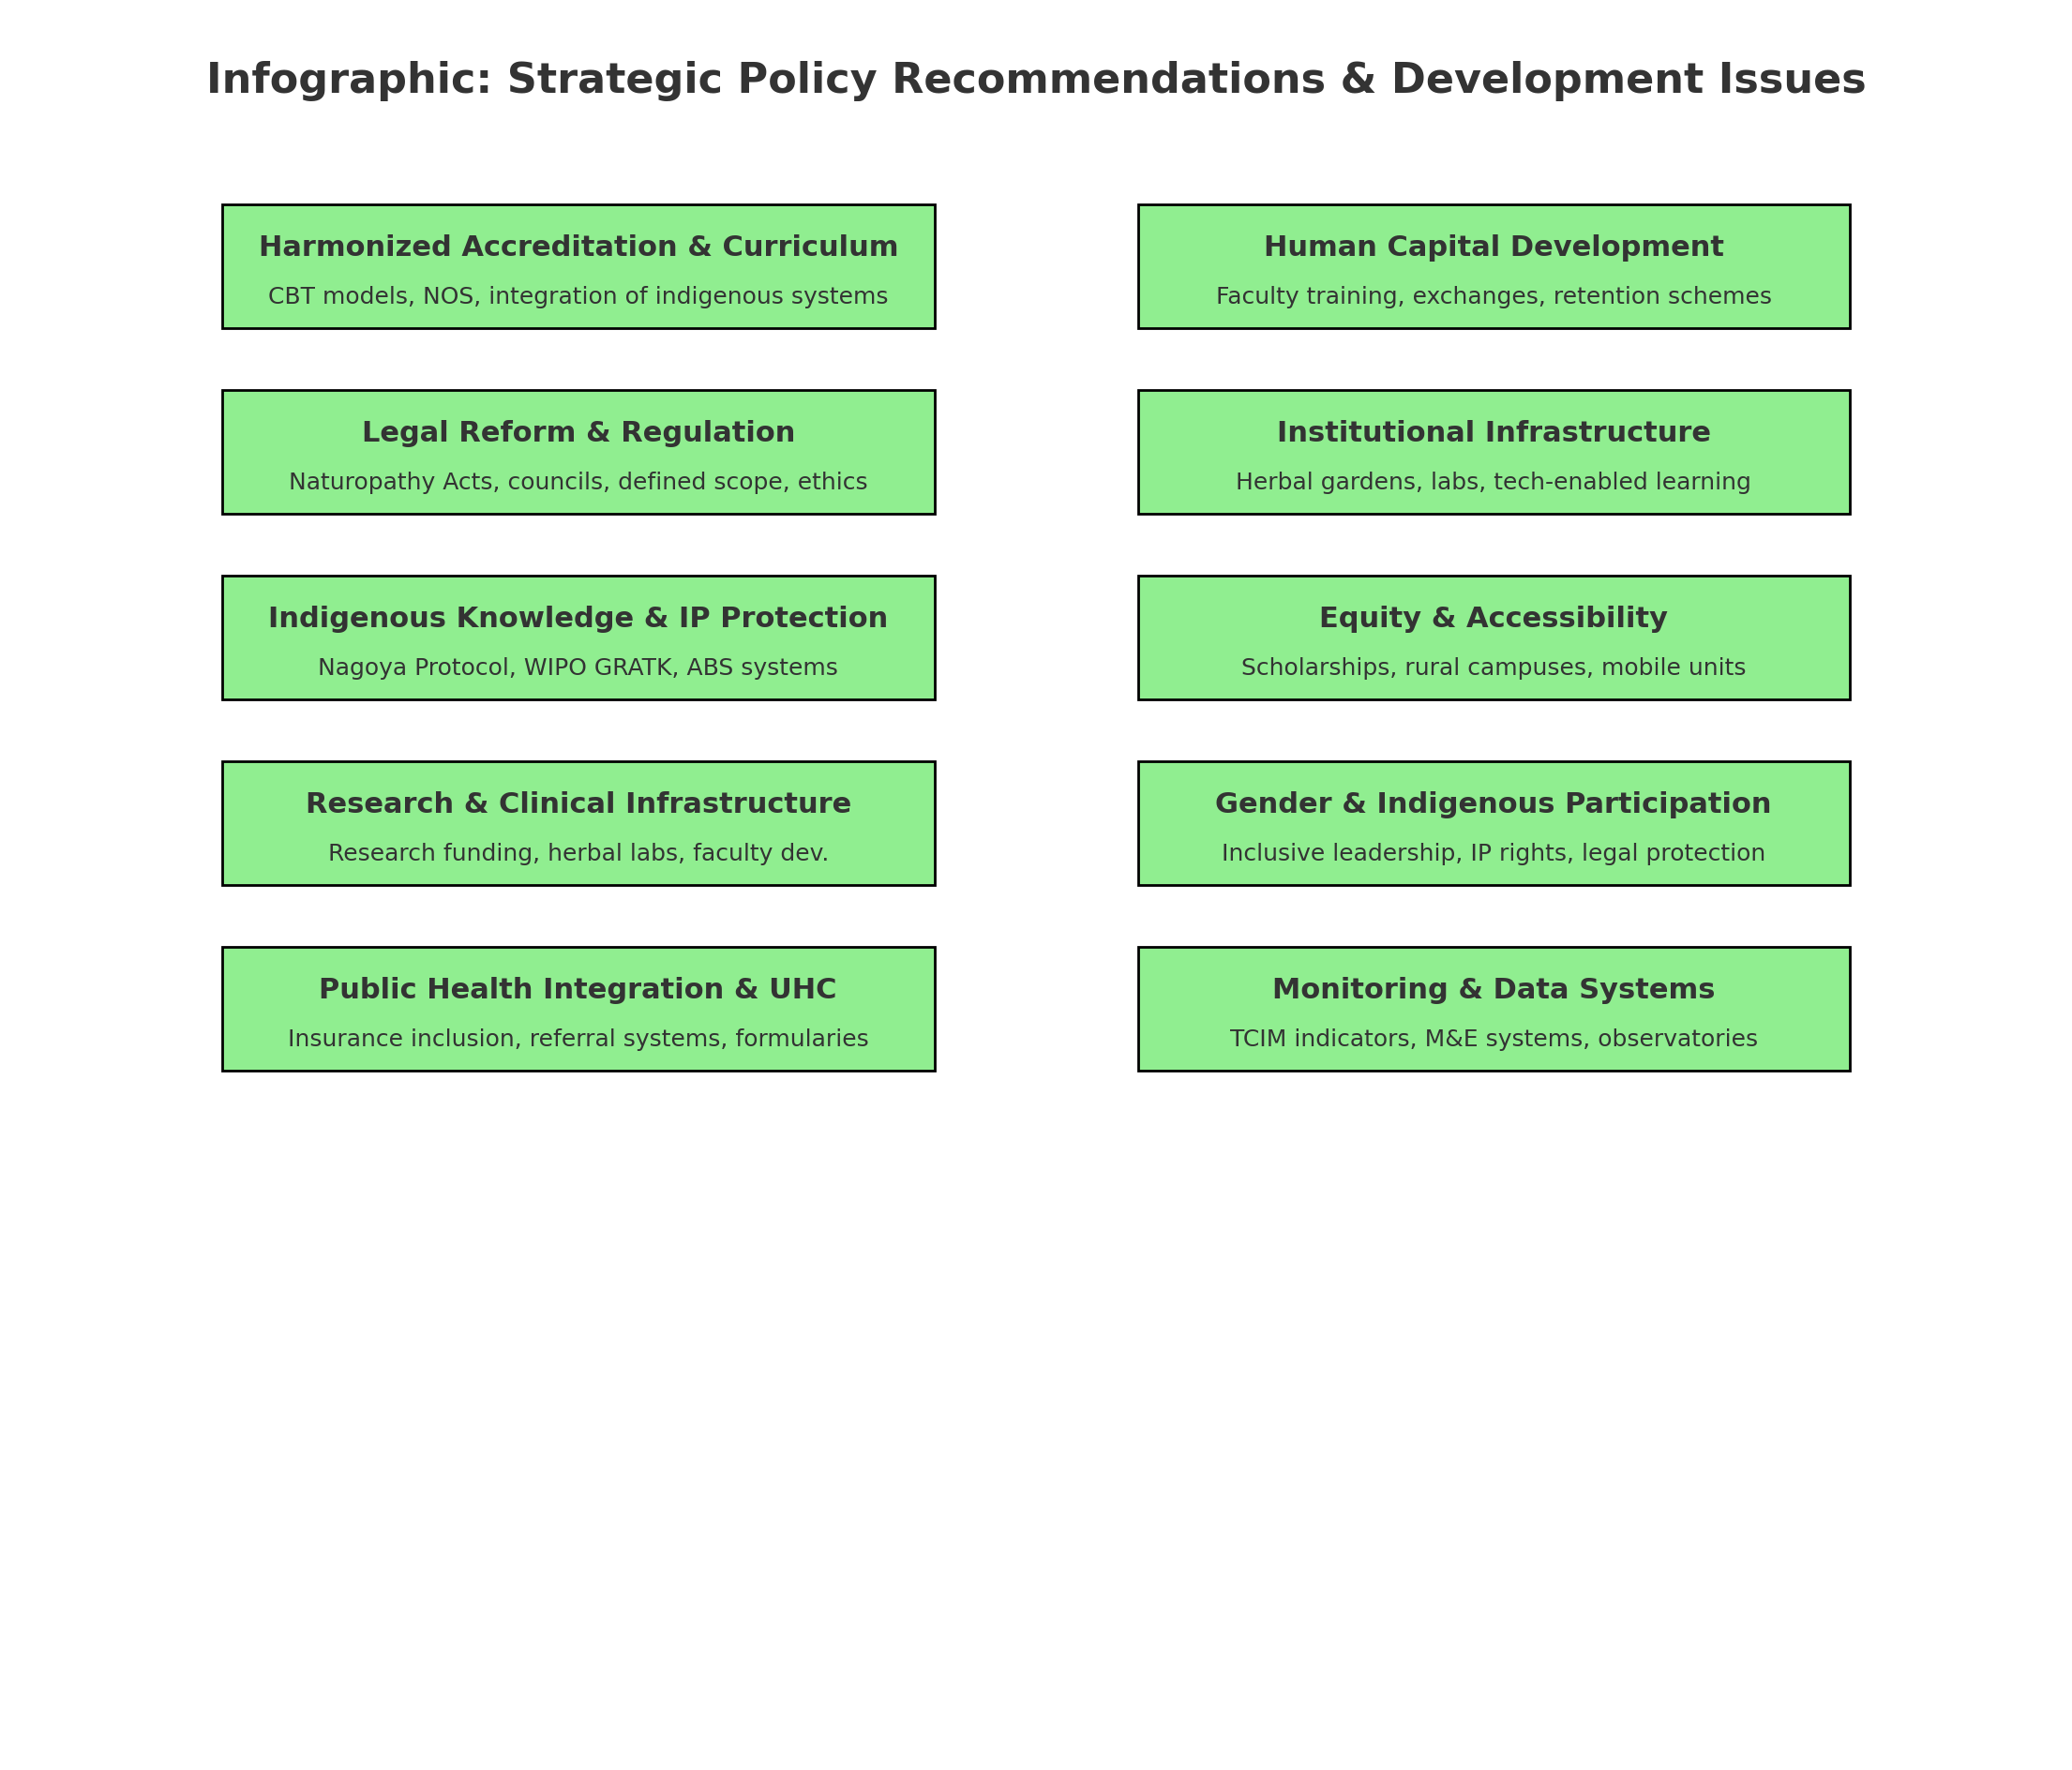

*Fig 11: Author’s Construct: Infographic summarizing the* ***Strategic Policy Recommendations and Development Issues*** *for naturopathic and herbal medicine in Africa:*

Disclaimer (Artificial intelligence)

Author(s) hereby declare that generative AI technologies such as Large Language Models, etc. have been used during the writing or editing of manuscripts. This explanation will include the name, version, model, and source of the generative AI technology as well as all input prompts provided to the generative AI technology

Details of the AI usage are given below:

1. (ChatGPT, 4.0) personalized Prof. DKB- AI Holistic Health Assistant assisted to in conducting the research and brainstorming the manuscript

**REFERENCES**

1. African Medicines Agency. (2025). African Medicines Agency. Wikipedia. <https://en.wikipedia.org/wiki/African_Medicines_Agency>
2. AU. (2015). *Practical Guidelines for the Coordinated Implementation of the Nagoya Protocol in Africa*. African Union. [jdsupra.com](https://www.jdsupra.com/legalnews/the-nagoya-protocol-regulating-research-2647225/?utm_source=chatgpt.com)[en.wikipedia.org](https://en.wikipedia.org/wiki/The_Globalization_of_Intellectual_Property_Rights?utm_source=chatgpt.com)[sciencedirect.com+2absch.cbd.int+2jdsupra.com+2](https://absch.cbd.int/api/v2013/documents/ACA06BA7-2ED4-19C0-F096-883C14068E94/attachments/AUPracticalGuidelinesOnABS_20150215_Druck.pdf?utm_source=chatgpt.com)
3. Abdullahi, A. A. (2011). Trends and challenges of traditional medicine in Africa. African Journal of Traditional, Complementary and Alternative Medicines, 8(S), 115–123. <https://doi.org/10.4314/ajtcam.v8i5S.5>
4. Arewa, O. (2006). Piracy, biopiracy, and borrowing: Culture, cultural heritage, and the globalization of intellectual property. Globalization of Intellectual Property Rights.
5. Adekola, T. A. (2019). Public health–oriented intellectual property and trade policies in Africa and the regional mechanism under Trade-Related Aspects of Intellectual Property Rights amendment. Public Health, 173, 1-4. DOI/10.1016/j.puhe.2019.04.019
6. Dunn, J.M., Steel, A.E., Adams, J. *et al.* Characteristics of global naturopathic education, regulation, and practice frameworks: results from an international survey. *BMC Complement Med Ther* **21**, 67 (2021). <https://doi.org/10.1186/s12906-021-03217-1>
7. Dr. Beth Anne Pratt and Dr. Laura J. Frost(2024), A Comparative Case Review of Governance of Traditional, Complementary and Integrative Medicine (TCIM). [cdn.who.int](https://cdn.who.int/media/docs/default-source/who-global-traditional-medicine-centre/a-comparative-case-review-of-governance-of-traditional--complementary-and-integrative-medicine-%28tcim%29.pdf?sfvrsn=f0d8a1f7_1&utm_source=chatgpt.com)
8. Ericksen-Pereira, W, Roman, N V, & Swart, R. (2021). A comparative analysis and evaluation of the naturopathic curriculum in South Africa. *African Journal of Health Professions Education*, *13*(4), 260-264. <https://doi.org/10.7196/ajhpe.2021.v13i4.1276>
9. Ikhoyameh M, Okete WE, Ogboye RM, Owoyemi OK, Gbadebo OS. Integrating traditional medicine into the African healthcare system post-Traditional Medicine Global Summit: challenges and recommendations. Pan Afr Med J. 2024 Mar 27;47:146. doi: 10.11604/pamj.2024.47.146.43011. PMID: 38933435; PMCID: PMC11204987.
10. Jasper Knight , Eleni Flack-Davison , Sidney Engelbrecht , Retha, G. Visagie , Winston Beukes e, Marizvikuru Mwale (2023) **Compliance with the Nagoya protocol in the Southern African Development Community. South African Journal of Botany. Volume 159, August 2023, Pages 302-318**
11. J Knight; E Flack-Davison; S Engelbrecht; R G Visagie, DCur; W Beukes, T Coetzee; M Mwale; D Ralefala(2022) A literature review analysis of engagement with the Nagoya Protocol, with specific application to Africa. S Afr J Bioethics Law 2022;15(2):69-74. <https://doi.org/10.7196/SAJBL.2022.v15i2.811>
12. Mekasha YT, Getahun H, Tegegne AA, Hasen G. Situational analysis and future directions for medicine retail outlets: compliance with pharmaceutical regulatory standards in Ethiopia. Front Med (Lausanne). 2025 Mar 12;12:1452875. doi: 10.3389/fmed.2025.1452875. PMID: 40166068; PMCID: PMC11956760.
13. Maheen Raja, Holger Crame , Myeong Soo Lee, L. Susan Wieland, Jeremy Y. Ng(2024) Addressing the Challenges of Traditional, Complementary, and Integrative Medicine Research: An International Perspective and Proposed Strategies Moving Forward. Perspectives on Integrative Medicine 2024;3(2):86-97. DOI: <https://doi.org/10.56986/pim.2024.06.004>
14. *Nyarkotey, P. (June 10, 2025). From Tradition to Transformation: Institutionalizing Naturopathy in Ghana through the TVET-CBT Framework. African Researchers Magazine (ISSN: 2714-2787).* [*https://www.africanresearchers.org/from-tradition-to-transformation-institutionalizing-naturopathy-in-ghana-through-the-tvet-cbt-framework/*](https://www.africanresearchers.org/from-tradition-to-transformation-institutionalizing-naturopathy-in-ghana-through-the-tvet-cbt-framework/)
15. Ngang, C. C. (2018). Intellectual property protection of African traditional medicine within the legal framework of the right to development. *University of Pretoria Law Review*. [repository.up.ac.za+1researchgate.net+1](https://repository.up.ac.za/bitstreams/7b822e33-e774-435c-87f8-603b058385fe/download?utm_source=chatgpt.com)
16. Obu R N, Bluwey L A, African naturopathic education: Ghana’s model using competency-based curriculum. ***J Prev Med Holist Health***2022;8(2):75-84
17. Obu, Raphael Nyarkotey. 2024. “A Comparative Analysis and Development of Legislative Regulatory Framework of Naturopathy and Traditional Medicines Practices in Southern Africa Region”. *Journal of Complementary and Alternative Medical Research* 25 (12):97-109. <https://doi.org/10.9734/jocamr/2024/v25i12599>.
18. Obu, P. R. N. . (2025). Legal Perspective on Traditional & Naturopathy Regulatory Framework in Africa. *Legal Perspective on Traditional & Naturopathy Regulatory Framework in Africa*, 1–52. <https://doi.org/10.9734/bpi/mono/978-93-49473-54-6>
19. Obu, R. N., Aggrey-Bluwey, L. and Osei –Attakora, S. (2022). The Practice and Regulatory Requirement for Naturopathy: Critical evaluation and effects of the Naturopathic Regulation in the Ghanaian Healthcare delivery. ADRRI Journal of Medical and Biomedical Research, Ghana: Vol. 4, No. 2 (5), Pp. 1-30, E- ISSN: 2026-6022, 30
20. Regulation and prevalence of homeopathy(2025) <https://en.wikipedia.org/wiki/Regulation_and_prevalence_of_homeopathy?utm_source=chatgpt.com>
21. Scott, W. R. (2004). Institutional theory: Contributing to a theoretical research program. In K. G. Smith, & M. A. Hitt, (Eds.), Great minds in management: The process of theory development (pp. 460-484). Oxford: Oxford University Press.
22. Steel A, Gallego-Perez DF, Ijaz N, Gall A, Bangpan M, Dos Santos Boeira L, Schveitzer MC, Chutaputti A, Mahlanza-Langer L, Pillai GKG, Posayanonda T, Sungchol K, Shankar D, Kuchenmüller T. Integration of Traditional, Complementary, and Integrative Medicine in the Institutionalization of Evidence-Informed Decision-Making: The World Health Organization Meeting Report. J Integr Complement Med. 2025 Apr;31(4):388-394. doi: 10.1089/jicm.2024.0837. Epub 2025 Jan 17. PMID: 39819104; PMCID: PMC7617372.
23. Tamanaha, B. Z. (2012). *Legal Pluralism*. Cambridge University Press
24. Wikipedia. (2025). Traditional African medicine. <https://en.wikipedia.org/wiki/Traditional_African_medicine>
25. World Health Organization. (2019). WHO global report on traditional and complementary medicine 2019. WHO.
26. World Health Organization. (2019). Traditional, Complementary and Integrative Medicine. WHO.
27. Wikipedia. (2025). Regulation and prevalence of homeopathy. [en.wikipedia.org](https://en.wikipedia.org/wiki/Regulation_and_prevalence_of_homeopathy?utm_source=chatgpt.com)
28. Wikipedia. (2025). Nagoya Protocol. [en.wikipedia.org](https://en.wikipedia.org/wiki/Nagoya_Protocol?utm_source=chatgpt.com)
29. Wikipedia. (2025). African Regional Intellectual Property Organization (ARIPO). [en.wikipedia.org+1en.wikipedia.org+1](https://en.wikipedia.org/wiki/African_Regional_Intellectual_Property_Organization?utm_source=chatgpt.com)
30. Wikipedia. (2025). Organisation Africaine de la Propriété Intellectuelle (OAPI). [en.wikipedia.org](https://en.wikipedia.org/wiki/Organisation_Africaine_de_la_Propri%C3%A9t%C3%A9_Intellectuelle?utm_source=chatgpt.com)
31. Wikipedia. (2025). African Medicines Agency.
32. Wankhede, P., Khelpande, N., Khode, D., Khode, N., Khunkar, S., & Khewale, D. (2021). Assess the Knowledge and Attitude Regarding Alternative System of Medicine among the Adults in Rural Community Area. Journal of Pharmaceutical Research International, 33(39A), 148–155. https://doi.org/10.9734/jpri/2021/v33i39A32153