**Production and Mechanical Properties of Austempered Ductile Iron (ADI) Using Periwinkle and Alloy Nodularizers for Crankshaft Applications**

**ABSTRACT**

The excellent mechanical properties of austempered ductile iron (ADI) have been harnessed to significantly increase its application in automobile parts and improve its performance. The produced ADI crankshaft in this research from investment casting using periwinkle shell as nodularizers technique is labelled A, B, C, D, E, F and G. The ADI has shown a good combined mechanical property, exceptional wear resistance, these properties are unavailable in forged steel crankshaft taking advantage of the significant savings in energy, and the resulting advancement of light weight, durable materials, and less expensive, is an evident in replacing forged steel crankshaft. The elemental composition of 25 microns calcined periwinkle ash at 600 °C used as nodularizers in the treatment of ductile iron was carried out with an X-ray fluorescence (XRF) machine (PANanalytical), for the concentration of specific elements attained was good enough as an alternative to ferrosilicon magnesium. The optimisation of the lost-wax crankshaft produced was analysed using the response surface methodology-version 17 MINITAB software of fractional factorial design, using variables such as calcined periwinkle ash because of their economic viability and desirable properties. In the ductile iron melt, the higher temperature of 1000 °C used for calcination offered a higher value of calcium oxide that produced poor mechanical properties of ductile iron from higher carbide formation, hence, the choice of 600 °C with less value of calcium oxide is evident which produce 96% nodularity and 200 nod/mm2 nodule count. The ductile iron produced conforms to ASTM A536 65 – 45 - 12 grade, cast into round rods, and isothermally heat treated at 300 °C austempering temperature at varied times of 30, 45 and 60 minutes that produced the ADI crankshaft. The increase in volume fraction of retained austenite and its carbon content provides favourable ductility and toughness. The good combined mechanical properties exhibited by sample G as a result of copper and vanadium addition were attributed to its high–volume fraction of acicular ferrite and fine ausferritic matrix. Thus, ADI produced from G is recommended for the production of the tricycle crankshaft.

**Keywords:** *Austempered ductile iron (ADI), Crankshaft, Mechanical Properties, Periwinkle Shell*

**1. INTRODUCTION**

“The way of occurrence of graphite structure in cast iron gives different types of iron produced, such as grey cast iron, white cast iron, ductile cast iron, malleable cast iron and so on. When magnesium is added to molten cast iron, it results in a nodular graphite structure in the iron; this is called nodular cast iron, spheroidal graphite cast iron or ductile iron” [1,30]. “Steel usually makes a rough-looking casting, and it reduces in size substantially due to solidification shrinkage (2 to 3%) and thermal contraction, as the casting cools to room temperature. The difficulty in controlling carbon in cast steels has also been a setback, since its strength is primarily a function of the carbon content” [2]. “The alternative material is undoubtedly austempered ductile iron (ADI). The need to produce engine parts for vehicles and industrial machines locally with ADI has come of age long before now, especially if the tremendous increase in the cost of imported machines and their spare parts is considered. ADI can be produced through austenitizing of ordinary ductile cast iron, followed by an isothermal austempering heat treatment at the temperature range of 250–450 °C (Avishan et al., 2025). ADI offers cost advantages over steel fabrication and forgings”. [3]. “Flexibility of design, the ability to reduce a multi–component fabricated assembly to a single casting, offers several obvious opportunities to save cost, designing complex castings like crankshafts using the investment process” [4].

“In fact, the process (casting) design flexibility and versatility have motivated the automobile industry to adopt casting as a better alternative process for manufacturing most of their engine component” [5],[6]. “Modern casting technologies are providing components in practically every industrial application, notwithstanding that solidification is the starting point for every wrought or powder product for downstream manufacturing” (Luo et al., 2022; Yerra et al., 2023). “However, in substituting forging with the casting process for crankshaft production, the restrictive limitation here is the poor casting properties of the conventional materials (steel). Also cast crankshaft should be able to handle loads from all dimensions as the grain structure is expected to be uniform and random with the investment casting process, being a very intricate shape component” [7], [8]. “Austempering temperatures are in the range of (230 – 450) °C according to the properties required in the casting’s application. At higher austempering temperature (upper bainitic range), the ferrite nucleates and grows into austenite”[9], [10]. “Lower austempering temperatures produce finer and greater volume fraction of ferrite and higher yield strength. The nature of the Ausferrite microstructure depends not only on austempering temperature but a lower volume fraction of ferrite, which is accompanied by lower yield strength” [11]. In this research work, the effect of copper, molybdenum and vanadium alloys, as well as the effect of heat treatment parameters such as austempering temperature and austempering time on mechanical properties and microstructure of the ductile iron on the crankshaft applications was studied.

Aliakbari (2021) [12] analysed the fatigue failure of a fractured truck crankshaft, where he evaluates the cause of the failure from several experimental studies, chemical composition, mechanical properties and microstructural studies.

Ratnesh and Amit (2003) [13]. revealed that “the appropriate substitute material is AISI–4140 alloy steel (EN 19C) steel identified and tested for the diesel motor crankshaft rather than ASTM A536 100- 70-03 (GGG70) high ductile steel. The material is heavier than ASTM A536 100 – 70-03 (GGG 70), but it has superior crankshaft properties. The high amount of strain is significantly high, allowing it to have a long service life. The outcomes from the ANSYS test showed that the shear force exerted on the ASTM A536 100 – 70 – 03 (GGG 70) high ductile material was greater than compared of AISI–4140 alloy steel (EN 19C) before enlistment solidifying. The analysis carried out determined that the weight of AISI–4140 alloy steel (EN 19C) was 3kg higher than ASTM A536 100–70-03 (GGG70)”.

Jiyaul and Abhishek (2020) [14] investigated that “dynamic simulation is conducted on a crankshaft from a single-cylinder stroke petrol engine. A three–dimensional model of a petrol engine crankshaft is created using SOLID WORKS software. Finite element analysis was performed to obtain the variation of stress magnitude at critical locations of the crankshaft” [15].

Ramadan *et al*. (2014) [16] and Abdullah *et al*. (2010) [17] show that “there is a significant importance in energy saving, which has led to the advancement of light-weight, durable and cost-effective materials. Research efforts on this material have mainly focused on possible improvements of mechanical properties by alloying elements as well as by subjecting it to appropriate heat treatment”.

Wang *et al.* (2018) [18] revealed, “ductile iron which is subjected to a particular isothermal heat treatment process, that is heating to the austenitizing temperature, quenching into a salt or oil bath at a temperature in the range of 200o C to 445o C and holding for the time required for transformation to occur at this temperature is known as austempered ductile iron (ADI), and the process is known as austempering heat treatment. Ductile cast iron undergoes a remarkable transformation when subjected to the austempering heat treatment process, and the resulting microstructure, known as “Ausferrite”, consists of fine acicular carbon-enriched stabilised austenite that gives it its special attributes to ADI” 19].

Erfanian *et al.* (2012) [20] observed that “the new microstructure of ADI gives superior properties of higher performance than aluminium alloys. Ausferrite exhibits twice the strength for a given level of ductility compared to the pearlite, ferrite or martensitic structures formed by conventional heat treatments”.

“The ADI emerged as a new engineering material in recent years, and its properties are comparable, or in some cases superior to those of forged steel”[21]

Wang *et al.* (2018) [22], Investigated the use of ADI for automobile components like the crankshaft will yield many advantages over forging. Some of these advantages are design and manufacturing flexibility, light weight, higher fatigue strength, good wear resistance, better machinability and significantly low manufacturing cost. Wang *et al.* (2018) [23] states that, the optimum combination of high carbon austenite and acicular ferrite confers excellent mechanical properties on ADI that made its engineering applications especially on the crankshaft compete favorably with forged steel and aluminum alloys.

Orlowicz *et al.* (2015) [24] reveal that, “conventionally, crankshafts are produced from AISI5140 (high carbon steel) by drop forging in dies. This process is, however, very expensive because of the high initial capital investment, especially in the procurement of the dies. Hence, there is a need for an alternative process which will compete with the conventional method at a relatively lesser cost. Out of the various metal forming processes existing, the casting process has proved to be the best alternative to forging for crankshaft production. Because of its intricate shapes and desired dimension with specified properties that are easily produced directly from molten metal with less expenditure of energy, material and labour” [25].

**2 Materials and Methods**

**2.1 Materials**

Pig iron, cast iron and steel scraps were used in this research and these materials, according to the charge calculation, were charged into the furnace for melting. Other materials charged include ferromolybdenum, ferrovanadium and copper from the same source as additives that improved the hardenability and microstructure. Also**,** Periwinkle shell was obtained, calcined and used as nodularizers that modified the morphology of graphite in the ductile iron. Plaster of Paris, otherwise called gypsum and water, was used to make the mould that creates the crankshaft cavity. Three different waxes were used to make a wax pattern of the crankshaft.

**2.2 Production of mould**

The mould is prepared using Plaster of Paris (POP), also called gypsum and water. Both gypsum and water are measured by weight and expressed in numerical ratio, in terms of 100 parts of plaster. The mixture is in a proportion of 100 parts of gypsum added to 67 parts of water and stirred slowly to a creamy consistency. The mixture is then poured into the mould boxes where the split pattern of the crankshaft is positioned. After the setting of the mould at 3 minutes, the pattern was removed from the mould, thereby creating a cavity in the mould.

**2.3. Charge materials preparation**

The raw materials for melting were cleaned with a hard wire brush that removed the sand and oil from the scraps. These materials were charged into the graphite tilting crucible furnace where melting commenced, and were melted to 1430 °C, which was a superheated temperature that compensated for temperature drop during ladle treatment. At this pouring temperature, the molten metal was tapped from the furnace into the treated ladle containing calcined periwinkle ash, which is a nodularizer covered with a steel plate that prevented the nodularizing material from floating. this method is known as the sandwich method. Meanwhile, the inoculation was carried out using ferrosilicon along the stream of molten metal to the ladle.

**2.4 Casting (lost–wax)**

The investment casting technique was adopted in this study due to the intricate shape of the crankshaft. In view of good dimensional stability, the investment casting using wax material was used following the steps below:

1. Wax pattern creation- A wax pattern is created in the shape of the final casting (crankshaft).
2. Investment mould: The mould was produced using plaster of Paris (POP) mixed in the proportion of 100 parts of gypsum to 67 parts of water, stirred slowly to a creamy consistency.
3. Combination of 3 waxes, namely: Bees, paraffin and stearin in proportions of 5%, 40% and 55% respectively, were blended, which produced good surface quality, high strength and dimensional stability. The wax pattern produced was coated with a refractory material and sand stucco to resist high temperature and provide strength to the mould, respectively.
4. In De-waxing, the ceramic shell mould was placed in an oven and heated to a high temperature that melts out the wax and moisture content from the mould.

Torocell’s equation was applied in the calculation of the time used in filling the mould cavity created by wax, as well as the cross-sectional area of the gate incorporated in the mould, as 2.66 Seconds and 11.87 cm2, respectively.

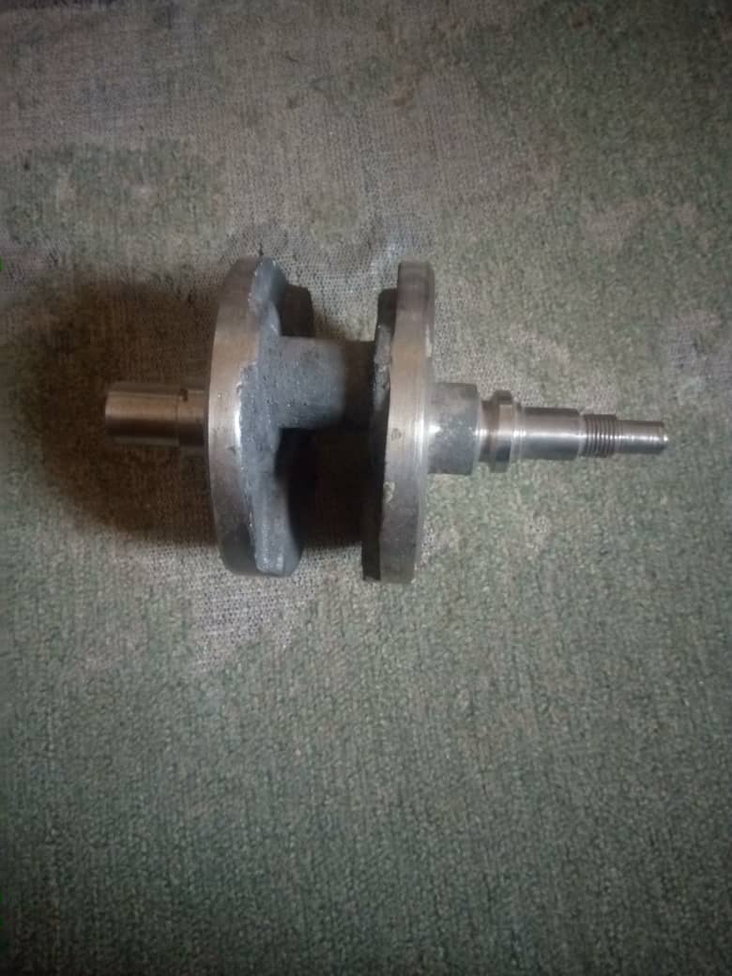 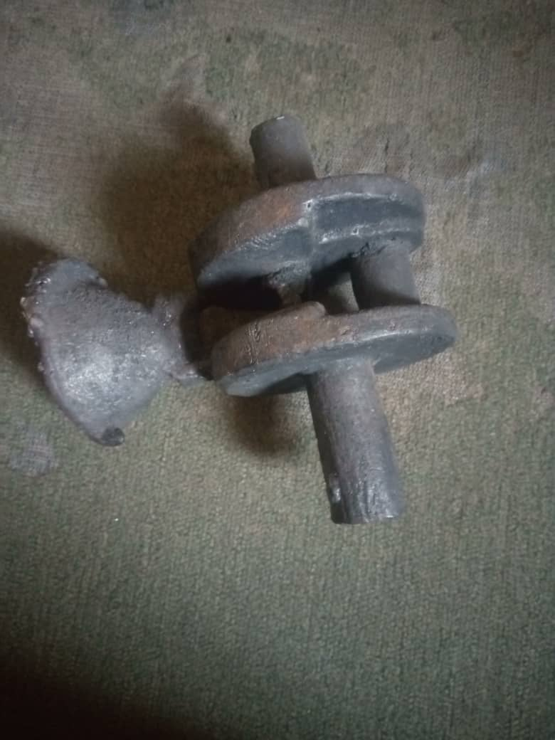

Fig 1a: ADI Crankshaft without In-gates Fig 1b: ADI Crankshaft with In-gates

**2.5 Heat Treatment Process**

Figure 2 shows the stages in the production of ADI, which consists of two separate and controlled steps– austenitizing and austempering.

 Figure 2: Heat treatment cycle for ADI

The initial preheating of the samples for 10 minutes to 450 °C removed oil and dirt from the sample surface in a preheating furnace, then the samples were heated to a temperature of 900 oC for 30 minutes in an enclosed furnace. The austenitizing temperature and time of 900 °C and 30 minutes, respectively, transformed the ferrite matrix into austenite, which allowed the dissolution of carbon into the austenite matrix in the sample. Then, the cast product was subjected to austempering, an isothermal heat treatment technique, in which samples were rapidly quenched in a molten salt bath of 50%wt sodium nitrate and 50%wt potassium nitrate salts. The transfer of the samples from an elevated temperature to the quench tank was carried out within 5 seconds while the temperature was monitored to ensure isothermal transformation of the Ausferrite structure. The austempering was carried out at a temperature of 300 °C for three (3) different times of 30 minutes, 45 minutes and 60 minutes, which studied the effect of the austempering time on the mechanical properties and its microstructural evolution. The temperature and times chosen have avoided the formation of pearlite as well as martensite at a lower austempering temperature of 300 °C. After the austempering process, where the transformation took place (Ausferrite), the transformed samples were fed into the hot water washing machine for 30 minutes, which removed salt from the surface of the samples.

**2.6 Mechanical Testing**

The hardness test, tensile test, impact test, fatigue test and wear test samples were prepared

according to the specification for analysis.

**3 RESULTS AND DISCUSSION**

**3.1 Chemical Composition Analysis**

The major chemical composition obtained shown in Table 1, is CaO in the periwinkle shell and met the standard. The large amount of calcium in the periwinkle shell implies its calcination to be used as nodularizing material as it desulphurizes and deoxidises due to its high affinity for sulfur and oxygen than magnesium.

During the production of ductile iron, calcium contributed to the incubation process by its reaction with sulfur and oxygen, which produced a silicate phase. The result was a high nucleation rate and high graphite spherical growth rate that conferred a high sphere number. The addition of calcium due to his much greater affinity with Sulphur and oxygen than magnesium, the desulphurization and deoxidation effectively protected the magnesium and creates better metamorphic condition for magnesium, increased the residual amount of magnesium, prevented and slow down the spheroidal recession; at the same time the sulphides generated became the core of graphite crystallization, increased and refined graphite sphere, improved its shape and distribution therefore reduced the chance of graphite distortion. In the ductile iron melt. The higher temperature of 1000 °C used for calcination offered a higher value of calcium oxide that produced poor mechanical properties of ductile iron from higher carbide formation; hence, the choice of 600 °C with less value of calcium oxide is evident, which produces 96% nodularity and 200 nod/mm2 nodule count.

**Table 1: Chemical Composition of Periwinkle Shell Ash Calcined at Different Temperatures**

|  |  |  |  |
| --- | --- | --- | --- |
| **Elemental Oxide (%)** | **600 oC** | **800 oC** | **1000 oC** |
| SiO2 | 30.1 | 34.80 | 30.74 |
| Al2O3 | 10.42 | 11.84 | 14.31 |
| Fe2O3 | 10.21 | 7.58 | 9.35 |
| CaO | 36.22 | 39.39 | 37.53 |
| MgO | 8.42 | 0.76 | 0.73 |
| SO3 | 0.90 | 0.16 | 0.35 |
| Na2O | 0.68 | 0.27 | 0.25 |
| K2O | 0.03 | 0.27 | 0.16 |
| P2O5 | 0.01 | 0.00 | 0.01 |
| TiO2 | 0.52 | 1.24 | 0.07 |
| LOI | 2.44 | 3.69 | 6.51 |
|  |  |  |  |
|  |  |  |  |

**Table 2: Chemical Composition of Produced Ductile Iron (%) using Periwinkle(A-G) as Nodularizers at 600o C**

|  |  |  |  |  |  |  |  |  |  |  |  |
| --- | --- | --- | --- | --- | --- | --- | --- | --- | --- | --- | --- |
|  | **%C** | **%Si** | **%Mn** | **%Cr** | **%S** | **%P** | **%Mo** | **%V** | **%Cu** | **%CPA** | **%Fe** |
| A | 3.760 | 2.726 | 0.282 | 0.028 | 0.010 | 0.024 | 0.100 | 0.800 | 0.400 | 1.000 | 94.000 |
| B | 3.600 | 2.610 | 0.270 | 0.027 | 0.009 | 0.023 | 0.200 | 1.300 | 0.300 | 5.500 | 90.000 |
| C | 3.392 | 2.459 | 0.254 | 0.025 | 0.009 | 0.022 | 0.300 | 1.300 | 0.400 | 1000 | 90.000 |
| D | 3.580 | 2.596 | 0.269 | 0.026 | 0.010 | 0.023 | 0.200 | 0.300 | 0.300 | 5.500 | 89.500 |
| E | 3.790 | 2.749 | 0.284 | 0.028 | 0.010 | 0.024 | 0.300 | 0.300 | 0.400 | 1.000 | 94.800 |
| F | 3.780 | 2.741 | 0.283 | 0.028 | 0.010 | 0.024 | 0.200 | 0.800 | 0.300 | 10.000 | 94.500 |
| G | 3.596 | 2.607 | 0.269 | 0.026 | 0.010 | 0.023 | 0.200 | 0.300 | 0.400 | 5.500 | 89.900 |

The conventional ductile iron casting composition differed quite from the composition of ADI casting in most cases. Consideration is paramount in selecting the composition has avoid any element that has an adverse effect on casting low quality through the production of non–spheroidal graphite, or the formation of carbides and inclusions, or other casting defects such as shrinkage.

The choice and the control of carbon, silicon and the major alloying elements that control the hardenability of the iron and the properties of the transformed microstructure became necessary as the determination of alloying requirements, such as the section size, type and the speed of the austempering quench, was considered.

The quenching of the sample, that is, the crankshaft in the used salt bath by proper agitation of the section size, has avoided the formation of pearlite during heat treatment, and the selection of alloys such as molybdenum, copper, and vanadium has equally helped in hardening the parts.

In selecting the raw materials, particularly the use of high purity pig iron for the production of ductile iron then subjected to isothermal heat treatment offered twin advantages of diluting the manganese in the steel scrap to the acceptable levels as well as undesirable trace element were controlled during melting because during solidification, manganese will segregate to the cell boundaries to forms carbide which can retards the austempering reaction, as manganese can also help strongly in increasing the hardenability of the ADI.

Also, the introduction of calcined periwinkle ash which was mixed with purified oil used in coating the surface of the shell mould especially at the critical points like crankpin and main bearing in the crankshaft has produced the higher austenitic carbon which increased the tensile strength, toughness as well as the fatigue strength of the produced ADI as the matrix impedes motion of dislocation in austenite during decarburization of heat treatment was avoided. The choice of vanadium alloy used in the production instead of conventional nickel helped at the austempering reaction at 300 ◦C, a microstructure constituted a fine ausferritic with a trace of carbide, resulting in good wear resistance obtained in the block–on–ring wear test, and mechanical properties were carried out.

**Table 3: Mechanical Properties of the Developed ADI**

|  |  |  |  |  |  |  |  |
| --- | --- | --- | --- | --- | --- | --- | --- |
| **Samples** | **Specimens**  **Holding Time(min)** | **Fatigue Strength (Mpa)** | **Hardness Test (HRC)** | **Impact Test (J)** | **Tensile strength (Mpa)** | **Elongation (%Max.)** | **Wear Rate**  **m3./m** |
| A | E30 | 305.9 | 51 | 10.01 | 500.00 | 4.19 | 1.45E-06 |
| E45 | 355.1 | 55.8 | 14.49 | 605.12 | 5.35 | 4.02E-07 |
| E60 | 308.6 | 51.5 | 10.45 | 600.15 | 4.28 | 1.37E-06 |
| B | F30 | 300.2 | 42.6 | 12.50 | 510.50 | 4.68 | 3.65E-06 |
| F45 | 337.0 | 48.0 | 16.32 | 564.12 | 6.14 | 4.11E-07 |
| F60 | 303.5 | 42.9 | 12.09 | 515.13 | 5.43 | 1.24E-06 |
| C | G30 | 300.6 | 32.5 | 15.34 | 580.06 | 5.54 | 1.13E-06 |
| G45 | 318.6 | 37.9 | 19.47 | 660.14 | 6.93 | 2.03E-07 |
| G60 | 302.0 | 32.9 | 15.50 | 620.03 | 5.65 | 1.13E-06 |
| D | H30 | 337 | 51.4 | 10.01 | 440.03 | 3.81 | 1.10E-06 |
| H45 | 388.6 | 55.8 | 14.44 | 560.03 | 4.95 | 1.12E-07 |
| H60 | 338 | 51.6 | 11.50 | 460.09 | 4.16 | 1.11E-06 |
| E | K30 | 328.94 | 41.73 | 10.03 | 655.63 | 7.32 | 2.46E-06 |
| K45 | 372.81 | 47.51 | 14.87 | 794.63 | 9.04 | 3.04E-07 |
| K60 | 331.05 | 41.93 | 10.09 | 710.13 | 7.41 | 2.50E-06 |
| F | M30 | 328.3 | 51 | 16.11 | 582.12 | 4.65 | 2.11E-06 |
| M45 | 367.2 | 55.8 | 19.13 | 688.13 | 7.67 | 2.92E-07 |
| M60 | 332.4 | 51.9 | 16.12 | 600.18 | 5.15 | 1.27E-06 |
| G | N30 | 329.8 | 52.5 | 14.2 | 865.15 | 5.04 | 2.05E-06 |
| N45 | 389.2 | 58.8 | 17.8 | 969.46 | 6.97 | 2.15E-07 |
| N60 | 339.4 | 53.9 | 14.3 | 837.13 | 4.82 | 2.06E-06 |

**3.2 Mechanical Properties**

**3.2.1 Effect of Austempering Time on Tensile Strength**

Figure 3: Variation of tensile strength with respect to the austempering time at a temperature of 300 oC.

Figure 3 reveals the difference in tensile strength with respect to the austempering times of 30 minutes, 45 minutes and 60 minutes. It was noticed that the tensile strength is increased from an austempering time of 30 minutes to 45 minutes, and starts decreasing from 45 minutes to 60 minutes.

The lower austempering produced a final ferrite needle structure contributed to the increased ADI materials tensile strength and yield strength.

From the results, it indicated that the copper addition leads to a significant increase in the strength of the as-cast from 588Mpa to 969.46Mpa. This shows that vanadium addition in strengthening of as-cast ductile iron is probably due to promoting and refining the pearlitic phase in comparison to the as-cast condition.

**3.2.2 Effect of Austempering Time on Elongation**

Figure 4: Variation of elongation with respect to the austempering time at a temperature of 300oC.

Figure 4 shows the variation of elongation with respect to the austempering time at a temperature of 300oC. the elongation is increasing from 30 minutes to 45 minutes, and from 45 minutes to 60 minutes, it is decreasing. At a low austempering time, the lower elongation values were recorded in the sample, which could be attributed to the presence of martensite in the matrix of the ausferritic structure. But the ductility is found to increase with increasing austempering time up to 45 minutes due to the increase in the amount of retained austenite and less martensitic.

The ductility of ADI is found to increase with an increase I austempering time due to an increase in the amount of retained austenite and martensite disappearance in the microstructure and the grade coarseness in nature. The copper addition could be the cause of an increase at the optimal time. Beyond the optimal time of 45 minutes, there was a decrease in ductility noted due to the start of stage II of the austempering reaction as the retained austenite decomposed to ferrite and carbide.

**3.2.3 Effect of Austempering Time on Hardness**

Figure 5: Variation of hardness with respect to the austempering time at a temperature of 300 oC.

As seen in Figure 5, it is observed that hardness was relatively high after austempering at 300 °C for 30 minutes. This could be due to the presence of martensite in the microstructure. Hardness reduced gradually and then increased with an increase in austempering time as the presence of martensite started its transformation into ferrite matrix, which leads to martensite content and acicular ferrite increased that leading to a decrease in hardness beyond the optimal time of 45 minutes.

**3.2.4 Effect of Austempering Time on Fatigue Strength**

Figure 6: Variation of Fatigue Strength with respect to the austempering time at a temperature of 300 oC

The excellent fatigue resistance of the ADI sample could be attributed to the increase in surface hardness, which was caused by the strain-induced transformation of retained austenite into martensite. As the austempering time increased, the fatigue strength increased with the corresponding increase in the amount of retained austenite and its carbon content.

**3.2.5 Effect of Austempering Time on Impact Test**

Figure 7: Variation of Impact Test with respect to the austempering time at a temperature of 300oC.

At lower temperatures, the material was more brittle, and the toughness was low due to the presence of high martensite, but the impact strength increased as the austempering time increased up to the optimal time of 45 minutes and started decreasing gradually. This may be due to the increase in retained austenite as a result of the increase in time, and the fall in impact strength at the end could be attributed to the precipitation of carbide from austenite. This confirmed the presence of the brittle phase both at higher and shorter austempering times than the optimum time.

* + 1. **Effect of Austempering Time on Wear Rate**

Figure 8: Variation of wear rate with respect to the austempering time at a temperature of 300 oC.

At lower temperatures, it is observed that the wear loss was reduced due to a fine lower ausferritic microstructure. As time increases, the wear loss is observed to increase, due to the coarse nature of the sample. The excellent wear resistance of the produced ADI layer could be attributed to the high hardness primary vanadium carbide and the large number of final secondary carbide precipitates out of the cast alloy layer.

* 1. **Microstructural Characterisation and Mechanical Properties**

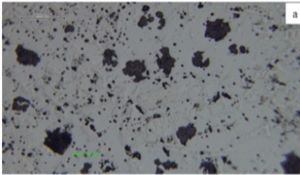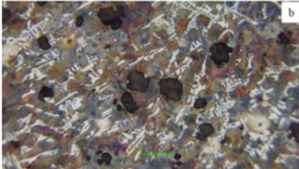

Figure 9: Microstructure of as-cast (sample N) on different surface conditions. (a) non-etched, (b) etched

Mechanical tests and microstructural examinations were performed. Mechanical properties were evaluated, which consist of tensile strength, hardness, and impact toughness. The tensile test was conducted as per ASTM E-8, and the impact test was carried out as per ASTM E-23. The mechanical tests, such as tensile and impact, were performed on three samples and averaged to represent the data for each austempering temperature treatment. The microstructure was characterised by optical microscopy. Evaluation of the microstructure was carried out with etched and non-etched surface conditions. Metallographic analysis with a non-etched surface aims to identify changes in graphite nodules (size and distribution) produced in three different austempering temperatures. Metallographic analysis with an etched surface was conducted to determine the phases present.

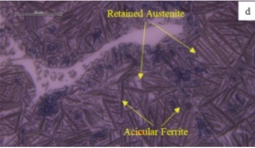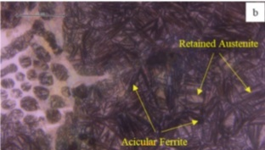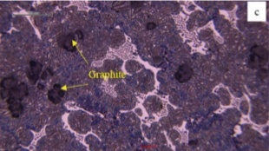

Figure: 10a at 30 minutes Figure: 10b at 45 minutes Figure: 10c at 60 minutes

Figure: 10. Scanning electron microscope on the etched surface condition

“Figure10, shows the phases in each sample, A, B and C, respectively. The microstructure of all studied ADI samples shows graphite nodules dispersed in an Ausferrite matrix. Retained austenite appears as the bright phase, while acicular ferrite appears as the dark phase. Carbon graphite was also observed as black nodules dispersed within the matrix. Figure 10d, shows the microstructure of the austempered sample observed by energy dispersive spectroscopy (EDS). The result indicates the presence of carbides. It can be due to the carbon content in the material and the V addition during the casting process. Certain phases present in the sample inﬂuence their mechanical properties. Austempering treatment of ductile cast iron makes the pearlitic matrix transform become acicular ferrite and retained austenite. The microstructure mainly consists of Ausferrite (ferrite and austenite), graphite nodules, and carbides. Austempering parameters, such as austempering temperature, austempering time, and austenitizing temperature, inﬂuenced this result. Previous work reported that increasing austempering temperature resulted in more ausferritic forming, and its needle became coarser” [26].

The addition of copper increased the strength and hardness of the alloy at higher temperatures, particularly. It also stabilised the austenite, as well as an increase in ductility. Meanwhile, the introduction of ferrovanadium, which added vanadium into the ductile cast iron, increased the strength and hardness of the alloy at shorter austempering times. Also, the addition of vanadium forms carbides that act as a barrier against wear, reducing the risk of surface damage and material loss. The molybdenum added stabilised austenite as well as eliminated the formation of pearlite, which could have contributed to wear in the material. At 30 minutes of austempering time, the ADI microstructure consists of retained austenite with a high carbon content along with a small amount of ferrite. Also present is the untransformed austenite with a high dislocation density.

At the austempering time of 45 minutes, the ADI microstructure undergoes a significant change, with the amount of retained austenite decreasing and the carbon content in the austenite decreasing. The transformation of austenite into ferrite began with an increase in the amount of ferrite as the ferrite grains became coarser. At 60 minutes, there was a significant decrease in retained austenite with the complete transformation of austenite into ferrite.

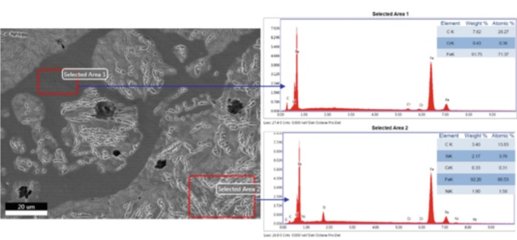

Figure 10d. EDS results, which show the presence of carbides

1. **CONCLUSION**

**Based on this study, it can be concluded as follows**

1. Using an optical emission spectrometer and a PANalytical X'pert High score machine, the chemical composition of the produced ADI microstructure was accurately measured, including the percentage of each element—carbon, manganese, chromium, vanadium, silicon, molybdenum, and transformation of phases.

2. Because the investment casting process produces little material waste and produces a smooth surface finish, it is a cost-effective choice that eliminates the need for further machining procedures.

3. The coating of the ceramic shell mold using the mixture optimized ratio of 25-micron calcined periwinkle ash and resin formed a deformable hardened layer at a certain depth on the surface with residual compressive stress on the surface, which resulted in a higher value of 388.6 Mpa fatigue strength along with exceptional wear resistance that is not available in other grades of ductile iron and ausferitic microstructure.

4. The grains were fine at lower austempering times because there was not enough carbon to maintain the stability of the austenite. As a result, they changed into martensite, which increased the tensile strength and hardness while decreasing the ductility. At higher austempering times, however, there was enough carbon to stabilise the austenite, resulting in low tensile strength and hardness because martensite vanished, increasing the ductility value.

5. The use of appropriate calcined periwinkle ash with a high-damping capacity material keeps the crankshaft from experiencing dynamic stress, which could result in high deformation from resonating frequency during operation and subsequently cause crankshaft rupture.

**Acknowledgment**

The research is supported by Projects Development Institute (PRODA), Presidential Road, Enugu, Enugu state. Nigeria.

Disclaimer (Artificial intelligence)

Option 1:

Author(s) hereby declare that NO generative AI technologies such as Large Language Models (ChatGPT, COPILOT, etc.) and text-to-image generators have been used during the writing or editing of this manuscript.

Option 2:

Author(s) hereby declare that generative AI technologies such as Large Language Models, etc. have been used during the writing or editing of manuscripts. This explanation will include the name, version, model, and source of the generative AI technology and as well as all input prompts provided to the generative AI technology

Details of the AI usage are given below:

1.

2.

3.

**References**

[1] Alabassian, F., Boutorabi, S. M. A., and Kheirandish, S. (2016). Effect of Inoculation and Casting Modulus on the Microstructure and Mechanical Properties of Ductile Ni-resist Cast Iron. *Material Science and Engineering A* 651: 467-473.

[2] Kawalec, M., and Kozana, J. (2014). Effect of microstructure of Fe-C-V Alloys on Selected FunctionalPproperties, *Archives of Foundry Engineering*, 14, (3): 33-36.

[3] Adewuyi, B.O. (2018). Metals and Materials: Creating Technological Entrepreneural Potentials, Inaugural Lecture Series 94. The Federal University of Technology, Akure. Nigeria. 7- 30

[4] Orlowicz, A.W., Mroz, M., Tupaj, M., and Trytek, A. (2015). Shaping Microstructure of Cast Iron Automobile Cylinder Liners aimed at Providing High Service Properties. *Achieves of Foundry Engineering,* 15 (2): 75-78.

[5] Orlowicz, A.W., Mroz, M., Tupaj, M., and Trytek, A. (2015). Shaping Microstructure of Cast Iron Automobile Cylinder Liners aimed at Providing High Service Properties. *Achieves of Foundry Engineering,* 15 (2): 75-78.

[6] Orlowicz, A.W., Mroz, M., Tupaj, M., and Trytek, A. (2015). Shaping Microstructure of Cast Iron Automobile Cylinder Liners aimed at Providing High Service Properties. *Achieves of Foundry Engineering,* 15 (2): 75-78.

[7] Francesco, L., Vittorio, D. C., and Maurio, C. (2015). Fatigue Crack Propagation in a Ferritic – Pearlitic DCI: Overload Effects on Damaging Mechanism, *Proceedia Engineering*, 109: 35-42.

[8] Artola, G., Gallastegi, I., Izaga, J., Barrena, M., and Rimmer, A. (2017). Austempered Ductile Iron (ADI) Alternative Material for High- Performance Applications, *International Journal Metalcast,* 11(1): 131-135.

[9] Heidarian, B., Nilli-Ahmadabadi, M., and Moradi, M. (2010). Mechanical Properties of Thixoformed formed Austempered Ductile Iron. *Transaction of Non Ferrous Metals Society of China* 20, 798- 804. Journal of cleaner production, (140): 1739-1748.

[10] Wang, B., Barber, G., Sun, X., Shaw, M., and Seaton, P. (2017). Characteristics of Transformation of Retained Austenite in Tempered Austempered Ductile Iron, *Journal of materials Engineering and performance* 26(5): 2095-2101.

[11] Krzynska, A. and Kochanski, A. (2014). Austenitization of Ferritic Ductile Iron, *Archives of Foundry Engineering,* 14 (4):49 – 54.

[12] Aliakbari, K. (2021). Fatigue Analysis of Ductile Iron Crankshaft in Four-Cylinder Diesel Engine. *International Journal of metal casting*, 5:1223-1237.

[13] Ratnesh, V., and Amiit, S. (2003). Performance Enhancement of Crankshaft under various factors. *International Journal of Research Publication and Reviews*. 156 – 181.

[14] Jiyaul, M., and Abhishek, M. (2020). Design and Analysis of Crankshaft by Forged Steel and Composite Material. 171 - 192.

[15] Boulifa, M. I., and Hadji, A. (2021). Study of the Influence of Alloying Elements on the Mechanical Characteristics and wear Behavior of a Ductile Cast Iron. *Frattura Ed Integrita Strutturale*, *15*(56), 74–83.

[16] Ramadan, M., and Fathy, N. (2014). Influence of Semi-Solid Isothermal Heat Treatment on Microstructure and Mechanical Properties of Ductile Cast Iron, *Journal of Minerals and Materials Characterization and Engineering,* 2 (1): 26 – 31.

[17]Abdullahi, B., Alias, S., Jaffar, A., Rashid, A. and Ramli, A. (2010). Mechanical Properties and Microstructure Analysis of 0.5% Nobium Alloyed Ductile Iron on under Austempered Process in Salt Bath Treatment, *International Conference on Mechanical and Electrical Technology* (ICMET) 610-614.

[18] Wang, Barber, G., Tao, C., Sun, X., and Ran, X. (2018). Characteristics of Tempering Response of Austempered ductile iron, *Journal of Material, Research and Technology*, 7(2):198- 202.

[19] Barnabas, A. A. ; Oyetunji, A. ; Seidu, S. O. ; and Adediran, A. A. (2018). Austempered Ductile Iron an Off-Spring of Cast Iron for Production of Agricultural Implement. *Journal of Environmental Science and Technology*, *vol 11*(pp 10-16), pg 10-16. 1994-7887.

[20] Erfanian- Naziftoosi, H., Haghdadi, N., and Jiani-Rashid, A. (2012). The Effect of Isothermal Heat Treatment Time on the Microstructure and Properties of 2.11% AL Austempered Ductile Iron, *Journal of Material Engineering*. perform, 21(8): 1785-1792.

[21] Yu, Y., Chen, Z., Wei, L., and Wang, B. (2017). The low-carbon technology characteristics of China’s ferrous metal industry. *Journal of cleaner production*, 140 (3): 1739-1748.

[22] Wang, B., He, M., Barber, G., Schall, J., Tao, C., and Sun, X. (2018). Rolling Contact Fatigue Resistance of Austempered Ductile Iron Processed at Various Austempering Holding Times, Wear, 398-399: 41-46

[23] Wang, B., He, M., Barber, G., Schall, J., Tao, C., and Sun, X. (2018). Rolling Contact Fatigue Resistance of Austempered Ductile Iron Processed at Various Austempering Holding Times, Wear, 398-399: 41-46

[24] Orlowicz, A.W., Mroz, M., Tupaj, M., and Trytek, A. (2015). Shaping Microstructure of Cast Iron Automobile Cylinder Liners aimed at Providing High Service Properties. *Achieves of Foundry Engineering,* 15 (2): 75-78.

[25] Balloy, D., Tissier, J. C., Giorgi, M. L., and Briant, M. (2010). Corrosion Mechanisms of Steel and Cast Iron by Molten Aluminum. *Metallurgical and Materials Transactions A: Physical Metallurgy and Materials Science*, *41*(9), 2366–2376.

[26] Regita, B., Antanas, C., Ramunas, C., and Audrius, J. (2021). “Influence of austempering temperature on the microstructure and mechanical properties of austempered ductile cast iron” Metals (Base l)., 11(6):967.

[27] Avishan, B., Charchi Aghdam, M., & Hosseinzadeh Khanmiri, M. (2025). Mechanical Stability of High-Carbon Retained Austenite and Corresponding TRIP Effect in Austempered Ductile Iron (ADI). *International Journal of Metalcasting*, 1-11.

[28] Luo, A. A., Sachdev, A. K., & Apelian, D. (2022). Alloy development and process innovations for light metals casting. *Journal of Materials Processing Technology*, *306*, 117606.

[29] Yerra, U., Gopal, M., Kolhe, V. M., Palkar, V., & Kumbhar, D. (2023). *Automotive Crankshaft Development in Austempered Ductile Iron Casting* (No. 2023-28-1302). SAE Technical Paper.

[30]Abdulrahman, S. O., Seidu, S. O., Oyetunji, A. A. (2024). Effect of Vanadium and Austempering Parameters on the Microstructure and Mechanical Properties of Austempered Ductile Iron (ADI) for Tricycle Crankshaft Applications. World Journal of Materials Science and Technology, 1(1), 1-9. <https://doi.org/10.11648/j.wjmst.20240101.11>