OPTIMIZATION OF A TRICKLING FILTER SYSTEM FOR THE REMOVAL OF CIPROFLOXACIN FROM SIMULATED PHARMACEUTICAL WASTEWATER

# **Abstract**

**The presence of ciprofloxacin, a widely used antibiotic, in pharmaceutical wastewater poses significant environmental challenges due to its persistence and potential to induce antibiotic resistance. This study investigates the optimization of a trickling filter system for the effective removal of ciprofloxacin from simulated pharmaceutical wastewater. Key operational parameters, including pump flow rate, initial concentration and contact time, were systematically varied to assess their impact on the removal efficiency of total suspended solids (TSS), total dissolved solids (TDS). Response (RSM) was employed to design experiments and analyze the interactions between variables. The optimized parameter factors conditions achieved contact time at 8hrs, concentration at 277.571mg/l and flow rate at 6.466m3/hr. Also optimized responses were achieved, a total suspended solids (TSS) of a ciprofloxacin removal efficiency of 84.766% (actual 83.5%), total dissolved solids (TDS) of a ciprofloxacin removal efficiency of 49.27% (actual 47.3%) and biological oxygen demand (BOD) of a ciprofloxacin removal efficiency of 33.005% (actual 32.6%), demonstrating the potential of trickling filter systems in mitigating pharmaceutical contaminants in wastewater. The application of the response surface methodology proved valuable in identifying the optimal conditions for maximum removal efficiency. These findings suggested that trickling filters represent a viable option for enhancing the treatment of pharmaceutical wastewater.**

**Keywords: Ciprofloxacin, Trickling Filter, Simulated Pharmaceutical Wastewater, Optimization, Response Surface Methodology**

# **Introduction**

**Antibiotics have been used extensively in human and veterinary medicine. Most antibiotics are incompletely metabolized; thus, their residues and degradation products are excreted and can enter water environments in various ways (45). There are different classes of antibiotics based on their mechanism of action, chemical structure, action spectrum, and route of administration (1). The most common classification of that was based on their mode of action. They include fluoroquinolones, quinolones, *β*-lactams, sulfonamides, monobactams, carbapenems, and aminoglycosides. Quinolones (ciprofloxacin, levofloxacin, norfloxacin, and ofloxacin) were broad-spectrum antibiotics that were widely prescribed (1a).**

**Ciprofloxacin (CIP) is a quinolone antibacterial agent classified as second-generation fluoroquinolone with broad-spectrum action that was commonly used to treat human and animal bacterial infections (2). It is frequently detected in wastewater due to its widespread use and incomplete removal during conventional treatment processes (3). The presence of CIP or any antibacterial derivative in wastewater and surface water is considered a significant environmental hazard, even at very low concentrations. At low concentrations, CIP may impair lymphocytes, lower sperm counts, and increase the risk of prostate and breast cancer. Studies have shown that CIP concentrations in wastewater from pharmaceutical plants in India have been found to be as high as 31 mg/L (44). This is because these products can increase the antibiotic resistance of pathogenic bacteria and generate modifications in the biological balance of aquatic ecosystems (4). Its stable chemical structure is difficult to remove by conventional techniques. Residual ciprofloxacin in the environment has become an emerging micropollutant that promotes the generation of resistance genes of bacteria and endangers ecosystem balance and human health (43). The continuous and unregulated discharge of CIP into the aquatic environment posed serious environmental and health problems to man and aquatic life. It has resulted in sickness and diseases to mankind and an imbalance in the ecosystem, and consequently, the food chain is threatened. The various concern on humans and the environment includes chronic toxicity, endocrine disruption, and direct toxicity of micro flora, even at low concentrations. The effect of CIP on the water in a low concentration affected the photosynthesis of plants, transformed the morphological structure of the algae, and then disrupted the aquatic ecosystem (5). When CIP-contaminated water is consumed by humans, it might cause anger, nausea, vomiting, headache, diarrhea, and tremors. The high concentration of CIP can cause severe kidney failure and increase liver and thrombocytopenic enzymes (6).**

**Several methods have been employed to remove CIP from aqueous solutions. They include adsorption in activated carbon (7); zeolites (8); montmorillonites (9); microalgae intake (10); photo catalytic degradation (11) and electrocoagulation (12); coagulation, sedimentation, biodegradation, photo-transformation, electrochemical, chlorination, ozonation, and Nano filtration through membranes (13;14). There was, therefore, the need to treat the influent streams using eco-friendly and energy-efficient methods prior to discharge into the receiving water bodies. Trickling filter techniques were simple, reliable, low-cost and effective in treating high concentrations of organic material. However, most of the treatment techniques that have been employed in the past have the issue of efficiency, generation of toxic by-products, high treatment cost, and high energy requirement (15). Therefore, efficient and low-cost treatment options that do not introduce harmful by-products were required to eliminate antibiotics from water. Due to the inherent limitations of the existing treatment processes, trickling filters present a good alternative since it was simple, reliable, low-cost, effective in treating high concentrations of organic material, relatively low power requirement and require moderate skill and technical expertise to operate the system (16;17). A trickling filter is an aerobic wastewater treatment process generally used for industrial effluents and domestic sewage treatment. Its operation consists of passing the effluent to be treated over a fixed bed of support medium. Optimizing the operational parameters of trickling filters is crucial to enhance their efficiency in removing specific contaminants such as total suspended solids (TSS) and total dissolved solids (TDS) of ciprofloxacin.**

# **Materials and Methods**

* 1. **Preparation of Ciprofloxacin Simulated Wastewater**

**1000mg (1g) of ciprofloxacin tablet was dissolved in the 1000 mL standard flask with distilled water, working solutions were prepared from the stock solution and the stock solution was stored in the refrigerator to minimize degradation and prevent it from losing its integrity.**

# **Trickling Filter Setup**

**A bioreactor body with a cylindrical shape and made of stainless steel was constructed. Its length of the reactor would be 152.4 and its diameter would be about 76.2 cm, as shown below in Fig 1. Modified PFF would be used as filter media in the trickling filter system for microbial growth. The PFF would be placed vertically in a trickling filter system of 129.5 cm in height, and diameter varies from 0.5 to 1.0 inches. A distributor would be installed at the top of the reactor to spread CIP wastewater uniformly over the filter media. Flow rates would be adjusted with the help of control valves. A 6-inch depth drainage layer would be constructed at the bottom of the reactor for ventilation and for the outflow of the wastewater from the reactor tank for final sedimentation. A settling tank would be provided for collecting and settling waste water. The system was operated at a flow rate of 2.6-9.3m3/hr and contact time of 2.6-9.3hrs.**

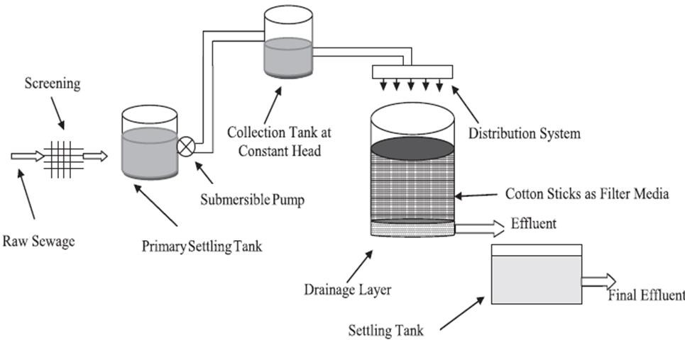

**Fig 1: Schematic diagram of Trickling Filter System setup**

# **Experimental Design and Optimization**

**Response surface methodology (RSM) was a collection of mathematical and statistical techniques for modelling and analysis of problems involving multivariate experimental design, statistical modelling focusing on three independent variables: flow rate, initial concentration and contact time and process optimization (18:19:20:21) using central composite design (CCD) which was employed to evaluate the effects and interactions of that variables on ciprofloxacin removal efficiency.**

# **Analytical Methods**

1. **Total suspended solids were determined through gravimetric analysis**
2. **Total dissolved solids were determined through gravimetric analysis.**
3. **Biological oxygen demand was measured using standard APHA methods (APHA, 2017).**
4. **Optimization of CIP Degradation Using Response Surface Methodology**

# **Performance Evaluation**

**The removal efficiency was calculated using (1)**

**Removal Efficiency (%) = co-ct/co × 100 (1)**

# **Results and Discussion**

* 1. **Batch Biodegradation Studies of the Trickling Filter System Operating Variables**
     1. **Effect of Combination of Flow rate and Contact time on TSS Removal Efficiency Flow rate has significant effect on percentage removal of TSS, TDS and BOD from simulated pharmaceutical wastewater treatment. As such, the effect of flow rate on optimization of trickling filter system for the removal of ciprofloxacin from simulated pharmaceutical wastewater treatment was evaluated using five different flow rates which were 2.6m3/hr, 4m3/hr, 6m3/hr, 8m3/hr and 9.3m3/hr, at concentration of 131.8mg/l, 200mg/l, 300mgl, 400mg/l and 468mg/l. It could be seen from Fig 2a that the highest percentage removal of TSS from simulated pharmaceutical wastewater was obtained at a flow rate of 2.6m3/hr and concentration of 131.8mg/l. The highest percentage removal of TSS with a decrease in flow rate was due to particle agglomeration and filter media performance. Decreased flow rates ensured efficient mass transfer between the liquid phase (wastewater) and the solid phase and stopped breakthrough occurrence (22:23:24). Therefore, the percentage removal of TSS obtained at a flow rate of 2.6m3/hr at a concentration of 131.8mg/l was 99.7%.**

**There was an increase in TDS percentage removal at 2.6m3/hr and concentration of**

**131.8mg/l in Figure 2b. There was an increase in TDS percentage removal as flow rates decreased because it allowed for longer contact times between the water and treatment media, potentially enhancing the removal efficiency of TDS from simulated**

**pharmaceutical wastewater using a trickling filter system. Increased flow rates reduced the efficiency of TDS removal due to shorter contact time. However, excessively low flow rates might lead to issues such as increased residence time in the treatment system, which could promote bacterial growth or other undesirable reactions (26). Therefore, TDS percentage removal from simulated pharmaceutical wastewater using a trickling filter system at 2.6m3/hr and concentration of 131.8mg/l was 58.7%. From Figure 2c, it was observed that there was an increase in BOD percentage efficiency as the flow rate decreased during the biodegradation because slower flow rates can allow contact times between the water and treatment media, which enhances the biological degradation of ciprofloxacin and associated organic matter contributing to BOD. Increased flow rates could reduce the efficiency of biological processes due to shorter contact times between the wastewater and microorganisms, which could result in lower BOD percentage efficiency as microorganisms have less time to metabolize organic matter, including ciprofloxacin (30; 31; 32). Therefore, the BOD percentage efficiency of ciprofloxacin was 51%.**



131.8mg/l

120

100

80

60

40

20

0

0

1

2

3

4

5

6

7

Time (hr)

2.6m3/hr

4m3/hr

6m3/hr

8m3/hr

9.3m3/hr

TSS Removal %

|  |  |  |  |  |  |  |
| --- | --- | --- | --- | --- | --- | --- |
|  |  |  |  |  |  |  |
|  |  |  |  |  |  |  |
|  |  |  |  |  |  |  |
|  |  |  |  |  |  |  |
|  |  |  |  |  |  |  |
|  |  |  |  |  |  |  |



131.8mg/l

60

50

40

30

20

10

0

0

1

2

3

4

5

6

7

Time (hr)

2.6m3/hr

4m3/hr

6m3/hr

8m3/hr

9.3m3/hr

BOD Efficiency %

TDS Removal %

|  |  |  |  |  |  |  |
| --- | --- | --- | --- | --- | --- | --- |
|  |  |  |  |  |  |  |
|  |  |  |  |  |  |  |
|  |  |  |  |  |  |  |
|  |  |  |  |  |  |  |
|  |  |  |  |  |  |  |
|  |  |  |  |  |  |  |

|  |  |  |  |  |  |  |
| --- | --- | --- | --- | --- | --- | --- |
|  |  |  |  |  |  |  |
|  |  |  |  |  |  |  |
|  |  |  |  |  |  |  |
|  |  |  |  |  |  |  |
|  |  |  |  |  |  |  |
|  |  |  |  |  |  |  |

**Fig 2 (a-c): Effect combination of flow rate and contact time on TSS removal efficiency from simulated ciprofloxacin pharmaceutical wastewater.**



131.8mg/l

60

50

40

30

20

10

0

0

1

2

3

4

5

6

7

Time (hr)

2.6m3/hr 4m3/hr 6m3/hr 8m3/hr 9.3m3/hr

* + 1. **Effect of Combination of Initial Concentration and Contact Time on TSS Removal Efficiency**

**Figures 3a-c below show the TSS, TDS and BOD percentage removal of ciprofloxacin from simulated pharmaceutical wastewater at different concentrations**

**of 131.8mg/l, 200mg/l, 300mg/l, 400mg/l and 468mg/l and contact time of 2.6hr, 4hr, 6hr, 8hr and 9.3hr using five different flow rates of 2.6m3/hr, 4m3/hr, 6m3/hr, 8m3/hr and 9.3m3/hr. From Figure 3a below, it could be observed that TSS percentage removal increases as the concentration of simulated pharmaceutical wastewater decreases at flow rates of 2.6m3/hr and concentration of 131.8mg/l, respectively, because there was less quantity of ciprofloxacin to be removed. Generally, high concentrations of ciprofloxacin could lead to reduced removal efficiency due to saturation of treatment mechanisms or competition with other contaminants for biodegradation sites (25). In Figure 3b, there was an increase in TDS percentage removal from simulated pharmaceutical wastewater as the concentration decreased due to less competition for reactive sites or biodegradation sites on treatment media (27). Higher concentration of TDS might lead to increased competition for reactive sites or complexation with other ions in the water, which could affect the mechanisms involved in TDS removal (28;29). Therefore, the TDS percentage removal from simulated pharmaceutical wastewater was 58.7% at a concentration of 131.8mg/l under a flow rate of 2.6m3/hr. It could be seen from Fig 3c that the highest BOD efficiency of ciprofloxacin was obtained at a concentration of 131.8mg/l in each of the three flow rates. There was an increase in BOD percentage removal as the concentration of ciprofloxacin decreased due to lower concentrations of ciprofloxacin in water could lead to lower levels of organic matter, which may contribute to decreased BOD. That lower organic load can potentially overwhelm biological treatment systems, increasing the percentage of BOD efficiency (33; 34; 35).**

**a**



2.6m3/hr

98

96

94

92

90

88

86

0

1

2

3

4

5

6

7

Time (hr)

131.8mg/l

200mg/l

300mg/l

400mg/l

468mg/l



2.6m3/hr

70

60

50

40

30

20

10

0

0

1

2

3

4

5

6

7

Time (hr)

131.8mg/l

200mg/l

300mg/l

400mg/l

468mg/l

TSS Removal %

TDS Removal %

**b**



60

2.6m3/hr

50

40

30

20

10

0

0

1

2

3

4

5

6

7

Time (hr)

131.8mg/l 200mg/l 300mg/l 400mg/l 468mg/l

BOD Efficiency %

|  |  |  |  |  |  |  |
| --- | --- | --- | --- | --- | --- | --- |
|  |  |  |  |  |  |  |
|  |  |  |  |  |  |  |
|  |  |  |  |  |  |  |
|  |  |  |  |  |  |  |
|  |  |  |  |  |  |  |
|  |  |  |  |  |  |  |

**c**

**Fig 3 (a-c): Effect of combination of initial concentration and contact time on TSS removal efficiency from simulated ciprofloxacin pharmaceutical wastewater using trickling filter system.**

# **Optimization and Model Validation**

* + 1. **Optimization and Modelling Validation of TSS Percentage Removal Efficiency**

**Table 1 showed the design CCD matrix consisting of number of run, independent factors, actual percentage and predicted percentage as randomized by the Design Expert software (version 8) and the respective response obtained from the experiment.**

**Table 1. CCD matrix factors and response of TSS percentage removal**

|  |  |  |  |  |  |
| --- | --- | --- | --- | --- | --- |
| **Source** | **Factor 1 Contact Time**  **hrs** | **Factor 2 Conc. Mg/l** | **Factor 3 Flow rate m3/hr** | **Actual %** | **Predicted**  **%** |
| **1** | **4** | **200** | **4** | **82.4** | **83.3808** |
| **2** | **8** | **200** | **4** | **88** | **89.0908** |
| **3** | **4** | **400** | **4** | **83.3** | **84.9356** |
| **4** | **8** | **400** | **4** | **86.2** | **85.9656** |
| **5** | **4** | **200** | **8** | **63.7** | **64.3689** |
| **6** | **8** | **200** | **8** | **77.8** | **76.5669** |
| **7** | **4** | **400** | **8** | **72.4** | **71.7317** |
| **8** | **8** | **400** | **8** | **79.8** | **79.2417** |
| **9** | **2.6** | **300** | **6** | **77.7** | **76.3429** |
| **10** | **9.4** | **300** | **6** | **86.7** | **87.4596** |
| **11** | **6** | **131.8** | **6** | **78.3** | **77.6145** |
| **12** | **6** | **468.1** | **6** | **81.1** | **81.188** |
| **13** | **6** | **300** | **2.6** | **90.3** | **88.4269** |
| **14** | **6** | **300** | **9.4** | **65.5** | **66.7757** |

|  |  |  |  |  |  |
| --- | --- | --- | --- | --- | --- |
| **15** | **6** | **300** | **6** | **83.3** | **83.3171** |
| **16** | **6** | **300** | **6** | **83.3** | **83.3171** |
| **17** | **6** | **300** | **6** | **83.3** | **83.3171** |
| **18** | **6** | **300** | **6** | **83.3** | **83.3171** |
| **19** | **6** | **300** | **6** | **83.3** | **83.3171** |
| **20** | **6** | **300** | **6** | **83.3** | **83.3171** |

* + 1. **Development of model equations of TSS percentage removal efficiency**

**It was also observed in the table 2 that the quadratic model has relatively high standard deviation of 3.08 and relatively low R2 (0.8512) in reasonable agreement with adjusted R2 (0.7174) The TSS percentage removal of ciprofloxacin by optimization of trickling filter system for the removal of ciprofloxacin from simulated pharmaceutical wastewater were obtained with respect to RSM as presented in table 1. Analysis of variance (ANOVA) for quadratic model, equation 3.1, was presented in Table 3. If p ˃ 0.05 threshold, it indicated significant input variables for the descriptive process models. Furthermore, the lower the model p-value (or the higher the F-ratio), the higher the significance of the input variable effect on the response variable (36). From table 3, it was evident that the effects of contact time, flow rate and concentration were significant (P˃0.1000). Equations 3.1 and 3.2 indicate the regression model prior to and after the elimination of insignificant factors.**

**%TSS =46.31+1.98A -3.42B -1.33C -0.20AB -0.050AC+0.18BC +0.47A2+1.37B2 -0.17C2 (3.1)**

**%TSS = 46.31+ 1.98A -3.42B -1.33C -0.20AB -0.050AC+0.18BC +1.37B2- 0.17C2 (3.2)**

**The model equations selected were further evaluated using the ANOVA component of the software. From Table 3, the response surface quadratic model for removal efficiency has an F-value of 60.84, indicating that the model is significant. For the model terms, p-**

**value less than 0.05 implies that the model term was significant (37; 38; 39; 40; 41), and the largest F-value signifies the model term having the most significant model significant effect on the response (42; 43). In that case, the significant model terms were A, B, C, AB, AC, BC, B2, and C2 were significant model terms while A2 was the insignificant model term. Values greater than 0.1000 indicate the model terms were not significant. The model term having the most significant effect on the response was C, with an F-value of 360.61.**

**Table 2. Model Summary Statistics of TSS Percentage Removal Efficiency**

|  |  |  |  |  |  |
| --- | --- | --- | --- | --- | --- |
| **Source** | **Std.dev.** | **R-squared** | **Adjusted R-**  **squared** | **Predicted R-**  **squared** | **Press** |
| **Linear** | **3.76** | **0.6451** | **0.5786** | **0.3661** | **403.50** |
| **2FI** | **3.69** | **0.7221** | **0.5938** | **-0.1195** | **712.64** |
| **Quadratic** | **3.08** | **0.8512** | **0.7174** | **-0.1317** | **720.41**  **Suggested** |
| **Cubic** | **2.68** | **0.9322** | **0.7853** | **-13.9420** | **9511.89**  **Aliased** |

**Table 3. Quadratic RSM ANOVA for the TSS percentage removal efficiency**

|  |  |  |  |  |  |
| --- | --- | --- | --- | --- | --- |
| **Source** | **Sum of**  **squares** | **Df** | **Mean**  **Square** | **F-**  **Square** | **P-Value**  **Prob>F** |
| **Model** | **859.24** | **9** | **95.47** | **60.84** | **<0.0001**  **Significant** |
| **A-Contact Time** | **149.18** | **1** | **149.18** | **95.07** | **<0.0001** |
| **B-Concentration** | **15.41** | **1** | **15.41** | **9.82** | **0.0106** |
| **C-Flow rate** | **565.86** | **1** | **565.86** | **360.61** | **<0.0001** |
| **AB** | **11.04** | **1** | **11.04** | **7.04** | **0.0242** |
| **AC** | **21.13** | **1** | **21.13** | **13.46** | **0.0043** |
| **BC** | **16.82** | **1** | **16.82** | **10.72** | **0.0084** |
| **A2** | **3.61** | **1** | **3.61** | **2.30** | **0.1602** |
| **B2** | **27.62** | **1** | **27.62** | **17.60** | **0.0018** |
| **C2** | **58.85** | **1** | **58.85** | **37.51** | **0.0001** |
| **Residual** | **15.69** | **10** | **1.57** |  |  |
| **Lack of fit** | **15.69** | **5** | **3.14** |  |  |
| **Pure Error** | **0.000** | **5** | **0.000** |  |  |
| **Corr. Total** | **874.93** | **19** |  |  |  |

* + 1. **Design of experiment of TDS percentage removal efficiency**

**Table 4 showed the design CCD matrix consisting of number of run, independent factors, actual percentage and predicted percentage as randomized by the Design Expert software (version 8) and the respective response obtained from the experiment.**

**Table 4. CCD matrix factors and response of TDS percentage removal efficiency**

|  |  |  |  |  |  |
| --- | --- | --- | --- | --- | --- |
| **Run** | **Factor 1 Contact Time**  **hrs** | **Factor 2 Conc. Mg/l** | **Factor 3 Flow rate m3/hr** | **Actual**  **%** | **Predicted**  **%** |
| **1** | **4** | **200** | **4** | **50** | **50.9619** |
| **2** | **8** | **200** | **4** | **53.5** | **55.1285** |
| **3** | **4** | **400** | **4** | **45.1** | **43.8889** |
| **4** | **8** | **400** | **4** | **48** | **47.5475** |
| **5** | **4** | **200** | **8** | **47** | **47.7592** |
| **6** | **8** | **200** | **8** | **50.5** | **52.0179** |
| **7** | **4** | **400** | **8** | **43** | **41.6782** |
| **8** | **8** | **400** | **8** | **45.5** | **45.1369** |
| **9** | **2.63641** | **300** | **6** | **43.5** | **44.3043** |
| **10** | **9.36350** | **300** | **6** | **52.2** | **50.9619** |
| **11** | **6** | **131.821** | **6** | **58.5** | **55.9273** |
| **12** | **6** | **468.179** | **6** | **42.3** | **44.4389** |
| **13** | **6** | **300** | **2.63641** | **48.3** | **48.0704** |
| **14** | **6** | **300** | **9.36350** | **43.8** | **43.5958** |
| **15** | **6** | **300** | **6** | **46.3** | **46.3124** |
| **16** | **6** | **300** | **6** | **46.3** | **46.3124** |
| **17** | **6** | **300** | **6** | **46.3** | **46.3124** |

|  |  |  |  |  |  |
| --- | --- | --- | --- | --- | --- |
| **18** | **6** | **300** | **6** | **46.3** | **46.3124** |
| **19** | **6** | **300** | **6** | **46.3** | **46.3124** |
| **20** | **6** | **300** | **6** | **46.3** | **46.3124** |

**3.2.4 Development of model equations of TDS percentage removal efficiency**

**It was also observed in Table 5 that the quadratic model has a relatively high standard deviation of 1.52 and relatively high R2 (0.9209) in reasonable agreement with adjusted R2 (0.8497). The TDS removal of ciprofloxacin from simulated ciprofloxacin pharmaceutical wastewater obtained with respect to RSM is presented in Table 6. Analysis of variance (ANOVA) for quadratic model equation 3.3 was presented in Table 6. If P˃0.0500 threshold, it indicated significant for the quadratic process models. Furthermore, the lower the model p-value (or the higher F- value), the higher the significance of the input variable effect on the response variable (36). It was evident that in table 6, the effects of contact time, concentration and flow rate were highly significant (P˃0.1000). Table 6 indicated that the quadratic coefficient of determination (R2) was 92.09%. Equations 3.3 and 3.4 indicate the quadratic model prior to and after the elimination of insignificant factors.**

**TDS%=46.31 +1.98A -3.42B-1.33C-0.20AB-0.050AC +0.18BC**

**+ 0.47A2 +1.37B2 -0.17C2 (3.3)**

**TDS%=46.31 +1.98A -3.42B +1.37B2 (3.4)**

**The model equations selected were further evaluated using the ANOVA component of the software. From Table 4, the response surface quadratic model for removal efficiency has an F-value of 12.94, indicating that the model was significant. For the model terms, a p-value less than 0.05 implies that the model term was significant (37; 38; 39; 40; 41), and the largest F-value signifies the model term having the most significant model significant effect on the response (42; 43). Values greater than 0.1000 indicate the model terms**

**are not significant. The model term having the most significant effect on the response was B with F-value of 69.27.**

**Table 5. Model Summary Statistics of TDS Percentage Removal Efficiency**

|  |  |  |  |  |  |
| --- | --- | --- | --- | --- | --- |
| **Source** | **Std.dev** | **R-Squared** | **Adjusted R-**  **Square** | **Predicted R-**  **Squared** | **Press** |
| **Linear** | **1.83** | **0.8149** | **0.7802** | **0.6816** | **92.63**  **Suggested** |
| **2FI** | **2.02** | **0.8149** | **0.7325** | **0.4676** | **154.82** |
| **Quadratic** | **1.52** | **0.9209** | **0.8497** | **0.3991** | **174.74**  **Suggested** |
| **Cubic** | **0.28** | **0.9984** | **0.9949** | **0.6427** | **103.91**  **Aliased** |

**Table 6. Quadratic RSM ANOVA for the TDS percentage removal efficiency**

|  |  |  |  |  |  |
| --- | --- | --- | --- | --- | --- |
| **Source** | **Sum of**  **squares** | **Df** | **Mean**  **square** | **F-value** | **P-value. Prob>F** |
| **Model** | **267.81** | **9** | **29.76** | **12.94** | **0.0002 Significant** |
| **A-contact time** | **53.50** | **1** | **53.50** | **23.26** | **0.0007** |
| **B-conc.** | **159.32** | **1** | **159.32** | **69..27** | **<0.0001** |
| **C-flow rate** | **24.17** | **1** | **24.17** | **10.51** | **0.0088** |
| **AB** | **0.32** | **1** | **0.32** | **0.14** | **0.7169** |
| **AC** | **0.020** | **1** | **0.020** | **8.695E-**  **003** | **0.9275** |
| **BC** | **0.25** | **1** | **0.25** | **0.11** | **0.7509** |
| **A2** | **3.14** | **1** | **3.14** | **1.37** | **0.2696** |
| **B2** | **26.99** | **1** | **26.99** | **11.73** | **0.0065** |
| **C2** | **0.41** | **1** | **0.41** | **0.18** | **0.6804** |

|  |  |  |  |  |  |
| --- | --- | --- | --- | --- | --- |
| **Residual** | **23.00** | **1** | **2.30** |  |  |
| **Lack of fit** | **23.00** | **5** | **4.60** |  |  |
| **Pure error** | **0.000** | **5** | **0.000** |  |  |
| **Cor total** | **290.81** |  |  |  |  |

* + 1. **Design of experiment of BOD percentage efficiency**

**Table 7 showed the design CCD matrix consisting of number of run, independent factors, actual percentage and predicted percentage as randomized by the Design Expert software (version 8) and the respective response obtained from the experiment.**

**Table 7. CCD matrix of factors and response of BOD percentage efficiency**

|  |  |  |  |  |  |
| --- | --- | --- | --- | --- | --- |
| **Run** | **Factor1**  **Time hr** | **Factor2**  **Conc. Mg/l** | **Factor 3 Flow**  **rate m3/hr** | **Actual %** | **Predicted %** |
| **1** | **4** | **200** | **4** | **36.6** | **37.0233** |
| **2** | **8** | **200** | **4** | **41.2** | **40.766** |
| **3** | **4** | **400** | **4** | **29** | **28.9729** |
| **4** | **8** | **400** | **4** | **32.3** | **31.5657** |
| **5** | **4** | **200** | **8** | **32.8** | **33.6125** |
| **6** | **8** | **200** | **8** | **36.1** | **36.2053** |
| **7** | **4** | **400** | **8** | **26** | **26.5122** |
| **8** | **8** | **400** | **8** | **28.3** | **27.9549** |
| **9** | **2.63641** | **300** | **6** | **30** | **29.0145** |
| **10** | **9.36350** | **300** | **6** | **32.5** | **33.3749** |
| **11** | **6** | **131.821** | **6** | **43.6** | **43.0983** |
| **12** | **6** | **468.179** | **6** | **29** | **29.3911** |
| **13** | **6** | **300** | **2.63641** | **33.2** | **33.6968** |
| **14** | **6** | **300** | **9.36350** | **28.4** | **27.7926** |
| **15** | **6** | **300** | **6** | **31.1** | **31.1032** |
| **16** | **6** | **300** | **6** | **31.1** | **31.1032** |
| **17** | **6** | **300** | **6** | **31.1** | **31.1032** |
| **18** | **6** | **300** | **6** | **31.1** | **31.1032** |
| **19** | **6** | **300** | **6** | **31.1** | **31.1032** |
| **20** | **6** | **300** | **6** | **31.1** | **31.1032** |

* + 1. **Development of model equation of BOD percentage efficiency**

**Tables 8 and 9 showed that the quadratic model for TSS percentage removal efficiency response was aliased. It was also observed in the table that the quadratic model has a relatively high standard deviation of 0.69 and relatively high R2 (0.9864) in reasonable agreement with adjusted (0.9742). From table 9, the model F-value of**

**80.74 implies that the model was significant. Values of “pro˃F” less than 0.0500 or**

**˂0.0001 indicates that the model terms were significant. In this case, A, B, C, and B2 were significant model terms. From table 9, it was evident that the effects of contact time, concentration and flow rate were highly significant. Equations 3.5 and 3.6 indicate the quadratic model prior to and after the elimination of insignificant factors.**

**%BOD=3.10 +1.30A -4.08B -1.76C -0.29AB -0.29AC +0.24BC+0.032A2 +1.82B2 -0.13C2**

**(3.5)**

**%BOD=3.10 +1.30A -4.08B -1.76C -0.29AB -0.29AC +0.24BC +1.82B2 (3.6)**

**The model equations selected were further evaluated using the ANOVA component of the software. From Table 9, the response surface quadratic model for removal efficiency has an F-value of 80.74, indicating that the model was significant. For the model terms,**

**a p-value less than 0.05 implies that the model term was significant (37; 38; 39; 40; 41), and the largest F-value signifies the model term having the most significant model significant effect on the response (42; 43). Values greater than 0.1000 indicate the model terms were not significant. The model term having the most significant effect on the response was B, with an F-value of 480.75**

**Table 8. Model Summary Statistic for BOD Percentage Efficiency**

|  |  |  |  |  |  |
| --- | --- | --- | --- | --- | --- |
| **Source** | **Std.**  **dev.** | **R-Squared** | **Adjusted R-**  **Squared** | **Predicted R-**  **Squared** | **PRESS** |
| **Linear** | **1.87** | **0.8397** | **0.8097** | **0.7255** | **95.41** |
| **2FI** | **2.04** | **0.8448** | **0.7732** | **0.6653** | **116.31** |
| **Quadratic** | **0.69** | **0.9864** | **0.9742** | **0.8968** | **35.85**  **Suggested** |
| **Cubic** | **0.071** | **0.9999** | **0.9997** | **0.6** | **6.75 Aliased** |

**Table 9. Quadratic RSM ANOVA for the BOD percentage removal efficiency**

|  |  |  |  |  |  |
| --- | --- | --- | --- | --- | --- |
| **Source** | **Sum of**  **Squares** | **Df** | **Mean**  **Square** | **F-Value** | **P-value. Prob>F** |
| **Model** | **342.81** | **9** | **38.09** | **80.74** | **<0.0001**  **Significant** |
| **A-Contact Time** | **22.95** | **1** | **22.95** | **48.65** | **<0.0001** |
| **B-Concentration** | **226.80** | **1** | **226.80** | **480.75** | **<0.0001** |
| **C-Flow rate** | **42.08** | **1** | **42.08** | **89.20** | **<0.0001** |
| **AB** | **0.66** | **1** | **0.66** | **1.400** | **0.2638** |
| **AC** | **0.66** | **1** | **0.66** | **1.400** | **0.2638** |
| **BC** | **0.45** | **1** | **0.45** | **0.96** | **0.3511** |
| **A2** | **0.015** | **1** | **0.015** | **0.032** | **0.8616** |
| **B2** | **47.62** | **1** | **47.62** | **100.94** | **<0.0001** |
| **C2** | **0.23** | **1** | **0.23** | **0.49** | **0.4996** |
| **Residual** | **4.72** | **10** | **0.47** |  |  |
| **Lack of Fit** | **4.72** | **5** | **0.94** |  |  |

|  |  |  |  |  |  |
| --- | --- | --- | --- | --- | --- |
| **Pure Error** | **0.000** | **5** | **0.000** |  |  |
| **Cor.Total** | **347.53** | **19** |  |  |  |

* + 1. **Comparison of actual (experimental) and predicted values of TSS, TDS and BOD percentage removal efficiency**

**The plot of actual vs predicted values for response TSS, TDS and BOD percentage removal efficiency, as observed in Fig 4a-c, showed very minimal divergence of points from the diagonal, indicating that response surface model equations could be used to adequately represent the interaction of the three factors. Figure 4a-c showed that the ANOVA results were valid because of the normal distribution of the experimental data. Thus, the values of the response predicted from the model in TSS, TDS and BOD were in line with actual values over the range of the selected operating variables of contact time, concentration and flow rate with relatively high coefficient of determination R2 (96.59), (92.09%) and (98.64%) respectively.**

**Normal Plot of Residuals**

**Normal Plot of Residuals**

**99 99**



**95**

**95**

Normal % Probability

**90**

**90**

Normal % Probability

**80**

**80 70**

**70**

**50**

**50**

**30**

**30 20**

**20 10**

**10 5**

**5**

**1**

**1**

**-3.00 -2.00 -1.00 0.00 1.00 2.00 3.00**

**Internally Studentized Residuals**

**-4.00 -2.00 0.00 2.00 4.00 6.00**

**Externally Studentized Residuals**

**a b**

**Normal Plot of Residuals**

**99**

**95**

**90**

Normal % Probability

**80**

**70**

**50**

**30**

**20**

**10**

**5**

**1**

**-3.00 -2.00 -1.00 0.00 1.00 2.00 3.00**

**Internally Studentized Residuals**

**c**

**Fig 4 (a-c) Normal probability plot of residuals for TSS, TDS and BOD**

* 1. **Combined effect of independent variable factors**
     1. **Combined effect of Contact time and Concentration on TSS, TDS and BOD percentage removal efficiency**

**Fig 5a showed the relationship between contact time, concentration and removal percentage. The surface appears mostly flat, suggesting consistent removal efficiency across different concentrations and contact times. Some color variations indicate slight changes in removal efficiency. Therefore, there was an increase in TSS percentage removal as the contact time increased at lower concentrations. From the figure below, the predicted TSS percentage removal was 84.76%. From Fig 5b, the surface plot showed a peak, indicating the optimal TDS percentage removal. That peak occurred at specific concentration levels and contact times. The yellow region of the surface slopes downward, which suggested that as concentration of ciprofloxacin increases with contact time increases, the TDS percentage removal decreases. Also, as the concentration of ciprofloxacin decreases with contact time increases, the TDS percentage removal increases. The optimal TDS percentage removal efficiency was 49.2994%. In Fig 5c, the peak of the black plot was at contact**

**time of 8hrs, although the contact time does not show a serious effect as the concentration does in the percentage efficiency of BOD. BOD percentage efficiency increases at contact time of 8hrs with a decrease in concentration. The predicted BOD percentage efficiency was 33.008%.**

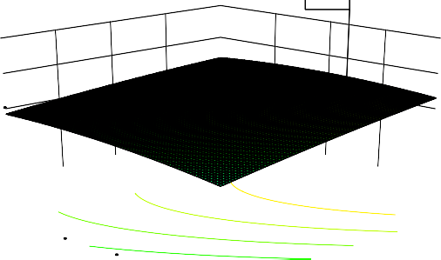

84.7659

100

90

80

70

60

400

8

350

7

300

B: concentration (mg/l)250

5

6

A: contact time (hrs)

200 4

**a**

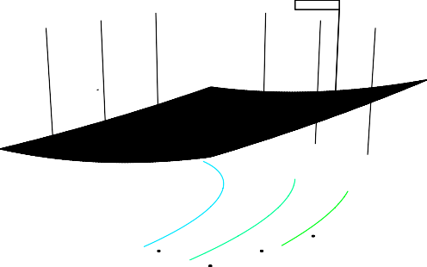

49.2994

60

55

50

45

40

400

8

350

7

300

B: concentration (mg/l)250

5

6

A: contact time (hrs)

200 4

TSS (%)

**b**

TDS (%)

**c**

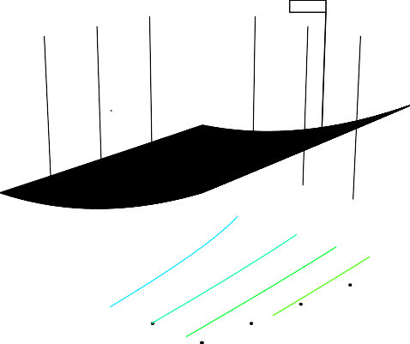

200 4

6

A: contact time (hrs)

5

300

B: concentration (mg/l)250

350 7

8

400

45

40

35

30

25

33.008

BOD (%)

**Fig 5 (a-c). Combined effect of contact time and conc. on TSS, TDS and BOD percentage removal efficiency**

* + 1. **Combined effect of Flow rate and Contact time on TSS percentage removal efficiency**

**Fig 6a demonstrated how different flow rates and contact times affect the TSS percentage removal. The color transitions from black at higher elevations to yellow at lower elevations. Therefore, there was an increase in TSS percentage removal at a flow rate of 6.4m3/hrs and contact time of 8hrs. The predicted TSS percentage removal was 84.7659%. In Figure 6b, the bars increased in height along the “C flow rate” axis (from left to right), indicating higher percentage removal of TDS with a lower flow rate. That suggested that certain flow rates lead to better TDS removal.**

**Interestingly, the bars along the “A contact time axis” increase at 8hrs. The predicted TDS percentage removal was 49.2994%. Figure 6c was a 3D graph plotted on a three-axis system. The x-axis was labelled “A: contact time (hrs), the y- axis was labelled “B: BOD% and the z-axis was labelled “C: flow rate (m3/hr). The surface plot in yellow represents some form of interaction or relationship between the variables’ contact time, BOD, and flow rate. Therefore, the flow rate affected/ determined the increase in BOD percentage efficiency at 8hrs.**

**a**

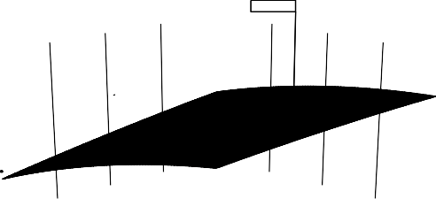

84.7659

100

90

80

70

60

8

8

7

7

6

C: flow rate (m3/hr)

5

5

6

A: contact time (hrs)

4 4

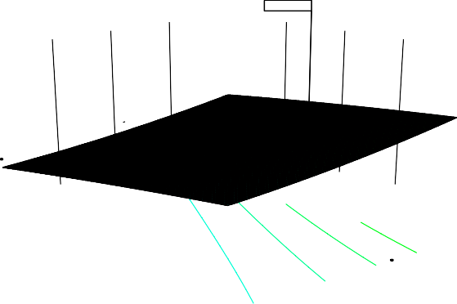

49.2994

60

55

50

45

40

8

8

7 7

6

C: flow rate (m3/hr)

5

5

6

A: contact time (hrs

4 4

TSS (%)

**b**

TDS (%)

**c**

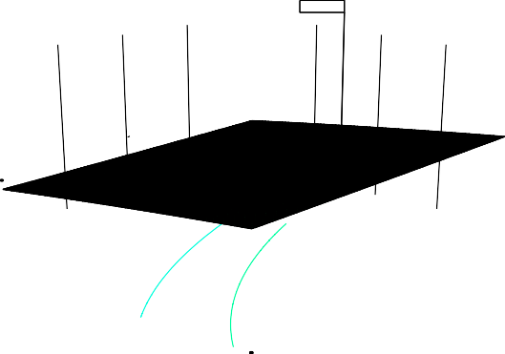

33.008

45

40

35

30

25

8

8

7

7

6

C: flow rate (m3/hr)

5

5

6

A: contact time (hrs)

4 4

BOD (%)

**Fig 6 (a-c). Combined effect of flow rate and contact time for TSS percentage removal efficiency**

* + 1. **Combined effect of Flow rate and Concentration on TSS, TDS and BOD percentage removal efficiency**

**In Fig 7a, the surface plots showed a peak, indicating the maximum removal percentage. That peak occurred around a flow rate of 6.4m3/hr and concentration of 277mg/l. Below the peak, there were yellow shaded regions. That area represented significant removal percentages over flow rate and concentration. It suggested that certain combinations of flow rate and ciprofloxacin concentration lead to effective percentage removal of TSS. The optimum efficiency TDS removal occurs at the predicted TDS percentage removal of 49.2994% by adjusting flow rate at 6.4m3/hr and concentration of 277mg/l. Figure 7b showed that TDS percentage removal efficiency increases at lower concentrations as the flow rates decrease. Figure 7c showed higher and lower predicted values. The optimum BOD efficiency was contributed mainly by the concentrations of ciprofloxacin, although the flow rates also contributed. The optimum BOD percentage efficiency was achieved at 277mg/l.**

**a**

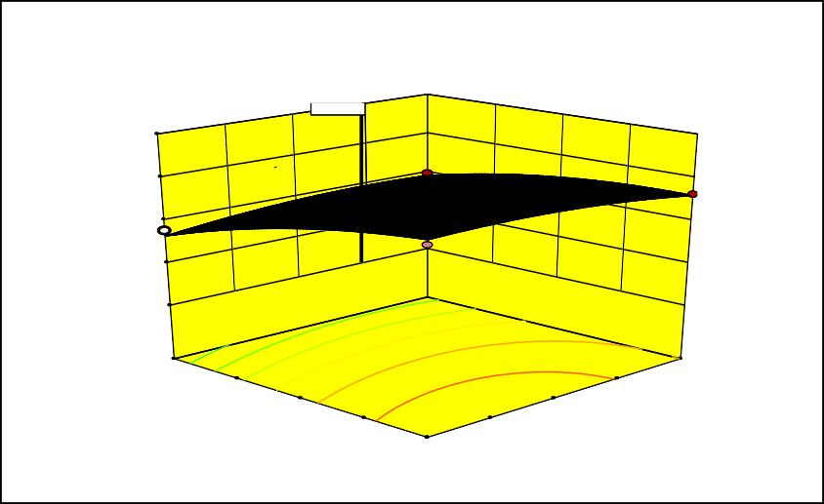

edicted value edicted value

84.7659

100

90

80

70

60

8

400

7

350

6

C: flow rate (m3/hr)

5

300

250 B: concentration (mg/l)

4 200

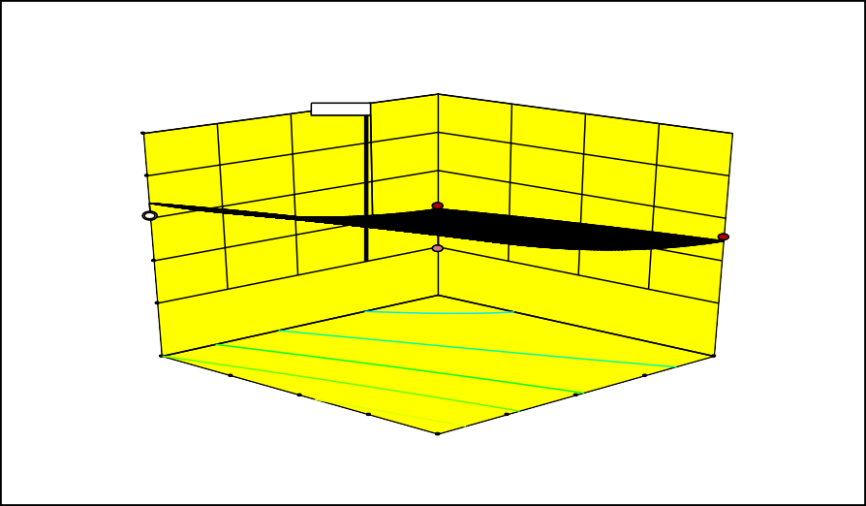

cted value cted value

49.2994

60

55

50

45

40

8

400

7

350

6

C: flow rate (m3/hr)

5

300

250 B: concentration (mg/l)

4 200

TSS (%)

**b**

TDS (%)

**c**

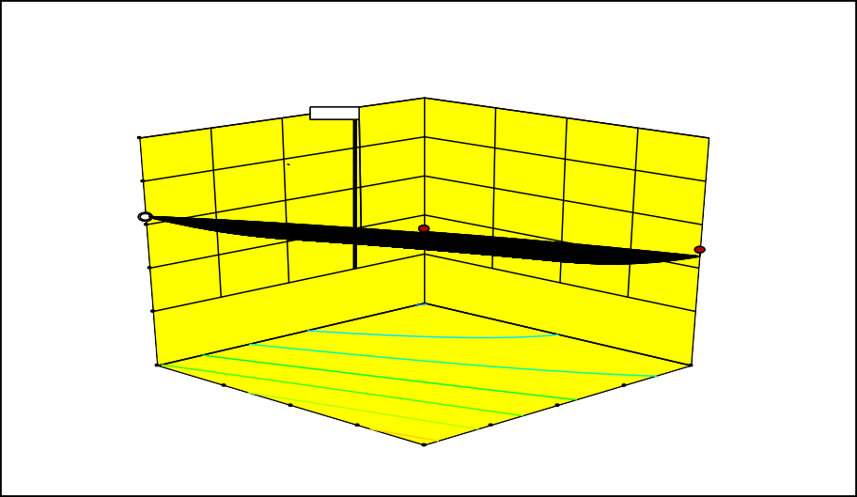

cted value cted value

33.008

45

40

35

30

25

8

400

7 350

6

C: flow rate (m3/hr)

5

300

250 B: concentration (mg/l)

4 200

BOD (%)

**Fig 7 (a-c). Combined effect of conc. and flow rate on TSS, TDS and BOD percentage removal**

# **Optimization**

**Optimization of three responses under the optimum operating conditions for the removal of ciprofloxacin from simulated pharmaceutical wastewater by application of modified palm fruit fiber using trickling filter system are:**

**Factors**

**A-Contact time =8hrs**

**B-Concentration =277.571mg/l C-Flow rate =6.468m3/hr Responses**

**TSS =84.766% (Actual =83.5%)**

**TDS =49.297% (Actual =47.3%)**

**BOD =33.005% (Actual =32.6%)**

# **Conclusion**

**The study demonstrated that trickling filter systems, when optimized for key operational parameters, can effectively remove ciprofloxacin from simulated pharmaceutical wastewater. The application of the response surface methodology proved valuable in identifying the optimal conditions for maximum removal efficiency. These findings suggested that trickling filters represent a viable option for enhancing the treatment of pharmaceutical wastewater.**

**DISCLAIMER**

**Author (s) hereby declare that NO generative AI technologies and text-to-image generators have been used during the writing or editing of manuscripts.**

**REFERENCE**

1. **IlurdozDe, M.S., Sadhwani, J.J., & Reboso, J.V. (2022)a. Antibiotic removal processes from water & wastewater for the protection of the aquatic environment - a review,” *Journal of Water Process Engineering*, 45, article 102474.**
2. **IlurdozDe, M.S., Sadhwani, J.J., & Reboso, J.V. (2022)b. Antibiotic removal processes from water & wastewater for the protection of the aquatic environment - a review,” *Journal of Water Process Engineering*, 45, article 102474.**
3. **Mezni, M., Saied, T., Horri, N., & Srasra, E. (2017). Removal of enrofloxacin from aqueous solutions using illite and synthetic zeolite X, *Surf. Eng. Appl. Electrochem*., 53, 89–97.**
4. **Kummerer, K. (2016). Pharmaceuticals in the Environment: Sources, Fate, Effects, and Risks. Springer-Verlag Berlin Heidelberg**
5. **El-Shafey, E.S.I., Al-Lawati, H., & Al-Sumri, A.S. (2012). Ciprofloxacin adsorption from aqueous solution onto chemically prepared carbon from date palm leaflets*, J. Environ. Sci*., 24, 1579–1586.**
6. **Samadi, M.T., Shokoohi, R., & Harati, R., (2015). Evaluation of Synthesized Fe3O4/MWCNTs Nanocomposite Used in the Heterogeneous Fenton Process for the Removal of Ciprofloxacin *Antibiotic. J. Water Wastewater*., (5): 80-89.**
7. **Yoosefian, M., Ahmadzadeh, S., Aghasi, M., & Dolatabadi, M. (2016). Optimization of electrocoagulation process for efficient removal of ciprofloxacin antibiotic using iron electrode; kinetic and isotherm studies of adsorption. *J. Mol. Liq*., 225: 544-553.**
8. **Ahmed, M.J. (2017). Adsorption of quinolone, tetracycline, and penicillin antibiotics from aqueous solution using activated carbons: review*, Environ. Toxicol. Pharmacol*., 50 (2017) 1–10.**
9. **Zide, D., Fatoki, O., Oputu, O., Opeolu, B., Nelana, S., & Olatunji, O. (2018). Zeolite ‘adsorption’ capacities in aqueous acidic media; the role of acid choice and quantification method on ciprofloxacin removal, *Microporous Mesoporous Mater*., 255, 226–241.**
10. **Wang, C.J., Li, Z.H., & Jiang, W.T. (2011). Adsorption of ciprofloxacin on 2:1 dioctahedral clay minerals, *Appl. Clay Sci*., 54, 723–728.**
11. **Xiong, J.Q., Kurade, M.B., & Jeon, B.H. (2018). Can microalgae remove pharmaceutical contaminants from water?, *Trends Biotechnol*., 36, 30–44**
12. **Gharaghani, M.A., & Malakootian, M. (2017). Photocatalytic degradation of the antibiotic ciprofloxacin by ZnO nanoparticles immobilized on a glass plate, Desal. Wat. Treat., 89, 304–314.**
13. **Yoosefian, M., Ahmadzadeh, S., Aghasi, M., & Dolatabadi, M. (2016). Optimization of electrocoagulation process for efficient removal of ciprofloxacin antibiotic using iron electrode; kinetic and isotherm studies of adsorption. *J. Mol. Liq*., 225: 544-553.**
14. **Sharma, N., & Dhiman, N. (2017). Kinetic and thermodynamic studies for ciprofloxacin hydrochloride adsorption from aqueous solution on CuO nanoparticles*, Int. J. ChemTech Res*., 10, 98–106.**
15. **Ding, R., Zhang, P.F., Seredych, M., & Bandosz, T.G. (2012). Removal of antibiotics from water using sewage sludge- and waste oil sludge-derived adsorbents, *Water Res*., 90, 40–6.**
16. **Balarak, D., Baniasadi, M., Lee, S ., & Joon, M. (2021). Ciprofloxacin adsorption onto Azolla filiculoides activated carbon from aqueous solutions,” *Desalination and Water Treatment*, 218, 444–453.**
17. **Arami, M., Limaee, N.Y., Mahmood, N. M., Tabrizi, N. S. (2006). Equilibrium and Kinetics Studies for the adsorption of direct and acid dyes from aqueous solution by soy meal hull: Journal of Harzardous Materials 135, 171-176.**
18. **Gratuito, M. K. B., Panyathanmaporn, T., Chumnanklang, R. A., Sirinutawittaya, N. and Dutta, A. (2008). Production of activated carbon from coconut shell: Optimization using response surface methodology. Bioresource Technology, 99, 4887-4895**
19. **Singh, K. P., Singh, A. K., Gupta, S. and Sinha, S. and Sinha, S. (2010). Experimental design and response surface modelling for optimization of Rhoda mine B removal from water by magnetic Nano composite. Chemical Engineering Journal, 165, 151-160**
20. **Xin-hui, D., Srinivasakannam, C., Qu, W. W., Xin, W., Jin-hui, P. and Li-bo, Z. (2012). Regeneration of microwave assisted spent activated carbon: Process optimization, adsorption isotherm and kinetics. Chemical Engineering and Processing, 53, 53-62**
21. **Roosta, M., Ghaedi, M., Shokri, N., Daneshfar, A., Sahraei, R. and Asghari, A. (2014). Optimization of the combined ultrasonic assisted/ adsorption method for the removal of malachite green by gold nanoparticles loaded on activated carbon: Experimental design. Spectrochimical Act A: Molecular and Bio molecular Spectroscopy, 118, 55-65**
22. **Hameed, B. H. and Foo, K. Y. (2010). Insights into the modelling of an adsorption isotherm systems. Chemical Engineering Journal, 15,2-10.**
23. **Patel, P. M. (2005). Supercritical Fluid Extraction of Rice Bran with Adsorption on Rice Hull Ash. PhD Dissertation, Louisiana State University, Louisiana, USA**
24. **Hameed, B. H. and Foo, K. Y. (2010). Insights into the modelling of an adsorption isotherm systems. Chemical Engineering Journal, 15,2-10**
25. **Khare, P. (2011)b. Treatment of phenolic water using adsorption. M. Tech Thesis, National Institute of Technology, Rourkela, India**
26. **Mohd-din, A. T., Hameed,B. H. and Ahmad, A. L., (2009). Batch adsorption of phenol onto physiochemical-activated coconut shell. Journal of Hazardous Materials, 161, 1522-1529**
27. **Gulipalli, CH,. Prasad, B., Wasewa, I.K. (2011). Batch study, equilibrium and kinetics of adsorption of selenium using rice husk ash (RHA). Journal of Engineering Science and Technlogy, 6(5), 586-605**
28. **Khare, P. (2011). Treatment of phenolic water using adsorption. M. Tech Thesis, National Institute of Technology, Rourkela, India**
29. **Soto, M. L., Moure, A., Dominguez, H. and Parajo, J. C. (2011). Recovery, concentration and purification of phenolic compounds by adsorption: A review. Journal of Food Engineering Safety, 71, 274-283**
30. **Hameed, B. H. and Foo, K. Y. (2010). Insights into the modelling of an adsorption isotherm systems. Chemical Engineering Journal, 15,2-10**
31. **Gayatri, S. L and Ahmaruzzaman, M. D. (2010). Adsorptive Technology for the removal of phenolic compounds from wastewater using low-cost adsorbent. Asian University Journal of Science and Technology, 5(2), 156-166**
32. **Kadhim, F. and Al-Seroury, F. A. (2012). Characterization of the removal of phenol from aqueous solution in fluidized bed column by rich husk adsorbent. Research Journal of Recent Sciences, 1, 145-151**
33. **Albadarin, A. B., Yang, Z., Mangwandi, C., Glocheux, Y., Walker, G. and Ahmad, M.N.M. (2013). Experimental design and batch experiments for optimization of Cr (VI) removal from aqueous solutions by hydrous Cerium**

**oxide nanoparticles. Chemical Engineering Research and Design,** [**http://dx.doi.org/10.1016/j.cherd. 2013.10.015**](http://dx.doi.org/10.1016/j.cherd.%202013.10.015)

1. **Rohman, A., Windarsih, A., Lukitaningsih, E., Rafi, M., Betania, K., Fadzillah,**

**N. A. (2020). The use of FTIR and Raman spectroscopy in combination with chemometrics for analysis of biomolecules in biomedical fluids: A review. Biomed. Spectrosc. Imaging. (8): 55-7**

1. **José, A. G., Belkis, C. S., Erick, R. B., & Jorge, R. (2019). Adsorption and kinetic studies of the removal of ciprofloxacin from aqueous solutions by diatomaceous earth, *Desalination and Water Treatment,* 162 (2019) 331–340.**
2. **Sahu, J. N., Acharya, J. and Meikapa, B. C. (2010). Optimization of production conditions for activated carbons from Tamarind wood by zinc chloride using response surface methodology. Bio resource Technology, 101, 1974-1982**
3. **Nasehir-Khan, E. M. Y., Faizal, L. M., Ismail, A., Oluegbenga, S. B. and Mohd,**

**A. A. (2010a). Effect of preparation conditions of activated carbon prepared from rice husk by CO2 activated for removal of Cu (11) from aqueous solution. International Journal of Engineering and Technology, 10(6), 47-51**

1. **Abdulgader, M., Yu, Q.J., Zinatizadeh, A.A., Williams, P., Rahimi, Z. (2020). Application of response surface methodology (RSM) for process analysis and Optimization of milk processing wastewater treatment using multistage flexible fiber biofilm reactor. J. Environ. Chem. Eng. 8, 103797.**
2. **Sivarajasekar, N. and Baskar, R. (2013). Adsorption of Basic Red 9 on activated waste Gossypium hirsutum seeds: Process modeling, analysis and optimization using statistical design. Journal of Industrial and Engineering Chemistry,** [**http://dx.doi.org/10.1016/j.jiec.2013.10.058**](http://dx.doi.org/10.1016/j.jiec.2013.10.058)
3. **Bhandari, A., Close, L. I., Kim, W., Hunter, R. P., Koch, D. E., & Surampalli, R.**

**Y. (2008). Occurrence of Ciprofloxacin, Sulfamethoxazole, and Azithromycin in Municipal Wastewater Treatment Plants. *Practice Periodical of Hazardous, Toxic, and Radioactive Waste Management*, 275-281**

1. **Zulfiqar, M., Samsudin, M. F. R., Sufian, S. (2019). Modelling and optimization of photocatalytic degradation of phenol via TiO2 nanoparticles: An insight**

**into response surface methodology and artificial neural network. J. Photochem.; photobiol. A Chem. 384, 112039.**

1. **Tan, I. A. W., Ahmad, A. L., and Hameed, B. H. (2008a). Removal of basic dye on high-surface-area activated carbon prepared from coconut husk: Equilibrium, kinetic and thermodynamic studies. Journal of Hazardous Materials, 153, 709-717.**
2. **Ma X, Wang Z. Removal of ciprofloxacin from wastewater by ultrasound/electric field/sodium persulfate (US/E/PS). Processes. 2022 Jan 7;10(1):124.**
3. **Du KQ, Li JF, Farid MA, Wang WH, Yang G. Preparation of high-efficient phosphoric acid modified biochar toward ciprofloxacin removal from wastewater. Industrial Crops and Products. 2025 Apr 1;226:120649.**
4. **Balarak D, Joghataei A, Mostafapour FK, Bazrafshan E. Ciprofloxacin Antibiotics Removal from Effluent Using Heat-acid Activated Red Mud. J. Pharm. Res. Int. [Internet]. 2018 Jan. 19 [cited 2025 Apr. 8];20(5):1-8.**