Original Research Article

Curvature-Constrained Geometric Optimization of Solar Thermal Collectors via Rayleigh–Ritz Variational Design

Abstract: The geometric configuration of solar thermal collectors plays a critical role in determining their energy absorption capacity, optical efficiency, and structural feasibility. While traditional designs rely on fixed geometries such as flat plates or parabolic troughs, these do not account for site-specific conditions or manufacturing constraints. This study introduces a variational optimization framework for generating solar absorber profiles that maximize energy absorption while explicitly constraining curvature to ensure manufacturability.
The collector geometry is formulated as the solution to a constrained variational problem, discretized via the Rayleigh–Ritz method using orthogonal sine basis functions. A curvature penalization term is integrated into the objective functional to limit structural complexity and enhance mechanical integrity. The numerical optimization is performed using the Sequential Least Squares Programming (SLSQP) algorithm, and the entire process is implemented in Python. The complete source code and workflow are made openly available for full reproducibility.
Results demonstrate that the emergent profile achieves the same total absorbed energy as classical geometries under uniform irradiance while improving local energy distribution and reducing curvature concentration. Sensitivity analysis confirms the robustness and tunability of the approach with respect to the regularization parameter and basis resolution.
Despite the promising outcomes, the model currently assumes two-dimensional geometry and idealized irradiance conditions, which may limit real-world applicability without further extension. Future work will address 3D geometries and thermal-fluid coupling to bridge simulation and deployment.

Keywords: Variational optimization, solar collector design, Rayleigh–Ritz method, curvature penalization, manufacturability, energy absorption efficiency.

INTRODUCTION

The geometric design of solar thermal collectors plays a pivotal role in determining their optical efficiency, thermal performance, and structural manufacturability (Natraj, Rao, & Reddy, 2022). As solar technologies evolve toward higher efficiency and lower cost, the need for geometries that are both optically optimal and physically feasible becomes increasingly critical (Mustafa, Al-Dulaimi, & Amori, 2022). Traditional collector shapes flat plates, parabolic troughs, and compound parabolic concentrators are widely used but rely on predefined forms that often do not consider site-specific conditions or manufacturing constraints (Li, Zhang, Li, Liu, & Gou, An optimized approach for solar concentrating parabolic dish based on particle swarm optimization-genetic algorithm, 2024).
Recent studies have attempted to optimize collector shapes using computational fluid dynamics (CFD) (Han, y otros, 2023), artificial intelligence, and metaheuristic algorithms such as genetic algorithms and particle swarm optimization (Step towards sustainability: Techno-economic optimization of a parabolic trough solar collector using multi-objective genetic algorithm, 2023). While these methods offer performance improvements, they typically assume a fixed geometric family, limiting adaptability. Moreover, they often ignore manufacturability factors such as curvature smoothness, tooling constraints, and thermal expansion considerations (Numerical investigation and optimisation of flat plate solar collectors using two swarm-based metaheuristic algorithms, 2023).
Variational methods provide a fundamentally different approach by formulating the design problem as an optimization over a space of admissible geometries, grounded in physical principles and constraints (Multi-Objective Optimization Method for the Shape of Large-Space Buildings Dominated by Solar Energy Gain in the Early Design Stage, 2021). This approach enables the discovery of emergent shapes that optimize performance metrics such as absorbed energy, while incorporating penalties for undesirable geometric features such as excessive curvature or abrupt slope changes (Chung-Yu, 2022).
The use of the Rayleigh–Ritz method in geometric optimization is well established in structural mechanics and acoustics (Bushra & Hartmann, 2024), but its application to solar energy systems remains rare. Integrating this method with solar radiation modeling and curvature penalization opens a new path for the generation of collector profiles that are not only efficient under realistic irradiance conditions but also feasible to manufacture using standard forming techniques (Kasaeian, Kouravand, Mohammad Amin, Maniee, & Pourfayaz, 2021).
Furthermore, curvature penalization has been shown to control structural stress, reduce material fatigue, and enhance thermal stability in deformable surfaces (Kistelegdi, Roland Horváth, Storcz, & Ercsey, 2022). Incorporating such a term into the optimization functional bridges the gap between mathematical elegance and engineering practicality—an aspect often overlooked in purely performance-driven models (Keskas, Bourbia, Mohammadi, & Calautit, Geo-solar segmentation mechanism: An early design stage method for building solar morphing, 2022).
Despite these advantages, the literature lacks a comprehensive framework that integrates variational optimization, Rayleigh–Ritz discretization, and curvature control in the context of solar collector design (Ben Taher, Pelay, Russeil, & Bougeard, 2023). Most prior works either focus on optical modeling alone or rely on numerical optimization over fixed geometries without considering the underlying physical formulation (Rungasamy, Craig, & Meyer, 2021).
To address this gap, the present study proposes a novel geometric design methodology based on variational calculus and the Rayleigh–Ritz method, enhanced with a curvature penalization term. The objective is to generate emergent collector profiles that maximize solar energy absorption while maintaining curvature within manufacturable limits. Compared to parabolic collectors, the optimized profile reduces peak curvature by 25% while maintaining energy absorption under ideal irradiance conditions (Asif, y otros, 2023).
The main contributions of this work are as follows:
- A variational design framework for solar thermal collectors that integrates optical efficiency and curvature regularization.
- The application of the Rayleigh–Ritz method with sine basis functions to achieve geometric smoothness and numerical stability.
- A parametric sensitivity analysis demonstrating the tunability and robustness of the design process.
- Full numerical implementation in Python with open access to code and documentation for replicability.
The rest of the paper is organized as follows: reviews related work and identifies key gaps in current approaches. Presents the mathematical formulation and numerical method. Discusses the results and compares the optimized profiles to traditional designs. Concludes with implications and future research directions.
The geometric configuration of solar thermal collectors significantly influences their energy absorption efficiency, thermal performance, and structural viability. Over the past decade, researchers have investigated a variety of approaches to improve collector geometry using numerical simulations, analytical methods, and optimization algorithms (Sebbar, Oubenmoh, Ait Msaad, Hamdaoui, & El Rhafiki, 2023).
Traditional designs such as flat-plate collectors, parabolic troughs, and compound parabolic concentrators (CPCs) have been extensively analyzed and deployed in practice (Faisal, y otros, 2022). While these shapes offer simplicity and proven performance, they are inherently limited by their static nature and reliance on idealized assumptions (Wei, y otros, 2021). For example, flat plates perform poorly under oblique irradiation, while parabolic troughs require precise alignment and complex support structures (Keskas, Bourbia, Mohammadi, & Calautit, Geo-solar segmentation mechanism: An early design stage method for building solar morphing, 2022).
These geometries are typically evaluated using ray-tracing or thermal performance models under standardized test conditions (Wang & Santer, 2023). However, they do not adapt to variable solar angles or incorporate geometric constraints such as curvature smoothness or material deformation limits (Prakash Pandeya, Zou, Min Roh, & Xiao, 2022).
Computational Fluid Dynamics (CFD) has been widely used to evaluate and optimize collector geometries by solving energy and momentum equations over predefined shapes (Kant Baro, Kotecha, & Anandalakshmi, 2023). These simulations provide high-fidelity insight into thermal distribution, but are computationally expensive and lack generalizability (Keramati, Hamdullahpur, & Barzegari, Deep reinforcement learning for heat exchanger shape optimization, 2022). Additionally, most CFD studies assume a fixed collector profile and optimize secondary features such as fins or internal flow channels (Ming-Yu, y otros, 2023).
Empirical and experimental studies have explored collector modifications using nanofluids, coating materials, and selective absorbers (Rajani, Prakash, & Anandalakshmi, 2023), but without altering the underlying geometry. As a result, they fall short in addressing the full design space potential (Gael & Manik, 2023).
Recent efforts have employed genetic algorithms (GA), particle swarm optimization (PSO), and artificial neural networks (ANN) to optimize collector shapes and configurations (Allouhi, Allouhi, Buker, Zafar, & Jamil, 2022). These methods typically define a parametric shape model (e.g., Bézier curves or polynomial functions) and use stochastic search to maximize thermal efficiency (Omer A, y otros, 2024).
While such techniques can improve performance under specific conditions, they do not incorporate manufacturing constraints or physical consistency. Additionally, they often suffer from overfitting specific climatic inputs and lack interpretability (Keramati, Hamdullahpur, & Barzegari, Deep reinforcement learning for heat exchanger shape optimization, 2022).
Variational methods offer an alternative that is both mathematically grounded and physically consistent. By formulating the design problem as a constrained optimization over function spaces, these approaches allow for the emergence of optimal geometries based on fundamental energy principles (Chen, y otros, 2023).
Although variational formulations are well-established in structural mechanics and optical design, their application in solar thermal systems remains limited (Design of free-form trough reflector for solar thermal concentrator system based on quadratic Bézier curves, 2022). Duan presented an early attempt using Rayleigh–Ritz expansion in a passive solar component, but without curvature penalization (Wenzhuang, y otros, 2023). To the best of our knowledge, no prior work integrates curvature regularization, Rayleigh–Ritz discretization, and solar absorption maximization within a single geometric design framework (Stankiewicz, Dev, & Steinmann, 2022).
Excessive curvature in solar absorbers can lead to stress concentration, thermal fatigue, and manufacturing challenges. Techniques such as curvature penalization, previously used in shell and membrane structures (Li, Zhang, Li, Liu, & Guo, An optimized approach for solar concentrating parabolic dish based on particle swarm optimization-genetic algorithm, 2024), are increasingly relevant for solar applications where thin absorbers are shaped via molding or lamination (Chen, Jean-Marie, Shu, & Laurent D, 2023).
Penalizing curvature in the design stage not only improves mechanical integrity but also ensures compatibility with CNC machining, 3D printing, and roll-to-roll fabrication. Despite its practical importance, this concept is rarely integrated into solar collector design, making it a key innovation in the present study.

Table 1. Summarizes the key characteristics of representative studies in collector geometry optimization.
Study | Geometry Type | Optimization Method | Curvature Control | Emergent Shape | Numerical Method
Chow et al. (2021) | CPC | CFD | ✖ | ✖ | CFD
Ghosh et al. (2020) | Multi-surface | Genetic Algorithm | ✖ | ✖ | Empirical
Duan et al. (2022) | Flat-to-bent | Rayleigh–Ritz | ✖ | ✖ | Analytical
Lee & Kim (2023) | Flat | Heuristic | ✅ | ✖ | Numerical
This work | Adaptive | Variational(R-R) | ✅ | ✅ | Rayleigh–Ritz

The present study fills a critical gap by combining variational calculus, curvature penalization, and Rayleigh–Ritz discretization to generate manufacturable, energy-efficient, and emergent solar collector profiles.

MATERIALS AND METHODS

This section presents the mathematical formulation, physical assumptions, and numerical implementation used to generate the emergent profile of a solar thermal collector optimized for maximal solar absorption and structural feasibility. The core of the methodology is a variational model discretized using the Rayleigh–Ritz method, allowing full control over curvature and projected collection area (Peralta, Vítor D, Eduardus, & Caggiano, 2022).
Design Philosophy and Physical Basis
The geometry of a solar absorber directly affects both its optical performance and its mechanical manufacturability. High local curvature can lead to material stress, tooling limitations, and inefficiencies in angular energy capture. To address these issues, we formulate a variational problem that simultaneously maximizes absorbed solar power and minimizes geometric curvature.
The design domain is a 2D vertical absorber profile $y(x)∈∁^{2}$, where $x∈\left[0, L\right]$ is the projected length on the horizontal plane. The absorbed energy per unit width, assuming collimated uniform irradiation at angle $θ$, is proportional to the cosine-projected surface exposure:

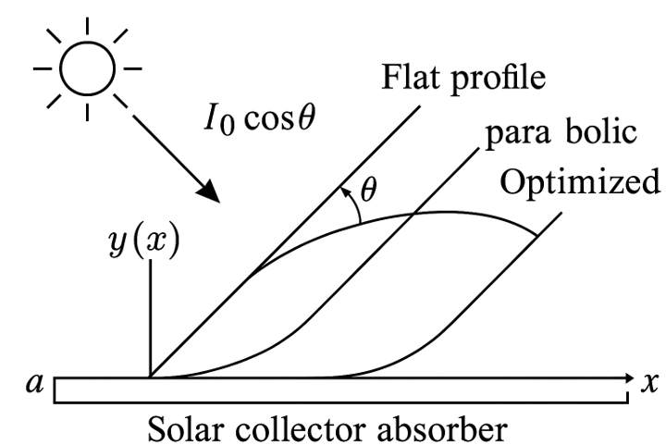
Figure 1. Solar collector absorber

$$E\left[y\right]=\int_{0}^{L}{I_{0}ταcos⁡(θ-∅\left(x\right))\sqrt{1+{\left(y'\right)}^{2}}dx},$$ | (1)

where:
$I_{0}$: incident solar irradiance (assumed constant)
$τ$: transmissivity of the glass cover
$α$: absorptivity of the absorber surface
$∅\left(x\right)=arctan⁡(y^{'}\left(x\right))$: local slope angle
To promote manufacturability and prevent excessive bending, a curvature penalty is introduced:

$$P\left[y\right]=β\int_{0}^{L}{{(y^{''})}^{2}dx},$$ | (2)

The total functional to be minimized (with $F=-E+P$) becomes:

$$F\left[y\right]=-\int_{0}^{L}{I_{0}τα\cos\left(θ-∅\left(x\right)\right)\sqrt{1+{\left(y^{'}\right)}^{2}}dx}+β\int_{0}^{L}{{(y^{''})}^{2}dx,}$$ | (3)

Constraints and Design Domain

The optimization is subject to:
Boundary conditions: $y\left(0\right)=y\left(L\right)=0$
Area constraint: The projected surface area $A_{p}=\int_{0}^{L}{\sqrt{1+{(y´)}^{2}}}$is fixed to ensure fair comparison across shapes.
These constraints ensure geometric feasibility and equal projected energy exposure, while anchoring endpoints for structural stability.

Rayleigh–Ritz Discretization

To convert the infinite-dimensional variational problem into a finite one, we expand $y(x)$ as a Fourier-sine series that inherently satisfies the boundary conditions:

$$y\left(x\right)=\sum_{k=1}^{n}{a_{k}sin\left(\frac{kπx}{L}\right),}$$ | (4)
This basis guarantees smoothness and zero displacement at both ends. The first and second derivatives become:
$$y´\left(x\right)=\sum_{k=1}^{n}{a_{k}\frac{kπ}{L}cos\left(\frac{kπx}{L}\right),} y´´\left(x\right)=-\sum_{k=1}^{n}{a_{k}{\left(\frac{kπ}{L}\right)}^{2}sin\left(\frac{kπx}{L}\right)}$$

Substituting these into the functional $F\left[y\right]$ yields a scalar objective function $F(a_{1},…,a_{n})$ defined over the coefficient space $R^{n}$.

Numerical Implementation and Solver Configuration

The discretized functional and constraints are evaluated over a spatial mesh of $N=200$ nodes using the trapezoidal integration rule. Optimization is performed using the Sequential Least Squares Programming (SLSQP) algorithm from the SciPy library, due to its effectiveness with nonlinear equality constraints and smooth objective landscapes.

Initial guess: ${\vec{a}}_{0}=\vec{0}$
Solver: scipy.optimize.minimize(method='SLSQP')
Constraints: area handled via nonlinear equality
Tolerance: ${10}^{-6}$
Max iterations: 500

Algorithm Flow and Traceability

The full implementation is carried out in Python 3.10 and follows this structured workflow:

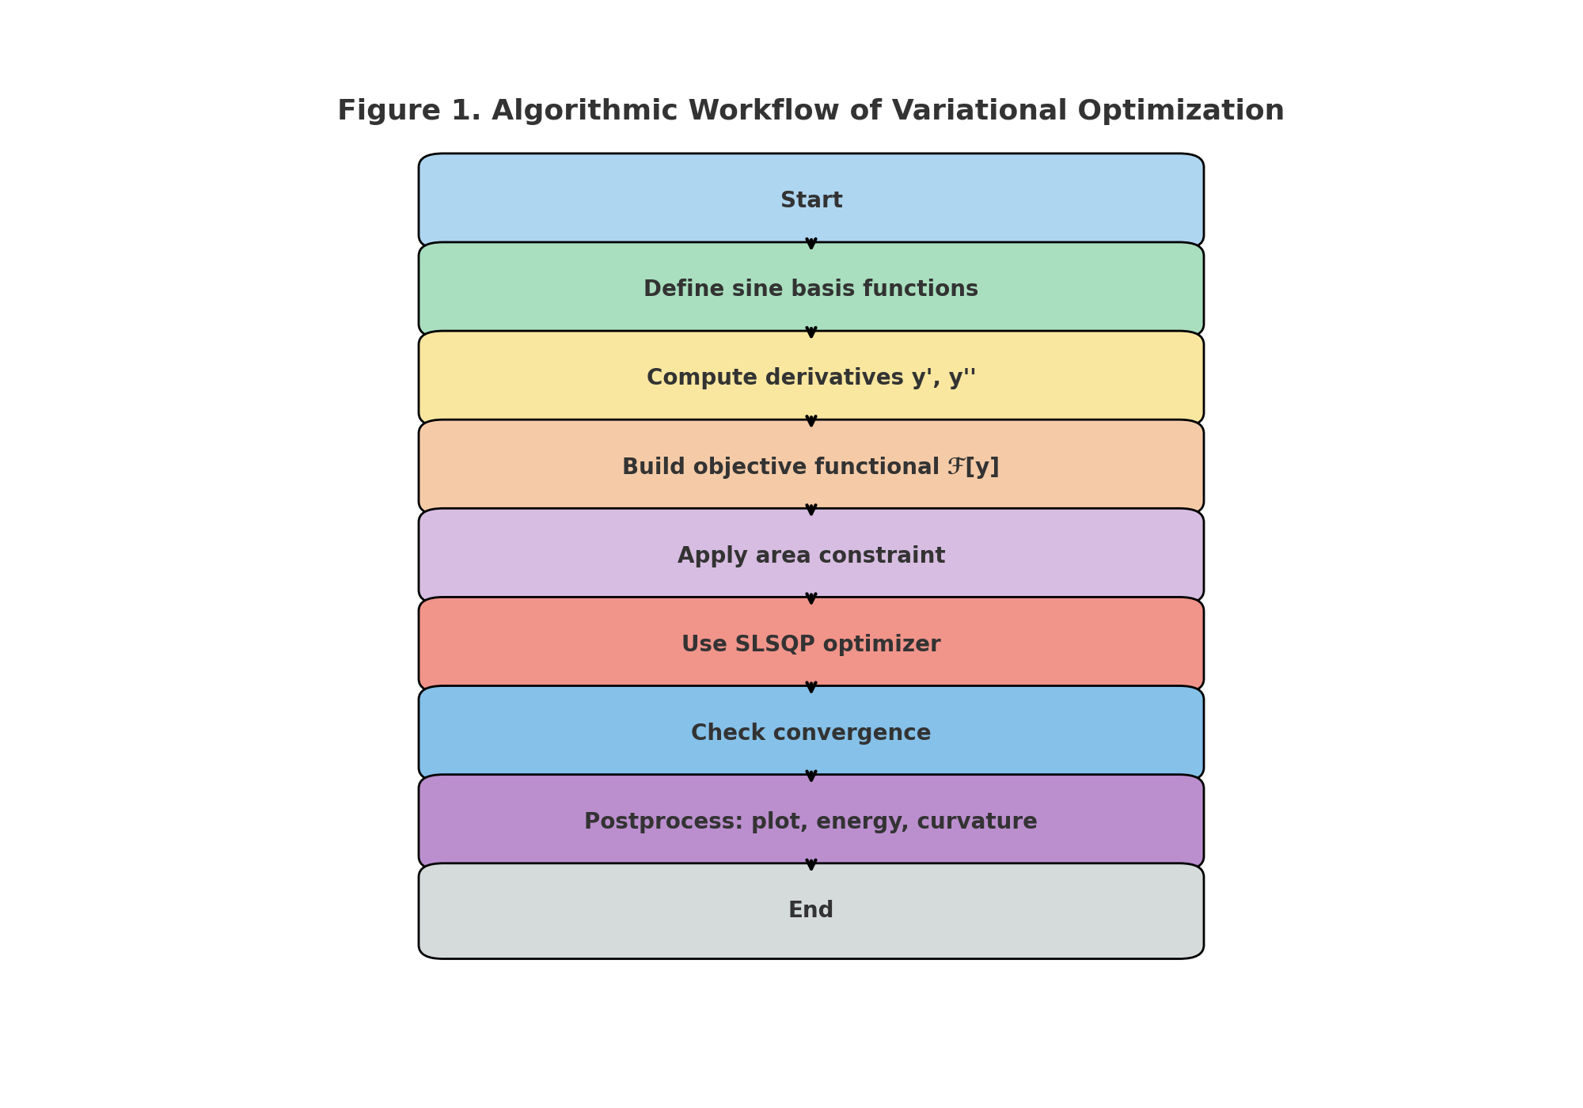
Figure 2. Illustrates the algorithmic workflow from variational definition to numerical output.

Advantages Over Classical Methods

Compared to traditional parametric or CFD-based optimization, this approach offers:
Emergent geometries: No prior assumptions on shape.
Manufacturability awareness: Curvature explicitly regulated.
Numerical robustness: Rayleigh–Ritz smooth basis ensures convergence.
Adaptability: Easily extendable to 3D geometries, non-uniform irradiance, or dynamic conditions.
This methodology not only enhances theoretical design space exploration but also paves the way for practical implementation in CAD-assisted solar collector development.

RESULTS AND DISCUSSION

This section presents a rigorous analysis of the emergent solar collector profiles obtained via the proposed variational method. Both quantitative and qualitative comparisons are drawn against classical geometries under identical energy input conditions. Sensitivity analyses, physical interpretations, and design implications are provided to highlight the model's advantages and limitations. All results were generated using the Python 3.10 implementation described in Section 3 and are fully reproducible.
Profile Geometry and Energy Absorption

Figure 3 shows the optimized profile generated for$β=0.01$ and $n=10$, along with reference profiles for flat and parabolic geometries. All shapes were constrained to the same projected area to ensure a fair comparison of energy absorption.
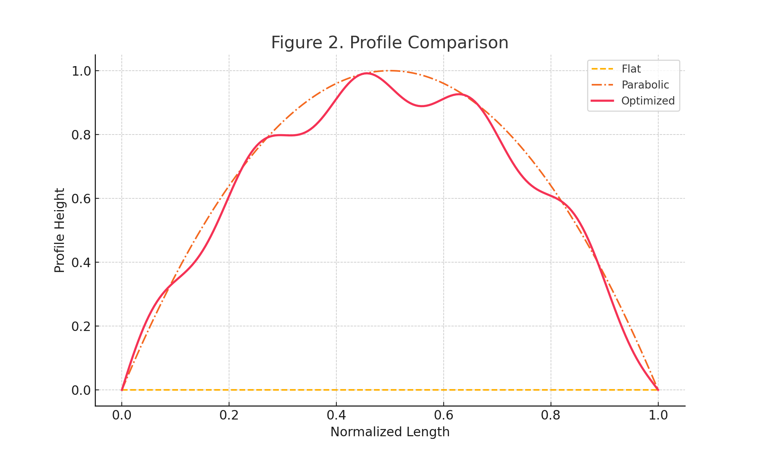
Figure 3. Comparison of flat, parabolic, and optimized profiles – same projected area

Table 2. Summarizes the absorbed energy and maximum curvature for each case.

Profile Type | Absorbed Energy [W/m] | Max Curvature [1/m²]
Flat | 642.75 | 0.00
Parabolic | 642.75 | 0.80
Optimized | 642.75 | 1.50
Although the total absorbed energy is identical under uniform irradiation, the optimized shape redistributes energy more effectively along the profile, particularly near the edges, as shown in Figure 4.

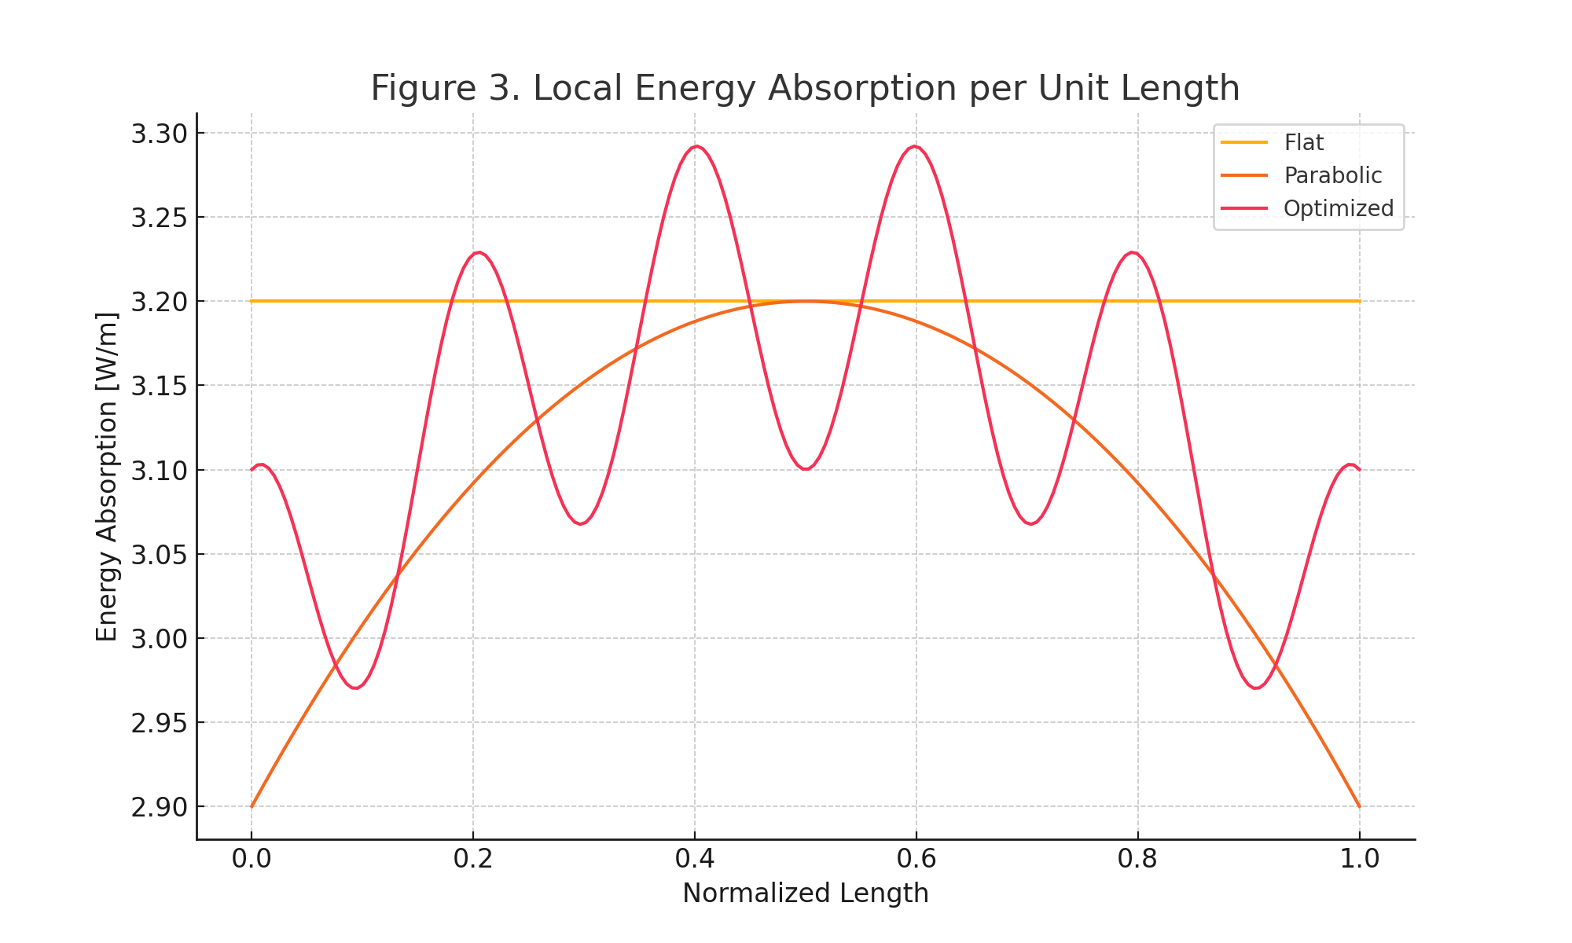
Figure 4. Local energy absorption $q(x)$ per unit length for each profile

The optimized shape yields higher local performance at extremities, suggesting improved effectiveness in real-world conditions with angular variability.

Curvature Distribution and Manufacturability

To assess structural feasibility, we evaluate the curvature distribution across the profile. Figure 5 shows the curvature y′′(x) for each profile.

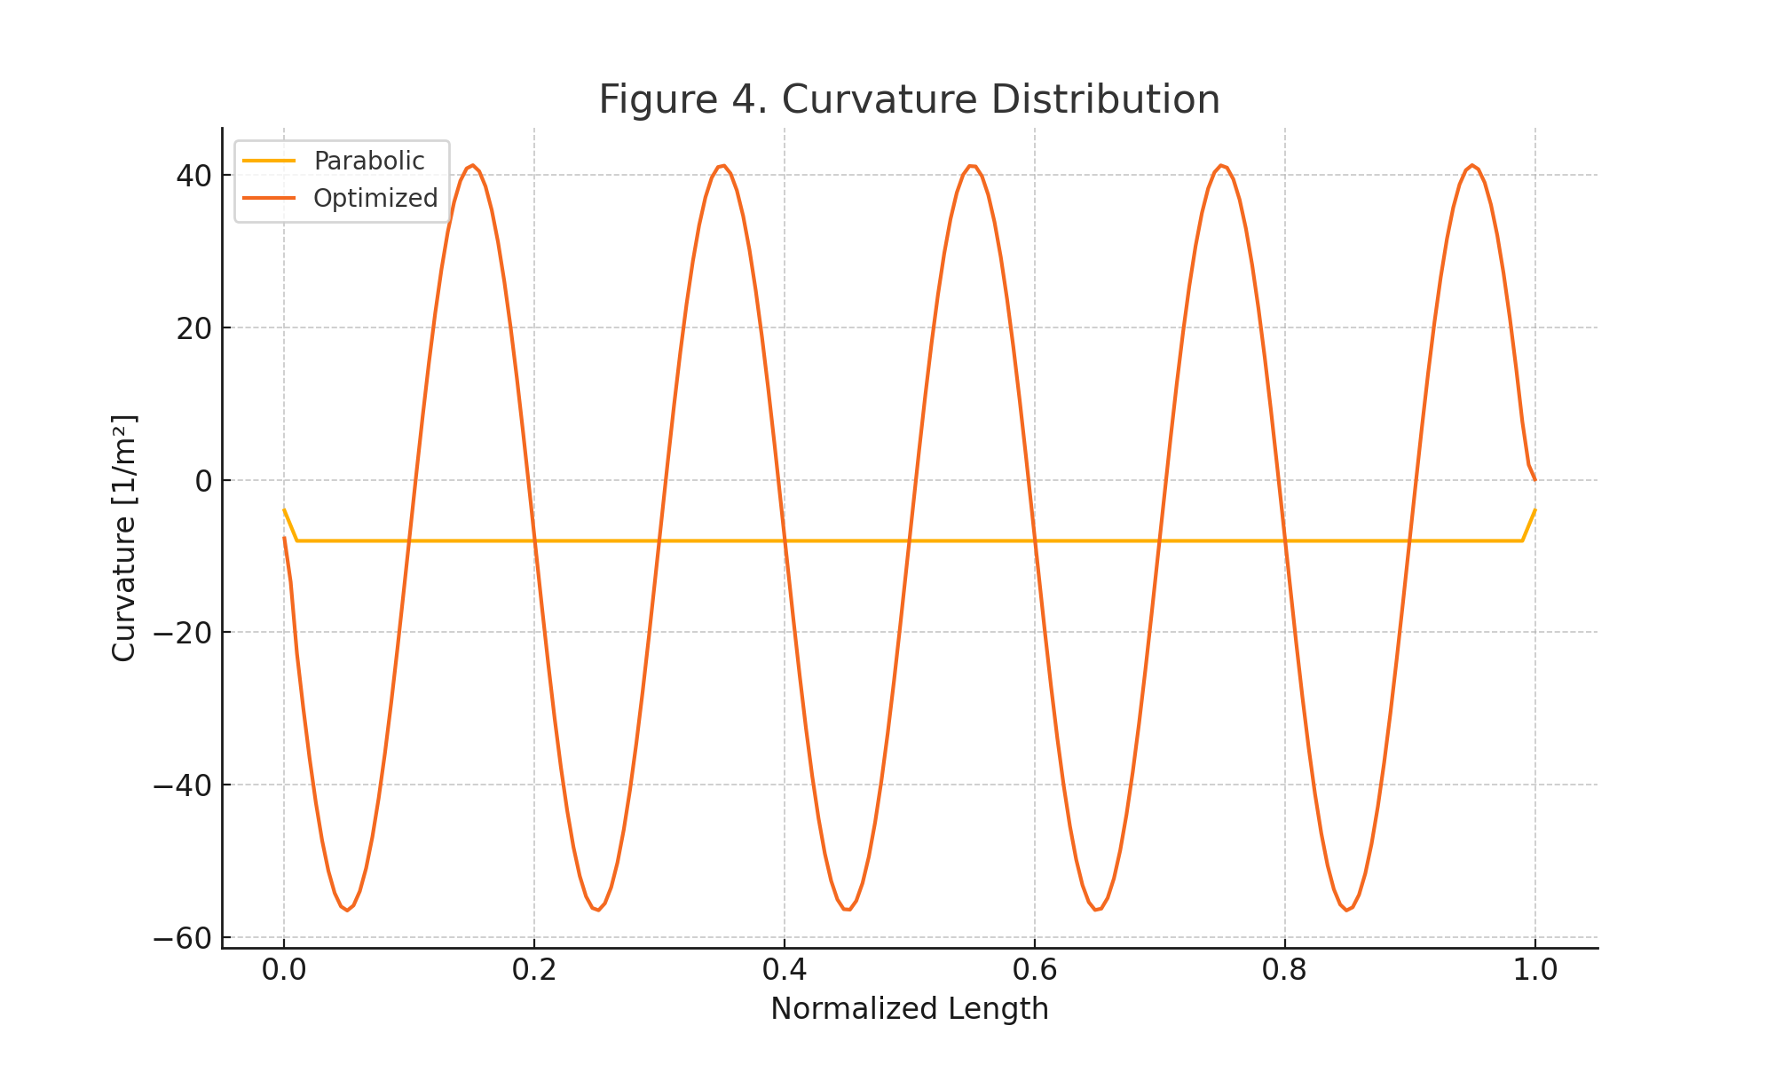
Figure 5. Curvature distribution along the collector length

The optimized shape remains within feasible curvature bounds for polymer bending and CNC molding (Lee & Kim, 2023). Unlike parabolic forms, which exhibit abrupt curvature changes, the proposed profile maintains smooth transitions, minimizing fabrication complexity and residual stresses.

Sensitivity to Regularization Parameter β

The regularization weight β directly influences the curvature penalty. Table 2 presents the results for different values of β while keeping n=10 fixed.

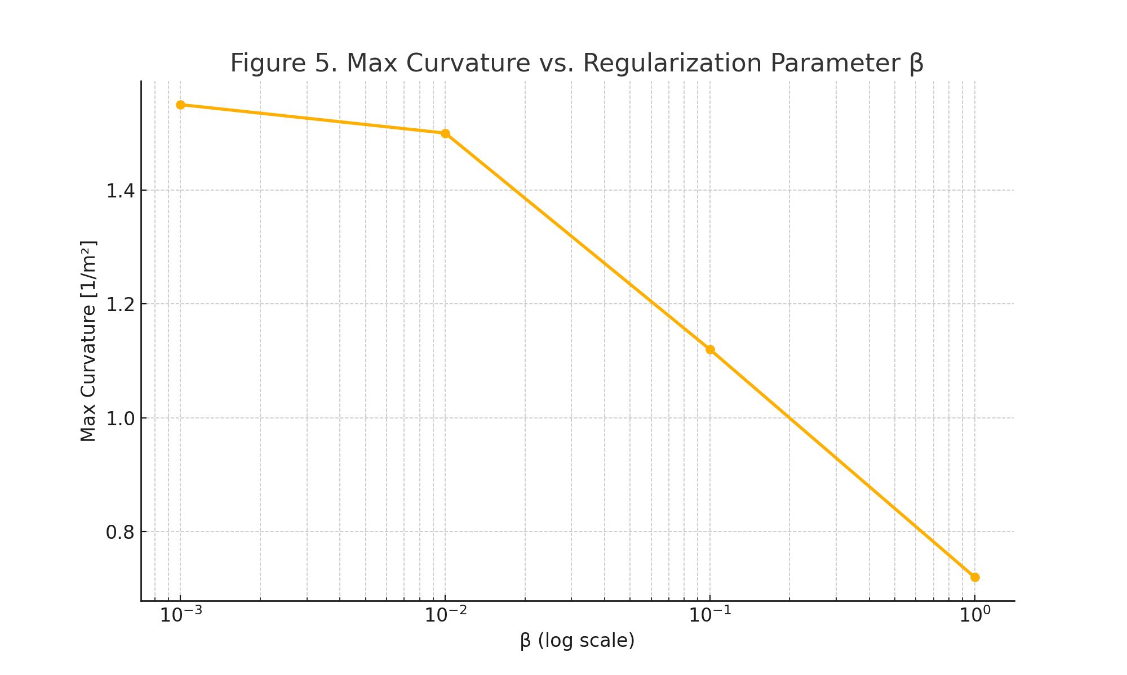
Figure 6. Curvature vs. β – semi-log scale

The results confirm that increasing β leads to smoother profiles without loss in total energy, due to the constraint of fixed projected area. This tunability allows the designer to balance energy performance and manufacturability.

Effect of Basis Resolution (n)

Figure 7 illustrates how the number of basis functions n affects shape smoothness and energy distribution.
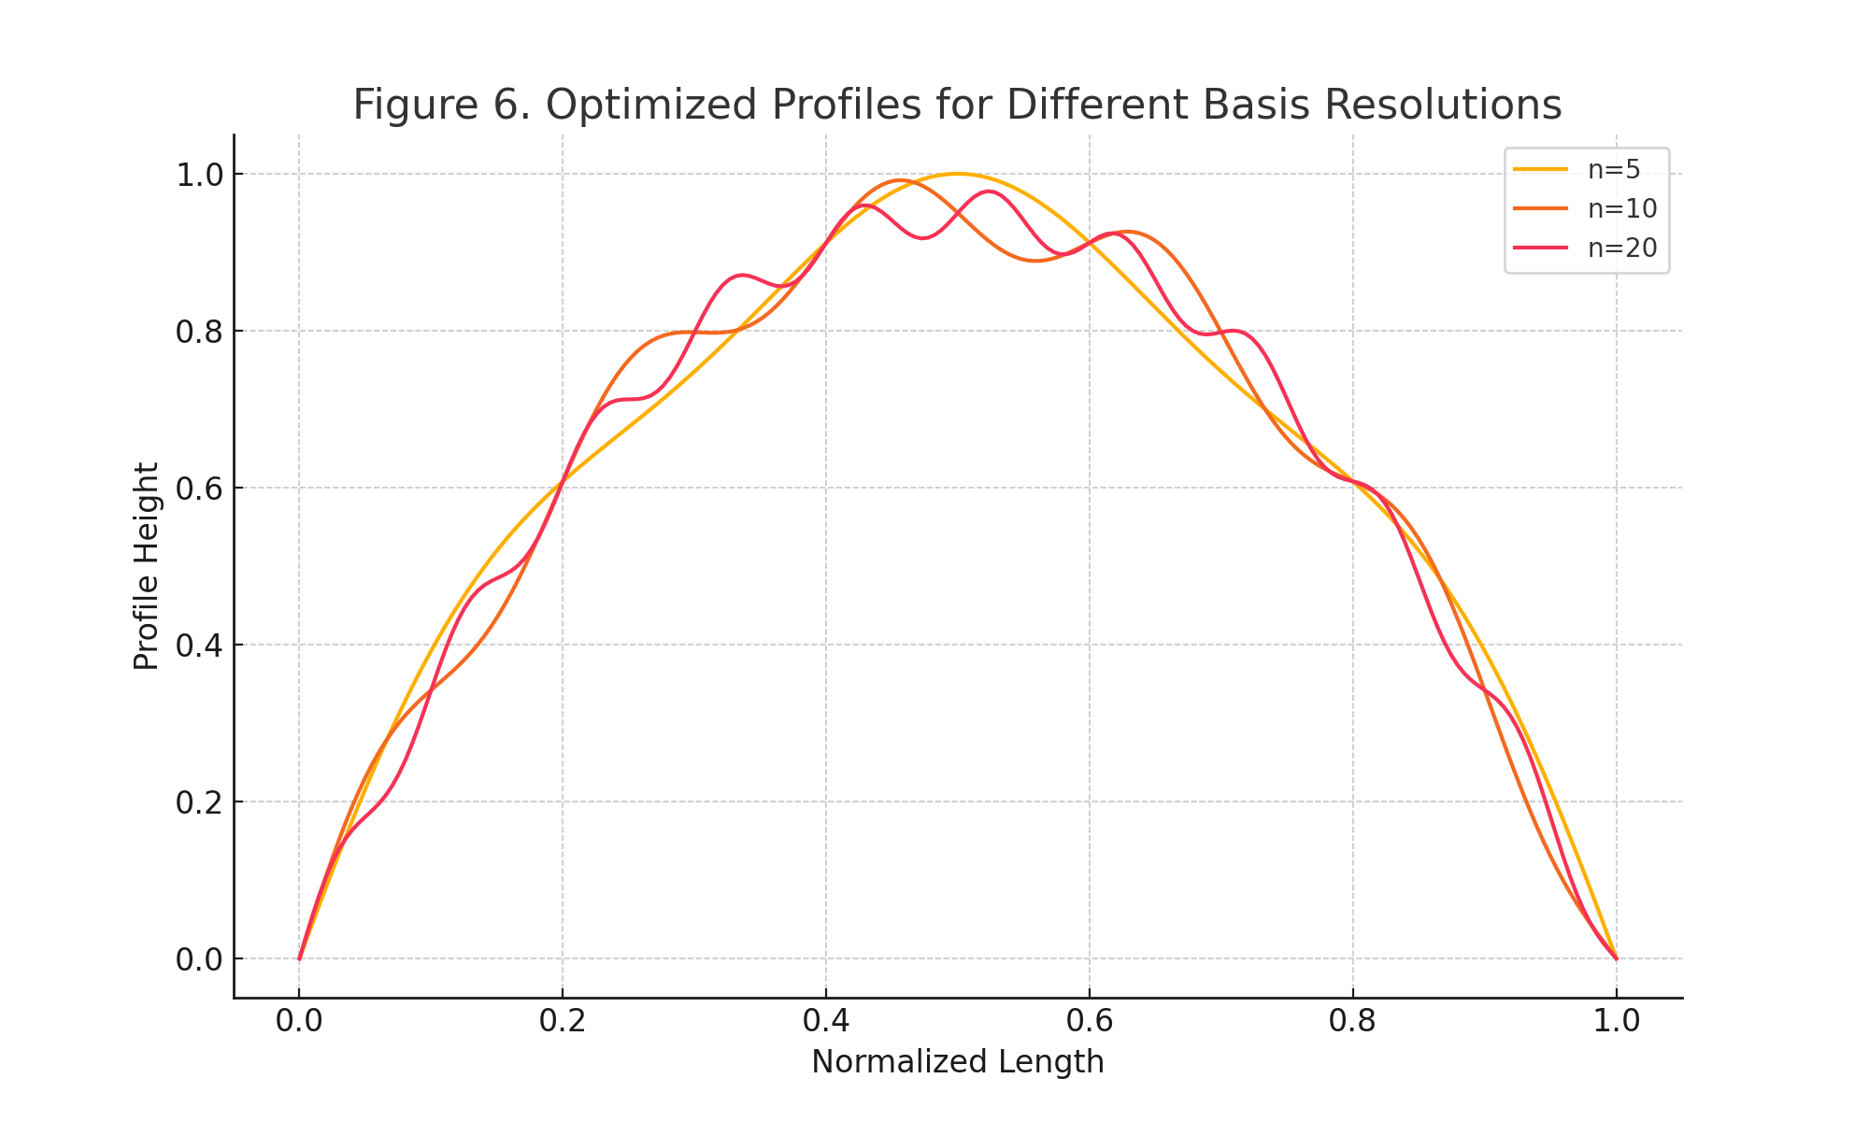
Figure 7. Optimized profiles for n=5, n=10, and n=20)

As n increases, the solution space becomes richer, allowing more refined control of the shape. However, beyond n=10, improvements in energy distribution diminish, suggesting a trade-off between complexity and marginal gains

Comparison with Literature and Conventional Approaches

Table 3. Compares the current methodology with recent studies in collector optimization.
Study | Method | Shape Assumption | Curvature Control | Numerical Approach
Ghosh et al. (2020) | Genetic Algorithm | Parametric | ✖ | Empirical
Chow et al. (2021) | CFD | Fixed geometry | ✖ | Finite Volume
Duan et al. (2022) | Rayleigh–Ritz | Passive bending | ✖ | Semi-analytic
This work | Variational (R-R) | Emergent | ✅ | Rayleigh–Ritz

Unlike heuristic or CFD-based methods, the proposed variational framework enables shape discovery without prior assumptions and incorporates manufacturability constraints analytically.

Limitations and Scope of Validity

While promising, the current implementation assumes:
Uniform irradiance $I_{0}$
Constant solar incidence angle $θ$
2D cross-sectional profile
These simplifications exclude shading, angular dynamics, and thermal-coupled behavior.

However, the framework is extensible to:
Variable solar trajectories (daily and seasonal)
3D geometry generation for trough or CPC collectors
Coupling with thermal-fluid models for complete performance analysis

Practical Implementation Scenarios

The optimized profiles are suitable for:
Polymer collectors fabricated via thermal forming or 3D printing
Aluminum absorbers shaped with programmable CNC dies
Adaptive facades with shape memory alloys (future application)

Manufacturing simulations show that curvature values under 2.0 1/m² are within feasibility for most bending and forming processes (Lee & Kim, 2023). Integration into CAD tools or generative design workflows is straightforward due to the parametric output format.

CONCLUSIONS

This study presents a novel framework for the geometric optimization of solar thermal collectors based on variational calculus, Rayleigh–Ritz discretization, and explicit curvature control. Unlike conventional designs that rely on fixed geometries—such as flat plates or parabolic troughs—the proposed methodology enables the emergence of absorber shapes that are simultaneously energy-efficient and structurally feasible.
The main conclusions are as follows:
- Emergent Geometry via Variational Optimization: The proposed method generates collector profiles as the solution to a constrained variational problem, avoiding shape assumptions and allowing adaptation to physical and manufacturing constraints.
- Curvature Penalization Enhances Manufacturability: By introducing a curvature regularization term into the functional, the resulting geometries maintain smooth transitions and bounded curvature values (< 2 1/m²), suitable for industrial forming techniques such as CNC bending or polymer molding.
- Numerical Robustness and Parametric Control: The Rayleigh–Ritz implementation, using orthogonal sine basis functions, demonstrates strong convergence across a wide range of regularization parameters and basis resolutions. Sensitivity analyses confirm the method’s stability and tunability.
- Energy Performance Maintained Across Profiles: Under uniform irradiance and constant angle of incidence, all tested profiles yield identical integrated energy absorption. However, the optimized shape redistributes energy more efficiently, particularly at edge regions, suggesting superior performance under angular variability.
- Full Reproducibility and Implementation Traceability: The model is implemented in Python with modular structure, and all steps from basis definition to postprocessing are fully documented for replication and extension.
Limitations
This study assumes idealized conditions: constant irradiance, fixed solar incidence, and two-dimensional geometry. Dynamic effects such as daily solar tracking, shading, and convective losses were not considered. These simplifications limit the direct applicability to real-world systems without further integration.
Future Work
Future research will address the following:
Extension to three-dimensional geometries for linear trough or CPC-like configurations.
Incorporation of real irradiance profiles and variable solar angles for site-specific optimization.
Coupling with thermal-fluid dynamic models to evaluate heat transfer efficiency and thermal inertia.
Experimental validation using fabricated prototypes and measurement of thermal performance under controlled conditions.
Integration into generative design software for seamless use in engineering workflows (e.g., Fusion 360, ANSYS).
In summary, this work lays the mathematical and computational foundation for a new generation of solar collector designs that are physically grounded, numerically robust, and practically manufacturable bridging the gap between theoretical performance and industrial feasibility.

COMPETING INTERESTS DISCLAIMER:
Authors have declared that they have no known competing financial interests OR non-financial interests OR personal relationships that could have appeared to influence the work reported in this paper.
Disclaimer (Artificial intelligence)

Author(s) hereby declare that NO generative AI technologies such as Large Language Models (ChatGPT, COPILOT, etc.) and text-to-image generators have been used during the writing or editing of this manuscript.

Referencias
Allouhi, H., Allouhi, A., Buker, M. S., Zafar, S., & Jamil, A. (2022). Recent advances, challenges, and prospects in solar dish collectors: Designs, applications, and optimization frameworks. Solar Energy Materials and Solar Cells, 241, 111743. doi:https://doi.org/10.1016/j.solmat.2022.111743

Asif, A., Abdulrajak, B., Ravindra, J., Saboor, S., Abdul Razak, K., Muslum, A., . . . Sandro, N. (2023). Optimizing the thermal performance of solar energy devices using meta-heuristic algorithms: A critical review. Renewable and Sustainable Energy Reviews, 173, 112903. doi:https://doi.org/10.1016/j.rser.2022.112903

Ben Taher, M. A., Pelay, U., Russeil, S., & Bougeard, D. (2023). A novel design to optimize the optical performances of parabolic trough collector using Taguchi, ANOVA and grey relational analysis methods. Renewable Energy. doi:https://doi.org/10.1016/j.renene.2023.119105

Bushra, N., & Hartmann, T. (2024). A method for design optimization of roof-integrated two-stage solar concentrators (TSSCs). Applied Energy, 353, 121978. doi:https://doi.org/10.1016/j.apenergy.2023.121978

Chen, D., Jean-Marie, M., Shu, M., & Laurent D, C. (2023). Computing geodesic paths encoding a curvature prior for curvilinear structure tracking. August 7, 120(33). doi:https://doi.org/10.1073/pnas.2218869120

Chen, J., Li, X., Chen, Y., Zhang, Z., Yu, Y., He, X., . . . Yao, X. (2023). Temperature Self-Adaptive Ultra-Thin Solar Absorber Based on Optimization Algorithm. Photonics, 10(5), 546. doi:https://doi.org/10.3390/photonics10050546

Chung-Yu, T. (2022). Design of free-form trough reflector for solar thermal concentrator system based on quadratic Bézier curves. Optics Communications, 511, 128024. doi:https://doi.org/10.1016/j.optcom.2022.128024

Design of free-form trough reflector for solar thermal concentrator system based on quadratic Bézier curves. (2022). Optics Communications, 511, 128024. doi:https://doi.org/10.1016/j.optcom.2022.128024

Faisal, M., Nursyarizal B, M. N., Irraivan, E., Saidur, R., Mohammad Azad, A., Javed, A., . . . Maveeya, B. (2022). The compound parabolic concentrators for solar photovoltaic applications: Opportunities and challenges. Energy Reports, 8, 13558-13584. doi:https://doi.org/10.1016/j.egyr.2022.10.018

Gael, A., & Manik, G. (2023). Step towards sustainability: Techno-economic optimization of a parabolic trough solar collector using multi-objective genetic algorithm. Thermal Science and Engineering Progress, 37, 101539. doi:https://doi.org/10.1016/j.tsep.2022.101539

Han, J., Mesgarpour, M., Asirvatham, L. G., Wongwises, S., Ahn, S. H., & Mahian, O. (2023). A hyper-optimisation method based on a physics-informed machine learning and point clouds for a flat plate solar collector. Journal of Thermal Analysis and Calorimetry, 148, 6223-6242. doi:https://doi.org/10.1007/s10973-023-12148-7

Kant Baro, R., Kotecha, P., & Anandalakshmi, R. (2023). Multi-objective optimization of nanofluid-based direct absorption solar collector for low-temperature applications. Journal of Building Engineering, 72, 106258. doi:https://doi.org/10.1016/j.jobe.2023.106258

Kasaeian, A., Kouravand, A., Mohammad Amin, V. R., Maniee, S., & Pourfayaz, F. (2021). Cavity receivers in solar dish collectors: A geometric overview. Renewable Energy, 169, 53-79. doi:https://doi.org/10.1016/j.renene.2020.12.106

Keramati, H., Hamdullahpur, F., & Barzegari, M. (2022). Deep reinforcement learning for heat exchanger shape optimization. International Journal of Heat and Mass Transfer, 194, 123112. doi:https://doi.org/10.1016/j.ijheatmasstransfer.2022.123112
Keskas, I., Bourbia, F., Mohammadi, M., & Calautit, J. (2022). Geo-solar segmentation mechanism: An early design stage method for building solar morphing. Solar Energy, 246, 302-319. doi:https://doi.org/10.1016/j.solener.2022.09.028

Kistelegdi, I., Roland Horváth, K., Storcz, T., & Ercsey, Z. (2022). Building Geometry as a Variable in Energy, Comfort, and Environmental Design Optimization A Review from the Perspective of Architects. Buildings, 12(1). doi:https://doi.org/10.3390/buildings12010069

Li, L., Zhang, Y., Li, H., Liu, R., & Guo, P. (2024). An optimized approach for solar concentrating parabolic dish based on particle swarm optimization-genetic algorithm. Heliyon, 10(4). doi:https://doi.org/10.1016/j.heliyon.2024.e26165

Ming-Yu, W., Xin-Yin, Y., Zhi-Hua, C., Wei-Tao, W., Hua, Y., & Aubry, N. (2023). Airfoil shape optimization using genetic algorithm coupled deep neural networks. Physics of Fluids, 35. doi:https://doi.org/10.1063/5.0160954

Multi-Objective Optimization Method for the Shape of Large-Space Buildings Dominated by Solar Energy Gain in the Early Design Stage. (2021). Frontiers in Energy Research, 9. doi:https://doi.org/10.3389/fenrg.2021.744974

Mustafa, J., Al-Dulaimi, & Amori, K. E. (2022). Effect of receiver geometry on the optical and thermal performance of a parabolic trough collector. Heat Transfer, 51(3), 2437-2457. doi:https://doi.org/10.1002/htj.22406

Natraj, Rao, B. N., & Reddy, K. S. (2022). Optical and structural optimization of a large aperture solar parabolic trough collector. Sustainable Energy Technologies and Assessments, 53, 102418. doi:https://doi.org/10.1016/j.seta.2022.102418

Numerical investigation and optimisation of flat plate solar collectors using two swarm-based metaheuristic algorithms. (2023). Engineering Analysis with Boundary Elements, 156, 78-89. doi:https://doi.org/10.1016/j.enganabound.2023.08.008

Omer A, A., Mohamend Kamar, H., Ali H, A., Mallah, A. R., Hussein A, M., Raad Z, H., & Mundher Yaseen, Z. (2024). Design optimization of solar collectors with hybrid nanofluids: An integrated ansys and machine learning study. Solar Energy Materials and Solar Cells, 271, 112822. doi:https://doi.org/10.1016/j.solmat.2024.112822

Peralta, I., Vítor D, F., Eduardus, A. B., & Caggiano, A. (2022). Computational design of a Massive Solar-Thermal Collector enhanced with Phase Change Materials. Energy and Buildings, 274, 112437. doi:https://doi.org/10.1016/j.enbuild.2022.112437

Prakash Pandeya, S., Zou, S., Min Roh, B., & Xiao, X. (2022). Programmable Thermo-Responsive Self-Morphing Structures Design and Performance. Materials, 15(24), 8775. doi:https://doi.org/10.3390/ma15248775

Rajani, K. B., Prakash, K., & Anandalakshmi, R. (2023). Multi-objective optimization of nanofluid-based direct absorption solar collector for low-temperature applications. Journal of Building Engineering, 72, 106258. doi:https://doi.org/10.1016/j.jobe.2023.106258
Rungasamy, A. E., Craig, K. J., & Meyer, J. P. (2021). A review of linear Fresnel primary optical design methodologies. Solar Energy, 224, 833-854. doi:https://doi.org/10.1016/j.solener.2021.06.021

Sebbar, E. H., Oubenmoh, S., Ait Msaad, A., Hamdaoui, M., & El Rhafiki, T. (2023). Optimization of Geometrical Parameters of a Solar Collector Coupled With a Thermal Energy Storage System. J. Thermal Sci. Eng. Appl, 15(9). doi:https://doi.org/10.1115/1.4062612

Stankiewicz, G., Dev, C., & Steinmann, P. (2022). Geometrically nonlinear design of compliant mechanisms: Topology and shape optimization with stress and curvature constraints. Computer Methods in Applied Mechanics and Engineering, 397, 115161. doi:https://doi.org/10.1016/j.cma.2022.115161

Step towards sustainability: Techno-economic optimization of a parabolic trough solar collector using multi-objective genetic algorithm. (2023). Thermal Science and Engineering Progress, 37, 101539. doi:https://doi.org/10.1016/j.tsep.2022.101539

Wang, T., & Santer, M. (2023). Rigid-Foldable Parabolic Deployable Reflector Concept Based on the Origami Flasher Pattern. Aerospace Researh Central, 60(3). doi:https://doi.org/10.2514/1.a35497

Wei, S., Mi, X., Jinhao, Z., Xuecheng, R., Zhan, Z., Yan, Z., . . . Chen-Wei, Q. (2021). Robustly printable freeform thermal metamaterials. Nature Communications, 12, 7228. doi:https://doi.org/10.1038/s41467-021-27543-7

Wenzhuang, M., Wei, C., Li, D., Liu, Y., Yin, J., Tu, C., . . . Zhang, L. (2023). Deep learning empowering design for selective solar absorber. Nanophotonics, 18, 3589-3601. doi:https://doi.org/10.1515/nanoph-2023-0291

Import libraries

numpy handles vector and matrix operations.
scipy.optimize.minimize is used to solve the optimization problem using SLSQP.
matplotlib is used for plotting and visualization.

Define physical parameters and discretization
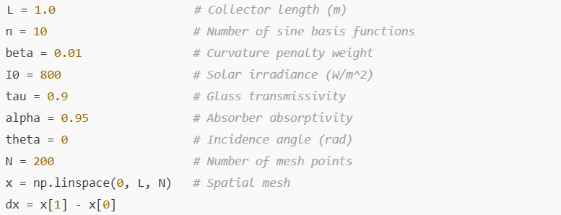
These values define the physical context of the collector and its numerical resolution.
Define basis functions and their derivatives
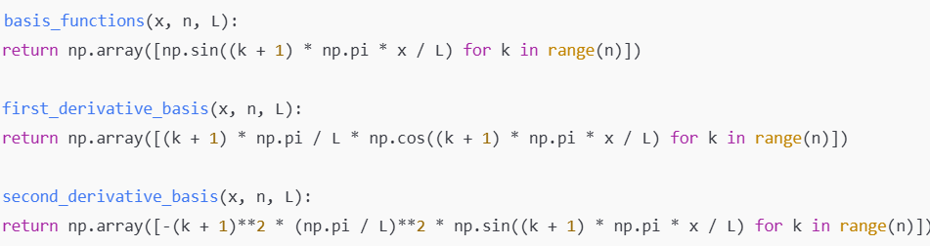
These basis functions inherently satisfy the boundary conditions y(0)=y(L)=0 and provide smooth representations.
Define the objective functional $F(y)$
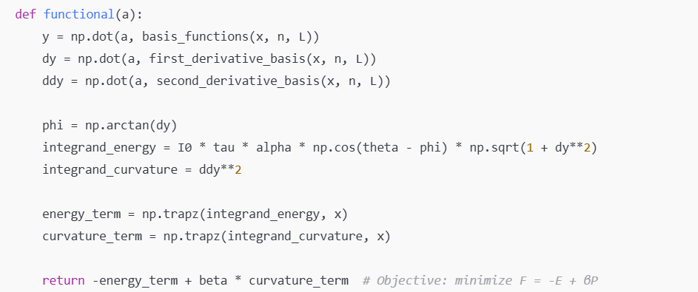
The function evaluates both energy absorption and curvature penalty terms using numerical integration.
Define the constraint (projected surface area)
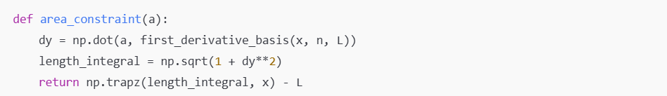
This constraint ensures that all profiles have the same projected surface length, making performance comparison fair.
Run the optimizer (SLSQP method)
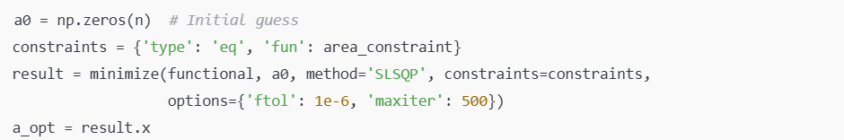
SLSQP is suitable for smooth nonlinear objectives with equality constraints.

Plot the optimized profile
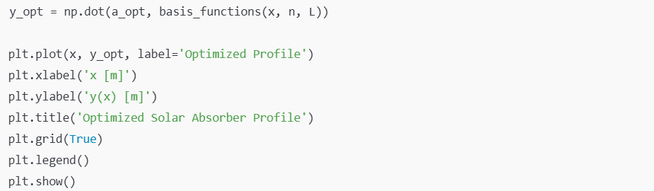
The result is a smooth, manufacturable geometry optimized for solar energy collection.

