Original Research Article
Self-oscillation characterization of planar steel gates based on fluid-solid coupling

ABSTRACT

The gate often vibrates during opening and closing when it is partially opened, or even when it is closed when the water and the vibration may cause vibration damage to the gate when the vibration is severe, resulting in major water conservancy project safety accidents. Therefore, it is of great significance to study the vibration characteristics of hydraulic gates. The main content of this paper is respectively in the absence of water and water conditions, the use of ANSYS on the gate of the self-vibration characteristics of the comparative analysis, and based on a single fluid-solid coupling principle, the joint Fluent and Modal module, to analyze the gate in different openings under the work of the intrinsic frequency and intrinsic vibration pattern of the rule of change. It is of great significance to the construction of water conservancy projects.

Keywords: Planar gate; Self-oscillation characteristics; Fluid-solid coupling; Finite element.

1. INTRODUCTION

In hydraulic engineering, the role of gates is crucial, which not only controls the flow and blockage of the spillway to ensure safe flood discharge during floods but also maintain the stability and safety of dams, embankments, and other hydraulic facilities^{[1]}. In addition, gates play a key role in regulating water levels, improving navigation conditions, and providing the necessary water control for irrigation and water supply. Vibration of hydraulic structures, especially hydraulic gates, is the root cause of damage to many hydraulic structures^{[2]}. Therefore, the study of the vibration characteristics of hydraulic gates is of great theoretical significance and value. In this paper, the self-vibration characteristics of plane gates are studied to explore the effect of the role of the water body on the intrinsic frequency and intrinsic vibration pattern of plane gates, and to establish a coupled model of the gate and the water body fluid-solid coupling, and to analyze the gate in different openings when the gate is working, the intrinsic frequency and the intrinsic vibration pattern of the rule of change^{[2]}.
2. Basic stability (static, no wind)

- Modeling of fluid-solid coupling
  - Modeling of the gate and water body
Based on the gate model, the water body model is established. Considering the effect of the length of the water body in front of the gate on the final modal analysis results^{[3]}, when the length of the water body in front of the gate is greater than 5 times or more than the height of the gate, the additional increase in the length of the water body has a negligible effect on the calculation results. The height of the gate is 4m, to ensure the accuracy of the calculation under the premise of minimizing the amount of calculation, the length of the water body in front of the gate is selected as 20m^{[4]}. 50% of the opening degree of the gate as an example of the establishment of the gate and the water body geometric model, as shown in Figure1.

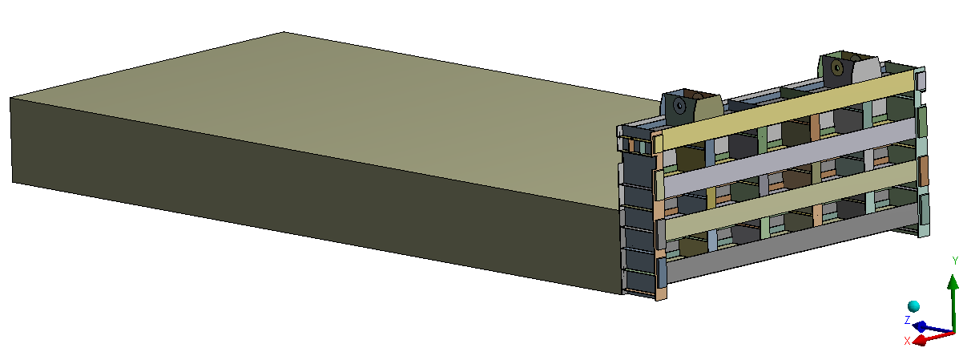
Fig.1 Geometric model of the gate and water body

The water body and gate are meshed in Mesh, with Fluid 30 cells for the water body model and Solid 186 cells for the gate. As the deformation of the gate is small, the effect of the deformation back to the water body is negligible, so the one-way fluid-solid coupling model is used^{[5]}. The Fluent module calculates the water flow, the use of the Static Structural module to simulate the pre-stress of the water body acting on the gate, and finally the Modal module to calculate the intrinsic frequency of the gate. The finite element model of the gate and water body is shown in Figure 2.

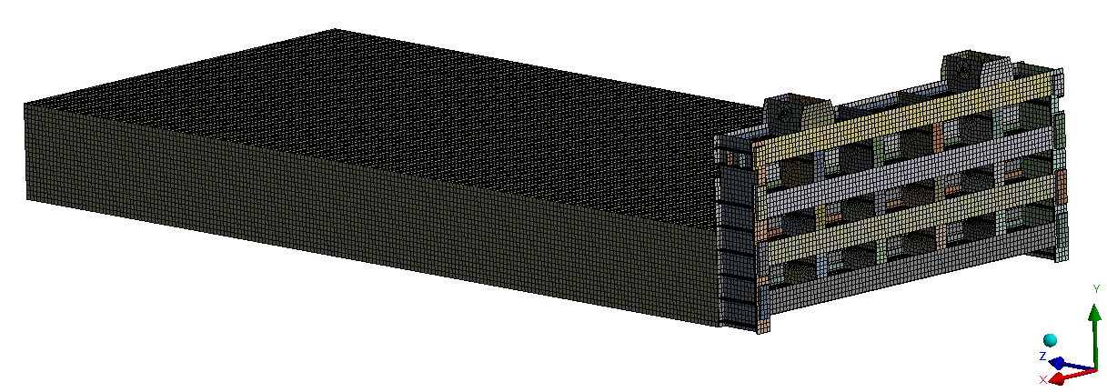
Fig.2 Finite element model of sluice gate and water body

  - Boundary conditions and working conditions of water bodies
In the Fluent module, the inlet of the water body is set as the pressure inlet, and the pressure value is set as 0.229 MPa; the interface with the gate structure is set as the fluid-solid coupling contact surface; the outlet of the water body is set as the pressure outlet, which is in contact with the air, and it is 1 standard atmospheric pressure, and the surfaces around the computational fluid model are set as the wall surfaces.
For gates, there are two operating conditions: closed and open:
Under the closing condition, displacement constraints are applied to the gate slider in the Z-direction; displacement constraints are applied to both sides of the gate in the X-direction; and frictionless constraints are applied to the bottom of the gate.
In the opening condition, the constraint at the bottom of the gate is canceled, the displacement constraint between the gate slider and the two sides is retained, and the displacement constraint of the gate lugs is increased in the Y direction.
- Self-oscillating characteristic analysis of plane gate
  - Self-oscillation characterization of the gate under no-water conditions
The first six orders of modal vibration patterns are extracted for the opening and closing conditions of the planar gate under the no-water condition, as shown in Fig.3 and Fig. 4, respectively.
From Figures 3(a) and 3(b), it can be found that the first two orders of vibration of the gate are the left-right swinging deformation of the lugs. The first order is that both lugs concave inward or bend outward at the same time; the second order is that one side of the lugs concave inward while the other side of the lugs bend outward. Figure 3(c) shows that the third order of the gate is the overall back-and-forth swing of the gate, which gradually decreases from the bottom to the sides. Figure 3(d) and Figure 3(e) show that the fourth and fifth-order vibration patterns of the gate are the left and right swings of the lugs. The fourth order is for both sides of the lugs to at the same time to the same direction of bending; the fifth order vibration pattern is for one side of the lugs to the left bending, and the other side of the lugs to the right bending. Figure 3(f) shows that the sixth-order vibration mode of the gate is the up-and-down vibration of the main beam of the gate.

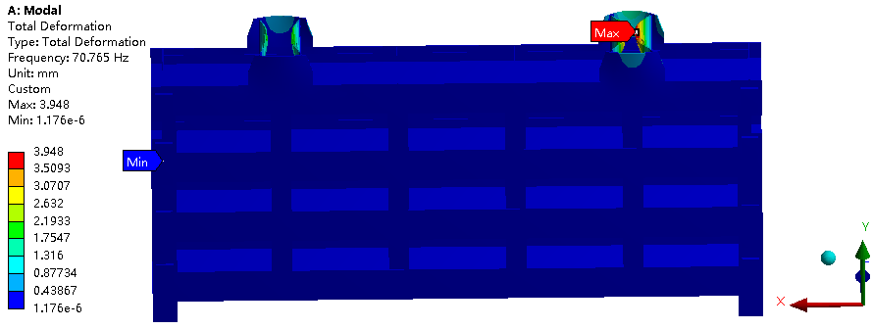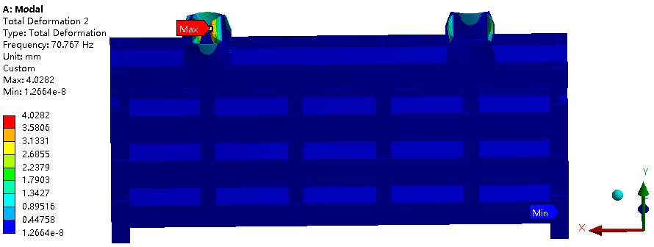
（a）first-order （b）second-order

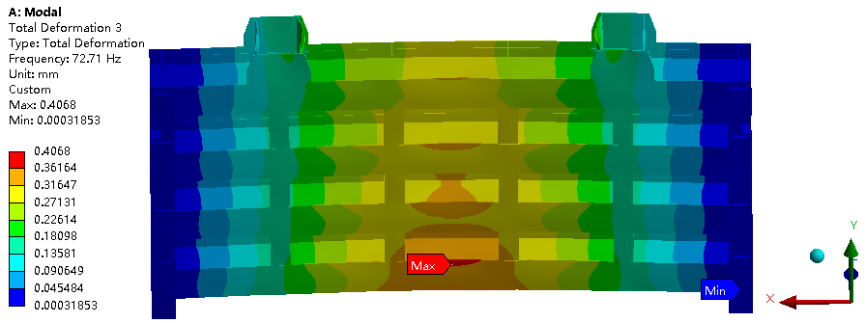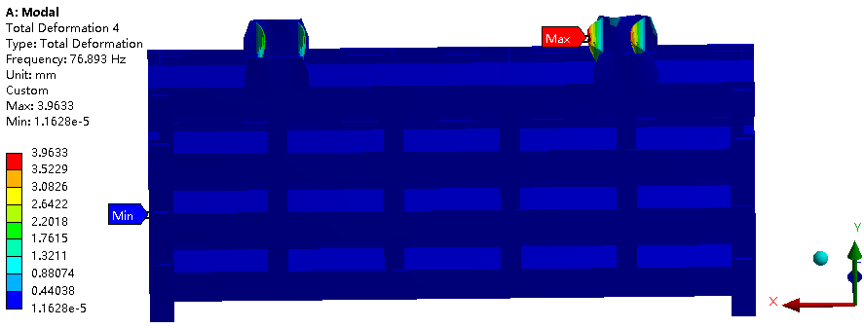
（c）third-order （d）fourth-order

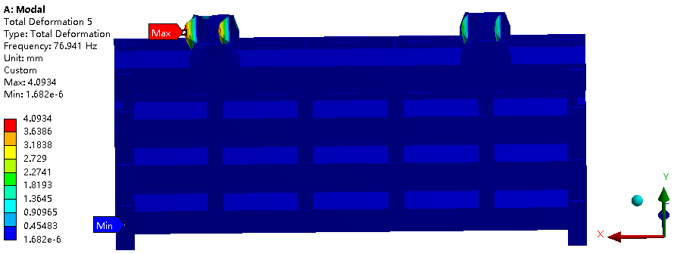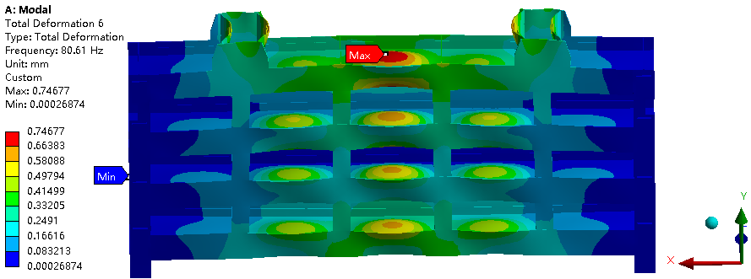
（e）fifth-order （f）sixth-order
Fig.3 Diagram of the first six mode shapes of the plane gate under the condition of no water closing

From Fig. 4(a), it can be found that the first-order vibration pattern of the gate is the back-and-forth oscillation of the main beam of the gate, which gradually decreases from the bottom to the sides. Figure 4(b) shows that the second-order vibration pattern of the gate is dominated by the up-and-down vibration of the main beam of the gate, accompanied by a slight back-and-forth twisting of the gate. Figure 4(c) shows that the third order of the gate is the overall front-back torsion of the gate, in which the deformation of the main beams of the uppermost and lowermost layers is the largest and gradually decreases to both sides, accompanied by a slight swing of the lugs. Figures 4(d) to 4(f) show that the fourth to sixth-order vibration patterns of the gate are the left and right swinging of the lugs. In the fourth order, one side of the lugs is inwardly concave swinging, and the other side of the lugs is swinging left and right; in the fifth order, both sides of the lugs are bending outward and concave inward at the same time; and in the sixth order, one side of the lugs is inwardly concave swinging, and the other side of the lugs are outwardly bending and swinging.

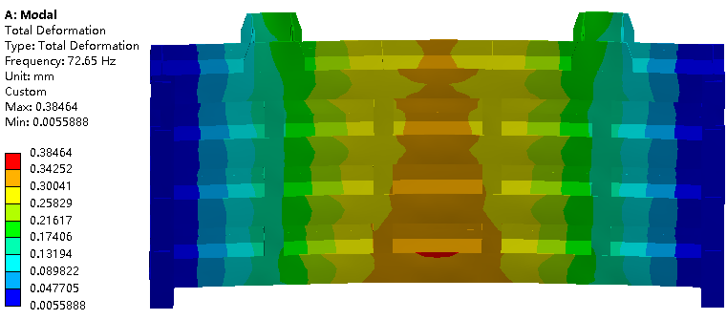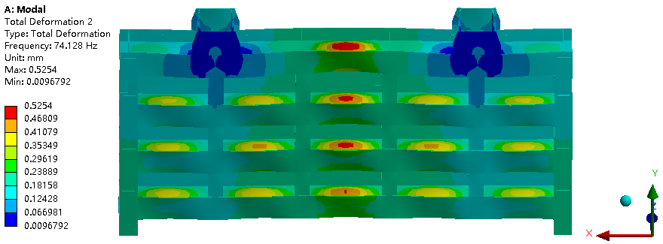
（a）first-order （b）second-order

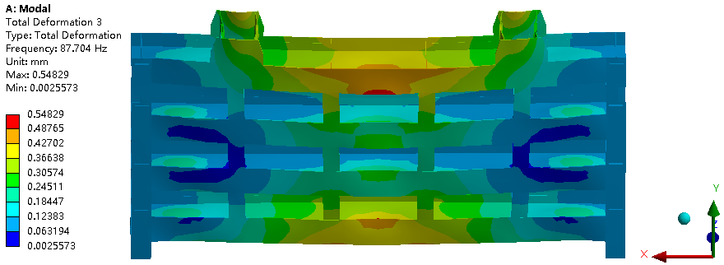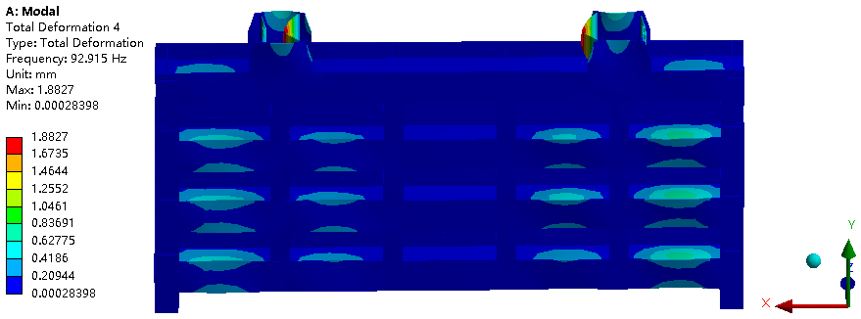
（c）third-order （d）fourth-order

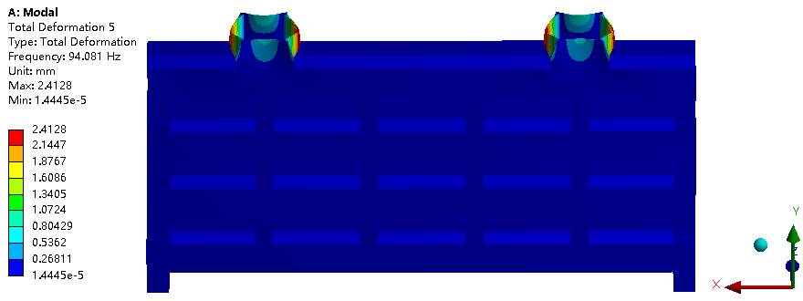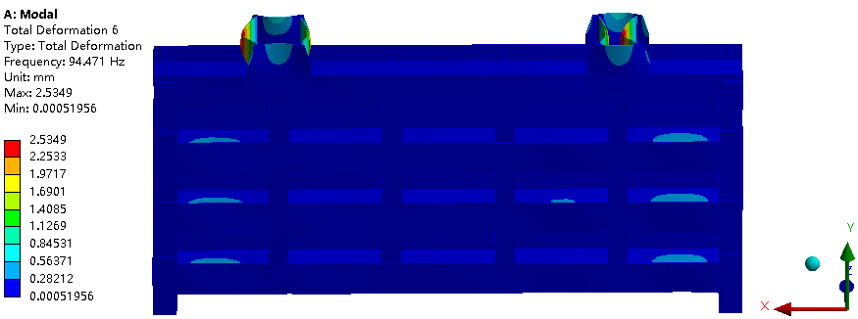
（e）fifth-order （f）sixth-order
Fig.4 Diagram of the first six mode shapes of the plane gate under the condition of no water opening

By comparing the vibration patterns of the gate under different working conditions, it can be found that in the case of gate closure, due to the existence of the bottom constraint, the low-order vibration pattern of the gate is less likely to occur in the overall twisting deformation, and more for the left and right wing of the lugs; however, in the case of gate opening without the existence of the bottom constraint, the low-order vibration pattern of the gate is mainly dominated by the overall twisting and swinging, and in the case of the higher-order vibration pattern, it is dominated by the swinging of the lugs. It can be found through Figure 5 that although the bottom constraints are removed from the gate in the open condition, the constraints on the lugs are added, resulting in a higher intrinsic frequency for the gate in the open condition than for the gate in the closed condition.

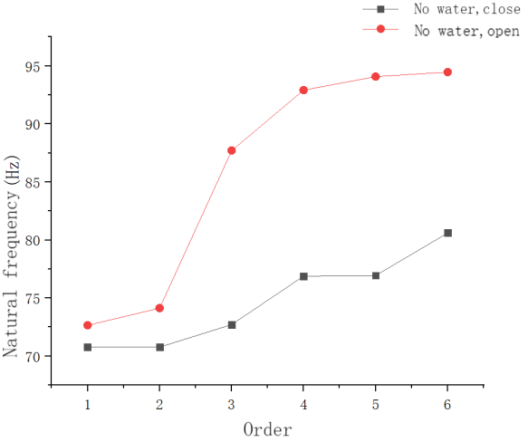
Fig.5 Line chart comparing the natural frequency of the flat gate under the condition of waterless closure and opening

  - Self-oscillating characteristic analysis of gate with water condition
When the gate is working, the action of the water body needs to be taken into account and the opening of the gate is categorized as closed, open 10%, open 30%, open 50%, open 70%, open 90%, and the first six orders of vibration patterns of the gate are extracted for the different working conditions, respectively.
As shown in Figure 6, the first six orders of the vibration pattern of the plane gate are under the condition of water closure. From Fig. 6(a), it can be found that the first-order vibration pattern of the gate is the overall backward and forward bending swing of the gate, with the first layer of the gate grid as the boundary, and the deformation is reduced from the spanning center cross-section to the two sides, and the upper and lower parts are bending along the downstream flow direction and the reverse flow direction, respectively. Figures 6(b) and 6(c) show that the second- and third-order vibration patterns of the gate are the left- and right-side oscillations of the lugs. The second order is that both lugs bend outward and concave inward at the same time; the third order is that one side of the lug concave inward, and the other side of the lug bends outward swing. Figure 6(d) shows that the fourth-order vibration pattern of the gate is a back-and-forth swing of the gate as a whole, and the deformation starts from the uppermost spanning cross-section of the gate and gradually decreases to both sides. Figure 6(e) and Figure 6(f) show that the fifth and sixth-order vibration patterns of the gate are the left and right swing of the lugs. The fifth order is for both sides of the lugs at the same time to the left or right bending swing; the sixth order is for one side of the lugs to the left bending swing, the other side of the lugs to the right bending swing.

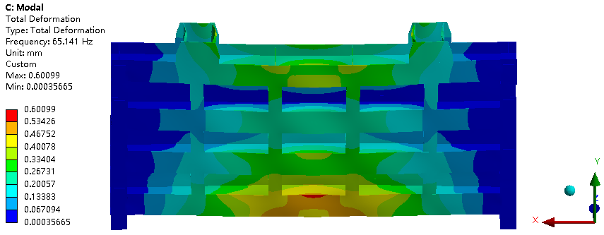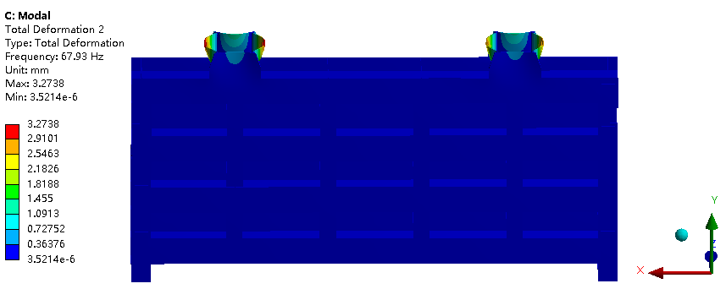
（a）first-order （b）second-order

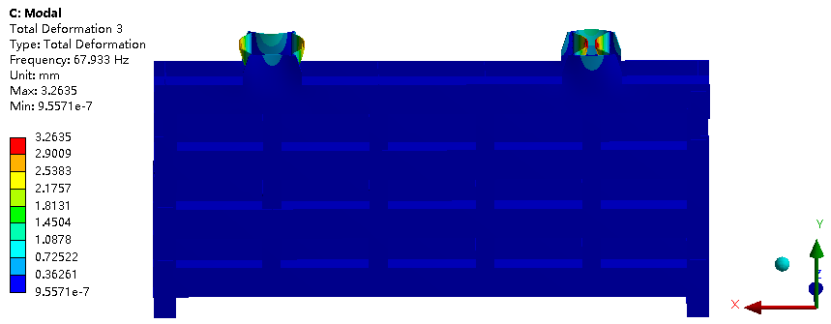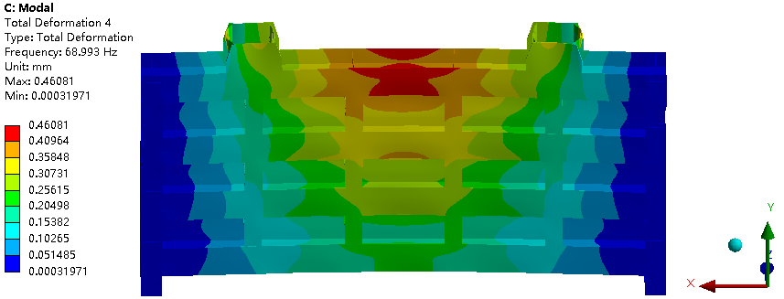
（c）third-order （d）fourth-order

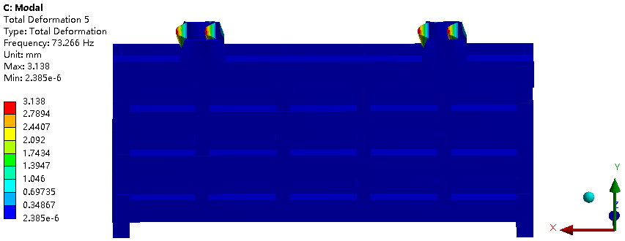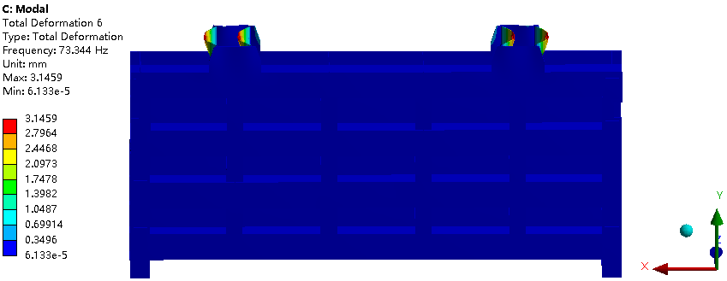
（e）fifth-order （f）sixth-order
Fig. 6 Diagram of the first six mode shapes of the plane gate under the condition of water closing

As shown in Figs. 7 comparing the order intrinsic frequencies of the planar gate without water closure and with water closure, it can be found that the intrinsic frequency of the gate in the water condition is significantly lower than that in the no-water condition under the condition of unchanged gate constraints. The results show that the effect of the water body on the self-oscillating characteristics of the gate is very significant under the consideration of fluid-structure coupling, and the action of the water body reduces the gate's solid frequency of each order.

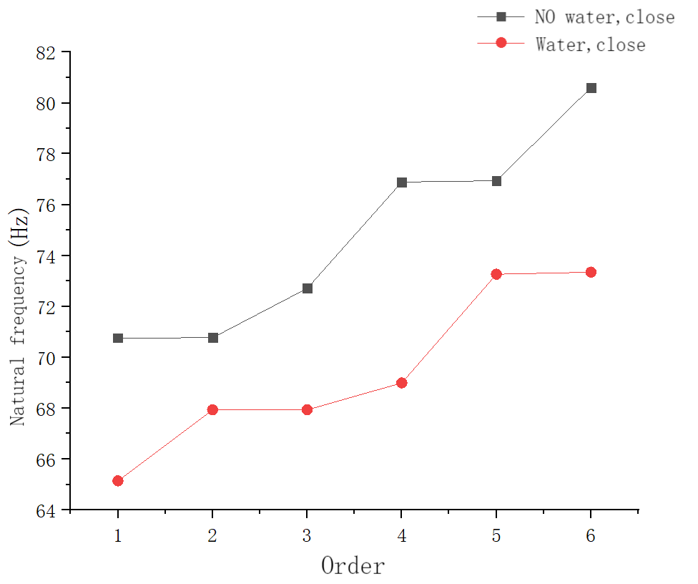
Fig. 7 Line chart comparing the natural frequency of a planar gate when it is closed without water and when it is closed when there is water

As shown in Figure8, the first six orders of vibration patterns are plotted for the 10% condition of plane gate opening. From Fig. 8(a), it can be found that the first-order vibration pattern of the gate is the overall back-and-forth bending swing of the gate, with the first layer of the gate grid as the boundary, and the deformation decreases from the mid-span cross-section to the two sides, and the upper and lower parts are bending back and forth along the downstream and upstream flow directions, respectively. Figure 8(b) shows that the second-order vibration pattern of the gate is the back-and-forth swing of the gate as a whole, and the deformation starts from the uppermost spanning cross-section of the gate, and gradually decreases to both sides, accompanied by up-and-down vibration at the center of the spanning cross-section of the main beam of the gate. Figure 8(c) shows that the third-order vibration pattern of the gate is the back-and-forth torsion of the gate as a whole, which is bounded by the main beam of the third layer of the gate, bending above and below along the direction of the flow of water and the direction of the flow of water, respectively, and vibrating up and down at the center of the spanning cross-section of the main beam of the gate. Figure 8(d) shows that the fourth-order vibration pattern of the gate is the up and down vibration of both sides of the main beam of the gate, which is separated along the mid-span cross-section of the main beam, with the left and right sides bending back and forth along the direction of gravity and the opposite direction of gravity, respectively. Figure 8(e) and Figure 8(f) show that the fifth-order and sixth-order vibration patterns of the gate are the up and down vibration of the gate main beam as a whole, and the deformation gradually decreases from the center of the cross-section in the span to both sides.

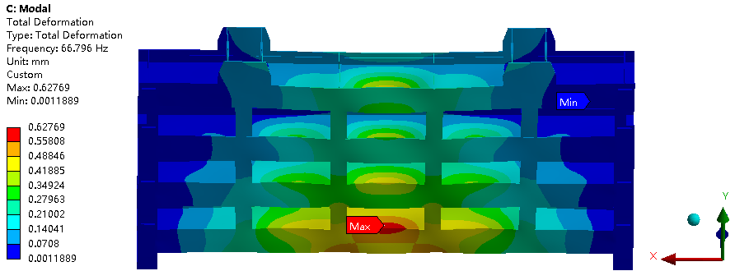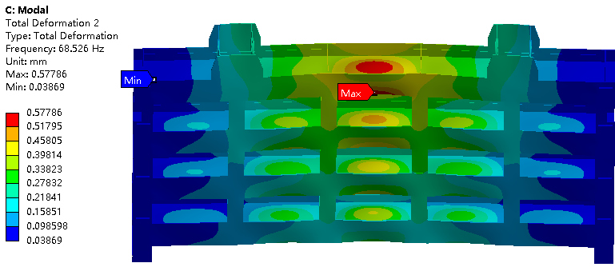
（a）first-order （b）second-order

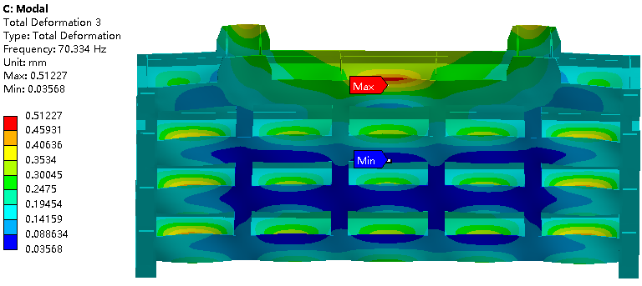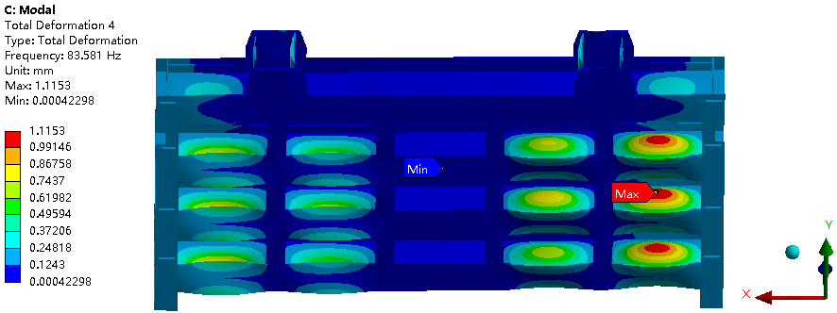
（c）third-order （d）fourth-order

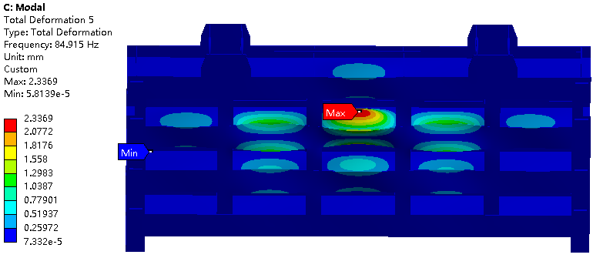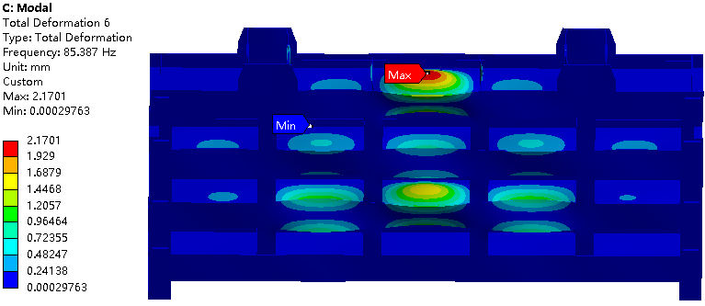
（e）fifth-order （f）sixth-order
Fig.8 Diagram of the first six mode shapes of the plane gate under the condition of 10% water opening

As shown in Figure 9, the first six orders of vibration patterns are plotted for the 30% condition of plane gate opening. From Fig. 9(a), it can be found that the first-order vibration pattern of the gate is the overall back-and-forth bending swing of the gate, with the first layer of the gate grid as the boundary, and the deformation decreases from the mid-span cross-section to the two sides, and the upper and lower parts are bending back and forth along with the downstream and upstream flow directions, respectively. Figure 9(b) shows that the second-order vibration pattern of the gate is the back-and-forth swing of the gate as a whole, and the deformation starts from the center of the spanning cross-section of the uppermost main beam of the gate and gradually decreases to both sides, accompanied by the up-and-down vibration of the center of the spanning cross-section of the main beam of the gate. Figure 9(c) shows that the third-order vibration pattern of the gate is the back-and-forth torsion of the gate as a whole, which is bounded by the main beam of the third layer of the gate, bending above and below along the direction of the flow of water and the direction of the flow of water, respectively, and vibrating up and down at the center of the spanning cross-section of the main beam of the gate. Figure 9(d) shows that the fourth-order vibration pattern of the gate is the up and down vibration of both sides of the main beam of the gate, which is separated along the mid-span cross-section of the main beam, with the left side and the right side bending back and forth along the direction of gravity and the opposite direction of gravity, respectively. Figure 3-7(e) and Figure 9(f) show that the fifth-order and sixth-order vibration patterns of the gate are the up and down vibration of the main beam of the gate, and the deformation starts from the center of the cross-section in the middle of the span and gradually decreases to both sides.

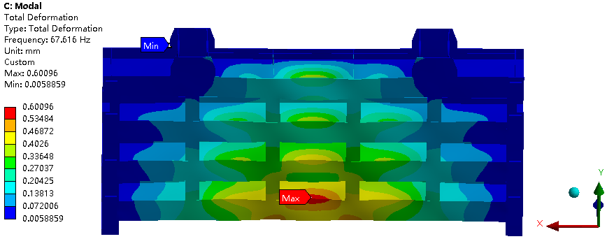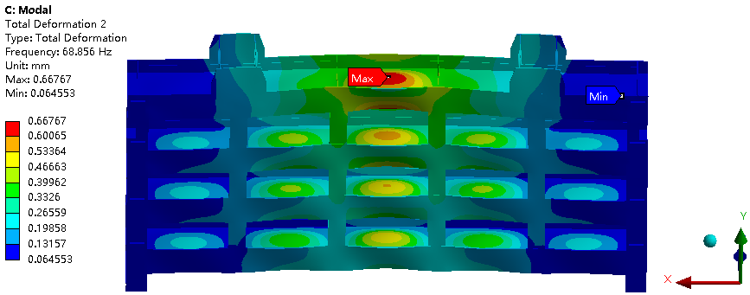
（a）first-order （b）second-order

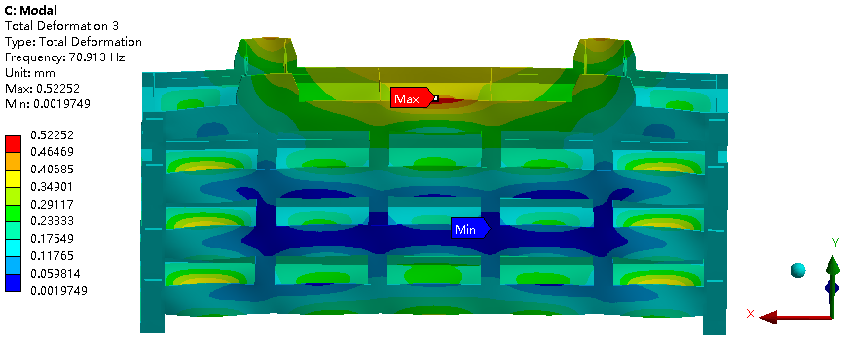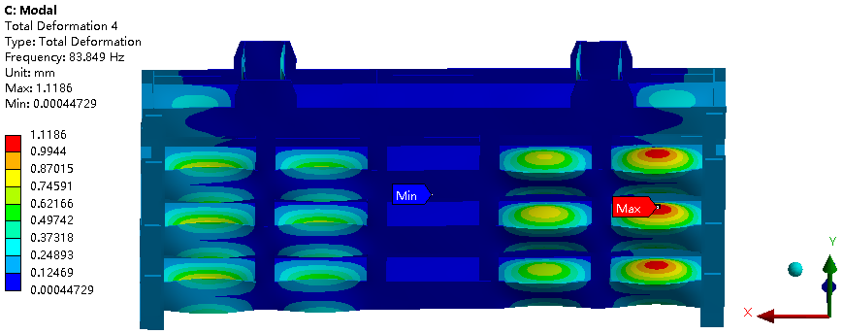
（c）third-order （d）fourth-order

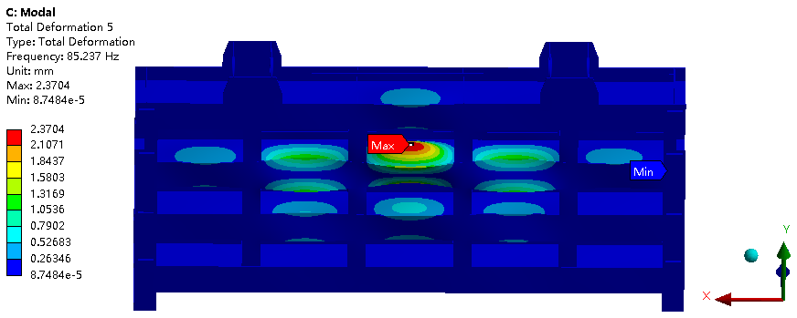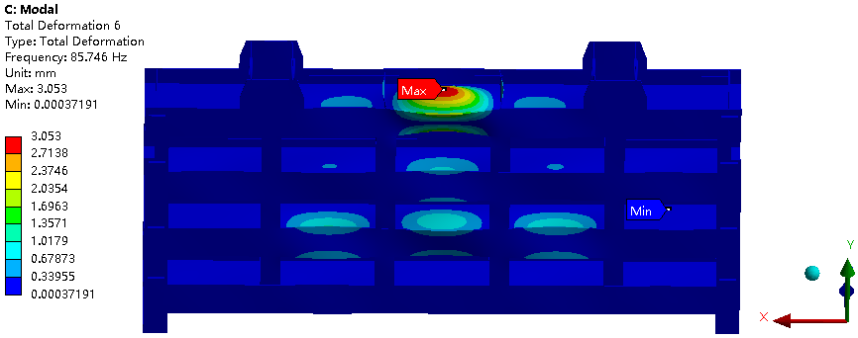
（e）fifth-order （f）sixth-order
Fig.9 Diagram of the first six mode shapes of the plane gate under the condition of 30% water opening

As shown in Figure10, the first six orders of vibration patterns are plotted for the 50% open condition of the plane gate. From Figure 10(a), it can be found that the first-order vibration pattern of the gate is the overall up-and-down vibration of the gate along the direction of gravity. Figure 10(b) shows that the second-order vibration pattern of the gate is the back-and-forth swing of the gate as a whole, and the deformation starts from the center of the span section of the lowest main beam of the gate and gradually decreases to both sides. Figure 10(c) shows that the third-order vibration pattern of the gate is the back-and-forth torsion of the gate as a whole, which is bounded by the main beam of the third layer of the gate, bending above and below along the direction of the flow of water and the direction of the flow of water, respectively, and vibrating up and down at the center of the spanning cross-section of the main beam of the gate. Figure 10(d) shows that the fourth-order vibration pattern of the gate is the up and down vibration of both sides of the main beam of the gate, which is separated along the mid-span cross-section of the main beam, with the left side and the right side bending back and forth along the direction of gravity and the opposite direction of gravity, respectively. Figure 10(e) and Figure 10(f) show that the fifth-order and sixth-order vibration patterns of the gate are the up and down vibration of the main beam of the gate, and the deformation starts from the center of the cross-section in the middle of the span and gradually decreases to both sides.

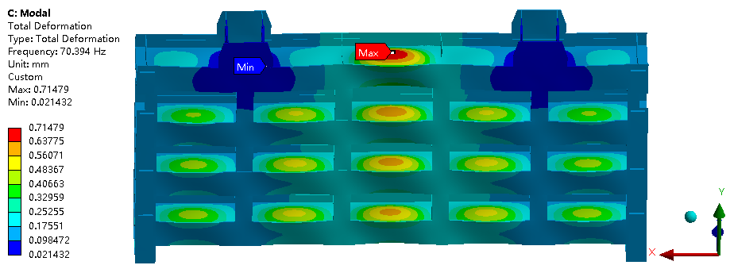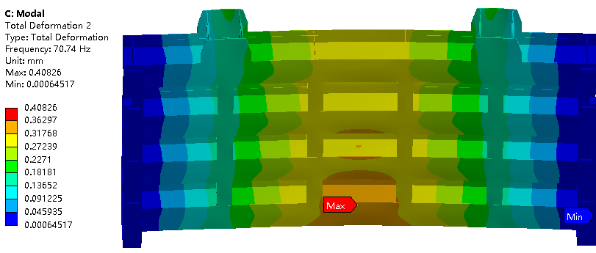
（a）first-order （b）second-order

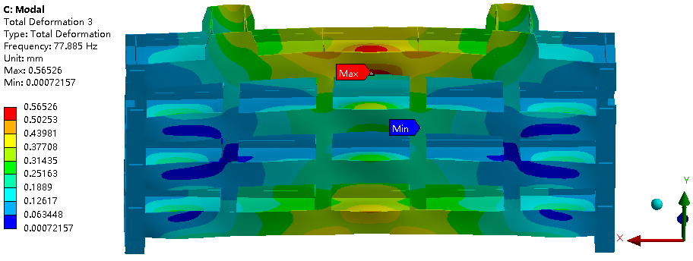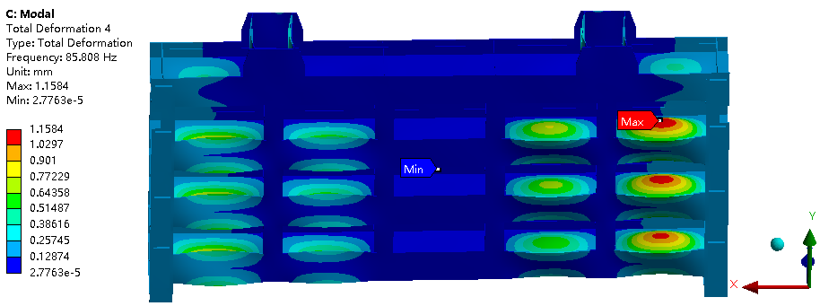
（c）third-order （d）fourth-order

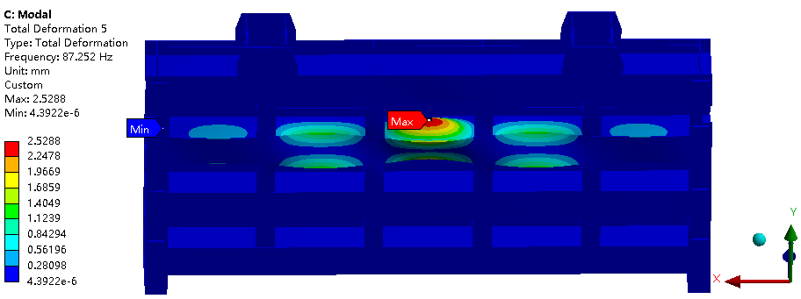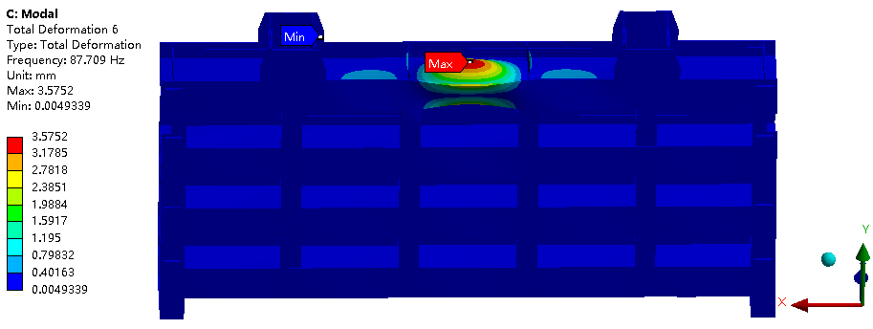
（e）fifth-order （f）sixth-order
Fig. 10 Diagram of the first six mode shapes of the plane gate under the condition of 50% water opening

As shown in Figure11, the first six orders of vibration patterns are plotted for the 70% condition of planar gate opening. From Figure 11(a), it can be found that the first-order vibration pattern of the gate is the overall up-and-down vibration of the gate along the direction of gravity. Figure 11(b) shows that the second-order vibration pattern of the gate is the back-and-forth swing of the gate as a whole, and the deformation starts from the center of the spanwise cross-section of the lowest main beam of the gate and gradually decreases to both sides. Figure 11(c) shows that the third-order vibration pattern of the gate is the back-and-forth torsion of the gate as a whole, which is bounded by the main beam of the third layer of the gate, bending above and below along the direction of the flow of water and the direction of the flow of water, respectively, and vibrating up and down at the center of the spanning cross-section of the main beam of the gate. Figure 11(d) shows that the fourth-order vibration pattern of the gate is the up and down vibration of both sides of the main beam of the gate, which is separated along the mid-span cross-section of the main beam, with the left side and the right side bending back and forth along the direction of gravity and the opposite direction of gravity, respectively. Figures 11(e) and 11(f) show the fifth-order and sixth-order vibration patterns of the gate as a side-to-side swing of the gate lugs.

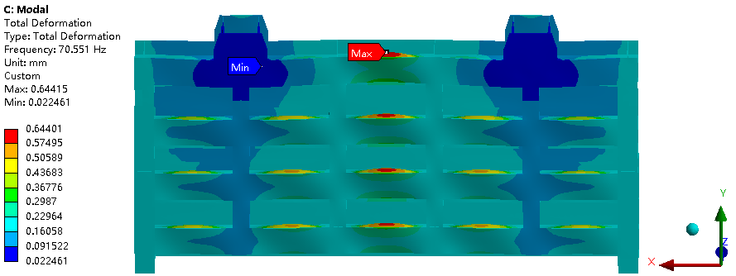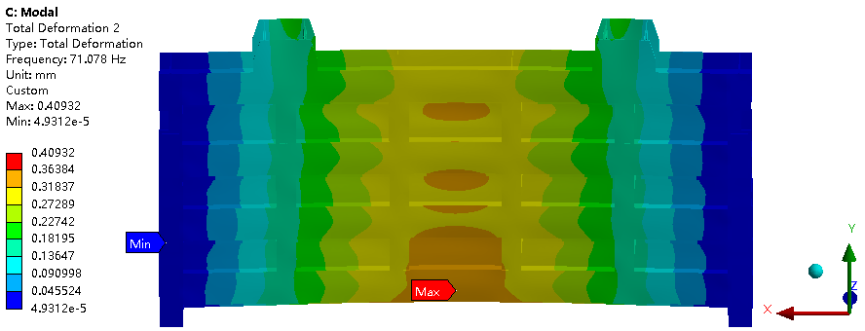
（a）first-order （b）second-order

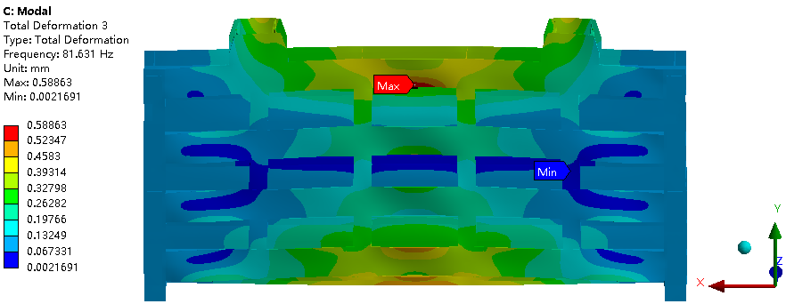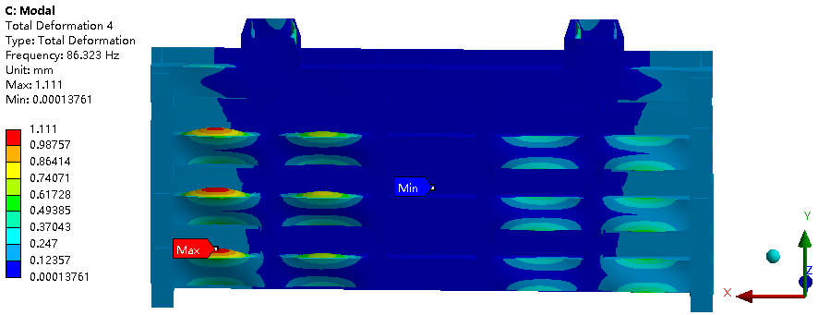
（c）third-order （d）fourth-order

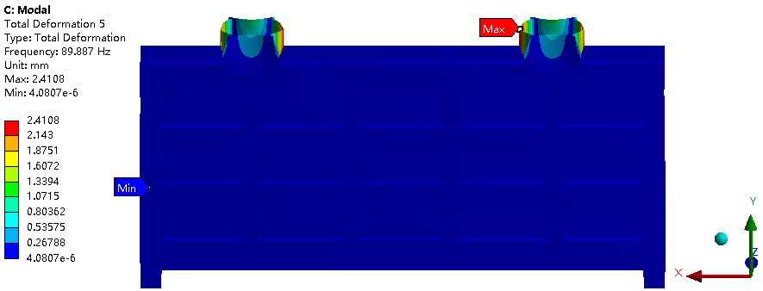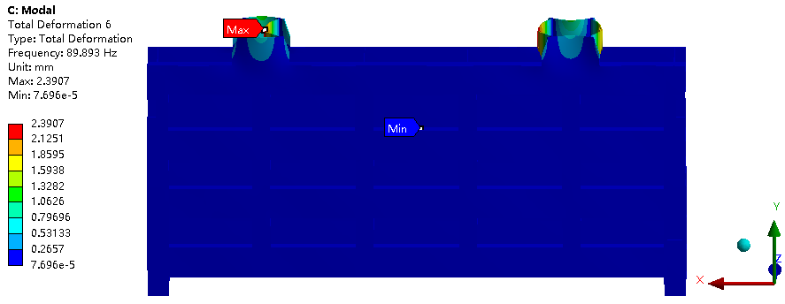
（e）fifth-order （f）sixth-order
Fig.11 Diagram of the first six mode shapes of the plane gate under the condition of 70% water opening

As shown in Figure 12, the first six orders of vibration patterns are plotted for the 90% open condition of the plane gate. From Figure 12(a), it can be found that the first-order vibration pattern of the gate is the overall up-and-down vibration of the gate along the direction of gravity. Figure 12(b) shows that the second-order vibration pattern of the gate is the back-and-forth swing of the gate as a whole, and the deformation starts from the center of the span section of the lowest main beam of the gate and gradually decreases to both sides. Figure 12(c) shows that the third-order vibration pattern of the gate is the back-and-forth torsion of the gate as a whole, which is bounded by the main beam of the third layer of the gate, bending above and below along the direction of the flow of water and the direction of the flow of water, respectively, and vibrating up and down at the center of the spanning cross-section of the main beam of the gate. Figure 12(d) shows that the fourth-order vibration pattern of the gate is the up and down vibration of both sides of the main beam of the gate, which is separated along the mid-span cross-section of the main beam, with the left side and the right side bending back and forth along the direction of gravity and the opposite direction of gravity, respectively. Figure 12(e) and Figure 12(f) show that the fifth-order and sixth-order vibration patterns of the gate are the up and down vibration of the main beam of the gate, and the deformation starts from the center of the cross-section in the middle of the span and gradually decreases to both sides. Among them, the fifth order is that both lugs bend outward and concave inward at the same time; the sixth order is that one side of the lugs concave inward and swings and the other side of the lugs bends outward and swing.

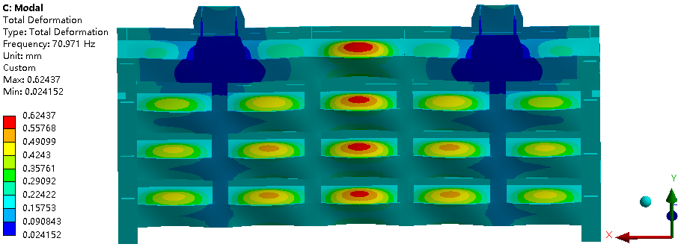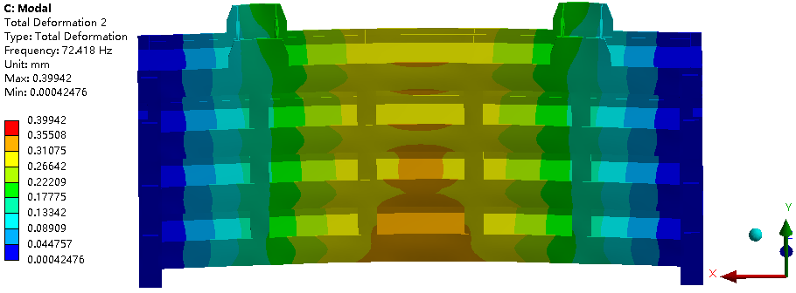
（a）first-order （b）second-order

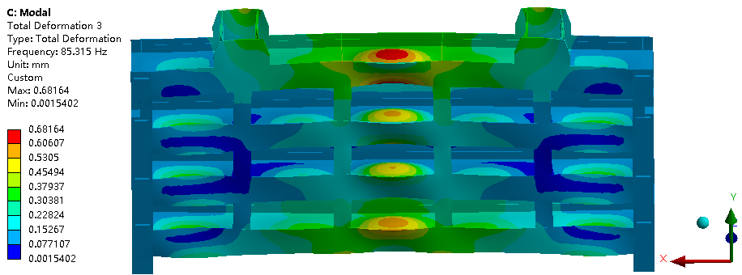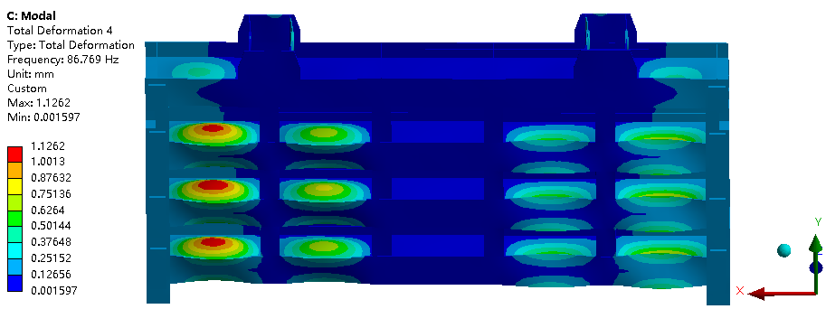
（c）third-order （d）fourth-order

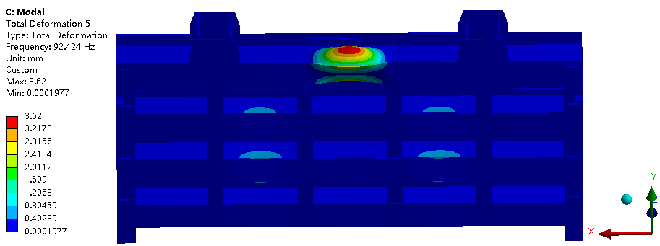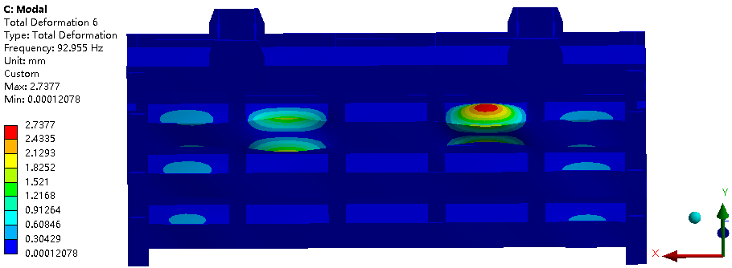
（e）fifth-order （f）sixth-order
Fig. 12 Diagram of the first six mode shapes of the plane gate under the condition of 90% water opening

A comparison of the intrinsic frequency of each order of the planar gate at different openings is shown in Fig. 13. It can be found that under the condition of constant constraint, the intrinsic frequency of the gate gradually increases with the gradual weakening of the water body action. The results show that under the consideration of fluid-structure coupling, the opening degree of the gate is positively correlated with the intrinsic frequency, and the effect of the water body on the intrinsic frequency of the gate is significant.

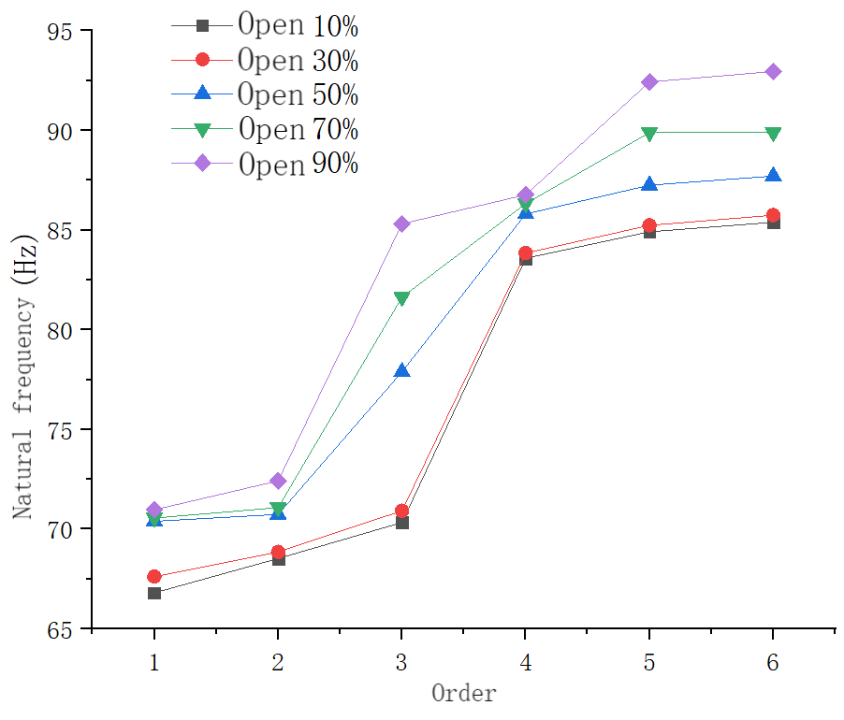
Fig.13 Comparison of natural frequencies of planar gates at different openings.

7. CONCLUSION

Based on the above study the main conclusions are as follows:
(1) Under no-water conditions, the intrinsic frequency of the gate under the open condition is higher than the intrinsic frequency under the closed condition.
(2) Without changing the constraints of the gate, the intrinsic frequency of the gate under the condition of having water is significantly lower than that under the condition of not having water, and the effect of the water body on the self-oscillation characteristics of the gate is significant, and the self-oscillation frequency of the gate decreases.
(3) With the increasing degree of opening of the plane gate, the self-oscillation frequency of the gate gradually rises, and the opening degree of the gate is positively correlated with the intrinsic frequency.

DISCLAIMER (ARTIFICIAL INTELLIGENCE)
Author(s) hereby declare that NO generative AI technologies such as Large Language Models (ChatGPT, COPILOT, etc.) and text-to-image generators have been used during the writing or editing of this manuscript.

References

[1] Griffin,O.M.Vortex-Excited Cross-Flow Vibrations of a Single Cylindrical Tube[J]. Journal of Pressure Vessel Technology, 1980, 102(2):158-166
[2] Ishii N, Imaichi K, Hirose A. Dynamic instability of Tainter-gates[J]. Practical experiences with flow-induced vibrations, 1980: 452-460.
[3] Ishii N. Folsom Dam gate failure evaluation based on modal analysis and suggestion[J]. USBR, 1995.
Thang N D,Naudascher E.Vortex-excited vibrations of underflow gates[J].Journal of Hydraulic Research, 1986, 24(2): 133-151.
[4] Kolkman P A. A simple scheme for calculating the added mass of hydraulic gates[J]. Journal of fluids and structures, 1988, 2(4): 339-353.
[5] Erdbrink C D, Krzhizhanovskaya V V, Sloot P M A. Reducing cross-flow vibrations of underflow gates: Experiments and numerical studies[J]. Journal of Fluids and Structures, 2014, 50: 25-48

