Review Article
Secure and Resilient Industrial IoT Architectures for Smart Manufacturing: A Comprehensive Review.

Abstract
Smart manufacturing, driven by the Industrial Internet of Things (IIoT), is transforming real-time data sharing, predictive maintenance, and process automation. However, the increasing complexity and connectivity of IIoT environments present significant security and resilience challenges that threaten operational safety, data integrity, and business continuity. This paper presents a comprehensive review of secure and resilient architectures for IIoT in smart manufacturing, highlighting the interaction between enabling technologies (e.g., edge computing, AI/ML, blockchain) and emerging threats in the cyber-physical environment. We explore vulnerabilities and attack surfaces and examine resilience strategies such as redundancy, fault tolerance, and self-healing capabilities that ensure ongoing operations despite disruptions. Key standards and best practices, including ISA/IEC 62443 and NIST frameworks, are evaluated for their effectiveness and limitations. Emerging trends—such as AI-driven proactive security, cyber-physical systems convergence, and green security initiatives—are discussed alongside open challenges and trade-offs in IIoT environments. Our analysis underscores the need for holistic, adaptive, and industry-specific solutions to enable secure and resilient IIoT architectures that foster innovation, productivity, and safety in the era of digital and connected factories.

1. Introduction
The Industrial Internet of Things (IIoT) is a key part of smart manufacturing by connecting disparate systems, automation, and decision-making in real time. Through the use of sensors, actuators, and sophisticated data analytics, IIoT makes the traditional plant a smart, adapting environment. These advances are resulting in significant productivity and quality enhancements as well as environmental benefits[1].
Yet, as IIoT ecosystems become more complex and interconnected, they also lead to security and resilience challenges. As IIoT converges IT and OT, it opens up manufacturing systems to various cyber and physical threats. Weakness in networking equipment of the connected components, the insecurity of old systems, which can lead to a domino of crash failures of the outdated devices, are just two examples of the challenges of a robust and flexible architecture. But above and beyond security, resiliency is crucial to ensure that manufacturing isn't left dead in the water by disruptions caused by cyberattacks, system failures, or even natural disasters[2].
In short, this article offers a detailed investigation into secure and resilient architectures for IIoT in smart manufacturing environments. It seeks to unify the existing problems, design principles, and the enabling technologies and best practices, with guidance and perspectives both for researchers and practitioners. By focusing on these important aspects, we have made clear pathways for enabling trustworthy IIoT systems, which will support the future of industrial innovation.

2. Industrial IoT in Smart Manufacturing
IIoT is the core driving force of the fourth industrial revolution, where traditional factories are being revolutionized into smarter, more flexible, and efficient production facilities. Fundamentally, IIoT combines the physical systems, cyber-physical interfaces, and digital networks to achieve real-time data collection, monitoring, and control. These are versatile capabilities that could apply across various smart manufacturing applications[3].
Sensors and analytics enable predictive maintenance in smart factories so that equipment failures can be predicted and downtime avoided, saving expensive downtime costs. It enables dynamic process optimization with automatic quality and throughput improvement through real-time monitoring of production lines! In addition, IIoT facilitates 'smart' supply chain integration, utilizing the production data with logistics and inventory management systems, overall improving the efficiency of a supply chain[4].
The backbone of these applications is the key IIoT building blocks and technologies. Sensors and actuators, on the other hand, measure real-time signals of plant operation and environmental conditions, and are the bridge between the physical and digital worlds. Edge and fog computing enable local data processing, which minimizes latency and facilitates real-time responses to dynamic changes on the factory shop floor. Cloud-based platforms offer centralized data storage and robust analytic functionality that can help to inform level decision making and long-term planning. Artificial intelligence and machine learning (AI/ML) Machine learning capabilities of AI/ML are crucial for IIoT systems to make sense of large, complex datasets, in order to deliver predictive insights and autonomous decision-making capabilities[5].
However, with such transformation power, IIoT in smart manufacturing also has considerable challenges. Old equipment is generally not as secure, connected, or configured as needed to integrate alone easily, and disparate systems present interoperability challenges. Data confidentiality and intellectual property rights are the key challenges with the sharing of sensitive design and process data in connected networks. Additionally, the increased attack surface for IIoT systems that comes with millions of connected devices brings with it new possible points of exposure from cyber or physical attack[6].
Dealing with the challenges of IIoT mandates a comprehensive strategy that takes into consideration not only IIoT’s potential but also concerns around security, resilience, and interoperability. By successfully navigating these challenges, smart manufacturing ecosystems can harness the full power of the IIoT to deliver innovation and achieve competitive differentiation. For the logical operational sequence and technology architecture of IIoT in smart manufacturing, we can consider a layered model[7]. Figure 1 is a conceptual diagram of the architecture to capture real-time data from the physical world, which is processed at the edge/fog level, transmitted to cloud platforms, and finally analysed using AI/ML technologies. This architecture provides the foundation for the intelligent, adaptive nature of today's smart factories.
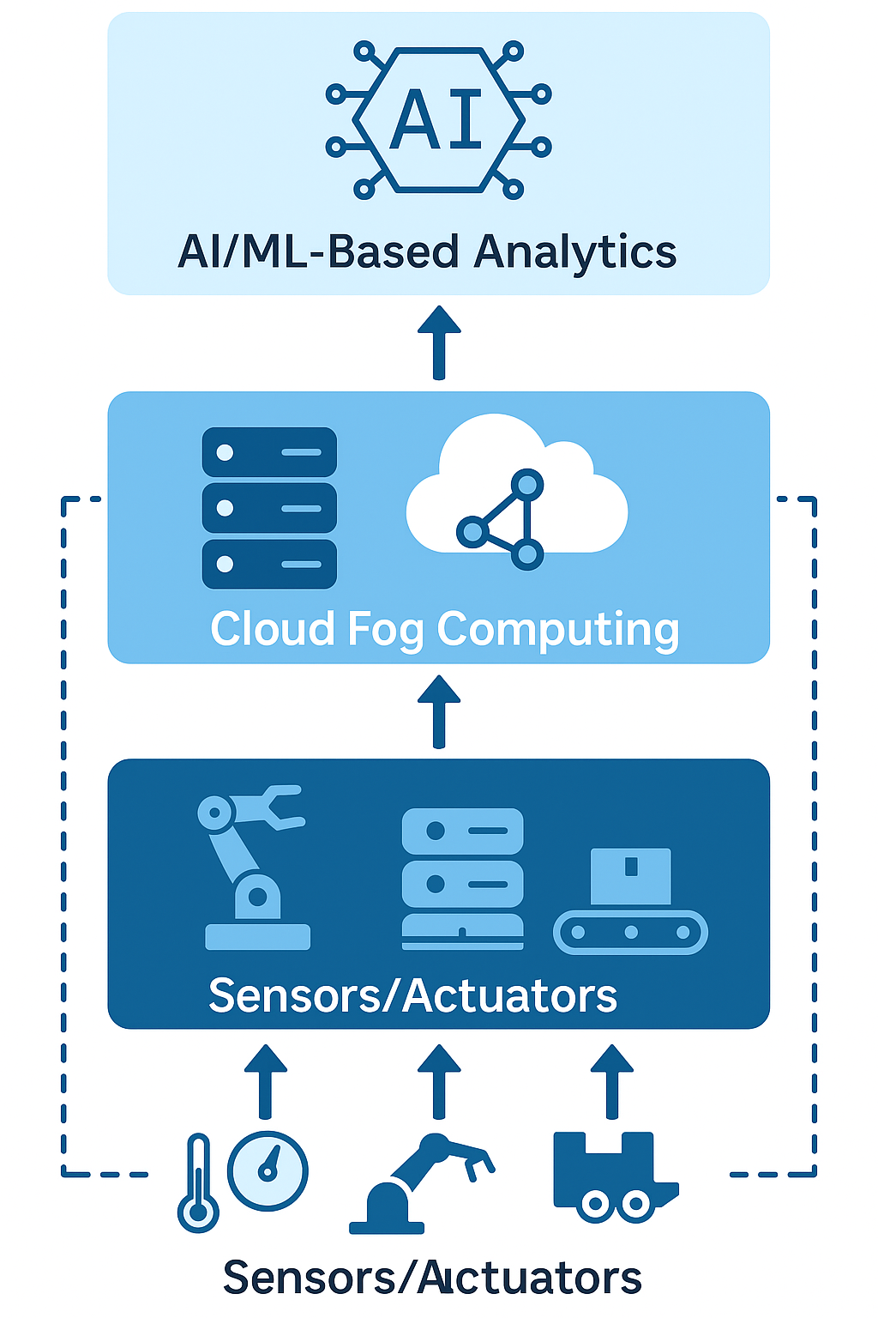
Figure 1: Layered Architecture of IIoT in Smart Manufacturing. This diagram illustrates the multi-layered architecture of an Industrial Internet of Things (IIoT) system in a smart manufacturing environment. It highlights the flow of data from physical devices (sensors and actuators), through edge and fog computing layers, into centralized cloud platforms, and finally into AI/ML analytics engines for decision-making and optimization.

3. Security Challenges in IIoT for Smart Manufacturing
As IIoT makes manufacturing a hyper-connected data-driven environment, there are significant and diverse security challenges. The threat landscape includes both cyber and physical risks, which, if exploited, can disrupt production, destroy machinery, and put intellectual property at risk.
Security threats in IIoT landscapes come in myriad flavors and growing complexity. Adversaries could take advantage of security flaws in communication protocols, use malware to interfere with operations, and use social engineering to access such systems unauthorized. Typical attack vectors for these kinds of systems involve network-based attacks, for instance, man-in-the-middle attacks on data streams, and attacks on the devices in the system that act as end-points to threats, i.e., a chain that ends from the most secure, usually sensors or PLCs. Such attacks can have disastrous effects, from halting production and inflicting financial losses to creating hazards on factory floors[7].
The challenges associated with physical security are also considerable for IIoT systems. Sabotage, accidental destruction. Physical devices or factory floors may be unauthorizedly accessed or tampered with, resulting in sabotage or unintended damage. As cyber and physical systems in IIoT meet, these threats frequently overlap: A cyberattack may have direct physical consequences (e.g., when equipment is manipulated to manufacture faulty goods or cause safety incidents)[8].
Weaknesses in IIoT systems expose these risks even further. Older technology that does not incorporate current security mechanisms like encryption and authentication is especially vulnerable to compromise. Insecure communication protocols, e.g., legacy fieldbuses employed in industry, or unprotected wireless networks, increase the attack surface. The proliferation of third-party devices and software also introduces weaknesses in the supply chain, whereby compromised parts serve as an attacker’s foothold[7,9].
Real-life events provide an example of these security problems. The notorious Stuxnet attack proved that malware, delivered with laser precision, could wreak havoc in an industrial control system and cause physical damage, ringing alarm bells for the manufacturing industry. More recently though, ransomware attacks crippled factories in the automotive and electronics sectors, halting production lines and bringing the financial implications of IIoT vulnerabilities into focus[10].
In that setting, standard IT security is not enough. Security for the IIoT demands a customized approach to identify and mitigate the distinct risks present on the plant floor with a mix of cyber and physical defenses that safeguard operations, ensure product quality, and a competitive edge in the rapidly digitizing industrial sector.

4. Resilience Challenges and Requirements
IIoT system resilience is the system's ability to ensure normal operation or recover quickly after being affected by attacks, device malfunction, or physical accidents in intelligent manufacturing environments. In a smart factory where systems communicate with each other and automated processes are crucial for productivity and safety, being resilient should not be an optional feature, but a requirement[11].
Determinants of IIoT systems’ resilience. Several factors determine the resilience of IIoT systems. Redundancy is key here, having other means of doing things, and reserve capacity. This could mean redundant networks, doubled sensors, and multiple storage of mirrored data to reduce single points of failure. Another key feature is fault tolerance, which allows IIoT systems to operate even when some components fail. For example, modular system architectures are capable of quarantining and bypassing malfunctioning modules without requiring a line shutdown[12].
Resilient IIoT A resilient IIoT Graphene presents multiple instances of self-healing performance. These include the ability to automatically detect and correct issues, often driven by AI or machine learning, to spot abnormal patterns in data streams and automatically recover. Edge and Fog Computing are key here, enabling on-site decision making which can quickly reconfigure systems even in the event of central systems being disconnected[5].
However, failures of resilience can still be found in smart manufacturing settings, and these failures often have serious consequences. The famous 2017 NotPetya ransomware attack is one instance that caused havoc for manufacturers worldwide. The affected equipment did not have enough overlapping independent systems, which allowed the ransomware to infect the equipment through an employee’s network and then easily and quickly spread throughout the whole network.
Supply chain failures are another example of resilience compromise. During the COVID-19 pandemic, for instance, a significant number of manufacturers suffered crippling operational disruptions in the face of unforeseen supply chain snags and an inability to adjust in real-time in their IIoT systems. Not a cyber attack as such, these disruptions served to emphasise the necessity of designing resiliency, not just into the device and network layers, but into interconnected supply networks[13].
These occurrences emphasize that the resiliency of IIoT systems comprises two folds, including the internal and external jitter resilience. It demands a comprehensive design strategy that predicts possible interruptions, prepares for quick recoveries, and guarantees ongoing functionality. As smart manufacturing advances, the methods for building resilience must evolve, merging technology, process, and people considerations to create resilient, future-ready industrial ecosystems. The relationship between the threat and the strength in IIoT is also crucial in order to build resilient IIoT architectures[14]. In Figure 2, we provide a comparative survey on the prevalent attack vectors in smart manufacturing systems and their respective outdated solution approaches to mitigate the attacks. This portrayal highlights the necessity for a balanced consideration of both threat-mitigating and system-recovering capabilities.

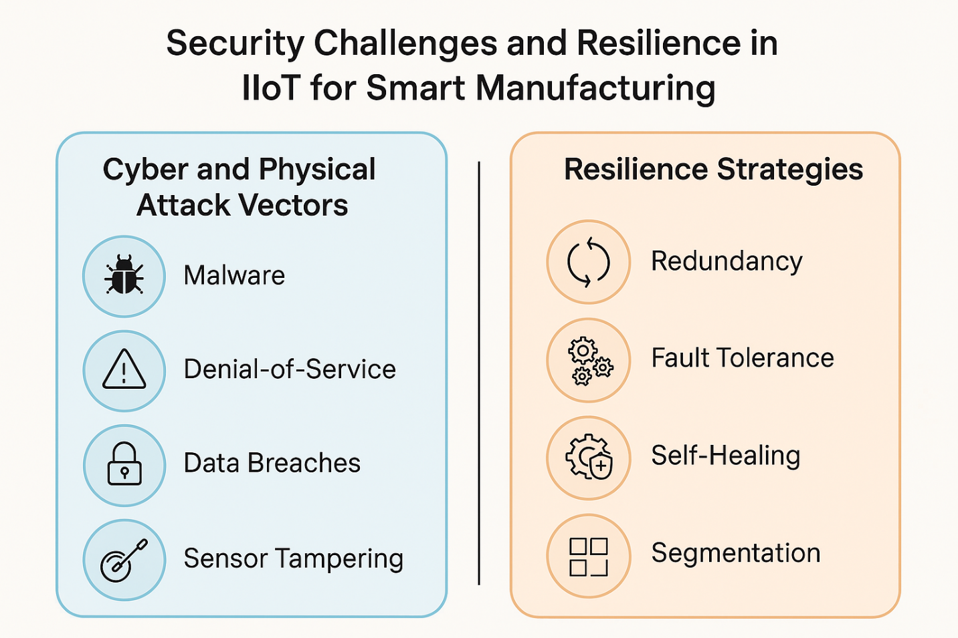
Figure 2: Security Threats and Resilience Strategies in IIoT-Based Smart Manufacturing. This infographic highlights key cyber and physical attack vectors threatening Industrial IoT (IIoT) systems in smart manufacturing, including malware, denial-of-service, data breaches, and sensor tampering. It contrasts these with corresponding resilience strategies such as redundancy, fault tolerance, self-healing mechanisms, and network segmentation, which collectively enhance system robustness and operational continuity.

5. Secure and Resilient IIoT Architectures: Approaches and Solutions
With the increasing complexity and size of the smart manufacturing ecosystem, securing IIoT systems while maintaining operational resilience is critical. Balance is the key to addressing both these challenges, including a combination of design philosophies, resiliency tactics, and technologies that can specifically be deployed in the harsh industrial environment[15].

Design Principles for Secure IIoT Architectures
Defense in Depth is a foundational principle that promotes the implementation of layered security measures to address risks in different locations. For IIoT solutions, this includes the protection of end points such as sensors and actuators, securing network communications, and the enforcement of application-level controls. And by overlaying these safeguards, the risk of a single point of failure is minimized for the manufacturers[16].
Zero Trust Architecture is increasingly relevant in IIoT environments. Unlike traditional perimeter-based security, zero trust mandates that no device, user, or service is inherently trusted. Every access request—whether from inside or outside the network—is authenticated and continuously validated. This approach addresses the dynamic nature of IIoT ecosystems, where devices regularly join and leave networks[17].
Least Privilege and Role-Based Access Control (RBAC) The principle of least privilege and role-based access control (RBAC) further enhances security. Access is limited solely to what a user or device needs to do its job. And in smart factories, that means paying close attention to access to operational technology (OT) assets such that only roes with an appropriate mandate can operate machines or change processes without due authorisation[18].
The Secure-by-Design mindset is critical from the beginning to the end and everywhere in between. Security is built in at every stage of design, not bolted on after system deployment. This forward-thinking strategy reduces risks posed by aging equipment, as well as supporting the long-term integrity of the system.
TECHNIQUES TO IMPROVE RESILIENCE IN IIOT
Resilience goes beyond just protecting against security threats to ensure IIoT systems can continue functioning even while under attack. Redundant networks are essential, involving duplicated hardware (such as twin sensors, backup gateways) and pathways to operate when the primary fails. Redundancy mechanisms may be implemented to include a plurality of interconnected communication paths, including, for example, wireless and wired paths, to mitigate single multimedia failure points[19].
Decentralized and Edge-Enabled Architectures further contribute to resilience. In an ordinary cloud-oriented model, losing your internet connection freezes the action. Applying edge and fog computing, there is local and at the edge decision making and data processing that reduces reliance on external networks, securing no-pause operations even if disconnection happens[20].
Adaptive and Self-Healing Systems provide an additional level of resiliency. Using AI and ML, these systems will be able to identify anomalies dynamically the moment they happen — say, an unexpected change in process or a device failure — and even take recovery actions without any human intervention. For instance, automatic failover to backup systems or on-the-fly generation of production workflows ensures minimal downtimes[21].
Digital Twins—the digital representations of physical assets and processes—serve as useful tools for resilience planning. They let manufacturers simulate disruptions and test recovery strategies without affecting the day-to-day business, so they're prepared for unexpected events[22].
The Importance of Technologies for Vulnerability Reduction and Resilience Building
A number of key technologies are crucial in achieving secure and robust IIoT architectures.
· Blockchain: Blockchain’s unchangeable and open ledger provides advanced device authentication and data authenticity in distributed IIoT networks. In manufacturing, blockchain is used to ensure the security of supply chain transactions, track maintenance operations, and confirm the authenticity of device firmware updates, to prevent unauthorized modifications or data corruption[23].
· Artificial Intelligence and Machine Learning (AI/ML): AI and ML algorithms analyze enormous streams of data to detect anomalies, predict failures, and optimize production. They form a base for adaptive security mechanisms, in particular anomaly-based IDSs, and predictive maintenance by monitoring sensor data for indications of equipment degradation in the early stage[24].
· Software-Defined Networks (SDNs) - SDNs add some degree of flexibility by decoupling network control and management from the underlying network hardware, so that data connections can be configured in real time. In IIoT scenarios, SDN may re-route traffic on-the-fly around compromised nodes or congestion points, thus increasing security (isolating infected nodes) and resilience (keeping the operation of data)[25].
· Network Function Virtualization (NFV): NFV uses virtualized security functions, such as firewalls, and it provides the flexibility to quickly deploy security along production zones and processes, but without physical reconfiguration.
Together, these technologies are a formidable toolkit for IIoT developers. When used strategically, they help manufacturers design systems that are secure from emerging threats and resilient to disruptions.

6. Frameworks, Standards, and Best Practices
Recognizing the complexity and critical nature of IIoT systems, numerous standards and frameworks have been developed to guide secure and resilient deployments in smart manufacturing environments. These resources help establish baseline requirements, foster consistency, and support regulatory compliance across the industry.
Standards- Relevant Summary
· ISA/IEC 62443: Considered one of the broadest and most comprehensive security standards for industrial control systems (ICS), ISA/IEC 62443 offers a risk-based framework for IIoT environments. It includes security program management, technical security controls, and systems lifecycle management, providing a blueprint for addressing IT and OT security together[26].
· NIST Cybersecurity Framework (CSF) – A Framework widely used across various industries, the NIST CSF uses a risk-based approach to implement a flexible, structured framework around five core functions: Identify, Protect, Detect, Respond, and Recover. The fact that its design is modular helps both the manufacturers and software developers to fully incorporate it into their IIoT architectures and continually changing threat environments[27].
· ISO/IEC 27001: This is a standard that is based on ISMS (information security management systems), and adopts a comprehensive method for handling sensitive information in IIoT networks. By tying IIoT deployments to the principles laid out in ISO/IEC 27001, manufacturers can provide strong data governance while also meeting global standards for data protection[28].
· IEC 61508 and 61511: Also, such methods developed for functional safety are more and more applicable to the IIoT context because cyber-physical risks in IIoT can relate to safety. Including functional safety in IIoT security planning will make you more resilient and protect your workers[29].
Recommendations for Securing IIoT Implementations
The interconnection of secure IIoT systems into smart manufacturing sets the following fundamental foundation principles:
· Thoroughly Risk Assess: By identifying, categorizing, and analyzing the risks to the entire IIoT ecosystem, including devices, networks, data flows, and potential attack vectors, manufacturers can focus on security and resilience where it will be most effective.
Deploy Segmentation and Zone-Based Architectures: Splitting IIoT networks into isolated security zones limits the scope of attacks and serves to localise failures. Take separating key control systems from more general enterprise networks: This reduces access in the enterprise system to internet-based attacks[12].
· Guarantee Safe Device Lifecycle Management: Manufacturers must secure all aspects of a device’s lifecycle—from its procurement to its decommissioning—including strong authentication, firmware integrity checks, and secure update mechanisms. Supply chain security, including the trusted vendor choice and a component validation process further lowers the same set of vulnerabilities[30].
· Patch Systems Regularly: Due to the dynamic nature of threats, it is always best for us to keep aligning security policies with patches on well-known vulnerabilities. Automated updating mechanisms may be established to facilitate an expedient process with minimal production interruption[31].
· Incident Response and Recovery Planning: Planning for incident response scenarios and practicing these plans on a recurring schedule will also help in being prepared to manage security breaches and operational interruptions. Such plans should also identify specific responsibilities, escalation paths, and recovery processes to avoid downtime and safeguard employee well-being[32].
Industry-Specific Practices and Compliance Challenges
There is a wide range of manufacturing environments, from automotive to electronics to food processing, and each has unique operational needs and compliance requirements. For example, in the automotive space, compliance with ISO/SAE 21434 (aimed at cybersecurity within automotive systems) will remain key as vehicles become endpoints of connected IIoT systems. Compliance with FDA and GAMP standards also guarantees product quality and patient safety in the pharmaceutical field[28].
Sector-specific activities further affect security and resilience priorities. Highly automated production lines might require real-time anomaly detection with very low latency, versus the needs of batch-based industries to ensure data integrity and traceability across the supply chain. These sectoral differences highlight the need to focus on IIoT security and resilience measures to operational requirements and expectations[33].
Yet, practical barriers to implementation remain, even with strong standards and best practices. Obsolete systems, limited budgets, and the size of industrial spaces can prevent the implementation of a phased approach to security and resilience. Moreover, optimizing strong security with performance and usability is still a challenging job, particularly in high-speed production settings[34].

7. Emerging Trends and Future Directions
The landscape of Industrial IoT (IIoT) security and resilience is dynamic, driven by rapidly evolving technologies and increasing operational demands in smart manufacturing. Emerging trends highlight new opportunities for strengthening IIoT systems while also revealing evolving challenges that require innovative solutions.
Integration of AI and ML for Proactive Security and Resilience
Artificial Intelligence (AI) and Machine learning (ML) are changing how manufacturers are thinking about security and resilience. Historically, security in IIoT has been rules-based, and this approach is a poor defence against advanced attacks and the context-specific nature of today’s production environments. AI and ML provide a possible proactive solution, allowing systems to recognize patterns from data and respond in real time to new threats[35].
For instance, ML-based anomaly detection can track sensor information, network activity, and device actions in real time and flag anomalous behavior, which can be a sign of new security threats or system failures. This predictive attribute also applies to equipment resiliency. Some AI algorithms can detect early signs of equipment breakdown, allowing for predictive maintenance to become possible and preventing unplanned downtime. Second, the system can be used to optimize how resources are allocated and recovery actions carried out, reducing any adverse effects on production.
Cyber-Physical System (CPS) Convergence and Implications
Cyber-physical systems (CPS) in IIoT bring opportunities and challenges. CPS integration paves the way for hitherto unachievable levels of automation, flexibility, and efficiency in smart factories, merging the digital know-how with the physical doing in highly adaptive manufacturing settings.
Yet CPS also muddles the distinction between cyber and physical risks. Cyber or digital attacks on digital systems can lead to instantaneous physical impacts, like machines catching fire or safety issues. On the other hand, if those IIoT devices are physically tampered with, you can introduce security holes in the digital process. Solving these intersecting risks requires an integrated approach that extends beyond conventional IT security and encompasses physical protections, live monitoring, and cross-domain threat intelligence. With the Industrial Internet of Things (IIoT) taking shape, a number of nascent trends are rewriting how smart manufacturing systems are secured and optimized[36]. As a result, Figures 2 and 3 capture three important trends, including AI/ML interfusion, the convergence of CPS, and green IIoT practices, which all point to more intelligent, connected, and green industrial ecosystems.
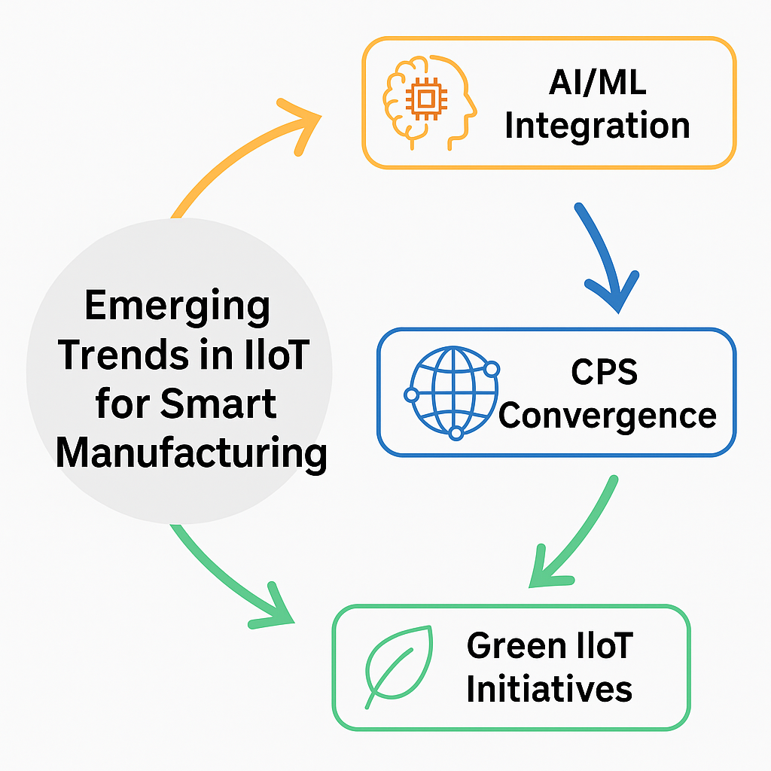

Figure 3: Emerging Trends in IIoT for Smart Manufacturing. This diagram illustrates three major emerging trends shaping the future of Industrial IoT (IIoT) in smart manufacturing: AI/ML integration for proactive decision-making and security; cyber-physical system (CPS) convergence for seamless digital-physical coordination; and green IIoT initiatives focused on sustainable and energy-efficient industrial practices.

Sustainability and Green IIoT Security Measures
With the growing emphasis of manufacturing industries on sustainability, security resilience, their strategies are also transitioning to meet environmental targets. Green IIoT security means reducing the footprint on energy and resources of cybersecurity/ resilience practices.
For example, the power consumption of data transmission and central processing becomes lower with edge and fog computing, which decreases the transferring/writing of data to remote cloud servers. Lightweight cryptographic algorithms and secure communication protocols, which have been specifically designed for the constraints of low-power devices, tighten the integration of the security approach and the energy-friendly design considerations. The IIoT energy management can also be better carried out by using AI-based optimization, which will enhance both operational sustainability and the security posture[37].
Sustainable security services, mitigation, and resilience counteractive strategies not only contribute to a decreased environmental impact but also ensure compliance with potential legislation in addition to playing a part in the cost-effectiveness in general, which is essential for the long-term competitiveness in smart manufacturing.
Future Research Gaps and Opportunities
Remaining Challenges and Research Opportunities As far as secure, data-centric transmission of data in IIoT is concerned, although a large progress has been made, there are remaining research gaps and open questions we outline in the following:
· Interoperability and Standardization: With manufacturers deploying both legacy and modern devices, the achievement of secure and seamless interoperability among heterogeneous systems is an ongoing impediment[38].
· Lightweight Security Solutions: The design of lightweight, but strong security measures for resource-constrained IIoT devices, including those in energy-constrained environments, is still an ongoing research direction.
· Resilience Metrics: Although the importance of resilience is generally recognized, quantitative models and metrics for the measurement and comparison of resilience among IIoT systems are still at an early phase[39].
· Human Factors: The authors believe that the Human element of the challenge, maintaining security and resilience concerning human operators, is clearly within the scope, including end-user awareness, training, and human-machine interface.
Further studies in these lines are essential to overcome the current gaps and pave the way for the next generation of secure, sustainable, and resilient smart manufacturing systems.

8. Discussion and Critical Analysis
The preceding sections have outlined the key components, challenges, and emerging trends in building secure and resilient IIoT architectures for smart manufacturing. This section provides a critical examination of current solutions, their limitations, and the ongoing trade-offs faced by industry stakeholders.
Comparison of Current Solutions and Their Limitations
Solutions today – from standards-based security frameworks to AI with anomaly detection – are already lining the path for secure IIoT implementations. Standards like ISA/IEC 62443 and the NIST Cybersecurity Framework provide complete documentation on risk assessment, technical controls, and continuous monitoring. Meanwhile, technologies such as blockchain, SDN, and NFV offer new mechanisms for ensuring the integrity of data, segmenting a network, and enforcing dynamic security policies[26].
But all these solutions have their restrictions. Most specifications are of the one-size-fits-all variety and do not comprehensively address the realities of legacy systems and diverse device ecologies. The following concerns have been identified concerning secure documents using blockchain: the overhead of blockchain technology may hamper real-time performance and scalability in a fast-paced production environment. In the same way, the AI and ML provide great insights but are grossly dependent on good data that is enough, a space where many manufacturers are still struggling[40].
Open Challenges and Trade-Offs in Secure and Resilient IIoT Design
Security Versus Operational Performance There’s no doubt that security and IT infrastructure performance are paramount to IIoT environments, but there’s a true and fundamental dichotomy in play here. Encryption could, for example, help protect against loss or tampering of data, but it also can cause latency that can disrupt time-sensitive industrial processes. Optimizing the compromise is not always easy, and in certain cases, it can force us to make concessions to the system architecture[8].
Heritage systems are, and likely continue to be, a major obstacle. Old equipment was not designed to communicate. Retrofitting reliable and secure capabilities into equipment never intended for connectivity all too often means investing heavily in time, resources, and skills. Similarly, if you are in a heterogeneous environment where different vendor devices need to work together, it makes standardizing on security policies and monitoring that much harder to do[12].
Supply chain integrity is another worry. As the IIoT ecosystem is leveraging the global supply chains, guaranteeing the integrity and trustworthiness of third-party constituents is essential. Supply chain compromises, as has been demonstrated in high-profile instances in other industries, can cause ripple effects in manufacturing settings.
Human and organizational factors are also major contributors. The most sophisticated technical solutions can still be defeated by a lack of training, lax policy enforcement, or organizational habits of resistance. This illustrates the importance of holistic solutions that consider technical, organizational, and human aspects[41].
Lessons Learned and Recommendations for Practitioners and Researchers
This critical review provides a few lessons:
End-to-end Design is Crucial: Security and resiliency cannot be an afterthought but need to be considered as a fundamental part of IIoT design. Architectures should be designed for defense in depth, zero trust, and resilience from the beginning.
Customize for Operations: Solution has to be customized to meet the unique requirements of a given manufacturing environment, regarding the trade-off between security and real-time performance, as well as compliance with industry-specific rules and practices.
Foster Collaboration: Ensuring security and resilience is a shared responsibility among IT, OT, and supply chain stakeholders. Cross-disciplinary teams that span across these domains will be critical for addressing complex, interrelated challenges.
Spend on Ongoing Education: Risk changes, so security and resilience must change with it. Continued surveillance, dynamic risk estimation, and perpetual training of the workforce would be paramount to remaining ahead of the evolving threats.
Future Research Lines on Emerging Topics: Lightweight security solutions, real-time resilience measurements, and human-centric strategies to enhance the security and resilience of IIoT without hindering operational efficiency.
For practitioners, implementing these lessons requires a proactive, strategic mindset. IIoT security and stability are not activities that you do once and never have to worry about again, but a series of long-term activities that need to progress side by side with technology development and new operational circumstances. There continue to be plentiful prospects for innovations of security and resilience in the IIoT for researchers—a bridge between theory and practice. The combination of AI, edge computing, blockchain, and green technology presents a rosy prospect of secure and resilient IIoT in smart manufacturing. But such potential can only be achieved with critical thinking, ongoing improvement, and close working relationships among stakeholders. By focusing on these values and tackling these challenges, the manufacturing sector can develop IIoT ecosystems that are not just efficient and productive, but safe, secure, resilient and sustainable, laying the foundation for a robust industrial future.

9. Conclusion
This review thus captures the rich architecture space for secure and resilient architectures for IIoT-enabled smart manufacturing ecosystems. After covering the transformative nature of IIoT in recent production environments, we looked at enabling technologies, such as sensors, edge computing, cloud platforms, and AI/ML, which culminate in an intelligent factory. These advances bring huge advantages of efficiency, flexibility, and data-driven information, but also bring new issues of security and resilience.
We then explored the changing threat landscape, showing the new vulnerabilities at the device, network, and system levels, and discussed how threat actors leverage these weaknesses to inflict damage in IIoT. Moreover, we discussed IIoT-specific resilience issues such as resilience for the need of redundancy, fault-tolerance, and self-healing to cope with disruptive events and maintain continuous operations.
To respond to these challenges, resilient IIoT architectures must follow strong design principles, including defense in depth, zero trust, and secure-by-design, and make use of innovative technologies, including blockchain, AI/ML, SDN, and NFV. Additionally, having international standards used in structured compliance-based guidance per the ISA/IEC 62443, as well as the NIST Cybersecurity Framework, is critical as well.
The above trends, including deployment of AI technologies on active security, convergence between cyber and physical systems, and the call for green security solutions, indicate future developments for IIoT robustness and security trends. These developments underscore the necessity for continued research and concrete innovation to help overcome current limitations, especially around lightweight security, interoperability, and human-centered approaches.
Secure and robust architectures for IIoT-enabled smart manufacturing are finally a non-negotiable requirement. They are the cornerstone of industrial plants that are safe, productive, and ready for the future. Through promoting interdisciplinary collaboration, holistic strategies, and ongoing responsiveness to challenges, practitioners and researchers will help to lead the next generation of smart manufacturing innovation, secure in the understanding that security and resilience are foundational requirements of success, not optional elements.

COMPETING INTERESTS DISCLAIMER:
Authors have declared that they have no known competing financial interests OR non-financial interests OR personal relationships that could have appeared to influence the work reported in this paper.

Disclaimer (Artificial intelligence)

Option 1:

Author(s) hereby declare that NO generative AI technologies such as Large Language Models (ChatGPT, COPILOT, etc.) and text-to-image generators have been used during the writing or editing of this manuscript.

Option 2:

Author(s) hereby declare that generative AI technologies such as Large Language Models, etc. have been used during the writing or editing of manuscripts. This explanation will include the name, version, model, and source of the generative AI technology and as well as all input prompts provided to the generative AI technology

Details of the AI usage are given below:
1.
2.
3.

REFERENCES
1. Farooq MS, Abdullah M, Riaz S, Alvi A, Rustam F, Flores MAL, et al. A Survey on the Role of Industrial IoT in Manufacturing for Implementation of Smart Industry. Sensors. 2023 Jan;23(21):8958.
2. Ahmed SF, Alam MdSB, Hoque M, Lameesa A, Afrin S, Farah T, et al. Industrial Internet of Things enabled technologies, challenges, and future directions. Computers and Electrical Engineering. 2023 Sep 1;110:108847.
3. Yaqub MZ, Alsabban A. Industry-4.0-Enabled Digital Transformation: Prospects, Instruments, Challenges, and Implications for Business Strategies. Sustainability. 2023 Jan;15(11):8553.
4. Zhong D, Xia Z, Zhu Y, Duan J. Overview of predictive maintenance based on digital twin technology. Heliyon. 2023 Apr 1;9(4):e14534.
5. Basir R, Qaisar S, Ali M, Aldwairi M, Ashraf MI, Mahmood A, et al. Fog Computing Enabling Industrial Internet of Things: State-of-the-Art and Research Challenges. Sensors. 2019 Jan;19(21):4807.
6. Abdullahi SM, Lazarova-Molnar S. On the adoption and deployment of secure and privacy-preserving IIoT in smart manufacturing: a comprehensive guide with recent advances. Int J Inf Secur. 2025 Jan 3;24(1):53.
7. Wang M, Sun Y, Sun H, Zhang B. Security Issues on Industrial Internet of Things: Overview and Challenges. Computers. 2023 Dec;12(12):256.
8. Dhirani LL, Armstrong E, Newe T. Industrial IoT, Cyber Threats, and Standards Landscape: Evaluation and Roadmap. Sensors (Basel). 2021 Jun 5;21(11):3901.
9. Abosata N, Al-Rubaye S, Inalhan G, Emmanouilidis C. Internet of Things for System Integrity: A Comprehensive Survey on Security, Attacks and Countermeasures for Industrial Applications. Sensors (Basel). 2021 May 24;21(11):3654.
10. Lawal OP, Egwuatu EC, Akanbi KO, Orobator ET, Eweje OZ, Omotayo EO, et al. Fighting Resistance With Data: Leveraging Digital Surveillance to Address Antibiotic Misuse in Nigeria. Path of Science. 2025 Mar 31;11(3):1009–17.
11. Frankó A, Hollósi G, Ficzere D, Varga P. Applied Machine Learning for IIoT and Smart Production—Methods to Improve Production Quality, Safety and Sustainability. Sensors. 2022 Jan;22(23):9148.
12. Wang T, Li D, Zhang B, Liu X, Shang W. Resilient Topology Reconfiguration for Industrial Internet of Things: A Feature-Driven Approach Against Heterogeneous Attacks. Entropy. 2025 May 7;27(5):503.
13. Aloqab A, Hu W, Abdulraqeb OA, Mohammed O, Raweh B. The Impact of the Corona Virus on Supply Chains: Opportunities and Challenges. Review of Economic Assessment. 2024 Jan 3;2(4):19–41.
14. Maqbool R, Saiba MR, Ashfaq S. Emerging industry 4.0 and Internet of Things (IoT) technologies in the Ghanaian construction industry: sustainability, implementation challenges, and benefits. Environ Sci Pollut Res Int. 2023;30(13):37076–91.
15. Ghobakhloo M, Mahdiraji HA, Iranmanesh M, Jafari-Sadeghi V. From Industry 4.0 Digital Manufacturing to Industry 5.0 Digital Society: a Roadmap Toward Human-Centric, Sustainable, and Resilient Production. Inf Syst Front [Internet]. 2024 Feb 22 [cited 2025 Jun 6]; Available from: https://doi.org/10.1007/s10796-024-10476-z
16. Schiller E, Aidoo A, Fuhrer J, Stahl J, Ziörjen M, Stiller B. Landscape of IoT security. Computer Science Review. 2022 May 1;44:100467.
17. Kang H, Liu G, Wang Q, Meng L, Liu J. Theory and Application of Zero Trust Security: A Brief Survey. Entropy (Basel). 2023 Nov 28;25(12):1595.
18. Lawal O, Elechi K, Adekunle F, Farinde O, Kolapo T, Igbokwe C, et al. A Review on Artificial Intelligence and Point-of-Care Diagnostics to Combat Antimicrobial Resistance in Resource-Limited Healthcare Settings like Nigeria: Review Article. Journal of Pharma Insights and Research. 2025 Apr 5;3(2):166–75.
19. Albayrak ZS, Vaz A, Bordes J, Ünlü S, Sep MSC, Vinkers CH, et al. Translational models of stress and resilience: An applied neuroscience methodology review. Neuroscience Applied. 2024 Jan 1;3:104064.
20. Andriulo FC, Fiore M, Mongiello M, Traversa E, Zizzo V. Edge Computing and Cloud Computing for Internet of Things: A Review. Informatics. 2024 Dec;11(4):71.
21. Feng J, Yu T, Zhang K, Cheng L. Integration of Multi-Agent Systems and Artificial Intelligence in Self-Healing Subway Power Supply Systems: Advancements in Fault Diagnosis, Isolation, and Recovery. Processes. 2025 Apr;13(4):1144.
22. Javaid M, Haleem A, Suman R. Digital Twin applications toward Industry 4.0: A Review. Cognitive Robotics. 2023 Jan 1;3:71–92.
23. Almarri S, Aljughaiman A. Blockchain Technology for IoT Security and Trust: A Comprehensive SLR. Sustainability. 2024 Jan;16(23):10177.
24. Lawal OP, Taiye AF, Okafor CE, Elechi KW, Orobator ET, Kolapo TJ, et al. The Automated Insulin Delivery System in Nigeria: Advances, Challenges, And Future Prospects in Closed-Loop Insulin Delivery Systems. Journal of Medical Science, Biology, and Chemistry. 2025 Jun 30;2(1):64–74.
25. Urrea C, Benítez D. Software-Defined Networking Solutions, Architecture and Controllers for the Industrial Internet of Things: A Review. Sensors. 2021 Jan;21(19):6585.
26. Cindrić I, Jurčević M, Hadjina T. Mapping of Industrial IoT to IEC 62443 Standards. Sensors. 2025 Jan;25(3):728.
27. What is NIST Cybersecurity Framework (CSF) 2.0? | Balbix [Internet]. [cited 2025 Jun 6]. Available from: https://www.balbix.com/insights/nist-cybersecurity-framework/
28. Kitsios F, Chatzidimitriou E, Kamariotou M. The ISO/IEC 27001 Information Security Management Standard: How to Extract Value from Data in the IT Sector. Sustainability. 2023 Jan;15(7):5828.
29. Peserico G, Morato A, Tramarin F, Vitturi S. Functional Safety Networks and Protocols in the Industrial Internet of Things Era. Sensors. 2021 Jan;21(18):6073.
30. Elechi KW, Igboaka CD, Tiamiyu BB, Ugbor MJE, Arthur C, Ezeh OM, et al. Phytochemical Screening of Ficus globosa Latex (Moraceae) as a Source of Novel Antimicrobial Compounds. Path of Science. 2025 Mar 31;11(3):9001–10.
31. Oseghale ID, Lawal OP, Ubebe DO, Orjiewulu VC, Igunma AA, Odey OP, et al. Ethnomedicinal and Phytopharmacological Aspects of Vernonia amygdalina (Bitter Leaf) Utilized as a Traditional Medicinal Herb. Asian Journal of Research in Biochemistry. 2024 Oct 14;14(6):41–57.
32. Wadhwa P. A Beginner’s Guide to Incident Response Plan [Internet]. Sprinto. 2024 [cited 2025 Jun 6]. Available from: https://sprinto.com/blog/incident-response-plan/
33. Okafor CE, Egwuatu EC, Owosagba VA, Njei T, Adeyemi BI, Onuche PUO, et al. From Bench to Bedside: Medicinal Chemistry Strategies in the Development of Kinase Inhibitors for Cancer Therapy. Journal of Cancer and Tumor International. 2025 May 10;15(2):79–96.
34. Ayomide IT, Promise LO, Christopher AA, Okikiola PP, Esther AD, Favour AC, et al. The Impact of Antimicrobial Resistance on Co-INFECTIONS: Management Strategies for HIV, TB and Malaria. International Journal of Pathogen Research. 2024 Nov 29;13(6):117–28.
35. Lawal O, Oyebamiji HO, Kelenna IJ, Chioma FJ, Oyefeso E, Adeyemi BI, et al. A Review on Usage of Digital Health Literacy to Combat Antibiotic Misuse and Misinformation in Nigeria: Review Article. Journal of Pharma Insights and Research. 2025 Apr 5;3(2):258–69.
36. Yaacoub JPA, Salman O, Noura HN, Kaaniche N, Chehab A, Malli M. Cyber-physical systems security: Limitations, issues and future trends. Microprocess Microsyst. 2020 Sep;77:103201.
37. Chen X, Despeisse M, Johansson B. Environmental Sustainability of Digitalization in Manufacturing: A Review. Sustainability. 2020 Jan;12(24):10298.
38. Xiao G, Guo J, Xu LD, Gong Z. User Interoperability With Heterogeneous IoT Devices Through Transformation. IEEE Transactions on Industrial Informatics. 2014 May;10(2):1486–96.
39. Allioui H, Mourdi Y. Exploring the Full Potentials of IoT for Better Financial Growth and Stability: A Comprehensive Survey. Sensors. 2023 Jan;23(19):8015.
40. Ahmed AA, Farhan K, Ninggal MIH, Alselwi G. Retrieving and Identifying Remnants of Artefacts on Local Devices Using Sync.com Cloud. Sensors. 2025 Jan;25(1):106.
41. Kuziemsky CE. The Role of Human and Organizational Factors in the Pursuit of One Digital Health. Yearb Med Inform. 2023 Jul 6;32(1):201–9.

