HIGH-SPEED RAIL IN NIGERIA: OPERATIONAL BARRIERS, STRATEGIC PATHWAYS, AND ECONOMIC POTENTIAL
Abstract
This study critically evaluates Nigeria's readiness for implementing high-speed rail (HSR) systems, examining operational barriers, strategic opportunities, and potential economic impacts. Given Nigeria’s population size and economic prominence in Africa, inadequate transportation infrastructure significantly hampers national and regional development. Consequently, this research assesses the feasibility and transformative potential of introducing high-speed rail as a key strategic infrastructure project. Employing a qualitative methodology, the study analyzes secondary data sourced from peer-reviewed academic articles, institutional reports, policy documents, and global case studies. The findings highlight substantial operational barriers including outdated legacy infrastructure, insufficient financing, governance inefficiencies, bureaucratic delays, and security vulnerabilities. Conversely, strategic pathways such as technological innovations, public-private partnerships (PPPs), transit-oriented development, and sustainable transport initiatives present viable solutions for addressing these challenges. Furthermore, comparative analysis with successful HSR projects in Morocco, China, and Europe underscores the importance of dedicated infrastructure, diversified funding strategies, transparent governance, and technology integration. Economic projections demonstrate that HSR could significantly enhance employment, regional trade, logistics efficiency, foreign direct investment, and tourism growth. The study concludes that while challenges remain significant, the effective adoption of global best practices can position Nigeria’s high-speed rail initiative as a catalyst for national economic transformation and regional integration. Policymakers, infrastructure planners, and investors can use these insights to develop informed strategies for infrastructure modernization in Nigeria.

Keywords: High-speed rail; Operational barriers; Infrastructure development; Public-private partnerships; Economic transformation

Introduction
Railway transportation is globally seen as an environmentally-friendly mode of mass transit system. Hence, many countries have continued to take steps to enhance the efficiency of their rail transportation industry. In Nigeria, railway transportation has been experiencing crisis in the last three decades. Today, railway transport accounts for an insignificant part of the transport sub-sector and contributes a very small proportion of value added to the transportation system (Bouraima et al., 2020; Ogochukwu et al., 2022). Efficient transportation infrastructure significantly shapes economic growth, regional integration, and environmental sustainability. Nigeria, despite its prominence as Africa's largest economy and most populous nation, continues to struggle with inefficient transport systems dominated by deteriorating road networks. High-speed rail has an important impact on the location choices of enterprises and the labor force, which is reflected in a complex space-time process. For regional economic integration, sustainable development, and reducing global poverty, qualitative and quantitative evaluation of the corresponding relationship between high-speed rail networks and population and industry is of great practical significance. The research on China’s high-speed rail network’s impact is important for planning and building the world’s rail networks because China is a leading country in this field (Chi & Han, 2023). The resulting infrastructural deficit severely restricts internal mobility, limits trade competitiveness, and deepens regional inequalities. In response, high-speed rail (HSR), characterized by trains operating at speeds above 250 km/h on dedicated tracks, emerges as a potentially transformative infrastructure solution capable of significantly enhancing national connectivity and economic productivity (Russo et al., 2023; Martí-Henneberg, 2013).
Historically, Nigeria's rail sector experienced a considerable decline from the 1980s onwards, resulting in substantial losses in passenger and freight volumes due to systemic neglect and persistent underinvestment (Nigerian Railway Corporation, 2003).

Figure 1. Decline in Nigerian rail usage (1964–2003), highlighting the significant drop in passenger and freight volumes
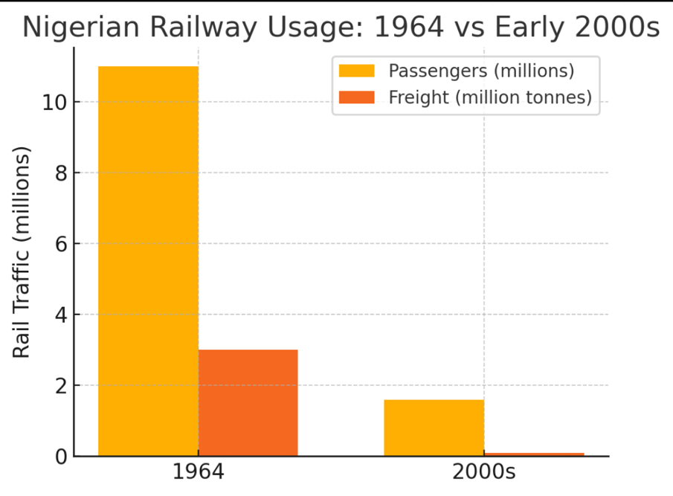
Note: Passenger traffic (yellow) and freight volume (orange) plummeted significantly, reflecting the collapse of the rail system.
Although recent initiatives, such as the National Railway Modernization Project, signal a governmental willingness to revive rail infrastructure, formidable obstacles persist, including ageing legacy infrastructure, inadequate funding mechanisms, inefficient governance, bureaucratic delays, and security risks (Babatunde, 2020).
This study addresses a critical gap within existing research: while global studies extensively discuss the benefits of HSR, there remains the limited focused examination of Nigeria-specific structural and institutional challenges and opportunities associated with HSR implementation. Thus, this paper seeks to assess Nigeria's readiness for high-speed rail through a rigorous exploration of infrastructural challenges, strategic implementation pathways, and anticipated economic impacts.
Research Questions:
- What are the primary infrastructural and operational challenges impeding HSR implementation in Nigeria?
- What strategic opportunities—technological, financial, or policy-related—can facilitate successful HSR deployment?
- What specific economic benefits, including job creation, trade enhancement, and regional development, could be realized from HSR infrastructure in Nigeria?
- Which regulatory reforms and governance frameworks are necessary to support effective HSR implementation?
- How do Nigeria’s potential HSR strategies compare with successful models from similar emerging economies?
By addressing these questions, this research provides essential insights to policymakers, infrastructure planners, and investors, guiding informed decision-making aimed at transportation modernization and economic transformation.

2. Literature Review

2.1 Global Development and Adoption of High-Speed Rail
Globally, HSR systems have become integral components of transport modernization strategies, significantly reducing travel times, improving regional connectivity, and spurring economic development. Originating with Japan's Shinkansen in 1964, HSR has since been adopted extensively in China, Spain, France, and Germany, transforming national mobility and economic landscapes (Huang & Zong, 2020). China exemplifies successful rapid expansion, developing an extensive network exceeding 35,000 km through sustained governmental investment and technological innovation (Li et al., 2021). This literature review is structured thematically, examining global HSR development, African case studies, and Nigeria-specific contexts. It also incorporates theoretical and policy perspectives to provide an analytical framework guiding the study’s comparative and strategic assessments (see Section 2.6).
Table 1
High-Speed Lines in Operation Worldwide
Year of Introducing  HSR System | Country | Length of HSR Line in  Operation in 2020 (km)
1964 | Japan | 3041
1977 | Italy | 921
1981 | France | 2734
1991 | Germany | 1571
1992 | Spain | 3330
1995 | Finland | 1120
1997 | Belgium | 209
2000 | USA | 735
2003 | United Kingdom | 113
2003 | China | 35,388
2004 | Switzerland | 144
2004 | South Korea | 893
2006 | The Netherlands | 90
2007 | Taiwan | 354
2009 | Turkey | 594
2012 | Austria | 254
2015 | Poland | 224
2018 | Saudi Arabia | 449
2018 | Morocco | 200
2019 | Denmark | 56
N/A | Czech Republic | 64
Global high-speed rail lines in operation, detailing country-wise track lengths and years of introduction

2.2 Economic and Spatial Impacts of High-Speed Rail
HSR infrastructure typically delivers significant multiplier effects, such as regional economic growth, increased employment opportunities, improved real estate values, and expanded tourism sectors. Empirical evidence from Spain, China, and Morocco highlights how effective HSR systems enhance spatial cohesion, reduce regional disparities, and stimulate sustainable economic development (Shi, 2018; Albalate & Bel, 2012; Strava, 2023).
Spain, with its extensive Alta Velocidad Española (AVE) network, offers a prominent example of successful spatial and economic integration through high-speed rail. The AVE system effectively connects major metropolitan areas and peripheral regions, enhancing territorial cohesion and supporting balanced regional development.
Figure 2
Spanish HSR Network Map
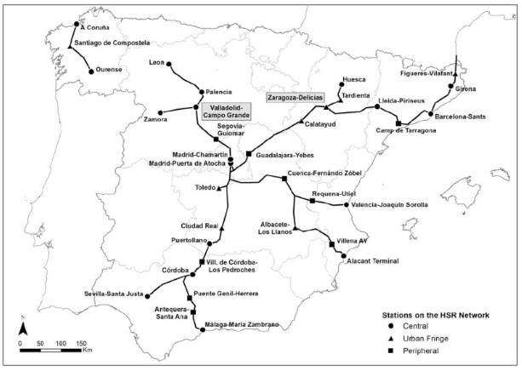
Figure illustrating Spain’s comprehensive high-speed rail network connecting major economic hubs.

The strategic spatial distribution of Spain's HSR network facilitates efficient intercity mobility, reducing economic disparities between central and peripheral regions, and exemplifies how effective transport infrastructure planning can align with broader regional economic and social objectives (Kortazar et al., 2021).
2.3. Barriers and Challenges to High-Speed Rail Implementation
Despite clear benefits, numerous obstacles often impede HSR development in developing countries. Primary challenges include insufficient infrastructure financing, bureaucratic inefficiencies, inconsistent regulatory frameworks, inadequate technological capability, and skilled-labour shortages (Babatunde, 2020).
2.4 Innovative Financing Models and Public-Private Partnerships (PPP)
Effective financing remains critical to successful infrastructure projects, particularly HSR systems due to their scale and capital intensity. Public-private partnerships (PPPs), infrastructure bonds, and targeted fiscal incentives have proven effective in mobilizing resources for large-scale rail infrastructure globally. Notably, Morocco’s Al-Boraq project exemplifies successful public-private partnership (PPP) implementation, combining national commitment with international financing. The 320 km/h line between Tangier and Casablanca demonstrates how well-coordinated infrastructure strategies can catalyze regional connectivity (OECD, UN ECA, & African Development Bank, 2022).

2.5 Comparative Lessons and Implications for Nigeria
Emerging economies such as Morocco, India, and China offer practical frameworks and strategies relevant to Nigeria’s rail development ambitions. Success factors identified from the comparative analysis include phased infrastructure development, robust institutional oversight, technological integration (e.g., predictive maintenance via AI systems), and strategic economic alignment (Li et al., 2021). Additionally, regional initiatives such as the African Union’s Agenda 2063 underline the strategic importance of integrated transport infrastructure, reinforcing the potential continental significance of Nigeria’s HSR efforts (African Union, 2020).
Table 2
Comparative Analysis of Case Studies

Comparative analysis of HSR case studies across selected countries, summarizing drivers, challenges, and economic outcomes.

2.6 Theoretical and Policy Perspectives
From a theoretical standpoint, transportation infrastructure, particularly high-speed rail, significantly influences urban and regional economic development. Central Place Theory (Christaller, 1933) proposes that urban settlements organize hierarchically based on accessibility and economic efficiency. By significantly reducing intercity travel times and improving connectivity, HSR infrastructure enhances urban hierarchies and integrates peripheral cities into national and regional economic systems.
Additionally, the New Economic Geography framework (Krugman, 1991) underscores the crucial role of reduced transportation costs in facilitating agglomeration economies, industrial clustering, and labor market integration. HSR systems operationalize this theoretical perspective by drastically lowering transit times and transportation costs, thereby fostering regional economic integration and increasing productivity (Russo et al., 2023; Shi, 2018).
Empirical support for these theoretical frameworks is evident in the experiences of China and Spain, where dedicated railway authorities, phased infrastructure execution, and integrated multimodal transport planning correlate with successful regional and economic outcomes (Li et al., 2021; Xu et al., 2022).
Within the African context, policies such as the African Union's Agenda 2063 explicitly advocate adopting integrated and sustainable transport systems as strategic instruments for regional economic integration and equitable spatial development. Morocco’s Al-Boraq project exemplifies the successful alignment of rail infrastructure with continental and national economic policies, providing pertinent policy insights adaptable to Nigeria's infrastructural aspirations (African Union, 2020; Strava, 2023).
Integrating these theoretical and policy perspectives provides critical grounding for understanding HSR’s potential to reshape Nigeria’s economic geography, policy approaches, and regional development strategies.
2.7 Literature Gaps Addressed by this Study
This research explicitly addresses several critical gaps identified within the existing literature:
- A comprehensive evaluation of Nigeria-specific operational, financial, and governance challenges impacting the implementation of high-speed rail systems.
- In-depth analysis of strategic opportunities uniquely applicable to Nigeria’s infrastructure, financial landscape, and institutional environment.
- Clearly defined economic projections tailored specifically to Nigeria’s potential high-speed rail development scenarios.
Through systematic literature synthesis, rigorous thematic analysis, and comparative global benchmarking, this study directly addresses these gaps, contributing valuable theoretical insights and providing actionable policy recommendations essential for guiding Nigeria's high-speed rail initiatives.

3. Methodology

3.1 Research Design
This study adopts a qualitative research methodology, employing thematic and comparative analysis to examine Nigeria’s readiness for high-speed rail (HSR) implementation. The qualitative design is selected for its effectiveness in exploring complex infrastructural, policy, and institutional contexts, offering nuanced insights into barriers and opportunities that purely quantitative methods may overlook (Creswell & Poth, 2018).
To ensure the credibility of findings, data sources were restricted to peer-reviewed academic literature, government publications, official policy documents, and institutional reports from reputable multilateral organizations such as the World Bank and African Development Bank. Sources were screened for relevance, methodological rigor, and publication authority to ensure analytical reliability.
3.2 Data Collection
Data collection was conducted using secondary sources, specifically academic articles, policy documents, governmental reports, industry publications, and international case studies relevant to high-speed rail. Sources were drawn primarily from recognized databases including Scopus, ScienceDirect, and institutional repositories such as the Nigerian Railway Corporation and the African Development Bank. The inclusion criterion prioritized sources published within the past decade (2014-2024), unless older materials provided essential historical context necessary to understand Nigeria’s railway legacy.

3.3 Data Analysis
Two primary analytical techniques were used:
    - Thematic analysis: This involved systematic coding of data into clearly defined themes aligned with the research objectives: operational challenges, strategic opportunities, economic impacts, financing and governance frameworks, and comparative insights. Themes were identified through iterative coding and refined until clear thematic clusters emerged.
    - Comparative content analysis: A structured comparison of global high-speed rail case studies from countries such as China, Morocco, and Spain was undertaken, highlighting transferable practices applicable to the Nigerian context.
To ensure analytical rigor, the study employed triangulation, cross-validating findings from multiple independent sources; academic, institutional, and policy-oriented, to enhance the credibility of conclusions and reduce researcher bias (Patton, 2015).

4. Results
Findings from the analysis are structured into five distinct subsections, each addressing a specific dimension of Nigeria's HSR implementation:

4.1 Operational and Infrastructural Challenges
The thematic analysis identified significant operational barriers, notably aging infrastructure, financial constraints, ineffective governance, inadequate technical capacity, and security risks.
Table 3
Key Operational and Infrastructural Challenges
Category | Description
Aging and Inadequate Infrastructure | Outdated rail tracks, insufficient stations, and obsolete technology
High Construction and Maintenance Costs | Cost overruns, expensive imports, and ongoing repair burdens
Funding Constraints | Over-reliance on loans and limited public investment capacity
Governance and Policy Issues | Bureaucratic inefficiencies, corruption, and incoherent policy frameworks
Security and Safety Concerns | Risks of vandalism, terrorism, theft, and inadequate surveillance systems
Environmental and Land Issues | Land acquisition delays and weak environmental impact mitigation
Limited Technical Expertise | Skills gaps in planning and execution; dependency on foreign contractors
Key operational and infrastructural challenges to high-speed rail development in Nigeria, including funding constraints, safety risks, and governance issues. Author’s synthesis
To visually synthesize these interrelated barriers, a conceptual model is presented below.
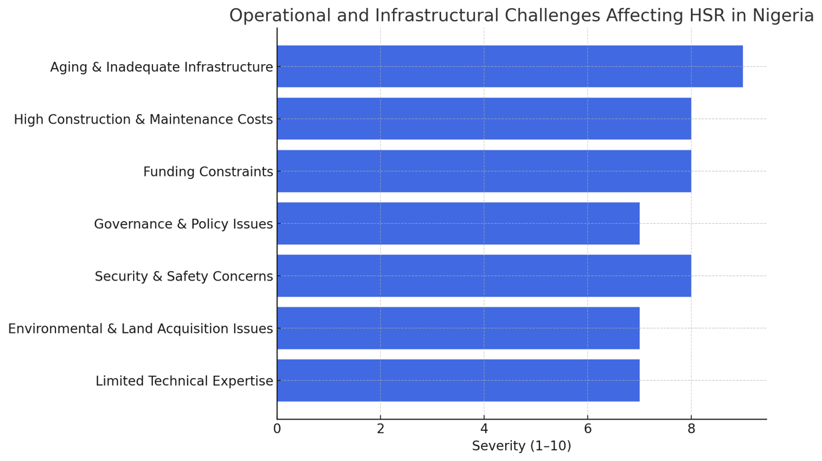
Figure 3
Key Operational and Infrastructural Challenges
Key Operational and Infrastructural Challenges – A visual summary of core barriers affecting Nigeria’s HSR implementation.
This figure illustrates how deeply embedded infrastructural, financial, institutional, and security issues collectively undermine the feasibility of launching and sustaining a high-speed rail system. The interconnected nature of these barriers also emphasizes the need for a systems-level response rather than piecemeal interventions.
These operational bottlenecks have deep historical roots in Nigeria’s underinvested rail sector. The country’s reliance on outdated rail stock, poor maintenance culture, and limited modernization has created a substantial execution gap compared to emerging economies like Morocco and India. In particular, bureaucratic inefficiencies and project delays—exacerbated by corruption and inconsistent regulatory frameworks—have discouraged investor participation and increased procurement costs.
The severity of these challenges also reflects Nigeria’s governance limitations in delivering large-scale transport infrastructure. For example, unresolved land acquisition disputes and unclear environmental regulations continue to delay rail corridor planning. Similarly, the lack of skilled domestic labor in HSR design and deployment perpetuates Nigeria’s dependence on foreign contractors, undermining long-term sustainability.
These factors not only prolong project timelines but also erode stakeholder confidence, raising risk premiums and reducing the attractiveness of Nigeria’s rail sector to private and institutional investors.

4.2 Strategic Opportunities for Successful Implementation of HSR
Several strategic opportunities emerged, including technological advancements (AI-based predictive maintenance), public-private partnerships (PPP), transit-oriented urban development, and sustainability initiatives aligning with Nigeria’s climate goals.
Table 4
Strategic Opportunities Enabling Successful HSR Implementation
Category | Description
Technological Innovations | AI-powered operations, automated signaling, and predictive maintenance
Public-Private Partnerships (PPP) | Co-financing, risk-sharing, and long-term asset investment mechanisms
Urban Development and Connectivity | Promotion of transit-oriented development and regional accessibility
Sustainable Transport Solutions | Green energy systems and low-emission infrastructure
Strategic opportunities for high-speed rail development in Nigeria, including technological, financial, and sustainability drivers. Author’s synthesis from literature and policy review.
These strategic enablers are also illustrated in the conceptual diagram below.
Figure 4
Strategic Opportunities for HSR Development
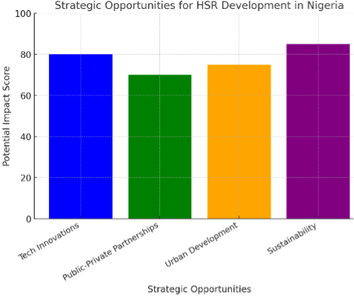
Strategic opportunities enabling high-speed rail adoption in Nigeria, including innovations and urban connectivity. Author’s visualization.
The figure highlights the multidimensional opportunities that can drive successful HSR implementation, ranging from advanced technologies to sustainable financing models and urban integration strategies.
Technological advances now allow for the integration of AI-based monitoring systems, real-time tracking, and smart rail diagnostics. These tools have reduced operational costs and improved safety in countries like China and South Korea and could be adopted in Nigeria through strategic procurement and international partnerships. Such technologies not only mitigate safety concerns but also support predictive maintenance, thereby extending the life cycle of rolling stock and infrastructure. Moreover, the potential for public-private partnerships (PPP) remains underutilized but promising. Models from Morocco’s Al-Boraq or India’s Dedicated Freight Corridor Corporation demonstrate how structured PPP frameworks can attract private capital while maintaining public oversight. Nigeria’s recent openness to PPP in energy and housing could be extended to rail infrastructure, especially along strategic economic corridors.
The growing demand for regional mobility and the pressure of urban sprawl also make HSR a tool for spatial transformation. Efficient intercity rail reduces urban congestion, encourages decentralization, and enhances connectivity between regional hubs. When integrated with city master plans, HSR infrastructure can anchor new economic zones, stimulate real estate, and incentivize industrial clusters.
From a climate perspective, high-speed rail presents an opportunity to decarbonize Nigeria’s transport sector. Transitioning from road-based freight to electrified rail systems would lower emissions while supporting the country’s climate action targets under the Paris Agreement and its Energy Transition Plan (ETP 2060).
In summary, Nigeria stands at a strategic inflexion point. Harnessing these opportunities, especially through coordinated policy, smart technologies, and investment frameworks, could reposition HSR not just as a transport project, but as a central driver of national development.

4.3 Economic Transformation Driven by HSR Expansion
High-speed rail (HSR) development in Nigeria has the potential to trigger far-reaching economic transformations. Drawing on global evidence, HSR projects typically yield substantial benefits in employment generation, trade facilitation, logistics efficiency, and tourism growth. These outcomes are maximized when rail corridors are integrated with economic zones, multimodal transport nodes, and urban planning frameworks.
Table 5A
Potential Economic Transformations
Category | Description
Job Creation and Industrial Growth | Labor demand in construction, maintenance, and rail-related manufacturing
Trade and Logistics Enhancement | Reduction in haulage time and cost across key supply chains
Foreign Direct Investment (FDI) | Capital inflows linked to large-scale infrastructure investment
Tourism and Service Growth | Increased intercity travel and hospitality sector activity
Anticipated economic transformation from HSR in Nigeria, highlighting employment, trade, FDI, and tourism impacts. Author’s synthesis.
To visually synthesize the key dimensions of these impacts, Figure 5 presents a conceptual framework illustrating how HSR supports economic growth across multiple sectors.
Figure 5
Potential Economic Transformations
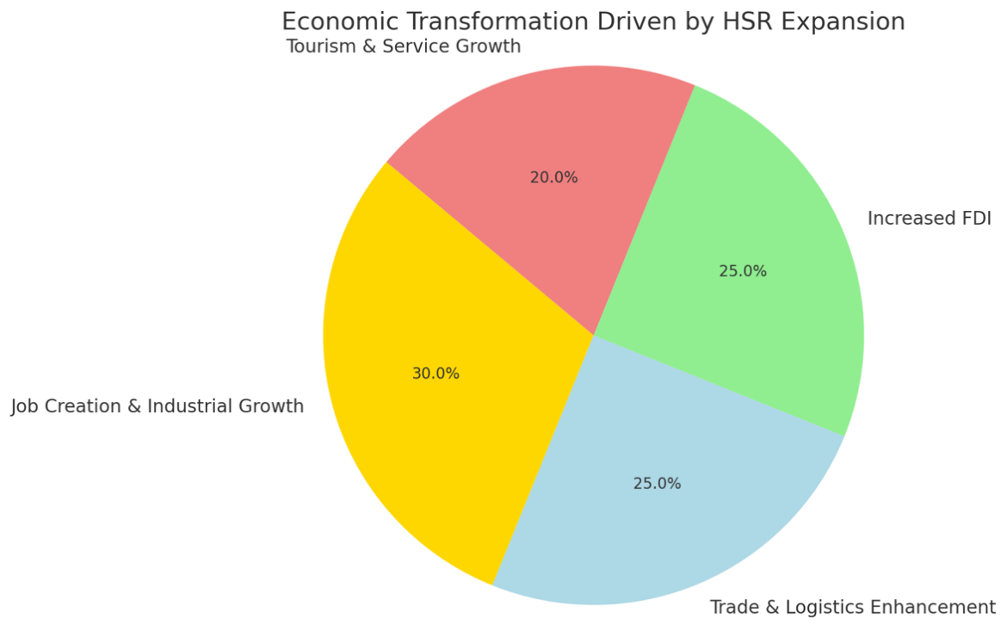
Potential Economic Transformations – graphic representation of expected macroeconomic benefits.
Building on these thematic categories, Table 5B presents projected economic outcomes, using institutional benchmarks to quantify the likely impact of high-speed rail development in Nigeria.
Table 5B
Projected Economic Impacts of HSR Implementation
Economic Indicator | Current Value | Projected Impact with HSR | Data Source
Employment Growth | 250,000 railway-related jobs (2023) | 1.2 million jobs by 2035 | Nigerian Railway Corporation, World Bank
Trade Volume Increase | $25 billion in road-based trade | $50 billion with HSR integration | African Development Bank
Urban Expansion Rate | 3.2% annual urban growth | 5.5% with efficient rail networks | National Bureau of Statistics
Logistics Cost Reduction | High due to poor roads | 35% reduction in freight costs | Lagos Chamber of Commerce
Projected economic outcomes of HSR implementation in Nigeria using sectoral indicators and secondary data. The author’s calculation is based on institutional sources.
Following the thematic and visual summaries, Table 5B quantifies the projected economic outcomes of high-speed rail implementation using institutional data and modelling benchmarks. These projections provide empirical support for the strategic value of HSR in Nigeria’s national development agenda.
One of the most immediate and measurable impacts is employment generation. The construction, operation, and maintenance of HSR infrastructure are expected to directly create over 1.2 million jobs by 2035, while indirectly stimulating employment in related sectors such as steel manufacturing, signalling systems, and real estate development. Trade and logistics are also poised for significant improvement. HSR corridors would reduce transit times and freight costs, enhancing the velocity of goods movement, particularly for perishable and time-sensitive products—and expanding regional market access. These efficiencies would support Nigeria’s deeper integration into continental trade frameworks, including the African Continental Free Trade Area (AfCFTA).
In terms of investment, large-scale, phased rail projects offer predictable, long-term revenue streams attractive to institutional investors. As demonstrated in countries like Morocco and China, the visibility and stability of HSR initiatives can catalyze foreign direct investment (FDI) in logistics, technology, and construction.
Finally, the tourism and services sectors are likely to benefit from improved intercity connectivity. High-speed links between commercial, cultural, and religious destinations could stimulate domestic travel, diversify service-sector revenue, and increase occupancy across Nigeria’s hospitality infrastructure.
These projections underscore the broader economic rationale for HSR investment, positioning the system as a strategic enabler of inclusive growth, industrialization, and regional integration.

4.4 Financing Models and Policy Frameworks for HSR Development
Sustainable financing models identified include PPPs, sovereign-backed infrastructure bonds, foreign direct investment, and multilateral funding mechanisms, coupled with stable regulatory frameworks.
Table 6
Financing Models and Policy Frameworks
Category | Description
Public-Private Partnerships (PPP) | Shared risk and investment between government and private sector
Government Funding & Subsidies | National budget allocation for public goods and services
Foreign Direct Investment (FDI) | Leveraging international partners for finance and expertise
Multilateral Loans and Grants | Accessing funding from the AfDB, World Bank, and IMF
Tax Incentives | Investment credits, tax holidays, and duty exemptions for rail developers
Legislative Frameworks | Stable, enforceable regulations to reduce investor uncertainty
Infrastructure Bonds | Mobilization of long-term domestic capital through bond markets
Railway Development Levies | Usage-based charges tied to freight or fuel to fund infrastructure
Financing mechanisms and regulatory models for HSR development in Nigeria. Synthesized from literature and policy frameworks. Author’s synthesis.
Following the overview of potential financing instruments and policy mechanisms in Table 6, it is clear that Nigeria’s traditional reliance on externally sourced public loans for infrastructure development is no longer sustainable. Fiscal constraints, rising debt-servicing obligations, and volatile oil revenues have diminished the government’s capacity to independently underwrite capital-intensive projects such as high-speed rail.
In this context, hybrid financing models—particularly public-private partnerships (PPPs) and sovereign-backed infrastructure bonds—offer viable alternatives to distribute financial risk and attract long-term capital. The Moroccan Al-Boraq project exemplifies this approach, successfully combining public funding with multilateral financing and international partnership support (African Development Bank, 2021). Nigeria could adapt this model by issuing infrastructure bonds targeted at domestic institutional investors, including pension funds, insurance firms, and diaspora capital markets. These instruments promote fiscal sustainability by aligning repayment schedules with infrastructure life cycles.
However, securing investment also requires institutional stability and regulatory clarity. Past infrastructure projects in Nigeria have been hindered by fragmented oversight, delays in approvals, and opaque procurement processes. To overcome these constraints, the establishment of an autonomous HSR development agency—equipped with clear mandates, fast-track regulatory mechanisms, and transparent governance—would be a critical step toward de-risking investment and improving stakeholder confidence.
Additionally, tax-based incentives can enhance private sector participation. Tools such as tax holidays, import duty exemptions on rail technology, and capital gains waivers for long-term investors—widely applied in countries like India and Brazil—can be replicated within Nigeria’s fiscal policy framework to promote rail sector growth.
Ultimately, financing high-speed rail in Nigeria requires more than capital—it demands institutional credibility, regulatory continuity, and innovative policy design. A blended model that integrates domestic resource mobilization, international partnerships, and investment-friendly regulation presents the most realistic pathway to implementation and sustainability.

4.5 Comparative Analysis of Nigeria’s Potential HSR System vs. Global Best Practices
To objectively evaluate Nigeria’s high-speed rail (HSR) potential, it is essential to draw comparative insights from global benchmarks. Countries such as Morocco, China, and Japan offer proven models of successful HSR implementation—each grounded in unique strategies across governance, financing, and technology integration.
Morocco’s Al-Boraq, launched in 2018, stands as Africa’s first operational HSR line. Developed through a structured public-private partnership (PPP), it mobilized $2 billion in funding from the Moroccan and French governments and multilateral lenders, including the African Development Bank (AfDB, 2021). The project halved travel time between Tangier and Casablanca, stimulated regional tourism, and created over 10,000 jobs (World Bank, 2022). Its success demonstrates the value of phased implementation, institutional coordination, and external capital mobilization.
China’s HSR expansion represents the most ambitious and policy-driven rail infrastructure program globally. Initiated in 2008, China’s network has grown to over 38,000 kilometers, supported by a state-led approach combining long-term infrastructure planning, centralized policy execution, and integration with regional economic corridors (Li et al., 2021). The Chinese model underscores the importance of sustained public investment, corridor-based economic planning, and bundled financing strategies, including land value capture and off-budget infrastructure bonds. For Nigeria, the lesson is clear: HSR should not be pursued as a stand-alone project but embedded in broader spatial and economic planning.
Japan’s Shinkansen, operational since 1964, offers a contrasting model built around operational efficiency, technological precision, and uncompromising safety standards. Its success is attributed to the use of fully dedicated standard-gauge tracks, autonomous rail agencies, and high investment in signalling and safety systems (Stow, 2003). Japan’s experience highlights the importance of infrastructure exclusivity—separating HSR from legacy freight and passenger lines—as well as institutional independence to ensure uninterrupted service quality. For Nigeria, this suggests the need to invest in new corridors rather than upgrading legacy lines, and to insulate rail agencies from political interference.
Together, these case studies illustrate that infrastructure outcomes are not solely determined by financial inputs or engineering capacity, but by strategic alignment of policy, regulation, and institutional design. These comparative insights are summarized in the table below.
Table 7
Comparative Analysis of Nigeria’s Potential HSR vs. Global Best Practices
Dimension | Global Best Practices | Nigeria’s Context | Lessons to Adapt
Infrastructure | Dedicated tracks, modern systems | Mixed-use legacy lines, slow modernization | Invest in new high-speed corridors
Funding Strategy | PPPs, sovereign funds, infrastructure bonds | Reliance on loans and government funds | Diversify financing and adopt phased PPP models
Technological Adoption | AI-based diagnostics, automation | Low integration of advanced technologies | Introduce smart rail technologies
Operational Efficiency | Real-time tracking, multimodal links | Frequent delays, fragmented connectivity | Build integrated, efficient rail hubs
Policy and Regulation | Transparent governance, legal continuity | Inconsistent policies, regulatory delays | Streamline and stabilize institutional frameworks
Economic Impact | Urban transformation, tourism growth, trade gains | Untapped urban-industrial potential | Align HSR with economic zoning and urban planning
Safety and Security | Advanced surveillance and rail policing systems | Vandalism, weak rail protection | Establish railway security units with smart monitoring
Environmental Strategy | Electrification, green transport | Limited eco-policy integration | Incorporate sustainability into HSR policy design
Comparative analysis of Nigeria’s HSR context versus global best practices in infrastructure, finance, technology, and governance. Author’s synthesis.
These international case studies affirm that successful infrastructure outcomes are not determined by engineering capacity alone, but by institutional coherence, strategic financing, and sustained political commitment. In each context—whether through Morocco’s coordinated PPP structure, China’s policy-driven expansion, or Japan’s dedicated infrastructure model—outcomes were shaped by long-term planning, clear governance, and integration with broader national objectives.
For Nigeria, translating these lessons into practice will require a deliberate shift away from fragmented governance and project-by-project planning. Instead, a systems-level approach—anchored in cross-sectoral coordination, regulatory consistency, and phased investment—will be essential for unlocking the full transformative potential of high-speed rail.
In summary, while Nigeria’s HSR initiative faces considerable structural and institutional challenges, the path forward lies in strategic adaptation. By aligning its ambitions with global best practices in regulation, financing, and spatial integration, Nigeria can position high-speed rail not merely as a transport solution, but as a foundational driver of national transformation.

5. Discussion

5.1 Synthesis and Comparison with Existing Literature
The findings of this study are consistent with global scholarship that highlights the transformative potential of high-speed rail (HSR) in driving regional integration, sustainable mobility, and economic competitiveness (Russo et al., 2023; Martí-Henneberg, 2013). Empirical parallels with countries such as China, Japan, and Morocco affirm the role of HSR in generating multiplier effects across employment, trade, and urban development. However, this study makes a distinct contribution by contextualizing these insights within Nigeria’s specific infrastructural, financial, and governance challenges—dimensions often underexplored in the literature.
The identification of persistent structural barriers—such as legacy infrastructure, fragmented regulatory oversight, and limited local technical capacity—extends prior research by emphasizing governance and institutional bottlenecks in developing economies (Olojede et al., 2023). Meanwhile, the study’s analysis of public-private partnerships (PPPs), AI-driven maintenance, and financing innovations aligns with recent findings from Li et al. (2021) and the African Development Bank (2021), affirming their transferability to the Nigerian context.

5.2 Theoretical Implications
This research advances infrastructure and transport economics literature by applying Central Place Theory (Christaller, 1933) and New Economic Geography (Krugman, 1991) to the case of Nigeria’s proposed HSR network. The study demonstrates how HSR investment can reshape urban hierarchies, facilitate industrial clustering, and integrate peripheral regions into national value chains. These theoretical frameworks are validated through cross-national comparisons, showing how spatial reorganization is catalyzed by reduced transit costs and increased intercity connectivity.
5.3 Practical Contributions
Practically, the study offers a blueprint for designing and financing a viable high-speed rail system in Nigeria. Key contributions include:
- A structured diagnostic of Nigeria’s operational and institutional weaknesses.
- An evidence-based rationale for blended financing instruments (e.g., infrastructure bonds, PPPs).
- Strategic guidance on aligning HSR with regional trade frameworks (e.g., AfCFTA, ECOWAS).
- Integration of predictive maintenance technologies and smart rail operations for long-term sustainability.
These insights serve not only academic audiences but also infrastructure planners, investors, and policymakers seeking data-driven strategies for national transport modernization.
5.4 Policy Alignment with National Transport Strategy
The study’s findings directly align with the priorities outlined in Nigeria’s National Transport Policy (2017), which emphasizes multimodal connectivity, private sector participation, and sustainable infrastructure delivery. By proposing dedicated HSR corridors, innovative financing instruments, and regionally integrated routes, this research reinforces key policy directives on enhancing intercity mobility, improving logistics performance, and attracting long-term investment into strategic transport assets. The practical recommendations also support Nigeria’s National Integrated Infrastructure Master Plan (NIIMP), which prioritizes rail expansion as a driver of economic diversification and inclusive growth.

5.4 Extending Current Understanding and Practice
This study extends existing knowledge by synthesizing global HSR lessons into a context-sensitive, actionable framework for Nigeria. It bridges the gap between abstract global models and the practical realities of a Sub-Saharan African megaproject environment. By combining empirical evidence with institutional and policy analysis, the research contributes a grounded, adaptable model for high-speed rail development in comparable low- and middle-income contexts.

6. Conclusion
This study has examined the feasibility and strategic value of implementing high-speed rail in Nigeria by analyzing five interrelated dimensions: operational challenges, strategic opportunities, economic impacts, financing models, and comparative best practices. It finds that while infrastructure and governance constraints are formidable, Nigeria stands to gain significantly from HSR if grounded in long-term planning, blended financing, and global policy adaptation.
Comparative insights from Morocco, China, and Japan reinforce the critical role of institutional alignment, corridor exclusivity, and phased capital deployment. The study also demonstrates that HSR is more than a transportation project—it is a national development catalyst capable of stimulating employment, boosting trade, improving regional connectivity, and driving sustainable urbanization.
Future research could build on this work by conducting feasibility simulations along priority corridors, evaluating public sentiment, or assessing carbon reduction potential under alternative energy scenarios. Ultimately, Nigeria’s success will depend on sustained political will, regulatory coherence, and a shift toward integrated, systems-based infrastructure development.

7. Recommendations
Based on thematic analysis and global benchmarking, the following actionable recommendations are proposed:
6.1 Develop Dedicated High-Speed Rail Corridors
Avoid shared-use infrastructure by constructing exclusive HSR corridors. Prioritize the Lagos–Kano and Port Harcourt–Abuja axes, integrated into a 20-year national master plan.
6.2 Issue Long-Term Infrastructure Bonds
Mobilize domestic institutional capital by issuing sovereign-backed infrastructure bonds with tax incentives. A semi-autonomous infrastructure agency should manage issuance and ensure transparency through milestone-based disbursement and investor reporting.
6.3 Integrate AI and Predictive Maintenance Technologies
Deploy AI-enabled systems for diagnostics, track surveillance, and maintenance forecasting. Incorporate digital ticketing, intelligent control rooms, and IoT sensors into rail design.
6.4 Align Rail Corridors with Regional Trade and Logistics
Embed HSR into regional trade frameworks (AfCFTA, ECOWAS) by connecting economic zones, ports, and customs stations. Design rail hubs to enable multimodal logistics.
6.5 Establish a National HSR Security and Surveillance Unit
Create a dedicated HSR protection unit using drone surveillance, biometric entry, and AI-based threat detection. Embed security-by-design into rail architecture and rolling stock.

Disclaimer (Artificial intelligence)
Author hereby declares that generative AI technologies such as Large Language Models were used during the editing and refinement of this manuscript. The following details are provided in compliance with ethical guidelines:
Details of the AI usage are given below:
- Technology Used: ChatGPT (GPT-4o)
- Provider: OpenAI (https://chat.openai.com)
- Model Version: GPT-4o, released May 2024
- Purpose: Assisting with editing, restructuring paragraphs, refining APA-style references, validating DOIs, and confirming in-text citation integrity.
- Prompts Provided: Examples include:
  - "Check if this reference is cited in the manuscript."
  - "Validate this DOI and update the APA format."

References
African Development Bank. (2021). Morocco’s Al Boraq high-speed rail project: Evaluation summary. African Development Bank Group. Retrieved from https://www.afdb.org/en/documents/morocco-al-boraq-high-speed-rail-project-evaluation-summary
Albalate, D., & Bel, G. (2012). High-speed rail: Lessons for policy makers from experiences abroad. Public Administration Review, 72(3), 336–349. https://doi.org/10.1111/j.1540-6210.2011.02492.x
Babatunde, I. A. (2020). The policy-institutional approach to transport failure in Nigeria. Open Access Library Journal, 7, e5996. https://doi.org/10.4236/oalib.1105996
Bouraima, M. B., Qiu, Y., Yusupov, B., & Ndjegwes, C. M. (2020). A study on the development strategy of the railway transportation system in the West African Economic and Monetary Union (WAEMU) based on the SWOT/AHP technique. Scientific african, 8, e00388.
Chi, F., & Han, H. (2023). The impact of high-speed rail on economic development: A county-level analysis. Land, 12(4), 874.
Christaller, W. (1933). Central places in Southern Germany (C. W. Baskin, Trans., 1966). Englewood Cliffs, NJ: Prentice-Hall.
Fajobi, T. A., & Muoghalu, C. O. (2022). Skill transfer in Sino-Nigerian rail transportation partnership: A quest for sustainability of the rail sub-sector in Nigeria. Organization and Human Capital Development (ORCADEV), 1(2), 34–50. https://doi.org/10.31098/orcadev.v1i2.1083
Huang, Y., & Zong, H. (2020). The spatial distribution and determinants of China’s high-speed train services. Transportation Research Part A: Policy and Practice, 142, 56–70. https://doi.org/10.1016/j.tra.2020.10.009
Krugman, P. (1991). Increasing returns and economic geography. Journal of Political Economy, 99(3), 483–499. https://doi.org/10.1086/261763
Li, H., Dong, X., Jiang, Q., & Dong, K. (2021). Policy analysis for high-speed rail in China: Evolution, evaluation, and expectation. Transport Policy, 106, 37-53.
Martí-Henneberg, J. (2013). European integration and national models for railway networks (1840–2010). Journal of Transport Geography, 26, 126–138. https://doi.org/10.1016/j.jtrangeo.2012.09.004
National Bureau of Statistics. (2023). Annual abstract of statistics: Urbanization and infrastructure. Retrieved from https://www.nigerianstat.gov.ng/
Nigerian Railway Corporation. (2003). Annual report on railway operations and freight volumes. Lagos: NRC.
Ogochukwu, C. G., Ogochukwu, O. F., Ogorchukwu, I. M., & Ebuka, I. A. (2022). Assessment of the performance of railway transportation in Nigeria from 1970 to 2010. Scientific African, 15, e01120.
World Bank. (2024). Greater Casablanca Passenger Mobility and Logistics Hub (P500964): Environmental and social impact assessment. https://documents1.worldbank.org/curated/en/099030524141510938/pdf/P5009641da2dbb0918d99139e741968158.pdf
Xu, F., Liu, Q., Zheng, X., Cao, L., & Yang, M. (2022). Research on the impact of China's high-speed rail opening on enterprise market power: Based on the perspective of market segmentation. Transport Policy, 128, 121–137. https://doi.org/10.1016/j.tranpol.2022.09.019

