**Smart Real-Time Electricity Monitoring and Remote Control System in Smart Homes**

***Abstract***

The rapid advancement of technology has significantly transformed modern living standards, driving an increasing demand for smart home automation solutions which are designed to optimize energy consumption, enhance user convenience, and provide remote controlling and monitoring capabilities. However, existing systems often suffer from high complexity, elevated costs, proprietary constraints, and incompatibility limiting their accessibility. This proposed project aims to develop an open-source, cost-effective, and user-friendly home automation system by integrating an Arduino microcontroller with a web-based control interface. The proposed system is designed to provide control household appliances, enhancing convenience and energy efficiency. By utilizing a wireless network, the system established a stable connection with the Arduino, demonstrating its effectiveness as a practical and accessible home automation solution. The final implementation successfully enabled remote control of household appliances through a mobile application, and web browser and automatically shut down any device whose consumption reaches a specific value. The accuracy of applying the new system to households reaches 98% and it is demonstrating improved performance as compared to existing systems. The project encourages smarter usage of electricity, reducing costs and therefore benefiting the environment.

***Keywords***

Arduino, Energy Efficiency, IoT, Mobile App, Real-Time Monitoring, Power Consumption, Smart Home

**1. Introduction**

Nowadays, it is a must for households to manage their energy usage more effectively. In many homes, people are unaware of which appliances consume the most electricity, leading to higher bills and unnecessary energy waste. This is particularly important in Egypt because energy shortages are common due to its high cost. Furthermore, there’s a growing need for more efficient energy use. As consequence, many researchers try to fill this gap by presenting many techniques to manage and control the usage of electricity in houses, buildings, or cities. Some researchers try to find more efficient ways for producing energy with less cost and eco-friendly [1] while others think of more efficient usage of energy in different sectors [2].

Some of the second type of researchers use smart appliances in a smart home, however, others attach sensors to appliances to measure the energy consumption and then inform the users to take action accordingly [3]. T.E Babalola et al in [4] develop smart sensors to monitor the weather in the environment, such as temperature and precipitation, then the sensed data is sent to the users through a website for monitoring only, with control over any device. L. Syafaah et al in [5] analyze the deployment of sensors in homes for power consumption monitoring and controlling. Many algorithms and models are produced to manage the usage by turning the appliances off if the consumption reaches a specific level [6-8].

[9] introduces a Radio Access Network (RAN)Intelligent Controller RIC power consumption model, which can be directly utilized to assess the system-level power consumption of RIC on different RAN site scenarios. A survey with the related works is presented by us in [10]. There are other works that focus on using sensors for monitoring other important energy forms, like Gas [11].

The main goal of this paper is to find a way to rationalize electricity consumption by informing individuals of their excess consumption and giving them the right to turn off lights or any electric device remotely through a simple mobile App or a website that anyone can understand. The proposed system has the following features:

* **Enable Real-Time Monitoring:** Provide users with real-time data on energy usage, including voltage, current, and power consumption.
* **Facilitate Remote Control:** Allow users to turn appliances on or off remotely using a mobile app or web interface.
* **Provide Alerts and Notifications:** Notify users when energy consumption exceeds set thresholds or if appliances are left on too long.
* **Promote Energy Efficiency:** Support users in making informed decisions that lead to reduced energy waste and lower bills.

A comparison is held between the proposed project and existing works in the same field. The difference between this project and others lies in the components that are used, which makes a better result in addition to more stability, more protection against electric damage, and higher scalability.

The paper is organized as follows: Section 2 illustrates the problem. Section 3 shows the methodology of the proposed project showing the hardware components used. Section 4 presents the findings and results of applying the project in a house and make it smart home and compares between it with other existing work. Section 5 concludes the project with future recommendation for expanding it.

**2. The problem Statement**

The problem that is intended to be solved in this project can be summarized in the following points:

* **High Energy Costs:** Users often face high electricity bills due to the lack of visibility and control over power usage.
* **No Real-Time Monitoring:** Many users lack tools to monitor their energy consumption in real time, making it hard to optimize and adjust usage quickly.
* **Inability to Control Devices Remotely:** Without remote access, appliances may be left on unintentionally, leading to wasted energy.
* **Lack of Data for Decision-Making:** Without usage data, users struggle to understand consumption patterns and take steps to save energy.

**3. The Methodology of the proposed project**

The proposed project uses sensors to track which devices are running and how much energy they use, then sends this data to users through a mobile application and a website for analysis and control. An automatic action can be taken once a reading reaches a specific limit by turning off that device. Besides, actions can also be taken by reducing the speed of fans, turning off lights if the light intensity reaches a threshold or shutting the air conditioning down if the outdoor temperature is a specific value. Furthermore, the mobile application helps users to disconnect the power of any device for any reason. Figure 1 shows the framework of the proposed system.

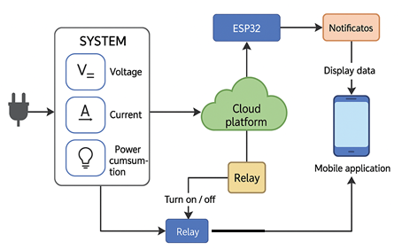

*Figure 1: Smart Real-Time Electricity monitor and control system framework*

***The main components of the proposed system***

* *Arduino Mega:* The Arduino Mega serves as the system’s central processing unit, handling the data provided from the sensors, executing commands, and communicating with other components. There are many types and versions, however, Arduino Mega is chosen over Arduino Uno due to its larger number of input/output (I/O) pins, allowing multiple devices and sensors to be connected simultaneously.
* *4-Channel Relay Module:* It acts as a switch, allowing the Arduino to control high-voltage devices safely. It provides electrical isolation, supports independent channel control, and ensures reliable switching between ON/OFF states.
* *Current Sensors:* The Current Sensor measures real-time current flow, enabling overload protection, energy monitoring, and signal output for precise control and analysis.
* *Voltage Sensor:* The Voltage Sensor measures real-time voltage levels, enabling monitoring, protection against fluctuations, and signal output for accurate analysis and control.
* *LCD Screen (1602A):*  It displays real-time data, which enhances user interaction. Besides it supports I2C for efficient communication and operates with low power consumption.
* *I2C Module for LCD:* it enhances communication efficiency by reducing wiring to two pins (SDA, SCL), enabling stable data transmission, multi-device connectivity, and optimized power usage.
* *ESP-01 Wi-Fi Module:* This module enables communication between the system and external applications over the internet, allowing users to control home devices remotely via a web interface or mobile app. It is highly efficient in data transmission and has low power consumption, making it an ideal choice for Internet of Things (IoT) applications.
* LEDs, Buttons, Wires: LEDs, Buttons, and Wires are essential components for system interaction and connectivity.
  + LEDs – Indicate system status, alerts, or active processes.
  + Buttons – Enable user input for control and configuration.
  + Wires – Facilitate reliable electrical connections between components.
* Loads (3 LEDs – 200W, 100W, 48W): Loads (3 LEDs – 200W, 100W, 48W) represent the electrical devices controlled by the system, simulating real-world power consumption.
  + 200W, 100W, 48W LEDs – Act as variable loads to test power management.
  + Energy Monitoring – Helps analyze consumption and efficiency.
  + System Testing – Validates relay and sensor functionality under different loads.
* **Thermistor (NTC 10kΩ):**

The 10 k Ω NTC thermistor measures ambient temperature and provides temperature-dependent resistance values. It is connected to one of the three loads, allowing temperature-based control (e.g., switching off a load if it overheats). This integration enhances the system's ability to manage loads based on environmental conditions, improving safety and efficiency.

* **LDR (Light Dependent Resistor, 3mm CDS):**

The 3mm LDR detects ambient light levels by varying its resistance with light intensity. It is connected to another load, enabling automatic control based on lighting conditions (e.g., turning a light on or off depending on the surrounding brightness). This improves energy savings and user convenience.

Figure 2 shows the final configuration of the complete circuit that monitors and controls the power inside a home.

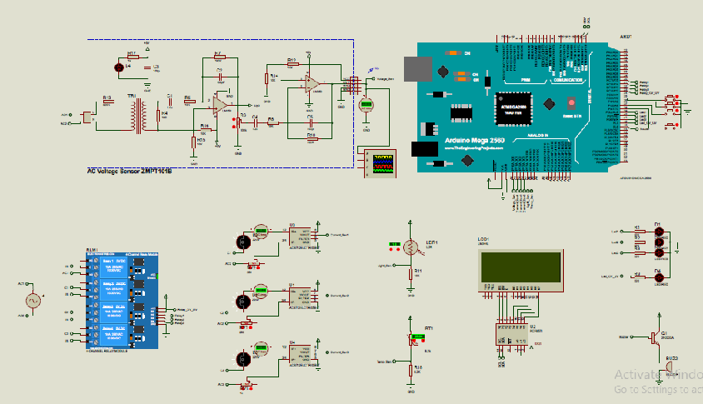*Figure 2: Configuration circuit for controlling and monitoring power consumption*

**4. Results and Discussion**

In this section, the configuration circuit of the proposed project is examined in several practical usage sessions under realistic conditions as discussed in the following subsections. Table 1 shows the basic metrics for the project.

*Table1: The basic metric for the project*

|  |  |
| --- | --- |
| **Metric** | **Result** |
| Voltage measurement accuracy | ±2% |
| Current measurement accuracy | ±10% |
| Temperature sensor accuracy | ±1°C |
| Light response sensitivity | Immediate (<1 sec) |
| Data update frequency | Every 2 seconds |
| Mobile app response time | < 2 seconds |
| Web interface response time | < 3 seconds |
| Number of devices controlled | 3 |
| Test sessions conducted | 4 |
| System uptime | 100% |

**4.1 Relationship Between Light Intensity and Lighting State**

Figure 3-A shows the relationship between ambient light intensity (in percentage) and the operational state of the lighting system. The system keeps the lights turned on ("1") when light intensity is below 30%, and automatically switches them off ("0") once the intensity exceeds this threshold. This control strategy helps optimize energy usage by utilizing natural light whenever possible to save power.

**4.2 Relationship Between Temperature and Air Conditioner State**

Figure 3-B shows the device's operating state (1 = ON, 0 = OFF) in relation to ambient temperature. The air conditioner remains ON at higher temperatures (above 26°C). Once the temperature drops to the threshold (25°C, for example), the device automatically switches OFF and stays off as the temperature continues to decrease in order to save power. This illustrates a basic temperature-based control mechanism, where the device autonomously turns off when the environment reaches a set threshold, optimizing energy use and preventing unnecessary operation, as shown in Figure 4.

**4.3 Power Consumption Distribution by Device Type**

Figure 3-C illustrates the instantaneous power usage (in watts) of three device categories—air conditioner, lighting, and other devices—over 10 minutes. This graph helps identify peak load periods, supporting more efficient energy management and scheduling. It is clear that:

* + The air conditioner (blue) operates at 200W for the first 6 minutes, then shuts off as the consumption increases.
  + Lighting (cyan) shows intermittent usage, alternating between 0W and 50W.
  + Other devices (orange) maintain a steady 100W, drop to 0W at minutes 7–8, then resume.
  + The highest total power consumption occurs at minute 5, reaching 350W, when all three device types are active.

|  |  |
| --- | --- |
| A | B |
| C | |

*Figure 3: The reaction of the proposed system to (A) the light intensity, (B) the temperature and (C) total consumed power*

* The pie chart in Figure 5 represents the distribution of power consumption among different types of devices as it appears to the users in the mobile application and website. The data shows that the air conditioner accounts for the largest share of energy usage at 60%, followed by other devices at 25%, and lighting at 15%. These results highlight the importance of optimizing air conditioner usage, which is the most energy-intensive. The goal is achieved through the intelligent control system presented in the previous graphs. The system is tested and the accuracy is measured and reaching 98%.

**4.4 A comparative analysis between the proposed system and existing works**

Table 2 shows briefly a comparison between the proposed system and existing works, which shows that the proposed project has higher accuracy and it is real-time which can save electricity and money.

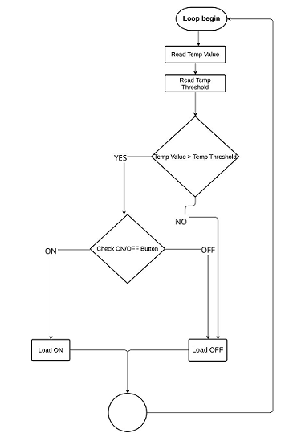

*Figure 4: Smart Real-Time Electricity monitor and control system flowchart*

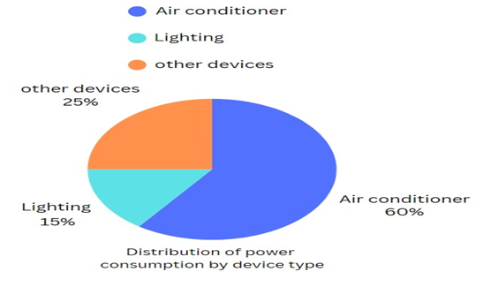

*Figure 5: Pie chart for the power consumption as appears in the designed mobile application*

*Table 2: A comparison between the proposed system and existing works*

|  |  |  |
| --- | --- | --- |
| **Comparison Criteria** | **Existing works** | **The proposed system** |
| Electrical monitoring | Current & voltage only [12] | Current, voltage, power, temp, light |
| Remote control interface | Web-based only [13] | Mobile app + Web |
| Environmental awareness | Limited or missing [14] | Temperature & light sensors |
| User interface variety | Single interface | Dual (App + Web) |
| System response time | 3-5 seconds [15] | < 2s (App), < 2.5s (Web) |
| Notification system | Sometimes | Yes, with threshold alerts |
| Testing environment | Simulated/lab-based | Home-like (4 sessions) |
| System uptime | Not always reported | 100% |
| Control capacity | 2-3 devices | 3 devices |
| Ease of scalability | Limited [16] | High |
| Accuracy | Average accuracy ~90% | 98% |

***5. Conclusion***

To help people understand their energy consumption, this smart system encourages smarter use of electricity, reducing costs and benefiting the environment. It’s a practical solution to help society save electricity and money. The new system provides a user-friendly interface and insightful analytics. It is a timely and relevant solution for managing household energy consumption using IoT and an Embedded system. It emphasizes on the relevance of IoT integration, energy efficiency, and safety of the system. By adding the sensors to the appliances and connecting the hardware system to the designed mobile application and Website, it is found that the system reacts perfectly with all designed criteria under different conditions. The idea can be applied in wider ranges in factories, hospitals, and all vital places for preventing power overconsumption.

Disclaimer (Artificial intelligence)

Option 1:

Author(s) hereby declare that NO generative AI technologies such as Large Language Models (ChatGPT, COPILOT, etc.) and text-to-image generators have been used during the writing or editing of this manuscript.

Option 2:

Author(s) hereby declare that generative AI technologies such as Large Language Models, etc. have been used during the writing or editing of manuscripts. This explanation will include the name, version, model, and source of the generative AI technology and as well as all input prompts provided to the generative AI technology

Details of the AI usage are given below:

1.

2.

3.

***References***

[1] O. Elbaksawi, N. A.S. Elminshawy, S. Diab, A. M. Eltamaly, A. Mahmoud, H. Elhadidy,” Innovative metaheuristic algorithm with comparative analysis of MPPT for 5.5 kW floating photovoltaic system,” Process Safety and Environmental Protection, 185 (2024) 1072–1088. <https://doi.org/10.1016/j.psep.2024.03.082>.

[2] Sh. S. Shanto, M. Rahman, J. Md. Oasik and H. Hossain,” Smart Greenhouse Monitoring System Using Blynk IoT App,” Journal of Engineering Research and Reports, Volume 25, Issue 2, Page 94-107, 2023; Article no. JERR.100213. ISSN: 2582-2926.

[3] A. T. Suryanto, B. S. Aprillia and C. E. Putri,” Control System for Smart Home Energy Management,” IOP Conference Series: Materials Science and Engineering, Vol. 982, 2020.

[4] ] T. E. Babalola, A. D. Babalola and M. S. Olokun,” Development of IOT Device for Sensing Weather and Environmental Pollutants,” Journal of Engineering Research and Reports 21(6): 29-40, 2021; Article no. JERR.76192, ISSN: 2582-2926.

[5] L. Syafaah, A. E. Minarno, F. D. S. Sumadi and G. W. Mukti,” Distance Measurement of ESP8266 for Smart Home Monitoring,” Journal of Physics: Conference Series, Vol. 1381, 2019.

[6] V. Nandhini, K. Bharathi, Shivam Giri, S. Sowvav and A. Suyampulingam,” Energy Management and Smart Control of Home Appliances,” Journal of Physics: Conference Series, Vol. 1706, 2020.

[7] M. Sh. Yahyaa, B. Muhammad, M. A. Abubakara, U. I. Abdullahib and Z. I. Musa,” Implementation of a Real-Time IoT Based Energy Management System.” Journal of Engineering Research and Reports, Volume 25, Issue 10, Page 19-29, 2023; Article no.JERR.107232 ISSN: 2582-2926.

[8] M. Aminu, A. Yerima, A. Salisu and A. Adamu,” Design and Implementation of an IOT Based Smart Home Monitoring and Control System Using NodeMCU,” Journal of Engineering Research and Reports, Volume 25, Issue 2, Page 78-88, 2023; Article no.JERR.99771 ISSN: 2582-2926

[9] J. P. S. H. Lima, G. N. Katsaros, R. Tafazolli and K. Nikitopoulos, "A Measurement-Based Power Consumption Model for Networks With Intelligent Control (RIC)," in IEEE Open Journal of the Communications Society, vol. 6, pp. 2017-2031, 2025, doi: 10.1109/OJCOMS.2025.3548430.

[10] H. Elhadidy, S. Eltahan, T Hamed, H. Badran, J. Ramez, M. Masoud, Y. Abdelfattah, M. Khaled, M. Elgabrony, M. Elkefafy, A. Essam, M. Hassan, E. Atef,” A systematic literature review of Smart Power Monitoring and Controlling Systems for smart homes,” Journal of Engineering Research and Reports, Vol. 27, Issue 4, PP. 438-445, 2025 ISSN: 2582-2926.

[11] Liu, Hongyu; Wang, Yuchen; Yu, Jiankang; Wang, Shuqing; Chen, Huijuan,” Design and Implementation of an Ultra-Low-Power Hazardous Gas Monitoring System,” Sensors, volume 25, Issue 8, 2025, DOI10.3390/s25082458

[12] K. O. Kadiri, A. M. Jamiu and A O. Abdulsalam, “Development of an Intelligent Smart Hub Renewable Generation System (ISHRGS) for both Urban and Rural Centres in Offa, Kwara State,” Journal of Engineering Research and Reports, 23(2): 7-18, 2022; Article no. JERR.90459, ISSN: 2582-2926.

[13] I. M. Nayyef and A. A. Husein,” Design and Implementation of IoT-Based Smart Power Monitoring and Management System Using WSNS,” International Journal of Embedded Systems and Applications (IJESA), Vol. 8, Issue 4, December 2018. DOI: 10.5121/ijesa.2018.8401

[14] T. T. Olufemi and O. O. Akinwole,” Application of Internet of Things (IoT) in Nigerian Power Grid Management,” Journal of Engineering Research and Reports, Volume 25, Issue 2, Page 89-93, 2023; Article no.JERR.99602 ISSN: 2582-2926.

[15] K. I. Anyanor, M. U. Efoke and J. P. I. Iloh,” An Enhanced Intelligent Facts Device for Reductionof Losses on Power Lines,” Journal of Engineering Research and Reports, 22(9): 22-33, 2022;Article no.JERR.86904 ISSN: 2582-2926

[16] Sh. S. Shanto, M. Rahman, J. Md. Oasik and H. Hossain,” Smart Greenhouse Monitoring System Using Blynk IoT App,” Journal of Engineering Research and Reports, Volume 25, Issue 2, Page 94-107, 2023; Article no. JERR.100213. ISSN: 2582-2926.