Original Research Article

An Experimental Study on the Effect of Foamed Concrete Bulk Density on its Thermal and Mechanical Properties

ABSTRACT
Foamed concrete is considered a lightweight thermal insulation material due to its air-filled cellular structure, which helps reduce dead loads on structures and save energy. It is produced by introducing a foaming agent that generates air bubbles into the cementitious mortar. The entrained air bubbles reduce the bulk density of the mortar, resulting in lightweight and thermally insulating foamed concrete.
This research aims to investigate the relationship between the bulk density of foamed concrete and its thermal properties—specifically thermal conductivity and thermal resistance—as well as its mechanical properties, with a focus on compressive strength. Additionally, the study seeks to establish mathematical correlations between these parameters. An experimental study was conducted on lightweight foamed concrete samples with dry bulk densities below 800 kg/m³. Ten foamed concrete mixtures were prepared using a synthetic foam generator with a fixed cement content of 350 kg/m³. The mix proportions were adjusted to achieve varying bulk densities by altering the water-to-cement ratio (W/C), foaming agent-to-cement ratio (F/C), and sand-to-cement ratio (S/C). Various tests were performed to determine the physical, thermal, and mechanical properties of the foamed concrete, including dry bulk density, thermal conductivity coefficient, thermal resistance, and compressive strength.
At the end of this research, the relationships between dry bulk density, thermal conductivity and compressive strength of foamed concrete were established.

Keywords: Foamed Concrete, Foaming Agent, Thermal Conductivity, Thermal Insulation, compressive strength.

1. Introduction
Due to urban expansion and the increasing number of residential buildings, energy consumption in the domestic sector has risen significantly, particularly for heating and cooling purposes. In some countries, building energy consumption exceeds 35% of total energy consumption [3]. Consequently, energy conservation in buildings has become a topic of great contemporary interest.
The use of thermal insulation materials in construction is one of the most cost-effective approaches to reducing energy consumption [2]. Many countries have implemented solutions involving insulation materials [3]. Constructing buildings with thermally insulating materials decreases fuel consumption and provides savings in electrical energy used for heating and cooling, thereby contributing to the preservation of national resources.
Various materials have been used for thermal insulation, including foamed concrete. However, foamed concrete was not widely adopted as a thermal insulation material for an extended period due to limited awareness of its reliability and exceptional insulating properties. These properties stem from its low bulk density, which results from its air-filled cellular structure [4].
Foamed concrete is a mixture of sand, cement, and water (the base mixture) along with preformed foam, which itself consists of a foaming agent, water, and air. Incorporating preformed foam into the base mixture generates air voids in the material's microstructure, reducing its bulk density. Increasing the foam content yields a lighter material [1,4,5,6,15].
In addition to its thermal insulation properties, foamed concrete exhibits other significant characteristics, including sound insulation and lightweight properties, which reduce dead loads on structures [7]. It also demonstrates high resistance to frost, fire, and seismic activity [1,4,5,7,8].
Notably, foamed concrete contains an air content ranging from 10% to 70%, contributing to its lightweight nature and thermal resistance. However, this high air content reduces its compressive strength and durability [7]. Therefore, it is essential to investigate the relationship between these competing properties especially for low densities.
While foamed concrete insulation is well-characterized at standard densities (1000-1600 kg/m³) [16], recent studies [14] reveal persistent challenges in predicting performance at ultra-low densities (< 800 kg/m³).
Our study mitigates these gaps by investigating the relationship between the dry bulk density of foamed concrete and its thermal and mechanical properties, focusing on lightweight foamed concrete samples with dry bulk densities below 800 kg/m³. The findings will contribute to optimizing the production of lightweight, thermally insulating foamed concrete.

2. Research Objective:
This study aims to investigate the relationship between the dry bulk density and the thermal properties of foamed concrete, specifically examining the thermal conductivity coefficient (λ) and thermal resistance (R), as well as its mechanical properties, with particular focus on compressive strength (R_{C}). These relationships will be expressed in the following forms:
$$=f\left(d\right), Rc=f\left(d\right)$$
Where:
- ρ_{d}: Dry density of foamed concrete (kg/m³)
- λ: Thermal conductivity coefficient (W/m·°C)
- R_{C}: compressive strength (MPa)
3. Research Significance:
The significance of this research lies in developing a deeper understanding of how foamed concrete properties influence each other. It is crucial to identify and interpret the relationships between the dry density (ρ_{d}) of foamed concrete and its:Thermal conductivity (λ), Thermal resistance (R) and compressive strength (R_{C}).
This understanding will enable better control of lightweight foamed concrete production technology for dry bulk densities below 800 kg/m³, allowing its manufacture according to international standards for thermal insulation applications. The study will thus provide new, economical construction techniques that align with global technological advancements in building materials.
4. A Literature Review on Thermally Insulating Foamed Concrete:
Generally, thermal insulation materials are lightweight and porous, and can be classified into two categories: organic insulation materials and inorganic insulation materials. In recent decades, organic insulation materials were widely used due to their advantages such as recyclability and natural resource conservation. However, they pose fire safety concerns, requiring caution during use because of their flammability risk in case of fire [3].
Consequently, there has been a gradual shift toward using inorganic insulation materials to replace organic ones in building exterior insulation. Foamed concrete is considered one of the inorganic thermal insulation materials and is a lightweight product. For these two reasons, foamed concrete has become widely used in construction and housing applications [8], as it helps reduce dead loads on structures and conserve energy [7].
Foamed concrete is defined as cellular or aerated concrete, where the cellular structure is created by introducing air voids. These voids result either from gases released through chemical reactions with the cementitious mortar [9] or from mechanical aeration of air with a foaming agent diluted in water at specific ratios [10,11]. Therefore, foamed concrete can be classified as a material with closed-cell structures, which contributes to its thermal insulation properties [4].
Materials with cellular (porous) structures featuring closed cells are classified as thermal insulators [12]. More specifically, introducing air voids into foamed concrete reduces its thermal conductivity because these air voids, known as closed cells, trap air inside and prevent its movement, thereby inhibiting heat flow. This results in a slower rate of heat transfer through the material. The trapped air within the bubbles gives foamed concrete higher thermal resistance, since air has lower thermal conductivity than concrete [4,15].
According to reference [13], foamed concrete can be used for thermal insulation purposes if it achieves a bulk density below 1450 kg/m³ and a compressive strength of at least 0.5 MPa.
Due to the distinctive properties of foamed concrete, including its low bulk density, weak thermal conductivity, high flowability, ease of manufacturing, and relatively low production cost, it has been used in many civil and structural engineering applications. Generally, low-density foamed concrete is used as cavity fill and for thermal insulation works, while high-density foamed concrete is used in structural applications [6,16].
Specifically, foamed concrete elements with a bulk density greater than 1600 kg/m³ are considered load-bearing structural elements in buildings, whereas those with a bulk density less than 1600 kg/m³ are mainly used as non-load-bearing elements such as fillers and internal partitions [5].
Despite extensive research on foamed concrete, recent reviews [14] highlight persistent challenges in predicting mechanical-thermal performance at ultra-low densities (<800 kg/m³), particularly due to inconsistent pore structure characterization and lack of standardized testing protocols for this density range.
5. Materials and Methods of the Research:
This research follows an experimental methodology where foamed concrete samples were manufactured in the Materials Testing Laboratory of the Faculty of Civil Engineering at Tishreen University. The samples were produced by mixing the construction materials used in foamed concrete production using a foamed concrete mixing machine. Laboratory tests were then conducted on the manufactured samples, building upon previous studies and experiments that examined foamed concrete and its production.
The research also employs an analytical approach, where the results were analyzed to establish the relationship between the dry bulk density of foamed concrete and each of the following properties: thermal conductivity, thermal resistance, and mechanical compressive strength of the foamed concrete samples.

The following materials were used in preparing the foamed concrete mixtures along with their characteristics:
- Ordinary Portland cement Type I: Class 32.5, produced by Tartous Cement Factory.
- Mixing water: Potable water.
- Sand: Fine sand with fineness modulus of 1.16 (MF=1.16) from Latakia quarries, having a sand equivalent of 88.11% (ES=88.11). The particle size distribution is shown in Figure (1).

Figure (1): Particle Size Distribution Curve of the Sand Used and Standard Specification Limits According to ASTM (American Society for Testing and Materials) Standards

- Foaming Agent: The foaming agent used is a synthetic polymer-based foaming agent compliant with ASTM C-86 standards. This agent appears as a transparent, light brown liquid that mixes instantly with water. Its specific gravity ranges between [1.02 - 1.04] at 25°C, with a freezing point between [3-5]°C. The agent is compatible with all types of Portland cement. Prior to use, it must be diluted at a ratio of 100 parts water to 1 part foaming agent.
6. Formulation of Foamed Concrete Mixes:
Ten mix designs were prepared with a fixed cement content of 350 kg/m³, with varying mix proportions to achieve different foamed concrete densities. In Mix A, constant ratios were maintained: water-to-cement ratio (W/C) = 0.56, sand-to-cement ratio (S/C) = 0.25, and foaming agent-to-cement ratio (F/C) = 0.011.
For the subsequent three mixes (B, C, D), the foaming agent-to-cement ratio was varied as F/C = {0.008, 0.015, 0.02}, while maintaining constant W/C = 0.56 and S/C = 0.25.
The following three mixes (E, F, G) examined variations in water-to-cement ratio with W/C = {0.47, 0.53, 0.58}, while keeping F/C = 0.011 and S/C = 0.25 fixed.
Finally, the last three mixes (H, I, J) investigated changes in sand-to-cement ratio with S/C = {0, 0.285, 0.333}, while maintaining constant F/C = 0.011 and W/C = 0.56.
The complete mix proportions for all foamed concrete formulations are presented in Table (1).

Table (1): Mix Proportions of Foamed Concrete

Sand-to-Cement Ratio  S/C | Synthetic Polymer-Based Foaming Agent-to-Cement Ratio  F/C | Water-to-Cement Ratio  W/C | Sand Weight (g) | Foaming Agent Weight (g) | Water Weight (g) | Cement Weight  (g) | Mix Name
0.25 | 0.011 | 0.56 | 250 | 11 | 560 | 1000 | A
0.25 | 0.008 | 0.56 | 250 | 8 | 560 | 1000 | B
0.25 | 0.015 | 0.56 | 250 | 15 | 560 | 1000 | C
0.25 | 0.02 | 0.56 | 250 | 20 | 560 | 1000 | D
0.25 | 0.011 | 0.47 | 250 | 11 | 470 | 1000 | E
0.25 | 0.011 | 0.53 | 250 | 11 | 530 | 1000 | F
0.25 | 0.011 | 0.58 | 250 | 11 | 580 | 1000 | G
0 | 0.011 | 0.56 | 0 | 11 | 560 | 1000 | H
0.285 | 0.011 | 0.56 | 285 | 11 | 560 | 1000 | I
0.333 | 0.011 | 0.56 | 333 | 11 | 560 | 1000 | J

7. Preparation of Test Specimens and Testing Protocol:
The materials described previously were used to prepare and cast the foamed concrete specimens. All mixtures were cast using the preformed foam method for foamed concrete production, following the specified sequence:
- The water and foaming agent were mixed according to the values specified in the table for each mixture, following precise weighing of both components using an electronic balance. The mixing process was conducted in the Materials Testing Laboratory using a foamed concrete mixing apparatus for 120 seconds at a rotational speed of 900 rpm to generate homogeneous foam, as illustrated in Figure (2).
- The cement and sand were precisely weighed according to the values specified in Table (1) for each mixture. These components were then separately added to the preformed foam. The mixing process was carried out for 180 seconds (T=180 sec) at a rotational speed of 900 rpm (V=900 rpm) to obtain a homogeneous foamed concrete mixture with a fluid consistency, as shown in Figure (3).
- Steel prismatic molds measuring 4×4×16 cm³ were prepared, cleaned, and lubricated for testing wet/dry bulk density and compressive strength. Six prismatic specimens of fresh foamed concrete were cast for each mix design. Additionally, two specimens per mix were cast in molds measuring 20×30×5 cm³ for thermal conductivity testing. All molds were carefully filled in a single pour and their surfaces were leveled.
- The specimens remained in their molds for 24 hours, after which the molds were removed and the specimens were labeled. The samples were then cured in a humid air environment for 28 days, placed on a metal mesh positioned above a water tank. Figure (4) shows the hardened foamed concrete specimens from one of the mixes after demolding.

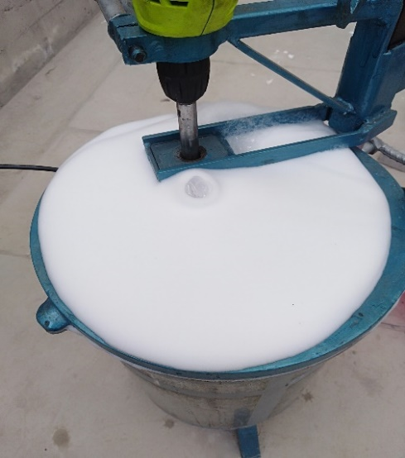 | 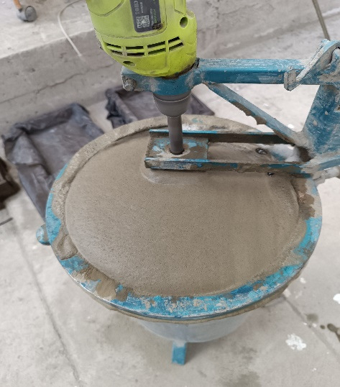
Figure (2): Foam Formation Process | Figure (3): Fresh Consistency of Foamed Concrete

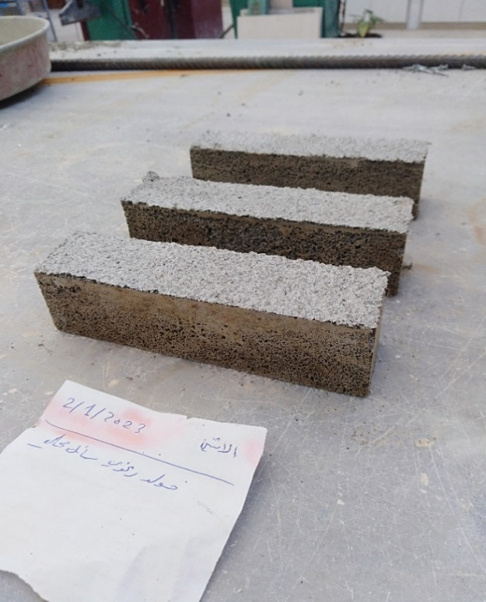 | 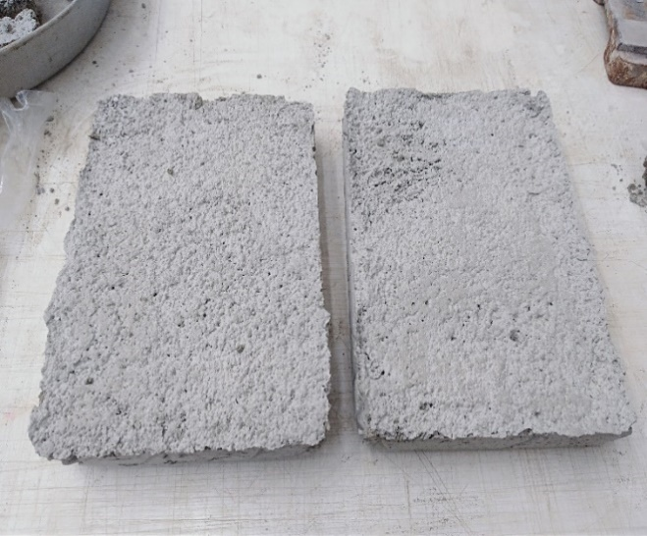
Figure (4): Hardened Foamed Concrete Specimens After Demolding

A series of tests were conducted on the prepared foamed concrete specimens from different concrete mixes, including dry density, compressive strength, and thermal conductivity.
For the compressive strength test, the procedure was conducted following the flexural tensile strength test on the aforementioned prismatic specimens. Each specimen was divided into two halves, and compressive testing was subsequently performed on each half using the compression testing machine available in the Materials Testing Laboratory of the Faculty of Civil Engineering. The specimen halves were positioned between the loading plates of the testing machine, and a continuously applied compressive load was imposed until failure.
For the thermal conductivity test, the flat slab specimens (20×30×5 cm³) were cut into two identical samples (15×20×5 cm³ each) to determine the thermal conductivity coefficient (λ) and subsequently calculate the thermal resistance (R).
The thermal insulation test was performed by placing the specimens over a heat source with specific orientation: the bottom surface received direct thermal exposure while the top surface remained at ambient environmental conditions
The specimens underwent this testing protocol for three hours. During the exposure period, surface temperatures were measured at both the heated and air-exposed surfaces using a laser thermometer. Temperature readings were taken three times at each surface, and the arithmetic mean was calculated for both temperature measurements.
The thermal conductivity coefficient (λ) was calculated using the following formula:
λ = (Q × L) / (A × ΔT)
[Unit: W/m·°C]
Where:
- Q represents the heat transfer quantity, measured in Watts (W)
- L denotes the specimen thickness through which heat transfers, measured in meters (m)
- A indicates the cross-sectional area for heat transfer, measured in square meters (m²)
- ΔT is the temperature difference (between temperatures T₁ and T₂), measured in either Celsius (°C) or Kelvin (K)
The thermal resistivity (R), defined as the reciprocal of the thermal conductivity coefficient, was determined using:
R = 1/λ
[Unit: m·°C/W]
Where:
λ represents the thermal conductivity coefficient with units of W/m·°C.
8. Results and Discussion:
Table (2) shows the test results of the studied mixtures. Each wet density value represents the average of three identical samples from one mixture, and the same applies to the dry density values. For the compressive strength values, each value represents the average of six identical samples from one mixture. Regarding the thermal conductivity coefficient values, each value represents the average of four identical samples from one mixture, and the same applies to the thermal resistance values.
After reviewing the mixture results, it was found that:
Mixture D, prepared with the following mix proportions (F/C=0.02, W/C=0.56, S/C=0.25), achieved: The lowest dry density value (ρd=343 kg/m³), The lowest thermal conductivity coefficient value (λ=0.069 W/m·°C) and a compressive strength of RC=0.37 MPa.
Mixture E, prepared with the following mix proportions (F/C=0.011, W/C=0.47, S/C=0.25), achieved: The highest dry density value (ρd=725 kg/m³), The highest thermal conductivity coefficient value (λ=0.166 W/m·°C) and a compressive strength of RC=2.81 MPa.

Table (2): Test Results of the Investigated Foamed Concrete Mixes
Thermal Resistance  (m.ºC/w) | Thermal Conductivity Coefficient  (W/m.°C) | Compressive Strength (Mpa) | Dry Density (kg/m³) | Wet Density (kg/m³) | Sand-to-Cement Ratio S/C | Foaming Agent-to-Cement Ratio  F/C | Water-to-Cement Ratio  W/C | Mix Name
7.865 | 0.127 | 1.22 | 606 | 676 | 0.25 | 0.011 | 0.56 | A
6.513 | 0.153 | 2.58 | 700 | 776 | 0.25 | 0.008 | 0.56 | B
10.461 | 0.095 | 0.7 | 466 | 544 | 0.25 | 0.015 | 0.56 | C
14.356 | 0.069 | 0.37 | 343 | 425 | 0.25 | 0.02 | 0.56 | D
5.996 | 0.166 | 2.81 | 725 | 800 | 0.25 | 0.011 | 0.47 | E
6.957 | 0.143 | 1.60 | 653 | 730 | 0.25 | 0.011 | 0.53 | F
8.548 | 0.116 | 0.96 | 544 | 625 | 0.25 | 0.011 | 0.58 | G
9.890 | 0.101 | 0.83 | 497 | 575 | 0 | 0.011 | 0.56 | H
7.189 | 0.139 | 1.36 | 626 | 701 | 0.285 | 0.011 | 0.56 | I
6.868 | 0.145 | 1.64 | 661 | 735 | 0.333 | 0.011 | 0.56 | J

8.1 Relationship Between Dry Density (ρd) and Thermal Conductivity Coefficient (λ) of Foamed Concrete:
The thermal conductivity coefficient of foamed concrete was observed to increase from 0.069 W/m·°C to 0.166 W/m·°C as the dry density increased from 343 kg/m³ to 725 kg/m³. This represents a 140.57% increase in thermal conductivity corresponding to a 111.3% increase in dry density. Figure (5) demonstrates this relationship through a proportional curve, indicating a direct correlation between dry density (ρd) and thermal conductivity coefficient (λ) of foamed concrete. The results clearly show that higher dry density values correspond to increased thermal conductivity coefficients.
This phenomenon can be attributed to the fact that lower dry density values indicate a greater volume of air voids in the mixture. Since air serves as an effective thermal insulator - with a thermal conductivity coefficient significantly lower than that of concrete - this results in reduced overall thermal conductivity of the samples [4,7]. Figure (5) illustrates that the minimum dry density (ρd=343 kg/m³) corresponds to the lowest thermal conductivity coefficient (λ=0.069 W/m·°C), achieved by Mix D with the following proportions: (F/C=0.02, W/C=0.56, S/C=0.25). The high foaming agent content (F/C=0.02), being the maximum experimental ratio used, explains the reduced dry density, as increased foaming agent quantity leads to greater air void formation in the mixture, consequently decreasing both density and thermal conductivity, in agreement with previous research findings [7].
Furthermore, Figure (5) presents the mathematical relationship between dry density (ρd) and thermal conductivity coefficient (λ) as a first-degree linear equation with a correlation coefficient of R²=0.98, demonstrating a strong positive correlation between these parameters.

Figure (5): Relationship Between Dry Density (ρd) and Thermal Conductivity Coefficient (λ) of Foamed Concrete

8.2 Relationship Between Dry Density (ρd) and Compressive Strength (RC) of Foamed Concrete:
Figure (6) shows that the lowest dry density (ρd=343 kg/m³) corresponds to a 28-day compressive strength of RC=0.37 MPa, while the highest dry density (ρd=725 kg/m³) corresponds to a 28-day compressive strength of RC=2.81 MPa. A decrease in dry density values from 725 kg/m³ to 343 kg/m³ resulted in a reduction of 28-day compressive strength values from 2.81 MPa to 0.37 MPa, meaning a 52.6% decrease in dry density values led to an 86.8% decrease in compressive strength values.
Figure (6) also shows the relationship between dry density (ρd) and compressive strength (RC) with a correlation coefficient of R²=0.94. As dry density values of foamed concrete decrease, the corresponding compressive strength values also decrease. This results from increased air bubbles generated by the foaming agent in foamed concrete - as the foaming agent content in the mixture increases, the volume of air voids increases, leading to decreased density and reduced volume of binding paste, which consequently lowers compressive strength. These findings align with the fundamental principles of foamed concrete mix design [1,4,5,6].

Figure (6): Relationship Between Dry Density (ρd) and Compressive Strength (Rc) of Foamed Concrete

9. Conclusions and Recommendations:
- The study successfully produced lightweight, thermally insulating foamed concrete with varying dry densities ranging from 343 to 725 kg/m³. The developed material exhibited thermal conductivity coefficients between 0.069 and 0.166 W/m·°C and compressive strengths ranging from 0.37 to 2.81 MPa, achieved using a Synthetic Polymer-Based Foaming Agent.
- The increase in dry density values significantly affected the thermal properties of foamed concrete, with thermal conductivity coefficient values increasing by 140.57% when dry density values increased by 111.3%.
- A clear correlation was observed between dry density values and compressive strength values of foamed concrete samples, where a 52.6% decrease in dry density values resulted in an 86.8% decrease in compressive strength values.
- The research derived empirical mathematical relationships connecting the physical, mechanical, and thermal properties of foamed concrete, including dry density (ρd), compressive strength (RC), and thermal conductivity coefficient (λ). These relationships were established through comprehensive experimental testing and data analysis, demonstrating consistent correlations between the key material parameters. The developed equations enable accurate prediction of foamed concrete behavior based on its density characteristics, providing valuable tools for material design and performance optimization in construction applications. All relationships were validated within the experimental density range of 343-725 kg/m³.
- It is recommended to investigate the effect of dry density on other properties of foamed concrete (such as durability, surface abrasion resistance, sound insulation, etc.) in future studies. Additionally, adopting different mix proportions in further research would help clarify their impact on the relationship between the physical, mechanical, and thermal properties of foamed concrete.

Disclaimer (Artificial intelligence)

Option 1:

Author(s) hereby declare that NO generative AI technologies such as Large Language Models (ChatGPT, COPILOT, etc.) and text-to-image generators have been used during the writing or editing of this manuscript.

Option 2:

Author(s) hereby declare that generative AI technologies such as Large Language Models, etc. have been used during the writing or editing of manuscripts. This explanation will include the name, version, model, and source of the generative AI technology and as well as all input prompts provided to the generative AI technology

Details of the AI usage are given below:
1.
2.
3.

References:
1- Aldridge, D. "Introduction to foamed concrete: what, why, how?." In Use of foamed concrete in construction: Proceedings of the international conference held at the University of Dundee, Scotland, UK on 5 July 2005, pp. 1-14. Thomas Telford Publishing, 2005.

2- Laukaitis, A., and B. Fiks. "Acoustical properties of aerated autoclaved concrete." Applied Acoustics 67, no. 3 (2006): 284-296.

3- Li, Tian, Fangmei Huang, Jiang Zhu, Jinhui Tang, and Jiaping Liu. "Effect of foaming gas and cement type on the thermal conductivity of foamed concrete." Construction and Building Materials 231 (2020): 117197.

4- Zahari, N. Mohd, I. Abdul Rahman, Ahmad Mujahid Ahmad Zaidi, and A. Mujahid. "Foamed concrete: potential application in thermal insulation." In Malaysian Technical Universities Conference on Engineering and Technology, pp. 47-52. 2009.

5- Falliano, Devid, Dario De Domenico, Giuseppe Ricciardi, and Ernesto Gugliandolo. "Experimental investigation on the compressive strength of foamed concrete: Effect of curing conditions, cement type, foaming agent and dry density." Construction and Building Materials 165 (2018): 735-749.

6- Ramamurthy, K., EK Kunhanandan Nambiar, and G. Indu Siva Ranjani. "A classification of studies on properties of foam concrete." Cement and concrete composites 31, no. 6 (2009): 388-396.

7- Kumar, N. Vinith, C. Arunkumar, and S. Srinivasa Senthil. "Experimental study on mechanical and thermal behavior of foamed concrete." Materials Today: Proceedings 5, no. 2 (2018): 8753-8760.

8- Jones, M. R., and Aikaterini McCarthy. "Behaviour and assessment of foamed concrete for construction applications." In Use of foamed concrete in construction: Proceedings of the international conference held at the University of Dundee, Scotland, UK on 5 July 2005, pp. 61-88. Thomas Telford Publishing, 2005.

9- Nurjaman, Hari Nugraha. "Panduan beton pracetak seluler untuk komponen lantai, atap dan dinding (ACI 523: 2R-96, IDT)."

10- Bindiganavile, Vivek, and Meghdad Hoseini. "Foamed concrete." In Developments in the Formulation and Reinforcement of Concrete, pp. 365-390. Woodhead Publishing, 2019.

11- Cox, L. S. "Major road and bridge projects with foam concrete." In Use of Foamed Concrete in Construction: Proceedings of the International Conference held at the University of Dundee, Scotland, UK on 5 July 2005, pp. 105-112. Thomas Telford Publishing, 2005.

12- Vesenjak, Matej, Andreas Öchsner, and Zoran Ren. "Influence of pore gas in closed-cell cellular structures under dynamic loading." LS-DYNA Anwenderforum, Bamberg (2005).

13- Al-Jabri, Khalifa S., A. W. Hago, A. S. Al-Nuaimi, and A. H. Al-Saidy. "Concrete blocks for thermal insulation in hot climate." Cement and Concrete Research 35, no. 8 (2005): 1472-1479.
14- Mohamed, Abdeliazim Mustafa, Bassam A. Tayeh, Samadar S. Majeed, Yazan Issa Abu Aisheh, and Musab Nimir Ali Salih. "Ultra-light foamed concrete mechanical properties and thermal insulation perspective: A comprehensive review." Journal of CO2 Utilization 83 (2024): 102827.
15- Concrete, Lightweight Foamed. "Strength properties of lightweight foamed concrete with steel fibre." (2024).
16- Richard, Alonge O., and Mahyuddin Ramli. "Experimental production of sustainable lightweight foamed concrete." British Journal of Applied Science & Technology 3, no. 4 (2013): 994.
17- Richard, A., and M. Ramli. "The Effects of Curing Methods on Early-age Strength of Sustainable Foamed Concrete." Advances in Research 3, no. 6 (2015): 548-557.

